**Lab 8: Normalization Lab 2**

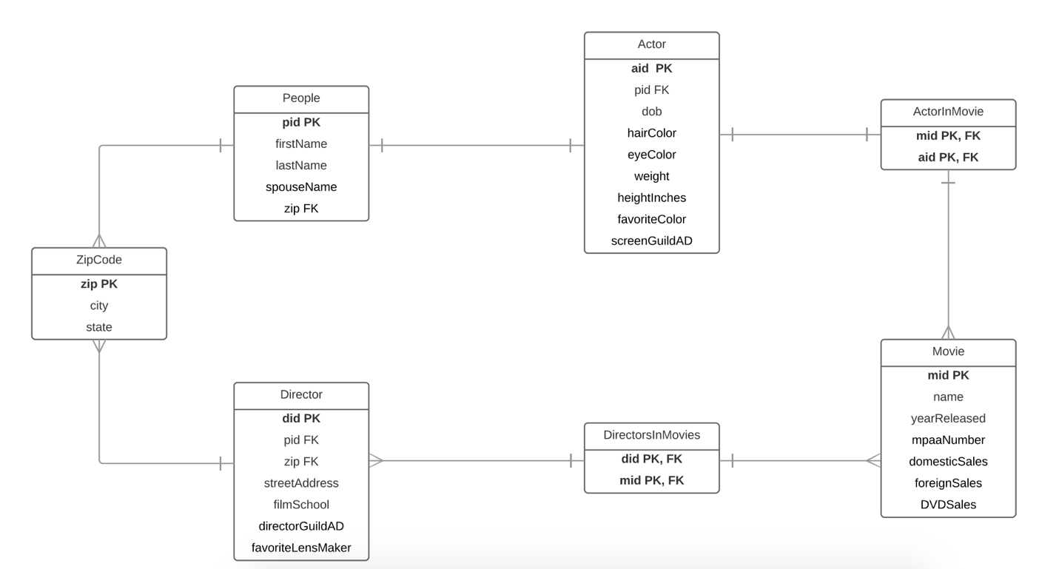

DROP TABLE IF EXISTS Actor;

DROP TABLE IF EXISTS Movie;

DROP TABLE IF EXISTS Director;

DROP TABLE IF EXISTS People;

DROP TABLE IF EXISTS ActorInMovie;

DROP TABLE IF EXISTS DirectorsInMovie;

-- Actor --

CREATE TABLE Actor (

aid char(5) not null,

pid char(5) not null,

dob text,

hairColor text,

eyeColor text,

weight text,

heightInches text,

favoriteColor text,

screenGuildAD text

);

-- Movie --

CREATE TABLE Movie (

mid char(5) not null,

name text,

yearReleased text,

mpaaNumber text,

domesticSales numeric(12,2),

foreignSales numeric(12,2),

DVDSales text

);

-- Director --

CREATE TABLE Director (

did char(5) not null,

zip char(5) not null,

pid char(5) not null,

streetAddress text,

filmSchool text,

directorGuildAD text,

favoriteLensMaker text

);

CREATE TABLE ZipCode (

zip char(5) not null,

city text,

state text

);

-- People --

CREATE TABLE People (

pid char(5) not null,

zip char(5) not null,

firstName text,

lastName text,

spouseName text

);

-- ActorInMovie --

CREATE TABLE ActorInMovie (

mid text,

aid text

);

-- DirectorsInMovie --

CREATE TABLE DirectorsInMovie (

did char(5) not null,

mid text

);

-- SQL statements for loading example data

-- Customers --

INSERT INTO Actor(aid, pid, dob, hairColor, eyeColor, weight, heightInches, favoriteColor, screenGuildAD)

VALUES('a01', 'p01', '11/01/1995', 'brown', 'blue', '189', '74', 'purple', '10/7/1989');

INSERT INTO Actor(aid, pid, dob, hairColor, eyeColor, weight, heightInches, favoriteColor, screenGuildAD)

VALUES('a02', 'p02', '10/6/1974', 'blonde', 'brown', '197', '70', 'pink', '10/7/1989');

INSERT INTO Actor(aid, pid, dob, hairColor, eyeColor, weight, heightInches, favoriteColor, screenGuildAD)

VALUES('a03', 'p03', '5/03/1987', 'brown', 'green', '160', '68', 'red', '10/7/1986');

INSERT INTO ZipCode(zip, city, state)

VALUES('11946', 'Hampton Bays', 'New York'),

('12601', 'Poughkeepsie', 'New York'),

('13475', 'Random Town', 'Pennsylvania');

-- Director --

INSERT INTO Director(did, pid, filmSchool, directorGuildAD, favoriteLensMaker, zip, streetAddress)

VALUES('d01', 'p04', 'Academy', '10/7/1983', 'Blue', '12601', '10 Emerson Court' ),

('d02', 'p05', 'NY Film', '10/7/1983', 'Black', '11946', '12 Harbor Road' ),

('d03', 'p06', 'School', '10/7/1989', 'Red', '13475', '5 Main Street' );

-- Movie --

INSERT INTO Movie(mid, name, yearReleased, mpaaNumber, domesticSales, foreignSales, DVDSales)

VALUES('m01', 'Aladdin', '1996', 'PG', '495.00', '800.00', '1200' ),

('m02', 'Frozen', '2015', 'PG', '987.00', '297.00', '2789' ),

('m03', 'The Great Gatsby', '2013', 'PG-13', '865.00', '329.00', '3787' );

-- People --

INSERT INTO People(pid, firstName, lastName, spouseName, zip)

VALUES('p01', 'John', 'Sasso', 'Taylor', '11946' );

INSERT INTO People(pid, firstName, lastName, spouseName, zip)

VALUES('p02', 'Roger', 'Moore', 'Demi', '12601' );

INSERT INTO People(pid, firstName, lastName, spouseName, zip)

VALUES('p03', 'Dave', 'Connelly', 'Lindsay', '12601' );

INSERT INTO People(pid, firstName, lastName, spouseName, zip)

VALUES('p04', 'Taylor', 'Dunn', 'David', '11946' );

INSERT INTO People(pid, firstName, lastName, spouseName, zip)

VALUES('p05', 'Shannon', 'Cover', 'JT', '13475' );

INSERT INTO People(pid, firstName, lastName, spouseName, zip)

VALUES('p06', 'Jason','Haley', 'Sreya', '13475' );

INSERT INTO People(pid, firstName, lastName, spouseName, zip)

VALUES('p07', 'Scott', 'Fritsh', 'Natalie', '13475' );

-- ActorInMovie --

INSERT INTO ActorInMovie(mid, aid)

VALUES('m02', 'a01'),

('m01', 'a02'),

('m01', 'a03'),

('m02', 'a02'),

('m02', 'a02'),

('m03', 'a02');

--DirectorsInMovie --

INSERT INTO DirectorsInMovie(did, mid)

VALUES('d01', 'm03'),

('d02', 'm01'),

('d01', 'm02'),

('d02', 'm03'),

('d03', 'm03'),

('d03', 'm02'),

('d01', 'm01'),

('d02', 'm02');

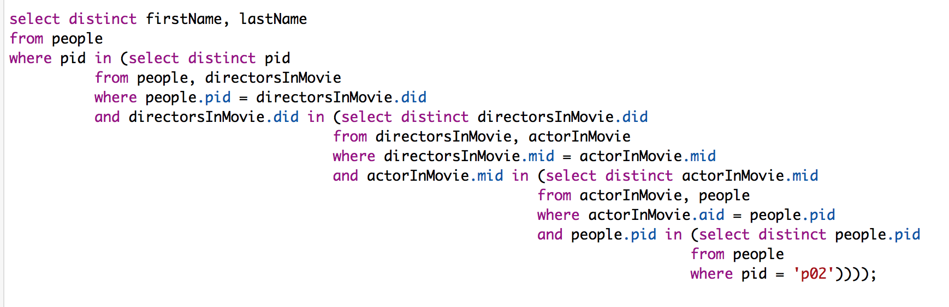

select distinct firstName, lastName

from people

where pid in (select distinct pid

from people, directorsInMovie

where people.pid = directorsInMovie.did

and directorsInMovie.did in (select distinct directorsInMovie.did

from directorsInMovie, actorInMovie

where directorsInMovie.mid = actorInMovie.mid

and actorInMovie.mid in (select distinct actorInMovie.mid

from actorInMovie, people

where actorInMovie.aid = people.pid

and people.pid in (select distinct people.pid

from people

where pid = 'p02'))));

**Dependencies:**

**People**

**pid 🡪 firstName**

**pid 🡪 lastName**

**pid 🡪 spouseName**

**Actor**

**pid 🡪 aid**

**aid 🡪 DOB**

**aid 🡪 eyeColor**

**aid 🡪 sagDate**

**aid 🡪 favoriteColor**

**aid 🡪 heightInches**

**aid 🡪 hairColor**

**aid 🡪 weight**

**Director**

**pid 🡪 did**

**did 🡪 filmSchool**

**did 🡪 directorGuildAD**

**did 🡪 favoriteLensMaker**

**did 🡪 streetAddress**

**did 🡪 zip**

**Movies**

**mid 🡪 title**

**mid 🡪 yearReleased**

**mid 🡪 mpaaNumber**

**mid 🡪 domesticSales**

**mid 🡪 foreignSales**

**mid 🡪 DVDSales**

**ZipCode**

**zip 🡪 city**

**zip 🡪 state**