Data Insights & Patterns
Online gambling estate analysis — Ministry of Digital Economy and Society, Thailand

Contents
Executive summary
Group A — The numbers
URLs analyzed per day
Status distribution
Top 10 URL suffixes
Group B — Subcategories
Gambling sites by product subcategory
Subcategory share
Assignment method by subcategory
Subcategory table
Signal tags across the estate
Heat map — Keyword × subcategory
Heat map — Signal tag × subcategory
Group C — Brands and clustering
Top 15 brand clusters by URL count
Cluster concentration
Heat map — Brand cluster × subcategory
Cluster expansion — gg88
Clusters spanning multiple subcategories
Clusters rotating top-level domains
Possible operator linkage
Naming conventions
Redirect propagation — lotto432e.com
Group D — Ranking
Gambling ranking
Group E — Key insights
Scale of the analysis
What is being offered
Brand clustering
How the estate is grown and marketed
Enforcement position
Group M — Model Insights
Introduction
Insights
Performance
Methodology

Executive summary
Reporting figure | Value
URLs analysed | 11,560
Gambling sites | 4,096 (35.4% of all URLs analysed)
Not gambling | 7,464
Brand clusters identified | 384, of which 286 hold more than one domain
Clusters covering half the estate | 29
Largest cluster | gg88 — 295 domains (7.2% of gambling URLs)
Dominant product subcategory | Slots — 1,221 (29.8% of gambling sites)
Most common signal tag | Abbreviations — 1,255 (30.6% of gambling sites)
Sites showing blocking indicators | 1
Subcategory assignment | 116 by keyword, 3,980 inferred from reasoning

Group A — The numbers
11,560  Total URLs analyzed | 4,096  Gambling sites | 384  Brand clusters identified | 23 days  Evaluation period  2026-08-31 → 2026-09-22

URLs analyzed per day
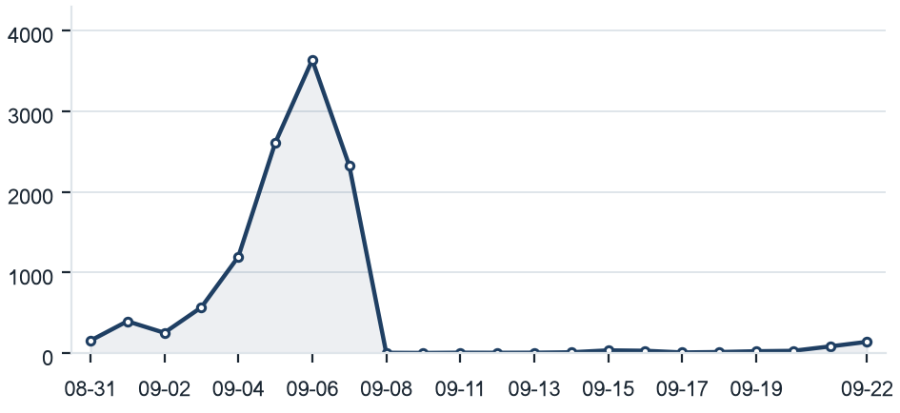
Distinct URLs updated on each date between 2026-08-31 and 2026-09-22.

Status distribution
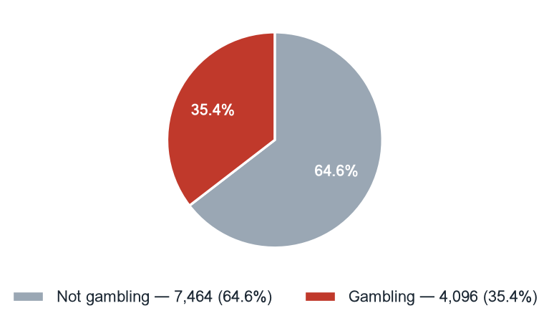
Status | Count | % of URLs analysed
Not gambling | 7,464 | 64.6%
Gambling | 4,096 | 35.4%

Top 10 URL suffixes
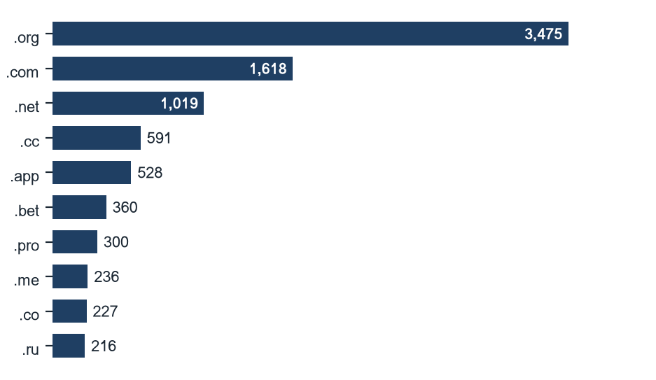
Suffix | Total | % of all | Gambling | % gambling
.org | 3,475 | 30.1% | 0 | 0.0%
.com | 1,618 | 14.0% | 573 | 35.4%
.net | 1,019 | 8.8% | 616 | 60.5%
.cc | 591 | 5.1% | 381 | 64.5%
.app | 528 | 4.6% | 372 | 70.5%
.bet | 360 | 3.1% | 347 | 96.4%
.pro | 300 | 2.6% | 251 | 83.7%
.me | 236 | 2.0% | 94 | 39.8%
.co | 227 | 2.0% | 37 | 16.3%
.ru | 216 | 1.9% | 2 | 0.9%

Group B — Subcategories

Gambling sites by product subcategory
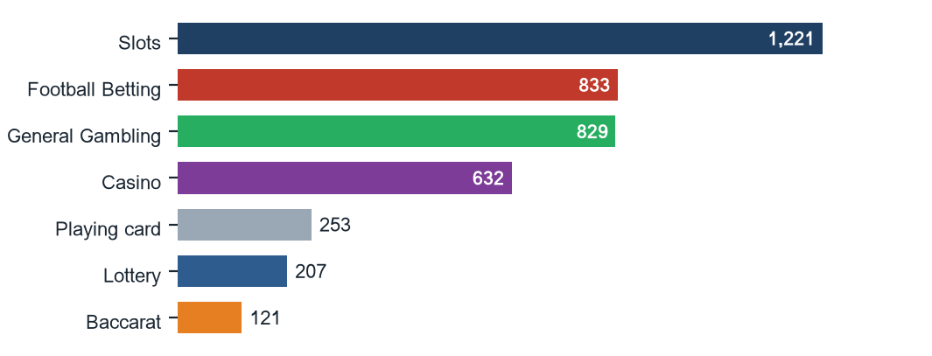

Subcategory share
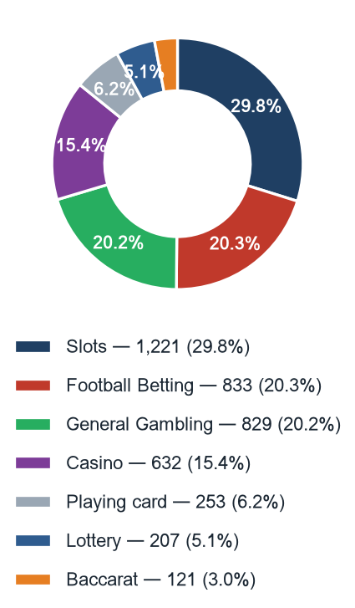

Assignment method by subcategory
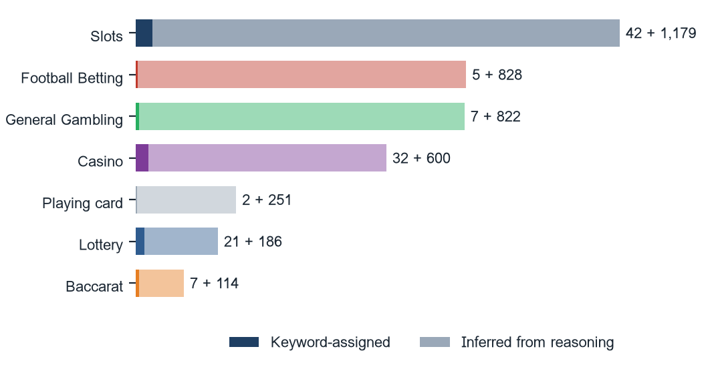
Inferred share 97.2% of gambling rows; General Gambling share 20.2%. Inferred assignments are read from the classifier reasoning, not from a lexicon match.

Subcategory table
Subcategory | Count | % of gambling | Keyword-assigned | Inferred | Distinct clusters
Slots | 1,221 | 29.8% | 42 | 1,179 | 260
Football Betting | 833 | 20.3% | 5 | 828 | 194
General Gambling | 829 | 20.2% | 7 | 822 | 188
Casino | 632 | 15.4% | 32 | 600 | 168
Playing card | 253 | 6.2% | 2 | 251 | 122
Lottery | 207 | 5.1% | 21 | 186 | 48
Baccarat | 121 | 3.0% | 7 | 114 | 68

Signal tags across the estate
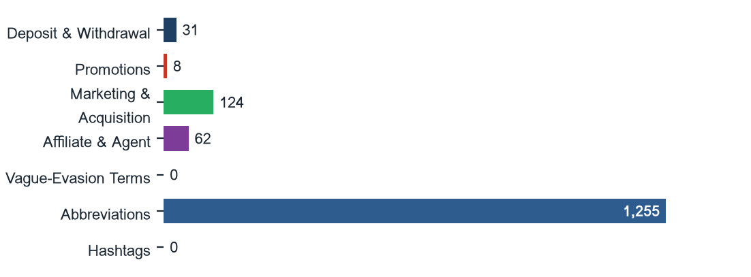
Mean signal tags per gambling site: 0.36. Signal tags record how a site operates or markets itself; they are never a subcategory.

Heat map — Keyword × subcategory
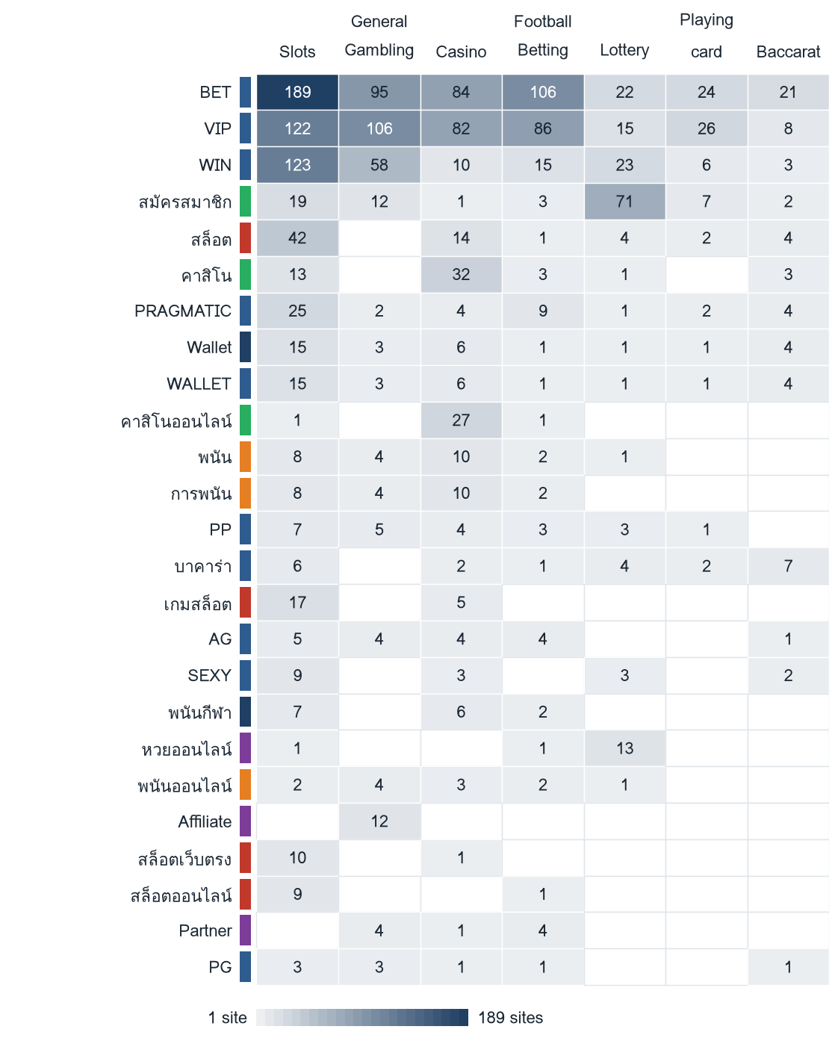
Top 25 matched keywords. The coloured strip beside each keyword is its own Appendix A category (Football Betting · Slots · Casino · Lottery · Baccarat · General Gambling · Deposit & Withdrawal · Marketing & Acquisition · Affiliate & Agent · Abbreviations), so cross-category bleed is visible. Zero cells are drawn empty, not pale.

Heat map — Signal tag × subcategory
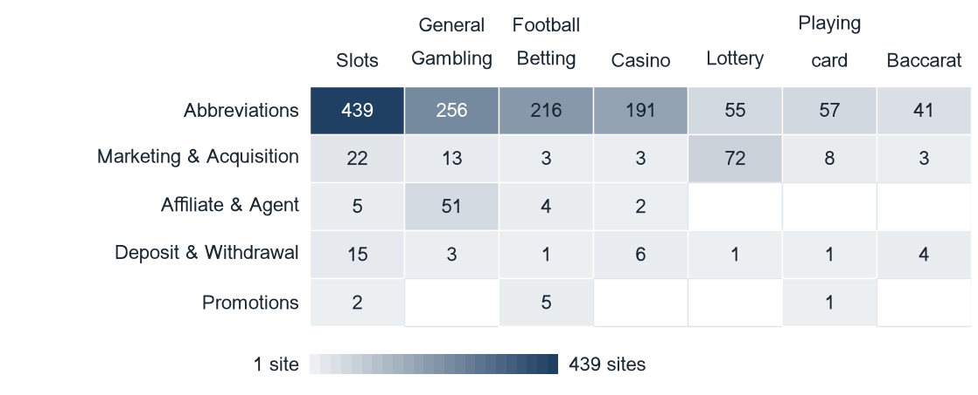
Which product types lean on promotional, payment or evasion language. Signal tags with no matches in this sample are not drawn.

Group C — Brands and clustering
384  Distinct clusters | 286  Clusters with ≥ 2 URLs | 98  Singletons | 29  Clusters covering half the estate

Top 15 brand clusters by URL count
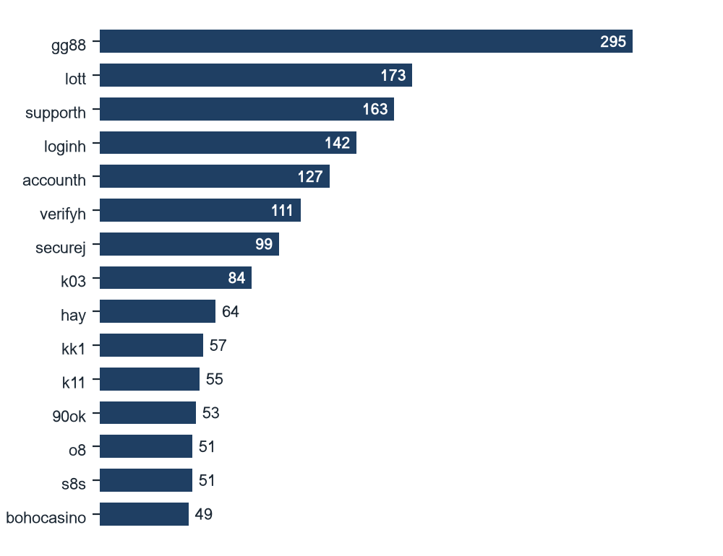
Cluster names are the shortest member stem. Top 5 clusters hold 22.0% of gambling URLs; top 10 hold 32.1%.

Cluster concentration
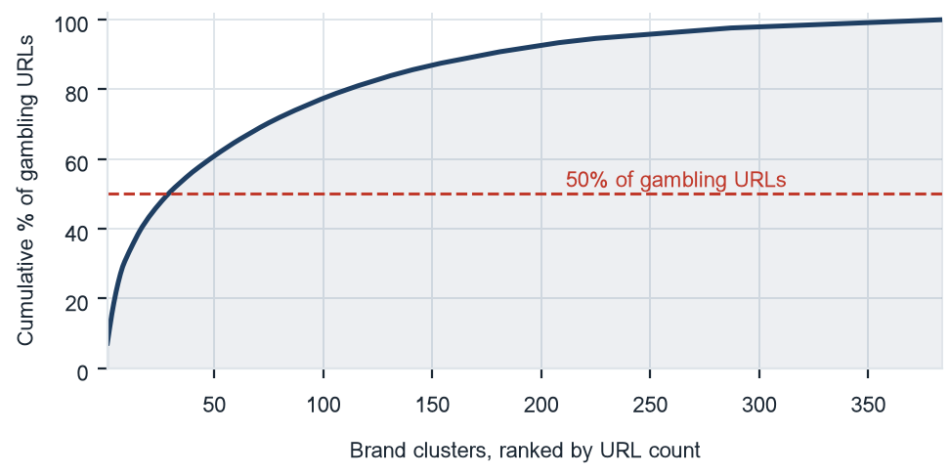
29 clusters cover 50% of gambling URLs.

Heat map — Brand cluster × subcategory
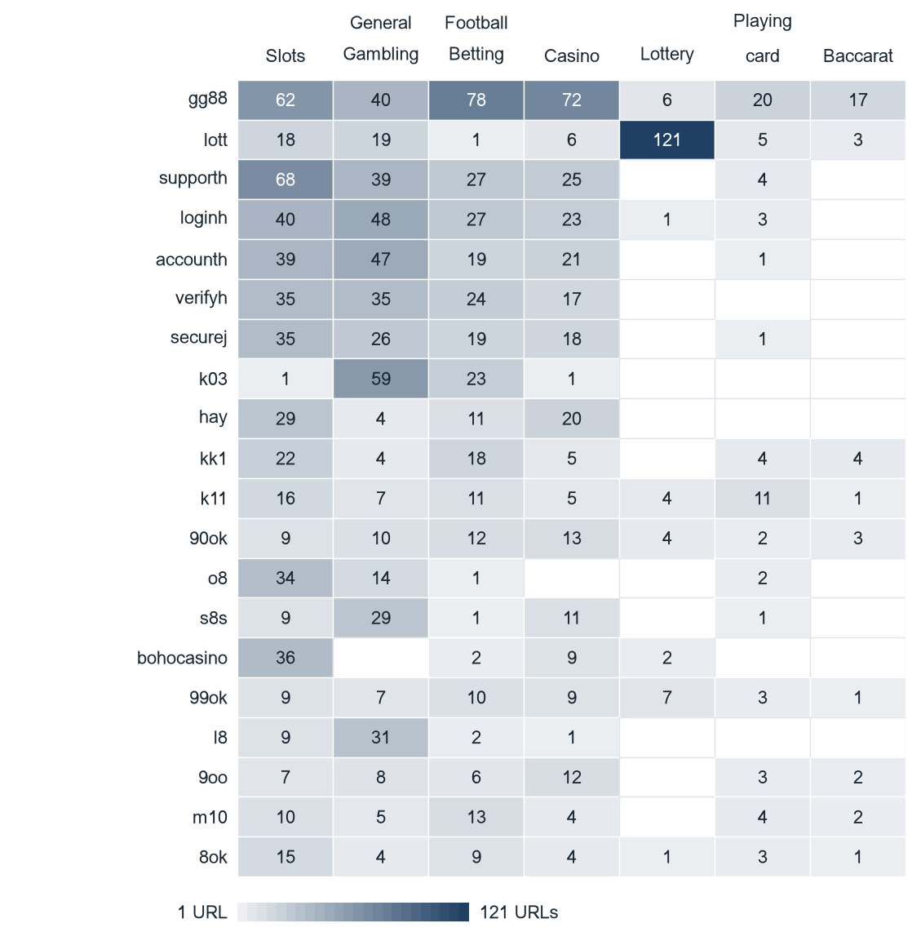
Top 20 clusters by URL count. A cluster spanning several columns is a multi-product operator.

Cluster expansion — gg88
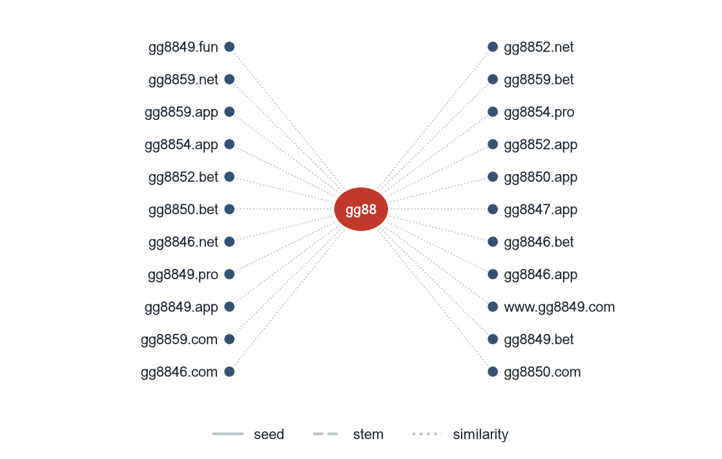
gg88 holds 295 domains across 20 top-level domains; the cluster was formed by similarity linkage.
Diagram shows 22 of 295 member domains.

Clusters spanning multiple subcategories
Cluster | URLs | Subcategories | Suffixes
gg88 | 295 | Football Betting (78), Casino (72), Slots (62) +4 more | .app, .bet, .casino, .cc +16
lott | 173 | Lottery (121), General Gambling (19), Slots (18) +4 more | .app, .bet, .cash, .cc +16
supporth | 163 | Slots (68), General Gambling (39), Football Betting (27) +2 more | .bet, .cc, .com, .game +3
loginh | 142 | General Gambling (48), Slots (40), Football Betting (27) +3 more | .bet, .cc, .game, .net +2
accounth | 127 | General Gambling (47), Slots (39), Casino (21) +2 more | .bet, .cc, .com, .game +4
verifyh | 111 | General Gambling (35), Slots (35), Football Betting (24) +1 more | .bet, .cc, .game, .net +1
securej | 99 | Slots (35), General Gambling (26), Football Betting (19) +2 more | .bet, .cc, .game, .net +1
k03 | 84 | General Gambling (59), Football Betting (23), Casino (1) +1 more | .cc, .net, .pro
hay | 64 | Slots (29), Casino (20), Football Betting (11) +1 more | .app, .bet, .cc, .click +5
kk1 | 57 | Slots (22), Football Betting (18), Casino (5) +3 more | .app, .bet, .cc, .click +9
k11 | 55 | Slots (16), Football Betting (11), Playing card (11) +4 more | .1, .app, .cc, .click +12
90ok | 53 | Casino (13), Football Betting (12), General Gambling (10) +4 more | .app, .bet, .buzz, .casino +17
o8 | 51 | Slots (34), General Gambling (14), Playing card (2) +1 more | .bet, .casino, .click, .club +4
s8s | 51 | General Gambling (29), Casino (11), Slots (9) +2 more | .com
bohocasino | 49 | Slots (36), Casino (9), Lottery (2) +1 more | .app, .bet, .casino, .co +11

232 clusters span two or more product subcategories; the 15 largest are shown.

Clusters rotating top-level domains
Cluster | Suffixes | Counts
gg88 | .net, .app, .pro, .bet, .com, .online +14 | .net×53, .app×48, .pro×46, .bet×36, .com×30, .online×17
lott | .com, .net, .live, .info, .bet, .cc +14 | .com×98, .net×12, .live×7, .info×7, .bet×7, .cc×6
supporth | .net, .cc, .game, .bet, .com, .icu +1 | .net×75, .cc×40, .game×31, .bet×13, .com×2, .icu×1
loginh | .net, .cc, .vip, .game, .bet, .shop | .net×60, .cc×48, .vip×14, .game×13, .bet×6, .shop×1
accounth | .net, .cc, .game, .bet, .com, .xyz +2 | .net×61, .cc×41, .game×13, .bet×7, .com×2, .xyz×1
verifyh | .net, .cc, .bet, .game, .shop | .net×57, .cc×39, .bet×12, .game×2, .shop×1
securej | .net, .cc, .bet, .game, .shop | .net×48, .cc×34, .bet×11, .game×5, .shop×1
k03 | .cc, .net, .pro | .cc×82, .net×1, .pro×1
hay | .net, .bet, .click, .com, .fun, .app +3 | .net×52, .bet×4, .click×2, .com×1, .fun×1, .app×1
kk1 | .pro, .app, .me, .fun, .bet, .net +7 | .pro×12, .app×11, .me×9, .fun×5, .bet×4, .net×3
k11 | .cc, .pro, .click, .app, .io, .xyz +10 | .cc×11, .pro×8, .click×7, .app×5, .io×5, .xyz×4
90ok | .club, .io, .click, .xyz, .bet, .casino +15 | .club×7, .io×5, .click×5, .xyz×4, .bet×4, .casino×3
o8 | .game, .casino, .click, .club, .bet, .live +2 | .game×42, .casino×2, .click×2, .club×1, .bet×1, .live×1
bohocasino | .com, .info, .co, .net, .fun, .top +9 | .com×31, .info×3, .co×2, .net×2, .fun×1, .top×1
99ok | .bet, .vip, .club, .pro, .app, .co +12 | .bet×15, .vip×3, .club×3, .pro×3, .app×3, .co×2

214 clusters appear under more than one top-level domain; the 15 largest are shown.

Possible operator linkage
Indicative — not a clustering decision
Cluster A | Cluster B | Shared signal keywords | Jaccard
7oo | op11 | BET, VIP, WALLET, WIN, Wallet +1 | 1.00
80p | ko9 | BET, PRAGMATIC, WALLET, WIN, Wallet +1 | 0.67
lott | p77 | Affiliate, BET, PP, PRAGMATIC, VIP +1 | 0.60
7ok | 7oo | BET, VIP, WALLET, WIN, Wallet | 0.83
7ok | op11 | BET, VIP, WALLET, WIN, Wallet | 0.83
90ok | k6 | Affiliate, BET, PRAGMATIC, VIP, WIN | 0.83
90ok | m02 | BET, PRAGMATIC, RTP, VIP, WIN | 0.83
k11 | p77 | BET, PP, PRAGMATIC, VIP, WIN | 0.83
k6 | p77 | Affiliate, BET, PRAGMATIC, VIP, WIN | 0.83
90ok | p77 | Affiliate, BET, PRAGMATIC, VIP, WIN | 0.71
7oo | ko9 | BET, WALLET, WIN, Wallet, สมัครสมาชิก | 0.62
ko9 | op11 | BET, WALLET, WIN, Wallet, สมัครสมาชิก | 0.62
70k | hagy | BET, WALLET, WIN, Wallet | 1.00
8ok | j10 | BET, PRAGMATIC, VIP, WIN | 1.00
8ok | k20 | BET, PRAGMATIC, VIP, WIN | 1.00

2,796 cluster pairs share a signal-keyword fingerprint at Jaccard ≥ 0.60; the 15 with the largest shared sets are shown. Shared promotional vocabulary is common across unrelated operators using the same affiliate templates, so these are leads for an analyst, not merges.

Naming conventions
• Recurring tokens: “mobile” (292 names), “login” (265 names), “support” (264 names). The same handful of tokens recurs across unrelated brand clusters, which is evidence of a templated naming scheme rather than independently chosen names.
• TLD switching: .net (427), .cc (308), .com (219), .bet (106). Names in the largest clusters span more than one top-level domain, so the operator rotates top-level domains rather than registering within one.
• 4,096 distinct domains across 384 brand clusters.

59  Direct — 1.4% | 192  Redirect — 4.7% | 3,845  Variant — 93.9%

Redirect propagation — lotto432e.com
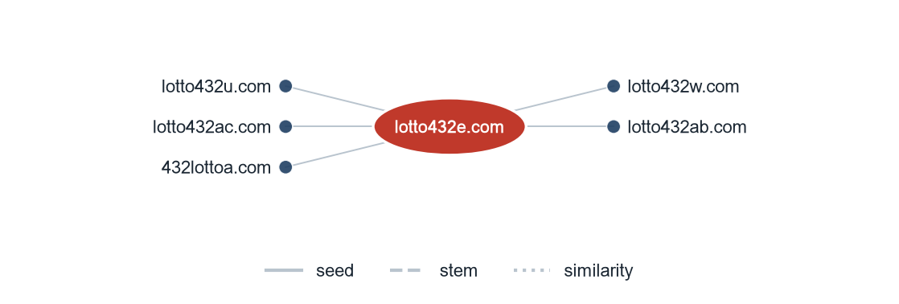
lotto432e.com is the busiest redirect source in the gambling set, reaching 5 distinct destination URLs.

Group D — Ranking

Gambling ranking
Rank | Domain | Cluster | Subcategory | Source
78,229 | lottovip.com | lott | Lottery | Other
90,304 | lottovip.bet | lott | Lottery | Variant
93,266 | lottovip.info | lott | Slots | Variant
184,475 | fun88thf.com | fun88hr | Football Betting | Variant
216,041 | lottovipp.com | lott | Lottery | Variant
402,382 | ruay.com | ruay | General Gambling | Other
517,141 | jun88.info | jun | Slots | Variant
517,141 | slavinaslot.top | jun | Slots | Redirect
547,370 | 99ok.vip | 99ok | Lottery | Variant
558,790 | gg8830.com | gg88 | Slots | Variant
595,712 | ruayy.com | ruay | Slots | Variant
706,458 | lotto432ad.com | lott | Lottery | Variant
715,861 | k7.game | k6 | General Gambling | Variant
727,399 | gg8832.com | gg88 | Slots | Variant
732,322 | gg8843.com | gg88 | General Gambling | Variant

Gambling sites carrying a numeric rank, ascending; the 15 highest-ranked are shown. 106 of 4,096 gambling rows carry a rank.

Group E — Key insights

Scale of the analysis
11,560 distinct URLs were analysed over 23 days (2026-08-31 → 2026-09-22), of which 4,096 are gambling sites, 7,464 are not gambling and 0 were unreachable.
The sample is large enough to reason about patterns, not isolated cases.

What is being offered
The three largest product subcategories are Slots (1,221, 29.8%), Football Betting (833, 20.3%), General Gambling (829, 20.2%). 20.2% of sites confirmed as gambling carry no evidenced product type and sit in General Gambling, and 97.2% of subcategory assignments were inferred from classifier reasoning rather than matched against the lexicon. 225 of the 286 lexicon keywords never matched a row in this sample.
Slots is the dominant product type, but at 29.8% of gambling rows the estate is spread across product types rather than concentrated in one.

Brand clustering
384 brand clusters were identified across 4,096 gambling URLs. 286 of them hold more than one domain. 29 clusters cover half the estate. The largest, gg88, holds 295 domains across 7 product subcategories.
The estate is diffuse — 29 clusters are needed to cover half of it — so per-URL blocking will have limited leverage.

How the estate is grown and marketed
3,845 gambling URLs were identified by the crawler as variants, 192 sit behind redirect chains and 59 were reached directly. The busiest redirect source is lotto432e.com with 5 destinations. 214 clusters appear under more than one top-level domain. The two most common signal tags are Abbreviations (30.6%) and Marketing & Acquisition (3.0%).
Redirects and TLD rotation keep a stable entry point while the sites behind it are replaced.

Enforcement position
1 page in this set already shows regulatory-blocking indicators — court orders, regulator notices or third-party block pages — in the classifier reasoning, 0.0% of the 11,560 URLs analysed.
At 0.0% the set is effectively pre-enforcement, and is a candidate for a first pass, prioritised by cluster rather than by URL.

Group M — Model Insights

Introduction

Insights

Performance

Methodology
Inferred share: 97.2% of gambling rows. General Gambling share: 20.2% of gambling rows.
The lexicon has poor coverage of this dataset: subcategory figures are indicative only. Most gambling rows carried no lexicon keyword and were placed by reading the classifier reasoning instead.
Clustering thresholds: names reduced to a stem, then merged on Jaro–Winkler similarity ≥ 0.90 where one stem is a prefix of the other or the two differ only in trailing characters. Crawler-asserted seed linkage takes precedence over stem matching. Operator-linkage pairs are reported at Jaccard ≥ 0.60 of their signal-keyword sets and are never merged.

