Data Insights & Patterns
31,798 URLs · 31 Aug – 28 Sep 2026
Issued to Ministry of Digital Economy and Society, Thailand
Prepared by SICPA SA
Date of issue 28/09/2026
Source system SICPADetect · lexicon Gambling_Keywords_Full_English_Categories_V1.xlsx (V1)

Contents
Executive summary
Group A — Model insights
Introduction
Insights
Performance
Group B — Most prominent gambling sites in Thailand
10 most prominent gambling sites in Thailand
Group C — The numbers
The numbers at a glance
URLs analysed per day
Status distribution
Top 10 URL suffixes
Group D — Subcategories
Gambling sites by product subcategory
Assignment method by subcategory
Subcategory table
Heat map — keyword by subcategory
Heat map — signal tag by subcategory
Group E — Brands and clustering
Clustering at a glance
Top 15 brand clusters by URL count
Heat map — brand cluster by subcategory
Cluster expansion — jun
Clusters spanning multiple subcategories
Clusters rotating top-level domains
Possible operator linkage
Naming conventions
Structure: direct, redirect, variant
Redirect propagation — www.min88.top
Group F — Ranking
Gambling ranking
Group G — Key insights
Scale of the analysis
What is being offered
Brand clustering
How the estate is grown and marketed
Enforcement position

Executive summary
Part 1a. Insights and trends
The estate analysed holds 31,798 distinct URLs over 29 days, of which 9,175 carry gambling content. The rest are sites classified as not gambling, sites that could not be reached, and records the source feed leaves unresolved.
Product type is dominated by slots, at 41.7% of gambling sites, with casino and football betting behind it. A further group is confirmed as gambling without an evidenced product type and is carried as General Gambling rather than pushed into a product bucket. Most assignments come from reading the reasoning text rather than from a lexicon match, so the product picture is indicative.
Operators are concentrated. 939 brand clusters sit behind the gambling URLs, and 46 of them cover half the estate. The largest spans every product type in the report, which is the signature of a multi product operator rather than a single game site.
The estate is grown by replication rather than by new entrants. Almost all gambling URLs are crawler identified variants of a domain already in the set; a smaller group sits behind redirect chains and only a thin layer was reached directly. Clusters rotate top level domains, and the signal most often present is provider and network branding rather than promotional or payment language.
Enforcement is barely visible in this window. Only a handful of pages carry a block notice, a court order or a regulator reference.
The evaluation period is too short to carry a direction of travel, so no trend is stated.
Part 1b. Key figures
Reporting figure | Value
URLs analysed | 31,798
Gambling sites | 9,175 (28.9% of URLs analysed)
Not gambling | 11,594
Unreachable | 28
Status not resolved by the source feed | 11,001
Brand clusters identified | 939
Clusters holding more than one domain | 656
Clusters covering half the gambling estate | 46
Largest cluster | jun — 609 URLs
Dominant product subcategory | Slots — 3,830 (41.7%)
Most common signal tag | Abbreviations — 3,209 (35.0%)
Sites showing blocking indicators | 7
Subcategory assignment: keyword versus inferred | 338 keyword · 8,837 inferred

Group A — Model insights
Introduction

Insights

Performance

Group B — Most prominent gambling sites in Thailand
10 most prominent gambling sites in Thailand
Rank | URL (defanged) | Domain | Brand cluster | Subcategory | Thai-targeting evidence | Source
78229 | hxxps://www[.]lottovip[.]com/register/af/21832 | lottovip.com | lott | Lottery | Thai currency: “Baht” | Youtube (lotto432)
90304 | hxxps://lottovip[.]bet/ | lottovip.bet | lott | Lottery | Thai-market product or brand terms: “BET” | Variant (lottovip.com)
184475 | hxxps://fun88thf[.]com/ | fun88thf.com | fun88tht | Football Betting | Thai-market product or brand terms: “VIP” | Variant (fun88tht.com)
216041 | hxxps://lottovipp[.]com/ | lottovipp.com | lott | Lottery | Thai-market product or brand terms: “WIN” | Variant (lottovip.com)
221001 | hxxps://suriyathai[.]net/ | suriyathai.net | suriya | General Gambling | Thai script: “สมัครสมาชิก” | Manual (claude.ai)
517141 | hxxps://slavinaslot[.]top/ | slavinaslot.top | jun | Slots | Thai-market product or brand terms: “VIP” | Redirect (jun88.info)
517141 | hxxps://jun88[.]info/ | jun88.info | jun | Slots | Thai-market product or brand terms: “VIP” | Variant (jun88.mobile)
547370 | hxxps://99ok[.]vip/ | 99ok.vip | 99ok | Lottery | Thai-market product or brand terms: “VIP” | Variant (99ok.bet)
558790 | hxxps://gg8830[.]com/ | gg8830.com | gg88 | Slots | Thai-market product or brand terms: “SEXY” | Variant (gg8825.app)
706458 | hxxps://lotto432ad[.]com/ | lotto432ad.com | lott | Lottery | Thai script: “สมัครสมาชิก” | Variant (lotto432ae.com)

Rank reflects search visibility in the source feed, not harm, reach or revenue.

Group C — The numbers
The numbers at a glance
31,798  Total URLs analysed | 9,175  Gambling sites | 939  Brand clusters identified | 29 days  2026-08-31 → 2026-09-28

URLs analysed per day
Daily count of URLs analysed across the evaluation period. Each point is one calendar day.
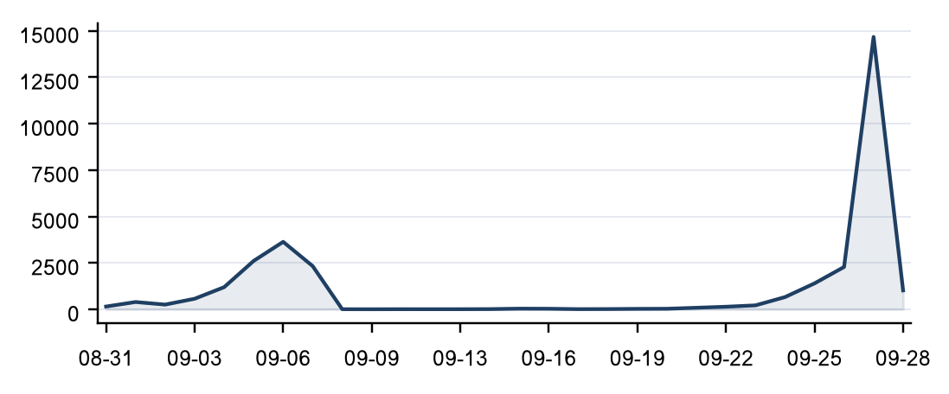

Status distribution
Share of the estate by classification status. Each segment is one status and the table below carries the counts.
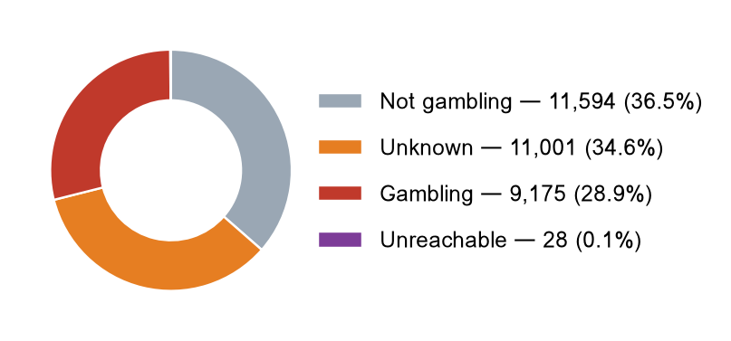
Status | Count | % of URLs analysed
Not gambling | 11,594 | 36.5%
Unknown | 11,001 | 34.6%
Gambling | 9,175 | 28.9%
Unreachable | 28 | 0.1%
Total | 31,798 | 100.0%

Top 10 URL suffixes
The ten most common URL suffixes in the estate. Bar length is the total count and the table separates the gambling share.
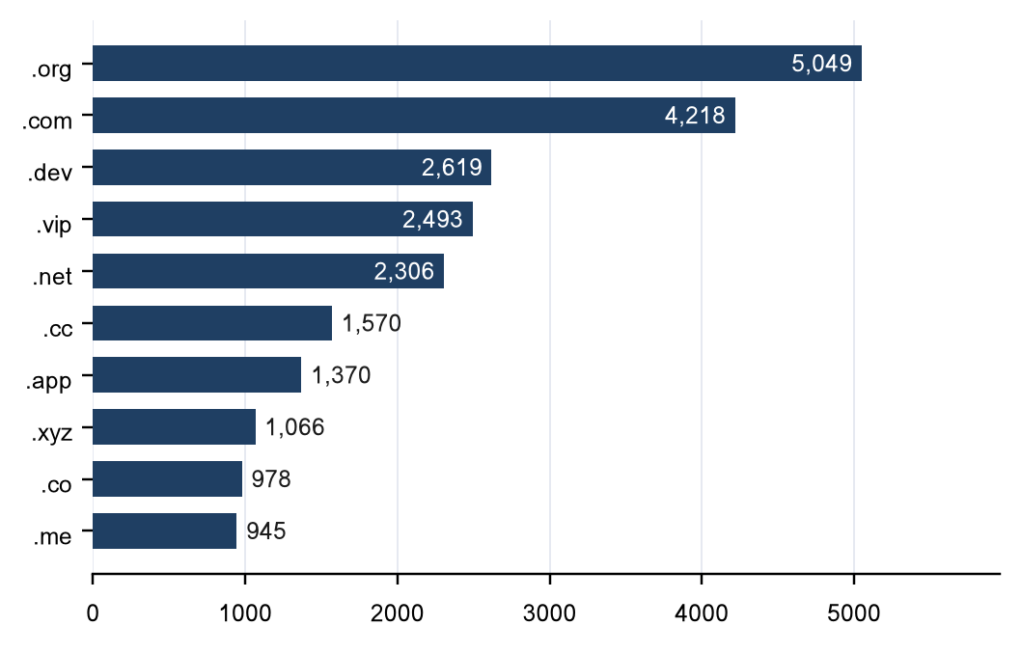
Suffix | Total | % of all | Gambling | % gambling
.org | 5,049 | 15.9% | 9 | 0.2%
.com | 4,218 | 13.3% | 1,389 | 32.9%
.dev | 2,619 | 8.2% | 451 | 17.2%
.vip | 2,493 | 7.8% | 872 | 35.0%
.net | 2,306 | 7.3% | 985 | 42.7%
.cc | 1,570 | 4.9% | 631 | 40.2%
.app | 1,370 | 4.3% | 591 | 43.1%
.xyz | 1,066 | 3.4% | 206 | 19.3%
.co | 978 | 3.1% | 177 | 18.1%
.me | 945 | 3.0% | 212 | 22.4%

Group D — Subcategories
Gambling sites by product subcategory
Gambling sites by product subcategory. Bar length is the site count and each label carries the count and the share of gambling rows.
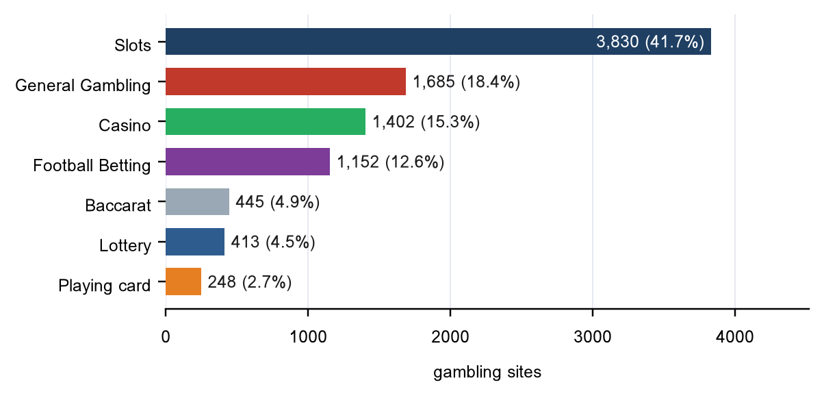

Assignment method by subcategory
How each subcategory was assigned. Solid fill is a lexicon keyword match and the lighter fill is reasoning inference.
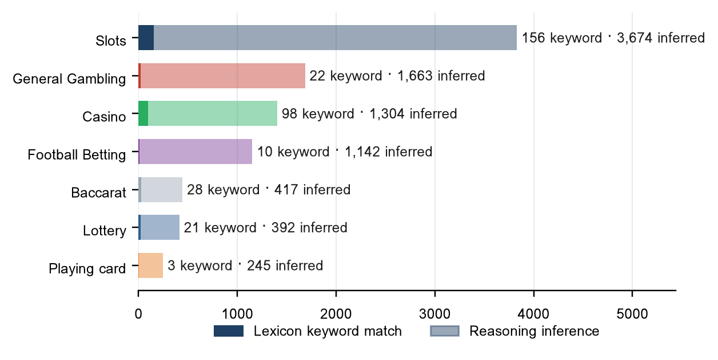
Inferred share 96.3% of gambling rows; General Gambling share 18.4%. An inferred share above 30% means the lexicon has poor coverage of this dataset, so subcategory figures are indicative only. A Thai-language lexicon run against an estate whose evidence text is largely English produces exactly this result.

Subcategory table
Subcategory | Count | % of gambling | Keyword | Inferred | Distinct clusters
Slots | 3,830 | 41.7% | 156 | 3,674 | 649
General Gambling | 1,685 | 18.4% | 22 | 1,663 | 430
Casino | 1,402 | 15.3% | 98 | 1,304 | 378
Football Betting | 1,152 | 12.6% | 10 | 1,142 | 287
Baccarat | 445 | 4.9% | 28 | 417 | 223
Lottery | 413 | 4.5% | 21 | 392 | 125
Playing card | 248 | 2.7% | 3 | 245 | 157
Total | 9,175 | 100.0% | 338 | 8,837 | —

Heat map — keyword by subcategory
Matched keywords against product subcategory. Each cell is the number of gambling sites carrying that keyword in that subcategory.
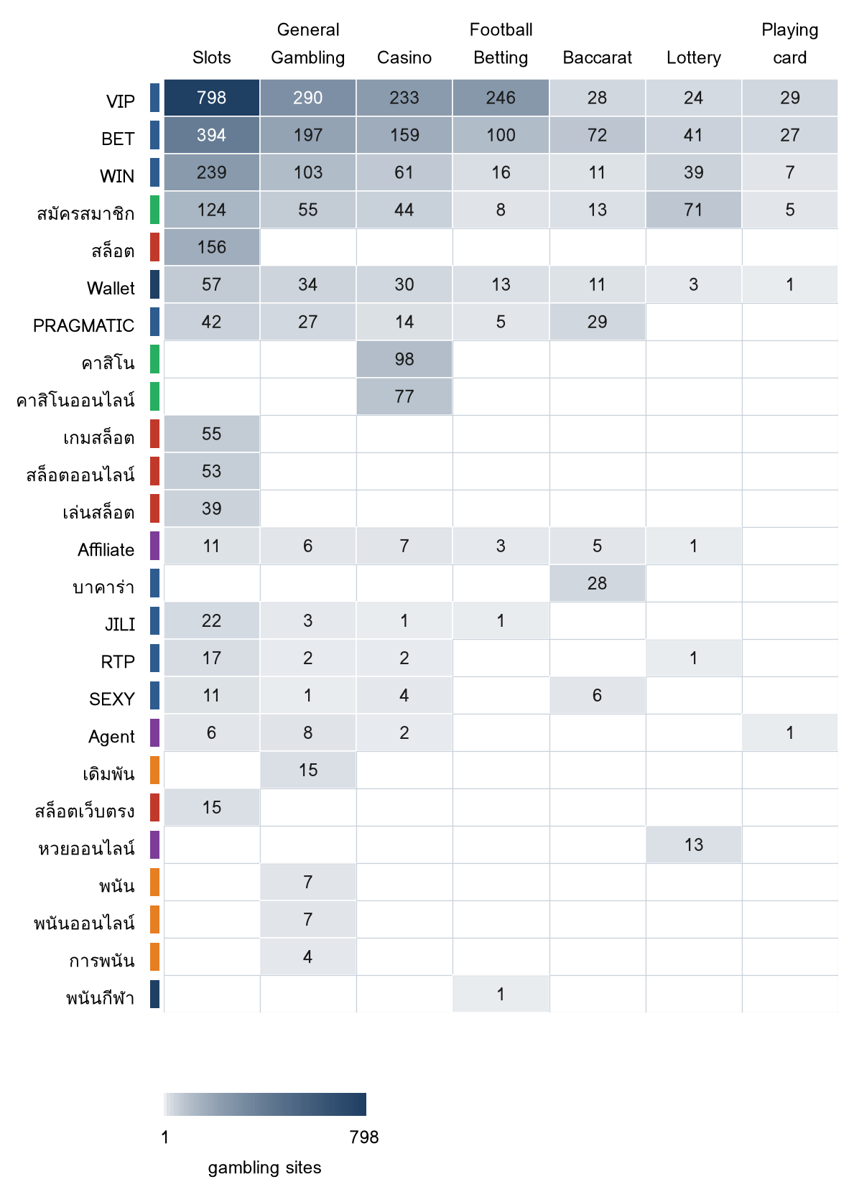
The strip beside each keyword carries its own lexicon category, so a keyword scoring across several product columns is visible as cross category bleed. Thai keywords are shown in their original script.

Heat map — signal tag by subcategory
Signal tags against product subcategory. Each cell is the number of gambling sites carrying that tag in that subcategory.
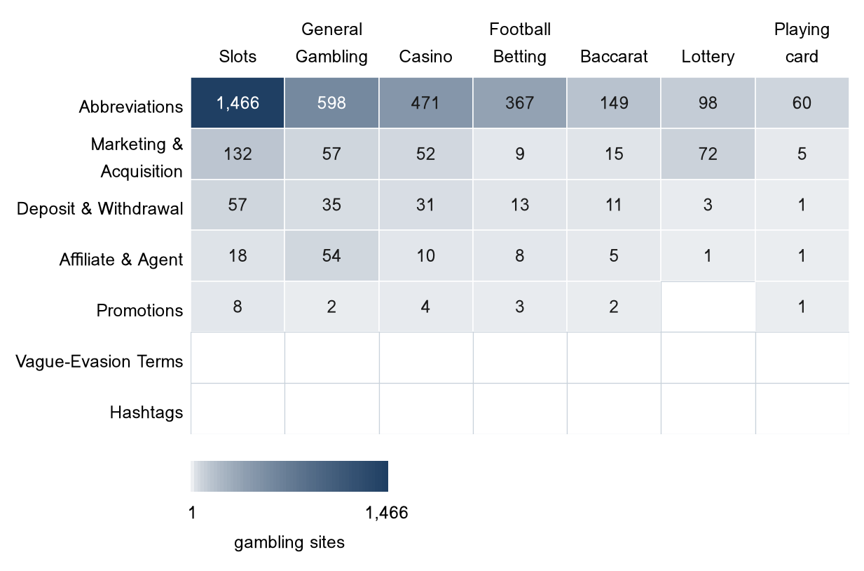

Group E — Brands and clustering
Clustering at a glance
939  Distinct clusters | 656  Clusters with 2 or more URLs | 283  Singletons | 46  Clusters covering half the estate

Top 15 brand clusters by URL count
The fifteen largest brand clusters by URL count. Bar length is the number of domains in the cluster.
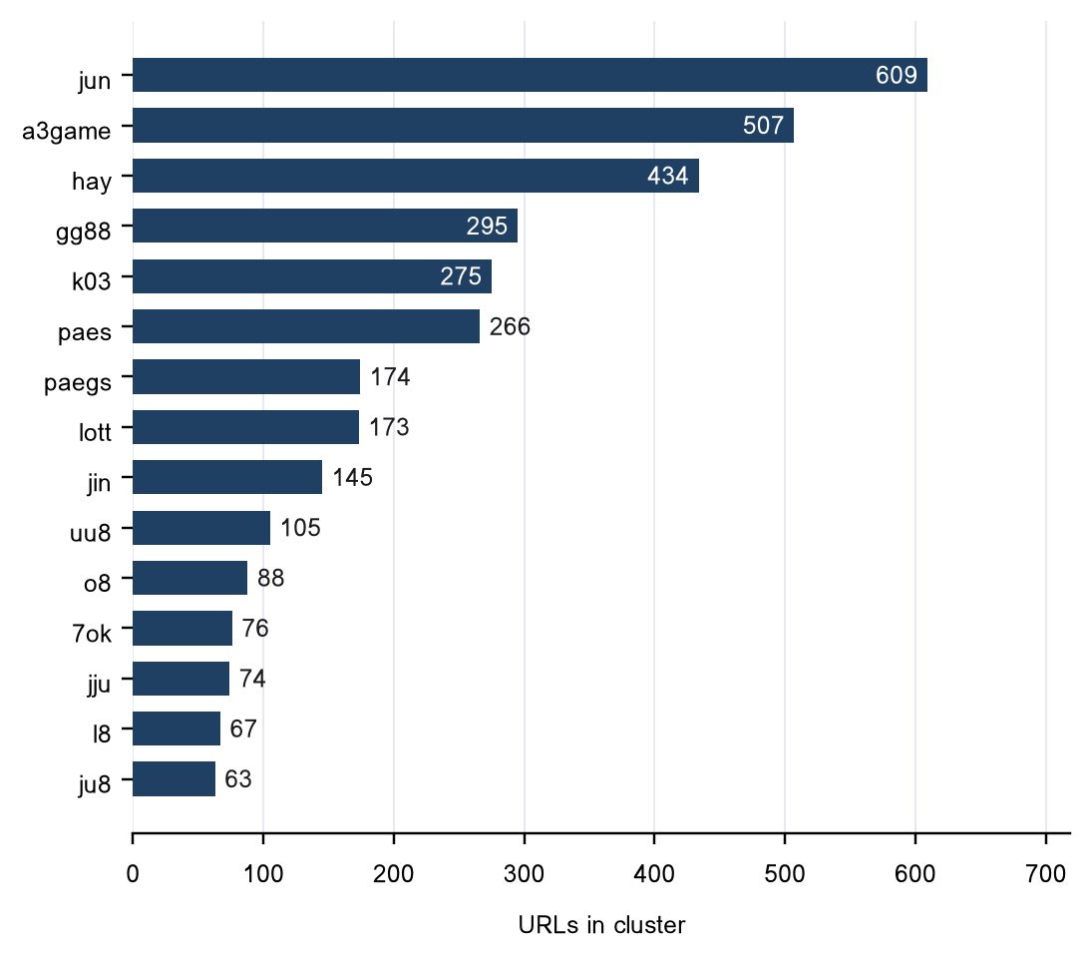

Heat map — brand cluster by subcategory
Brand clusters against product subcategory. Each cell is the number of URLs a cluster holds in that subcategory.
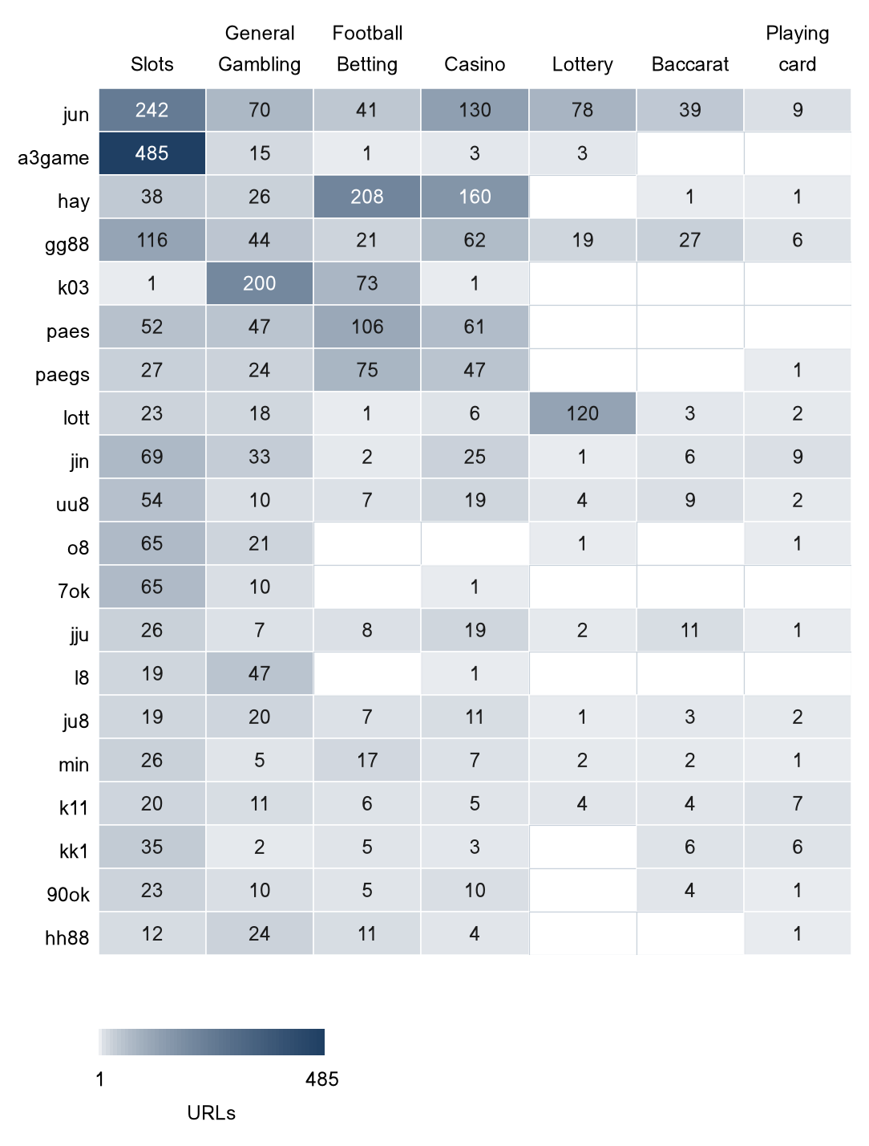

Cluster expansion — jun
The largest brand cluster and its member domains. Edge style records why each domain joined the cluster.
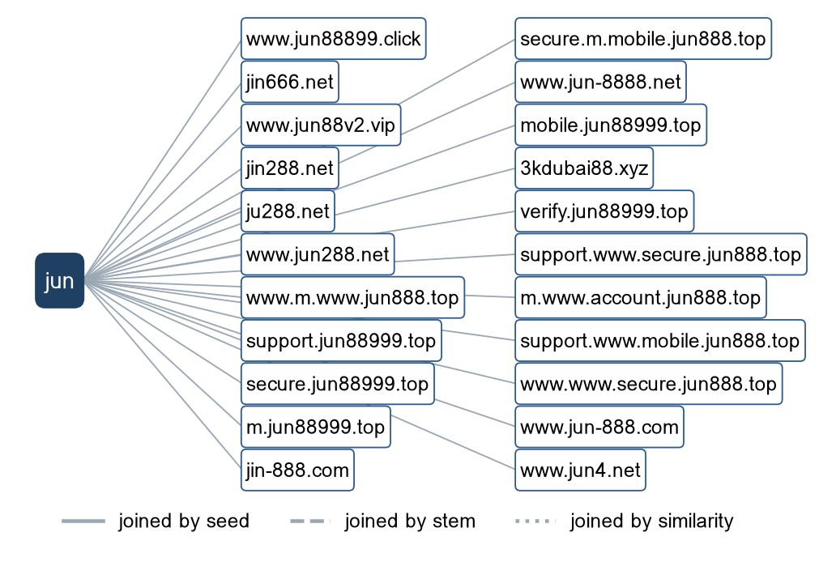
jun holds 609 gambling URLs across 7 product subcategories; the diagram shows 22 of them.

Clusters spanning multiple subcategories
Cluster | URLs | Subcategories | Suffixes
jun | 609 | Slots 242, Casino 130, Lottery 78, General Gambling 70 | .top, .com, .net, .bet, .cc
a3game | 507 | Slots 485, General Gambling 15, Lottery 3, Casino 3 | .vip, .app, .click, .club
hay | 434 | Football Betting 208, Casino 160, Slots 38, General Gambling 26 | .net, .cc, .bet, .click, .pro
gg88 | 295 | Slots 116, Casino 62, General Gambling 44, Baccarat 27 | .net, .app, .pro, .bet, .com
k03 | 275 | General Gambling 200, Football Betting 73, Slots 1, Casino 1 | .cc, .xyz, .pro, .net
paes | 266 | Football Betting 106, Casino 61, Slots 52, General Gambling 47 | .dev, .com
paegs | 174 | Football Betting 75, Casino 47, Slots 27, General Gambling 24 | .dev
lott | 173 | Lottery 120, Slots 23, General Gambling 18, Casino 6 | .com, .net, .live, .info, .bet
jin | 145 | Slots 69, General Gambling 33, Casino 25, Playing card 9 | .vip, .com, .pro, .net, .co
uu8 | 105 | Slots 54, Casino 19, General Gambling 10, Baccarat 9 | .cc, .com, .net, .pro, .app
o8 | 88 | Slots 65, General Gambling 21, Lottery 1, Playing card 1 | .game, .click, .casino, .co, .uk
7ok | 76 | Slots 65, General Gambling 10, Casino 1 | .bet, .shop, .live, .pro
jju | 74 | Slots 26, Casino 19, Baccarat 11, Football Betting 8 | .pro, .net, .fun, .com, .xyz
l8 | 67 | General Gambling 47, Slots 19, Casino 1 | .game, .casino, .bet, .club, .pro
ju8 | 63 | General Gambling 20, Slots 19, Casino 11, Football Betting 7 | .com, .click, .pro, .buzz, .site

Clusters rotating top-level domains
Cluster | Suffixes and counts | URLs
jun | .top (99), .com (95), .net (82), .bet (38), .cc (36), .fun (30), .pro (29), .app (28) | 609
a3game | .vip (498), .app (6), .click (2), .club (1) | 507
hay | .net (408), .cc (14), .bet (5), .click (2), .pro (1), .club (1), .app (1), .fun (1) | 434
gg88 | .net (53), .app (48), .pro (46), .bet (36), .com (30), .online (17), .vip (15), .club (13) | 295
k03 | .cc (272), .xyz (1), .pro (1), .net (1) | 275
paes | .dev (265), .com (1) | 266
lott | .com (98), .net (12), .live (7), .info (7), .bet (7), .cc (6), .online (5), .click (4) | 173
jin | .vip (25), .com (22), .pro (16), .net (14), .co (14), .bet (11), .app (8), .click (8) | 145
uu8 | .cc (15), .com (13), .net (11), .pro (10), .app (9), .co (6), .xyz (6), .bet (4) | 105
o8 | .game (79), .click (2), .casino (2), .co (1), .uk (1), .live (1), .bet (1), .club (1) | 88
7ok | .bet (66), .shop (6), .live (3), .pro (1) | 76
jju | .pro (11), .net (10), .fun (9), .com (9), .xyz (8), .top (6), .co (6), .bet (6) | 74
l8 | .game (61), .casino (2), .bet (1), .club (1), .pro (1), .fun (1) | 67
ju8 | .com (30), .click (11), .pro (10), .buzz (4), .site (4), .fun (3), .dev (1) | 63
min | .app (6), .com (6), .net (6), .co (4), .top (3), .city (2), .site (2), .cash (2) | 60

501 clusters span more than one top-level domain; the fifteen largest are listed.

Possible operator linkage
Indicative — not a clustering decision.
Cluster A | Cluster B | Shared signal keywords | Jaccard
9oo | mu8 | BET, PRAGMATIC, VIP, WALLET, Wallet | 1.00
9oo | n98bet | BET, PRAGMATIC, VIP, WALLET, Wallet | 1.00
mu8 | n98bet | BET, PRAGMATIC, VIP, WALLET, Wallet | 1.00
m88thcasino | jun88t | VIP, WALLET, Wallet | 1.00
jub | kn88 | BET, PRAGMATIC, WALLET, WIN, Wallet, สมัครสมาชิก | 1.00
hu88 | p27 | BET, VIP, WALLET, Wallet | 1.00
hu88 | br | BET, VIP, WALLET, Wallet | 1.00
ib8 | op11 | BET, VIP, WALLET, WIN, Wallet, สมัครสมาชิก | 1.00
ib8 | ub88 | BET, VIP, WALLET, WIN, Wallet, สมัครสมาชิก | 1.00
ib8 | 7oo | BET, VIP, WALLET, WIN, Wallet, สมัครสมาชิก | 1.00
op11 | ub88 | BET, VIP, WALLET, WIN, Wallet, สมัครสมาชิก | 1.00
op11 | 7oo | BET, VIP, WALLET, WIN, Wallet, สมัครสมาชิก | 1.00
j16 | jnu | BET, PRAGMATIC, WALLET, Wallet | 1.00
j16 | lun | BET, PRAGMATIC, WALLET, Wallet | 1.00
ub88 | 7oo | BET, VIP, WALLET, WIN, Wallet, สมัครสมาชิก | 1.00

593 cluster pairs score 0.60 or above. Shared promotional vocabulary is common across unrelated operators using the same affiliate templates, so a pair here is a lead for an analyst rather than a merge.

Naming conventions
- Recurring tokens across the largest clusters: "vip" (651), "mobile" (636), "m." (599). The same tokens recur across otherwise unrelated names, which is evidence of a templated naming scheme.
- TLD switching: the names span 60 suffixes — .net (605), .vip (563), .dev (441), .cc (365). Operators rotate top-level domains.
- 3068 distinct domains across 20 brand clusters.

Structure: direct, redirect, variant
83  Reached directly (0.9%) | 520  Behind a redirect (5.7%) | 8,572  Crawler-identified variants (93.4%)

Redirect propagation — www.min88.top
The busiest redirect source and the destinations reached from it. Each node is one domain.
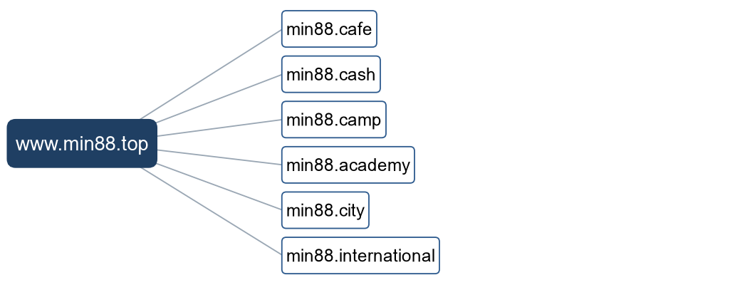
www.min88.top reaches 6 destinations in this window.

Group F — Ranking
Gambling ranking
Rank | Domain | Brand cluster | Subcategory | Source
78,229 | lottovip.com | lott | Lottery | Youtube (lotto432)
90,304 | lottovip.bet | lott | Lottery | Variant (lottovip.com)
93,266 | lottovip.info | lott | Slots | Variant (lottovip.com)
184,475 | fun88thf.com | fun88tht | Football Betting | Variant (fun88tht.com)
198,736 | jun88wb.com | jun88w | Casino | Variant (jun88wh.com)
214,795 | allslotwallet.online | allslotwallet | Slots | Manual (claude.ai)
216,041 | lottovipp.com | lott | Lottery | Variant (lottovip.com)
221,001 | suriyathai.net | suriya | General Gambling | Manual (claude.ai)
303,254 | jun88wf.com | jun88w | Lottery | Variant (jun88wt.com)
397,330 | jun88wa.com | jun88e | Slots | Variant (jun88ea.com)
402,382 | ruay.com | ruay | General Gambling | Youtube (หวยออนไลน์)
466,858 | jun88wc.com | jun88w | Slots | Variant (jun88wd.com)
517,141 | slavinaslot.top | jun | Slots | Redirect (jun88.info)
517,141 | jun88.info | jun | Slots | Variant (jun88.mobile)
547,370 | 99ok.vip | 99ok | Lottery | Variant (99ok.bet)

236 gambling rows carry a numeric rank; the fifteen best ranked are listed.

Group G — Key insights
Scale of the analysis
The standard working set holds 31,798 distinct URLs over 29 days (2026-08-31 to 2026-09-28). 9,175 carry gambling content, 11,594 do not, 28 could not be reached and 11,001 arrive with a status the source feed does not resolve. Gambling is 28.9% of the set.
Take: The sample is large enough to reason about patterns, not isolated cases.

What is being offered
The three largest product subcategories are Slots (3,830, 41.7%), General Gambling (1,685, 18.4%), Casino (1,402, 15.3%). 18.4% of gambling sites are confirmed as gambling without an evidenced product type and are carried as General Gambling. 96.3% of subcategory assignments come from reasoning inference rather than a lexicon keyword, and 212 of the 291 lexicon entries never matched a row in this sample.
Take: Slots is the dominant product type, but at 41.7% of gambling rows the estate is spread across product types rather than concentrated. The lexicon resolves product type for only a small minority of rows here — coverage is weakest on Slots, Promotions, Hashtags — so these figures are indicative only.

Brand clustering
939 brand clusters sit behind 9,175 gambling URLs. 656 hold more than one domain and 283 are singletons. 46 clusters cover half the estate; the top five cover 23.1% and the top ten 32.5%. The largest, jun, holds 609 domains across 7 product subcategories.
Take: The estate is diffuse: with 46 clusters needed to cover half of it, per URL blocking will have limited leverage and cluster level action is the only route that scales.

How the estate is grown and marketed
8,572 gambling URLs are crawler-identified variants, 520 sit behind redirect chains and 83 were reached directly. The busiest redirect source, www.min88.top, reaches 6 destinations. 501 clusters rotate across more than one top-level domain. The two most common signal tags are Abbreviations (35.0%) and Marketing & Acquisition (3.7%).
Take: Redirects and TLD rotation keep a stable entry point while the sites behind it are replaced, so enforcement aimed at a single domain is absorbed by the next variant.

Enforcement position
7 pages in the set carry a regulatory-blocking indicator — a block notice, a court order or a regulator reference — out of 31,798 URLs analysed.
Take: This set is a candidate for a first enforcement pass, prioritised by cluster rather than by URL.

Lexicon source Gambling_Keywords_Full_English_Categories_V1.xlsx, version V1, Appendix A of the report specification; 14 categories, 291 entries, 286 distinct keywords — Football Betting 21 · Slots 32 · Casino 14 · Lottery 20 · Playing card 12 · Baccarat 11 · General Gambling 22 · Deposit & Withdrawal 24 · Promotions 27 · Marketing & Acquisition 25 · Affiliate & Agent 20 · Vague-Evasion Terms 20 · Abbreviations 22 · Hashtags 21. Inferred share 96.3%; General Gambling share 18.4%. Rows normalised from a licensed-gambling status value: 0. Abbreviations flagged as probable false-positive sources: BET 28.4% of Abbreviations matches; VIP 47.3% of Abbreviations matches. Clustering thresholds: Jaro–Winkler 0.90 with a prefix or trailing-character condition; market and version affixes stripped (th, thai, thb, aff, affiliate, vip, official, v-number, trailing digits); stems under three characters reverted.

