

Data Insights & Patterns
29,976 URLs · 4 Sep – 21 Oct 2026
Issued to | Ministry of Digital Economy and Society, Thailand
Prepared by | SICPA SA
Date of issue | 22/10/2026
Source system | SICPADetect, lexicon version V1 (Gambling_Keywords_Full_English_Categories_V1.xlsx)

Contents
Executive Summary 3
Insights and trends 3
Key figures 3
Model Insights 4
Introduction 4
Executive Summary 4
Overall and per class results 4
Error Analysis 5
Segments and Confidence 5
Data Analysis 6
How URLs are classified 6
10 most prominent gambling sites in Thailand 7
10 most prominent gambling sites in Thailand 7
The numbers 7
From collection to analysis 8
URLs analysed per day 9
Status distribution 9
Unreachable URLs by cause 10
Top 10 URL suffixes 10
Pages showing blocking indicators 11
Subcategories 12
Gambling sites by product subcategory 12
Assignment method by subcategory 13
Subcategory table 14
Heat map — Keyword × subcategory 15
Heat map — Signal tag × subcategory 16
Brands and clustering 16
What brand clusters are 16
Domains with the most URLs 17
Top 15 brand clusters by URL count 18
Heat map — Brand cluster × subcategory 19
Cluster expansion — jun8 20
Clusters spanning multiple subcategories 21
Clusters rotating top-level domains 22
Possible operator linkage 23
Naming conventions 23
Structure: direct → redirect → variant 24
Ranking 24
Gambling ranking 24
Ranked brand clusters 25
Key insights 25
Scale of the analysis 25
What is being offered 26
Brand clustering 26
How the estate is grown and marketed 26
Enforcement position 27
Annexes 28
Annex 1 — Subcategory definitions 28
Annex 2 — Ranked domains used for clustering 30

Executive Summary

Insights and trends
SICPADetect analysed 29,976 URLs, of which 47.3% were judged to offer or promote gambling.
Casino is the leading product subcategory, with Slots second. Most subcategory assignments rest on the model's description of each page rather than on a lexicon match, so the lexicon has poor coverage of this dataset and subcategory figures are indicative only.
One domain, 49m.co, carries 20.3% of the gambling URLs through many hostnames. 15 host farms of this kind together carry more than a third of the gambling URLs.
Abbreviations is the most common signal tag. The export records no redirect or variant links, so the report cannot say how the estate moves between domains.
The period is too short to carry a trend, so no direction is stated. Daily volume arrives in bursts, and two gaps appear between them; the cause of each is not recorded.
No page shows a Thai enforcement indicator. Some pages show other block page phrases. The collection network was not recorded, so enforcement may be understated.

Key figures
URLs analysed | 29,976
URLs set aside as Needs more analysis | 0
Gambling URLs and share | 14,182 · 47.3%
Not gambling, unreachable and unknown | 15,682 not gambling · 0 unreachable · 112 unknown
Domains carrying the gambling URLs | 6,820
Brand clusters identified | 2,809, of which 974 hold more than one domain
Clusters needed to cover half of the gambling URLs | 45
Largest cluster | 49m · 2,885 URLs · 1 domain · 20.3% of gambling URLs
Largest domain | 49m.co · 2,885 URLs · 20.3% of gambling URLs
Host farms | 15 · 4,971 URLs · 35.1% of gambling URLs
Dominant product subcategory | Casino · 31.4% of gambling URLs
Most common signal tag | Abbreviations · 27.1% of gambling URLs
URLs with Thai enforcement indicators · other block pages | 0 · 7 · collection network not recorded
Keyword versus inferred subcategory assignment | 469 keyword (3.3%) · 13,713 inferred (96.7%)

Model Insights

Introduction
The results in this section come from a controlled test of the SICPADetect classification model. The test was run against a predefined dataset, fixed in advance so that results are consistent and can be reproduced. It was designed to measure model performance only. The test dataset is separate from, and not related to, the data examined in the Data Analysis section, so figures in this section should not be compared or combined with figures elsewhere in this report.

Executive Summary

Overall and per class results

Error Analysis

Segments and Confidence

Data Analysis

How URLs are classified
Every URL in this analysis receives one of five outcomes. Gambling: the classifier judged, from what was recorded about the page, that the site offers or promotes gambling. Not gambling: the page was read and judged not to offer gambling. Unreachable: the page could not be fetched or read from the collection network, so no judgement was made. Needs more analysis: the classifier could not decide with enough confidence, so the URL is set aside for human review; these URLs are counted in From collection to analysis and are excluded from every other figure in this section. Unknown: the export carried a status outside these four. Figures in this section count URLs, one URL being one address analysed; where a card counts domains instead, it says so.

10 most prominent gambling sites in Thailand

10 most prominent gambling sites in Thailand
Rank | URL | Domain | Brand cluster | Subcategory | Thai targeting evidence | Source
93,155 | metal--vip.com | metal--vip.com | metal | Slots | Thai script: เข้าสู่ระบบ | Not recorded
221,001 | suriyathai.net | suriyathai.net | suriya | General Gambling | Thai script: สมัครสมาชิก | Not recorded
254,190 | anthonyhead.com | anthonyhead.com | anthonyhead | Casino | Thai currency: Baht | Not recorded
254,190 | kohochocolates.com | kohochocolates.c… | kohochoco… | Casino | Thai currency: Baht | Not recorded
293,057 | bifestathailand.com | bifestathailand.com | bifestathail… | General Gambling | Thai currency: THB | Not recorded
293,057 | lgbtnewsnow.org | lgbtnewsnow.org | lgbtnewsnow | General Gambling | Thai currency: THB | Not recorded
514,501 | sacasino.ad | sacasino.ad | sacasino | Baccarat | Thai script: บาคาร่า | Not recorded
758,592 | 9ufa.vip | 9ufa.vip | 9ufa | General Gambling | Thai script: เครดิตฟรี | Not recorded
766,101 | awayge.farm | awayge.farm | awayge | Slots | Thai script: เกมสล็อต | Not recorded
779,002 | dreamworld777.buzz | dreamworld777.b… | dreamworld | Playing card | Thai script: สล็อต | Not recorded

Shortened in the table: kohochocolates.com, kohochocolates, bifestathailand, dreamworld777.buzz.
Rank reflects search visibility in the source feed, not harm, reach or revenue.

The numbers
29,976  Total URLs analysed |  | 14,182  Gambling URLs |  | 6,820  Gambling domains |  | 48 days  2026-09-04 →  2026-10-21  Evaluation period

From collection to analysis
URLs at each stage from the export to the analysis. Each box carries the URLs kept and each branch the URLs set aside.
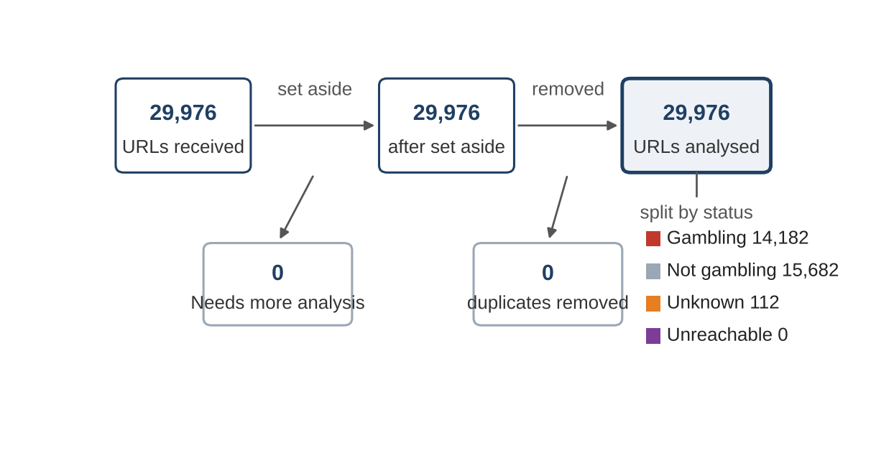
Stage | URLs
URLs received | 29,976
Set aside as Needs more analysis | 0
Duplicates removed | 0
URLs analysed | 29,976

URLs analysed split by status: Not gambling 15,682, Gambling 14,182, Unknown 112, Unreachable 0.

URLs analysed per day
Daily count of URLs analysed across the evaluation period. Each point is one calendar day and shaded bands mark gaps.
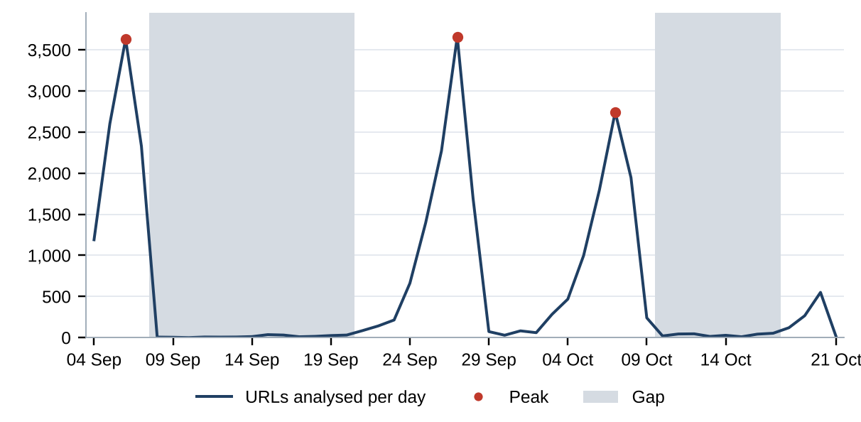
Gap threshold: 10% of the daily mean of 625 URLs, which is 62 URLs a day. 24 days fall below it. Gaps: 2026-09-08 to 2026-09-20 (13 days, 190 URLs; cause not recorded); 2026-10-10 to 2026-10-17 (8 days, 257 URLs; cause not recorded). Peaks, above 3 times the mean (1,873 URLs a day): 2026-09-05 to 2026-09-07 (3 days, 8,558 URLs; cause not recorded); 2026-09-26 to 2026-09-27 (2 days, 5,930 URLs; cause not recorded); 2026-10-07 to 2026-10-08 (2 days, 4,689 URLs; cause not recorded). A URL is dated by the last time its record changed, so a re-analysed URL moves to its later date.

Status distribution
Share of the estate by classification status. Each segment is one status and the table beside it carries the counts.
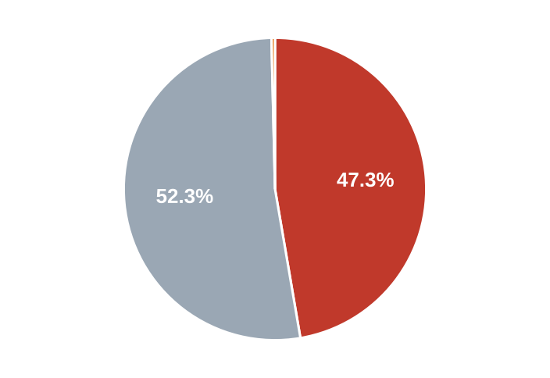
  Status | URLs | %
  Gambling | 14,182 | 47.3%
  Not gambling | 15,682 | 52.3%
  Unknown | 112 | 0.4%
  Unreachable | 0 | 0.0%
  Total | 29,976 | 100.0%

0 URLs classified as Needs more analysis are set aside before this count and appear in From collection to analysis. The 112 Unknown URLs carry an analysis error status in the export and no description.

Unreachable URLs by cause
The export contains no Unreachable URLs, and whether unreachable URLs are removed before export is not recorded.
Collection network: not recorded.

Top 10 URL suffixes
The ten most common URL suffixes in the estate. Bar length is the total count and the table separates the gambling share.
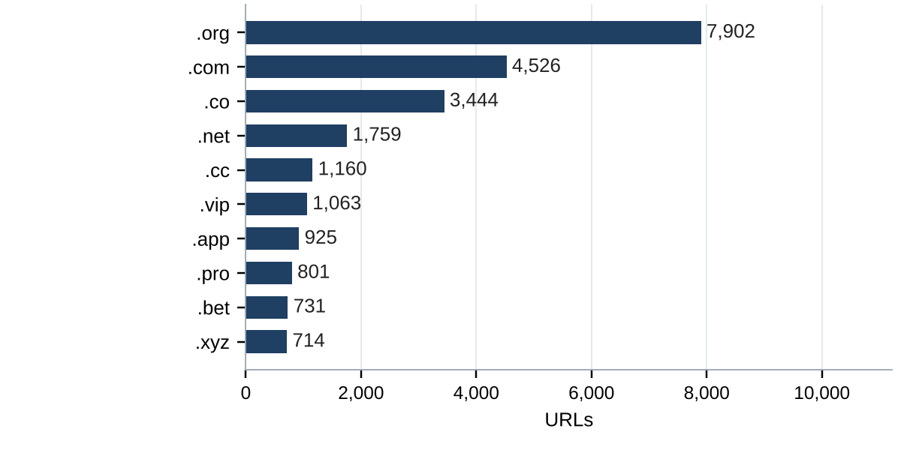
Suffix | URLs | % of all | Gambling URLs | % gambling
.org | 7,902 | 26.4% | 19 | 0.2%
.com | 4,526 | 15.1% | 2,106 | 46.5%
.co | 3,444 | 11.5% | 3,116 | 90.5%
.net | 1,759 | 5.9% | 1,102 | 62.6%
.cc | 1,160 | 3.9% | 683 | 58.9%
.vip | 1,063 | 3.5% | 955 | 89.8%
.app | 925 | 3.1% | 643 | 69.5%
.pro | 801 | 2.7% | 682 | 85.1%
.bet | 731 | 2.4% | 703 | 96.2%
.xyz | 714 | 2.4% | 348 | 48.7%

6,951 URLs sit outside the top 10 suffixes.

Pages showing blocking indicators
URL | Brand cluster | Indicator | Phrase found | Excerpt
e.dra.gov.pk | — | Other | regulatory authority | L: The URL contains the text 'dra.gov.pk', indicating it is related to the Drug…
fawts.glass-safe.com | — | Other | illegal content | hot: The website contains adult content and a warning message about potentially…
hn94.cc | — | Other | illegal content | shot: The website contains adult content and a pop-up warning about potentially…
nh83.cc | — | Other | illegal content | hot: The website contains adult content and a warning message about potentially…
nh85.cc | — | Other | illegal content | website contains adult content and prompts a warning message about potentially…
tn93.cc | — | Other | illegal content | hot: The website contains adult content and a warning message about potentially…
vu98.cc | — | Other | illegal content | hot: The website contains adult content and a warning message about potentially…

The model's description of each page is scanned for fixed block page phrases in English and Thai, such as court order and blocked site notices; a phrase naming a Thai court, MDES or a Thai ISP counts as a Thai enforcement indicator. 0 pages show Thai enforcement indicators and 7 show other block pages. Collection network: not recorded, so blocked sites may appear reachable and the counts may understate enforcement.

Subcategories

Gambling sites by product subcategory
Gambling sites by product subcategory. Bar length is the site count and each label carries the count and the share of gambling rows.
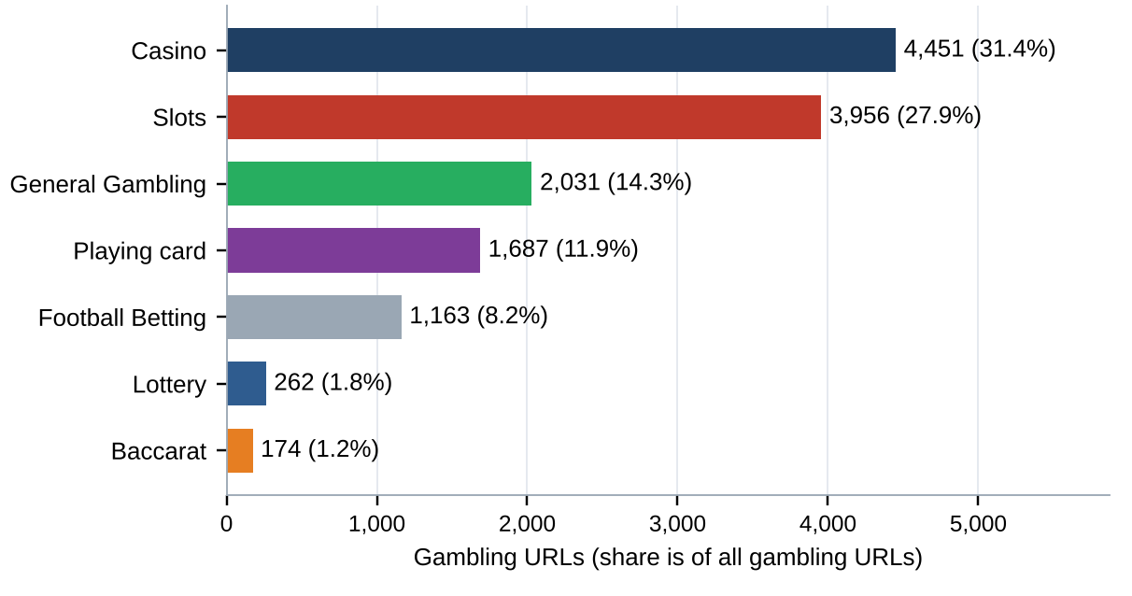
458 gambling URLs carry no description and are Unspecified, so they sit outside the seven bars; the Subcategory table lists them.

Assignment method by subcategory
How each subcategory was assigned. Solid fill is a lexicon keyword match and the lighter fill is reasoning inference.
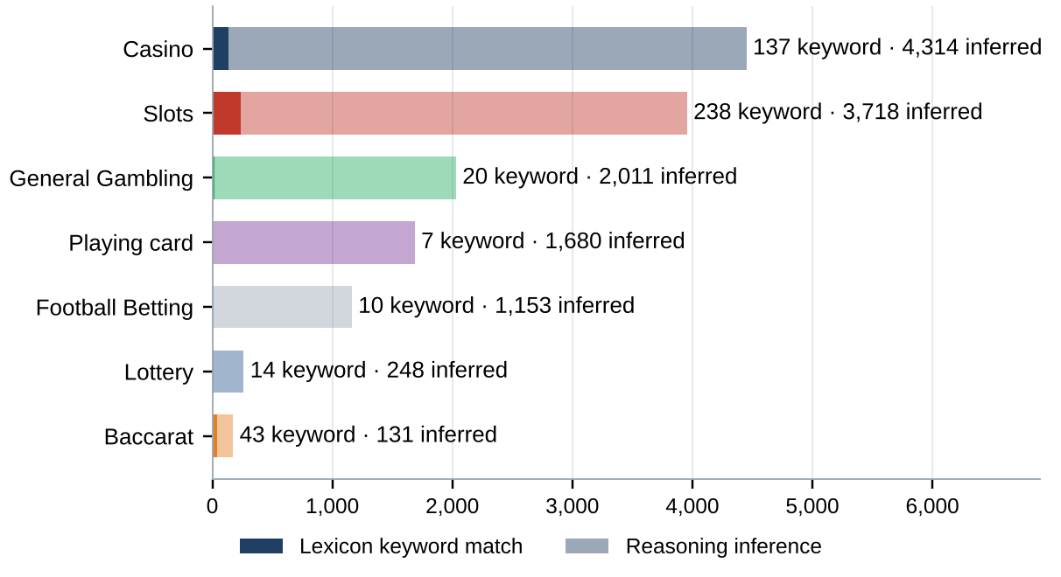
What a lexicon match means
A site is assigned to a subcategory by lexicon match when a word or phrase from the gambling keyword lexicon appears in what was recorded about the site and that word belongs to the category assigned. A site whose description contains สล็อต is assigned to Slots by lexicon match. The lexicon is the SICPADetect Thai gambling keyword lexicon at the version shown on the title page, with 286 keywords in 14 categories. Seven categories describe the product and decide the subcategory. The other seven describe how a site markets itself and are reported as signal tags. A lexicon match rests on a word that can be pointed to, so it can be checked. An inferred assignment rests on the model's reading of its own description, so it carries lower confidence.
Inferred share: 96.7% of gambling URLs. General Gambling share: 14.3% of gambling URLs. The lexicon has poor coverage of this dataset, and subcategory figures are indicative only.

Subcategory table
Subcategory | URLs | % of gambling | Keyword assigned | Inferred | Distinct clusters
Casino | 4,451 | 31.4% | 137 | 4,314 | 1,284
Slots | 3,956 | 27.9% | 238 | 3,718 | 950
General Gambling | 2,031 | 14.3% | 20 | 2,011 | 733
Playing card | 1,687 | 11.9% | 7 | 1,680 | 203
Football Betting | 1,163 | 8.2% | 10 | 1,153 | 536
Lottery | 262 | 1.8% | 14 | 248 | 79
Baccarat | 174 | 1.2% | 43 | 131 | 127
Unspecified | 458 | 3.2% | 0 | 458 | 417
Total | 14,182 | 100.0% | 469 | 13,713

1 General Gambling URL is a listing, review or ranking site, pending jointly agreed labelling rules.

Heat map — Keyword × subcategory
Matched keywords against product subcategory. Each cell is the number of gambling sites carrying that keyword in that subcategory.
 | Keyword | Casino | Slots | General Gambling | Playing card | Football Betting | Lottery | Baccarat
 | VIP | 576 | 748 | 324 | 34 | 142 | 14 | 15
 | BET | 436 | 294 | 224 | 27 | 169 | 21 | 32
 | WIN | 173 | 267 | 131 | 9 | 22 | 26 | 4
 | สมัครสมาชิก | 76 | 160 | 62 | 7 | 14 | 47 | 13
 | สล็อต | 70 | 238 |  | 6 | 4 | 2 | 32
 | WALLET | 54 | 57 | 50 | 1 | 12 | 1 | 6
 | Wallet | 54 | 57 | 50 | 1 | 12 | 1 | 6
 | คาสิโน | 137 | 31 |  |  | 2 | 1 | 7
 | คาสิโน | 137 | 31 |  |  | 2 | 1 | 7
 | PRAGMATIC | 81 | 35 | 32 | 1 | 5 | 2 | 15
 | คาสิโนออนไลน์ | 95 | 4 |  |  | 2
 | คาสิโนออนไลน์ | 95 | 4 |  |  | 2
 | สล็อตออนไลน์ | 6 | 91 |  |  | 1
 | เกมสล็อต | 13 | 82
 | บาคาร่า | 13 | 20 |  | 6 | 2 | 1 | 43
 | Affiliate | 16 | 38 | 9 |  | 2 | 2 | 2
 | JILI | 6 | 32 | 8 |  | 19
 | เล่นสล็อต | 1 | 54 |  |  | 1
 | เดิมพัน | 10 | 7 | 16 |  | 1 |  | 2
 | RTP | 5 | 18 | 5 |  | 1 | 1 | 1
 | พนัน | 10 | 10 | 4 |  | 1 |  | 2
 | JDB | 6 | 18 | 2
 | AUTO | 4 | 15 | 4 |  | 1 |  | 1
 | SEXY | 6 | 7 | 1 |  | 2 |  | 4
 | เครดิตฟรี | 6 | 6 | 5 |  |  |  | 3

Legend: 0 is an empty cell; the palest fill is 1; the darkest fill is 748.
Strip colour is the keyword's own lexicon category: ■ Slots ■ Casino ■ Baccarat ■ General Gambling ■ Deposit & Withdrawal ■ Promotions ■ Marketing & Acquisition ■ Affiliate & Agent ■ Abbreviations
Top 25 of 79 matched keywords, ranked by the number of gambling URLs matching. Rows with no matched subcategory among the seven are counted in other cards.

Heat map — Signal tag × subcategory
Signal tags against product subcategory. Each cell is the number of gambling sites carrying that tag in that subcategory.
Signal tag | Casino | Slots | General Gambling | Playing card | Football Betting | Lottery | Baccarat
Abbreviations | 1,257 | 1,338 | 695 | 66 | 345 | 58 | 72
Marketing & Acquisition | 90 | 176 | 66 | 7 | 18 | 47 | 16
Deposit & Withdrawal | 55 | 59 | 52 | 1 | 12 | 2 | 6
Affiliate & Agent | 21 | 41 | 19 | 1 | 5 | 2 | 2
Promotions | 11 | 9 | 11 |  | 4 |  | 3
Vague-Evasion Terms
Hashtags

Legend: 0 is an empty cell; the palest fill is 1; the darkest fill is 1,338.

Brands and clustering

What brand clusters are
What a cluster is
A brand cluster is a group of URLs, and the domains they sit on, judged to belong to one gambling brand or operator. A domain joins a cluster in one of four ways, in order of strength. A redirect or a generated variant links it to another domain with a matching name. It matches a brand in an external ranking of gambling domains for Thailand, listed in Annex 2. Its name reduces to the same stem as another once market tags, version numbers and suffixes are removed, so ufabet168th.com and ufabet-vip.net both become ufabet while short names keep their numbers and jun88 and jun68 stay apart. Or its stem is near identical in spelling. A domain matching nothing else is a singleton. Hostnames on one registered domain share a cluster.
Why clusters matter
Operators rarely run one site. They register many domains, rotate top level domains and move players between them through redirects, so blocked addresses are replaced. Counting URLs overstates the number of operators. Clustering shows how many operations exist, how concentrated the estate is and which operators run several products, and acting on a cluster reaches every domain in it. Clusters are an analytical grouping based on names, crawler links and an external ranking, not a legal finding about ownership, and the Possible operator linkage table is indicative only.

2,809  Distinct clusters |  | 974  Clusters with 2 or more domains |  | 1,835  Singletons, one domain each |  | 45  Clusters covering half of gambling URLs

Domains with the most URLs
49m.co carries 20.3% of gambling URLs
How to read this table
The table lists the registered domains that carry the most gambling URLs in this sample, largest first. Each row gives the domain, its URLs, their share of all gambling URLs, its brand cluster, the first and last day SICPADetect recorded it and whether it is a host farm. A domain carrying 20 or more gambling URLs is a host farm, meaning many hostnames under one registered name. Such hostnames usually come from a setting that makes every name under the domain lead to the same site, so they may not be separate pages. Action against the domain reaches every hostname at once, where blocking hostname by hostname never catches up.
Domain | URLs | % of gambling URLs | Brand cluster | First seen | Last seen | Host farm
49m.co | 2,885 | 20.3% | 49m | 2026-10-03 | 2026-10-09 | Yes
a3game.vip | 502 | 3.5% | a3game | 2026-09-23 | 2026-09-28 | Yes
hayy.net | 407 | 2.9% | hay | 2026-09-04 | 2026-09-07 | Yes
k03.cc | 272 | 1.9% | k03 | 2026-09-04 | 2026-09-07 | Yes
paes.dev | 269 | 1.9% | paes | 2026-09-24 | 2026-09-28 | Yes
paegs.dev | 176 | 1.2% | paegs | 2026-09-24 | 2026-09-28 | Yes
o8.game | 73 | 0.5% | o8.game | 2026-09-04 | 2026-09-07 | Yes
abbet.xyz | 70 | 0.5% | abbet | 2026-10-18 | 2026-10-20 | Yes
jun888.top | 67 | 0.5% | jun8 | 2026-09-24 | 2026-09-28 | Yes
7ok.bet | 66 | 0.5% | 7ok | 2026-09-04 | 2026-09-07 | Yes
l8.game | 57 | 0.4% | l8.game | 2026-09-04 | 2026-09-07 | Yes
jn86.cc | 40 | 0.3% | jn86 | 2026-09-24 | 2026-09-28 | Yes
oo7.vip | 37 | 0.3% | oo7 | 2026-09-04 | 2026-09-07 | Yes
mwbet.info | 27 | 0.2% | mwbet | 2026-10-18 | 2026-10-20 | Yes
ju088.com | 23 | 0.2% | ju088 | 2026-09-25 | 2026-09-28 | Yes

15 host farms carry 4,971 gambling URLs, 35.1% of all gambling URLs. 720 domains cover half of the gambling URLs. Fetch evidence for the host farms: not recorded.

Top 15 brand clusters by URL count
The fifteen largest brand clusters. Bar length is the number of URLs in the cluster.
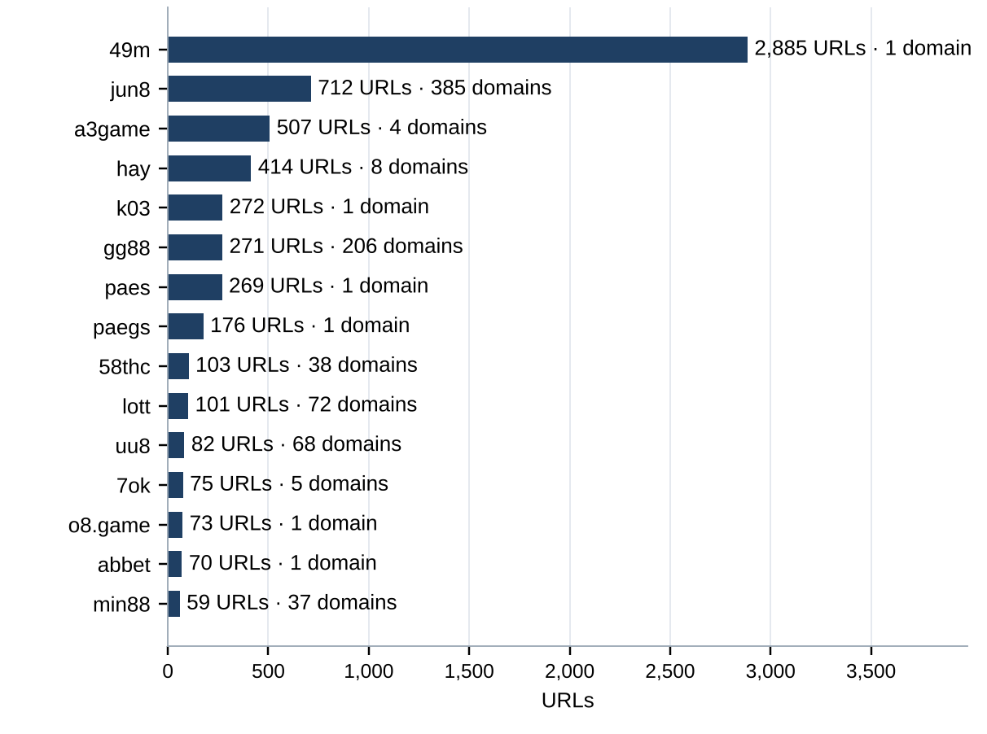

Heat map — Brand cluster × subcategory
Brand clusters against product subcategory. Each cell is the number of URLs a cluster holds in that subcategory.
Brand cluster | Casino | Slots | General Gambling | Playing card | Football Betting | Lottery | Baccarat
49m | 553 | 781 | 198 | 1,353
jun8 | 311 | 170 | 76 | 27 | 49 | 69 | 10
a3game | 3 | 494 | 10
hay | 322 | 19 | 15 |  | 58
k03 |  |  | 192 |  | 80
gg88 | 145 | 49 | 40 | 8 | 21 | 1 | 7
paes | 166 | 18 | 47 |  | 38
paegs | 119 | 13 | 24 |  | 20
58thc |  | 103
lott | 7 | 5 | 11 | 2 | 1 | 74
uu8 | 39 | 20 | 11 | 2 | 7 | 1 | 2
7ok | 2 | 68 | 4 |  |  | 1
o8.game | 3 | 52 | 18
abbet | 63 | 7
min88 | 7 | 4 | 1 | 1 | 46
l8.game | 1 | 12 | 44
mwbet | 35 | 9 |  |  | 7
bohocasino | 35 | 10 | 1 |  |  | 1
jin88 | 8 | 15 | 15 | 7 | 1 | 1
oo7 | 8 | 4 | 33 |  | 2

Legend: 0 is an empty cell; the palest fill is 1; the darkest fill is 1,353.
Top 20 clusters by URL count. URLs with no description are Unspecified and fall outside the seven columns.

Cluster expansion — jun8
The largest brand cluster holding three or more domains and its member domains. Edge style records why each domain joined the cluster.
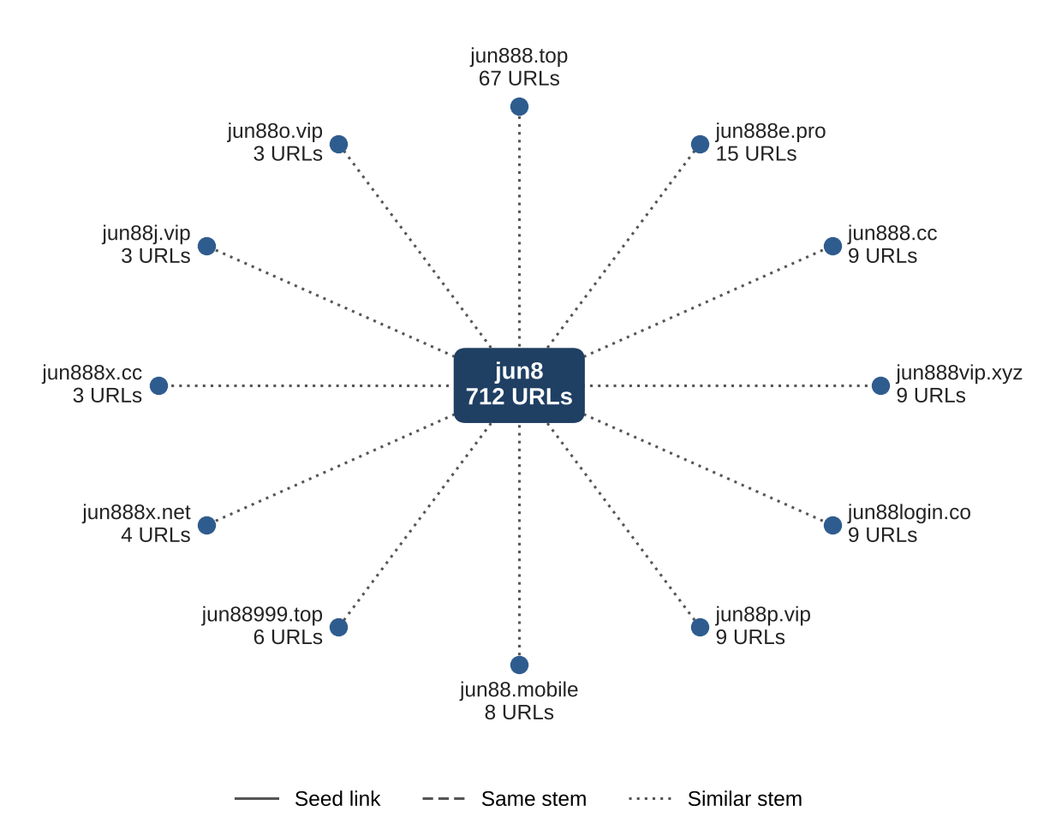
jun8 holds 712 URLs on 385 domains; the twelve domains with the most URLs are drawn. The largest cluster, 49m, sits on 1 domain, so this cluster is shown instead.

Clusters spanning multiple subcategories
How to read this table
The table lists brand clusters whose sites fall into two or more product subcategories. Each row gives the cluster, its URLs, each subcategory present with its URL count and the domain suffixes it uses. Subcategories are assigned to each site, not to the cluster, so a cluster qualifies when at least two of its sites carry different product subcategories. Where General Gambling appears beside a specific product, a product could not be evidenced for those sites, which does not mean the brand offers a second product. Annex 1 defines each subcategory. Action against such a brand reaches all of its products at once.
Cluster | URLs | Subcategories | Suffixes
49m | 2,885 | Playing card 1,353 · Slots 781 · Casino 553 · General Gambling 198 | co
jun8 | 712 | Casino 311 · Slots 170 · General Gambling 76 · Lottery 69 · Football Betting 49 · Playing card 27 · Baccarat 10 | app, bet, black, buzz, casino, cc, +29 more
a3game | 507 | Slots 494 · General Gambling 10 · Casino 3 | app, click, net, vip
hay | 414 | Casino 322 · Football Betting 58 · Slots 19 · General Gambling 15 | app, bet, club, co, net, pro, +2 more
k03 | 272 | General Gambling 192 · Football Betting 80 | cc
gg88 | 271 | Casino 145 · Slots 49 · General Gambling 40 · Football Betting 21 · Playing card 8 · Baccarat 7 · Lottery 1 | app, bet, casino, cc, click, club, +13 more
paes | 269 | Casino 166 · General Gambling 47 · Football Betting 38 · Slots 18 | dev
paegs | 176 | Casino 119 · General Gambling 24 · Football Betting 20 · Slots 13 | dev
lott | 101 | Lottery 74 · General Gambling 11 · Casino 7 · Slots 5 · Playing card 2 · Football Betting 1 | bet, cc, cfd, click, co, co.th, +10 more
uu8 | 82 | Casino 39 · Slots 20 · General Gambling 11 · Football Betting 7 · Baccarat 2 · Playing card 2 · Lottery 1 | app, bet, buzz, casino, cc, click, +16 more
7ok | 75 | Slots 68 · General Gambling 4 · Casino 2 · Lottery 1 | bet, club, io, live, pro
o8.game | 73 | Slots 52 · General Gambling 18 · Casino 3 | game
abbet | 70 | Casino 63 · Slots 7 | xyz
min88 | 59 | Football Betting 46 · Casino 7 · Slots 4 · General Gambling 1 · Playing card 1 | academy, actor, app, art, auction, cafe, +23 more
l8.game | 57 | General Gambling 44 · Slots 12 · Casino 1 | game

The 15 largest of 850 clusters spanning two or more subcategories are listed; 835 further clusters are not shown.

Clusters rotating top-level domains
How to read this table
The table lists brand clusters whose domains use two or more top level domains, the ending of an address. Each line gives the cluster, one suffix it uses, how many member domains use that suffix and the first and last day SICPADetect recorded them. A two part ending such as .co.th counts as one suffix, and a cluster qualifies when its members use at least two different suffixes. Registering one brand name under several endings keeps the brand reachable when one domain is blocked, because a player only has to change the ending. Not every case is evasion, since some operators register several endings to protect a name or serve different markets.
Cluster | Suffix | Domains | First seen | Last seen
jun8 | .com | 159 | 2026-09-22 | 2026-10-19
 | .net | 27 | 2026-09-22 | 2026-09-28
 | .pro | 16 | 2026-09-22 | 2026-09-28
 | .app | 15 | 2026-09-22 | 2026-09-27
 | .info | 15 | 2026-09-22 | 2026-09-28
 | +30 more suffixes
a3game | .app | 1 | 2026-09-23 | 2026-09-24
 | .click | 1 | 2026-09-23 | 2026-09-24
 | .net | 1 | 2026-09-23 | 2026-09-23
 | .vip | 1 | 2026-09-23 | 2026-09-28
hay | .app | 1 | 2026-09-05 | 2026-09-05
 | .bet | 1 | 2026-09-05 | 2026-09-05
 | .club | 1 | 2026-09-05 | 2026-09-05
 | .co | 1 | 2026-09-05 | 2026-09-05
 | .net | 1 | 2026-09-04 | 2026-09-07
 | +3 more suffixes
gg88 | .app | 34 | 2026-09-04 | 2026-09-07
 | .net | 34 | 2026-09-04 | 2026-09-07
 | .pro | 30 | 2026-09-04 | 2026-09-07
 | .bet | 21 | 2026-09-04 | 2026-09-07
 | .com | 18 | 2026-09-04 | 2026-09-07
 | +14 more suffixes
58thc | .com | 37 | 2026-10-02 | 2026-10-07
 | .pro | 1 | 2026-10-07 | 2026-10-07

5 of the 903 clusters using two or more suffixes are listed, largest first, with up to five suffixes each. 36 clusters gained domains first recorded 7 or more days after the cluster first appeared, 123 domains in all. Dates are when SICPADetect recorded each domain, not when it was registered, blocked or replaced. The period is under 60 days, so it is too short to confirm rotation over time.

Possible operator linkage
Indicative — not a clustering decision
How to read this table
The table lists pairs of brand clusters with different names that use an unusually similar set of signal keywords, the lexicon words describing how a site promotes itself, takes payment or evades blocking. The Jaccard score is the number of signal keywords the two clusters share divided by the number of distinct signal keywords either uses, from 0 for no overlap to 1 for identical sets. Words used by a large share of the sample and abbreviations known to match by accident are removed first, and only pairs scoring 0.60 or more with at least 3 shared keywords are listed. A close match can point to one operator or to unrelated operators sharing an affiliate template. The pairs are leads to verify, and clusters are never merged on this score.
Cluster A | Cluster B | Shared keywords | Jaccard
7ok | mega168 | pragmatic, rtp, wallet, win, สมัครสมาชิก | 1.00
jun77 | jub789 | pragmatic, wallet, win, สมัครสมาชิก | 1.00
gu88 | n78 | pragmatic, wallet, สมัครสมาชิก | 1.00
kk2 | n83 | jili, pragmatic, สมัครสมาชิก | 1.00
kk2 | nextspin | jili, pragmatic, สมัครสมาชิก | 1.00
ko9 | ln88 | wallet, win, สมัครสมาชิก | 1.00
ko9 | ub8 | wallet, win, สมัครสมาชิก | 1.00
ms88 | gu88 | pragmatic, wallet, สมัครสมาชิก | 1.00
ms88 | n78 | pragmatic, wallet, สมัครสมาชิก | 1.00
mu8 | hub88 | pragmatic, wallet, win | 1.00
mun8 | vrtex | auto, wallet, สมัครสมาชิก | 1.00
n83 | nextspin | jili, pragmatic, สมัครสมาชิก | 1.00
ruay | m98login | win, จ่ายจริง, สมัครสมาชิก | 1.00
ub8 | ln88 | wallet, win, สมัครสมาชิก | 1.00
uu8 | hub88 | pragmatic, wallet, win | 1.00

124 pairs qualify; the 15 with the highest score are listed. Keywords are shown in lower case where they differ only in case.

Naming conventions
- Recurring tokens: m. (2,423 hostnames), login (2,087 hostnames) and support (1,849 hostnames) recur in the hostnames of the ten largest clusters, which points to a templated naming scheme.
- TLD switching: names span several suffixes, led by .co (3,116), .com (2,106), .net (1,102) and .vip (955), which shows operators rotating top level domains.
- The gambling URLs sit on 6,820 domains across 2,809 brand clusters.
- 240 gambling URLs have names made only of template words such as login, secure or verify; they are kept as singletons unless a crawler link or ranked brand ties them to a cluster.

Structure: direct → redirect → variant
14,182  Direct · 100.0% |  | 0  Redirect · 0.0% |  | 0  Variant · 0.0%

URLs, summing to 14,182 gambling URLs. The export records no redirect or variant links and no fetch status, so variant verification is not recorded: no variant row is counted and none is described as verified.

Ranking

Gambling ranking
How to read this table
The table lists the gambling sites in this sample that carry a rank in the SICPADetect feed, best ranked first, up to fifteen. Each row gives the rank, the domain, its brand cluster, its subcategory and where SICPADetect found it. The rank is the position recorded in the source feed and reflects search visibility, so the lower the number, the more visible the site. It is not the external ranking used to anchor brand clusters in Annex 2, and unlike the 10 most prominent gambling sites in Thailand table it is not filtered for a Thai audience or limited to one row per domain. The most visible sites are those users are most likely to reach.
Rank | Domain | Brand cluster | Subcategory | Source
93,155 | metal--vip.com | metal | Slots | Not recorded
214,132 | allslotwallet.online | allslotwallet | Slots | Not recorded
221,001 | suriyathai.net | suriya | General Gambling | Not recorded
252,597 | u11k.pro | u11 | Football Betting | Not recorded
254,190 | anthonyhead.com | anthonyhead | Casino | Not recorded
254,190 | kohochocolates.com | kohochocolates | Casino | Not recorded
293,057 | bifestathailand.com | bifestathailand | General Gambling | Not recorded
293,057 | lgbtnewsnow.org | lgbtnewsnow | General Gambling | Not recorded
303,254 | jun88wf.com | jun8 | Casino | Not recorded
397,330 | jun88wa.com | jun8 | Casino | Not recorded
466,858 | jun88wc.com | jun8 | Slots | Not recorded
514,501 | sacasino.ad | sacasino | Baccarat | Not recorded
517,141 | jun88.info | jun8 | Casino | Not recorded
517,141 | slavinaslot.top | slavinaslot | Casino | Not recorded
547,370 | 99ok.vip | 99ok | Lottery | Not recorded

Ranked brand clusters
How to read this table
The table lists brand clusters that contain at least one gambling site carrying a rank in the SICPADetect feed. Each row gives the cluster, its URLs, the best rank among its members, how many members are ranked and its subcategories. One ranked gambling member is enough to qualify. Clusters are ordered by their best rank, so the most visible brands come first, and the URL count shows how large each operation is. A brand that is both highly visible and large is where action reaches the most users and the most addresses at once. Rank measures visibility only, not harm, reach or revenue, and no combined score is calculated.
Cluster | URLs | Best rank | Ranked URLs | Subcategories
metal | 2 | 93,155 | 1 | Slots 2
allslotwallet | 1 | 214,132 | 1 | Slots 1
suriya | 1 | 221,001 | 1 | General Gambling 1
u11 | 33 | 252,597 | 1 | Slots 16 · Football Betting 12 · General Gambling 3 · Casino 2
anthonyhead | 1 | 254,190 | 1 | Casino 1
kohochocolates | 1 | 254,190 | 1 | Casino 1
bifestathailand | 1 | 293,057 | 1 | General Gambling 1
lgbtnewsnow | 1 | 293,057 | 1 | General Gambling 1
jun8 | 712 | 303,254 | 31 | Casino 311 · Slots 170 · General Gambling 76 · Lottery 69
sacasino | 1 | 514,501 | 1 | Baccarat 1
slavinaslot | 2 | 517,141 | 1 | Casino 2
99ok | 17 | 547,370 | 2 | Slots 9 · Casino 4 · General Gambling 2 · Lottery 2
gg88 | 271 | 558,790 | 16 | Casino 145 · Slots 49 · General Gambling 40 · Football Betting 21
betwgb | 1 | 582,212 | 1 | Football Betting 1
hh9 | 32 | 632,178 | 11 | General Gambling 18 · Football Betting 7 · Slots 4 · Casino 3

The 15 clusters with the best rank are listed; 202 further clusters hold at least one ranked gambling URL.

Key insights

Scale of the analysis
The analysis covers 29,976 distinct URLs over 48 days, from 2026-09-04 to 2026-10-21. Of these, 14,182 are gambling, 15,682 are not gambling and 0 are unreachable, and 112 carry an unknown status. 0 further URLs were set aside as Needs more analysis. Daily volume has 2 gaps: 2026-09-08 to 2026-09-20; 2026-10-10 to 2026-10-17. The cause of each is not recorded.
The sample is large enough to reason about patterns, not isolated cases.

What is being offered
The three leading product subcategories are Casino (4,451, 31.4%), Slots (3,956, 27.9%) and General Gambling (2,031, 14.3%). 14.3% of gambling URLs are confirmed as gambling without an evidenced product type. 96.7% of subcategory assignments are inferred from the model's description rather than matched to the lexicon, and 207 of the 286 lexicon keywords never matched. The lexicon has poor coverage of this dataset, so subcategory figures are indicative only.
Casino is the dominant product type, but the estate is spread across product types rather than concentrated in one.

Brand clustering
2,809 clusters cover 14,182 gambling URLs on 6,820 domains. 974 of them hold more than one domain. 45 clusters and 720 domains cover half of the estate. The largest cluster, 49m, holds 2,885 URLs (20.3% of gambling URLs) on 1 domain, across 4 subcategories. The largest domain, 49m.co, holds 2,885 URLs (20.3%). 15 host farms carry 35.1% of the gambling URLs.
One registered domain carries 20.3% of the estate through many hostnames, so action at domain level reaches all of them at once, where URL by URL blocking would need one entry per hostname. Beyond that domain, the estate is spread across many operators: 45 clusters and 720 domains are needed to cover half of the gambling URLs.

How the estate is grown and marketed
0 URLs are crawler identified variants, 0 URLs sit behind redirect chains and 14,182 URLs were reached directly. The export records no redirect or variant links, so no busiest redirect source can be named and variant verification is not recorded. 903 clusters use more than one top level domain. The two most common signal tags are Abbreviations (27.1%) and Marketing & Acquisition (3.0%).
Top level domain rotation keeps a brand name stable while the address behind it changes.

Enforcement position
0 pages show Thai enforcement indicators, meaning Thai court orders or MDES or Thai ISP block pages, and 7 pages show other block pages. The model's description of each page is scanned for fixed block page phrases in English and Thai, such as court order and blocked site notices, and a phrase naming a Thai court, MDES or a Thai ISP counts as a Thai enforcement indicator. Every page found is listed in the Pages showing blocking indicators table. Collection network: not recorded.
Only Thai authority indicators are described as enforcement in Thailand, and none was found, so this set appears to be pre enforcement and is a candidate for a first enforcement pass, prioritised by domain and cluster rather than by URL. The collection network was not recorded, so the enforcement count may be understated.

Annexes

Annex 1 — Subcategory definitions
Each site classified as gambling is assigned one of the seven product subcategories below, according to what it offers. General Gambling applies only when a site is confirmed as gambling but no specific product can be evidenced. A subcategory is assigned by lexicon match when one of the keywords listed under it appears in what was recorded about the site, and by inference from the model's description when none is found. How a site markets or operates itself is recorded separately as signal tags and does not decide its subcategory. The keywords under each subcategory are its complete set in the lexicon, shown in their original script. A few keywords appear under both a specific product and General Gambling; they always count toward the specific product.
Football Betting · 21 keywords
Betting on the outcome of football and other sports matches, including match odds, single match and accumulator ("step") bets, and tipping or match analysis offered to bettors.
พ⁠นั⁠น⁠บ⁠อ⁠ล · พ⁠นั⁠น⁠บ⁠อ⁠ล⁠อ⁠อ⁠น⁠ไล⁠น์ · แท⁠ง⁠บ⁠อ⁠ล · แท⁠ง⁠บ⁠อ⁠ล⁠อ⁠อ⁠น⁠ไล⁠น์ · พ⁠นั⁠น⁠ฟุ⁠ต⁠บ⁠อ⁠ล · แท⁠ง⁠ฟุ⁠ต⁠บ⁠อ⁠ล · ส⁠ป⁠อ⁠ร์⁠ต⁠บุ๊⁠ค · บ⁠อ⁠ล⁠อ⁠อ⁠น⁠ไล⁠น์ · ร⁠า⁠ค⁠า⁠บ⁠อ⁠ล · บ⁠อ⁠ล⁠ส⁠เต็⁠ป · บ⁠อ⁠ล⁠เดี่⁠ย⁠ว · ส⁠เต็⁠ป⁠บ⁠อ⁠ล · แท⁠ง⁠บ⁠อ⁠ล⁠ชุ⁠ด · ที⁠เด็⁠ด⁠บ⁠อ⁠ล · วิ⁠เค⁠ร⁠า⁠ะ⁠ห์⁠บ⁠อ⁠ล · โต๊⁠ะ⁠บ⁠อ⁠ล · ล้⁠ม⁠โต๊⁠ะ⁠บ⁠อ⁠ล · เดิ⁠ม⁠พั⁠น⁠ฟุ⁠ต⁠บ⁠อ⁠ล · เว็⁠บ⁠แท⁠ง⁠บ⁠อ⁠ล · บ⁠อ⁠ล⁠ส⁠เต็⁠ป⁠แม่⁠น · พ⁠นั⁠น⁠กี⁠ฬ⁠า
Slots · 32 keywords
Online slot machine games, including sites that promote particular slot providers, high payout rates or slots played directly without an agent.
ส⁠ล็⁠อ⁠ต · ส⁠ล็⁠อ⁠ต⁠อ⁠อ⁠น⁠ไล⁠น์ · เก⁠ม⁠ส⁠ล็⁠อ⁠ต · เก⁠ม⁠ส⁠ล็⁠อ⁠ต⁠อ⁠อ⁠น⁠ไล⁠น์ · ส⁠ล็⁠อ⁠ต⁠แต⁠ก⁠ง่⁠า⁠ย · ส⁠ล็⁠อ⁠ต⁠แต⁠ก⁠บ่⁠อ⁠ย · ส⁠ล็⁠อ⁠ต⁠แต⁠ก⁠ห⁠นั⁠ก · ส⁠ล็⁠อ⁠ต⁠แต⁠ก⁠จ⁠ริ⁠ง · ส⁠ล็⁠อ⁠ต⁠ให⁠ม่ · ส⁠ล็⁠อ⁠ต⁠เว็⁠บ⁠ต⁠ร⁠ง · ส⁠ล็⁠อ⁠ต⁠ว⁠อ⁠เล⁠ท · เล่⁠น⁠ส⁠ล็⁠อ⁠ต · ส⁠ล็⁠อ⁠ต⁠เค⁠ร⁠ดิ⁠ต⁠ฟ⁠รี · ส⁠ล็⁠อ⁠ต⁠แต⁠ก⁠ทุ⁠ก⁠วั⁠น · ส⁠ล็⁠อ⁠ต⁠ม⁠า⁠แร⁠ง · ส⁠ล็⁠อ⁠ต⁠ย⁠อ⁠ด⁠นิ⁠ย⁠ม · ส⁠ล็⁠อ⁠ต⁠ค่⁠า⁠ย⁠ดั⁠ง · ส⁠ล็⁠อ⁠ต⁠ไม่⁠ผ่⁠า⁠น⁠เอ⁠เย่⁠น⁠ต์ · ส⁠ล็⁠อ⁠ต ⁠p⁠g · ส⁠ล็⁠อ⁠ต ⁠j⁠o⁠k⁠e⁠r · ส⁠ล็⁠อ⁠ต ⁠j⁠i⁠l⁠i · ส⁠ล็⁠อ⁠ต ⁠p⁠r⁠a⁠g⁠m⁠a⁠t⁠i⁠c · ส⁠ล็⁠อ⁠ต ⁠x⁠o · ส⁠ล็⁠อ⁠ต ⁠a⁠u⁠t⁠o · ส⁠ล็⁠อ⁠ต⁠แต⁠ก⁠ไว · ส⁠ล็⁠อ⁠ต⁠ฝ⁠า⁠ก⁠ถ⁠อ⁠น⁠อ⁠อ⁠โต้ · ส⁠ล็⁠อ⁠ต⁠ฝ⁠า⁠ก⁠ไม่⁠มี⁠ขั้⁠น⁠ต่⁠ำ · ส⁠ล็⁠อ⁠ต⁠โบ⁠นั⁠ส⁠แต⁠ก⁠ห⁠นั⁠ก · ส⁠ล็⁠อ⁠ต⁠ส⁠า⁠ย⁠ฟ⁠รี · ส⁠ล็⁠อ⁠ต⁠ปั่⁠น⁠ง่⁠า⁠ย · ส⁠ล็⁠อ⁠ต ⁠R⁠T⁠P ⁠สู⁠ง · ส⁠ล็⁠อ⁠ต⁠คื⁠น⁠ก⁠ำ⁠ไร
The keyword lists are those of the SICPADetect lexicon at the version shown on the title page.

Annex 1 — Subcategory definitions (continued)
Casino · 14 keywords
Online and live casino table and wheel games other than baccarat and card games, such as roulette, dragon tiger, hi lo dice and wheel spin games.
ค⁠า⁠สิ⁠โน · ค⁠า⁠สิ⁠โน⁠อ⁠อ⁠น⁠ไล⁠น์ · ค⁠า⁠สิ⁠โน⁠ส⁠ด · ค⁠า⁠สิ⁠โน⁠ส⁠ด⁠อ⁠อ⁠น⁠ไล⁠น์ · เสื⁠อ⁠มั⁠ง⁠ก⁠ร · รู⁠เล็⁠ต · รู⁠เล็⁠ต⁠อ⁠อ⁠น⁠ไล⁠น์ · รู⁠เล๊⁠ต · ไฮ⁠โล · ไฮ⁠โล⁠อ⁠อ⁠น⁠ไล⁠น์ · ไฮ⁠โล⁠ไท⁠ย · ห⁠มุ⁠น⁠ว⁠ง⁠ล้⁠อ⁠โบ⁠นั⁠น⁠ซ่⁠า⁠ร⁠า⁠ย⁠วั⁠น · ห⁠มุ⁠น⁠ว⁠ง⁠ล้⁠อ⁠โบ⁠นั⁠น⁠ซ่⁠า · ปั่⁠น⁠แป⁠ะ
Lottery · 20 keywords
Betting on lottery and number draws, including the Thai government and underground lotteries, Lao, Hanoi and Malaysian draws, fast draw yi ki lotteries and lotteries settled on stock index figures.
ห⁠ว⁠ย⁠อ⁠อ⁠น⁠ไล⁠น์ · แท⁠ง⁠ห⁠ว⁠ย · ซื้⁠อ⁠ห⁠ว⁠ย⁠อ⁠อ⁠น⁠ไล⁠น์ · ห⁠ว⁠ย⁠ยี่⁠กี · ห⁠ว⁠ย⁠ฮ⁠า⁠น⁠อ⁠ย · ห⁠ว⁠ย⁠ล⁠า⁠ว · ห⁠ว⁠ย⁠รั⁠ฐ⁠บ⁠า⁠ล · ห⁠ว⁠ย⁠ม⁠า⁠เล⁠ย์ · ห⁠ว⁠ย⁠จั⁠บ⁠ยี่⁠กี · จั⁠บ⁠ยี่⁠กี ⁠V⁠I⁠P · ห⁠ว⁠ย⁠ใต้⁠ดิ⁠น · ห⁠ว⁠ย⁠อ⁠อ⁠น⁠ไล⁠น์⁠จ่⁠า⁠ย⁠จ⁠ริ⁠ง · เว็⁠บ⁠ห⁠ว⁠ย · เว็⁠บ⁠แท⁠ง⁠ห⁠ว⁠ย · H⁠u⁠a⁠y · H⁠u⁠a⁠y⁠l⁠a⁠n · ห⁠ว⁠ย⁠หุ้⁠น · ห⁠ว⁠ย⁠หุ้⁠น⁠ไท⁠ย · ห⁠ว⁠ย⁠หุ้⁠น⁠ต่⁠า⁠ง⁠ป⁠ร⁠ะ⁠เท⁠ศ · ห⁠ว⁠ย⁠ชุ⁠ด
Playing card · 12 keywords
Card games other than baccarat, such as pok deng, blackjack, poker and Thai two card and three card games.
ไพ่ · ไพ่⁠อ⁠อ⁠น⁠ไล⁠น์ · ไพ่ ⁠อ⁠อ⁠น⁠ไล⁠น์ · ไพ่⁠ป๊⁠อ⁠ก · ป๊⁠อ⁠ก⁠เด้⁠ง · ป๊⁠อ⁠ก⁠เด้⁠ง⁠อ⁠อ⁠น⁠ไล⁠น์ · แบ⁠ล็⁠ค⁠แจ็⁠ค · แบ⁠ล็⁠ค⁠แจ็⁠ค⁠อ⁠อ⁠น⁠ไล⁠น์ · โป๊⁠ก⁠เก⁠อ⁠ร์ · โป๊⁠ก⁠เก⁠อ⁠ร์⁠อ⁠อ⁠น⁠ไล⁠น์ · ตี⁠ไก่⁠ส⁠อ⁠ง⁠ใบ · ตี⁠ไก่⁠ส⁠า⁠ม⁠ใบ
Baccarat · 11 keywords
Baccarat in any form, live or online, including demo tables and betting formula or prediction services sold for baccarat.
บ⁠า⁠ค⁠า⁠ร⁠า · บ⁠า⁠ค⁠า⁠ร่⁠า · บ⁠า⁠ค⁠า⁠ร่⁠า⁠อ⁠อ⁠น⁠ไล⁠น์ · ไพ่⁠บ⁠า⁠ค⁠า⁠ร่⁠า · บ⁠า⁠ค⁠า⁠ร่⁠า⁠ส⁠ด · โต๊⁠ะ⁠บ⁠า⁠ค⁠า⁠ร่⁠า · บ⁠า⁠ค⁠า⁠ร่⁠า⁠ท⁠ด⁠ล⁠อ⁠ง · บ⁠า⁠ค⁠า⁠ร่⁠า⁠ฟ⁠รี · บ⁠า⁠ค⁠า⁠ร่⁠า⁠ร⁠ะ⁠บ⁠บ ⁠A⁠I · บ⁠า⁠ค⁠า⁠ร่⁠า⁠ขั้⁠น⁠เท⁠พ · สู⁠ต⁠ร⁠บ⁠า⁠ค⁠า⁠ร่⁠า
General Gambling · 22 keywords
Sites confirmed as gambling whose recorded content uses only generic gambling or betting vocabulary, so no specific product can be evidenced. Assigned only when no other subcategory applies.
พ⁠นั⁠น · ก⁠า⁠ร⁠พ⁠นั⁠น · พ⁠นั⁠น⁠อ⁠อ⁠น⁠ไล⁠น์ · เว็⁠บ⁠พ⁠นั⁠น · เว็⁠บ⁠เดิ⁠ม⁠พั⁠น · เดิ⁠ม⁠พั⁠น · เดิ⁠ม⁠พั⁠น⁠อ⁠อ⁠น⁠ไล⁠น์ · ค⁠า⁠สิ⁠โน · ค⁠า⁠สิ⁠โน⁠อ⁠อ⁠น⁠ไล⁠น์ · บ่⁠อ⁠น · บ่⁠อ⁠น⁠อ⁠อ⁠น⁠ไล⁠น์ · เว็⁠บ⁠เก⁠ม⁠พ⁠นั⁠น · เก⁠ม⁠พ⁠นั⁠น · เว็⁠บ⁠เสี่⁠ย⁠ง⁠โช⁠ค · เสี่⁠ย⁠ง⁠โช⁠ค · เว็⁠บ⁠เก⁠ม⁠เงิ⁠น · เล่⁠น⁠เงิ⁠น⁠จ⁠ริ⁠ง · เก⁠ม⁠ได้⁠เงิ⁠น⁠จ⁠ริ⁠ง · เดิ⁠ม⁠พั⁠น⁠กี⁠ฬ⁠า · พ⁠นั⁠น⁠กี⁠ฬ⁠า · พ⁠นั⁠น⁠บ⁠อ⁠ล · แท⁠ง⁠บ⁠อ⁠ล
The keyword lists are those of the SICPADetect lexicon at the version shown on the title page.

Annex 2 — Ranked domains used for clustering
Ranking of gambling domains for Thailand · external data provider · 159 of 200 ranked domains applied
Brand clusters are anchored to a ranking of gambling domains for Thailand supplied by an external data provider. When a URL in this sample matches a ranked brand, it is grouped under that brand's name instead of the name it happens to carry. The ranking is an analytical reference. A place in it is not evidence of ownership, harm or reach, and a match never adds a site to the gambling set.
Rank | Ranked domain | Brand | Match basis | URLs matched | Cluster
1 | 22onlinegames.com | 22onlinega… | Brand name and extended names | 1 | 22onlineg…
3 | debet.tv | debet | Brand name and extended names | 1 | debet
4 | aiscore.com | aiscore | Brand name and extended names | 1 | aiscore
5 | ufabet.com | ufabet | Brand name and extended names | 1 | ufabet
7 | invl.me | invl | Brand name only | 2 | invl
8 | lottoheng168.com | lottoheng | Brand name and extended names | 1 | lottoheng
9 | 888scoreonline.net | 888scoreo… | Brand name and extended names | 1 | 888score…
10 | hacksawgaming.com | hacksawg… | Brand name and extended names | 4 | hacksawg…
12 | playin.com | playin | Brand name and extended names | 3 | playin
14 | gosh.io | gosh | Brand name only | 1 | gosh
15 | 24live.com | 24live | Brand name and extended names | 2 | 24live
16 | 326821905591.com | 32682190… | This domain only | 1 | 32682190…
19 | vlr.gg | vlr | This domain only | 1 | vlr
20 | 7mkr.com | 7mkr | This domain only | 1 | 7mkr
21 | flashscore.co.uk | flashscore | Brand name and extended names | 6 | flashscore
22 | 808ball15.com | 808ball | Brand name and extended names | 2 | 808ball
24 | bet365.com | bet365 | Brand name and extended names | 0 | —
25 | mlnhngoc.net | mlnhngoc | Brand name and extended names | 1 | mlnhngoc
26 | m8geqpm2kpnf78dkfx… | m8geqpm… | This domain only | 1 | m8geqpm…
27 | 13o.net | 13o | Brand name only | 1 | 13o
28 | nolimitcity.com | nolimitcity | Brand name and extended names | 2 | nolimitcity
29 | 1xbet.com | 1xbet | Brand name and extended names | 2 | 1xbet
30 | betufa.com | betufa | Brand name and extended names | 1 | betufa
31 | d3my3ye7lo15uo.clou… | d3my3ye7l… | This domain only | 1 | d3my3ye…
32 | viieuvkf.com | viieuvkf | This domain only | 1 | viieuvkf
34 | anaidahog.com | anaidahog | Brand name and extended names | 1 | anaidahog
36 | m1rs.com | m1rs | This domain only | 1 | m1rs
37 | spinova-hub.com | spinovahub | Brand name and extended names | 1 | spinovahub

Annex 2 — Ranked domains used for clustering (continued)
Rank | Ranked domain | Brand | Match basis | URLs matched | Cluster
38 | beer777.com | beer | Brand name only | 3 | beer
41 | kaga88.com | kaga | Brand name only | 4 | kaga
42 | painamour.com | painamour | Brand name and extended names | 1 | painamour
43 | bet365.ee | bet365 | Brand name and extended names | With rank 24 | —
44 | seriesdet.com | seriesdet | Brand name and extended names | 1 | seriesdet
45 | singaporepools.com.sg | singaporep… | Brand name and extended names | 2 | singapore…
46 | stake.com | stake | Brand name and extended names | 4 | stake
47 | rainbet.com | rainbet | Brand name and extended names | 1 | rainbet
49 | wsgamings.com | wsgamings | Brand name and extended names | 2 | wsgamings
50 | jackpots.ch | jackpots | Brand name and extended names | 1 | jackpots
52 | pic5678.com | pic | Brand name only | 2 | pic
54 | sporticos.com | sporticos | Brand name and extended names | 1 | sporticos
55 | rsg-games.com | rsggames | Brand name and extended names | 1 | rsggames
59 | casino.org | casino.org | This domain only | 0 | —
60 | coktv1.com | cokt | Brand name only | 1 | cokt
61 | games.kaga88.com | kaga | Brand name only | With rank 41 | kaga
62 | royal558.com | royal | Brand name and extended names | 5 | royal
63 | dafabet.com | dafabet | Brand name and extended names | 0 | —
64 | nowgoal26.com | nowgoal | Brand name and extended names | 6 | nowgoal
66 | glivesport.com | glivesport | Brand name and extended names | 1 | glivesport
67 | pragmaticplay.com | pragmaticp… | Brand name and extended names | 1 | pragmatic…
68 | lottovip.bet | lottovip | Brand name and extended names | 8 | lottovip
69 | chatursply.com | chatursply | Brand name and extended names | 1 | chatursply
70 | afiyukent.one | afiyukent | Brand name and extended names | 1 | afiyukent
71 | 8provider.com | 8provider | Brand name and extended names | 1 | 8provider
72 | iqoption.net | iqoption | Brand name and extended names | 1 | iqoption
73 | millipiyangoonline.com | millipiyang… | Brand name and extended names | 1 | millipiyan…
74 | stp4bet.net | stp4bet | Brand name and extended names | 2 | stp4bet
77 | corevibe-network.com | corevibene… | Brand name and extended names | 1 | coreviben…
78 | flashscore.com.ua | flashscore | Brand name and extended names | With rank 21 | flashscore
79 | wuoza.com | wuoza | Brand name and extended names | 1 | wuoza
80 | papasqueens.com | papasquee… | Brand name and extended names | 0 | —
81 | ouraidream.com | ouraidream | Brand name and extended names | 1 | ouraidream

Annex 2 — Ranked domains used for clustering (continued)
Rank | Ranked domain | Brand | Match basis | URLs matched | Cluster
84 | w88cric.com | w88cric | Brand name and extended names | 3 | w88cric
85 | askmebet.live | askmebet | Brand name and extended names | 2 | askmebet
86 | chainers.io | chainers | Brand name and extended names | 1 | chainers
87 | minhngoc.net.vn | minhngoc | Brand name and extended names | 1 | minhngoc
89 | crickfree.be | crickfree | Brand name and extended names | 1 | crickfree
91 | asianbookie.com | asianbookie | Brand name and extended names | 4 | asianbookie
92 | nova88.com | nova | Brand name only | 4 | nova
94 | ekamsply.com | ekamsply | Brand name and extended names | 1 | ekamsply
95 | connect234.com | connect | Brand name and extended names | 1 | connect
97 | 888casino.it | 888casino | Brand name and extended names | 2 | 888casino
98 | issuya.com | issuya | Brand name and extended names | 1 | issuya
99 | crex.com | crex | Brand name only | 1 | crex
100 | sport.888casino.it | 888casino | Brand name and extended names | With rank 97 | 888casino
102 | 1x-bet.mobi | 1xbet | Brand name and extended names | With rank 29 | 1xbet
103 | slotcatalog.com | slotcatalog | Brand name and extended names | 2 | slotcatalog
104 | thboxing.com | thboxing | Brand name and extended names | 2 | thboxing
105 | gys5.com | gys | This domain only | 1 | gys
106 | m88.com | m88 | This domain only | 1 | m88
107 | stevenbridges.co | stevenbrid… | Brand name and extended names | 1 | stevenbri…
108 | allbetasia.com | allbetasia | Brand name and extended names | 3 | allbetasia
109 | betway.com | betway | Brand name and extended names | 1 | betway
110 | bigwinboard.com | bigwinboard | Brand name and extended names | 3 | bigwinboard
111 | shuffle.com | shuffle | Brand name and extended names | 2 | shuffle
112 | ballthaitv.com | ballthaitv | Brand name and extended names | 1 | ballthaitv
113 | scoresinlive.com | scoresinlive | Brand name and extended names | 1 | scoresinlive
114 | fun88.com | fun | Brand name only | 3 | fun
115 | 622coffee.com | 622coffee | Brand name and extended names | 1 | 622coffee
117 | betfair.com | betfair | Brand name and extended names | 1 | betfair
119 | givamblog.com | givamblog | Brand name and extended names | 1 | givamblog
120 | pokerstars.com | pokerstars | Brand name and extended names | 2 | pokerstars
121 | fon.bet | fon | Brand name only | 1 | fon
124 | pokerstarslive.com | pokerstars | Brand name and extended names | With rank 120 | pokerstars
125 | njtv-01.com | njtv | This domain only | 1 | njtv

Annex 2 — Ranked domains used for clustering (continued)
Rank | Ranked domain | Brand | Match basis | URLs matched | Cluster
126 | footballpredictions.com | footballpre… | Brand name and extended names | 1 | footballpr…
127 | api-ugaming.com | apiugaming | Brand name and extended names | 1 | apiugaming
128 | stake.ceo | stake | Brand name and extended names | With rank 46 | stake
129 | 3rmwa7p.com | 3rmwa7p | This domain only | 1 | 3rmwa7p
130 | livescore.red | livescore | Brand name and extended names | 2 | livescore
131 | ballhengheng.com | ballhenghe… | Brand name and extended names | 2 | ballhengh…
132 | twoplustwo.com | twoplustwo | Brand name and extended names | 1 | twoplustwo
134 | casino.com | casino.com | This domain only | 0 | —
136 | manko.fun | manko | Brand name and extended names | 1 | manko
137 | bojel.com | bojel | Brand name and extended names | 1 | bojel
138 | chipy.com | chipy | Brand name and extended names | 1 | chipy
139 | xskt.com.vn | xskt | This domain only | 1 | xskt
140 | bch.games | bch | This domain only | 1 | bch
141 | dhlottery.co.kr | dhlottery | Brand name and extended names | 1 | dhlottery
142 | sagaming.com | sagaming | Brand name and extended names | 3 | sagaming
143 | hkjc.com | hkjc | This domain only | 2 | hkjc
144 | betika.com | betika | Brand name and extended names | 3 | betika
145 | backgammongalaxy.com | backgamm… | Brand name and extended names | 1 | backgam…
146 | thehendonmob.com | thehendon… | Brand name and extended names | 1 | thehendo…
148 | melbetegypt.com | melbetegypt | Brand name and extended names | 1 | melbetegypt
149 | cyberscore.live | cyberscore | Brand name and extended names | 1 | cyberscore
150 | national-lottery.co.uk | nationallott… | Brand name and extended names | 1 | nationallot…
151 | oddschecker.com | oddschecker | Brand name and extended names | 0 | —
152 | lckts.com | lckts | This domain only | 1 | lckts
153 | sbfplay99.com | sbfplay | Brand name and extended names | 4 | sbfplay
154 | ohoboxing.com | ohoboxing | Brand name and extended names | 0 | —
155 | recharge.game | recharge | Brand name and extended names | 1 | recharge
156 | racenet.com.au | racenet | Brand name and extended names | 1 | racenet
157 | fatty777.xyz | fatty | Brand name and extended names | 1 | fatty
158 | 2ded.com | 2ded | Brand name only | 2 | 2ded
159 | marathonbet.ru | marathonbet | Brand name and extended names | 1 | marathon…
160 | bet911.com | bet911 | Brand name and extended names | 1 | bet911
161 | cloudbet.com | cloudbet | Brand name and extended names | 1 | cloudbet

Annex 2 — Ranked domains used for clustering (continued)
Rank | Ranked domain | Brand | Match basis | URLs matched | Cluster
162 | duel.com | duel | Brand name only | 1 | duel
163 | footystats.org | footystats | Brand name and extended names | 1 | footystats
164 | az24.vn | az24 | Brand name only | 1 | az24
165 | sbobet.com | sbobet | Brand name and extended names | 2 | sbobet
166 | racing.com | racing | Brand name and extended names | 2 | racing
167 | bc.game | bc | This domain only | 1 | bc
168 | d1q60f0kk3cf0.cloudfr… | d1q60f0kk3cf | This domain only | 1 | d1q60f0k…
169 | dordir.com | dordir | Brand name and extended names | 1 | dordir
170 | sunmacau.com | sunmacau | Brand name and extended names | 1 | sunmacau
171 | dol-rtknetwork.com | dolrtknetwork | Brand name and extended names | 1 | dolrtknetw…
173 | bebayankhs.com | bebayankhs | Brand name and extended names | 1 | bebayankhs
174 | mivasstore.com | mivasstore | Brand name and extended names | 1 | mivasstore
175 | sportsbet.com.au | sportsbet | Brand name and extended names | 2 | sportsbet
176 | tpi.li | tpi | Brand name only | 1 | tpi
177 | casino.guru | casino.guru | This domain only | 0 | —
178 | grabyourluck.com | grabyourluck | Brand name and extended names | 1 | grabyourl…
180 | exma.io | exma | Brand name only | 1 | exma
182 | pubg.plus | pubg | Brand name only | 1 | pubg
183 | football.nowgoal26.com | nowgoal | Brand name and extended names | With rank 64 | nowgoal
184 | storehyson.com | storehyson | Brand name and extended names | 1 | storehyson
185 | brabet.com | brabet | Brand name and extended names | 1 | brabet
186 | mycasino.ch | mycasino | Brand name and extended names | 1 | mycasino
187 | crowncoinscasino.com | crowncoin… | Brand name and extended names | 1 | crowncoin…
188 | goal-th.com | goalth | Brand name and extended names | 1 | goalth
189 | ggbetconnect.com | ggbetconn… | Brand name and extended names | 1 | ggbetcon…
192 | paddypower.com | paddypower | Brand name and extended names | 1 | paddypower
194 | tadagaming.com | tadagaming | Brand name and extended names | 3 | tadagaming
195 | olbg.com | olbg | Brand name only | 1 | olbg
197 | thscore.fun | thscore | Brand name and extended names | 7 | thscore
198 | slotstemple.com | slotstemple | Brand name and extended names | 2 | slotstemple
199 | 777.ua | 777 | This domain only | 1 | 777
200 | m-918kiss.com | m918kiss | Brand name and extended names | 2 | m918kiss

143 of 159 ranked domains matched at least one URL in this sample, together covering 230 gambling URLs (1.6% of gambling URLs).
41 ranked domains are awaiting analyst review, were not applied and are not listed.
Shortened in the table: 22onlinegames, 888scoreonline, hacksawgaming, 326821905591, m8geqpm2kpnf78dkfxp9ksg94ndx9weaoa39.com, m8geqpm2kpnf78dkfxp9ksg94ndx9weaoa, d3my3ye7lo15uo.cloudfront.net, d3my3ye7lo15uo, singaporepools, pragmaticplay, millipiyangoonline, corevibenetwork, papasqueens, stevenbridges, footballpredictions, ballhengheng, backgammongalaxy, thehendonmob, nationallottery, marathonbet, d1q60f0kk3cf0.cloudfront.net, d1q60f0kk3cf, dolrtknetwork, grabyourluck, crowncoinscasino, ggbetconnect.
Rank is as supplied by the external data provider and is not a measure of harm, reach or revenue; it is separate from the rank shown in the Gambling ranking card. Grouping a URL under a ranked brand is an analytical grouping, not a legal finding about ownership.

Lexicon source: Gambling_Keywords_Full_English_Categories_V1.xlsx, version V1; 286 keywords in 14 categories (Football Betting 21, Slots 32, Casino 14, Lottery 20, Playing card 12, Baccarat 11, General Gambling 22, Deposit & Withdrawal 24, Promotions 27, Marketing & Acquisition 25, Affiliate & Agent 20, Vague-Evasion Terms 20, Abbreviations 22, Hashtags 21). Inferred share 96.7% and General Gambling share 14.3% of gambling URLs; the lexicon has poor coverage of this dataset and subcategory figures are indicative only. Rows normalised from Licensed gambling: 0. Abbreviations flagged as probable false positive sources, each above 20% of Abbreviations matches: BET, VIP. Clustering thresholds: near miss similarity 0.90 Jaro–Winkler with a prefix or last character relation; variant compatibility 0.90; cluster dominance 25%; domain dominance 10%; host farm threshold 20 URLs on one domain; late joiner interval 7 days; operator linkage Jaccard 0.60 or more with at least 3 shared keywords, excluding flagged abbreviations and keywords matched in more than 10% of gambling rows, with discrimination limits of 200 qualifying pairs and 20 pairs for any one cluster. Gap threshold 10% of mean daily volume (62 URLs a day) over a mean of 625 URLs a day; peak threshold 3 times the mean (1,873 URLs a day). Collection network: not recorded.

