

Data Insights & Patterns
29,057 URLs · 4 Sep – 19 Oct 2026
Issued to | Ministry of Digital Economy and Society, Thailand
Prepared by | SICPA SA
Date of issue | 20/10/2026
Source system | SICPADetect · lexicon Gambling_Keywords_Full_English_Categories_V1.xlsx (V1)

Contents
Executive Summary 3
Insights and trends 3
Key figures 3
Model Insights 4
Introduction 4
Executive Summary 4
Overall and per class results 5
Error Analysis 5
Segments and Confidence 6
Data Analysis 6
10 most prominent gambling sites in Thailand 6
10 most prominent gambling sites in Thailand 6
The numbers 7
URLs analyzed per day 7
Status distribution 8
Top 10 URL suffixes 9
Subcategories 10
Gambling sites by product subcategory 10
Assignment method by subcategory 11
Subcategory table 12
Heat map: keyword by subcategory 13
Heat map: signal tag by subcategory 14
Brands and clustering 15
What brand clusters are 15
Top 15 brand clusters by URL count 16
Heat map: brand cluster by subcategory 17
Cluster expansion: 49m 18
Clusters spanning multiple subcategories 19
Clusters rotating top-level domains 20
Possible operator linkage 21
Naming conventions 22
Ranking 23
Gambling ranking 23
Key insights 24
Scale of the analysis 24
What is being offered 24
Brand clustering 24
How the estate is grown and marketed 24
Enforcement position 25
Annexes 25
Annex 1 — Subcategory definitions 25
Annex 2 — Ranked domains used for clustering 28

Executive Summary

Insights and trends
The sample holds 29,057 URLs analysed over the evaluation period, and 13,815 of them are gambling sites.
Slots and Casino are the two largest product types and the estate is spread across product types rather than concentrated in one. Most product assignments rest on the model's reading of its own description instead of a lexicon match, so subcategory figures are indicative.
Operators are diffuse. It takes 49 brand clusters to cover half of the gambling URLs, out of 2,798 clusters in all.
Marketing leans on short brand abbreviations and acquisition vocabulary. Many clusters rotate top level domains and use templated subdomain names such as account, login and mobile.
Analysis volume arrives in distinct bursts across the period, with no sustained rise or fall that supports a trend.
No page in the sample shows regulatory blocking indicators.

Key figures
Figure | Value
URLs analysed | 29,057
Gambling sites and share | 13,815 (47.5%)
Not gambling and unreachable | 15,242 not gambling · 0 unreachable
Brand clusters identified | 2,798, of which 1,272 hold more than one domain
Clusters needed to cover half of gambling URLs | 49
Largest cluster and its size | 49m · 2,885 domains
Dominant product subcategory and share | Slots · 28.0%
Most common signal tag and share | Abbreviations · 27.1%
Sites already showing blocking indicators | 0
Keyword versus inferred assignment | 458 keyword · 13,357 inferred (3.3% / 96.7%)

Model Insights

Introduction
The results in this section come from a controlled test of the SICPADetect classification model. The test was run against a predefined dataset, fixed in advance so that results are consistent and can be reproduced. It was designed to measure model performance only. The test dataset is separate from, and not related to, the data examined in the Data Analysis section, so figures in this section should not be compared or combined with figures elsewhere in this report.

Executive Summary

Overall and per class results

Error Analysis

Segments and Confidence

Data Analysis

10 most prominent gambling sites in Thailand

10 most prominent gambling sites in Thailand
Rank | URL / domain | Brand cluster | Subcategory | Thai-targeting evidence | Source
93,117 | metal--vip.com | met | Slots | Thai script: “เข้าสู่ระบบ” | x
221,001 | suriyathai.net | suriya | General Gambling | Thai script: “สมัครสมาชิก” | x
254,190 | anthonyhead.com | anthonyhead | Casino | Thai currency: “Baht” | x
254,190 | kohochocolates.com | kohochocolates | Casino | Thai currency: “Baht” | Not recorded
293,057 | bifestathailand.com | bifestathailand | General Gambling | Thai currency: “THB” | Not recorded
293,057 | lgbtnewsnow.org | lgbtnewsnow | General Gambling | Thai currency: “THB” | x
514,501 | sacasino.ad | sacasino | Baccarat | Thai script: “บาคาร่า” | x
733,816 | 707jili.com | 707jili | Slots | Thai script: “สล็อตออนไลน์ สล็อตเว็บตรง” | Not recorded
758,592 | 9ufa.vip | 9ufa | General Gambling | Thai script: “เครดิตฟรี” | Not recorded
766,101 | awayge.farm | awayge | Slots | Thai script: “เกมสล็อต” | x

Rank reflects search visibility in the source feed, not harm, reach or revenue.

The numbers
29,057  Total URLs analyzed | 13,815  Gambling sites | 2,798  Brand clusters identified | 46 days  Evaluation period  2026-09-04 → 2026-10-19

URLs analyzed per day
Daily count of URLs analysed across the evaluation period. Each point is one calendar day.
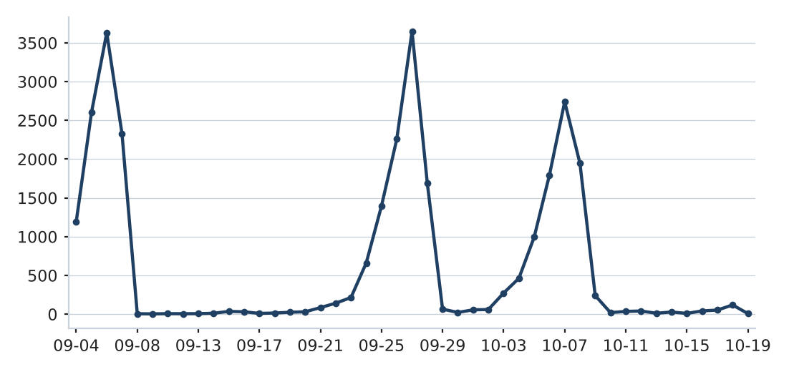

Status distribution
Share of the estate by classification status. Each segment is one status and the table beside it carries the counts.
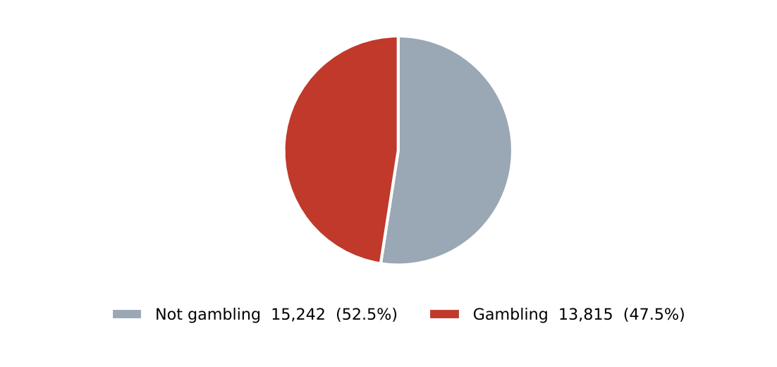
Status | Count | %
Not gambling | 15,242 | 52.5%
Gambling | 13,815 | 47.5%

Top 10 URL suffixes
The ten most common URL suffixes in the estate. Bar length is the total count and the table separates the gambling share.
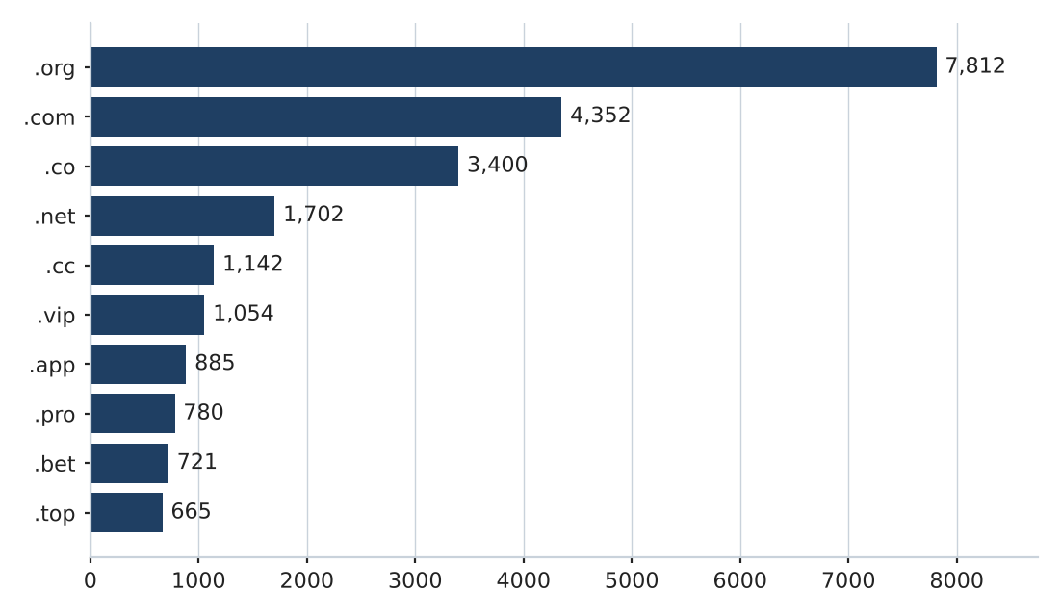
Suffix | Total | % of all | Gambling | % gambling
.org | 7,812 | 26.9% | 19 | 0.2%
.com | 4,352 | 15.0% | 2,061 | 47.4%
.co | 3,400 | 11.7% | 3,091 | 90.9%
.net | 1,702 | 5.9% | 1,082 | 63.6%
.cc | 1,142 | 3.9% | 673 | 58.9%
.vip | 1,054 | 3.6% | 952 | 90.3%
.app | 885 | 3.0% | 623 | 70.4%
.pro | 780 | 2.7% | 669 | 85.8%
.bet | 721 | 2.5% | 694 | 96.3%
.top | 665 | 2.3% | 353 | 53.1%

Subcategories

Gambling sites by product subcategory
Gambling sites by product subcategory. Bar length is the site count and each label carries the count and the share of gambling rows.
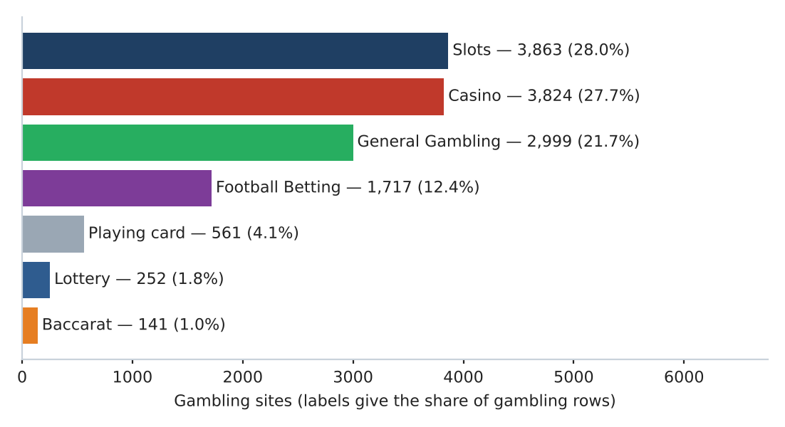

Assignment method by subcategory
How each subcategory was assigned. Solid fill is a lexicon keyword match and the lighter fill is reasoning inference.
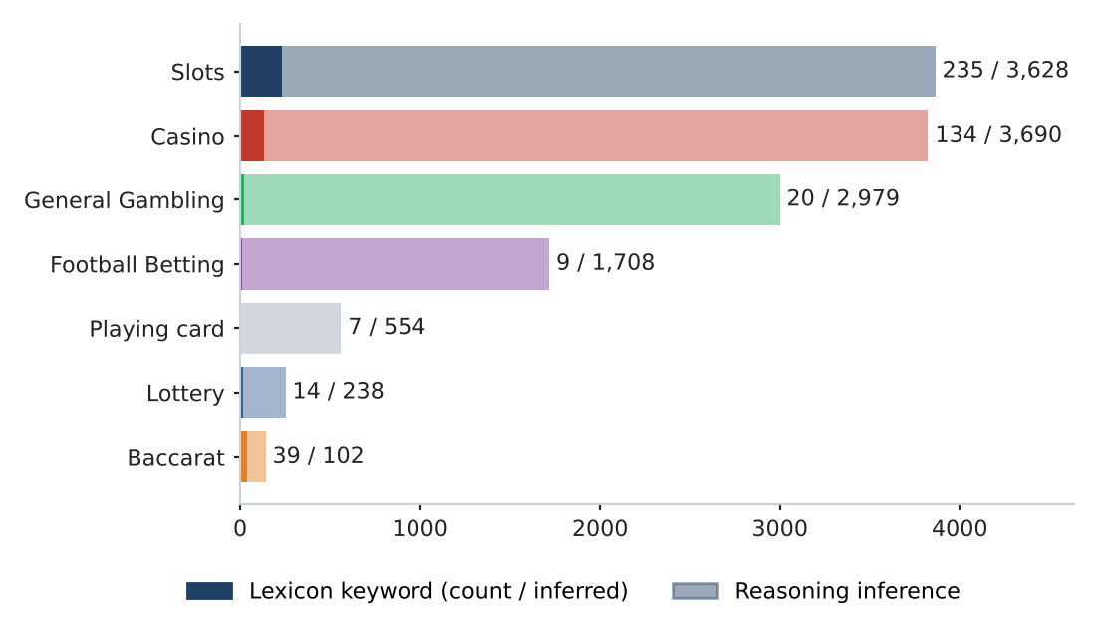

What a lexicon match means
A site is assigned to a subcategory by lexicon match when a word or phrase from the gambling keyword lexicon appears in what was recorded about the site, such as the model's description, extracted keywords, remarks from the SICPADetect automated classification pipeline, or the URL and domain, and that word belongs to the product category the site was assigned. A site whose description contains สล็อต is assigned to Slots by lexicon match. The lexicon is the SICPADetect Thai gambling keyword lexicon, at the version shown on the title page: 286 keywords in 14 categories, mostly in Thai script. Seven categories describe the gambling product and decide the subcategory. The other seven describe how a site markets or operates itself and are reported as signal tags, never as a subcategory. A lexicon match rests on a specific word that can be pointed to on the site, so the assignment can be checked and repeated. An inferred assignment rests on the model's reading of its own description when no lexicon word was found, so it carries lower confidence. A large inferred share means the sites use vocabulary the lexicon does not yet cover.
Inferred share 96.7% of gambling rows. General Gambling share 21.7% of gambling rows.

Subcategory table
Subcategory | Count | % of gambling | Keyword-assigned | Inferred | Distinct clusters
Slots | 3,863 | 28.0% | 235 | 3,628 | 939
Casino | 3,824 | 27.7% | 134 | 3,690 | 1,169
General Gambling | 2,999 | 21.7% | 20 | 2,979 | 724
Football Betting | 1,717 | 12.4% | 9 | 1,708 | 679
Playing card | 561 | 4.1% | 7 | 554 | 257
Lottery | 252 | 1.8% | 14 | 238 | 77
Baccarat | 141 | 1.0% | 39 | 102 | 107

458 gambling rows carry no description text and are not placed in a product subcategory.

Heat map: keyword by subcategory
Matched keywords against product subcategory. Each cell is the number of gambling sites carrying that keyword in that subcategory.
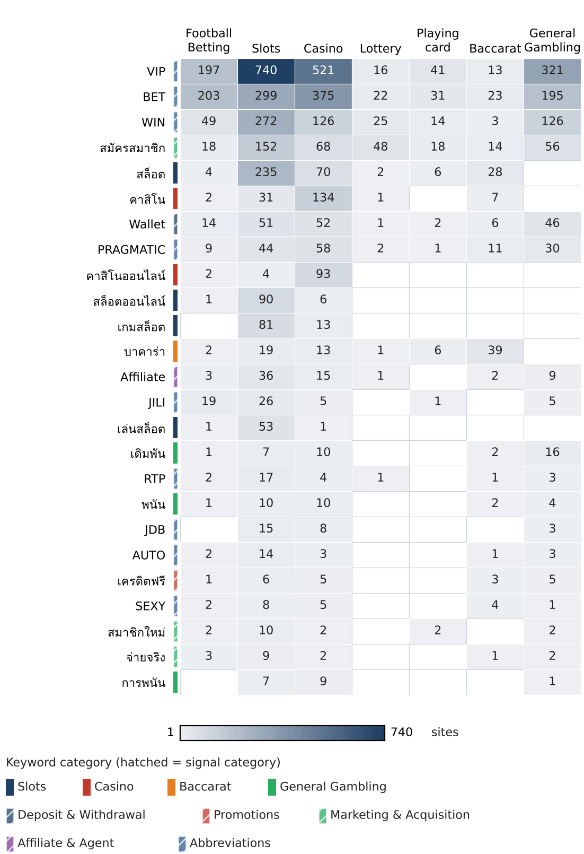

Heat map: signal tag by subcategory
Signal tags against product subcategory. Each cell is the number of gambling sites carrying that tag in that subcategory.
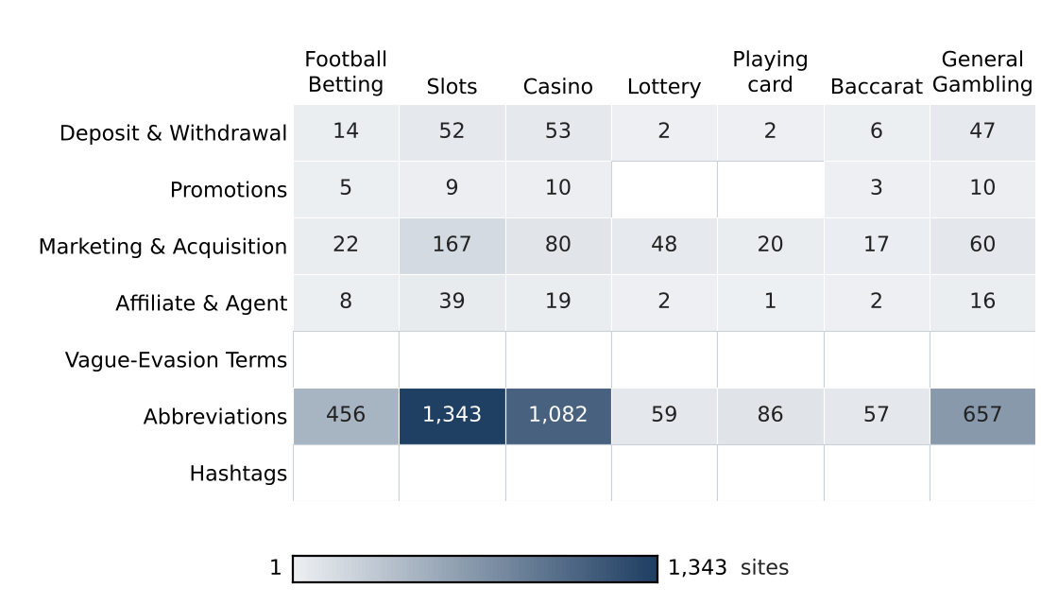

Brands and clustering

What brand clusters are

What a cluster is
A brand cluster is a group of domains judged to belong to the same gambling brand or operator. Domains join a cluster in one of four ways. The crawler finds one as a variant of, or a redirect from, another. One matches a brand in a ranking of gambling domains for Thailand supplied by an external data provider and is grouped under that brand's name, and Annex 2 lists the ranked brands applied. Their names reduce to the same stem once market tags, version numbers and suffixes are removed, so siam855thb5.com and siam-th.net reduce to siam. Or their stems are near identical in spelling. A domain that matches no other domain and no ranked brand is a singleton.

Why clusters matter
Operators rarely run a single site. They register many domains, rotate top level domains and move players between them through redirects, so that when one address is blocked another takes its place. Clustering shows how many distinct operations exist, how concentrated the estate is, and which operators run several product types. Acting on a cluster reaches every domain in it, where acting on one URL leaves the rest of the brand running.
Clusters are an analytical grouping based on names, crawler links and an external domain ranking, not a legal finding about ownership, and the Possible operator linkage table is indicative only.

2,798  Distinct clusters | 1,272  Clusters with 2 or more URLs | 1,526  Singletons | 49  Clusters to cover half of gambling URLs

Top 15 brand clusters by URL count
The fifteen largest brand clusters by URL count. Bar length is the number of domains in the cluster.
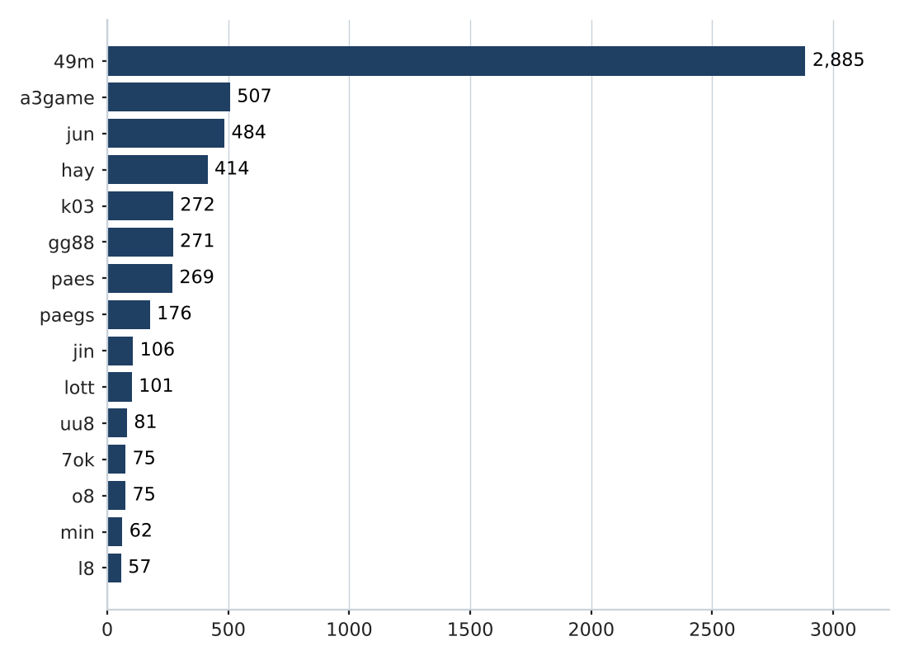

Heat map: brand cluster by subcategory
Brand clusters against product subcategory. Each cell is the number of URLs a cluster holds in that subcategory.
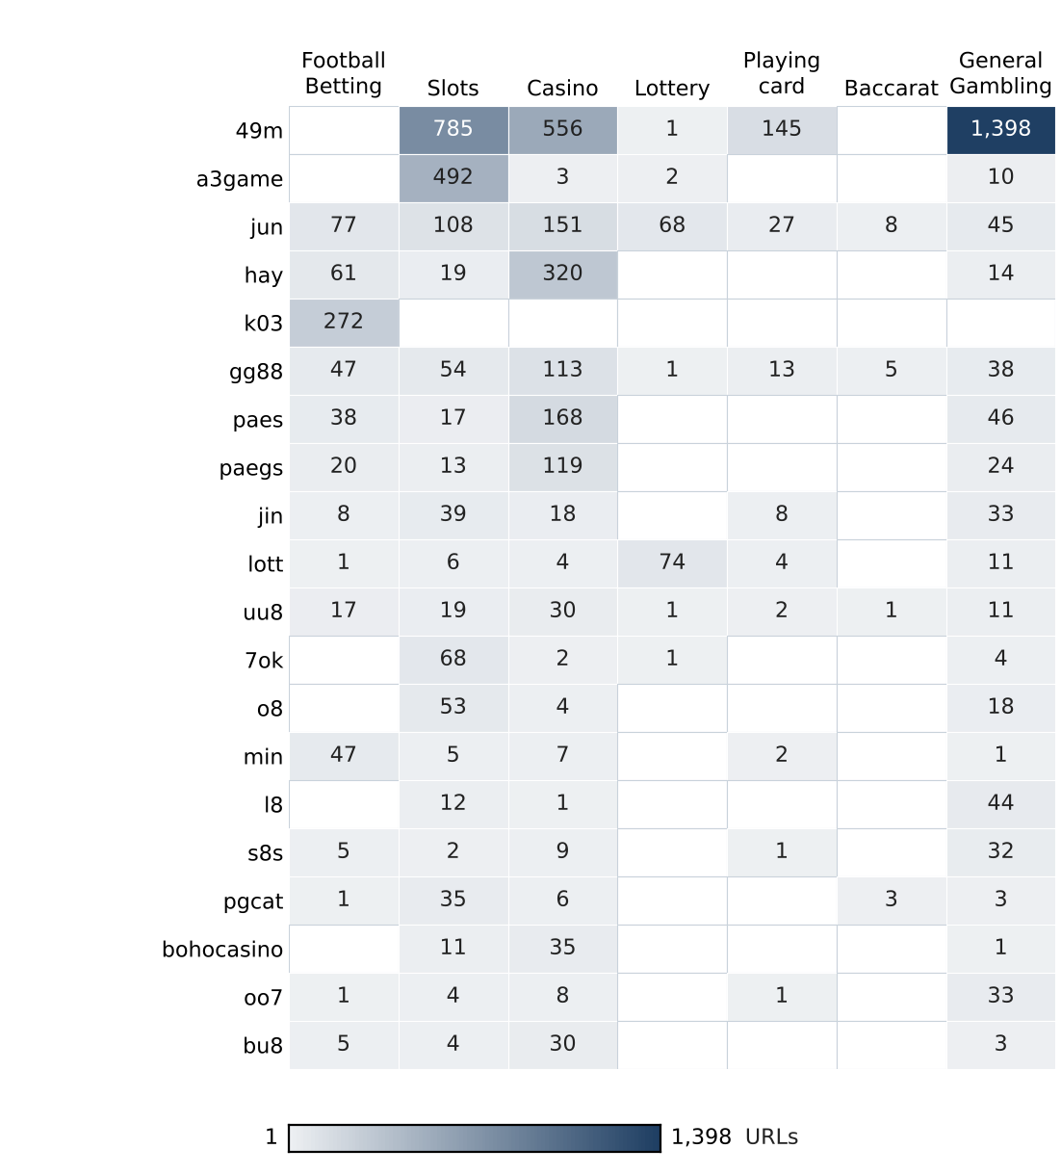

Cluster expansion: 49m
The largest brand cluster and its member domains. Edge style records why each domain joined the cluster.
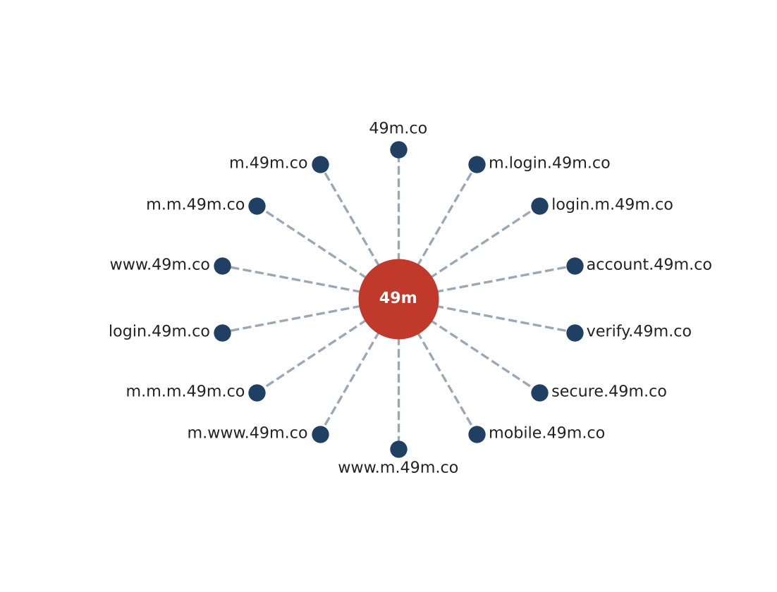
Domains in this cluster share the stem 49m and differ in the subdomain labels placed before it; dashed edges mark membership by shared stem.
Fourteen of 2,885 member domains are drawn.

Clusters spanning multiple subcategories
How to read this table
This table lists brand clusters whose sites fall into two or more product subcategories, for example one brand that runs both slots sites and football betting sites. Each row gives the cluster name, the number of its URLs in this sample, each subcategory present with its site count, and the domain suffixes the cluster uses. Subcategories are assigned to each site, not to the cluster, so a cluster qualifies when at least two of its sites carry different product subcategories. Where General Gambling appears beside a specific product, no product could be evidenced for those sites. Annex 1 defines each subcategory. These brands offer several gambling products under one name, so action against the brand reaches all of them at once.
Cluster | URL count | Subcategories | Suffixes
49m | 2,885 | Slots 785, Casino 556, Lottery 1, Playing card 145, General Gambling 1,398 | .co
a3game | 507 | Slots 492, Casino 3, Lottery 2, General Gambling 10 | .vip, .app, .click, .net
jun | 484 | Football Betting 77, Slots 108, Casino 151, Lottery 68, Playing card 27, Baccarat 8, General Gambling 45 | .top, .com, .net, .bet, .cc …
hay | 414 | Football Betting 61, Slots 19, Casino 320, General Gambling 14 | .net, .app, .bet, .club, .co …
gg88 | 271 | Football Betting 47, Slots 54, Casino 113, Lottery 1, Playing card 13, Baccarat 5, General Gambling 38 | .net, .app, .pro, .bet, .com …
paes | 269 | Football Betting 38, Slots 17, Casino 168, General Gambling 46 | .dev
paegs | 176 | Football Betting 20, Slots 13, Casino 119, General Gambling 24 | .dev
jin | 106 | Football Betting 8, Slots 39, Casino 18, Playing card 8, General Gambling 33 | .vip, .com, .co, .net, .bet …
lott | 101 | Football Betting 1, Slots 6, Casino 4, Lottery 74, Playing card 4, General Gambling 11 | .com, .net, .cc, .live, .online …
uu8 | 81 | Football Betting 17, Slots 19, Casino 30, Lottery 1, Playing card 2, Baccarat 1, General Gambling 11 | .cc, .com, .net, .pro, .click …
7ok | 75 | Slots 68, Casino 2, Lottery 1, General Gambling 4 | .bet, .live, .io, .club, .pro
o8 | 75 | Slots 53, Casino 4, General Gambling 18 | .game, .live
min | 62 | Football Betting 47, Slots 5, Casino 7, Playing card 2, General Gambling 1 | .net, .com, .app, .vip, .actor …
l8 | 57 | Slots 12, Casino 1, General Gambling 44 | .game
s8s | 49 | Football Betting 5, Slots 2, Casino 9, Playing card 1, General Gambling 32 | .com

The 15 largest of 856 clusters spanning two or more product subcategories. Suffix lists show the five most frequent.

Clusters rotating top-level domains
How to read this table
This table lists brand clusters whose member domains use two or more top-level domains, the ending of the address, for example the same brand name registered under .com, .net and .co. Each row gives the cluster, the suffixes it uses and how many member domains use each suffix. The suffix is the public suffix removed when a name is reduced to its stem, so a two part ending such as .co.th counts as one suffix. A cluster qualifies when its members use at least two different suffixes. Registering one brand name under several endings keeps the brand reachable when one domain is blocked, because a player only has to change the ending. Some operators register several endings to protect their name or serve different markets.
Cluster | Suffixes | Counts
a3game | .vip, .app, .click, .net | 502, 2, 2, 1
jun | .top, .com, .net, .bet, .cc, .app, .fun, .pro … | 93, 71, 54, 32, 25, 25, 24, 23 …
hay | .net, .app, .bet, .club, .co, .pro, .vip, .xyz | 407, 1, 1, 1, 1, 1, 1, 1
gg88 | .net, .app, .pro, .bet, .com, .online, .vip, .club … | 50, 43, 41, 31, 28, 17, 15, 11 …
jin | .vip, .com, .co, .net, .bet, .pro, .app, .online … | 21, 16, 14, 13, 7, 7, 5, 4 …
lott | .com, .net, .cc, .live, .online, .click, .info, .bet … | 60, 6, 5, 4, 4, 4, 4, 3 …
uu8 | .cc, .com, .net, .pro, .click, .co, .app, .bet … | 11, 10, 9, 7, 5, 5, 5, 4 …
7ok | .bet, .live, .io, .club, .pro | 66, 5, 2, 1, 1
o8 | .game, .live | 73, 2
min | .net, .com, .app, .vip, .actor, .art, .auction, .cc … | 7, 6, 4, 3, 2, 2, 2, 2 …
pgcat | .com, .info, .bet, .buzz, .click, .club, .fun, .online … | 25, 3, 2, 2, 2, 2, 2, 2 …
bohocasino | .com, .info, .co, .net, .app, .bet, .casino, .fun … | 29, 3, 2, 2, 1, 1, 1, 1 …
oo7 | .vip, .click, .app, .bet, .club, .io, .net, .pro | 39, 2, 1, 1, 1, 1, 1, 1
bu8 | .com, .app, .bid, .cab, .club, .in, .info, .kim … | 6, 2, 2, 2, 2, 2, 2, 2 …
siam | .com, .co, .io, .net, .shop, .vip, .app, .buzz … | 27, 2, 2, 2, 2, 2, 1, 1 …

The 15 largest of 901 clusters holding two or more suffixes. Suffixes and counts list the eight most frequent, in the same order.

Possible operator linkage
Indicative — not a clustering decision
How to read this table
This table lists pairs of brand clusters with different names that use an unusually similar set of signal keywords, the lexicon words describing how a site promotes itself, takes payment or avoids blocking. Each row gives the two clusters, the signal keywords they share and their Jaccard score. The score is the number of signal keywords the two clusters share, divided by the number of distinct signal keywords either of them uses. It runs from 0, nothing in common, to 1, identical sets. Only pairs scoring 0.60 or more are listed. A close match can point to one operator running two brands. It can equally come from unrelated operators using the same affiliate website template, so the pairs are leads to verify. The clusters are never merged on this score.
Cluster A | Cluster B | Shared keywords | Jaccard
pgcat | mst | BET, JILI, PRAGMATIC, VIP, WALLET, WIN, Wallet, สมัครสมาชิก, เครดิตฟรี, แจกเครดิตฟรี | 0.71
7ok | meg | BET, PRAGMATIC, RTP, VIP, WALLET, WIN, Wallet, สมัครสมาชิก | 1.00
7ok | wingame | BET, PRAGMATIC, VIP, WALLET, WIN, Wallet, สมัครสมาชิก | 0.78
7ok | 19ufa | BET, PRAGMATIC, RTP, WALLET, WIN, Wallet, สมัครสมาชิก | 0.78
meg | wingame | BET, PRAGMATIC, VIP, WALLET, WIN, Wallet, สมัครสมาชิก | 0.78
meg | 19ufa | BET, PRAGMATIC, RTP, WALLET, WIN, Wallet, สมัครสมาชิก | 0.78
7ok | ezslot | BET, PRAGMATIC, VIP, WALLET, WIN, Wallet, สมัครสมาชิก | 0.70
ezslot | meg | BET, PRAGMATIC, VIP, WALLET, WIN, Wallet, สมัครสมาชิก | 0.70
ezslot | wingame | BET, PRAGMATIC, VIP, WALLET, WIN, Wallet, สมัครสมาชิก | 0.70
7ok | mst | BET, PRAGMATIC, VIP, WALLET, WIN, Wallet, สมัครสมาชิก | 0.64
jin | 7ok | BET, RTP, VIP, WALLET, WIN, Wallet, สมัครสมาชิก | 0.64
jin | meg | BET, RTP, VIP, WALLET, WIN, Wallet, สมัครสมาชิก | 0.64
meg | mst | BET, PRAGMATIC, VIP, WALLET, WIN, Wallet, สมัครสมาชิก | 0.64
mst | 52m | BET, PRAGMATIC, VIP, WIN, สมัครสมาชิก, เครดิตฟรี, แจกเครดิตฟรี | 0.64
mst | wingame | BET, PRAGMATIC, VIP, WALLET, WIN, Wallet, สมัครสมาชิก | 0.64

40,828 pairs of multi-URL clusters score 0.60 or higher; the 15 with the most shared keywords are shown.

Naming conventions
- Recurring tokens: m (3,460), login (2,097), support (1,894) appear most often in names within the largest clusters, which is consistent with a templated naming scheme.
- TLD switching: names in the largest clusters span .co (2,923), .vip (553), .net (547), .dev (445), so these operators rotate top-level domains.
- 13,815 distinct domains across 2,798 brand clusters.

Ranking

Gambling ranking
How to read this table
This table lists the gambling sites in this sample that carry a rank in the SICPADetect feed, best ranked first, up to fifteen. Each row gives the rank, the domain, its brand cluster, its subcategory and where SICPADetect found it. The rank is the position recorded for the site in the source feed and reflects its search visibility: the lower the number, the more visible the site. It is not the external ranking used to anchor brand clusters in Annex 2, and unlike the 10 most prominent gambling sites in Thailand table it is not filtered for a Thai audience or limited to one row per domain. Rank measures visibility only, not harm, reach or revenue.
Rank | Domain | Brand cluster | Subcategory | Source
93,117 | metal--vip.com | met | Slots | x
214,132 | allslotwallet.online | allslotwallet | Slots | Not recorded
221,001 | suriyathai.net | suriya | General Gambling | x
252,597 | u11k.pro | u11 | Football Betting | Not recorded
254,190 | anthonyhead.com | anthonyhead | Casino | x
254,190 | kohochocolates.com | kohochocolates | Casino | Not recorded
293,057 | bifestathailand.com | bifestathailand | General Gambling | Not recorded
293,057 | lgbtnewsnow.org | lgbtnewsnow | General Gambling | x
303,254 | jun88wf.com | jun88w | Casino | Not recorded
397,330 | jun88wa.com | jun88w | Casino | Not recorded
466,858 | jun88wc.com | jun88w | Slots | Not recorded
514,501 | sacasino.ad | sacasino | Baccarat | x
517,141 | jun88.info | jun | Casino | Not recorded
517,141 | slavinaslot.top | slavinaslot | Casino | Not recorded
547,370 | 99ok.vip | 99ok | Lottery | Not recorded

Rank reflects search visibility in the source feed, not harm, reach or revenue.

Key insights

Scale of the analysis
The analysis covers 29,057 distinct URLs over 46 days, from 4 Sep 2026 to 19 Oct 2026. Of these, 13,815 are gambling, 15,242 are not gambling and 0 are unreachable.
The sample is large enough to reason about patterns, not isolated cases.

What is being offered
The three largest product subcategories are Slots (3,863, 28.0%), Casino (3,824, 27.7%) and General Gambling (2,999, 21.7%). 21.7% of gambling sites are confirmed as gambling without an evidenced product type, and 96.7% of subcategory assignments are inferred. 207 lexicon keywords never matched.
Slots is the dominant product type, but at 28.0% of gambling rows the estate is spread across product types rather than concentrated.

Brand clustering
2,798 clusters sit across 13,815 gambling URLs. 1,272 hold more than one domain, and 49 clusters cover half the estate. The largest, 49m, holds 2,885 domains across 5 subcategories.
The estate is diffuse and per-URL blocking will have limited leverage.

How the estate is grown and marketed
900 clusters rotate across more than one top-level domain. The two most common signal tags are Abbreviations (27.1%) and Marketing & Acquisition (3.0%).
TLD rotation keeps a stable entry point while the sites behind it are replaced.

Enforcement position
0 pages with evidence relevant to Thailand already show regulatory-blocking indicators such as court orders, regulator notices or block pages. The set appears pre-enforcement.
This set is a candidate for a first enforcement pass, prioritised by cluster rather than by URL.

Annexes

Annex 1 — Subcategory definitions
Each site classified as gambling is assigned one of the seven product subcategories below, according to what it offers. General Gambling applies only when a site is confirmed as gambling but no specific product can be evidenced. A subcategory is assigned by lexicon match when one of the keywords listed under it appears in what was recorded about the site, and by inference from the model's description when none is found. How a site markets or operates itself is recorded separately as signal tags and does not decide its subcategory. The keywords under each subcategory are its complete set in the lexicon, shown in their original script. A few keywords appear under both a specific product and General Gambling; they always count toward the specific product.
Football Betting · 21 keywords
Betting on the outcome of football and other sports matches, including match odds, single match and accumulator ("step") bets, and tipping or match analysis offered to bettors.
พ⁠นั⁠น⁠บ⁠อ⁠ล · พ⁠นั⁠น⁠บ⁠อ⁠ล⁠อ⁠อ⁠น⁠ไ⁠ล⁠น์ · แ⁠ท⁠ง⁠บ⁠อ⁠ล · แ⁠ท⁠ง⁠บ⁠อ⁠ล⁠อ⁠อ⁠น⁠ไ⁠ล⁠น์ · พ⁠นั⁠น⁠ฟุ⁠ต⁠บ⁠อ⁠ล · แ⁠ท⁠ง⁠ฟุ⁠ต⁠บ⁠อ⁠ล · ส⁠ป⁠อ⁠ร์⁠ต⁠บุ๊⁠ค · บ⁠อ⁠ล⁠อ⁠อ⁠น⁠ไ⁠ล⁠น์ · รา⁠คา⁠บ⁠อ⁠ล · บ⁠อ⁠ล⁠ส⁠เ⁠ต็⁠ป · บ⁠อ⁠ล⁠เ⁠ดี่⁠ย⁠ว · ส⁠เ⁠ต็⁠ป⁠บ⁠อ⁠ล · แ⁠ท⁠ง⁠บ⁠อ⁠ล⁠ชุ⁠ด · ที⁠เ⁠ด็⁠ด⁠บ⁠อ⁠ล · วิ⁠เ⁠ค⁠ราะ⁠ห์⁠บ⁠อ⁠ล · โ⁠ต๊ะ⁠บ⁠อ⁠ล · ล้⁠ม⁠โ⁠ต๊ะ⁠บ⁠อ⁠ล · เ⁠ดิ⁠ม⁠พั⁠น⁠ฟุ⁠ต⁠บ⁠อ⁠ล · เ⁠ว็⁠บ⁠แ⁠ท⁠ง⁠บ⁠อ⁠ล · บ⁠อ⁠ล⁠ส⁠เ⁠ต็⁠ป⁠แ⁠ม่⁠น · พ⁠นั⁠น⁠กี⁠ฬา
Slots · 32 keywords
Online slot machine games, including sites that promote particular slot providers, high payout rates or slots played directly without an agent.
ส⁠ล็⁠อ⁠ต · ส⁠ล็⁠อ⁠ต⁠อ⁠อ⁠น⁠ไ⁠ล⁠น์ · เ⁠ก⁠ม⁠ส⁠ล็⁠อ⁠ต · เ⁠ก⁠ม⁠ส⁠ล็⁠อ⁠ต⁠อ⁠อ⁠น⁠ไ⁠ล⁠น์ · ส⁠ล็⁠อ⁠ต⁠แ⁠ต⁠ก⁠ง่า⁠ย · ส⁠ล็⁠อ⁠ต⁠แ⁠ต⁠ก⁠บ่⁠อ⁠ย · ส⁠ล็⁠อ⁠ต⁠แ⁠ต⁠ก⁠ห⁠นั⁠ก · ส⁠ล็⁠อ⁠ต⁠แ⁠ต⁠ก⁠จ⁠ริ⁠ง · ส⁠ล็⁠อ⁠ต⁠ใ⁠ห⁠ม่ · ส⁠ล็⁠อ⁠ต⁠เ⁠ว็⁠บ⁠ต⁠ร⁠ง · ส⁠ล็⁠อ⁠ต⁠ว⁠อ⁠เ⁠ล⁠ท · เ⁠ล่⁠น⁠ส⁠ล็⁠อ⁠ต · ส⁠ล็⁠อ⁠ต⁠เ⁠ค⁠ร⁠ดิ⁠ต⁠ฟ⁠รี · ส⁠ล็⁠อ⁠ต⁠แ⁠ต⁠ก⁠ทุ⁠ก⁠วั⁠น · ส⁠ล็⁠อ⁠ต⁠มา⁠แ⁠ร⁠ง · ส⁠ล็⁠อ⁠ต⁠ย⁠อ⁠ด⁠นิ⁠ย⁠ม · ส⁠ล็⁠อ⁠ต⁠ค่า⁠ย⁠ดั⁠ง · ส⁠ล็⁠อ⁠ต⁠ไ⁠ม่⁠ผ่า⁠น⁠เ⁠อ⁠เ⁠ย่⁠น⁠ต์ · ส⁠ล็⁠อ⁠ต pg · ส⁠ล็⁠อ⁠ต joker · ส⁠ล็⁠อ⁠ต jili · ส⁠ล็⁠อ⁠ต pragmatic · ส⁠ล็⁠อ⁠ต xo · ส⁠ล็⁠อ⁠ต auto · ส⁠ล็⁠อ⁠ต⁠แ⁠ต⁠ก⁠ไ⁠ว · ส⁠ล็⁠อ⁠ต⁠ฝา⁠ก⁠ถ⁠อ⁠น⁠อ⁠อ⁠โ⁠ต้ · ส⁠ล็⁠อ⁠ต⁠ฝา⁠ก⁠ไ⁠ม่⁠มี⁠ขั้⁠น⁠ต่ำ · ส⁠ล็⁠อ⁠ต⁠โ⁠บ⁠นั⁠ส⁠แ⁠ต⁠ก⁠ห⁠นั⁠ก · ส⁠ล็⁠อ⁠ต⁠สา⁠ย⁠ฟ⁠รี · ส⁠ล็⁠อ⁠ต⁠ปั่⁠น⁠ง่า⁠ย · ส⁠ล็⁠อ⁠ต RTP สู⁠ง · ส⁠ล็⁠อ⁠ต⁠คื⁠น⁠กำ⁠ไ⁠ร

Annex 1 — Subcategory definitions (continued)
Casino · 14 keywords
Online and live casino table and wheel games other than baccarat and card games, such as roulette, dragon tiger, hi lo dice and wheel spin games.
คา⁠สิ⁠โ⁠น · คา⁠สิ⁠โ⁠น⁠อ⁠อ⁠น⁠ไ⁠ล⁠น์ · คา⁠สิ⁠โ⁠น⁠ส⁠ด · คา⁠สิ⁠โ⁠น⁠ส⁠ด⁠อ⁠อ⁠น⁠ไ⁠ล⁠น์ · เ⁠สื⁠อ⁠มั⁠ง⁠ก⁠ร · รู⁠เ⁠ล็⁠ต · รู⁠เ⁠ล็⁠ต⁠อ⁠อ⁠น⁠ไ⁠ล⁠น์ · รู⁠เ⁠ล๊⁠ต · ไ⁠ฮ⁠โ⁠ล · ไ⁠ฮ⁠โ⁠ล⁠อ⁠อ⁠น⁠ไ⁠ล⁠น์ · ไ⁠ฮ⁠โ⁠ล⁠ไ⁠ท⁠ย · ห⁠มุ⁠น⁠ว⁠ง⁠ล้⁠อ⁠โ⁠บ⁠นั⁠น⁠ซ่า⁠รา⁠ย⁠วั⁠น · ห⁠มุ⁠น⁠ว⁠ง⁠ล้⁠อ⁠โ⁠บ⁠นั⁠น⁠ซ่า · ปั่⁠น⁠แ⁠ปะ
Lottery · 20 keywords
Betting on lottery and number draws, including the Thai government and underground lotteries, Lao, Hanoi and Malaysian draws, fast draw yi ki lotteries and lotteries settled on stock index figures.
ห⁠ว⁠ย⁠อ⁠อ⁠น⁠ไ⁠ล⁠น์ · แ⁠ท⁠ง⁠ห⁠ว⁠ย · ซื้⁠อ⁠ห⁠ว⁠ย⁠อ⁠อ⁠น⁠ไ⁠ล⁠น์ · ห⁠ว⁠ย⁠ยี่⁠กี · ห⁠ว⁠ย⁠ฮา⁠น⁠อ⁠ย · ห⁠ว⁠ย⁠ลา⁠ว · ห⁠ว⁠ย⁠รั⁠ฐ⁠บา⁠ล · ห⁠ว⁠ย⁠มา⁠เ⁠ล⁠ย์ · ห⁠ว⁠ย⁠จั⁠บ⁠ยี่⁠กี · จั⁠บ⁠ยี่⁠กี VIP · ห⁠ว⁠ย⁠ใ⁠ต้⁠ดิ⁠น · ห⁠ว⁠ย⁠อ⁠อ⁠น⁠ไ⁠ล⁠น์⁠จ่า⁠ย⁠จ⁠ริ⁠ง · เ⁠ว็⁠บ⁠ห⁠ว⁠ย · เ⁠ว็⁠บ⁠แ⁠ท⁠ง⁠ห⁠ว⁠ย · Huay · Huaylan · ห⁠ว⁠ย⁠หุ้⁠น · ห⁠ว⁠ย⁠หุ้⁠น⁠ไ⁠ท⁠ย · ห⁠ว⁠ย⁠หุ้⁠น⁠ต่า⁠ง⁠ป⁠ระ⁠เ⁠ท⁠ศ · ห⁠ว⁠ย⁠ชุ⁠ด
Playing card · 12 keywords
Card games other than baccarat, such as pok deng, blackjack, poker and Thai two card and three card games.
ไ⁠พ่ · ไ⁠พ่⁠อ⁠อ⁠น⁠ไ⁠ล⁠น์ · ไ⁠พ่ อ⁠อ⁠น⁠ไ⁠ล⁠น์ · ไ⁠พ่⁠ป๊⁠อ⁠ก · ป๊⁠อ⁠ก⁠เ⁠ด้⁠ง · ป๊⁠อ⁠ก⁠เ⁠ด้⁠ง⁠อ⁠อ⁠น⁠ไ⁠ล⁠น์ · แ⁠บ⁠ล็⁠ค⁠แ⁠จ็⁠ค · แ⁠บ⁠ล็⁠ค⁠แ⁠จ็⁠ค⁠อ⁠อ⁠น⁠ไ⁠ล⁠น์ · โ⁠ป๊⁠ก⁠เ⁠ก⁠อ⁠ร์ · โ⁠ป๊⁠ก⁠เ⁠ก⁠อ⁠ร์⁠อ⁠อ⁠น⁠ไ⁠ล⁠น์ · ตี⁠ไ⁠ก่⁠ส⁠อ⁠ง⁠ใ⁠บ · ตี⁠ไ⁠ก่⁠สา⁠ม⁠ใ⁠บ

Annex 1 — Subcategory definitions (continued)
Baccarat · 11 keywords
Baccarat in any form, live or online, including demo tables and betting formula or prediction services sold for baccarat.
บา⁠คา⁠รา · บา⁠คา⁠ร่า · บา⁠คา⁠ร่า⁠อ⁠อ⁠น⁠ไ⁠ล⁠น์ · ไ⁠พ่⁠บา⁠คา⁠ร่า · บา⁠คา⁠ร่า⁠ส⁠ด · โ⁠ต๊ะ⁠บา⁠คา⁠ร่า · บา⁠คา⁠ร่า⁠ท⁠ด⁠ล⁠อ⁠ง · บา⁠คา⁠ร่า⁠ฟ⁠รี · บา⁠คา⁠ร่า⁠ระ⁠บ⁠บ AI · บา⁠คา⁠ร่า⁠ขั้⁠น⁠เ⁠ท⁠พ · สู⁠ต⁠ร⁠บา⁠คา⁠ร่า
General Gambling · 22 keywords
Sites confirmed as gambling whose recorded content uses only generic gambling or betting vocabulary, so no specific product can be evidenced. Assigned only when no other subcategory applies.
พ⁠นั⁠น · กา⁠ร⁠พ⁠นั⁠น · พ⁠นั⁠น⁠อ⁠อ⁠น⁠ไ⁠ล⁠น์ · เ⁠ว็⁠บ⁠พ⁠นั⁠น · เ⁠ว็⁠บ⁠เ⁠ดิ⁠ม⁠พั⁠น · เ⁠ดิ⁠ม⁠พั⁠น · เ⁠ดิ⁠ม⁠พั⁠น⁠อ⁠อ⁠น⁠ไ⁠ล⁠น์ · คา⁠สิ⁠โ⁠น · คา⁠สิ⁠โ⁠น⁠อ⁠อ⁠น⁠ไ⁠ล⁠น์ · บ่⁠อ⁠น · บ่⁠อ⁠น⁠อ⁠อ⁠น⁠ไ⁠ล⁠น์ · เ⁠ว็⁠บ⁠เ⁠ก⁠ม⁠พ⁠นั⁠น · เ⁠ก⁠ม⁠พ⁠นั⁠น · เ⁠ว็⁠บ⁠เ⁠สี่⁠ย⁠ง⁠โ⁠ช⁠ค · เ⁠สี่⁠ย⁠ง⁠โ⁠ช⁠ค · เ⁠ว็⁠บ⁠เ⁠ก⁠ม⁠เ⁠งิ⁠น · เ⁠ล่⁠น⁠เ⁠งิ⁠น⁠จ⁠ริ⁠ง · เ⁠ก⁠ม⁠ไ⁠ด้⁠เ⁠งิ⁠น⁠จ⁠ริ⁠ง · เ⁠ดิ⁠ม⁠พั⁠น⁠กี⁠ฬา · พ⁠นั⁠น⁠กี⁠ฬา · พ⁠นั⁠น⁠บ⁠อ⁠ล · แ⁠ท⁠ง⁠บ⁠อ⁠ล
The keyword lists are those of the SICPADetect lexicon at the version shown on the title page.

Annex 2 — Ranked domains used for clustering
Ranking of gambling domains for Thailand · external data provider · 159 of 200 ranked domains applied
Brand clusters are anchored to a ranking of gambling domains for Thailand supplied by an external data provider. When a URL in this sample matches a ranked brand, it is grouped under that brand's name instead of the name it happens to carry. The ranking is an analytical reference. A place in it is not evidence of ownership, harm or reach, and a match never adds a site to the gambling set.
Rank | Ranked domain | Brand | Match basis | URLs matched | Cluster
1 | 22onlinegames.com | 22onlinegames | Brand name and extended names | 1 | 22onlinegames
3 | debet.tv | debet | Brand name and extended names | 1 | debet
4 | aiscore.com | aiscore | Brand name and extended names | 1 | aiscore
5 | ufabet.com | ufabet | Brand name and extended names | 1 | ufabet
7 | invl.me | invl | Brand name only | 2 | invl
8 | lottoheng168.com | lottoheng | Brand name and extended names | 1 | lottoheng
9 | 888scoreonline.net | 888scoreonline | Brand name and extended names | 1 | 888scoreonline
10 | hacksawgaming.com | hacksawgaming | Brand name and extended names | 4 | hacksawgaming
12 | playin.com | playin | Brand name and extended names | 3 | playin
14 | gosh.io | gosh | Brand name only | 1 | gosh
15 | 24live.com | 24live | Brand name and extended names | 2 | 24live

Annex 2 — Ranked domains used for clustering (continued)
Rank | Ranked domain | Brand | Match basis | URLs matched | Cluster
16 | 326821905591.com | 326821905591 | This domain only | 1 | 326821905591
19 | vlr.gg | vlr | This domain only | 1 | vlr
20 | 7mkr.com | 7mkr | This domain only | 1 | 7mkr
21 | flashscore.co.uk | flashscore | Brand name and extended names | 6 | flashscore
22 | 808ball15.com | 808ball | Brand name and extended names | 2 | 808ball
24 | bet365.com | bet365 | Brand name and extended names | 0 | —
25 | mlnhngoc.net | mlnhngoc | Brand name and extended names | 1 | mlnhngoc
26 | m8geqpm2kpnf78dkfxp9ksg94ndx9weaoa39.com | m8geqpm2kpnf78dkfxp9ksg94ndx9weaoa | This domain only | 1 | m8geqpm2kpnf78dkfxp9ksg94ndx9weaoa
27 | 13o.net | 13o | Brand name only | 1 | 13o
28 | nolimitcity.com | nolimitcity | Brand name and extended names | 2 | nolimitcity
29 | 1xbet.com | 1xbet | Brand name and extended names | 2 | 1xbet
30 | betufa.com | betufa | Brand name and extended names | 1 | betufa
31 | d3my3ye7lo15uo.cloudfront.net | d3my3ye7lo15uo | This domain only | 1 | d3my3ye7lo15uo
32 | viieuvkf.com | viieuvkf | This domain only | 1 | viieuvkf
34 | anaidahog.com | anaidahog | Brand name and extended names | 1 | anaidahog
36 | m1rs.com | m1rs | This domain only | 1 | m1rs
37 | spinova-hub.com | spinovahub | Brand name and extended names | 1 | spinovahub
38 | beer777.com | beer | Brand name only | 3 | beer
41 | kaga88.com | kaga | Brand name only | 4 | kaga
42 | painamour.com | painamour | Brand name and extended names | 1 | painamour
43 | bet365.ee | bet365 | Brand name and extended names | With rank 24 | —
44 | seriesdet.com | seriesdet | Brand name and extended names | 1 | seriesdet
45 | singaporepools.com.sg | singaporepools | Brand name and extended names | 2 | singaporepools
46 | stake.com | stake | Brand name and extended names | 4 | stake

Annex 2 — Ranked domains used for clustering (continued)
Rank | Ranked domain | Brand | Match basis | URLs matched | Cluster
47 | rainbet.com | rainbet | Brand name and extended names | 1 | rainbet
49 | wsgamings.com | wsgamings | Brand name and extended names | 2 | wsgamings
50 | jackpots.ch | jackpots | Brand name and extended names | 1 | jackpots
52 | pic5678.com | pic | Brand name only | 2 | pic
54 | sporticos.com | sporticos | Brand name and extended names | 1 | sporticos
55 | rsg-games.com | rsggames | Brand name and extended names | 1 | rsggames
59 | casino.org | casino.org | This domain only | 0 | —
60 | coktv1.com | cokt | Brand name only | 1 | cokt
61 | games.kaga88.com | kaga | Brand name only | With rank 41 | kaga
62 | royal558.com | royal | Brand name and extended names | 5 | royal
63 | dafabet.com | dafabet | Brand name and extended names | 0 | —
64 | nowgoal26.com | nowgoal | Brand name and extended names | 6 | nowgoal
66 | glivesport.com | glivesport | Brand name and extended names | 1 | glivesport
67 | pragmaticplay.com | pragmaticplay | Brand name and extended names | 1 | pragmaticplay
68 | lottovip.bet | lottovip | Brand name and extended names | 8 | lottovip
69 | chatursply.com | chatursply | Brand name and extended names | 1 | chatursply
70 | afiyukent.one | afiyukent | Brand name and extended names | 1 | afiyukent
71 | 8provider.com | 8provider | Brand name and extended names | 1 | 8provider
72 | iqoption.net | iqoption | Brand name and extended names | 1 | iqoption
73 | millipiyangoonline.com | millipiyangoonline | Brand name and extended names | 1 | millipiyangoonline
74 | stp4bet.net | stp4bet | Brand name and extended names | 2 | stp4bet
77 | corevibe-network.com | corevibenetwork | Brand name and extended names | 1 | corevibenetwork
78 | flashscore.com.ua | flashscore | Brand name and extended names | With rank 21 | flashscore
79 | wuoza.com | wuoza | Brand name and extended names | 1 | wuoza

Annex 2 — Ranked domains used for clustering (continued)
Rank | Ranked domain | Brand | Match basis | URLs matched | Cluster
80 | papasqueens.com | papasqueens | Brand name and extended names | 0 | —
81 | ouraidream.com | ouraidream | Brand name and extended names | 1 | ouraidream
84 | w88cric.com | w88cric | Brand name and extended names | 3 | w88cric
85 | askmebet.live | askmebet | Brand name and extended names | 2 | askmebet
86 | chainers.io | chainers | Brand name and extended names | 1 | chainers
87 | minhngoc.net.vn | minhngoc | Brand name and extended names | 1 | minhngoc
89 | crickfree.be | crickfree | Brand name and extended names | 1 | crickfree
91 | asianbookie.com | asianbookie | Brand name and extended names | 4 | asianbookie
92 | nova88.com | nova | Brand name only | 4 | nova
94 | ekamsply.com | ekamsply | Brand name and extended names | 1 | ekamsply
95 | connect234.com | connect | Brand name and extended names | 1 | connect
97 | 888casino.it | 888casino | Brand name and extended names | 2 | 888casino
98 | issuya.com | issuya | Brand name and extended names | 1 | issuya
99 | crex.com | crex | Brand name only | 1 | crex
100 | sport.888casino.it | 888casino | Brand name and extended names | With rank 97 | 888casino
102 | 1x-bet.mobi | 1xbet | Brand name and extended names | With rank 29 | 1xbet
103 | slotcatalog.com | slotcatalog | Brand name and extended names | 2 | slotcatalog
104 | thboxing.com | thboxing | Brand name and extended names | 2 | thboxing
105 | gys5.com | gys | This domain only | 1 | gys
106 | m88.com | m88 | This domain only | 1 | m88
107 | stevenbridges.co | stevenbridges | Brand name and extended names | 1 | stevenbridges
108 | allbetasia.com | allbetasia | Brand name and extended names | 3 | allbetasia
109 | betway.com | betway | Brand name and extended names | 1 | betway
110 | bigwinboard.com | bigwinboard | Brand name and extended names | 3 | bigwinboard

Annex 2 — Ranked domains used for clustering (continued)
Rank | Ranked domain | Brand | Match basis | URLs matched | Cluster
111 | shuffle.com | shuffle | Brand name and extended names | 2 | shuffle
112 | ballthaitv.com | ballthaitv | Brand name and extended names | 1 | ballthaitv
113 | scoresinlive.com | scoresinlive | Brand name and extended names | 1 | scoresinlive
114 | fun88.com | fun | Brand name only | 3 | fun
115 | 622coffee.com | 622coffee | Brand name and extended names | 1 | 622coffee
117 | betfair.com | betfair | Brand name and extended names | 1 | betfair
119 | givamblog.com | givamblog | Brand name and extended names | 1 | givamblog
120 | pokerstars.com | pokerstars | Brand name and extended names | 2 | pokerstars
121 | fon.bet | fon | Brand name only | 1 | fon
124 | pokerstarslive.com | pokerstars | Brand name and extended names | With rank 120 | pokerstars
125 | njtv-01.com | njtv | This domain only | 1 | njtv
126 | footballpredictions.com | footballpredictions | Brand name and extended names | 1 | footballpredictions
127 | api-ugaming.com | apiugaming | Brand name and extended names | 1 | apiugaming
128 | stake.ceo | stake | Brand name and extended names | With rank 46 | stake
129 | 3rmwa7p.com | 3rmwa7p | This domain only | 1 | 3rmwa7p
130 | livescore.red | livescore | Brand name and extended names | 2 | livescore
131 | ballhengheng.com | ballhengheng | Brand name and extended names | 2 | ballhengheng
132 | twoplustwo.com | twoplustwo | Brand name and extended names | 1 | twoplustwo
134 | casino.com | casino.com | This domain only | 0 | —
136 | manko.fun | manko | Brand name and extended names | 1 | manko
137 | bojel.com | bojel | Brand name and extended names | 1 | bojel
138 | chipy.com | chipy | Brand name and extended names | 1 | chipy
139 | xskt.com.vn | xskt | This domain only | 1 | xskt
140 | bch.games | bch | This domain only | 1 | bch

Annex 2 — Ranked domains used for clustering (continued)
Rank | Ranked domain | Brand | Match basis | URLs matched | Cluster
141 | dhlottery.co.kr | dhlottery | Brand name and extended names | 1 | dhlottery
142 | sagaming.com | sagaming | Brand name and extended names | 3 | sagaming
143 | hkjc.com | hkjc | This domain only | 2 | hkjc
144 | betika.com | betika | Brand name and extended names | 3 | betika
145 | backgammongalaxy.com | backgammongalaxy | Brand name and extended names | 1 | backgammongalaxy
146 | thehendonmob.com | thehendonmob | Brand name and extended names | 1 | thehendonmob
148 | melbetegypt.com | melbetegypt | Brand name and extended names | 1 | melbetegypt
149 | cyberscore.live | cyberscore | Brand name and extended names | 1 | cyberscore
150 | national-lottery.co.uk | nationallottery | Brand name and extended names | 1 | nationallottery
151 | oddschecker.com | oddschecker | Brand name and extended names | 0 | —
152 | lckts.com | lckts | This domain only | 1 | lckts
153 | sbfplay99.com | sbfplay | Brand name and extended names | 4 | sbfplay
154 | ohoboxing.com | ohoboxing | Brand name and extended names | 0 | —
155 | recharge.game | recharge | Brand name and extended names | 1 | recharge
156 | racenet.com.au | racenet | Brand name and extended names | 1 | racenet
157 | fatty777.xyz | fatty | Brand name and extended names | 1 | fatty
158 | 2ded.com | 2ded | Brand name only | 2 | 2ded
159 | marathonbet.ru | marathonbet | Brand name and extended names | 1 | marathonbet
160 | bet911.com | bet911 | Brand name and extended names | 1 | bet911
161 | cloudbet.com | cloudbet | Brand name and extended names | 1 | cloudbet
162 | duel.com | duel | Brand name only | 1 | duel
163 | footystats.org | footystats | Brand name and extended names | 1 | footystats
164 | az24.vn | az24 | Brand name only | 1 | az24
165 | sbobet.com | sbobet | Brand name and extended names | 2 | sbobet

Annex 2 — Ranked domains used for clustering (continued)
Rank | Ranked domain | Brand | Match basis | URLs matched | Cluster
166 | racing.com | racing | Brand name and extended names | 2 | racing
167 | bc.game | bc | This domain only | 1 | bc
168 | d1q60f0kk3cf0.cloudfront.net | d1q60f0kk3cf | This domain only | 1 | d1q60f0kk3cf
169 | dordir.com | dordir | Brand name and extended names | 1 | dordir
170 | sunmacau.com | sunmacau | Brand name and extended names | 1 | sunmacau
171 | dol-rtknetwork.com | dolrtknetwork | Brand name and extended names | 1 | dolrtknetwork
173 | bebayankhs.com | bebayankhs | Brand name and extended names | 1 | bebayankhs
174 | mivasstore.com | mivasstore | Brand name and extended names | 1 | mivasstore
175 | sportsbet.com.au | sportsbet | Brand name and extended names | 2 | sportsbet
176 | tpi.li | tpi | Brand name only | 1 | tpi
177 | casino.guru | casino.guru | This domain only | 0 | —
178 | grabyourluck.com | grabyourluck | Brand name and extended names | 1 | grabyourluck
180 | exma.io | exma | Brand name only | 1 | exma
182 | pubg.plus | pubg | Brand name only | 1 | pubg
183 | football.nowgoal26.com | nowgoal | Brand name and extended names | With rank 64 | nowgoal
184 | storehyson.com | storehyson | Brand name and extended names | 1 | storehyson
185 | brabet.com | brabet | Brand name and extended names | 1 | brabet
186 | mycasino.ch | mycasino | Brand name and extended names | 1 | mycasino
187 | crowncoinscasino.com | crowncoinscasino | Brand name and extended names | 1 | crowncoinscasino
188 | goal-th.com | goalth | Brand name and extended names | 1 | goalth
189 | ggbetconnect.com | ggbetconnect | Brand name and extended names | 1 | ggbetconnect
192 | paddypower.com | paddypower | Brand name and extended names | 1 | paddypower
194 | tadagaming.com | tadagaming | Brand name and extended names | 3 | tadagaming
195 | olbg.com | olbg | Brand name only | 1 | olbg

Annex 2 — Ranked domains used for clustering (continued)
Rank | Ranked domain | Brand | Match basis | URLs matched | Cluster
197 | thscore.fun | thscore | Brand name and extended names | 7 | thscore
198 | slotstemple.com | slotstemple | Brand name and extended names | 2 | slotstemple
199 | 777.ua | 777 | This domain only | 1 | 777
200 | m-918kiss.com | m918kiss | Brand name and extended names | 2 | m918kiss

143 of 159 ranked domains matched at least one URL in this sample, together covering 230 gambling URLs (1.7% of gambling URLs).
41 ranked domains are awaiting analyst review, were not applied and are not listed.
Rank is as supplied by the external data provider and is not a measure of harm, reach or revenue; it is separate from the rank shown in the Gambling ranking card. Grouping a URL under a ranked brand is an analytical grouping, not a legal finding about ownership.

Lexicon source: Gambling_Keywords_Full_English_Categories_V1.xlsx, version V1; keywords per category: Football Betting 21; Slots 32; Casino 14; Lottery 20; Playing card 12; Baccarat 11; General Gambling 22; Deposit & Withdrawal 24; Promotions 27; Marketing & Acquisition 25; Affiliate & Agent 20; Vague-Evasion Terms 20; Abbreviations 22; Hashtags 21. Inferred share 96.7%; General Gambling share 21.7%; the lexicon has poor coverage of this dataset and subcategory figures are indicative only. Rows normalised from Licensed gambling: 0. Probable false-positive source among abbreviations: VIP, BET (more than 20% of abbreviation matches). Clustering thresholds: Jaro–Winkler similarity 0.90 or higher with a shared prefix; operator linkage Jaccard 0.60 or higher.

