Data Insights & Patterns
12,435 URLs · 31 Aug 2026 – 24 Sep 2026
Issued to Ministry of Digital Economy and Society, Thailand
Prepared by SICPA SA
Date of issue 25/09/2026
Source system SICPADetect · lexicon Appendix A (V1)

Contents
Executive summary
Group A — Model Insights
Introduction
Insights
Performance
Group B — 10 most prominent gambling sites in Thailand
10 most prominent gambling sites in Thailand
Group C — The numbers
The estate at a glance
URLs analyzed per day
Status distribution
Top 10 URL suffixes
Group D — Subcategories
Gambling sites by product subcategory
Assignment method by subcategory
Subcategory table
Heat map — Keyword by subcategory
Heat map — Signal tag by subcategory
Group E — Brands and clustering
Clustering at a glance
Top 15 brand clusters by URL count
Heat map — Brand cluster by subcategory
Cluster expansion — 02j
Clusters spanning multiple subcategories
Clusters rotating top-level domains
Possible operator linkage
Naming conventions
Structure: direct, redirect, variant
Redirect propagation — lotto432e.com
Group F — Ranking
Gambling ranking
Group G — Key insights
Scale of the analysis
What is being offered
Brand clustering
How the estate is grown and marketed
Enforcement position

Executive summary
Part 1a. Insights and trends.
The estate analysed holds 12,435 distinct URLs, of which 37.0% are gambling sites. The remainder are not gambling. Product mix is led by Slots, followed by Football Betting, General Gambling.
Operator concentration is the strongest structural finding. 2 brand clusters cover half of all gambling URLs, and the largest single cluster holds 36.0% of them. Most clusters hold more than one domain, so the estate is built from a small number of operators replicating domains rather than from many independent sites.
The estate is grown almost entirely through crawler-identified variants rather than through direct discovery, with a smaller redirect layer in front of it. Clusters rotate across multiple top-level domains, so a domain-by-domain response is overtaken as fast as it is applied.
Subcategory figures rest on reasoning inference rather than lexicon keyword matches for 97.0% of gambling rows. The lexicon is Thai and this estate is largely Latin script, so product type is indicative only and should not be read as a measured distribution.
The evaluation period spans 25 days, which is too short to carry a trend, so no direction is stated.
Enforcement indicators are effectively absent from the captured text.
Part 1b. Key figures.
Reporting figure | Value
URLs analysed | 12,435
Gambling sites | 4,597 (37.0%)
Not gambling | 7,838
Unreachable | 0
Brand clusters identified | 63
Clusters holding more than one domain | 32
Clusters covering half the estate | 2
Largest cluster | 02j — 1,654 URLs
Dominant product subcategory | Slots — 35.7%
Most common signal tag | Abbreviations — 30.2%
Sites showing blocking indicators | 1
Keyword-assigned vs inferred | 3.0% vs 97.0%

Group A — Model Insights
Introduction

Insights

Performance

Group B — 10 most prominent gambling sites in Thailand
10 most prominent gambling sites in Thailand
Rank | URL (defanged) | Domain | Brand cluster | Subcategory | Thai-targeting evidence | Source
78,229 | hxxps://www[.]lottovip[.]com/register/af/21832 | lottovip.com | loto | Lottery | Thai currency: “Baht” | Youtube (lotto432)
90,304 | hxxps://lottovip[.]bet/ | lottovip.bet | loto | Lottery | Thai-market product or brand term: “BET” | Variant (lottovip.com)
184,475 | hxxps://fun88thf[.]com/ | fun88thf.com | fun | Football Betting | Thai-market product or brand term: “VIP” | Variant (fun88tht.com)
216,041 | hxxps://lottovipp[.]com/ | lottovipp.com | loto | Lottery | Thai-market product or brand term: “WIN” | Variant (lottovip.com)
517,141 | hxxps://slavinaslot[.]top/ | slavinaslot.top | hub | Slots | Thai-market product or brand term: “VIP” | Redirect (jun88.info)
517,141 | hxxps://jun88[.]info/ | jun88.info | hub | Slots | Thai-market product or brand term: “VIP” | Variant (jun88.mobile)
547,370 | hxxps://99ok[.]vip/ | 99ok.vip | 02j | Lottery | Thai-market product or brand term: “VIP” | Variant (99ok.bet)
558,790 | hxxps://gg8830[.]com/ | gg8830.com | 02j | Slots | Thai-market product or brand term: “SEXY” | Variant (gg8825.app)
706,458 | hxxps://lotto432ad[.]com/ | lotto432ad.com | loto | Lottery | Thai script: “สมัครสมาชิก” | Variant (lotto432ae.com)
715,861 | hxxps://k7[.]game/ | k7.game | 007 | General Gambling | Thai-market product or brand term: “BET” | Variant (k6.game)

Drawn from 56 ranked gambling rows that carry Thai-audience evidence, collapsed to one row per registrable domain. Rank reflects search visibility in the source feed, not harm, reach or revenue.

Group C — The numbers
The estate at a glance

12,435  Total URLs analyzed | 4,597  Gambling sites | 63  Brand clusters identified | 25 days  Evaluation period

Evaluation period 2026-08-31 to 2026-09-24.
URLs analyzed per day
Daily count of URLs analysed across the evaluation period. Each point is one calendar day.
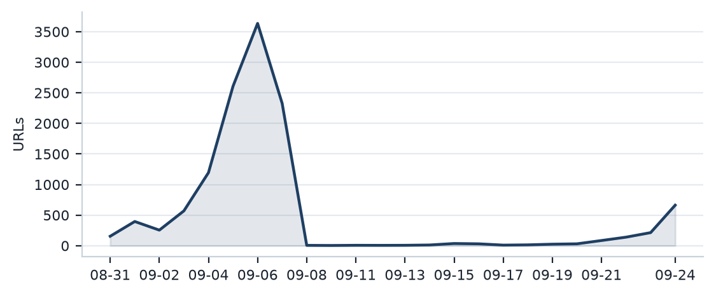

Status distribution
Share of the estate by classification status. Each segment is one status and the table below carries the counts.
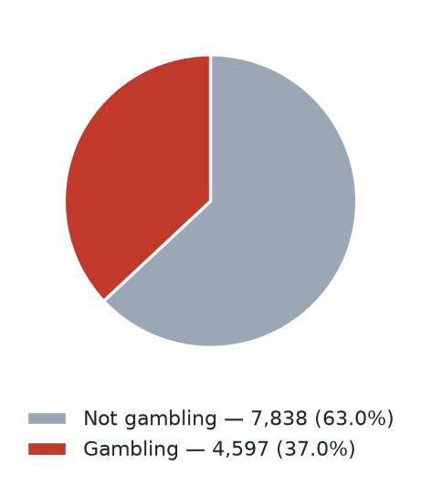
Status | Count | % of URLs
Not gambling | 7,838 | 63.0%
Gambling | 4,597 | 37.0%
Total | 12,435 | 100.0%

Top 10 URL suffixes
The ten most common URL suffixes in the estate. Bar length is the total count and the table separates the gambling share.
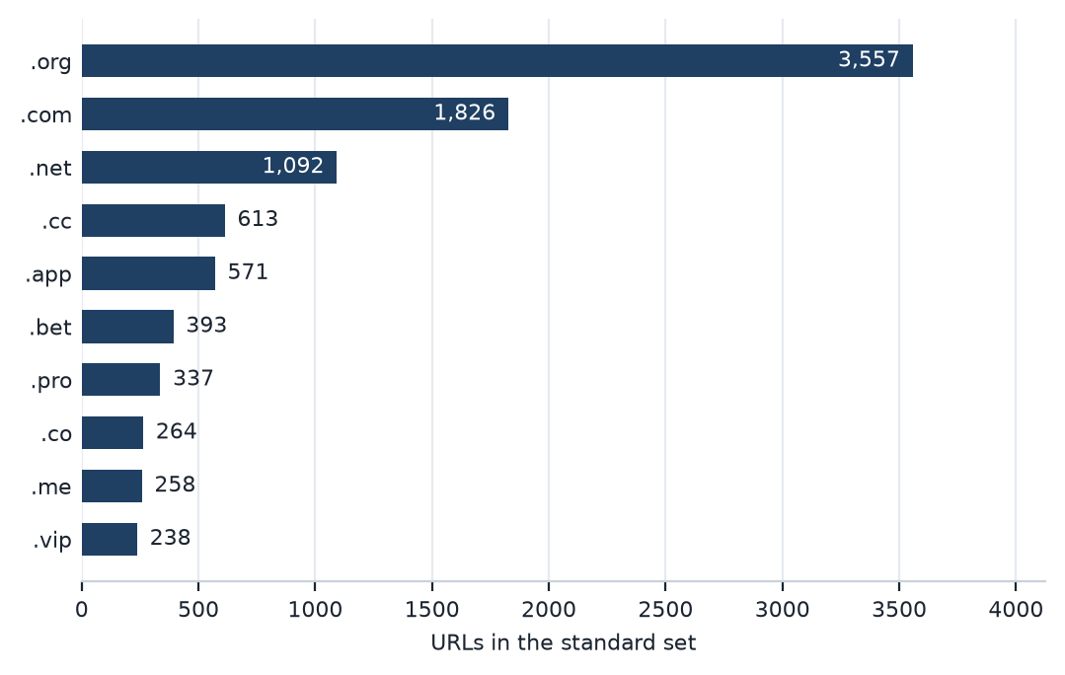
Suffix | Total | % of all | Gambling | % gambling
.org | 3,557 | 28.6% | 2 | 0.1%
.com | 1,826 | 14.7% | 688 | 37.7%
.net | 1,092 | 8.8% | 662 | 60.6%
.cc | 613 | 4.9% | 394 | 64.3%
.app | 571 | 4.6% | 401 | 70.2%
.bet | 393 | 3.2% | 379 | 96.4%
.pro | 337 | 2.7% | 285 | 84.6%
.co | 264 | 2.1% | 60 | 22.7%
.me | 258 | 2.1% | 111 | 43.0%
.vip | 238 | 1.9% | 198 | 83.2%

Group D — Subcategories
Gambling sites by product subcategory
Gambling sites by product subcategory. Bar length is the site count and each label carries the count and the share of gambling rows.
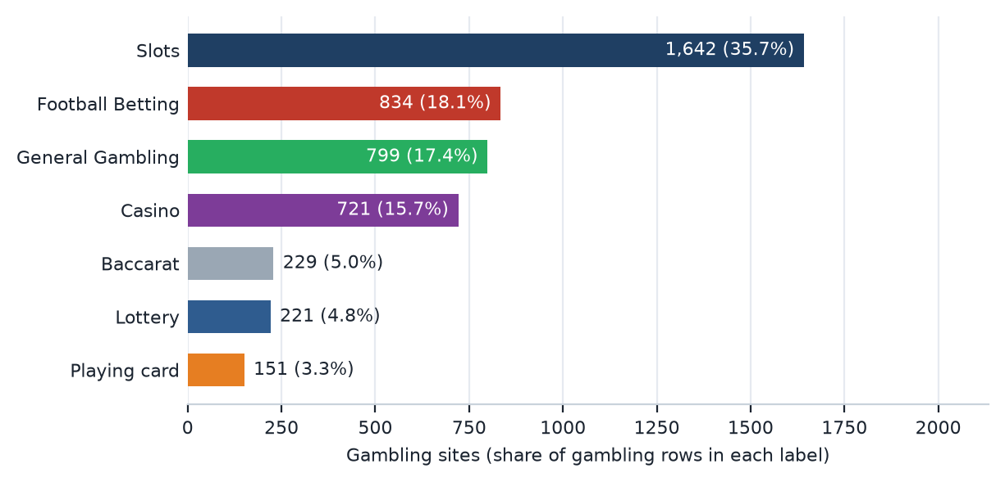

Assignment method by subcategory
How each subcategory was assigned. Solid fill is a lexicon keyword match and the lighter fill is reasoning inference.
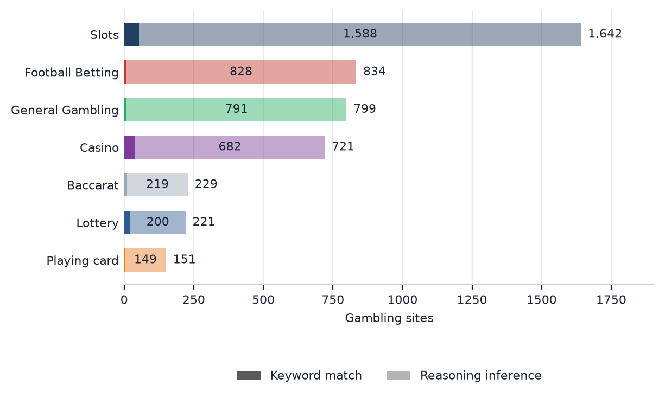
inferredShare 97.0% · generalShare 17.4%.

Subcategory table
Subcategory | Count | % of gambling | Keyword-assigned | Inferred | Distinct clusters
Slots | 1,642 | 35.7% | 54 | 1,588 | 46
Football Betting | 834 | 18.1% | 6 | 828 | 16
General Gambling | 799 | 17.4% | 8 | 791 | 22
Casino | 721 | 15.7% | 39 | 682 | 20
Baccarat | 229 | 5.0% | 10 | 219 | 9
Lottery | 221 | 4.8% | 21 | 200 | 14
Playing card | 151 | 3.3% | 2 | 149 | 8
Total | 4,597 | 100.0% | 140 | 4,457

The lexicon has poor coverage of this dataset: 97.0% of gambling rows were assigned by reasoning inference and 17.4% carry no evidenced product type. Subcategory figures are indicative only.

Heat map — Keyword by subcategory
Matched keywords against product subcategory. Each cell is the number of gambling sites carrying that keyword in that subcategory.
 | Football  Betting | Slots | Casino | Lottery | Playing  card | Baccarat | General  Gambling
█ BET | 69 | 245 | 90 | 28 | 19 | 37 | 105
█ VIP | 94 | 136 | 103 | 15 | 15 | 13 | 122
█ WIN | 13 | 125 | 22 | 24 | 1 | 6 | 77
█ สมัครสมาชิก | 2 | 35 | 7 | 69 | 1 | 3 | 20
█ สล็อต | 2 | 54 | 15 | 4 | 2 | 6
█ คาสิโน | 2 | 15 | 39 | 1 |  | 4
█ คาสิโน | 2 | 15 | 39 | 1 |  | 4
█ PG | 2 | 30 | 5 |  |  | 7 | 15
█ Wallet | 5 | 24 | 10 | 1 | 1 | 8 | 5
█ WALLET | 5 | 24 | 10 | 1 | 1 | 8 | 5
█ PRAGMATIC | 4 | 16 | 8 |  |  | 12 | 10
█ คาสิโนออนไลน์ | 1 | 1 | 33
█ คาสิโนออนไลน์ | 1 | 1 | 33
█ บาคาร่า | 1 | 7 | 3 | 4 | 2 | 10
█ พนัน | 1 | 8 | 11 | 1 |  |  | 4
█ การพนัน | 1 | 8 | 11 |  |  |  | 4
█ เกมสล็อต |  | 18 | 5
█ SEXY |  | 11 | 4 |  |  | 2 | 1
█ พนันกีฬา | 1 | 7 | 7
█ พนันกีฬา | 1 | 7 | 7
█ หวยออนไลน์ | 1 | 1 |  | 13
█ SA |  | 13 | 1
█ Affiliate | 1 | 5 | 3 | 1 |  | 2 | 2
█ สล็อตออนไลน์ | 1 | 13
█ เล่นสล็อต |  | 11

Scale: 1 site (lightest fill) to 245 sites (darkest fill). An empty cell is zero sites.
The coloured strip beside each keyword is its Appendix A category, so cross-category bleed is visible.

Heat map — Signal tag by subcategory
Signal tags against product subcategory. Each cell is the number of gambling sites carrying that tag in that subcategory.
 | Football  Betting | Slots | Casino | Lottery | Playing  card | Baccarat | General  Gambling
Deposit & Withdrawal | 5 | 24 | 10 | 1 | 1 | 8 | 5
Promotions | 3 | 5 | 1 |  |  | 1 | 1
Marketing & Acquisition | 3 | 39 | 9 | 70 | 1 | 4 | 21
Affiliate & Agent | 5 | 10 | 5 | 1 |  | 2 | 33
Vague-Evasion Terms
Abbreviations | 186 | 507 | 228 | 58 | 35 | 77 | 296
Hashtags

Scale: 1 site (lightest fill) to 507 sites (darkest fill). An empty cell is zero sites.

Group E — Brands and clustering
Clustering at a glance

63  Distinct clusters | 32  Clusters with 2 or more URLs | 31  Singletons | 2  Clusters covering half

Top 15 brand clusters by URL count
The fifteen largest brand clusters by URL count. Bar length is the number of domains in the cluster.
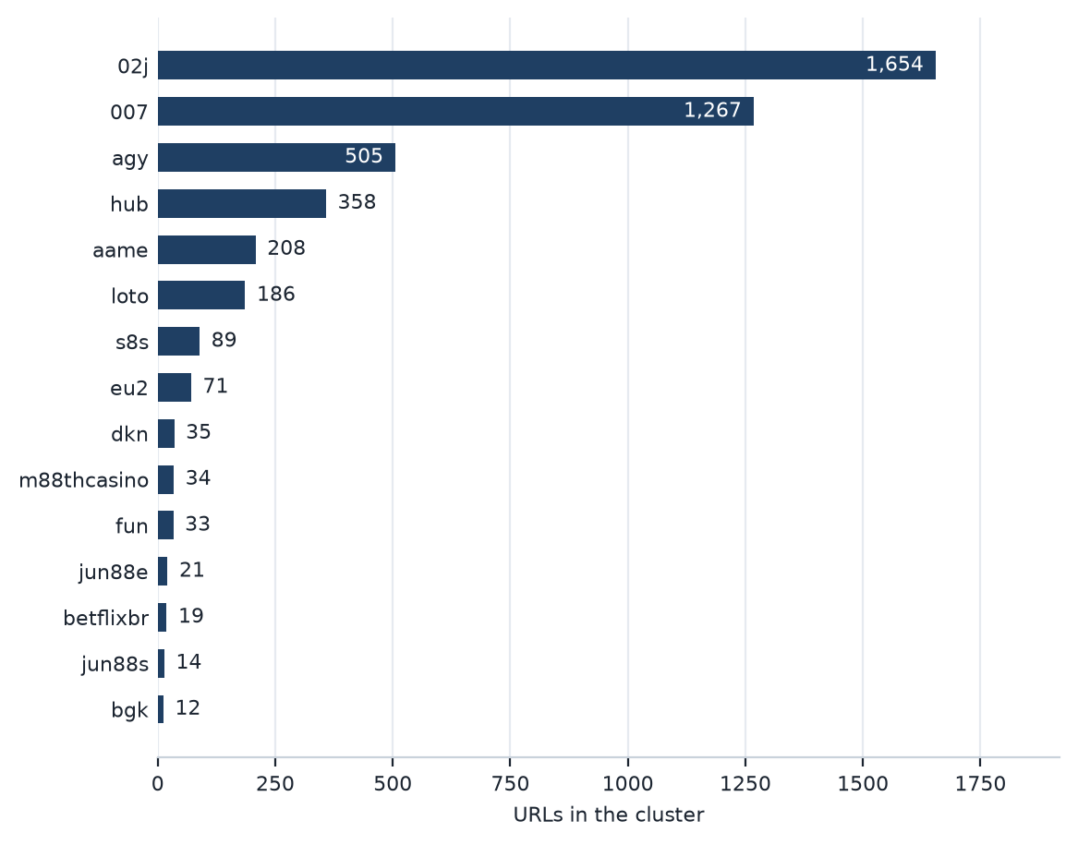

Heat map — Brand cluster by subcategory
Brand clusters against product subcategory. Each cell is the number of URLs a cluster holds in that subcategory.
 | Football  Betting | Slots | Casino | Lottery | Playing  card | Baccarat | General  Gambling
02j | 148 | 698 | 277 | 50 | 78 | 98 | 305
007 | 354 | 438 | 94 | 6 | 43 | 66 | 266
agy | 210 | 68 | 175 | 10 | 3 | 4 | 35
hub | 26 | 165 | 68 | 10 | 13 | 35 | 41
aame | 43 | 69 | 31 | 6 | 7 | 14 | 38
loto | 2 | 25 | 5 | 122 | 2 | 4 | 26
s8s | 8 | 11 | 18 | 1 |  |  | 51
eu2 | 14 | 26 | 19 | 4 | 4 | 2 | 2
dkn |  | 28 |  | 2 |  | 5
m88thcasino |  | 20 | 13 |  |  |  | 1
fun | 16 | 7 | 5 | 2 |  |  | 3
jun88e | 2 | 10 | 4 | 4 |  |  | 1
betflixbr |  | 19
jun88s | 4 | 5 | 3 | 1 |  |  | 1
bgk |  |  | 2 |  |  |  | 10
8ra | 3 | 6 |  |  |  |  | 2
rsagroup |  | 7
fa99ae |  | 2 |  |  |  |  | 4
m88thaibet | 1 | 1 | 1 |  |  |  | 3
com |  |  |  |  |  |  | 4

Scale: 1 site (lightest fill) to 698 sites (darkest fill). An empty cell is zero sites.

Cluster expansion — 02j
The largest brand cluster and its member domains. Edge style records why each domain joined the cluster.
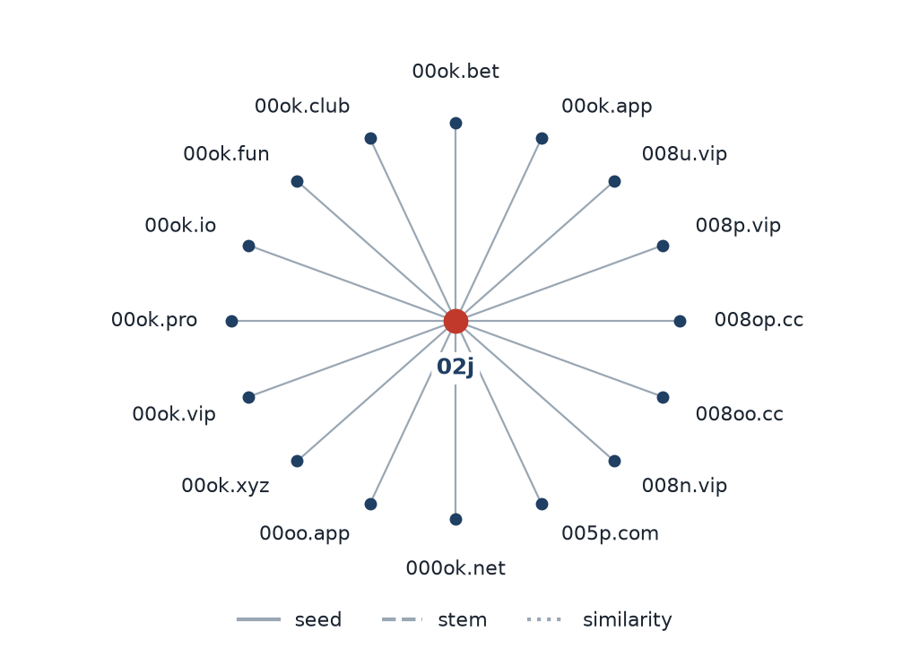
02j holds 1,654 URLs across 39 top-level domains. Member domains shown: 000ok.net, 005p.com, 008n.vip, 008oo.cc, 008op.cc, 008p.vip, 008u.vip, 00ok.app, 00ok.bet, 00ok.club, 00ok.fun, 00ok.io, 00ok.pro, 00ok.vip, 00ok.xyz, 00oo.app.

Clusters spanning multiple subcategories
Cluster | URL count | Subcategories | Suffixes
02j | 1,654 | Slots 698, General Gambling 305, Casino 277, Football Betting 148, Baccarat 98, Playing card 78, Lottery 50 | .bet 249, .app 235, .pro 156, .net 131, .com 131, .vip 119
007 | 1,267 | Slots 438, Football Betting 354, General Gambling 266, Casino 94, Baccarat 66, Playing card 43, Lottery 6 | .cc 326, .game 194, .app 109, .pro 78, .click 69, .bet 61
agy | 505 | Football Betting 210, Casino 175, Slots 68, General Gambling 35, Lottery 10, Baccarat 4, Playing card 3 | .net 415, .bet 18, .cc 16, .vip 10, .com 9, .pro 9
hub | 358 | Slots 165, Casino 68, General Gambling 41, Baccarat 35, Football Betting 26, Playing card 13, Lottery 10 | .com 41, .net 37, .pro 32, .bet 30, .co 24, .app 20
aame | 208 | Slots 69, Football Betting 43, General Gambling 38, Casino 31, Baccarat 14, Playing card 7, Lottery 6 | .com 105, .vip 19, .net 13, .app 11, .click 10, .live 7
loto | 186 | Lottery 122, General Gambling 26, Slots 25, Casino 5, Baccarat 4, Football Betting 2, Playing card 2 | .com 102, .net 15, .live 8, .info 7, .bet 7, .cc 6
s8s | 89 | General Gambling 51, Casino 18, Slots 11, Football Betting 8, Lottery 1 | .com 79, .vip 4, .net 2, .live 2, .top 1, .xyz 1
eu2 | 71 | Slots 26, Casino 19, Football Betting 14, Playing card 4, Lottery 4, Baccarat 2, General Gambling 2 | .com 42, .club 4, .net 4, .bet 3, .co 3, .app 2
dkn | 35 | Slots 28, Baccarat 5, Lottery 2 | .app 9, .net 7, .co 4, .online 3, .info 3, .com 2
m88thcasino | 34 | Slots 20, Casino 13, General Gambling 1 | .com 2, .club 2, .co 2, .live 2, .net 2, .online 2
fun | 33 | Football Betting 16, Slots 7, Casino 5, General Gambling 3, Lottery 2 | .com 32, .tours 1
jun88e | 21 | Slots 10, Casino 4, Lottery 4, Football Betting 2, General Gambling 1 | .com 19, .buzz 2
jun88s | 14 | Slots 5, Football Betting 4, Casino 3, General Gambling 1, Lottery 1 | .com 14
bgk | 12 | General Gambling 10, Casino 2 | .in 2, .com 2, .tv 1, .live 1, .vip 1, .cc 1
8ra | 11 | Slots 6, Football Betting 3, General Gambling 2 | .com 4, .live 2, .bet 2, .app 1, .vip 1, .bf 1

Clusters rotating top-level domains
Cluster | Suffixes and counts
02j | .bet 249, .app 235, .pro 156, .net 131, .com 131, .vip 119, .club 93, .click 56, .shop 51, .me 46
007 | .cc 326, .game 194, .app 109, .pro 78, .click 69, .bet 61, .club 61, .fun 50, .me 43, .casino 39
agy | .net 415, .bet 18, .cc 16, .vip 10, .com 9, .pro 9, .app 9, .fun 5, .club 5, .io 2
hub | .com 41, .net 37, .pro 32, .bet 30, .co 24, .app 20, .site 18, .casino 15, .top 14, .me 14
aame | .com 105, .vip 19, .net 13, .app 11, .click 10, .live 7, .bet 6, .info 4, .pro 4, .me 4
loto | .com 102, .net 15, .live 8, .info 7, .bet 7, .cc 6, .online 5, .click 5, .co 5, .app 4
s8s | .com 79, .vip 4, .net 2, .live 2, .top 1, .xyz 1
eu2 | .com 42, .club 4, .net 4, .bet 3, .co 3, .app 2, .click 2, .land 2, .life 2, .fun 2
dkn | .app 9, .net 7, .co 4, .online 3, .info 3, .com 2, .vip 2, .bet 2, .nl 1, .in 1
m88thcasino | .com 2, .club 2, .co 2, .live 2, .net 2, .online 2, .site 2, .vip 2, .shop 2, .pro 2
fun | .com 32, .tours 1
jun88e | .com 19, .buzz 2
bgk | .in 2, .com 2, .tv 1, .live 1, .vip 1, .cc 1, .app 1, .net 1, .me 1, .bet 1
8ra | .com 4, .live 2, .bet 2, .app 1, .vip 1, .bf 1
fa99ae | .com 5, .in 1

Possible operator linkage
Indicative — not a clustering decision
Cluster A | Cluster B | Shared keywords | Jaccard
m88thcasino | betflixbr | VIP, WALLET, Wallet | 0.75
agy | betflixbr | BET, VIP, WALLET, Wallet | 0.67
02j | 007 | Affiliate, Agent, BET, JILI, PG, PRAGMATIC, RTP, VIP | 0.60

Naming conventions
- Recurring tokens: “bet” (412), “app” (405), “m.” (376) — evidence of a templated naming scheme.
- TLD switching: .net (659), .com (649), .app (401), .cc (394) — the operators rotate top level domains.
- 4,540 distinct domains across 20 brand clusters.

Structure: direct, redirect, variant

56  Direct | 247  Redirect | 4,294  Variant

Shares of gambling URLs: direct 1.2%, redirect 5.4%, variant 93.4%.
Redirect propagation — lotto432e.com
The busiest redirect source and the destinations reached from it. Each node is one domain.
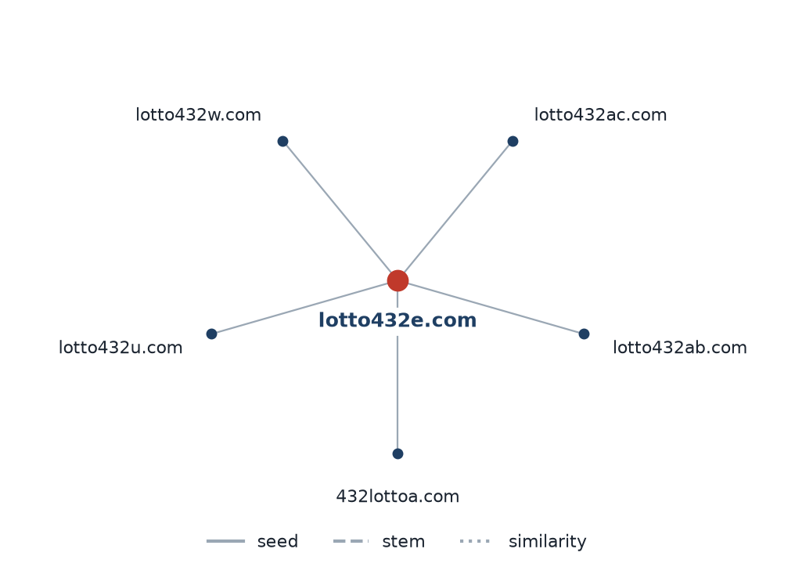
lotto432e.com reaches 5 destinations. Destinations shown: 432lottoa.com, lotto432ab.com, lotto432ac.com, lotto432w.com, lotto432u.com.

Group F — Ranking
Gambling ranking
Rank | Domain | Brand cluster | Subcategory | Source
78,229 | lottovip.com | loto | Lottery | Youtube (lotto432)
90,304 | lottovip.bet | loto | Lottery | Variant (lottovip.com)
93,266 | lottovip.info | loto | Slots | Variant (lottovip.com)
184,475 | fun88thf.com | fun | Football Betting | Variant (fun88tht.com)
216,041 | lottovipp.com | loto | Lottery | Variant (lottovip.com)
397,330 | jun88wa.com | jun88e | Slots | Variant (jun88ea.com)
402,382 | ruay.com | eu2 | General Gambling | Youtube (หวยออนไลน์)
517,141 | slavinaslot.top | hub | Slots | Redirect (jun88.info)
517,141 | jun88.info | hub | Slots | Variant (jun88.mobile)
547,370 | 99ok.vip | 02j | Lottery | Variant (99ok.bet)
558,790 | gg8830.com | 02j | Slots | Variant (gg8825.app)
595,712 | ruayy.com | eu2 | Casino | Variant (ruay.com)
706,458 | lotto432ad.com | loto | Lottery | Variant (lotto432ae.com)
715,861 | k7.game | 007 | General Gambling | Variant (k6.game)
727,399 | gg8832.com | 02j | Slots | Variant (gg8835.com)

123 gambling rows carry a numeric rank.

Group G — Key insights
Scale of the analysis
The standard working set holds 12,435 distinct URLs gathered over an evaluation period of 25 days (2026-08-31 to 2026-09-24). Of these, 4,597 are gambling sites, 7,838 are not gambling and 0 were unreachable. 11,499 rows awaiting adjudication and 9 duplicate URLs were removed before any figure was computed.
The sample is large enough to reason about patterns, not isolated cases.

What is being offered
The three largest product subcategories are Slots 1,642 (35.7%); Football Betting 834 (18.1%); General Gambling 799 (17.4%). 17.4% of gambling rows are confirmed as gambling without an evidenced product type, and 97.0% of subcategory assignments come from reasoning inference rather than a lexicon keyword match. 220 of the 291 lexicon entries never matched a single row.
Slots leads at 35.7% of gambling rows, but the estate is spread across product types rather than concentrated in one.

Brand clustering
63 brand clusters were formed across 4,597 gambling URLs. 32 hold more than one domain and 31 are singletons. 2 clusters cover half the estate. The largest, 02j, holds 1,654 domains across 7 product subcategories.
A small number of operators account for most of the estate, and enforcement against clusters is far more efficient than against individual URLs.

How the estate is grown and marketed
4,294 gambling URLs are crawler-identified variants, 247 sit behind redirect chains and 56 were reached directly. The busiest redirect source is lotto432e.com with 5 destinations. 17 clusters rotate across more than one top-level domain. The two most common signal tags are Abbreviations 30.2%, Marketing & Acquisition 3.2%.
Redirects and TLD rotation keep a stable entry point while the sites behind it are replaced.

Enforcement position
1 page carries a regulatory-blocking indicator in its captured text. The single match is the phrase “regulatory authority” inside a third-party government domain rather than a block notice served against a gambling site, so no row in this sample evidences enforcement against it.
This set is a candidate for a first enforcement pass, prioritised by cluster rather than by URL.

lexiconSource Gambling_Keywords_Full_English_Categories_V1.xlsx · lexiconVersion Appendix A (V1) · keywords per tab Football Betting 21, Slots 32, Casino 14, Lottery 20, Playing card 12, Baccarat 11, General Gambling 22, Deposit & Withdrawal 24, Promotions 27, Marketing & Acquisition 25, Affiliate & Agent 20, Vague-Evasion Terms 20, Abbreviations 22, Hashtags 21 · inferredShare 97.0% · generalShare 17.4% · rows normalised from Licensed gambling 0 · abbreviations flagged as probable false-positive sources: VIP (498 of 1,597 Abbreviations matches), BET (593 of 1,597 Abbreviations matches) · clustering thresholds: Jaro-Winkler 0.90 with a prefix or suffix constraint, seed linkage resolved to the root of the chain, cluster named from its shortest member stem of at least three characters.

