Ministry of Digital Economy and Society, Thailand
Data Insights & Patterns
Pilot reporting period · 4 Sep 2026 to 30 Sep 2026
Issued to | Ministry of Digital Economy and Society, Thailand
Prepared by | SICPA SA
Date of issue | 30/09/2026
Source system | SICPADetect

Contents
Executive summary
Model Insights
Introduction
Insights
Performance
10 most prominent gambling sites in Thailand
10 most prominent gambling sites in Thailand
The numbers
URLs analysed per day
Status distribution
Top 10 URL suffixes
Subcategories
Gambling sites by product subcategory
Assignment method by subcategory
Subcategory table
Heat map – Keyword × subcategory
Heat map – Signal tag × subcategory
Brands and clustering
What brand clusters are
Top 15 brand clusters by URL count
Heat map – Brand cluster × subcategory
Cluster expansion – 8
Clusters spanning multiple subcategories
Clusters rotating top-level domains
Possible operator linkage
Naming conventions
Redirect propagation – min88.top
Ranking
Gambling ranking
Key insights
Scale of the analysis
What is being offered
Brand clustering
How operators expand and promote their domains
Enforcement position

Executive summary
Insights and trends
SICPADetect analysed 20,215 distinct URLs during the pilot reporting period, which runs from 4 Sep 2026 to 30 Sep 2026. It classified 8,833 of them, 43.7% of the set, as gambling. It classified the remaining URLs as not gambling or unreachable.
The two largest product subcategories are Casino, at 36.4% of gambling rows, and Slots, at 29.9%. No single category accounts for a majority of the gambling set. SICPADetect assigned most gambling rows by model inference rather than by a lexicon match, so subcategory figures based on model inference are indicative.
A brand cluster is a group of domains that appear linked by naming pattern, redirect behaviour, crawler relationship or shared brand stem. SICPADetect identified 91 clusters, of which 42 hold more than one domain. The largest holds 8,344 of the identified gambling URLs. Acting on one cluster can therefore cover many related domains in a single step. These links are indicative and do not establish common ownership.
The identified gambling URLs show the domain proliferation patterns SICPADetect looks for. Operators register related domains under one brand stem, they rotate top-level domains, and they redirect users from one domain to another. Prioritising by cluster covers more of this activity than acting on one URL at a time.
Only 7 URLs in the analysed set already carried blocking or enforcement indicators. MDES can therefore include most identified gambling URLs in a first prioritised enforcement pass.
Key figures
Reporting figure | Value
URLs analysed | 20,215
Gambling sites and share | 8,833 (43.7%)
Not gambling | 11,338 (56.1%)
Unreachable | 44 (0.2%)
Status not yet resolved | 0 (0.0%)
Brand clusters identified | 91
Clusters holding more than one domain | 42
Clusters covering half of identified gambling URLs | 1
Largest cluster and its size | 8 · 8,344 URLs
Largest product subcategory and share | Casino · 36.4%
Most common signal tag and share | Abbreviations · 41.0%
URLs already showing blocking indicators | 7
Lexicon match versus model inference | 292 (3.3%) versus 8,541 (96.7%)

URLs analysed counts distinct URLs kept in the dataset after collection, filtering, deduplication and analysis. It does not count raw crawl attempts.

Model Insights

Introduction

Insights

Performance

10 most prominent gambling sites in Thailand

10 most prominent gambling sites in Thailand
Rank | URL | Domain | Brand cluster | Subcategory | Thai-targeting evidence | Source
221,001 | https://suriyathai.net/ | suriyathai.net | suriya | General Gambling | Thai script: “สมัครสมาชิก” | Analyst-enriched
779,601 | https://e699zz.com/ | e699zz.com | e699zz | Football Betting | Thai script: “ฝากจันท์” | Analyst-enriched
797,918 | https://jun8891.com/ | jun8891.com | 8 | Playing card | Thai script: “สมัครเล่นรับ” | Crawler variant
811,629 | https://mun8.com/ | mun8.com | 8 | Slots | Thai currency: “THB” | Crawler variant
851,797 | https://y2k168.net/ | y2k168.net | y2k | General Gambling | Explicit Thai reference: “Thai language” | Analyst-enriched
1,071,656 | https://neko44rf.com/ | neko44rf.com | neko44rf | Slots | Thai script: “ย้อนเงินล่าสุด” | Analyst-enriched
1,137,614 | https://1x789.app/ | 1x789.app | 8 | Slots | Thai script: “สล็อตเว็บสล็อตออนไลน์ รวมจุดค่าย” | Crawler variant
1,137,907 | https://fin882.co/ | fin882.co | fin | Slots | Thai script: “เกมสล็องค่ายทรช มีลอดคยุส” | Analyst-enriched
1,139,176 | https://hengheng-888.xyz/ | hengheng-888.xyz | hengheng | General Gambling | Thai currency: “Baht” | Analyst-enriched
1,644,353 | https://1x789.me/ | 1x789.me | 8 | Slots | Thai script: “สล็อตเว็บสล็อตออนไลน์ รวมจูงดกดาย” | Crawler variant

Rank reflects search visibility or source-feed position. It does not measure harm, revenue, user volume or enforcement priority.
113 otherwise eligible ranked rows were excluded because their description carried a Vietnamese-audience indicator.
“Analyst-enriched” means an analyst verified or added details after SICPADetect’s automated detection. SICPADetect’s detection process is automated.

The numbers
20,215  URLs analysed | 8,833  Gambling sites | 91  Brand clusters identified | 27 days  Pilot reporting period  4 Sep 2026 to 30 Sep 2026

URLs analysed per day
Daily count of URLs analysed across the pilot reporting period. Each point is one calendar day.
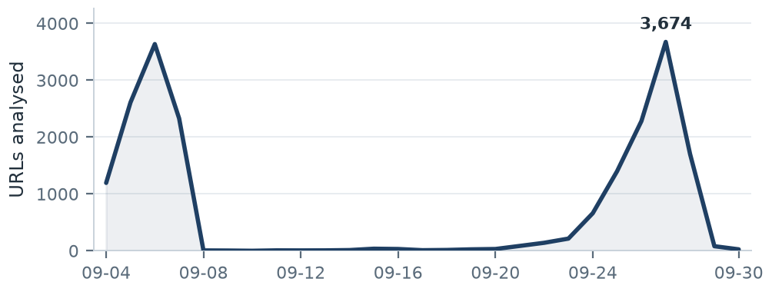
Daily volumes range from 0 to 3,674 URLs a day. Crawler queue timing, source ingestion batches, deduplication, site availability, validation delays and crawl strategy changes during the pilot all move this figure, and this variation is normal in a pilot. Read daily volumes as operational processing volumes. They do not measure fixed daily crawl capacity.

Status distribution
Share of URLs analysed by classification status. Each segment is one status and the table beside it carries the counts.
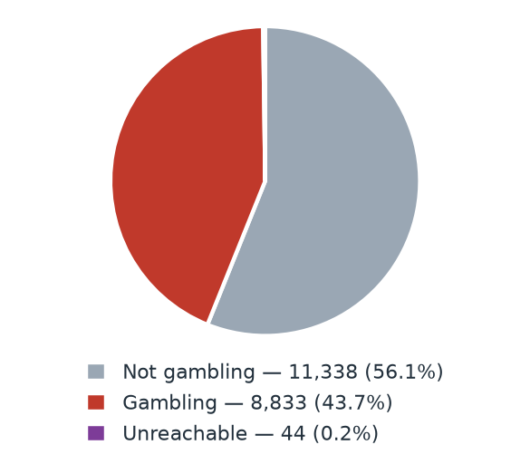
Status | Count | % of URLs analysed
Not gambling | 11,338 | 56.1%
Gambling | 8,833 | 43.7%
Unreachable | 44 | 0.2%

Top 10 URL suffixes
The ten most common URL suffixes among URLs analysed. Bar length is the total count and the table separates the gambling share.
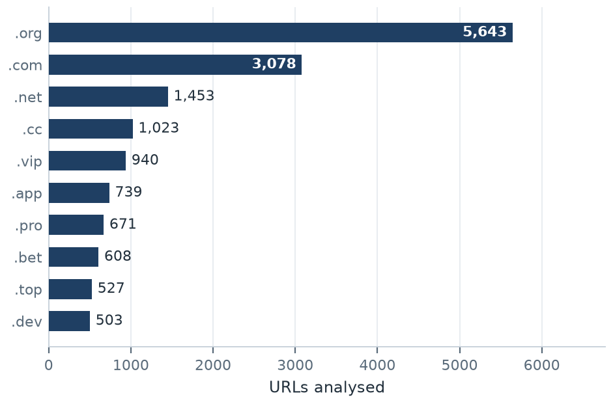
Suffix | Total | % of all | Gambling | % gambling
.org | 5,643 | 27.9% | 9 | 0.2%
.com | 3,078 | 15.2% | 1,277 | 41.5%
.net | 1,453 | 7.2% | 964 | 66.3%
.cc | 1,023 | 5.1% | 626 | 61.2%
.vip | 940 | 4.7% | 859 | 91.4%
.app | 739 | 3.7% | 558 | 75.5%
.pro | 671 | 3.3% | 593 | 88.4%
.bet | 608 | 3.0% | 591 | 97.2%
.top | 527 | 2.6% | 279 | 52.9%
.dev | 503 | 2.5% | 451 | 89.7%

Subcategories

Gambling sites by product subcategory
Each bar is one product subcategory. Bar length is the number of gambling sites and each label carries the count and the share of gambling rows.
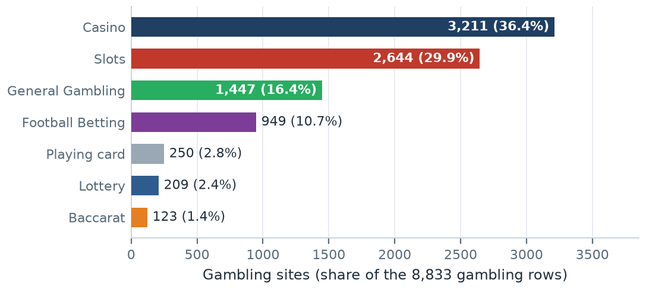

Assignment method by subcategory
How each subcategory was assigned. Solid fill is a lexicon match and the lighter fill is model inference.
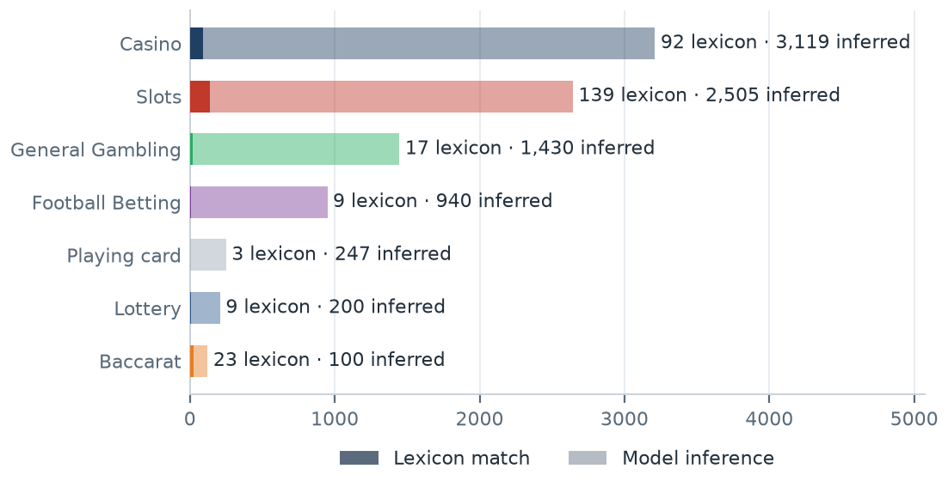
What a lexicon match means
SICPADetect assigns a subcategory by lexicon match when a recorded text field about the site contains a keyword from the gambling lexicon, and that keyword belongs to the assigned product category. The recorded fields are the model-generated site description and classification rationale, extracted keywords, analyst remarks, and the URL and domain. A site whose recorded text contains สล็อต is assigned to Slots by lexicon match. When no product keyword appears, the model assigns the closest subcategory from what the site description and classification rationale say the site offers. The two methods are separate: a lexicon match rests on a specific keyword found in the text, while model inference rests on the model’s reading of the site. The SICPADetect Thai gambling keyword lexicon holds 286 keywords in 14 categories, most in Thai script. 7 product categories decide the subcategory. The remaining categories describe how a site markets or operates itself and appear as signal tags. A lexicon match can be checked against the site and repeated, so it carries higher confidence. A larger lexicon share of a bar means that subcategory figure rests on more direct evidence. A large model inference share means the sites use vocabulary the lexicon does not yet cover.
SICPADetect assigned 96.7% of gambling rows by model inference and 16.4% to General Gambling. The lexicon covers part of the vocabulary used in this dataset, so subcategory figures based on model inference are indicative.

Subcategory table
Subcategory | Count | % of gambling | Lexicon match | Model inference | Distinct clusters
Casino | 3,211 | 36.4% | 92 | 3,119 | 33
Slots | 2,644 | 29.9% | 139 | 2,505 | 56
General Gambling | 1,447 | 16.4% | 17 | 1,430 | 23
Football Betting | 949 | 10.7% | 9 | 940 | 17
Playing card | 250 | 2.8% | 3 | 247 | 8
Lottery | 209 | 2.4% | 9 | 200 | 5
Baccarat | 123 | 1.4% | 23 | 100 | 4

Heat map – Keyword × subcategory
Matched keywords against product subcategory. Each cell is the number of gambling sites carrying that keyword in that subcategory.
 | Slots | Casino | General  Gambling | Football  Betting | Baccarat | Lottery | Playing  card
█ VIP | 676 | 505 | 261 | 125 | 7 | 13 | 20
█ BET | 268 | 344 | 151 | 120 | 22 | 18 | 23
█ PP | 129 | 296 | 57 | 52 | 7 | 9 | 29
█ WIN | 181 | 122 | 95 | 13 | 2 | 22 | 2
█ สมัครสมาชิก | 106 | 56 | 47 | 10 | 9 | 42 | 4
█ สล็อต | 139 | 48 |  | 4 | 18 | 2 | 2
█ Wallet | 50 | 47 | 28 | 9 | 6 | 1
█ คาสิโน | 25 | 92 |  | 2 | 3
█ PRAGMATIC | 46 | 54 |  | 4 | 9 | 1 | 1
█ คาสิโนออนไลน์ | 3 | 72 |  | 2
█ เกมสล็อต | 53 | 12
█ สล็อตออนไลน์ | 51 | 5 |  | 1
█ บาคาร่า | 14 | 10 |  | 2 | 23 | 1 | 2
█ AG | 15 | 5 | 9 | 6 | 3 |  | 2
█ เล่นสล็อต | 38 |  |  | 1
█ Affiliate | 9 | 13 | 6 | 3 | 2 | 1
█ เดิมพัน | 4 | 9 | 13 | 1 | 2
█ JILI | 17 | 1 |  | 7 |  |  | 1
█ พนัน | 9 | 9 | 4 | 1 | 1
█ SA | 10 | 8 |  | 2 | 1 | 1
█ RTP | 12 | 5 | 2 |  |  | 1
█ PG | 10 | 2 | 3 | 1 | 2
█ การพนัน | 7 | 9 | 1
█ Agent | 4 | 3 | 7 |  |  |  | 1
█ SEXY | 4 | 6 |  |  | 3

Scale █ 1 █ 676 ░ 0, no site recorded
The coloured strip beside each keyword marks the lexicon category the keyword belongs to, so a keyword drawn from one category and counted under another subcategory is visible.

Heat map – Signal tag × subcategory
Signal tags against product subcategory. Each cell is the number of gambling sites carrying that tag in that subcategory.
 | Slots | Casino | General  Gambling | Football  Betting | Lottery | Playing  card | Baccarat
█ Abbreviations | 1,291 | 1,281 | 552 | 306 | 56 | 77 | 57
█ Marketing & Acquisition | 111 | 64 | 49 | 11 | 42 | 4 | 10
█ Affiliate & Agent | 13 | 18 | 143 | 6 | 1 | 1 | 2
█ Deposit & Withdrawal | 50 | 48 | 29 | 9 | 1 |  | 6
█ Promotions | 4 | 7 | 2 | 2 |  |  | 2
█ Vague-Evasion Terms
█ Hashtags

Scale █ 1 █ 1,291 ░ 0, no site recorded

Brands and clustering

What brand clusters are
What a cluster is
A brand cluster is a group of domains that appear linked by naming pattern, redirect behaviour, crawler relationship or shared brand stem. SICPADetect links domains in three ways. The crawler found one domain as a variant of, or a redirect from, another, and this crawler relationship is the strongest basis. The domain names reduce to the same brand stem once market tags, version numbers and suffixes are removed. Or the stems differ by only a few trailing characters. A domain linked to no other is a singleton. In the largest cluster, jun-08.com and jun-68.com both reduce to the stem jun.
Why clusters matter
Gambling operators often register many related domains, rotate top-level domains and redirect users between them, so a new address can replace a blocked one. A URL count therefore gives more addresses than there are distinct operations behind them. Clusters show how many distinct operations appear in the identified gambling URLs, how concentrated those URLs are, and which clusters offer several product types. Acting on a cluster can cover all of its related domains in one step. Clusters are an indicative analytical grouping based on names and crawler links. They do not establish legal ownership, and the possible operator linkage table is indicative in the same way.

91  Distinct clusters | 42  Clusters with 2 or more URLs | 49  Singletons | 1  Clusters covering half of identified gambling URLs

Top 15 brand clusters by URL count
Each bar is one brand cluster. Bar length is the number of domains the cluster holds.
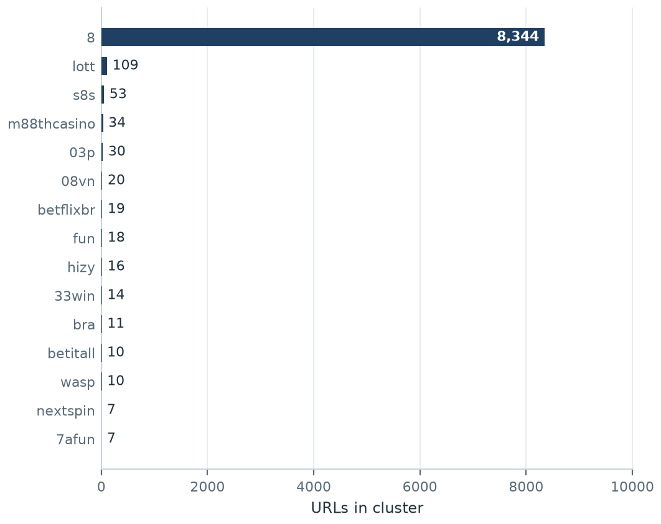

Heat map – Brand cluster × subcategory
Brand clusters against product subcategory. Each cell is the number of URLs a cluster holds in that subcategory.
 | Casino | Slots | General  Gambling | Football  Betting | Playing  card | Lottery | Baccarat
8 | 3,086 | 2,499 | 1,358 | 911 | 238 | 133 | 119
lott | 7 | 14 | 12 | 2 | 2 | 72
s8s | 8 | 3 | 35 | 6 | 1
m88thcasino | 13 | 20 | 1
03p | 15 | 7 | 5 | 2 | 1
08vn | 10 | 5 | 5
betflixbr | 15 | 4
fun | 9 | 1 | 2 | 6
hizy | 9 | 6 |  | 1
33win |  | 9 |  |  | 5
bra | 2 | 3 | 2 | 4
betitall | 2 |  |  | 8
wasp | 1 | 6 | 3
nextspin | 1 | 6
7afun | 2 | 1 | 4
ruay | 6 | 1
kfc | 3 | 2 |  |  | 1
fa99ae |  | 2 | 4
pigauto |  | 4
pgsoftgames | 2 | 2

Scale █ 1 █ 3,086 ░ 0, no site recorded

Cluster expansion – 8
The largest brand cluster and its member domains. Edge style records why each domain joined the cluster.
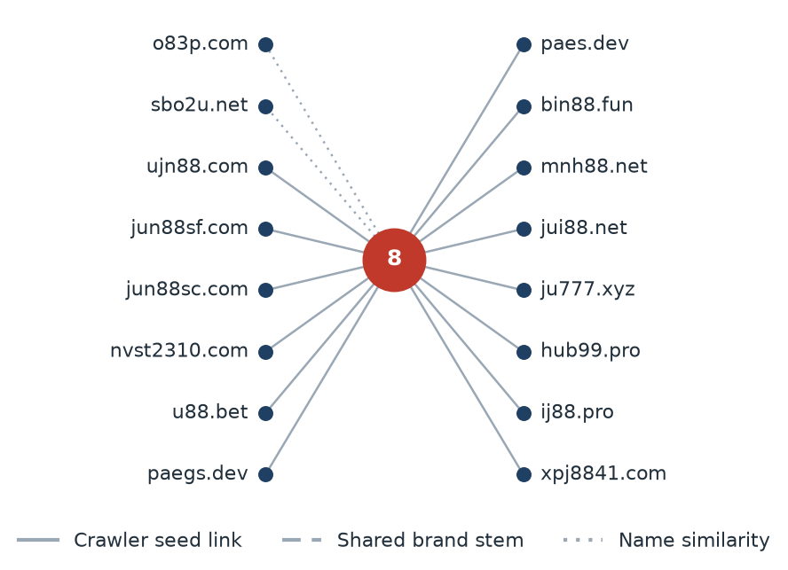
The diagram shows 16 of the 8,344 URLs in this cluster, named by their registrable domain. Most members joined through a crawler seed link, which means SICPADetect reached them as a variant of, or a redirect from, another member.

Clusters spanning multiple subcategories
Cluster | URL count | Subcategories | Suffixes
8 | 8,344 | Baccarat, Casino, Football Betting, General Gambling, Lottery, Playing card, Slots | .com .net .vip .cc .pro .bet
lott | 109 | Casino, Football Betting, General Gambling, Lottery, Playing card, Slots | .com .net .online .click .cc .live
s8s | 53 | Casino, Football Betting, General Gambling, Playing card, Slots | .com
m88thcasino | 34 | Casino, General Gambling, Slots | .com .club .co .live .net .online
03p | 30 | Casino, Football Betting, General Gambling, Playing card, Slots | .club .pro .bet .app .click .top
08vn | 20 | Casino, General Gambling, Slots | .com .uk .xyz .vip .pro .app
betflixbr | 19 | Casino, Slots | .com
fun | 18 | Casino, Football Betting, General Gambling, Slots | .com .tours
hizy | 16 | Casino, Football Betting, Slots | .bet .club .app .net .fun .pro
33win | 14 | Playing card, Slots | .co .online .info .net .nl .app
bra | 11 | Casino, Football Betting, General Gambling, Slots | .com .live .bet .app .vip .bf
betitall | 10 | Casino, Football Betting | .com .click
wasp | 10 | Casino, General Gambling, Slots | .com .vip .bet .live
nextspin | 7 | Casino, Slots | .vip .me .pro .com .xyz
7afun | 7 | Casino, General Gambling, Slots | .com .vip .top .xyz
ruay | 7 | Casino, Slots | .app .co .club .click .net
kfc | 6 | Casino, Playing card, Slots | .com .xyz .bet
fa99ae | 6 | General Gambling, Slots | .com .in
pgsoftgames | 4 | Casino, Slots | .live .online
winsiam | 4 | Casino, Football Betting, Playing card, Slots | .vip .ai

Clusters rotating top-level domains
Cluster | Suffixes | Counts
8 | .com .net .vip .cc .pro .bet | 1036 936 840 620 581 573
m88thcasino | .com .club .co .live .net .online | 2 2 2 2 2 2
lott | .com .net .online .click .cc .live | 63 9 4 4 4 4
03p | .club .pro .bet .app .click .top | 6 5 4 3 3 2
33win | .co .online .info .net .nl .app | 3 2 2 2 1 1
08vn | .com .uk .xyz .vip .pro .app | 6 5 3 2 2 1
hizy | .bet .club .app .net .fun .pro | 4 3 3 2 2 1
bra | .com .live .bet .app .vip .bf | 4 2 2 1 1 1
nextspin | .vip .me .pro .com .xyz | 2 2 1 1 1
ruay | .app .co .club .click .net | 2 2 1 1 1
wasp | .com .vip .bet .live | 7 1 1 1
7afun | .com .vip .top .xyz | 4 1 1 1
kfc | .com .xyz .bet | 4 1 1
pigauto | .co .com .info | 2 1 1
rx168 | .xyz .vip .site | 1 1 1
casino5s | .vip .com .me | 1 1 1
pgslots | .com .shop .win | 1 1 1
memberbfk | .win .biz .tv | 1 1 1
woloplay | .com .net .app | 1 1 1
fun | .com .tours | 17 1

Possible operator linkage
Indicative – not a clustering decision
Cluster A | Cluster B | Shared keywords | Jaccard
rx168 | fun | VIP | 1.00
a1aura | winsiam | VIP, สมัครสมาชิก | 1.00
dkon | 6ou | PP | 1.00
bra | s8s | BET, PP, VIP | 0.75
m88thcasino | betflixbr | VIP, WALLET, Wallet | 0.75
08vn | ruay | PP, VIP, WIN | 0.75
casino5s | 08vn | VIP, WIN | 0.67
casino5s | 7afun | VIP, WIN | 0.67
pgsoftgames | pgslots | PG, WIN | 0.67
eazybet | bra | BET, VIP | 0.67
eazybet | 7afun | BET, VIP | 0.67

Shared promotional vocabulary is common across unrelated operators using the same affiliate templates. These pairs are a lead for an analyst, not a clustering decision.

Naming conventions
• Recurring tokens: vip in 978 names, m. in 782 names, mobile in 729 names. The largest clusters use a templated naming scheme.
• Top-level domain switching: .com in 1,253 names, .net in 959 names, .vip in 858 names, .cc in 626 names. The operators behind these clusters rotate top-level domains.
• 8,784 distinct domains across 42 brand clusters.

70  Reached directly (0.8%) | 486  Redirect-derived (5.5%) | 8,277  Crawler variants (93.7%)

Redirect propagation – min88.top
The busiest redirect source and the destinations reached from it. Each node is one domain.
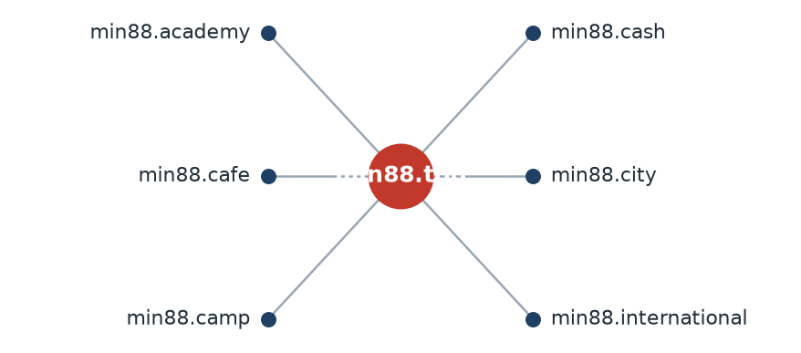
SICPADetect reached 6 distinct gambling URLs through redirects from min88.top.

Ranking

Gambling ranking
Rank | Domain | Brand cluster | Subcategory | Source
92,922 | gernpang88.com | gernpang | General Gambling | Analyst-enriched
129,213 | duangpang168.com | duangpang | General Gambling | Analyst-enriched
198,736 | jun88wb.com | 8 | Casino | Crawler variant
214,795 | allslotwallet.online | allslotwallet | Slots | Analyst-enriched
221,001 | suriyathai.net | suriya | General Gambling | Analyst-enriched
303,254 | jun88wf.com | 8 | Casino | Crawler variant
397,330 | jun88wa.com | 8 | Casino | Crawler variant
466,858 | jun88wc.com | 8 | Slots | Crawler variant
517,141 | slavinaslot.top | 8 | Casino | Redirect-derived
517,141 | jun88.info | 8 | Casino | Crawler variant
547,370 | 99ok.vip | 8 | Lottery | Crawler variant
558,790 | gg8830.com | 8 | Slots | Crawler variant
632,178 | hh98.net | 8 | General Gambling | Crawler variant
655,235 | lottery.co.th | lott | Lottery | Analyst-enriched
680,737 | hh98.site | 8 | General Gambling | Crawler variant

Rank reflects search visibility or source-feed position. It does not measure harm, revenue, user volume or enforcement priority.
“Analyst-enriched” means an analyst verified or added details after SICPADetect’s automated detection. SICPADetect’s detection process is automated.

Key insights

Scale of the analysis
SICPADetect analysed 20,215 distinct URLs over a pilot reporting period of 27 days, from 4 Sep 2026 to 30 Sep 2026. It classified 8,833 as gambling, 11,338 as not gambling and 44 as unreachable.
Take: SICPADetect classified 8,833 URLs as gambling, 43.7% of the URLs analysed. A 27-day period is short, so this report states no trend direction over time.

What is being offered
The three largest product subcategories are Casino with 3,211 sites (36.4%), Slots with 2,644 sites (29.9%) and General Gambling with 1,447 sites (16.4%). SICPADetect confirmed 16.4% of gambling sites as gambling without an evidenced product type, and assigned 96.7% of gambling rows by model inference rather than by a lexicon match. 213 of the 286 lexicon keywords never matched a site in this dataset. The lexicon is written in Thai script and much of the recorded text in this export is in English, so a low lexicon match rate is expected here. Extending the lexicon to the transliterated and English vocabulary present in this dataset would raise the share of subcategory figures that rest on a direct keyword match.
Take: Casino is the largest product subcategory at 36.4% of gambling rows. No single category accounts for a majority, and Slots follows at 29.9%.

Brand clustering
SICPADetect grouped the 8,833 identified gambling URLs into 91 indicative brand clusters. 42 of them hold more than one domain, and 49 are singletons. A single cluster covers half of the identified gambling URLs. The largest cluster, named 8, holds 8,344 domains across 7 product subcategories. SICPADetect reached most of these domains as crawler variants of one another, so the cluster records an observed crawler relationship rather than an inferred one. The grouping is indicative and does not establish common ownership.
Take: A small number of clusters hold half of the identified gambling URLs, so action on those clusters covers a large part of the set.

How operators expand and promote their domains
Of the identified gambling URLs, 8,277 are crawler variants, 486 are redirect-derived and 70 were reached directly. The busiest redirect source, min88.top, leads to 6 destinations. 27 clusters use more than one top-level domain. The two most common signal tags are Abbreviations at 41.0% of gambling rows and Marketing & Acquisition at 3.3%. A signal tag records how a site markets or operates itself, and a site can carry several tags or none.
Take: Operators use redirects and top-level domain rotation to keep users reaching their sites when individual domains change.

Enforcement position
Only 7 URLs in the analysed set already carried blocking or enforcement indicators. MDES can therefore include most identified gambling URLs in a first prioritised enforcement pass.
Take: Cluster-based prioritisation lets MDES act on groups of related domains instead of handling each URL separately.

Lexicon source: Gambling_Keywords_Full_English_Categories_V1.xlsx, version V1. Keywords per category: Football Betting 21 · Slots 32 · Casino 14 · Lottery 20 · Playing card 12 · Baccarat 11 · General Gambling 22 · Deposit & Withdrawal 24 · Promotions 27 · Marketing & Acquisition 25 · Affiliate & Agent 20 · Vague-Evasion Terms 20 · Abbreviations 22 · Hashtags 21. Subcategory assignment: 96.7% by model inference, 16.4% assigned to General Gambling. Rows whose status required normalisation from the upstream classifier on ingest: 0. Abbreviation matches flagged as a probable false-positive source: VIP at 40.2% of all Abbreviations matches, BET at 23.6% of all Abbreviations matches. Brand clustering thresholds: crawler seed linkage takes precedence; stems merge on a Jaro–Winkler similarity of 0.90 or above where one stem is a prefix of the other or the two differ only in trailing characters. The pilot reporting period starts at the first exported record, 4 Sep 2026, because no pilot start date was supplied for this run.

