Ministry of Digital Economy and Society
Kingdom of Thailand

Data Insights & Patterns
31,798 URLs · 31 Aug 2026 – 28 Sep 2026

Issued to | Ministry of Digital Economy and Society, Thailand
Prepared by | SICPA SA
Date of issue | 29/09/2026
Source system | SICPADetect · lexicon Gambling_Keywords_Full_English_Categories_V1

Contents
Model Insights
Introduction
Insights
Performance
10 most prominent gambling sites in Thailand
10 most prominent gambling sites in Thailand
The numbers
Estate at a glance
URLs analysed per day
Status distribution
Top 10 URL suffixes
Subcategories
Gambling sites by product subcategory
Assignment method by subcategory
Subcategory table
Heat map: keyword against product subcategory
Heat map: signal tag against product subcategory
Brands and clustering
What brand clusters are
Clustering at a glance
Top 15 brand clusters by URL count
Heat map: brand cluster against product subcategory
Cluster expansion: sitejin88paes
Clusters spanning multiple subcategories
Clusters rotating top-level domains
Possible operator linkage
Naming conventions
Structure: direct, redirect and variant
Redirect propagation: www.min88.top
Ranking
Gambling ranking
Key insights
Scale of the analysis
What is being offered
Brand clustering
How the estate is grown and marketed
Enforcement position

Executive summary
Insights and trends
The estate analysed covers 31,798 distinct URLs, just under three in ten classified as gambling. The rest were judged not to be gambling, were unreachable, or were still being collected when the export was taken.
No single product type accounts for even two fifths of the gambling estate, so the sites are spread across product types rather than concentrated on one. Casino and slot offerings carry most of the gambling rows, with football betting and lottery behind them. Almost all of these assignments rest on the model's reading of the site rather than on a lexicon keyword, so they are indicative only.
Collapsing domains onto the operator behind them yields 2,491 brand clusters, 1,342 of them holding more than one domain. Half the gambling URLs sit inside 78 clusters, so the estate is diffuse, with no small group of operators behind the bulk of it.
The estate is grown mechanically rather than one site at a time. Most gambling rows reached the feed as crawler-identified variants of a known domain, a smaller share behind redirect chains, and only a fraction directly. Clusters rotate across top-level domains and reuse templated subdomain names. Marketing language is thinner than the product vocabulary suggests: Abbreviations is the most common signal tag, carried largely by provider branding in domain names, while promotional and evasion vocabulary barely registers.
Enforcement has barely touched this set. Almost no page carried an indicator of regulatory blocking, so it sits ahead of enforcement rather than behind it.
Key figures
Reporting figure | Value
URLs analysed | 31,798
Gambling sites | 9,175 (28.9%)
Not gambling | 11,594
Unreachable | 28
Status not yet resolved | 11,001
Brand clusters identified | 2,491
Clusters holding more than one domain | 1,342
Clusters covering half the gambling estate | 78
Largest cluster | sitejin88paes (1,894 domains)
Dominant product subcategory | Casino (35.5%)
Most common signal tag | Abbreviations (35.3%)
Sites showing blocking indicators | 7
Subcategory assignment: keyword vs inferred | 3.7% / 96.3%

Model Insights
Introduction

Insights

Performance

10 most prominent gambling sites in Thailand
10 most prominent gambling sites in Thailand
Rank | URL | Domain | Brand cluster | Subcategory | Thai-targeting evidence | Source
78,229 | https://www.lottovip.com/register/af/21832 | lottovip.com | lott | Lottery | Thai currency: Baht | Youtube (lotto432)
221,001 | https://suriyathai.net/ | suriyathai.net | suriya | General Gambling | Thai script: สมัครสมาชิก | Manual (claude.ai)
706,458 | https://lotto432ad.com/ | lotto432ad.com | lotto432b | Lottery | Thai script: สมัครสมาชิก | Variant (lotto432ae.co
797,918 | https://jun8891.com/ | jun8891.com | jun | Playing card | Thai script: สมัครเล่นรับ | Variant (jun8888.info)
811,629 | https://mun8.com/ | mun8.com | mun | Slots | Thai currency: THB | Variant (mun89.com)
851,797 | https://y2k168.net/ | y2k168.net | y2k | General Gambling | Explicit Thai reference: Thai | Manual (claude.ai)
852,443 | https://auto.woloplay.net/ | auto.woloplay.net | woloplay | General Gambling | Thai script: สมัครเล่น | Redirect (woloplay.net
852,443 | https://woloplay.net/ | woloplay.net | woloplay | General Gambling | Thai script: สมัครเล่น | Variant (woloplay.pro)
1,137,614 | https://1x789.app/ | 1x789.app | 1x789 | Slots | Thai script: สล็อตเว็บสล็อตออนไลน์ | Variant (1x789.cc)
1,137,907 | https://fin882.co/ | fin882.co | fin | Slots | Thai script: เกมสล็องค่ายทรช | Manual (claude.ai)

Rank reflects search visibility in the source feed, not harm, reach or revenue.

The numbers
31,798  Total URLs analysed | 9,175  Gambling sites | 2,491  Brand clusters identified | 29 days  Evaluation period  31 Aug 2026 → 28 Sep 2026

URLs analysed per day
Daily count of URLs analysed across the evaluation period. Each point is one calendar day.
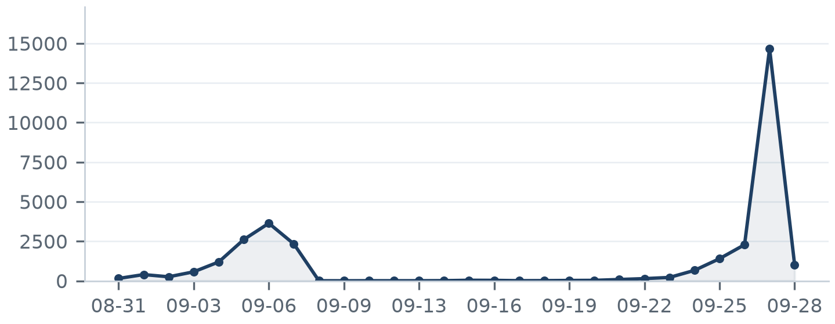

Status distribution
Share of the estate by classification status. Each segment is one status and the table carries the counts.
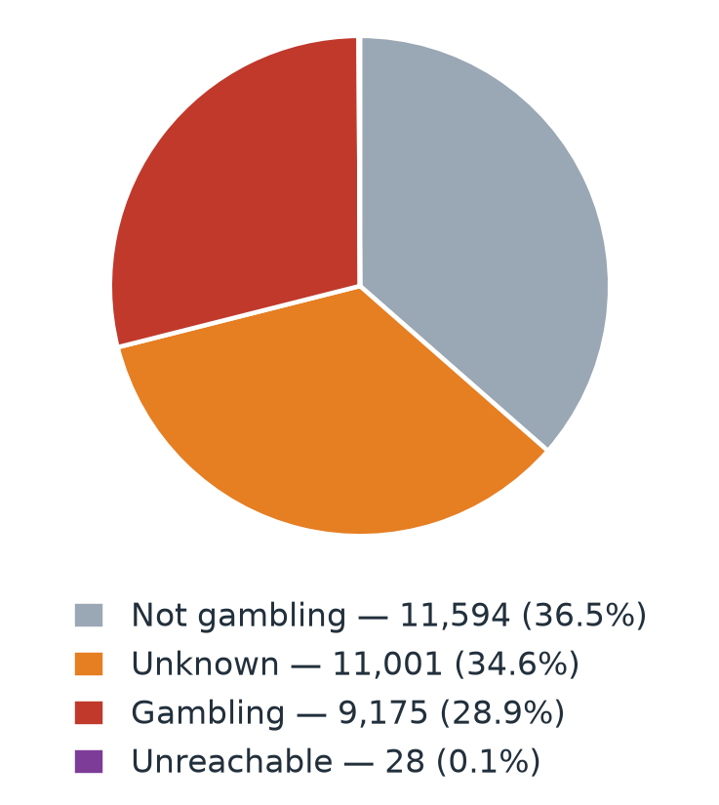
Status | Count | % of all URLs
Not gambling | 11,594 | 36.5%
Unknown | 11,001 | 34.6%
Gambling | 9,175 | 28.9%
Unreachable | 28 | 0.1%

Top 10 URL suffixes
The ten most common URL suffixes in the estate. Bar length is the total count and the table separates the gambling share.
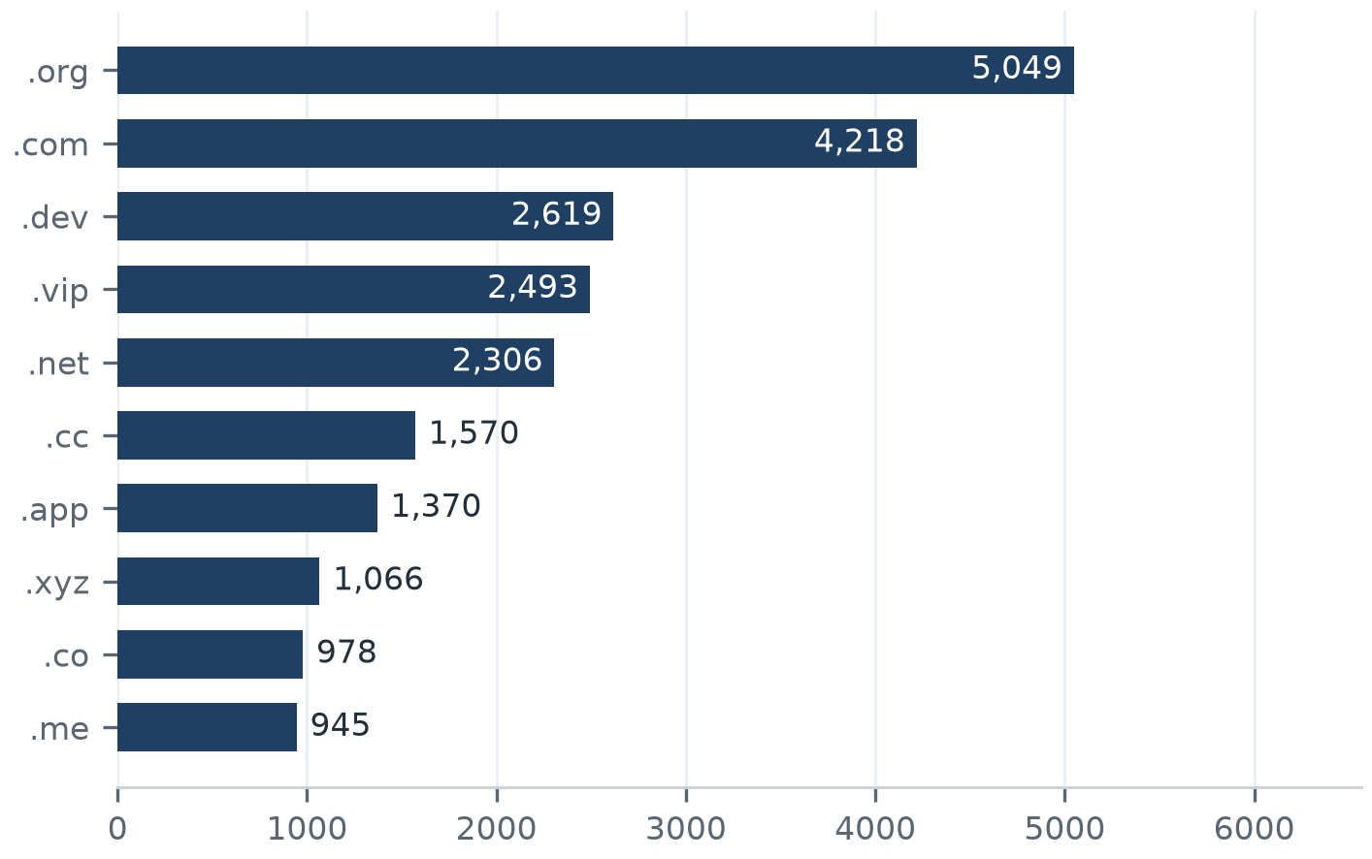
Suffix | Total | % of all | Gambling | % gambling
.org | 5,049 | 15.9% | 9 | 0.2%
.com | 4,218 | 13.3% | 1,389 | 32.9%
.dev | 2,619 | 8.2% | 451 | 17.2%
.vip | 2,493 | 7.8% | 872 | 35.0%
.net | 2,306 | 7.3% | 985 | 42.7%
.cc | 1,570 | 4.9% | 631 | 40.2%
.app | 1,370 | 4.3% | 591 | 43.1%
.xyz | 1,066 | 3.4% | 206 | 19.3%
.co | 978 | 3.1% | 177 | 18.1%
.me | 945 | 3.0% | 212 | 22.4%

Subcategories
Gambling sites by product subcategory
Gambling sites by product subcategory. Bar length is the site count and each label carries the count and the share of gambling rows.
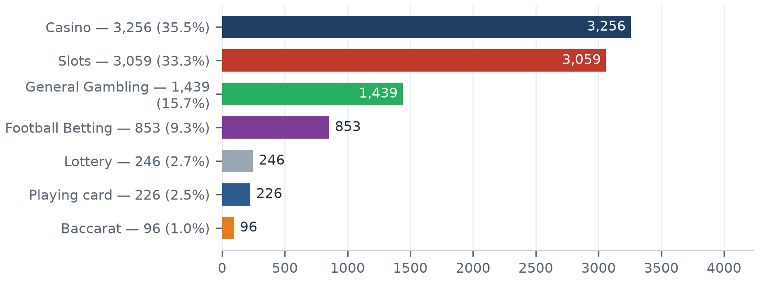
Share is of gambling rows, not of all URLs analysed.

Assignment method by subcategory
How each subcategory was assigned. Solid fill is a lexicon keyword match and the lighter fill is reasoning inference.
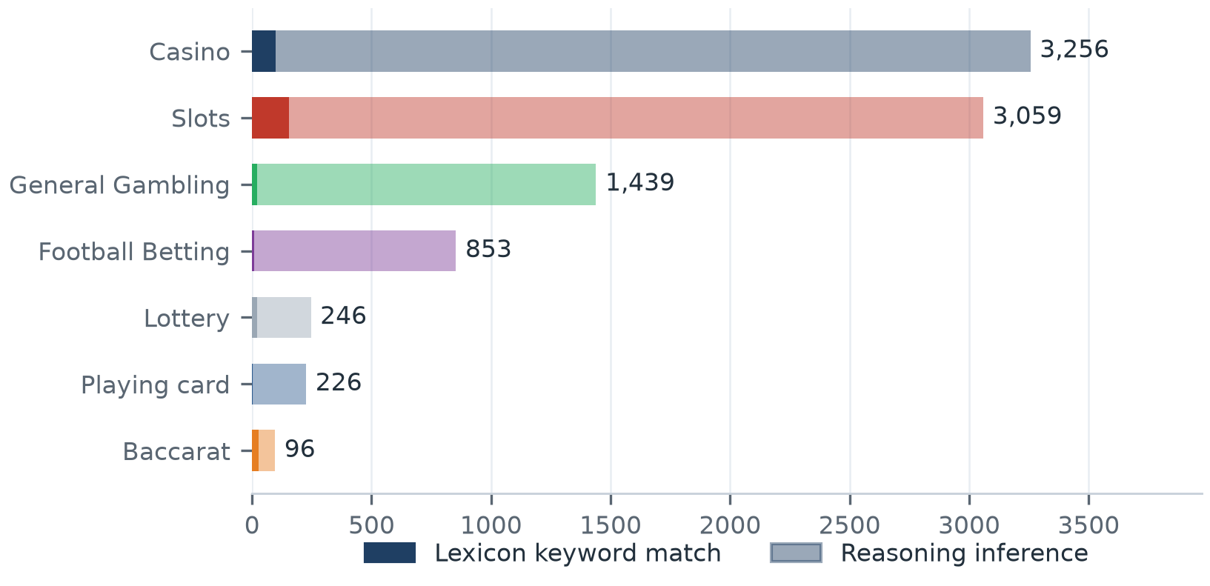
What a lexicon match means
A site is assigned to a subcategory by lexicon match when a word from the gambling keyword lexicon appears in what was recorded about it, in the model's description, the extracted keywords, analyst remarks, or the URL and domain, and that word belongs to the category the site was assigned. A site whose description contains สล็อต is assigned to Slots by lexicon match. The lexicon is the SICPADetect Thai gambling keyword lexicon named on the title page: 286 keywords in 14 categories, mostly in Thai script. Seven categories decide the subcategory and seven are reported as signal tags. A lexicon match rests on a word that can be pointed to, so the assignment can be checked. An inferred assignment rests on the model's own description, and carries lower confidence.
96.3% of gambling rows were assigned by reasoning inference and 15.7% were assigned to General Gambling. The lexicon has poor coverage of this dataset and these subcategory figures are indicative only.

Subcategory table
Subcategory | Count | % of gambling | Keyword | Inferred | Distinct clusters
Casino | 3,256 | 35.5% | 98 | 3,158 | 603
Slots | 3,059 | 33.3% | 156 | 2,903 | 623
General Gambling | 1,439 | 15.7% | 22 | 1,417 | 410
Football Betting | 853 | 9.3% | 10 | 843 | 293
Lottery | 246 | 2.7% | 21 | 225 | 68
Playing card | 226 | 2.5% | 3 | 223 | 131
Baccarat | 96 | 1.0% | 28 | 68 | 66

Heat map: keyword against product subcategory
Matched keywords against product subcategory. Each cell is the number of gambling sites carrying that keyword in that subcategory.
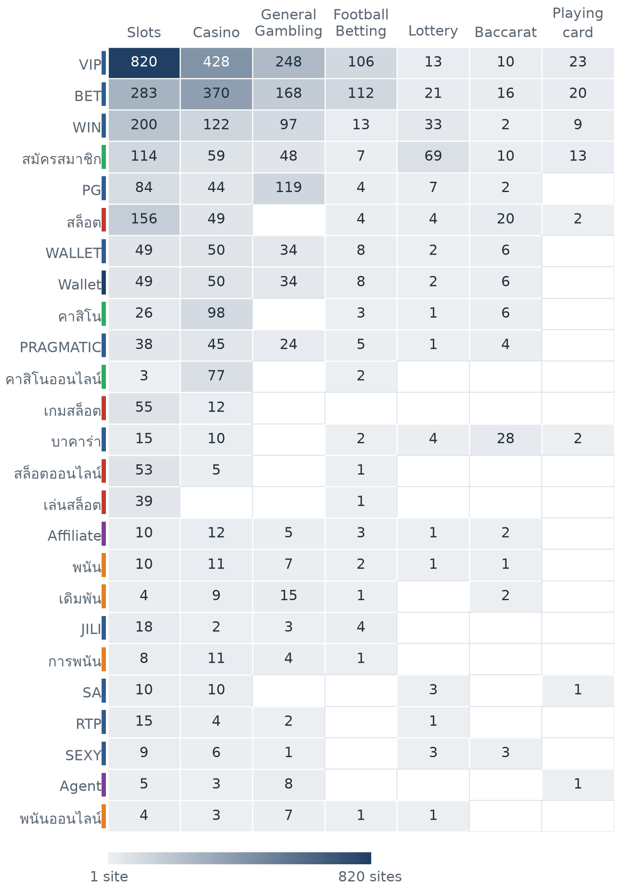
The strip beside each keyword shows the lexicon category the keyword belongs to, so a keyword scoring inside another product column is visible as cross-category bleed.

Heat map: signal tag against product subcategory
Signal tags against product subcategory. Each cell is the number of gambling sites carrying that tag in that subcategory.
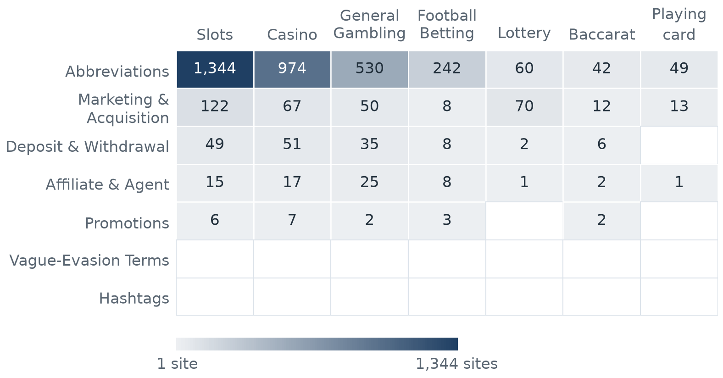

Brands and clustering
What brand clusters are
What a cluster is
A brand cluster is a group of domains judged to belong to the same gambling brand or operator. Domains join a cluster in one of three ways: the crawler found one as a variant of, or a redirect from, another, which is the strongest basis; their names reduce to the same stem once market tags, version numbers and suffixes are removed, so siam855thb5.com and siam-th.net both reduce to siam; or their stems are near identical in spelling. A domain that matches no other is a singleton.
Why clusters matter
Operators rarely run a single site. They register many domains, rotate top-level domains and move players between them through redirects, so that when one address is blocked another takes its place. Counting URLs therefore overstates how many operators there are. Clustering shows how many distinct operations exist and which run several product types, which changes where enforcement has leverage: acting on a cluster reaches every domain in it. Clusters are an analytical grouping based on names and crawler links, not a legal finding about ownership, and the possible operator linkage table is indicative only.

2,491  Distinct clusters | 1,342  Clusters with 2 or more URLs | 1,149  Singletons | 78  Clusters covering half the gambling estate

Top 15 brand clusters by URL count
The fifteen largest brand clusters by URL count. Bar length is the number of domains in the cluster.
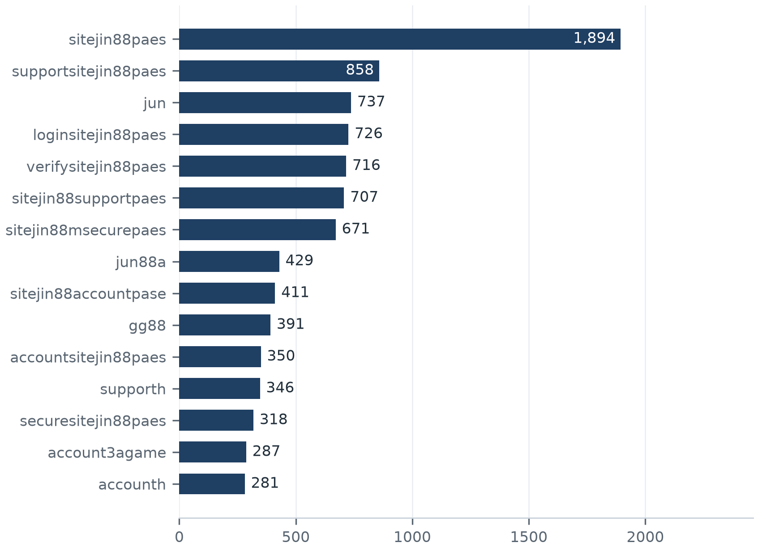

Heat map: brand cluster against product subcategory
Brand clusters against product subcategory. Each cell is the number of URLs a cluster holds in that subcategory.
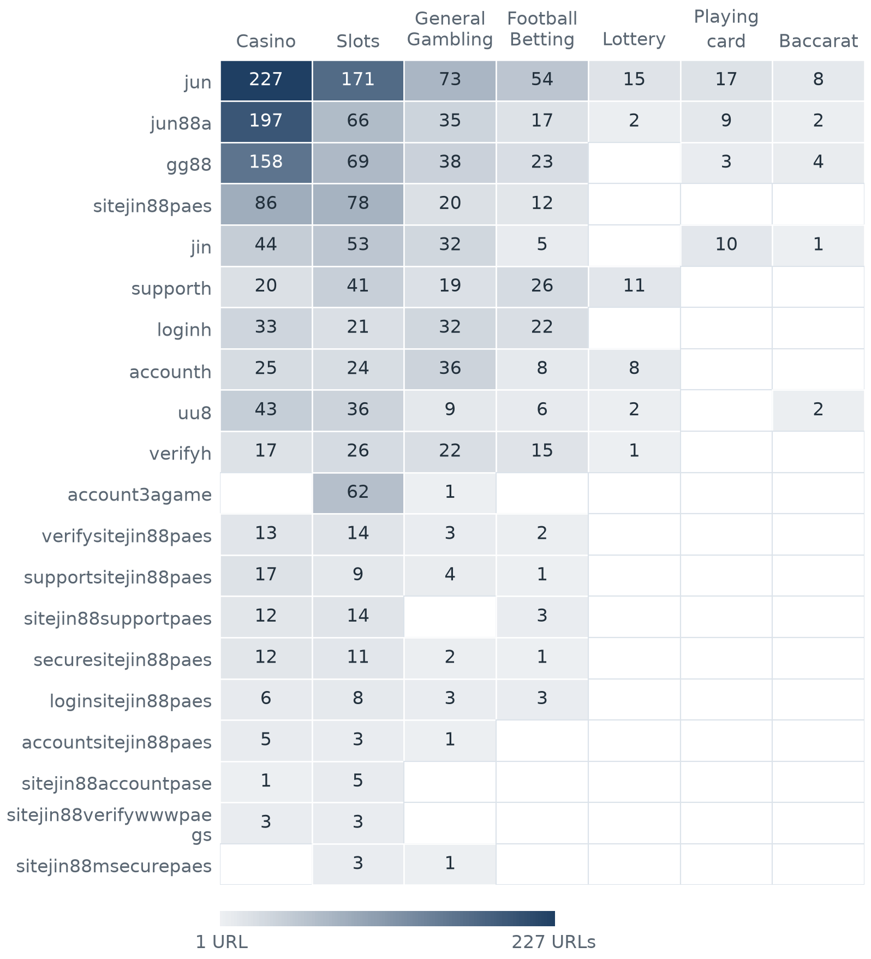

Cluster expansion: sitejin88paes
The largest brand cluster and its member domains. Edge style records why each domain joined the cluster.
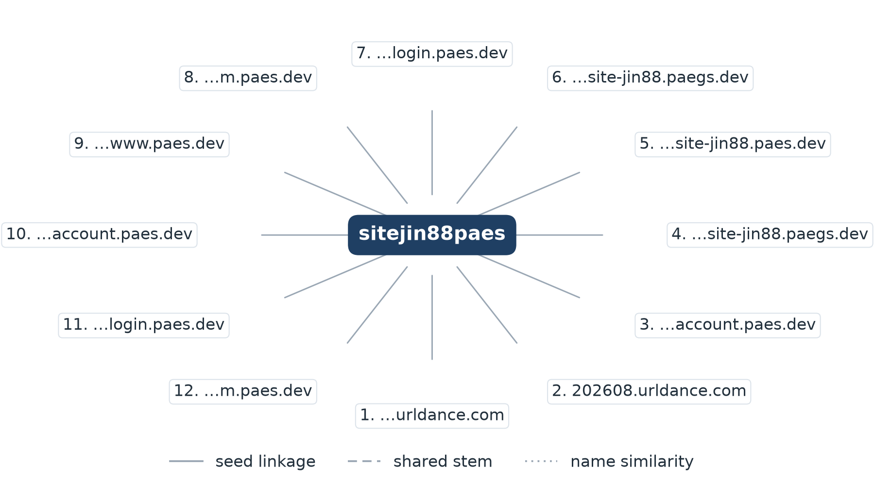
The sitejin88paes cluster holds 1,894 URLs across 19 top-level domains, joined on seed linkage. 1,882 further member domains are not drawn.
Domains drawn, numbered clockwise from the top: 1. 2026-09-24.urldance.com; 2. 202608.urldance.com; 3. account.m.site-jin88.account.paes.dev; 4. account.m.site-jin88.paegs.dev; 5. account.m.site-jin88.paes.dev; 6. account.mobile.site-jin88.paegs.dev; 7. account.site-jin88.login.login.paes.dev; 8. account.site-jin88.login.m.paes.dev; 9. account.site-jin88.login.www.paes.dev; 10. account.site-jin88.m.account.paes.dev; 11. account.site-jin88.m.login.paes.dev; 12. account.site-jin88.m.m.paes.dev

Clusters spanning multiple subcategories
Cluster | URL count | Subcategories | Suffixes
jun | 737 | Casino 227, Slots 171, General Gambling 73, Football Betting 54, Playing card 17 | .com, .net, .top, .org, .bet, .cc
jun88a | 429 | Casino 197, Slots 66, General Gambling 35, Football Betting 17, Playing card 9 | .com, .vip, .org, .net, .pro, .co
gg88 | 391 | Casino 158, Slots 69, General Gambling 38, Football Betting 23, Baccarat 4 | .org, .net, .app, .pro, .bet, .com
sitejin88paes | 1,894 | Casino 86, Slots 78, General Gambling 20, Football Betting 12 | .dev, .net, .xyz, .app, .me, .co
jin | 207 | Slots 53, Casino 44, General Gambling 32, Playing card 10, Football Betting 5 | .com, .vip, .org, .co, .net, .pro
supporth | 346 | Slots 41, Football Betting 26, Casino 20, General Gambling 19, Lottery 11 | .org, .net, .cc, .com, .game, .bet
loginh | 281 | Casino 33, General Gambling 32, Football Betting 22, Slots 21 | .org, .net, .cc, .xyz, .com, .vip
accounth | 281 | General Gambling 36, Casino 25, Slots 24, Lottery 8, Football Betting 8 | .org, .cc, .net, .bet, .com, .game
uu8 | 235 | Casino 43, Slots 36, General Gambling 9, Football Betting 6, Baccarat 2 | .com, .cc, .net, .org, .co, .pro
lotto432b | 92 | Lottery 71, General Gambling 9, Slots 4, Casino 3 | .com, .info, .org, .click, .live, .bet
lott | 107 | Lottery 48, Slots 12, General Gambling 11, Casino 5, Playing card 3 | .com, .org, .net, .cc, .live, .bet
verifyh | 249 | Slots 26, General Gambling 22, Casino 17, Football Betting 15, Lottery 1 | .org, .cc, .net, .com, .bet, .top
jju | 98 | Casino 37, Slots 19, General Gambling 7, Football Betting 6, Baccarat 5 | .net, .com, .pro, .xyz, .top, .fun
account3agame | 287 | Slots 62, General Gambling 1 | .vip, .com, .in, .org, .net
ju8 | 98 | Casino 23, General Gambling 18, Slots 9, Football Betting 8, Playing card 1 | .com, .pro, .click, .top, .buzz, .site

552 clusters span two or more product subcategories; the fifteen largest are shown.

Clusters rotating top-level domains
Cluster | Suffixes | Counts by suffix
jun | 34 | .com (142), .net (94), .top (70), .org (69), .bet (39), .cc (36), .fun (33), .pro (31)
min | 31 | .com (12), .app (6), .net (6), .org (5), .co (4), .in (4), .xyz (3), .top (3)
jin | 26 | .com (40), .vip (28), .org (21), .co (19), .net (18), .pro (16), .bet (12), .app (8)
uu8 | 26 | .com (38), .cc (29), .net (21), .org (18), .co (13), .pro (13), .app (12), .xyz (11)
ruay | 26 | .com (42), .org (16), .app (8), .net (8), .co (8), .online (6), .fun (6), .hu (5)
gra | 26 | .org (22), .com (14), .hu (9), .co (7), .us (5), .xyz (4), .ru (4), .in (4)
jun88a | 25 | .com (245), .vip (31), .org (22), .net (18), .pro (17), .co (14), .me (11), .online (10)
k11 | 24 | .org (29), .cc (14), .top (12), .com (9), .pro (9), .net (8), .click (7), .xyz (7)
90ok | 24 | .org (13), .club (7), .click (5), .io (5), .bet (4), .xyz (4), .vip (3), .info (3)
m10 | 24 | .click (11), .org (9), .app (6), .club (6), .bet (5), .cc (4), .com (4), .in (3)
hi86 | 24 | .com (5), .club (4), .app (3), .org (3), .vip (2), .tv (2), .top (2), .pro (2)
bu88 | 23 | .com (10), .kim (4), .men (4), .info (3), .app (3), .uno (3), .bid (3), .pro (3)
aga | 23 | .org (21), .com (13), .co (8), .me (6), .hu (6), .pro (5), .bet (4), .live (4)
no3 | 23 | .us (4), .org (4), .bet (3), .net (2), .fun (2), .app (2), .co (2), .club (2)
gg88 | 22 | .org (77), .net (55), .app (48), .pro (46), .bet (36), .com (36), .vip (18), .online (17)

796 clusters carry domains on more than one top-level domain; the fifteen rotating most widely are shown.

Possible operator linkage
Indicative — not a clustering decision
Cluster A | Cluster B | Shared signal keywords | Jaccard
gg88 | jum | Affiliate, BET, PG, PRAGMATIC, VIP, WALLET | 0.67
jin | jju | BET, PG, PRAGMATIC, RTP, VIP, WALLET | 0.67
gg88 | jin | BET, FC, PG, PRAGMATIC, VIP, WALLET | 0.62
80p | kn88 | BET, PG, PRAGMATIC, WALLET, WIN, Wallet | 0.78
kn88 | ko9 | BET, PG, PRAGMATIC, WALLET, WIN, Wallet | 0.78
uu8 | jum | BET, PG, PRAGMATIC, VIP, WALLET, WIN | 0.78
jin | hh98 | BET, PG, PRAGMATIC, VIP, WALLET, Wallet | 0.70
jin | kn88 | BET, PG, PRAGMATIC, WALLET, WIN, Wallet | 0.70
jju | hh98 | BET, PG, PRAGMATIC, VIP, WALLET, Wallet | 0.70
uu8 | jin | BET, PG, PRAGMATIC, VIP, WALLET, WIN | 0.70
80p | ko9 | BET, PG, PRAGMATIC, WALLET, WIN, Wallet | 0.64
gg88 | uu8 | BET, PG, PRAGMATIC, VIP, WALLET, WIN | 0.64
ib8 | op11 | BET, VIP, WALLET, WIN, Wallet, สมัครสมาชิก | 1.00
ib8 | ub88 | BET, VIP, WALLET, WIN, Wallet, สมัครสมาชิก | 1.00
ub88 | op11 | BET, VIP, WALLET, WIN, Wallet, สมัครสมาชิก | 1.00

6,056 pairs of multi-URL clusters score at or above 0.60. The pairs with the largest shared fingerprints are shown. Shared promotional vocabulary is common across unrelated operators using the same affiliate templates, so these pairs are a lead for an analyst rather than evidence of common ownership.

Naming conventions
Recurring tokens. Domain names in the largest clusters repeat a small set of tokens: m. (1,564), login (1,022), account (918). The repetition is evidence of a templated naming scheme rather than independently chosen names.
Top-level domain switching. Those names span more than one suffix: .com (857), .org (762), .net (582), .dev (578). The operators rotate top-level domains rather than staying on one.
Distinct count. 6,287 distinct domains across 20 brand clusters.

83  Direct  0.9% of gambling rows | 520  Redirect  5.7% of gambling rows | 8,572  Variant  93.4% of gambling rows

Redirect propagation: www.min88.top
The busiest redirect source and the destinations reached from it. Each node is one domain.
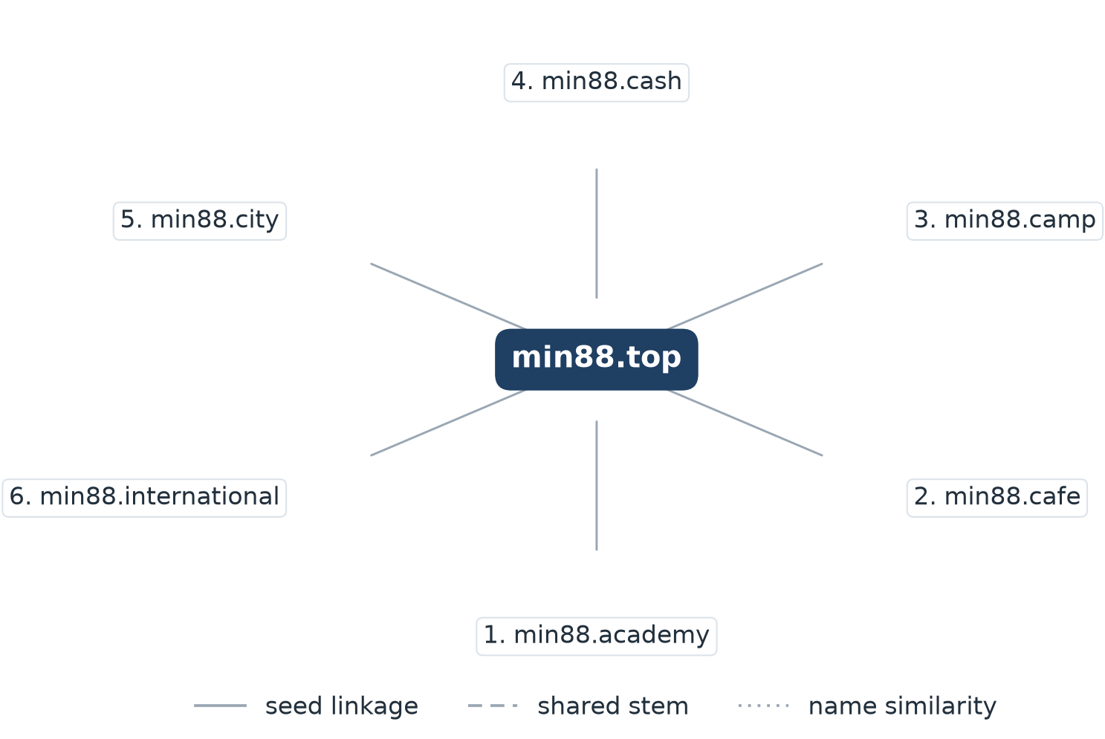
6 distinct gambling URLs were reached by redirect from www.min88.top.
Destinations drawn, numbered clockwise from the top: 1. min88.academy; 2. min88.cafe; 3. min88.camp; 4. min88.cash; 5. min88.city; 6. min88.international

Ranking
Gambling ranking
Rank | Domain | Brand cluster | Subcategory | Source
78,229 | lottovip.com | lott | Lottery | Youtube (lotto432)
90,304 | lottovip.bet | lott | Lottery | Variant (lottovip.com)
93,266 | lottovip.info | lott | Slots | Variant (lottovip.com)
184,475 | fun88thf.com | fun88hr | Football Betting | Variant (fun88tht.com)
198,736 | jun88wb.com | jun88a | Casino | Variant (jun88wh.com)
214,795 | allslotwallet.online | allslotwallet | Slots | Manual (claude.ai)
216,041 | lottovipp.com | lott | Lottery | Variant (lottovip.com)
221,001 | suriyathai.net | suriya | General Gambling | Manual (claude.ai)
303,254 | jun88wf.com | jun88a | Casino | Variant (jun88wt.com)
397,330 | jun88wa.com | jun88a | Casino | Variant (jun88ea.com)
402,382 | ruay.com | ruay | Football Betting | Youtube (หวยออนไลน์)
466,858 | jun88wc.com | jun88a | Casino | Variant (jun88wd.com)
517,141 | slavinaslot.top | jun | Casino | Redirect (jun88.info)
517,141 | jun88.info | jun | Casino | Variant (jun88.mobile)
547,370 | 99ok.vip | 99ok | Lottery | Variant (99ok.bet)

236 gambling rows carry a numeric rank; the fifteen best ranked are shown.

Key insights
Scale of the analysis
The standard working set holds 31,798 distinct URLs, covering 29 days from 31 Aug 2026 to 28 Sep 2026. Of these, 9,175 were classified as gambling (28.9% of the set), 11,594 as not gambling and 28 as unreachable. A further 11,001 rows carried a status the report treats as unknown.
The sample is large enough to reason about patterns, not isolated cases.

What is being offered
The three largest product subcategories are Casino with 3,256 sites (35.5%), Slots with 3,059 sites (33.3%), General Gambling with 1,439 sites (15.7%). 15.7% of gambling rows were confirmed as gambling without an evidenced product type, and 96.3% of all subcategory assignments rest on reasoning inference rather than a lexicon keyword. 206 of the 286 lexicon keywords never matched a single row.
Casino is the largest product type but stays under two fifths of the gambling estate, so the estate is spread across product types rather than concentrated.

Brand clustering
2,491 brand clusters were formed across 9,175 gambling URLs. 1,342 of them hold more than one domain and 1,149 are singletons. 78 clusters cover half the gambling estate. The largest, sitejin88paes, holds 1,894 domains across 4 product subcategories.
The estate is diffuse, and per-URL blocking will have limited leverage against it.

How the estate is grown and marketed
8,572 gambling rows (93.4%) reached the feed as crawler-identified variants, 520 (5.7%) behind redirect chains and 83 (0.9%) were reached directly. The busiest redirect source is www.min88.top, with 6 destinations. 796 clusters rotate across more than one top-level domain. The two most common signal tags are Abbreviations at 35.3% and Marketing & Acquisition at 3.7%.
Redirects and top-level domain rotation keep a stable entry point while the sites behind it are replaced.

Enforcement position
7 pages in the standard set already show an indicator of regulatory blocking, such as a court order, a regulator notice or a third-party block page. Against 31,798 URLs reviewed that is a very small share of the estate.
A measurable but very small share is already under enforcement; the rest of the set is a candidate for a first enforcement pass, prioritised by cluster rather than by URL.

Lexicon source: Gambling_Keywords_Full_English_Categories_V1.xlsx, reproduced as Appendix A of the report specification. Lexicon version: Gambling_Keywords_Full_English_Categories_V1; 286 distinct keywords across 14 categories (Football Betting 21, Slots 32, Casino 14, Lottery 20, Playing card 12, Baccarat 11, General Gambling 22, Deposit & Withdrawal 24, Promotions 27, Marketing & Acquisition 25, Affiliate & Agent 20, Vague-Evasion Terms 20, Abbreviations 22, Hashtags 21). Assignments by reasoning inference: 96.3% of gambling rows; assignments to General Gambling: 15.7%. Rows normalised from Licensed gambling: 0. Abbreviation flagged as a probable false-positive source: PG (99 of 137 abbreviation matches). Clustering thresholds: Jaro-Winkler 0.90 for a near-miss merge, minimum stem length 3 characters, minimum common prefix 4 characters; all-numeric stems are excluded from merging.

