Ministry of Digital Economy and Society, Thailand

Data Insights & Patterns
21,978 URLs · 4 Sep – 5 Oct 2026

Issued to | Ministry of Digital Economy and Society, Thailand
Prepared by | SICPA SA
Date of issue | 06/10/2026
Source system | SICPADetect, keyword lexicon V1

Contents
Executive summary
Insights and trends
Key figures
Model Insights
Introduction
Insights
Performance
The numbers
Key metrics
URLs analyzed per day
Status distribution
Top 10 URL suffixes
Subcategories
Gambling sites by product subcategory
Assignment method by subcategory
Subcategory table
Heat map: keyword by subcategory
Heat map: signal tag by subcategory
Brands and clustering
What brand clusters are
Cluster metrics
Top 15 brand clusters by URL count
Heat map: brand cluster by subcategory
Cluster expansion: jun
Clusters spanning multiple subcategories
Clusters rotating top level domains
Possible operator linkage
Naming conventions
Ranking
Gambling ranking
Key insights
Scale of the analysis
What is being offered
Brand clustering
How the estate is grown and marketed
Enforcement position

Executive summary

Insights and trends
The estate analysed holds 21,978 URLs updated across 32 days, and 9,858 of them are gambling sites.
Casino leads the product types, followed by Slots. Most subcategory assignments rest on reasoning inference rather than lexicon matches, so the subcategory figures are indicative only.
Operators are spread across many brands. 328 brand clusters are needed to cover half of the gambling URLs, and the largest cluster spans many top level domains.
Provider and network abbreviations are the most common signal tag, at 34.4% of gambling sites. Promotional and evasion vocabulary is rare in the descriptions recorded.
No gambling site in this sample shows a regulatory blocking indicator, so the set appears to be before any enforcement action.
The daily series is uneven across the evaluation period, so no direction is stated. No gambling site carries a numeric rank, so no ranked table of sites with Thai audience evidence could be built.

Key figures
Figure | Value
URLs analysed | 21,978
Gambling sites and share | 9,858 (44.9%)
Not gambling and unreachable | 12,120 not gambling; 0 unreachable
Brand clusters identified | 3,516; 1,331 hold more than one domain
Clusters needed to cover half of gambling URLs | 328
Largest cluster and its size | jun; 407 domains
Dominant product subcategory and share | Casino; 40.5%
Most common signal tag and share | Abbreviations; 34.4%
Sites already showing blocking indicators | 0
Keyword versus inferred assignment | 395 keyword; 9,463 inferred
Table 1. Key figures for the evaluation period.

Model Insights

Introduction

Insights

Performance

The numbers

Key metrics
21,978  Total URLs analyzed | 9,858  Gambling sites | 3,516  Brand clusters identified | 32 days  2026-09-04 → 2026-10-05

URLs analyzed per day
Daily count of URLs analysed across the evaluation period. Each point is one calendar day.
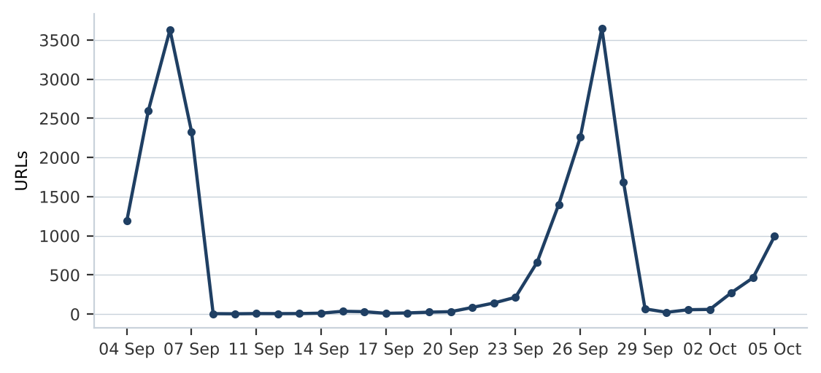
Figure 1. URLs analysed per day, by date of last update.

Status distribution
Share of the estate by classification status. Each segment is one status and the table carries the counts.
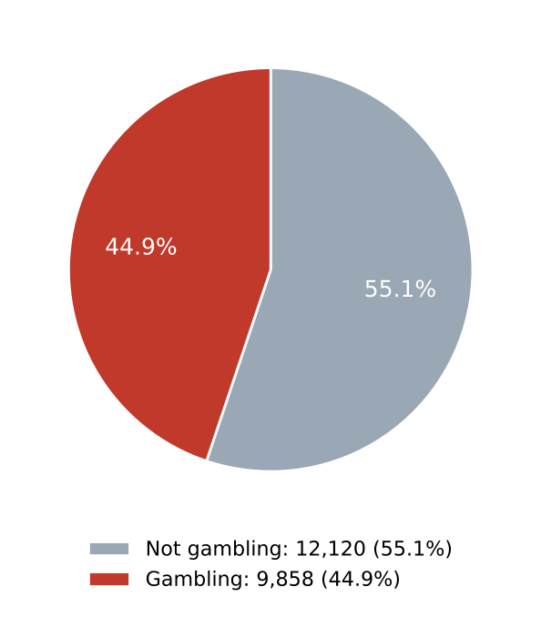
Figure 2. Share of URLs by classification status.
Status | Count | % of all
Not gambling | 12,120 | 55.1%
Gambling | 9,858 | 44.9%
Table 2. Status distribution.

Top 10 URL suffixes
The ten most common URL suffixes in the estate. Bar length is the total count and the table separates the gambling share.
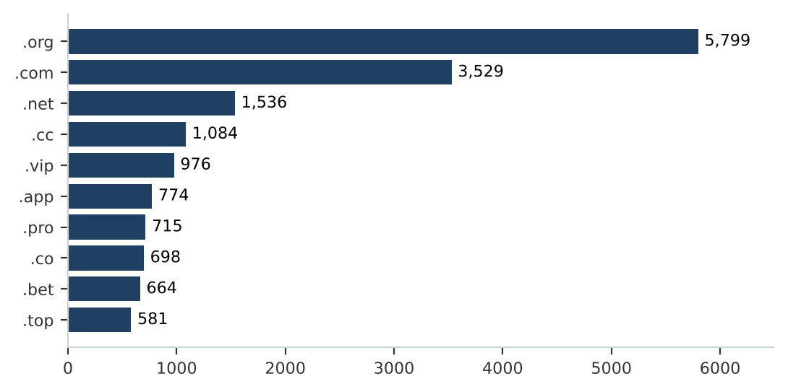
Figure 3. Top ten URL suffixes by total count.
Suffix | Total | % of all | Gambling | % gambling
.org | 5,799 | 26.4% | 12 | 0.2%
.com | 3,529 | 16.1% | 1,534 | 43.5%
.net | 1,536 | 7.0% | 998 | 65.0%
.cc | 1,084 | 4.9% | 653 | 60.2%
.vip | 976 | 4.4% | 886 | 90.8%
.app | 774 | 3.5% | 578 | 74.7%
.pro | 715 | 3.3% | 620 | 86.7%
.co | 698 | 3.2% | 437 | 62.6%
.bet | 664 | 3.0% | 642 | 96.7%
.top | 581 | 2.6% | 314 | 54.0%
Table 3. Top ten URL suffixes with gambling share.

Subcategories

Gambling sites by product subcategory
Gambling sites by product subcategory. Bar length is the site count and each label carries the count and the share of gambling rows.
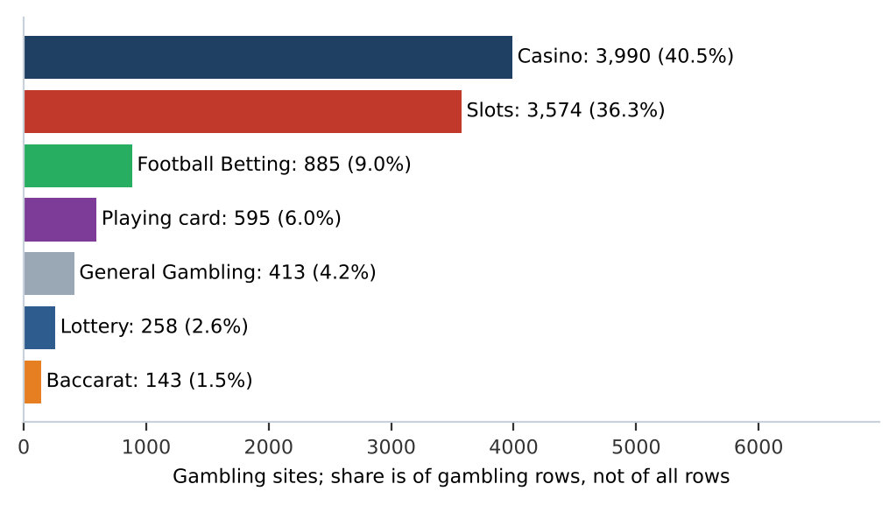
Figure 4. Gambling sites by product subcategory.

Assignment method by subcategory
How each subcategory was assigned. Solid fill is a lexicon keyword match and the lighter fill is reasoning inference.
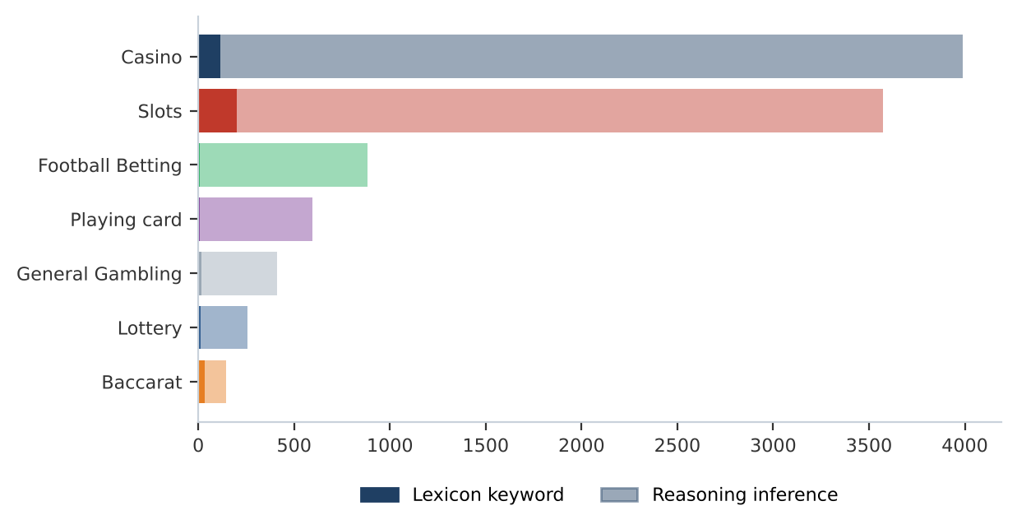
Figure 5. Assignment method by subcategory. Inferred share 96.0%; General Gambling share 4.2%. The lexicon has poor coverage of this dataset and subcategory figures are indicative only.
What a lexicon match means
A site is assigned to a subcategory by lexicon match when a word or phrase from the gambling keyword lexicon appears in what was recorded about the site, such as the model's description, extracted keywords, analyst remarks, or the URL and domain, and that word belongs to the product category the site was assigned. A site whose description contains สล็อต is assigned by lexicon match to the product category that word belongs to. The lexicon is the SICPADetect Thai gambling keyword lexicon, version V1, with 286 keywords in 14 categories, mostly in Thai script. Seven categories describe the product and decide the subcategory. The other seven describe how a site markets or operates itself and are reported as signal tags. A lexicon match rests on a specific word that can be pointed to on the site, so it can be checked and repeated. An inferred assignment rests on the model's reading of its own description, so it carries lower confidence.

Subcategory table
Subcategory | Count | % of gambling | Keyword | Inferred | Distinct clusters
Casino | 3,990 | 40.5% | 115 | 3,875 | 1,782
Slots | 3,574 | 36.3% | 200 | 3,374 | 1,626
Football Betting | 885 | 9.0% | 9 | 876 | 547
Playing card | 595 | 6.0% | 7 | 588 | 362
General Gambling | 413 | 4.2% | 18 | 395 | 272
Lottery | 258 | 2.6% | 13 | 245 | 113
Baccarat | 143 | 1.5% | 33 | 110 | 108
Table 4. Subcategory counts with assignment method and distinct clusters.

Heat map: keyword by subcategory
Matched keywords against product subcategory. Each cell is the number of gambling sites carrying that keyword in that subcategory.
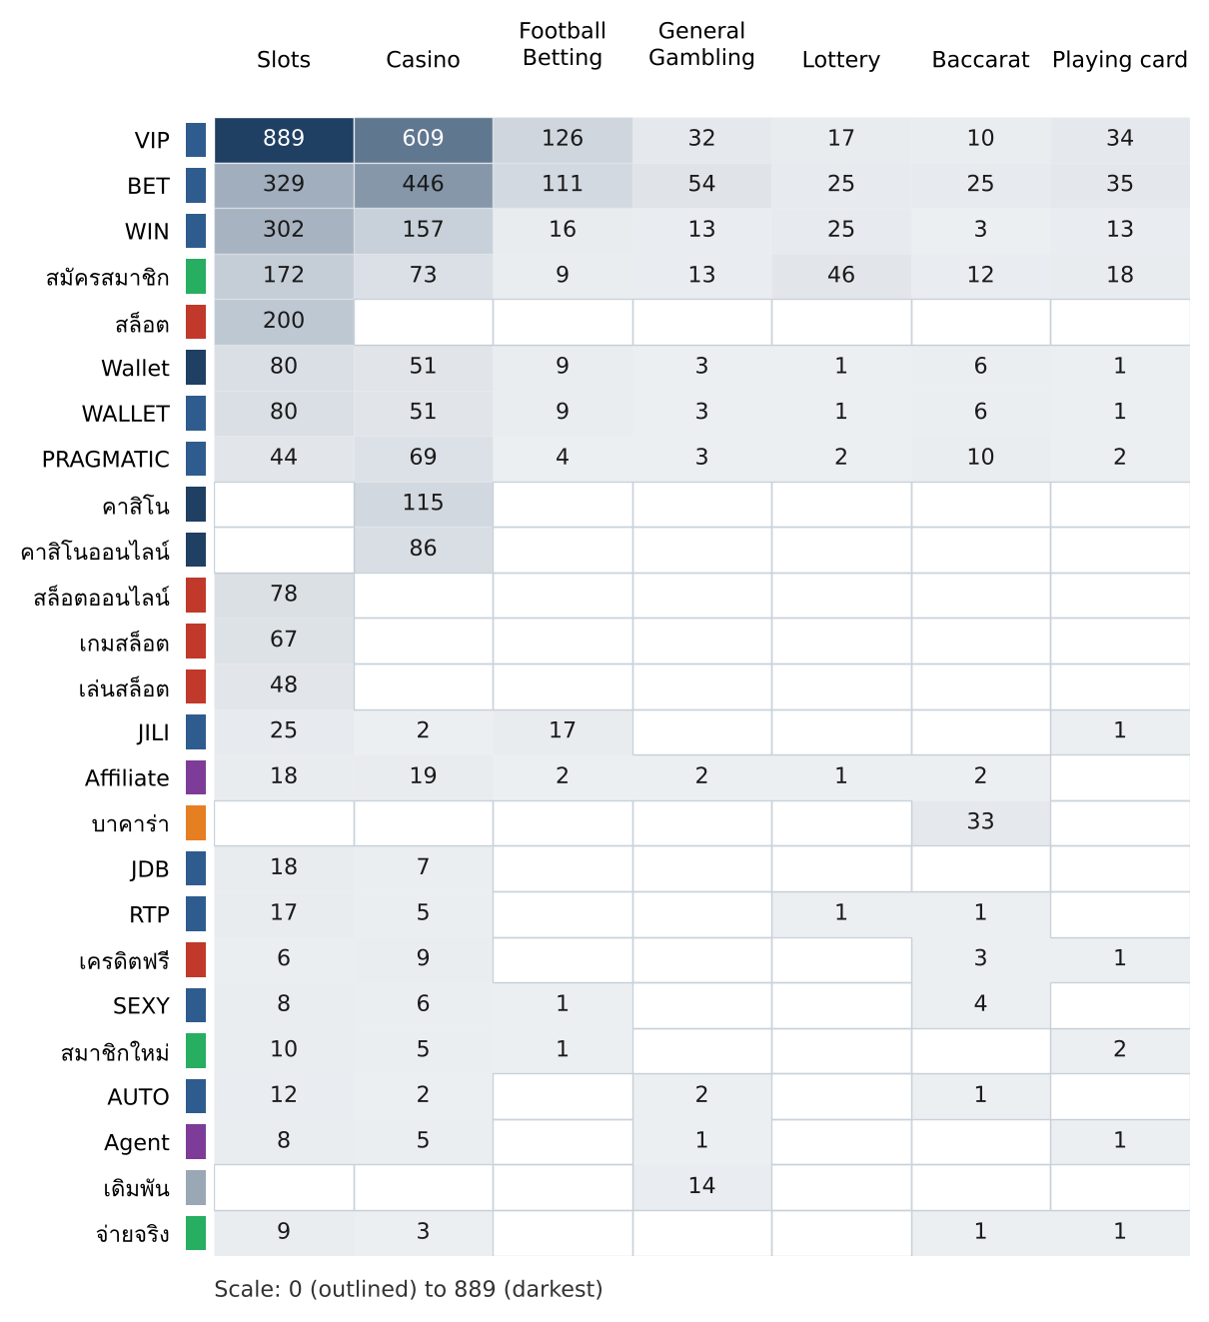
Figure 6. Top 25 matched keywords by product subcategory. The coloured strip beside each keyword marks its lexicon category.

Heat map: signal tag by subcategory
Signal tags against product subcategory. Each cell is the number of gambling sites carrying that tag in that subcategory.
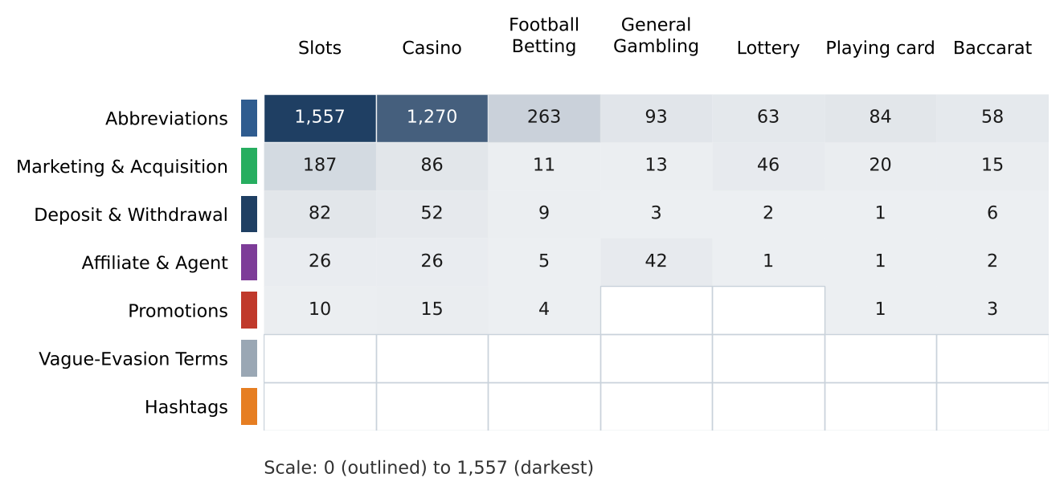
Figure 7. Signal tags by product subcategory.

Brands and clustering

What brand clusters are
What a cluster is
A brand cluster is a group of domains judged to belong to the same gambling brand or operator. Domains join a cluster in one of two ways in this analysis: their names reduce to the same stem once market tags, version numbers and suffixes are removed, so jun-88.com and jun88.net both reduce to jun, or their stems are near identical in spelling. Where a crawler links one domain to another as a variant or redirect, that link is the strongest basis, but this sample carries no such links. A domain that matches no other is a singleton.
Why clusters matter
Operators rarely run a single site. They register many domains, rotate top level domains and move players between them, so that when one address is blocked another takes its place. Counting URLs therefore overstates how many operators there are and hides who is behind the estate. Clustering shows how many distinct operations exist, how concentrated the estate is, and which operators run several product types. That changes where enforcement has leverage: acting on a cluster reaches every domain in it, where acting on a single URL leaves the rest of the brand running. Clusters are an analytical grouping based on names, not a legal finding about ownership, and the linkage table is indicative only.

Cluster metrics
3,516  Distinct clusters | 1,331  Clusters with 2 or more URLs | 2,185  Singletons | 328  Clusters to reach half of gambling URLs

Top 15 brand clusters by URL count
The fifteen largest brand clusters by URL count. Bar length is the number of domains in the cluster.
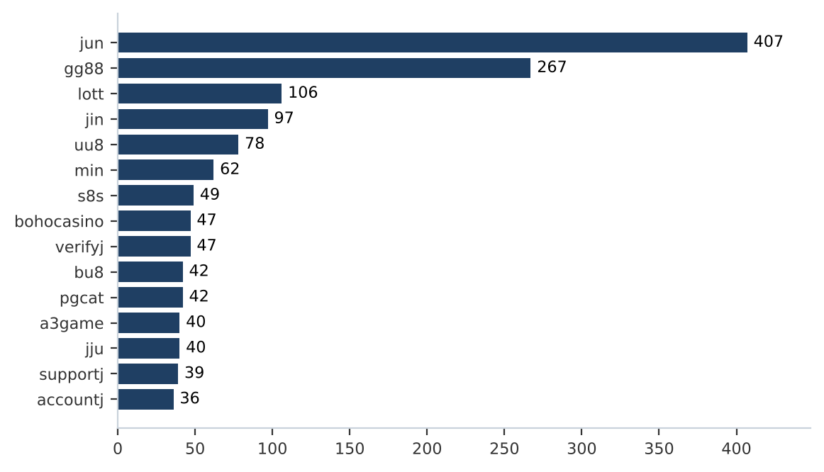
Figure 8. Top 15 brand clusters. The top 5 hold 9.7% and the top 10 hold 12.2% of gambling URLs.

Heat map: brand cluster by subcategory
Brand clusters against product subcategory. Each cell is the number of URLs a cluster holds in that subcategory.
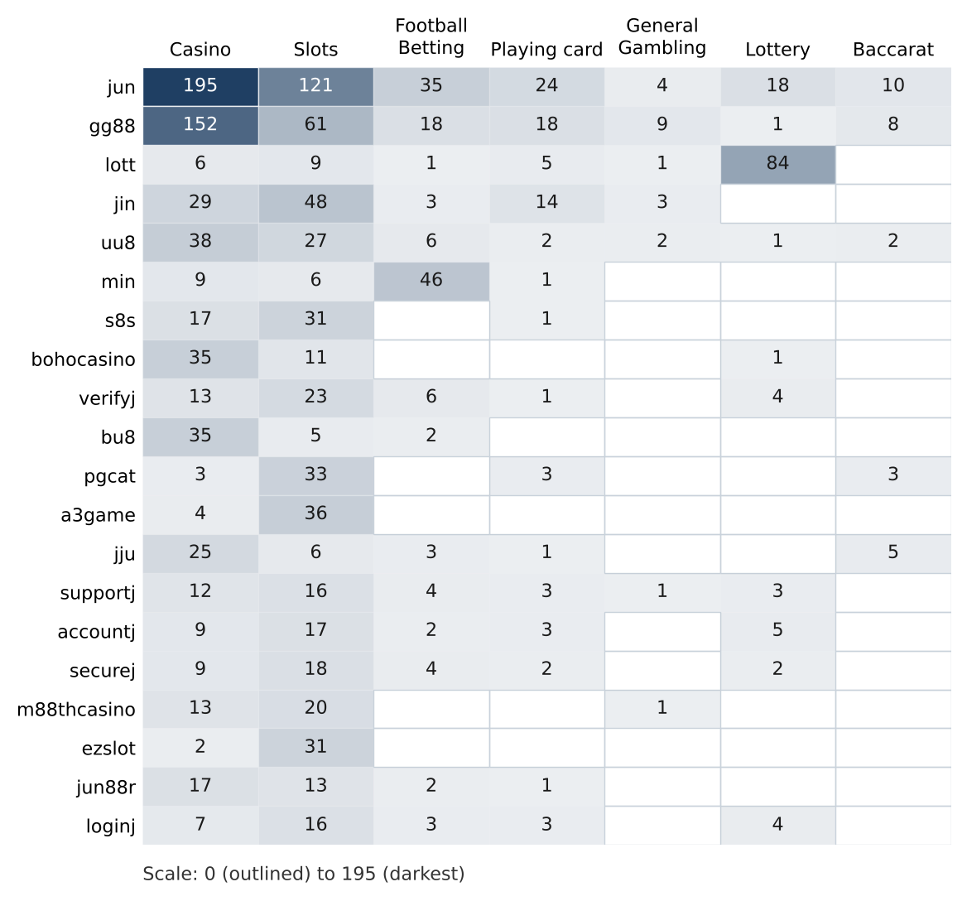
Figure 9. Top 20 brand clusters by product subcategory.

Cluster expansion: jun
The largest brand cluster and its member domains. Edge style records why each domain joined the cluster.
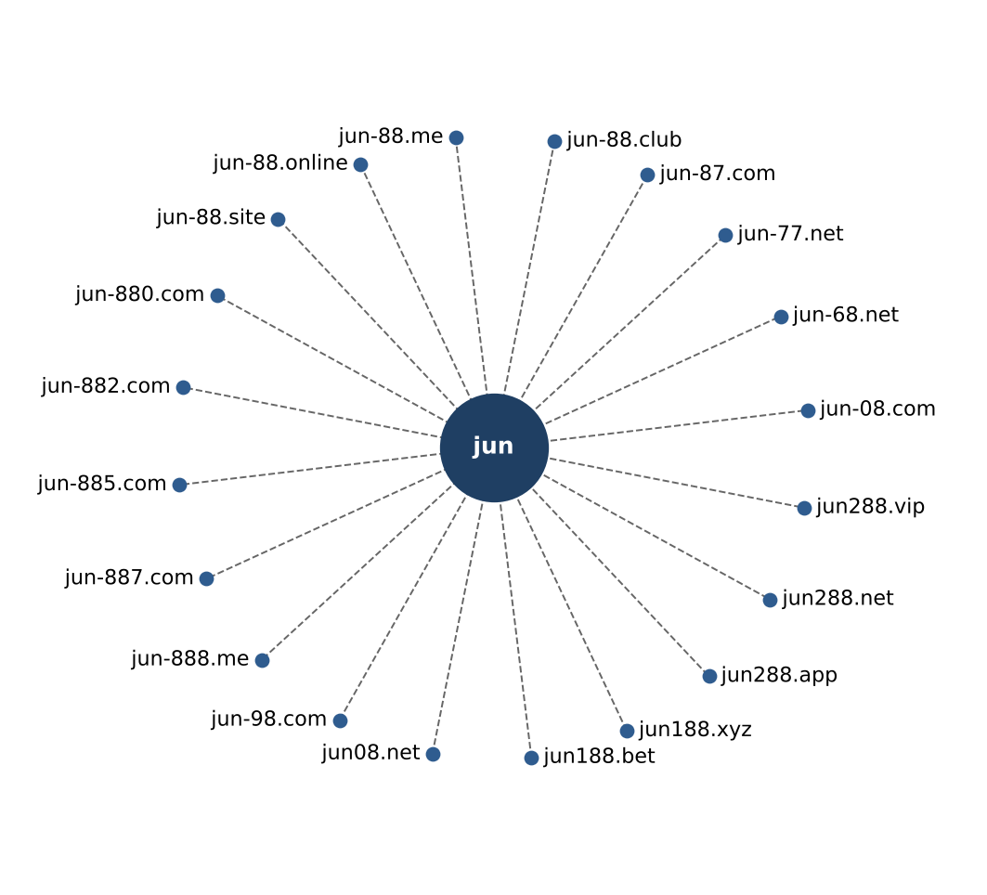
Figure 10. Expansion of the jun cluster. Dashed edges join domains whose stem equals the cluster name; dotted edges join domains merged by spelling similarity. Every second member domain is drawn, 24 of 407.

Clusters spanning multiple subcategories
Cluster | URLs | Subcategories | Suffixes
jun | 407 | Casino 195, Slots 121, Football Betting 35, Playing card 24, Lottery 18, Baccarat 10, General Gambling 4 | .app, .bet, .black, .buzz, .casino, .cc, .click, .club +22 more
gg88 | 267 | Casino 152, Slots 61, Playing card 18, Football Betting 18, General Gambling 9, Baccarat 8, Lottery 1 | .app, .bet, .casino, .cc, .click, .club, .co, .com +11 more
lott | 106 | Lottery 84, Slots 9, Casino 6, Playing card 5, Football Betting 1, General Gambling 1 | .app, .bet, .cc, .click, .co, .com, .fun, .info +8 more
jin | 97 | Slots 48, Casino 29, Playing card 14, Football Betting 3, General Gambling 3 | .app, .bet, .cash, .casino, .cc, .city, .click, .club +11 more
uu8 | 78 | Casino 38, Slots 27, Football Betting 6, General Gambling 2, Baccarat 2, Playing card 2, Lottery 1 | .app, .bet, .buzz, .casino, .cc, .click, .co, .com +14 more
min | 62 | Football Betting 46, Casino 9, Slots 6, Playing card 1 | .academy, .actor, .app, .art, .auction, .cafe, .camp, .cash +21 more
s8s | 49 | Slots 31, Casino 17, Playing card 1 | .com
bohocasino | 47 | Casino 35, Slots 11, Lottery 1 | .app, .bet, .casino, .co, .com, .fun, .info, .io +7 more
verifyj | 47 | Slots 23, Casino 13, Football Betting 6, Lottery 4, Playing card 1 | .bet, .cc, .club, .co, .com, .dev, .game, .me +6 more
bu8 | 42 | Casino 35, Slots 5, Football Betting 2 | .app, .bid, .buzz, .cab, .casino, .cc, .club, .com +13 more
pgcat | 42 | Slots 33, Casino 3, Playing card 3, Baccarat 3 | .bet, .buzz, .cc, .click, .club, .co, .com, .fun +6 more
a3game | 40 | Slots 36, Casino 4 | .app, .click, .net, .vip
jju | 40 | Casino 25, Slots 6, Baccarat 5, Football Betting 3, Playing card 1 | .app, .bet, .casino, .cc, .click, .co, .com, .fun +6 more
supportj | 39 | Slots 16, Casino 12, Football Betting 4, Lottery 3, Playing card 3, General Gambling 1 | .bet, .cc, .club, .co, .com, .dev, .game, .me +6 more
accountj | 36 | Slots 17, Casino 9, Lottery 5, Playing card 3, Football Betting 2 | .bet, .cc, .club, .co, .com, .dev, .game, .me +5 more
securej | 35 | Slots 18, Casino 9, Football Betting 4, Playing card 2, Lottery 2 | .bet, .cc, .club, .co, .com, .dev, .game, .me +5 more
m88thcasino | 34 | Slots 20, Casino 13, General Gambling 1 | .buzz, .casino, .cc, .click, .club, .co, .com, .info +9 more
ezslot | 33 | Slots 31, Casino 2 | .bet, .buzz, .cc, .club, .co, .info, .land, .live +9 more
jun88r | 33 | Casino 17, Slots 13, Football Betting 2, Playing card 1 | .com, .pro
loginj | 33 | Slots 16, Casino 7, Lottery 4, Football Betting 3, Playing card 3 | .bet, .cc, .club, .co, .com, .dev, .game, .me +5 more
Table 5. The 20 largest of 827 clusters spanning two or more product subcategories.

Clusters rotating top level domains
Cluster | Suffixes | Counts
jun | 30 | .com 71, .net 53, .top 37, .bet 32, .app 25, .fun 24, .pro 23, .xyz 16 …
min | 29 | .net 7, .com 6, .app 4, .vip 3, .actor 2, .art 2, .auction 2, .cc 2 …
uu8 | 22 | .com 10, .net 9, .cc 8, .pro 7, .click 5, .app 5, .co 5, .xyz 4 …
bu8 | 21 | .com 6, .app 2, .bid 2, .cab 2, .club 2, .in 2, .info 2, .kim 2 …
gg88 | 19 | .net 46, .app 43, .pro 41, .bet 31, .com 28, .online 17, .vip 15, .club 11 …
jin | 19 | .com 16, .co 14, .net 13, .vip 12, .bet 7, .pro 7, .app 5, .online 4 …
m88thcasino | 17 | .buzz 2, .casino 2, .cc 2, .click 2, .club 2, .co 2, .com 2, .info 2 …
ezslot | 17 | .bet 4, .live 3, .buzz 2, .cc 2, .info 2, .land 2, .me 2, .pink 2 …
lott | 16 | .com 60, .net 9, .cc 4, .live 4, .online 4, .bet 4, .click 4, .info 4 …
hh9 | 16 | .pro 3, .net 3, .vip 3, .bet 3, .club 2, .click 2, .com 2, .fun 2 …
bohocasino | 15 | .com 29, .info 3, .net 2, .co 2, .app 1, .bet 1, .casino 1, .fun 1 …
mu8 | 15 | .net 4, .cc 4, .me 3, .bet 3, .online 2, .fun 2, .shop 2, .pro 1 …
verifyj | 14 | .cc 13, .top 8, .vip 6, .xyz 4, .com 4, .dev 2, .me 2, .pro 2 …
pgcat | 14 | .com 19, .info 3, .bet 2, .buzz 2, .click 2, .club 2, .fun 2, .online 2 …
jju | 14 | .com 5, .net 5, .xyz 5, .pro 4, .co 4, .top 4, .cc 2, .click 2 …
supportj | 14 | .com 6, .top 6, .vip 6, .cc 5, .xyz 3, .me 2, .dev 2, .pro 2 …
ku8 | 14 | .com 7, .net 4, .pro 3, .casino 2, .io 2, .live 2, .top 2, .us 2 …
116lotto | 14 | .com 5, .click 2, .app 2, .me 2, .net 2, .online 2, .shop 2, .vip 2 …
hu8 | 14 | .app 3, .casino 2, .click 2, .online 2, .com 2, .fun 2, .net 2, .me 1 …
ib8 | 14 | .io 3, .site 3, .bet 2, .info 2, .online 2, .club 1, .fun 1, .live 1 …
Table 6. The 20 clusters with the most suffixes, of 839 clusters using two or more.

Possible operator linkage
Indicative, not a clustering decision.
Cluster A | Cluster B | Shared keywords | Jaccard
uu8 | mu8 | BET, PRAGMATIC, VIP, WALLET, WIN, Wallet | 1.00
bu8 | hh88 | Affiliate, BET, VIP, WIN | 1.00
bu8 | 2agame | Affiliate, BET, VIP, WIN | 1.00
bu8 | 80jili | Affiliate, BET, VIP, WIN | 1.00
bu8 | 89ok | Affiliate, BET, VIP, WIN | 1.00
supportj | accountj | BET, VIP, WIN, สมัครสมาชิก | 1.00
supportj | loginj | BET, VIP, WIN, สมัครสมาชิก | 1.00
supportj | ib8 | BET, VIP, WIN, สมัครสมาชิก | 1.00
accountj | loginj | BET, VIP, WIN, สมัครสมาชิก | 1.00
accountj | ib8 | BET, VIP, WIN, สมัครสมาชิก | 1.00
loginj | ib8 | BET, VIP, WIN, สมัครสมาชิก | 1.00
hh9 | oo7 | BET, PRAGMATIC, VIP, WIN | 1.00
hh9 | kk00 | BET, PRAGMATIC, VIP, WIN | 1.00
hh9 | j89 | BET, PRAGMATIC, VIP, WIN | 1.00
hh88 | 2agame | Affiliate, BET, VIP, WIN | 1.00
Table 7. The first 15 of 55,927 cluster pairs at Jaccard 0.60 or above, ordered by score and then by shared keyword count.

Naming conventions
- Recurring tokens in the largest clusters: vip (206), mobile (186), m. (177). This points to a templated naming scheme.
- TLD switching: the largest clusters span several suffixes, most often .com (459), .net (227), .cc (179), .vip (142). The operators rotate top level domains.
- 2,287 distinct domains across 50 brand clusters.

Ranking

Gambling ranking
Rank | Domain | Brand cluster | Subcategory
— | 000ok.net | 000ok | Casino
— | 002025.com | 002025 | Casino
— | 005p.com | 005p | Casino
— | 007game.pro | 007game | Slots
— | 007squidgame.club | 007squidgame | Slots
— | 008416.com | 008416 | Casino
— | 008464.com | 008464 | Casino
— | 008n.vip | 008n | Slots
— | 008op.cc | 008op | Playing card
— | 008p.vip | 008p | Slots
Table 8. Sample of gambling sites. No site in this export carries a numeric rank.

Key insights

Scale of the analysis
21,978 distinct URLs were analysed over 32 days, 2026-09-04 → 2026-10-05. Of these, 9,858 are gambling, 12,120 are not gambling and 0 are unreachable.
The sample is large enough to reason about patterns, not isolated cases.

What is being offered
The top three product subcategories are Casino (3,990, 40.5%), Slots (3,574, 36.3%) and Football Betting (885, 9.0%). 4.2% of sites are confirmed as gambling without an evidenced product type, and 96.0% of assignments are inferred. 215 lexicon keywords never matched.
Casino is the dominant product type. The lexicon has poor coverage of this dataset, so subcategory figures are indicative only.

Brand clustering
3,516 clusters span 9,858 gambling URLs. 1,331 hold more than one domain, and 328 clusters cover half the estate. The largest, jun, holds 407 domains across 7 subcategories.
The estate is diffuse and per URL blocking will have limited leverage.

How the estate is grown and marketed
839 clusters rotate across more than one top level domain. The two most common signal tags are Abbreviations (34.4%) and Marketing & Acquisition (3.8%). This export carries no source field, so variant and redirect structure is not available.
TLD rotation keeps a brand stable while the addresses behind it change.

Enforcement position
0 gambling pages show regulatory blocking indicators such as court orders, regulator notices or block pages. The set appears to be before enforcement.
This set is a candidate for a first enforcement pass, prioritised by cluster rather than by URL.
Lexicon source: Gambling_Keywords_Full_English_Categories_V1.xlsx, version V1; keywords per category: Football Betting 21; Slots 32; Casino 14; Lottery 20; Playing card 12; Baccarat 11; General Gambling 22; Deposit & Withdrawal 24; Promotions 27; Marketing & Acquisition 25; Affiliate & Agent 20; Vague-Evasion Terms 20; Abbreviations 22; Hashtags 21. Inferred share 96.0%; General Gambling share 4.2%. Rows normalised from Licensed gambling: 0. Abbreviations above 20% of abbreviation matches (probable false positive sources): VIP, BET. Clustering: Jaro–Winkler similarity 0.90 or above with a prefix relation; minimum stem length 3; cluster linkage Jaccard 0.60. Input fields: domain, status, reasons, tags, dates; URL, source and rank were not present, so rows are de-duplicated by domain and inferred assignments follow the English reasoning text and tags.

