Ministry of Digital Economy and Society
DATA INSIGHTS & PATTERNS
21,978 URLs · 4 Sept 2026 – 5 Oct 2026
Issued to: Ministry of Digital Economy and Society, Thailand
Prepared by: SICPA SA
Date of issue: 06/10/2026
Source system: SICPADetect, lexicon V1

CONTENTS

EXECUTIVE SUMMARY
Insights and trends
The estate analysed comprises 21,978 distinct URLs recorded between 4 Sept 2026 and 5 Oct 2026. Of these, 9,858 are classified as gambling (44.9%) and the remainder as not gambling.
Slots is the largest product subcategory, followed by Football Betting and General Gambling, and no single product holds a majority of gambling sites. Most subcategory assignments rest on reasoning inference, so the product figures are indicative only.
The gambling URLs reduce to 2,273 brand clusters, of which 1,138 hold more than one domain. 108 clusters cover half of all gambling URLs, so a limited number of operations account for a large share of the estate.
Gambling sites are marketed mainly through Abbreviations and Marketing & Acquisition language. No page in this sample carries a regulatory blocking indicator. The source feed carries no crawl lineage, so the report cannot say how the estate is grown through redirects or variants.
Key figures
Table 1. Key figures
Figure | Value
URLs analysed | 21,978
Gambling sites and share | 9,858 (44.9%)
Not gambling | 12,120
Brand clusters identified | 2,273
Clusters holding more than one domain | 1,138
Clusters needed to cover half of gambling URLs | 108
Largest cluster | a3game (507 domains)
Dominant product subcategory | Slots (31.4% of gambling sites)
Most common signal tag | Abbreviations (34.2%)
Sites showing blocking indicators | 0
Keyword assigned versus inferred | 395 keyword, 9,463 inferred

MODEL INSIGHTS

INTRODUCTION

INSIGHTS

PERFORMANCE

THE NUMBERS

ESTATE AT A GLANCE
Total URLs analysed | Gambling sites | Brand clusters | Evaluation period
21,978 | 9,858 | 2,273 | 32 days (2026-09-04 to 2026-10-05)
Table 2. Headline figures, referenced in the executive summary.

URLS ANALYSED PER DAY
Daily count of URLs analysed across the evaluation period. Each point is one calendar day.
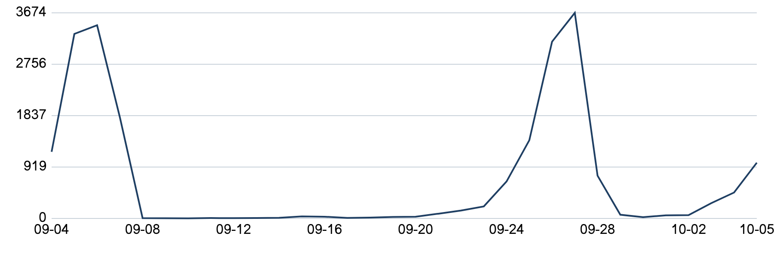
Figure 1. URLs analysed per day.

STATUS DISTRIBUTION
Share of the estate by classification status. Each segment is one status and the table carries the counts.
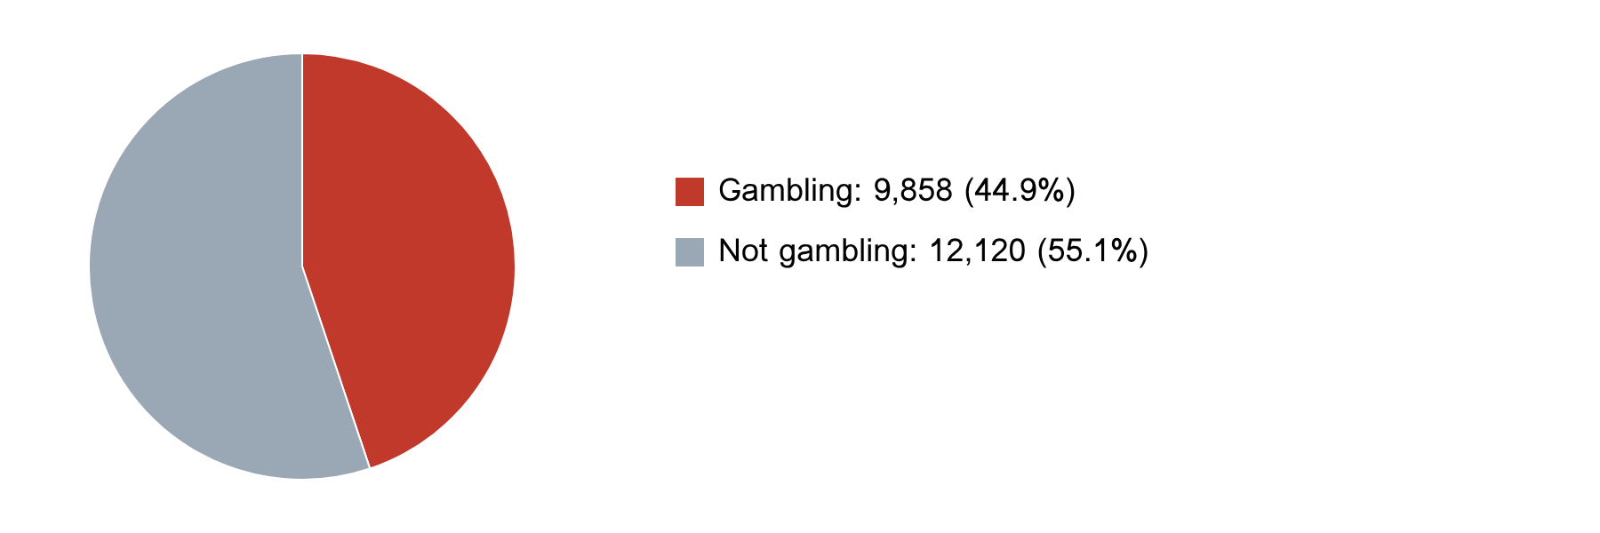
Status | Count | Share
Not gambling | 12,120 | 55.1%
Gambling | 9,858 | 44.9%
Figure 2. Status distribution (Table 3 gives the counts).

TOP 10 URL SUFFIXES
The ten most common URL suffixes in the estate. Bar length is the total count and the table separates the gambling share.
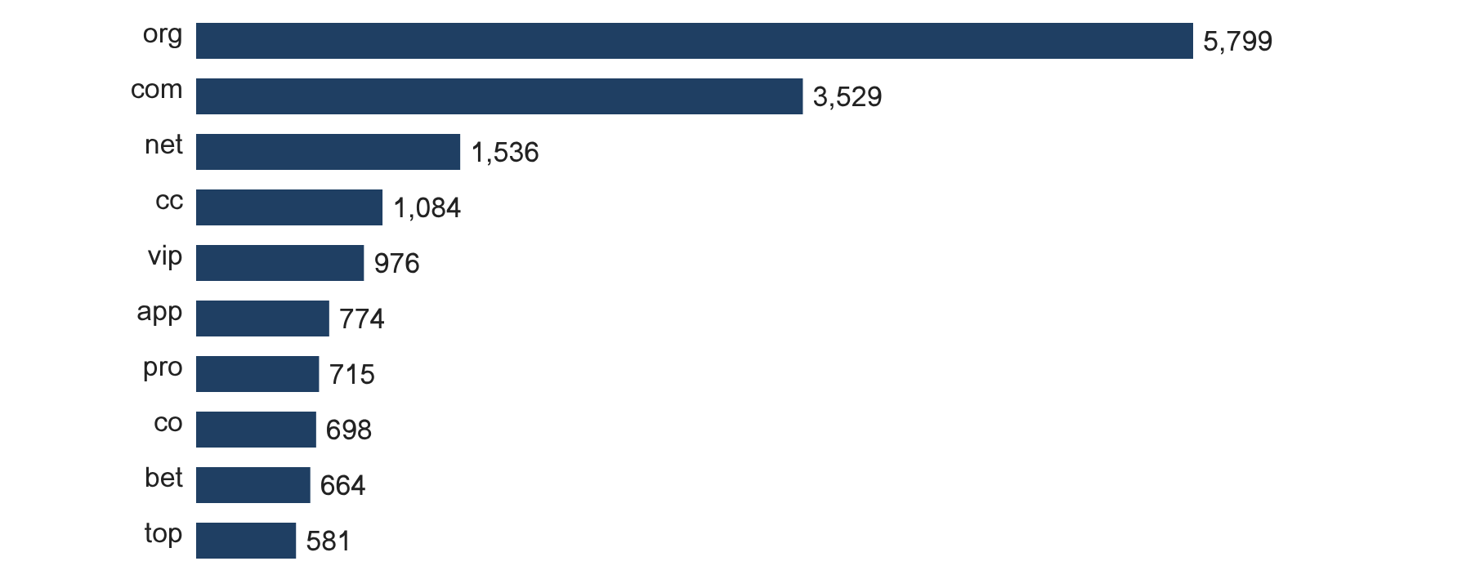
Suffix | Total | % of all | Gambling | % gambling
org | 5,799 | 26.4% | 12 | 0.2%
com | 3,529 | 16.1% | 1,534 | 43.5%
net | 1,536 | 7.0% | 998 | 65.0%
cc | 1,084 | 4.9% | 653 | 60.2%
vip | 976 | 4.4% | 886 | 90.8%
app | 774 | 3.5% | 578 | 74.7%
pro | 715 | 3.3% | 620 | 86.7%
co | 698 | 3.2% | 437 | 62.6%
bet | 664 | 3.0% | 642 | 96.7%
top | 581 | 2.6% | 314 | 54.0%
Table 3. Top 10 URL suffixes.

SUBCATEGORIES

GAMBLING SITES BY PRODUCT SUBCATEGORY
Gambling sites by product subcategory. Bar length is the site count and each label carries the count and the share of gambling rows.
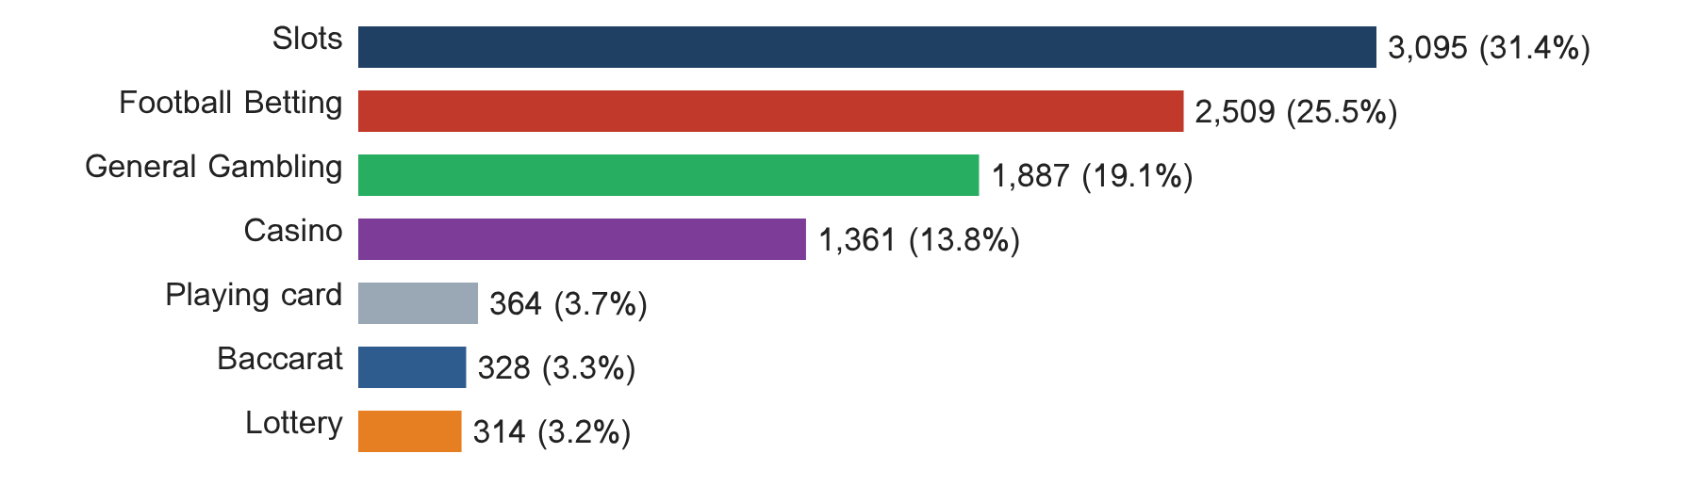
Figure 3. Gambling sites by product subcategory, share of gambling rows.

ASSIGNMENT METHOD BY SUBCATEGORY
How each subcategory was assigned. Solid fill is a lexicon keyword match and the lighter fill is reasoning inference.
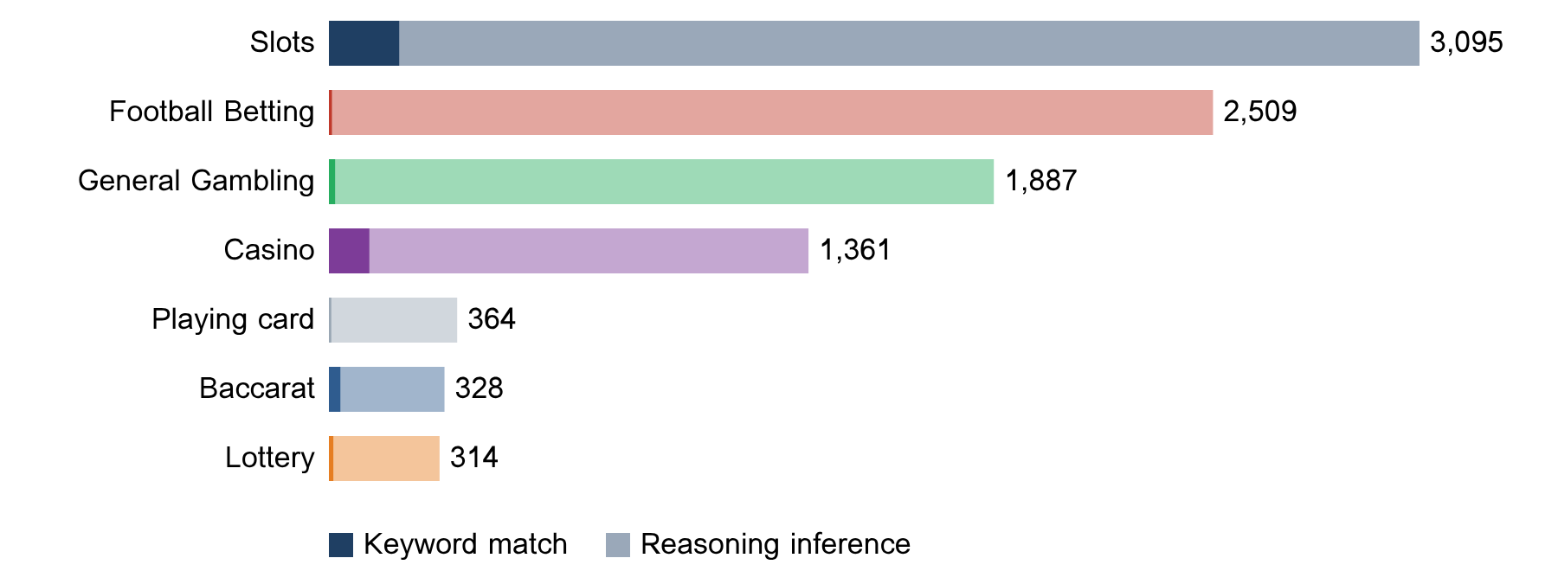
What a lexicon match means
A site is assigned to a subcategory by lexicon match when a word or phrase from the gambling keyword lexicon appears in what was recorded about the site, such as the model description or the domain, and that word belongs to the product category the site was assigned. A description containing บาคาร่าออนไลน์ is assigned to Baccarat by lexicon match. The lexicon is the SICPADetect Thai gambling keyword lexicon, version V1, with 286 keywords in 14 categories, mostly in Thai script. Seven categories describe the gambling product and decide the subcategory. The other seven describe how a site markets or operates and are reported as signal tags. A lexicon match rests on a word that can be pointed to, so it can be checked and repeated. An inferred assignment rests on the model reading of its own description and carries lower confidence.
Figure 4. Assignment method by subcategory. Inferred share 96.0%, general gambling share 19.1%.

SUBCATEGORY TABLE
Subcategory | Count | % of gambling | Keyword | Inferred | Clusters
Slots | 3,095 | 31.4% | 200 | 2,895 | 1,017
Football Betting | 2,509 | 25.5% | 9 | 2,500 | 905
General Gambling | 1,887 | 19.1% | 18 | 1,869 | 716
Casino | 1,361 | 13.8% | 115 | 1,246 | 563
Playing card | 364 | 3.7% | 7 | 357 | 218
Baccarat | 328 | 3.3% | 33 | 295 | 228
Lottery | 314 | 3.2% | 13 | 301 | 107
Table 4. Subcategory assignment counts.

KEYWORD BY SUBCATEGORY HEAT MAP
Matched keywords against product subcategory. Each cell is the number of gambling sites carrying that keyword in that subcategory.
 | Football Betting | Slots | Casino | Lottery | Playing card | Baccarat | General Gambling
VIP (Abbreviations) | 357 | 755 | 237 | 18 | 30 | 25 | 295
BET (Abbreviations) | 305 | 262 | 152 | 27 | 31 | 48 | 200
WIN (Abbreviations) | 42 | 273 | 54 | 23 | 16 | 9 | 112
สมัครสมาชิก (Marketing & Acquisition) | 17 | 133 | 52 | 45 | 13 | 27 | 56
สล็อต (Slots) | 4 | 200 | 60 | 2 | 6 | 25 | 0
WALLET (Abbreviations) | 20 | 49 | 32 | 1 | 1 | 9 | 39
Wallet (Deposit & Withdrawal) | 20 | 49 | 32 | 1 | 1 | 9 | 39
คาสิโน (Casino) | 2 | 25 | 115 | 1 | 0 | 7 | 0
PRAGMATIC (Abbreviations) | 27 | 45 | 16 | 1 | 0 | 16 | 29
คาสิโนออนไลน์ (Casino) | 2 | 3 | 86 | 0 | 0 | 0 | 0
สล็อตออนไลน์ (Slots) | 1 | 78 | 6 | 0 | 0 | 0 | 0
เกมสล็อต (Slots) | 0 | 67 | 13 | 0 | 0 | 0 | 0
บาคาร่า (Baccarat) | 2 | 17 | 12 | 1 | 6 | 33 | 0
เล่นสล็อต (Slots) | 1 | 48 | 1 | 0 | 0 | 0 | 0
JILI (Abbreviations) | 22 | 16 | 2 | 0 | 1 | 0 | 4
Affiliate (Affiliate & Agent) | 5 | 17 | 8 | 1 | 0 | 5 | 8
เดิมพัน (General Gambling) | 1 | 4 | 10 | 0 | 0 | 2 | 14
พนัน (General Gambling) | 1 | 10 | 10 | 0 | 0 | 2 | 4
JDB (Abbreviations) | 0 | 6 | 3 | 0 | 0 | 14 | 2
RTP (Abbreviations) | 3 | 15 | 2 | 1 | 0 | 1 | 2
เครดิตฟรี (Promotions) | 0 | 5 | 3 | 0 | 2 | 3 | 6
SEXY (Abbreviations) | 3 | 6 | 3 | 0 | 0 | 6 | 1
สมาชิกใหม่ (Marketing & Acquisition) | 5 | 8 | 2 | 0 | 0 | 0 | 3
AUTO (Abbreviations) | 3 | 8 | 1 | 0 | 0 | 1 | 4
การพนัน (General Gambling) | 0 | 7 | 9 | 0 | 0 | 0 | 1
Table 5. Top 25 matched keywords by product subcategory, with the lexicon category in brackets. Zero cells are white.

SIGNAL TAG BY SUBCATEGORY HEAT MAP
Signal tags against product subcategory. Each cell is the number of gambling sites carrying that tag in that subcategory.
 | Football Betting | Slots | Casino | Lottery | Playing card | Baccarat | General Gambling
Deposit & Withdrawal | 20 | 50 | 33 | 2 | 1 | 9 | 40
Promotions | 6 | 8 | 6 | 0 | 2 | 3 | 8
Marketing & Acquisition | 23 | 146 | 60 | 45 | 14 | 30 | 60
Affiliate & Agent | 8 | 22 | 11 | 1 | 1 | 5 | 20
Vague-Evasion Terms | 0 | 0 | 0 | 0 | 0 | 0 | 0
Abbreviations | 740 | 1300 | 464 | 66 | 72 | 118 | 615
Hashtags | 0 | 0 | 0 | 0 | 0 | 0 | 0
Table 6. Signal tags by product subcategory. Mean tags per gambling site: 0.41.

BRANDS AND CLUSTERING

WHAT BRAND CLUSTERS ARE
What a cluster is
A brand cluster is a group of domains judged to belong to the same gambling brand or operator. Domains join a cluster when their names reduce to the same stem once market tags, version numbers and suffixes are removed, or when their stems are near identical in spelling. A domain that matches no other is a singleton. This sample carries no crawler lineage, so no cluster rests on seed linkage.
Why clusters matter
Operators rarely run a single site. They register many domains and rotate top level domains so that when one address is blocked another takes its place. Counting URLs overstates how many operators there are. Clustering shows how many distinct operations exist, how concentrated the estate is, and which operators run several product types. Acting on a cluster reaches every domain in it. Clusters are an analytical grouping based on names, not a legal finding about ownership, and the linkage table is indicative only.

CLUSTER HEADLINE FIGURES
Distinct clusters | With 2 or more URLs | Singletons | Clusters to cover half
2,273 | 1,138 | 1,135 | 108
Table 7. Cluster counts. The top 5 clusters hold 19.4% and the top 10 hold 28.6% of gambling URLs.

TOP 15 BRAND CLUSTERS BY URL COUNT
The fifteen largest brand clusters by URL count. Bar length is the number of domains in the cluster.
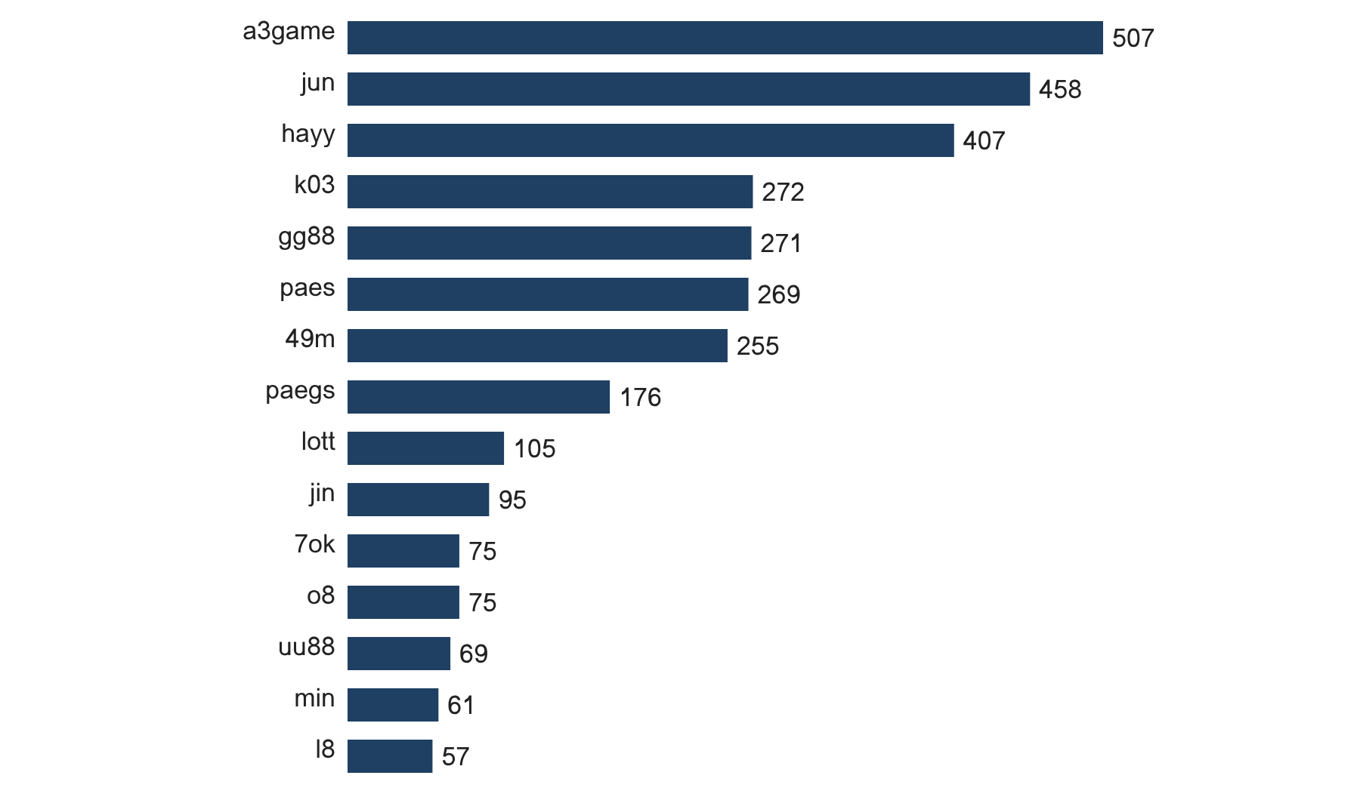
Figure 5. Top 15 brand clusters.

BRAND CLUSTER BY SUBCATEGORY HEAT MAP
Brand clusters against product subcategory. Each cell is the number of URLs a cluster holds in that subcategory.
 | Football Betting | Slots | Casino | Lottery | Playing card | Baccarat | General Gambling
a3game | 0 | 496 | 1 | 0 | 0 | 0 | 10
jun | 106 | 101 | 94 | 71 | 18 | 17 | 51
hayy | 215 | 20 | 158 | 0 | 0 | 0 | 14
k03 | 75 | 0 | 0 | 0 | 0 | 0 | 197
gg88 | 94 | 53 | 49 | 5 | 8 | 20 | 42
paes | 134 | 26 | 62 | 0 | 0 | 0 | 47
49m | 0 | 12 | 58 | 0 | 38 | 0 | 147
paegs | 94 | 11 | 47 | 0 | 0 | 0 | 24
lott | 2 | 11 | 0 | 76 | 3 | 1 | 12
jin | 20 | 28 | 5 | 0 | 9 | 0 | 33
7ok | 0 | 68 | 1 | 1 | 0 | 1 | 4
o8 | 0 | 57 | 0 | 0 | 0 | 0 | 18
uu88 | 16 | 26 | 10 | 2 | 1 | 5 | 9
min | 50 | 3 | 1 | 0 | 2 | 4 | 1
l8 | 0 | 12 | 1 | 0 | 0 | 0 | 44
s8s | 0 | 3 | 13 | 0 | 0 | 0 | 33
bohocasino | 2 | 34 | 10 | 0 | 0 | 0 | 1
jn86 | 25 | 15 | 0 | 0 | 0 | 0 | 0
pgcat | 3 | 26 | 4 | 0 | 1 | 4 | 2
bu88 | 4 | 31 | 3 | 0 | 0 | 0 | 1
Table 8. Top 20 clusters by product subcategory.

CLUSTER EXPANSION: A3GAME
The largest brand cluster and its member domains. Each node is one domain joined by stem or spelling similarity.
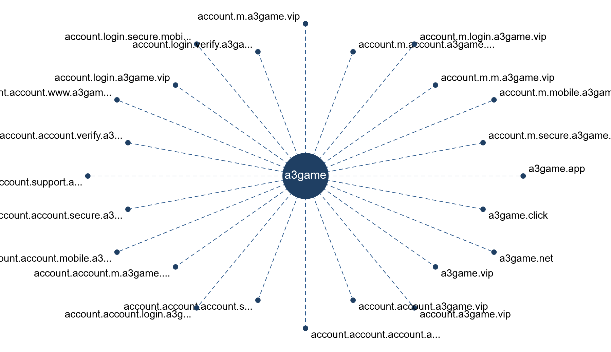
Figure 6. Cluster a3game, first 24 of 507 member domains. Dashed edges mark stem or similarity membership.

CLUSTERS SPANNING MULTIPLE SUBCATEGORIES
Cluster | URLs | Subcategories | Suffixes
a3game | 507 | Slots 496, Casino 1 | vip app click net
jun | 458 | Lottery 71, Slots 101, Football Betting 106, Casino 94, Playing card 18, Baccarat 17 | top com net bet cc
hayy | 407 | Football Betting 215, Casino 158, Slots 20 | net
gg88 | 271 | Baccarat 20, Playing card 8, Slots 53, Football Betting 94, Casino 49, Lottery 5 | net app pro bet com
paes | 269 | Football Betting 134, Casino 62, Slots 26 | dev
49m | 255 | Slots 12, Playing card 38, Casino 58 | co
paegs | 176 | Casino 47, Football Betting 94, Slots 11 | dev
lott | 105 | Slots 11, Lottery 76, Playing card 3, Football Betting 2, Baccarat 1 | com net cc live online
jin | 95 | Slots 28, Football Betting 20, Casino 5, Playing card 9 | vip com net co pro
7ok | 75 | Slots 68, Baccarat 1, Casino 1, Lottery 1 | bet live io club pro
uu88 | 69 | Slots 26, Casino 10, Football Betting 16, Lottery 2, Baccarat 5, Playing card 1 | cc net com app pro
min | 61 | Football Betting 50, Slots 3, Baccarat 4, Casino 1, Playing card 2 | net com app vip actor
l8 | 57 | Slots 12, Casino 1 | game
s8s | 49 | Slots 3, Casino 13 | com
bohocasino | 47 | Slots 34, Casino 10, Football Betting 2 | com info net co app
Table 9. Clusters spanning two or more product subcategories (665 in total, top 15 shown).

CLUSTERS ROTATING TOP LEVEL DOMAINS
Cluster | Suffixes and counts
a3game | vip 502, app 2, click 2, net 1
jun | top 91, com 65, net 51, bet 31, cc 25, app 25
gg88 | net 50, app 43, pro 41, bet 31, com 28, online 17
lott | com 59, net 9, cc 4, live 4, online 4, bet 4
jin | vip 19, com 16, net 13, co 12, pro 6, bet 5
7ok | bet 66, live 5, io 2, club 1, pro 1
o8 | game 73, live 2
uu88 | cc 11, net 9, com 7, app 5, pro 5, co 4
min | net 7, com 6, app 3, vip 3, actor 2, art 2
bohocasino | com 29, info 3, net 2, co 2, app 1, bet 1
pgcat | com 17, info 3, bet 2, buzz 2, click 2, club 2
bu88 | com 6, bid 2, cab 2, club 2, in 2, info 2
oo7 | vip 37, click 2
ju88 | com 24, click 4, buzz 2, pro 2, site 2, fun 2
m88thcasino | buzz 2, casino 2, cc 2, click 2, club 2, co 2
Table 10. Clusters using two or more suffixes (802 in total, top 15 shown).

POSSIBLE OPERATOR LINKAGE
Indicative, not a clustering decision.
Cluster A | Cluster B | Shared keywords | Jaccard
gg88 | hh88 | Affiliate, Partner | 1.00
jin | ju88 | Agent, Wallet | 1.00
7ok | jjun | Wallet, สมัครสมาชิก | 1.00
7ok | mun | Wallet, สมัครสมาชิก | 1.00
7ok | jub | Wallet, สมัครสมาชิก | 1.00
7ok | wingame | Wallet, สมัครสมาชิก | 1.00
7ok | hun | Wallet, สมัครสมาชิก | 1.00
7ok | jon | Wallet, สมัครสมาชิก | 1.00
7ok | kh88 | Wallet, สมัครสมาชิก | 1.00
7ok | hub | Wallet, สมัครสมาชิก | 1.00
7ok | jn789 | Wallet, สมัครสมาชิก | 1.00
7ok | ms88 | Wallet, สมัครสมาชิก | 1.00
Table 11. Pairs of clusters with Jaccard similarity of 0.60 or more on signal keywords, abbreviations excluded (268 pairs, top 12 shown).

NAMING CONVENTIONS
Recurring tokens in the largest clusters: "m." in 901 names, "mobile" in 738 names, "login" in 701 names, which points to a templated naming scheme.
Domains span several suffixes, led by org (5,799), com (3,529), net (1,536), cc (1,084), which indicates operators rotate top level domains.
9,858 distinct domains across 2,273 brand clusters.

RANKING
The feed carries no numeric rank, so the table shows a sample of gambling rows with rank shown as a dash.
Rank | Domain | Cluster | Subcategory
— | 000ok.net | 000ok | Casino
— | 002025.com | 002025 | Casino
— | 005p.com | 005p | General Gambling
— | 007game.pro | 007game | Baccarat
— | 007squidgame.club | 007squidgame | Slots
— | 008416.com | 008416 | General Gambling
— | 008464.com | 008464 | General Gambling
— | 008n.vip | 008n | Slots
— | 008op.cc | 008op | General Gambling
— | 008p.vip | 008p | Slots
Table 12. Gambling ranking sample.

KEY INSIGHTS

SCALE OF THE ANALYSIS
The analysis covers 21,978 distinct URLs over 32 days (2026-09-04 to 2026-10-05). Of these, 9,858 are gambling and 12,120 are not gambling. None were unreachable.
The sample is large enough to reason about patterns, not isolated cases.

WHAT IS BEING OFFERED
The top three product subcategories are Slots with 3,095 sites (31.4%), Football Betting with 2,509 sites (25.5%), General Gambling with 1,887 sites (19.1%). 19.1% of sites are confirmed gambling without an evidenced product type and 96.0% were assigned by inference. 212 lexicon keywords never matched.
The estate is spread across product types rather than concentrated. The lexicon has poor coverage of this dataset, so subcategory figures are indicative only.

BRAND CLUSTERING
2,273 clusters span 9,858 gambling URLs. 1,138 hold more than one domain and 108 clusters cover half the estate. The largest, a3game, holds 507 domains across 2 subcategories.
The estate is diffuse and per URL blocking will have limited leverage.

HOW THE ESTATE IS GROWN AND MARKETED
No source or redirect data is present, so crawler variants and redirect chains cannot be measured. 802 clusters rotate across more than one suffix. The two most common signal tags are Abbreviations (34.2%) and Marketing & Acquisition (3.8%).
Suffix rotation keeps a stable brand while the addresses behind it change.

ENFORCEMENT POSITION
0 pages show regulatory blocking indicators. The set appears pre enforcement.
This set is a candidate for a first enforcement pass, prioritised by cluster rather than by URL.
Lexicon: Gambling_Keywords_Full_English_Categories_V1, 286 keywords (Football Betting 21; Slots 32; Casino 14; Lottery 20; Playing card 12; Baccarat 11; General Gambling 22; Deposit & Withdrawal 24; Promotions 27; Marketing & Acquisition 25; Affiliate & Agent 20; Vague-Evasion Terms 20; Abbreviations 22; Hashtags 21). Inferred share 96.0%, general gambling share 19.1%. Rows normalised from Licensed gambling: 0. Abbreviation flagged as probable false positive source: VIP, BET. Clustering: Jaro Winkler 0.90 with prefix condition; linkage Jaccard 0.60.

