Ministry of Digital Economy and Society, Thailand
Data Insights & Patterns
21,978 URLs · 4 Sep – 5 Oct 2026
Issued to Ministry of Digital Economy and Society, Thailand
Prepared by SICPA SA
Date of issue 06/10/2026
Source system SICPADetect, keyword lexicon V1

Contents
Executive summary 3
Model Insights 4
Introduction 4
Insights 4
Performance 4
The numbers 5
Key metrics 5
URLs analyzed per day 5
Status distribution 6
Top 10 URL suffixes 7
Subcategories 8
Gambling sites by product subcategory 8
Assignment method by subcategory 9
Subcategory table 10
Heat map: keyword by subcategory 11
Heat map: signal tag by subcategory 12
Brands and clustering 12
What brand clusters are 12
Cluster metrics 13
Top 15 brand clusters by URL count 13
Heat map: brand cluster by subcategory 14
Cluster expansion: a3game 15
Clusters spanning multiple subcategories 16
Clusters rotating top level domains 17
Possible operator linkage 18
Naming conventions 18
Ranking 19
Gambling ranking 19
Key insights 19
Scale of the analysis 19
What is being offered 20
Brand clustering 20
How the estate is grown and marketed 20
Enforcement position 21

Executive summary
Insights and trends
The estate analysed holds 21,978 URLs updated over 32 days, and 9,858 of them are gambling sites.
Casino, Slots and Football Betting are the leading product types. Nearly all subcategory assignments rest on reasoning inference rather than lexicon matches, so subcategory figures are indicative only.
Operators are spread across many brands. 90 brand clusters cover half of the gambling URLs, and the largest cluster, a3game, holds 507 domains.
Abbreviations is the most common signal tag. Promotional and evasion vocabulary is rare in the descriptions recorded.
7 pages already show regulatory blocking indicators, so most of the set appears to be before any enforcement action.
The daily count of URLs analysed is uneven across the evaluation period, with two separate peaks, so no overall direction is stated. No gambling site in this sample carries a numeric rank, so no ranked site with Thai audience evidence is listed.
Key figures
Figure | Value
URLs analysed | 21,978
Gambling sites and share | 9,858 (44.9%)
Not gambling and unreachable | 12,120 not gambling; 0 unreachable
Brand clusters identified | 2,064; 1,073 hold more than one domain
Clusters needed to cover half of gambling URLs | 90
Largest cluster and its size | a3game; 507 domains
Dominant product subcategory and share | Casino; 29.0%
Most common signal tag and share | Abbreviations; 34.4%
Sites showing blocking indicators | 7
Keyword versus inferred split | 4.0% keyword; 96.0% inferred

Model Insights

Introduction

Insights

Performance

The numbers

Key metrics
21,978  Total URLs analyzed | 9,858  Gambling sites | 2,064  Brand clusters identified | 32 days  Evaluation period, 2026-09-04 → 2026-10-05

URLs analyzed per day
Daily count of URLs analysed across the evaluation period. Each point is one calendar day.
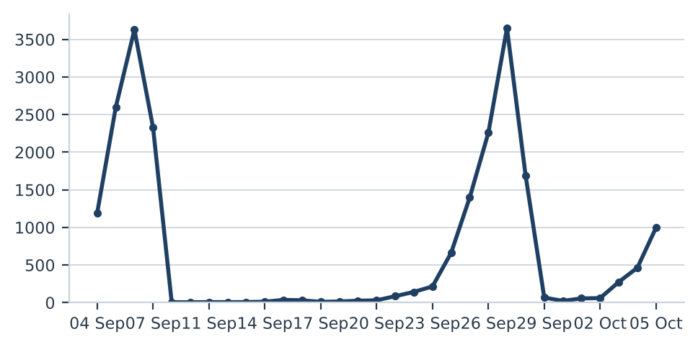

Status distribution
Share of the estate by classification status. Each segment is one status and the table beside it carries the counts.
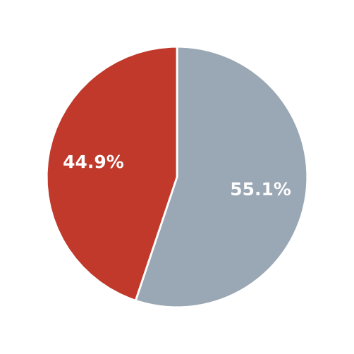
  Status | Count | %
  Not gambling | 12,120 | 55.1%
  Gambling | 9,858 | 44.9%

Top 10 URL suffixes
The ten most common URL suffixes in the estate. Bar length is the total count and the table separates the gambling share.
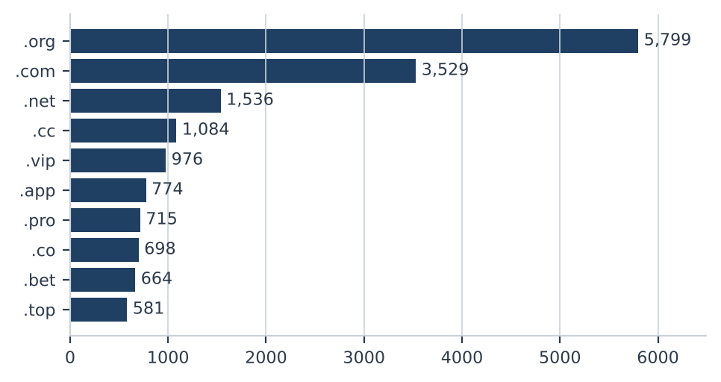
Suffix | Total | % of all | Gambling | % gambling
.org | 5,799 | 26.4% | 12 | 0.2%
.com | 3,529 | 16.1% | 1,534 | 43.5%
.net | 1,536 | 7.0% | 998 | 65.0%
.cc | 1,084 | 4.9% | 653 | 60.2%
.vip | 976 | 4.4% | 886 | 90.8%
.app | 774 | 3.5% | 578 | 74.7%
.pro | 715 | 3.3% | 620 | 86.7%
.co | 698 | 3.2% | 437 | 62.6%
.bet | 664 | 3.0% | 642 | 96.7%
.top | 581 | 2.6% | 314 | 54.0%

Subcategories

Gambling sites by product subcategory
Gambling sites grouped by product subcategory. Bar length is the site count and each label carries the count and the share of gambling rows.
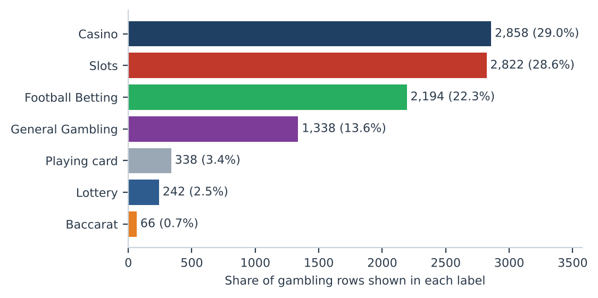
Shares are of gambling rows, not of all rows.

Assignment method by subcategory
How each subcategory was assigned. Solid fill is a lexicon keyword match and the lighter fill is reasoning inference.
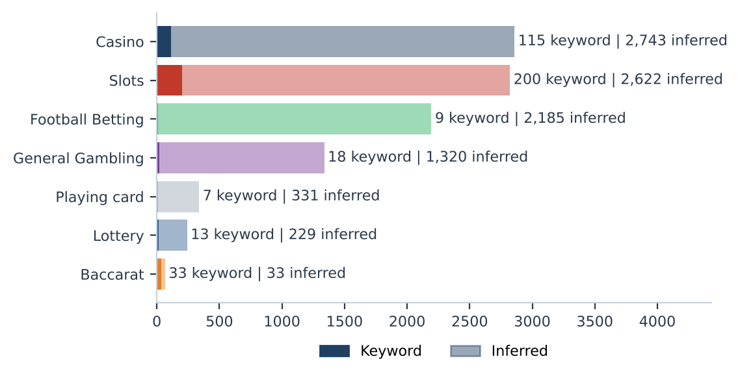
What a lexicon match means
A site is assigned to a subcategory by lexicon match when a word or phrase from the gambling keyword lexicon appears in what was recorded about the site, such as the model description or the domain, and that word belongs to the product category assigned. A description containing สล็อต is assigned to Slots by lexicon match. The lexicon is the SICPADetect Thai gambling keyword lexicon at the version on the title page, with 286 keywords in 14 categories. Seven categories describe the product and decide the subcategory. Seven describe marketing and operation, as signal tags. A lexicon match rests on a word that can be pointed to, so the assignment can be checked. An inferred assignment rests on the model reading of its own description and carries lower confidence.
Inferred share of gambling rows: 96.0%. General Gambling share of gambling rows: 13.6%. The lexicon has poor coverage of this dataset, so subcategory figures are indicative only.

Subcategory table
Subcategory | Count | % of gambling | Keyword assigned | Inferred | Distinct clusters
Casino | 2,858 | 29.0% | 115 | 2,743 | 950
Slots | 2,822 | 28.6% | 200 | 2,622 | 859
Football Betting | 2,194 | 22.3% | 9 | 2,185 | 768
General Gambling | 1,338 | 13.6% | 18 | 1,320 | 581
Playing card | 338 | 3.4% | 7 | 331 | 117
Lottery | 242 | 2.5% | 13 | 229 | 61
Baccarat | 66 | 0.7% | 33 | 33 | 48

Heat map: keyword by subcategory
Matched keywords against product subcategory. Each cell is the number of gambling sites carrying that keyword in that subcategory.
 |  | Football Betting | Slots | Casino | Lottery | Playing card | Baccarat | General Gambling
 | VIP | 318 | 725 | 371 | 16 | 23 | 6 | 258
 | BET | 241 | 270 | 307 | 21 | 6 | 11 | 169
 | WIN | 51 | 241 | 103 | 21 | 5 | 2 | 106
 | สมัครสมาชิก | 19 | 140 | 69 | 47 | 4 | 12 | 52
 | สล็อต | 4 | 200 | 60 | 2 | 6 | 25
 | Wallet | 15 | 66 | 42 |  |  | 6 | 22
 | WALLET | 15 | 66 | 42 |  |  | 6 | 22
 | คาสิโน | 2 | 25 | 115 | 1 |  | 7
 | คาสิโน | 2 | 25 | 115 | 1 |  | 7
 | PRAGMATIC | 5 | 120 | 8 |  |  | 1
 | คาสิโนออนไลน์ | 2 | 3 | 86
 | คาสิโนออนไลน์ | 2 | 3 | 86
 | สล็อตออนไลน์ | 1 | 78 | 6
 | เกมสล็อต |  | 67 | 13
 | บาคาร่า | 2 | 17 | 12 | 1 | 6 | 33
 | เล่นสล็อต | 1 | 48 | 1
 | JILI | 7 | 37 | 1
 | Affiliate | 3 | 18 | 12 | 1 |  | 2 | 8
 | เดิมพัน | 1 | 4 | 10 |  |  | 2 | 14
 | พนัน | 1 | 10 | 10 |  |  | 2 | 4
 | JDB |  | 12 | 12 |  |  |  | 1
 | RTP | 3 | 16 | 2 |  |  | 1 | 2
 | เครดิตฟรี | 1 | 5 | 5 |  |  | 3 | 5
 | SEXY | 3 | 8 | 6 |  |  | 2
 | SA | 11 |  | 6 |  |  | 1

 | Low: 1 |  | High: 725

Left strip colour marks the keyword category: Abbreviations; Marketing & Acquisition; Slots; Deposit & Withdrawal; Casino; General Gambling; Baccarat; Affiliate & Agent; Promotions.

Heat map: signal tag by subcategory
Signal tags against product subcategory. Each cell is the number of gambling sites carrying that tag in that subcategory.
 |  | Football Betting | Slots | Casino | Lottery | Playing card | Baccarat | General Gambling
 | Abbreviations | 618 | 1337 | 811 | 53 | 33 | 27 | 513
 | Marketing & Acquisition | 24 | 152 | 79 | 47 | 5 | 15 | 56
 | Deposit & Withdrawal | 15 | 67 | 43 | 1 |  | 6 | 23
 | Affiliate & Agent | 8 | 23 | 16 | 1 | 1 | 2 | 14
 | Promotions | 5 | 10 | 8 |  |  | 3 | 7
 | Vague-Evasion Terms
 | Hashtags

 | Low: 1 |  | High: 1337

Brands and clustering

What brand clusters are
What a cluster is
A brand cluster is a group of domains judged to belong to the same gambling brand or operator. A domain joins a cluster in one of three ways. The crawler may have found it as a variant of, or a redirect from, another domain, which is the strongest basis. Otherwise its name reduces to the same stem once market tags, version numbers and suffixes are removed, so a3game.app and a3game.click both reduce to a3game. Or its stem is near identical to another. A domain that matches no other is a singleton.
Why clusters matter
Operators rarely run a single site. They register many domains, rotate top level domains and redirect players between them, so a blocked address is replaced. Counting URLs therefore overstates how many operators exist and hides who stands behind the estate. Clustering shows how many distinct operations there are, how concentrated the estate is, and which operators run several product types. Acting on a cluster reaches every domain in it, where acting on a single URL leaves the rest of the brand running. Clusters are an analytical grouping based on names and crawler links, not a legal finding about ownership, and the linkage table is indicative only.

Cluster metrics
2,064  Distinct clusters | 1,073  Clusters with 2 or more URLs | 991  Singletons | 90  Clusters to cover half of gambling URLs

Top 15 brand clusters by URL count
The fifteen largest brand clusters by URL count. Bar length is the number of domains in the cluster.
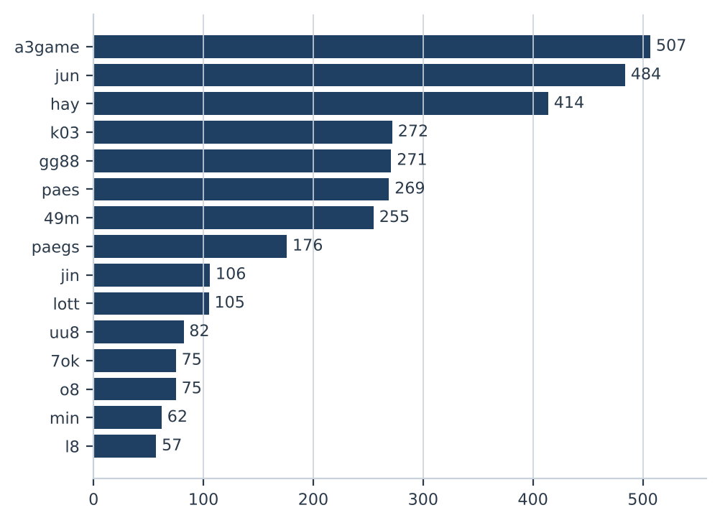

Heat map: brand cluster by subcategory
Brand clusters against product subcategory. Each cell is the number of URLs a cluster holds in that subcategory.
 | Football Betting | Slots | Casino | Lottery | Playing card | Baccarat | General Gambling
a3game |  | 491 | 3 | 3 |  |  | 10
jun | 104 | 117 | 135 | 66 | 12 | 7 | 43
hay | 132 | 10 | 261 |  |  |  | 11
k03 | 272
gg88 | 52 | 50 | 127 |  | 1 | 1 | 40
paes | 104 | 25 | 94 |  |  |  | 46
49m |  | 12 | 74 |  | 169
paegs | 65 | 11 | 76 |  |  |  | 24
jin | 19 | 31 | 20 | 1 | 7 |  | 28
lott | 2 | 10 | 4 | 77 | 2 |  | 10
uu8 | 19 | 21 | 29 | 1 | 1 |  | 11
7ok |  | 69 | 2 | 1 |  |  | 3
o8 |  | 55 | 2 |  |  |  | 18
min | 47 | 5 | 8 |  | 1 |  | 1
l8 |  | 12 | 1 |  |  |  | 44
s8s |  | 4 | 12 |  |  |  | 33
bohocasino |  | 8 | 38 |  |  |  | 1
oo7 | 2 | 12 | 7 |  |  |  | 26
bu8 | 5 | 27 | 6 | 1 |  |  | 3
jju | 7 | 7 | 19 |  |  | 4 | 3

 | Low: 1 |  | High: 491

Cluster expansion: a3game
The largest brand cluster and its member domains. Edge style records why each domain joined the cluster.
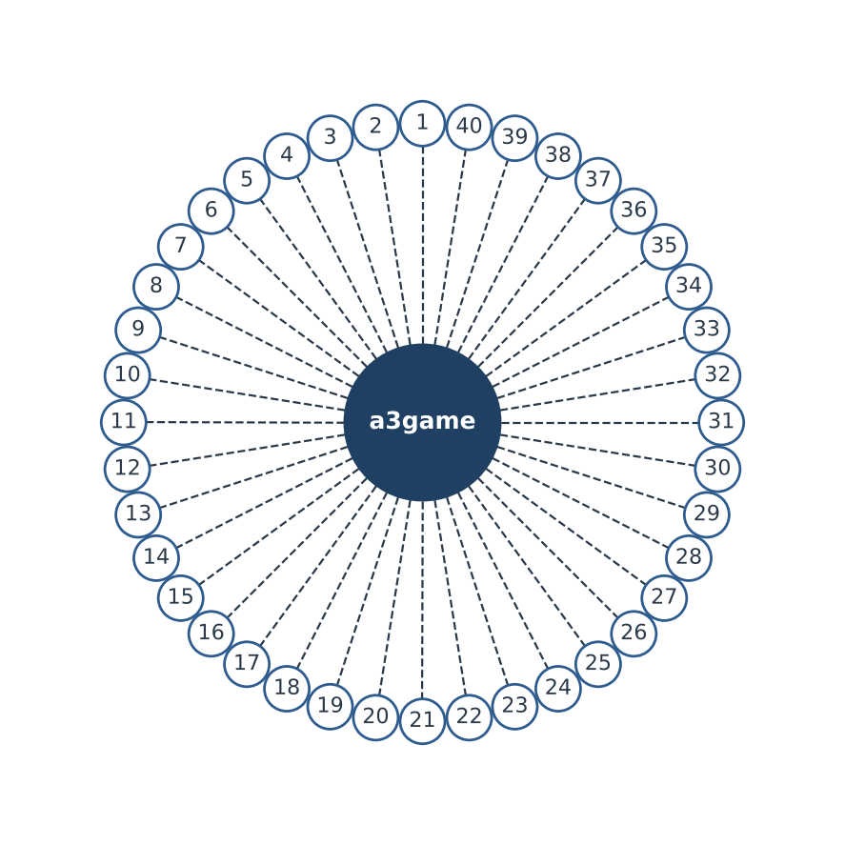
Dashed edges mark members that share the cluster stem. Dotted edges mark members that joined by spelling similarity.
1 | a3game.app | 21 | account.m.login.a3game.vip
2 | a3game.click | 22 | account.m.m.a3game.vip
3 | a3game.net | 23 | account.m.mobile.a3game.vip
4 | a3game.vip | 24 | account.m.secure.a3game.vip
5 | account.a3game.vip | 25 | account.m.support.a3game.vip
6 | account.account.a3game.vip | 26 | account.m.www.a3game.vip
7 | account.account.account.a3game.vip | 27 | account.m.www.mobile.a3game.vip
8 | account.account.account.support.a3game.vip | 28 | account.mobile.a3game.vip
9 | account.account.login.a3game.vip | 29 | account.mobile.account.a3game.vip
10 | account.account.m.a3game.vip | 30 | account.mobile.login.a3game.vip
11 | account.account.mobile.a3game.vip | 31 | account.mobile.m.a3game.vip
12 | account.account.secure.a3game.vip | 32 | account.mobile.m.www.a3game.vip
13 | account.account.support.a3game.vip | 33 | account.mobile.mobile.a3game.vip
14 | account.account.verify.a3game.vip | 34 | account.mobile.secure.a3game.vip
15 | account.account.www.a3game.vip | 35 | account.mobile.support.a3game.vip
16 | account.login.a3game.vip | 36 | account.secure.a3game.vip
17 | account.login.secure.mobile.a3game.vip | 37 | account.secure.mobile.a3game.vip
18 | account.login.verify.a3game.vip | 38 | account.secure.secure.a3game.vip
19 | account.m.a3game.vip | 39 | account.secure.verify.a3game.vip
20 | account.m.account.a3game.vip | 40 | account.support.a3game.vip

Showing 40 of 507 member domains.

Clusters spanning multiple subcategories
Cluster | URL count | Subcategories | Suffixes
a3game | 507 | Slots 491; General Gambling 10; Casino 3; Lottery 3 | .app, .click, .net, .vip
jun | 484 | Casino 135; Slots 117; Football Betting 104; Lottery 66; General Gambling 43; Playing card 12; Baccarat 7 | .top, .cc, .mobile, .xyz
hay | 414 | Casino 261; Football Betting 132; General Gambling 11; Slots 10 | .net, .app, .bet, .club
gg88 | 271 | Casino 127; Football Betting 52; Slots 50; General Gambling 40; Playing card 1; Baccarat 1 | .pro, .app, .bet, .cc
paes | 269 | Football Betting 104; Casino 94; General Gambling 46; Slots 25 | .dev
49m | 255 | Playing card 169; Casino 74; Slots 12 | .co
paegs | 176 | Casino 76; Football Betting 65; General Gambling 24; Slots 11 | .dev
jin | 106 | Slots 31; General Gambling 28; Casino 20; Football Betting 19; Playing card 7; Lottery 1 | .vip, .com, .net, .bet
lott | 105 | Lottery 77; Slots 10; General Gambling 10; Casino 4; Playing card 2; Football Betting 2 | .com, .th, .cc, .fun
uu8 | 82 | Casino 29; Slots 21; Football Betting 19; General Gambling 11; Lottery 1; Playing card 1 | .cc, .app, .io, .click
7ok | 75 | Slots 69; General Gambling 3; Casino 2; Lottery 1 | .bet, .club, .io, .live
o8 | 75 | Slots 55; General Gambling 18; Casino 2 | .game, .live
min | 62 | Football Betting 47; Casino 8; Slots 5; Playing card 1; General Gambling 1 | .com, .net, .academy, .actor
l8 | 57 | General Gambling 44; Slots 12; Casino 1 | .game
s8s | 49 | General Gambling 33; Casino 12; Slots 4 | .com

Largest 15 of 791 clusters spanning two or more product subcategories.

Clusters rotating top level domains
Cluster | Suffixes | Counts
jun | 30 | .top 93, .com 71, .net 54, .bet 32, .cc 25, .app 25
min | 29 | .net 7, .com 6, .app 4, .vip 3, .actor 2, .art 2
uu8 | 22 | .cc 11, .com 9, .net 9, .pro 7, .app 6, .click 5
bu8 | 21 | .com 6, .app 2, .bid 2, .cab 2, .club 2, .in 2
gg88 | 19 | .net 50, .app 43, .pro 41, .bet 31, .com 28, .online 17
jin | 19 | .vip 21, .com 16, .co 14, .net 13, .bet 7, .pro 7
m88thcasino | 17 | .buzz 2, .casino 2, .cc 2, .click 2, .club 2, .co 2
ezslot | 17 | .bet 4, .live 3, .buzz 2, .cc 2, .info 2, .land 2
lott | 16 | .com 59, .net 9, .cc 4, .live 4, .online 4, .bet 4
hh9 | 16 | .pro 3, .net 3, .vip 3, .bet 3, .club 2, .click 2
bohocasino | 15 | .com 29, .info 3, .net 2, .co 2, .app 1, .bet 1
mu8 | 15 | .net 4, .cc 3, .me 3, .bet 3, .online 2, .fun 2
jju | 14 | .com 5, .net 5, .xyz 5, .pro 4, .co 4, .top 4
pgcat | 14 | .com 17, .info 3, .bet 2, .buzz 2, .click 2, .club 2
ku8 | 14 | .com 7, .net 4, .pro 3, .casino 2, .io 2, .live 2

Top 15 of 757 clusters using two or more suffixes, ranked by number of suffixes.

Possible operator linkage
Indicative, not a clustering decision
Cluster A | Cluster B | Shared keywords | Jaccard
gg88 | hh88 | Affiliate, Partner | 1.00
7ok | jju | Wallet, สมัครสมาชิก | 1.00
7ok | mun | Wallet, สมัครสมาชิก | 1.00
7ok | jub | Wallet, สมัครสมาชิก | 1.00
7ok | ko9 | Wallet, สมัครสมาชิก | 1.00
7ok | ub8 | Wallet, สมัครสมาชิก | 1.00
7ok | wingame | Wallet, สมัครสมาชิก | 1.00
7ok | jon | Wallet, สมัครสมาชิก | 1.00
7ok | hun | Wallet, สมัครสมาชิก | 1.00
7ok | kh88 | Wallet, สมัครสมาชิก | 1.00
7ok | hub | Wallet, สมัครสมาชิก | 1.00
7ok | jn789 | Wallet, สมัครสมาชิก | 1.00
7ok | m98 | Wallet, สมัครสมาชิก | 1.00
7ok | ms88 | Wallet, สมัครสมาชิก | 1.00
7ok | dreamworld | Wallet, สมัครสมาชิก | 1.00

Top 15 of 224 pairs with at least two shared signal keywords and a Jaccard score of 0.60 or more. Abbreviation keywords are excluded.

Naming conventions
• Recurring tokens across the 10 largest clusters: m. (781 names), mobile (653 names), login (630 names), out of 2,859 domain names. This is consistent with a templated naming scheme.
• Names in the largest cluster span more than one suffix: .vip (502), .app (2), .click (2), .net (1). The operator rotates top level domains.
• 9,858 distinct domains across 2,064 brand clusters.

Ranking

Gambling ranking
Sample of gambling sites. None carries a numeric rank in this dataset.
Rank | Domain | Brand cluster | Subcategory | Source
— | 000ok.net | 000ok | Casino | —
— | 002025.com | 002025 | Casino | —
— | 005p.com | 005p | Football Betting | —
— | 007game.pro | 007game | Slots | —
— | 007squidgame.club | 007squidgame | Slots | —
— | 008416.com | 008416 | General Gambling | —
— | 008464.com | 008464 | General Gambling | —
— | 008n.vip | 008n | Slots | —
— | 008op.cc | 008op | Playing card | —
— | 008p.vip | 008p | Slots | —

Rank reflects search visibility in the source feed, not harm, reach or revenue.

Key insights

Scale of the analysis
21,978 distinct URLs were analysed over 32 days, from 2026-09-04 to 2026-10-05. Of these, 9,858 are gambling, 12,120 are not gambling and 0 are unreachable.
The sample is large enough to reason about patterns, not isolated cases.

What is being offered
The top three product subcategories are Casino (2,858, 29.0%), Slots (2,822, 28.6%) and Football Betting (2,194, 22.3%). 13.6% of gambling sites are confirmed as gambling without an evidenced product type, and 96.0% of assignments are inferred. 210 lexicon keywords never matched.
The estate is spread across product types rather than concentrated, with Casino the largest. The lexicon has poor coverage of this dataset and subcategory figures are indicative only; Vague-Evasion Terms, Hashtags have the weakest coverage, with no keyword matched.

Brand clustering
2,064 clusters cover 9,858 gambling URLs. 1,073 of them hold more than one domain, and 90 clusters cover half the estate. The largest, a3game, holds 507 domains across 4 subcategories.
The estate is diffuse and per URL blocking has limited leverage.

How the estate is grown and marketed
757 clusters rotate across more than one top level domain. The two most common signal tags are Abbreviations (34.4% of gambling sites) and Marketing & Acquisition (3.8%).
Rotation across top level domains keeps a stable brand name while the addresses behind it change. Promotions and Vague-Evasion Terms are not dominant, so the acquisition route is not primarily promotional content.

Enforcement position
7 pages already show regulatory blocking indicators such as court orders, regulator notices or block pages.
A measurable share is already under enforcement, and the remainder is a candidate for a first enforcement pass, prioritised by cluster rather than by URL.

Lexicon source: Gambling_Keywords_Full_English_Categories_V1.xlsx, version V1. Keywords per category: Football Betting 21, Slots 32, Casino 14, Lottery 20, Playing card 12, Baccarat 11, General Gambling 22, Deposit & Withdrawal 24, Promotions 27, Marketing & Acquisition 25, Affiliate & Agent 20, Vague-Evasion Terms 20, Abbreviations 22, Hashtags 21. Inferred share 96.0%. General Gambling share 13.6%. Rows normalised from Licensed gambling: 0. Abbreviations flagged as probable false positives: none. Clustering: Jaro-Winkler similarity at or above 0.90 with prefix relation; linkage Jaccard at or above 0.60.

