Data Insights & Patterns
Online gambling estate — structure, brands and enforcement position
Prepared for | Ministry of Digital Economy and Society (MDES), Thailand
Evaluation period | 2026-08-06 → 2026-09-17 (43 days)
URLs analysed | 23,496
Gambling sites identified | 9,102 (38.7% of the set)
Brand clusters identified | 1,010

Contents
…

1 Executive summary
This report analyses 23,496 distinct URLs reviewed over 43 days (2026-08-06 → 2026-09-17). Of these, 9,102 (38.7%) were assessed as gambling sites, 14,380 as not gambling and 14 as unreachable. The gambling estate resolves to 1,010 brand clusters, of which 764 hold more than one domain. Concentration is low: the largest cluster, “bet”, accounts for 177 URLs (1.9% of the estate), and 125 clusters are needed to cover half of it.
The dominant product type is Casino at 39.9% of gambling sites, followed by Slots (21.1%) and General Gambling (20.5%). These subcategory figures are indicative only: 97.6% of gambling rows carried no product keyword from the lexicon and were placed by reading the classifier's own reasoning text. Only 73 of the 286 lexicon keywords matched anything in this sample.
Structurally, the estate is overwhelmingly crawler-propagated: 92.6% of gambling URLs are identified variants of a known seed and a further 6.0% sit behind redirects, leaving only 1.4% reached directly. 559 clusters rotate across more than one top-level domain. No page in the set showed regulatory-blocking indicators, so this estate appears to be pre-enforcement and is a candidate for a first blocking pass.

1.1 Reporting figures at a glance
Reporting figure | Value
URLs analysed | 23,496
Gambling sites | 9,102 (38.7%)
Not gambling | 14,380
Unreachable | 14
Brand clusters identified | 1,010
Clusters holding more than one domain | 764
Clusters needed to cover 50% of gambling URLs | 125
Largest cluster | bet — 177 URLs (1.9%)
Dominant product subcategory | Casino — 3,635 (39.9%)
Most common signal tag | Abbreviations — 3,502 (38.5%)
Sites showing blocking indicators | 0
Subcategory assignment: keyword vs inferred | 221 keyword / 8,881 inferred (97.6% inferred)

Table 1. Headline reporting figures for the evaluation period.

2 The numbers

2.1 Scale of the analysis
23,496 | 9,102 | 1,010 | 43
Total URLs analyzed | Gambling sites | Brand clusters identified | Days  2026-08-06 → 2026-09-17

Table 2. Headline volumes for the evaluation period.

2.2 URLs analyzed per day
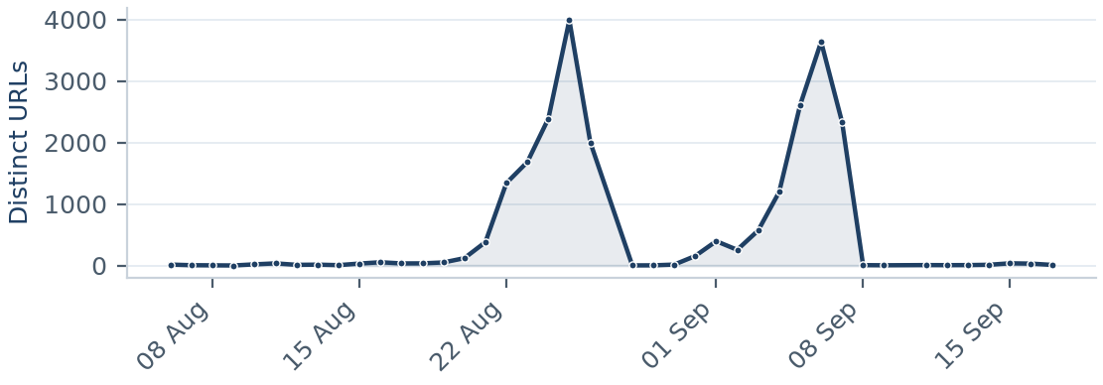
Figure 1. Distinct URLs updated per day across the evaluation period (41 days carried activity).
Figure 1 shows review volume was not spread evenly across the period; the series covers 41 distinct dates between 2026-08-06 and 2026-09-17.

2.3 Status distribution
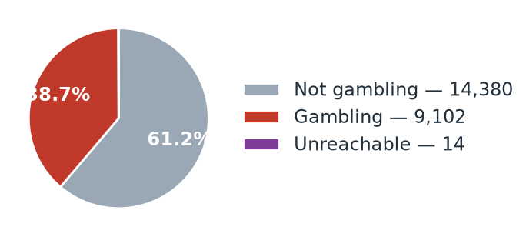
Figure 2. Share of the analysed set by assessed status.
Figure 2 and Table 3 give the same split.
Status | Count | % of set
Not gambling | 14,380 | 61.2%
Gambling | 9,102 | 38.7%
Unreachable | 14 | 0.1%

Table 3. Assessed status across the analysed set.

2.4 Top 10 URL suffixes
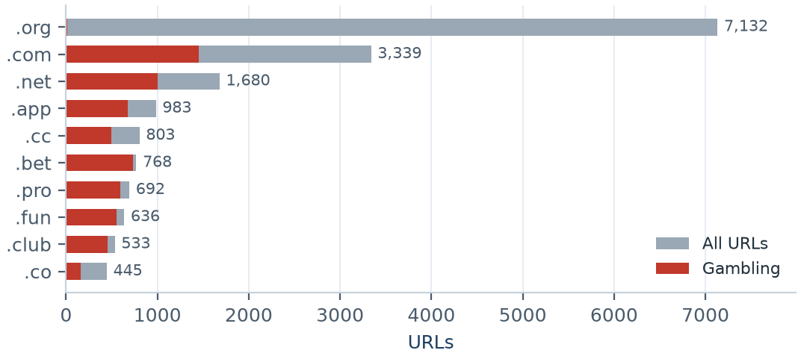
Figure 3. The ten most common URL suffixes, with the gambling share of each.
Suffix | Total | % of all | Gambling | % gambling
.org | 7,132 | 30.4% | 10 | 0.1%
.com | 3,339 | 14.2% | 1,451 | 43.5%
.net | 1,680 | 7.2% | 1,001 | 59.6%
.app | 983 | 4.2% | 673 | 68.5%
.cc | 803 | 3.4% | 492 | 61.3%
.bet | 768 | 3.3% | 736 | 95.8%
.pro | 692 | 2.9% | 591 | 85.4%
.fun | 636 | 2.7% | 549 | 86.3%
.club | 533 | 2.3% | 451 | 84.6%
.co | 445 | 1.9% | 158 | 35.5%

Table 4. URL suffix distribution and the gambling rate within each suffix.
Table 4 shows the suffixes differ sharply in gambling rate: .org is the most common suffix overall (30.4% of the set) but only 0.1% of it is gambling, while the highest-rate suffix in the top ten reaches 95.8%.

2.5 Source analysis
Source category | Total | Gambling | Not gambling | % gambling
Manual | 450 | 68 | 368 | 15.1%
Google Search | 405 | 36 | 369 | 8.9%
Variant | 20,981 | 8,427 | 12,554 | 40.2%
Redirect | 1,231 | 546 | 685 | 44.4%
Other | 429 | 25 | 404 | 5.8%

Table 5. How each discovery source performed, measured against its own total.

3 Subcategories
Before the figures in this section are read: 97.6% of gambling rows matched no product keyword from the lexicon and 20.5% resolved only to General Gambling. The lexicon has poor coverage of this dataset, and every subcategory figure in this section is therefore indicative only.

3.1 Gambling sites by product subcategory
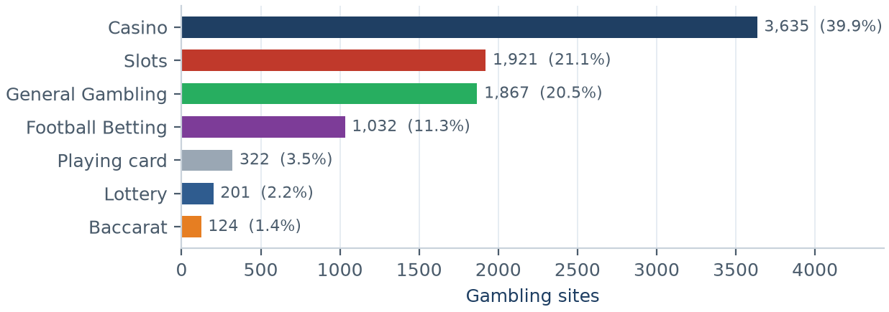
Figure 4. Gambling sites by product subcategory, descending.
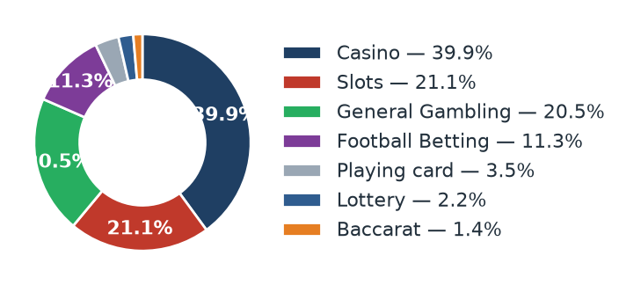
Figure 5. The same distribution as a share of the gambling estate.

3.2 Assignment method by subcategory
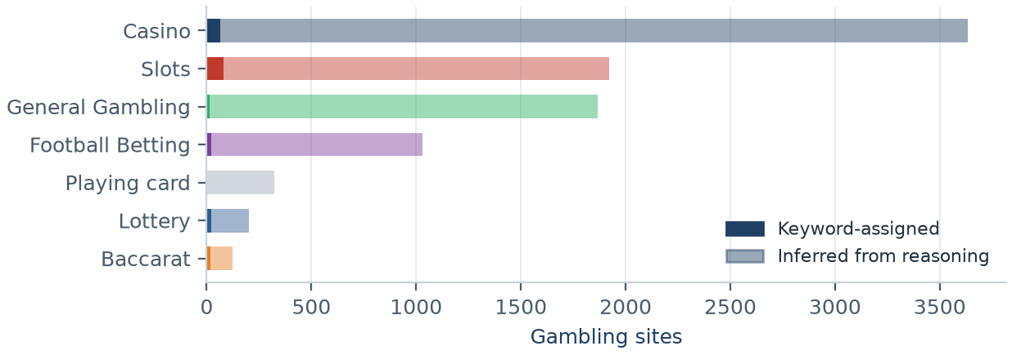
Figure 6. Keyword-assigned versus inferred rows within each subcategory. Inferred share 97.6%; General Gambling share 20.5%.
Figure 6 separates the two assignment routes. The solid portion of each bar was assigned from a lexicon keyword match; the lighter portion was inferred by reading the classifier's reasoning text. Across the estate 221 rows were keyword-assigned and 8,881 inferred.

3.3 Subcategory table
Subcategory | Count | % of gambling | Keyword | Inferred | Clusters
Casino | 3,635 | 39.9% | 63 | 3,572 | 633
Slots | 1,921 | 21.1% | 81 | 1,840 | 540
General Gambling | 1,867 | 20.5% | 13 | 1,854 | 535
Football Betting | 1,032 | 11.3% | 23 | 1,009 | 379
Playing card | 322 | 3.5% | 2 | 320 | 186
Lottery | 201 | 2.2% | 21 | 180 | 74
Baccarat | 124 | 1.4% | 18 | 106 | 93

Table 6. Product subcategories with their assignment split and cluster spread.

3.4 Signal tags across the estate
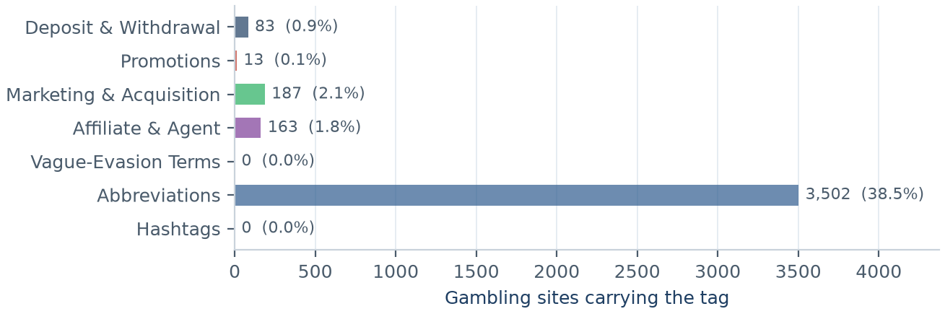
Figure 7. Gambling sites carrying each signal tag. Mean tags per site: 0.43.
Figure 7 counts how sites operate and market themselves rather than what they sell. At 0.43 tags per gambling site the estate is sparsely tagged, and two categories — Vague-Evasion Terms and Hashtags — did not match at all.

3.5 Heat map — keyword by subcategory
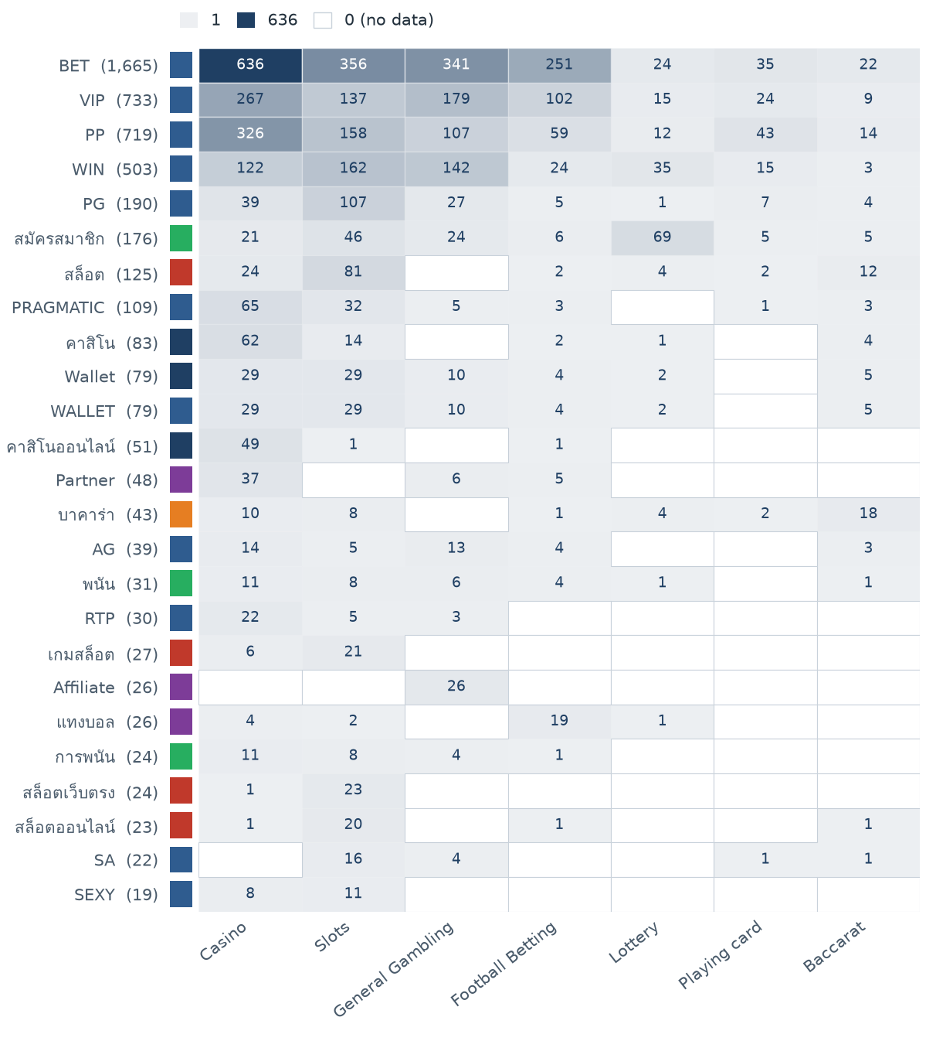
Figure 8. The 25 most frequently matched keywords against the seven product subcategories. The coloured strip beside each keyword shows the lexicon category it belongs to, so cross-category bleed is visible.
Figure 8 shows the matched vocabulary is dominated by short Latin abbreviations rather than product terms, which is why so few rows could be assigned by keyword.

3.6 Heat map — signal tag by subcategory
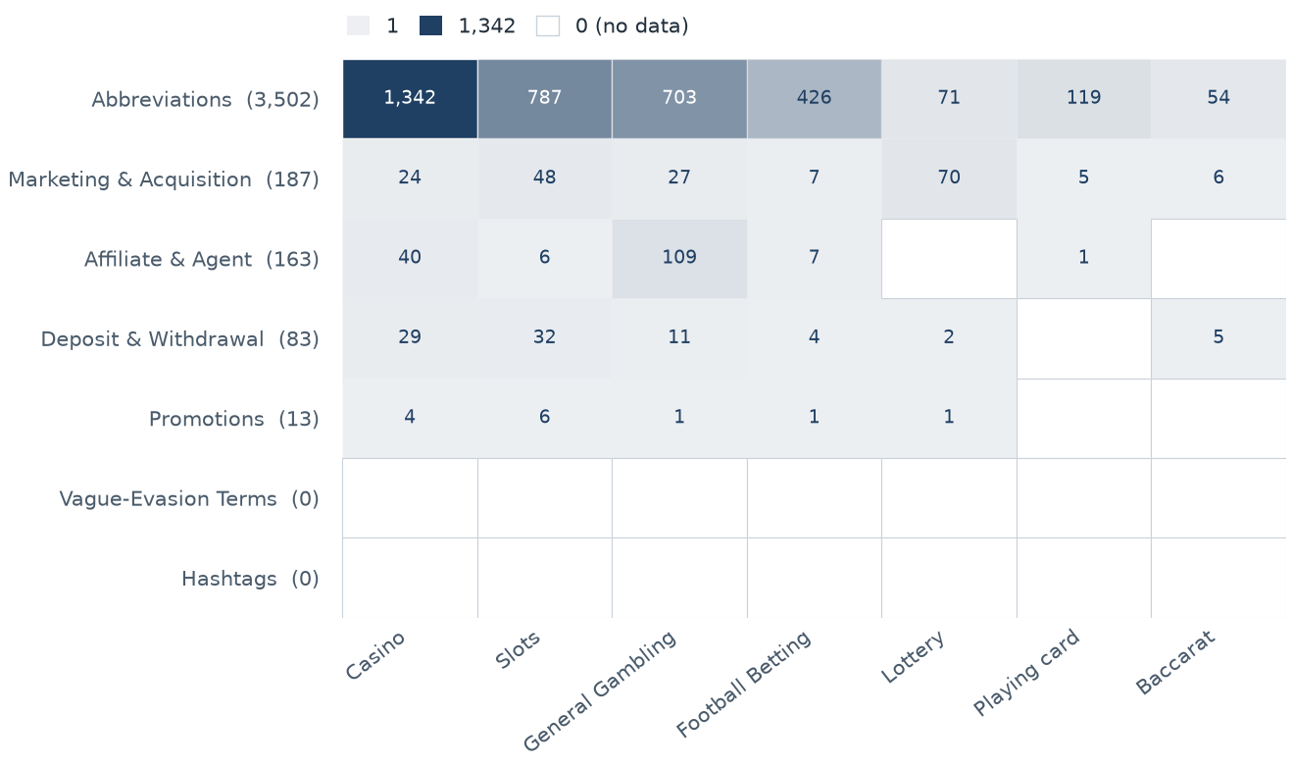
Figure 9. Signal categories against product subcategories, by site count.
Figure 9 shows which products lean on promotional, payment or evasion language.

4 Brands and clustering

4.1 Cluster counts
1,010 | 764 | 246 | 125
Distinct clusters | Clusters with 2+ URLs | Singletons | Clusters to cover 50%

Table 7. Brand-cluster counts across the gambling estate.

4.2 Top 15 brand clusters by URL count
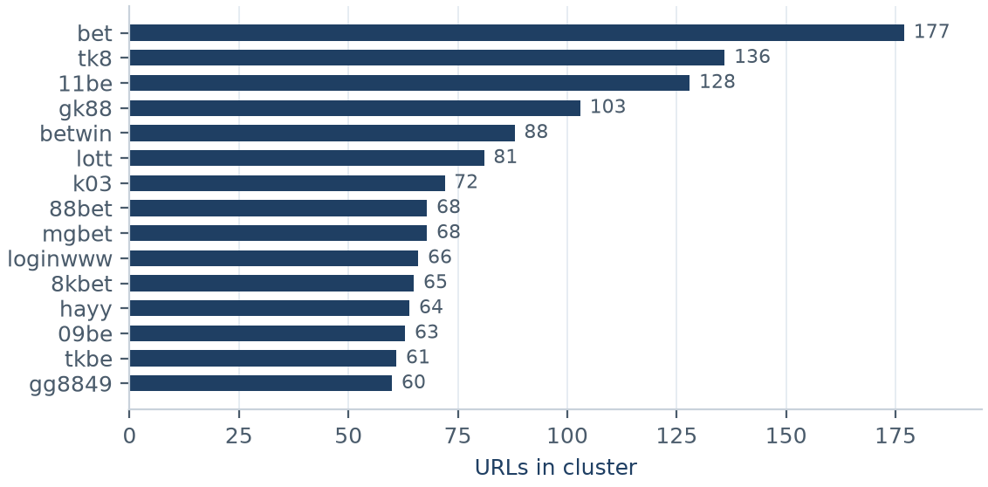
Figure 10. The fifteen largest brand clusters by number of URLs.

4.3 Cluster concentration
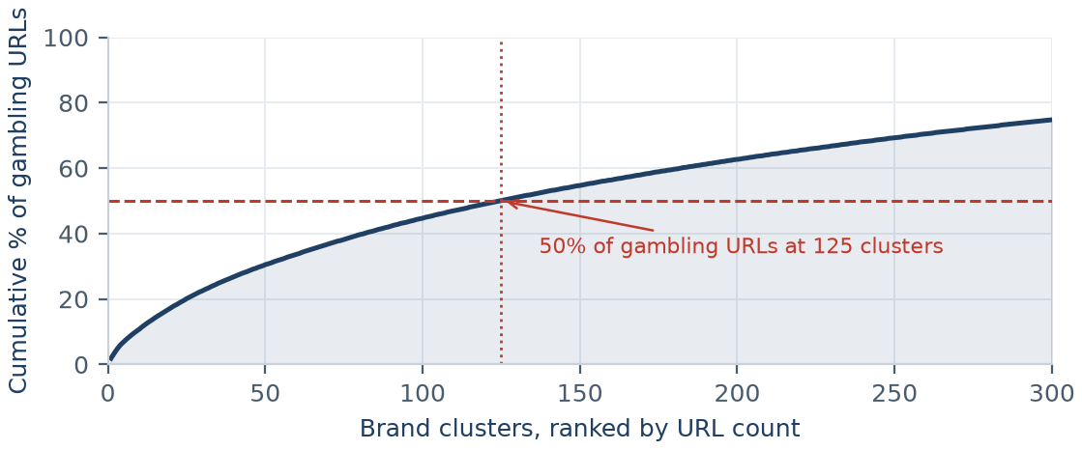
Figure 11. Cumulative share of gambling URLs as clusters are added in rank order. The top 5 clusters hold 6.9% and the top 10 hold 10.8%.
Figure 11 is the clearest statement of leverage in this report. The curve rises slowly: 125 clusters are needed before half the gambling estate is covered, so there is no small set of operators to target first.

4.4 Heat map — brand cluster by subcategory
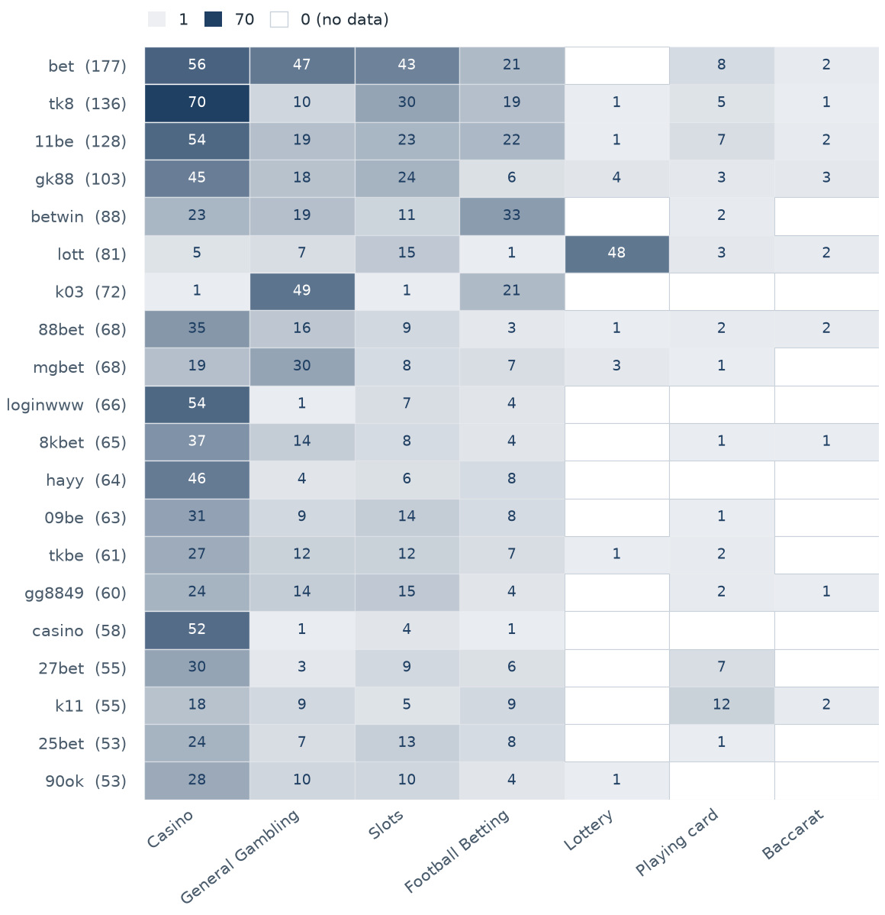
Figure 12. The 20 largest clusters against the seven product subcategories. Multi-product operators appear as horizontal bands.

4.5 Cluster expansion — bet
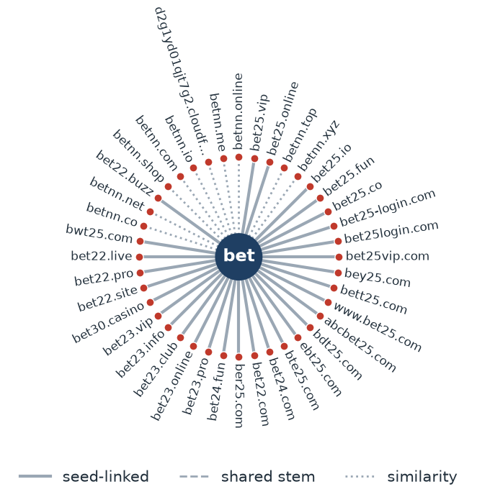
Figure 13. Members of the largest cluster, “bet” (177 URLs; up to 40 shown). Edge style records why each domain joined: solid for crawler-asserted seed linkage, dashed for a shared stem, dotted for near-miss similarity.
Figure 13 shows the shape the whole estate repeats: a stable brand token carrying numeric and suffix variation across several top-level domains, with membership asserted mostly by the crawler rather than inferred.

4.6 Clusters spanning multiple subcategories
513 clusters span two or more product subcategories. The largest are listed below.
Cluster | URLs | Subcategories | Suffixes
bet | 177 | Casino (56), General Gambling (47), Slots (43), Football Betting (21) | .com (30), .club (22), .app (15), .net (14)
tk8 | 136 | Casino (70), Slots (30), Football Betting (19), General Gambling (10) | .pro (27), .net (18), .club (16), .co (12)
11be | 128 | Casino (54), Slots (23), Football Betting (22), General Gambling (19) | .com (31), .club (10), .online (9), .app (8)
gk88 | 103 | Casino (45), Slots (24), General Gambling (18), Football Betting (6) | .com (22), .club (12), .click (11), .vip (9)
betwin | 88 | Football Betting (33), Casino (23), General Gambling (19), Slots (11) | .com (17), .app (13), .pro (8), .online (6)
lott | 81 | Lottery (48), Slots (15), General Gambling (7), Casino (5) | .com (25), .net (8), .cc (6), .bet (5)
k03 | 72 | General Gambling (49), Football Betting (21), Slots (1), Casino (1) | .cc (70), .pro (1), .net (1)
88bet | 68 | Casino (35), General Gambling (16), Slots (9), Football Betting (3) | .casino (13), .pro (5), .club (5), .shop (4)
mgbet | 68 | General Gambling (30), Casino (19), Slots (8), Football Betting (7) | .com (44), .cc (5), .ws (4), .club (3)
loginwww | 66 | Casino (54), Slots (7), Football Betting (4), General Gambling (1) | .fun (54), .bet (11), .site (1)
8kbet | 65 | Casino (37), General Gambling (14), Slots (8), Football Betting (4) | .bet (19), .com (16), .fun (9), .top (7)
hayy | 64 | Casino (46), Football Betting (8), Slots (6), General Gambling (4) | .net (52), .bet (4), .click (2), .cc (1)
09be | 63 | Casino (31), Slots (14), General Gambling (9), Football Betting (8) | .club (8), .net (8), .bet (7), .pro (6)
tkbe | 61 | Casino (27), General Gambling (12), Slots (12), Football Betting (7) | .bet (14), .casino (11), .pro (9), .live (6)
gg8849 | 60 | Casino (24), Slots (15), General Gambling (14), Football Betting (4) | .com (13), .pro (10), .bet (9), .net (9)

Table 8. Multi-product clusters, the 15 largest of 513.

4.7 Clusters rotating top-level domains
559 clusters place their domains across more than one top-level domain. The largest are listed below.
Cluster | Suffixes and counts
bet | .com (30), .club (22), .app (15), .net (14), .cc (13), .pro (11), .bet (11), .fun (9)
tk8 | .pro (27), .net (18), .club (16), .co (12), .app (10), .bet (9), .buzz (6), .fun (6)
11be | .com (31), .club (10), .online (9), .app (8), .net (8), .pro (8), .bet (6), .click (6)
gk88 | .com (22), .club (12), .click (11), .vip (9), .co (6), .net (6), .us (5), .site (4)
betwin | .com (17), .app (13), .pro (8), .online (6), .net (6), .club (6), .bet (5), .click (5)
lott | .com (25), .net (8), .cc (6), .bet (5), .live (5), .online (4), .pro (4), .co (3)
k03 | .cc (70), .pro (1), .net (1)
88bet | .casino (13), .pro (5), .club (5), .shop (4), .click (4), .site (4), .online (4), .vip (3)
mgbet | .com (44), .cc (5), .ws (4), .club (3), .app (3), .ru (2), .bet (2), .tv (2)
loginwww | .fun (54), .bet (11), .site (1)
8kbet | .bet (19), .com (16), .fun (9), .top (7), .cc (3), .in (2), .site (2), .info (1)
hayy | .net (52), .bet (4), .click (2), .cc (1), .pro (1), .club (1), .app (1), .fun (1)
09be | .club (8), .net (8), .bet (7), .pro (6), .app (5), .vip (5), .co (4), .fun (4)
tkbe | .bet (14), .casino (11), .pro (9), .live (6), .app (4), .click (4), .site (3), .club (2)
gg8849 | .com (13), .pro (10), .bet (9), .net (9), .app (7), .vip (5), .fun (4), .io (1)

Table 9. TLD rotation, the 15 largest of 559 rotating clusters.

4.8 Possible operator linkage
Indicative — not a clustering decision.
14,082 pairs of multi-URL clusters share at least 60% of their signal-keyword fingerprint. Shared promotional vocabulary is common across unrelated operators using the same affiliate templates, so these are leads for an analyst rather than evidence of a single operator. The strongest pairs are listed below.
Cluster A | Cluster B | Shared keywords | Jaccard
11be | k11 | BET, PG, PP, PRAGMATIC, VIP, WIN | 1.00
11be | kkb | BET, PG, PP, PRAGMATIC, VIP, WIN | 1.00
11be | 8ok | BET, PG, PP, PRAGMATIC, VIP, WIN | 1.00
11be | btw | BET, PG, PP, PRAGMATIC, VIP, WIN | 1.00
11be | j10 | BET, PG, PP, PRAGMATIC, VIP, WIN | 1.00
11be | kk00 | BET, PG, PP, PRAGMATIC, VIP, WIN | 1.00
11be | k20 | BET, PG, PP, PRAGMATIC, VIP, WIN | 1.00
11be | k3bet | BET, PG, PP, PRAGMATIC, VIP, WIN | 1.00
88bet | 27bet | BET, PG, PRAGMATIC, RTP, VIP, WIN | 1.00
hayy | bohocasino | BET, PP, VIP, WIN | 1.00
hayy | gg8852 | BET, PP, VIP, WIN | 1.00
k11 | kkb | BET, PG, PP, PRAGMATIC, VIP, WIN | 1.00
k11 | 8ok | BET, PG, PP, PRAGMATIC, VIP, WIN | 1.00
hayy | 0betlogin | BET, PP, VIP, WIN | 1.00
bohocasino | gg8852 | BET, PP, VIP, WIN | 1.00

Table 10. Clusters with a shared signal-keyword fingerprint, the 15 strongest of 14,082 pairs.

4.9 Naming conventions
Recurring tokens: bet (631), vip (145), login (117) — evidence of a templated naming scheme across the largest clusters.
TLD switching: .com (206), .net (135), .cc (105), .bet (104) — the largest operators rotate top-level domains.
Distinct count: 1,300 distinct domains across 15 brand clusters.

4.10 Structure: direct, redirect and variant
1.4% | 6.0% | 92.6%
Reached directly  129 URLs | Behind a redirect  546 URLs | Crawler variants  8,427 URLs

Table 11. How gambling URLs in the estate were reached.
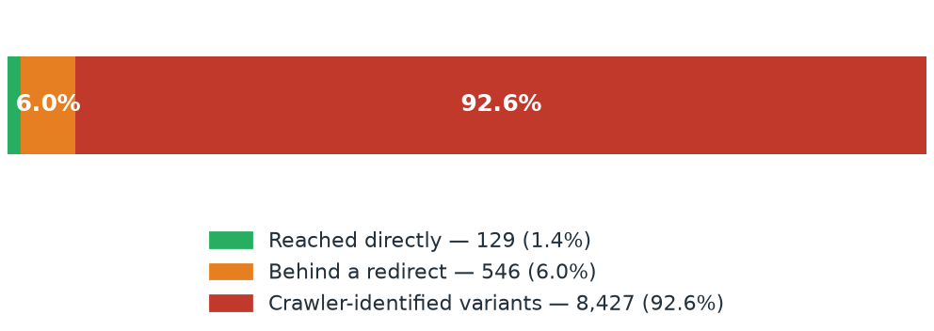
Figure 14. The same split as a single proportional bar.

4.11 Redirect propagation — localcoffeemontclair.com
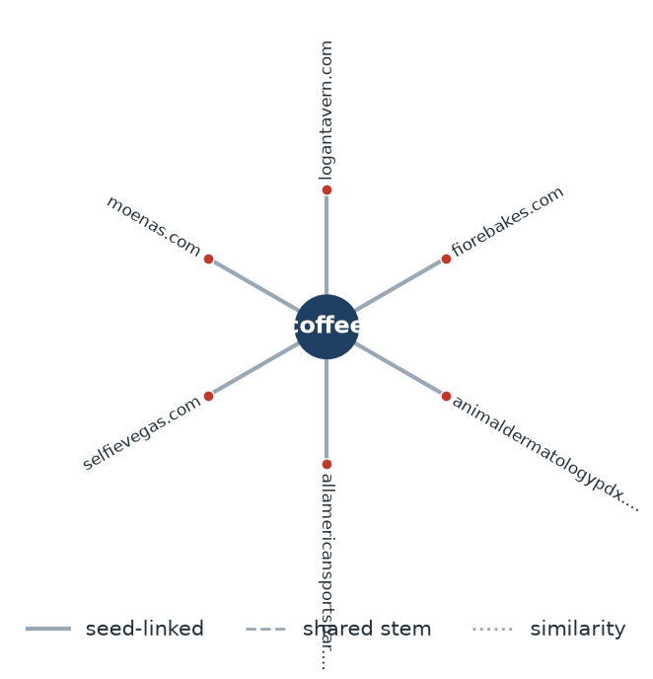
Figure 15. Destinations reached from the busiest redirect source, localcoffeemontclair.com (6 distinct URLs).
Redirect source | Distinct destination URLs
localcoffeemontclair.com | 6
b.37.app | 6
lotto432e.com | 5
kdbet.pro | 5
slotxo6.co | 4
i9bet.click | 4
bet26.site | 4
gulfstreamair.com | 4
adirondackbrewing.com | 4
ccsmm.net | 4

Table 12. The ten busiest redirect sources in the gambling estate.

5 Ranking
374 gambling sites carried a numeric rank. The fifteen highest-ranked are listed below; a lower rank number means a more visible site.
Rank | Domain | Cluster | Subcategory | Source
2,282 | polymarket.com | polymarket | General Gambling | Other
13,809 | speed-manga.net | speedmanga | Lottery | Manual
18,261 | bwin.com | btw | Football Betting | Variant
21,603 | casino.com | casino | Casino | Manual
36,241 | khonbafutbon.com | sbobet | Football Betting | Redirect
36,241 | sbobet.com | sbobet | Football Betting | Manual
61,164 | dafabet.com | dafabet | Casino | Manual
77,632 | 5gbet.com | 5mgbet | General Gambling | Variant
78,229 | lottovip.com | lott | Lottery | Other
87,599 | mgbet.com | mgbet | General Gambling | Variant
88,727 | gbets.in | gnbet | Slots | Variant
90,304 | lottovip.bet | lott | Lottery | Variant
93,196 | jlbet.co | ilbet | Slots | Variant
93,266 | lottovip.info | lott | Slots | Variant
101,396 | videopoker.go2cloud.org | videopoker | General Gambling | Redirect

Table 13. Gambling ranking — the most visible gambling sites in the set.

6 Key insights

6.1 Scale of the analysis
23,496 distinct URLs were analysed over 43 days (2026-08-06 → 2026-09-17). Of these, 9,102 were assessed as gambling, 14,380 as not gambling and 14 as unreachable.
Take The sample is large enough to reason about patterns, not isolated cases.

6.2 What is being offered
The three largest product subcategories are Casino (3,635 sites, 39.9%), Slots (1,921, 21.1%) and General Gambling (1,867, 20.5%).
20.5% of gambling sites were confirmed as gambling without an evidenced product type, and 97.6% of all gambling rows were placed by reading the classifier's reasoning rather than by a lexicon match. 213 of the 286 lexicon keywords never matched anything in this sample.
Take Casino is the dominant product type, but at 39.9% of gambling sites it is under forty percent — the estate is spread across product types rather than concentrated in one.

6.3 Brand clustering
The 9,102 gambling URLs resolve to 1,010 brand clusters, of which 764 hold more than one domain and 246 are singletons. 125 clusters are needed to cover half the estate. The largest, “bet”, holds 177 domains across 6 product subcategories.
Take The estate is diffuse — no small group of operators dominates it — so per-URL blocking will have limited leverage and enforcement should still be organised by cluster.

6.4 How the estate is grown and marketed
8,427 gambling URLs (92.6%) are crawler-identified variants of a known seed, 546 (6.0%) sit behind redirect chains and only 129 (1.4%) were reached directly. The busiest redirect source is localcoffeemontclair.com, with 6 distinct destinations.
559 clusters rotate across more than one top-level domain. The two most common signal tags are Abbreviations (38.5% of gambling sites) and Marketing & Acquisition (2.1%).
Take Redirects and TLD rotation keep a stable entry point while the sites behind it are replaced, so blocking a destination domain does not remove the route to it. Promotional and evasion vocabulary is not dominant in this sample, so there is no evidence here that acquisition runs mainly through promotional content.

6.5 Enforcement position
No page in the analysed set carried a regulatory-blocking indicator — no court-order notice, regulator notice or block page was found in the classifier's reasoning text.
Take This set appears to be pre-enforcement and is a candidate for a first enforcement pass, prioritised by cluster rather than by URL.

7 Methodology
Parameter | Value
Inferred share (rows placed by reasoning, not keyword) | 97.6%
General Gambling share | 20.5%
Brand-stem similarity threshold | Jaro–Winkler ≥ 0.90
Similarity merge constraint | one stem must be a prefix of the other, or differ only in trailing characters
Minimum brand stem length | 3 characters
Signal-keyword linkage threshold (indicative only) | Jaccard ≥ 0.60

Table 14. Quality figures and clustering thresholds used in this analysis.

