

Data Insights & Patterns
29,864 URLs · 4 Sep – 21 Oct 2026
Issued to | Ministry of Digital Economy and Society, Thailand
Prepared by | SICPA SA
Date of issue | 22/10/2026
Source system | SICPADetect, lexicon version V1 (Gambling_Keywords_Full_English_Categories_V1.xlsx)

Contents
Executive Summary 3
Insights and trends 3
Key figures 3
Model Insights 4
Introduction 4
Executive Summary 4
Overall and per class results 4
Error Analysis 4
Segments and Confidence 4
Data Analysis 5
How URLs are classified 5
10 most prominent gambling sites in Thailand 6
10 most prominent gambling sites in Thailand 6
The numbers 6
From collection to analysis 7
URLs analyzed per day 8
Status distribution 9
Unreachable URLs by cause 9
Top 10 URL suffixes 10
Pages showing blocking indicators 11
Subcategories 12
Gambling sites by product subcategory 12
Assignment method by subcategory 13
Subcategory table 14
Heat map — Keyword × subcategory 15
Heat map — Signal tag × subcategory 16
Brands and clustering 16
What brand clusters are 16
Domains with the most URLs 17
Top 15 brand clusters by URL count 18
Heat map — Brand cluster × subcategory 19
Cluster expansion — jun8 20
Clusters spanning multiple subcategories 21
Clusters rotating top-level domains 22
Possible operator linkage 23
Naming conventions 23
Structure: direct → redirect → variant 24
Ranking 24
Gambling ranking 24
Ranked brand clusters 25
Key insights 26
Scale of the analysis 26
What is being offered 26
Brand clustering 26
How the estate is grown and marketed 27
Enforcement position 27
Annexes 28
Annex 1 — Subcategory definitions 28
Annex 2 — Ranked domains used for clustering 31

Executive Summary
Insights and trends
SICPADetect analysed 29,864 URLs, and 47.5% of them were judged to offer or promote gambling.
Slots is the dominant product type, with Casino second. Most subcategory assignments rest on the model's description of each page rather than on a lexicon match, so product figures are indicative only.
The gambling URLs sit on 6,827 domains. One domain, 49m.co, carries 20.3% of gambling URLs through many hostnames. The domains with 20 or more gambling URLs, 15 host farms in all, carry 35.1% between them. Beyond these, the estate is spread across many brand clusters, and many clusters use more than one top level domain.
Abbreviations is the most common signal tag. The export records no redirect or variant links, so the report cannot say how the estate spreads between domains.
The evaluation period is too short to carry a trend, so no direction is stated. Three gaps of three or more days fell below the gap threshold, 8 to 20 September, 30 September to 2 October and 10 to 17 October, and their causes are not recorded.
No URL shows a Thai enforcement indicator, and some URLs show other block page phrases. Each model description of a page is scanned for fixed block page phrases in English and Thai, such as court order and blocked site notices, and a phrase naming a Thai court, MDES or a Thai ISP counts as a Thai enforcement indicator. The collection network was not recorded. Enforcement may be understated.
Key figures
URLs analysed | 29,864
URLs set aside as Needs more analysis | 0
Gambling URLs and share | 14,182 (47.5%)
Not gambling and unreachable | 15,682 not gambling · 0 unreachable
Domains carrying the gambling URLs | 6,827
Brand clusters identified | 2,794, of which 988 hold more than one domain
Clusters needed to cover half of gambling URLs | 45
Largest cluster | 49m · 2,885 URLs · 1 domain · 20.3% of gambling URLs
Largest domain | 49m.co · 2,885 URLs · 20.3% of gambling URLs
Host farms | 15 domains with 20 or more gambling URLs · 4,971 URLs · 35.1% of gambling URLs
Dominant product subcategory | Slots · 32.5% of gambling URLs
Most common signal tag | Abbreviations · 27.1% of gambling URLs
URLs with Thai enforcement indicators · other block page phrases | 0 · 7 · collection network not recorded
Keyword versus inferred subcategory assignment | 469 keyword (3.3%) · 13,713 inferred (96.7%)

Model Insights
Introduction
The results in this section come from a controlled test of the SICPADetect classification model. The test was run against a predefined dataset, fixed in advance so that results are consistent and can be reproduced. It was designed to measure model performance only. The test dataset is separate from, and not related to, the data examined in the Data Analysis section, so figures in this section should not be compared or combined with figures elsewhere in this report.

Executive Summary

Overall and per class results

Error Analysis

Segments and Confidence

Data Analysis
How URLs are classified
Every URL in this analysis receives one of five outcomes. Gambling: the classifier judged, from what was recorded about the page, that the site offers or promotes gambling. Not gambling: the page was read and judged not to offer gambling. Unreachable: the page could not be fetched or read from the collection network, so no judgement was made. Needs more analysis: the classifier could not decide with enough confidence, so the URL is set aside for human review; these URLs are counted in From collection to analysis and are excluded from every other figure in this section. Unknown: the export carried a status outside these four. Figures in this section count URLs, one URL being one address analysed; where a card counts domains instead, it says so.

10 most prominent gambling sites in Thailand
10 most prominent gambling sites in Thailand
rank | URL | domain | brand cluster | subcategory | Thai-targeting evidence | source
93,155 | metal--vip.com | metal--vip.com | metal | Slots | Thai script: เข้าสู่ระบบ | Not recorded
221,001 | suriyathai.net | suriyathai.net | suriya | Football Betting | Thai script: สมัครสมาชิก | Not recorded
254,190 | anthonyhead.com | anthonyhead.com | anthonyhead | Casino | Thai currency: Baht | Not recorded
254,190 | kohochocolates.… | kohochocolates.… | kohochocolates | Casino | Thai currency: Baht | Not recorded
293,057 | bifestathailand… | bifestathailand… | bifestathaila… | Slots | Thai currency: THB | Not recorded
293,057 | lgbtnewsnow.org | lgbtnewsnow.org | lgbtnewsnow | Slots | Thai currency: THB | Not recorded
514,501 | sacasino.ad | sacasino.ad | sacasino | Baccarat | Thai script: บาคาร่า | Not recorded
758,592 | 9ufa.vip | 9ufa.vip | 9ufa | Casino | Thai script: เครดิตฟรี | Not recorded
766,101 | awayge.farm | awayge.farm | awayge | Slots | Thai script: เกมสล็อต | Not recorded
779,002 | dreamworld777.b… | dreamworld777.b… | dreamworld | Playing card | Thai script: สล็อต | Not recorded

Shortened in the table: bifestathailand, bifestathailand.com, dreamworld777.buzz, kohochocolates.com.
Rank reflects search visibility in the source feed, not harm, reach or revenue.

The numbers
29,864  Total URLs analyzed |  | 14,182  Gambling URLs |  | 6,827  Gambling domains |  | 48 days  Evaluation period  2026-09-04 →  2026-10-21

From collection to analysis
URLs at each stage from the export to the analysis. Each box carries the URLs kept and each branch the URLs set aside.
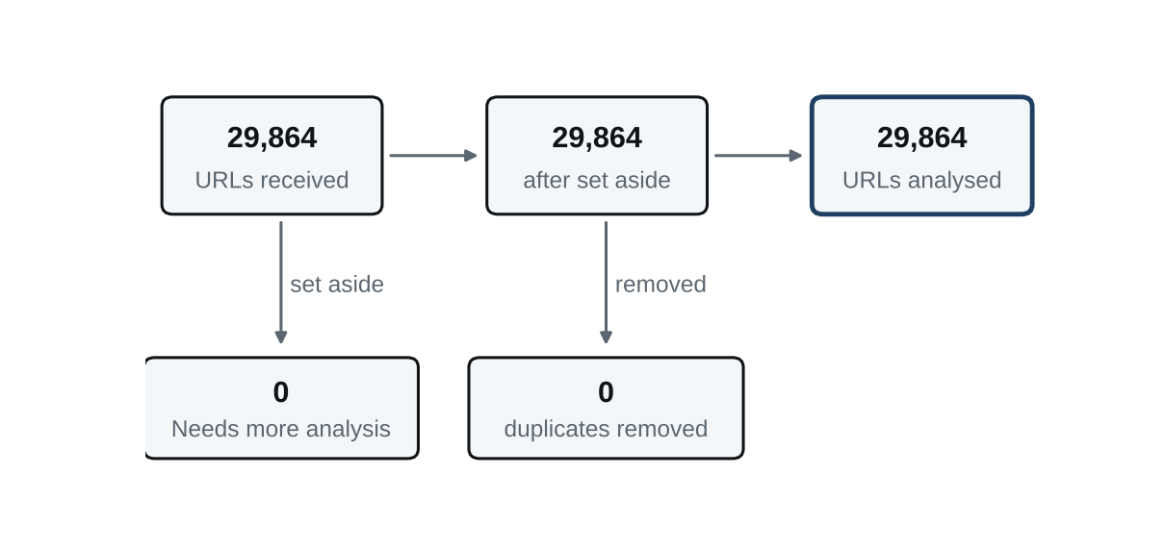
Stage | URLs
URLs received | 29,864
Set aside as Needs more analysis | 0
Duplicates removed | 0
URLs analysed | 29,864

URLs analysed split by status: Not gambling 15,682; Gambling 14,182.

URLs analyzed per day
Daily count of URLs analysed across the evaluation period. Each point is one calendar day and shaded bands mark gaps.
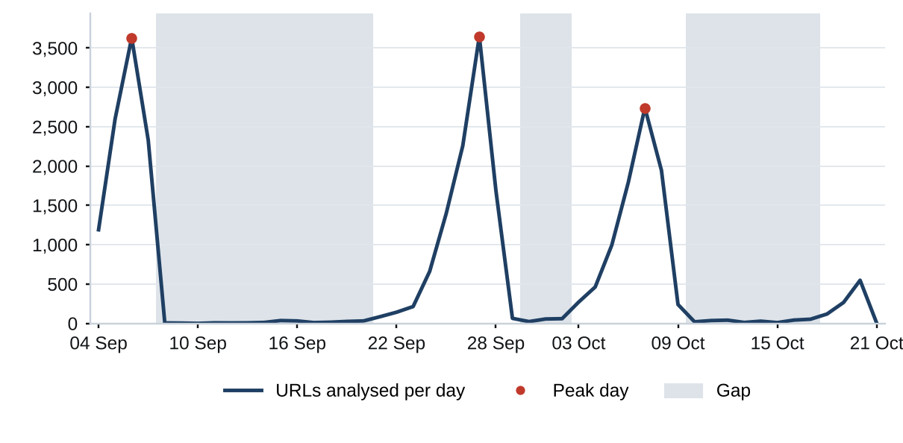
Gap threshold: 10% of the daily mean of 622 URLs, which is 62 URLs a day. 25 days fall below it. Gaps: 2026-09-08 to 2026-09-20 (13 days, 190 URLs, cause not recorded); 2026-09-30 to 2026-10-02 (3 days, 139 URLs, cause not recorded); 2026-10-10 to 2026-10-17 (8 days, 242 URLs, cause not recorded). Peaks, days above three times the mean: 2026-09-05 to 2026-09-07 (3 days, 8,558 URLs, cause not recorded); 2026-09-26 to 2026-09-27 (2 days, 5,907 URLs, cause not recorded); 2026-10-07 to 2026-10-08 (2 days, 4,685 URLs, cause not recorded). A URL is dated by the last time its record changed, so a re-analysed URL moves to its later date.

Status distribution
Share of the estate by classification status. Each segment is one status and the table below carries the counts.
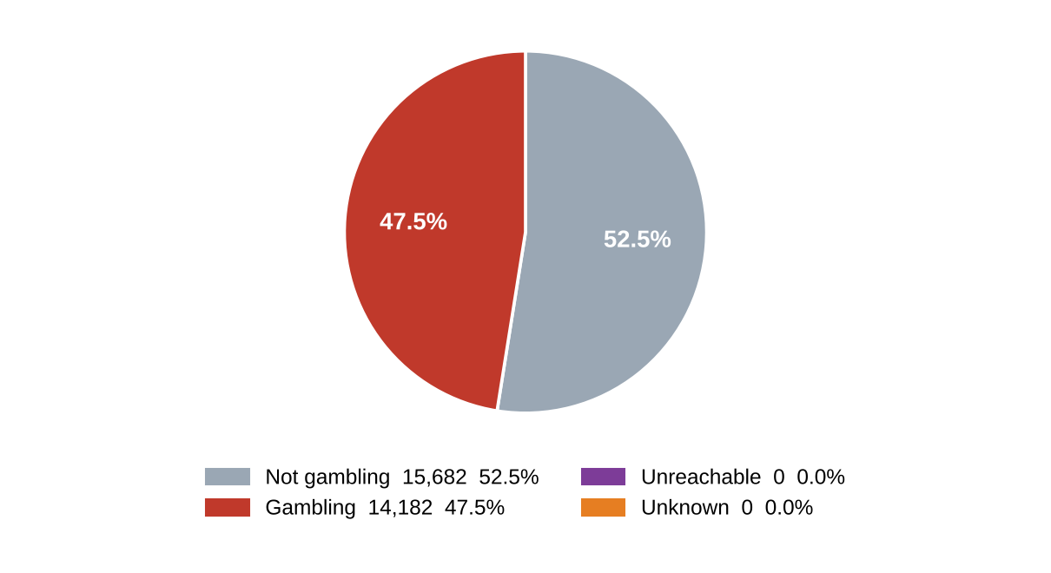
status | count | % of URLs
Not gambling | 15,682 | 52.5%
Gambling | 14,182 | 47.5%
Unreachable | 0 | 0.0%
Unknown | 0 | 0.0%
Total | 29,864 | 100.0%

No URLs were classified as Needs more analysis, so none were set aside before this count. The stage appears in From collection to analysis.

Unreachable URLs by cause
The export contains no Unreachable URLs, and whether unreachable URLs are removed before export is not recorded.
The collection network was not recorded.

Top 10 URL suffixes
The ten most common URL suffixes in the estate. Bar length is the total count and the table separates the gambling share.
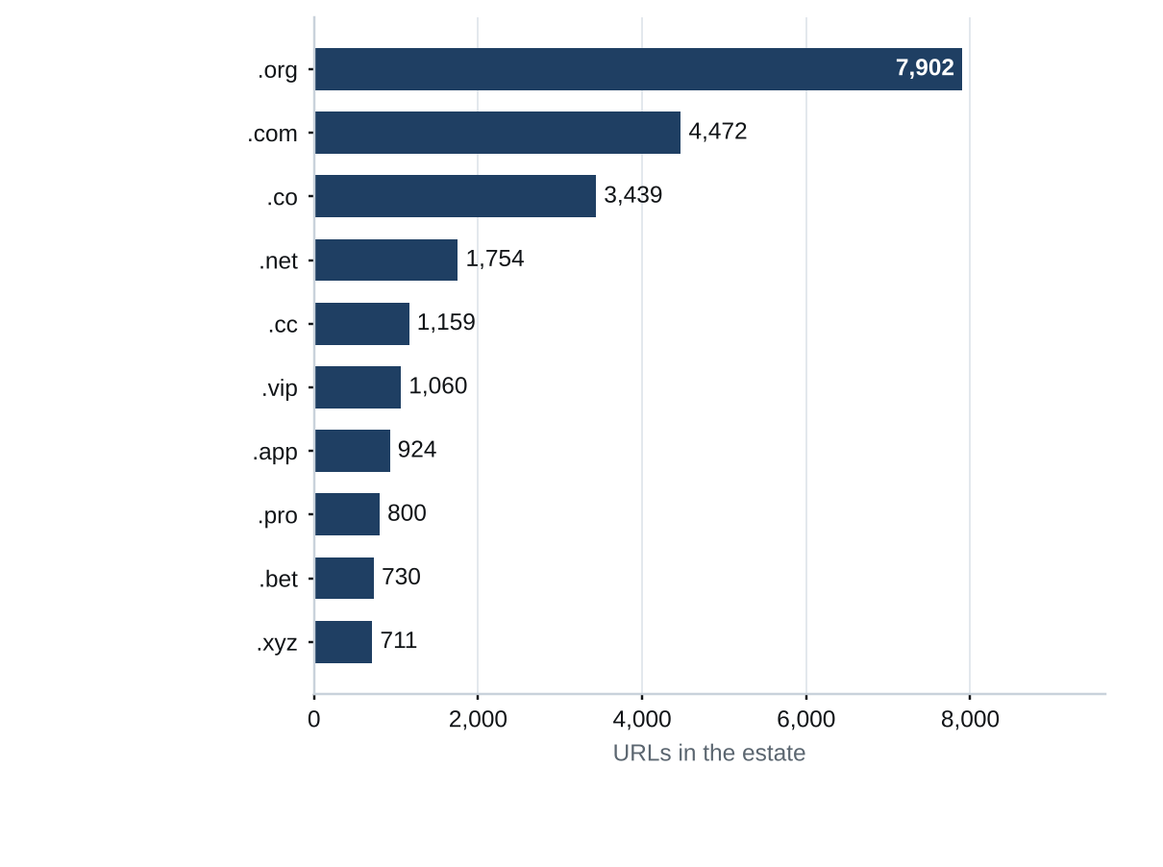
suffix | total | % of all | gambling | % gambling
.org | 7,902 | 26.5% | 19 | 0.2%
.com | 4,472 | 15.0% | 2,106 | 47.1%
.co | 3,439 | 11.5% | 3,116 | 90.6%
.net | 1,754 | 5.9% | 1,102 | 62.8%
.cc | 1,159 | 3.9% | 683 | 58.9%
.vip | 1,060 | 3.5% | 955 | 90.1%
.app | 924 | 3.1% | 643 | 69.6%
.pro | 800 | 2.7% | 682 | 85.2%
.bet | 730 | 2.4% | 703 | 96.3%
.xyz | 711 | 2.4% | 348 | 48.9%

195 other suffixes fall outside the top 10.

Pages showing blocking indicators
URL | brand cluster | indicator | phrase found | excerpt
e.dra.gov.pk | — | Other | regulatory authority | it is related to the Drug Regulatory Authority of Pakistan. Screenshot: The…
fawts.glass-saf… | — | Other | illegal content | message about potentially illegal content, which is unrelated to online…
hn94.cc | — | Other | illegal content | warning about potentially illegal content, indicating it is not related to…
nh83.cc | — | Other | illegal content | message about potentially illegal content, which is unrelated to online…
nh85.cc | — | Other | illegal content | message about potentially illegal content, indicating it is not related to…
tn93.cc | — | Other | illegal content | message about potentially illegal content, indicating it is not related to…
vu98.cc | — | Other | illegal content | message about potentially illegal content, which does not relate to online…

Shortened in the table: fawts.glass-safe.com.
Each model description of a page is scanned for fixed block page phrases in English and Thai, such as court order and blocked site notices, and a phrase naming a Thai court, MDES or a Thai ISP counts as a Thai enforcement indicator. The collection network was not recorded.

Subcategories
Gambling sites by product subcategory
Gambling sites by product subcategory. Bar length is the site count and each label carries the count and the share of gambling rows.
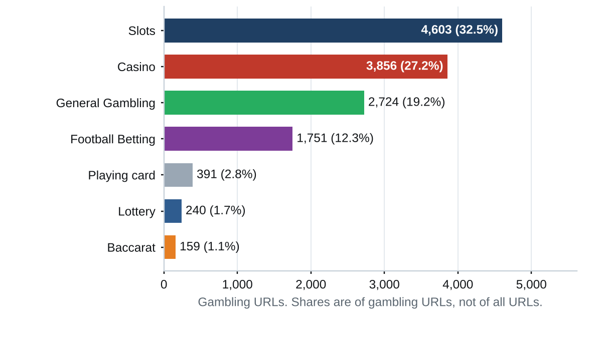
458 gambling URLs (3.2%) carry no description, so no subcategory is assigned and they are not plotted.

Assignment method by subcategory
How each subcategory was assigned. Solid fill is a lexicon keyword match and the lighter fill is reasoning inference.
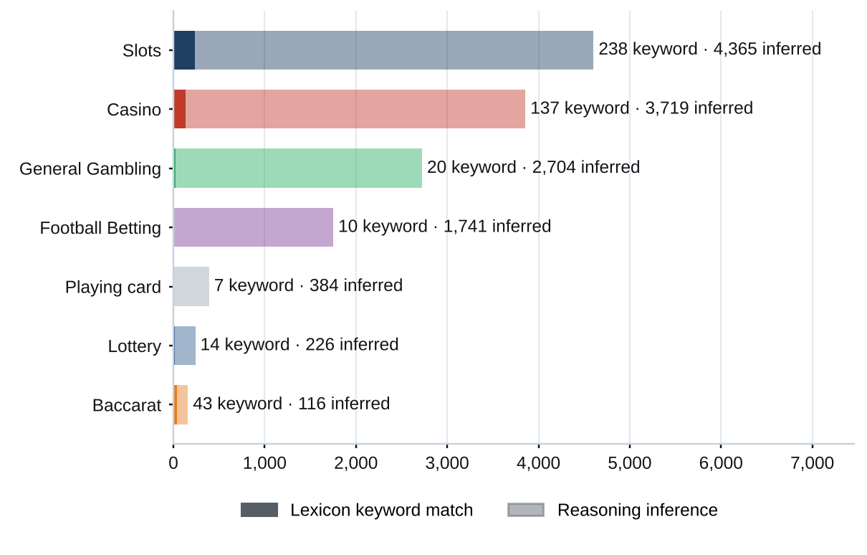
What a lexicon match means
A site is assigned to a subcategory by lexicon match when a word or phrase from the gambling keyword lexicon appears in what was recorded about the site and belongs to the product category assigned. The recorded text covers the model's description, extracted keywords, remarks, URL and domain. A site whose description contains สล็อต is assigned to Slots by lexicon match. The lexicon holds 286 keywords in 14 categories, mostly in Thai script. Seven describe the gambling product and decide the subcategory, and seven describe how a site markets itself and are reported as signal tags. A lexicon match rests on a word that can be pointed to. An inferred assignment rests on the model's reading of its own description and carries lower confidence.
Inferred share of gambling URLs: 96.7%. General Gambling share of gambling URLs: 19.2%.

Subcategory table
subcategory | count | % of gambling | keyword-assigned | inferred | distinct clusters
Slots | 4,603 | 32.5% | 238 | 4,365 | 1,003
Casino | 3,856 | 27.2% | 137 | 3,719 | 1,299
General Gambling | 2,724 | 19.2% | 20 | 2,704 | 540
Football Betting | 1,751 | 12.3% | 10 | 1,741 | 730
Playing card | 391 | 2.8% | 7 | 384 | 194
Lottery | 240 | 1.7% | 14 | 226 | 83
Baccarat | 159 | 1.1% | 43 | 116 | 120
Unspecified | 458 | 3.2% | 0 | 458 | 415
Total | 14,182 | 100.0% | 469 | 13,713

2,666 of the General Gambling URLs are listing, review or ranking sites, pending jointly agreed labelling rules.

Heat map — Keyword × subcategory
Matched keywords against product subcategory. Each cell is the number of gambling sites carrying that keyword in that subcategory.
 |  | Slots | Casino | Football Betting | General Gambling | Baccarat | Lottery | Playing card
 | VIP | 822 | 546 | 226 | 208 | 12 | 16 | 23
 | BET | 311 | 427 | 279 | 109 | 25 | 23 | 29
 | WIN | 298 | 159 | 58 | 87 | 4 | 22 | 4
 | สมัครสมาชิก | 170 | 78 | 18 | 42 | 13 | 45 | 13
 | สล็อต | 238 | 70 | 4 |  | 32 | 2 | 6
 | WALLET | 85 | 52 | 23 | 13 | 6 | 1 | 1
 | Wallet | 85 | 52 | 23 | 13 | 6 | 1 | 1
 | คาสิโน | 31 | 137 | 2 |  | 7 | 1
 | คาสิโน | 31 | 137 | 2 |  | 7 | 1
 | PRAGMATIC | 41 | 81 | 18 | 11 | 15 | 2 | 3
 | คาสิโนออนไลน์ | 4 | 95 | 2
 | คาสิโนออนไลน์ | 4 | 95 | 2
 | สล็อตออนไลน์ | 91 | 6 | 1
 | เกมสล็อต | 82 | 13
 | บาคาร่า | 20 | 13 | 2 |  | 43 | 1 | 6
 | Affiliate | 11 | 9 | 3 | 44 | 2
 | JILI | 32 | 7 | 19 | 5 |  |  | 2
 | เล่นสล็อต | 54 | 1 | 1
 | เดิมพัน | 7 | 10 | 1 | 16 | 2
 | RTP | 18 | 5 | 3 | 3 | 1 | 1
 | พนัน | 10 | 10 | 1 | 4 | 2
 | JDB | 19 | 6 | 1
 | AUTO | 15 | 4 | 2 | 3 | 1
 | SEXY | 5 | 5 | 2 | 4 | 4
 | เครดิตฟรี | 6 | 10 |  | 1 | 3

Count scale: 1 |  |  |  |  |  | 822

Strip colour is the keyword’s own lexicon category: ■ Abbreviations ■ Marketing & Acquisition ■ Slots ■ Deposit & Withdrawal ■ Casino ■ General Gambling ■ Baccarat ■ Affiliate & Agent ■ Promotions

Heat map — Signal tag × subcategory
Signal tags against product subcategory. Each cell is the number of gambling sites carrying that tag in that subcategory.
 | General Gambling | Slots | Casino | Football Betting | Lottery | Baccarat | Playing card
Abbreviations | 405 | 1,485 | 1,202 | 562 | 56 | 62 | 59
Affiliate & Agent | 2,666 | 15 | 15 | 9 |  | 2 | 1
Marketing & Acquisition | 43 | 186 | 94 | 22 | 45 | 16 | 14
Deposit & Withdrawal | 14 | 87 | 53 | 23 | 2 | 6 | 2
Promotions | 3 | 13 | 15 | 4 |  | 3
Vague-Evasion Terms
Hashtags

Count scale: 1 |  |  |  |  |  | 2,666

Brands and clustering
What brand clusters are
What a cluster is
A brand cluster is a group of URLs, and the domains they sit on, judged to belong to the same gambling brand or operator. A domain joins a cluster when the crawler followed a redirect to it or generated it as a variant of a matching name, when it matches a brand in a ranking of gambling domains for Thailand from an external data provider, listed in Annex 2, or when its name reduces to the same stem as another once market tags, version numbers and suffixes are removed, so ufabet168th.com and ufabet-vip.net both reduce to ufabet while jun88 and jun68 stay apart. A domain matching nothing is a singleton, and all hostnames on one registered domain belong to the same cluster.
Why clusters matter
Operators rarely run one site. They register many domains, rotate top level domains and move players between them, so when one address is blocked another takes its place. Clusters show how many distinct operations there are, how concentrated the estate is and which operators run several products, so acting on a cluster reaches every domain in it. Clusters are an analytical grouping based on names, crawler links and an external domain ranking, not a legal finding about ownership, and the Possible operator linkage table is indicative only.

2,794  Distinct clusters |  | 988  Clusters with 2 or more domains |  | 1,806  Singletons, one domain each |  | 45  Clusters to cover half of gambling URLs

Domains with the most URLs
Largest domain holds 20.3% of gambling URLs
How to read this table
The table lists the registered domains that carry the most gambling URLs in this sample. Each row gives the domain, its URLs, their share of all gambling URLs, the brand cluster it belongs to, the first and last day SICPADetect recorded it and whether it is a host farm. The domains are listed largest first, and a domain carrying 20 or more gambling URLs is marked as a host farm, meaning many hostnames under one registered name. Many hostnames under one domain usually come from a single setting that makes every name under the domain lead to the same site, so they may not be separate pages. Action against the domain itself reaches every one of its hostnames at once, where blocking hostname by hostname never catches up.
domain | URLs | % of gambling URLs | brand cluster | first seen | last seen | host farm
49m.co | 2,885 | 20.3% | 49m | 2026-10-03 | 2026-10-09 | Yes
a3game.vip | 502 | 3.5% | a3game | 2026-09-23 | 2026-09-28 | Yes
hayy.net | 407 | 2.9% | hay | 2026-09-04 | 2026-09-07 | Yes
k03.cc | 272 | 1.9% | k03 | 2026-09-04 | 2026-09-07 | Yes
paes.dev | 269 | 1.9% | paes | 2026-09-24 | 2026-09-28 | Yes
paegs.dev | 176 | 1.2% | paegs | 2026-09-24 | 2026-09-28 | Yes
o8.game | 73 | 0.5% | o8 | 2026-09-04 | 2026-09-07 | Yes
abbet.xyz | 70 | 0.5% | abbet | 2026-10-18 | 2026-10-20 | Yes
jun888.top | 67 | 0.5% | jun8 | 2026-09-24 | 2026-09-28 | Yes
7ok.bet | 66 | 0.5% | 7ok | 2026-09-04 | 2026-09-07 | Yes
l8.game | 57 | 0.4% | l8 | 2026-09-04 | 2026-09-07 | Yes
jn86.cc | 40 | 0.3% | jn86 | 2026-09-24 | 2026-09-28 | Yes
oo7.vip | 37 | 0.3% | oo7 | 2026-09-04 | 2026-09-07 | Yes
mwbet.info | 27 | 0.2% | mwbet | 2026-10-18 | 2026-10-20 | Yes
ju088.com | 23 | 0.2% | ju088 | 2026-09-25 | 2026-09-28 | Yes

15 host farms carry 4,971 gambling URLs, 35.1% of gambling URLs. 722 domains cover half of the gambling URLs. Fetch evidence for the host farms is not recorded.

Top 15 brand clusters by URL count
The fifteen largest brand clusters. Bar length is the number of URLs in the cluster.
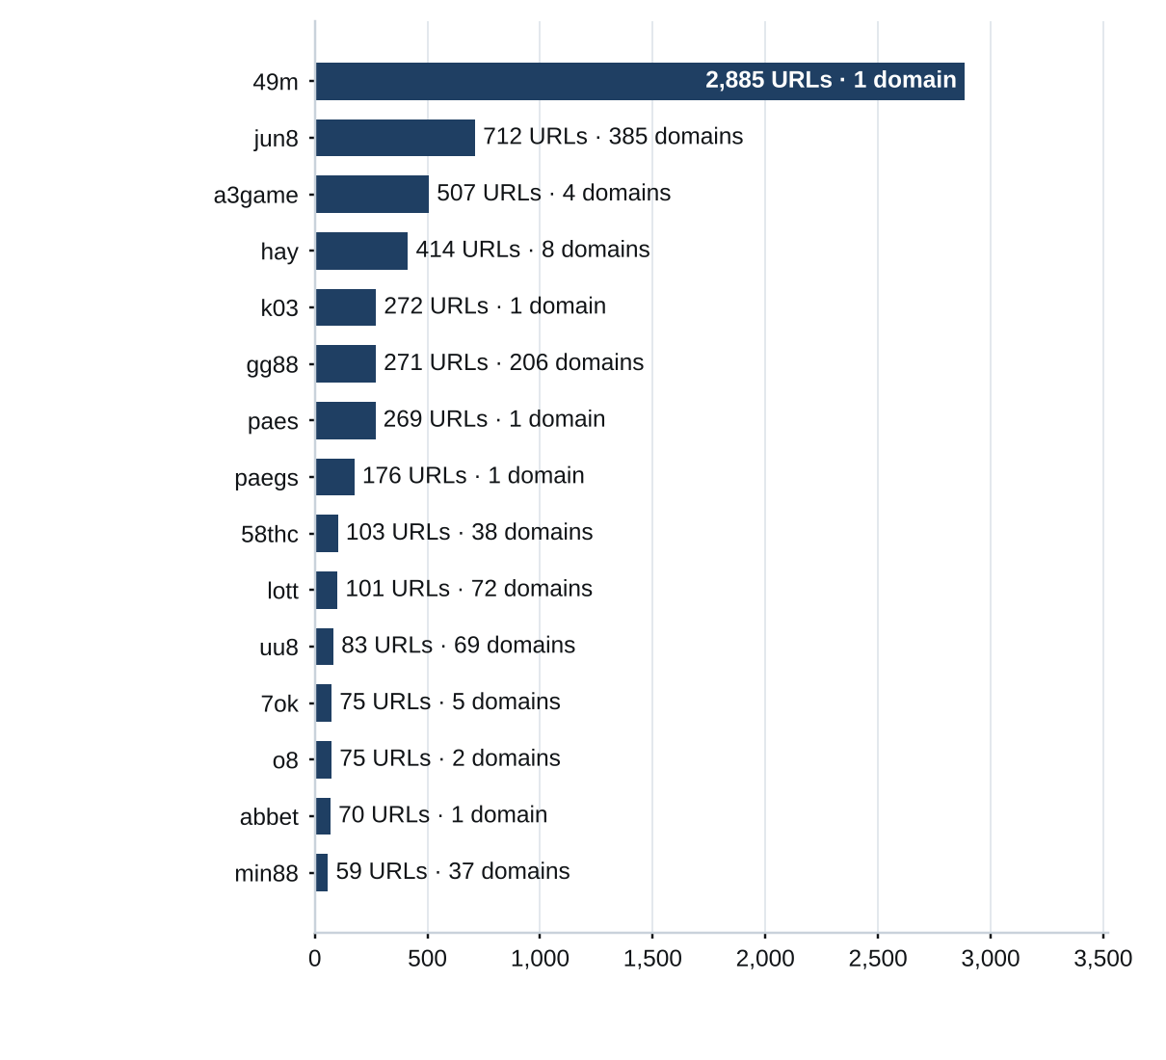

Heat map — Brand cluster × subcategory
Brand clusters against product subcategory. Each cell is the number of URLs a cluster holds in that subcategory.
 | Slots | General Gambling | Casino | Football Betting | Lottery | Playing card | Baccarat
49m | 1,164 | 1,529 | 123 |  | 1 | 68
jun8 | 170 | 98 | 252 | 105 | 49 | 31 | 7
a3game | 478 | 25 | 2 |  | 2
hay | 32 | 19 | 303 | 60
k03 |  | 73 |  | 199
gg88 | 56 | 23 | 139 | 27 | 3 | 17 | 6
paes | 61 | 20 | 152 | 36
paegs | 35 | 15 | 107 | 19
58thc | 102 | 1
lott | 6 | 7 | 7 | 2 | 74 | 4
uu8 | 25 | 4 | 37 | 13 | 1 | 1 | 2
7ok | 54 | 16 | 2 | 2 | 1
o8 | 59 | 12 | 4
abbet | 7 |  | 63
min88 | 4 | 6 | 6 | 42 |  | 1
l8 | 41 | 15 | 1
mwbet | 9 |  | 35 | 7
bohocasino | 10 | 10 | 26 |  | 1
jin88 | 16 | 10 | 14 | 3 |  | 4
oo7 | 18 | 5 | 8 | 16

Count scale: 1 |  |  |  |  |  | 1,529

Cluster expansion — jun8
The largest brand cluster and its member domains. Edge style records why each domain joined the cluster.
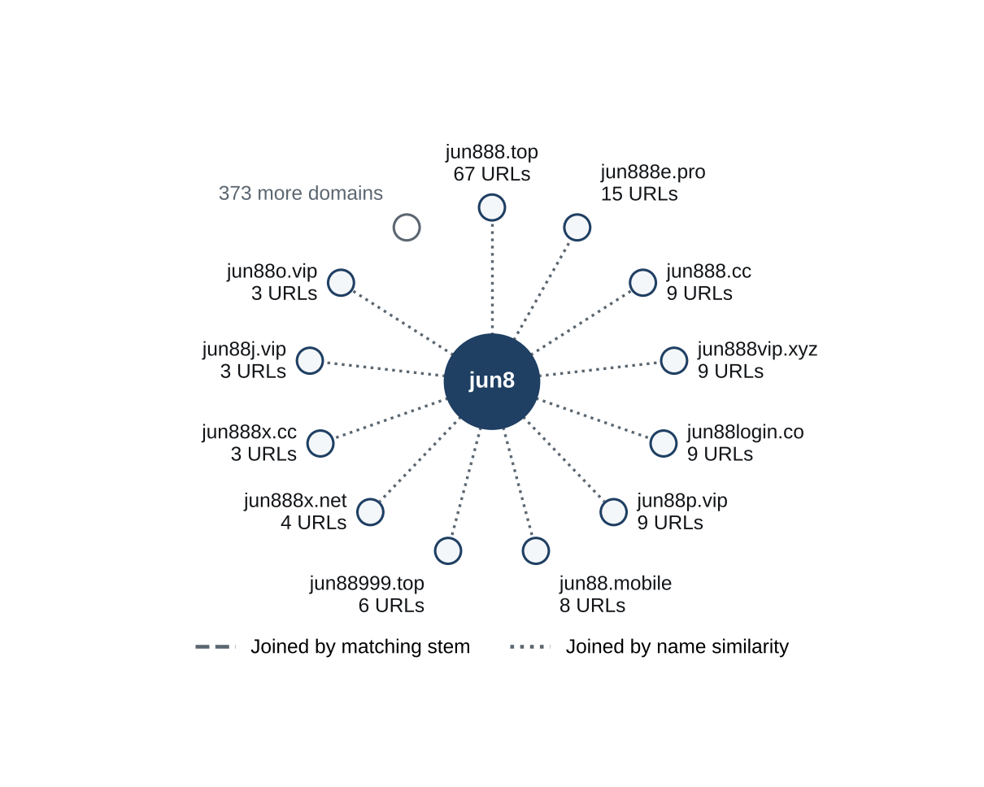
The largest cluster, 49m, holds 1 domain, so the diagram shows jun8, the largest cluster with at least 3 domains. jun8 holds 385 domains and 712 URLs. The 12 domains with the most URLs are drawn.

Clusters spanning multiple subcategories
How to read this table
The table lists brand clusters whose member sites fall into two or more product subcategories, for example one brand that runs both slots sites and football betting sites. Each row gives the cluster, its URLs in this sample, each subcategory present with its site count and the domain suffixes the cluster uses. Subcategories are assigned to each site, not to the cluster, so a cluster qualifies when at least two of its sites carry different product subcategories. Where General Gambling appears beside a specific product, a product could not be evidenced for those sites. Definitions are in Annex 1. These brands offer several gambling products under one name, so action against the brand reaches all of them at once.
cluster | URL count | subcategories | suffixes
49m | 2,885 | General Gambling 1,529 · Slots 1,164 · Casino 123 · Playing card 68 · Lottery 1 | .co
jun8 | 712 | Casino 252 · Slots 170 · Football Betting 105 · General Gambling 98 · Lottery 49 · Playing card 31 · Baccarat 7 | .com, .net, .pro, .app, .info, .top …
a3game | 507 | Slots 478 · General Gambling 25 · Casino 2 · Lottery 2 | .app, .click, .net, .vip
hay | 414 | Casino 303 · Football Betting 60 · Slots 32 · General Gambling 19 | .net, .app, .bet, .club, .co, .pro …
k03 | 272 | Football Betting 199 · General Gambling 73 | .cc
gg88 | 271 | Casino 139 · Slots 56 · Football Betting 27 · General Gambling 23 · Playing card 17 · Baccarat 6 · Lottery 3 | .app, .net, .pro, .bet, .com, .online …
paes | 269 | Casino 152 · Slots 61 · Football Betting 36 · General Gambling 20 | .dev
paegs | 176 | Casino 107 · Slots 35 · Football Betting 19 · General Gambling 15 | .dev
58thc | 103 | Slots 102 · General Gambling 1 | .com, .pro
lott | 101 | Lottery 74 · General Gambling 7 · Casino 7 · Slots 6 · Playing card 4 · Football Betting 2 | .com, .cc, .click, .net, .info, .online …
uu8 | 83 | Casino 37 · Slots 25 · Football Betting 13 · General Gambling 4 · Baccarat 2 · Lottery 1 · Playing card 1 | .com, .net, .pro, .app, .cc, .co …
7ok | 75 | Slots 54 · General Gambling 16 · Casino 2 · Football Betting 2 · Lottery 1 | .bet, .club, .io, .live, .pro
o8 | 75 | Slots 59 · General Gambling 12 · Casino 4 | .game, .live
abbet | 70 | Casino 63 · Slots 7 | .xyz
min88 | 59 | Football Betting 42 · General Gambling 6 · Casino 6 · Slots 4 · Playing card 1 | .com, .net, .app, .vip, .academy, .actor …

884 further clusters span multiple subcategories and are not shown.

Clusters rotating top-level domains
How to read this table
The table lists brand clusters whose member domains use two or more top level domains, the ending of the address, for example one brand name registered under .com, .net and .co. Each line gives the cluster, one suffix it uses, how many member domains use that suffix and the first and last day SICPADetect recorded them. A two part ending such as .co.th counts as one suffix, and a cluster qualifies when its members use at least two different suffixes. Registering one brand name under several endings keeps the brand reachable when one domain is blocked, because a player only has to change the ending. Some operators register several endings to protect their name or to serve different markets.
cluster | suffix | domains | first seen | last seen
jun8 | .com | 159 | 2026-09-22 | 2026-10-19
jun8 | .net | 27 | 2026-09-22 | 2026-09-28
jun8 | .pro | 16 | 2026-09-22 | 2026-09-28
jun8 | .app | 15 | 2026-09-22 | 2026-09-27
jun8 | .info | 15 | 2026-09-22 | 2026-09-28
jun8 | .online | 14 | 2026-09-22 | 2026-09-27
jun8 | 29 further suffixes | 139
a3game | .app | 1 | 2026-09-23 | 2026-09-24
a3game | .click | 1 | 2026-09-23 | 2026-09-24
a3game | .net | 1 | 2026-09-23 | 2026-09-23
a3game | .vip | 1 | 2026-09-23 | 2026-09-28
hay | .app | 1 | 2026-09-05 | 2026-09-05
hay | .bet | 1 | 2026-09-05 | 2026-09-05
hay | .club | 1 | 2026-09-05 | 2026-09-05
hay | .co | 1 | 2026-09-05 | 2026-09-05
hay | .net | 1 | 2026-09-04 | 2026-09-07
hay | .pro | 1 | 2026-09-05 | 2026-09-05
hay | 2 further suffixes | 2
gg88 | .app | 34 | 2026-09-04 | 2026-09-07
gg88 | .net | 34 | 2026-09-04 | 2026-09-07
gg88 | .pro | 30 | 2026-09-04 | 2026-09-07
gg88 | .bet | 21 | 2026-09-04 | 2026-09-07
gg88 | .com | 18 | 2026-09-04 | 2026-09-07
gg88 | .online | 17 | 2026-09-06 | 2026-09-07
gg88 | 13 further suffixes | 52

The 4 largest rotating clusters are shown, each with the 6 suffixes that have the most domains. 913 further clusters rotate across suffixes and are not shown. 37 clusters gained domains at least 7 days after their first sighting, 124 domains in all.
Dates are when SICPADetect recorded each domain, not when it was registered, blocked or replaced. The period is under 60 days, so it is too short to confirm rotation over time.

Possible operator linkage
Indicative — not a clustering decision
How to read this table
The table lists pairs of brand clusters with different names that use a similar set of signal keywords, the lexicon words describing how a site promotes itself, takes payment or avoids blocking. Each row gives the two clusters, the shared keywords and the Jaccard score. The score is the shared keywords divided by all the distinct keywords either cluster uses, from 0 for nothing in common to 1 for identical sets. Words common across the sample are left out first, and only pairs scoring 0.60 or more with three shared keywords are listed. A close match can point to one operator running two brands, or to unrelated operators using one affiliate template, so each pair is a lead to verify.
cluster A | cluster B | shared keywords | Jaccard
7ok | mega168 | pragmatic, rtp, wallet, win, สมัครสมาชิก | 1.00
jun77 | jub789 | pragmatic, wallet, win, สมัครสมาชิก | 1.00
gu88 | n78 | pragmatic, wallet, สมัครสมาชิก | 1.00
kk2 | n83 | jili, pragmatic, สมัครสมาชิก | 1.00
kk2 | nextspin | jili, pragmatic, สมัครสมาชิก | 1.00
ko9 | ln88 | wallet, win, สมัครสมาชิก | 1.00
ko9 | ub8 | wallet, win, สมัครสมาชิก | 1.00
ms88 | gu88 | pragmatic, wallet, สมัครสมาชิก | 1.00
ms88 | n78 | pragmatic, wallet, สมัครสมาชิก | 1.00
mu8 | hub88 | pragmatic, wallet, win | 1.00
mun8 | vrtex | auto, wallet, สมัครสมาชิก | 1.00
n83 | nextspin | jili, pragmatic, สมัครสมาชิก | 1.00
ruay | m98login | win, จ่ายจริง, สมัครสมาชิก | 1.00
ub8 | ln88 | wallet, win, สมัครสมาชิก | 1.00
uu8 | hub88 | pragmatic, wallet, win | 1.00

124 pairs qualify. The top 15 are shown.

Naming conventions
• Recurring tokens: "m." in 2,508 hostnames, "login" in 2,170 hostnames, "support" in 1,928 hostnames. These point to a templated naming scheme.
• Suffix switching: .com (1,059 URLs), .net (903 URLs), .vip (833 URLs), .pro (594 URLs). Many clusters use more than one top level domain.
• The gambling URLs sit on 6,827 domains across 2,794 brand clusters.

14,182  Direct URLs |  | 0  Redirect URLs |  | 0  Variant URLs

Structure: direct → redirect → variant
Direct, redirect and variant URLs sum to the gambling URLs. The export carries no variant or redirect links, no HTTP status and no final URL, so no variant is verified beyond what the export shows.

Ranking
Gambling ranking
How to read this table
The table lists the gambling sites in this sample that carry a rank in the SICPADetect feed, best ranked first, up to fifteen. Each row gives the rank, the domain, its brand cluster, its subcategory and where SICPADetect found it. The rank is the position recorded for the site in the source feed and reflects its search visibility, so the lower the number, the more visible the site. It is not the external ranking used to anchor brand clusters in Annex 2, and it is not filtered for a Thai audience or limited to one row per domain. The highest ranked sites are the ones users are most likely to reach. Rank measures visibility only, not harm, reach or revenue.
rank | domain | brand cluster | subcategory | source
93,155 | metal--vip.com | metal | Slots | Not recorded
214,132 | allslotwallet.online | allslotwallet | Slots | Not recorded
221,001 | suriyathai.net | suriya | Football Betting | Not recorded
252,597 | u11k.pro | u11 | Football Betting | Not recorded
254,190 | anthonyhead.com | anthonyhead | Casino | Not recorded
254,190 | kohochocolates.com | kohochocolates | Casino | Not recorded
293,057 | bifestathailand.com | bifestathailand | Slots | Not recorded
293,057 | lgbtnewsnow.org | lgbtnewsnow | Slots | Not recorded
303,254 | jun88wf.com | jun8 | Casino | Not recorded
397,330 | jun88wa.com | jun8 | General Gambling | Not recorded
466,858 | jun88wc.com | jun8 | Slots | Not recorded
514,501 | sacasino.ad | sacasino | Baccarat | Not recorded
517,141 | jun88.info | jun8 | Casino | Not recorded
517,141 | slavinaslot.top | slavinaslot | Casino | Not recorded
547,370 | 99ok.vip | 99ok | Lottery | Not recorded

Ranked brand clusters
How to read this table
The table lists brand clusters that contain at least one gambling site carrying a rank in the SICPADetect feed. Each row gives the cluster, its URLs, the best rank among its members, how many members are ranked and its subcategories. One ranked gambling member is enough to qualify. Clusters are ordered by their best rank, so the most visible brands come first, and the URL count shows how large each operation is. A brand that is both highly visible and large is where action reaches the most users and the most addresses at once. Rank measures visibility only, not harm, reach or revenue, and no combined score is calculated.
cluster | URLs | best rank | ranked URLs | subcategories
metal | 2 | 93,155 | 1 | Slots 2
allslotwallet | 1 | 214,132 | 1 | Slots 1
suriya | 1 | 221,001 | 1 | Football Betting 1
u11 | 33 | 252,597 | 1 | Slots 17 · Football Betting 9 · General Gambling 5 · Casino 2
anthonyhead | 1 | 254,190 | 1 | Casino 1
kohochocolates | 1 | 254,190 | 1 | Casino 1
bifestathailand | 1 | 293,057 | 1 | Slots 1
lgbtnewsnow | 1 | 293,057 | 1 | Slots 1
jun8 | 712 | 303,254 | 31 | Casino 252 · Slots 170 · Football Betting 105 · General Gambling 98 · Lottery 49 · Playing card 31 · Baccarat 7
sacasino | 1 | 514,501 | 1 | Baccarat 1
slavinaslot | 2 | 517,141 | 1 | Casino 2
99ok | 17 | 547,370 | 2 | Slots 8 · Casino 7 · Football Betting 1 · Lottery 1
gg88 | 271 | 558,790 | 16 | Casino 139 · Slots 56 · Football Betting 27 · General Gambling 23 · Playing card 17 · Baccarat 6 · Lottery 3
betwgb | 1 | 582,212 | 1 | Football Betting 1
hh9 | 32 | 632,178 | 11 | General Gambling 13 · Football Betting 10 · Slots 6 · Casino 3

Key insights
Scale of the analysis
The analysis covers 29,864 distinct URLs over 48 days, from 2026-09-04 to 2026-10-21. Of these, 14,182 are gambling, 15,682 are not gambling and 0 are unreachable. No further URLs were set aside as Needs more analysis. Gaps of three or more days fell below the gap threshold: 2026-09-08 to 2026-09-20, cause not recorded; 2026-09-30 to 2026-10-02, cause not recorded; 2026-10-10 to 2026-10-17, cause not recorded.
The sample is large enough to reason about patterns, not isolated cases.

What is being offered
The three leading product subcategories are Slots (4,603, 32.5%), Casino (3,856, 27.2%) and General Gambling (2,724, 19.2%). 19.2% of gambling URLs are confirmed as gambling without an evidenced product type. 96.7% of subcategory assignments are inferred from the model's description rather than matched to a lexicon keyword. 207 lexicon keywords never matched.
Slots is the dominant product type. It holds less than 40% of gambling URLs, so the estate is spread across product types rather than concentrated. The lexicon has poor coverage of this dataset, so subcategory figures are indicative only.

Brand clustering
2,794 clusters cover 14,182 gambling URLs on 6,827 domains. 988 of the clusters hold more than one domain. 45 clusters and 722 domains cover half of the gambling URLs. The largest cluster, 49m, holds 2,885 URLs (20.3% of gambling URLs) on 1 domain, across 5 subcategories. The largest domain, 49m.co, holds 2,885 URLs (20.3%). 15 host farms carry 35.1% of gambling URLs.
One registered domain carries 20.3% of the estate through many hostnames, so action at domain level reaches all of them at once, where URL by URL blocking would need one entry per hostname. Beyond it, the estate is diffuse: 45 clusters and 722 domains are needed to cover half of the gambling URLs.

How the estate is grown and marketed
The export records no variant or redirect links, so no URL reads as a crawler variant or as behind a redirect chain, and all 14,182 gambling URLs read as reached directly. 917 clusters rotate across more than one top level domain. The two most common signal tags are Abbreviations (27.1%) and Affiliate & Agent (19.1%).
Top level domain rotation is the one growth route the export supports. It records no redirect or variant links, so it cannot show how the estate spreads between domains.

Enforcement position
No page shows Thai enforcement indicators, such as Thai court orders, MDES or Thai ISP block pages, and 7 pages show other block pages. Each model description of a page is scanned for fixed block page phrases in English and Thai, such as court order and blocked site notices, and a phrase naming a Thai court, MDES or a Thai ISP counts as a Thai enforcement indicator. The Pages showing blocking indicators table lists every page found. The collection network was not recorded.
Only Thai authority indicators are described as enforcement in Thailand. None appears in this set, so it is a candidate for a first enforcement pass, prioritised by domain and cluster rather than by URL. The collection network was not recorded, so the enforcement count may be understated.

Annexes
Annex 1 — Subcategory definitions
Each site classified as gambling is assigned one of the seven product subcategories below, according to what it offers. General Gambling applies only when a site is confirmed as gambling but no specific product can be evidenced. A subcategory is assigned by lexicon match when one of the keywords listed under it appears in what was recorded about the site, and by inference from the model's description when none is found. How a site markets or operates itself is recorded separately as signal tags and does not decide its subcategory. The keywords under each subcategory are its complete set in the lexicon, shown in their original script. A few keywords appear under both a specific product and General Gambling; they always count toward the specific product.
Football Betting · 21 keywords
Betting on the outcome of football and other sports matches, including match odds, single match and accumulator ("step") bets, and tipping or match analysis offered to bettors.
พ⁠นั⁠น⁠บ⁠อ⁠ล · พ⁠นั⁠น⁠บ⁠อ⁠ล⁠อ⁠อ⁠น⁠ไล⁠น์ · แท⁠ง⁠บ⁠อ⁠ล · แท⁠ง⁠บ⁠อ⁠ล⁠อ⁠อ⁠น⁠ไล⁠น์ · พ⁠นั⁠น⁠ฟุ⁠ต⁠บ⁠อ⁠ล · แท⁠ง⁠ฟุ⁠ต⁠บ⁠อ⁠ล · ส⁠ป⁠อ⁠ร์⁠ต⁠บุ๊⁠ค · บ⁠อ⁠ล⁠อ⁠อ⁠น⁠ไล⁠น์ · ร⁠า⁠ค⁠า⁠บ⁠อ⁠ล · บ⁠อ⁠ล⁠ส⁠เต็⁠ป · บ⁠อ⁠ล⁠เดี่⁠ย⁠ว · ส⁠เต็⁠ป⁠บ⁠อ⁠ล · แท⁠ง⁠บ⁠อ⁠ล⁠ชุ⁠ด · ที⁠เด็⁠ด⁠บ⁠อ⁠ล · วิ⁠เค⁠ร⁠า⁠ะ⁠ห์⁠บ⁠อ⁠ล · โต๊⁠ะ⁠บ⁠อ⁠ล · ล้⁠ม⁠โต๊⁠ะ⁠บ⁠อ⁠ล · เดิ⁠ม⁠พั⁠น⁠ฟุ⁠ต⁠บ⁠อ⁠ล · เว็⁠บ⁠แท⁠ง⁠บ⁠อ⁠ล · บ⁠อ⁠ล⁠ส⁠เต็⁠ป⁠แม่⁠น · พ⁠นั⁠น⁠กี⁠ฬ⁠า
Slots · 32 keywords
Online slot machine games, including sites that promote particular slot providers, high payout rates or slots played directly without an agent.
ส⁠ล็⁠อ⁠ต · ส⁠ล็⁠อ⁠ต⁠อ⁠อ⁠น⁠ไล⁠น์ · เก⁠ม⁠ส⁠ล็⁠อ⁠ต · เก⁠ม⁠ส⁠ล็⁠อ⁠ต⁠อ⁠อ⁠น⁠ไล⁠น์ · ส⁠ล็⁠อ⁠ต⁠แต⁠ก⁠ง่⁠า⁠ย · ส⁠ล็⁠อ⁠ต⁠แต⁠ก⁠บ่⁠อ⁠ย · ส⁠ล็⁠อ⁠ต⁠แต⁠ก⁠ห⁠นั⁠ก · ส⁠ล็⁠อ⁠ต⁠แต⁠ก⁠จ⁠ริ⁠ง · ส⁠ล็⁠อ⁠ต⁠ให⁠ม่ · ส⁠ล็⁠อ⁠ต⁠เว็⁠บ⁠ต⁠ร⁠ง · ส⁠ล็⁠อ⁠ต⁠ว⁠อ⁠เล⁠ท · เล่⁠น⁠ส⁠ล็⁠อ⁠ต · ส⁠ล็⁠อ⁠ต⁠เค⁠ร⁠ดิ⁠ต⁠ฟ⁠รี · ส⁠ล็⁠อ⁠ต⁠แต⁠ก⁠ทุ⁠ก⁠วั⁠น · ส⁠ล็⁠อ⁠ต⁠ม⁠า⁠แร⁠ง · ส⁠ล็⁠อ⁠ต⁠ย⁠อ⁠ด⁠นิ⁠ย⁠ม · ส⁠ล็⁠อ⁠ต⁠ค่⁠า⁠ย⁠ดั⁠ง · ส⁠ล็⁠อ⁠ต⁠ไม่⁠ผ่⁠า⁠น⁠เอ⁠เย่⁠น⁠ต์ · ส⁠ล็⁠อ⁠ต⁠ ⁠p⁠g · ส⁠ล็⁠อ⁠ต⁠ ⁠j⁠o⁠k⁠e⁠r · ส⁠ล็⁠อ⁠ต⁠ ⁠j⁠i⁠l⁠i · ส⁠ล็⁠อ⁠ต⁠ ⁠p⁠r⁠a⁠g⁠m⁠a⁠t⁠i⁠c · ส⁠ล็⁠อ⁠ต⁠ ⁠x⁠o · ส⁠ล็⁠อ⁠ต⁠ ⁠a⁠u⁠t⁠o · ส⁠ล็⁠อ⁠ต⁠แต⁠ก⁠ไว · ส⁠ล็⁠อ⁠ต⁠ฝ⁠า⁠ก⁠ถ⁠อ⁠น⁠อ⁠อ⁠โต้ · ส⁠ล็⁠อ⁠ต⁠ฝ⁠า⁠ก⁠ไม่⁠มี⁠ขั้⁠น⁠ต่⁠ำ · ส⁠ล็⁠อ⁠ต⁠โบ⁠นั⁠ส⁠แต⁠ก⁠ห⁠นั⁠ก · ส⁠ล็⁠อ⁠ต⁠ส⁠า⁠ย⁠ฟ⁠รี · ส⁠ล็⁠อ⁠ต⁠ปั่⁠น⁠ง่⁠า⁠ย · ส⁠ล็⁠อ⁠ต⁠ ⁠R⁠T⁠P⁠ ⁠สู⁠ง · ส⁠ล็⁠อ⁠ต⁠คื⁠น⁠ก⁠ำ⁠ไร

Annex 1 — Subcategory definitions (continued)
Casino · 14 keywords
Online and live casino table and wheel games other than baccarat and card games, such as roulette, dragon tiger, hi lo dice and wheel spin games.
ค⁠า⁠สิ⁠โน · ค⁠า⁠สิ⁠โน⁠อ⁠อ⁠น⁠ไล⁠น์ · ค⁠า⁠สิ⁠โน⁠ส⁠ด · ค⁠า⁠สิ⁠โน⁠ส⁠ด⁠อ⁠อ⁠น⁠ไล⁠น์ · เสื⁠อ⁠มั⁠ง⁠ก⁠ร · รู⁠เล็⁠ต · รู⁠เล็⁠ต⁠อ⁠อ⁠น⁠ไล⁠น์ · รู⁠เล๊⁠ต · ไฮ⁠โล · ไฮ⁠โล⁠อ⁠อ⁠น⁠ไล⁠น์ · ไฮ⁠โล⁠ไท⁠ย · ห⁠มุ⁠น⁠ว⁠ง⁠ล้⁠อ⁠โบ⁠นั⁠น⁠ซ่⁠า⁠ร⁠า⁠ย⁠วั⁠น · ห⁠มุ⁠น⁠ว⁠ง⁠ล้⁠อ⁠โบ⁠นั⁠น⁠ซ่⁠า · ปั่⁠น⁠แป⁠ะ
Lottery · 20 keywords
Betting on lottery and number draws, including the Thai government and underground lotteries, Lao, Hanoi and Malaysian draws, fast draw yi ki lotteries and lotteries settled on stock index figures.
ห⁠ว⁠ย⁠อ⁠อ⁠น⁠ไล⁠น์ · แท⁠ง⁠ห⁠ว⁠ย · ซื้⁠อ⁠ห⁠ว⁠ย⁠อ⁠อ⁠น⁠ไล⁠น์ · ห⁠ว⁠ย⁠ยี่⁠กี · ห⁠ว⁠ย⁠ฮ⁠า⁠น⁠อ⁠ย · ห⁠ว⁠ย⁠ล⁠า⁠ว · ห⁠ว⁠ย⁠รั⁠ฐ⁠บ⁠า⁠ล · ห⁠ว⁠ย⁠ม⁠า⁠เล⁠ย์ · ห⁠ว⁠ย⁠จั⁠บ⁠ยี่⁠กี · จั⁠บ⁠ยี่⁠กี⁠ ⁠V⁠I⁠P · ห⁠ว⁠ย⁠ใต้⁠ดิ⁠น · ห⁠ว⁠ย⁠อ⁠อ⁠น⁠ไล⁠น์⁠จ่⁠า⁠ย⁠จ⁠ริ⁠ง · เว็⁠บ⁠ห⁠ว⁠ย · เว็⁠บ⁠แท⁠ง⁠ห⁠ว⁠ย · H⁠u⁠a⁠y · H⁠u⁠a⁠y⁠l⁠a⁠n · ห⁠ว⁠ย⁠หุ้⁠น · ห⁠ว⁠ย⁠หุ้⁠น⁠ไท⁠ย · ห⁠ว⁠ย⁠หุ้⁠น⁠ต่⁠า⁠ง⁠ป⁠ร⁠ะ⁠เท⁠ศ · ห⁠ว⁠ย⁠ชุ⁠ด
Playing card · 12 keywords
Card games other than baccarat, such as pok deng, blackjack, poker and Thai two card and three card games.
ไพ่ · ไพ่⁠อ⁠อ⁠น⁠ไล⁠น์ · ไพ่⁠ ⁠อ⁠อ⁠น⁠ไล⁠น์ · ไพ่⁠ป๊⁠อ⁠ก · ป๊⁠อ⁠ก⁠เด้⁠ง · ป๊⁠อ⁠ก⁠เด้⁠ง⁠อ⁠อ⁠น⁠ไล⁠น์ · แบ⁠ล็⁠ค⁠แจ็⁠ค · แบ⁠ล็⁠ค⁠แจ็⁠ค⁠อ⁠อ⁠น⁠ไล⁠น์ · โป๊⁠ก⁠เก⁠อ⁠ร์ · โป๊⁠ก⁠เก⁠อ⁠ร์⁠อ⁠อ⁠น⁠ไล⁠น์ · ตี⁠ไก่⁠ส⁠อ⁠ง⁠ใบ · ตี⁠ไก่⁠ส⁠า⁠ม⁠ใบ

Annex 1 — Subcategory definitions (continued)
Baccarat · 11 keywords
Baccarat in any form, live or online, including demo tables and betting formula or prediction services sold for baccarat.
บ⁠า⁠ค⁠า⁠ร⁠า · บ⁠า⁠ค⁠า⁠ร่⁠า · บ⁠า⁠ค⁠า⁠ร่⁠า⁠อ⁠อ⁠น⁠ไล⁠น์ · ไพ่⁠บ⁠า⁠ค⁠า⁠ร่⁠า · บ⁠า⁠ค⁠า⁠ร่⁠า⁠ส⁠ด · โต๊⁠ะ⁠บ⁠า⁠ค⁠า⁠ร่⁠า · บ⁠า⁠ค⁠า⁠ร่⁠า⁠ท⁠ด⁠ล⁠อ⁠ง · บ⁠า⁠ค⁠า⁠ร่⁠า⁠ฟ⁠รี · บ⁠า⁠ค⁠า⁠ร่⁠า⁠ร⁠ะ⁠บ⁠บ⁠ ⁠A⁠I · บ⁠า⁠ค⁠า⁠ร่⁠า⁠ขั้⁠น⁠เท⁠พ · สู⁠ต⁠ร⁠บ⁠า⁠ค⁠า⁠ร่⁠า
General Gambling · 22 keywords
Sites confirmed as gambling whose recorded content uses only generic gambling or betting vocabulary, so no specific product can be evidenced. Assigned only when no other subcategory applies.
พ⁠นั⁠น · ก⁠า⁠ร⁠พ⁠นั⁠น · พ⁠นั⁠น⁠อ⁠อ⁠น⁠ไล⁠น์ · เว็⁠บ⁠พ⁠นั⁠น · เว็⁠บ⁠เดิ⁠ม⁠พั⁠น · เดิ⁠ม⁠พั⁠น · เดิ⁠ม⁠พั⁠น⁠อ⁠อ⁠น⁠ไล⁠น์ · ค⁠า⁠สิ⁠โน · ค⁠า⁠สิ⁠โน⁠อ⁠อ⁠น⁠ไล⁠น์ · บ่⁠อ⁠น · บ่⁠อ⁠น⁠อ⁠อ⁠น⁠ไล⁠น์ · เว็⁠บ⁠เก⁠ม⁠พ⁠นั⁠น · เก⁠ม⁠พ⁠นั⁠น · เว็⁠บ⁠เสี่⁠ย⁠ง⁠โช⁠ค · เสี่⁠ย⁠ง⁠โช⁠ค · เว็⁠บ⁠เก⁠ม⁠เงิ⁠น · เล่⁠น⁠เงิ⁠น⁠จ⁠ริ⁠ง · เก⁠ม⁠ได้⁠เงิ⁠น⁠จ⁠ริ⁠ง · เดิ⁠ม⁠พั⁠น⁠กี⁠ฬ⁠า · พ⁠นั⁠น⁠กี⁠ฬ⁠า · พ⁠นั⁠น⁠บ⁠อ⁠ล · แท⁠ง⁠บ⁠อ⁠ล
The keyword lists are those of the SICPADetect lexicon at the version shown on the title page.

Annex 2 — Ranked domains used for clustering
Ranking of gambling domains for Thailand · external data provider · 159 of 200 ranked domains applied
Brand clusters are anchored to a ranking of gambling domains for Thailand supplied by an external data provider. When a URL in this sample matches a ranked brand, it is grouped under that brand's name instead of the name it happens to carry. The ranking is an analytical reference. A place in it is not evidence of ownership, harm or reach, and a match never adds a site to the gambling set.
rank | ranked domain | brand | match basis | URLs matched | cluster
1 | 22onlinegames.com | 22onlinegames | Brand name and extended names | 1 | 22onlinega…
3 | debet.tv | debet | Brand name and extended names | 1 | debet
4 | aiscore.com | aiscore | Brand name and extended names | 1 | aiscore
5 | ufabet.com | ufabet | Brand name and extended names | 1 | ufabet
7 | invl.me | invl | Brand name only | 2 | invl
8 | lottoheng168.com | lottoheng | Brand name and extended names | 1 | lottoheng
9 | 888scoreonline.net | 888scoreonl… | Brand name and extended names | 1 | 888scoreon…
10 | hacksawgaming.com | hacksawgaming | Brand name and extended names | 4 | hacksawgam…
12 | playin.com | playin | Brand name and extended names | 3 | playin
14 | gosh.io | gosh | Brand name only | 1 | gosh
15 | 24live.com | 24live | Brand name and extended names | 2 | 24live
16 | 326821905591.com | 326821905591 | This domain only | 1 | 326821905591
19 | vlr.gg | vlr | This domain only | 1 | vlr
20 | 7mkr.com | 7mkr | This domain only | 1 | 7mkr
21 | flashscore.co.uk | flashscore | Brand name and extended names | 6 | flashscore
22 | 808ball15.com | 808ball | Brand name and extended names | 2 | 808ball
24 | bet365.com | bet365 | Brand name and extended names | 0 | —
25 | mlnhngoc.net | mlnhngoc | Brand name and extended names | 1 | mlnhngoc
26 | m8geqpm2kpnf78dkfxp9… | m8geqpm2kpn… | This domain only | 1 | m8geqpm2kp…
27 | 13o.net | 13o | Brand name only | 1 | 13o
28 | nolimitcity.com | nolimitcity | Brand name and extended names | 2 | nolimitcity
29 | 1xbet.com | 1xbet | Brand name and extended names | 2 | 1xbet
30 | betufa.com | betufa | Brand name and extended names | 1 | betufa
31 | d3my3ye7lo15uo.cloud… | d3my3ye7lo1… | This domain only | 1 | d3my3ye7lo…

Annex 2 — Ranked domains used for clustering (continued)
rank | ranked domain | brand | match basis | URLs matched | cluster
32 | viieuvkf.com | viieuvkf | This domain only | 1 | viieuvkf
34 | anaidahog.com | anaidahog | Brand name and extended names | 1 | anaidahog
36 | m1rs.com | m1rs | This domain only | 1 | m1rs
37 | spinova-hub.com | spinovahub | Brand name and extended names | 1 | spinovahub
38 | beer777.com | beer | Brand name only | 3 | beer
41 | kaga88.com | kaga | Brand name only | 4 | kaga
42 | painamour.com | painamour | Brand name and extended names | 1 | painamour
43 | bet365.ee | bet365 | Brand name and extended names | With rank 24 | —
44 | seriesdet.com | seriesdet | Brand name and extended names | 1 | seriesdet
45 | singaporepools.com.sg | singaporepo… | Brand name and extended names | 2 | singaporep…
46 | stake.com | stake | Brand name and extended names | 4 | stake
47 | rainbet.com | rainbet | Brand name and extended names | 1 | rainbet
49 | wsgamings.com | wsgamings | Brand name and extended names | 2 | wsgamings
50 | jackpots.ch | jackpots | Brand name and extended names | 1 | jackpots
52 | pic5678.com | pic | Brand name only | 2 | pic
54 | sporticos.com | sporticos | Brand name and extended names | 1 | sporticos
55 | rsg-games.com | rsggames | Brand name and extended names | 1 | rsggames
59 | casino.org | casino.org | This domain only | 0 | —
60 | coktv1.com | cokt | Brand name only | 0 | —
61 | games.kaga88.com | kaga | Brand name only | With rank 41 | kaga
62 | royal558.com | royal | Brand name and extended names | 5 | royal
63 | dafabet.com | dafabet | Brand name and extended names | 0 | —
64 | nowgoal26.com | nowgoal | Brand name and extended names | 6 | nowgoal
66 | glivesport.com | glivesport | Brand name and extended names | 1 | glivesport
67 | pragmaticplay.com | pragmaticplay | Brand name and extended names | 1 | pragmaticp…
68 | lottovip.bet | lottovip | Brand name and extended names | 8 | lottovip
69 | chatursply.com | chatursply | Brand name and extended names | 1 | chatursply
70 | afiyukent.one | afiyukent | Brand name and extended names | 1 | afiyukent
71 | 8provider.com | 8provider | Brand name and extended names | 1 | 8provider
72 | iqoption.net | iqoption | Brand name and extended names | 1 | iqoption
73 | millipiyangoonline.com | millipiyang… | Brand name and extended names | 1 | millipiyan…
74 | stp4bet.net | stp4bet | Brand name and extended names | 2 | stp4bet
77 | corevibe-network.com | corevibenet… | Brand name and extended names | 1 | corevibene…
78 | flashscore.com.ua | flashscore | Brand name and extended names | With rank 21 | flashscore

Annex 2 — Ranked domains used for clustering (continued)
rank | ranked domain | brand | match basis | URLs matched | cluster
79 | wuoza.com | wuoza | Brand name and extended names | 1 | wuoza
80 | papasqueens.com | papasqueens | Brand name and extended names | 0 | —
81 | ouraidream.com | ouraidream | Brand name and extended names | 1 | ouraidream
84 | w88cric.com | w88cric | Brand name and extended names | 3 | w88cric
85 | askmebet.live | askmebet | Brand name and extended names | 2 | askmebet
86 | chainers.io | chainers | Brand name and extended names | 1 | chainers
87 | minhngoc.net.vn | minhngoc | Brand name and extended names | 1 | minhngoc
89 | crickfree.be | crickfree | Brand name and extended names | 1 | crickfree
91 | asianbookie.com | asianbookie | Brand name and extended names | 4 | asianbookie
92 | nova88.com | nova | Brand name only | 4 | nova
94 | ekamsply.com | ekamsply | Brand name and extended names | 1 | ekamsply
95 | connect234.com | connect | Brand name and extended names | 1 | connect
97 | 888casino.it | 888casino | Brand name and extended names | 2 | 888casino
98 | issuya.com | issuya | Brand name and extended names | 1 | issuya
99 | crex.com | crex | Brand name only | 1 | crex
100 | sport.888casino.it | 888casino | Brand name and extended names | With rank 97 | 888casino
102 | 1x-bet.mobi | 1xbet | Brand name and extended names | With rank 29 | 1xbet
103 | slotcatalog.com | slotcatalog | Brand name and extended names | 2 | slotcatalog
104 | thboxing.com | thboxing | Brand name and extended names | 2 | thboxing
105 | gys5.com | gys | This domain only | 1 | gys
106 | m88.com | m88 | This domain only | 1 | m88
107 | stevenbridges.co | stevenbridges | Brand name and extended names | 1 | stevenbrid…
108 | allbetasia.com | allbetasia | Brand name and extended names | 3 | allbetasia
109 | betway.com | betway | Brand name and extended names | 1 | betway
110 | bigwinboard.com | bigwinboard | Brand name and extended names | 3 | bigwinboard
111 | shuffle.com | shuffle | Brand name and extended names | 2 | shuffle
112 | ballthaitv.com | ballthaitv | Brand name and extended names | 1 | ballthaitv
113 | scoresinlive.com | scoresinlive | Brand name and extended names | 1 | scoresinlive
114 | fun88.com | fun | Brand name only | 3 | fun
115 | 622coffee.com | 622coffee | Brand name and extended names | 1 | 622coffee
117 | betfair.com | betfair | Brand name and extended names | 1 | betfair
119 | givamblog.com | givamblog | Brand name and extended names | 1 | givamblog
120 | pokerstars.com | pokerstars | Brand name and extended names | 2 | pokerstars
121 | fon.bet | fon | Brand name only | 1 | fon

Annex 2 — Ranked domains used for clustering (continued)
rank | ranked domain | brand | match basis | URLs matched | cluster
124 | pokerstarslive.com | pokerstars | Brand name and extended names | With rank 120 | pokerstars
125 | njtv-01.com | njtv | This domain only | 1 | njtv
126 | footballpredictions.… | footballpre… | Brand name and extended names | 1 | footballpr…
127 | api-ugaming.com | apiugaming | Brand name and extended names | 1 | apiugaming
128 | stake.ceo | stake | Brand name and extended names | With rank 46 | stake
129 | 3rmwa7p.com | 3rmwa7p | This domain only | 1 | 3rmwa7p
130 | livescore.red | livescore | Brand name and extended names | 2 | livescore
131 | ballhengheng.com | ballhengheng | Brand name and extended names | 2 | ballhengheng
132 | twoplustwo.com | twoplustwo | Brand name and extended names | 1 | twoplustwo
134 | casino.com | casino.com | This domain only | 0 | —
136 | manko.fun | manko | Brand name and extended names | 1 | manko
137 | bojel.com | bojel | Brand name and extended names | 1 | bojel
138 | chipy.com | chipy | Brand name and extended names | 1 | chipy
139 | xskt.com.vn | xskt | This domain only | 1 | xskt
140 | bch.games | bch | This domain only | 1 | bch
141 | dhlottery.co.kr | dhlottery | Brand name and extended names | 1 | dhlottery
142 | sagaming.com | sagaming | Brand name and extended names | 3 | sagaming
143 | hkjc.com | hkjc | This domain only | 2 | hkjc
144 | betika.com | betika | Brand name and extended names | 3 | betika
145 | backgammongalaxy.com | backgammong… | Brand name and extended names | 1 | backgammon…
146 | thehendonmob.com | thehendonmob | Brand name and extended names | 1 | thehendonmob
148 | melbetegypt.com | melbetegypt | Brand name and extended names | 1 | melbetegypt
149 | cyberscore.live | cyberscore | Brand name and extended names | 1 | cyberscore
150 | national-lottery.co.uk | nationallot… | Brand name and extended names | 1 | nationallo…
151 | oddschecker.com | oddschecker | Brand name and extended names | 0 | —
152 | lckts.com | lckts | This domain only | 1 | lckts
153 | sbfplay99.com | sbfplay | Brand name and extended names | 4 | sbfplay
154 | ohoboxing.com | ohoboxing | Brand name and extended names | 0 | —
155 | recharge.game | recharge | Brand name and extended names | 1 | recharge
156 | racenet.com.au | racenet | Brand name and extended names | 1 | racenet
157 | fatty777.xyz | fatty | Brand name and extended names | 1 | fatty
158 | 2ded.com | 2ded | Brand name only | 2 | 2ded
159 | marathonbet.ru | marathonbet | Brand name and extended names | 1 | marathonbet
160 | bet911.com | bet911 | Brand name and extended names | 1 | bet911

Annex 2 — Ranked domains used for clustering (continued)
rank | ranked domain | brand | match basis | URLs matched | cluster
161 | cloudbet.com | cloudbet | Brand name and extended names | 1 | cloudbet
162 | duel.com | duel | Brand name only | 1 | duel
163 | footystats.org | footystats | Brand name and extended names | 1 | footystats
164 | az24.vn | az24 | Brand name only | 1 | az24
165 | sbobet.com | sbobet | Brand name and extended names | 2 | sbobet
166 | racing.com | racing | Brand name and extended names | 2 | racing
167 | bc.game | bc | This domain only | 1 | bc
168 | d1q60f0kk3cf0.cloudf… | d1q60f0kk3cf | This domain only | 1 | d1q60f0kk3cf
169 | dordir.com | dordir | Brand name and extended names | 1 | dordir
170 | sunmacau.com | sunmacau | Brand name and extended names | 1 | sunmacau
171 | dol-rtknetwork.com | dolrtknetwork | Brand name and extended names | 1 | dolrtknetw…
173 | bebayankhs.com | bebayankhs | Brand name and extended names | 1 | bebayankhs
174 | mivasstore.com | mivasstore | Brand name and extended names | 1 | mivasstore
175 | sportsbet.com.au | sportsbet | Brand name and extended names | 2 | sportsbet
176 | tpi.li | tpi | Brand name only | 1 | tpi
177 | casino.guru | casino.guru | This domain only | 0 | —
178 | grabyourluck.com | grabyourluck | Brand name and extended names | 1 | grabyourluck
180 | exma.io | exma | Brand name only | 1 | exma
182 | pubg.plus | pubg | Brand name only | 1 | pubg
183 | football.nowgoal26.com | nowgoal | Brand name and extended names | With rank 64 | nowgoal
184 | storehyson.com | storehyson | Brand name and extended names | 1 | storehyson
185 | brabet.com | brabet | Brand name and extended names | 1 | brabet
186 | mycasino.ch | mycasino | Brand name and extended names | 1 | mycasino
187 | crowncoinscasino.com | crowncoinsc… | Brand name and extended names | 1 | crowncoins…
188 | goal-th.com | goalth | Brand name and extended names | 1 | goalth
189 | ggbetconnect.com | ggbetconnect | Brand name and extended names | 1 | ggbetconnect
192 | paddypower.com | paddypower | Brand name and extended names | 1 | paddypower
194 | tadagaming.com | tadagaming | Brand name and extended names | 3 | tadagaming
195 | olbg.com | olbg | Brand name only | 1 | olbg
197 | thscore.fun | thscore | Brand name and extended names | 7 | thscore
198 | slotstemple.com | slotstemple | Brand name and extended names | 2 | slotstemple
199 | 777.ua | 777 | This domain only | 1 | 777
200 | m-918kiss.com | m918kiss | Brand name and extended names | 2 | m918kiss

1. 142 of 159 ranked domains matched at least one URL in this sample, together covering 229 gambling URLs (1.6% of gambling URLs).
2. 41 ranked domains are awaiting analyst review, were not applied and are not listed.
Rank is as supplied by the external data provider and is not a measure of harm, reach or revenue; it is separate from the rank shown in the Gambling ranking card. Grouping a URL under a ranked brand is an analytical grouping, not a legal finding about ownership. Shortened in the table: 888scoreonline, backgammongalaxy, corevibenetwork, crowncoinscasino, d1q60f0kk3cf0.cloudfront.net, d3my3ye7lo15uo, d3my3ye7lo15uo.cloudfront.net, footballpredictions, footballpredictions.com, m8geqpm2kpnf78dkfxp9ksg94ndx9weaoa, m8geqpm2kpnf78dkfxp9ksg94ndx9weaoa39.com, millipiyangoonline, nationallottery, singaporepools.

Lexicon source: Gambling_Keywords_Full_English_Categories_V1.xlsx, version V1; keywords per tab: Football Betting 21; Slots 32; Casino 14; Lottery 20; Playing card 12; Baccarat 11; General Gambling 22; Deposit & Withdrawal 24; Promotions 27; Marketing & Acquisition 25; Affiliate & Agent 20; Vague-Evasion Terms 20; Abbreviations 22; Hashtags 21. Inferred share 96.7%; General Gambling share 19.2%. Rows normalised from Licensed gambling: 0. Abbreviations flagged as probable false positive sources: BET, VIP. Clustering thresholds: near miss similarity 0.90; variant compatibility 0.90; cluster dominance 25%; domain dominance 10%; host farm threshold 20 URLs on one domain; late joiner interval 7 days; operator linkage excludes flagged abbreviations and keywords matched in more than 10% of gambling rows, folds case, needs at least 3 shared keywords and a Jaccard score of 0.60, and is withheld above 200 pairs or 20 pairs for one cluster. Gap threshold 10% of the daily mean of 622 URLs; peak threshold 3 times the mean. Collection network: not recorded.

