

Data Insights & Patterns
29,057 URLs · 4 Sep – 19 Oct 2026
Issued to | Ministry of Digital Economy and Society, Thailand
Prepared by | SICPA SA
Date of issue | 20/10/2026
Source system | SICPADetect · lexicon Gambling_Keywords_Full_English_Categories_V1.xlsx (V1)

Contents
Executive Summary 3
Insights and trends 3
Key figures 3
Model Insights 4
Introduction 4
Executive Summary 4
Overall and per class results 5
Error Analysis 5
Segments and Confidence 6
Data Analysis 6
10 most prominent gambling sites in Thailand 6
10 most prominent gambling sites in Thailand 6
The numbers 7
URLs analyzed per day 7
Status distribution 8
Top 10 URL suffixes 9
Subcategories 10
Gambling sites by product subcategory 10
Assignment method by subcategory 11
Subcategory table 12
Heat map: keyword by subcategory 13
Heat map: signal tag by subcategory 14
Brands and clustering 14
What brand clusters are 14
Top 15 brand clusters by URL count 15
Heat map: brand cluster by subcategory 16
Cluster expansion: 49m 17
Clusters spanning multiple subcategories 18
Clusters rotating top-level domains 19
Possible operator linkage 20
Naming conventions 20
Ranking 21
Gambling ranking 21
Key insights 21
Scale of the analysis 21
What is being offered 22
Brand clustering 22
How the estate is grown and marketed 22
Enforcement position 22

Executive Summary

Insights and trends
The sample holds 29,057 URLs analysed over the evaluation period, and 13,815 of them are gambling sites.
Slots and Casino are the two largest product types and the estate is spread across product types rather than concentrated in one. Most product assignments rest on the model's reading of its own description instead of a lexicon match, so subcategory figures are indicative.
Operators are diffuse. It takes 49 brand clusters to cover half of the gambling URLs, out of 2,798 clusters in all.
Marketing leans on short brand abbreviations and acquisition vocabulary. Many clusters rotate top level domains and use templated subdomain names such as account, login and mobile.
Analysis volume arrives in distinct bursts across the period, with no sustained rise or fall that supports a trend.
No page in the sample shows regulatory blocking indicators.

Key figures
Figure | Value
URLs analysed | 29,057
Gambling sites and share | 13,815 (47.5%)
Not gambling and unreachable | 15,242 not gambling · 0 unreachable
Brand clusters identified | 2,798, of which 1,272 hold more than one domain
Clusters needed to cover half of gambling URLs | 49
Largest cluster and its size | 49m · 2,885 domains
Dominant product subcategory and share | Slots · 28.0%
Most common signal tag and share | Abbreviations · 27.1%
Sites already showing blocking indicators | 0
Keyword versus inferred assignment | 458 keyword · 13,357 inferred (3.3% / 96.7%)

Model Insights

Introduction
The results in this section come from a controlled test of the SICPADetect classification model. The test was run against a predefined dataset, fixed in advance so that results are consistent and can be reproduced. It was designed to measure model performance only. The test dataset is separate from, and not related to, the data examined in the Data Analysis section, so figures in this section should not be compared or combined with figures elsewhere in this report.

Executive Summary

Overall and per class results

Error Analysis

Segments and Confidence

Data Analysis

10 most prominent gambling sites in Thailand

10 most prominent gambling sites in Thailand
Rank | URL / domain | Brand cluster | Subcategory | Thai-targeting evidence | Source
93,117 | metal--vip.com | met | Slots | Thai script: “เข้าสู่ระบบ” | x
221,001 | suriyathai.net | suriya | General Gambling | Thai script: “สมัครสมาชิก” | x
254,190 | anthonyhead.com | anthonyhead | Casino | Thai currency: “Baht” | x
254,190 | kohochocolates.com | kohochocolates | Casino | Thai currency: “Baht” | Not recorded
293,057 | bifestathailand.com | bifestathailand | General Gambling | Thai currency: “THB” | Not recorded
293,057 | lgbtnewsnow.org | lgbtnewsnow | General Gambling | Thai currency: “THB” | x
514,501 | sacasino.ad | sacasino | Baccarat | Thai script: “บาคาร่า” | x
733,816 | 707jili.com | 707jili | Slots | Thai script: “สล็อตออนไลน์ สล็อตเว็บตรง” | Not recorded
758,592 | 9ufa.vip | 9ufa | General Gambling | Thai script: “เครดิตฟรี” | Not recorded
766,101 | awayge.farm | awayge | Slots | Thai script: “เกมสล็อต” | x

Rank reflects search visibility in the source feed, not harm, reach or revenue.

The numbers
29,057  Total URLs analyzed | 13,815  Gambling sites | 2,798  Brand clusters identified | 46 days  Evaluation period  2026-09-04 → 2026-10-19

URLs analyzed per day
Daily count of URLs analysed across the evaluation period. Each point is one calendar day.
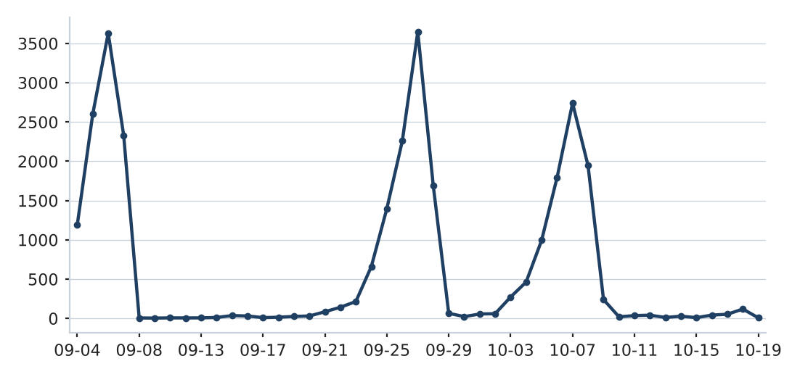

Status distribution
Share of the estate by classification status. Each segment is one status and the table beside it carries the counts.
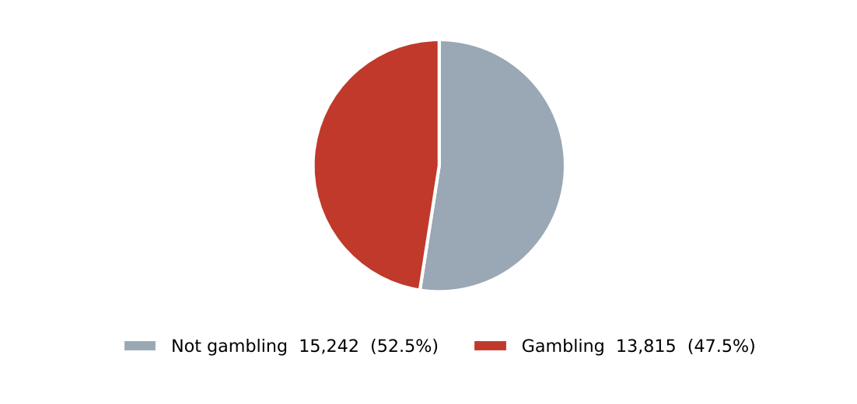
Status | Count | %
Not gambling | 15,242 | 52.5%
Gambling | 13,815 | 47.5%

Top 10 URL suffixes
The ten most common URL suffixes in the estate. Bar length is the total count and the table separates the gambling share.
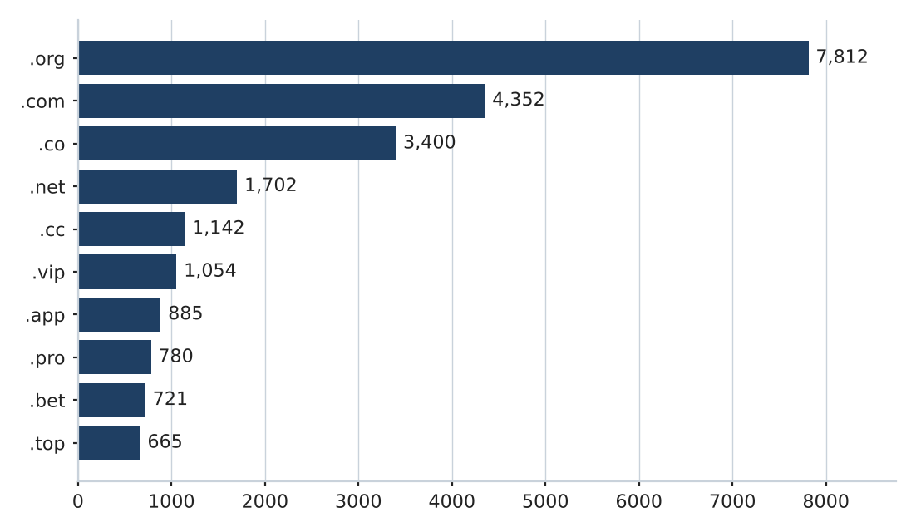
Suffix | Total | % of all | Gambling | % gambling
.org | 7,812 | 26.9% | 19 | 0.2%
.com | 4,352 | 15.0% | 2,061 | 47.4%
.co | 3,400 | 11.7% | 3,091 | 90.9%
.net | 1,702 | 5.9% | 1,082 | 63.6%
.cc | 1,142 | 3.9% | 673 | 58.9%
.vip | 1,054 | 3.6% | 952 | 90.3%
.app | 885 | 3.0% | 623 | 70.4%
.pro | 780 | 2.7% | 669 | 85.8%
.bet | 721 | 2.5% | 694 | 96.3%
.top | 665 | 2.3% | 353 | 53.1%

Subcategories

Gambling sites by product subcategory
Gambling sites by product subcategory. Bar length is the site count and each label carries the count and the share of gambling rows.
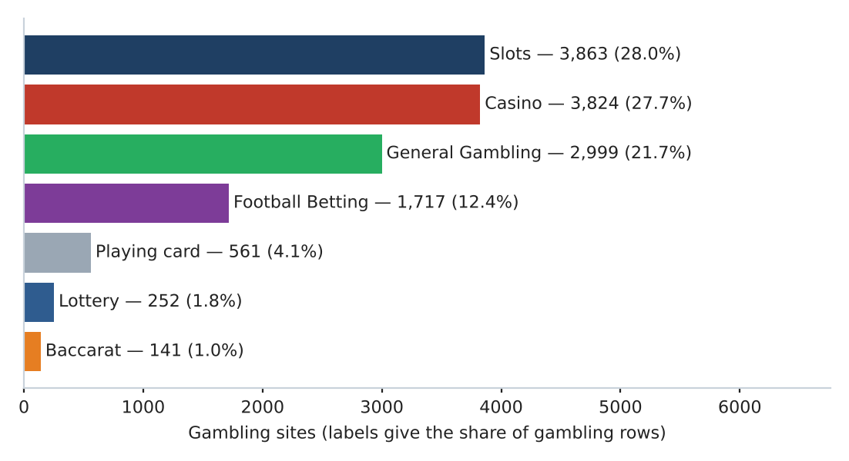

Assignment method by subcategory
How each subcategory was assigned. Solid fill is a lexicon keyword match and the lighter fill is reasoning inference.
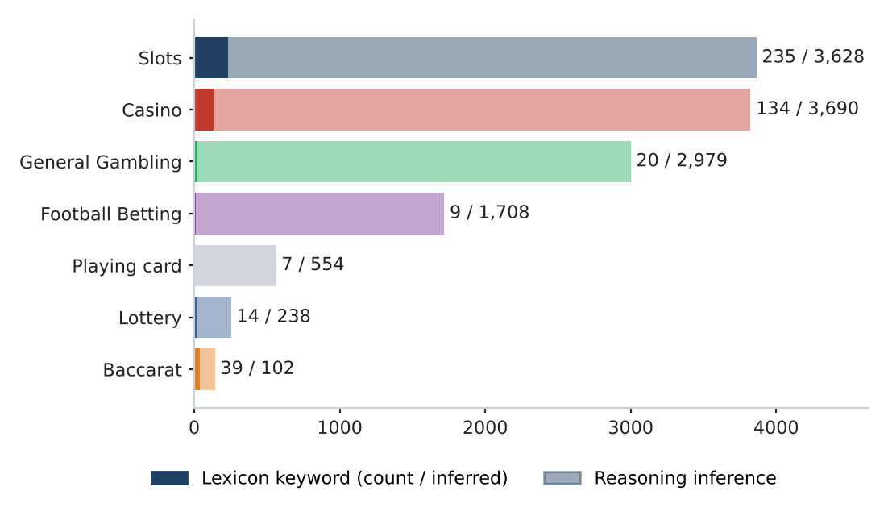

What a lexicon match means
A site is assigned to a subcategory by lexicon match when a word or phrase from the gambling keyword lexicon appears in what was recorded about the site, such as the model's description, extracted keywords, remarks from the SICPADetect automated classification pipeline, or the URL and domain, and that word belongs to the product category the site was assigned. A site whose description contains สล็อต is assigned to Slots by lexicon match. The lexicon is the SICPADetect Thai gambling keyword lexicon, at the version shown on the title page: 286 keywords in 14 categories, mostly in Thai script. Seven categories describe the gambling product and decide the subcategory. The other seven describe how a site markets or operates itself and are reported as signal tags, never as a subcategory. A lexicon match rests on a specific word that can be pointed to on the site, so the assignment can be checked and repeated. An inferred assignment rests on the model's reading of its own description when no lexicon word was found, so it carries lower confidence. A large inferred share means the sites use vocabulary the lexicon does not yet cover.
Inferred share 96.7% of gambling rows. General Gambling share 21.7% of gambling rows.

Subcategory table
Subcategory | Count | % of gambling | Keyword-assigned | Inferred | Distinct clusters
Slots | 3,863 | 28.0% | 235 | 3,628 | 939
Casino | 3,824 | 27.7% | 134 | 3,690 | 1,169
General Gambling | 2,999 | 21.7% | 20 | 2,979 | 724
Football Betting | 1,717 | 12.4% | 9 | 1,708 | 679
Playing card | 561 | 4.1% | 7 | 554 | 257
Lottery | 252 | 1.8% | 14 | 238 | 77
Baccarat | 141 | 1.0% | 39 | 102 | 107

458 gambling rows carry no description text and are not placed in a product subcategory.

Heat map: keyword by subcategory
Matched keywords against product subcategory. Each cell is the number of gambling sites carrying that keyword in that subcategory.
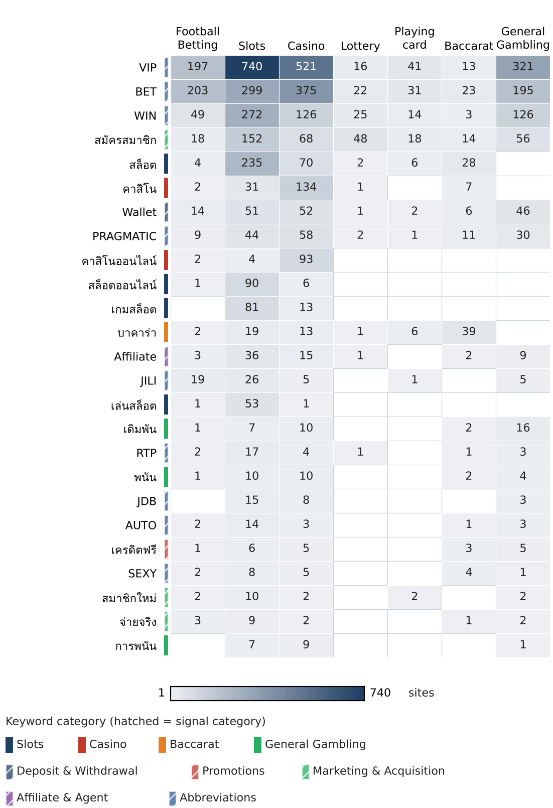

Heat map: signal tag by subcategory
Signal tags against product subcategory. Each cell is the number of gambling sites carrying that tag in that subcategory.
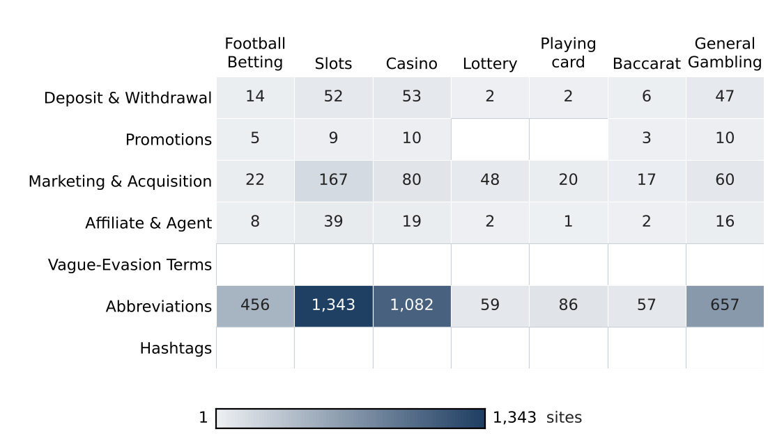

Brands and clustering

What brand clusters are

What a cluster is
A brand cluster is a group of domains judged to belong to the same gambling brand or operator. Domains join a cluster in one of three ways. The crawler finds one as a variant of, or a redirect from, another, which is the strongest basis. Their names reduce to the same stem once market tags, version numbers and suffixes are removed, so siam855thb5.com and siam-th.net both reduce to siam. Or their stems are near identical in spelling. A domain that matches no other is a singleton.

Why clusters matter
Operators rarely run a single site. They register many domains, rotate top level domains and move players between them through redirects, so that when one address is blocked another takes its place. Counting URLs therefore overstates how many operators there are and hides who is behind the estate. Clustering shows how many distinct operations exist, how concentrated the estate is, and which operators run several product types. Acting on a cluster reaches every domain in it, where acting on a single URL leaves the rest of the brand running.
Clusters are an analytical grouping based on names and crawler links, not a legal finding about ownership, and the linkage table is indicative only.

2,798  Distinct clusters | 1,272  Clusters with 2 or more URLs | 1,526  Singletons | 49  Clusters to cover half of gambling URLs

Top 15 brand clusters by URL count
The fifteen largest brand clusters by URL count. Bar length is the number of domains in the cluster.
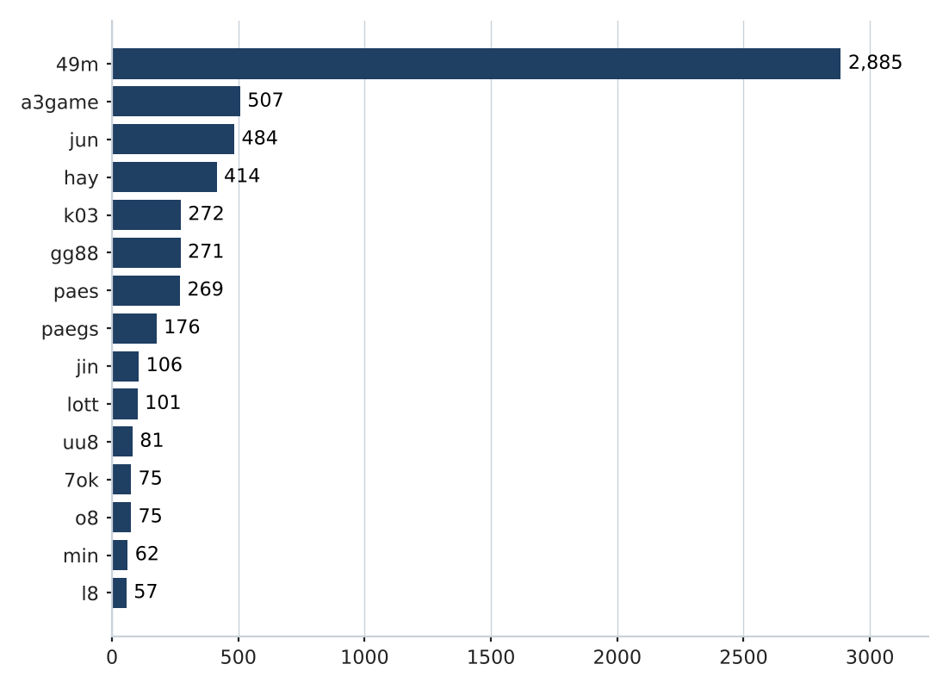

Heat map: brand cluster by subcategory
Brand clusters against product subcategory. Each cell is the number of URLs a cluster holds in that subcategory.
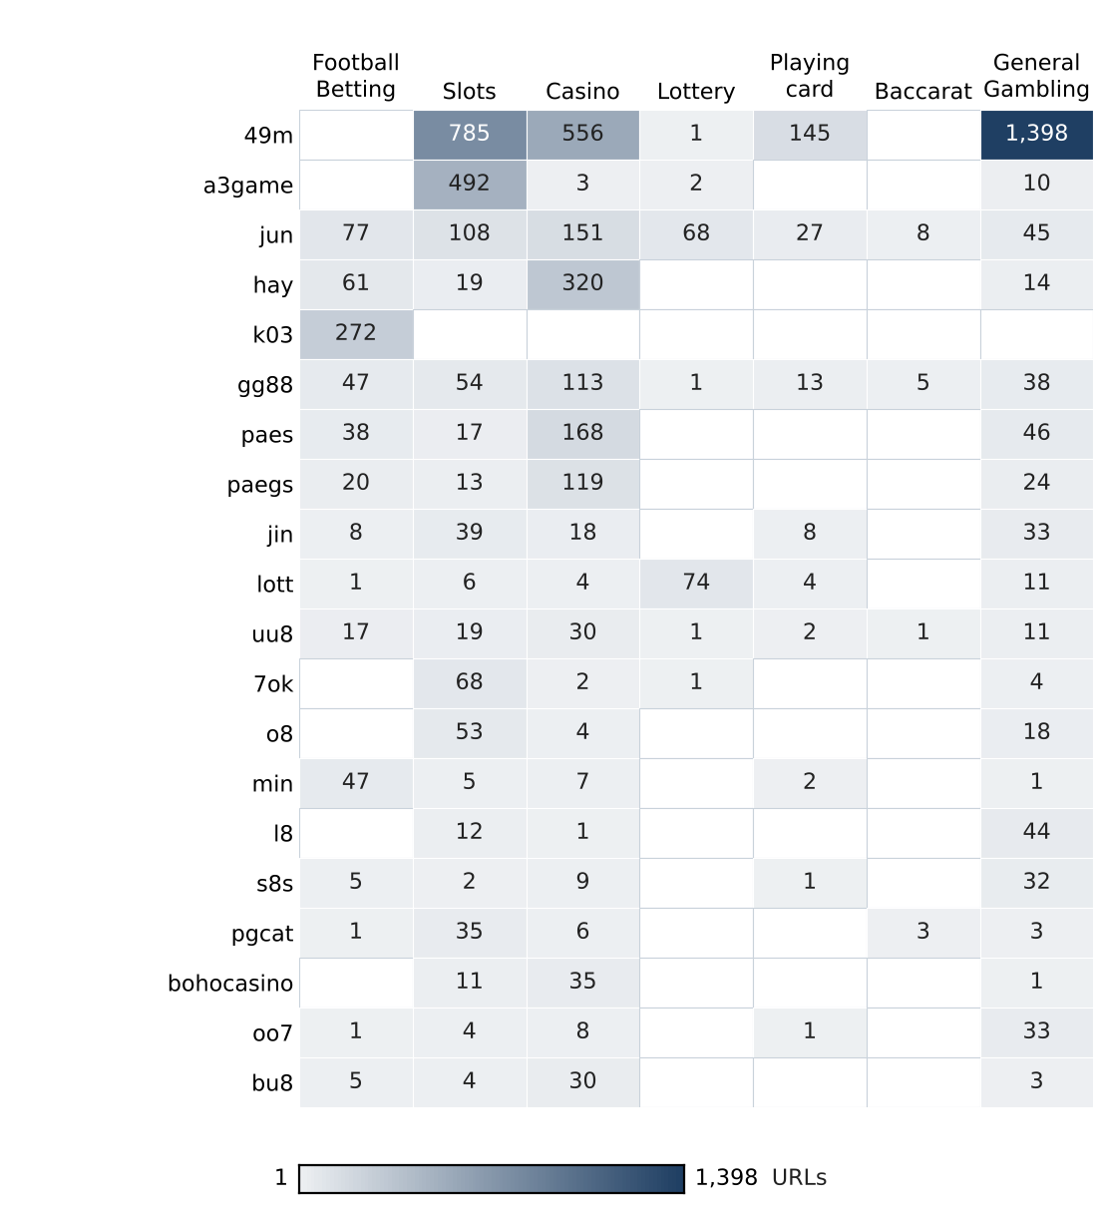

Cluster expansion: 49m
The largest brand cluster and its member domains. Edge style records why each domain joined the cluster.
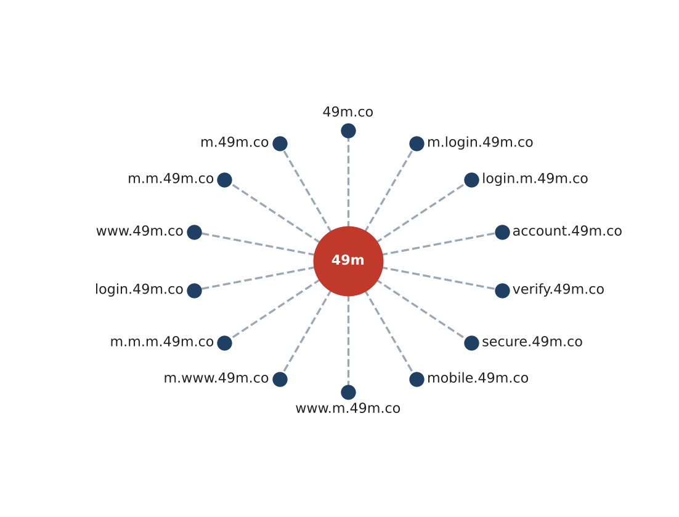
Domains in this cluster share the stem 49m and differ in the subdomain labels placed before it; dashed edges mark membership by shared stem.
Fourteen of 2,885 member domains are drawn.

Clusters spanning multiple subcategories
Cluster | URL count | Subcategories | Suffixes
49m | 2,885 | Slots, Casino, Lottery, Playing card, General Gambling | .co
a3game | 507 | Slots, Casino, Lottery, General Gambling | .vip, .app, .click, .net
jun | 484 | Football Betting, Slots, Casino, Lottery, Playing card, Baccarat, General Gambling | .top, .com, .net, .bet, .cc …
hay | 414 | Football Betting, Slots, Casino, General Gambling | .net, .app, .bet, .club, .co …
gg88 | 271 | Football Betting, Slots, Casino, Lottery, Playing card, Baccarat, General Gambling | .net, .app, .pro, .bet, .com …
paes | 269 | Football Betting, Slots, Casino, General Gambling | .dev
paegs | 176 | Football Betting, Slots, Casino, General Gambling | .dev
jin | 106 | Football Betting, Slots, Casino, Playing card, General Gambling | .vip, .com, .co, .net, .bet …
lott | 101 | Football Betting, Slots, Casino, Lottery, Playing card, General Gambling | .com, .net, .cc, .live, .online …
uu8 | 81 | Football Betting, Slots, Casino, Lottery, Playing card, Baccarat, General Gambling | .cc, .com, .net, .pro, .click …
7ok | 75 | Slots, Casino, Lottery, General Gambling | .bet, .live, .io, .club, .pro
o8 | 75 | Slots, Casino, General Gambling | .game, .live
min | 62 | Football Betting, Slots, Casino, Playing card, General Gambling | .net, .com, .app, .vip, .actor …
l8 | 57 | Slots, Casino, General Gambling | .game
s8s | 49 | Football Betting, Slots, Casino, Playing card, General Gambling | .com

The 15 largest of 856 clusters spanning two or more product subcategories. Suffix lists show the five most frequent.

Clusters rotating top-level domains
Cluster | Suffixes | Counts
a3game | 4 | .vip 502, .app 2, .click 2, .net 1
jun | 30 | .top 93, .com 71, .net 54, .bet 32, .cc 25, .app 25 …
hay | 8 | .net 407, .app 1, .bet 1, .club 1, .co 1, .pro 1 …
gg88 | 19 | .net 50, .app 43, .pro 41, .bet 31, .com 28, .online 17 …
jin | 19 | .vip 21, .com 16, .co 14, .net 13, .bet 7, .pro 7 …
lott | 16 | .com 60, .net 6, .cc 5, .live 4, .online 4, .click 4 …
uu8 | 22 | .cc 11, .com 10, .net 9, .pro 7, .click 5, .co 5 …
7ok | 5 | .bet 66, .live 5, .io 2, .club 1, .pro 1
o8 | 2 | .game 73, .live 2
min | 29 | .net 7, .com 6, .app 4, .vip 3, .actor 2, .art 2 …
pgcat | 14 | .com 25, .info 3, .bet 2, .buzz 2, .click 2, .club 2 …
bohocasino | 15 | .com 29, .info 3, .co 2, .net 2, .app 1, .bet 1 …
oo7 | 8 | .vip 39, .click 2, .app 1, .bet 1, .club 1, .io 1 …
bu8 | 21 | .com 6, .app 2, .bid 2, .cab 2, .club 2, .in 2 …
siam | 11 | .com 27, .co 2, .io 2, .net 2, .shop 2, .vip 2 …

The 15 largest of 901 clusters holding two or more suffixes. Counts list the six most frequent suffixes.

Possible operator linkage
Indicative — not a clustering decision
Cluster A | Cluster B | Shared keywords | Jaccard
pgcat | mst | BET, JILI, PRAGMATIC, VIP, WALLET, WIN, Wallet, สมัครสมาชิก, เครดิตฟรี, แจกเครดิตฟรี | 0.71
7ok | meg | BET, PRAGMATIC, RTP, VIP, WALLET, WIN, Wallet, สมัครสมาชิก | 1.00
7ok | wingame | BET, PRAGMATIC, VIP, WALLET, WIN, Wallet, สมัครสมาชิก | 0.78
7ok | 19ufa | BET, PRAGMATIC, RTP, WALLET, WIN, Wallet, สมัครสมาชิก | 0.78
meg | wingame | BET, PRAGMATIC, VIP, WALLET, WIN, Wallet, สมัครสมาชิก | 0.78
meg | 19ufa | BET, PRAGMATIC, RTP, WALLET, WIN, Wallet, สมัครสมาชิก | 0.78
7ok | ezslot | BET, PRAGMATIC, VIP, WALLET, WIN, Wallet, สมัครสมาชิก | 0.70
ezslot | meg | BET, PRAGMATIC, VIP, WALLET, WIN, Wallet, สมัครสมาชิก | 0.70
ezslot | wingame | BET, PRAGMATIC, VIP, WALLET, WIN, Wallet, สมัครสมาชิก | 0.70
7ok | mst | BET, PRAGMATIC, VIP, WALLET, WIN, Wallet, สมัครสมาชิก | 0.64
jin | 7ok | BET, RTP, VIP, WALLET, WIN, Wallet, สมัครสมาชิก | 0.64
jin | meg | BET, RTP, VIP, WALLET, WIN, Wallet, สมัครสมาชิก | 0.64
meg | mst | BET, PRAGMATIC, VIP, WALLET, WIN, Wallet, สมัครสมาชิก | 0.64
mst | 52m | BET, PRAGMATIC, VIP, WIN, สมัครสมาชิก, เครดิตฟรี, แจกเครดิตฟรี | 0.64
mst | wingame | BET, PRAGMATIC, VIP, WALLET, WIN, Wallet, สมัครสมาชิก | 0.64

40,828 pairs of multi-URL clusters score 0.60 or higher; the 15 with the most shared keywords are shown.

Naming conventions
- Recurring tokens: m (3,460), login (2,097), support (1,894) appear most often in names within the largest clusters, which is consistent with a templated naming scheme.
- TLD switching: names in the largest clusters span .co (2,923), .vip (553), .net (547), .dev (445), so these operators rotate top-level domains.
- 13,815 distinct domains across 2,798 brand clusters.

Ranking

Gambling ranking
Rank | Domain | Brand cluster | Subcategory | Source
93,117 | metal--vip.com | met | Slots | x
214,132 | allslotwallet.online | allslotwallet | Slots | Not recorded
221,001 | suriyathai.net | suriya | General Gambling | x
252,597 | u11k.pro | u11 | Football Betting | Not recorded
254,190 | anthonyhead.com | anthonyhead | Casino | x
254,190 | kohochocolates.com | kohochocolates | Casino | Not recorded
293,057 | bifestathailand.com | bifestathailand | General Gambling | Not recorded
293,057 | lgbtnewsnow.org | lgbtnewsnow | General Gambling | x
303,254 | jun88wf.com | jun88w | Casino | Not recorded
397,330 | jun88wa.com | jun88w | Casino | Not recorded
466,858 | jun88wc.com | jun88w | Slots | Not recorded
514,501 | sacasino.ad | sacasino | Baccarat | x
517,141 | jun88.info | jun | Casino | Not recorded
517,141 | slavinaslot.top | slavinaslot | Casino | Not recorded
547,370 | 99ok.vip | 99ok | Lottery | Not recorded

Rank reflects search visibility in the source feed, not harm, reach or revenue.

Key insights

Scale of the analysis
The analysis covers 29,057 distinct URLs over 46 days, from 4 Sep 2026 to 19 Oct 2026. Of these, 13,815 are gambling, 15,242 are not gambling and 0 are unreachable.
The sample is large enough to reason about patterns, not isolated cases.

What is being offered
The three largest product subcategories are Slots (3,863, 28.0%), Casino (3,824, 27.7%) and General Gambling (2,999, 21.7%). 21.7% of gambling sites are confirmed as gambling without an evidenced product type, and 96.7% of subcategory assignments are inferred. 207 lexicon keywords never matched.
Slots is the dominant product type, but at 28.0% of gambling rows the estate is spread across product types rather than concentrated.

Brand clustering
2,798 clusters sit across 13,815 gambling URLs. 1,272 hold more than one domain, and 49 clusters cover half the estate. The largest, 49m, holds 2,885 domains across 5 subcategories.
The estate is diffuse and per-URL blocking will have limited leverage.

How the estate is grown and marketed
900 clusters rotate across more than one top-level domain. The two most common signal tags are Abbreviations (27.1%) and Marketing & Acquisition (3.0%).
TLD rotation keeps a stable entry point while the sites behind it are replaced.

Enforcement position
0 pages with evidence relevant to Thailand already show regulatory-blocking indicators such as court orders, regulator notices or block pages. The set appears pre-enforcement.
This set is a candidate for a first enforcement pass, prioritised by cluster rather than by URL.

Lexicon source: Gambling_Keywords_Full_English_Categories_V1.xlsx, version V1; keywords per category: Football Betting 21; Slots 32; Casino 14; Lottery 20; Playing card 12; Baccarat 11; General Gambling 22; Deposit & Withdrawal 24; Promotions 27; Marketing & Acquisition 25; Affiliate & Agent 20; Vague-Evasion Terms 20; Abbreviations 22; Hashtags 21. Inferred share 96.7%; General Gambling share 21.7%; the lexicon has poor coverage of this dataset and subcategory figures are indicative only. Rows normalised from Licensed gambling: 0. Probable false-positive source among abbreviations: VIP, BET (more than 20% of abbreviation matches). Clustering thresholds: Jaro–Winkler similarity 0.90 or higher with a shared prefix; operator linkage Jaccard 0.60 or higher.

