

Data Insights & Patterns
29,864 URLs · 4 Sep – 20 Oct 2026
Issued to | Ministry of Digital Economy and Society, Thailand
Prepared by | SICPA SA
Date of issue | 21/10/2026
Source system | SICPADetect, lexicon V1 (Gambling_Keywords_Full_English_Categories_V1.xlsx)

Contents
Executive Summary | 3
Insights and trends | 3
Key figures | 3
Model Insights | 5
Introduction | 5
Executive Summary | 5
Overall and per class results | 6
Error Analysis | 6
Segments and Confidence | 6
Data Analysis | 7
10 most prominent gambling sites in Thailand | 7
10 most prominent gambling sites in Thailand | 7
The numbers | 7
How URLs are classified | 7
From collection to analysis | 8
URLs analyzed per day | 9
Status distribution | 10
Top 10 URL suffixes | 11
Subcategories | 12
Gambling sites by product subcategory | 12
Assignment method by subcategory | 13
Subcategory table | 14
Heat map: Keyword × subcategory | 15
Heat map: Signal tag × subcategory | 16
Brands and clustering | 16
What brand clusters are | 16
Domains with the most URLs | 17
Top 15 brand clusters by URL count | 18
Heat map: Brand cluster × subcategory | 19
Cluster expansion: jun8 | 20
Inside the largest cluster | 21
Clusters spanning multiple subcategories | 22
Clusters rotating top-level domains | 23
Possible operator linkage | 24
Naming conventions | 25
Structure: direct → redirect → variant | 25
Ranking | 26
Gambling ranking | 26
Ranked brand clusters | 27
Key insights | 28
Scale of the analysis | 28
What is being offered | 28
Brand clustering | 28
How the estate is grown and marketed | 29
Enforcement position | 29
Annexes | 30
Annex 1 — Subcategory definitions | 30
Annex 2 — Ranked domains used for clustering | 33

Executive Summary
Insights and trends
SICPADetect analysed 29,864 URLs over a 47 day evaluation period. 47.5% of them were judged to offer or promote gambling and the remainder were judged not to.
Slots is the dominant product type, with Casino second. Most subcategory assignments rest on the model's own description rather than on a lexicon keyword, so product figures are indicative only.
The gambling URLs sit on 6,827 domains and resolve into 2,719 brand clusters, of which 995 hold more than one domain. One domain, 49m.co, carries 20.3% of the gambling URLs through many hostnames. 15 host farms carry 35.1% of them.
Abbreviations is the most common signal tag. The export records no variant or redirect links, so the report cannot say how the estate spreads between domains. Many clusters use more than one top level domain.
The evaluation period is too short to carry a trend, so no direction is stated for daily volume. 3 gaps of three or more days fall below the gap threshold, and their cause is not recorded. The operations log was not supplied, so no cause is recorded for the peaks.
No URL shows a Thai enforcement indicator. The collection network was not recorded, so enforcement may be understated.
Key figures
URLs analysed | 29,864
URLs set aside as Needs more analysis | 0
Gambling URLs and share | 14,182 (47.5%)
Not gambling and unreachable URLs | 15,682 not gambling · 0 unreachable
Domains carrying the gambling URLs | 6,827
Brand clusters identified | 2,719, of which 995 hold more than one domain
Clusters needed to cover half of gambling URLs | 43
Largest cluster | 49m · 2,885 URLs · 1 domain · 20.3% of gambling URLs
Largest domain | 49m.co · 2,885 URLs · 20.3% of gambling URLs
Host farms | 15 domains with 20 or more gambling URLs · 4,971 URLs · 35.1% of gambling URLs
Dominant product subcategory | Slots · 44.6% of gambling URLs
Most common signal tag | Abbreviations · 27.1% of gambling URLs
URLs with Thai enforcement indicators · other block page phrases | 0 · 7 · collection network not recorded
Keyword versus inferred subcategory assignment | 471 keyword (3.3%) · 13,711 inferred (96.7%)

Model Insights

Introduction
The results in this section come from a controlled test of the SICPADetect classification model. The test was run against a predefined dataset, fixed in advance so that results are consistent and can be reproduced. It was designed to measure model performance only. The test dataset is separate from, and not related to, the data examined in the Data Analysis section, so figures in this section should not be compared or combined with figures elsewhere in this report.

Executive Summary

Overall and per class results

Error Analysis

Segments and Confidence

Data Analysis

10 most prominent gambling sites in Thailand

10 most prominent gambling sites in Thailand
Rank | Domain | Brand cluster | Subcategory | Thai targeting evidence | Source
93117 | metal--vip.com | metal | Slots | Thai script: เข้าสู่ระบบ | x
221001 | suriyathai.net | suriya | General Gambling | Thai script: สมัครสมาชิก | x
254190 | anthonyhead.com | anthonyhead | Casino | Thai currency: Baht | x
254190 | kohochocolates.com | kohochocolates | Casino | Thai currency: Baht | Not recorded
293057 | bifestathailand.com | bifestathailand | Slots | Thai currency: THB | Not recorded
293057 | lgbtnewsnow.org | lgbtnewsnow | Slots | Thai currency: THB | x
514501 | sacasino.ad | sacasino | Baccarat | Thai script: บาคาร่า | x
733816 | 707jili.com | 707jili | Slots | Thai script: สล็อตออนไลน์ สล็อตเว็บตรง | Not recorded
758592 | 9ufa.vip | 9ufa | Casino | Thai script: เครดิตฟรี | Not recorded
766101 | awayge.farm | awayge | Slots | Thai script: เกมสล็อต | x

Rank reflects search visibility in the source feed, not harm, reach or revenue. Evidence is quoted from the description text in its original script. The export records no URL beyond the domain.

The numbers

How URLs are classified
Every URL in this analysis receives one of five outcomes. Gambling: the classifier judged, from what was recorded about the page, that the site offers or promotes gambling. Not gambling: the page was read and judged not to offer gambling. Unreachable: the page could not be fetched or read from the collection network, so no judgement was made. Needs more analysis: the classifier could not decide with enough confidence, so the URL is set aside for human review; these URLs are counted in From collection to analysis and are excluded from every other figure in this section. Unknown: the export carried a status outside these four. Figures in this section count URLs, one URL being one address analysed; where a card counts domains instead, it says so.

29,864  Total URLs analyzed |  | 14,182  Gambling URLs |  | 6,827  Gambling domains |  | 47 days  Evaluation period  2026-09-04 → 2026-10-20

From collection to analysis
URLs at each stage from the export to the analysis. Each box carries the URLs kept and each branch the URLs set aside.
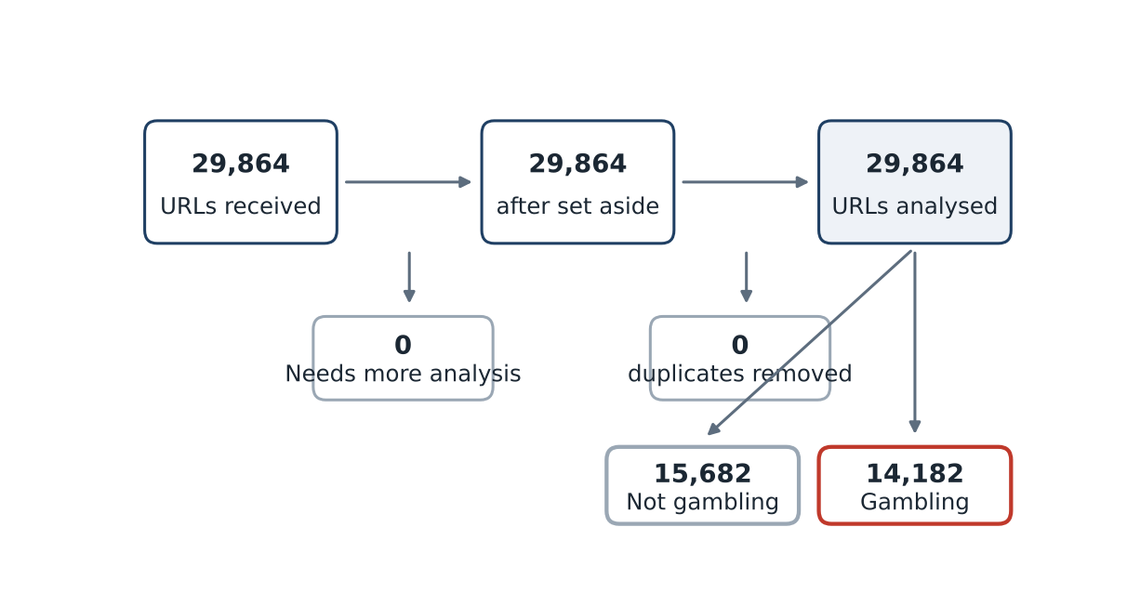
Stage | URLs
URLs received | 29,864
Set aside as Needs more analysis | 0
Duplicates removed | 0
URLs analysed | 29,864

URLs analysed split by status: Not gambling 15,682 · Gambling 14,182.

URLs analyzed per day
Daily count of URLs analysed across the evaluation period. Each point is one calendar day and shaded bands mark gaps.
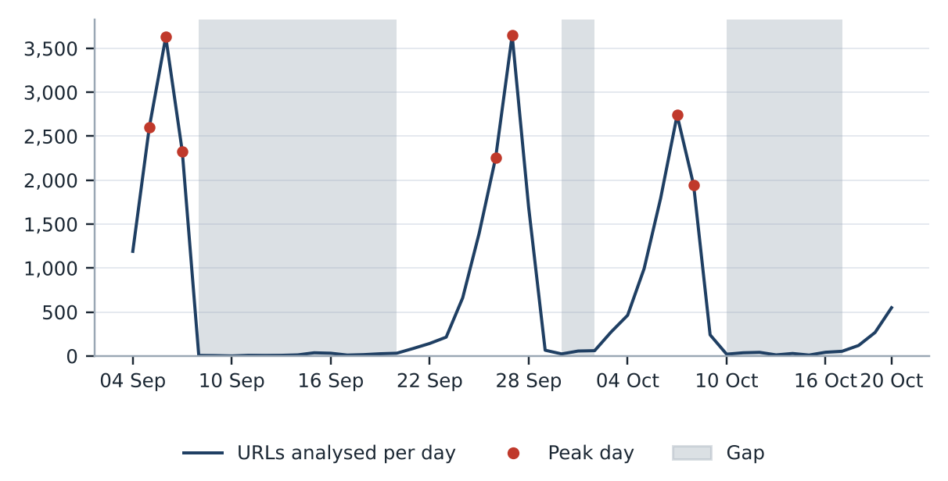
Gap threshold: 10% of the mean of 635 URLs a day, which is 64 URLs a day. 24 days fall below it. Gap 2026-09-08 to 2026-09-20 (13 days, 190 URLs), cause not recorded. Gap 2026-09-30 to 2026-10-02 (3 days, 139 URLs), cause not recorded. Gap 2026-10-10 to 2026-10-17 (8 days, 242 URLs), cause not recorded. Peak periods, days above three times the mean daily count: 2026-09-05 to 2026-09-07 (8,558 URLs); 2026-09-26 to 2026-09-27 (5,907 URLs); 2026-10-07 to 2026-10-08 (4,685 URLs). The cause of each peak is not recorded. A URL is dated by the last time its record changed, so a re-analysed URL moves to its later date.

Status distribution
Share of the estate by classification status. Each segment is one status and the table beside it carries the counts.
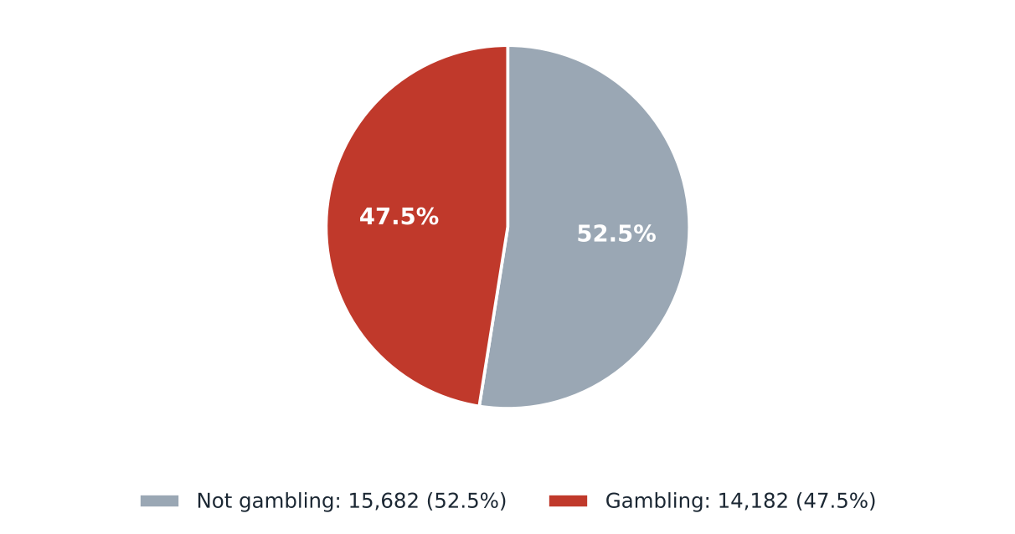
Status | Count | Share
Not gambling | 15,682 | 52.5%
Gambling | 14,182 | 47.5%
Total | 29,864 | 100.0%

0 URLs classified as Needs more analysis are set aside before this count and appear in From collection to analysis.

Top 10 URL suffixes
The ten most common URL suffixes in the estate. Bar length is the total count and the table separates the gambling share.
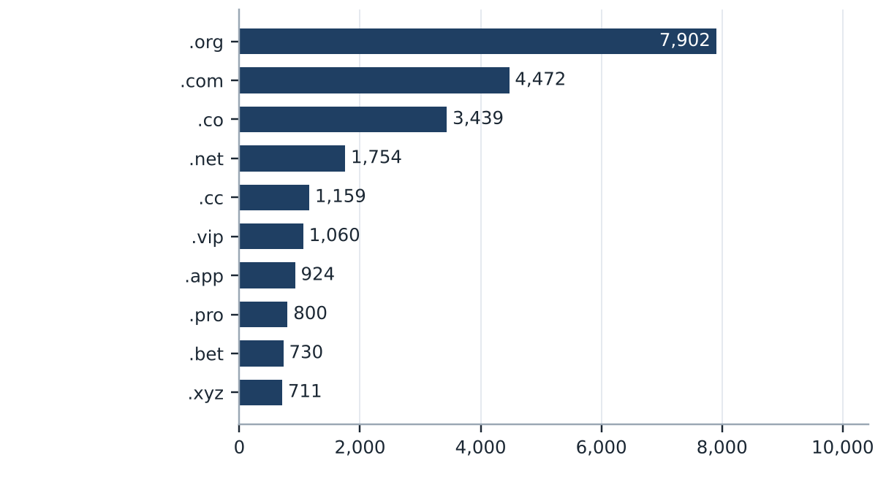
Suffix | Total URLs | % of all | Gambling URLs | % gambling
.org | 7,902 | 26.5% | 19 | 0.2%
.com | 4,472 | 15.0% | 2,106 | 47.1%
.co | 3,439 | 11.5% | 3,116 | 90.6%
.net | 1,754 | 5.9% | 1,102 | 62.8%
.cc | 1,159 | 3.9% | 683 | 58.9%
.vip | 1,060 | 3.5% | 955 | 90.1%
.app | 924 | 3.1% | 643 | 69.6%
.pro | 800 | 2.7% | 682 | 85.2%
.bet | 730 | 2.4% | 703 | 96.3%
.xyz | 711 | 2.4% | 348 | 48.9%

195 further suffixes covering 6,913 URLs fall outside the top 10. Suffix is the last dot segment of the domain.

Subcategories

Gambling sites by product subcategory
Gambling sites by product subcategory. Bar length is the site count and each label carries the count and the share of gambling rows.
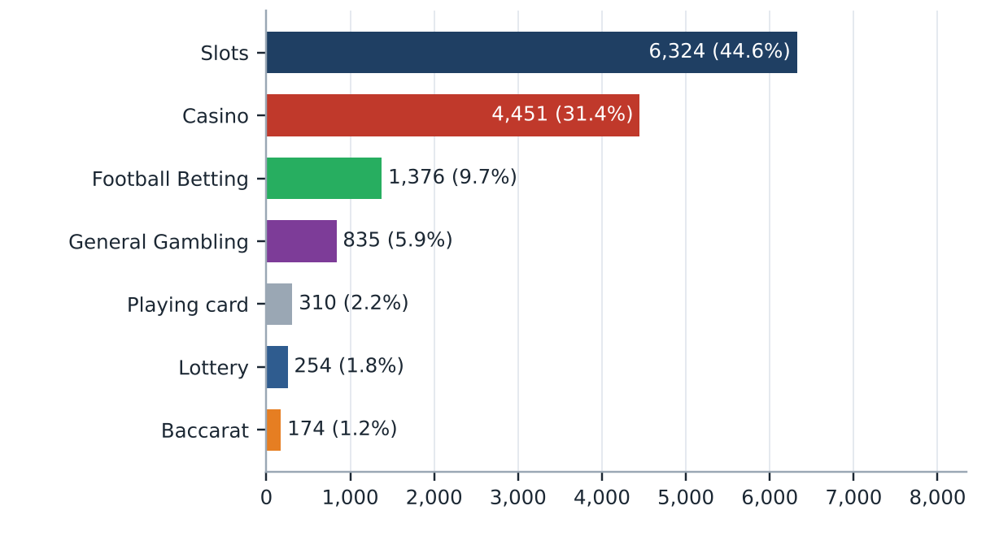
Shares are of gambling rows, not of all rows. 458 gambling rows have no reasoning text, are assigned Unspecified and are not drawn.

Assignment method by subcategory
How each subcategory was assigned. Solid fill is a lexicon keyword match and the lighter fill is reasoning inference.
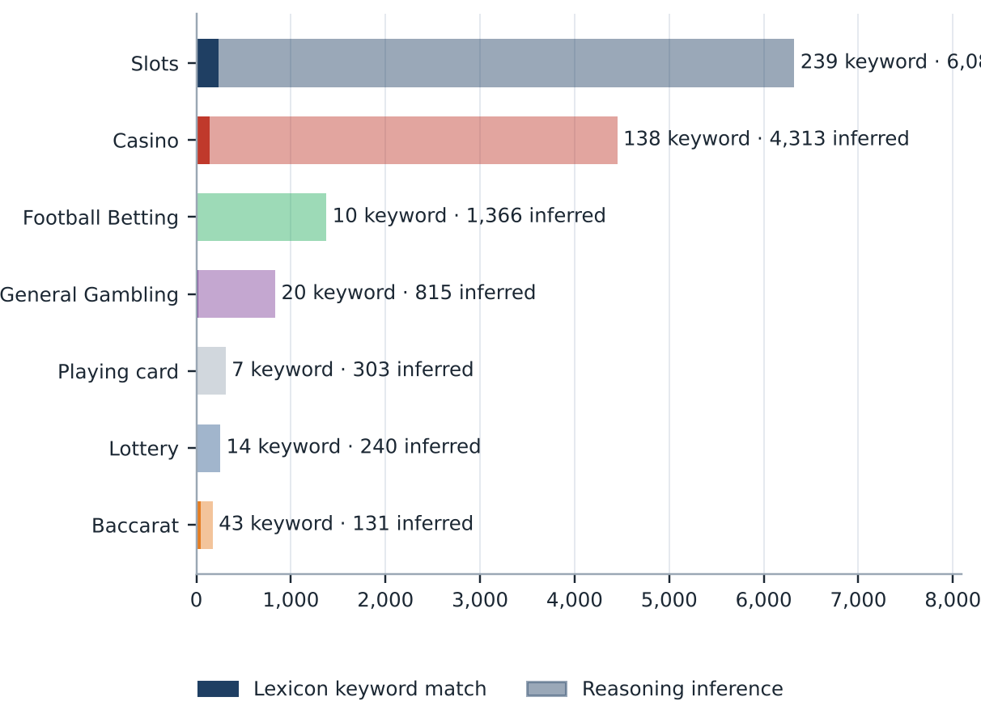
What a lexicon match means
A lexicon match means a word from the gambling keyword lexicon appears in what was recorded about the site, such as the model's description or the URL, and that word belongs to the product category assigned. A site whose description contains สล็อต is assigned to Slots this way. The lexicon is the SICPADetect Thai gambling keyword list shown on the title page, with 286 keywords in 14 categories. Seven categories decide the subcategory and seven are reported as signal tags. A match rests on a word that can be pointed to, so it can be checked and repeated. An inferred assignment rests on the model's reading of its own description, so it carries lower confidence. A large inferred share means the sites use vocabulary the lexicon does not yet cover.
Inferred share of gambling rows: 96.7%. General Gambling share: 5.9%. The lexicon has poor coverage of this dataset, so subcategory figures are indicative only.

Subcategory table
Subcategory | Count | % of gambling | Keyword assigned | Inferred | Distinct clusters
Slots | 6,324 | 44.6% | 239 | 6,085 | 1,168
Casino | 4,451 | 31.4% | 138 | 4,313 | 1,378
Football Betting | 1,376 | 9.7% | 10 | 1,366 | 534
General Gambling | 835 | 5.9% | 20 | 815 | 228
Playing card | 310 | 2.2% | 7 | 303 | 152
Lottery | 254 | 1.8% | 14 | 240 | 79
Baccarat | 174 | 1.2% | 43 | 131 | 125
Unspecified | 458 | 3.2% | 0 | 458 | 418
Total | 14,182 | 100.0% | 471 | 13,711

676 of the General Gambling URLs are listing, review or ranking sites, pending jointly agreed labelling rules.

Heat map: Keyword × subcategory
Matched keywords against product subcategory. Each cell is the number of gambling sites carrying that keyword in that subcategory.
 |  | Slots | Casino | Football Betting | General Gambling | Baccarat | Lottery | Playing card
 | VIP | 1,031 | 530 | 168 | 73 | 15 | 17 | 19
 | BET | 408 | 497 | 172 | 54 | 29 | 24 | 20
 | WIN | 371 | 155 | 44 | 32 | 4 | 24 | 2
 | สมัครสมาชิก | 201 | 82 | 17 | 12 | 13 | 47 | 7
 | สล็อต | 239 | 70 | 4 |  | 32 | 2 | 6
 | WALLET | 99 | 58 | 13 | 3 | 6 | 1 | 1
 | Wallet | 99 | 58 | 13 | 3 | 6 | 1 | 1
 | คาสิโน | 31 | 138 | 2 |  | 7 | 1
 | คาสิโน | 31 | 138 | 2 |  | 7 | 1
 | PRAGMATIC | 58 | 82 | 4 | 8 | 15 | 3 | 1
 | คาสิโนออนไลน์ | 4 | 96 | 2
 | คาสิโนออนไลน์ | 4 | 96 | 2
 | สล็อตออนไลน์ | 92 | 6 | 1
 | เกมสล็อต | 82 | 13
 | บาคาร่า | 20 | 13 | 2 |  | 43 | 1 | 6
 | Affiliate | 40 | 16 | 3 | 6 | 2 | 2
 | JILI | 39 | 7 | 19
 | เล่นสล็อต | 54 | 1 | 1
 | เดิมพัน | 7 | 10 | 1 | 16 | 2
 | RTP | 23 | 5 | 1 |  | 1 | 1
 | พนัน | 10 | 10 | 1 | 4 | 2
 | JDB | 20 | 6
 | AUTO | 18 | 3 | 1 | 3
 | SEXY | 8 | 6 | 2 |  | 4
 | เครดิตฟรี | 6 | 10 | 1 |  | 3

Scale: palest fill = 1, darkest fill = 1,031. Empty cells are zero.
■ Abbreviations ■ Marketing & Acquisition ■ Slots ■ Deposit & Withdrawal ■ Casino ■ General Gambling ■ Baccarat ■ Affiliate & Agent ■ Promotions
The coloured strip beside each keyword shows the lexicon category the keyword belongs to. A keyword listed under two categories appears once for each. Rows are the 25 most matched keywords; columns show the seven product subcategories.

Heat map: Signal tag × subcategory
Signal tags against product subcategory. Each cell is the number of gambling sites carrying that tag in that subcategory.
 | Slots | Casino | General Gambling | Football Betting | Lottery | Baccarat | Playing card
Abbreviations | 1,863 | 1,254 | 155 | 387 | 63 | 68 | 42
Affiliate & Agent | 47 | 23 | 678 | 8 | 2 | 2 | 1
Marketing & Acquisition | 217 | 99 | 12 | 22 | 47 | 16 | 7
Deposit & Withdrawal | 103 | 59 | 3 | 13 | 2 | 6 | 1
Promotions | 14 | 16 |  | 5 |  | 3
Hashtags
Vague-Evasion Terms

Scale: palest fill = 1, darkest fill = 1,863. Empty cells are zero.
Rows are the seven signal categories of the lexicon. Gambling sites with no reasoning text and no product keyword are assigned Unspecified and are not drawn here.

Brands and clustering

What brand clusters are
What a cluster is
A brand cluster is a group of URLs, and the domains they sit on, judged to belong to the same gambling brand or operator. Domains join a cluster in one of four ways. The crawler followed a redirect between them, or generated one as a variant of the other's name, which is seed linkage. One matches a brand in an external ranking of gambling domains for Thailand and is grouped under that brand's name, as listed in Annex 2. Their names reduce to the same stem once market tags, version numbers and suffixes are removed, so ufabet168th.com and ufabet-vip.net both reduce to ufabet. Their stems are near identical. A domain that matches nothing else is a singleton. Every hostname on a registered domain is in the same cluster.
Why clusters matter
Operators rarely run one site. They register many domains, rotate top level domains and move players between them through redirects, so when one address is blocked another takes its place. Counting URLs therefore overstates how many operators there are. Clustering shows how many distinct operations exist and which run several product types, so acting on a cluster reaches every domain in it. Clusters are an analytical grouping based on names, crawler links and an external domain ranking, not a legal finding about ownership, and the Possible operator linkage table is indicative only.

2,719  Distinct clusters |  | 995  Clusters with 2 or more domains |  | 1,724  Singletons, one domain each |  | 43  Clusters covering half of gambling URLs

Domains with the most URLs
Largest domain holds 20.3% of gambling URLs
How to read this table
The table lists the registered domains that carry the most gambling URLs in this sample. Each row gives the domain, its number of URLs, their share of all gambling URLs, the brand cluster it belongs to, the first and last day SICPADetect recorded it, and whether it is a host farm. A domain carrying 20 or more gambling URLs is marked as a host farm, meaning many hostnames under one registered name. Many hostnames under one domain usually come from a single setting that makes every name under the domain lead to the same site, so they may not be separate pages. Action against the domain itself reaches every one of its hostnames at once.
Domain | URLs | % of gambling URLs | Brand cluster | First seen | Last seen | Host farm
49m.co | 2,885 | 20.3% | 49m | 2026-10-03 | 2026-10-09 | Yes
a3game.vip | 502 | 3.5% | a3game | 2026-09-23 | 2026-09-28 | Yes
hayy.net | 407 | 2.9% | hay | 2026-09-04 | 2026-09-07 | Yes
k03.cc | 272 | 1.9% | k03 | 2026-09-04 | 2026-09-07 | Yes
paes.dev | 269 | 1.9% | paes | 2026-09-24 | 2026-09-28 | Yes
paegs.dev | 176 | 1.2% | paes | 2026-09-24 | 2026-09-28 | Yes
o8.game | 73 | 0.5% | o8 | 2026-09-04 | 2026-09-07 | Yes
abbet.xyz | 70 | 0.5% | abbet | 2026-10-18 | 2026-10-20 | Yes
jun888.top | 67 | 0.5% | jun8 | 2026-09-24 | 2026-09-28 | Yes
7ok.bet | 66 | 0.5% | 7ok | 2026-09-04 | 2026-09-07 | Yes
l8.game | 57 | 0.4% | l8 | 2026-09-04 | 2026-09-07 | Yes
jn86.cc | 40 | 0.3% | jn86 | 2026-09-24 | 2026-09-28 | Yes
oo7.vip | 37 | 0.3% | oo7 | 2026-09-04 | 2026-09-07 | Yes
mwbet.info | 27 | 0.2% | mwbet | 2026-10-18 | 2026-10-20 | Yes
ju088.com | 23 | 0.2% | ju088 | 2026-09-25 | 2026-09-28 | Yes

15 domains are host farms, carrying 4,971 gambling URLs (35.1% of gambling URLs). 722 domains cover half of the gambling URLs. The export records no HTTP status, so fetch evidence for the host farms is not recorded.
The top 15 domains are shown; 6,812 domains are outside the table. The top 5 domains hold 30.6% of gambling URLs and the top 10 hold 33.8%.

Top 15 brand clusters by URL count
The fifteen largest brand clusters. Bar length is the number of URLs in the cluster and each label also gives its domains.
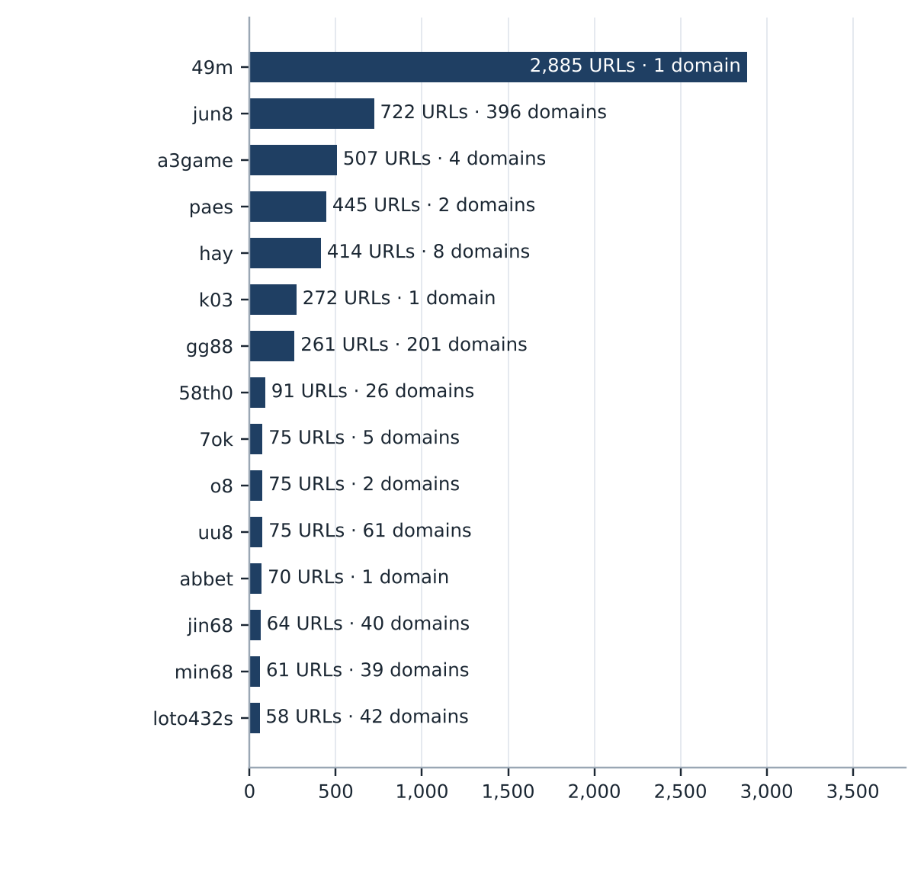
The top 5 clusters hold 35.1% of gambling URLs and the top 10 hold 40.5%.

Heat map: Brand cluster × subcategory
Brand clusters against product subcategory. Each cell is the number of URLs a cluster holds in that subcategory.
 | Slots | Casino | General Gambling | Football Betting | Lottery | Playing card | Baccarat
49m | 1,860 | 487 | 460 |  |  | 78
jun8 | 193 | 315 | 19 | 93 | 68 | 22 | 12
a3game | 497 | 3 | 7
paes | 227 | 156 | 4 | 58
hay | 170 | 223 | 6 | 15
k03 |  |  | 2 | 270
gg88 | 67 | 146 | 8 | 25 | 1 | 7 | 7
58th0 | 91
7ok | 71 | 2 | 1 |  | 1
o8 | 71 | 4
uu8 | 30 | 33 | 1 | 7 | 1 | 1 | 2
abbet | 6 | 63 | 1
jin68 | 28 | 28 | 2 | 1 |  | 5
min68 | 5 | 9 | 9 | 38
loto432s | 3 | 4 | 1 | 1 | 49
l8 | 56 | 1
mwbet | 9 | 30 | 5 | 7
bohocasino | 17 | 31 | 1
oo7 | 37 | 10
jun09 | 15 | 25 |  | 2 | 3 |  | 1

Scale: palest fill = 1, darkest fill = 1,860. Empty cells are zero.
Rows are the 20 largest clusters. Multi product operators appear as horizontal bands.

Cluster expansion: jun8
A brand cluster and its member domains, each labelled with its URL count. Edge style records why each domain joined the cluster.
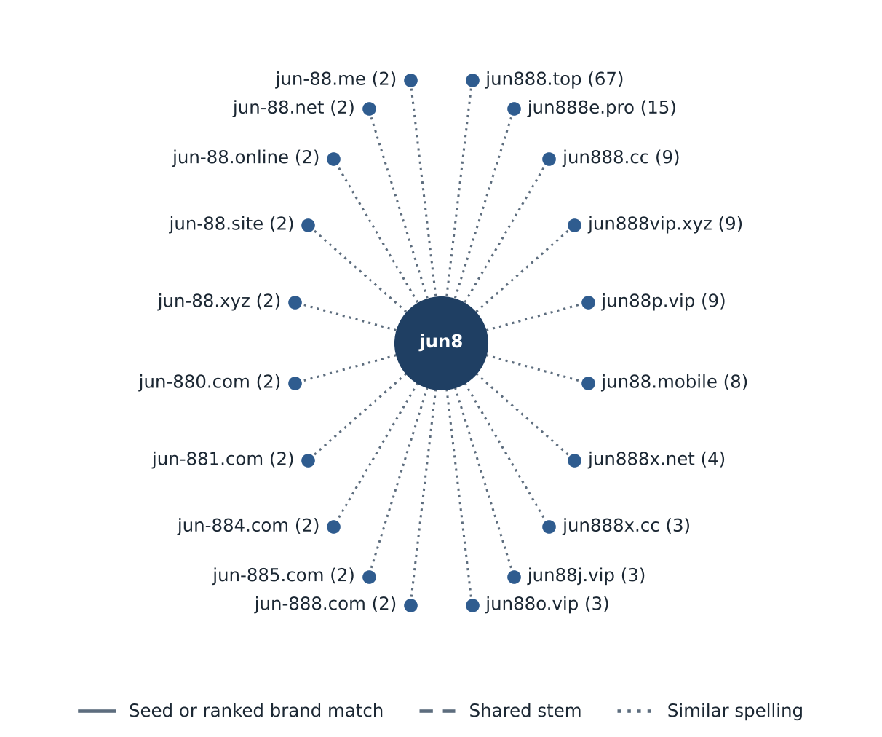
The largest cluster, 49m, holds 1 domain, so the diagram shows the largest cluster with at least 3 domains instead.
20 of 396 member domains are shown.

Inside the largest cluster
How to read this table
The table lists the member names that make up the largest brand cluster. Each row is one stem, the name left once market tags, numbers and suffixes are removed, with its URLs, its distinct domains, how those URLs joined the cluster and whether the crawler found them directly, through a redirect or as a generated variant. Every stem in the largest cluster is listed, largest first, with smaller stems grouped in a final row. The joining routes are those described in What brand clusters are. Acting on a cluster is only worth more than acting on single URLs if the cluster reflects one real operation, so this table lets the reader check the grouping before relying on it.
Member stem | URLs | Domains | How joined | Variant · redirect · direct | Ranked brand
49m | 2,885 | 1 | stem 2,885 | 0 · 0 · 2,885 | —
Total | 2,885 | 1 | stem 2,885 | 0 · 0 · 2,885

The largest cluster sits on one domain, 49m.co. See Domains with the most URLs.
Variant links rejected by the compatibility test: 0. The export records no seed links, so none were tested.

Clusters spanning multiple subcategories
How to read this table
The table lists brand clusters whose member sites fall into two or more product subcategories, for example one brand that runs both slots sites and football betting sites. Each row gives the cluster name, the number of its URLs in this sample, each subcategory present with its site count, and the domain suffixes the cluster uses. Subcategories are assigned to each site, not to the cluster, so a cluster qualifies when at least two of its sites carry different product subcategories. Where General Gambling appears beside a specific product, it means a product could not be evidenced for those sites, not necessarily that the brand offers a second product. Definitions of each subcategory are in Annex 1. These brands offer several gambling products under one name, so action against the brand reaches all of them at once.
Cluster | URLs | Subcategories | Suffixes
49m | 2,885 | Slots 1,860 · Casino 487 · General Gambling 460 · Playing card 78 | .co
jun8 | 722 | Casino 315 · Slots 193 · Football Betting 93 · Lottery 68 · Playing card 22 · General Gambling 19 · Baccarat 12 | .app, .bet, .black, .buzz, .casino +29
a3game | 507 | Slots 497 · General Gambling 7 · Casino 3 | .app, .click, .net, .vip
paes | 445 | Slots 227 · Casino 156 · Football Betting 58 · General Gambling 4 | .dev
hay | 414 | Casino 223 · Slots 170 · Football Betting 15 · General Gambling 6 | .app, .bet, .club, .co, .net +3
k03 | 272 | Football Betting 270 · General Gambling 2 | .cc
gg88 | 261 | Casino 146 · Slots 67 · Football Betting 25 · General Gambling 8 · Baccarat 7 · Playing card 7 · Lottery 1 | .app, .bet, .casino, .cc, .click +14
7ok | 75 | Slots 71 · Casino 2 · General Gambling 1 · Lottery 1 | .bet, .club, .io, .live, .pro
o8 | 75 | Slots 71 · Casino 4 | .game, .live
uu8 | 75 | Casino 33 · Slots 30 · Football Betting 7 · Baccarat 2 · Lottery 1 · Playing card 1 · General Gambling 1 | .app, .bet, .buzz, .casino, .cc +17
abbet | 70 | Casino 63 · Slots 6 · General Gambling 1 | .xyz
jin68 | 64 | Slots 28 · Casino 28 · Playing card 5 · General Gambling 2 · Football Betting 1 | .app, .bet, .cash, .casino, .cc +12
min68 | 61 | Football Betting 38 · General Gambling 9 · Casino 9 · Slots 5 | .academy, .actor, .app, .art, .auction +24
loto432s | 58 | Lottery 49 · Casino 4 · Slots 3 · General Gambling 1 · Football Betting 1 | .bet, .click, .com, .info, .live +2
l8 | 57 | Slots 56 · Casino 1 | .game

816 clusters qualify; the 15 largest are shown, so 801 rows are outside the table.

Clusters rotating top-level domains
How to read this table
The table lists brand clusters whose member domains use two or more top level domains, the ending of the address, for example the same brand name registered under .com, .net and .co. Each line gives the cluster, one suffix it uses, how many member domains use that suffix and the first and last day SICPADetect recorded them. The suffix is the public suffix removed when a name is reduced to its stem, so a two part ending such as .co.th counts as one suffix, and a cluster qualifies when its members use at least two different suffixes. Registering one brand name under several endings keeps the brand reachable when one domain is blocked, and the suffix list shows which endings to watch for the brand. Not every case is evasion, since some operators register several endings to protect their name or to serve different markets.
Cluster | Suffix | Domains | First seen | Last seen
jun8 | .com | 163 | 2026-09-22 | 2026-10-19
 | .net | 30 | 2026-09-22 | 2026-09-28
 | .pro | 19 | 2026-09-22 | 2026-09-28
 | .bet | 15 | 2026-09-22 | 2026-09-27
 | .app | 14 | 2026-09-22 | 2026-09-27
 | +29 more suffixes
a3game | .app | 1 | 2026-09-23 | 2026-09-24
 | .click | 1 | 2026-09-23 | 2026-09-24
 | .net | 1 | 2026-09-23 | 2026-09-23
 | .vip | 1 | 2026-09-23 | 2026-09-28
hay | .app | 1 | 2026-09-05 | 2026-09-05
 | .bet | 1 | 2026-09-05 | 2026-09-05
 | .club | 1 | 2026-09-05 | 2026-09-05
 | .co | 1 | 2026-09-05 | 2026-09-05
 | .net | 1 | 2026-09-04 | 2026-09-07
 | +3 more suffixes
gg88 | .app | 33 | 2026-09-04 | 2026-09-07
 | .net | 33 | 2026-09-04 | 2026-09-07
 | .pro | 30 | 2026-09-04 | 2026-09-07
 | .bet | 20 | 2026-09-04 | 2026-09-07
 | .com | 17 | 2026-09-04 | 2026-09-07
 | +14 more suffixes
58th0 | .com | 25 | 2026-10-02 | 2026-10-07
 | .pro | 1 | 2026-10-07 | 2026-10-07

46 clusters have domains first seen at least 7 days after the cluster was first seen, 124 domains in all.
924 clusters qualify; the 5 largest that fit are shown, so 919 are outside the table, and each shows at most five suffixes. Dates are when SICPADetect recorded each domain, not when it was registered, blocked or replaced. The period is under 60 days, so it is too short to confirm rotation over time.

Possible operator linkage
Indicative — not a clustering decision
How to read this table
The table lists pairs of brand clusters with different names that use an unusually similar set of signal keywords, the lexicon words describing how a site promotes itself, takes payment or avoids blocking. Each row gives the two clusters, the signal keywords they share and their Jaccard score. The score is the number of signal keywords the two clusters share, divided by the number of distinct signal keywords either of them uses, and it runs from 0, nothing in common, to 1, identical sets. Words used by a large share of the sample, and abbreviations known to match by accident, are left out before the score is calculated. Only pairs scoring 0.60 or more and sharing at least three of the remaining keywords are listed. A close match can point to one operator running two brands, but it can equally come from unrelated operators using the same affiliate website template, so the pairs are leads to verify and the clusters are never merged on this score.
Cluster A | Cluster B | Shared keywords | Jaccard
7ok | mega167 | pragmatic, rtp, wallet, win, สมัครสมาชิก | 1.00
gu88 | n78 | pragmatic, wallet, สมัครสมาชิก | 1.00
kk2 | n83 | jili, pragmatic, สมัครสมาชิก | 1.00
kk2 | nextspin | jili, pragmatic, สมัครสมาชิก | 1.00
ko9 | ln88 | wallet, win, สมัครสมาชิก | 1.00
ko9 | ub8 | wallet, win, สมัครสมาชิก | 1.00
lott | jun77 | pragmatic, win, สมัครสมาชิก | 1.00
ms88 | gu88 | pragmatic, wallet, สมัครสมาชิก | 1.00
ms88 | n78 | pragmatic, wallet, สมัครสมาชิก | 1.00
mu8 | hub88 | pragmatic, wallet, win | 1.00
mun8 | vrtex | auto, wallet, สมัครสมาชิก | 1.00
n83 | nextspin | jili, pragmatic, สมัครสมาชิก | 1.00
ruay | m98login | win, จ่ายจริง, สมัครสมาชิก | 1.00
ub8 | ln88 | wallet, win, สมัครสมาชิก | 1.00
uu8 | hub88 | pragmatic, wallet, win | 1.00

118 pairs qualify. The 15 with the highest score are shown, so 103 are outside the table.

Naming conventions
- Recurring tokens: "m." in 2,454 hostnames, "login" in 2,100 hostnames, "support" in 1,879 hostnames, among 5,747 hostnames in the ten largest clusters. This points to a templated naming scheme.
- TLD switching: .co 2,906, .vip 542, .net 504, .dev 445. The operators rotate top level domains.
- The gambling URLs sit on 6,827 domains across 2,719 brand clusters.
- 1 gambling URLs have names made only of template words such as login, secure or verify; they are kept as singletons unless a crawler link or ranked brand ties them to a cluster.

14,182  Direct URLs |  | 0  Redirect URLs |  | 0  Variant URLs

Structure: direct → redirect → variant
Direct, redirect and variant URLs sum to the 14,182 gambling URLs. The export records no variant or redirect source for any URL, so no variant verification figures can be given and every gambling URL is counted as direct.

Ranking

Gambling ranking
How to read this table
The table lists the gambling sites in this sample that carry a rank in the SICPADetect feed, best ranked first, up to fifteen. Each row gives the rank, the domain, its brand cluster, its subcategory and where SICPADetect found it. The rank is the position recorded for the site in the source feed and reflects its search visibility, where a lower number means a more visible site. It is not the external ranking used to anchor brand clusters in Annex 2, and unlike the ten most prominent gambling sites in Thailand table it is not filtered for a Thai audience or limited to one row per domain. The highest ranked sites are the ones users are most likely to reach. Rank measures visibility only, not harm, reach or revenue.
Rank | Domain | Brand cluster | Subcategory | Source
93117 | metal--vip.com | metal | Slots | x
214132 | allslotwallet.online | allslotwallet | Slots | Not recorded
221001 | suriyathai.net | suriya | General Gambling | x
252597 | u11k.pro | u11 | Football Betting | Not recorded
254190 | anthonyhead.com | anthonyhead | Casino | x
254190 | kohochocolates.com | kohochocolates | Casino | Not recorded
293057 | bifestathailand.com | bifestathailand | Slots | Not recorded
293057 | lgbtnewsnow.org | lgbtnewsnow | Slots | x
303254 | jun88wf.com | jun8 | Casino | Not recorded
397330 | jun88wa.com | jun8 | Casino | Not recorded
466858 | jun88wc.com | jun8 | Slots | Not recorded
514501 | sacasino.ad | sacasino | Baccarat | x
517141 | jun88.info | jun8 | Casino | Not recorded
517141 | slavinaslot.top | slavinaslot | Casino | Not recorded
547370 | 99ok.vip | 99ok | Lottery | Not recorded

310 gambling URLs carry a rank; the 15 best ranked are shown.

Ranked brand clusters
How to read this table
The table lists brand clusters that contain at least one gambling site carrying a rank in the SICPADetect feed. Each row gives the cluster, its number of URLs, the best rank among its members, how many members are ranked and its subcategories. One ranked gambling member is enough for a cluster to qualify. Clusters are ordered by their best rank, so the most visible brands come first, and the URL count shows how large each operation is. A brand that is both highly visible and large is where action reaches the most users and the most addresses at once. Rank measures visibility only, not harm, reach or revenue, and no combined score is calculated.
Cluster | URLs | Best rank | Ranked URLs | Subcategories
metal | 2 | 93117 | 1 | Slots 2
allslotwallet | 1 | 214132 | 1 | Slots 1
suriya | 1 | 221001 | 1 | General Gambling 1
u11 | 33 | 252597 | 1 | Slots 19 · Football Betting 12 · Casino 2
anthonyhead | 1 | 254190 | 1 | Casino 1
kohochocolates | 1 | 254190 | 1 | Casino 1
bifestathailand | 1 | 293057 | 1 | Slots 1
lgbtnewsnow | 1 | 293057 | 1 | Slots 1
jun8 | 722 | 303254 | 30 | Casino 315 · Slots 193 · Football Betting 93 · Lottery 68 · Playing card 22 · General Gambling 19 · Baccarat 12
sacasino | 1 | 514501 | 1 | Baccarat 1
slavinaslot | 2 | 517141 | 1 | Casino 2
99ok | 17 | 547370 | 2 | Slots 11 · Casino 4 · Lottery 2
gg88 | 261 | 558790 | 15 | Casino 146 · Slots 67 · Football Betting 25 · General Gambling 8 · Baccarat 7 · Playing card 7 · Lottery 1
betwgb | 1 | 582212 | 1 | Football Betting 1
hh9 | 32 | 632178 | 11 | Casino 12 · Football Betting 7 · General Gambling 7 · Slots 6

219 clusters hold a ranked gambling URL; the 15 with the best rank are shown.

Key insights

Scale of the analysis
The analysis covers 29,864 distinct URLs over 47 days, from 2026-09-04 to 2026-10-20. Of these, 14,182 are gambling, 15,682 are not gambling and 0 are unreachable. A further 0 URLs were set aside as Needs more analysis. 3 gaps of three or more days fall below the gap threshold of 64 URLs a day, and the cause of each gap and peak is not recorded.
The sample is large enough to reason about patterns, not isolated cases.

What is being offered
The three leading product subcategories are Slots (6,324, 44.6%), Casino (4,451, 31.4%), Football Betting (1,376, 9.7%). 5.9% of gambling sites are confirmed as gambling without an evidenced product type. 96.7% of subcategory assignments are inferred rather than matched to a lexicon keyword, and 207 of the 286 lexicon keywords never matched. The lexicon has poor coverage of this dataset, so subcategory figures are indicative only.
Slots is the dominant product type.

Brand clustering
The 14,182 gambling URLs sit on 6,827 domains and form 2,719 brand clusters, and 995 of them hold more than one domain. 43 clusters and 722 domains cover half of the estate. The largest cluster, 49m, holds 2,885 URLs (20.3% of gambling URLs) on 1 domain under 1 member stem, across 4 subcategories. The largest domain, 49m.co, holds 2,885 URLs (20.3%). 15 host farms carry 35.1% of gambling URLs.
One registered domain carries 20.3% of the estate through many hostnames, so action at domain level reaches all of them at once, where URL by URL blocking would need one entry per hostname.

How the estate is grown and marketed
The export records no variant or redirect links, so all 14,182 gambling URLs count as reached directly, with 0 variants and 0 behind redirect chains. 924 clusters rotate across more than one top level domain. The two most common signal tags are Abbreviations (27.1%) and Affiliate & Agent (5.4%).
TLD rotation keeps a brand reachable when one domain is blocked.

Enforcement position
0 pages show Thai enforcement indicators, such as Thai court orders or MDES and Thai ISP block pages, and 7 contain a block page phrase that is not tied to a Thai authority. The collection network was not recorded, so the enforcement count may be understated.
This set is a candidate for a first enforcement pass, prioritised by domain and cluster rather than by URL.

Annexes

Annex 1 — Subcategory definitions
Each site classified as gambling is assigned one of the seven product subcategories below, according to what it offers. General Gambling applies only when a site is confirmed as gambling but no specific product can be evidenced. A subcategory is assigned by lexicon match when one of the keywords listed under it appears in what was recorded about the site, and by inference from the model's description when none is found. How a site markets or operates itself is recorded separately as signal tags and does not decide its subcategory. The keywords under each subcategory are its complete set in the lexicon, shown in their original script. A few keywords appear under both a specific product and General Gambling; they always count toward the specific product.
Football Betting · 21 keywords
Betting on the outcome of football and other sports matches, including match odds, single match and accumulator ("step") bets, and tipping or match analysis offered to bettors.
พนันบอล · พนันบอลออนไลน์ · แทงบอล · แทงบอลออนไลน์ · พนันฟุตบอล
แทงฟุตบอล · สปอร์ตบุ๊ค · บอลออนไลน์ · ราคาบอล · บอลสเต็ป
บอลเดี่ยว · สเต็ปบอล · แทงบอลชุด · ทีเด็ดบอล · วิเคราะห์บอล · โต๊ะบอล
ล้มโต๊ะบอล · เดิมพันฟุตบอล · เว็บแทงบอล · บอลสเต็ปแม่น · พนันกีฬา
Slots · 32 keywords
Online slot machine games, including sites that promote particular slot providers, high payout rates or slots played directly without an agent.
สล็อต · สล็อตออนไลน์ · เกมสล็อต · เกมสล็อตออนไลน์ · สล็อตแตกง่าย
สล็อตแตกบ่อย · สล็อตแตกหนัก · สล็อตแตกจริง · สล็อตใหม่
สล็อตเว็บตรง · สล็อตวอเลท · เล่นสล็อต · สล็อตเครดิตฟรี
สล็อตแตกทุกวัน · สล็อตมาแรง · สล็อตยอดนิยม · สล็อตค่ายดัง
สล็อตไม่ผ่านเอเย่นต์ · สล็อต pg · สล็อต joker · สล็อต jili
สล็อต pragmatic · สล็อต xo · สล็อต auto · สล็อตแตกไว
สล็อตฝากถอนออโต้ · สล็อตฝากไม่มีขั้นต่ำ · สล็อตโบนัสแตกหนัก
สล็อตสายฟรี · สล็อตปั่นง่าย · สล็อต RTP สูง · สล็อตคืนกำไร
Casino · 14 keywords
Online and live casino table and wheel games other than baccarat and card games, such as roulette, dragon tiger, hi lo dice and wheel spin games.
คาสิโน · คาสิโนออนไลน์ · คาสิโนสด · คาสิโนสดออนไลน์ · เสือมังกร
รูเล็ต · รูเล็ตออนไลน์ · รูเล๊ต · ไฮโล · ไฮโลออนไลน์ · ไฮโลไทย
หมุนวงล้อโบนันซ่ารายวัน · หมุนวงล้อโบนันซ่า · ปั่นแปะ

Annex 1 — Subcategory definitions (continued)
Lottery · 20 keywords
Betting on lottery and number draws, including the Thai government and underground lotteries, Lao, Hanoi and Malaysian draws, fast draw yi ki lotteries and lotteries settled on stock index figures.
หวยออนไลน์ · แทงหวย · ซื้อหวยออนไลน์ · หวยยี่กี · หวยฮานอย
หวยลาว · หวยรัฐบาล · หวยมาเลย์ · หวยจับยี่กี · จับยี่กี VIP · หวยใต้ดิน
หวยออนไลน์จ่ายจริง · เว็บหวย · เว็บแทงหวย · Huay · Huaylan · หวยหุ้น
หวยหุ้นไทย · หวยหุ้นต่างประเทศ · หวยชุด
Playing card · 12 keywords
Card games other than baccarat, such as pok deng, blackjack, poker and Thai two card and three card games.
ไพ่ · ไพ่ออนไลน์ · ไพ่ ออนไลน์ · ไพ่ป๊อก · ป๊อกเด้ง · ป๊อกเด้งออนไลน์
แบล็คแจ็ค · แบล็คแจ็คออนไลน์ · โป๊กเกอร์ · โป๊กเกอร์ออนไลน์
ตีไก่สองใบ · ตีไก่สามใบ
Baccarat · 11 keywords
Baccarat in any form, live or online, including demo tables and betting formula or prediction services sold for baccarat.
บาคารา · บาคาร่า · บาคาร่าออนไลน์ · ไพ่บาคาร่า · บาคาร่าสด
โต๊ะบาคาร่า · บาคาร่าทดลอง · บาคาร่าฟรี · บาคาร่าระบบ AI
บาคาร่าขั้นเทพ · สูตรบาคาร่า
General Gambling · 22 keywords
Sites confirmed as gambling whose recorded content uses only generic gambling or betting vocabulary, so no specific product can be evidenced. Assigned only when no other subcategory applies.
พนัน · การพนัน · พนันออนไลน์ · เว็บพนัน · เว็บเดิมพัน · เดิมพัน
เดิมพันออนไลน์ · คาสิโน · คาสิโนออนไลน์ · บ่อน · บ่อนออนไลน์
เว็บเกมพนัน · เกมพนัน · เว็บเสี่ยงโชค · เสี่ยงโชค · เว็บเกมเงิน
เล่นเงินจริง · เกมได้เงินจริง · เดิมพันกีฬา · พนันกีฬา · พนันบอล
แทงบอล
The keyword lists are those of the SICPADetect lexicon at the version shown on the title page (V1).

Annex 2 — Ranked domains used for clustering
Ranking of gambling domains for Thailand · external data provider · 159 of 200 ranked domains applied
Brand clusters are anchored to a ranking of gambling domains for Thailand supplied by an external data provider. When a URL in this sample matches a ranked brand, it is grouped under that brand's name instead of the name it happens to carry. The ranking is an analytical reference. A place in it is not evidence of ownership, harm or reach, and a match never adds a site to the gambling set.
Rank | Ranked domain | Brand | Match basis | URLs matched | Cluster
1 | 22onlinegames.com | 22onlinegames | Brand name and extended names | 1 | 22onlinegames
3 | debet.tv | debet | Brand name and extended names | 1 | debet
4 | aiscore.com | aiscore | Brand name and extended names | 1 | aiscore
5 | ufabet.com | ufabet | Brand name and extended names | 1 | ufabet
7 | invl.me | invl | Brand name only | 2 | invl
8 | lottoheng168.com | lottoheng | Brand name and extended names | 1 | lottoheng
9 | 888scoreonline.net | 888scoreonline | Brand name and extended names | 1 | 888scoreonline
10 | hacksawgaming.com | hacksawgaming | Brand name and extended names | 4 | hacksawgaming
12 | playin.com | playin | Brand name and extended names | 3 | playin
14 | gosh.io | gosh | Brand name only | 1 | gosh
15 | 24live.com | 24live | Brand name and extended names | 2 | 24live
16 | 326821905591.com | 326821905591 | This domain only | 1 | 326821905591
19 | vlr.gg | vlr | This domain only | 1 | vlr
20 | 7mkr.com | 7mkr | This domain only | 1 | 7mkr
21 | flashscore.co.uk | flashscore | Brand name and extended names | 6 | flashscore
22 | 808ball15.com | 808ball | Brand name and extended names | 2 | 808ball
24 | bet365.com | bet365 | Brand name and extended names | 0 | —

Annex 2 — Ranked domains used for clustering (continued)
Rank | Ranked domain | Brand | Match basis | URLs matched | Cluster
25 | mlnhngoc.net | mlnhngoc | Brand name and extended names | 1 | mlnhngoc
26 | m8geqpm2kpnf78dkfxp9ksg94ndx9weaoa39.com | m8geqpm2kpnf78dkfxp9ksg94ndx9weaoa | This domain only | 1 | m8geqpm2kpnf78dkfxp9ksg94ndx9weaoa
27 | 13o.net | 13o | Brand name only | 1 | 13o
28 | nolimitcity.com | nolimitcity | Brand name and extended names | 2 | nolimitcity
29 | 1xbet.com | 1xbet | Brand name and extended names | 2 | 1xbet
30 | betufa.com | betufa | Brand name and extended names | 1 | betufa
31 | d3my3ye7lo15uo.cloudfront.net | d3my3ye7lo15uo | This domain only | 1 | d3my3ye7lo15uo
32 | viieuvkf.com | viieuvkf | This domain only | 1 | viieuvkf
34 | anaidahog.com | anaidahog | Brand name and extended names | 1 | anaidahog
36 | m1rs.com | m1rs | This domain only | 1 | m1rs
37 | spinova-hub.com | spinovahub | Brand name and extended names | 1 | spinovahub
38 | beer777.com | beer | Brand name only | 3 | beer
41 | kaga88.com | kaga | Brand name only | 4 | kaga
42 | painamour.com | painamour | Brand name and extended names | 1 | painamour
43 | bet365.ee | bet365 | Brand name and extended names | With rank 24 | —
44 | seriesdet.com | seriesdet | Brand name and extended names | 1 | seriesdet
45 | singaporepools.com.sg | singaporepools | Brand name and extended names | 2 | singaporepools
46 | stake.com | stake | Brand name and extended names | 4 | stake
47 | rainbet.com | rainbet | Brand name and extended names | 1 | rainbet
49 | wsgamings.com | wsgamings | Brand name and extended names | 2 | wsgamings
50 | jackpots.ch | jackpots | Brand name and extended names | 1 | jackpots
52 | pic5678.com | pic | Brand name only | 2 | pic
54 | sporticos.com | sporticos | Brand name and extended names | 1 | sporticos
55 | rsg-games.com | rsggames | Brand name and extended names | 1 | rsggames
59 | casino.org | casino.org | This domain only | 0 | —
60 | coktv1.com | cokt | Brand name only | 1 | cokt
61 | games.kaga88.com | kaga | Brand name only | With rank 41 | kaga
62 | royal558.com | royal | Brand name and extended names | 5 | royal
63 | dafabet.com | dafabet | Brand name and extended names | 0 | —
64 | nowgoal26.com | nowgoal | Brand name and extended names | 6 | nowgoal

Annex 2 — Ranked domains used for clustering (continued)
Rank | Ranked domain | Brand | Match basis | URLs matched | Cluster
66 | glivesport.com | glivesport | Brand name and extended names | 1 | glivesport
67 | pragmaticplay.com | pragmaticplay | Brand name and extended names | 1 | pragmaticplay
68 | lottovip.bet | lottovip | Brand name and extended names | 8 | lottovip
69 | chatursply.com | chatursply | Brand name and extended names | 1 | chatursply
70 | afiyukent.one | afiyukent | Brand name and extended names | 1 | afiyukent
71 | 8provider.com | 8provider | Brand name and extended names | 1 | 8provider
72 | iqoption.net | iqoption | Brand name and extended names | 1 | iqoption
73 | millipiyangoonline.com | millipiyangoonline | Brand name and extended names | 1 | millipiyangoonline
74 | stp4bet.net | stp4bet | Brand name and extended names | 2 | stp4bet
77 | corevibe-network.com | corevibenetwork | Brand name and extended names | 1 | corevibenetwork
78 | flashscore.com.ua | flashscore | Brand name and extended names | With rank 21 | flashscore
79 | wuoza.com | wuoza | Brand name and extended names | 1 | wuoza
80 | papasqueens.com | papasqueens | Brand name and extended names | 0 | —
81 | ouraidream.com | ouraidream | Brand name and extended names | 1 | ouraidream
84 | w88cric.com | w88cric | Brand name and extended names | 3 | w88cric
85 | askmebet.live | askmebet | Brand name and extended names | 2 | askmebet
86 | chainers.io | chainers | Brand name and extended names | 1 | chainers
87 | minhngoc.net.vn | minhngoc | Brand name and extended names | 1 | minhngoc
89 | crickfree.be | crickfree | Brand name and extended names | 1 | crickfree
91 | asianbookie.com | asianbookie | Brand name and extended names | 4 | asianbookie
92 | nova88.com | nova | Brand name only | 4 | nova
94 | ekamsply.com | ekamsply | Brand name and extended names | 1 | ekamsply
95 | connect234.com | connect | Brand name and extended names | 1 | connect
97 | 888casino.it | 888casino | Brand name and extended names | 2 | 888casino
98 | issuya.com | issuya | Brand name and extended names | 1 | issuya
99 | crex.com | crex | Brand name only | 1 | crex
100 | sport.888casino.it | 888casino | Brand name and extended names | With rank 97 | 888casino
102 | 1x-bet.mobi | 1xbet | Brand name and extended names | With rank 29 | 1xbet
103 | slotcatalog.com | slotcatalog | Brand name and extended names | 2 | slotcatalog
104 | thboxing.com | thboxing | Brand name and extended names | 2 | thboxing

Annex 2 — Ranked domains used for clustering (continued)
Rank | Ranked domain | Brand | Match basis | URLs matched | Cluster
105 | gys5.com | gys | This domain only | 1 | gys
106 | m88.com | m88 | This domain only | 1 | m88
107 | stevenbridges.co | stevenbridges | Brand name and extended names | 1 | stevenbridges
108 | allbetasia.com | allbetasia | Brand name and extended names | 3 | allbetasia
109 | betway.com | betway | Brand name and extended names | 1 | betway
110 | bigwinboard.com | bigwinboard | Brand name and extended names | 3 | bigwinboard
111 | shuffle.com | shuffle | Brand name and extended names | 2 | shuffle
112 | ballthaitv.com | ballthaitv | Brand name and extended names | 1 | ballthaitv
113 | scoresinlive.com | scoresinlive | Brand name and extended names | 1 | scoresinlive
114 | fun88.com | fun | Brand name only | 3 | fun
115 | 622coffee.com | 622coffee | Brand name and extended names | 1 | 622coffee
117 | betfair.com | betfair | Brand name and extended names | 1 | betfair
119 | givamblog.com | givamblog | Brand name and extended names | 1 | givamblog
120 | pokerstars.com | pokerstars | Brand name and extended names | 2 | pokerstars
121 | fon.bet | fon | Brand name only | 1 | fon
124 | pokerstarslive.com | pokerstars | Brand name and extended names | With rank 120 | pokerstars
125 | njtv-01.com | njtv | This domain only | 1 | njtv
126 | footballpredictions.com | footballpredictions | Brand name and extended names | 1 | footballpredictions
127 | api-ugaming.com | apiugaming | Brand name and extended names | 1 | apiugaming
128 | stake.ceo | stake | Brand name and extended names | With rank 46 | stake
129 | 3rmwa7p.com | 3rmwa7p | This domain only | 1 | 3rmwa7p
130 | livescore.red | livescore | Brand name and extended names | 2 | livescore
131 | ballhengheng.com | ballhengheng | Brand name and extended names | 2 | ballhengheng
132 | twoplustwo.com | twoplustwo | Brand name and extended names | 1 | twoplustwo
134 | casino.com | casino.com | This domain only | 0 | —
136 | manko.fun | manko | Brand name and extended names | 1 | manko
137 | bojel.com | bojel | Brand name and extended names | 1 | bojel
138 | chipy.com | chipy | Brand name and extended names | 1 | chipy
139 | xskt.com.vn | xskt | This domain only | 1 | xskt
140 | bch.games | bch | This domain only | 1 | bch

Annex 2 — Ranked domains used for clustering (continued)
Rank | Ranked domain | Brand | Match basis | URLs matched | Cluster
141 | dhlottery.co.kr | dhlottery | Brand name and extended names | 1 | dhlottery
142 | sagaming.com | sagaming | Brand name and extended names | 3 | sagaming
143 | hkjc.com | hkjc | This domain only | 2 | hkjc
144 | betika.com | betika | Brand name and extended names | 3 | betika
145 | backgammongalaxy.com | backgammongalaxy | Brand name and extended names | 1 | backgammongalaxy
146 | thehendonmob.com | thehendonmob | Brand name and extended names | 1 | thehendonmob
148 | melbetegypt.com | melbetegypt | Brand name and extended names | 1 | melbetegypt
149 | cyberscore.live | cyberscore | Brand name and extended names | 1 | cyberscore
150 | national-lottery.co.uk | nationallottery | Brand name and extended names | 1 | nationallottery
151 | oddschecker.com | oddschecker | Brand name and extended names | 0 | —
152 | lckts.com | lckts | This domain only | 1 | lckts
153 | sbfplay99.com | sbfplay | Brand name and extended names | 4 | sbfplay
154 | ohoboxing.com | ohoboxing | Brand name and extended names | 0 | —
155 | recharge.game | recharge | Brand name and extended names | 1 | recharge
156 | racenet.com.au | racenet | Brand name and extended names | 1 | racenet
157 | fatty777.xyz | fatty | Brand name and extended names | 1 | fatty
158 | 2ded.com | 2ded | Brand name only | 2 | 2ded
159 | marathonbet.ru | marathonbet | Brand name and extended names | 1 | marathonbet
160 | bet911.com | bet911 | Brand name and extended names | 1 | bet911
161 | cloudbet.com | cloudbet | Brand name and extended names | 1 | cloudbet
162 | duel.com | duel | Brand name only | 1 | duel
163 | footystats.org | footystats | Brand name and extended names | 1 | footystats
164 | az24.vn | az24 | Brand name only | 0 | —
165 | sbobet.com | sbobet | Brand name and extended names | 2 | sbobet
166 | racing.com | racing | Brand name and extended names | 2 | racing
167 | bc.game | bc | This domain only | 1 | bc
168 | d1q60f0kk3cf0.cloudfront.net | d1q60f0kk3cf | This domain only | 1 | d1q60f0kk3cf
169 | dordir.com | dordir | Brand name and extended names | 1 | dordir
170 | sunmacau.com | sunmacau | Brand name and extended names | 1 | sunmacau
171 | dol-rtknetwork.com | dolrtknetwork | Brand name and extended names | 1 | dolrtknetwork

Annex 2 — Ranked domains used for clustering (continued)
Rank | Ranked domain | Brand | Match basis | URLs matched | Cluster
173 | bebayankhs.com | bebayankhs | Brand name and extended names | 1 | bebayankhs
174 | mivasstore.com | mivasstore | Brand name and extended names | 1 | mivasstore
175 | sportsbet.com.au | sportsbet | Brand name and extended names | 2 | sportsbet
176 | tpi.li | tpi | Brand name only | 1 | tpi
177 | casino.guru | casino.guru | This domain only | 0 | —
178 | grabyourluck.com | grabyourluck | Brand name and extended names | 1 | grabyourluck
180 | exma.io | exma | Brand name only | 1 | exma
182 | pubg.plus | pubg | Brand name only | 1 | pubg
183 | football.nowgoal26.com | nowgoal | Brand name and extended names | With rank 64 | nowgoal
184 | storehyson.com | storehyson | Brand name and extended names | 1 | storehyson
185 | brabet.com | brabet | Brand name and extended names | 1 | brabet
186 | mycasino.ch | mycasino | Brand name and extended names | 1 | mycasino
187 | crowncoinscasino.com | crowncoinscasino | Brand name and extended names | 1 | crowncoinscasino
188 | goal-th.com | goalth | Brand name and extended names | 1 | goalth
189 | ggbetconnect.com | ggbetconnect | Brand name and extended names | 1 | ggbetconnect
192 | paddypower.com | paddypower | Brand name and extended names | 1 | paddypower
194 | tadagaming.com | tadagaming | Brand name and extended names | 3 | tadagaming
195 | olbg.com | olbg | Brand name only | 1 | olbg
197 | thscore.fun | thscore | Brand name and extended names | 7 | thscore
198 | slotstemple.com | slotstemple | Brand name and extended names | 2 | slotstemple
199 | 777.ua | 777 | This domain only | 1 | 777
200 | m-918kiss.com | m918kiss | Brand name and extended names | 2 | m918kiss

142 of 159 ranked domains matched at least one URL in this sample, together covering 229 gambling URLs (1.6% of gambling URLs).
41 ranked domains are awaiting analyst review, were not applied and are not listed.
Rank is as supplied by the external data provider and is not a measure of harm, reach or revenue; it is separate from the rank shown in the Gambling ranking card. Grouping a URL under a ranked brand is an analytical grouping, not a legal finding about ownership.

Lexicon source: Gambling_Keywords_Full_English_Categories_V1.xlsx, version V1; keywords per category: Football Betting 21; Slots 32; Casino 14; Lottery 20; Playing card 12; Baccarat 11; General Gambling 22; Deposit & Withdrawal 24; Promotions 27; Marketing & Acquisition 25; Affiliate & Agent 20; Vague-Evasion Terms 20; Abbreviations 22; Hashtags 21. Inferred share of gambling rows 96.7%; General Gambling share 5.9%. The lexicon has poor coverage of this dataset, so subcategory figures are indicative only. Rows arriving with a legacy status label that is normalised to Gambling: 0. Abbreviations flagged as a probable false positive source because each accounts for more than 20% of Abbreviations matches: VIP, BET. Clustering thresholds: near miss similarity 0.90, variant compatibility 0.90, cluster dominance 25% of gambling URLs, domain dominance 10% of gambling URLs, host farm threshold 20 URLs on one domain, late joiner interval 7 days. Operator linkage: abbreviations flagged above and keywords matched in more than 10% of gambling rows are excluded (BET, VIP), at least 3 shared keywords, and the table is withheld above 200 qualifying pairs or when one cluster appears in more than 20 pairs. Gap threshold: three or more consecutive days below 10% of the mean daily count (635 URLs a day, threshold 64); peak threshold: days above three times the mean. Collection network: not recorded.

