Ministry of Digital Economy and Society
Thailand

Data Insights & Patterns
Pilot reporting period · 4 Sep 2026 to 7 Oct 2026

Issued to | Ministry of Digital Economy and Society, Thailand
Prepared by | SICPA SA
Date of issue | 07/10/2026
Source system | SICPADetect

Contents

Executive summary
Model Insights
Introduction
Insights
Performance
10 most prominent gambling sites in Thailand
10 most prominent gambling sites in Thailand
The numbers
Key counts for the pilot reporting period
URLs analysed per day
Status distribution
Top 10 URL suffixes
Subcategories
Gambling sites by product subcategory
Assignment method by subcategory
Subcategory table
Heat map: keyword by subcategory
Heat map: signal tag by subcategory
Brands and clustering
What brand clusters are
Cluster counts
Top 15 brand clusters by URL count
Heat map: brand cluster by subcategory
Cluster expansion: 49m
Clusters spanning multiple subcategories
Clusters rotating top-level domains
Possible operator linkage
Naming conventions
Structure: direct, redirect and variant
Redirect propagation: www.min88.top
Ranking
Gambling ranking
Key insights
Scale of the analysis
What is being offered
Brand clustering
How operators expand and promote their domains
Enforcement position

Executive summary
Insights and trends
SICPADetect analysed 24,605 distinct URLs during the pilot reporting period, 4 Sep 2026 to 7 Oct 2026, and classified 11,648 of them, 47.3%, as gambling. The remaining URLs were classified as not gambling.
The two largest product subcategories are General Gambling at 25.5% of gambling rows and Slots at 25.1%. No single category accounts for a majority of the gambling set. Subcategory figures based on model inference are indicative.
A brand cluster is a group of domains that appear linked by naming pattern, redirect behaviour, crawler relationship or shared brand stem. SICPADetect identified 1,102 clusters, of which 757 hold more than one domain, and the largest holds 1,586 domains. Acting on one cluster can cover many related domains. The links are indicative and do not establish common ownership.
The identified gambling URLs show related domains registered under one brand stem, rotation across top-level domains and redirects between domains. Prioritising by cluster covers more of this activity than acting on one URL at a time.
Only 7 URLs in the analysed set already carried blocking or enforcement indicators. MDES can therefore include most identified gambling URLs in a first prioritised enforcement pass.
The pilot reporting period covers 34 days of operational processing, so this report states no direction of travel for the volume of gambling activity.
Key figures
Reporting figure | Value
URLs analysed | 24,605
Gambling sites and share | 11,648 (47.3%)
Not gambling and unreachable | 12,957 not gambling
Brand clusters identified | 1,102, of which 757 hold more than one domain
Clusters covering half of the identified gambling URLs | 30
Largest cluster and its size | 49m, 1,586 domains
Largest product subcategory and share | General Gambling (25.5%)
Most common signal tag and share | Abbreviations (37.1%)
URLs already showing blocking indicators | 7
Lexicon match and model inference split | 428 by lexicon match, 11,220 by model inference

Table 1. Headline figures for the pilot reporting period.
“URLs analysed” counts distinct URLs kept in the dataset after collection, filtering, deduplication and analysis. It does not count raw crawl attempts.

Model Insights

Introduction

Insights

Performance

10 most prominent gambling sites in Thailand

10 most prominent gambling sites in Thailand
Rank | URL | Domain | Brand cluster | Subcategory | Thai-targeting evidence | Source
221,001 | https://suriyathai.net/ | suriyathai.net | suriya | General Gambling | Thai script: สมัครสมาชิก | Analyst-enriched
733,816 | https://707jili.com/ | 707jili.com | 707jili | Slots | Thai script: สล็อตออนไลน์ สล็อตเว็บตรง | Crawler variant
739,727 | https://play-tga.net/ | play-tga.net | playtba | Baccarat | Thai script: รับโบนัสทุกวัน | Analyst-enriched
756,681 | https://www.9ufa.vip/ | 9ufa.vip | 9ufa | General Gambling | Thai script: สมาชิกใหม่ เครดิตฟรี | Analyst-enriched
779,002 | https://dreamworld777.buzz/ | dreamworld777.buzz | dreamworld | Playing card | Thai script: ป๊อกเด้ง | Analyst-enriched
779,601 | https://e699zz.com/ | e699zz.com | e699zz | General Gambling | Thai script: ฝากจันท์ | Analyst-enriched
797,918 | https://jun8891.com/ | jun8891.com | jun | Playing card | Thai script: สมัครเล่นรับ | Crawler variant
808,172 | https://meetang.cc/ | meetang.cc | meetang | Slots | Thai script: เกมสล็อตสนุกสุดฟิ๊ก | Analyst-enriched
811,629 | https://mun8.com/ | mun8.com | mun | Slots | Thai currency: THB | Crawler variant
811,871 | https://mst88.work/ | mst88.work | mst | Playing card | Thai script: แจกเครดิต | Redirect-derived

Table 2. The highest ranked gambling sites carrying Thai audience evidence in their description text.
Rank reflects search visibility or source-feed position. It does not measure harm, revenue, user volume or enforcement priority.
"Analyst-enriched" means an analyst verified or added details after SICPADetect’s automated detection. SICPADetect’s detection process is automated.

The numbers
24,605  URLs analysed |  | 11,648  Gambling sites |  | 1,102  Brand clusters identified |  | 34 days  Pilot reporting period  4 Sep 2026 to 7 Oct 2026

URLs analysed per day
Daily count of URLs analysed across the pilot reporting period. Each point is one calendar day.
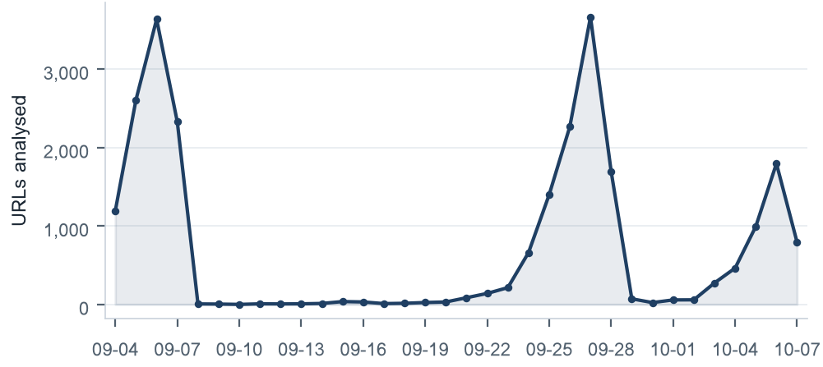
Figure 1. Daily count of URLs analysed, 4 Sep 2026 to 7 Oct 2026.
Daily volumes range from 0 to 3,664 URLs a day. The variation follows crawler queue timing, source ingestion batches, deduplication, site availability, validation delays and crawl strategy changes made during the pilot, which are the normal causes of variation in a pilot of this kind. Read daily volumes as operational processing volumes. They do not measure fixed daily crawl capacity.

Status distribution
Share of URLs analysed by classification status. Each segment is one status and the table beneath it carries the counts.
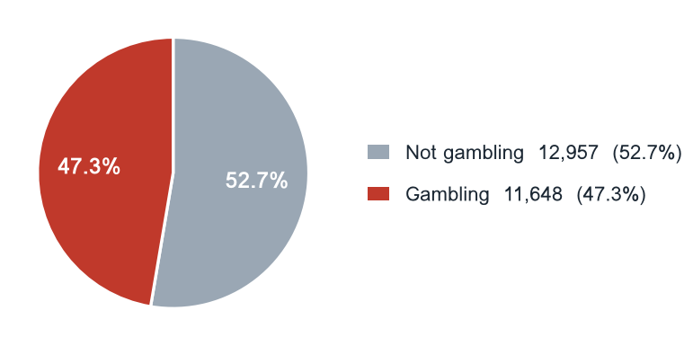
Figure 2. Share of URLs analysed by classification status.
Status | URLs | % of URLs analysed
Not gambling | 12,957 | 52.7%
Gambling | 11,648 | 47.3%

Table 3. Classification status of every URL analysed.

Top 10 URL suffixes
The ten most common URL suffixes among URLs analysed. Bar length is the total count and the table separates the gambling share.
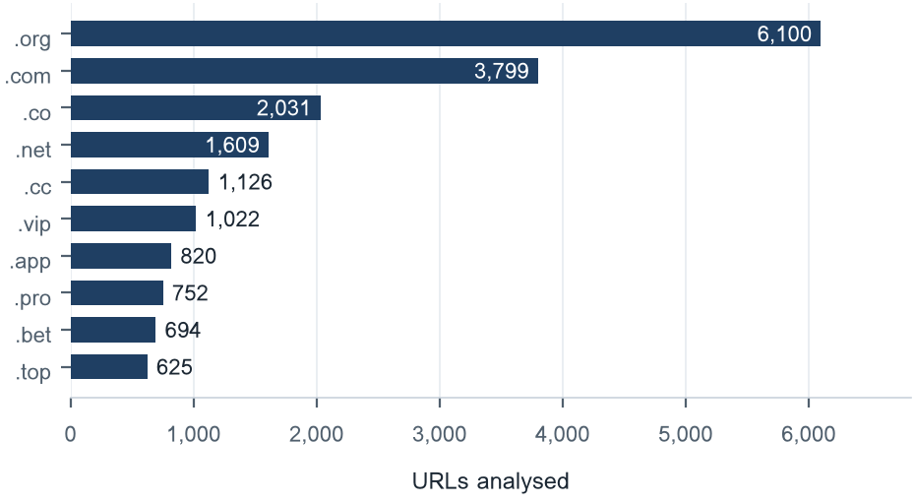
Figure 3. The ten most common URL suffixes among URLs analysed.
Suffix | Total | % of all | Gambling | % gambling
.org | 6,100 | 24.8% | 11 | 0.2%
.com | 3,799 | 15.4% | 1,661 | 43.7%
.co | 2,031 | 8.3% | 1,755 | 86.4%
.net | 1,609 | 6.5% | 1,034 | 64.3%
.cc | 1,126 | 4.6% | 666 | 59.1%
.vip | 1,022 | 4.2% | 925 | 90.5%
.app | 820 | 3.3% | 598 | 72.9%
.pro | 752 | 3.1% | 648 | 86.2%
.bet | 694 | 2.8% | 670 | 96.5%
.top | 625 | 2.5% | 325 | 52.0%

Table 4. URL suffixes ranked by total count, with the gambling share of each.

Subcategories

Gambling sites by product subcategory
Gambling sites by product subcategory. Bar length is the site count and each label carries the count and the share of gambling rows.
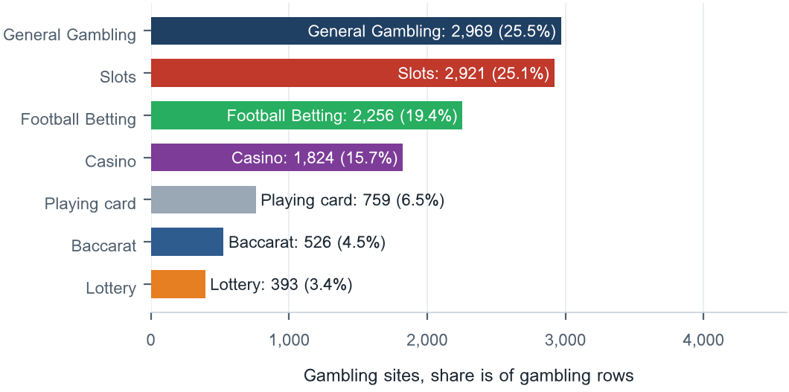
Figure 4. Gambling sites by product subcategory, with each share taken of gambling rows.

Assignment method by subcategory
How each subcategory was assigned. Solid fill is a lexicon match and the lighter fill is model inference.
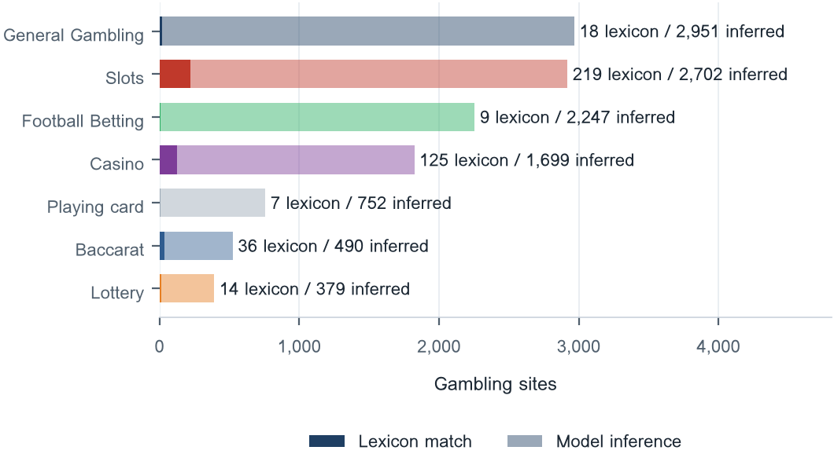
What a lexicon match means
SICPADetect assigns a subcategory by lexicon match when a recorded text field contains a gambling lexicon keyword that belongs to the assigned product category. Those fields are the model-generated site description and classification rationale, extracted keywords, analyst remarks, and the URL and domain. A site whose recorded text contains สล็อต is assigned to Slots. Where no product keyword appears, the model assigns the closest subcategory from what the site description says the site offers. The methods are separate: a lexicon match rests on a keyword in the text, model inference on the model’s reading of the site. The lexicon holds 286 keywords in 14 categories, most in Thai script. The 7 product categories decide the subcategory, and the rest appear as signal tags. A lexicon match can be checked and repeated, so it carries higher confidence. A larger lexicon share means more direct evidence. A large model inference share means the sites use vocabulary the lexicon does not yet cover.
Figure 5. Lexicon match and model inference by subcategory. Model inference assigned 96.3% of gambling rows, and 25.5% of gambling rows carry the General Gambling catch-all.

Subcategory table
Subcategory | Count | % of gambling | Keyword assigned | Inferred | Distinct clusters
General Gambling | 2,969 | 25.5% | 18 | 2,951 | 526
Slots | 2,921 | 25.1% | 219 | 2,702 | 597
Football Betting | 2,256 | 19.4% | 9 | 2,247 | 495
Casino | 1,824 | 15.7% | 125 | 1,699 | 406
Playing card | 759 | 6.5% | 7 | 752 | 283
Baccarat | 526 | 4.5% | 36 | 490 | 253
Lottery | 393 | 3.4% | 14 | 379 | 127

Table 5. Product subcategories with the assignment method split and the number of distinct brand clusters in each.

Heat map: keyword by subcategory
Matched keywords against product subcategory. Each cell is the number of gambling sites carrying that keyword in that subcategory.
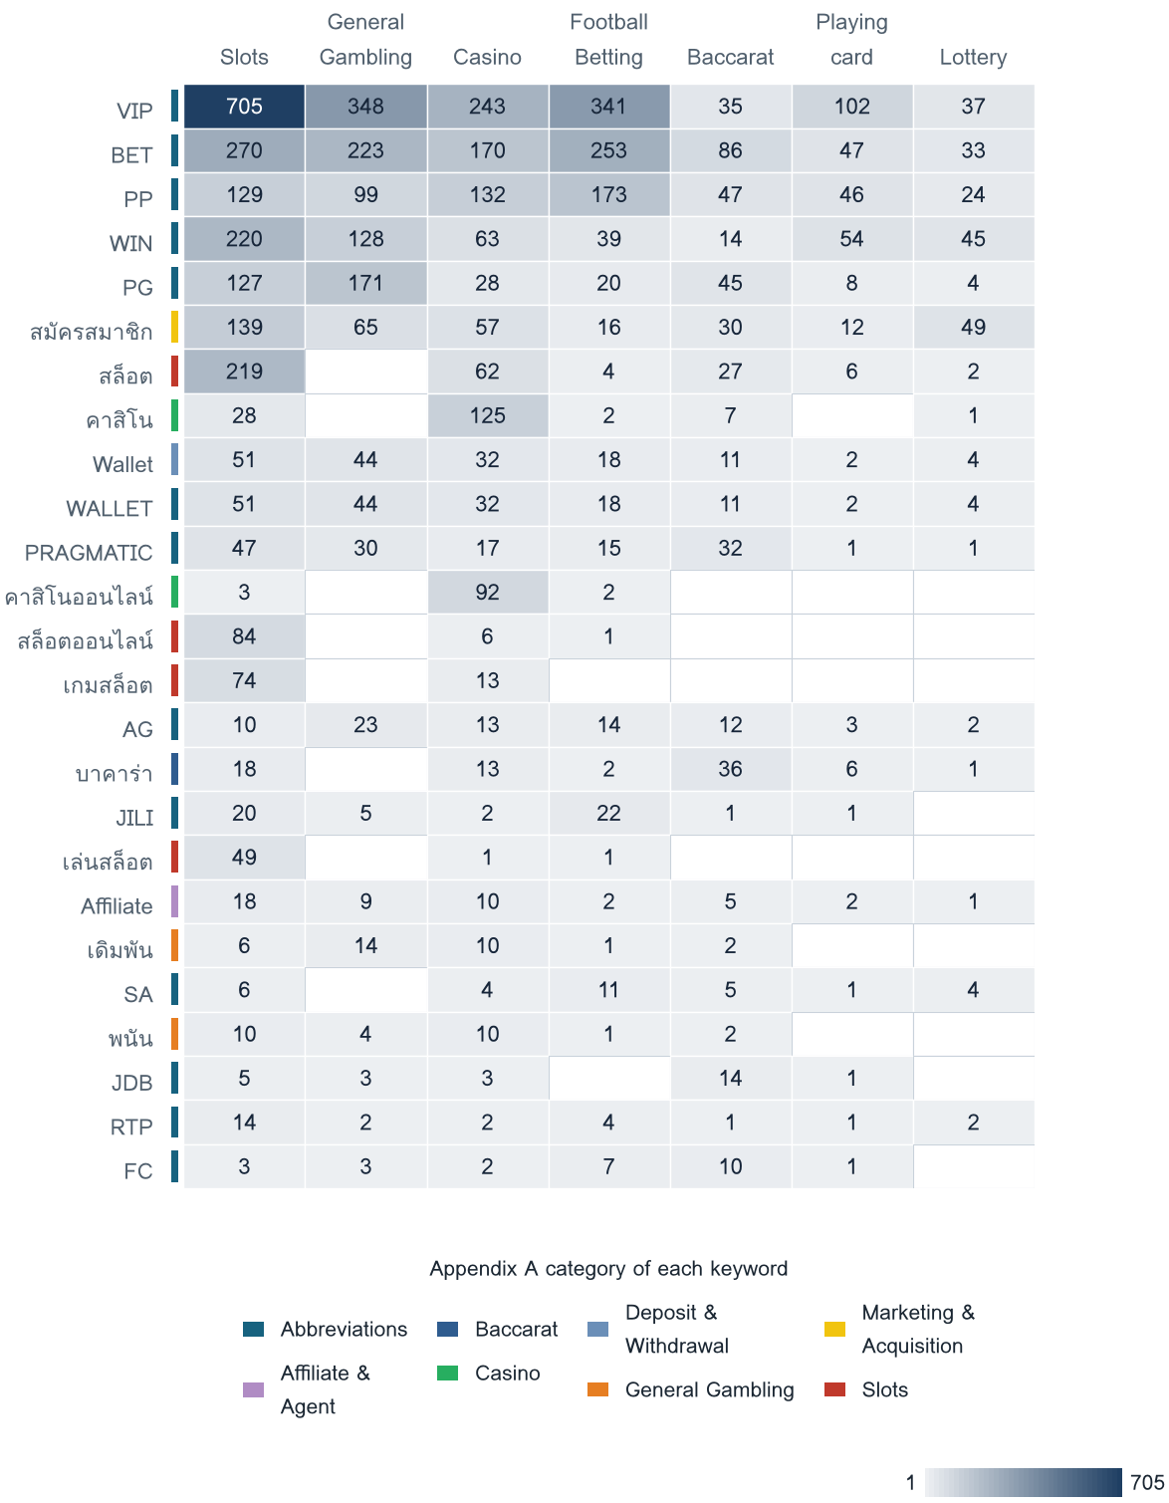
Figure 6. The 25 most frequently matched keywords against product subcategory. The strip beside each keyword gives its own lexicon category.

Heat map: signal tag by subcategory
Signal tags against product subcategory. Each cell is the number of gambling sites carrying that tag in that subcategory.
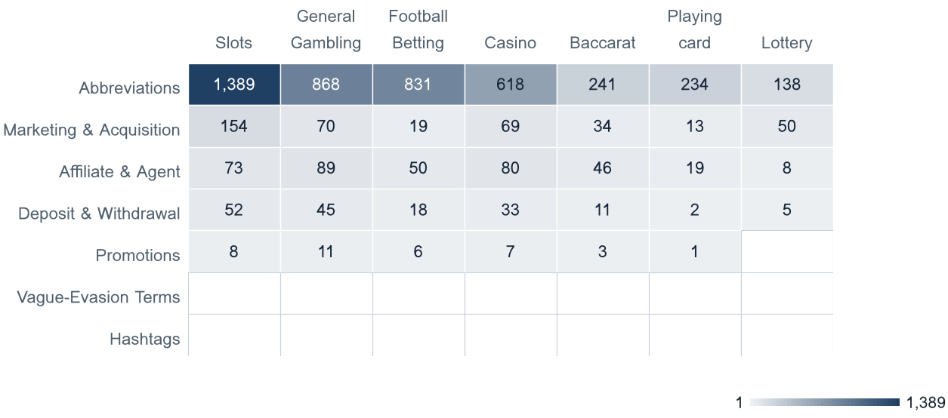
Figure 7. Signal tags against product subcategory, showing which products lean on promotional, payment or evasion language.

Brands and clustering

What brand clusters are
What a cluster is
A brand cluster is a group of domains that appear linked by naming pattern, redirect behaviour, crawler relationship or shared brand stem. SICPADetect links domains in three ways. The crawler found one domain as a variant of, or a redirect from, another, and this crawler relationship is the strongest basis. The domain names reduce to the same brand stem once market tags, version numbers and suffixes are removed. Or the stems differ by only a few trailing characters. A domain linked to no other is a singleton. In this dataset, account.49m.co and account.login.49m.co both reduce to the stem 49m.
Why clusters matter
Gambling operators often register many related domains, rotate top-level domains and redirect users between them, so a new address can replace a blocked one. A URL count therefore gives more addresses than there are distinct operations behind them. Clusters show how many distinct operations appear in the identified gambling URLs, how concentrated those URLs are, and which clusters offer several product types. Acting on a cluster can cover all of its related domains in one step. Clusters are an indicative grouping based on names and crawler links, they do not establish legal ownership, and the possible operator linkage table is indicative.

1,102  Distinct clusters |  | 757  Clusters with 2 or more URLs |  | 345  Singletons |  | 30  Clusters covering half of the identified gambling URLs

Top 15 brand clusters by URL count
The fifteen largest brand clusters by URL count. Bar length is the number of domains in the cluster.
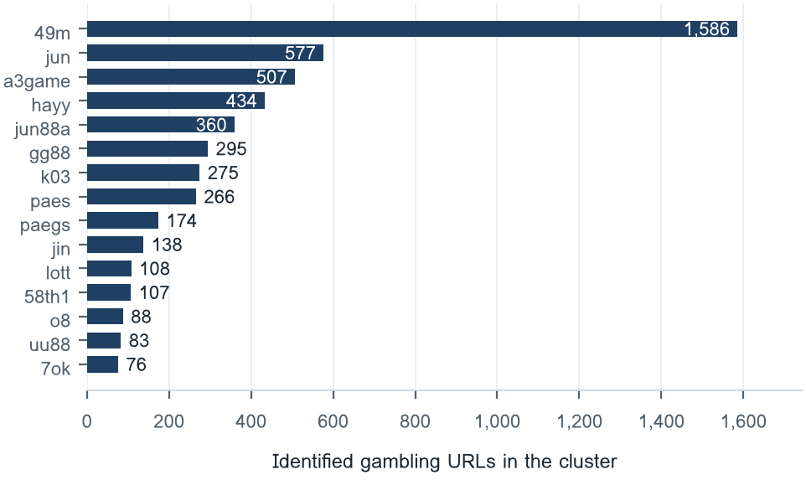
Figure 8. The fifteen largest brand clusters. The top five hold 29.7% of identified gambling URLs and the top ten hold 39.6%.

Heat map: brand cluster by subcategory
Brand clusters against product subcategory. Each cell is the number of URLs a cluster holds in that subcategory.
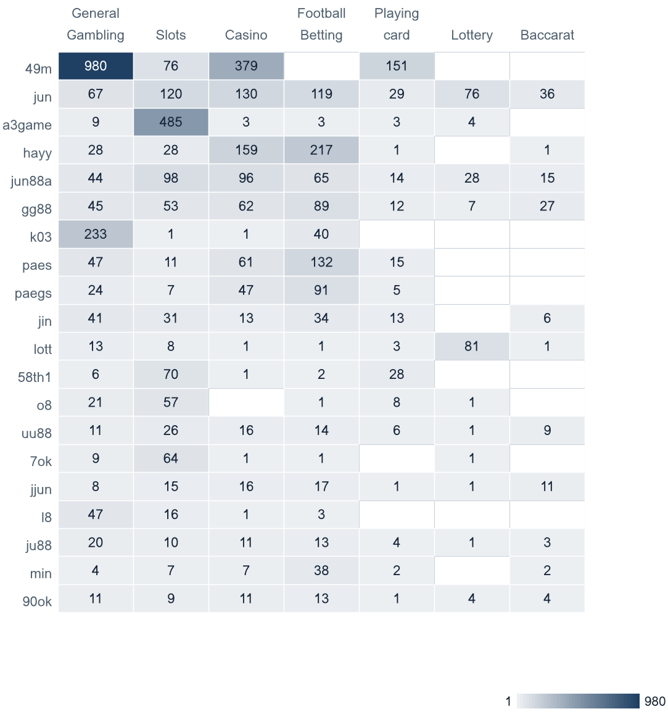
Figure 9. The 20 largest brand clusters against product subcategory. A horizontal band marks a cluster offering several product types.

Cluster expansion: 49m
The largest brand cluster and its member domains. Edge style records why each domain joined the cluster.
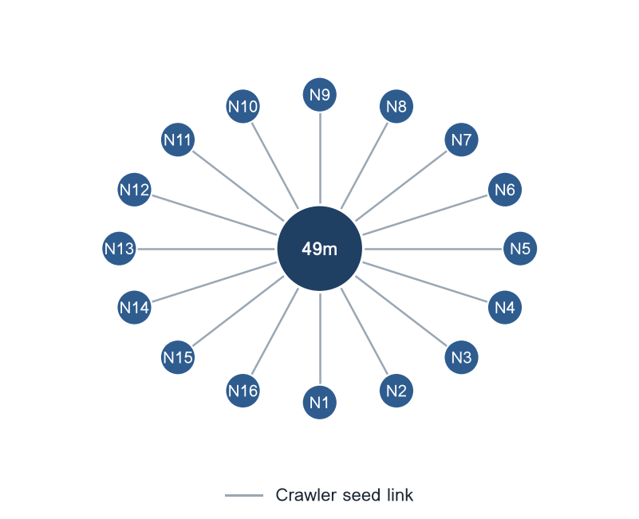
Figure 10. Member domains of the 49m cluster: N1 = account.49m.co; N2 = account.login.49m.co; N3 = account.login.account.49m.co; N4 = account.login.account.account.49m.co; N5 = account.login.account.login.49m.co; N6 = account.login.account.m.49m.co; N7 = account.login.account.mobile.49m.co; N8 = account.login.account.secure.49m.co; N9 = account.login.account.support.49m.co; N10 = account.login.account.verify.49m.co; N11 = account.login.account.www.49m.co; N12 = account.login.login.49m.co; N13 = account.login.login.m.49m.co; N14 = account.login.m.49m.co; N15 = account.login.m.account.49m.co; N16 = account.login.m.m.49m.co.
The 49m cluster holds 1,586 identified gambling URLs, which is 13.6% of the identified gambling URLs in this sample. The diagram shows 16 of its member domains.

Clusters spanning multiple subcategories
Cluster | URL count | Subcategories | Suffixes
49m | 1,586 | Casino, General Gambling, Playing card, Slots | .co, .top
jun | 577 | Baccarat, Casino, Football Betting, General Gambling, Lottery, Playing card, Slots | .166, .app, .bet, .black, .buzz, .casino, .cc, .click
a3game | 507 | Casino, Football Betting, General Gambling, Lottery, Playing card, Slots | .app, .click, .club, .vip
hayy | 434 | Baccarat, Casino, Football Betting, General Gambling, Playing card, Slots | .app, .bet, .cc, .click, .club, .com, .fun, .net
jun88a | 360 | Baccarat, Casino, Football Betting, General Gambling, Lottery, Playing card, Slots | .app, .buzz, .cc, .click, .club, .co, .com, .cooking
gg88 | 295 | Baccarat, Casino, Football Betting, General Gambling, Lottery, Playing card, Slots | .app, .bet, .casino, .cc, .click, .club, .co, .com
k03 | 275 | Casino, Football Betting, General Gambling, Slots | .cc, .net, .pro, .xyz
paes | 266 | Casino, Football Betting, General Gambling, Playing card, Slots | .com, .dev
paegs | 174 | Casino, Football Betting, General Gambling, Playing card, Slots | .dev
jin | 138 | Baccarat, Casino, Football Betting, General Gambling, Playing card, Slots | .224, .225, .226, .49, .app, .bet, .cc, .click
lott | 108 | Baccarat, Casino, Football Betting, General Gambling, Lottery, Playing card, Slots | .app, .bet, .cc, .click, .co, .com, .fun, .info
58th1 | 107 | Casino, Football Betting, General Gambling, Playing card, Slots | .bet, .com, .pro
o8 | 88 | Football Betting, General Gambling, Lottery, Playing card, Slots | .bet, .casino, .click, .club, .co, .game, .live, .uk
uu88 | 83 | Baccarat, Casino, Football Betting, General Gambling, Lottery, Playing card, Slots | .app, .bet, .casino, .cc, .click, .co, .com, .fun
7ok | 76 | Casino, Football Betting, General Gambling, Lottery, Slots | .bet, .live, .pro, .shop

Table 6. The largest of the 616 brand clusters that span two or more product subcategories.

Clusters rotating top-level domains
Cluster | Suffixes | Counts
jun | .top, .com, .net, .bet, .cc, .app, .fun, .pro, .xyz, .me | 98, 85, 79, 36, 36, 28, 27, 25, 22, 16
min | .app, .com, .net, .co, .top, .city, .site, .cash, .team, .cc | 6, 6, 6, 4, 3, 2, 2, 2, 2, 2
jun88a | .com, .co, .pro, .net, .vip, .me, .online, .cc, .info, .app | 199, 22, 22, 19, 17, 11, 10, 10, 7, 7
jin | .vip, .com, .pro, .net, .co, .bet, .app, .click, .online, .fun | 23, 22, 16, 14, 13, 10, 8, 8, 4, 4
90ok | .club, .click, .io, .bet, .xyz, .vip, .casino, .app, .site, .pro | 7, 5, 5, 4, 4, 3, 3, 3, 2, 2
bu88 | .com, .men, .app, .uno, .kim, .bid, .pro, .buzz, .tech, .club | 7, 4, 3, 3, 3, 3, 3, 2, 2, 2
gg88 | .net, .app, .pro, .bet, .com, .online, .vip, .club, .xyz, .io | 53, 48, 46, 36, 30, 17, 15, 13, 6, 6
uu88 | .cc, .com, .net, .pro, .app, .xyz, .bet, .co, .info, .click | 14, 10, 9, 7, 6, 6, 4, 4, 4, 3
ezslot | .me, .live, .club, .info, .co, .online, .bet, .to, .tech, .top | 3, 3, 2, 2, 2, 2, 2, 2, 2, 2
99ok | .bet, .pro, .club, .vip, .app, .io, .info, .cc, .site, .co | 15, 3, 3, 3, 3, 2, 2, 2, 2, 2
77jili | .net, .pro, .club, .bet, .com, .co, .app, .site, .win, .vip | 5, 4, 4, 4, 3, 3, 3, 2, 2, 2
m88thcasino | .com, .club, .co, .live, .net, .online, .site, .vip, .shop, .pro | 2, 2, 2, 2, 2, 2, 2, 2, 2, 2
lott | .com, .net, .online, .click, .cc, .live, .info, .bet, .app, .co | 62, 9, 4, 4, 4, 4, 4, 4, 2, 2
ku88 | .com, .net, .pro, .casino, .live, .us, .io, .top, .mx, .nl | 8, 5, 5, 3, 3, 3, 2, 2, 1, 1
hh88 | .com, .site, .vip, .net, .shop, .xyz, .click, .online, .info, .bet | 30, 4, 2, 2, 2, 2, 2, 1, 1, 1

Table 7. The 588 brand clusters whose domains span two or more top-level domains, ranked by the number of suffixes used.

Possible operator linkage
Indicative: not a clustering decision.
Cluster A | Cluster B | Shared keywords | Jaccard
pgcat | mst | BET, FC, JILI, PG, PRAGMATIC, VIP, WALLET, WIN, Wallet, สมัครสมาชิก | 0.75
jin | mega | BET, PG, PP, PRAGMATIC, RTP, VIP, WALLET, WIN, Wallet, สมัครสมาชิก | 0.91
jin | mst | BET, FC, PG, PRAGMATIC, VIP, WALLET, WIN, Wallet, สมัครสมาชิก | 0.64
gg88 | jin | BET, FC, PG, PP, PRAGMATIC, VIP, WALLET, WIN, Wallet | 0.60
ezslot | 9ufa | BET, PG, PRAGMATIC, VIP, WALLET, WIN, Wallet, สมัครสมาชิก, สมาชิกใหม่ | 0.60
mega | 9ufa | BET, PG, PRAGMATIC, RTP, VIP, WALLET, WIN, Wallet, สมัครสมาชิก | 0.60
dreamworld | 80p | BET, PG, PP, WALLET, WIN, Wallet, สมัครสมาชิก, ได้เงินจริง | 0.80
uu88 | mega | BET, PG, PP, PRAGMATIC, VIP, WALLET, WIN, Wallet | 0.73
n98 | mega | BET, PG, PP, RTP, VIP, WALLET, Wallet, สมัครสมาชิก | 0.73
ezslot | wingame | BET, PG, PRAGMATIC, VIP, WALLET, WIN, Wallet, สมัครสมาชิก | 0.73
mega | wingame | BET, PG, PRAGMATIC, VIP, WALLET, WIN, Wallet, สมัครสมาชิก | 0.73
jin | uu88 | BET, PG, PP, PRAGMATIC, VIP, WALLET, WIN, Wallet | 0.67
jin | n98 | BET, PG, PP, RTP, VIP, WALLET, Wallet, สมัครสมาชิก | 0.67
jin | wingame | BET, PG, PRAGMATIC, VIP, WALLET, WIN, Wallet, สมัครสมาชิก | 0.67
jjun | mega | BET, PG, PP, PRAGMATIC, RTP, WALLET, Wallet, สมัครสมาชิก | 0.67

Table 8. Pairs of multi-URL clusters whose signal keyword sets overlap at a Jaccard similarity of 0.60 or more. 11,211 pairs met the threshold. Shared promotional vocabulary is common across unrelated operators, so these pairs are leads for an analyst and not a clustering decision.

Naming conventions
- Recurring tokens appear across the domain names in the largest clusters: m. in 2,153 names, login in 1,300 names, mobile in 1,232 names. The repetition is evidence of a templated naming scheme.
- The names in the largest clusters span more than one suffix: .co in 1,626 names, .net in 592 names, .vip in 564 names, .com in 514 names. The operators behind these clusters rotate top-level domains.
- 5,074 distinct domains across 15 brand clusters.

125  Reached directly |  | 594  Redirect-derived |  | 10,929  Crawler variants

Redirect propagation: www.min88.top
The busiest redirect source and the destinations reached from it. Each node is one domain.
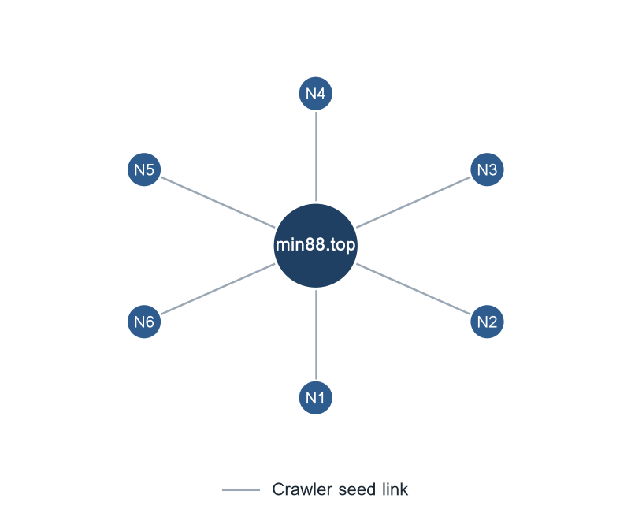
Figure 11. Destinations reached from www.min88.top: N1 = min88.academy; N2 = min88.cafe; N3 = min88.camp; N4 = min88.cash; N5 = min88.city; N6 = min88.international.

Ranking

Gambling ranking
Rank | Domain | Brand cluster | Subcategory | Source
91,874 | metal--vip.com | metal | Slots | Analyst-enriched
92,922 | gernpang88.com | gernpang | General Gambling | Analyst-enriched
129,213 | duangpang168.com | duangpang | General Gambling | Analyst-enriched
198,736 | jun88wb.com | jun88a | Casino | Crawler variant
214,795 | allslotwallet.online | allslotwallet | Slots | Analyst-enriched
219,821 | u11k.pro | u11k | Football Betting | Crawler variant
221,001 | suriyathai.net | suriya | General Gambling | Analyst-enriched
303,254 | jun88wf.com | jun88a | Lottery | Crawler variant
397,330 | jun88wa.com | jun88a | Football Betting | Crawler variant
466,858 | jun88wc.com | jun88a | Slots | Crawler variant
517,141 | slavinaslot.top | jun | Slots | Redirect-derived
517,141 | jun88.info | jun | Slots | Crawler variant
547,370 | 99ok.vip | 99ok | Lottery | Crawler variant
558,790 | gg8830.com | gg88 | Slots | Crawler variant
582,212 | betwgb.com | betwgb | General Gambling | Analyst-enriched

Table 9. The 15 highest ranked gambling sites of the 268 that carry a numeric rank.
Rank reflects search visibility or source-feed position. It does not measure harm, revenue, user volume or enforcement priority.
"Analyst-enriched" means an analyst verified or added details after SICPADetect’s automated detection. SICPADetect’s detection process is automated.

Key insights

Scale of the analysis
SICPADetect analysed 24,605 distinct URLs during the pilot reporting period of 34 days, 4 Sep 2026 to 7 Oct 2026. The classification outcomes were 11,648 gambling and 12,957 not gambling.
Take. SICPADetect classified 11,648 URLs as gambling, 47.3% of the URLs analysed. Daily volumes in this period follow processing batches, so the period does not support a statement about the direction of gambling activity over time.

What is being offered
The three largest product subcategories are General Gambling with 2,969 sites at 25.5%, Slots with 2,921 sites at 25.1% and Football Betting with 2,256 sites at 19.4%. SICPADetect confirmed 2,969 gambling sites, 25.5% of the gambling set, as gambling without an evidenced product type. Model inference assigned the subcategory for 96.3% of gambling rows. Of the 286 keywords in the lexicon, 204 never matched a row in this dataset.
Take. General Gambling is the largest product subcategory at 25.5%. No single category accounts for a majority, and Slots follows at 25.1%.

Brand clustering
SICPADetect groups the 11,648 identified gambling URLs into 1,102 indicative brand clusters. 757 clusters hold more than one domain, and 30 clusters cover half of the identified gambling URLs. The largest, 49m, holds 1,586 domains across 4 product subcategories.
Take. The identified gambling URLs spread across many clusters, each holding a small share, so cluster prioritisation still groups related domains, and each action covers fewer URLs.

How operators expand and promote their domains
Of the 11,648 identified gambling URLs, 10,929 are crawler variants, 594 are redirect-derived and 125 were reached directly. The busiest redirect source, www.min88.top, reaches 6 destinations. 588 clusters use more than one top-level domain. The two most common signal tags are Abbreviations at 37.1% and Marketing & Acquisition at 3.5%.
Take. Operators use redirects and top-level domain rotation to keep users reaching their sites when individual domains change.

Enforcement position
Only 7 URLs in the analysed set already carried blocking or enforcement indicators. MDES can therefore include most identified gambling URLs in a first prioritised enforcement pass.
Take. Cluster-based prioritisation lets MDES act on groups of related domains instead of handling each URL separately.

Lexicon source: Gambling_Keywords_Full_English_Categories_V1.xlsx, reproduced as Appendix A of the report specification, revision v5.3. Keywords per category: Football Betting 21, Slots 32, Casino 14, Lottery 20, Playing card 12, Baccarat 11, General Gambling 22, Deposit & Withdrawal 24, Promotions 27, Marketing & Acquisition 25, Affiliate & Agent 20, Vague-Evasion Terms 20, Abbreviations 22, Hashtags 21. Model inference assigned 96.3% of gambling rows; 25.5% of gambling rows carry the General Gambling catch-all. Rows arriving with status Licensed gambling and normalised to Gambling: 0. Probable false-positive source among the Abbreviations keywords: VIP at 35.3% of all Abbreviations matches, BET at 21.1% of all Abbreviations matches. Clustering thresholds: Jaro-Winkler similarity of at least 0.90 for a near-miss merge, with a shared leading prefix and a minimum stem length of 4 characters. Brand stems are taken from the registrable label of each host. No pilot start date was supplied for this run, so the pilot reporting period starts at the first exported record, 4 Sep 2026. Source export: thailand_07_10_26.csv, 24,653 rows read, 48 duplicate URLs dropped.

