
Data Insights & Patterns
11,560 URLs · 31 Aug – 22 Sep 2026
Issued to | Ministry of Digital Economy and Society, Thailand
Prepared by | SICPA SA
Date of issue | 24/09/2026
Source system | SICPADetect · lexicon Gambling_Keywords_Full_English_Categories_V1

Contents
Executive summary
Group A — Model Insights
Introduction
Insights
Performance
Group B — 10 most prominent gambling sites in Thailand
10 most prominent gambling sites in Thailand
Group C — The numbers
Metric cards row
URLs analyzed per day
Status distribution
Top 10 URL suffixes
Group D — Subcategories
Gambling sites by product subcategory
Assignment method by subcategory
Subcategory table
Heat map — Keyword × subcategory
Heat map — Signal tag × subcategory
Group E — Brands and clustering
Metric cards row
Top 15 brand clusters by URL count
Heat map — Brand cluster × subcategory
Cluster expansion — gg88
Clusters spanning multiple subcategories
Clusters rotating top-level domains
Possible operator linkage
Naming conventions
Structure: direct → redirect → variant
Redirect propagation — lotto432e.com
Group F — Ranking
Gambling ranking
Group G — Key insights
Scale of the analysis
What is being offered
Brand clustering
How the estate is grown and marketed
Enforcement position

Executive summary
Part 1a. Insights and trends.
The feed resolves to 11,560 distinct URLs, of which 35.4% are gambling. The rest are not gambling, and no URL in the set was unreachable.
Product mix is led by Slots, then Football Betting and General Gambling. No single product type accounts for a third of the gambling estate, so the set is better read as a spread of offerings than as one dominant market.
Operators are diffuse. 55 brand clusters are needed to cover half the gambling estate, and the largest cluster, gg88, holds well under a tenth of it. Cluster-level enforcement therefore reaches less of the estate here than it would against a concentrated market.
Growth is almost entirely by variant. Crawler-identified variants account for 93.9% of gambling rows, with redirect chains and directly reached sites making up the remainder. Clusters rotate top-level domains while keeping the same name stem. Marketing language is dominated by the Abbreviations tag.
Enforcement has barely started against this set: only one page carries a regulatory blocking indicator.
Part 1b. Key figures.
Figure | Value
URLs analysed | 11,560
Gambling sites | 4,096 (35.4%)
Not gambling | 7,464
Unreachable | 0
Brand clusters identified | 1,818 (973 hold more than one domain)
Clusters covering half the estate | 55
Largest cluster | gg88 — 391 URLs
Dominant product subcategory | Slots — 1,271 (31.0%)
Most common signal tag | Abbreviations — 1,270 (31.0%)
Sites showing blocking indicators | 1
Subcategory assignment, keyword versus inferred | 116 keyword / 3,980 inferred

Group A — Model Insights
Introduction

Insights

Performance

Group B — 10 most prominent gambling sites in Thailand
10 most prominent gambling sites in Thailand
Rank | URL | Domain | Brand cluster | Subcategory | Thai-targeting evidence | Source
78,229 | hxxps://www[.]lottovip[.]com/register/af/21832 | lottovip.com | lott | Lottery | Thai currency: “baht” | Youtube (lotto432)
90,304 | hxxps://lottovip[.]bet/ | lottovip.bet | lott | Lottery | Thai-market product or brand terms: “WIN” | Variant (lottovip.com)
184,475 | hxxps://fun88thf[.]com/ | fun88thf.com | fun88tht | Football Betting | Thai-market product or brand terms: “VIP” | Variant (fun88tht.com)
216,041 | hxxps://lottovipp[.]com/ | lottovipp.com | lott | Lottery | Thai-market product or brand terms: “WIN” | Variant (lottovip.com)
517,141 | hxxps://jun88[.]info/ | jun88.info | jun | Slots | Thai-market product or brand terms: “VIP” | Variant (jun88.mobile)
517,141 | hxxps://slavinaslot[.]top/ | slavinaslot.top | jun | Slots | Thai-market product or brand terms: “VIP” | Redirect (jun88.info)
558,790 | hxxps://gg8830[.]com/ | gg8830.com | gg88 | Slots | Thai-market product or brand terms: “SEXY” | Variant (gg8825.app)
706,458 | hxxps://lotto432ad[.]com/ | lotto432ad.com | lotto | Lottery | Thai script: “สมัครสมาชิก” | Variant (lotto432ae.com)
715,861 | hxxps://k7[.]game/ | k7.game | k6 | General Gambling | Thai-market product or brand terms: “BET” | Variant (k6.game)
727,399 | hxxps://gg8832[.]com/ | gg8832.com | gg88 | Slots | Thai-market product or brand terms: “SEXY” | Variant (gg8835.com)

Rank reflects search visibility in the source feed, not harm, reach or revenue.

Group C — The numbers
11,560  Total URLs analyzed | 4,096  Gambling sites | 1,818  Brand clusters identified | 23 days  2026-08-31 → 2026-09-22

URLs analyzed per day
Daily count of URLs analysed across the evaluation period. Each point is one calendar day.
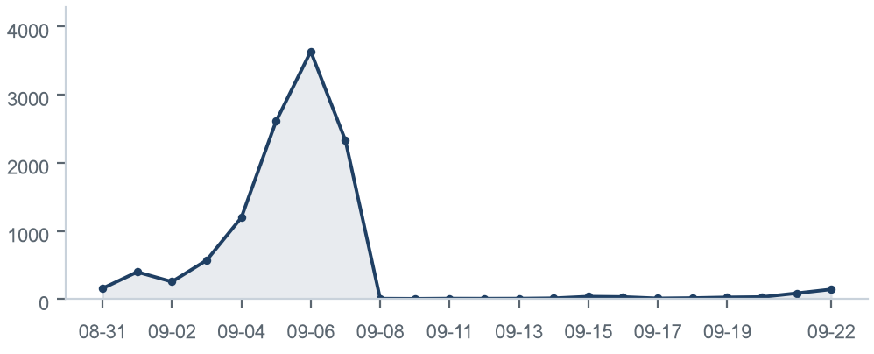

Status distribution
Share of the estate by classification status. Each segment is one status and the table below carries the counts.
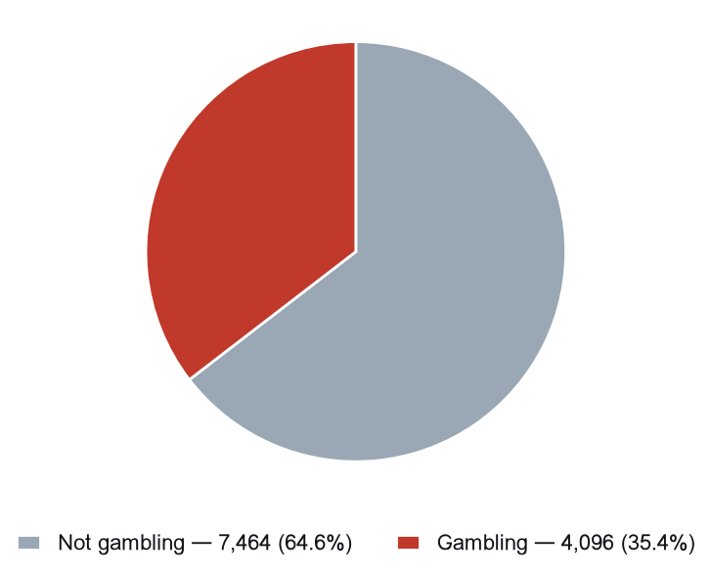
Status | Count | % of all URLs
Not gambling | 7,464 | 64.6%
Gambling | 4,096 | 35.4%

Top 10 URL suffixes
The ten most common URL suffixes in the estate. Bar length is the total count and the table separates the gambling share.
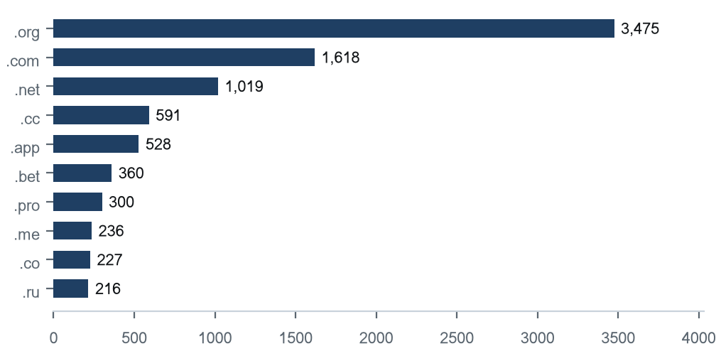
Suffix | Total | % of all | Gambling | % gambling
.org | 3,475 | 30.1% | 0 | 0.0%
.com | 1,618 | 14.0% | 573 | 35.4%
.net | 1,019 | 8.8% | 616 | 60.5%
.cc | 591 | 5.1% | 381 | 64.5%
.app | 528 | 4.6% | 372 | 70.5%
.bet | 360 | 3.1% | 347 | 96.4%
.pro | 300 | 2.6% | 251 | 83.7%
.me | 236 | 2.0% | 94 | 39.8%
.co | 227 | 2.0% | 37 | 16.3%
.ru | 216 | 1.9% | 2 | 0.9%

Group D — Subcategories
Gambling sites by product subcategory
Gambling sites by product subcategory. Bar length is the site count and each label carries the count and the share of gambling rows.
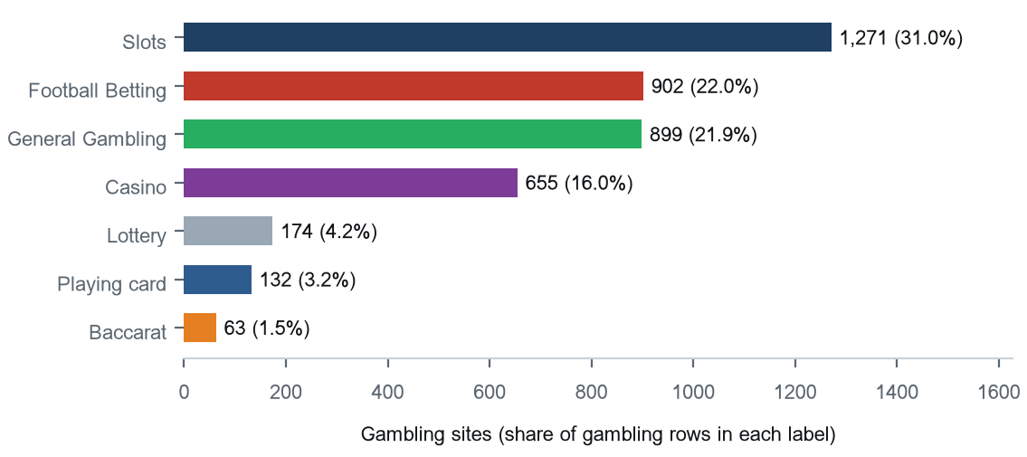

Assignment method by subcategory
How each subcategory was assigned. Solid fill is a lexicon keyword match and the lighter fill is reasoning inference.
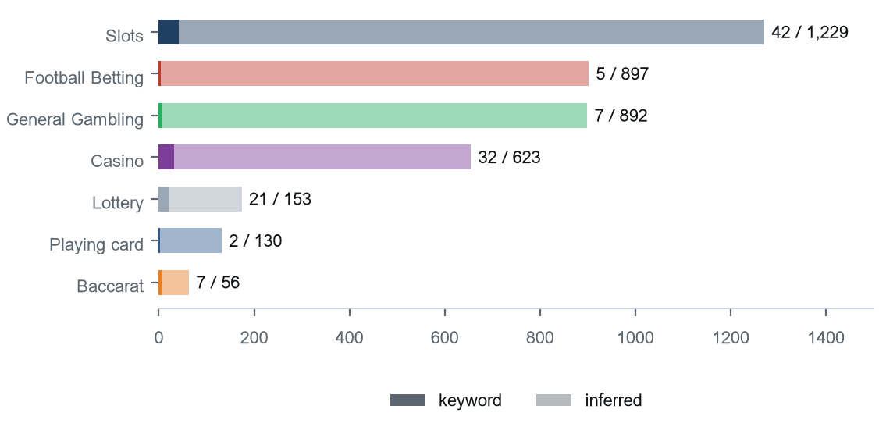
Inferred share 97.2% of gambling rows; General Gambling share 21.9%.

Subcategory table
Subcategory | Count | % of gambling | Keyword-assigned | Inferred | Distinct clusters
Slots | 1,271 | 31.0% | 42 | 1,229 | 309
Football Betting | 902 | 22.0% | 5 | 897 | 225
General Gambling | 899 | 21.9% | 7 | 892 | 227
Casino | 655 | 16.0% | 32 | 623 | 189
Lottery | 174 | 4.2% | 21 | 153 | 31
Playing card | 132 | 3.2% | 2 | 130 | 81
Baccarat | 63 | 1.5% | 7 | 56 | 38

Heat map — Keyword × subcategory
Matched keywords against product subcategory. Each cell is the number of gambling sites carrying that keyword in that subcategory.
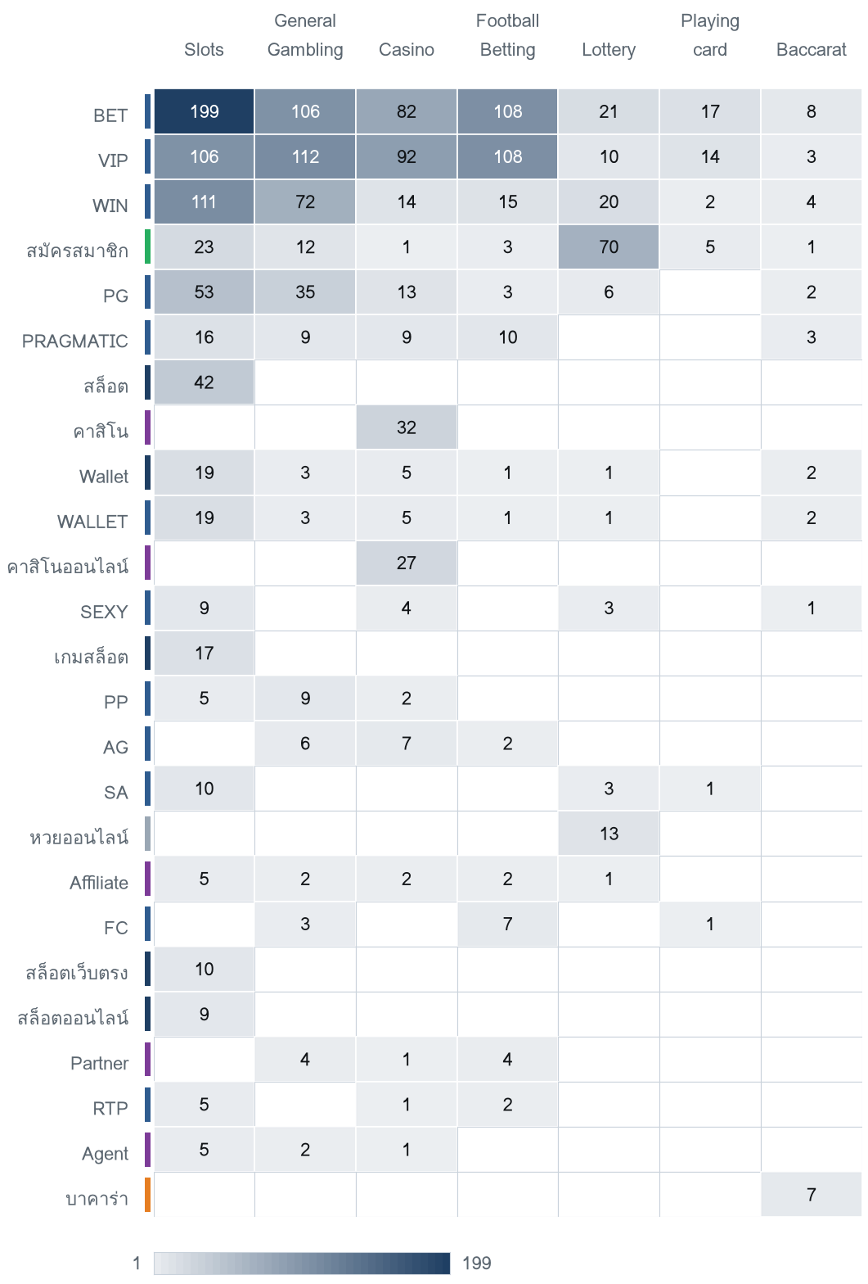
The strip beside each keyword carries the colour of its own Appendix A category, so cross-category bleed is visible.

Heat map — Signal tag × subcategory
Signal tags against product subcategory. Each cell is the number of gambling sites carrying that tag in that subcategory.
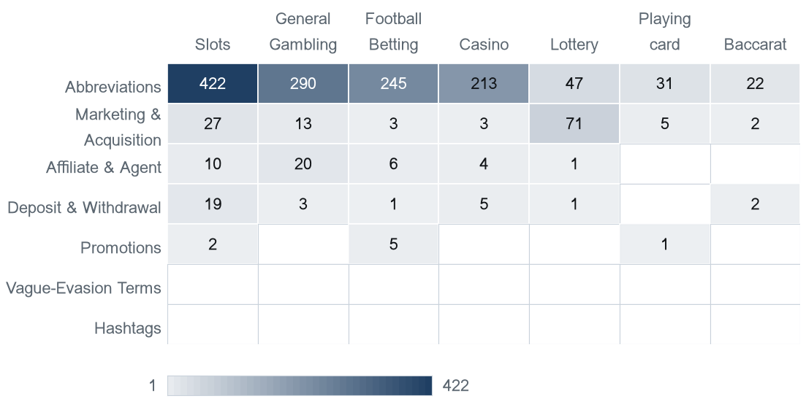

Group E — Brands and clustering
1,818  Distinct clusters | 973  Clusters with 2 or more URLs | 845  Singletons | 55  Clusters covering half the estate

Top 15 brand clusters by URL count
The fifteen largest brand clusters by URL count. Bar length is the number of domains in the cluster.
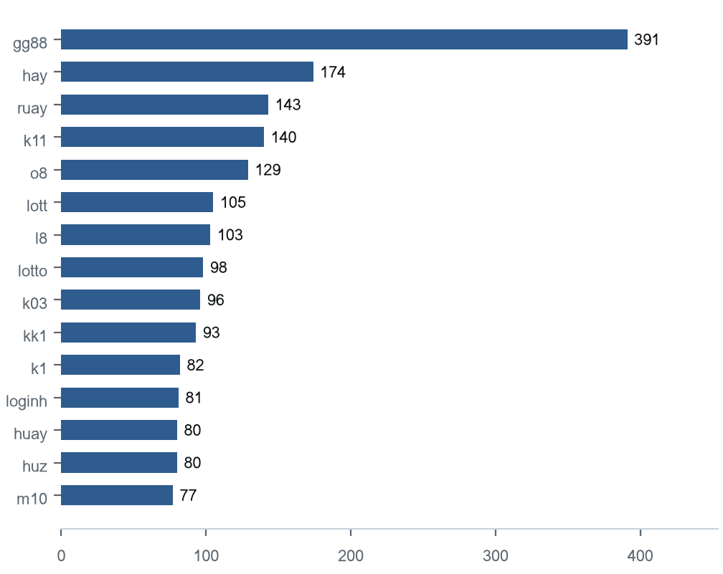

Heat map — Brand cluster × subcategory
Brand clusters against product subcategory. Each cell is the number of URLs a cluster holds in that subcategory.
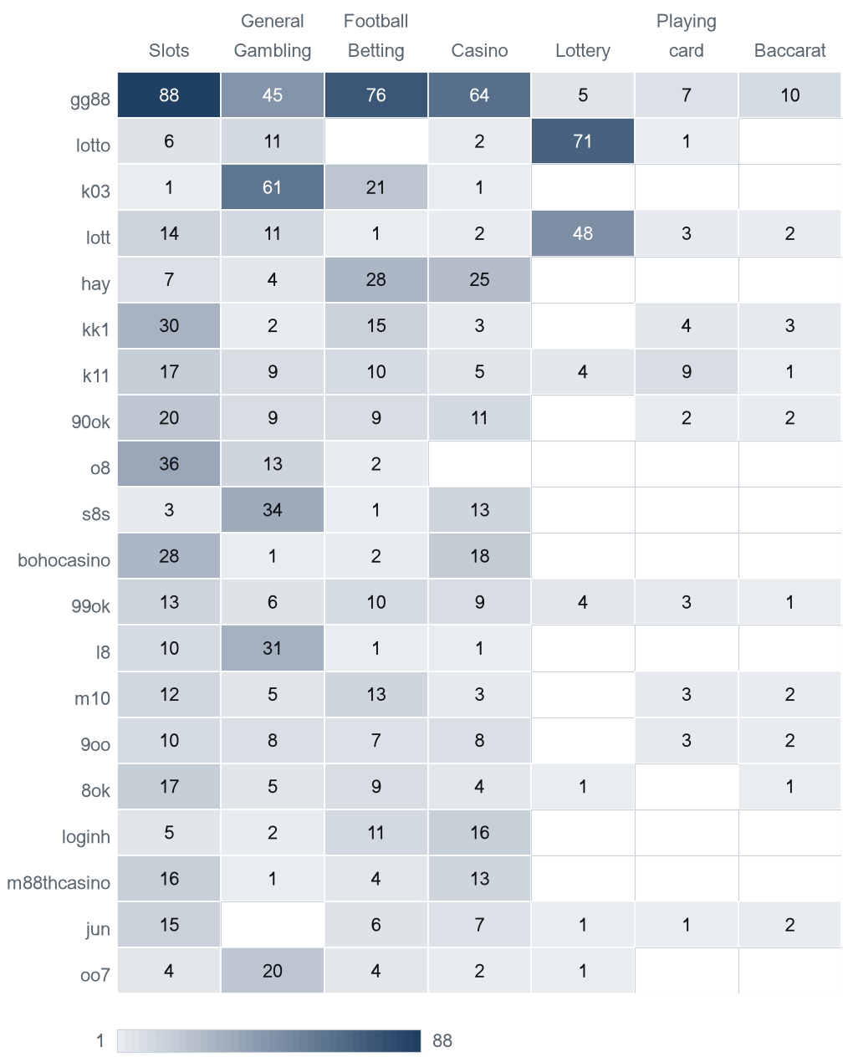

Cluster expansion — gg88
The largest brand cluster and its member domains. Edge style records why each domain joined the cluster.
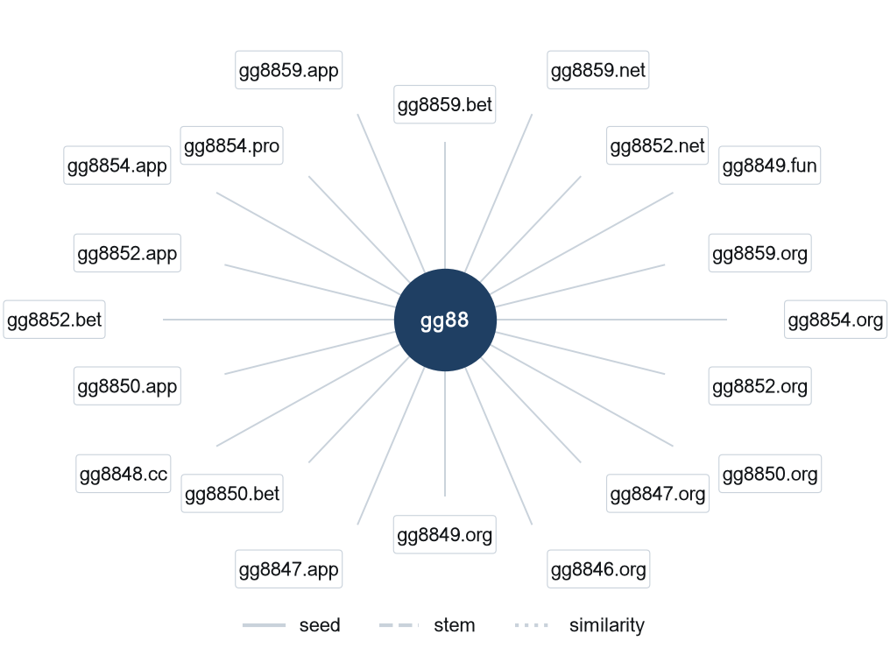
gg88 holds 391 domains; the diagram shows the first 20.

Clusters spanning multiple subcategories
Cluster | URL count | Subcategories | Suffixes
gg88 | 391 | Slots 88, Football Betting 76, Casino 64, General Gambling 45, Baccarat 10, Playing card 7, Lottery 5 | .org 77, .net 55, .app 48, .pro 46, .bet 36, .com 36
hay | 174 | Football Betting 28, Casino 25, Slots 7, General Gambling 4 | .net 77, .org 41, .com 14, .fun 5, .hu 5, .co 4
ruay | 143 | Casino 16, Slots 8, Lottery 4, General Gambling 1, Football Betting 1 | .com 42, .org 16, .app 8, .co 8, .net 8, .online 6
k11 | 140 | Slots 17, Football Betting 10, General Gambling 9, Playing card 9, Casino 5, Lottery 4, Baccarat 1 | .org 29, .cc 14, .top 12, .com 9, .pro 9, .net 8
o8 | 129 | Slots 36, General Gambling 13, Football Betting 2 | .org 42, .game 42, .shop 5, .co 5, .cc 4, .com 4
lott | 105 | Lottery 48, Slots 14, General Gambling 11, Playing card 3, Baccarat 2, Casino 2, Football Betting 1 | .com 26, .org 18, .net 9, .live 6, .cc 6, .bet 5
l8 | 103 | General Gambling 31, Slots 10, Football Betting 1, Casino 1 | .game 37, .org 33, .hu 8, .co 5, .com 5, .ru 3
lotto | 98 | Lottery 71, General Gambling 11, Slots 6, Casino 2, Playing card 1 | .com 74, .org 6, .info 5, .net 4, .click 3, .bet 2
k03 | 96 | General Gambling 61, Football Betting 21, Casino 1, Slots 1 | .cc 91, .top 2, .net 1, .info 1, .pro 1
kk1 | 93 | Slots 30, Football Betting 15, Playing card 4, Baccarat 3, Casino 3, General Gambling 2 | .org 15, .pro 12, .app 12, .me 10, .net 6, .fun 6
k1 | 82 | General Gambling 5, Slots 4, Football Betting 2 | .org 10, .co 8, .net 8, .com 7, .cc 6, .game 5
loginh | 81 | Casino 16, Football Betting 11, Slots 5, General Gambling 2 | .net 41, .org 20, .com 9, .hu 3, .info 3, .me 2
huay | 80 | Slots 9, Lottery 7, Casino 5, General Gambling 2 | .com 21, .org 7, .app 7, .pro 6, .info 5, .co 4
huz | 80 | Casino 7, Slots 6, Football Betting 2 | .app 11, .org 10, .net 10, .com 5, .me 5, .cc 5
m10 | 77 | Football Betting 13, Slots 12, General Gambling 5, Playing card 3, Casino 3, Baccarat 2 | .click 11, .org 9, .club 6, .app 6, .bet 5, .com 4

Clusters rotating top-level domains
Cluster | Suffixes | Counts
gg88 | .org, .net, .app, .pro, .bet, .com, .vip, .online | 77, 55, 48, 46, 36, 36, 18, 17
hay | .net, .org, .com, .fun, .hu, .co, .bet, .tv | 77, 41, 14, 5, 5, 4, 4, 4
ruay | .com, .org, .app, .co, .net, .online, .fun, .hu | 42, 16, 8, 8, 8, 6, 6, 5
k11 | .org, .cc, .top, .com, .pro, .net, .click, .ru | 29, 14, 12, 9, 9, 8, 7, 7
o8 | .org, .game, .shop, .co, .cc, .com, .io, .in | 42, 42, 5, 5, 4, 4, 4, 4
lott | .com, .org, .net, .live, .cc, .bet, .pro, .online | 26, 18, 9, 6, 6, 5, 4, 4
l8 | .game, .org, .hu, .co, .com, .ru, .net, .casino | 37, 33, 8, 5, 5, 3, 3, 2
lotto | .com, .org, .info, .net, .click, .bet, .live, .fun | 74, 6, 5, 4, 3, 2, 2, 1
k03 | .cc, .top, .net, .info, .pro | 91, 2, 1, 1, 1
kk1 | .org, .pro, .app, .me, .net, .fun, .xyz, .com | 15, 12, 12, 10, 6, 6, 5, 5
k1 | .org, .co, .net, .com, .cc, .game, .io, .pro | 10, 8, 8, 7, 6, 5, 4, 4
loginh | .net, .org, .com, .hu, .info, .me, .cc, .bet | 41, 20, 9, 3, 3, 2, 1, 1
huay | .com, .org, .app, .pro, .info, .co, .net, .io | 21, 7, 7, 6, 5, 4, 4, 3
huz | .app, .org, .net, .com, .me, .cc, .io, .info | 11, 10, 10, 5, 5, 5, 5, 4
m10 | .click, .org, .club, .app, .bet, .com, .cc, .online | 11, 9, 6, 6, 5, 4, 4, 3

Possible operator linkage
Indicative — not a clustering decision
Cluster A | Cluster B | Shared keywords | Jaccard
hay | o8 | BET · VIP · WIN | 1.00
hay | ru4 | BET · VIP · WIN | 1.00
hay | bohocasino | BET · VIP · WIN | 1.00
hay | j6 | BET · VIP · WIN | 1.00
hay | 9ok | BET · VIP · WIN | 1.00
hay | 19ok | BET · VIP · WIN | 1.00
hay | k88 | BET · VIP · WIN | 1.00
hay | support7ok | BET · VIP · WIN | 1.00
hay | account7ok | BET · VIP · WIN | 1.00
hay | 13l | BET · VIP · WIN | 1.00
hay | login7ok | BET · VIP · WIN | 1.00
k11 | 8ok | BET · PG · PRAGMATIC · VIP · WIN | 1.00
k11 | j10 | BET · PG · PRAGMATIC · VIP · WIN | 1.00
k11 | kk00 | BET · PG · PRAGMATIC · VIP · WIN | 1.00
k11 | k20 | BET · PG · PRAGMATIC · VIP · WIN | 1.00
o8 | ru4 | BET · VIP · WIN | 1.00
o8 | bohocasino | BET · VIP · WIN | 1.00
o8 | j6 | BET · VIP · WIN | 1.00
o8 | 9ok | BET · VIP · WIN | 1.00
o8 | 19ok | BET · VIP · WIN | 1.00

Naming conventions
• Recurring tokens across the largest clusters point to a templated naming scheme: m. (238), mobile (210), login (114).
• Names span more than one suffix, so the operators rotate top-level domains: .org (333), .com (261), .net (238), .cc (149).
• 1,872 distinct domains across 15 brand clusters.

59  Direct (1.4%) | 192  Redirect (4.7%) | 3,845  Variant (93.9%)

Redirect propagation — lotto432e.com
The busiest redirect source and the destinations reached from it. Each node is one domain.
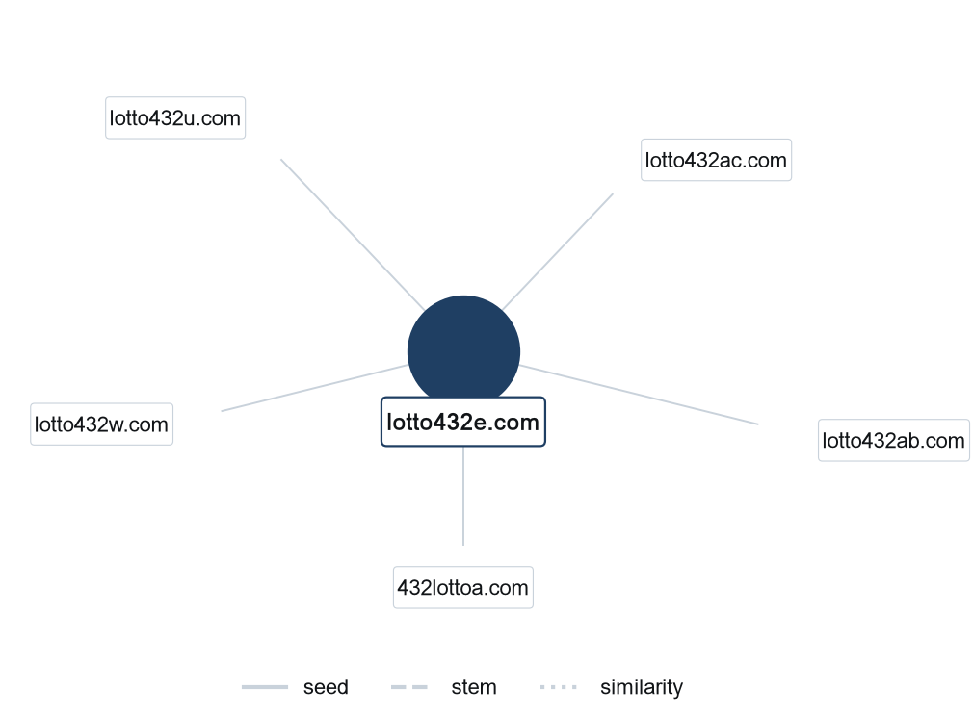
lotto432e.com reaches 5 destinations in this sample; the diagram shows the first 5.

Group F — Ranking
Gambling ranking
Rank | Domain | Brand cluster | Subcategory | Source
78,229 | lottovip.com | lott | Lottery | Youtube (lotto432)
90,304 | lottovip.bet | lott | Lottery | Variant (lottovip.com)
93,266 | lottovip.info | lott | Slots | Variant (lottovip.com)
184,475 | fun88thf.com | fun88tht | Football Betting | Variant (fun88tht.com)
216,041 | lottovipp.com | lott | Lottery | Variant (lottovip.com)
402,382 | ruay.com | ruay | General Gambling | Youtube (หวยออนไลน์)
517,141 | jun88.info | jun | Slots | Variant (jun88.mobile)
517,141 | slavinaslot.top | jun | Slots | Redirect (jun88.info)
547,370 | 99ok.vip | 99ok | Lottery | Variant (99ok.bet)
558,790 | gg8830.com | gg88 | Slots | Variant (gg8825.app)
595,712 | ruayy.com | ruay | Casino | Variant (ruay.com)
706,458 | lotto432ad.com | lotto | Lottery | Variant (lotto432ae.com)
715,861 | k7.game | k6 | General Gambling | Variant (k6.game)
727,399 | gg8832.com | gg88 | Slots | Variant (gg8835.com)
732,322 | gg8843.com | gg88 | General Gambling | Variant (gg8846.net)

Group G — Key insights
Scale of the analysis
11,560 distinct URLs were analysed over 23 days, 2026-08-31 to 2026-09-22. 4,096 are gambling (35.4% of the set), 7,464 are not gambling and 0 were unreachable.
The sample is large enough to reason about patterns, not isolated cases.

What is being offered
The three largest product subcategories are Slots 1,271 (31.0%), Football Betting 902 (22.0%), General Gambling 899 (21.9%). 21.9% of gambling rows are confirmed as gambling without an evidenced product type, and 97.2% of subcategory assignments come from reasoning inference rather than a lexicon keyword. 233 of the 286 lexicon keywords never matched.
Slots leads at 31.0% of gambling rows, but under forty per cent: the estate is spread across product types rather than concentrated in one.

Brand clustering
1,818 brand clusters were identified across 4,096 gambling URLs. 973 hold more than one domain and 55 clusters cover half the estate. The largest, gg88, holds 391 domains across 7 product subcategories.
It takes 55 clusters to cover half the estate: the estate is diffuse and per-URL blocking will have limited leverage.

How the estate is grown and marketed
3,845 gambling rows are crawler-identified variants (93.9%), 192 sit behind redirect chains (4.7%) and 59 were reached directly (1.4%). The busiest redirect source is lotto432e.com with 5 destinations. 25 clusters rotate across more than one top-level domain. The two most common signal tags are Abbreviations (31.0% of gambling rows) and Marketing & Acquisition (3.0%).
Redirects and top-level-domain rotation keep a stable entry point while the sites behind it are replaced.

Enforcement position
1 page in the set already show regulatory blocking indicators such as court orders, regulator notices or block pages.
A measurable share of the estate is already under enforcement; the remainder is not.

Lexicon source Gambling_Keywords_Full_English_Categories_V1.xlsx, version V1, reproduced as Appendix A of the report specification: Football Betting 21 · Slots 32 · Casino 14 · Lottery 20 · Playing card 12 · Baccarat 11 · General Gambling 22 · Deposit & Withdrawal 24 · Promotions 27 · Marketing & Acquisition 25 · Affiliate & Agent 20 · Vague-Evasion Terms 20 · Abbreviations 22 · Hashtags 21. Inferred share 97.2% of gambling rows; General Gambling share 21.9%. Inferred share is above 30%, so the lexicon has poor coverage of this dataset and the subcategory figures are indicative only. 0 rows arrived as Licensed gambling and were normalised to Gambling. Abbreviations flagged as a probable false-positive source, each above 20% of all abbreviation matches: VIP, BET. Clustering thresholds: Jaro–Winkler 0.90 for the near-miss merge, applied once and never chained, and signal-keyword Jaccard 0.60 for the indicative linkage table.

