

Data Insights & Patterns
29,976 URLs · 4 Sep – 21 Oct 2026
Issued to | Ministry of Digital Economy and Society, Thailand
Prepared by | SICPA SA
Date of issue | 22/10/2026
Source system | SICPADetect · lexicon Gambling_Keywords_Full_English_Categories_V1 (14 categories, 286 keywords)

Contents
Executive Summary 3
Insights and trends 3
Key figures 3
Model Insights 4
Introduction 4
Executive Summary 4
Overall and per class results 5
Error Analysis 5
Segments and Confidence 5
Data Analysis 6
How URLs are classified 6
10 most prominent gambling sites in Thailand 7
10 most prominent gambling sites in Thailand 7
The numbers 7
From collection to analysis 8
URLs analyzed per day 9
Status distribution 10
Unreachable URLs by cause 10
Top 10 URL suffixes 11
Pages showing blocking indicators 12
Subcategories 13
Gambling sites by product subcategory 13
Assignment method by subcategory 14
Subcategory table 15
Heat map: Keyword × subcategory 16
Heat map: Signal tag × subcategory 17
Brands and clustering 17
What brand clusters are 17
Domains with the most URLs 18
Top 15 brand clusters by URL count 19
Heat map: Brand cluster × subcategory 20
Cluster expansion: jun8 21
Clusters spanning multiple subcategories 22
Clusters rotating top level domains 23
Possible operator linkage 24
Naming conventions 25
Structure: direct → redirect → variant 25
Ranking 26
Gambling ranking 26
Ranked brand clusters 27
Key insights 28
Scale of the analysis 28
What is being offered 28
Brand clustering 28
How the estate is grown and marketed 29
Enforcement position 29
Annexes 30
Annex 1 — Subcategory definitions 30
Annex 2 — Ranked domains used for clustering 33

Executive Summary

Insights and trends
The sample holds 29,976 URLs analysed between 4 September 2026 and 21 October 2026. Of these, 14,182 are gambling, carried by 6,827 domains.
Slots and Casino are the leading product types, each close to a third of gambling URLs. The lexicon resolves few assignments directly, so product figures are indicative only.
One registered domain carries 20.3% of the gambling URLs through many hostnames built from template words. In all, 15 host farms carry 35.1% of gambling URLs.
Many brand clusters rotate top level domains and reuse templated hostnames. The export records no redirect or variant structure.
The evaluation period is too short to carry a trend. Daily volume fell to near empty levels from 8 September to 20 September 2026 and from 10 October to 17 October 2026; the cause is not recorded.
No page shows a Thai enforcement indicator, and seven pages show other block pages. The collection network is not recorded, so enforcement may be understated.

Key figures
Figure | Value
URLs analysed | 29,976
URLs set aside as Needs more analysis | 0
Gambling URLs and share of URLs analysed | 14,182 (47.3%)
Not gambling URLs · Unreachable URLs | 15,682 · 112
Domains carrying the gambling URLs | 6,827
Brand clusters identified · holding more than one domain | 2,809 · 990
Clusters needed to cover half of gambling URLs | 46
Largest cluster | 49m: 2,885 URLs on 1 domain (20.3% of gambling URLs)
Largest domain | 49m.co: 2,885 URLs (20.3% of gambling URLs)
Host farms · gambling URLs they carry | 15 · 4,971 (35.1%)
Dominant product subcategory | Slots (30.8% of gambling URLs)
Most common signal tag | Abbreviations (27.1% of gambling URLs)
URLs with Thai enforcement indicators · URLs with other block pages | 0 · 7
Collection network | Not recorded
Subcategory assignment: lexicon keyword · inferred | 3.3% · 96.7%

Model Insights

Introduction
The results in this section come from a controlled test of the SICPADetect classification model. The test was run against a predefined dataset, fixed in advance so that results are consistent and can be reproduced. It was designed to measure model performance only. The test dataset is separate from, and not related to, the data examined in the Data Analysis section, so figures in this section should not be compared or combined with figures elsewhere in this report.

Executive Summary

Overall and per class results

Error Analysis

Segments and Confidence

Data Analysis

How URLs are classified
Every URL in this analysis receives one of five outcomes. Gambling: the classifier judged, from what was recorded about the page, that the site offers or promotes gambling. Not gambling: the page was read and judged not to offer gambling. Unreachable: the page could not be fetched or read from the collection network, or SICPADetect could not complete its analysis, so no judgement was made. Needs more analysis: the classifier could not decide with enough confidence, so the URL is set aside for human review; these URLs are counted in From collection to analysis and are excluded from every other figure in this section. Unknown: the export carried a status outside these four. Figures in this section count URLs, one URL being one address analysed; where a card counts domains instead, it says so.

10 most prominent gambling sites in Thailand

10 most prominent gambling sites in Thailand
Rank | URL | Domain | Brand cluster | Subcategory | Thai targeting evidence | Source
93155 | metal--vip.com | metal--vip.com | metal | Slots | Thai script: เข้าสู่ระบบ | Not recorded
221001 | suriyathai.net | suriyathai.net | suriya | General Gambling | Thai script: สมัครสมาชิก | Not recorded
254190 | anthonyhead.com | anthonyhead.com | anthonyhead | Slots | Thai currency: Baht | Not recorded
254190 | kohochocolates.com | kohochocolates.com | kohochocolates | Slots | Thai currency: Baht | Not recorded
293057 | bifestathailand.com | bifestathailand.com | bifestathailand | Slots | Thai currency: THB | Not recorded
293057 | lgbtnewsnow.org | lgbtnewsnow.org | lgbtnewsnow | Slots | Thai currency: THB | Not recorded
514501 | sacasino.ad | sacasino.ad | sacasino | Baccarat | Thai script: บาคาร่า | Not recorded
758592 | 9ufa.vip | 9ufa.vip | 9ufa | General Gambling | Thai script: เครดิตฟรี | Not recorded
766101 | awayge.farm | awayge.farm | awayge | Slots | Thai script: เกมสล็อต | Not recorded
779002 | dreamworld777.buzz | dreamworld777.buzz | dreamworld | Playing card | Thai script: สล็อต | Not recorded

Rank reflects search visibility in the source feed, not harm, reach or revenue. Evidence is quoted from the description text recorded for each site, never from its URL or domain.

The numbers
29,976  Total URLs analyzed |  | 14,182  Gambling URLs |  | 6,827  Gambling domains |  | 48 days  2026-09-04 →  2026-10-21  Evaluation period

From collection to analysis
URLs at each stage from the export to the analysis. Each box carries the URLs kept and each branch the URLs set aside.
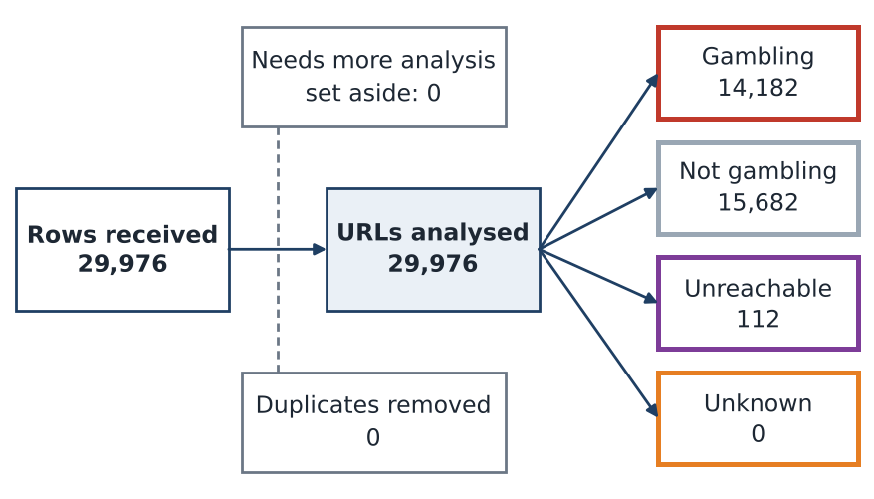
Stage | URLs
Rows received | 29,976
Set aside as Needs more analysis | 0
Duplicates removed | 0
URLs analysed | 29,976

The URLs analysed split into 14,182 gambling, 15,682 not gambling, 112 unreachable and 0 unknown.

URLs analyzed per day
Daily count of URLs analysed across the evaluation period. Each point is one calendar day and shaded bands mark gaps and peaks.
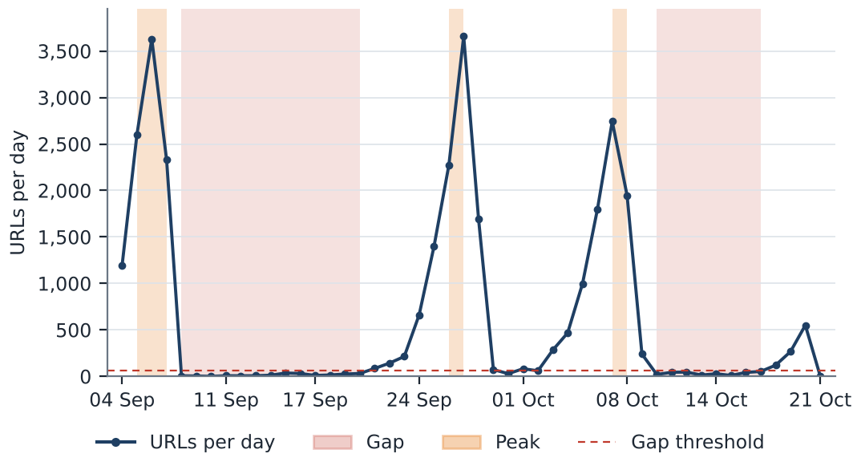
Gap threshold: 62.5 URLs a day, which is 10% of the mean of 624.5 URLs a day; 24 days fall below it. Gaps: 8 September to 20 September 2026 (13 days, 190 URLs), cause not recorded; 10 October to 17 October 2026 (8 days, 257 URLs), cause not recorded. Peaks: 5 September to 7 September 2026 (3 days, 8,558 URLs), cause not recorded; 26 September to 27 September 2026 (2 days, 5,930 URLs), cause not recorded; 7 October to 8 October 2026 (2 days, 4,689 URLs), cause not recorded. A URL is dated by the last time its record changed, which is not necessarily the date it was first collected.

Status distribution
Share of the estate by classification status. Each segment is one status and the table beneath carries the counts.
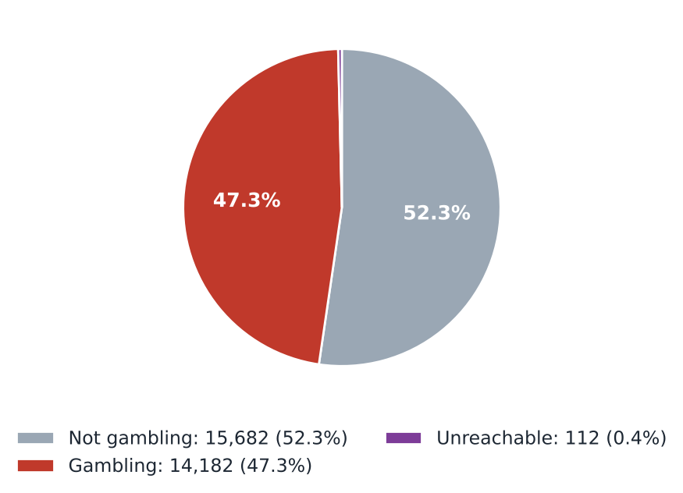
Status | URLs | % of URLs
Not gambling | 15,682 | 52.3%
Gambling | 14,182 | 47.3%
Unreachable | 112 | 0.4%
Total | 29,976 | 100.0%

0 URLs classified as Needs more analysis are set aside before this count and appear in From collection to analysis.

Unreachable URLs by cause
Cause | URLs | % of unreachable
Analysis error: SICPADetect could not complete its analysis | 112 | 100.0%
Total | 112 | 100.0%

Collection network: not recorded. The export carries no fetch diagnostics, so no other cause can be assigned.

Top 10 URL suffixes
The ten most common URL suffixes in the estate. Bar length is the total count and the table separates the gambling share.
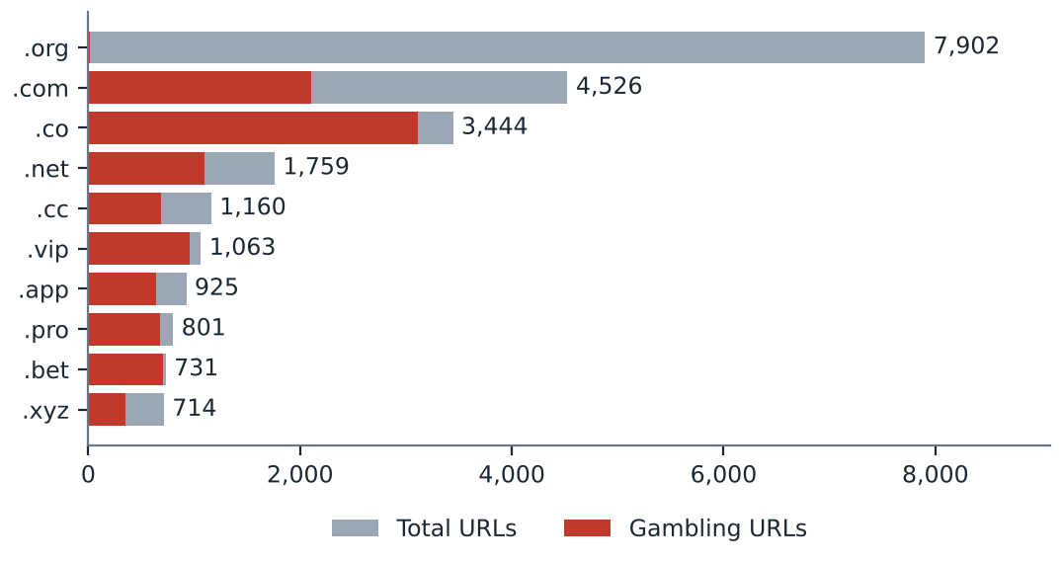
Suffix | Total URLs | % of all URLs | Gambling URLs | % gambling
.org | 7,902 | 26.4% | 19 | 0.2%
.com | 4,526 | 15.1% | 2,106 | 46.5%
.co | 3,444 | 11.5% | 3,116 | 90.5%
.net | 1,759 | 5.9% | 1,102 | 62.6%
.cc | 1,160 | 3.9% | 683 | 58.9%
.vip | 1,063 | 3.5% | 955 | 89.8%
.app | 925 | 3.1% | 643 | 69.5%
.pro | 801 | 2.7% | 682 | 85.1%
.bet | 731 | 2.4% | 703 | 96.2%
.xyz | 714 | 2.4% | 348 | 48.7%

6,951 URLs sit outside the top 10, on 209 other suffixes.

Pages showing blocking indicators
URL | Brand cluster | Indicator | Phrase found | Excerpt
e.dra.gov.pk | — | Other | regulatory authority | contains the text 'dra.gov.pk', indicating it is related to the Drug Regulatory…
fawts.glass-safe.com | — | Other | illegal content | ebsite contains adult content and a warning message about potentially illegal…
hn94.cc | — | Other | illegal content | website contains adult content and a pop-up warning about potentially illegal…
nh83.cc | — | Other | illegal content | ebsite contains adult content and a warning message about potentially illegal…
nh85.cc | — | Other | illegal content | ontains adult content and prompts a warning message about potentially illegal…
tn93.cc | — | Other | illegal content | ebsite contains adult content and a warning message about potentially illegal…
vu98.cc | — | Other | illegal content | ebsite contains adult content and a warning message about potentially illegal…

The model's description of each page is scanned for fixed block page phrases in English and Thai, such as court order and blocked site notices, and a phrase naming a Thai court, MDES or a Thai ISP counts as a Thai enforcement indicator. 0 pages carry Thai authority indicators and 7 pages carry other indicators. Collection network: not recorded, so these counts may understate enforcement.

Subcategories

Gambling sites by product subcategory
Gambling sites by product subcategory. Bar length is the site count and each label carries the count and the share of gambling rows.
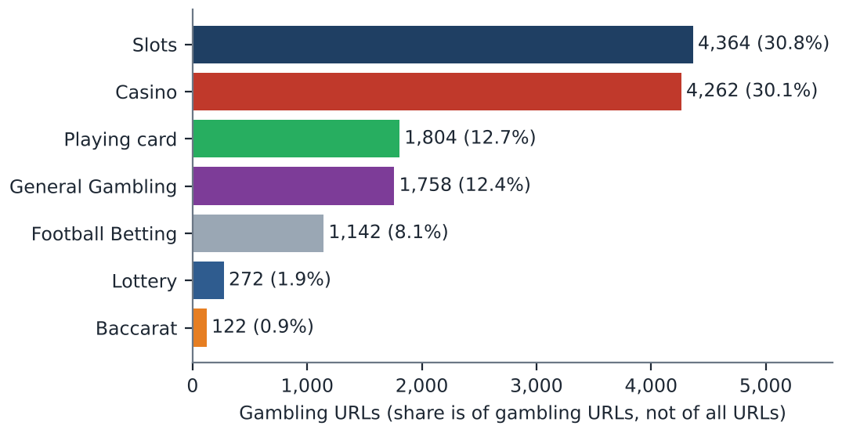
Shares are of 14,182 gambling URLs. 458 URLs have no reasoning recorded and carry the Unspecified subcategory, which is not a product subcategory and is shown in the subcategory table.

Assignment method by subcategory
How each subcategory was assigned. Solid fill is a lexicon keyword match and the lighter fill is reasoning inference.
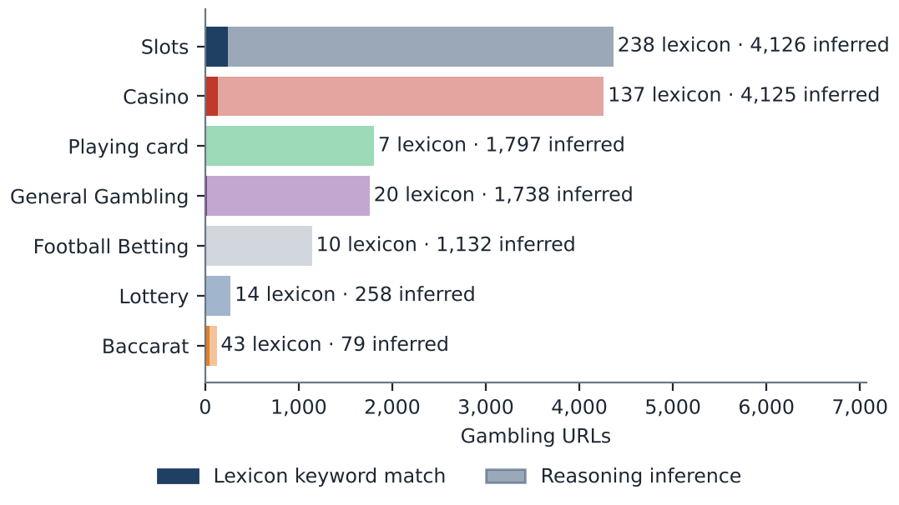
What a lexicon match means
A site is assigned to a subcategory by lexicon match when a word or phrase from the gambling keyword lexicon appears in what was recorded about the site and belongs to the product category assigned. The record covers the model's description, extracted keywords, remarks, URL and domain. A site whose description contains สล็อต is assigned to Slots by lexicon match. The lexicon is the SICPADetect Thai gambling keyword lexicon at the version on the title page, with 286 keywords in 14 categories, mostly in Thai script. Seven categories decide the subcategory and seven are reported as signal tags. A lexicon match rests on a word that can be pointed to, so it can be checked. An inferred assignment rests on the model's own description and carries lower confidence.
Inferred share of gambling URLs: 96.7%. General Gambling share: 12.4%. With an inferred share above 30% the lexicon has poor coverage of this dataset, and subcategory figures are indicative only.

Subcategory table
Subcategory | Gambling URLs | % of gambling | Keyword assigned | Inferred | Distinct clusters
Slots | 4,364 | 30.8% | 238 | 4,126 | 1,036
Casino | 4,262 | 30.1% | 137 | 4,125 | 1,282
Playing card | 1,804 | 12.7% | 7 | 1,797 | 217
General Gambling | 1,758 | 12.4% | 20 | 1,738 | 711
Football Betting | 1,142 | 8.1% | 10 | 1,132 | 476
Lottery | 272 | 1.9% | 14 | 258 | 87
Baccarat | 122 | 0.9% | 43 | 79 | 92
Unspecified | 458 | 3.2% | 0 | 458 | 420
Total | 14,182 | 100.0% | 469 | 13,713 | 2,809

35 URLs in General Gambling are listing, review or ranking sites, pending jointly agreed labelling rules. The total row counts each cluster once.

Heat map: Keyword × subcategory
Matched keywords against product subcategory. Each cell is the number of gambling sites carrying that keyword in that subcategory.
 |  | Slots | Casino | General Gambling | Football Betting | Baccarat | Lottery | Playing card
 | VIP | 887 | 490 | 283 | 117 | 12 | 21 | 43
 | BET | 340 | 441 | 206 | 148 | 18 | 22 | 28
 | WIN | 295 | 160 | 120 | 17 | 2 | 26 | 12
 | สมัครสมาชิก | 155 | 81 | 61 | 14 | 13 | 48 | 7
 | สล็อต | 238 | 70 | 0 | 4 | 32 | 2 | 6
 | WALLET | 65 | 54 | 41 | 13 | 6 | 1 | 1
 | Wallet | 65 | 54 | 41 | 13 | 6 | 1 | 1
 | คาสิโน | 31 | 137 | 0 | 2 | 7 | 1 | 0
 | คาสิโน | 31 | 137 | 0 | 2 | 7 | 1 | 0
 | PRAGMATIC | 129 | 29 | 0 | 4 | 9 | 0 | 0
 | คาสิโนออนไลน์ | 4 | 95 | 0 | 2 | 0 | 0 | 0
 | คาสิโนออนไลน์ | 4 | 95 | 0 | 2 | 0 | 0 | 0
 | สล็อตออนไลน์ | 91 | 6 | 0 | 1 | 0 | 0 | 0
 | เกมสล็อต | 82 | 13 | 0 | 0 | 0 | 0 | 0
 | บาคาร่า | 20 | 13 | 0 | 2 | 43 | 1 | 6
 | Affiliate | 37 | 18 | 9 | 2 | 2 | 1 | 0
 | JILI | 38 | 10 | 3 | 14 | 0 | 0 | 0
 | เล่นสล็อต | 54 | 1 | 0 | 1 | 0 | 0 | 0
 | เดิมพัน | 7 | 10 | 16 | 1 | 2 | 0 | 0
 | RTP | 19 | 4 | 5 | 1 | 1 | 1 | 0
 | พนัน | 10 | 10 | 4 | 1 | 2 | 0 | 0
 | JDB | 13 | 12 | 1 | 0 | 0 | 0 | 0
 | AUTO | 15 | 4 | 5 | 1 | 0 | 0 | 0
 | SEXY | 6 | 7 | 1 | 2 | 4 | 0 | 0
 | เครดิตฟรี | 6 | 5 | 6 | 0 | 3 | 0 | 0

Scale ██ 1 ██ 887 Bordered empty cell = 0
■ Abbreviations ■ Marketing & Acquisition ■ Slots ■ Deposit & Withdrawal ■ Casino ■ General Gambling ■ Baccarat ■ Affiliate & Agent ■ Promotions
The coloured strip gives the Appendix A category of each keyword, so keywords shared by two categories appear on two rows. Rows are the 25 most frequently matched keywords.

Heat map: Signal tag × subcategory
Signal tags against product subcategory. Each cell is the number of gambling sites carrying that tag in that subcategory.
 | Slots | Casino | General Gambling | Football Betting | Lottery | Playing card | Baccarat
Abbreviations | 1,614 | 1,127 | 605 | 296 | 64 | 77 | 48
Marketing & Acquisition | 171 | 95 | 64 | 18 | 48 | 8 | 16
Deposit & Withdrawal | 68 | 55 | 42 | 13 | 2 | 1 | 6
Affiliate & Agent | 41 | 23 | 50 | 5 | 2 | 1 | 2
Promotions | 9 | 10 | 12 | 4 | 0 | 0 | 3
Hashtags | 0 | 0 | 0 | 0 | 0 | 0 | 0
Vague-Evasion Terms | 0 | 0 | 0 | 0 | 0 | 0 | 0

Scale ██ 1 ██ 1,614 Bordered empty cell = 0

Brands and clustering

What brand clusters are
What a cluster is
A brand cluster is a group of URLs, and the domains they sit on, judged to belong to the same gambling brand or operator. A domain joins a cluster in one of four ways, in order of strength. The crawler followed a redirect or generated a matching variant name. The domain matches a brand in an external ranking of gambling domains for Thailand, listed in Annex 2. Names reduce to the same stem once market tags, version numbers and suffixes are removed, so ufabet168th.com and ufabet-vip.net both reduce to ufabet, while jun88 and jun68 stay apart. Or stems are near identical in spelling. A domain matching nothing is a singleton. All hostnames on one registered domain share a cluster.
Why clusters matter
Operators rarely run a single site. They register many domains, rotate top level domains and move players between them, so when one address is blocked another takes its place. Counting URLs overstates how many operators exist. Acting on a cluster reaches every domain in it, where acting on one URL leaves the rest of the brand running. Clusters are an analytical grouping based on names, crawler links and an external domain ranking, not a legal finding about ownership, and the Possible operator linkage table is indicative only.

2,809  Distinct clusters |  | 990  Clusters with ≥ 2 domains |  | 1,819  Singletons (one domain each) |  | 46  Clusters to cover half of gambling URLs

Domains with the most URLs
The largest domain carries 20.3% of gambling URLs
How to read this table
The table lists the registered domains that carry the most gambling URLs in this sample. Each row gives the domain, its URLs, their share of gambling URLs, its brand cluster, the first and last day SICPADetect recorded it, and whether it is a host farm. Domains are listed largest first. A domain carrying 20 or more gambling URLs is a host farm, meaning many hostnames under one registered name. Many hostnames usually come from a single setting that makes every name under the domain lead to the same site, so they may not be separate pages. Action against the domain reaches every hostname at once, where blocking hostname by hostname never catches up.
Domain | URLs | % of gambling URLs | Brand cluster | First seen | Last seen | Host farm
49m.co | 2,885 | 20.3% | 49m | 2026-10-03 | 2026-10-09 | Yes
a3game.vip | 502 | 3.5% | a3game | 2026-09-23 | 2026-09-28 | Yes
hayy.net | 407 | 2.9% | hay | 2026-09-04 | 2026-09-07 | Yes
k03.cc | 272 | 1.9% | k03 | 2026-09-04 | 2026-09-07 | Yes
paes.dev | 269 | 1.9% | paes | 2026-09-24 | 2026-09-28 | Yes
paegs.dev | 176 | 1.2% | paegs | 2026-09-24 | 2026-09-28 | Yes
o8.game | 73 | 0.5% | o8 | 2026-09-04 | 2026-09-07 | Yes
abbet.xyz | 70 | 0.5% | abbet | 2026-10-18 | 2026-10-20 | Yes
jun888.top | 67 | 0.5% | jun8 | 2026-09-24 | 2026-09-28 | Yes
7ok.bet | 66 | 0.5% | 7ok | 2026-09-04 | 2026-09-07 | Yes
l8.game | 57 | 0.4% | l8 | 2026-09-04 | 2026-09-07 | Yes
jn86.cc | 40 | 0.3% | jn86 | 2026-09-24 | 2026-09-28 | Yes
oo7.vip | 37 | 0.3% | oo7 | 2026-09-04 | 2026-09-07 | Yes
mwbet.info | 27 | 0.2% | mwbet | 2026-10-18 | 2026-10-20 | Yes
ju088.com | 23 | 0.2% | ju088 | 2026-09-25 | 2026-09-28 | Yes

15 host farms carry 4,971 gambling URLs, 35.1% of gambling URLs. 722 domains cover half of gambling URLs. Fetch evidence for the host farms is not recorded.

Top 15 brand clusters by URL count
The fifteen largest brand clusters. Bar length is the number of URLs in the cluster.
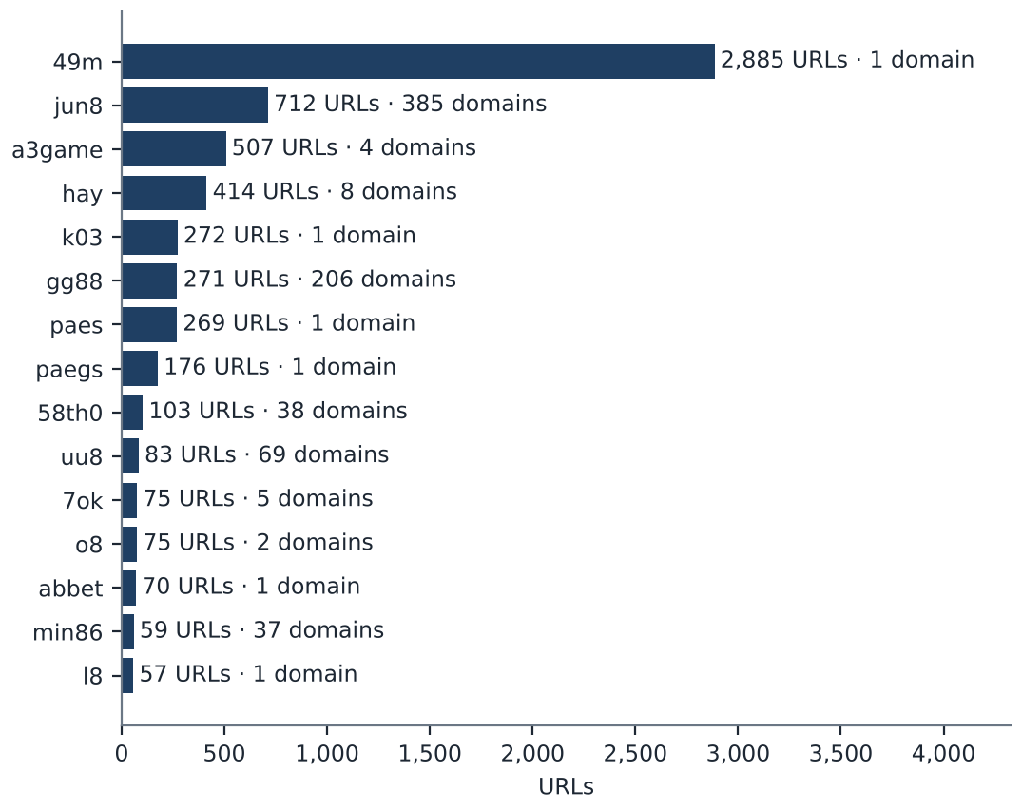

Heat map: Brand cluster × subcategory
Brand clusters against product subcategory. Each cell is the number of URLs a cluster holds in that subcategory.
 | Slots | Casino | Playing card | General Gambling | Football Betting | Lottery | Baccarat
49m | 748 | 492 | 1,447 | 198 | 0 | 0 | 0
jun8 | 142 | 335 | 33 | 79 | 49 | 67 | 7
a3game | 489 | 3 | 0 | 10 | 0 | 5 | 0
hay | 119 | 279 | 0 | 11 | 5 | 0 | 0
k03 | 0 | 0 | 0 | 27 | 245 | 0 | 0
gg88 | 62 | 139 | 4 | 37 | 26 | 0 | 3
paes | 112 | 107 | 0 | 32 | 18 | 0 | 0
paegs | 76 | 81 | 0 | 12 | 7 | 0 | 0
58th0 | 103 | 0 | 0 | 0 | 0 | 0 | 0
uu8 | 27 | 30 | 1 | 9 | 11 | 3 | 2
7ok | 69 | 2 | 0 | 3 | 0 | 1 | 0
o8 | 52 | 5 | 0 | 18 | 0 | 0 | 0
abbet | 6 | 64 | 0 | 0 | 0 | 0 | 0
min86 | 6 | 9 | 1 | 1 | 41 | 1 | 0
l8 | 12 | 1 | 0 | 44 | 0 | 0 | 0
lotto432b | 3 | 2 | 0 | 6 | 0 | 44 | 0
mwbet | 6 | 40 | 0 | 0 | 5 | 0 | 0
bohocasino | 16 | 31 | 0 | 0 | 0 | 0 | 0
jin87 | 15 | 10 | 8 | 12 | 1 | 1 | 0
oo7 | 12 | 9 | 0 | 26 | 0 | 0 | 0

Scale ██ 1 ██ 1,447 Bordered empty cell = 0
Rows are the 20 largest clusters by URL count. URLs with no reasoning recorded carry the Unspecified subcategory and fall outside the seven columns.

Cluster expansion: jun8
A brand cluster and the registered domains that belong to it. Edge style records why each domain joined the cluster.
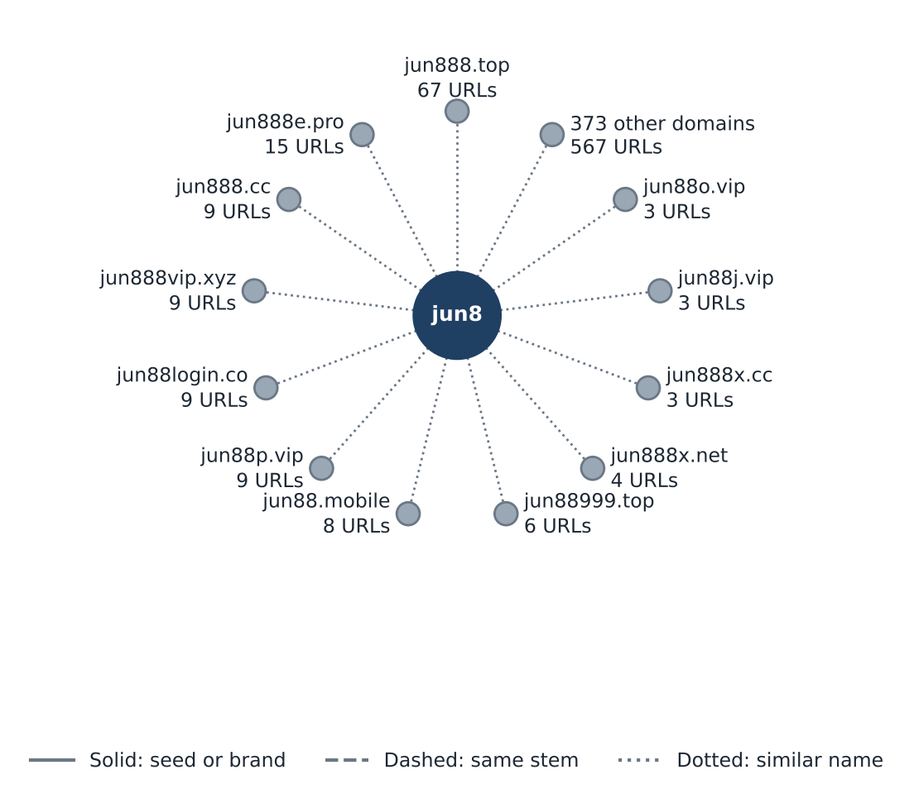
The largest cluster, 49m, sits on 1 domain, so this card shows jun8, the largest cluster holding at least 3 domains. It holds 385 domains; the twelve with the most URLs are shown and the rest are grouped in one node.

Clusters spanning multiple subcategories
How to read this table
The table lists brand clusters whose member sites fall into two or more product subcategories, for example one brand running both slots and football betting sites. Each row gives the cluster, its URLs, each subcategory present with its site count, and the domain suffixes it uses. Subcategories are assigned to each site, not to the cluster, so a cluster qualifies when at least two of its sites carry different product subcategories. Where General Gambling appears beside a specific product, a product could not be evidenced for those sites. Definitions are in Annex 1. These brands offer several products under one name, so action against the brand reaches all of them.
Cluster | URLs | Subcategories | Suffixes
49m | 2,885 | Playing card 1,447 · Slots 748 · Casino 492 · General Gambling 198 | .co
jun8 | 712 | Casino 335 · Slots 142 · General Gambling 79 · Lottery 67 · Football Betting 49 · Playing card 33 · Baccarat 7 | .app · .bet · .black · .buzz · .casino · .cc · +29 more
a3game | 507 | Slots 489 · General Gambling 10 · Lottery 5 · Casino 3 | .app · .click · .net · .vip
hay | 414 | Casino 279 · Slots 119 · General Gambling 11 · Football Betting 5 | .app · .bet · .club · .co · .net · .pro · +2 more
k03 | 272 | Football Betting 245 · General Gambling 27 | .cc
gg88 | 271 | Casino 139 · Slots 62 · General Gambling 37 · Football Betting 26 · Playing card 4 · Baccarat 3 | .app · .bet · .casino · .cc · .click · .club · +13 more
paes | 269 | Slots 112 · Casino 107 · General Gambling 32 · Football Betting 18 | .dev
paegs | 176 | Casino 81 · Slots 76 · General Gambling 12 · Football Betting 7 | .dev
uu8 | 83 | Casino 30 · Slots 27 · Football Betting 11 · General Gambling 9 · Lottery 3 · Baccarat 2 · Playing card 1 | .app · .bet · .buzz · .casino · .cc · .click · +16 more
7ok | 75 | Slots 69 · General Gambling 3 · Casino 2 · Lottery 1 | .bet · .club · .io · .live · .pro
o8 | 75 | Slots 52 · General Gambling 18 · Casino 5 | .game · .live
abbet | 70 | Casino 64 · Slots 6 | .xyz
min86 | 59 | Football Betting 41 · Casino 9 · Slots 6 · Lottery 1 · General Gambling 1 · Playing card 1 | .academy · .actor · .app · .art · .auction · .cafe · +23 more
l8 | 57 | General Gambling 44 · Slots 12 · Casino 1 | .game
lotto432b | 55 | Lottery 44 · General Gambling 6 · Slots 3 · Casino 2 | .bet · .click · .com · .info · .live · .net · +1 more

The 15 largest of 851 qualifying clusters are listed; 836 fall outside the table.

Clusters rotating top level domains
How to read this table
The table lists brand clusters whose member domains use two or more top level domains, the ending of the address, such as .com, .net and .co. Each line gives the cluster, one suffix it uses, how many member domains use it, and the first and last day SICPADetect recorded them. A two part ending such as .co.th counts as one suffix, and a cluster qualifies when its members use at least two different suffixes. Registering one name under several endings keeps the brand reachable when one domain is blocked, because a player only changes the ending. Not every case is evasion; some operators register several endings to protect their name or serve different markets.
Cluster | Suffix | Domains | First seen | Last seen
jun8 | .com | 159 | 2026-09-22 | 2026-10-19
 | .net | 27 | 2026-09-22 | 2026-09-28
 | .pro | 16 | 2026-09-22 | 2026-09-28
 | .app | 15 | 2026-09-22 | 2026-09-27
 | +31 more | 168 | 2026-09-21 | 2026-09-28
gg88 | .app | 34 | 2026-09-04 | 2026-09-07
 | .net | 34 | 2026-09-04 | 2026-09-07
 | .pro | 30 | 2026-09-04 | 2026-09-07
 | .bet | 21 | 2026-09-04 | 2026-09-07
 | +15 more | 87 | 2026-09-04 | 2026-09-07
uu8 | .com | 9 | 2026-09-26 | 2026-09-27
 | .net | 8 | 2026-09-26 | 2026-09-28
 | .pro | 7 | 2026-09-25 | 2026-09-27
 | .app | 6 | 2026-09-27 | 2026-09-28
 | +18 more | 39 | 2026-09-25 | 2026-09-28
lotto432b | .com | 29 | 2026-09-04 | 2026-09-07
 | .info | 4 | 2026-09-04 | 2026-09-05
 | .click | 3 | 2026-09-04 | 2026-09-06
 | .bet | 1 | 2026-09-04 | 2026-09-05
 | +3 more | 3 | 2026-09-04 | 2026-09-06
58th0 | .com | 37 | 2026-10-02 | 2026-10-07
 | .pro | 1 | 2026-10-07 | 2026-10-07

The 5 clusters with the most domains are listed, up to 4 suffixes each; 914 further clusters rotate suffixes and are not shown. 36 clusters gained domains first recorded at least 7 days after the cluster's first appearance, 111 domains in all. Dates are when SICPADetect recorded each domain, not when it was registered, blocked or replaced. The period of 48 days is under 60 days, so it is too short to confirm rotation over time.

Possible operator linkage
Indicative — not a clustering decision
How to read this table
The table lists pairs of differently named brand clusters that use an unusually similar set of signal keywords, the lexicon words describing how a site promotes itself, takes payment or avoids blocking. Each row gives the clusters, shared keywords and score. The score is the number of shared signal keywords divided by the number of distinct signal keywords either cluster uses, from 0 for nothing in common to 1 for identical sets. Common words and abbreviations known to match by accident are left out first. Only pairs scoring 0.60 or more with at least three shared keywords are listed. A close match can point to one operator running two brands, or to unrelated operators using the same affiliate template, so the clusters are never merged on this score.
Cluster A | Cluster B | Shared keywords | Jaccard
7ok | mega167 | pragmatic · rtp · wallet · win · สมัครสมาชิก | 1.00
jun77 | jub789 | pragmatic · wallet · win · สมัครสมาชิก | 1.00
gu88 | n78 | pragmatic · wallet · สมัครสมาชิก | 1.00
kk2 | n83 | jili · pragmatic · สมัครสมาชิก | 1.00
kk2 | nextspin | jili · pragmatic · สมัครสมาชิก | 1.00
ko9 | ln88 | wallet · win · สมัครสมาชิก | 1.00
ko9 | ub8 | wallet · win · สมัครสมาชิก | 1.00
ms88 | gu88 | pragmatic · wallet · สมัครสมาชิก | 1.00
ms88 | n78 | pragmatic · wallet · สมัครสมาชิก | 1.00
mu8 | hub88 | pragmatic · wallet · win | 1.00
mun8 | vrtex | auto · wallet · สมัครสมาชิก | 1.00
n83 | nextspin | jili · pragmatic · สมัครสมาชิก | 1.00
ruay | m98login | win · จ่ายจริง · สมัครสมาชิก | 1.00
ub8 | ln88 | wallet · win · สมัครสมาชิก | 1.00
uu8 | hub88 | pragmatic · wallet · win | 1.00

The 15 highest scoring of 130 qualifying pairs are listed.

Naming conventions
• Recurring tokens: the hostnames in the 20 largest clusters most often contain m. (3,511), login (2,170) and support (1,928), which is evidence of a templated naming scheme.
• Top level domain switching: the names in those clusters span several suffixes, led by .co (2,941), .vip (598), .net (524), .com (477), so operators rotate top level domains.
• The gambling URLs sit on 6,827 domains across 2,809 brand clusters.

14,182  Direct URLs |  | 0  Redirect URLs |  | 0  Variant URLs

Structure: direct → redirect → variant
The three figures above sum to 14,182 gambling URLs. Variant verification: the export records 0 variant rows, so none can be verified. The export carries no HTTP status or final URL, so no variant is shown to be a live site the classifier read.

Ranking

Gambling ranking
How to read this table
The table lists the gambling sites in this sample that carry a rank in the SICPADetect feed, best ranked first, up to fifteen. Each row gives the rank, domain, brand cluster, subcategory and where SICPADetect found the site. The rank is the position recorded in the source feed and reflects search visibility: the lower the number, the more visible the site. It is not the external ranking that anchors brand clusters in Annex 2, and unlike the 10 most prominent gambling sites in Thailand table it is not filtered for a Thai audience or limited to one row per domain. The highest ranked sites are the ones users are most likely to reach. Rank measures visibility only, not harm, reach or revenue.
Rank | Domain | Brand cluster | Subcategory | Source
93,155 | metal--vip.com | metal | Slots | Not recorded
214,132 | allslotwallet.online | allslotwallet | Slots | Not recorded
221,001 | suriyathai.net | suriya | General Gambling | Not recorded
252,597 | u11k.pro | u11 | Football Betting | Not recorded
254,190 | anthonyhead.com | anthonyhead | Slots | Not recorded
254,190 | kohochocolates.com | kohochocolates | Slots | Not recorded
293,057 | bifestathailand.com | bifestathailand | Slots | Not recorded
293,057 | lgbtnewsnow.org | lgbtnewsnow | Slots | Not recorded
303,254 | jun88wf.com | jun8 | Casino | Not recorded
397,330 | jun88wa.com | jun8 | Casino | Not recorded
466,858 | jun88wc.com | jun8 | Casino | Not recorded
514,501 | sacasino.ad | sacasino | Baccarat | Not recorded
517,141 | jun88.info | jun8 | Casino | Not recorded
517,141 | slavinaslot.top | slavinaslot | Casino | Not recorded
547,370 | 99ok.vip | 99ok | Lottery | Not recorded

Ranked brand clusters
How to read this table
The table lists brand clusters that contain at least one gambling site carrying a rank in the SICPADetect feed. Each row gives the cluster, its number of URLs, the best rank among its members, how many members are ranked and its subcategories. One ranked gambling member is enough for a cluster to qualify. Clusters are ordered by their best rank, so the most visible brands come first, and the URL count shows how large each operation is. A brand that is both highly visible and large is where action reaches the most users and the most addresses at once. Rank measures visibility only, not harm, reach or revenue, and no combined score is calculated.
Cluster | URLs | Best rank | Ranked URLs | Subcategories
metal | 2 | 93,155 | 1 | Slots 2
allslotwallet | 1 | 214,132 | 1 | Slots 1
suriya | 1 | 221,001 | 1 | General Gambling 1
u11 | 33 | 252,597 | 1 | Casino 12 · Football Betting 9 · Slots 9 · General Gambling 3
anthonyhead | 1 | 254,190 | 1 | Slots 1
kohochocolates | 1 | 254,190 | 1 | Slots 1
bifestathailand | 1 | 293,057 | 1 | Slots 1
lgbtnewsnow | 1 | 293,057 | 1 | Slots 1
jun8 | 712 | 303,254 | 31 | Casino 335 · Slots 142 · General Gambling 79 · Lottery 67 · Football Betting 49 · Playing card 33 · Baccarat 7
sacasino | 1 | 514,501 | 1 | Baccarat 1
slavinaslot | 2 | 517,141 | 1 | Casino 2
99ok | 17 | 547,370 | 2 | Slots 10 · Casino 3 · General Gambling 2 · Lottery 2
gg88 | 271 | 558,790 | 16 | Casino 139 · Slots 62 · General Gambling 37 · Football Betting 26 · Playing card 4 · Baccarat 3
betwgb | 1 | 582,212 | 1 | Football Betting 1
hh9 | 32 | 632,178 | 11 | General Gambling 18 · Football Betting 8 · Slots 3 · Casino 3

The 15 best ranked of 218 qualifying clusters are listed; 203 fall outside the table.

Key insights

Scale of the analysis
The analysis covers 29,976 distinct URLs over 48 days, from 2026-09-04 to 2026-10-21. Of these, 14,182 are gambling, 15,682 are not gambling and 112 are unreachable. 0 further URLs were set aside as Needs more analysis. Daily volume stayed below the gap threshold for two stretches, 8 September to 20 September 2026 (13 days, 190 URLs) and 10 October to 17 October 2026 (8 days, 257 URLs). The cause of each is not recorded.
The sample is large enough to reason about patterns, not isolated cases.

What is being offered
Slots (30.8%), Casino (30.1%) and Playing card (12.7%) are the three largest product subcategories, with 4,364, 4,262 and 1,804 URLs. 12.4% of gambling URLs are confirmed as gambling without an evidenced product type, and 96.7% of subcategory assignments rest on inference rather than a lexicon match. 207 of the 286 lexicon keywords never matched. The lexicon has poor coverage of this dataset, so subcategory figures are indicative only.
Slots is the largest product type, but at 30.8% of gambling URLs the estate is spread across product types rather than concentrated.

Brand clustering
2,809 clusters cover 14,182 gambling URLs on 6,827 domains. 990 hold more than one domain. 46 clusters and 722 domains cover half the estate. The largest cluster, 49m, holds 2,885 URLs (20.3% of gambling URLs) on 1 domain, across 4 subcategories. The largest domain, 49m.co, holds 2,885 URLs (20.3%). 15 host farms carry 35.1% of gambling URLs.
One registered domain carries 20.3% of the estate through many hostnames, so action at domain level reaches all of them at once, where URL by URL blocking would need one entry per hostname. Beyond it, the estate is diffuse: 46 clusters and 722 domains are needed to cover half of the gambling URLs.

How the estate is grown and marketed
The export records 0 crawler identified variants, 0 URLs behind redirect chains and 14,182 URLs reached directly, so no redirect source can be named and variant verification is not recorded. 919 clusters rotate across more than one top level domain. The two most common signal tags are Abbreviations (27.1% of gambling URLs) and Marketing & Acquisition (3.0%). VIP and BET are flagged as probable false positives and drive most of the Abbreviations tag.
Top level domain rotation lets a brand keep one recognisable name while the address behind it changes. The export records no redirects, so redirect propagation cannot be assessed.

Enforcement position
0 pages show Thai enforcement indicators (Thai court orders, MDES or Thai ISP block pages) and 7 pages show other block pages. The model's description of each page is scanned for fixed block page phrases in English and Thai, such as court order and blocked site notices, and a phrase naming a Thai court, MDES or a Thai ISP counts as a Thai enforcement indicator. Every page found is listed in the Pages showing blocking indicators table. The collection network is not recorded.
Only Thai authority indicators are described as enforcement in Thailand, and none is present, so this set is a candidate for a first enforcement pass, prioritised by domain and cluster rather than by URL. The collection network is not recorded, so the enforcement count may be understated.

Annexes

Annex 1 — Subcategory definitions
Each site classified as gambling is assigned one of the seven product subcategories below, according to what it offers. General Gambling applies only when a site is confirmed as gambling but no specific product can be evidenced. A subcategory is assigned by lexicon match when one of the keywords listed under it appears in what was recorded about the site, and by inference from the model's description when none is found. How a site markets or operates itself is recorded separately as signal tags and does not decide its subcategory. The keywords under each subcategory are its complete set in the lexicon, shown in their original script. A few keywords appear under both a specific product and General Gambling; they always count toward the specific product.
Football Betting · 21 keywords
Betting on the outcome of football and other sports matches, including match odds, single match and accumulator ("step") bets, and tipping or match analysis offered to bettors.
พนันบอล · | พนันบอลออนไลน์ · | แทงบอล ·
แทงบอลออนไลน์ · | พนันฟุตบอล · | แทงฟุตบอล ·
สปอร์ตบุ๊ค · | บอลออนไลน์ · | ราคาบอล ·
บอลสเต็ป · | บอลเดี่ยว · | สเต็ปบอล ·
แทงบอลชุด · | ทีเด็ดบอล · | วิเคราะห์บอล ·
โต๊ะบอล · | ล้มโต๊ะบอล · | เดิมพันฟุตบอล ·
เว็บแทงบอล · | บอลสเต็ปแม่น · | พนันกีฬา

Slots · 32 keywords
Online slot machine games, including sites that promote particular slot providers, high payout rates or slots played directly without an agent.
สล็อต · | สล็อตออนไลน์ · | เกมสล็อต ·
เกมสล็อตออนไลน์ · | สล็อตแตกง่าย · | สล็อตแตกบ่อย ·
สล็อตแตกหนัก · | สล็อตแตกจริง · | สล็อตใหม่ ·
สล็อตเว็บตรง · | สล็อตวอเลท · | เล่นสล็อต ·
สล็อตเครดิตฟรี · | สล็อตแตกทุกวัน · | สล็อตมาแรง ·
สล็อตยอดนิยม · | สล็อตค่ายดัง · | สล็อตไม่ผ่านเอเย่นต์ ·
สล็อต pg · | สล็อต joker · | สล็อต jili ·
สล็อต pragmatic · | สล็อต xo · | สล็อต auto ·
สล็อตแตกไว · | สล็อตฝากถอนออโต้ · | สล็อตฝากไม่มีขั้นต่ำ ·
สล็อตโบนัสแตกหนัก · | สล็อตสายฟรี · | สล็อตปั่นง่าย ·
สล็อต RTP สูง · | สล็อตคืนกำไร

Casino · 14 keywords
Online and live casino table and wheel games other than baccarat and card games, such as roulette, dragon tiger, hi lo dice and wheel spin games.
คาสิโน · | คาสิโนออนไลน์ · | คาสิโนสด ·
คาสิโนสดออนไลน์ · | เสือมังกร · | รูเล็ต ·
รูเล็ตออนไลน์ · | รูเล๊ต · | ไฮโล ·
ไฮโลออนไลน์ · | ไฮโลไทย · | หมุนวงล้อโบนันซ่ารายวัน ·
หมุนวงล้อโบนันซ่า · | ปั่นแปะ

Lottery · 20 keywords
Betting on lottery and number draws, including the Thai government and underground lotteries, Lao, Hanoi and Malaysian draws, fast draw yi ki lotteries and lotteries settled on stock index figures.
หวยออนไลน์ · | แทงหวย · | ซื้อหวยออนไลน์ ·
หวยยี่กี · | หวยฮานอย · | หวยลาว ·
หวยรัฐบาล · | หวยมาเลย์ · | หวยจับยี่กี ·
จับยี่กี VIP · | หวยใต้ดิน · | หวยออนไลน์จ่ายจริง ·
เว็บหวย · | เว็บแทงหวย · | Huay ·
Huaylan · | หวยหุ้น · | หวยหุ้นไทย ·
หวยหุ้นต่างประเทศ · | หวยชุด

Playing card · 12 keywords
Card games other than baccarat, such as pok deng, blackjack, poker and Thai two card and three card games.
ไพ่ · | ไพ่ออนไลน์ · | ไพ่ ออนไลน์ ·
ไพ่ป๊อก · | ป๊อกเด้ง · | ป๊อกเด้งออนไลน์ ·
แบล็คแจ็ค · | แบล็คแจ็คออนไลน์ · | โป๊กเกอร์ ·
โป๊กเกอร์ออนไลน์ · | ตีไก่สองใบ · | ตีไก่สามใบ

Baccarat · 11 keywords
Baccarat in any form, live or online, including demo tables and betting formula or prediction services sold for baccarat.
บาคารา · | บาคาร่า · | บาคาร่าออนไลน์ ·
ไพ่บาคาร่า · | บาคาร่าสด · | โต๊ะบาคาร่า ·
บาคาร่าทดลอง · | บาคาร่าฟรี · | บาคาร่าระบบ AI ·
บาคาร่าขั้นเทพ · | สูตรบาคาร่า

General Gambling · 22 keywords
Sites confirmed as gambling whose recorded content uses only generic gambling or betting vocabulary, so no specific product can be evidenced. Assigned only when no other subcategory applies.
พนัน · | การพนัน · | พนันออนไลน์ ·
เว็บพนัน · | เว็บเดิมพัน · | เดิมพัน ·
เดิมพันออนไลน์ · | คาสิโน · | คาสิโนออนไลน์ ·
บ่อน · | บ่อนออนไลน์ · | เว็บเกมพนัน ·
เกมพนัน · | เว็บเสี่ยงโชค · | เสี่ยงโชค ·
เว็บเกมเงิน · | เล่นเงินจริง · | เกมได้เงินจริง ·
เดิมพันกีฬา · | พนันกีฬา · | พนันบอล ·
แทงบอล

The keyword lists are those of the SICPADetect lexicon at the version shown on the title page.

Annex 2 — Ranked domains used for clustering
Ranking of gambling domains for Thailand · external data provider · 159 of 200 ranked domains applied
Brand clusters are anchored to a ranking of gambling domains for Thailand supplied by an external data provider. When a URL in this sample matches a ranked brand, it is grouped under that brand's name instead of the name it happens to carry. The ranking is an analytical reference. A place in it is not evidence of ownership, harm or reach, and a match never adds a site to the gambling set.
Rank | Ranked domain | Brand | Match basis | URLs matched | Cluster
1 | 22onlinegames.com | 22onlinegames | Brand name and extended names | 1 | 22onlinegames
3 | debet.tv | debet | Brand name and extended names | 1 | debet
4 | aiscore.com | aiscore | Brand name and extended names | 1 | aiscore
5 | ufabet.com | ufabet | Brand name and extended names | 1 | ufabet
7 | invl.me | invl | Brand name only | 2 | invl
8 | lottoheng168.com | lottoheng | Brand name and extended names | 1 | lottoheng
9 | 888scoreonline.net | 888scoreonline | Brand name and extended names | 1 | 888scoreonline
10 | hacksawgaming.com | hacksawgaming | Brand name and extended names | 4 | hacksawgaming
12 | playin.com | playin | Brand name and extended names | 3 | playin
14 | gosh.io | gosh | Brand name only | 1 | gosh
15 | 24live.com | 24live | Brand name and extended names | 2 | 24live
16 | 326821905591.com | 326821905591 | This domain only | 1 | 326821905591
19 | vlr.gg | vlr | This domain only | 1 | vlr
20 | 7mkr.com | 7mkr | This domain only | 1 | 7mkr
21 | flashscore.co.uk | flashscore | Brand name and extended names | 6 | flashscore
22 | 808ball15.com | 808ball | Brand name and extended names | 2 | 808ball
24 | bet365.com | bet365 | Brand name and extended names | 0 | —
25 | mlnhngoc.net | mlnhngoc | Brand name and extended names | 1 | mlnhngoc
26 | m8geqpm2kpnf78dkfxp9ksg94ndx9weaoa39.com | m8geqpm2kpnf78dkfxp9ksg94ndx9weaoa | This domain only | 1 | m8geqpm2kpnf78dkfxp9ksg94ndx9weaoa
27 | 13o.net | 13o | Brand name only | 1 | 13o
28 | nolimitcity.com | nolimitcity | Brand name and extended names | 2 | nolimitcity
29 | 1xbet.com | 1xbet | Brand name and extended names | 2 | 1xbet
30 | betufa.com | betufa | Brand name and extended names | 1 | betufa
31 | d3my3ye7lo15uo.cloudfront.net | d3my3ye7lo15uo | This domain only | 1 | d3my3ye7lo15uo
32 | viieuvkf.com | viieuvkf | This domain only | 1 | viieuvkf
34 | anaidahog.com | anaidahog | Brand name and extended names | 1 | anaidahog
36 | m1rs.com | m1rs | This domain only | 1 | m1rs
37 | spinova-hub.com | spinovahub | Brand name and extended names | 1 | spinovahub
38 | beer777.com | beer | Brand name only | 3 | beer
41 | kaga88.com | kaga | Brand name only | 4 | kaga
42 | painamour.com | painamour | Brand name and extended names | 1 | painamour
43 | bet365.ee | bet365 | Brand name and extended names | With rank 24 | —
44 | seriesdet.com | seriesdet | Brand name and extended names | 1 | seriesdet
45 | singaporepools.com.sg | singaporepools | Brand name and extended names | 2 | singaporepools
46 | stake.com | stake | Brand name and extended names | 4 | stake
47 | rainbet.com | rainbet | Brand name and extended names | 1 | rainbet
49 | wsgamings.com | wsgamings | Brand name and extended names | 2 | wsgamings
50 | jackpots.ch | jackpots | Brand name and extended names | 1 | jackpots
52 | pic5678.com | pic | Brand name only | 2 | pic
54 | sporticos.com | sporticos | Brand name and extended names | 1 | sporticos
55 | rsg-games.com | rsggames | Brand name and extended names | 1 | rsggames
59 | casino.org | casino.org | This domain only | 0 | —
60 | coktv1.com | cokt | Brand name only | 0 | —
61 | games.kaga88.com | kaga | Brand name only | With rank 41 | kaga
62 | royal558.com | royal | Brand name and extended names | 5 | royal
63 | dafabet.com | dafabet | Brand name and extended names | 0 | —
64 | nowgoal26.com | nowgoal | Brand name and extended names | 6 | nowgoal
66 | glivesport.com | glivesport | Brand name and extended names | 1 | glivesport
67 | pragmaticplay.com | pragmaticplay | Brand name and extended names | 1 | pragmaticplay
68 | lottovip.bet | lottovip | Brand name and extended names | 8 | lottovip
69 | chatursply.com | chatursply | Brand name and extended names | 1 | chatursply
70 | afiyukent.one | afiyukent | Brand name and extended names | 1 | afiyukent
71 | 8provider.com | 8provider | Brand name and extended names | 1 | 8provider
72 | iqoption.net | iqoption | Brand name and extended names | 1 | iqoption
73 | millipiyangoonline.com | millipiyangoonline | Brand name and extended names | 1 | millipiyangoonline
74 | stp4bet.net | stp4bet | Brand name and extended names | 2 | stp4bet
77 | corevibe-network.com | corevibenetwork | Brand name and extended names | 1 | corevibenetwork
78 | flashscore.com.ua | flashscore | Brand name and extended names | With rank 21 | flashscore
79 | wuoza.com | wuoza | Brand name and extended names | 1 | wuoza
80 | papasqueens.com | papasqueens | Brand name and extended names | 0 | —
81 | ouraidream.com | ouraidream | Brand name and extended names | 1 | ouraidream
84 | w88cric.com | w88cric | Brand name and extended names | 3 | w88cric
85 | askmebet.live | askmebet | Brand name and extended names | 2 | askmebet
86 | chainers.io | chainers | Brand name and extended names | 1 | chainers
87 | minhngoc.net.vn | minhngoc | Brand name and extended names | 1 | minhngoc
89 | crickfree.be | crickfree | Brand name and extended names | 1 | crickfree
91 | asianbookie.com | asianbookie | Brand name and extended names | 4 | asianbookie
92 | nova88.com | nova | Brand name only | 4 | nova
94 | ekamsply.com | ekamsply | Brand name and extended names | 1 | ekamsply
95 | connect234.com | connect | Brand name and extended names | 1 | connect
97 | 888casino.it | 888casino | Brand name and extended names | 2 | 888casino
98 | issuya.com | issuya | Brand name and extended names | 1 | issuya
99 | crex.com | crex | Brand name only | 1 | crex
100 | sport.888casino.it | 888casino | Brand name and extended names | With rank 97 | 888casino
102 | 1x-bet.mobi | 1xbet | Brand name and extended names | With rank 29 | 1xbet
103 | slotcatalog.com | slotcatalog | Brand name and extended names | 2 | slotcatalog
104 | thboxing.com | thboxing | Brand name and extended names | 2 | thboxing
105 | gys5.com | gys | This domain only | 1 | gys
106 | m88.com | m88 | This domain only | 1 | m88
107 | stevenbridges.co | stevenbridges | Brand name and extended names | 1 | stevenbridges
108 | allbetasia.com | allbetasia | Brand name and extended names | 3 | allbetasia
109 | betway.com | betway | Brand name and extended names | 1 | betway
110 | bigwinboard.com | bigwinboard | Brand name and extended names | 3 | bigwinboard
111 | shuffle.com | shuffle | Brand name and extended names | 2 | shuffle
112 | ballthaitv.com | ballthaitv | Brand name and extended names | 1 | ballthaitv
113 | scoresinlive.com | scoresinlive | Brand name and extended names | 1 | scoresinlive
114 | fun88.com | fun | Brand name only | 3 | fun
115 | 622coffee.com | 622coffee | Brand name and extended names | 1 | 622coffee
117 | betfair.com | betfair | Brand name and extended names | 1 | betfair
119 | givamblog.com | givamblog | Brand name and extended names | 1 | givamblog
120 | pokerstars.com | pokerstars | Brand name and extended names | 2 | pokerstars
121 | fon.bet | fon | Brand name only | 1 | fon
124 | pokerstarslive.com | pokerstars | Brand name and extended names | With rank 120 | pokerstars
125 | njtv-01.com | njtv | This domain only | 1 | njtv
126 | footballpredictions.com | footballpredictions | Brand name and extended names | 1 | footballpredictions
127 | api-ugaming.com | apiugaming | Brand name and extended names | 1 | apiugaming
128 | stake.ceo | stake | Brand name and extended names | With rank 46 | stake
129 | 3rmwa7p.com | 3rmwa7p | This domain only | 1 | 3rmwa7p
130 | livescore.red | livescore | Brand name and extended names | 2 | livescore
131 | ballhengheng.com | ballhengheng | Brand name and extended names | 2 | ballhengheng
132 | twoplustwo.com | twoplustwo | Brand name and extended names | 1 | twoplustwo
134 | casino.com | casino.com | This domain only | 0 | —
136 | manko.fun | manko | Brand name and extended names | 1 | manko
137 | bojel.com | bojel | Brand name and extended names | 1 | bojel
138 | chipy.com | chipy | Brand name and extended names | 1 | chipy
139 | xskt.com.vn | xskt | This domain only | 1 | xskt
140 | bch.games | bch | This domain only | 1 | bch
141 | dhlottery.co.kr | dhlottery | Brand name and extended names | 1 | dhlottery
142 | sagaming.com | sagaming | Brand name and extended names | 3 | sagaming
143 | hkjc.com | hkjc | This domain only | 2 | hkjc
144 | betika.com | betika | Brand name and extended names | 3 | betika
145 | backgammongalaxy.com | backgammongalaxy | Brand name and extended names | 1 | backgammongalaxy
146 | thehendonmob.com | thehendonmob | Brand name and extended names | 1 | thehendonmob
148 | melbetegypt.com | melbetegypt | Brand name and extended names | 1 | melbetegypt
149 | cyberscore.live | cyberscore | Brand name and extended names | 1 | cyberscore
150 | national-lottery.co.uk | nationallottery | Brand name and extended names | 1 | nationallottery
151 | oddschecker.com | oddschecker | Brand name and extended names | 0 | —
152 | lckts.com | lckts | This domain only | 1 | lckts
153 | sbfplay99.com | sbfplay | Brand name and extended names | 4 | sbfplay
154 | ohoboxing.com | ohoboxing | Brand name and extended names | 0 | —
155 | recharge.game | recharge | Brand name and extended names | 1 | recharge
156 | racenet.com.au | racenet | Brand name and extended names | 1 | racenet
157 | fatty777.xyz | fatty | Brand name and extended names | 1 | fatty
158 | 2ded.com | 2ded | Brand name only | 2 | 2ded
159 | marathonbet.ru | marathonbet | Brand name and extended names | 1 | marathonbet
160 | bet911.com | bet911 | Brand name and extended names | 1 | bet911
161 | cloudbet.com | cloudbet | Brand name and extended names | 1 | cloudbet
162 | duel.com | duel | Brand name only | 1 | duel
163 | footystats.org | footystats | Brand name and extended names | 1 | footystats
164 | az24.vn | az24 | Brand name only | 1 | az24
165 | sbobet.com | sbobet | Brand name and extended names | 2 | sbobet
166 | racing.com | racing | Brand name and extended names | 2 | racing
167 | bc.game | bc | This domain only | 1 | bc
168 | d1q60f0kk3cf0.cloudfront.net | d1q60f0kk3cf | This domain only | 1 | d1q60f0kk3cf
169 | dordir.com | dordir | Brand name and extended names | 1 | dordir
170 | sunmacau.com | sunmacau | Brand name and extended names | 1 | sunmacau
171 | dol-rtknetwork.com | dolrtknetwork | Brand name and extended names | 1 | dolrtknetwork
173 | bebayankhs.com | bebayankhs | Brand name and extended names | 1 | bebayankhs
174 | mivasstore.com | mivasstore | Brand name and extended names | 1 | mivasstore
175 | sportsbet.com.au | sportsbet | Brand name and extended names | 2 | sportsbet
176 | tpi.li | tpi | Brand name only | 1 | tpi
177 | casino.guru | casino.guru | This domain only | 0 | —
178 | grabyourluck.com | grabyourluck | Brand name and extended names | 1 | grabyourluck
180 | exma.io | exma | Brand name only | 1 | exma
182 | pubg.plus | pubg | Brand name only | 1 | pubg
183 | football.nowgoal26.com | nowgoal | Brand name and extended names | With rank 64 | nowgoal
184 | storehyson.com | storehyson | Brand name and extended names | 1 | storehyson
185 | brabet.com | brabet | Brand name and extended names | 1 | brabet
186 | mycasino.ch | mycasino | Brand name and extended names | 1 | mycasino
187 | crowncoinscasino.com | crowncoinscasino | Brand name and extended names | 1 | crowncoinscasino
188 | goal-th.com | goalth | Brand name and extended names | 0 | —
189 | ggbetconnect.com | ggbetconnect | Brand name and extended names | 1 | ggbetconnect
192 | paddypower.com | paddypower | Brand name and extended names | 1 | paddypower
194 | tadagaming.com | tadagaming | Brand name and extended names | 3 | tadagaming
195 | olbg.com | olbg | Brand name only | 1 | olbg
197 | thscore.fun | thscore | Brand name and extended names | 7 | thscore
198 | slotstemple.com | slotstemple | Brand name and extended names | 2 | slotstemple
199 | 777.ua | 777 | This domain only | 1 | 777
200 | m-918kiss.com | m918kiss | Brand name and extended names | 2 | m918kiss

141 of 159 ranked domains matched at least one URL in this sample, together covering 228 gambling URLs (1.6% of gambling URLs).
41 ranked domains are awaiting analyst review, were not applied and are not listed.
Rank is as supplied by the external data provider and is not a measure of harm, reach or revenue; it is separate from the rank shown in the Gambling ranking card. Grouping a URL under a ranked brand is an analytical grouping, not a legal finding about ownership.

Lexicon: Gambling_Keywords_Full_English_Categories_V1.xlsx (Appendix A of the report specification), version V1; keywords per category: Football Betting 21, Slots 32, Casino 14, Lottery 20, Playing card 12, Baccarat 11, General Gambling 22, Deposit & Withdrawal 24, Promotions 27, Marketing & Acquisition 25, Affiliate & Agent 20, Vague-Evasion Terms 20, Abbreviations 22, Hashtags 21. Inferred share 96.7%; General Gambling share 12.4%; the lexicon has poor coverage of this dataset and subcategory figures are indicative only. Rows received with the status Licensed gambling and normalised to Gambling: 0. Rows received with an analysis error status and counted as Unreachable: 112. Abbreviations flagged as probable false positives (above 20% of Abbreviations matches): VIP, BET. Clustering thresholds: near miss similarity 0.90; variant compatibility 0.90; cluster dominance 25%; domain dominance 10%; host farm threshold 20 URLs on one domain; late joiner interval 7 days; operator linkage Jaccard 0.60 with at least 3 shared keywords, excluding flagged abbreviations and keywords matched in more than 10% of gambling rows, and not shown when more than 200 pairs qualify or one cluster appears in more than 20 pairs. Gap threshold 10% of mean daily volume (62.5 URLs a day); peak threshold 3 times mean daily volume (1873.5 URLs a day); mean daily volume 624.5 URLs a day. Collection network: not recorded.

