

Data Insights & Patterns
29,976 URLs · 4 Sep – 22 Oct 2026
Issued to
Ministry of Digital Economy and Society, Thailand
Prepared by
SICPA SA
Date of issue
23/10/2026
Source system
SICPADetect, lexicon V1 (Gambling_Keywords_Full_English_Categories_V1.xlsx)

Contents
Executive Summary 6
Insights and trends 4
Key figures 4
Model Insights 6
Introduction 6
Executive Summary 6
Overall and per class results 7
Error Analysis 7
Segments and Confidence 7
Data Analysis 8
How URLs are classified 8
10 most prominent gambling sites in Thailand 8
10 most prominent gambling sites in Thailand 8
The numbers 9
From collection to analysis 9
URLs analyzed per day 10
Status distribution 11
Unreachable URLs by cause 11
Top 10 URL suffixes 12
Pages showing blocking indicators 13
Subcategories 14
Gambling sites by product subcategory 14
Assignment method by subcategory 15
Subcategory table 16
Heat map: keyword by subcategory 17
Heat map: signal tag by subcategory 18
Brands and clustering 18
What brand clusters are 18
Domains with the most URLs 19
Top 15 brand clusters by URL count 20
Heat map: brand cluster by subcategory 21
Cluster expansion: 49m 22
Clusters spanning multiple subcategories 23
Clusters rotating top-level domains 24
Possible operator linkage 25
Naming conventions 25
Redirect propagation: www.min88.top 26
Ranking 27
Gambling ranking 27
Ranked brand clusters 28
Key insights 28
Scale of the analysis 28
What is being offered 29
Brand clustering 29
How the estate is grown and marketed 29
Enforcement position 30
Annexes 31
Annex 1: Subcategory definitions 31
Annex 2: Ranked domains used for clustering 34

Executive Summary

Executive summary
Insights and trends
SICPADetect analysed 29,976 URLs over 49 days. 14,182 of them are gambling, carried on 6,827 domains.
Slots and Casino lead the product mix, but 96.7% of subcategory assignments rest on reasoning inference rather than a lexicon keyword, so product figures are indicative only.
One registered domain, 49m.co, carries 20.3% of gambling URLs through many template named hostnames. Host farms of this kind, many hostnames on one domain, carry 35.1% of gambling URLs in total.
The largest brand cluster, 49m, is the cluster that holds that domain, so cluster size and domain size describe largely the same operation.
Most gambling URLs are reached directly. The signal tags most often recorded are Abbreviations and Marketing & Acquisition, and a minority of URLs sit behind redirects.
The period is too short to state a direction of change. Volume arrived in bursts, with gaps from 2026-09-08 to 2026-09-20; 2026-10-10 to 2026-10-17; the cause of each gap was not recorded.
No page in this sample carries a Thai enforcement indicator, and a small number show block pages from other authorities. Blocking evidence reflects what was visible from the collection network, and the collection network was not recorded, so these counts may understate enforcement.
Key figures
Reporting figure | Value
URLs analysed | 29,976
URLs set aside as Needs more analysis | 0
Gambling URLs and share | 14,182 · 47.3%
Not gambling and unreachable | 15,682 · 112
Domains carrying the gambling URLs | 6,827
Brand clusters identified, and those holding more than one domain | 2,968 · 1,180
Clusters needed to cover half of the gambling URLs | 66
Largest cluster, its URLs and domains, and share of gambling URLs | 49m · 2,925 URLs · 41 domains · 20.6%
Largest domain, its URLs and share of gambling URLs | 49m.co · 2,885 URLs · 20.3%
Host farms, and the share of gambling URLs they carry | 15 · 35.1%
Dominant product subcategory and share of gambling URLs | Slots · 29.3%
Most common signal tag and share of gambling URLs | Abbreviations · 27.1%
URLs with Thai enforcement indicators, and other block pages | 0 · 7 · collection network not recorded
Subcategories assigned by lexicon keyword, and by inference | 469 · 13,713

Model Insights

Introduction
The results in this section come from a controlled test of the SICPADetect classification model. The test was run against a predefined dataset, fixed in advance so that results are consistent and can be reproduced. It was designed to measure model performance only. The test dataset is separate from, and not related to, the data examined in the Data Analysis section, so figures in this section should not be compared or combined with figures elsewhere in this report.

Executive Summary

Overall and per class results

Error Analysis

Segments and Confidence

Data Analysis

How URLs are classified
Every URL in this analysis receives one of five outcomes. Gambling: the classifier judged, from what was recorded about the page, that the site offers or promotes gambling. Not gambling: the page was read and judged not to offer gambling. Unreachable: the page could not be fetched or read from the collection network, or SICPADetect could not complete its analysis, so no judgement was made. Needs more analysis: the classifier could not decide with enough confidence, so the URL is set aside for human review; these URLs are counted in From collection to analysis and are excluded from every other figure in this section. Unknown: the export carried a status outside these four. Figures in this section count URLs, one URL being one address analysed; where a card counts domains instead, it says so.

10 most prominent gambling sites in Thailand

10 most prominent gambling sites in Thailand
Rank | URL | Domain | Brand cluster | Subcategory | Thai targeting evidence | Source
93,155 | metal--vip.com | metal--vip.com | metal | Slots | Thai script: เข้าสู่ระบบ | System
221,001 | suriyathai.net | suriyathai.net | suriya | General Gambling | Thai script: สมัครสมาชิก | System
254,190 | anthonyhead.com | anthonyhead.com | anthonyhead | Slots | Thai currency: Baht | System
254,190 | kohochocolates.com | kohochocolates.com | anthonyhead | Slots | Thai currency: Baht | Redirect · referrer: anthonyhead.com
293,057 | bifestathailand.com | bifestathailand.com | lgbtnewsnow | Slots | Thai currency: THB | Redirect · referrer: lgbtnewsnow.org
293,057 | lgbtnewsnow.org | lgbtnewsnow.org | lgbtnewsnow | Slots | Thai currency: THB | System
514,501 | sacasino.ad | sacasino.ad | sacasino | Baccarat | Thai script: บาคาร่า | System
758,592 | 9ufa.vip | 9ufa.vip | 9ufa | Casino | Thai script: เครดิตฟรี | System
766,101 | awayge.farm | awayge.farm | awayge | Slots | Thai script: เกมสล็อต | System
779,002 | dreamworld777.buzz | dreamworld777.buzz | dreamworld | Playing card | Thai script: สล็อต | System

Rank reflects search visibility in the source feed, not harm, reach or revenue.

The numbers
29,976  Total URLs analysed |  | 14,182  Gambling URLs |  | 6,827  Gambling domains |  | 49 days  Evaluation period  2026-09-04 →  2026-10-22

From collection to analysis
URLs at each stage from the export to the analysis. Each box carries the URLs kept and each branch the URLs set aside.
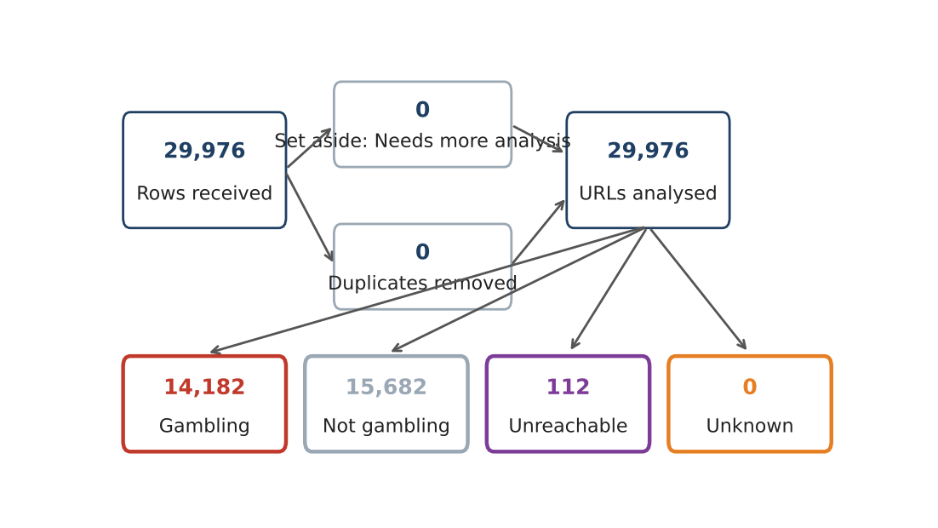
Stage | URLs
Rows received | 29,976
Set aside as Needs more analysis | 0
Duplicates removed | 0
URLs analysed | 29,976
of which Not gambling | 15,682
of which Gambling | 14,182
of which Unreachable | 112
Total analysed (reconciles to URLs analysed) | 29,976

URLs analyzed per day
Daily count of URLs analysed across the evaluation period. Each point is one calendar day and shaded bands mark gaps and peaks.
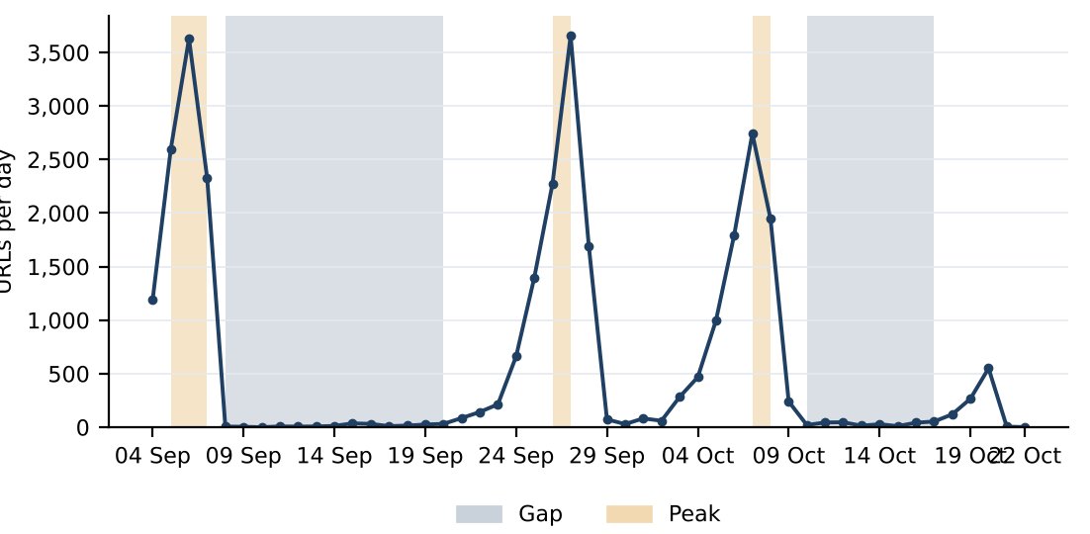
The gap threshold is 61 URLs a day, 10% of the mean of 612, and 25 days fall below it. Gap 2026-09-08 to 2026-09-20 (13 days, 190 URLs): cause not recorded. Gap 2026-10-10 to 2026-10-17 (8 days, 257 URLs): cause not recorded. Peak 2026-09-05 to 2026-09-07 (3 days, 8,558 URLs): cause not recorded. Peak 2026-09-26 to 2026-09-27 (2 days, 5,929 URLs): cause not recorded. Peak 2026-10-07 to 2026-10-08 (2 days, 4,689 URLs): cause not recorded. A URL is dated by the last time its record changed, which is not necessarily the day it was first collected.

Status distribution
Share of the estate by classification status. Each segment is one status and the table below carries the counts.
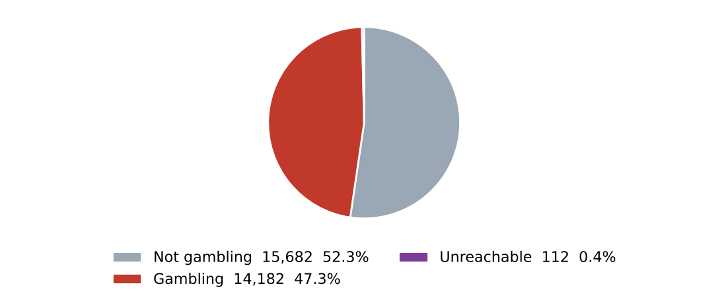
Status | URLs | % of URLs
Not gambling | 15,682 | 52.3%
Gambling | 14,182 | 47.3%
Unreachable | 112 | 0.4%
Total | 29,976 | 100.0%

0 URLs classified as Needs more analysis are set aside before this count and appear in From collection to analysis.

Unreachable URLs by cause
Cause | URLs | % of unreachable
Analysis error: SICPADetect could not complete its analysis | 112 | 100.0%
Total | 112 | 100.0%

The collection network was not recorded.

Top 10 URL suffixes
The ten most common URL suffixes in the estate. Bar length is the total count and the table separates the gambling share.
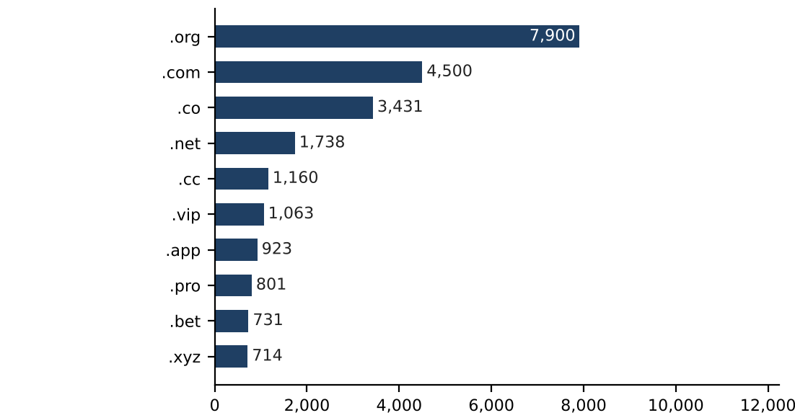
Suffix | URLs | % of all URLs | Gambling URLs | % gambling
.org | 7,900 | 26.4% | 19 | 0.2%
.com | 4,500 | 15.0% | 2,085 | 46.3%
.co | 3,431 | 11.4% | 3,104 | 90.5%
.net | 1,738 | 5.8% | 1,083 | 62.3%
.cc | 1,160 | 3.9% | 683 | 58.9%
.vip | 1,063 | 3.5% | 955 | 89.8%
.app | 923 | 3.1% | 643 | 69.7%
.pro | 801 | 2.7% | 682 | 85.1%
.bet | 731 | 2.4% | 703 | 96.2%
.xyz | 714 | 2.4% | 348 | 48.7%

7,015 URLs sit on 279 further suffixes outside the top 10.

Pages showing blocking indicators
URL | Brand cluster | Indicator | Phrase found | Excerpt
e.dra.gov.pk | — | Other | regulatory authority | L: The URL contains the text 'dra.gov.pk', indicating it is related to the Drug…
fawts.glass-safe.com | — | Other | illegal content | hot: The website contains adult content and a warning message about potentially…
hn94.cc | — | Other | illegal content | shot: The website contains adult content and a pop-up warning about potentially…
nh83.cc | — | Other | illegal content | hot: The website contains adult content and a warning message about potentially…
nh85.cc | — | Other | illegal content | website contains adult content and prompts a warning message about potentially…
tn93.cc | — | Other | illegal content | hot: The website contains adult content and a warning message about potentially…
vu98.cc | — | Other | illegal content | hot: The website contains adult content and a warning message about potentially…

The model's description of each page is scanned for fixed block page phrases in English and Thai, such as court order and blocked site notices; a phrase naming a Thai court, MDES or a Thai ISP counts as a Thai enforcement indicator. Blocking evidence reflects what was visible from the collection network, and the collection network was not recorded, so these counts may understate enforcement.

Subcategories

Gambling sites by product subcategory
Gambling sites by product subcategory. Bar length is the site count and each label carries the count and the share of gambling rows.
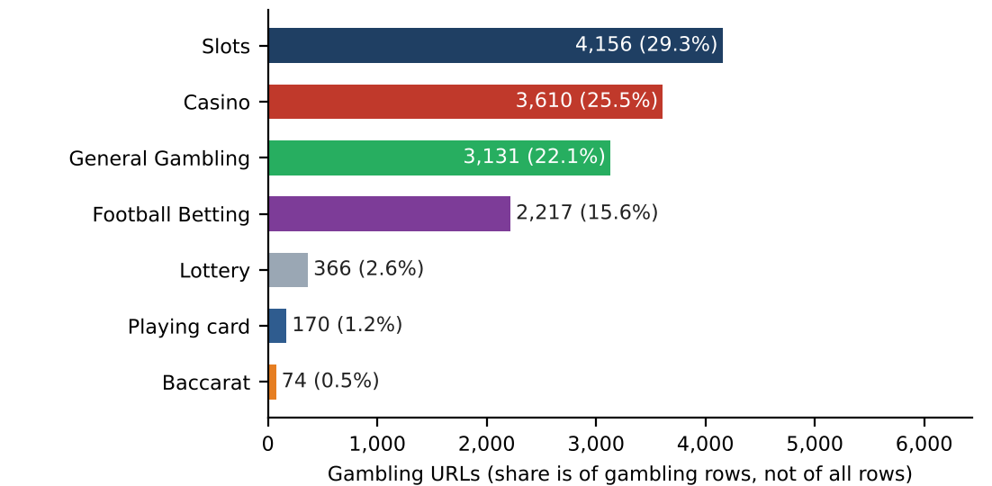
458 gambling URLs with no description recorded are assigned Unspecified and are not a product subcategory; they appear in the subcategory table.

Assignment method by subcategory
How each subcategory was assigned. Solid fill is a lexicon keyword match and the lighter fill is reasoning inference.
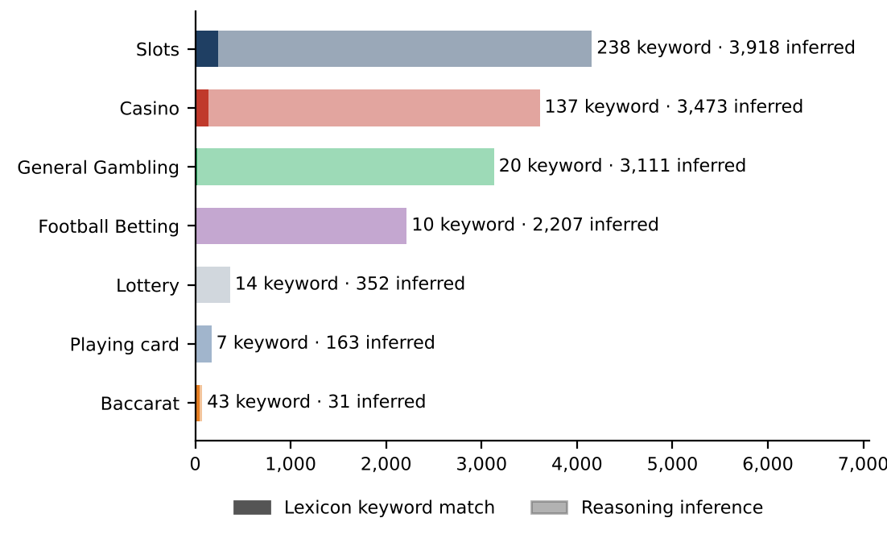
What a lexicon match means
A site is assigned to a subcategory by lexicon match when a word or phrase from the gambling keyword lexicon appears in what was recorded about the site, such as the model description, extracted keywords, remarks or the URL and domain, and that word belongs to the product category assigned. A description containing สล็อต is assigned to Slots by lexicon match. The lexicon is the SICPADetect Thai gambling keyword lexicon at the version on the title page, with 286 keywords in 14 categories, mostly in Thai script. Seven categories describe the product and decide the subcategory. The other seven describe how a site markets or operates itself and are reported as signal tags. A lexicon match rests on a specific word that can be pointed to, so it can be checked and repeated. An inferred assignment rests on the model reading of its own description and carries lower confidence.
Inferred assignments are 96.7% of gambling rows and General Gambling is 22.1%. The lexicon has poor coverage of this dataset, so subcategory figures are indicative only.

Subcategory table
Subcategory | URLs | % of gambling | Keyword assigned | Inferred | Distinct clusters
Slots | 4,156 | 29.3% | 238 | 3,918 | 1,104
Casino | 3,610 | 25.5% | 137 | 3,473 | 1,197
General Gambling | 3,131 | 22.1% | 20 | 3,111 | 783
Football Betting | 2,217 | 15.6% | 10 | 2,207 | 829
Lottery | 366 | 2.6% | 14 | 352 | 144
Playing card | 170 | 1.2% | 7 | 163 | 68
Baccarat | 74 | 0.5% | 43 | 31 | 52
Unspecified | 458 | 3.2% | 0 | 458 | 416
Total | 14,182 | 100.0% | 469 | 13,713

314 General Gambling URLs are listing, review or ranking sites, pending jointly agreed labelling rules.

Heat map: keyword by subcategory
Matched keywords against product subcategory. Each cell is the number of gambling sites carrying that keyword in that subcategory.
 |  | Slots | Casino | General Gambling | Football Betting | Lottery | Baccarat | Playing card
 | VIP | 793 | 347 | 346 | 315 | 32 | 7 | 13
 | BET | 337 | 343 | 201 | 265 | 41 | 12 | 4
 | WIN | 310 | 110 | 124 | 53 | 33 | 2
 | สมัครสมาชิก | 148 | 80 | 56 | 24 | 55 | 13 | 3
 | สล็อต | 238 | 70 |  | 4 | 2 | 32 | 6
 | WALLET | 56 | 49 | 42 | 19 | 8 | 6 | 1
 | Wallet | 56 | 49 | 42 | 19 | 8 | 6 | 1
 | คาสิโน | 31 | 137 |  | 2 | 1 | 7
 | PRAGMATIC | 64 | 52 | 27 | 15 | 7 | 6
 | คาสิโนออนไลน์ | 4 | 95 |  | 2
 | สล็อตออนไลน์ | 91 | 6 |  | 1
 | เกมสล็อต | 82 | 13
 | บาคาร่า | 20 | 13 |  | 2 | 1 | 43 | 6
 | Affiliate | 41 | 13 | 8 | 3 | 2 | 2
 | JILI | 31 | 10 | 4 | 19 | 1
 | เล่นสล็อต | 54 | 1 |  | 1
 | เดิมพัน | 7 | 10 | 16 | 1 |  | 2
 | RTP | 20 | 2 | 6 | 1 | 1 | 1
 | พนัน | 10 | 10 | 4 | 1 |  | 2
 | JDB | 5 | 15 | 5 |  | 1
 | AUTO | 12 | 4 | 2 | 5 | 2
 | เครดิตฟรี | 5 | 10 | 1 | 1 |  | 3
 | SEXY | 6 | 7 |  | 4 | 1 | 2
 | สมาชิกใหม่ | 7 | 4 | 3 | 5
 | จ่ายจริง | 10 | 2 | 1 | 3 |  | 1

Scale: lightest fill is 1, darkest fill is 793. A blank cell with a hairline border is 0. The strip beside each keyword shows its own lexicon category: Slots, Casino, Baccarat, General Gambling, Deposit & Withdrawal, Promotions, Marketing & Acquisition, Affiliate & Agent, Abbreviations in colour order of the palette.

Heat map: signal tag by subcategory
Signal tags against product subcategory. Each cell is the number of gambling sites carrying that tag in that subcategory.
 | Slots | General Gambling | Casino | Football Betting | Lottery | Baccarat | Playing card
Abbreviations | 1,478 | 676 | 871 | 644 | 112 | 33 | 17
Marketing & Acquisition | 162 | 59 | 95 | 30 | 55 | 16 | 3
Affiliate & Agent | 46 | 327 | 17 | 7 | 2 | 2 | 1
Deposit & Withdrawal | 58 | 43 | 50 | 19 | 10 | 6 | 1
Promotions | 8 | 7 | 15 | 5 |  | 3
Vague-Evasion Terms
Hashtags

Scale: lightest fill is 1, darkest fill is 1,478. A blank cell with a hairline border is 0.

Brands and clustering

What brand clusters are
What a cluster is
A brand cluster is a group of URLs, and the domains they sit on, judged to belong to the same gambling brand or operator. Domains join a cluster in one of four ways, in order of strength. The crawler followed a redirect from one to another, or generated one as a variant of another and the names match. One matches a brand in a ranking of gambling domains for Thailand from an external data provider, so it is grouped under that brand name even when its own name differs. Their names reduce to the same stem once market tags, version numbers and suffixes are removed, so ufabet168th.com and ufabet-vip.net both reduce to ufabet while jun88 and jun68 stay apart. Or their stems are near identical in spelling. A domain matching nothing else is a singleton, and all hostnames on one registered domain always share a cluster.
Why clusters matter
Operators rarely run a single site. They register many domains, rotate top-level domains and move players between them through redirects, so when one address is blocked another takes its place. Counting URLs therefore overstates how many operators exist and hides who is behind the estate. Clustering shows how many distinct operations there are, how concentrated the estate is and which operators run several product types. Acting on a cluster reaches every domain in it, where acting on one URL leaves the rest of the brand running. Clusters are an analytical grouping based on names, crawler links and an external domain ranking, not a legal finding about ownership, and the Possible operator linkage table is indicative only.

2,968  Distinct clusters |  | 1,180  Clusters with 2 or more domains |  | 1,788  Singletons, one domain each |  | 66  Clusters to cover half of gambling URLs

Domains with the most URLs
The largest domain carries 20.3% of gambling URLs
How to read this table
The table lists the registered domains that carry the most gambling URLs in this sample, largest first. Each row gives the domain, its URLs, their share of all gambling URLs, the brand cluster it belongs to, the first and last day SICPADetect recorded it and whether it is a host farm. A domain carrying 20 or more gambling URLs is marked as a host farm: many hostnames under one registered name. Many hostnames under one domain usually come from a single setting that makes every name under the domain lead to the same site, so they may not be separate pages. Action against the domain reaches every hostname at once, where blocking hostname by hostname never catches up.
Domain | URLs | % of gambling URLs | Brand cluster | First seen | Last seen | Host farm
49m.co | 2,885 | 20.3% | 49m | 2026-10-03 | 2026-10-09 | Yes
a3game.vip | 502 | 3.5% | a3game | 2026-09-23 | 2026-09-28 | Yes
hayy.net | 407 | 2.9% | hay | 2026-09-04 | 2026-09-07 | Yes
k03.cc | 272 | 1.9% | k03 | 2026-09-04 | 2026-09-07 | Yes
paes.dev | 269 | 1.9% | paes | 2026-09-24 | 2026-09-28 | Yes
paegs.dev | 176 | 1.2% | paegs | 2026-09-24 | 2026-09-28 | Yes
o8.game | 73 | 0.5% | o8 | 2026-09-04 | 2026-09-07 | Yes
abbet.xyz | 70 | 0.5% | abbet | 2026-10-18 | 2026-10-20 | Yes
jun888.top | 67 | 0.5% | jun8 | 2026-09-24 | 2026-09-28 | Yes
7ok.bet | 66 | 0.5% | 7ok | 2026-09-04 | 2026-09-07 | Yes
l8.game | 57 | 0.4% | l8 | 2026-09-04 | 2026-09-07 | Yes
jn86.cc | 40 | 0.3% | jn86 | 2026-09-24 | 2026-09-28 | Yes
oo7.vip | 37 | 0.3% | oo7 | 2026-09-04 | 2026-09-07 | Yes
mwbet.info | 27 | 0.2% | mwbet | 2026-10-18 | 2026-10-20 | Yes
ju088.com | 23 | 0.2% | ju088 | 2026-09-25 | 2026-09-28 | Yes

15 host farms carry 4,971 gambling URLs, 35.1% of gambling URLs. 722 domains cover half of the gambling URLs. Fetch evidence for the host farms is not recorded.

Top 15 brand clusters by URL count
The fifteen largest brand clusters. Bar length is the number of URLs in the cluster and each label also gives its domains.
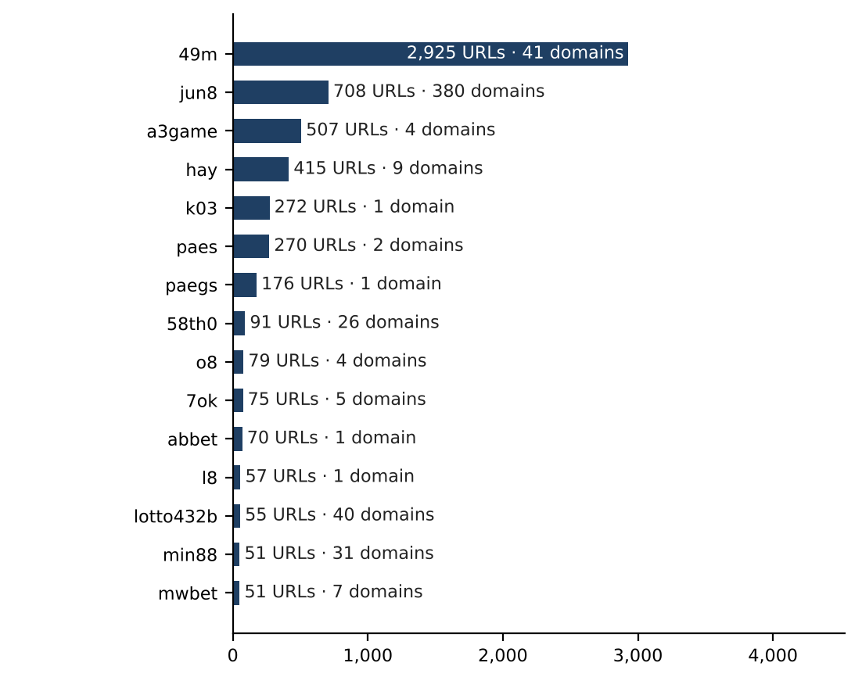

Heat map: brand cluster by subcategory
Brand clusters against product subcategory. Each cell is the number of URLs a cluster holds in that subcategory.
 | Slots | General Gambling | Casino | Football Betting | Lottery | Playing card | Baccarat
49m | 812 | 1,455 | 587 |  | 1 | 70
jun8 | 142 | 104 | 254 | 120 | 72 | 10 | 6
a3game | 491 | 10 | 3 | 1 | 2
hay | 15 | 24 | 248 | 127 | 1
k03 |  | 11 |  | 261
paes | 50 | 47 | 69 | 101 | 3
paegs | 28 | 26 | 59 | 63
58th0 | 91
o8 | 55 | 18 | 6
7ok | 68 | 5 | 2
abbet | 16 |  | 54
l8 | 12 | 44 | 1
lotto432b | 4 | 6 | 1 |  | 44
min88 | 1 |  | 3 | 47
mwbet | 15 |  | 30 | 6
pgcat | 34 | 2 | 7 | 2 |  |  | 3
ezslot | 26 | 2 | 5 | 12 |  |  | 1
bohocasino | 12 |  | 31 |  | 2
jin88 | 10 | 13 | 8 | 4 | 5 | 3
lottovip | 5 | 2 | 3 | 2 | 29 | 2

Scale: lightest fill is 1, darkest fill is 1,455. A blank cell with a hairline border is 0.
Rows show the 20 largest clusters. Counts cover the seven product subcategories, so a cluster total can be lower than its URL count where Unspecified URLs are held.

Cluster expansion: 49m
The largest brand cluster with at least three domains and its member domains. Edge style records why each domain joined the cluster.
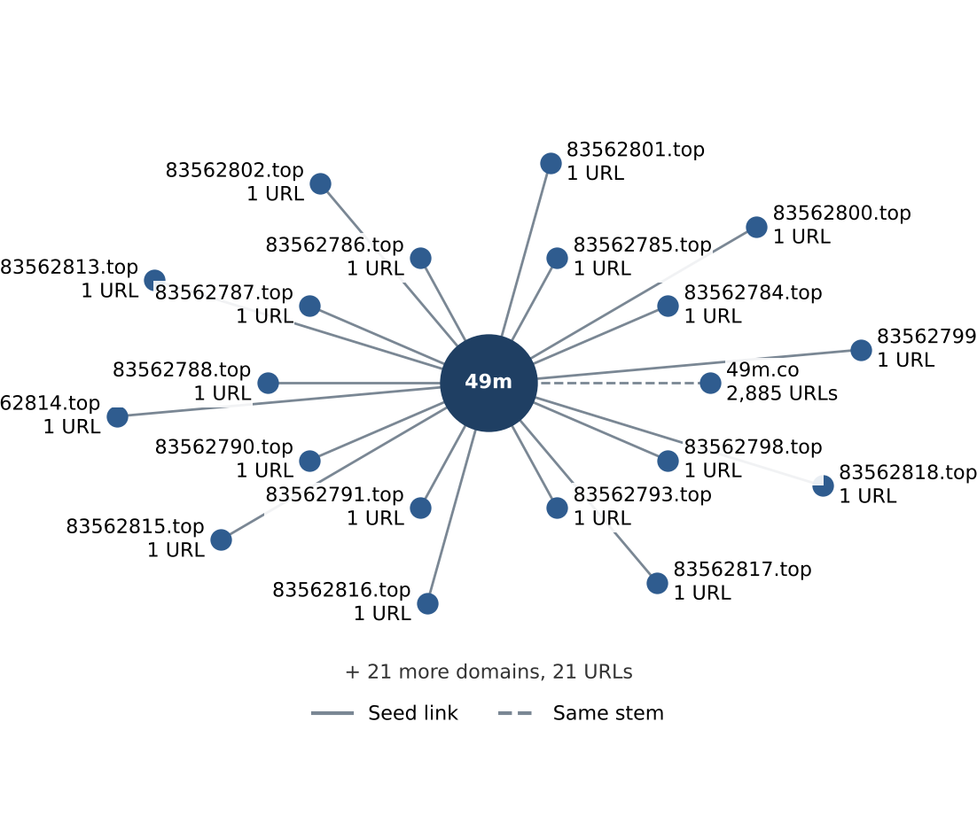
The largest cluster holds 41 domains and 2,925 URLs. Names are shown as registered domains; the diagram draws the 20 domains with the most URLs.
Interpretation: 49m holds 41 domains, and one of them, 49m.co, carries 2,885 of its 2,925 URLs.

Clusters spanning multiple subcategories
How to read this table
The table lists brand clusters whose member sites fall into two or more product subcategories, for example one brand running both slots and football betting sites. Each row gives the cluster, its URLs, each subcategory present with its site count and the suffixes it uses. Subcategories are assigned to sites, not clusters, so a cluster qualifies when two of its sites carry different products. General Gambling beside a specific product means a product could not be evidenced, not necessarily a second product. Such brands offer several products under one name, so action against the brand reaches all of them. Annex 1 defines each subcategory.
Cluster | URLs | Subcategories | Suffixes
49m | 2,925 | General Gambling 1,455 · Slots 812 · Casino 587 · Playing card 70 · Lottery 1 | .co, .top
jun8 | 708 | Casino 254 · Slots 142 · Football Betting 120 · General Gambling 104 · Lottery 72 · Playing card 10 · Baccarat 6 | .app, .bet, .black, .buzz, .casino, .cc, and 33 more
a3game | 507 | Slots 491 · General Gambling 10 · Casino 3 · Lottery 2 · Football Betting 1 | .app, .click, .net, .vip
hay | 415 | Casino 248 · Football Betting 127 · General Gambling 24 · Slots 15 · Lottery 1 | .app, .bet, .club, .co, .com, .net, and 3 more
k03 | 272 | Football Betting 261 · General Gambling 11 | .cc
paes | 270 | Football Betting 101 · Casino 69 · Slots 50 · General Gambling 47 · Lottery 3 | .com, .dev
paegs | 176 | Football Betting 63 · Casino 59 · Slots 28 · General Gambling 26 | .dev
o8 | 79 | Slots 55 · General Gambling 18 · Casino 6 | .co.uk, .com.co, .game, .live
7ok | 75 | Slots 68 · General Gambling 5 · Casino 2 | .bet, .club, .io, .live, .pro
abbet | 70 | Casino 54 · Slots 16 | .xyz
l8 | 57 | General Gambling 44 · Slots 12 · Casino 1 | .game
lotto432b | 55 | Lottery 44 · General Gambling 6 · Slots 4 · Casino 1 | .bet, .click, .com, .info, .live, .net, and 1 more
min88 | 51 | Football Betting 47 · Casino 3 · Slots 1 | .academy, .actor, .app, .art, .auction, .cafe, and 23 more
mwbet | 51 | Casino 30 · Slots 15 · Football Betting 6 | .app, .bet, .club, .co, .info, .pro, and 1 more
pgcat | 48 | Slots 34 · Casino 7 · Baccarat 3 · Football Betting 2 · General Gambling 2 | .bet, .buzz, .cc, .click, .club, .co, and 8 more

The 15 largest of 954 qualifying clusters are listed; 939 further clusters qualify.

Clusters rotating top-level domains
How to read this table
The table lists brand clusters whose member domains use two or more top-level domains, the ending of the address, such as the same brand under .com, .net and .co. Each line gives the cluster, one suffix it uses, the member domains on that suffix and the first and last day SICPADetect recorded them. A two part ending such as .co.th counts as one suffix. Registering one name under several endings keeps the brand reachable when one domain is blocked, so blocking a single domain leaves its siblings running. Not every case is evasion, since some operators register several endings to protect a name.
Cluster | Suffix | Domains | First seen | Last seen
49m | .top | 40 | 2026-10-04 | 2026-10-07
49m | .co | 1 | 2026-10-03 | 2026-10-09
jun8 | .com | 154 | 2026-09-22 | 2026-10-19
jun8 | .net | 21 | 2026-09-23 | 2026-09-28
jun8 | .me | 18 | 2026-09-22 | 2026-09-28
jun8 | .info | 16 | 2026-09-22 | 2026-09-28
a3game | .app | 1 | 2026-09-23 | 2026-09-24
a3game | .net | 1 | 2026-09-23 | 2026-09-23
a3game | .click | 1 | 2026-09-23 | 2026-09-24
a3game | .vip | 1 | 2026-09-23 | 2026-09-28
hay | .club | 1 | 2026-09-05 | 2026-09-05
hay | .pro | 1 | 2026-09-05 | 2026-09-05
hay | .com | 1 | 2026-09-04 | 2026-09-04
hay | .app | 1 | 2026-09-05 | 2026-09-05
paes | .dev | 1 | 2026-09-24 | 2026-09-28
paes | .com | 1 | 2026-09-25 | 2026-09-25
58th0 | .com | 25 | 2026-10-02 | 2026-10-07
58th0 | .pro | 1 | 2026-10-07 | 2026-10-07

The 6 largest of 1,111 qualifying clusters are listed, with up to 4 suffixes each. 16 clusters gained domains at least 7 days after the cluster was first seen, 46 domains in all.
Dates are when SICPADetect recorded each domain, not when it was registered, blocked or replaced. The period of 49 days is too short to confirm rotation over time.

Possible operator linkage
Indicative, not a clustering decision
How to read this table
The table lists pairs of brand clusters with different names that use an unusually similar set of signal keywords, the lexicon words describing how a site promotes itself, takes payment or avoids blocking. The Jaccard score is the number of keywords two clusters share divided by the number of distinct keywords either uses, from 0 for nothing in common to 1 for identical sets. Common words and abbreviations known to match by accident are left out first, and only pairs scoring 0.60 or more with at least three shared keywords qualify. A close match can point to one operator, or to unrelated operators using one affiliate template, so each pair is a lead to verify and clusters are never merged on it.
362 pairs of clusters qualify, and the remaining shared vocabulary is too common to point to shared operators.

Naming conventions
• Recurring tokens in the hostnames of the 20 largest clusters: m. (3,501), login (2,151), support (1,921). This points to a templated naming scheme.
• Top level domain switching: names in the largest clusters span .co (2,947), .vip (544), .com (456), .net (456), so operators rotate top level domains.
• The gambling URLs sit on 6,827 domains across 2,968 brand clusters.

13,495  Direct URLs |  | 687  Redirect URLs |  | 0  Variant URLs
Structure: direct, redirect, variant. Of 7,805 variant URLs in the standard set, 0 are gambling, 7,805 not gambling, 0 unreachable and 0 unknown. 0 gambling variant URLs carry a recorded description. No fetch status or final address is recorded for variants.

Redirect propagation: www.min88.top
The busiest redirect source and the destinations reached from it. Each node is one domain.
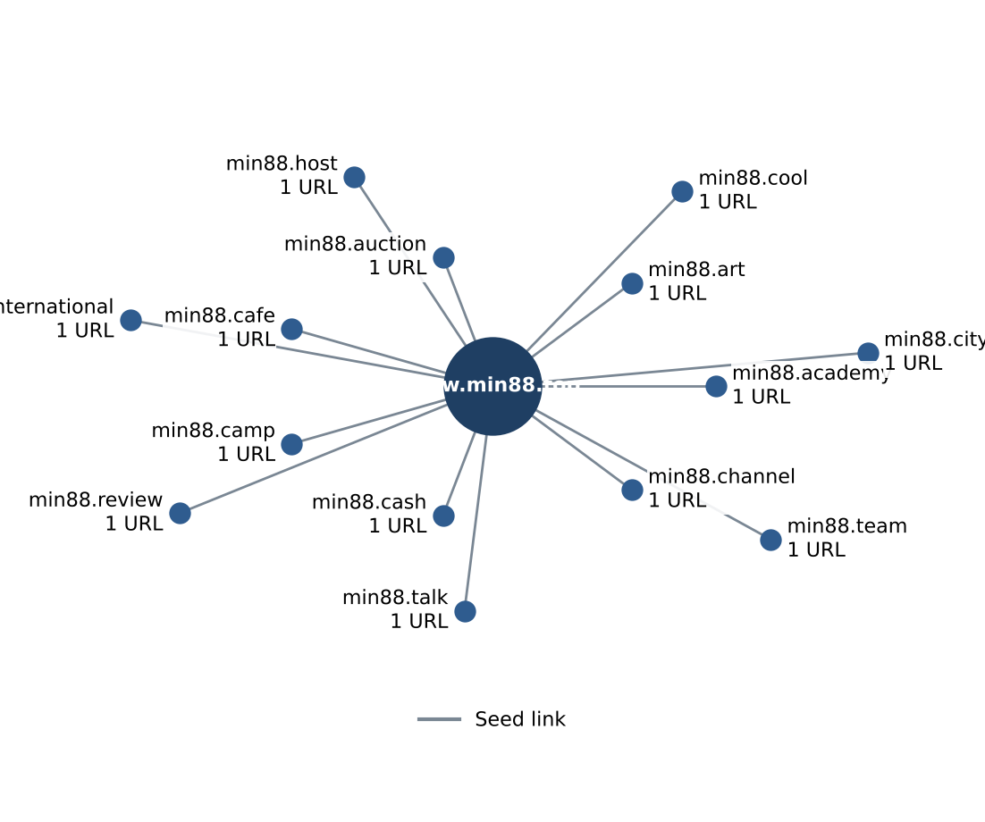

Ranking

Gambling ranking
How to read this table
The table lists the gambling sites in this sample that carry a rank in the SICPADetect feed, best ranked first, up to fifteen. Each row gives the rank, the domain, its brand cluster, its subcategory and where SICPADetect found it. The rank is the position recorded in the source feed and reflects search visibility, so a lower number means a more visible site. It is not the external ranking used to anchor clusters in Annex 2, and unlike the 10 most prominent gambling sites in Thailand table it is neither filtered for a Thai audience nor limited to one row per domain. The most visible sites are those users are most likely to reach, but rank does not measure harm, reach or revenue.
Rank | Domain | Brand cluster | Subcategory | Source
93,155 | metal--vip.com | metal | Slots | System
214,132 | allslotwallet.online | allslotwallet | Slots | System
221,001 | suriyathai.net | suriya | General Gambling | System
252,597 | u11k.pro | u11 | Football Betting | System
254,190 | anthonyhead.com | anthonyhead | Slots | System
254,190 | kohochocolates.com | anthonyhead | Slots | Redirect · referrer: anthonyhead.com
293,057 | bifestathailand.com | lgbtnewsnow | Slots | Redirect · referrer: lgbtnewsnow.org
293,057 | lgbtnewsnow.org | lgbtnewsnow | Slots | System
303,254 | jun88wf.com | jun8 | Casino | System
397,330 | jun88wa.com | jun8 | Casino | System
466,858 | jun88wc.com | jun8 | Casino | System
514,501 | sacasino.ad | sacasino | Baccarat | System
517,141 | jun88.info | jun8 | Casino | System
517,141 | slavinaslot.top | jun8 | Casino | Redirect · referrer: jun88.info
547,370 | 99ok.vip | 99ok | Lottery | System

Ranked brand clusters
How to read this table
The table lists brand clusters that contain at least one gambling site carrying a rank in the SICPADetect feed. Each row gives the cluster, its URLs, the best rank among its members, how many members are ranked and its subcategories. One ranked member is enough to qualify. Clusters are ordered by best rank, so the most visible brands come first, and the URL count shows how large each operation is. A brand that is both highly visible and large is where action reaches the most users and addresses at once. Rank measures visibility only, not harm, reach or revenue, and no combined score is calculated.
Cluster | URLs | Best rank | Ranked URLs | Subcategories
metal | 2 | 93,155 | 1 | Slots 2
allslotwallet | 1 | 214,132 | 1 | Slots 1
suriya | 1 | 221,001 | 1 | General Gambling 1
u11 | 32 | 252,597 | 1 | Football Betting 15 · Casino 11 · Slots 3 · General Gambling 3
anthonyhead | 2 | 254,190 | 2 | Slots 2
lgbtnewsnow | 2 | 293,057 | 2 | Slots 2
jun8 | 708 | 303,254 | 41 | Casino 254 · Slots 142 · Football Betting 120 · General Gambling 104 · Lottery 72 · Playing card 10 · Baccarat 6
sacasino | 1 | 514,501 | 1 | Baccarat 1
99ok | 17 | 547,370 | 3 | Slots 5 · Football Betting 4 · Casino 4 · General Gambling 2 · Lottery 2
gg8830 | 9 | 558,790 | 1 | Casino 5 · Football Betting 3 · General Gambling 1
betwgb | 1 | 582,212 | 1 | Football Betting 1
hh98 | 25 | 632,178 | 11 | General Gambling 18 · Football Betting 4 · Casino 2 · Lottery 1
lott | 8 | 655,235 | 1 | Lottery 4 · General Gambling 2 · Slots 1 · Casino 1
playtga | 14 | 701,733 | 3 | Casino 4 · Football Betting 4 · Slots 4 · Baccarat 1 · Lottery 1
gg8832 | 6 | 727,399 | 1 | Slots 2 · Casino 2 · Football Betting 2

Key insights

Scale of the analysis
SICPADetect analysed 29,976 distinct URLs over 49 days, from 2026-09-04 to 2026-10-22. Of these, 14,182 are gambling, 15,682 are not gambling and 112 are unreachable; 0 further URLs were set aside as Needs more analysis. Volume dipped below the gap threshold in 2026-09-08 to 2026-09-20 and 2026-10-10 to 2026-10-17; the cause of each gap was not recorded.
The sample is large enough to reason about patterns, not isolated cases.

What is being offered
Slots, Casino and General Gambling are the three largest product subcategories, with 4,156 (29.3%), 3,610 (25.5%) and 3,131 (22.1%) gambling URLs. 22.1% of gambling URLs are confirmed as gambling without an evidenced product type, and 96.7% of subcategories were inferred from the model description rather than matched to a lexicon keyword. 207 of the 286 lexicon keywords never matched.
Slots is the dominant product type, and the estate is spread across product types rather than concentrated in one. The lexicon has poor coverage of this dataset, with the weakest coverage in Lottery, Playing card, Baccarat, so subcategory figures are indicative only.

Brand clustering
The 14,182 gambling URLs sit on 6,827 domains across 2,968 brand clusters, of which 1,180 hold more than one domain. 66 clusters and 722 domains cover half of the gambling URLs. The largest cluster, 49m, holds 2,925 URLs (20.6% of gambling URLs) on 41 domains, across 5 subcategories. The largest domain, 49m.co, holds 2,885 URLs (20.3%). 15 host farms carry 35.1% of gambling URLs.
One registered domain carries 20.3% of the estate through many hostnames, so action at domain level reaches all of them at once, where URL by URL blocking would need one entry per hostname. Beyond it, the estate is diffuse: 66 clusters and 722 domains are needed to cover half of the gambling URLs.

How the estate is grown and marketed
0 gambling URLs are crawler identified variants, 687 sit behind redirect chains and 13,495 were reached directly. The busiest redirect source, www.min88.top, leads to 14 destinations. 1,111 clusters rotate across more than one top level domain. The two most common signal tags are Abbreviations (27.1%) and Marketing & Acquisition (3.0%). No fetch status or final address is recorded, so variant verification is not recorded beyond the description.
Redirects and top level domain rotation keep a stable entry point while the sites behind it are replaced.

Enforcement position
0 pages show Thai enforcement indicators, such as Thai court orders or MDES and Thai ISP block pages, and 7 pages show other block pages. The model description of each page is scanned for fixed block page phrases in English and Thai, and every page found is listed in the Pages showing blocking indicators table. The collection network was not recorded.
This set appears pre enforcement and is a candidate for a first enforcement pass, prioritised by domain and cluster rather than by URL. The collection network was not recorded, so the enforcement count may be understated.

Annexes

Annex 1: Subcategory definitions
Each site classified as gambling is assigned one of the seven product subcategories below, according to what it offers. General Gambling applies only when a site is confirmed as gambling but no specific product can be evidenced. A subcategory is assigned by lexicon match when one of the keywords listed under it appears in what was recorded about the site, and by inference from the model's description when none is found. How a site markets or operates itself is recorded separately as signal tags and does not decide its subcategory. The keywords under each subcategory are its complete set in the lexicon, shown in their original script. A few keywords appear under both a specific product and General Gambling; they always count toward the specific product.
Football Betting · 21 keywords
Betting on the outcome of football and other sports matches, including match odds, single match and accumulator ("step") bets, and tipping or match analysis offered to bettors.
พนันบอล · | พนันบอลออนไลน์ · | แทงบอล
แทงบอลออนไลน์ · | พนันฟุตบอล · | แทงฟุตบอล
สปอร์ตบุ๊ค · | บอลออนไลน์ · | ราคาบอล
บอลสเต็ป · | บอลเดี่ยว · | สเต็ปบอล
แทงบอลชุด · | ทีเด็ดบอล · | วิเคราะห์บอล
โต๊ะบอล · | ล้มโต๊ะบอล · | เดิมพันฟุตบอล
เว็บแทงบอล · | บอลสเต็ปแม่น · | พนันกีฬา

Slots · 32 keywords
Online slot machine games, including sites that promote particular slot providers, high payout rates or slots played directly without an agent.
สล็อต · | สล็อตออนไลน์ · | เกมสล็อต
เกมสล็อตออนไลน์ · | สล็อตแตกง่าย · | สล็อตแตกบ่อย
สล็อตแตกหนัก · | สล็อตแตกจริง · | สล็อตใหม่
สล็อตเว็บตรง · | สล็อตวอเลท · | เล่นสล็อต
สล็อตเครดิตฟรี · | สล็อตแตกทุกวัน · | สล็อตมาแรง
สล็อตยอดนิยม · | สล็อตค่ายดัง · | สล็อตไม่ผ่านเอเย่นต์
สล็อต pg · | สล็อต joker · | สล็อต jili
สล็อต pragmatic · | สล็อต xo · | สล็อต auto
สล็อตแตกไว · | สล็อตฝากถอนออโต้ · | สล็อตฝากไม่มีขั้นต่ำ
สล็อตโบนัสแตกหนัก · | สล็อตสายฟรี · | สล็อตปั่นง่าย
สล็อต RTP สูง · | สล็อตคืนกำไร

Casino · 14 keywords
Online and live casino table and wheel games other than baccarat and card games, such as roulette, dragon tiger, hi lo dice and wheel spin games.
คาสิโน · | คาสิโนออนไลน์ · | คาสิโนสด
คาสิโนสดออนไลน์ · | เสือมังกร · | รูเล็ต
รูเล็ตออนไลน์ · | รูเล๊ต · | ไฮโล
ไฮโลออนไลน์ · | ไฮโลไทย · | หมุนวงล้อโบนันซ่ารายวัน
หมุนวงล้อโบนันซ่า · | ปั่นแปะ

Lottery · 20 keywords
Betting on lottery and number draws, including the Thai government and underground lotteries, Lao, Hanoi and Malaysian draws, fast draw yi ki lotteries and lotteries settled on stock index figures.
หวยออนไลน์ · | แทงหวย · | ซื้อหวยออนไลน์
หวยยี่กี · | หวยฮานอย · | หวยลาว
หวยรัฐบาล · | หวยมาเลย์ · | หวยจับยี่กี
จับยี่กี VIP · | หวยใต้ดิน · | หวยออนไลน์จ่ายจริง
เว็บหวย · | เว็บแทงหวย · | Huay
Huaylan · | หวยหุ้น · | หวยหุ้นไทย
หวยหุ้นต่างประเทศ · | หวยชุด

Playing card · 12 keywords
Card games other than baccarat, such as pok deng, blackjack, poker and Thai two card and three card games.
ไพ่ · | ไพ่ออนไลน์ · | ไพ่ ออนไลน์
ไพ่ป๊อก · | ป๊อกเด้ง · | ป๊อกเด้งออนไลน์
แบล็คแจ็ค · | แบล็คแจ็คออนไลน์ · | โป๊กเกอร์
โป๊กเกอร์ออนไลน์ · | ตีไก่สองใบ · | ตีไก่สามใบ

Baccarat · 11 keywords
Baccarat in any form, live or online, including demo tables and betting formula or prediction services sold for baccarat.
บาคารา · | บาคาร่า · | บาคาร่าออนไลน์
ไพ่บาคาร่า · | บาคาร่าสด · | โต๊ะบาคาร่า
บาคาร่าทดลอง · | บาคาร่าฟรี · | บาคาร่าระบบ AI
บาคาร่าขั้นเทพ · | สูตรบาคาร่า

General Gambling · 22 keywords
Sites confirmed as gambling whose recorded content uses only generic gambling or betting vocabulary, so no specific product can be evidenced. Assigned only when no other subcategory applies.
พนัน · | การพนัน · | พนันออนไลน์
เว็บพนัน · | เว็บเดิมพัน · | เดิมพัน
เดิมพันออนไลน์ · | คาสิโน · | คาสิโนออนไลน์
บ่อน · | บ่อนออนไลน์ · | เว็บเกมพนัน
เกมพนัน · | เว็บเสี่ยงโชค · | เสี่ยงโชค
เว็บเกมเงิน · | เล่นเงินจริง · | เกมได้เงินจริง
เดิมพันกีฬา · | พนันกีฬา · | พนันบอล
แทงบอล

The keyword lists are those of the SICPADetect lexicon at the version shown on the title page.

Annex 2: Ranked domains used for clustering
Ranking of gambling domains for Thailand · external data provider · 159 of 200 ranked domains applied
Brand clusters are anchored to a ranking of gambling domains for Thailand supplied by an external data provider. When a URL in this sample matches a ranked brand, it is grouped under that brand's name instead of the name it happens to carry. The ranking is an analytical reference. A place in it is not evidence of ownership, harm or reach, and a match never adds a site to the gambling set.
Rank | Ranked domain | Brand | Match basis | URLs matched | Cluster
1 | 22onlinegames.com | 22onlinegames | Brand name and extended names | 1 | 22onlinegames
3 | debet.tv | debet | Brand name and extended names | 1 | debet
4 | aiscore.com | aiscore | Brand name and extended names | 1 | aiscore
5 | ufabet.com | ufabet | Brand name and extended names | 1 | ufabet
7 | invl.me | invl | Brand name only | 2 | invl
8 | lottoheng168.com | lottoheng | Brand name and extended names | 1 | lottoheng
9 | 888scoreonline.net | 888scoreonline | Brand name and extended names | 1 | 888scoreonline
10 | hacksawgaming.com | hacksawgaming | Brand name and extended names | 4 | hacksawgaming
12 | playin.com | playin | Brand name and extended names | 3 | playin
14 | gosh.io | gosh | Brand name only | 1 | gosh
15 | 24live.com | 24live | Brand name and extended names | 2 | 24live
16 | 326821905591.com | 326821905591 | This domain only | 1 | 326821905591
19 | vlr.gg | vlr | This domain only | 1 | vlr
20 | 7mkr.com | 7mkr | This domain only | 1 | 7mkr
21 | flashscore.co.uk | flashscore | Brand name and extended names | 6 | flashscore
22 | 808ball15.com | 808ball | Brand name and extended names | 2 | 808ball
24 | bet365.com | bet365 | Brand name and extended names | 0 | —
25 | mlnhngoc.net | mlnhngoc | Brand name and extended names | 1 | mlnhngoc
26 | m8geqpm2kpnf78dkfxp9ksg94ndx9weaoa39.com | m8geqpm2kpnf78dkfxp9ksg94ndx9weaoa | This domain only | 1 | m8geqpm2kpnf78dkfxp9ksg94ndx9weaoa
27 | 13o.net | 13o | Brand name only | 1 | 13o
28 | nolimitcity.com | nolimitcity | Brand name and extended names | 2 | nolimitcity
29 | 1xbet.com | 1xbet | Brand name and extended names | 2 | 1xbet
30 | betufa.com | betufa | Brand name and extended names | 1 | betufa
31 | d3my3ye7lo15uo.cloudfront.net | d3my3ye7lo15uo | This domain only | 1 | d3my3ye7lo15uo
32 | viieuvkf.com | viieuvkf | This domain only | 1 | viieuvkf
34 | anaidahog.com | anaidahog | Brand name and extended names | 1 | anaidahog
36 | m1rs.com | m1rs | This domain only | 1 | m1rs
37 | spinova-hub.com | spinovahub | Brand name and extended names | 1 | spinovahub
38 | beer777.com | beer | Brand name only | 3 | beer
41 | kaga88.com | kaga | Brand name only | 4 | kaga
42 | painamour.com | painamour | Brand name and extended names | 1 | painamour
43 | bet365.ee | bet365 | Brand name and extended names | With rank 24 | —
44 | seriesdet.com | seriesdet | Brand name and extended names | 1 | seriesdet
45 | singaporepools.com.sg | singaporepools | Brand name and extended names | 2 | singaporepools
46 | stake.com | stake | Brand name and extended names | 4 | stake
47 | rainbet.com | rainbet | Brand name and extended names | 1 | rainbet
49 | wsgamings.com | wsgamings | Brand name and extended names | 2 | wsgamings
50 | jackpots.ch | jackpots | Brand name and extended names | 1 | jackpots
52 | pic5678.com | pic | Brand name only | 2 | pic
54 | sporticos.com | sporticos | Brand name and extended names | 1 | sporticos
55 | rsg-games.com | rsggames | Brand name and extended names | 1 | rsggames
59 | casino.org | casino.org | This domain only | 0 | —
60 | coktv1.com | cokt | Brand name only | 0 | —
61 | games.kaga88.com | kaga | Brand name only | With rank 41 | kaga
62 | royal558.com | royal | Brand name and extended names | 3 | royal
63 | dafabet.com | dafabet | Brand name and extended names | 0 | —
64 | nowgoal26.com | nowgoal | Brand name and extended names | 6 | nowgoal
66 | glivesport.com | glivesport | Brand name and extended names | 1 | glivesport
67 | pragmaticplay.com | pragmaticplay | Brand name and extended names | 1 | pragmaticplay
68 | lottovip.bet | lottovip | Brand name and extended names | 10 | lottovip
69 | chatursply.com | chatursply | Brand name and extended names | 1 | chatursply
70 | afiyukent.one | afiyukent | Brand name and extended names | 1 | afiyukent
71 | 8provider.com | 8provider | Brand name and extended names | 1 | 8provider
72 | iqoption.net | iqoption | Brand name and extended names | 1 | iqoption
73 | millipiyangoonline.com | millipiyangoonline | Brand name and extended names | 1 | millipiyangoonline
74 | stp4bet.net | stp4bet | Brand name and extended names | 2 | stp4bet
77 | corevibe-network.com | corevibenetwork | Brand name and extended names | 1 | corevibenetwork
78 | flashscore.com.ua | flashscore | Brand name and extended names | With rank 21 | flashscore
79 | wuoza.com | wuoza | Brand name and extended names | 1 | wuoza
80 | papasqueens.com | papasqueens | Brand name and extended names | 0 | —
81 | ouraidream.com | ouraidream | Brand name and extended names | 1 | ouraidream
84 | w88cric.com | w88cric | Brand name and extended names | 3 | w88cric
85 | askmebet.live | askmebet | Brand name and extended names | 2 | askmebet
86 | chainers.io | chainers | Brand name and extended names | 1 | chainers
87 | minhngoc.net.vn | minhngoc | Brand name and extended names | 1 | minhngoc
89 | crickfree.be | crickfree | Brand name and extended names | 1 | crickfree
91 | asianbookie.com | asianbookie | Brand name and extended names | 4 | asianbookie
92 | nova88.com | nova | Brand name only | 4 | nova
94 | ekamsply.com | ekamsply | Brand name and extended names | 1 | ekamsply
95 | connect234.com | connect | Brand name and extended names | 1 | connect
97 | 888casino.it | 888casino | Brand name and extended names | 2 | 888casino
98 | issuya.com | issuya | Brand name and extended names | 1 | issuya
99 | crex.com | crex | Brand name only | 1 | crex
100 | sport.888casino.it | 888casino | Brand name and extended names | With rank 97 | 888casino
102 | 1x-bet.mobi | 1xbet | Brand name and extended names | With rank 29 | 1xbet
103 | slotcatalog.com | slotcatalog | Brand name and extended names | 2 | slotcatalog
104 | thboxing.com | thboxing | Brand name and extended names | 2 | thboxing
105 | gys5.com | gys | This domain only | 1 | gys
106 | m88.com | m88 | This domain only | 1 | m88
107 | stevenbridges.co | stevenbridges | Brand name and extended names | 1 | stevenbridges
108 | allbetasia.com | allbetasia | Brand name and extended names | 4 | allbetasia
109 | betway.com | betway | Brand name and extended names | 1 | betway
110 | bigwinboard.com | bigwinboard | Brand name and extended names | 3 | bigwinboard
111 | shuffle.com | shuffle | Brand name and extended names | 2 | shuffle
112 | ballthaitv.com | ballthaitv | Brand name and extended names | 1 | ballthaitv
113 | scoresinlive.com | scoresinlive | Brand name and extended names | 1 | scoresinlive
114 | fun88.com | fun | Brand name only | 2 | fun
115 | 622coffee.com | 622coffee | Brand name and extended names | 1 | 622coffee
117 | betfair.com | betfair | Brand name and extended names | 1 | betfair
119 | givamblog.com | givamblog | Brand name and extended names | 1 | givamblog
120 | pokerstars.com | pokerstars | Brand name and extended names | 2 | pokerstars
121 | fon.bet | fon | Brand name only | 1 | fon
124 | pokerstarslive.com | pokerstars | Brand name and extended names | With rank 120 | pokerstars
125 | njtv-01.com | njtv | This domain only | 1 | njtv
126 | footballpredictions.com | footballpredictions | Brand name and extended names | 1 | footballpredictions
127 | api-ugaming.com | apiugaming | Brand name and extended names | 1 | apiugaming
128 | stake.ceo | stake | Brand name and extended names | With rank 46 | stake
129 | 3rmwa7p.com | 3rmwa7p | This domain only | 1 | 3rmwa7p
130 | livescore.red | livescore | Brand name and extended names | 2 | livescore
131 | ballhengheng.com | ballhengheng | Brand name and extended names | 2 | ballhengheng
132 | twoplustwo.com | twoplustwo | Brand name and extended names | 1 | twoplustwo
134 | casino.com | casino.com | This domain only | 0 | —
136 | manko.fun | manko | Brand name and extended names | 1 | manko
137 | bojel.com | bojel | Brand name and extended names | 1 | bojel
138 | chipy.com | chipy | Brand name and extended names | 1 | chipy
139 | xskt.com.vn | xskt | This domain only | 1 | xskt
140 | bch.games | bch | This domain only | 1 | bch
141 | dhlottery.co.kr | dhlottery | Brand name and extended names | 1 | dhlottery
142 | sagaming.com | sagaming | Brand name and extended names | 3 | sagaming
143 | hkjc.com | hkjc | This domain only | 2 | hkjc
144 | betika.com | betika | Brand name and extended names | 3 | betika
145 | backgammongalaxy.com | backgammongalaxy | Brand name and extended names | 1 | backgammongalaxy
146 | thehendonmob.com | thehendonmob | Brand name and extended names | 1 | thehendonmob
148 | melbetegypt.com | melbetegypt | Brand name and extended names | 1 | melbetegypt
149 | cyberscore.live | cyberscore | Brand name and extended names | 1 | cyberscore
150 | national-lottery.co.uk | nationallottery | Brand name and extended names | 1 | nationallottery
151 | oddschecker.com | oddschecker | Brand name and extended names | 0 | —
152 | lckts.com | lckts | This domain only | 1 | lckts
153 | sbfplay99.com | sbfplay | Brand name and extended names | 4 | sbfplay
154 | ohoboxing.com | ohoboxing | Brand name and extended names | 0 | —
155 | recharge.game | recharge | Brand name and extended names | 1 | recharge
156 | racenet.com.au | racenet | Brand name and extended names | 1 | racenet
157 | fatty777.xyz | fatty | Brand name and extended names | 1 | fatty
158 | 2ded.com | 2ded | Brand name only | 2 | 2ded
159 | marathonbet.ru | marathonbet | Brand name and extended names | 1 | marathonbet
160 | bet911.com | bet911 | Brand name and extended names | 1 | bet911
161 | cloudbet.com | cloudbet | Brand name and extended names | 1 | cloudbet
162 | duel.com | duel | Brand name only | 1 | duel
163 | footystats.org | footystats | Brand name and extended names | 1 | footystats
164 | az24.vn | az24 | Brand name only | 0 | —
165 | sbobet.com | sbobet | Brand name and extended names | 2 | sbobet
166 | racing.com | racing | Brand name and extended names | 2 | racing
167 | bc.game | bc | This domain only | 1 | bc
168 | d1q60f0kk3cf0.cloudfront.net | d1q60f0kk3cf | This domain only | 1 | d1q60f0kk3cf
169 | dordir.com | dordir | Brand name and extended names | 1 | dordir
170 | sunmacau.com | sunmacau | Brand name and extended names | 1 | sunmacau
171 | dol-rtknetwork.com | dolrtknetwork | Brand name and extended names | 1 | dolrtknetwork
173 | bebayankhs.com | bebayankhs | Brand name and extended names | 1 | bebayankhs
174 | mivasstore.com | mivasstore | Brand name and extended names | 1 | mivasstore
175 | sportsbet.com.au | sportsbet | Brand name and extended names | 2 | sportsbet
176 | tpi.li | tpi | Brand name only | 1 | tpi
177 | casino.guru | casino.guru | This domain only | 0 | —
178 | grabyourluck.com | grabyourluck | Brand name and extended names | 1 | grabyourluck
180 | exma.io | exma | Brand name only | 1 | exma
182 | pubg.plus | pubg | Brand name only | 1 | pubg
183 | football.nowgoal26.com | nowgoal | Brand name and extended names | With rank 64 | nowgoal
184 | storehyson.com | storehyson | Brand name and extended names | 1 | storehyson
185 | brabet.com | brabet | Brand name and extended names | 1 | brabet
186 | mycasino.ch | mycasino | Brand name and extended names | 1 | mycasino
187 | crowncoinscasino.com | crowncoinscasino | Brand name and extended names | 1 | crowncoinscasino
188 | goal-th.com | goalth | Brand name and extended names | 1 | goalth
189 | ggbetconnect.com | ggbetconnect | Brand name and extended names | 1 | ggbetconnect
192 | paddypower.com | paddypower | Brand name and extended names | 1 | paddypower
194 | tadagaming.com | tadagaming | Brand name and extended names | 3 | tadagaming
195 | olbg.com | olbg | Brand name only | 1 | olbg
197 | thscore.fun | thscore | Brand name and extended names | 8 | thscore
198 | slotstemple.com | slotstemple | Brand name and extended names | 2 | slotstemple
199 | 777.ua | 777 | This domain only | 1 | 777
200 | m-918kiss.com | m918kiss | Brand name and extended names | 2 | m918kiss
141 of 159 ranked domains matched at least one URL in this sample, together covering 229 gambling URLs (1.6% of gambling URLs).
41 ranked domains are awaiting analyst review, were not applied and are not listed.
Rank is as supplied by the external data provider and is not a measure of harm, reach or revenue; it is separate from the rank shown in the Gambling ranking card. Grouping a URL under a ranked brand is an analytical grouping, not a legal finding about ownership.
Lexicon: SICPADetect Thai gambling keyword lexicon, source workbook Gambling_Keywords_Full_English_Categories_V1.xlsx, version V1; keywords per category: Football Betting 21, Slots 32, Casino 14, Lottery 20, Playing card 12, Baccarat 11, General Gambling 22, Deposit & Withdrawal 24, Promotions 27, Marketing & Acquisition 25, Affiliate & Agent 20, Vague-Evasion Terms 20, Abbreviations 22, Hashtags 21. Inferred share 96.7%; General Gambling share 22.1%. Rows received as Licensed gambling and normalised: 0. Rows normalised from analysis errors: 112. Abbreviations flagged as probable false positives: none. Clustering thresholds: near miss similarity 0.90; variant compatibility 0.90; cluster dominance 25%; domain dominance 10%; host farm threshold 20 URLs on one domain; late joiner interval 7 days; operator linkage Jaccard 0.60 with at least 3 shared keywords, keywords matched in more than 10% of gambling rows and flagged abbreviations excluded, and discrimination limits of 200 qualifying pairs and 20 pairs for any one cluster. Gap threshold: a run of 3 or more days below 10% of the mean of 611.8 URLs a day, or 61.2 URLs; peak threshold: days above 3 times the mean, or 1835.3 URLs. Collection network: not recorded.

