Data Insights & Patterns
Online gambling estate — analysis of a SICPADetect export
Ministry of Digital Economy and Society, Thailand
Prepared for | Ministry of Digital Economy and Society, Thailand
Solution | SICPADetect
Date of issue | 2026-09-03
URLs analysed | 648
Evaluation period | 1 day (2026-08-27 → 2026-08-27)

Contents

1. Executive summary
This report analyses 648 distinct URLs drawn from a SICPADetect export covering a single update date (2026-08-27 → 2026-08-27). Of those, 118 are gambling sites, 18.2 per cent of the set. The analytical weight of the report sits on two axes: what each gambling site offers, expressed as a single product subcategory, and which operator sits behind it, expressed as a brand cluster. Table 1 collects the reporting figures; the sections that follow set out how each was derived.
The estate is concentrated rather than uniform: 66 brand clusters span the gambling URLs, of which 23 hold more than one domain, and 15 clusters account for half of all gambling URLs. Subcategory coverage is the main caveat — 61.9 per cent of subcategories were inferred from reasoning text rather than matched on a lexicon keyword, so the product breakdown in section 3 should be read as indicative.
URLs analysed | 648
Gambling sites (share of URLs analysed) | 118 (18.2%)
Not gambling | 336
Unreachable | 168
Brand clusters identified | 66
Clusters holding more than one domain | 23
Clusters covering half the gambling estate | 15
Largest cluster | moenas (7 domains)
Dominant product subcategory | Football Betting (32.2%)
Most common signal tag | Abbreviations (40.7%)
Sites already showing blocking indicators | 0
Subcategory assignment: keyword vs inferred | 45 keyword / 73 inferred
Table 1 — Reporting figures for this analysis.

2. The numbers
The standard working set holds 648 rows. It was built by dropping rows still awaiting adjudication and de-duplicating on URL; every metric in this report is computed over that set. Gambling sites account for 118 rows (18.2 per cent), sites that are not gambling for 336, unreachable sites for 168 and rows whose analysis did not complete for 26.

2.1 Volume over time
Every row in the set carries the same update date, 2026-08-27, so the volume series in Figure 1 is a single point of 648 distinct URLs. The evaluation period is one day, which is what the requested date range asked for; it is not a gap in the data.
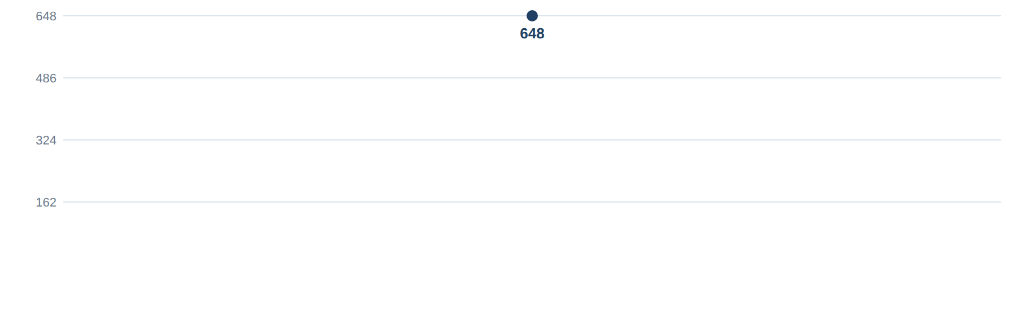
Figure 1 — Distinct URLs updated per date across the evaluation period.

2.2 Status distribution
Figure 2 and Table 2 give the same distribution two ways. Sites that are not gambling are the largest single group at 51.9 per cent, which is expected in a set assembled from broad discovery rather than from a curated list of suspected operators.
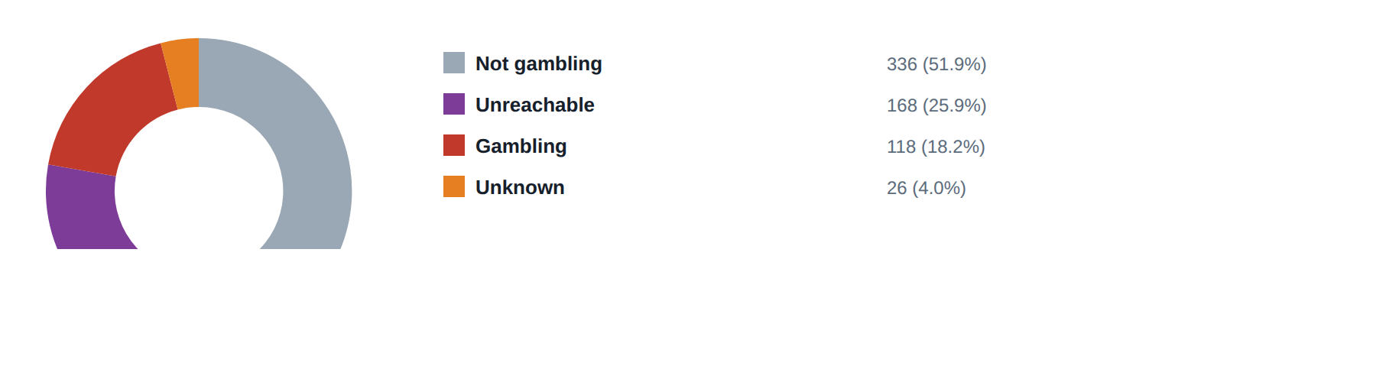
Figure 2 — Status distribution across the standard working set.
Status | Count | Per cent
Not gambling | 336 | 51.9
Unreachable | 168 | 25.9
Gambling | 118 | 18.2
Unknown | 26 | 4.0
Table 2 — Status distribution, counts and shares.

2.3 URL suffixes
Figure 3 and Table 3 rank the ten most common URL suffixes. The share of gambling sites within a suffix matters more than the raw count: a suffix carrying few URLs but a high gambling share is a cheaper enforcement target than a large general-purpose suffix.
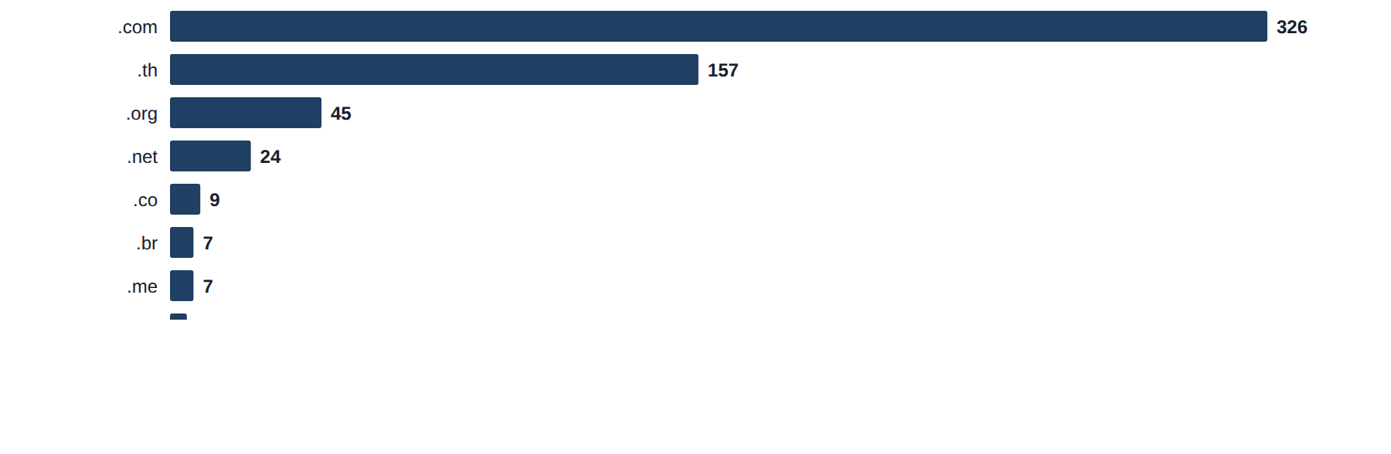
Figure 3 — The ten URL suffixes carrying the most URLs.
Suffix | Total | Per cent of all | Gambling | Per cent gambling
.com | 326 | 50.3 | 92 | 28.2
.th | 157 | 24.2 | 1 | 0.6
.org | 45 | 6.9 | 7 | 15.6
.net | 24 | 3.7 | 6 | 25.0
.co | 9 | 1.4 | 1 | 11.1
.br | 7 | 1.1 | 0 | 0.0
.me | 7 | 1.1 | 1 | 14.3
.asia | 5 | 0.8 | 0 | 0.0
.id | 4 | 0.6 | 0 | 0.0
.tv | 4 | 0.6 | 0 | 0.0
Table 3 — Top ten URL suffixes with gambling share.

3. What the gambling sites offer
Every gambling row carries exactly one product subcategory, chosen from the seven product categories in the classification reference. Where a lexicon keyword matched the evidence text the assignment is keyword-derived; where none matched, the subcategory was inferred from what the analysis reasoning described the site as offering. The two are never presented as equivalent: Figure 6 and Table 4 both carry the split.
45 of 118 gambling rows were assigned on a keyword and 73 by inference, an inferred share of 61.9 per cent. Because that exceeds 30 per cent, the lexicon has poor coverage of this dataset and the subcategory figures in this section are indicative only. A predominantly Thai-language lexicon run against a set of largely English and transliterated domains produces exactly this pattern: 26 of the 286 distinct keywords matched anything at all.

3.1 Distribution by product subcategory
The three largest subcategories are Football Betting (38 sites, 32.2 per cent), Slots (35 sites, 29.7 per cent), Casino (19 sites, 16.1 per cent). Figures 4 and 5 show the ranking and the share; Table 4 carries the counts with their assignment method and the number of distinct brand clusters each subcategory spans.
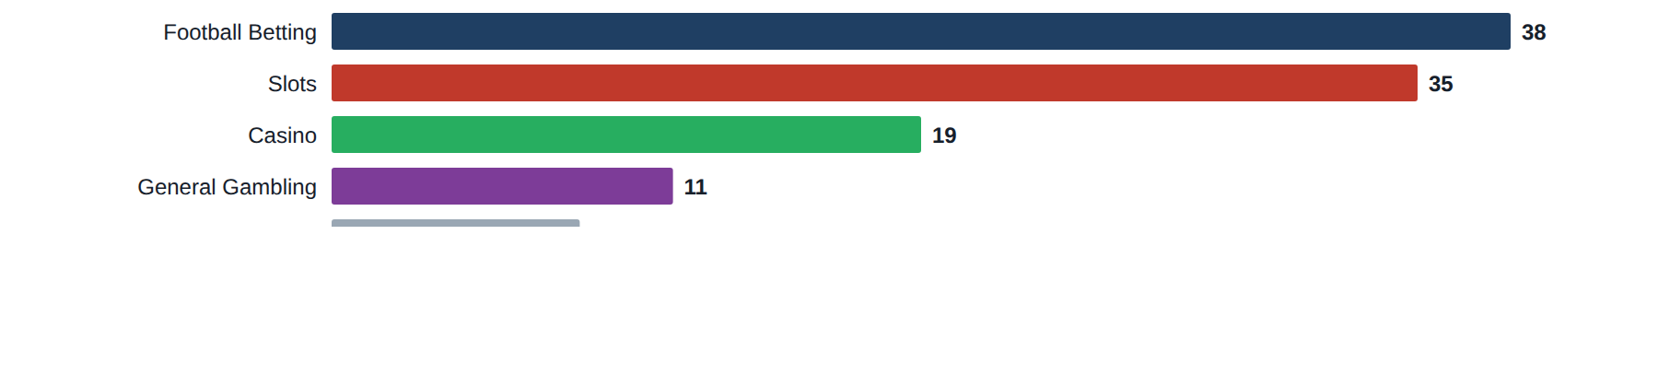
Figure 4 — Gambling sites by product subcategory, descending.
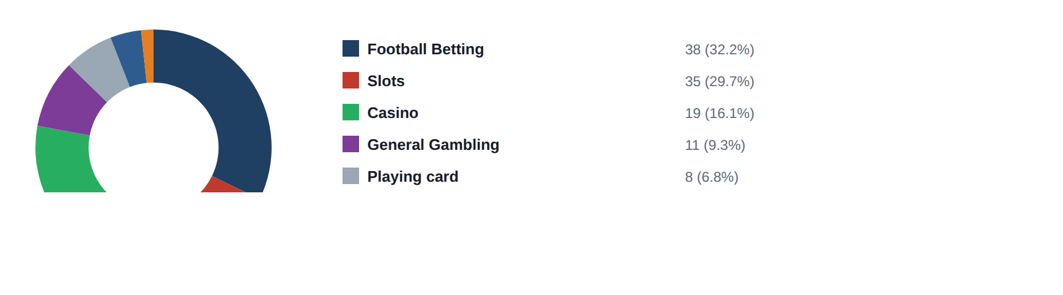
Figure 5 — Share of gambling sites held by each product subcategory.

3.2 How each subcategory was assigned
Figure 6 splits each subcategory bar into its keyword-derived and inferred portions, the inferred portion drawn in the same hue at reduced opacity. Sites confirmed as gambling without an evidenced product type fall to the General Gambling catch-all, 9.3 per cent of gambling rows; that is the correct answer for those rows rather than a failure, and no product type was guessed for them.
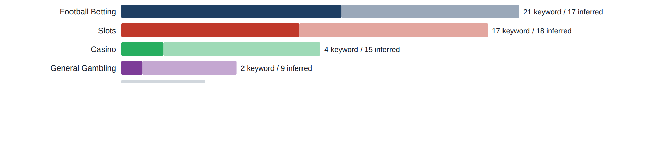
Figure 6 — Keyword-derived versus inferred subcategory assignment, by subcategory.
Subcategory | Count | Per cent of gambling | Keyword | Inferred | Clusters
Football Betting | 38 | 32.2 | 21 | 17 | 17
Slots | 35 | 29.7 | 17 | 18 | 18
Casino | 19 | 16.1 | 4 | 15 | 13
General Gambling | 11 | 9.3 | 2 | 9 | 8
Playing card | 8 | 6.8 | 0 | 8 | 6
Lottery | 5 | 4.2 | 0 | 5 | 4
Baccarat | 2 | 1.7 | 1 | 1 | 2
Table 4 — Product subcategories with assignment method and cluster spread.

3.3 Signal tags
Signal tags record how a site operates or markets itself rather than what it sells, so a site may carry several or none. Across 118 gambling rows, 78 tags were assigned, a mean of 0.66 per site. Figure 7 ranks them, led by Abbreviations at 40.7 per cent.
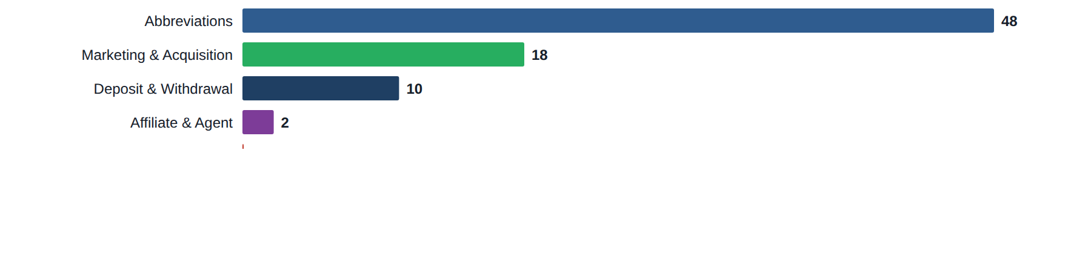
Figure 7 — Signal tags across the gambling estate.

3.4 Keyword and signal heat maps
Table 5 crosses the most frequently matched keywords against the product subcategories they were found in. Reading across a row shows whether a keyword is specific to one product or bleeds across several; a keyword carried on more than one reference category appears once per category, which is why the same term can occupy two rows. Zero cells are left as page background so that "no sites" is visually distinct from "few sites".
Keyword | Football Betting | Slots | Casino | General Gambling | Playing card | Lottery | Baccarat | Total
BET | 10 | 9 | 5 | 1 | 1 | 2 |  | 28
แทงบอล | 21 |  |  |  |  |  |  | 21
แทงบอล | 21 |  |  |  |  |  |  | 21
สล็อต |  | 17 |  |  |  |  |  | 17
สมัครสมาชิก | 3 | 9 | 2 | 1 |  |  |  | 15
สล็อตเว็บตรง |  | 13 |  |  |  |  |  | 13
WALLET |  | 6 | 4 |  |  |  |  | 10
Wallet |  | 6 | 4 |  |  |  |  | 10
RTP |  | 7 |  |  | 1 |  |  | 8
เว็บแทงบอล | 8 |  |  |  |  |  |  | 8
WIN |  | 3 | 4 |  |  |  |  | 7
VIP | 1 | 2 |  | 1 |  |  |  | 4
คาสิโน |  |  | 4 |  |  |  |  | 4
คาสิโน |  |  | 4 |  |  |  |  | 4
บอลออนไลน์ | 4 |  |  |  |  |  |  | 4
แทงบอลออนไลน์ | 4 |  |  |  |  |  |  | 4
จ่ายจริง | 3 |  |  |  |  |  |  | 3
สมาชิกใหม่ |  | 1 | 1 | 1 |  |  |  | 3
Affiliate |  | 1 |  |  |  |  |  | 1
Agent |  |  |  |  | 1 |  |  | 1
คาสิโนออนไลน์ |  |  | 1 |  |  |  |  | 1
คาสิโนออนไลน์ |  |  | 1 |  |  |  |  | 1
บาคาร่า |  |  |  |  |  |  | 1 | 1
พนัน |  |  |  | 1 |  |  |  | 1
พนันออนไลน์ |  |  |  | 1 |  |  |  | 1
Table 5 — Keyword by product subcategory; cell values are gambling sites.
Table 6 does the same for signal tags, showing which products lean on promotional, payment or evasion language.
Signal tag | Slots | Football Betting | Casino | General Gambling | Playing card | Lottery | Baccarat | Total
Abbreviations | 22 | 11 | 9 | 2 | 2 | 2 |  | 48
Marketing & Acquisition | 9 | 6 | 2 | 1 |  |  |  | 18
Deposit & Withdrawal | 6 |  | 4 |  |  |  |  | 10
Affiliate & Agent | 1 |  |  |  | 1 |  |  | 2
Hashtags |  |  |  |  |  |  |  | 0
Promotions |  |  |  |  |  |  |  | 0
Vague-Evasion Terms |  |  |  |  |  |  |  | 0
Table 6 — Signal tag by product subcategory; cell values are gambling sites.

4. Brands and clustering
Clustering collapses many domains onto the operator behind them, and it is the part of this analysis with the most direct bearing on enforcement. A row joins a cluster either because the crawler asserted a seed relationship — a variant or a redirect naming its origin — or because its name stem matches another row's. Seed linkage always wins, because it is asserted rather than inferred. A cluster is named by its shortest member stem.
The 118 gambling URLs resolve to 66 clusters: 23 hold more than one domain and 43 are singletons. The top five clusters hold 24.6 per cent of gambling URLs and the top ten 39.8 per cent, with 15 clusters needed to cover half the estate.

4.1 The largest clusters
Figure 8 ranks the fifteen largest clusters by URL count and Figure 9 plots cumulative share against cluster rank, with a reference line at half the estate. The curve is the practical result: it shows how far down the ranking enforcement has to reach before it has covered half of the gambling URLs.
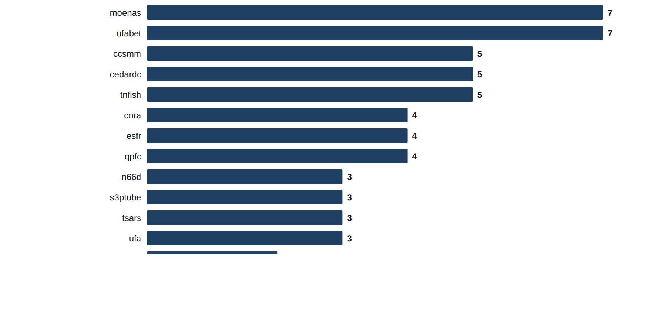
Figure 8 — The fifteen largest brand clusters by URL count.
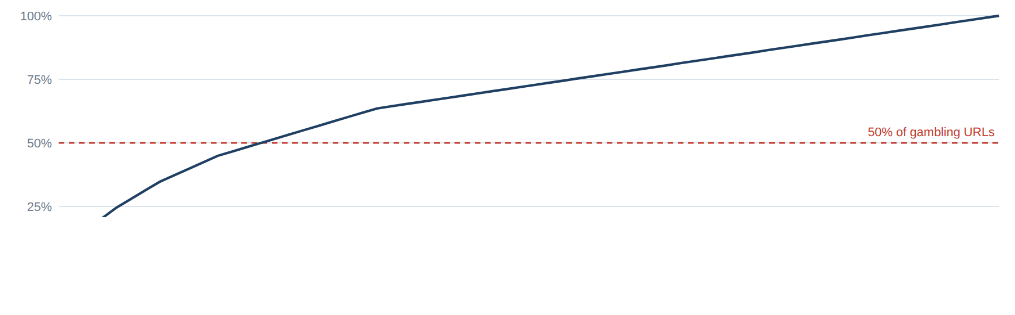
Figure 9 — Cumulative share of gambling URLs by cluster rank, with a reference line at 50 per cent.

4.2 Cluster by subcategory
Table 7 crosses the twenty largest clusters against the product subcategories. A cluster occupying more than one column is a multi-product operator; those rows read as horizontal bands.
Cluster | Football Betting | Slots | Casino | General Gambling | Playing card | Lottery | Baccarat | Total
moenas |  | 7 |  |  |  |  |  | 7
ufabet | 6 |  |  | 1 |  |  |  | 7
ccsmm | 5 |  |  |  |  |  |  | 5
cedardc |  | 5 |  |  |  |  |  | 5
tnfish | 5 |  |  |  |  |  |  | 5
cora |  |  | 4 |  |  |  |  | 4
esfr | 4 |  |  |  |  |  |  | 4
qpfc | 4 |  |  |  |  |  |  | 4
n66d |  |  |  | 3 |  |  |  | 3
s3ptube |  | 3 |  |  |  |  |  | 3
tsars |  | 3 |  |  |  |  |  | 3
ufa | 1 |  |  |  | 2 |  |  | 3
855sky |  | 2 |  |  |  |  |  | 2
aster |  |  |  |  | 2 |  |  | 2
casino |  |  | 2 |  |  |  |  | 2
fontshulaw |  |  | 2 |  |  |  |  | 2
happyluke |  |  |  |  |  | 2 |  | 2
infinitdenim |  |  |  | 2 |  |  |  | 2
lightingmetropolis | 2 |  |  |  |  |  |  | 2
mrpacho |  |  | 2 |  |  |  |  | 2
Table 7 — Brand cluster by product subcategory; cell values are URL counts.

4.3 Cluster expansion — moenas
moenas is the largest cluster, holding 7 domains across 1 product subcategory. Figure 10 draws the cluster with its member domains; edge style records why each member joined — a solid edge for an asserted seed relationship, dashed for a matching name stem, dotted for a near-miss name merge.
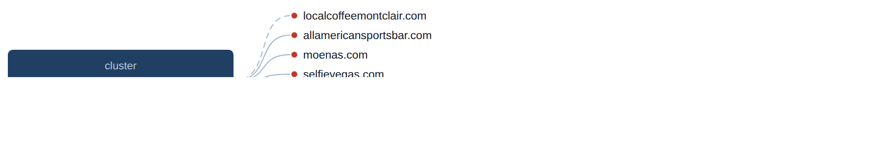
Figure 10 — Members of the moenas cluster, with the basis on which each joined.

4.4 Clusters spanning several subcategories
Table 8 lists the clusters whose members fall in more than one product subcategory. These are the operators running several product lines behind one brand family, so blocking a single product leaves the rest reachable.
Cluster | URLs | Subcategories | Suffixes
ufabet | 7 | Football Betting (6), General Gambling (1) | .global (1), .menu (1), .vet (1), .fans (1), .me (1), .associates (1), .academy (1)
ufa | 3 | Playing card (2), Football Betting (1) | .vet (1), .com (1), .club (1)
Table 8 — Clusters spanning more than one product subcategory.

4.5 Clusters rotating top-level domains
14 clusters appear under more than one top-level domain; Table 9 lists the 14 with the widest spread. Rotation of this kind is what makes per-URL blocking expensive: the operator keeps the name and changes the suffix.
Cluster | Suffixes | Counts
ufabet | .global, .menu, .vet, .fans, .me, .associates, .academy | 1, 1, 1, 1, 1, 1, 1
qpfc | .com, .info, .org | 2, 1, 1
ufa | .vet, .com, .club | 1, 1, 1
ccsmm | .net, .com | 1, 4
cedardc | .com, .org | 4, 1
tnfish | .com, .org | 4, 1
cora | .com, .org | 3, 1
esfr | .com, .org | 3, 1
n66d | .com, .dev | 2, 1
s3ptube | .com, .net | 2, 1
855sky | .com, .net | 1, 1
casino | .com, .org | 1, 1
msslot | .net, .com | 1, 1
ufagool | .com, .net | 1, 1
Table 9 — Clusters appearing under more than one top-level domain.

4.6 Possible operator linkage
Two clusters sharing an unusual signal-keyword fingerprint may be the same operator even when their names differ. This is a lead for an analyst, not a clustering decision: shared promotional vocabulary is common across unrelated operators using the same affiliate templates, and no cluster was ever merged on this signal.
No cluster pair shares a signal-keyword fingerprint of more than one term. 7 pairs reached the similarity threshold on a single shared keyword only; a one-term overlap is not a fingerprint, so those pairs are withheld rather than presented as leads.

4.7 Naming conventions
The domain names inside the largest clusters were examined for recurring structure. The findings below are drawn from those names alone.
- Recurring tokens: «bet» in 7 names, «th» in 5 names, «casino» in 2 names — evidence of a templated naming scheme.
- TLD switching: .com (53), .org (6), .net (5), .vet (2) — the operator rotates top-level domains.
- 75 distinct domains across 23 brand clusters.

4.8 How the estate is reached
Of the 118 gambling URLs, 70 (59.3 per cent) were reached directly, 48 (40.7 per cent) sit behind a redirect chain and 0 (0.0 per cent) were identified by the crawler as variants of another domain. The busiest redirect source, localcoffeemontclair.com, points at 6 distinct gambling destinations; Figure 11 draws them.
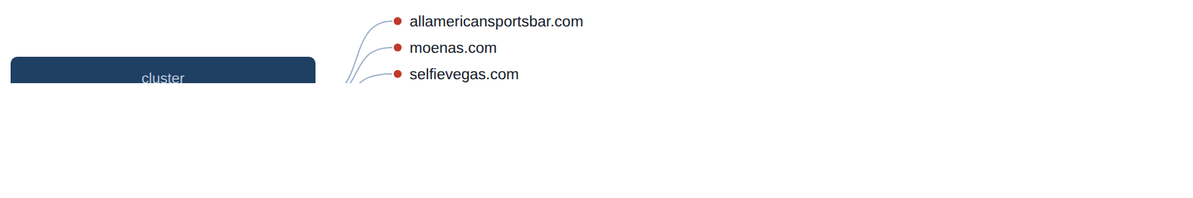
Figure 11 — Gambling destinations reached by redirect from localcoffeemontclair.com.

5. Ranking
74 gambling rows carry a numeric popularity rank. Table 10 lists the fifteen most popular, ascending. Rank is a proxy for reach, so the head of this table is where blocking removes the most traffic per action.
Rank | Domain | Cluster | Subcategory | Source
10,413 | casino.org | casino | Casino | Manual
14,494 | speed-manga.net | speedmanga | Football Betting | Manual
21,520 | casino.com | casino | Casino | Manual
25,994 | newsbtc.com | newsbtc | Casino | Manual
37,150 | roobet.com | roobet | Playing card | Manual
61,102 | dafabet.com | dafabet | Lottery | Manual
196,658 | mansionbet.com | mansionbet | General Gambling | Manual
231,062 | themecentury.com | themecentury | General Gambling | Manual
231,062 | n66d.com | themecentury | General Gambling | Redirect
231,062 | ambking1234.dev | themecentury | General Gambling | Redirect
272,990 | rabona.com | rabona | Football Betting | Manual
316,600 | cobracasino.com | cobracasino | Slots | Manual
322,801 | slotsia.com | slotsia | Slots | Manual
378,201 | tsars.com | tsars | Slots | Manual
378,201 | go2tssars.com | tsars | Slots | Redirect
Table 10 — The fifteen most popular gambling sites by numeric rank.

6. Key insights

6.1 Scale of the analysis
The standard set holds 648 distinct URLs over an evaluation period of 1 day (2026-08-27 → 2026-08-27), of which 118 are gambling sites, 336 are not gambling and 168 were unreachable.
The sample is large enough to reason about patterns, not isolated cases.

6.2 What is being offered
The three largest product subcategories are Football Betting (38 sites, 32.2 per cent), Slots (35 sites, 29.7 per cent), Casino (19 sites, 16.1 per cent). 9.3 per cent of gambling sites are confirmed as gambling without an evidenced product type. 61.9 per cent of subcategories were inferred from reasoning text rather than matched on a lexicon keyword, and 260 of the 286 distinct lexicon keywords never matched. Because the inferred share exceeds 30 per cent, the lexicon has poor coverage of this dataset and the subcategory figures are indicative only.
Football Betting leads, but at 32.2 per cent of gambling rows the estate is spread across product types rather than concentrated.

6.3 Brand clustering
66 clusters span the 118 gambling URLs; 23 hold more than one domain and 15 clusters cover half the estate. The largest, moenas, holds 7 domains across 1 product subcategory.
The estate is diffuse: 15 clusters are needed to cover half of it, so per-URL blocking will have limited leverage.

6.4 How the estate is grown and marketed
0 gambling URLs are crawler-identified variants, 48 sit behind redirect chains and 70 were reached directly. The busiest redirect source, localcoffeemontclair.com, points at 6 destinations. 14 clusters appear under more than one top-level domain. The two most common signal tags are Abbreviations (40.7 per cent) and Marketing & Acquisition (15.3 per cent).
Redirects and TLD rotation keep a stable entry point while the sites behind it are replaced.

6.5 Enforcement position
No page in this sample carries a regulatory-blocking indicator, so the set appears pre-enforcement. 5 pages matched a blocking phrase only because the crawl met an anti-bot challenge; those are access failures rather than enforcement, and are excluded from the count.
This set is a candidate for a first enforcement pass, prioritised by cluster rather than by URL.

7. Methodology
Subcategories inferred from reasoning text rather than matched on a lexicon keyword: 61.9 per cent. Gambling sites confirmed without an evidenced product type: 9.3 per cent.
Clustering thresholds: an asserted seed relationship takes precedence; otherwise rows sharing an identical name stem group together; a near-miss merge requires a Jaro–Winkler similarity of at least 0.90 with one stem a prefix of the other, and 0 such merges were applied here. Signal-keyword corroboration is reported at a Jaccard similarity of at least 0.60 and never merges clusters. Percentages are given to one decimal place.

