

Data Insights & Patterns
24,605 URLs · 4 Sep 2026 – 7 Oct 2026
Issued to | Ministry of Digital Economy and Society, Thailand
Prepared by | SICPA SA
Date of issue | 07/10/2026
Source system | SICPADetect · lexicon Gambling_Keywords_Full_English_Categories_V1

Contents
Executive Summary
Executive summary
Insights and trends
Key figures
Model Insights
Introduction
Executive Summary
Overall and per class results
Error Analysis
Segments and Confidence
Data Analysis
10 most prominent gambling sites in Thailand
10 most prominent gambling sites in Thailand
The numbers
Key counts
URLs analyzed per day
Status distribution
Top 10 URL suffixes
Subcategories
Gambling sites by product subcategory
Assignment method by subcategory
Subcategory table
Heat map — Keyword × subcategory
Heat map — Signal tag × subcategory
Brands and clustering
What brand clusters are
Cluster counts
Top 15 brand clusters by URL count
Heat map — Brand cluster × subcategory
Cluster expansion — jun
Clusters spanning multiple subcategories
Clusters rotating top-level domains
Possible operator linkage
Naming conventions
Structure: direct, redirect, variant
Redirect propagation — www.min88.top
Ranking
Gambling ranking
Key insights
Scale of the analysis
What is being offered
Brand clustering
How the estate is grown and marketed
Enforcement position

Executive Summary
Executive summary
Insights and trends
This report covers 24,605 distinct URLs analysed over a single evaluation period. Just under half of them are classified as gambling and the rest are not. The sample is large enough to describe patterns across the estate rather than individual cases.
By product type the estate leans towards casino and slots, with a further quarter confirmed as gambling but carrying no evidenced product type. These figures are indicative only: the lexicon is written in Thai while the descriptions here are predominantly English, so most assignments rest on reasoning inference rather than on a lexicon match.
The estate is diffuse rather than concentrated. 1,533 brand clusters were identified, most of them holding more than one domain, and it takes 166 of them to cover half the gambling URLs. No single operator dominates.
Growth is overwhelmingly mechanical. The great majority of gambling URLs were reached as crawler identified variants of a domain already known, a smaller group sits behind redirect chains and few were reached directly. Many clusters rotate across more than one top level domain, and provider branding is the most common signal recorded.
Volume across the 34 days of the period is uneven, concentrated in bursts rather than spread evenly. The series records when URLs were analysed, not when the sites appeared.
Enforcement is at an early stage: 7 pages in the sample already carry regulatory blocking indicators, against an estate of several thousand gambling URLs.
Key figures
Reporting figure | Value
URLs analysed | 24,605
Gambling sites | 11,648 (47.3% of the estate)
Not gambling | 12,957
Brand clusters identified | 1,533, of which 1,030 hold more than one domain
Clusters covering half the gambling URLs | 166
Largest brand cluster | jun (568 URLs, 4.9% of gambling rows)
Dominant product subcategory | Casino (3,671, 31.5% of gambling rows)
Most common signal tag | Abbreviations (3,572, 30.7% of gambling rows)
Sites showing blocking indicators | 7
Subcategory assignment: keyword versus inferred | 428 by lexicon keyword (3.7%), 11,220 by reasoning inference (96.3%)

Table 1 — Headline figures for the estate analysed.

Model Insights
Introduction
The results in this section come from a controlled test of the SICPADetect classification model. The test was run against a predefined dataset, fixed in advance so that results are consistent and can be reproduced. It was designed to measure model performance only. The test dataset is separate from, and not related to, the data examined in the Data Analysis section, so figures in this section should not be compared or combined with figures elsewhere in this report.

Executive Summary

Overall and per class results

Error Analysis

Segments and Confidence

Data Analysis

10 most prominent gambling sites in Thailand
10 most prominent gambling sites in Thailand
Rank | URL | Domain | Brand cluster | Subcategory | Thai-targeting evidence | Source
221,001 | https://suriyathai.net/ | suriyathai.net | suriya | General Gambling | Thai script: สมัครสมาชิก | Manual
733,816 | https://707jili.com/ | 707jili.com | 707jili | Slots | Thai script: สล็อตออนไลน์ สล็อตเว็บตรง | Variant · referrer: 707jili.vip
739,727 | https://play-tga.net/ | play-tga.net | playtga | Slots | Thai script: รับโบนัสทุกวัน | Manual
756,681 | https://www.9ufa.vip/ | 9ufa.vip | 9uf | General Gambling | Thai script: สมาชิกใหม่ เครดิตฟรี | Manual
779,002 | https://dreamworld777.buzz/ | dreamworld777.buzz | dreamworld | Playing card | Thai script: สล็อต | Manual
779,601 | https://e699zz.com/ | e699zz.com | e699zz | Football Betting | Thai script: ฝากจันท์ | Manual
797,918 | https://jun8891.com/ | jun8891.com | jun | Playing card | Thai script: สมัครเล่นรับ | Variant · referrer: jun8888.info
808,172 | https://meetang.cc/ | meetang.cc | meetang | Slots | Thai script: เกมสล็อตสนุกสุดฟิ๊ก | Manual
811,629 | https://mun8.com/ | mun8.com | mun | Slots | Thai currency: THB | Variant · referrer: mun89.com
811,871 | https://mst88.work/ | mst88.work | mst | Playing card | Thai script: แจกเครดิต | Redirect · referrer: mst88.site

10 otherwise eligible ranked rows were excluded because their description carried a Vietnamese-audience indicator.
Table 2 — Rank reflects search visibility in the source feed, not harm, reach or revenue.

The numbers
24,605  Total URLs analyzed | 11,648  Gambling sites | 1,533  Brand clusters identified | 34 days  Evaluation period  2026-09-04 → 2026-10-07

URLs analyzed per day
Daily count of URLs analysed across the evaluation period. Each point is one calendar day.
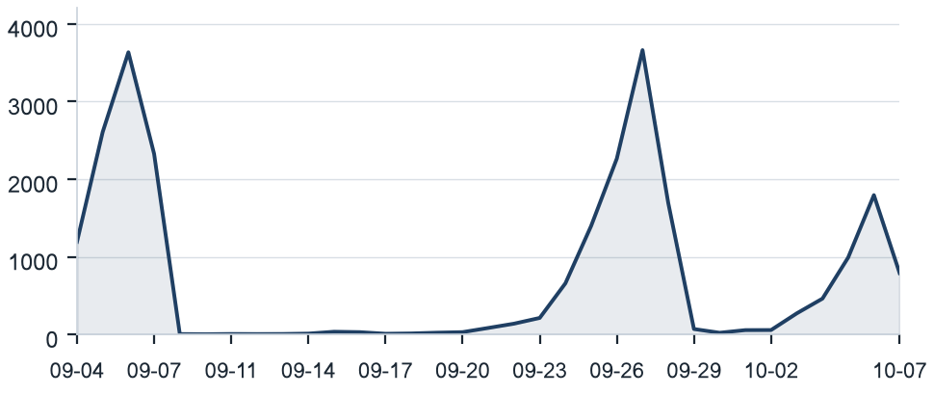
Figure 1 — URLs analysed per calendar day, 2026-09-04 to 2026-10-07.

Status distribution
Share of the estate by classification status. Each segment is one status and the table below it carries the counts.
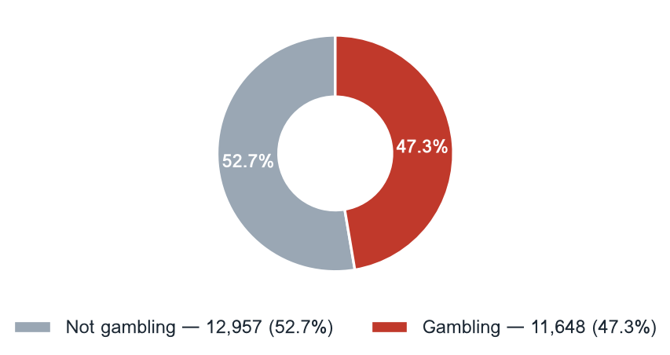
Status | Count | % of estate
Not gambling | 12,957 | 52.7%
Gambling | 11,648 | 47.3%

Figure 2 — Classification status across the standard working set.

Top 10 URL suffixes
The ten most common URL suffixes in the estate. Bar length is the total count and the table separates the gambling share.
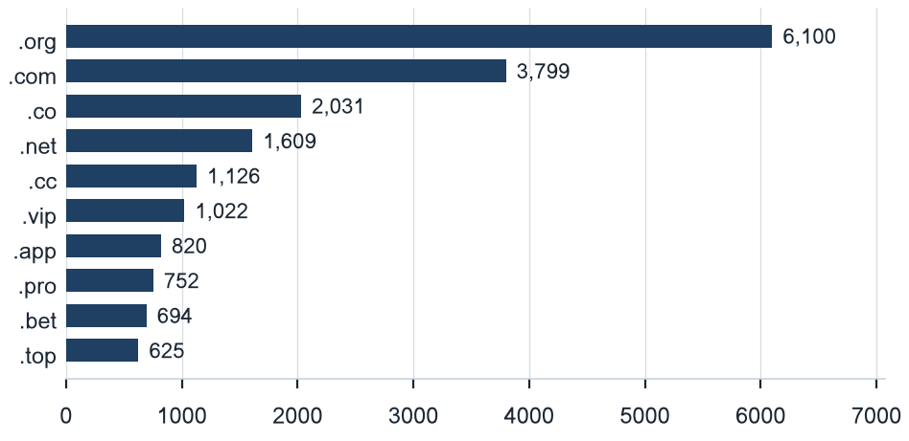
Suffix | Total | % of all | Gambling | % gambling
.org | 6,100 | 24.8% | 11 | 0.2%
.com | 3,799 | 15.4% | 1,661 | 43.7%
.co | 2,031 | 8.3% | 1,755 | 86.4%
.net | 1,609 | 6.5% | 1,034 | 64.3%
.cc | 1,126 | 4.6% | 666 | 59.1%
.vip | 1,022 | 4.2% | 925 | 90.5%
.app | 820 | 3.3% | 598 | 72.9%
.pro | 752 | 3.1% | 648 | 86.2%
.bet | 694 | 2.8% | 670 | 96.5%
.top | 625 | 2.5% | 325 | 52.0%

Figure 3 — The ten most common URL suffixes and their gambling share.

Subcategories
Gambling sites by product subcategory
Gambling sites by product subcategory. Bar length is the site count and each label carries the count and the share of gambling rows.
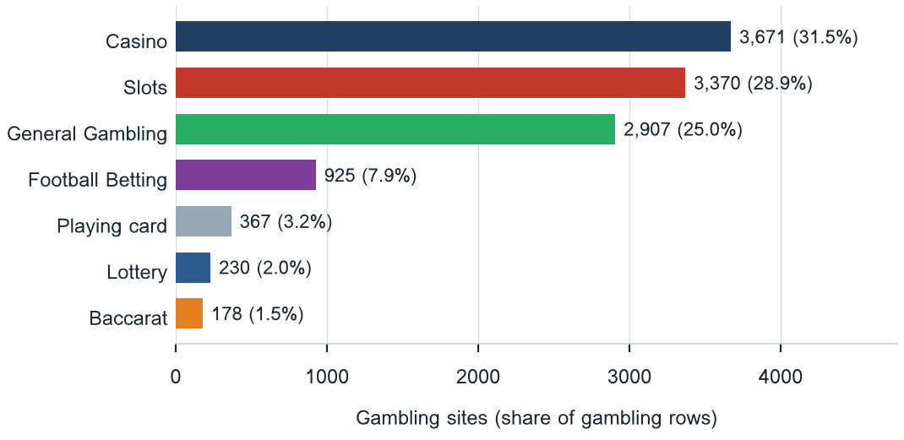
Figure 4 — Product subcategory distribution across 11,648 gambling rows.

Assignment method by subcategory
How each subcategory was assigned. Solid fill is a lexicon keyword match and the lighter fill is reasoning inference.
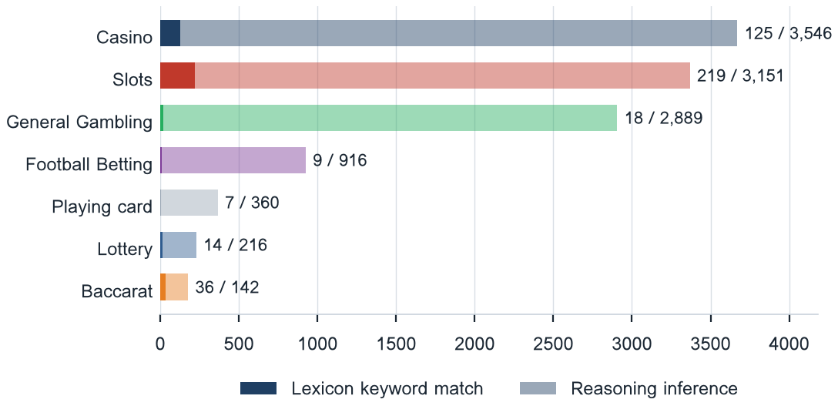
What a lexicon match means
A site is assigned by lexicon match when a word from the gambling keyword lexicon appears in what was recorded about it, in the description, the extracted keywords, the remarks of the SICPADetect automated classification pipeline, or the URL, and that word belongs to the category assigned. A description containing คาสิโน is assigned to Casino. The lexicon is the SICPADetect Thai gambling keyword lexicon, at the title page version: 286 keywords in 14 categories, mostly Thai. Seven decide the subcategory; the other seven become signal tags. A lexicon match rests on a word that can be pointed to, so it can be rechecked. An inferred assignment rests on the model's own reading and carries lower confidence. A large inferred share means the sites use vocabulary the lexicon does not cover.
Figure 5 — Inferred share 96.3%; general gambling share 25.0%. The lexicon has poor coverage of this dataset, so subcategory figures are indicative only.

Subcategory table
Subcategory | Count | % of gambling | Keyword | Inferred | Clusters
Casino | 3,671 | 31.5% | 125 | 3,546 | 868
Slots | 3,370 | 28.9% | 219 | 3,151 | 857
General Gambling | 2,907 | 25.0% | 18 | 2,889 | 725
Football Betting | 925 | 7.9% | 9 | 916 | 376
Playing card | 367 | 3.2% | 7 | 360 | 221
Lottery | 230 | 2.0% | 14 | 216 | 86
Baccarat | 178 | 1.5% | 36 | 142 | 111

Table 3 — Subcategory counts with their assignment method split and the number of distinct brand clusters in each.

Heat map — Keyword × subcategory
Matched keywords against product subcategory. Each cell is the number of gambling sites carrying that keyword in that subcategory.
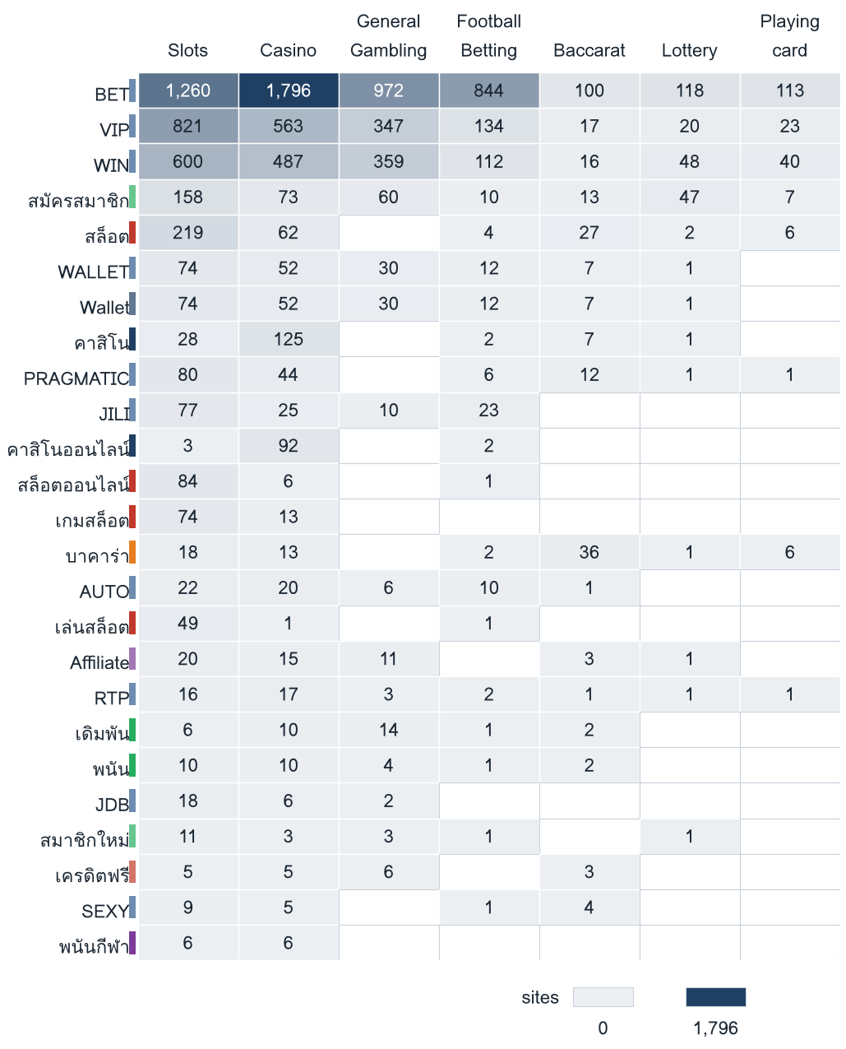
Figure 6 — The 25 most frequently matched keywords. The coloured strip beside each keyword marks its own lexicon category, so cross-category bleed is visible.

Heat map — Signal tag × subcategory
Signal tags against product subcategory. Each cell is the number of gambling sites carrying that tag in that subcategory.
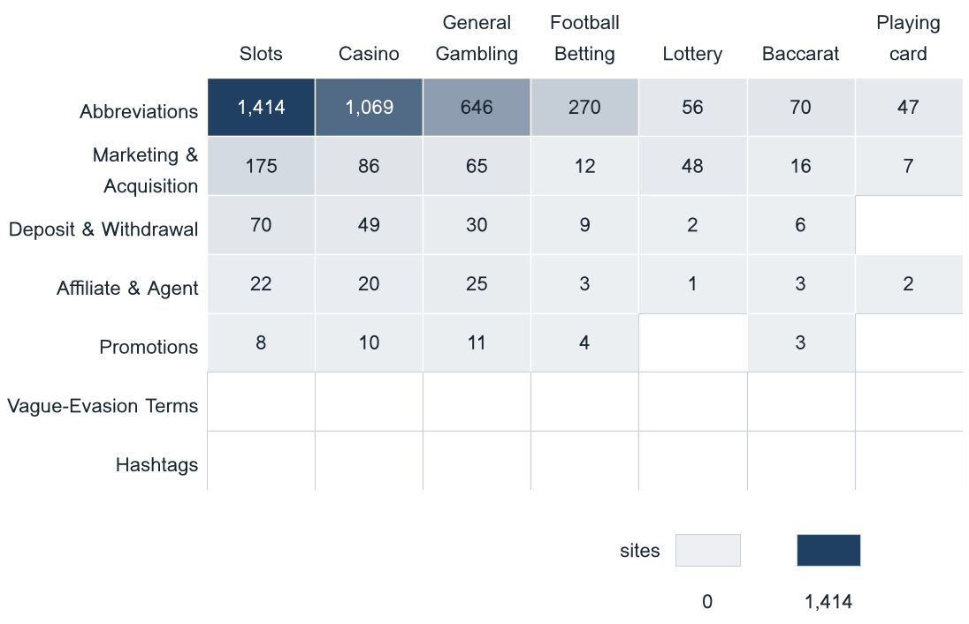
Figure 7 — Which product types lean on promotional, payment or evasion language.

Brands and clustering
What brand clusters are
What a cluster is
A brand cluster is a group of domains judged to belong to the same gambling brand or operator. Domains join in one of three ways: the crawler found one as a variant of, or a redirect from, another, which is seed linkage and the strongest basis; their names reduce to the same stem once market tags, version numbers and suffixes are removed, so www.jun88v1.org and www.juni93.com both reduce to jun; or their stems are near identical in spelling. A domain matching no other is a singleton.
Why clusters matter
Operators rarely run a single site. They register many domains, rotate top level domains and move players between them through redirects, so that when one address is blocked another takes its place. Counting URLs therefore overstates how many operators exist and hides who is behind the estate. Clustering shows how many distinct operations there are and which run several product types. That changes where enforcement has leverage: acting on a cluster reaches every domain in it, where acting on one URL leaves the rest of the brand running. Clusters are an analytical grouping based on names and crawler links, not a legal finding about ownership, and the possible operator linkage table is indicative only.

1,533  Distinct clusters | 1,030  Clusters with 2 or more URLs | 503  Singletons | 166  Clusters covering half the estate

Top 15 brand clusters by URL count
The fifteen largest brand clusters by URL count. Bar length is the number of domains in the cluster.
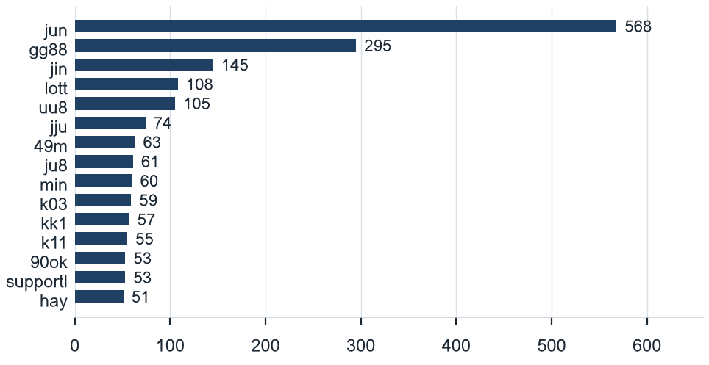
Figure 8 — Largest brand clusters among 11,648 gambling URLs.

Heat map — Brand cluster × subcategory
Brand clusters against product subcategory. Each cell is the number of URLs a cluster holds in that subcategory.
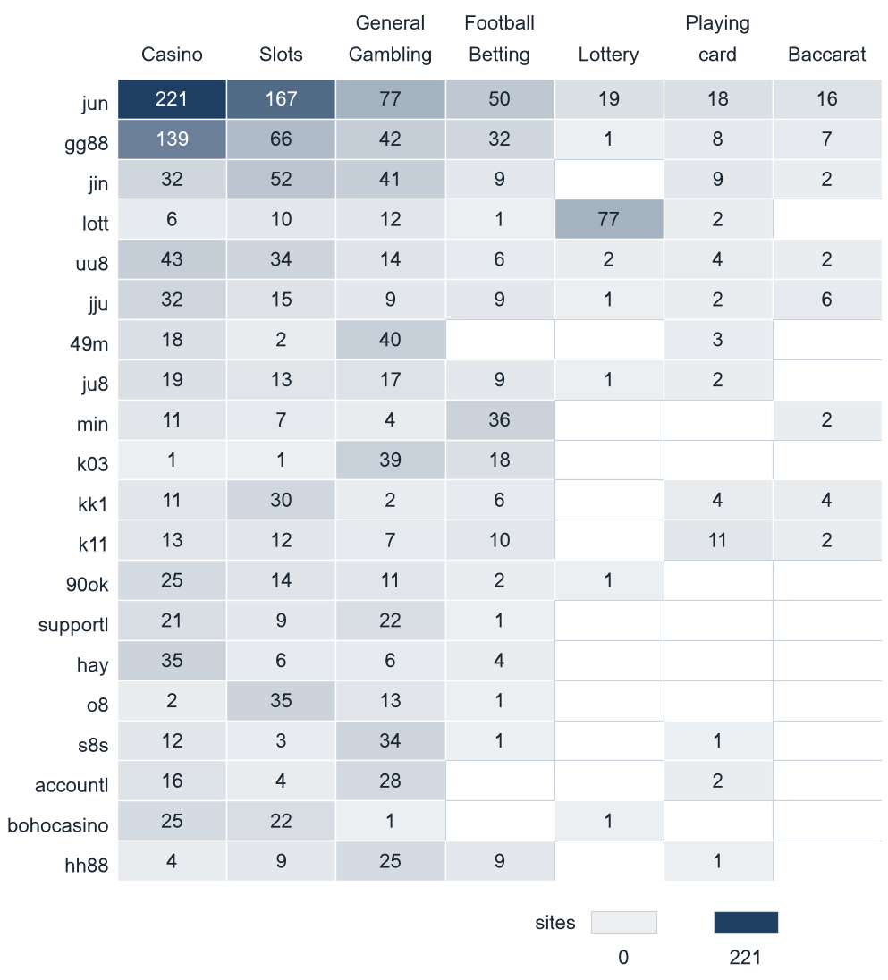
Figure 9 — The twenty largest clusters. Multi-product operators appear as horizontal bands.

Cluster expansion — jun
The largest brand cluster and its member domains. Edge style records why each domain joined the cluster.
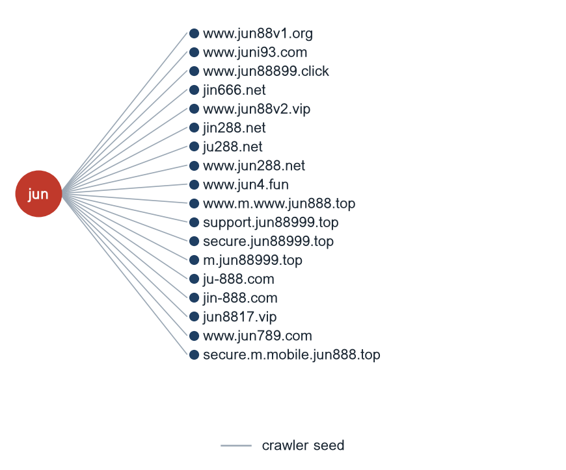
The jun cluster holds 568 URLs; the 18 domains shown are its first members by order of analysis. A further 550 are not drawn.
Figure 10 — Member domains of the largest brand cluster.

Clusters spanning multiple subcategories
Cluster | URL count | Subcategories | Suffixes
jun | 568 | Casino (221), Slots (167), General Gambling (77), Football Betting (50), Lottery (19) | .com (132), .net (90), .org (73), .top (73), .bet (38)
gg88 | 295 | Casino (139), Slots (66), General Gambling (42), Football Betting (32), Playing card (8) | .org (77), .net (55), .app (48), .pro (46), .bet (36)
jin | 145 | Slots (52), General Gambling (41), Casino (32), Football Betting (9), Playing card (9) | .com (38), .org (28), .vip (27), .co (19), .net (18)
lott | 108 | Lottery (77), General Gambling (12), Slots (10), Casino (6), Playing card (2) | .com (65), .org (22), .net (10), .live (5), .xyz (5)
uu8 | 105 | Casino (43), Slots (34), General Gambling (14), Football Betting (6), Playing card (4) | .cc (23), .org (21), .com (16), .net (14), .pro (11)
jju | 74 | Casino (32), Slots (15), General Gambling (9), Football Betting (9), Baccarat (6) | .pro (11), .xyz (10), .net (10), .com (10), .fun (9)
49m | 63 | General Gambling (40), Casino (18), Playing card (3), Slots (2) | .co (64), .org (5), .top (2), .ru (1), .cc (1)
ju8 | 61 | Casino (19), General Gambling (17), Slots (13), Football Betting (9), Playing card (2) | .com (41), .click (11), .pro (10), .buzz (7), .site (4)
min | 60 | Football Betting (36), Casino (11), Slots (7), General Gambling (4), Baccarat (2) | .com (10), .org (8), .app (6), .net (6), .co (4)
k03 | 59 | General Gambling (39), Football Betting (18), Slots (1), Casino (1) | .cc (64), .top (1), .pro (1), .info (1), .net (1)
kk1 | 57 | Slots (30), Casino (11), Football Betting (6), Playing card (4), Baccarat (4) | .org (15), .app (12), .pro (12), .me (10), .cc (6)
k11 | 55 | Casino (13), Slots (12), Playing card (11), Football Betting (10), General Gambling (7) | .org (29), .cc (14), .top (12), .pro (9), .net (8)
90ok | 53 | Casino (25), Slots (14), General Gambling (11), Football Betting (2), Lottery (1) | .org (13), .club (7), .click (5), .io (5), .bet (4)
supportl | 53 | General Gambling (22), Casino (21), Slots (9), Football Betting (1) | .org (36), .co (26), .net (16), .game (14), .com (4)
hay | 51 | Casino (35), General Gambling (6), Slots (6), Football Betting (4) | .net (61), .org (20), .com (10), .fun (5), .hu (4)

632 clusters span two or more product subcategories; the 15 largest are listed.
Table 4 — Multi-product operators.

Clusters rotating top-level domains
Cluster | Suffixes | Counts
jun | .com, .net, .org, .top, .bet, .fun | 132, 90, 73, 73, 38, 33
gg88 | .org, .net, .app, .pro, .bet, .com | 77, 55, 48, 46, 36, 36
jin | .com, .org, .vip, .co, .net, .pro | 38, 28, 27, 19, 18, 16
lott | .com, .org, .net, .live, .xyz, .online | 65, 22, 10, 5, 5, 4
uu8 | .cc, .org, .com, .net, .pro, .app | 23, 21, 16, 14, 11, 9
jju | .pro, .xyz, .net, .com, .fun, .top | 11, 10, 10, 10, 9, 7
49m | .co, .org, .top, .ru, .cc | 64, 5, 2, 1, 1
ju8 | .com, .click, .pro, .buzz, .site, .fun | 41, 11, 10, 7, 4, 3
min | .com, .org, .app, .net, .co, .in | 10, 8, 6, 6, 4, 4
k03 | .cc, .top, .pro, .info, .net | 64, 1, 1, 1, 1
kk1 | .org, .app, .pro, .me, .cc, .fun | 15, 12, 12, 10, 6, 6
k11 | .org, .cc, .top, .pro, .net, .com | 29, 14, 12, 9, 8, 8
90ok | .org, .club, .click, .io, .bet, .xyz | 13, 7, 5, 5, 4, 4
supportl | .org, .co, .net, .game, .com, .hu | 36, 26, 16, 14, 4, 3
hay | .net, .org, .com, .fun, .hu, .bet | 61, 20, 10, 5, 4, 4

1,185 clusters hold domains under more than one suffix; the 15 largest are listed.
Table 5 — Top-level domain rotation within a cluster.

Possible operator linkage
Indicative — not a clustering decision
Cluster A | Cluster B | Shared signal keywords | Jaccard
k11 | 8ok | BET, PRAGMATIC, VIP, WIN | 1.00
supportl | mun | VIP, WIN | 1.00
hay | o8 | BET, VIP, WIN | 1.00
hay | bohocasino | BET, VIP, WIN | 1.00
hay | ju7 | BET, VIP, WIN | 1.00
hay | oo7 | BET, VIP, WIN | 1.00
o8 | bohocasino | BET, VIP, WIN | 1.00
o8 | ju7 | BET, VIP, WIN | 1.00
o8 | oo7 | BET, VIP, WIN | 1.00
bohocasino | ju7 | BET, VIP, WIN | 1.00
bohocasino | oo7 | BET, VIP, WIN | 1.00
ju7 | oo7 | BET, VIP, WIN | 1.00
uu8 | mu8 | BET, PRAGMATIC, VIP, WALLET, Wallet | 0.83
ju8 | jb8 | BET, JDB, PRAGMATIC, VIP, WIN | 0.83
k11 | jb8 | BET, PRAGMATIC, VIP, WIN | 0.80

Shared promotional vocabulary is common across unrelated operators using the same affiliate templates, so these pairs are a lead for an analyst and were not merged.
Table 6 — Cluster pairs whose signal-keyword fingerprints overlap.

Naming conventions
- Recurring tokens: m. (301), mobile (194), login (182). The same tokens repeating across unrelated domains is evidence of a templated naming scheme.
- Top-level domain switching: .com (497), .org (428), .net (303), .co (206). Operators rotate top-level domains rather than registering under one.
- 2,906 distinct domains across 20 brand clusters.

125  Reached directly  1.1% | 594  Behind a redirect  5.1% | 10,929  Crawler-identified variants  93.8%

Redirect propagation — www.min88.top
The busiest redirect source and the destinations reached from it. Each node is one domain.
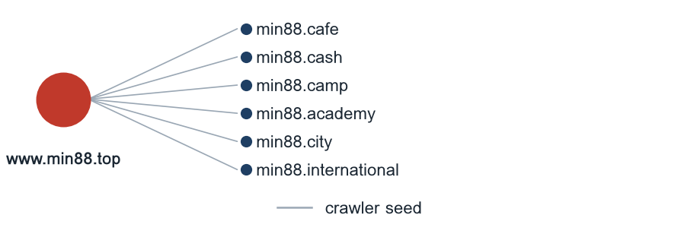
Figure 11 — Destinations reached from the busiest redirect source.

Ranking
Gambling ranking
Rank | Domain | Brand cluster | Subcategory | Source
91,874 | metal--vip.com | met | Slots | Manual
92,922 | gernpang88.com | gernpang | General Gambling | Manual
129,213 | duangpang168.com | duangpang | General Gambling | Manual
198,736 | jun88wb.com | jun88w | Casino | Variant · referrer: jun88wh.com
214,795 | allslotwallet.online | allslotwallet | Slots | Manual
219,821 | u11k.pro | u11 | Football Betting | Variant · referrer: u11k.net
221,001 | suriyathai.net | suriya | General Gambling | Manual
303,254 | jun88wf.com | jun88w | Casino | Variant · referrer: jun88wt.com
397,330 | jun88wa.com | jun88e | Casino | Variant · referrer: jun88ea.com
466,858 | jun88wc.com | jun88w | Slots | Variant · referrer: jun88wd.com
517,141 | slavinaslot.top | jun | Casino | Redirect · referrer: jun88.info
517,141 | jun88.info | jun | Casino | Variant · referrer: jun88.mobile
547,370 | 99ok.vip | 99ok | Lottery | Variant · referrer: 99ok.bet
558,790 | gg8830.com | gg88 | Slots | Variant · referrer: gg8825.app
582,212 | betwgb.com | betwgb | General Gambling | Manual

268 gambling rows carry a numeric rank; the fifteen highest ranked are listed.
Table 7 — Gambling ranking by search visibility in the source feed.

Key insights
Scale of the analysis
The analysis covers 24,605 distinct URLs over 34 days, from 2026-09-04 to 2026-10-07. Of these, 11,648 are classified as gambling, 12,957 as not gambling, and none were recorded as unreachable.
The sample is large enough to reason about patterns, not isolated cases.

What is being offered
The three largest product subcategories are Casino with 3,671 rows (31.5%); Slots with 3,370 rows (28.9%); General Gambling with 2,907 rows (25.0%). A further 25.0% of gambling rows are confirmed as gambling without an evidenced product type. 96.3% of subcategory assignments were made by reasoning inference rather than by a lexicon keyword match, and 212 of the 286 lexicon keywords never matched a single row in this sample.
Casino is the dominant product type recorded, but at 31.5% of gambling rows the estate is spread across product types rather than concentrated in one.

Brand clustering
1,533 brand clusters were identified across 11,648 gambling URLs. 1,030 of them hold more than one domain and 503 hold only one. It takes 166 clusters to cover half the gambling URLs. The largest, jun, holds 568 domains across 7 product subcategories.
The estate is diffuse: half of it is spread across 166 separate clusters, so per URL blocking will have limited leverage and enforcement needs to work at cluster level to keep pace.

How the estate is grown and marketed
10,929 gambling URLs were reached as crawler identified variants (93.8%), 594 sat behind redirect chains (5.1%) and 125 were reached directly (1.1%). The busiest redirect source is www.min88.top, reaching 6 destinations. 1,185 clusters rotate across more than one top level domain. The two most common signal tags are Abbreviations (30.7% of gambling rows) and Marketing & Acquisition (3.5% of gambling rows).
Redirects and top level domain rotation keep a stable entry point while the sites behind it are replaced.

Enforcement position
7 pages in the sample already show regulatory blocking indicators such as court orders, regulator notices or block pages, against 11,648 gambling URLs in total.
A measurable share is already under enforcement, and the remainder is a candidate for a first pass, prioritised by cluster rather than by URL.

Lexicon source: SICPADetect Thai gambling keyword lexicon, workbook Gambling_Keywords_Full_English_Categories_V1.xlsx. Lexicon version: Gambling_Keywords_Full_English_Categories_V1. Keywords per category: Football Betting 21; Slots 32; Casino 14; Lottery 20; Playing card 12; Baccarat 11; General Gambling 22; Deposit & Withdrawal 24; Promotions 27; Marketing & Acquisition 25; Affiliate & Agent 20; Vague-Evasion Terms 20; Abbreviations 22; Hashtags 21. Inferred share 96.3%. General gambling share 25.0%. Rows normalised from Licensed gambling on ingest: 0. Probable false-positive source among abbreviation matches: VIP, 46.2% of all abbreviation matches; BET, 27.6% of all abbreviation matches. Clustering thresholds: Jaro–Winkler similarity 0.90 for a near-miss merge, restricted to stems sharing a prefix; a stem under 3 characters reverts to its pre-affix form; cluster linkage pairs are reported at a Jaccard of 0.60 or above on signal-keyword sets of at least two keywords.

