

Data Insights & Patterns
29,059 URLs · 4 Sep – 18 Oct 2026
Issued to | Ministry of Digital Economy and Society, Thailand
Prepared by | SICPA SA
Date of issue | 19/10/2026
Source system | SICPADetect, lexicon version V1

Contents
Executive Summary 3
Insights and trends 3
Key figures 3
Model Insights 4
Introduction 4
Executive Summary 4
Overall and per class results 5
Error Analysis 5
Segments and Confidence 5
Data Analysis 6
10 most prominent gambling sites in Thailand 6
10 most prominent gambling sites in Thailand 6
The numbers 6
URLs analyzed per day 7
Status distribution 7
Top 10 URL suffixes 8
Subcategories 9
Gambling sites by product subcategory 9
Assignment method by subcategory 10
Subcategory table 11
Heat map: Keyword × subcategory 12
Heat map: Signal tag × subcategory 13
Brands and clustering 13
What brand clusters are 13
Top 15 brand clusters by URL count 14
Heat map: Brand cluster × subcategory 15
Cluster expansion: jun 16
Clusters spanning multiple subcategories 17
Clusters rotating top-level domains 18
Possible operator linkage 19
Naming conventions 19
Ranking 20
Gambling ranking 20
Key insights 20
Scale of the analysis 20
What is being offered 21
Brand clustering 21
How the estate is grown and marketed 21
Enforcement position 21

Executive Summary

Insights and trends
The sample holds 29,059 URLs analysed over the evaluation period, of which 13,818 are gambling sites.
Slots, General Gambling and Casino are the three largest product types. Almost all product assignments rest on reasoning inference rather than lexicon match (96.7%), so product figures are indicative only.
The gambling URLs reduce to 6,049 brand clusters, and 671 clusters cover half of them. The largest cluster is jun. Many clusters rotate across more than one top level domain.
Abbreviations and Marketing & Acquisition are the most common signal tags among gambling sites.
URL volume arrives in separate bursts with low activity between them, so the evaluation period does not support a statement of direction.
7 pages in the sample show regulatory blocking indicators.

Key figures
Figure | Value
URLs analysed | 29,059
Gambling sites and share | 13,818 (47.6%)
Not gambling and unreachable | 15,241 not gambling, 0 unreachable
Brand clusters identified | 6,049, of which 1,847 hold more than one domain
Clusters needed to cover half of gambling URLs | 671
Largest cluster | jun (400 domains)
Dominant product subcategory | Slots (25.8%)
Most common signal tag | Abbreviations (27.1%)
Sites showing blocking indicators | 7
Keyword versus inferred split | 3.3% keyword, 96.7% inferred

Model Insights

Introduction
The results in this section come from a controlled test of the SICPADetect classification model. The test was run against a predefined dataset, fixed in advance so that results are consistent and can be reproduced. It was designed to measure model performance only. The test dataset is separate from, and not related to, the data examined in the Data Analysis section, so figures in this section should not be compared or combined with figures elsewhere in this report.

Executive Summary

Overall and per class results

Error Analysis

Segments and Confidence

Data Analysis

10 most prominent gambling sites in Thailand

10 most prominent gambling sites in Thailand
Rank | URL | Domain | Brand cluster | Subcategory | Thai targeting evidence | Source
221,001 | — | suriyathai.net | suriya | General Gambling | Thai script: สมัครสมาชิก | —
254,190 | — | anthonyhead.com | anthonyhead | Casino | Thai currency: THB | —
254,190 | — | kohochocolates.com | kohochocolates | Casino | Thai currency: THB | —
293,057 | — | bifestathailand.com | bifestathailand | General Gambling | Thai currency: THB | —
293,057 | — | lgbtnewsnow.org | lgbtnewsnow | General Gambling | Thai currency: THB | —
514,501 | — | sacasino.ad | sacasino | Baccarat | Thai script: บาคาร่า | —
733,816 | — | 707jili.com | 707jili | Slots | Thai script: สล็อตออนไลน์ สล็อตเว็บตรง | —
739,727 | — | play-tga.net | playtga | Baccarat | Thai script: รับโบนัสทุกวัน | —
756,681 | — | 9ufa.vip | 9ufa | General Gambling | Thai script: สมาชิกใหม่ เครดิตฟรี | —
766,101 | — | awayge.farm | awayge | Slots | Thai script: เกมสล็อต | —

Rank reflects search visibility in the source feed, not harm, reach or revenue.

The numbers
29,059  Total URLs analyzed |  | 13,818  Gambling sites |  | 6,049  Brand clusters identified |  | 45 days  Evaluation period  4 Sep 2026 → 18 Oct 2026

URLs analyzed per day
Daily count of URLs analysed across the evaluation period. Each point is one calendar day.
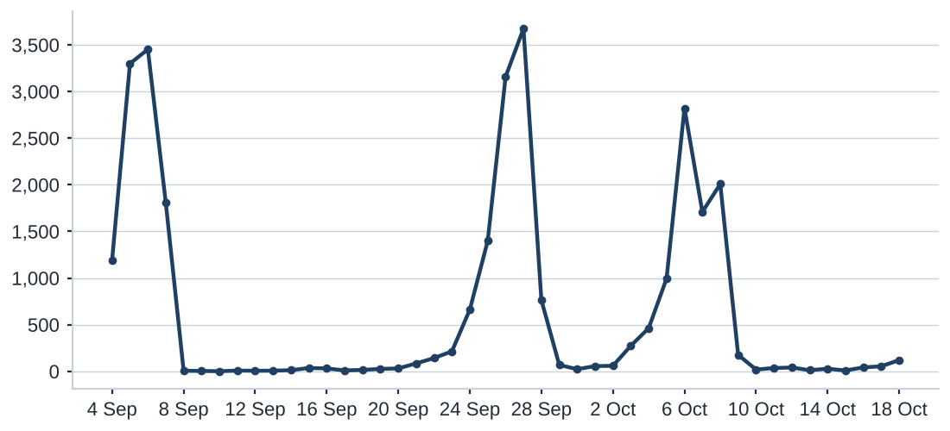

Status distribution
Share of the estate by classification status. Each segment is one status and the table carries the counts.
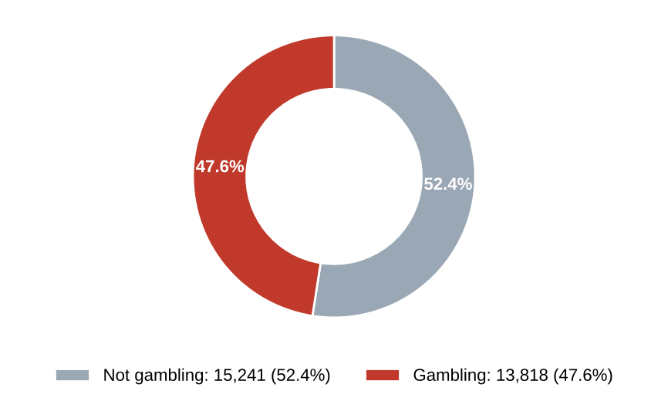
Status | Count | %
Not gambling | 15,241 | 52.4%
Gambling | 13,818 | 47.6%

Top 10 URL suffixes
The ten most common URL suffixes in the estate. Bar length is the total count and the table separates the gambling share.
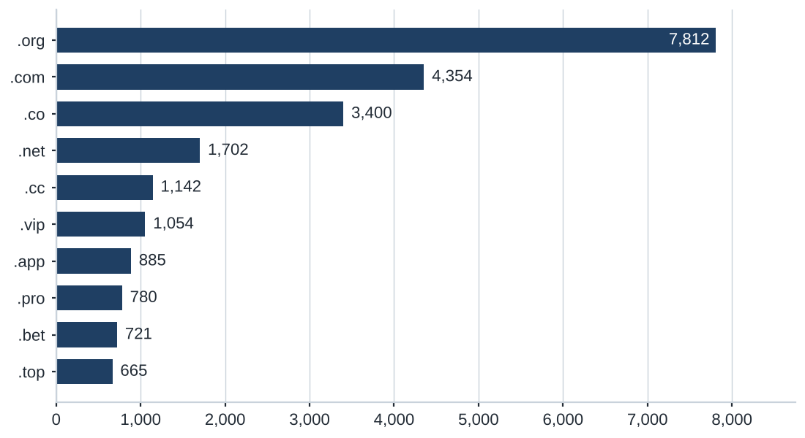
Suffix | Total | % of all | Gambling | % gambling
.org | 7,812 | 26.9% | 19 | 0.2%
.com | 4,354 | 15.0% | 2,064 | 47.4%
.co | 3,400 | 11.7% | 3,091 | 90.9%
.net | 1,702 | 5.9% | 1,082 | 63.6%
.cc | 1,142 | 3.9% | 673 | 58.9%
.vip | 1,054 | 3.6% | 952 | 90.3%
.app | 885 | 3.0% | 623 | 70.4%
.pro | 780 | 2.7% | 669 | 85.8%
.bet | 721 | 2.5% | 694 | 96.3%
.top | 665 | 2.3% | 353 | 53.1%

Subcategories

Gambling sites by product subcategory
Gambling sites by product subcategory. Bar length is the site count and each label carries the count and the share of gambling rows.
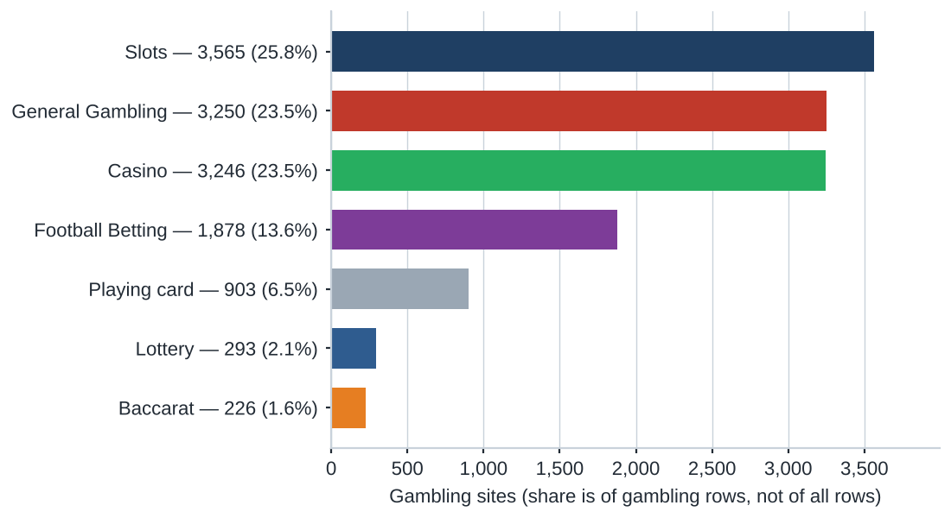
457 gambling rows (3.3%) carry no description and are recorded as Unspecified, outside the seven product subcategories.

Assignment method by subcategory
How each subcategory was assigned. Solid fill is a lexicon keyword match and the lighter fill is reasoning inference.
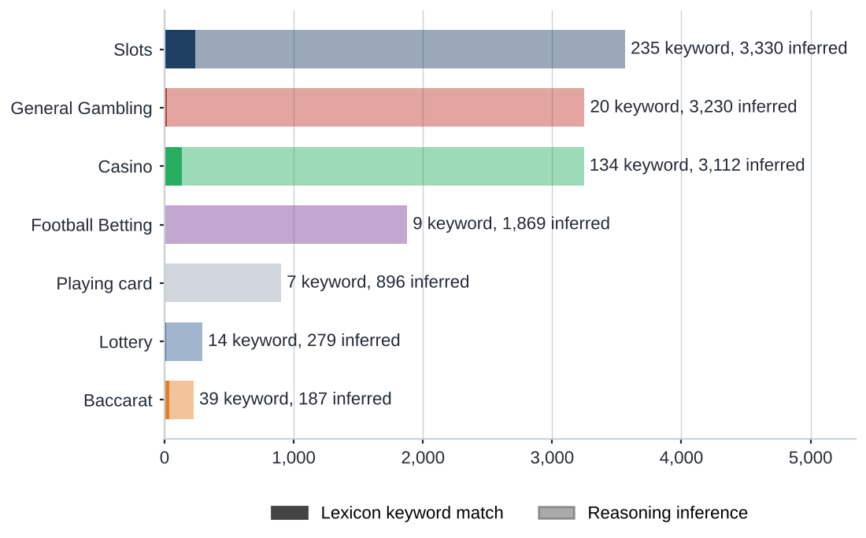
What a lexicon match means
A site is assigned to a subcategory by lexicon match when a word or phrase from the gambling keyword lexicon appears in what was recorded about the site, and that word belongs to the product category assigned. The recorded text is the model's description, extracted keywords, remarks, URL and domain. A description containing สล็อต is assigned to the category that word belongs to. The lexicon is the SICPADetect Thai gambling keyword lexicon at the version on the title page: 286 keywords in 14 categories, mostly in Thai script. Seven categories decide the subcategory and seven are reported as signal tags. A lexicon match can be checked against a specific word. An inferred assignment rests on the model's reading of its own description, so it carries lower confidence.
Inferred share 96.7%; General Gambling share 23.5%. The lexicon has poor coverage of this dataset, so subcategory figures are indicative only.

Subcategory table
Subcategory | Count | % of gambling | Keyword-assigned | Inferred | Distinct clusters
Slots | 3,565 | 25.8% | 235 | 3,330 | 2,079
General Gambling | 3,250 | 23.5% | 20 | 3,230 | 2,017
Casino | 3,246 | 23.5% | 134 | 3,112 | 1,662
Football Betting | 1,878 | 13.6% | 9 | 1,869 | 1,099
Playing card | 903 | 6.5% | 7 | 896 | 647
Unspecified | 457 | 3.3% | 0 | 457 | 412
Lottery | 293 | 2.1% | 14 | 279 | 154
Baccarat | 226 | 1.6% | 39 | 187 | 165

Heat map: Keyword × subcategory
Matched keywords against product subcategory. Each cell is the number of gambling sites carrying that keyword in that subcategory.
 |  | Slots | General Gambling | Casino | Football Betting | Playing card | Lottery | Baccarat
 | VIP (Abbreviations) | 684 | 335 | 351 | 330 | 99 | 26 | 24
 | BET (Abbreviations) | 269 | 223 | 327 | 212 | 62 | 26 | 30
 | WIN (Abbreviations) | 212 | 131 | 144 | 39 | 58 | 27 | 4
 | สมัครสมาชิก (Marketing & Acquisition) | 137 | 58 | 75 | 20 | 20 | 49 | 15
 | สล็อต (Slots) | 235 |  | 70 | 4 | 6 | 2 | 28
 | คาสิโน (Casino) | 31 |  | 134 | 2 |  | 1 | 7
 | คาสิโน (General Gambling) | 31 |  | 134 | 2 |  | 1 | 7
 | WALLET (Abbreviations) | 60 | 39 | 46 | 16 | 3 | 1 | 7
 | Wallet (Deposit & Withdrawal) | 60 | 39 | 46 | 16 | 3 | 1 | 7
 | PRAGMATIC (Abbreviations) | 49 | 28 | 43 | 17 | 4 | 1 | 13
 | คาสิโนออนไลน์ (Casino) | 4 |  | 93 | 2
 | คาสิโนออนไลน์ (General Gambling) | 4 |  | 93 | 2
 | สล็อตออนไลน์ (Slots) | 90 |  | 6 | 1
 | เกมสล็อต (Slots) | 81 |  | 13
 | บาคาร่า (Baccarat) | 19 |  | 13 | 2 | 6 | 1 | 39
 | Affiliate (Affiliate & Agent) | 35 | 10 | 14 | 3 | 1 | 1 | 3
 | JILI (Abbreviations) | 24 | 3 | 6 | 22 | 1
 | เล่นสล็อต (Slots) | 53 |  | 1 | 1
 | เดิมพัน (General Gambling) | 7 | 16 | 10 | 1 |  |  | 2
 | RTP (Abbreviations) | 16 | 3 | 2 | 3 | 1 | 2 | 1
 | พนัน (General Gambling) | 10 | 4 | 10 | 1 |  |  | 2
 | JDB (Abbreviations) | 4 | 3 | 18 |  | 1
 | AUTO (Abbreviations) | 14 | 3 | 2 | 4 |  |  | 1
 | เครดิตฟรี (Promotions) | 5 | 3 | 8 |  | 1 |  | 3
 | SEXY (Abbreviations) | 5 | 1 | 6 | 3 |  |  | 4

Scale: 1 → 684 Blank cell: no sites.
The coloured strip on each row marks the lexicon category of the keyword, shown in brackets. Sites without a product subcategory are not in a column.

Heat map: Signal tag × subcategory
Signal tags against product subcategory. Each cell is the number of gambling sites carrying that tag in that subcategory.
 |  | Slots | General Gambling | Casino | Football Betting | Playing card | Lottery | Baccarat
 | Abbreviations | 1,214 | 686 | 869 | 607 | 204 | 72 | 78
 | Marketing & Acquisition | 149 | 63 | 88 | 26 | 22 | 49 | 18
 | Deposit & Withdrawal | 61 | 40 | 47 | 16 | 3 | 2 | 7
 | Affiliate & Agent | 39 | 86 | 17 | 6 | 2 | 2 | 3
 | Promotions | 8 | 8 | 11 | 6 | 1 |  | 3
 | Vague-Evasion Terms
 | Hashtags

Scale: 1 → 1,214 Blank cell: no sites.

Brands and clustering

What brand clusters are
What a cluster is
A brand cluster is a group of domains judged to belong to the same gambling brand or operator. Domains join a cluster in one of three ways: the crawler found one as a variant or redirect of another; their names reduce to the same stem once market tags, version numbers and suffixes are removed, so jun-68.com and jun-88.app both reduce to jun; or their stems are near identical in spelling. A domain that matches no other is a singleton.
Why clusters matter
Operators rarely run a single site. They register many domains, rotate top level domains and move players between them through redirects, so that when one address is blocked another takes its place. Counting URLs therefore overstates the number of operators. Clustering shows how many distinct operations exist, how concentrated the estate is and which operators run several product types. Acting on a cluster reaches every domain in it, where acting on a single URL leaves the rest of the brand running.
Clusters are an analytical grouping based on names and crawler links, not a legal finding about ownership, and the linkage table is indicative only.

6,049  Distinct clusters |  | 1,847  Clusters with 2 or more URLs |  | 4,202  Singletons |  | 671  Clusters covering half of gambling URLs

Top 15 brand clusters by URL count
The fifteen largest brand clusters by URL count. Bar length is the number of domains in the cluster.
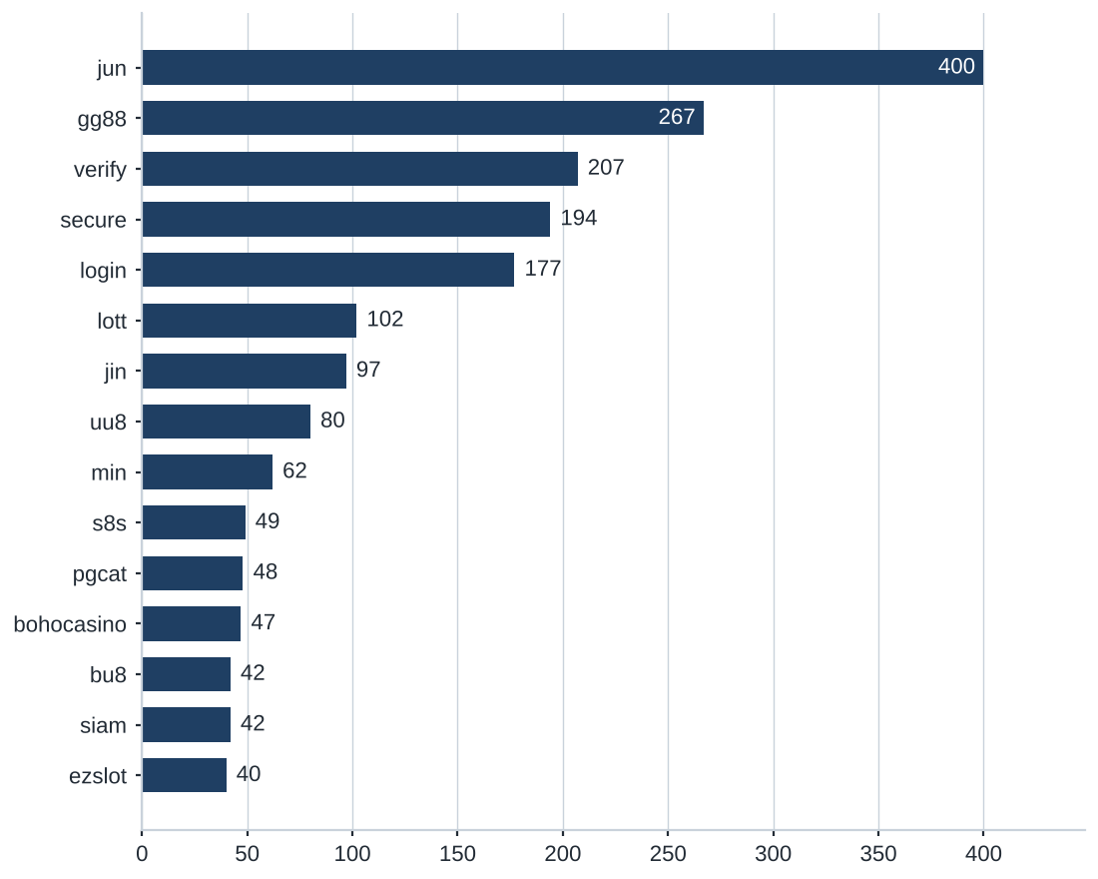

Heat map: Brand cluster × subcategory
Brand clusters against product subcategory. Each cell is the number of URLs a cluster holds in that subcategory.
 |  | Slots | General Gambling | Casino | Football Betting | Playing card | Lottery | Baccarat
 | jun | 91 | 48 | 146 | 66 | 26 | 10 | 13
 | gg88 | 50 | 37 | 119 | 40 | 9 | 1 | 11
 | verify | 73 | 64 | 25 | 32 | 10 | 3
 | secure | 63 | 68 | 23 | 28 | 11 | 1
 | login | 56 | 60 | 26 | 21 | 8 | 6
 | lott | 4 | 11 | 5 | 1 | 6 | 73 | 1
 | jin | 30 | 26 | 21 | 5 | 15
 | uu8 | 24 | 9 | 26 | 12 | 2 | 2 | 5
 | min | 4 | 1 | 10 | 41 | 4 | 1 | 1
 | s8s | 2 | 33 | 13 |  | 1
 | pgcat | 31 | 3 | 7 | 2 |  |  | 5
 | bohocasino | 8 | 1 | 38
 | bu8 | 3 | 3 | 32 | 3 |  | 1
 | siam | 7 | 30 | 3 |  |  | 2
 | ezslot | 26 |  | 5 | 8 |  |  | 1
 | jju | 8 | 3 | 18 | 5 |  | 1 | 5
 | yes | 7 | 22 | 7 |  | 4
 | supportmo | 11 | 14 | 6 | 4 | 3 | 1
 | supportj | 13 | 11 | 3 | 5 | 3 | 3
 | ju88 | 9 | 8 | 12 | 5 | 2 | 1

Scale: 1 → 146 Blank cell: no sites.
The twenty largest clusters are shown. Rows follow cluster size.

Cluster expansion: jun
The largest brand cluster and a sample of its member domains. Edge style records why each domain joined the cluster.
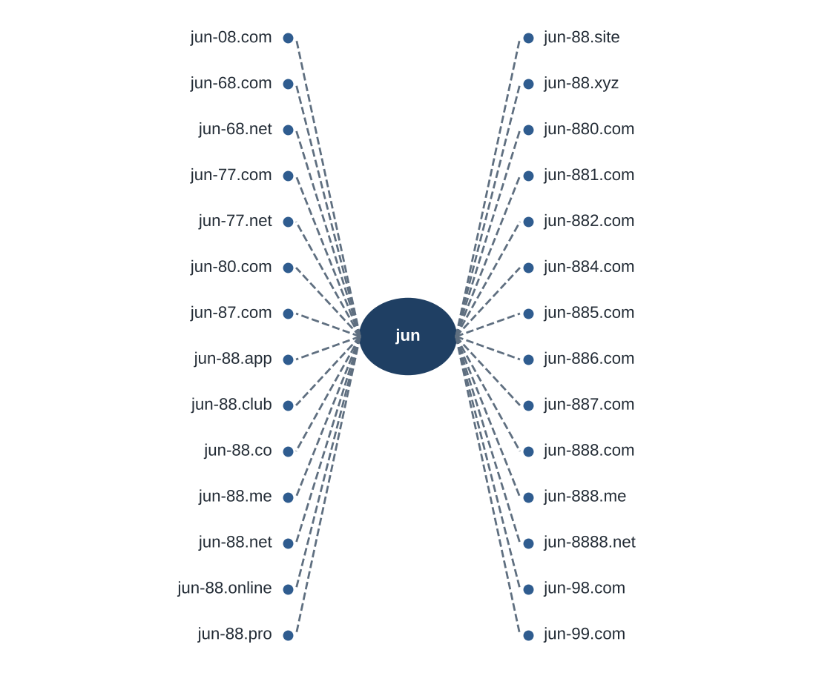
Dashed edges join domains whose stem matches the cluster name, dotted edges join domains merged on spelling similarity. 28 of 400 member domains are shown.

Clusters spanning multiple subcategories
Cluster | URLs | Subcategories | Suffixes
jun | 400 | Casino 146, Slots 91, Football Betting 66, General Gambling 48, Playing card 26, Baccarat 13, Lottery 10 | .com, .net, .bet, .top …
gg88 | 267 | Casino 119, Slots 50, Football Betting 40, General Gambling 37, Baccarat 11, Playing card 9, Lottery 1 | .net, .app, .pro, .bet …
verify | 207 | Slots 73, General Gambling 64, Football Betting 32, Casino 25, Playing card 10, Lottery 3 | .cc, .co, .com, .game …
secure | 194 | General Gambling 68, Slots 63, Football Betting 28, Casino 23, Playing card 11, Lottery 1 | .co, .cc, .com, .net …
login | 177 | General Gambling 60, Slots 56, Casino 26, Football Betting 21, Playing card 8, Lottery 6 | .cc, .co, .com, .game …
lott | 102 | Lottery 73, General Gambling 11, Playing card 6, Casino 5, Slots 4, Football Betting 1, Baccarat 1 | .com, .net, .cc, .live …
jin | 97 | Slots 30, General Gambling 26, Casino 21, Playing card 15, Football Betting 5 | .com, .co, .net, .vip …
uu8 | 80 | Casino 26, Slots 24, Football Betting 12, General Gambling 9, Baccarat 5, Lottery 2, Playing card 2 | .net, .com, .cc, .pro …
min | 62 | Football Betting 41, Casino 10, Playing card 4, Slots 4, Baccarat 1, Lottery 1, General Gambling 1 | .net, .com, .app, .vip …
s8s | 49 | General Gambling 33, Casino 13, Slots 2, Playing card 1 | .com
pgcat | 48 | Slots 31, Casino 7, Baccarat 5, General Gambling 3, Football Betting 2 | .com, .info, .bet, .buzz …
bohocasino | 47 | Casino 38, Slots 8, General Gambling 1 | .com, .info, .co, .net …
bu8 | 42 | Casino 32, Football Betting 3, Slots 3, General Gambling 3, Lottery 1 | .com, .app, .bid, .cab …
siam | 42 | General Gambling 30, Slots 7, Casino 3, Lottery 2 | .com, .co, .io, .net …
ezslot | 40 | Slots 26, Football Betting 8, Casino 5, Baccarat 1 | .bet, .live, .me, .info …

1,272 clusters span two or more product subcategories. The fifteen largest are listed.

Clusters rotating top-level domains
Cluster | Suffixes | Counts
jun | 30 | .com 71, .net 53, .bet 32, .top 30, .app 25 …
gg88 | 19 | .net 46, .app 43, .pro 41, .bet 31, .com 28 …
verify | 17 | .cc 45, .co 29, .com 25, .game 18, .net 17 …
secure | 16 | .co 42, .cc 34, .com 22, .net 17, .game 17 …
login | 15 | .cc 37, .co 30, .com 20, .game 18, .net 15 …
lott | 16 | .com 61, .net 6, .cc 5, .live 4, .online 4 …
jin | 19 | .com 16, .co 14, .net 13, .vip 12, .bet 7 …
uu8 | 23 | .net 9, .com 9, .cc 8, .pro 7, .app 6 …
min | 29 | .net 7, .com 6, .app 4, .vip 3, .actor 2 …
pgcat | 14 | .com 25, .info 3, .bet 2, .buzz 2, .click 2 …
bohocasino | 15 | .com 29, .info 3, .co 2, .net 2, .app 1 …
bu8 | 21 | .com 6, .app 2, .bid 2, .cab 2, .club 2 …
siam | 11 | .com 27, .co 2, .io 2, .net 2, .shop 2 …
ezslot | 17 | .bet 4, .live 4, .me 4, .info 3, .club 2 …
jju | 14 | .com 5, .net 5, .xyz 5, .pro 4, .co 4 …

953 clusters use two or more suffixes. The fifteen largest are listed.

Possible operator linkage
Indicative, not a clustering decision
Cluster A | Cluster B | Shared keywords | Jaccard
ko9 | n98vip | BET, WALLET, WIN, Wallet, สมัครสมาชิก | 1.00
jon | kh88 | BET, WALLET, Wallet, สมัครสมาชิก | 1.00
jon | kjun | BET, WALLET, Wallet, สมัครสมาชิก | 1.00
kh88 | kjun | BET, WALLET, Wallet, สมัครสมาชิก | 1.00
hun | jn789 | WALLET, Wallet, สมัครสมาชิก | 1.00
uu8 | mu8 | BET, PRAGMATIC, VIP, WALLET, WIN, Wallet | 1.00
supportj | accountj | BET, VIP, WIN, สมัครสมาชิก | 1.00
bu8 | hh88 | Affiliate, BET, VIP, WIN | 1.00
supportj | ib8 | BET, VIP, WIN, สมัครสมาชิก | 1.00
accountj | ib8 | BET, VIP, WIN, สมัครสมาชิก | 1.00

8,225 cluster pairs share a signal keyword set with Jaccard similarity of 0.60 or more. The ten with the most distinctive shared keywords are listed. Shared promotional vocabulary is common across unrelated operators.

Naming conventions
Recurring tokens in the domain names of the fifteen largest clusters: login (224 names), m. (218 names), verify (207 names). The pattern is consistent with a templated naming scheme.
Domain names in the largest clusters span several suffixes, led by .com (394), .net (188), .cc (156), .co (145). Operators rotate top level domains.
1,854 distinct domains across the 15 largest brand clusters.

Ranking

Gambling ranking
Rank | Domain | Brand cluster | Subcategory | Source
79,472 | betway.mw | betway | Football Betting | —
88,464 | chibi-manga.com | chibimanga | Casino | —
91,874 | metal--vip.com | met | Slots | —
92,922 | gernpang88.com | gernpang | General Gambling | —
129,213 | duangpang168.com | duangpang | General Gambling | —
198,736 | jun88wb.com | jun88w | Casino | —
214,795 | allslotwallet.online | allslotwallet | Slots | —
219,821 | u11k.pro | u11 | Football Betting | —
221,001 | suriyathai.net | suriya | General Gambling | —
254,190 | anthonyhead.com | anthonyhead | Casino | —
254,190 | kohochocolates.com | kohochocolates | Casino | —
293,057 | bifestathailand.com | bifestathailand | General Gambling | —
293,057 | lgbtnewsnow.org | lgbtnewsnow | General Gambling | —
303,254 | jun88wf.com | jun88w | Casino | —
397,330 | jun88wa.com | jun88w | Casino | —

Rank reflects search visibility in the source feed. The fifteen best ranked gambling rows are listed.

Key insights

Scale of the analysis
The analysis covers 29,059 distinct URLs over 45 days, from 4 Sep 2026 to 18 Oct 2026. Of these, 13,818 are gambling, 15,241 are not gambling and 0 are unreachable.
The sample is large enough to reason about patterns, not isolated cases.

What is being offered
The three largest product subcategories are Slots (3,565, 25.8%), General Gambling (3,250, 23.5%), Casino (3,246, 23.5%). 23.5% of gambling sites are confirmed as gambling without an evidenced product type, and 96.7% of subcategory assignments are inferred rather than matched to a lexicon keyword. 209 lexicon entries never matched a gambling site.
Slots is the dominant product type, and it holds under 40% of gambling rows, so the estate is spread across product types rather than concentrated.

Brand clustering
13,818 gambling URLs reduce to 6,049 clusters. 1,847 hold more than one domain, and 671 clusters cover half of the estate. The largest, jun, holds 400 domains across 7 subcategories.
The estate is diffuse and per URL blocking will have limited leverage.

How the estate is grown and marketed
953 clusters rotate across more than one top level domain. The two most common signal tags are Abbreviations (27.1%) and Marketing & Acquisition (3.0%). The source feed carries no variant or redirect structure for this sample, so none is reported.
Rotation across top level domains keeps a stable brand while the addresses behind it are replaced.

Enforcement position
7 pages already show regulatory blocking indicators, such as court orders, regulator notices or block pages.
A measurable share is already under enforcement.

Lexicon source: Gambling_Keywords_Full_English_Categories_V1.xlsx, version V1; keywords per category: Football Betting 21; Slots 32; Casino 14; Lottery 20; Playing card 12; Baccarat 11; General Gambling 22; Deposit & Withdrawal 24; Promotions 27; Marketing & Acquisition 25; Affiliate & Agent 20; Vague-Evasion Terms 20; Abbreviations 22; Hashtags 21. Inferred share 96.7%; General Gambling share 23.5%. Rows normalised from Licensed gambling: 0. VIP accounts for 44.9% of Abbreviations matches and is a probable false positive source. BET accounts for 28.0% of Abbreviations matches and is a probable false positive source. Two letter abbreviations were counted only as standalone domain tokens. Clustering thresholds: Jaro Winkler similarity 0.90 with prefix relation, stems of 3 or more characters; operator linkage Jaccard 0.60.

