Freeze-Dryer Operating Procedures

**Purpose**: Freeze-drying, also known as lyophilisation, is a low temperature dehydration process, which involves freezing samples, then removing the ice by sublimation under vacuum. This is in contrast to dehydration by most conventional methods that evaporate water using heat.

**Preparing samples to freeze-dry:**

* Ideal samples are as dry as possible prior to freezing. High surface area to volume ratios, preferred.
* Samples should be frozen, preferably at -20ºC for 24 hrs prior to freeze drying.
* Load samples onto sample tray, making sure the containers remain open (e.g., if using a whirlpak bag). Keep tray with loaded samples in freezer until ready to load in freeze dryer.

**Start Up**

* Assure that freeze dryer is dry prior to starting and plexiglas disk with orange gaskets is on top of the freeze dryer (inner lip face down) (Fig. 1).

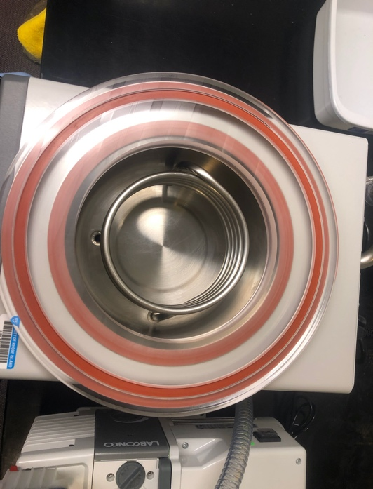Fig. 1) Plexiglas disk with only one orange gasket be facing up (not two!).

Fig. 2) Rubber stopper should be placed securely into the drain hose.

* Assure that stopper and securely placed into the drain hose (Fig. 2)
* Assure that all valves on the sample container manifold are in the closed position (bevel facing up) (Fig. 3).

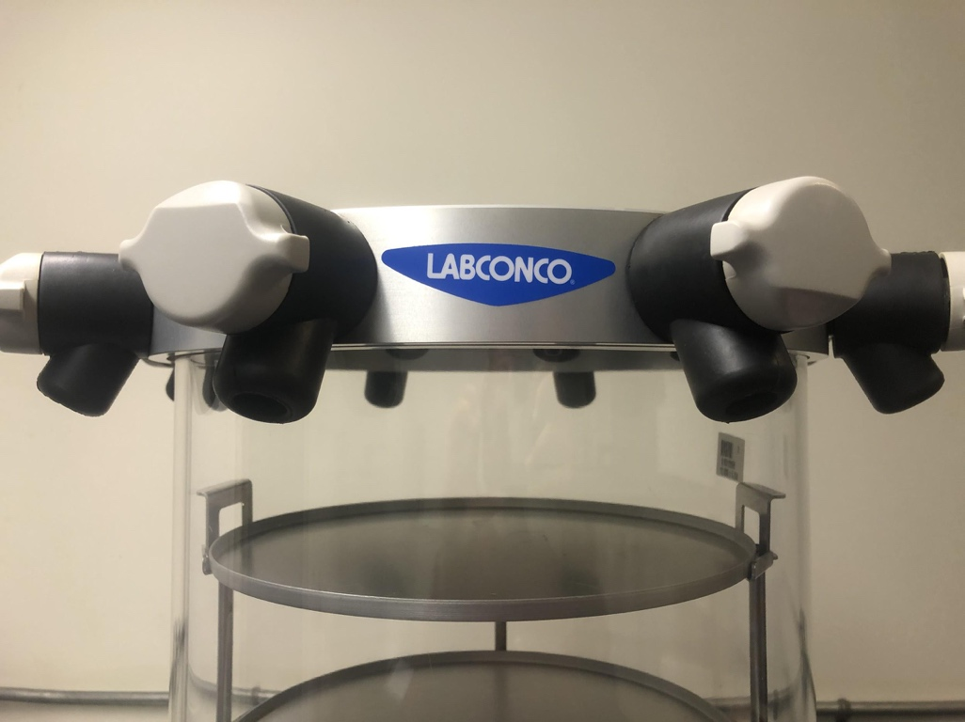Fig. 3) The valve on the left is sealed, with the bevel facing up, the valve on the right is open, with the bevel facing down. To freeze-dry, all valves should be in the closed position (left).

* Turn on freeze dryer with black switch on the lower right side of the unit.

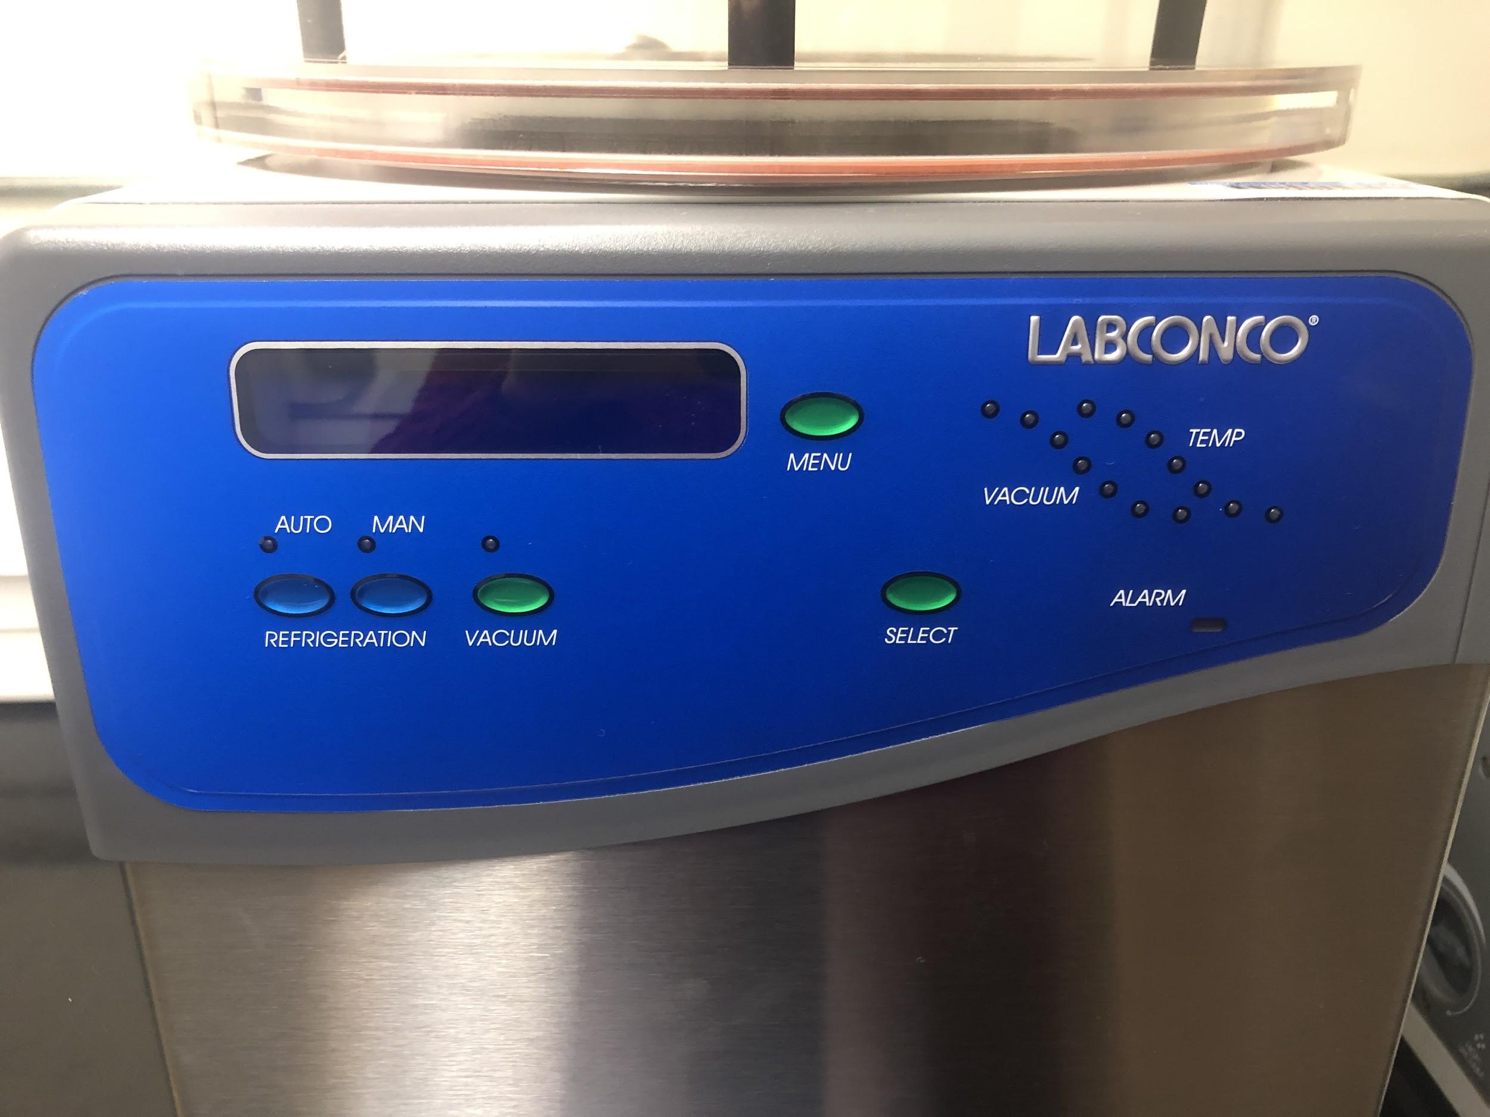

Fig. 4) Freeze-dryer user interface.

* Press panel switch labeled REFRIGERATION AUTO (green LED above will light up).
  + Temp will ramp down to -40°C and then kick on the vacuum pump automatically.
  + While temp is decreasing, remove tray of samples from freezer, place shelving unit on the Plexiglas disk, and place plexiglas cylinder with metal manifold on top of the disk.

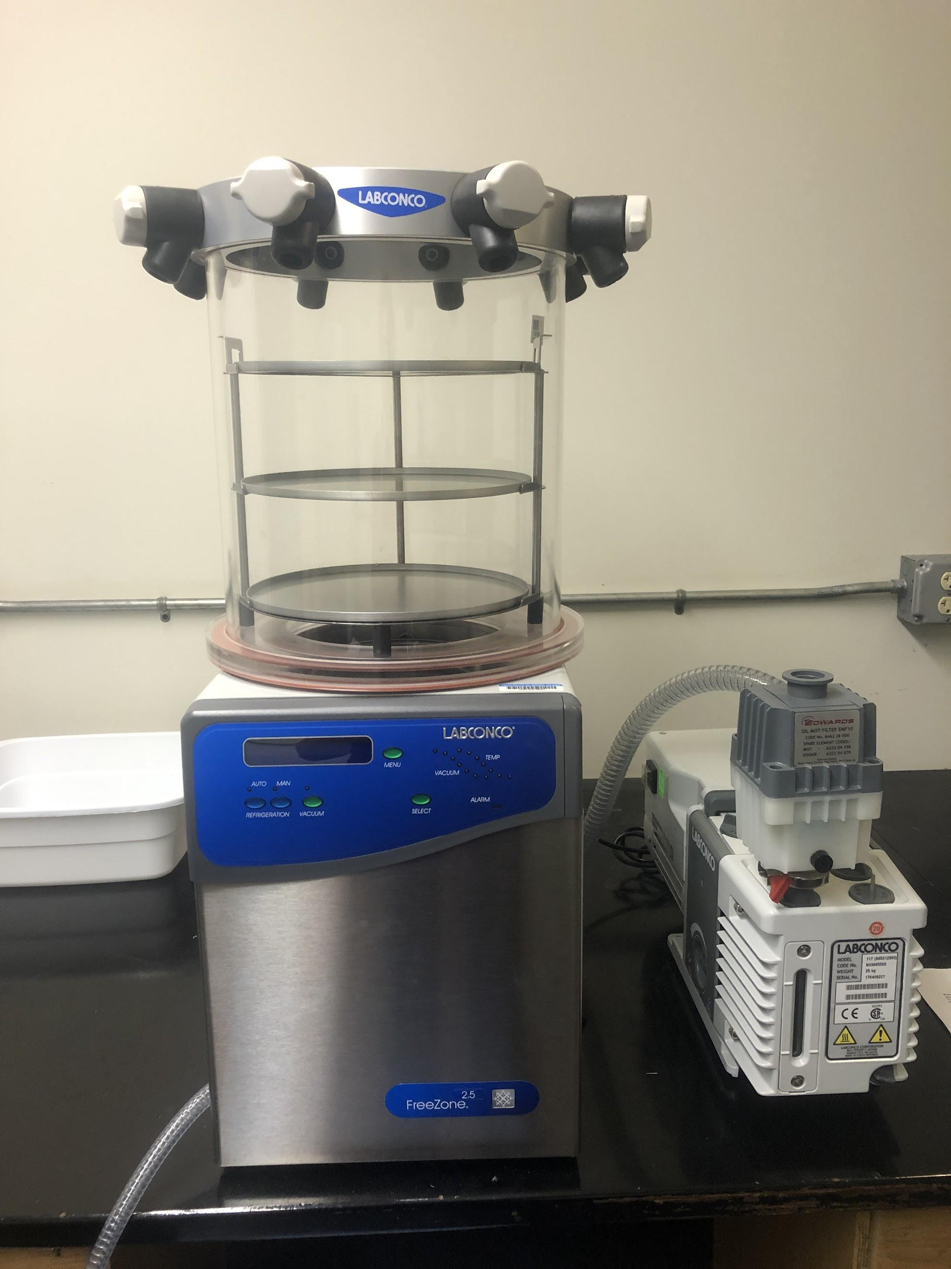

Metal manifold

Shelving Unit

Plexiglas cylinder

Plexiglas disk

* + Vacuum pump will take ~5 minutes to get down to pressure. Pressure >5mBar will read as “Hi”, <5mBar will show actual pressure. Green light will flash when pressure is between 0.450 and 0.133 mBar. Green light will be solid below 0.133 mBar.
* Allow time for samples to freeze dry. Typically 24-72 hrs depending on sample type/size.

**Shut Down**

* Press VACUUM button to shut off vacuum, then press the REFRIGERATION AUTO button to shut off refrigeration, then turn off entire freeze dryer with switch on the bottom right side.
* Release pressure from chamber by opening one valve on manifold gradually. Note: release vacuum slowly at first to prevent samples from flying around inside the chamber.

**Defrosting**

* Let machine sit at ambient temperature to defrost, warming too quick could cause cracking.
* When all ice has melted, put drain hose in bucket and remove black plug to drain.
* Remove Plexiglas cylinder and Plexiglas disk, rinse with DI water to remove any residue, and wipe the chamber and Plexiglas components dry (use the cloth in the drawer next to the machine).
* After draining is done, reinstall drain hose plug.