Helpful tips can be found here: <https://stableisotopefacility.ucdavis.edu/13cand15ntips.html>

**Dry and grind your samples**

* Solid samples should be freeze-dried (preferable) or oven-dried at 50-60°C. Note "Over dry" samples will "gain weight" as it absorbs moisture from the air. The material should be allowed to acclimate to the ambient humidity for a few days to get proper weights. Moist samples (bad) will be sticky, clumpy, difficult to grind, or may "lose weight" when it is weighed on a microbalance as it loses moisture to the air.
* Small samples that meet the target weight, such as leaf disks, sections of root, small insects, or fish scales, can be encapsulated whole into tin (Sn) capsules. Anytime you are measuring a subsample (i.e., not the entire sample), it is important to homogenize the sample by grinding it in a clean mortar and pestle. Mortar and pestles should be cleaned with ethanol and a kim wipe between each sample

**Preparing to encapsulate your samples**

Two pairs of forceps and a small spatula

Microbalance that reads to tenths of mg at least

Appropriate capsules (tin for Cand N, silver for acid fumed)

96, 48 or 32 position polystyrene trays (dependent on sample size)

Laboratory kim wipes and ethanol

Lab notebook or computer to record weights

* All samples must be enclosed in tin (Sn) capsules for analysis of C and N, or silver (Ag) if they are acid fumed in the capsule. *DO NOT* use of any alternative capsule (e.g. nickel (Ni)).
* The amount of sample to be weighed depends on the amount of carbon and nitrogen in the dried material. A sample should contain between 20-150µg N and 200-2000µg C. Use the UC Davis Sample Weight Calculator to determine appropriate sample weights: <https://stableisotopefacility.ucdavis.edu/sample-weight-calculator.html>
* Set up your weigh station: Make sure the counter space, microbalance, and weighing forceps and scoops are cleaned with ethanol and kim wipe before and after each sample. Place a clean sheet of weigh paper on the balance to catch potential spills. Replace between each new sample.

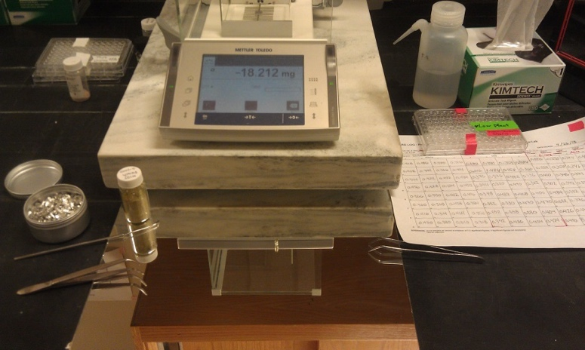

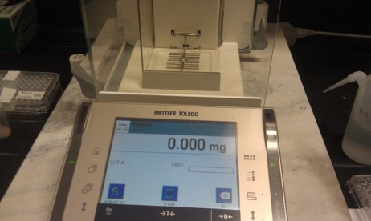**Weighing and packaging samples:**

1. Using forceps, place an empty tin capsule on the balance and hit Tare to zero the weight (note, keep the container of tin capsules closed when not in use to minimize contamination)
2. 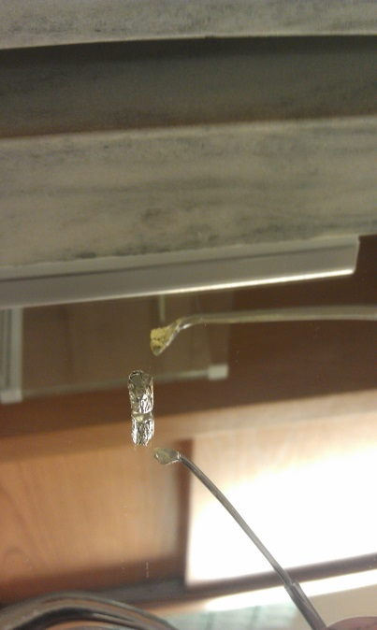Using forceps, remove the capsule and place it on a sheet of weigh paper on the bench in next to the microbalance. Carefully add a small scoop of your material into the capsule. To get all the material off your scoop, gently tap the scoop with a free pair of forceps, being careful not to knock over the capsule. Start with a small amount and add more if you need it. It is harder to remove material if you loaded too much.
3. 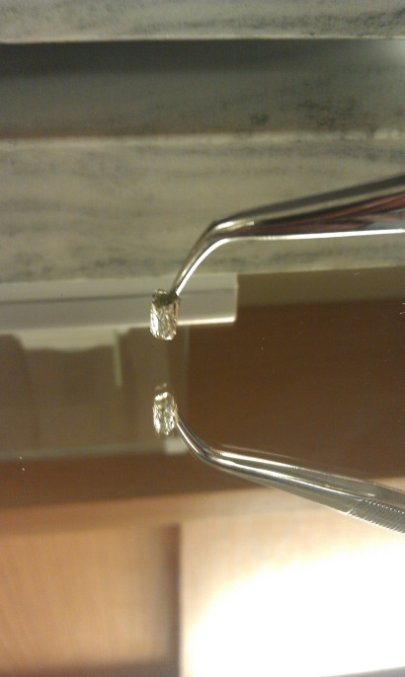Using forceps, gently tap the capsule with your sample down on the bench a few times. This forms the bottom flat so it stands better, and causes all loose material to fall into the tin or off the outside of the tin. It is much better to have any loose material fall off here than in your microbalance!
4. 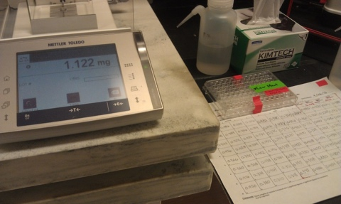Return the capsule with your sample to the balance and check the weight. If it is low, go back to step 2. If it is too heavy, gently dump some material out onto the weigh paper. If it is close to your target weight, close all draft shields, wait for the weight to stabilize (the small o disappears), and record the final value on your log sheet.
5. 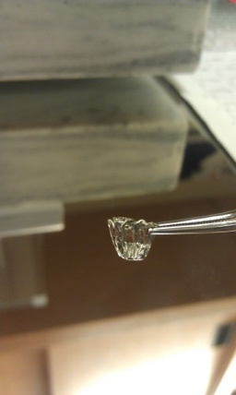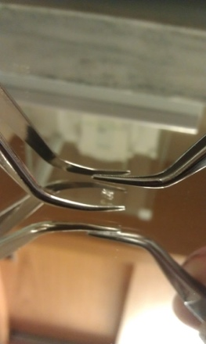Remove the capsule with your sample from the balance, being careful not to spill anything from the capsule. If you do, reweigh the capsule and add more sample to reach your target weight. Be sure to record the new final weight.
6. 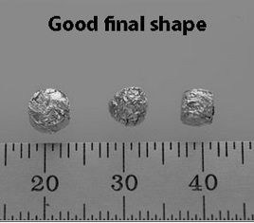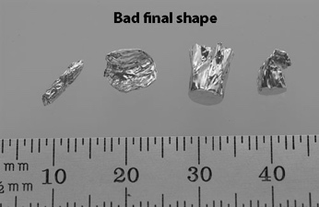Seal the capsule shut using two forceps. First, pinch the top of the capsule with one forcep and use the other to pinch the capsule flat, starting from the top. Then pinch the flattened capsule in half, folding the top down to meet the bottom. Then fold the capsule in half sideways forming a square. Place the square on the weigh paper and carefully pinch the squared capsule on all sides to compress any sharp corners. Be careful not to squeeze too hard or you’ll rupture the capsule and spill the contents. Samples in squares and spheres are good, but long cigar shapes, flat pancakes or large rectangles are bad (likely to get caught in autosampler)

**Organize your samples**

1. After each sample with weighed and encapsulated, carefully transfer it into a clean 96-well tray. Start at A1 and work across rows, then down columns. Be careful to place one sample in each well. Do not drop a sample into a well that already has another sample. If you do, remove both samples and reweigh them. Do not trust yourself to guess which sample is which. Do not leave empty wells between samples. Group similar sample materials together to optimize sample analysis.
2. When you are done weighing samples, place an index card (cut to size) over the tray wells before securing the lid shut. Do not use Parafilm or adhesive tape to cover the open wells as the adhesive may contaminate your samples. Tape the lid securely closed using tape on all four sides.
3. Label the lid of each sample tray with a unique name that includes your last name, the date, and a unique identifier for the samples (e.g., McMahon_20190611_penguinfeather). Results will be reported using the unique tray name and sample well position (e.g., A1). Avoid labeling multiple trays with similar names.
4. Clean up the weigh station when you are done, wiping down the counter, balance, and tools with ethanol and a kim wipe, putting away tools, weigh paper, and tin capsules, and turning off the microbalance.