# **COVID-19 Safety Plan for Research Laboratories and Field Research**

**Here we describe the steps that will be taken to minimize personnel density, allow distancing, and reduce the chances for COVID19 transmission. These steps are consistent with CDC guidelines, state guidelines, and the** [**URI Principles and Framework Guiding a Phased Approach to Restarting University Research Activity**](https://web.uri.edu/research-admin/externalrelations/news/uri-resumption-of-research-activities-guidance/)**.**

**Draft lab layouts:** [**https://docs.google.com/presentation/d/1MNjZLG1DlWenIxdDfq7p8pdKBag1RUtu/edit#slide=id.p3**](https://docs.google.com/presentation/d/1MNjZLG1DlWenIxdDfq7p8pdKBag1RUtu/edit#slide=id.p3)

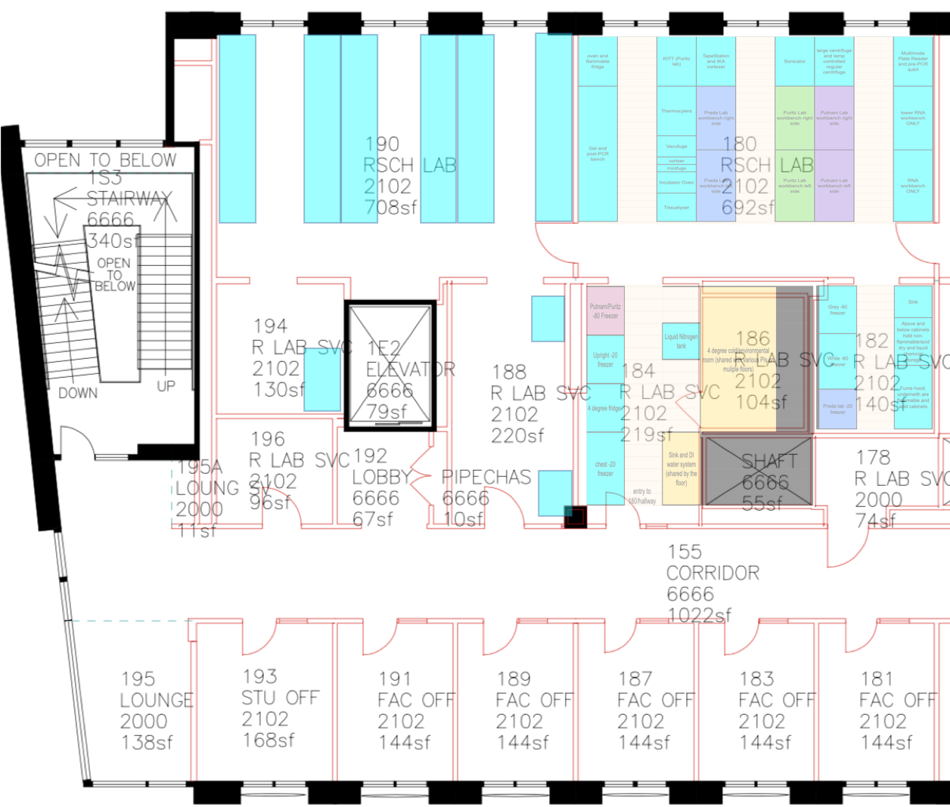

**Figure 1. CBLS First Floor Lab Spaces**

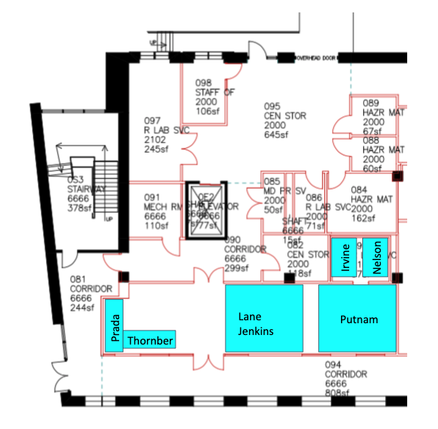

**Figure 2. CBLS Plaza Lab Spaces**

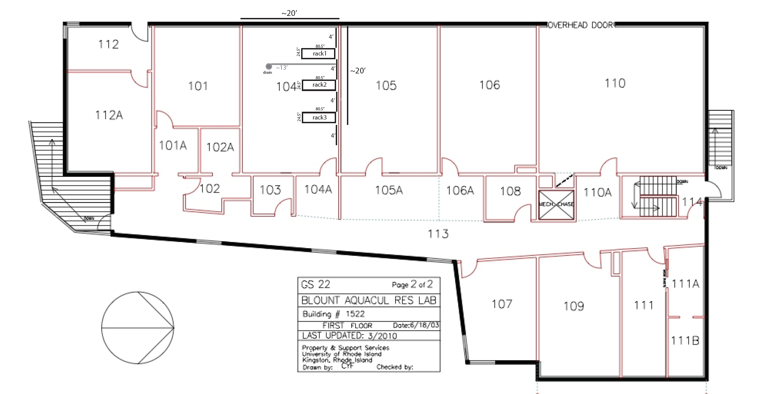

**Figure 3. GSO Blount Aquarium Building Lab Spaces**

**Draft Plan - Updated 20200701**

**1) A description of the of areas or locations (size, configuration, shared or single space, etc.) where people may be present, such as the lab, project space, and areas with common equipment:**

For the entire lab space, 5 people maximum at any one time (e.g., one working on computers in 188 and 2 in 190 and 2 in 180). Any work that could be done at home, should be done at home. While waiting for PCR, for example, students should stay in the lab, or outside a building, but not offices or hallways, etc. There is no use of the shared group offices at this time.

**CBLS First Floor (Fig. 1)**

CBLS 188 - 220 sqft - 1 person max

CBLS 190 - 708 sqft - 3 people max, one per bench row and work on opposite ends of benches

CBLS 194 – 130 sqft – 1 person max

CBLS 182 - 140 sqft - 1 person max

CBLS 184 - 219 sqft - 1 person max

CBLS 186 - 104 sqft - 1 person max

CBLS 180 - 692 sqft - 3 people max, one per bench row and work on opposite ends of benches

**CBLS Plaza Level (Fig. 2)**

This is a shared space. It is currently shared between the following: Jenkins, Lane, Putnam, Prada, Thornber, Irvine. These PIs have been contacted and agree to the shared space plan.

CBLS 097 - storage - sqft - 1 person max

CBLS 092 - Aquarium Room - 4 people max

CBLS 093 - Environmental Chamber - 1 person max

Additionally, we will be maintaining a real-time online calendar for usage specifically for the CBLS Aquarium Room area:

<https://calendar.google.com/calendar?cid=dXJpLmVkdV9wYTdiaWhkbmgwYjd1dmtqajliOGY2dHMwc0Bncm91cC5jYWxlbmRhci5nb29nbGUuY29t>

**GSO Blount (Fig. 3)**

GSO Blount 104 - Putnam, Puritz (shared with Dr. Jackie Webb and Dr. Anabella Maia)- 26.6’ x 17.5’ = 465.5 sq ft, maximum 4 people.

We will follow the specific plan developed by GSO. It is copied below for reference. Additionally, we will be maintaining a real-time online calendar for usage specifically for Blount 104 (<https://calendar.google.com/calendar?cid=dXJpLmVkdV9mMHY3Y3JjNTU5ZXJndnRuZ25vZGE2dmJlNEBncm91cC5jYWxlbmRhci5nb29nbGUuY29t>) :

Aquarium - Coordinators: Dave Palazzetti and Ed Baker

The following protocol is meant to ensure safety for people working in the Aquarium and Blount Buildings. Individual labs will have their own protocols for in-lab activities. However, for the labs with just one person working at a time, there is a need to cooperate and communicate between lab groups to ensure there is sufficient oversight of lab activities and appropriate attention to safety. This document defines a protocol to allow people working in labs to maintain a safe social distance. Because several lab spaces are jointly used by multiple lab groups, clear coordination of lab usage is necessary to keep a clean, virus-free working space. This document also defines a protocol for oversight of lab activities ranging from low to high risk. Finally, we expect that this protocol will be updated as the COVI D -19 pandemic landscape shifts.

1. Identify who is in the building:
   * 1. make sure all people who work in labs in the Aquarium and Blount buildings have access to the Aquarium/Blount COVID Occupancy Google calendar.
     2. Note: the calendar may be helpful if we need to track contacts or building occupants should there be an outbreak.
2. Scheduling:
   * 1. People working in the lab should make a schedule for the week and post it on the Aquarium/Blount COVID occupancy Google calendar. Each person should include the room number(s) used, the time frame, their name and cell #. This should be filled out even if one plans to just use the office.
     2. To consider: People are free to set up alternate phone numbers (e.g. through Google Voice or other apps) if they feel uncomfortable using their personal cell numbers.
3. Use the Buddy System if you plan to work in the lab:
   * 1. Find a buddy: This does not need to be someone from your lab. There are a few people at the Aquarium or Blount full time and can serve as a buddy.
     2. Review planned activities: Contact your buddy, let them know whether you will be conducting LOW, MED or HIGH risk lab activities and when you might need them to be physically present for HIGH risk activities. Otherwise, plan to mutually check in on 30-45 min intervals for MED risk and 2 hr intervals for LOW risk activities.
     3. Check in and check out. Remember to check in with your buddy and also check out for your time in the building.
     4. Never, under any circumstances, should you conduct HIGH risk activities alone.
4. Restroom usage
   * 1. The restroom should be used on a one-at-a-time basis.
     2. If you need to use the restroom, please knock on the door first and make sure that no one else is in there.

**2) The number of people that will be in the area/space at any one time and how that number minimizes personnel density and will generally provide for distancing of 6 feet (e.g., density of staff should not be more than 113 sq. ft per person).**

Hold to the recommended 113 sq. ft per person and keeping 6ft distance at all times. We have further restricted maximum persons in most spaces beyond the 113 sq. ft requirement due to lab equipment constraints.

**3) A description of anticipated work schedules, including staggering, alternate days, partial days or other adjustment and how work schedules minimize personnel density and provide for general distancing of 6 feet.**

We will provide access to the lab in periods for partial days and/or alternating days. This will be in the form of an online real time schedule.

(<https://calendar.google.com/calendar?cid=dXJpLmVkdV92aWkwZGNidGNjczljMDU2OGZkamwzc2V1NEBncm91cC5jYWxlbmRhci5nb29nbGUuY29t>) with equal number of slots per PI open until midnight on the day before. After midnight the slots are first come, first served to any member of the 4 labs.

**4) State if coordination with other teams or labs also using the space or area is required and if so how will you coordinate access to minimize personnel density;**

Currently coordinating with Puritz, Putnam, Prada, Thornber labs that all share the space. This is run by having the same plan and an online real time schedule with equal number of slots per PI as discussed above.

**5) A description of situations or conditions where individuals will need to be in close proximity to perform work, operate equipment, travel, etc. and what steps will be taken to minimize contact time and lessen transmission risk.**

There are no such situations in the Putnam lab for CBLS and GSO work.

There are no such situations in the Puritz lab for CBLS and GSO work.

There are no such situations in the Prada lab for CBLS and GSO work.

There are no such situations in the Thornber lab for CBLS work.

For Puritz lab, field collections will be restricted exclusively to RI waters, involve only two people, maintaining social distancing of at least 6 feet at all times, and each will drive separately to prevent prolonged exposure.

**6) A description of any barriers, partitions or other methods to physically separate people that will be used.**

We have adhered to the low density, social distancing measures, and PPE, so no additional barriers are needed at this time.

**7) A description of any special PPE requirements beyond required cloth face coverings that will be required.**

Safety glasses will be required at all times in the lab. These will be held by individuals and not shared.

**8) A description of any work that cannot be done while wearing PPE or a cloth face covering and steps that will be taken to minimize the potential for viral spread.**

There is no work that cannot be done while wearing a cloth face covering.

**9) Other area/location specific steps or considerations**

Single enter and exit point in CBLS 184, with only one person in the entrance/exit at any time.

The door between CBLS 180 and CBLS 170 will remain closed at all times, except in emergencies.

**10) Describe the process that will be used to clean common touch points and equipment that will not be cleaned by URI Custodial Staff.**

CDC and state guidelines must be followed. The minimum standard that must be used by all areas is to at least daily clean/disinfected using an [EPA-registered cleaning product](https://www.epa.gov/pesticide-registration/list-n-disinfectants-use-against-sars-cov-2), 10% bleach solution or a 70% alcohol solution. The touch points include:

* Benchtops, desktops, and other work surfaces;
* Equipment controls, touchpads, handles and latches;
* Drawer and cabinet handles;
* Sashes of chemical safety hoods and biosafety cabinets;
* Hand tools, micropipettors;
* Faucet handles and sprayer grips;
* Chair backs and armrests (fabric furniture that cannot be decontaminated should not be used);
* Doorknobs and light switches;
* Keyboards, touchpads, and mice.

Specific cleaning protocol is to use 10% bleach solution on bench and counter tops, but to use 70% ethanol/isopropanol on any other surface or equipment.

Each person working in the lab will complete a checkout checklist at the end of each lab session. This will indicate they check in with a PI (remotely or on site) and the lab manager (on site) wore the required PPE (mask, gloves, and safety glasses), and completed lab disinfecting. This will be displayed on the lab wall and it will be logged on a google form (<https://forms.gle/ZjnCd9NrpgW1fAmJ9>).

**Keep disinfectants in sealed bottles when not actively using and remake the bottles once per week. Indicate the date by recording it on the bottle on tape.

**11) Describe any high touch equipment or areas that cannot be disinfected daily (using an** [**EPA-registered cleaning product**](https://www.epa.gov/pesticide-registration/list-n-disinfectants-use-against-sars-cov-2)**, 10% bleach solution, or a 70% alcohol solution) and steps that will be used to prevent transmission. For example, an electron microscope that cannot be sprayed with an alcohol solution but will be covered with plastic that is changed with each new user**.

We do not have any equipment or touchpoints that cannot be sterilized with either 10% bleach or 70% ethanol.

**12) Describe the process that will be used to monitor compliance with this COVID-19 Safety Plan, as well as CDC, state, and University requirements related to COVID-19 in the workplace.**

Check in, check out, with individual PIs (remotely or on site) and lab manager (on site)

Completion of end of work checklist that includes statement of adherence to this policy.

**13) Describe how operations could be curtailed should the university have to move backwards in the Phases (e.g., movement back from Phase 3 to Phase 2). Describe any issues/concerns/impacts with curtailing operations.**

For our work, this concern applies more to the animal care portions than the molecular work. The molecular work can be stopped very quickly (immediately), and the animal husbandry would have to be run to completion if essential or would be reduced to remain at a base level of maintenance.



Hollie Putnam – hputnam@uri.edu

Carlos Prada - prada@uri.edu



Jon Puritz - jpuritz@uri.edu

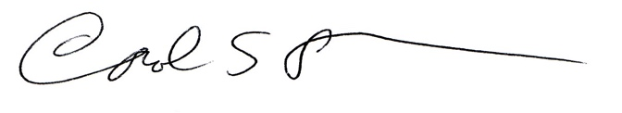

Carol Thornber - [thornber@uri.edu](mailto:thornber@uri.edu)

Catherien Raker – [ceraker@uri.edu](mailto:ceraker@uri.edu)



Taylor Lindsay – [taylor_lindsay@uri.edu](mailto:taylor_lindsay@uri.edu)