xCoral Bulk Isotope Protocol
Adapted from Wall & McMahon protocols by Taylor Lindsay

Host & Symbiont Tissue Preparation

Materials

- Homogenizer
- 15 mL falcon tube (2 per sample)
- 1.5 mL microcentrifuge tubes (2 per sample)
- PBS 7.4
- 25 mm sintered glass filter ?
- Pre-burned aluminum foil
- tin boats (Costech Analytical: 9 x 10mm, part # 041080)
- Nylon mesh (20 μm pore size: Millepore Nyon Net Filters Ref #NY2004700)
- Glass side-arm flask (250mL)
- Vacuum pump
- Sonicator bath
- Ethanol
- DI II
- 1000 uL pipette & tips

Protocol

- Follow the airbrushing protocol described here to create the tissue homogenate in PBS.
- Thaw frozen homogenate and re-homogenize for 30 seconds before continuing with the steps below.
- Label two 15 mL falcon tubes with sample name, and label one as iso-sym and one as iso-host.
- Label two microcentrifuge tubes with sample name, and label one as iso-sym and one as iso-host.
- Set up the vacuum pump with the iso-sym 15 mL falcon tube into a sidearm flask to collect the filtrate. Connect the sidearm flask to the pump and assemble the filter with the nylon mesh and the 25 mm sintered glass filter. ????
- Remove an aliquot of the tissue homogenate and place it in new 15 mL falcon tube. For most samples, 5mL is sufficient, but if the sample appears to be clearer than usual, more may be need.
- Filter the fraction to be used in isotope analysis through the nylon mesh to remove residual carbonate from the skeleton and large tissue chunks from samples. (Maier et al., 2010).
  - Keep pump on low pressure (≤ -0.2 Bar)
  - Rinse fritted-glass filter between samples with ethanol and DI II
- After filtering the blastate, the symbiont cells need to be separated from host tissues
  - If a sonication bath or tissue sonicator present, can use this to help break apart host & symbiont cells
  - Sonication bath: keep samples on ice, and have water bath a slushy of water + ice. Sonicate for 10 – 15min.
- Centrifuge the filtered homogenate in the iso-sym tube at 1500 – 2000 x g for 3 – 5 min to separate host/symbionts.
  - After centrifuging, check supernatant under microscope to see if symbiont cells present. Complete separation is likely never 100%, but several rounds of centrifugation can make this as “good as possible”.
- Remove host fraction (supernatant) and place into iso-host falcon tube (15 mL).
  - Symbiont pellet: Wash symbiont pellet with 2mL PBS to remove host fraction residue on top of pellet (white, fluffy, mucus-fat layer). Transfer this homogenate to the iso-sym microcentrifuge tube.
  - Centrifuge at 1500 x g. Should require 1 – 2 runs on centrifuge of 3 – 5 min. Add the supernatant to supernatant iso-host falcon tube.
  - Host fraction: Should be ~ 5 – 6 mL at this stage. Centrifuge at ~ 7500 x g or 8000 rpm. This will centrifuge most/all the host fraction material out of the supernatant.
    - After this, discard supernatant, and add 2 mL DI II to pellet, rinsing any debris on the sides of the tube to the bottom.
    - Use a pipette to transfer this homogenate to the iso-host microcentrifuge tube.
    - Centrifuge at ~ 2000 x g for 5 min.
    - Discard supernatant, and rinse with 1 ml DI II. This is needed to remove salts prior to isotope analysis.
- Once host and symbiont fractions are rinsed and in DI II, add each to microcentrifuge tubes. Centrifuge at top speed on benchtop centrifuge (13,000 x g) for 1 min; discard supernatant.
- Pellets (host and symbiont) frozen at -80°C in labeled microcentrifuge tubes.

Freeze-drying Samples (at McMahon Lab)

Materials

- Lyophilizer

Protocol
- Load samples onto sample tray, making sure containers are open. Keep samples in freezer until ready to load into freeze dryer
- Assure that the freeze dryer is dry and the plexiglass disc with orange gaskets is on top of the freeze dryer with the inner lip facing down, prior to starting.

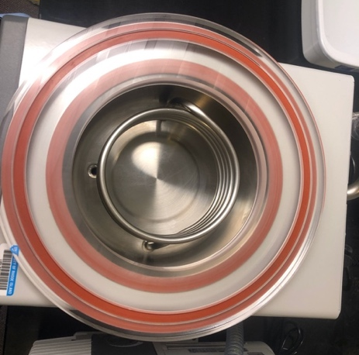
- Plexiglass disk with only one orange gasket facing up and rubber stopper should be placed securely into drain hose.
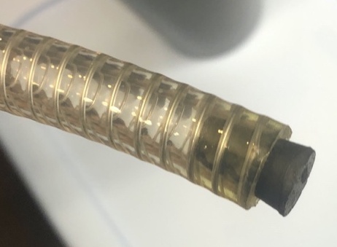
- Assure that all valves on the sample container manifold are in closed position (facing up). This photo shows the valve on the left is sealed, with the bevel facing up, while the right one is open with the bevel facing down. For freeze drying, all valves should be closed like the left one.

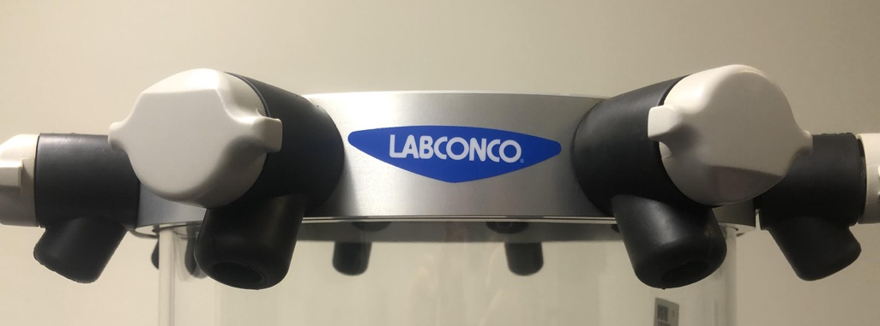
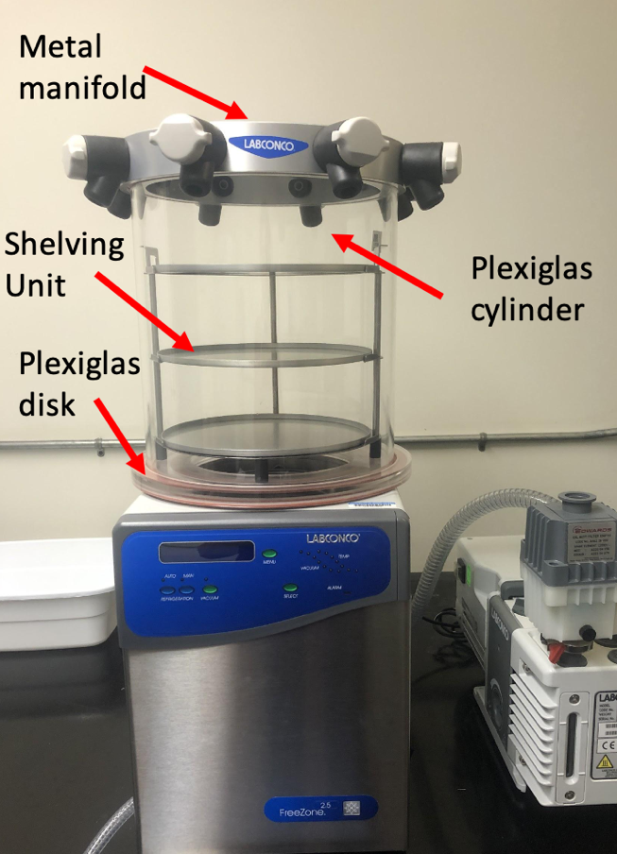
- Turn on freeze dryer with black switch on lower right side of unit.
- Press panel switch labeled REFRIGERATION AUTO (green LED above will light up.
- Temp will ramp down to -40˚ and then kick on the vacuum pump automatically.
- While temp is decreasing, remove tray of samples from freezer, place shelving unit on plexiglass disk, and place plexiglass cylinder with metal manifold on top of the disk.

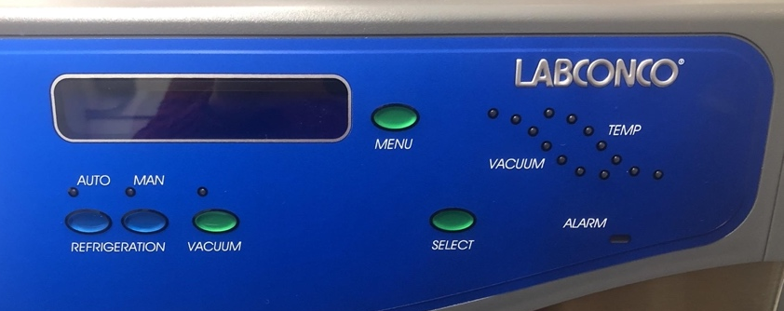

- Vacuum pump will take ~5 minutes to get down to pressure. Pressure >5mBar will read as “Hi”, <5mBar will show actual pressure. Green light will flash when pressure is between 0.450 and 0.133 mBar. Green light will be solid below 0.133 mBar. Allow time for samples to freeze dry.
- Shut down lyophilizer: Press VACUUM button to shut off vacuum, then press the REFRIGERATION AUTO button to shut off refrigeration, then turn off entire freeze dryer with switch on the bottom right side. Release pressure from chamber by opening one valve on manifold gradually. Note: release vacuum slowly at first to prevent samples from flying around inside the chamber.
- Defrosting: Let machine sit at ambient temperature to defrost, warming too quick could cause cracking.
  - When all ice has melted, put drain hose in bucket and remove black plug to drain.
  - Remove Plexiglas cylinder and Plexiglas disk, rinse with DI water to remove any residue, and wipe the chamber and Plexiglas components dry (use the cloth in the drawer next to the machine).
  - After draining is done, reinstall drain hose plug.

Packing samples in Tins

Materials

- Two pairs of forceps
- Small spatula
- Microbalance that reads to tenths of mg at least
- Tin capsules
- 96, 48, or 32 position polystyrene trays
- Kim wipes
- Ethanol
- Lab notebook / computer
- Weigh paper

Protocol
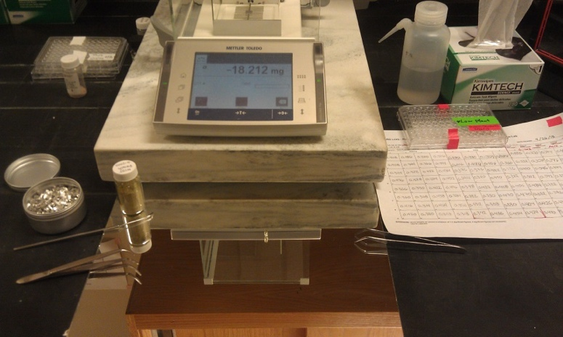
- Set up your weigh station: Make sure the counter space, microbalance, and weighing forceps and scoops are cleaned with ethanol and kim wipe before and after each sample. Place a clean sheet of weigh paper on the balance to catch potential spills. Replace between each new sample.
- Goal weight: < 0.5 – 1 mg (Wall)
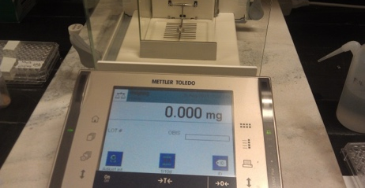
- Weighing & packing samples: Using forceps, place an empty tin capsule on the balance and hit Tare to zero the weight (note, keep the container of tin capsules closed when not in use to minimize contamination)
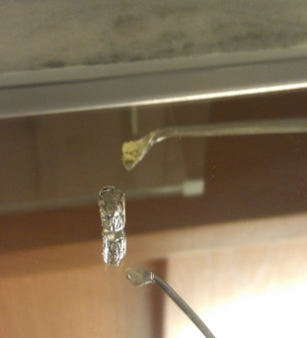
- Using forceps, remove the capsule and place it on a sheet of weigh paper on the bench in next to the microbalance. Carefully add a small scoop of your material into the capsule. To get all the material off your scoop, gently tap the scoop with a free pair of forceps, being careful not to knock over the capsule. Start with a small amount and add more if you need it. It is harder to remove material if you loaded too much.
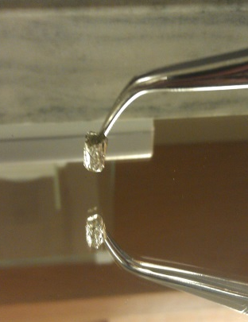
- Using forceps, gently tap the capsule with your sample down on the bench a few times. This forms the bottom flat so it stands better, and causes all loose material to fall into the tin or off the outside of the tin. It is much better to have any loose material fall off here than in your microbalance!
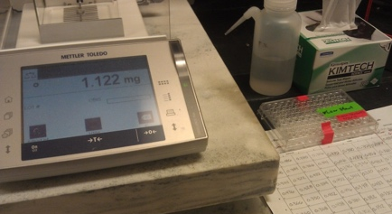
- Return the capsule with your sample to the balance and check the weight. If it is low, go back to step 2. If it is too heavy, gently dump some material out onto the weigh paper. If it is close to your target weight, close all draft shields, wait for the weight to stabilize (the small o disappears), and record the final value on your log sheet.
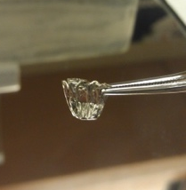
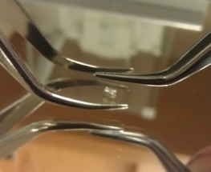
- Remove the capsule with your sample from the balance, being careful not to spill anything from the capsule. If you do, reweigh the capsule and add more sample to reach your target weight. Be sure to record the new final weight.
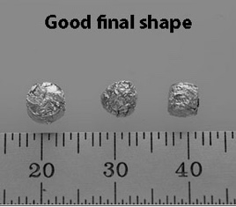
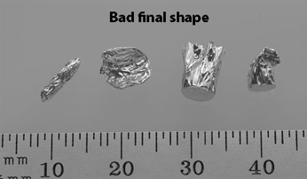
- Seal the capsule shut using two forceps. First, pinch the top of the capsule with one forcep and use the other to pinch the capsule flat, starting from the top. Then pinch the flattened capsule in half, folding the top down to meet the bottom. Then fold the capsule in half sideways forming a square. Place the square on the weigh paper and carefully pinch the squared capsule on all sides to compress any sharp corners. Be careful not to squeeze too hard or you’ll rupture the capsule and spill the contents. Samples in squares and spheres are good, but long cigar shapes, flat pancakes or large rectangles are bad (likely to get caught in autosampler)
- Organize your samples: After each sample with weighed and encapsulated, carefully transfer it into a clean 96-well tray. Start at A1 and work across rows, then down columns. Be careful to place one sample in each well. Do not drop a sample into a well that already has another sample. If you do, remove both samples and reweigh them. Do not trust yourself to guess which sample is which. Do not leave empty wells between samples. Group similar sample materials together to optimize sample analysis.
- When you are done weighing samples, place an index card (cut to size) over the tray wells before securing the lid shut. Do not use Parafilm or adhesive tape to cover the open wells as the adhesive may contaminate your samples. Tape the lid securely closed using tape on all four sides.
- Label the lid of each sample tray with a unique name that includes your last name, the date, and a unique identifier for the samples (e.g., McMahon_20190611_penguinfeather). Results will be reported using the unique tray name and sample well position (e.g., A1). Avoid labeling multiple trays with similar names.
- Clean up the weigh station when you are done, wiping down the counter, balance, and tools with ethanol and a kim wipe, putting away tools, weigh paper, and tin capsules, and turning off the microbalance.

References

