Airbrushing Protocol
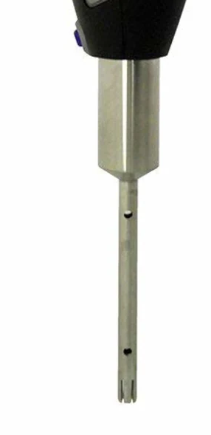
Adapted from Putnam lab protocols by T. Lindsay

Materials

- Forceps
- Airbrush Supplies (Compressor, hose, airbrush brush)
- Quart size ziplock bags (1 per sample)
- 50 mL falcon tubes (1 per sample)
- Tube Rack
- Sharpie
Do not submerge second hole
- 70% Ethanol to clean surface
- Clean Squeeze bottle with DI
- Gloves
- Kim wipes
- Scissors
- Tissue homogenizer

Protocol

Prep:
- Put on gloves
- Make sure you have enough 70% ethanol for your day (mix more if needed)
- Sanitize work area and equipment with 70% ethanol and a kim wipe
- Select samples, unwrap them and place them in the hood to thaw
- Label 50 mL falcon tube with sample and project names
- Set up remaining equipment
Airbrushing:
- Use cleaned forceps to remove epiphytes (discard in trash)
- Place coral fragment in new clean ziplock bag
- Airbrush with DI
  - Be sure to remove tissue from entire area including deep tissue
  - Attempt to keep total volume below 50mL to fit into one falcon tube
  - If chunks of skeleton or epiphytes are visible in slurry, remove with clean forceps
- Transfer slurry into sterile falcon tube by cutting corner of bag.
- Rinse sides of bag using the DI squeeze bottle, adding the rinse liquid to falcon tube
- Record total volume of tissue slurry and store in ice bucket until homogenization.
- Between each sample, clean the tip of the airbrush and the forceps
- When done, empty water and run air through the airbrush to dry the insides.
Homogenizing:
- Prior to homogenizing, write down the volume of the sample on the outside of the tube
- Homogenize slurry for 30 sec in falcon tube using tissue homogenizer at half power.
  - If slurry is more than 50 mL, homogenize both falcon tubes then pour back and forth between tubes to ensure even mixing
- Between each sample, clean the homogenizer by running it in 70% ethanol for 10 seconds, then run in DI for 10 seconds.

Aliquot Protocols
Adapted from Putnam lab protocols by T. Lindsay

Materials

- 4 x 1.5 mL microcentrifuge tubes
- Centrifuge
- Vortex
- 1000 uL Pipet and tips
- 2 Disposal containers (for tips and for excess supernatant)

Protocol

- Label four 1.5-mL microcentrifuge tubes for each sample
  - Include project name, sample name, sample treatment, and “CHL”, “SYM-D”, “HOST-PTAC”, or “SYM-PTAC”
  - On lid, record the sample and treatment names.
- Pipette 1mL homogenized tissue slurry to each of the CHL and SYM-PTAC tubes.
- Centrifuge both 1.5 mL tubes at 0.5xg for 1min.
- From the CHL tube, pipet off and discard the supernatant (~1mL). The pellet is the chlorophyl sample.
- From the SYM-PTAC tube, pipet off the supernatant and transfer into the HOST-PTAC tube. This is the host protein/antioxidant/lipid sample.
- To the symbiont pellet from the SYM-PTAC tube, add 1 mL DI water to resuspend pellet. Vortex for 30 seconds and pipet up and down to fully dissolve pellet.
- Once dissolved, transfer 500 µL from the SYM-PTAC tube to the SYM-D tube. These two tubes are the symbiont density and the symbiont protein/antioxidant/lipid samples.
- Place the four tubes in their respective freezer boxes and record which box number they’re in.
- Freeze the remainder of the homogenate in the falcon tube in -40˚C until use.

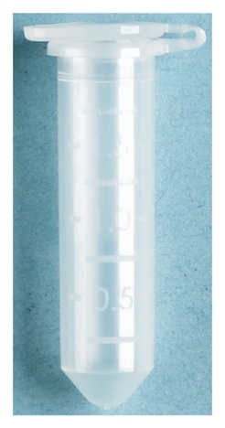
Labeling Guide for Rotjan Lab Astrangia Samples Summer 2026

Project Name: NSF_APOC
Sample name (something like): MDA104
Where MDA indicates the dive number
MDC123
HOST-PTAC
And 104 is the sample number

