**Investigating Drivers of Population Change on**

**Commercially Important Fish Species on Puerto Rican Reefs**

Taylor Lindsay

BIO 539 Spring 2021

**Introduction**

Coral reefs are complex ecosystems that have become heavily impacted by human use and global climate change. Once facet of this complexity is the trophic interactions that are at play in fisheries and conservation efforts. For years, scientists have believed that one of the best ways to protect reef ecosystems is to create a marine protected area (MPA), in which fishing is restricted or banned (Bruno, Cote, & Toth, 2019). The theory behind this conservation strategy is called the Managed – Resilience Theory. By restricting fishing, scientists predict there will be an increase in the abundance of herbivorous fish, which would reduce the abundance of microalgae, therefore preventing the coral from being smothered (Bruno, Cote, & Toth, 2019). However, the majority of studies have not found that this strategy is effective at increasing the number of herbivorous fish (Bruno, Cote, & Toth, 2019; McClanahan & Muthiga, 2020). Further research is needed to investigate the population dynamics of these fish, and to determine what factors affect their changes. Puerto Rico is a good study site because of its large number of MPAs around the island (Beltran, 2020).

This study will focus on three large groups of commercially and ecologically important reef species in Puerto Rico: snappers, groupers, and parrotfish. Of these, snappers and groupers have a long history of overfishing in Puerto Rico (Coleman, et al., 2000). Snappers and groupers are both upper-trophic carnivorous fishes. Parrotfish, however, have not traditionally been fished for human consumption, as higher trophic fishes are commonly depleted first (Mumby, et al., 2012). Parrotfish also play a complex ecological role in reef systems; parrotfish are herbivores that consume both macroalgae and hard coral tissues. They are most commonly known for their role as bioeroders, as they consume and process calcium carbonate from coral skeletons, and return the material to the reef as particulate matter (Bruno, Cote, & Toth, 2019). Because they both consume the corals and protect them by removing algae, parrotfish abundance can have huge effects on the condition of a coral reef.

The goals of this study are 1) to analyze the population dynamics of snapper, grouper, and parrotfish in Puerto Rico from 1999 - 2020, and 2) to determine the variables that affect the fishes population dynamics. These variables will include the presence of MPAs, depth zone, location, year, and benthic cover type.

**Methods**

*Field Methodology*

Data for this analysis was collected by NOAA’s Puerto Rico Coral Reef Conservation Program (PRCRMP) from 1999 – 2020. The monitoring program consists of 16 field sites around the island of Puerto Rico, with permanent transects in multiple locations and depth zones at each site. Sessile – benthic reef communities were analyzed using the chain-link method following the CARICOMP (1994) protocol on photographs of each transect (Kjerfve, 1998). Reef fish abundance was counted by divers conducting belt – transect observations that were 10m long and 3m wide. For commercially important fish (see Hernandez, 2020 for list), divers also recorded a visual total length estimate. Later, this length estimate was paired with length – weight relationships available at FishBase.org and the abundance data to calculate the biomass for each species at each transect. Notably, the methodology for fish size and biomass changed in 2015, so this report will only use biomass data from 2015 – 2020. This methodology was described in detail by Garcia-Sais et al. (2017) and in the PRCRMP field methodology report (Field Methodology of the P.R. Coral Reef Monitoring Program, 2019).

*Data background and preparation*

Data for the PRCRMP has been updated multiple times. For this analysis, numerical data is taken from version 3.3. For this analysis, the datasets that were used included the ‘Site Classification Database’, ‘Benthic Sessile Data’, ‘Fish Inverts Abundance Data’, and ‘Fish Inverts Biomass Data’. Version 2.2 was also used to create a dataset of species taxonomic information. Prior to analysis, some of the column names and site names in these datasets were substituted due to inconsistent formatting or unreadable symbols.

*Data Analysis*

To investigate the population dynamics of the three fishes of interest, the species were grouped based on family taxonomic classification: snappers from *Lutjanidae*, groupers *Serranidae*, and parrotfishes from *Scaridae*. For each transect, the total number of all the species within a group was summed to find a total. A function was then created to calculate the mean, standard deviation, standard error, and sample size from these totals for each year. This process was repeated for each of the three fish groups for both abundance and biomass data. Site information on MPAs and benthic cover was also merged into each of the six datasets. The abundance and biomass datasets were then compared to the year, depth, location, MPA status and benthic cover (also referred to as coral biotope) using linear models. A linear model with the best fit was created based on the model with the highest adjusted R2 value. ANOVAs were run to determine the differences between the coral biotope classifications. Scatterplots were used to represent the linear models, and boxplots represent the ANOVAs. All analysis was done in r.

**Results**

Over the course of this study, population dynamics of the fishes in Puerto Rico have changed significantly. Parrotfish abundance has decreased significantly since 1999 (p = <0.001), while parrotfish biomass has not shown a significant change (p = 0.221) (Figure 1). Similarly, grouper abundance has decreased significantly (p = <0.001), while grouper biomass has significantly increased (p = 0.00744) (Figure 2). Neither snapper abundance nor biomass showed any significant changes over the study period (p = 0.99, p = 0.297) (Figure 3). Notably, the year is not a good predictor for any of the three groups (see R2 values in Table 1).

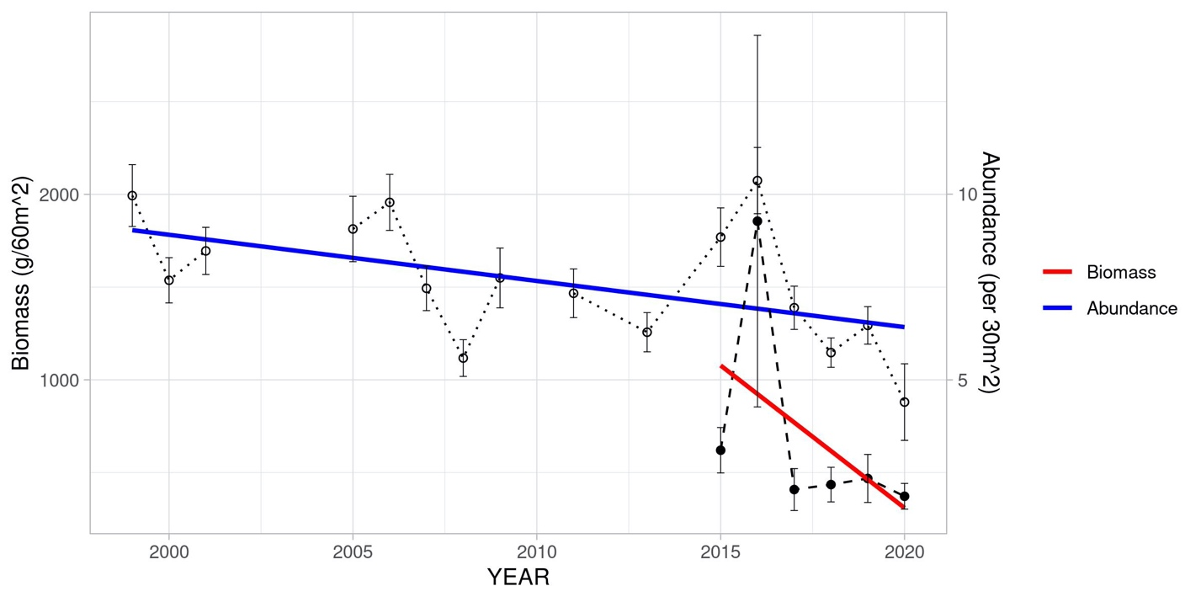

**Figure 1. Parrotfish population dynamics in Puerto Rico from 1999 - 2020.** Abundance significantly decreased from 1999 – 2000 (p = 7.19e-05, R2 = 0.0111). Biomass also showed a decreasing, yet non-significant trend (p = 0.221, R2 = 0.0111). Points represent the annual mean, error bars represent the standard error, and the blue and red lines represent linear models of each variable.

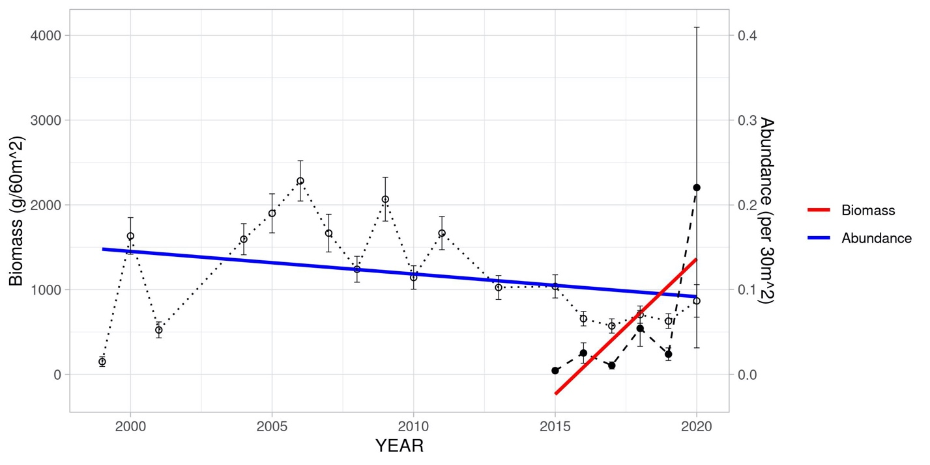

**Figure 2. Grouper population dynamics in Puerto Rico from 1999 - 2000.** Abundance decreased significantly over time (p = 4.69e-06, R2 = 0.0146), while biomass increased significantly (p = 0.00744, R2 = 0.0778). Points represent the annual mean, error bars represent the standard error, and the blue and red lines represent linear models of each variable.

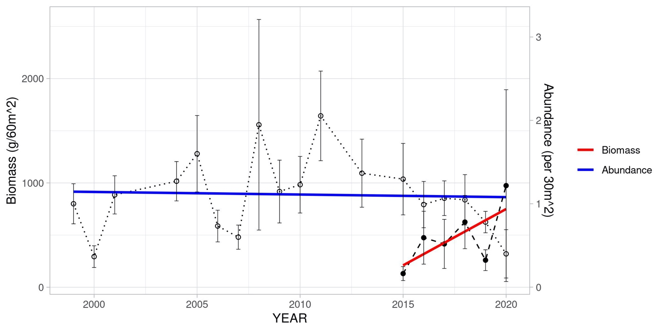

**Figure 3. Snapper population dynamics in Puerto Rico from 1999-2020**. Neither abundance (p = 0.99, R2 = 1.00e-07), nor biomass (p = 0.297, R2 = 0.0122) changed significantly. Points represent the annual mean, error bars represent the standard error, and the blue and red lines represent linear models of each variable.

***Table 1. Linear models for the three fish groups’ abundance and biomass data.*** *Each fish group has an individual linear model for each of the five factors, plus one linear model with all five factors combined. Additional linear models were added when only some of the factors were independently significant. Significance based on an alpha value of 0.05 and indicated with a *.*

|  |  |  |  |  |
| --- | --- | --- | --- | --- |
| **Linear Model Inputs** | **Abundance**  **p value** | **Abundance Adjusted R2** | **Biomass**  **p value** | **Biomass Adjusted R2** |
| **Parrotfish** | | | | |
| Depth Zone | < 0.001 * | 0.0214 | 0.57 | 0.0227 |
| Year | < 0.001 * | 0.011 | 0.221 | 0.011 |
| MPA Status | < 0.001 * | 0.00878 | 0.0773 | 0.0347 |
| Location | < 0.001 * | 0.137 | 0.834 | 0.113 |
| Coral Biotope | < 0.001 * | 0.0395 | 0.953 | 0.00781 |
| Depth + Year + MPA + Location + Biotope | < 0.001 * | 0.17 | 0.642 | -0.0369 |
| **Grouper** | | | | |
| Depth Zone | < 0.001 * | 0.117 | < 0.001 * | 0.178 |
| Year | < 0.001 * | 0.0146 | 0.00744 * | 0.0778 |
| MPA Status | < 0.001 * | 0.0645 | 0.917 | < 0.001 |
| Location | < 0.001 * | 0.364 | < 0.001 * | 0.399 |
| Coral Biotope | < 0.001 * | 0.0608 | 0.58 | 0.0325 |
| Depth + Year + Location | - | - | < 0.001 * | 0.345 |
| Depth + Year + MPA + Location + Biotope | < 0.001 * | 0.41 | < 0.001 * | 0.371 |
| **Snapper** | | | | |
| Depth Zone | 0.687 | 0.00103 | 0.285 | 0.0424 |
| Year | 0.99 | < 0.001 | 0.297 | 0.0122 |
| MPA Status | 0.331 | < 0.001 | 0.383 | 0.00855 |
| Location | 0.00301 * | 0.0259 | 0.113 | 0.235 |
| Coral Biotope | 0.0295 * | 0.00753 | 0.527 | 0.036 |
| Location + Biotope | 0.00205 * | 0.0164 | - | - |
| Depth + Year + MPA + Location + Biotope | 0.00305 * | 0.0169 | 0.291 | 0.0461 |

Table 1 shows the linear models for each of the five variables, compared with the abundance and biomass of each fish group. Here, the coral biotope is the general category set for each of the locations, not the exact measurements taken at each transect. Therefore, coral biotope, as well as MPA status, are directly linked with the location. For both parrotfish and grouper, all five variables have a significant relationship with abundance. Both also have the highest R2 value for the model including all five variables (parrotfish R2 = 0.17, grouper R2 = 0.41). Snapper abundance only has significant relationships with location and coral biotope, but is best explained by a model including all five variables (R2 = 0.0169). Parrotfish and snapper have no significant relationships between biomass and any of the five variables examined. Grouper biomass has significant relationships with depth, year, and location, but biomass is best explained by a model containing all five variables. Interestingly, the strongest models for biomass and abundance for both parrotfish and snapper are lower than R2 = 0.2, making them very weak predictors of population variation. Conversely, the models for grouper were much stronger, with a model including all five variables predicting 41% of the variability in grouper abundance and 37% of the variability in grouper biomass.

Figure 4 shows the changes in benthic cover type over time. Data for this graph was taken from the ‘benthic sessile’ dataset, and is not directly related to the ‘coral biotope’ categories. Stony corals included all scleractinian corals, which are the foundational reef builders in Puerto Rico. Stony coral did not have a significant change over time (p = 0.595), but Figure 4 shows a decreasing trend. It is likely that individual species within scleractinia have decreased significantly over time. The macroalgal percent cover has increased significantly over time (p = 0.0416). It appears that there has been a general shift in benthic cover type from stony corals to macroalgae in Puerto Rico.

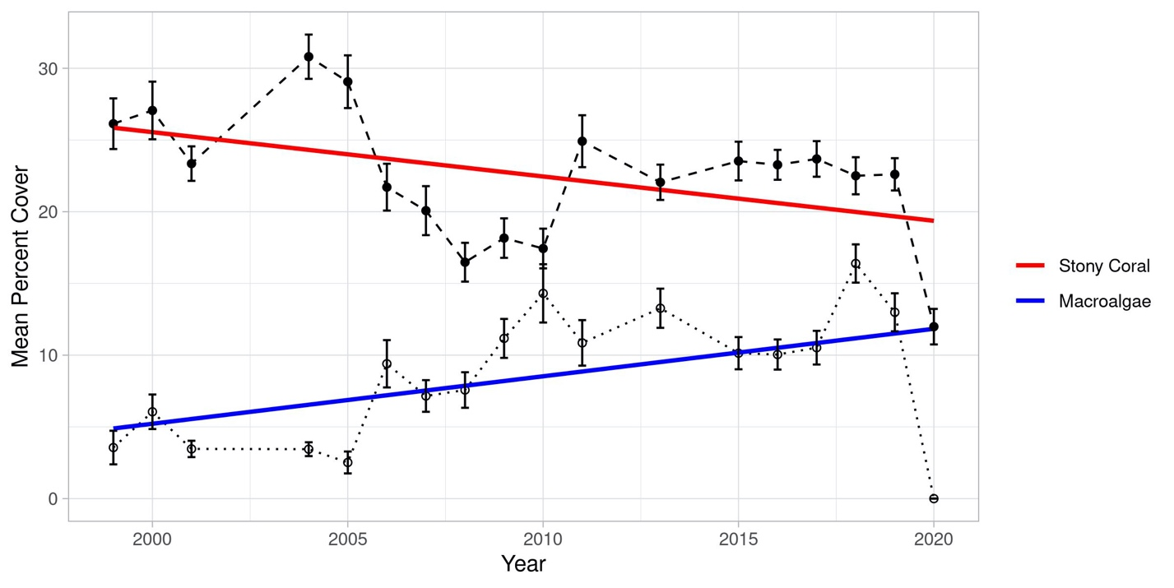

**Figure 4. Stony Coral and Macroalgae percent cover from 1999 – 2020 in Puerto Rico**. Stony coral percent cover did not change significantly (p = 0.0595, R2 = 0.2046) but has shown a decreasing trend. Macroalgal percent cover has increased significantly over time (p = 0.0416, R2 = .2348).

Marine protected area status was not significantly correlated with biomass for any of the fish groups. Figure 5 shows the relationships between the fish group abundance and MPA status. These graphs are heavily skewed towards 0. Parrotfish have a significantly higher abundance outside of MPAs than inside (p = < 0.001), while grouper have a significantly higher abundance inside of MPAs (p = < 0.001). Snapper abundance did not have a significant difference based on MPA status (p = 0.331).

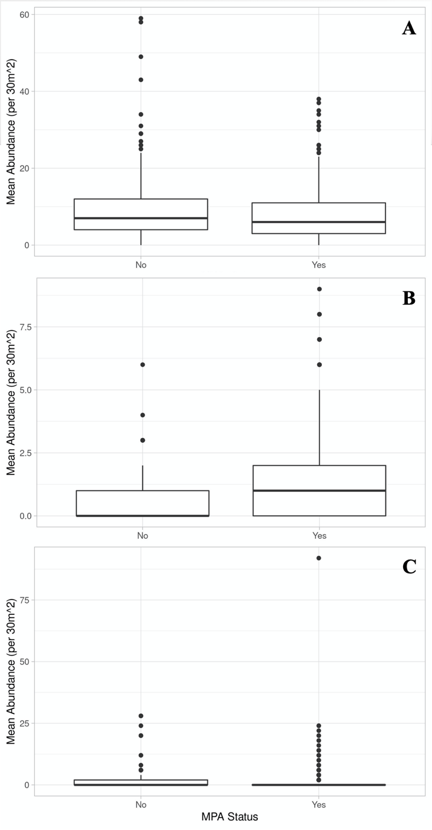

**Figure 5. The relationship between mean fish abundance and MPA status in Puerto Rico**. (A) Parrotfish abundance is significantly higher outside of MPAs than within MPAs (p = <0.001, R2 = 0.00878). (B) Grouper abundance is significantly higher inside of MPAs than outside (p = <0.001, R2 = 0.0646). (C) There is no significant difference between snapper abundance inside and outside of MPAs (p = 0.331, R2 = <0.001).

Coral biotope had a significant relationship with abundance for all three of the fish groups. Figure 6 shows the details of these relationships based on ANOVA results, so the significance values vary slightly from the linear models used in Table 1. Figure 6 shows that parrotfish had a preference for high to moderate hard corals, and *O. annularis* or octocoral dominated areas. Groupers showed a preference for low coral areas. Both parrotfish and groupers showed a significant preference against *A. palmata* locations, which may be related to depth preference as *A. palmata* is typically a shallow- water coral.

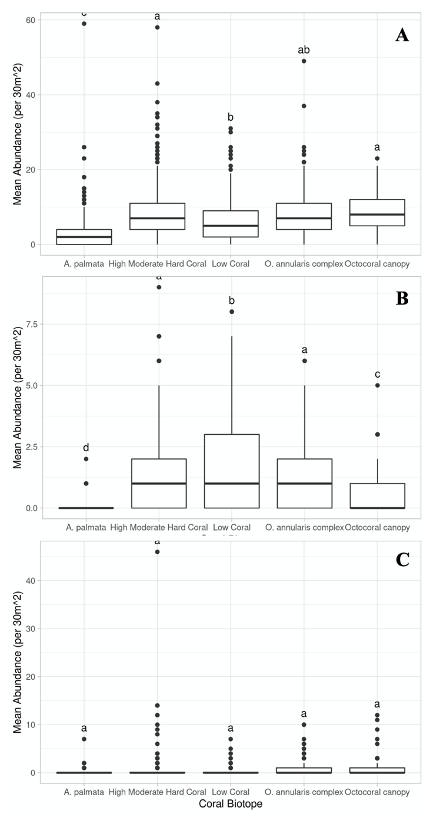

**Figure 6. The relationships between the coral biotope and the mean fish abundance in Puerto Rico.** (A) There are significant differences in parrotfish abundance in the coral biotopes. (B) There are significant differences in biotope preferences for groupers (C) There are no differences in biotope preferences for snappers.

**Discussion**

This analysis has shown that the three fish groups of interest are not subject to the same population dynamics, nor are they affected by the same factors. Overall, however, there is reason to believe that there are large shifts occurring in reef ecosystems, including declines in fish abundance and shifts in benthic cover types, which is widely supported by other studies (McClanahan, 2020). Additional research is needed to understand the population dynamics of these species, especially parrotfish, as their ecological role is so closely tied to coral survival and abundance.

Parrotfish abundances have decreased significantly over the past 20 years, but there has been no observed change in biomass in the last five years. Parrotfish abundance is also significantly impacted by depth, location, benthic cover type and MPA status. However, parrotfish abundances were higher outside of MPAs than within them, contradicting the Managed – Resilience Theory. Parrotfish also showed a preference for habitats that were occupied by hard coral biotopes. Future work should investigate the trophic dynamics between the parrotfish, macroalgae, and coral cover on these reefs.

In the past 20 years, groupers have experienced a decline in abundance while also experiencing an increase in biomass over the past 5 years. This suggests that while there are fewer fish, they tend to be larger individuals. This may be the result of good MPA practices, but more investigation is needed to parse out this relationship. The models created for groupers were also very strong, providing evidence that the factors focused on in this study are good predictors of grouper abundance and biomass.

Snapper abundance and biomass has not significantly changed over the study period, and were also not affected by depth or MPA status. Past studies have found that snapper were positively impacted by MPAs because they are upper tropic predators (McClanahan & Muthiga, 2020). Of the fish groups in this study, snapper appear to be the most stable group, with the only significant impacts on their abundance coming from location and coral biotope. Based on these results, snapper are of less concern for future conservation efforts than the other fish groups.

Future work must include more detailed analysis of the differences between the locations in this study. Factors such as human population or distance to the nearest city would be indicative of the fishing pressure in each location, which likely has a large impact on the fish population dynamics. The MPA dynamics should also be fleshed out, as some of these locations only became MPAs during the duration of the study, and likely have not yet felt the effects of this change. Finally, additional environmental factors such as ocean current regime, ocean temperature, wave action, etc. must be added to this investigation to create a full picture of these fishes’ population dynamics.

# Works Cited

Beltran, D. (2020). *US CARIBBEAN MARINE MANAGED AREAS DATA REPORT.* University of Rhode Island, Kingson, RI.

Bruno, J. F., Cote, I. M., & Toth, L. T. (2019). Climate Change, Coral Loss, and the Curious Case of the Parrotfish Paradigm: Why Don’t Marine Protected Areas Improve Reef Resilience? *Annual Review of Marine Science*(11), 307 - 334.

Coleman, F. C., Koenig, C. C., Huntsman, G. R., Musick, J. A., Eklund, A. M., McGovern, J. C., . . . Grimes, C. B. (2000). Long-lived Reef Fishes: The Grouper-Snapper Complex. *Fisheries, 25*(3), 14-21.

(2019). *Field Methodology of the P.R. Coral Reef Monitoring Program.* Department of Natural and Environmental Resources (DNER).

Garcia-Sais, J. R., Williams, S. M., & Amirrezvani, A. (2017). Mortality, recovery, and community shifts of scleractinian corals in Puerto Rico one decade after the 2005 regional bleaching event. *PeerJ*.

Hernandez, M. G. (2020). *Puerto Rico Coral Reef Monitoring Program (PRCRMP) - Data Dictionary.* DNER & NOAA.

Kjerfve, B. (1998). CARICOMP Caribbean coral reef, SEAGRASS AND MANGROVE SITES. *Coastal region and small island papers*.

McClanahan, T. R. (2020). Decadal turnover of thermally stressed coral taxa support a risk-spreading approach to marine reserve design. *Coral Reefs, 39*, 1549-1563.

McClanahan, T. R., & Muthiga, N. A. (2020). Change in fish and benthic communities in Belizean patch reefs in and outside of a marine reserve, across a parrotfish capture ban. *Marine Ecology Progress Series, 645*, 25 - 40.

Mumby, P. J., Steneck, R. S., Edwards, A. J., Ferrari, R., Coleman, R., Harborne, A. R., & Gibson, J. P. (2012). Fishing down a Caribbean food web relaxes trophic cascades. *Marine Ecology Progress Series, 445*, 13-24.

**Appendix**

Data analysis available on Github: <https://github.com/taylor-lindsay/PR_Fish>

Raw Data: <https://www1.usgs.gov/obis-usa/ipt/resource?r=prcrmp_database>