COMP 8051 - Updated Project Design Document
Taylor Ockerman | A01085319
Custom 2D SDL3 Hybrid ECS Engine for Particle-Based Sandbox Gameplay
GitHub Repository | https://github.com/taylor-ockerman/COMP8501-GameEngine
Project Board | https://trello.com/invite/b/69a89939926c99e6b6b76406/ATTI1ce78ea09658d1efbb78293f964837f340914F39/gamearchproject

1. Project Overview
This project is a custom 2D game engine focused on pixel-based material simulation. The engine is designed to support sandbox-style gameplay where the player can spawn, remove, and manipulate materials such as sand, water, stone, smoke, fire, oil, and other grid-based particles. The overall goal is to combine a traditional side-view game structure with a Noita-inspired material system.
Technically, the engine uses a hybrid architecture. Standard gameplay features such as movement, animation, collision, UI, audio, and camera behaviour are handled through an Entity Component System (ECS). High-volume material simulation is handled by a dedicated ParticleGrid that stores cells and supports chunk-based (spatial partitioning) optimization.

2. Engine Design and Architecture
The engine is built in C++ using SDL3 as the media layer. It is a purely 2D engine intended for tile-based levels, sprite rendering, and real-time material simulation. The central design decision is to split responsibilities between ECS-driven gameplay systems and a custom particle grid so that each part of the engine solves the kind of problem it is best suited for.

Architecture Summary
Layer | Purpose | Examples
Entities + Components | Represent game objects and attach data | Player, particles, HUD labels, menu items, level objects
Systems | Apply logic to matching entities/components each frame | Input, movement, gravity, collision, animation, camera, UI, audio
ParticleGrid | Stores cell data. Contains getters, bounds checking, and chunk coordinate conversion functions | Chunk activity, neighbour queries

Architecture Diagram
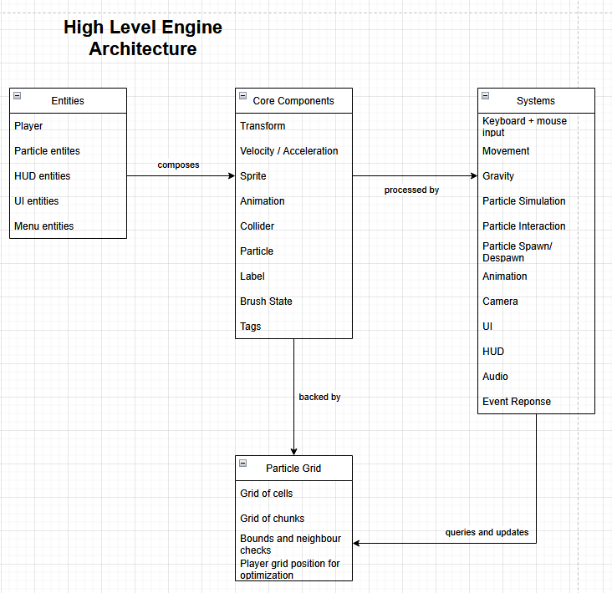
Figure 1. High-level relationship between entities, components, systems, and the particle grid.

3. Current ECS Design

Key Entities
- Player entity: handles movement, collision, animation, and interaction with the world.
- Particle entities: represent rendered/material instances that synchronize with the particle grid.
- HUD/UI entities: display brush selection, labels, and menu information.
- Menu entities: support pause/menu states and related interface elements.
- Level objects: static or interactive objects such as walls and map elements.

Core Components
Component | Purpose
Transform | Stores world position, rotation, scale, and previous position.
Velocity / Acceleration | Supports motion, gravity, and input-driven movement.
Sprite | Stores texture references, source/destination rectangles, visibility, and render layer.
Animation | Tracks clips, current frame, playback timing, and directional states.
Collider | Defines collision bounds, tags, offsets, and whether collision is enabled.
Particle | Links an entity to particle type and grid coordinates.
Label | Stores text, font, colour, cached texture, and UI placement.
BrushState | Stores selected material, brush size, and cursor state for spawning/erasing.
Tag components | Lightweight tags such as PlayerTag for fast filtering.

Implemented / Planned Systems
Category | System | Role in Engine
Input | Keyboard Input System | Processes player movement, jumping, and action input.
Input | Mouse Input System | Handles brush placement, material spawning, and erase interactions.
Gameplay | Movement System | Applies movement based on velocity and frame time.
Gameplay | Gravity System | Applies downward acceleration and supports grounded behaviour.
Gameplay | Collider Sync System | Keeps collider bounds aligned with transform changes.
Gameplay | Collision System | Detects overlaps and resolves entity/entity or entity/world collisions.
Simulation | Particle Simulation System | Updates particle motion and state using grid rules.
Simulation | Particle Interaction System | Handles material interactions such as fire, water, smoke, and other effects.
Simulation | Particle Spawn / Despawn System | Creates, removes, and synchronizes particles from player actions or events.
Rendering | Animation System | Advances animation clips and updates sprite frames.
Rendering | Camera System | Follows the player and constrains view to map bounds.
Rendering | UI / Brush HUD Render System | Displays material selection and brush radius feedback.
Infrastructure | Audio / Event Response Systems | Plays one-shot and looping audio and routes gameplay events.

4. Game Design
Working title: Sandy Sim. The intended player experience is a 2D sandbox/puzzle game where a controllable character uses different materials to solve movement or environmental problems. The core fantasy is that the world feels reactive: sand piles up, liquids spread, smoke rises, and the player can alter the level by adding or removing matter.
Although the original design targeted a puzzle-focused experience, the strongest completed feature set is the engine layer itself: player movement, particle spawning, multiple materials, real-time simulation, UI feedback, animation, and audio support.

5. Tools and Technical Stack
- Language: C++
- Media layer and rendering: SDL3
- Image / font / audio support: SDL_image, SDL_ttf, SDL_mixer
- Map authoring: Tiled
- IDE and build workflow: CLion + CMake
- Version control: GitHub
- Task tracking: Trello

6. Technical Risks and Mitigation
Risk | Why it matters | Mitigation
Performance under many active particles | Dense material simulation can become expensive and affect frame rate. | Use chunk-based activity tracking, update only active regions, and minimize unnecessary entity/grid synchronization.
Complex material interactions | Rules such as density, displacement, burning, extinguishing, and gas spread can create hard-to-debug edge cases. | Add materials gradually, define clear per-material properties, and test interactions in isolation.
Collision and simulation overlap | Player movement, solid tiles, and particles can conflict if occupancy and collision resolution are not kept consistent. | Separate grid rules from physics resolution and keep collider/grid synchronization explicit.
Scope management | A custom engine plus a full puzzle game can exceed the available course timeline. | Prioritize engine fundamentals first and treat extra gameplay features as stretch goals.

7. Minimum Viable Product and Status
Feature | Original MVP target | Current status
Grid-based material simulation | Required | Completed
Sand and water materials | Required | Completed
Player movement and mouse controls | Required | Completed
Ability to spawn, destroy, and move materials | Required | Completed
Player model with basic animations | Required | Completed
Basic HUD for selection feedback | Required | Completed
One puzzle mechanic (pressure plates or similar) | Required | Not completed
One playable puzzle level | Required | Not completed

