Intro to Audio Mixing

Logic Session we will work though today is available here for download:
https://drive.google.com/file/d/1voTiR91ezcdVg04ZDi5TENgO9HwLmuxr/view?usp=sharing
Click on the three-dots and then “download”

What is Mixing?
“We are mixing engineers, but more importantly: we are sonic artists.” — Roey Izhaki, Mixing Audio
Mixing is the process of combining individual recorded tracks into a finished single piece of audio. It is both a technical craft and a creative act.
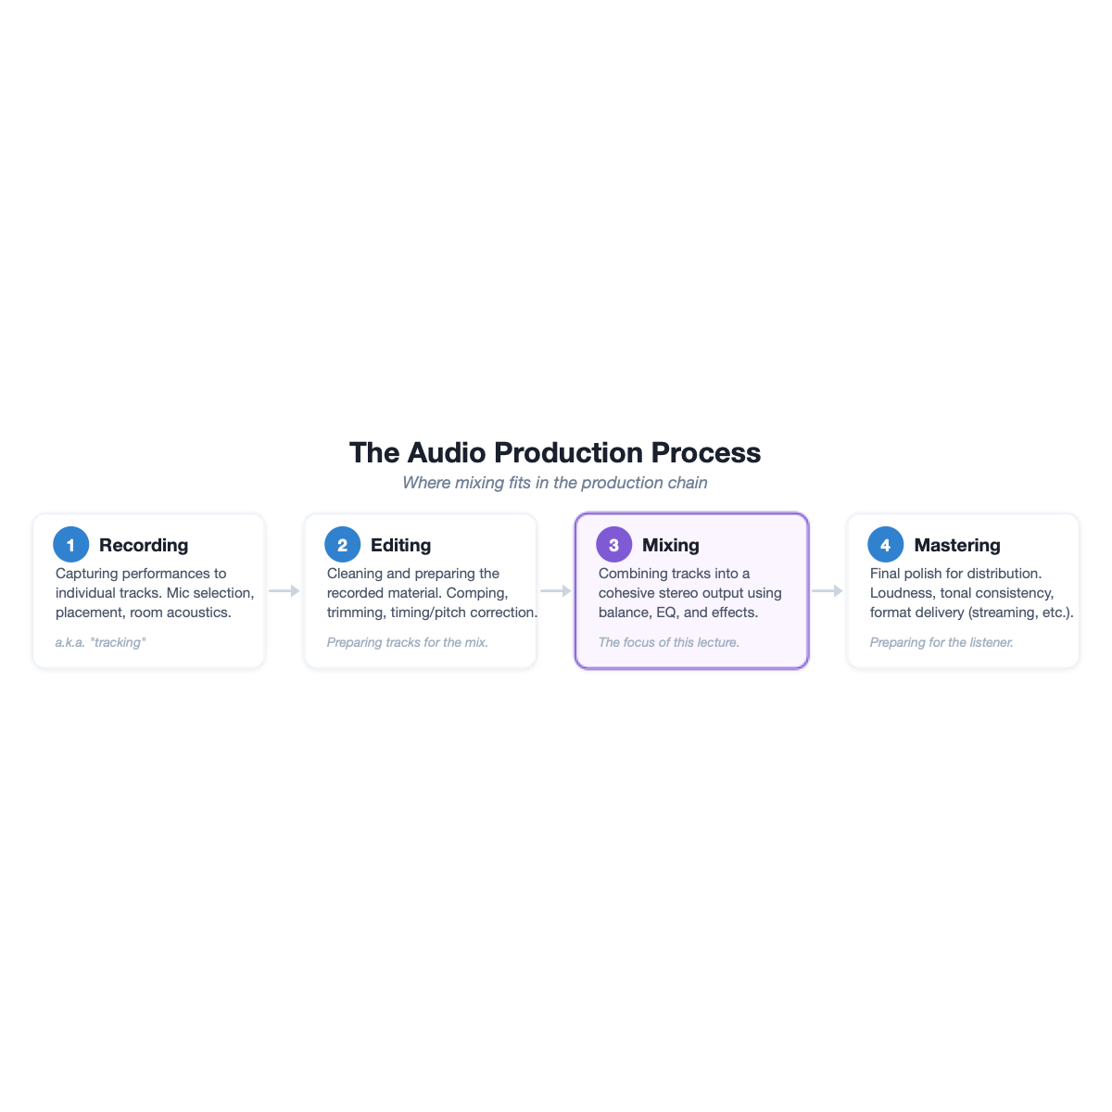

Owsinski’s Six Elements of a Mix
Bobby Owsinski’s framework from The Mixing Engineer’s Handbook organizes everything in a mix into six elements:
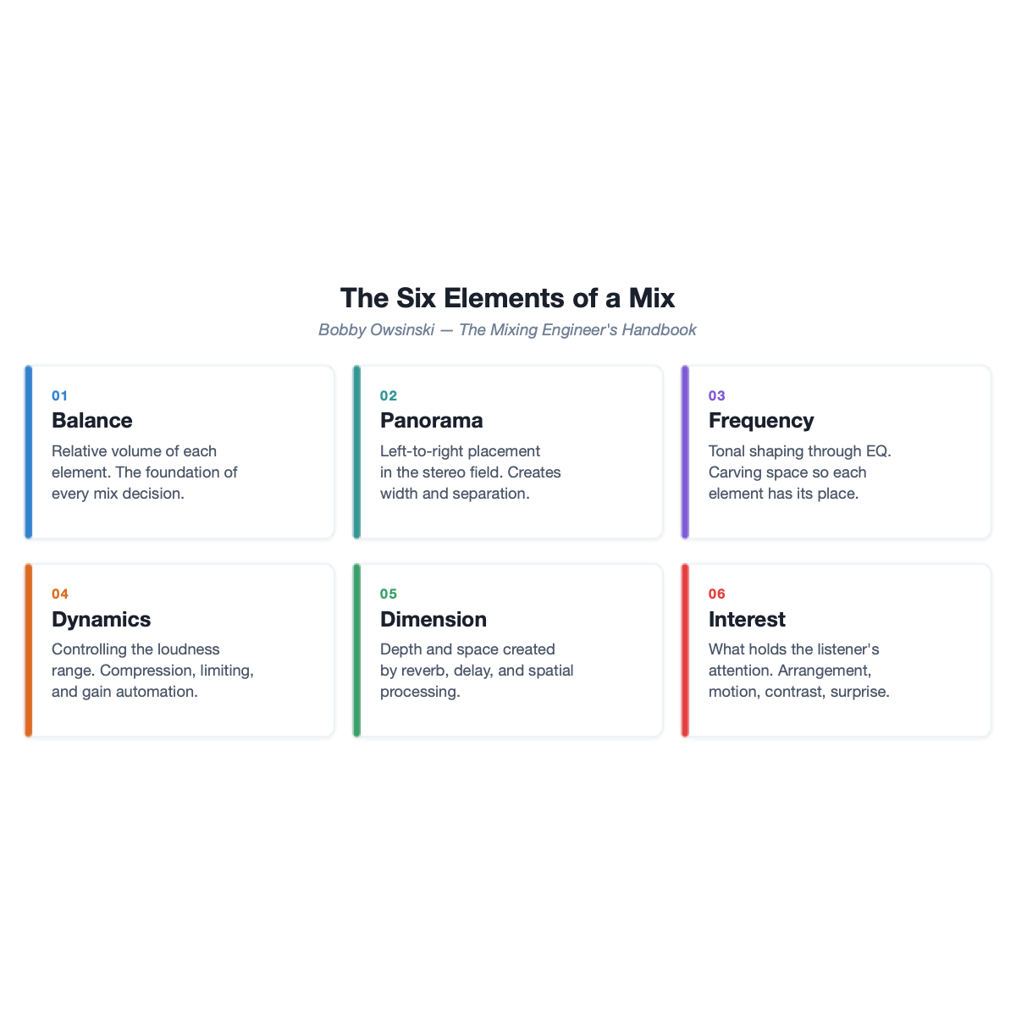

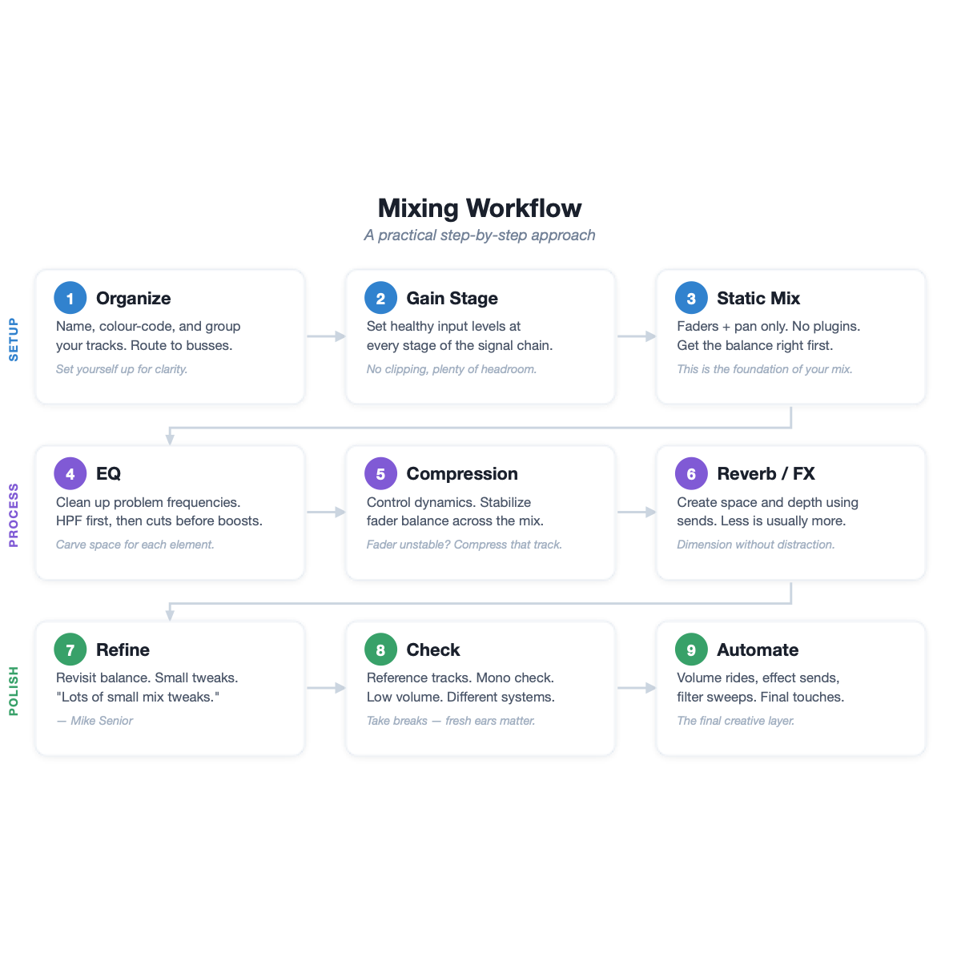

1. Organize
Name, colour-code, and group your tracks. Route related channels to subgroup busses (e.g., all drums to a “Drums” bus). create a mix bus and global reverb bus. Set yourself up for clarity or signal flow and organization before you touch any processing.
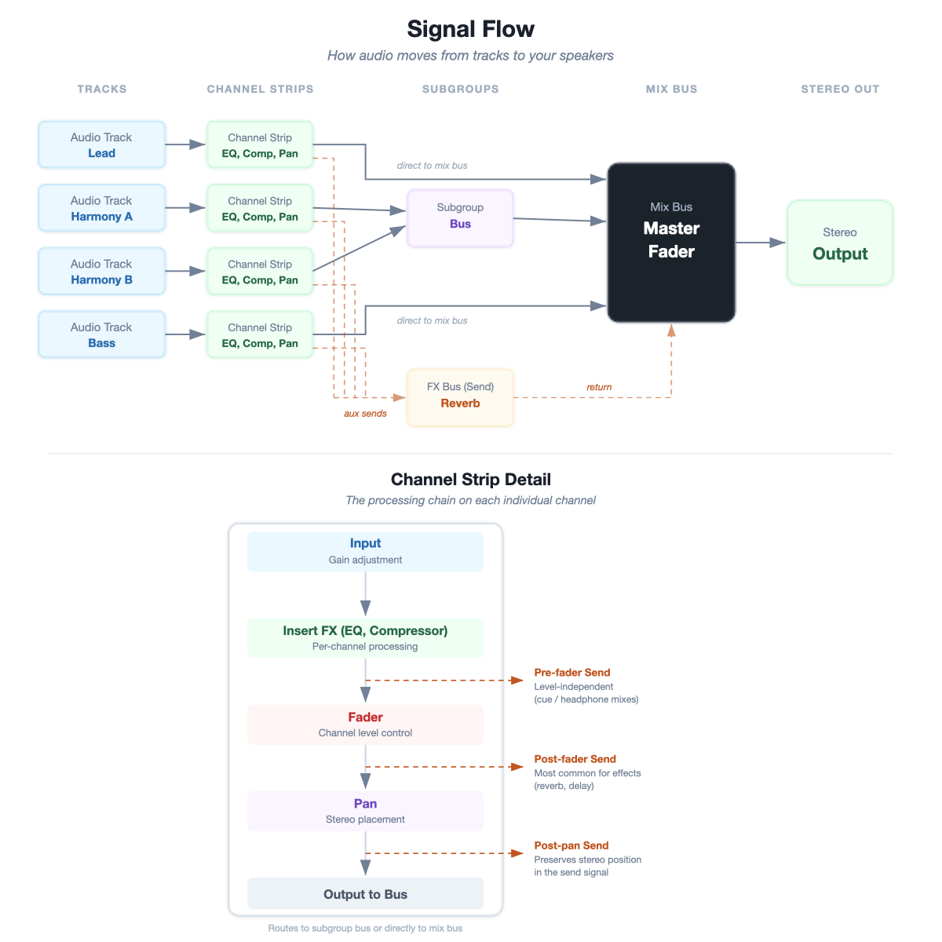
Signal Flow
Key concept: Use inserts for processing that’s unique to a channel (EQ, compression). Use sends for effects shared across multiple channels and additive effects (reverb, delay). This creates a cohesive sense of space, finer control of the sound, and saves CPU.

2. Gain Stage
Gain staging means setting healthy and balanced signal levels across all tracks. The goal is to keep levels in the “sweet spot”: loud enough for a clean signal, quiet enough to avoid clipping and leave headroom.
Gain staging can be achieved with a gain plugin at the top of the processing chain or other means depending on the DAW. Leave your faders at unity, those will be used later on!

Best Practices
- Start at the source: Set your channel input gain so peaks sit around -18 to -12 dBFS — this leaves plenty of headroom and keeps plugins operating in their sweet spot
- Unity gain through plugins: After adding EQ or compression (stage 4 and 5), check that the output level roughly matches the input level. Louder isn’t better — it just tricks your ears and makes the comparison harder.
- Watch the mix bus: Keep your master fader at 0 dB. If the mix bus is clipping, turn individual channels down rather than pulling the master fader down.
- Leave Headroom: On your mix bus aim for peaks below -6 dBFS — this leaves room for mastering.

3. Static Mix & Panning
Use the faders and pan only — no plugins. Get the balance right first. This is the foundation of your mix.
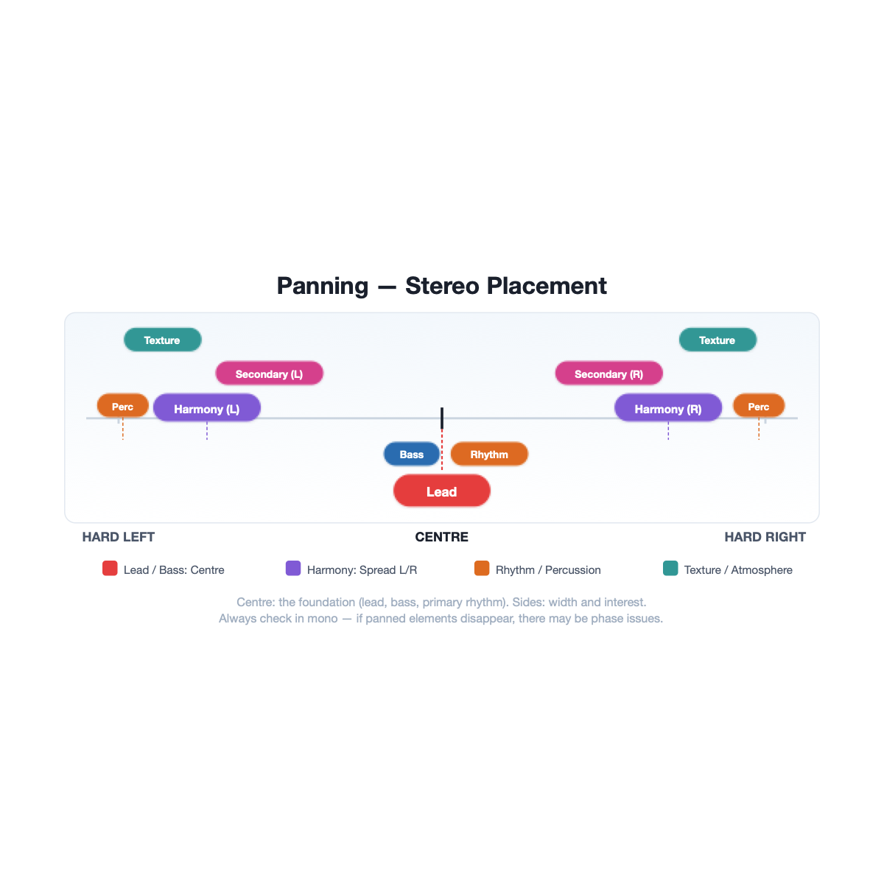
Some typical panning: - Centre: Lead, bass, and primary rhythm. - Sides: Harmony, secondary elements, texture, percussion. consider hard panning and using the entire width available! - Check in mono: If panned elements disappear in mono, there may be phase issues.

4. EQ (Equalization)
EQ shapes the frequency content of a sound — what you hear as tone, brightness, warmth, or muddiness.

The Frequency Spectrum
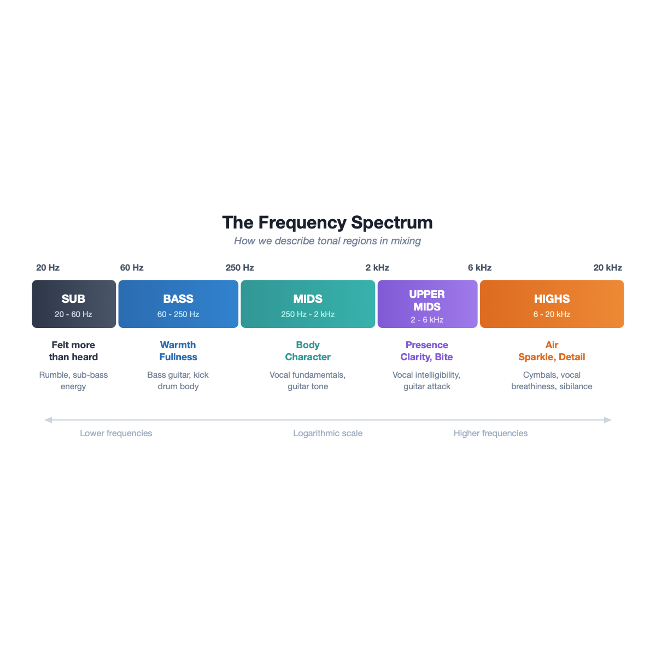

EQ Controls
Parameter | What It Does | Think of It As…
Frequency | Selects the centre frequency to boost or cut | Where on the spectrum you’re working
Gain | How much you boost (+) or cut (−), in dB | How much you’re turning that frequency range up or down
Q (Bandwidth) | How wide or narrow the affected range is | Low Q = broad and gentle; High Q = narrow and surgical

Common Filter Types
Filter | Shape | Typical Use
Bell (Peak) | Symmetrical boost/cut around a centre frequency | General-purpose tonal shaping — the most common EQ filter
High-Pass (HPF / Low Cut) | Passes highs, removes everything below a cutoff | Cleaning low-end rumble from non-bass instruments
Low-Pass (LPF / High Cut) | Passes lows, removes everything above a cutoff | Taming harsh high-frequency content or creating a “distant” effect
High Shelf | Boosts or cuts all frequencies above a set point | Adding “air” or reducing brightness across the top end
Low Shelf | Boosts or cuts all frequencies below a set point | Adding warmth or reducing low-end weight
Notch (Band-Reject) | Very narrow cut at a specific frequency | Removing a specific resonance or hum (e.g., 60 Hz electrical hum)
A parametric EQ gives you independent control of frequency, gain, and Q for each band — it is the standard EQ type in most DAWs and the most flexible tool for mixing.

Owsinski’s Six Trouble Frequency Areas
Frequency | Problem | Solution
~200 Hz | Mud, boominess | HPF or gentle cut
300-500 Hz | Boxiness | Narrow cut
~800 Hz | Cheap, hollow | Narrow cut
1-1.5 kHz | Nasal, honky | Narrow cut
4-6 kHz | Harsh, sibilant | Gentle cut or de-esser
10 kHz+ | Hiss, sibilance | Shelf cut or de-esser

Best Practices of EQ
- Subtractive first: Cut problem frequencies before boosting desired ones — introduces fewer artifacts (Senior, Mixing Secrets)
- HPF on nearly everything: Unless it’s bass or kick, high-pass filter to remove unnecessary low-end rumble.
- Cut narrow, boost wide: Surgical cuts target problems and broad boosts sound more natural
- Don’t use it if it doesn’t need it!

5. Compression
Compression controls dynamic range — the difference between the loudest and quietest parts of a signal.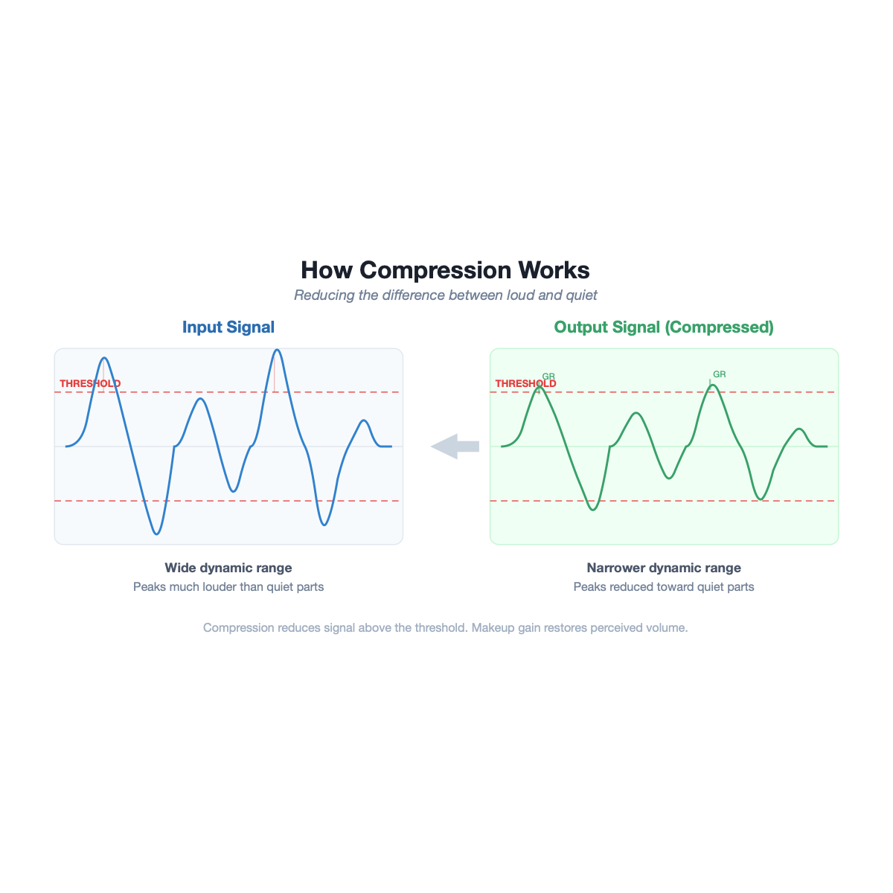

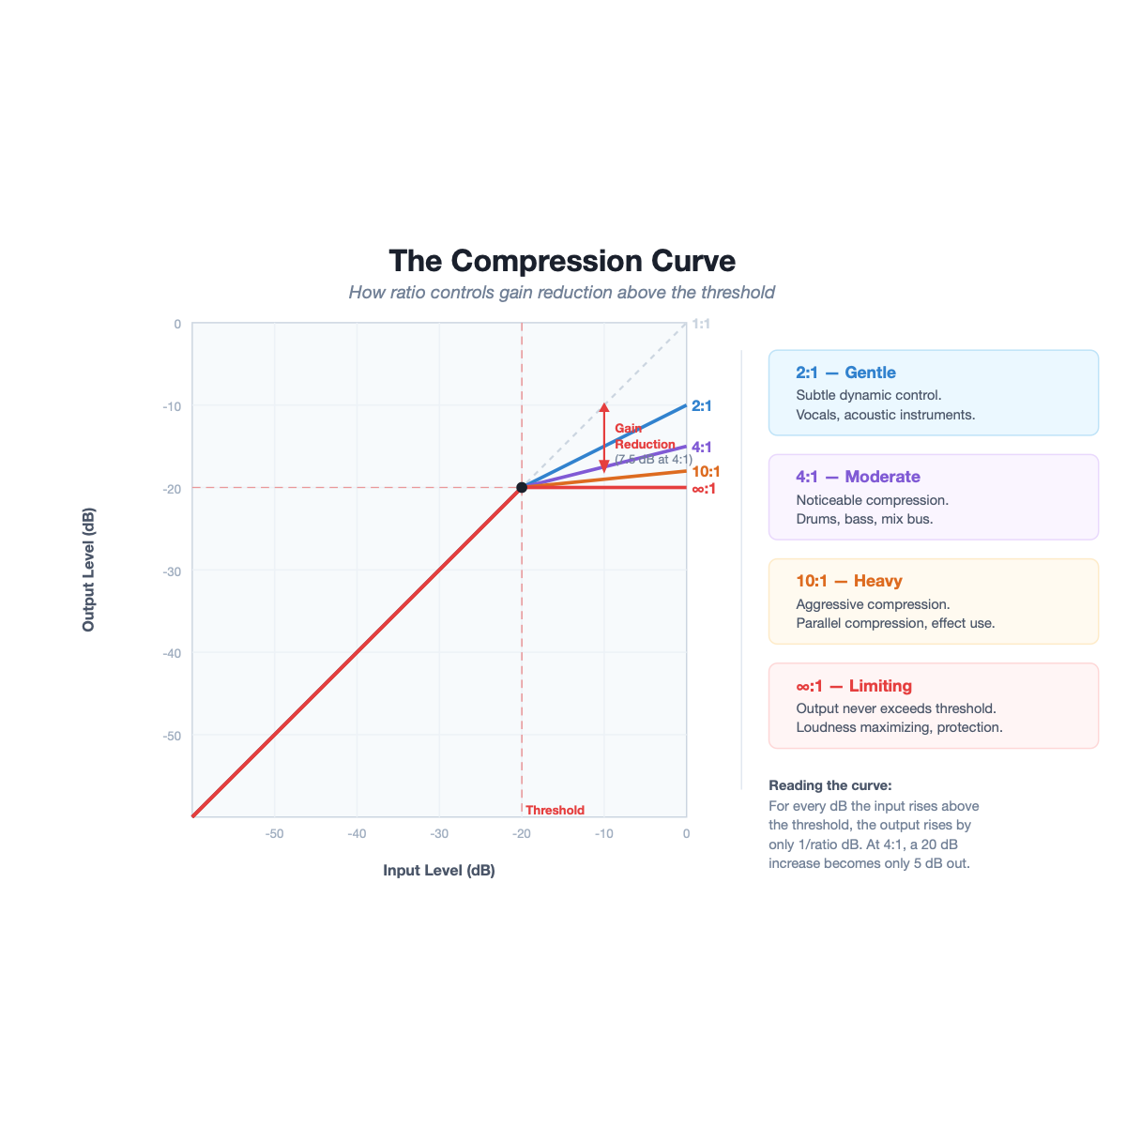

Key Parameters
Parameter | What It Does | Think of It As…
Threshold | Level where compression begins | The “trigger point”
Ratio | How much to reduce above threshold | How aggressively the dynamic range is compressed
Attack | How quickly compression engages | Fast = catches transients; Slow = lets transients through
Release | How quickly compression stops | Fast = can produce a pumping effect; Slow = smooth
Makeup Gain | Boosts output to compensate for reduction | Restoring perceived volume
You can think of a compressor kind of like an automated fader that brings down the level past a certain loudness.

Best Practices
- Start gentle: Low ratio (2:1-4:1), moderate threshold, and adjust from there
- Listen, don’t just look at meters: Use your ears, not the gain reduction display
- Compression is a balance tool: “From a mix perspective, the primary purpose of compression is to achieve a stable balance.” — Mike Senior, Mixing Secrets
- The fader instability diagnostic: If you keep adjusting a fader, that track probably needs compression (Senior)

6. Reverb / FX
Reverb can create a global sense of space but can also be used as an effect on a single track or subgroup. Today we will focus on the idea of a global reverb that helps to create a sense of shared space and coherence to a mix.
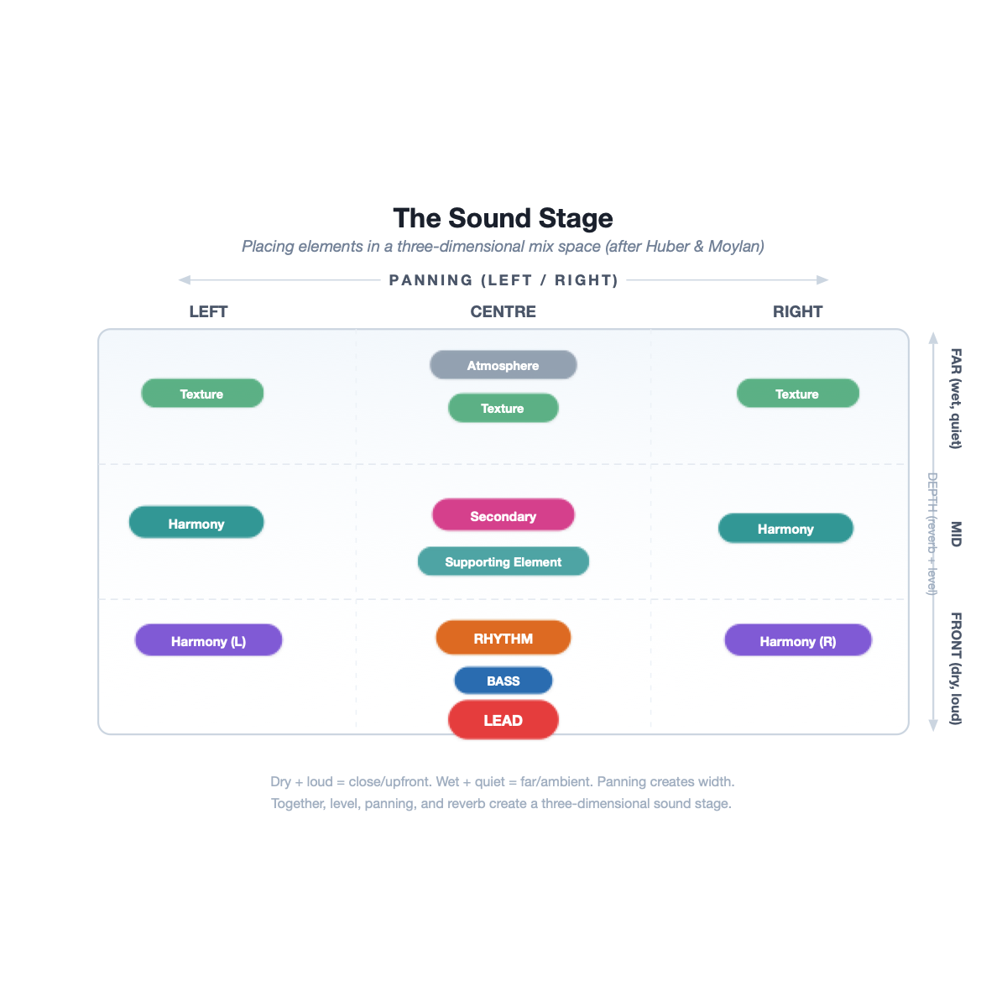

Key Parameters
Parameter | What It Does |  | Tip
Pre-delay | Gap before reverb begins | Longer = keeps lead element clear and upfront
Decay time | Length of reverb tail | Consider matching to song tempo — reverb can be rhythmic
Wet/dry | Blend of effect vs. original | Less is usually more
Type | Hall, room, plate, spring, etc. | Each has a character; experiment and get to know the sound of these different types

Best Practices
- Use sends, not inserts for additive effects like reverb: Route multiple channels to a shared reverb bus with 100% wet and 0% dry signal to control how much reverb is added to the mix and cohere various parts together into the same virtual space

7. Refine
Revisit your balance. Make small tweaks to fader levels, EQ, and compression now that all the processing is in place. This might also be a nice place to have a little break and step away from the mix before returning with fresh ears.

8. Check
- Reference tracks: Compare your mix against professional mixes in a similar genre.
- Mono check: Collapse to mono to check for phase issues; can you still hear everything?
- Low volume: Does the balance hold at quieter levels?
- Different systems: Headphones, laptop speakers, car — your mix should translate.

9. Automate
Volume rides, effect sends, panning movement, filter sweeps — automation is the final stage and a great place to get creative.

Free Resources
Resource | What It Is | URL
cambridge-mt.com | 500+ free multitrack sessions for mixing practice | cambridge-mt.com/ms/mtk/
iZotope Learn Hub | Articles and guides on mixing fundamentals | izotope.com/en/learn
Produce Like A Pro (YouTube) | Full mixing tutorials with free multitracks | YouTube

Recommended Reading
- Bobby Owsinski — The Mixing Engineer’s Handbook (5th ed., 2022) — Accessible framework + engineer interviews
- Mike Senior — Mixing Secrets for the Small Studio (2nd ed., 2019) — Practical, budget-friendly, hands-on
- Roey Izhaki — Mixing Audio (4th ed., 2024) — Comprehensive technical reference
- William Moylan — The Art of Recording (2002/2015) — Deep analytical and aesthetic perspective
- David Miles Huber — Modern Recording Techniques (9th ed., 2017) — Broad survey of the full recording chain

