mf6Voronoi Studio
Quick Start Guide
Version 3.0.0
From shapefiles to a MODFLOW 6 grid in about ten minutes
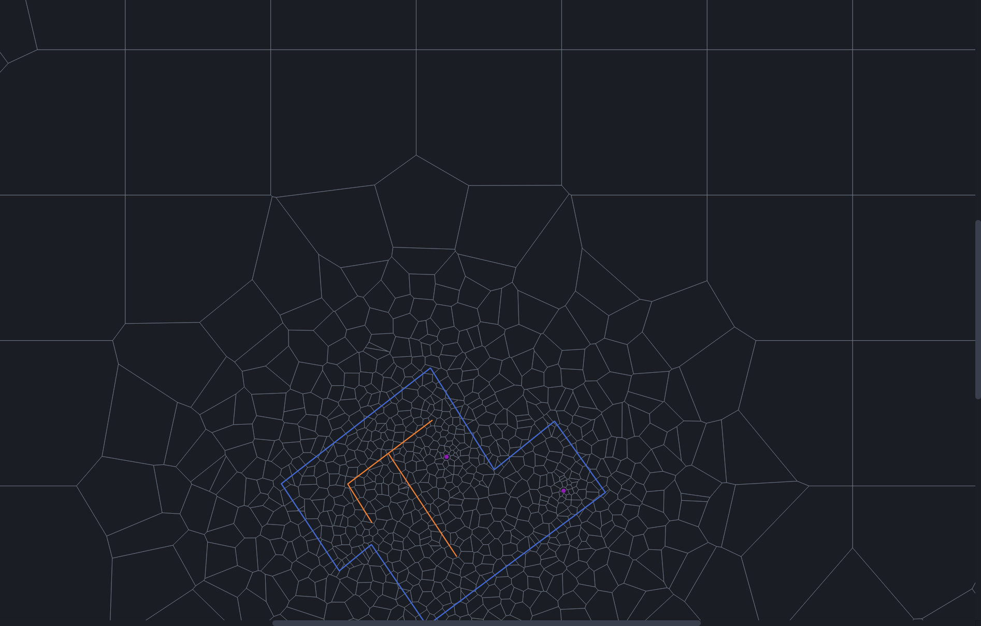
Follow these seven steps on the Example folder that ships with the
application. For the full reference, see the User Manual.
mf6Voronoi — Saul Montoya
GUI developer — An Ho Taylor
Viva el Software Libre

Contents
1. Before you start 3
The window 3
2. The seven steps 4
Step 1 — Set the coordinate system 4
Step 2 — Import the model limit 4
Step 3 — Add the refinement layers 5
Step 4 — Set the refinement options 5
Step 5 — Generate the mesh 6
Step 6 — Check the mesh and the report 7
Step 7 — Export and save 8
3. At a glance 10
Toolbar 10
Keyboard and mouse 10
Five things that catch people out 10
Where to go next 10

1. Before you start
mf6Voronoi Studio turns a model boundary and a handful of GIS features into an unstructured Voronoi grid for MODFLOW 6 — fine where you need detail, coarse where you do not.
This guide walks one complete pass using the Example folder installed alongside the application. Work through it once and you will have produced a real grid and a ModelMuse-ready model.
You need | Details
The application | mf6Voronoi Studio 3.0.0 (check with Help → About)
The Example folder | Shipped with the application; used throughout this guide
One projected CRS | In metres or feet. The Example data is EPSG:32631, in metres
About ten minutes | The mesh in this guide generates in roughly three seconds

The one rule that matters. Every file you import must be in the same projected coordinate system, and cell sizes are distances in that system’s unit. Geographic (latitude/longitude) data is rejected.

The window
The map is on the left; a scrolling column of panels is on the right, arranged top to bottom in the order you work through them.
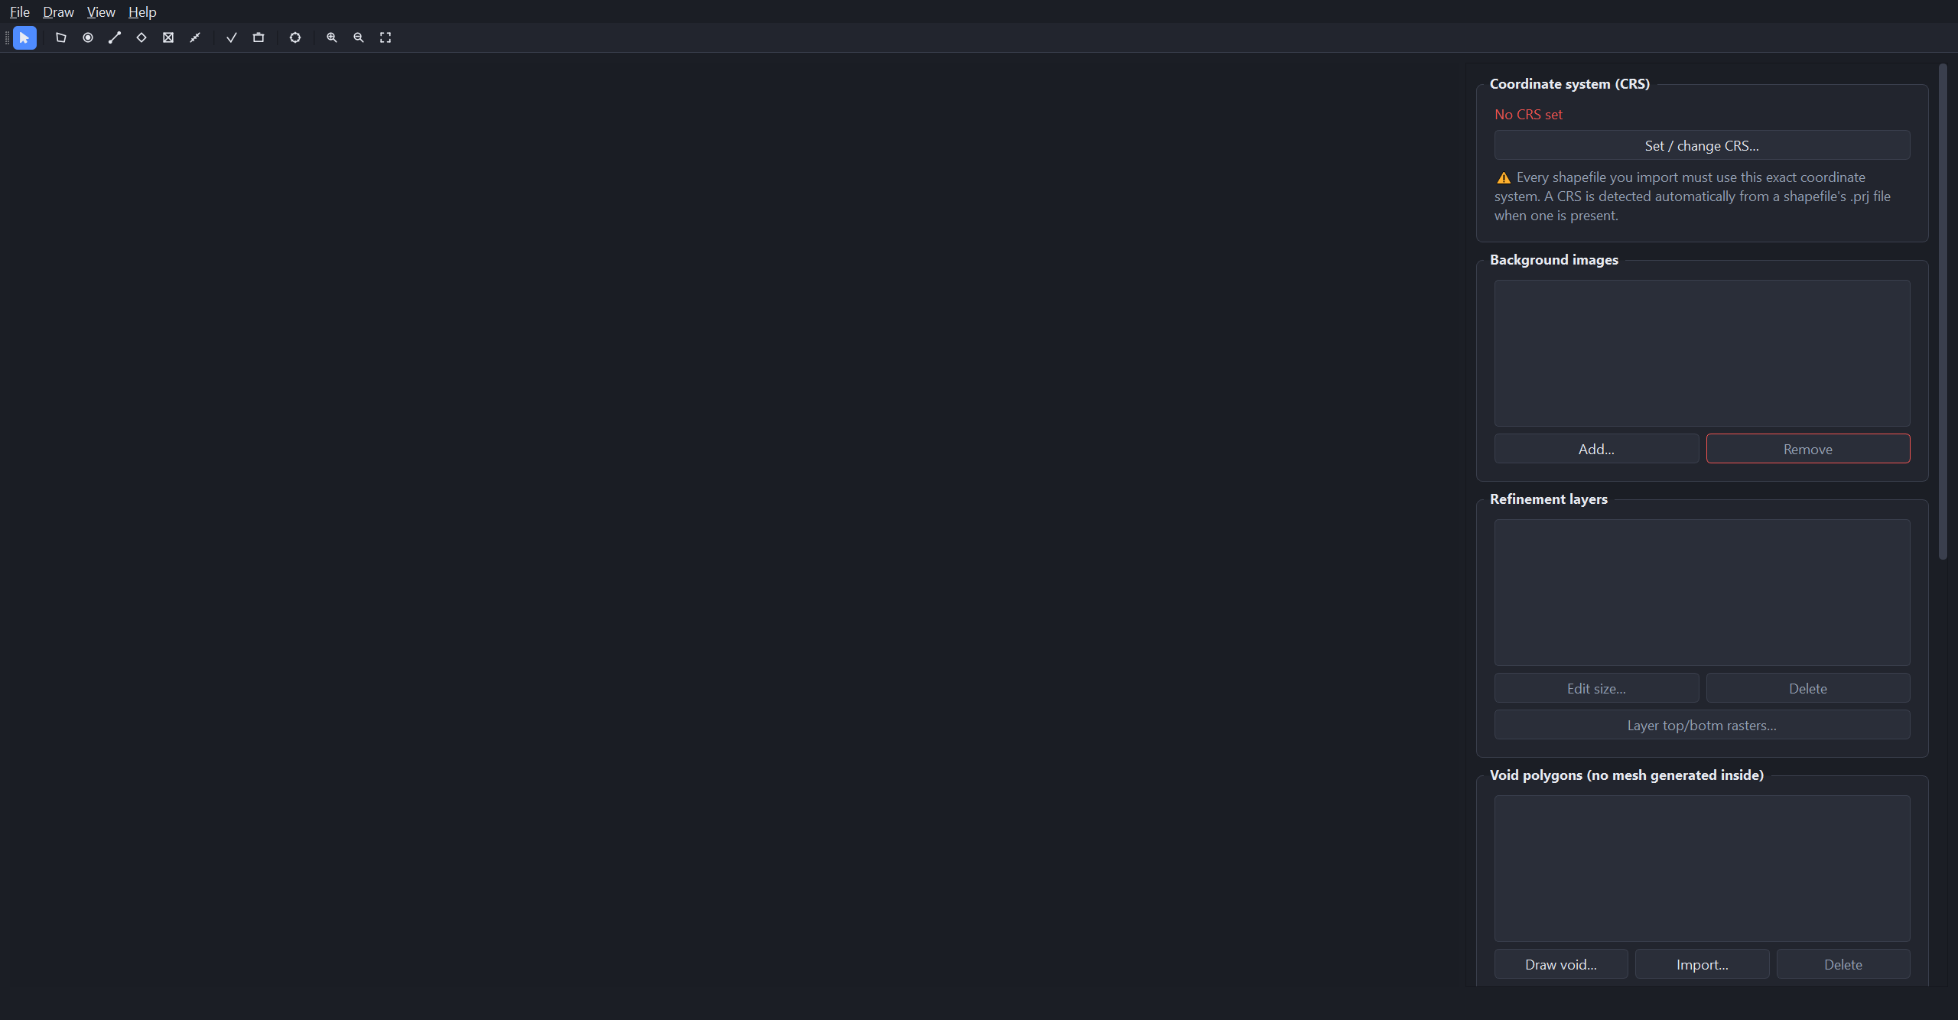
Figure 1. The application on first launch.

2. The seven steps

Step 1 — Set the coordinate system
In the Coordinate system (CRS) panel click Set / change CRS…, type 32631 and click OK. The panel should then read "WGS 84 / UTM zone 31N (EPSG:32631) — unit: meter".
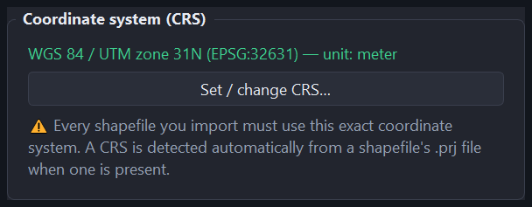
Figure 2. The CRS panel once it is set.
You can skip this step. Importing the limit polygon first picks up the CRS from its .prj file automatically.

Step 2 — Import the model limit
Choose File → Import limit polygon… and select Example\modelLimit.shp. The boundary appears in cyan and the map fits itself to it.
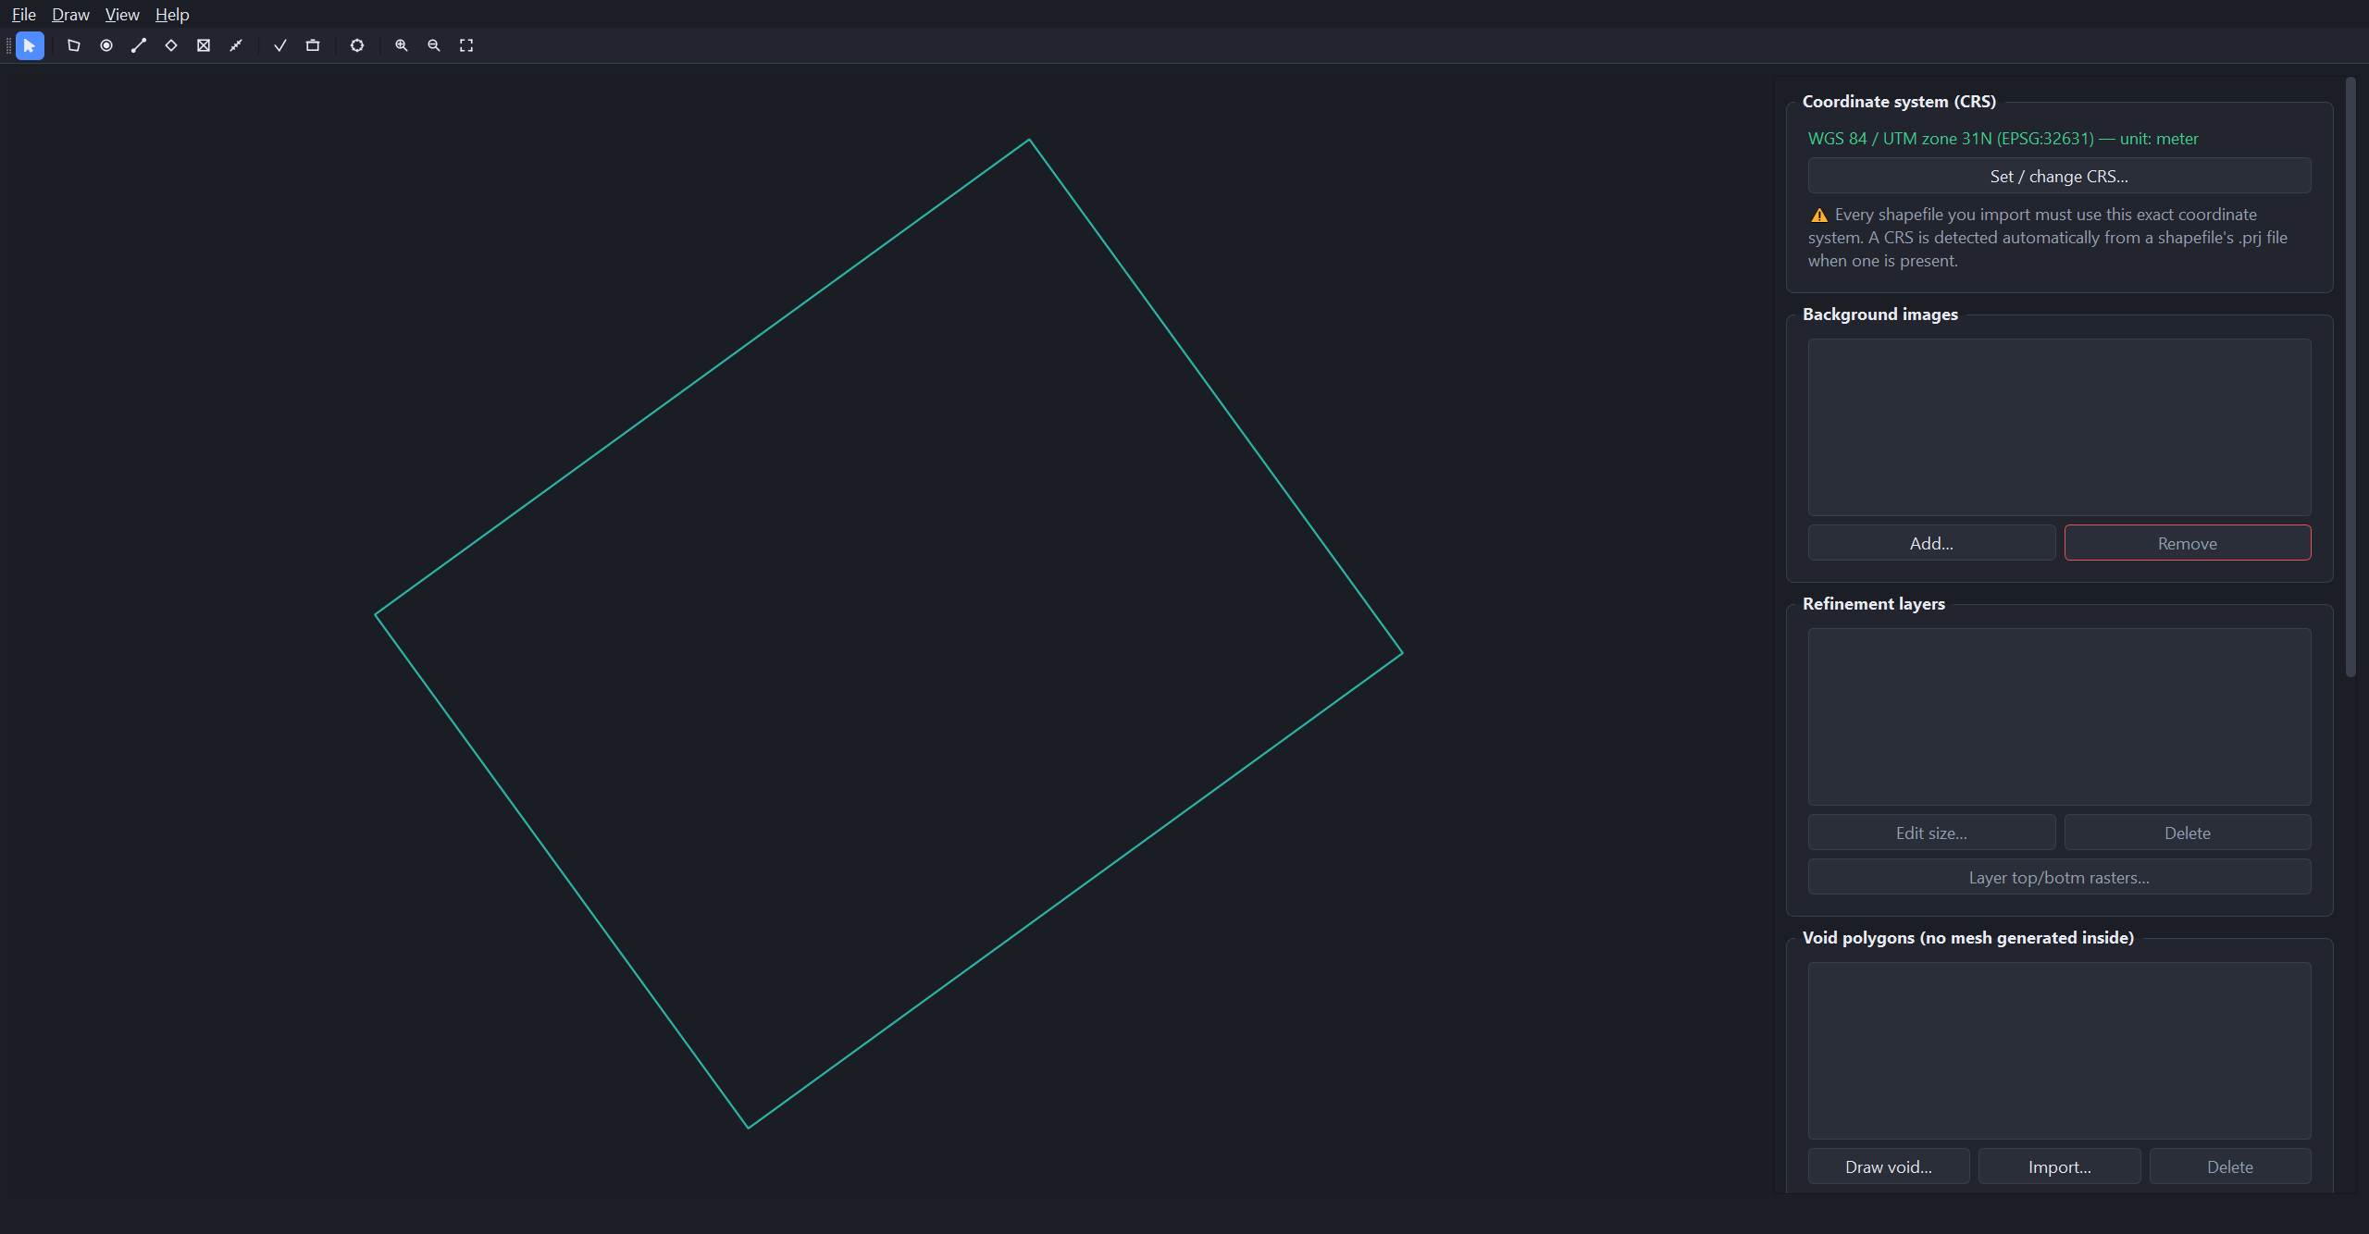
Figure 3. The model limit, loaded and fitted.
It must be exactly one single-part polygon. If yours is multipart, dissolve it in GIS first.

Step 3 — Add the refinement layers
These are the features the grid should follow closely. For each one, choose File → Import refinement shapefile…, pick the file, then give it a name and a target cell size.
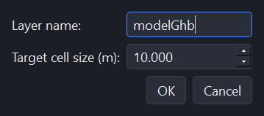
Figure 4. Naming a layer and setting its target cell size.
Import these five, in this order — coarsest first, so cell sizes step down smoothly from the boundary to the wells:
Shapefile | Name | Target cell size
modelGhb.shp | modelGhb | 10 m
site.shp | site | 4 m
hfb.shp | hfb | 3 m
drains.shp | drains | 2 m
pointWell.shp | pointWell | 1 m

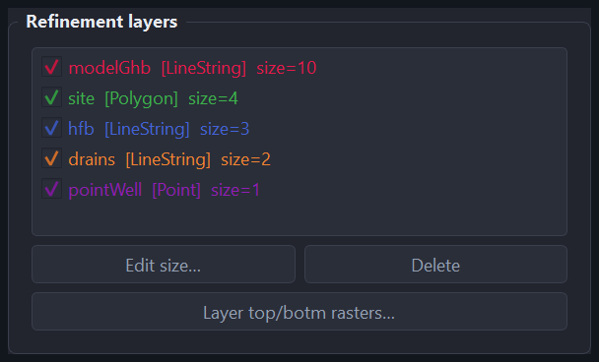
Figure 5. All five layers loaded.
You can draw layers instead of importing them — the Draw menu and the toolbar have point, line and polygon modes. Remember to click Finish layer (the check button) when you are done, or nothing is committed.

Step 4 — Set the refinement options
Scroll down to "Voronoi refinement options" and enter these four values:
Option | Value | What it controls
Coarse (max) cell size | 20 m | The biggest cell, used far from every feature
Refinement multiplier | 1.3 | How fast cells grow outwards — about 30 % per ring
Allow overlapping refinement | On | Lets refinement zones overlap instead of competing
Fix short edges below | 0.2 m | Re-seeds cells with edges shorter than this

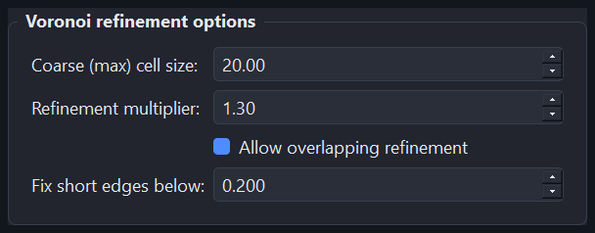
Figure 6. The options for this run.
A useful starting point on your own data: coarse size about 1/15 of the shorter side of your model, multiplier between 1.2 and 1.5.

Step 5 — Generate the mesh
Click ⚙ Generate Voronoi mesh in the Mesh panel (or the gear button on the toolbar), accept the default mesh name, and wait. This example finishes in about three seconds and tells you when it is done.
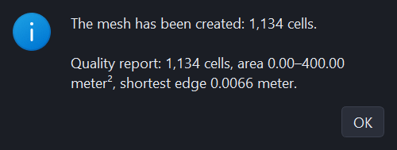
Figure 7. The completion popup.
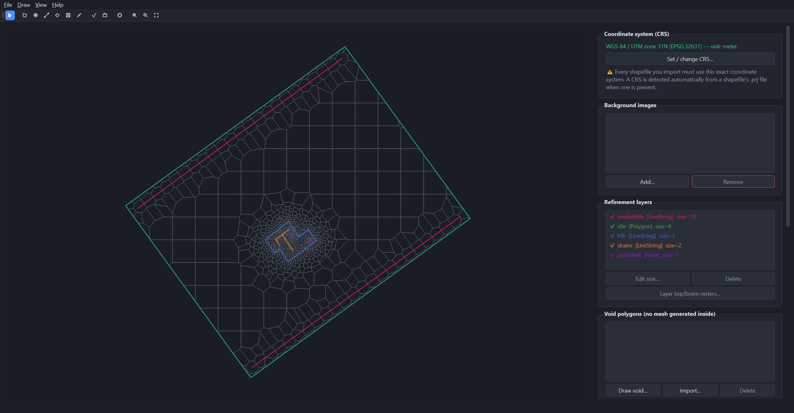
Figure 8. The result: 1,134 cells, fine at the centre, coarse towards the corners.

Step 6 — Check the mesh and the report
Zoom in on the middle of the model. The cells should tighten smoothly towards each feature — no abrupt jump from coarse to fine.
Figure 9. Refinement tightening from 20 m cells to 1 m at the two wells (magenta).
The quality report fills in on its own. Three numbers are worth a glance every time:
Check | This run | What it means
Total area | 44,293.75 m² | Must equal your model limit area. It does here, exactly — nothing was lost when the mesh was clipped to the boundary.
Cell area max | 400.00 m² | The 20 m coarse size squared, so the coarse setting was actually reached.
Cells (ncpl) | 1,134 | The size of your grid. If it is far larger than you expected, raise the finest target size or the multiplier.

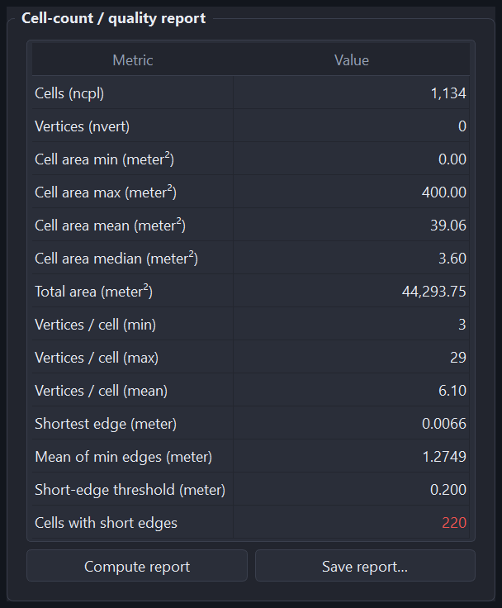
Figure 10. The full report for this run.
Do not panic at "Cells with short edges". The count is relative to the threshold you set. On this same mesh a 0.5 m threshold flags 60 % of cells; the 0.2 m used here flags 19 %. Set it to a small fraction of your finest target cell size and watch it as a trend between runs, not as a pass or fail.

Step 7 — Export and save
To get | Use | Result
The grid in GIS | File → Export mesh shapefile… | An ESRI polygon shapefile with a .prj
The raw DISV arrays | File → Export DISV properties (JSON)… | ncpl, nvert, vertices, cell2d, centroids
A MODFLOW 6 model | File → Export ModelMuse MODFLOW 6 model… | Eight files including mfsim.nam and the .disv
Your work back tomorrow | File → Save project (Ctrl+S) | One .mf6vor file holding everything, mesh included

The ModelMuse export in brief
- Choose File → Export ModelMuse MODFLOW 6 model…
- Set the number of layers to 4.
- Set the model top to modelTop.tif and the four layer bottoms to bottomLy1.tif–bottomLy4.tif (click Raster… on each row).
- Pick an empty output folder and click OK.
- In ModelMuse: File → Import → Import MODFLOW-6 Model… → select mfsim.nam.
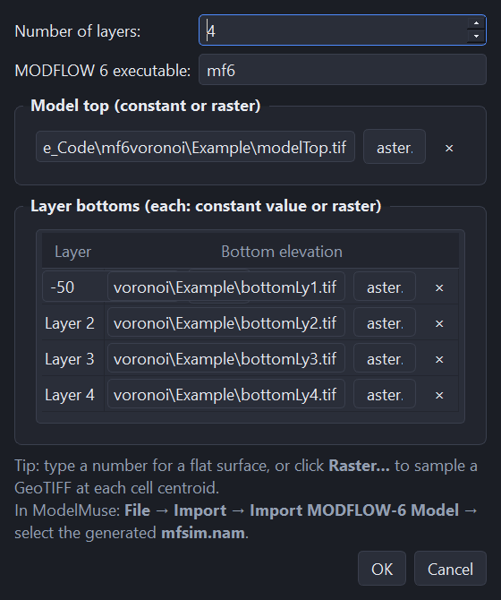
Figure 11. The export dialog, set up for four layers with a raster for each surface.
Any surface can be a plain number instead of a raster — type it in the field rather than browsing for a file.

3. At a glance

Toolbar
Figure 12. Left to right: Navigate · Limit · +Points · +Lines · +Polygons · +Void · Measure · Finish layer · Cancel layer · Generate mesh · Zoom in · Zoom out · Fit to data.
The first seven are modes: one is active at a time, and its button stays pressed. Navigate is the default.

Keyboard and mouse
Input | Does
Ctrl+N / Ctrl+O / Ctrl+S | New project / Open project / Save project
Ctrl+Shift+S | Save project as…
Enter | Finish the shape you are drawing
Esc | Cancel the shape or measurement in progress, otherwise deselect
Delete | Remove the selected background image or void polygon
Left-drag | Pan the map (in Navigate mode)
Middle-drag | Pan the map (in any mode)
Mouse wheel | Zoom in and out
Double-click | Finish the shape you are drawing

Five things that catch people out
- Drawn features vanish. They are not committed until you click Finish layer (the check button).
- A shapefile is refused. Its CRS differs from the project’s. Re-project it in GIS — the application will not do it for you.
- The limit will not load. It must be exactly one single-part polygon.
- Vertices (nvert) shows 0. Expected — it stays 0 until you export the DISV properties or a ModelMuse model.
- Far more cells than expected. Your finest target size is very small relative to the coarse size. Halving a target size roughly quadruples the cells in that zone.

Where to go next
The User Manual covers every menu command, every sidebar panel, the drawing tools, void polygons, background images — including the new "Online satellite map" tab for fetching a georeferenced satellite basemap directly from the internet — the measure tool, how to read each quality metric, and a troubleshooting table.

mf6Voronoi Studio is a graphical front-end for the mf6Voronoi package by Hatari Labs: https://github.com/hatarilabs/mf6Voronoi

Viva el Software Libre

