

**Sea Star Wasting Surveys**

**Results from Otter Rock and Cascade Head Marine Reserves 2015-2018**

In April 2014 the sea star wasting syndrome (SSWS) epidemic spread to Oregon. This outbreak was more widespread and affected more sea stars than ever recorded. Due to this event, the marine reserves in Oregon were able to help address an important emerging issue. To add to the existing database on SSWS and increase understanding of its extent, the Oregon Department of Fish and Wildlife (ODFW) Marine Reserves Ecological Monitoring Team utilized two sampling methods to monitor SSWS at Otter Rock Marine Reserve and Cascade Head Marine Reserve, outlined below.

Otter Rock and Cascade Head intertidal sites were added in 2015 to expand intertidal ecological monitoring efforts in Oregon’s marine reserves. These two sites include suitable rocky intertidal habitats to survey but previously were not monitored by ODFW or other academic partners (Oregon State University, University of California, Santa Cruz). As part of the protected area within the reserves, these intertidal sites can provide valuable information on the effects of no-take management as well as the natural changes in sea star populations due to the wasting disease. Therefore, establishing baseline data of these previously unsurveyed sites followed by continued monitoring are important steps in assessing the spread of disease and the state of the sea stars in the reserves.

**Methods**

*Timed Searches*

Timed searches were conducted in the intertidal zones of the two marine reserves during negative low tides. This survey method is to target adult individuals (50-210mm) that may not be very abundant in the 10m2 transects. With this method we hope to get a better estimate of adult populations. Using the guidelines set by MARINe researchers at the University of California, Santa Cruz (<http://www.eeb.ucsc.edu/pacificrockyintertidal/data-products/sea-star-wasting/>), samplers roamed throughout the site while counting and measuring the radius of all *Pisaster ochraceus* found. *Evasterias troschelii* was also a target species, although none has been found to date in these surveys. To measure an individual sea star, the tape measure was placed along the length of the tip of the straightest, longest arm to the true center of the oral disk and not the madreporite, which is typically located off the center. This measurement was then recorded to the nearest 5 mm for individuals less than 10 mm and to the nearest 10 mm for those greater than 10 mm.

Following size measurement, the general disease condition was assessed and categorized in increasing severity from 0 to 4 (Table 1).

**Table 1. Disease Categories.**

|  |  |
| --- | --- |
| Category | Condition |
| 0 | Healthy |
| 1 | Lesion on 1 arm or body |
| 2 | Lesions on 2 arms or 1 arm and body and/or deteriorating arm(s) |
| 3 | Lesions on most of body and/or 1-2 missing arms |
| 4 | Severe tissue deterioration/death and/or ≥ 3 missing arms |

When spawning, sea stars release a milky exudate from their oral disks that resembles the lesions on afflicted sea stars. Care was taken to differentiate these spawning sea stars from diseased individuals for accurate disease assessment.

Total search time and the number of samplers were recorded for each of the timed search efforts. Any time not spent actively searching for sea stars was not recorded. The survey aimed to count as many *P. ochraceus* adults and recruits as possible, as well as *E. troschelii* when present. We note that there may be differences in search effort by different surveyors over the years that could skew this data. To account for this difference we divided the total sea stars found in each size class by the “search effort” of each timed search. Search effort is defined as the time spent searching multiplied by the number of people searching. Additionally because of the nature of the searching, roaming and not having a defined area to search completely, sea stars 5-40mm may be overlooked. Hence, this data should be considered with caution as the strength of the data may not be robust.

For analysis …. “*” denotes a p-value less than 0.05, “**” denotes a p-value less than 0.01, “***” denotes a p-value less than 0.001.

Timed searches were conducted over two days at Otter Rock Marine Reserve in 2015 (N=2), 2016 (N=5), 2017 (N=7), 2018 (N=5). Timed searches were conducted once at Cascade Head Marine Reserve in 2015 (N=1), and over two days in 2016 (N=4), 2017 (N=8), and 2018 (N=4). Survey dates for Otter Rock Marine Reserve included 7/2/15, 7/16/15, 7/5/16, 8/3/16, 6/22/17, 8/8/17, 5/17/18, and 7/15/18; and 7/6/15, 7/6/16, 8/4/16, 6/23/17, 7/24/17, 5/18/2018, and 8/12/18 for Cascade Head Marine Reserve.

Data collected for the timed searches was uploaded to the MARINe website.

*Belt Transects*

In addition to the timed searches, belt transects were conducted at each site to generate density data and survey the suite of sea star species present. Belt transect methodology was developed by Dr. Bruce Menge at Oregon State University. Transects consisted of 2 x 5 m transect tapes placed perpendicular to each other, with GPS waypoints taken at the start of each location for potential re-surveying of these transects. Ideally, 5 randomly placed belt transects would be completed in the low zone (below the lower edge of the *M. californianus* mussel beds) for each sampling trip. However, the incoming tide and available samplers limited the number of completed transects.

Inside each belt transect, the area was searched intensively for all sea star species. During this survey, it was important to look very carefully, as most of the sea stars found in these transects were juveniles measuring 30 mm or less that matched the surroundings extremely well. Moving objects and looking in cracks and crevices was critical in locating the majority of these juveniles. Upon finding a sea star, the same measurement method and disease assessment employed in the timed search was used.

For analysis …. “*” denotes a p-value less than 0.05, “**” denotes a p-value less than 0.01, “***” denotes a p-value less than 0.001.

Belt transects were conducted at Otter Rock Marine Reserve twice in 2015, 2016, 2017, and 2018 on 7/2/15 (*N* = 5), 7/16/15 (*N* = 4), 7/5/2016 (*N* = 4), 8/3/16 (*N* = 4), 6/22/17 (*N* = 3), 8/8/17 (*N* = 3), 5/16/18 (N=2), 5/17/18 (N=3), and 7/15/18 (N=5). Belt transects were conducted at Cascade Head Marine Reserve once in 2015 on 7/6/15 (*N* = 3), twice in 2016 on 7/6/16 (*N* = 3) and 8/4/16 (*N* = 3), twice in 2017 on 6/23/17 (*N* = 4) and 7/24/17 (*N* = 4), and twice in 2018 on 5/18/18 (N=5) and 8/12/18.

Data collected for the belt transects was sent to the Menge Lab at Oregon State University.

Sea star wasting does occur most of the time at very low levels, less than 10% of population diseased. For these surveys we are looking for levels above this, particularly anything that reaches near 20% is of concern.

Otter Rock Key Findings

Timed Search Survey Data

1. The observed number of *Pisaster ochraceus* adults per unit of search effort increased from 2015-2018 (Kruskal, p=0.018).

Belt Transect Data

1. The density of *P. ochraceus* increased from 2015 to 2017 but then decreased in 2018 (ANOVA, p=0.011).
2. *Henricia spp.* and *Leptasterias spp.* density remain relatively constant over the four years
3. From 2016 to 2018 *P. ochraceus* and *Leptasterias spp.* densities are extremely similar to one another.
4. Recruit and Adult densities have a positive relationship between 2015-2018 with both remaining very low (<0.5/m2) across all four years

Combined Data

1. Prevalence of wasting almost always below normal levels (only exception in 2017 with mildly and total diseased individuals)
2. Severely diseased individuals follow a different trend than the mildly and total diseased individuals but this trend is the same as Cascade Head’s trend for all levels of severity in diseased individuals.

****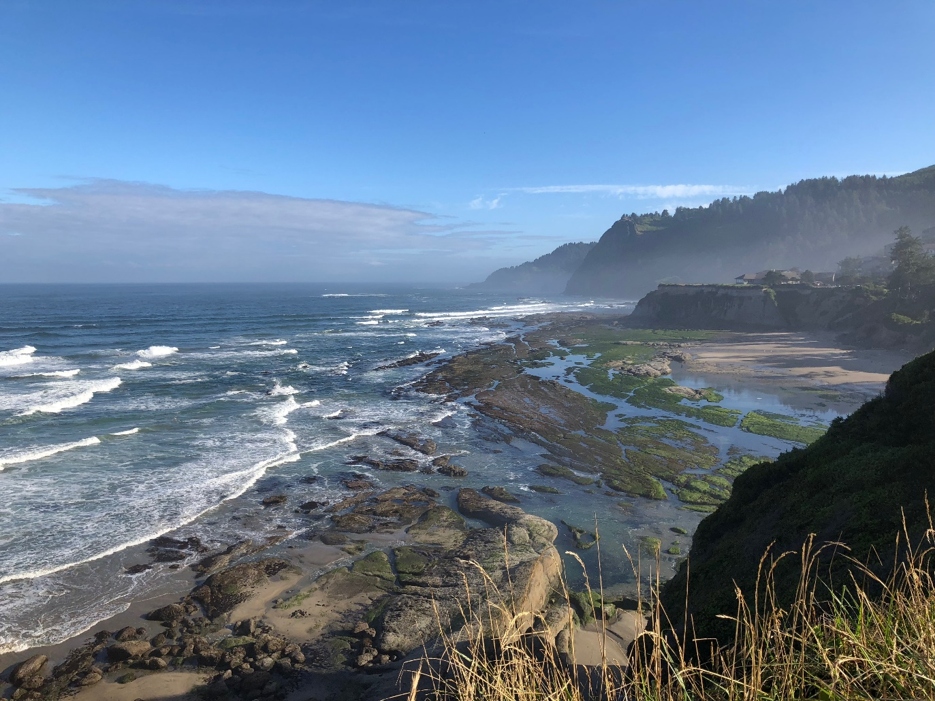

Results

**Otter Rock**

*Timed Searches*

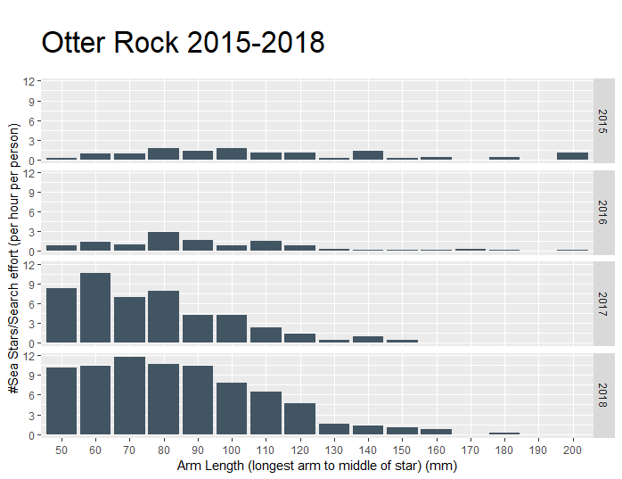

Figure 1. Otter Rock Marine Reserve size distribution of the total number per year of *P. ochraceus*. per unit of search effort from all timed searches for 2015-2018.

Intertidal sea star surveys at Otter Rock yielded insight into potential population recovery of adult *P. ochraceus* from sea star wasting disease. The number of adult *P. ochraceus* found per unit of search effort changed significantly over the four years (Kruskal, p=0.018*). This difference comes from 2018 being significantly greater in adult *P. ochraceus* compared with 2016 (Tukey, p=0.011*). While adults overall increase, the very large adults (>130mm) remain low for all four years.

The mean and median arm length of adults was highest in 2015 and decreased until 2017. However in 2018 both the mean and median arm length of adults increased slightly. This increasing trend may continue as the more resistant younger stars continue to grow.

The search effort per year did vary: 2015 had 4.55 hoursXpeople, 2016 had 5.86 hoursXpeople, 2017 had 2.17 hoursXpeople, and 2018 had 3.83 hoursXpeople. The total number of sea stars observed was 58 in 2015, 74 in 2016, 103 in 2017, and 297 in 2018.

*Belt Transects*

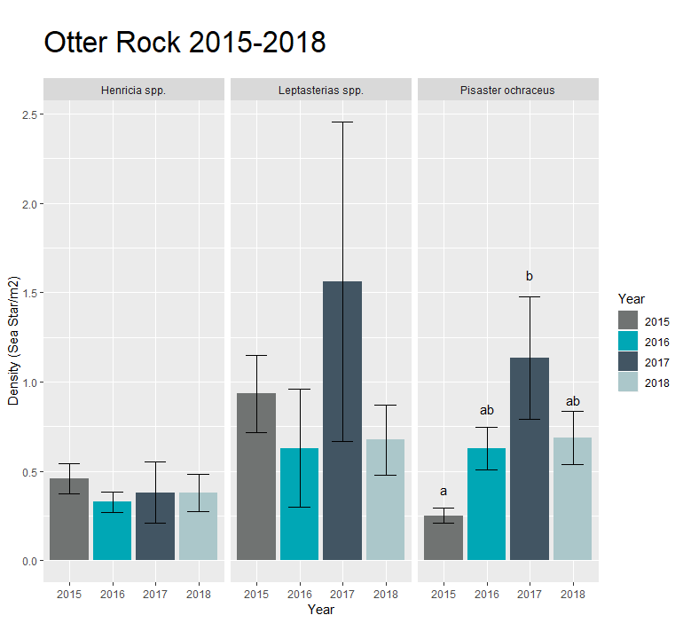

Figure 2. Otter Rock Marine Reserve mean sea star densities (±SE) per species from all belt transects for 2015-2018 (*\*\* denotes p < .01*).

*Henricia spp.* was observed during all four years at low densities, ranging from the lowest density at 0.33/m2 to the highest at 0.46/m2. There was no significant change in density across the four years sampled (ANOVA, p=0.85).

*Leptasterias spp.* density did fluctuate over the four years ranging from 0.63/m2 to 1.56/m2.However this change was not significant (log transformed ANOVA, p=0.43). Large variation in observations caused the standard error to be too large to make a statistically significant conclusion about change.

*P. ochraceus* density also fluctuated over the four years ranging from 0.25/m2 to 1.13/m2. For *P. ochraceus* density there was a significant change (Kruskal, p=0.014). This change was driven by an increase in sea stars between 2015 and 2017 (Tukey, p=0.014).

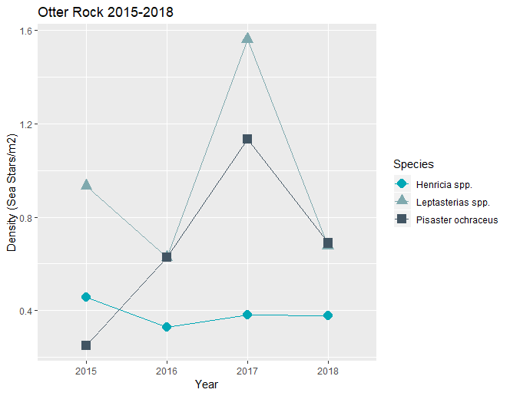

Figure 3. Otter Rock Marine Reserve mean sea star densities from all belt transects for 2015-2018.

In 2016 *P. ochraceus* begins to follow the same density trend as *Leptasterias spp.* and this trend continues through 2018. Additionally densities of *P. ochraceus* were always similar or below densities of *Leptasterias spp*.

*Henricia spp.* is at lower densities than both other sea stars from 2016 to 2018. Only in 2015 *P. ochraceus* was even lower in densities than *Henricia spp.* most likely because *P. ochraceus* had not yet recovered from sea star wasting while *Henricia spp.* was rarely seen affected by wasting.

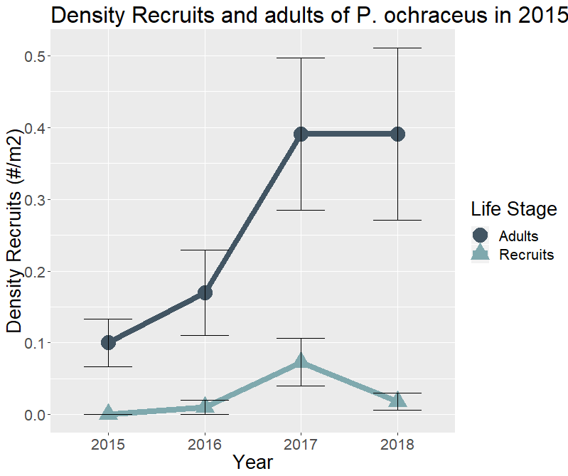

Figure 4. Otter Rock Marine Reserve mean *Pisaster ochraceus* recruit and adult densities (±SE) from all belt transects for 2015-2018.

There were no recruits observed in 2015 at Otter Rock. Recruit densities spiked in 2017 but then dropped sharply in 2018. There seems to be a positive correlation between adult and recruit densities. Both were low in 2015 and high in 2017. However recruit densities did drop in 2018 while adult densities remained the same. Additionally adult densities were always higher than recruit densities at Otter Rock

This doesn’t appear to follow the suggested reason for high recruitment found by Menge et al. 2016 after wasting. They observed high recruitment levels in 2014-2015, at much higher densities compared with adults. They also hypothesized that recruitment spiked because adult populations were low and thus reduced competition for food. Not only does Otter Rock always have lower recruit densities than adult densities but because it also has a positive correlation between adult and recruit densities, it is unlikely that competition controls the density of recruits.

*Combined Data (both Belt Transect and Timed Search)*

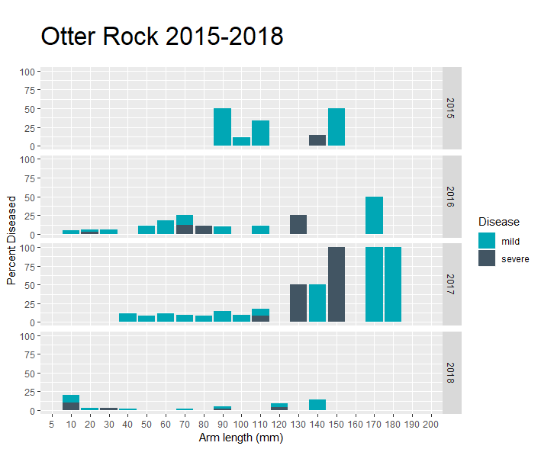

Figure 5. Otter Rock Marine Reserve percent diseased *Pisaster ochraceus*  per arm length (mm) stacked by severity of symptoms (mild: one lesion; severe: multiple lesions, arms falling off, dissolving) from 2015-2018 for all *P. ochraceus* recorded each year both from timed searches and belt transects.

Severe symptoms were more common among adults (≥50mm). Any symptom, either mild or severe, was less common among recruit and juvenile *P. ochraceus* compared with adults. Wasting had the highest percentages in large adults (≥130).

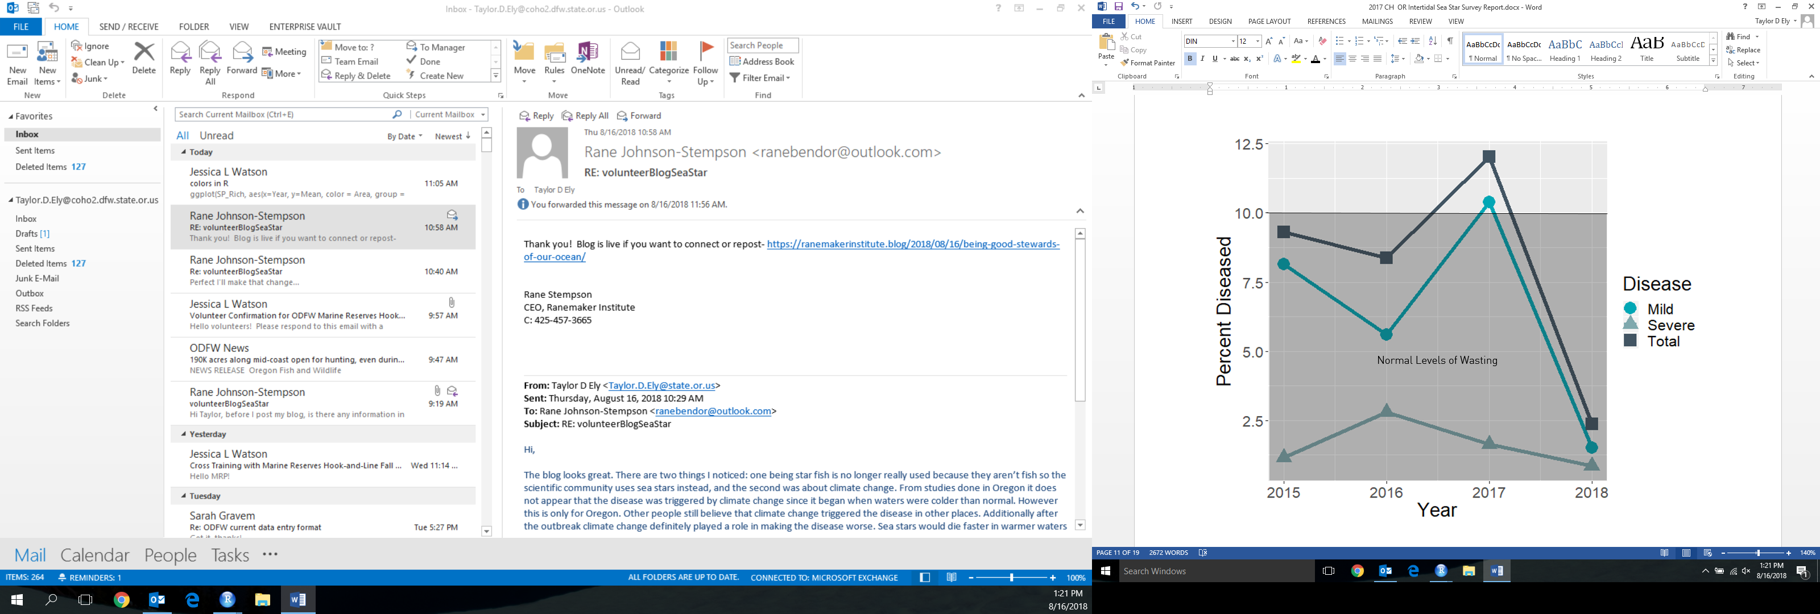

Figure 6. Otter Rock Marine Reserve percent diseased *Pisaster ochraceus*  grouped by severity of symptoms (mild: one lesion; severe: multiple lesions, arms falling off, dissolving; total: any symptom) from 2015-2018 for all *P. ochraceus* recorded each year both from timed searches and belt transects.

While the percent wasting of mild and total diseased individuals fluctuates from 2015-2018, only in 2017 does it slightly exceed normal levels (10%). This spike in mildly and total wasting individuals in 2017 at Otter Rock is different than that of Cascade Head (See Figure 12). At Cascade Head there is a spike in mildly and total wasting individuals in 2016 and in 2017 the percent wasting is below the normal level. By 2018 all levels of diseased individuals were minimal.

Individuals with severe symptoms follow a different trend than the mildly diseased and total diseased individuals. The trend of severely diseased individuals at Otter Rock is the same as the trend of severely diseased individuals at Cascade Head (see Figure 12). So while the total and mildly diseased individuals suggest that there are site-specific annual variation in sea star wasting prevalence, the severely wasted individuals do not support this notion.

Cascade Head Key Findings

Timed Search Survey Data

1. The mean arm length of *P. ochraceus* decreased drastically from 2015-2017 but increased in 2018 suggesting resistance in larger individuals is increasing most likely due to the sea stars that survived through wasting being resistant and continuing to grow

Belt Transect Data

1. *Pisaster ochraceus* and *Leptasterias spp*. density remain relatively constant over the four years
2. *Henricia spp.* was seen only once at Cascade Head
3. From 2016 to 2018 *P. ochraceus* and *Leptasterias spp.* densities observed opposite trends
4. Recruit and Adult densities of *P. ochraceus* have an inverse relationship between 2015-2018 suggesting that competition between the two may occur

Combined Data

1. Prevalence of wasting almost always below normal levels (only exception in 2016 with total diseased individuals
2. Prevalence of wasting at all levels of severity was very low (<1%) by 2018



Results

**Cascade Head**

*Timed Searches*

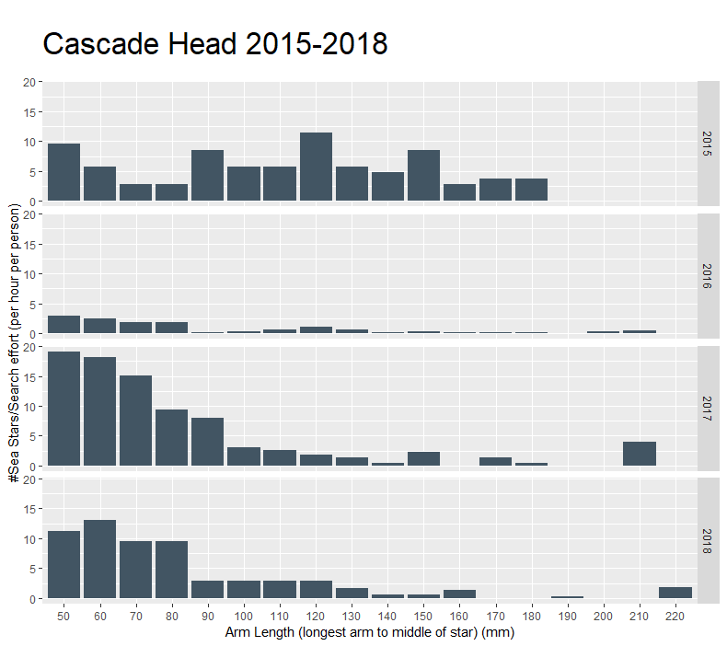

Figure 7. Cascade Head Marine Reserve size distribution of the total number per year of *P. ochraceus*. per unit of search effort from all timed searches for 2015-2018.

Intertidal timed search surveys at Cascade Head Marine Reserve showed a large fluctuation in *P. ochraceus* numbers per unit search effort over the four years (Kruskal, p=0.029). There is a drastic difference in the low numbers of 2016 compared with all other years sampled. The only significant difference in adult *P. ochraceus* found per unit search effort was that 2016 was significantly lower than 2017 (Tukey, p=0.024). However, populations recovered in 2017 and 2018. The mean arm length at Cascade Head follows the same pattern as Otter Rock over the four years (see Figure 1). Mean arm length is highest in 2015 and lowest in 2017 but slightly increases in 2018. The median arm length at Cascade Head follows a slightly different pattern with 2015 very large and then a huge decrease in 2016 but remains constant through 2018.

Search effort varied across years: 2015 had 1.05 hoursXpeople, 2016 had 5.47 hoursXpeople, 2017 had 2.25 hoursXpeople, and 2018 had 3.13 hoursXpeople. The total number of sea stars observed was 120 in 2015, 132 in 2016, 275 in 2017, and 341 in 2018.

*Belt Transect*

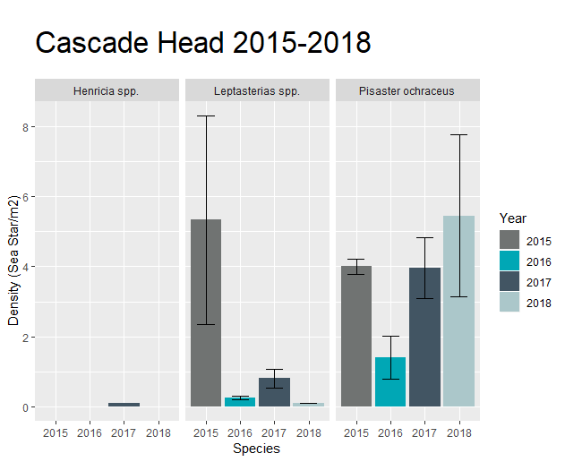

Figure 8. Cascade Head Marine Reserve mean sea star densities (±SE) from all belt transects for 2015-2018.

*Henricia spp.* was only observed at very low density in 2017.

*Leptasterias spp.* density fluctuated greatly over the four years ranging from the lowest in 2018 at 0.10/m2 to the highest at 5.33/m2 in 2015. However there is no statistical change in densities in *Leptasterias spp.* over the years (Kruskal, p=0.89).

*P. ochraceus* density also fluctuated over the four years ranging from the lowest in 2016 at 1.40/m2 to the highest in 2018 at 5.46/m2. Despite this fluctuation there was no significant change in the densities of *P. ochraceus* over the years (Kruskal, p=0.103).

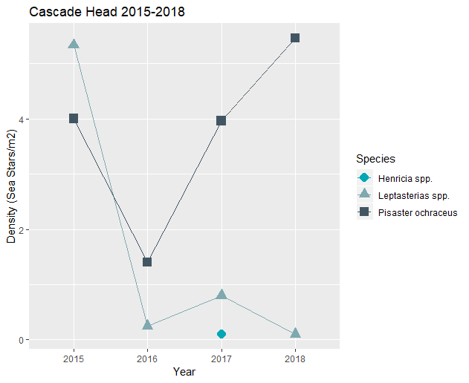

Figure 9. Cascade Head Marine Reserve mean sea star densities from all belt transects for 2015-2018.

Only in 2015 were *Leptasterias spp.* densities higher than *P. ochraceus* densities. In 2016 both species observed a drop in density which may be linked to the increase in percent wasting that year observed in *P. ochraceus* populations at Cascade Head. In 2017 and 2018 *P. ochraceus* recovered and rose to densities higher than in 2015. *Leptasterias spp.* did not recover and remained low in 2017 and 2018. This pattern is very different compared to Otter Rock (See Figure 3). At Cascade Head the relationship between *P. ochraceus* densities and *Leptasterias spp.* densities appears to be inverse but at Otter Rock it is a positive relationship where the two densities remain very similar from 2016-2018.

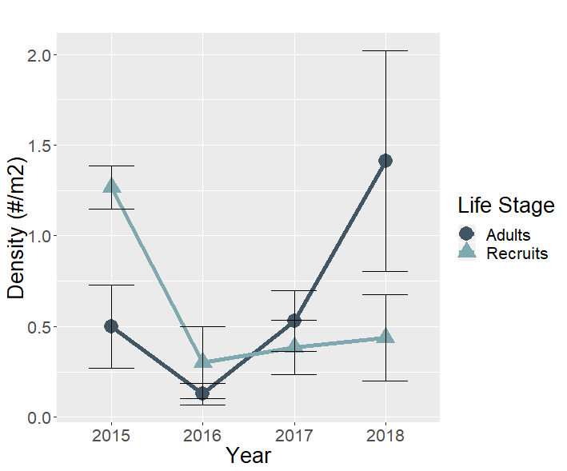

Figure 10. Cascade Head Marine Reserve mean(±SE) *P. ochraceus* recruit and adult densities from all belt transects for 2015-2018.

The trend observed at Cascade Head follows a trend that is similar to findings along Oregon’s coast after wasting occurred (Menge et al. 2016). In a previous study a large increase in recruitment was seen with densities higher than that of adults in 2014-2015 after wasting devastated the adult populations. This is seen in 2015 at Cascade Head. However the adult density start to recover in 2017 and 2018 and with this recovery the recruit density remains very low. This inverse relationship between adult and recruit densities supports the hypothesis from Menge et al. (2016) that there is competition, most likely for food, occurring between the adults and recruit populations which allowed the recruits to boom after wasting reduced the adult densities. However this trend was not seen at Otter Rock (See Figure 4) indicating that there are probably site specific forces that can influence recruit and adult densities in different ways.

*Combined Data (both Belt Transect and Timed Search)*

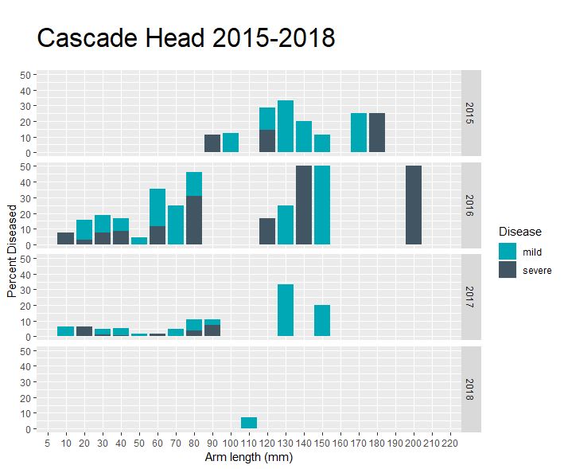

Figure 11. Cascade Head Marine Reserve percent diseased *Pisaster ochraceus*  per arm length (mm) stacked by severity of symptoms (mild: one lesion; severe: multiple lesions, arms falling off, dissolving) from 2015-2018 for all *P. ochraceus* recorded each year both from timed searches and belt transects.

In 2015 wasting at any severity only affected adults. In 2016 wasting was spread out across all life stages with some arm lengths of adults having very high percentages of wasting. By 2017 wasting was decreasing across the arm lengths but still present in every life stage. In 2018 wasting was very minimal and only present in one arm length of adults.

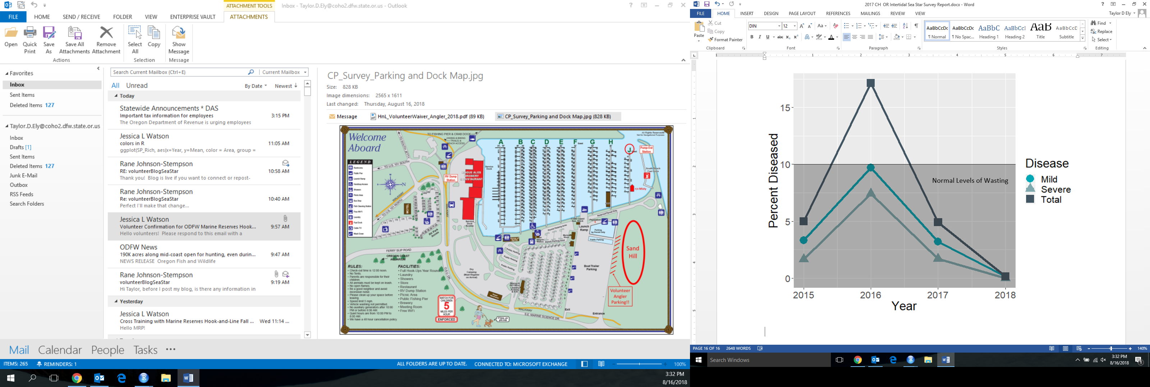

Figure 12. Cascade Head Marine Reserve percent diseased *Pisaster ochraceus*  grouped by severity symptoms (mild: one lesion; severe: multiple lesions, arms falling off, dissolving; total: any symptom) of symptoms from 2015-2018 for all *P. ochraceus* recorded each year both from timed searches and belt transects.

Only in 2016 was the prevalence of total wasting symptoms over normal levels (10%). Mild and severe symptoms separated never reached above normal levels of wasting. By 2018 all severities of wasting were at very low levels, almost at 0%.

At Cascade Head all three severities of symptoms follow the same trend in levels of wasting just to different degrees.

Cross Site Comparison Key Findings

Health of Sea Stars:

1. By 2018 the prevalence of wasting had dropped to very low levels at both sites
2. Severe symptom prevalence at both sites observed an increase in 2016
3. Prevalence of wasting for all symptoms was almost always below normal levels of wasting (10%). Additionally severe symptom prevalence was always below normal levels of wasting.

Population Density Recovery:

1. *Henricia spp.* and *Leptasterias spp.* observed a statistically constant population density at both sites over the four years
2. Density of *P. ochraceus* was statistically constant over the four years at Cascade Head but at Otter Rock there was some variation. 2017 densities at Otter Rock were higher than 2015 but then dropped back down in 2018.
3. *Leptasterias spp.* densities at Otter Rock followed a similar trend over the four years as *P. ochraceus* densities showing a positive relationship. However at Cascade Head these two species densities observed opposite trends over the four years showing an inverse relationship.
4. *P. ochraceus* adult and recruit densities had different relationships at the two sites. At Otter Rock adult and recruit *P. ochraceus* densities were both very low and generally had a positive relationship. However at Cascade Head recruit *P. ochraceus* densities was much higher than the adult densities and when adult densities were increasing recruit densities remained low. This inverse relationship appears to supports previous studies1 hypothesis that there may be competition between adult and recruit populations for food that drives an inverse relationship between the two densities.
5. Adult *P. ochraceus* densities at both sites were increasing over the four years suggesting recovery of the adult population of *P. ochraceus*

References

1. Menge et al. (2016) Sea Star Wasting Disease in the Keystone Predator *Pisaster ochraceus* in Oregon: Insights into Different Population Impacts, Recovery, Predation Rate, and Temperature Effects from Long-Term Research. *PLoS ONE* 11(5): e0153994. Doi:10.1371/journal.pone.0153994