


Interface Plan
August 08, 2023
WVDOH Transportation Asset Management System (TAMS)

Version History
VERSION | DATE | DESCRIPTION | AUTHOR | REVIEWER
1.0 | 12-03-2021 | Initial draft to solicit schema for the interfaces | Kumara Prasanna
2.0 | 02-10-2023 | Major document updates | Rashmita Nayak
3.0 | 02-14-2023 | Document formatting and minor updates. Added details to 2.1 CSV naming convention | Adam Erb,  Chris Chau
4.0 | 03-17-2023 | Document Updated. Cost interface added. Comments replied to and reformatted | Rashmita Nayak, Nilotpal Chatterjee
5.0 | 05-09-2023 | Section 3 of the document expanded on. Comments replied to. | Rashmita Nayak, Nilotpal Chatterjee
6.0 | 08-07-2023 | Updated run time of all interfaces, all Interface IDs, Task and Cost Interface sections, Email and Error Handling sections | Rashmita Nayak,  Nilotpal Chatterjee | Adam Erb

Table of Contents
1 Introduction 9
2 Interface Detailed Designs 10
2.1 File Naming Convention for Integrations Utilizing CSV and FTP 11
2.1.1 Initial Design 11
2.1.2 Requirement Analysis 11
2.1.3 Planned Naming Convention 12
2.2 Account Codes Interface Schema (ACC) 13
2.2.1 Process 13
2.2.2 Interface ID 14
2.2.3 CSV File Name 14
2.2.4 Frequency 14
2.2.5 Volume 14
2.2.6 Integration Methodology 14
2.2.7 Field Mapping and Data 14
2.2.8 Source Data Filter 14
2.2.9 Column Mapping 15
2.2.10 Mockups 16
2.3 Employee Interface Schema (EMP) 17
2.3.1 Process 17
2.3.2 Interface ID 17
2.3.3 CSV File Name 17
2.3.4 Frequency 17
2.3.5 Volume 17
2.3.6 Integration Methodology 17
2.3.7 Field Mapping and Data 17
2.3.8 Source Data Filter 18
2.3.9 Column Mapping 18
2.4 Equipment Interface Schema (EQP) 18
2.4.1 Process 18
2.4.2 Interface ID 19
2.4.3 CSV File Name 19
2.4.4 Frequency 19
2.4.5 Volume 19
2.4.6 Integration Methodology 19
2.4.7 Field Mapping and Data 19
2.4.8 Source Data Filter 19
2.4.9 Column Mapping 19
2.5 Material Interface Schema (MAT) 21
2.5.1 Process 21
2.5.2 Interface ID 21
2.5.3 CSV File Name 21
2.5.4 Frequency 21
2.5.5 Volume 21
2.5.6 Integration Methodology 22
2.5.7 Field Mapping and Data 22
2.5.8 Source Data Filter 22
2.5.9 Column Mapping 22
2.6 Task Interface Schema (TASK) 24
2.6.1 Process 24
2.6.1.1 Create Task Order 24
2.6.1.2 Close Task Order 24
2.6.1.3 Reopen Task Order 25
2.6.2 Security 25
2.6.3 Frequency 25
2.6.4 Volume 25
2.6.5 Integration methodology 25
2.6.6 Field Mappings 25
2.6.6.1 Create Task Orders 25
2.6.6.2 Close Task Orders 26
2.6.6.3 Reopen Task Orders 27
2.6.7 Mockups 27
2.7 Cost Interface Schema (COST) 31
2.7.1 Process 31
2.7.2 Interface IDs 32
2.7.3 CSV File Name 32
2.7.4 Frequency 32
2.7.5 Volume: 32
2.7.6 Integration Methodology 32
2.7.7 Field Mapping and Data: 32
2.7.8 Source Data Filter: 32
2.7.9 Column Mapping 32
2.7.10 Mockups 36
3 Integration Execution 37
3.1 Scheduling 37
3.1.1 Daily Schedule 38
3.1.2 Manual Scheduling 39
3.2 Error Logging 41
3.2.1 Log Folder Location 42
3.3 Error Handling 42
3.4 Archive Files 42
3.5 E-mail Notification 43
4 Glossary of Terms 45

Table of Figures
Figure 1 – Hierarchy of Budget Structure 40 and 95 13
Figure 2 - Account Codes UI Mockup 17
Figure 3 – Submit Task Button on the Task Form 28
Figure 4 - Submit Task Button on Task Grid View With Possibility of Multiple Tasks Selected 29
Figure 5 - Close Task Button on Task Form 29
Figure 6 - Close Task Button on Task Grid View with Possibility of Multiple Tasks Selected 30
Figure 7 - Reopen Task Button on Task Form 30
Figure 8 - Reopen Task Button on Task Grid View with Possibility of Multiple Tasks Selected 31
Figure 9 - Submit Task action failure message due to Invalid Account Code 31
Figure 10 - Actual Cost UI Mockup - 1 38
Figure 11 - Actual Cost UI Mockup - 2 39
Figure 12 - OM WV Integrations Daily Schedule 40
Figure 13 - Windows Task Scheduler 41
Figure 14 - Windows Task Scheduler - General Tab 41
Figure 15 - Windows Task Scheduler - Trigger Tab 42
Figure 16 - Sample Error in Error Logs 43
Figure 17 - Sample Info in Error Logs 43
Figure 18 - Sample Info in Error Logs 43
Figure 19 - Sample Trace in Error Logs 43
Figure 20- Sample Warning In Error Logs 43
Figure 21 – Email - Integration Complete (Part 1) 45
Figure 22 - Email - Integration Complete (Part 2) 45
Figure 23 – Email - Integration Failed 46
Figure 24 - Email - CSV File Missing 46

Table of Tables
Table 1 - Integration Interfaces Summary 10
Table 2 - Recommended URL Part Lengths 12
Table 3 – White Paper Reference for Account Codes Interface 13
Table 4 – Account Codes Field Mapping – Budget Structure 40 15
Table 5 – Account Codes Field Mapping – Budget Structure 95 16
Table 6 – Whitepaper Reference for EMP Interface 17
Table 7 – Field Mapping Layout – Employee 18
Table 8 – Whitepaper Reference – EQP Interface 19
Table 9 – Equipment Master Data 21
Table 10 – Whitepaper Reference for MAT Interface 22
Table 11 – Material Master Data 24
Table 12 - White Paper Reference for TASK Interface 25
Table 13 – CGI Financials Web Service Parameters (Create Task Order) 27
Table 14 – CGI Financials Web Service Parameters (Close Task Order) 27
Table 15 - CGI Financials Web Service Parameters (Reopen Task Order) 28
Table 16 - Whitepaper Reference for COST Interface 32
Table 17 - Cost Interface Column Mapping – Common Fields in both PYRL and FIN File (Part 1) 35
Table 18 - Cost Interface Column Mapping – Common Fields in both PYRL and FIN File (Part 2) 36
Table 19 - Cost Interface Column Mapping – Common Fields in both PYRL and FIN File (Part 3) 37
Table 20 - Cost Interface Column Mapping – Fields Only in FIN File 38
Table 21 – Glossary of Terms 47
Table 22 - Interface Inventory 50

Introduction
This Interface Plan documents the detailed requirements for each unique interface to be implemented between dTIMS and the WVDOH managed systems, such as wvOASIS.
This document includes the description of the schema for the planned integration between dTIMS and WVDOH systems (including wvOASIS CGI Advantage and others). References are made to the straw man proposal described in the whitepaper "Anticipated Interfaces to Support Costing on Maintenance Management System Work Orders," drafted by Mott McDonald on December 3rd, 2020.
An overview of integrations between dTIMS and wvOASIS is documented in System Detail Design Document “D1-14 - System Detail Design Document (SDDD)”. This document can further be used as a reference to map the data schema between dTIMS and wvOASIS.

Interface Detailed Designs
The primary purpose for integrating TAMS and WVDOT ERP Systems is to retrieve actual costs incurred on maintenance activities, including labor, equipment, material, and other invoice costs from the state’s accounting system, wvOASIS into TAMS.
To retrieve the actual costs against Tasks in TAMS, the time entry system in HRM needs to assign time entries against a Task Order with the correct Account Codes. For a Task Order to be created in wvOASIS with the correct Account Codes, the TAMS Task with valid account codes should be submitted to wvOASIS. However, for the TAMS Task to be created with the correct Account Codes, the valid Account Codes should be sent to TAMS from wvOASIS.

Table 1 below provides an overview of the required ERP integrations. Non-ERP related integrations are listed in Table 19.
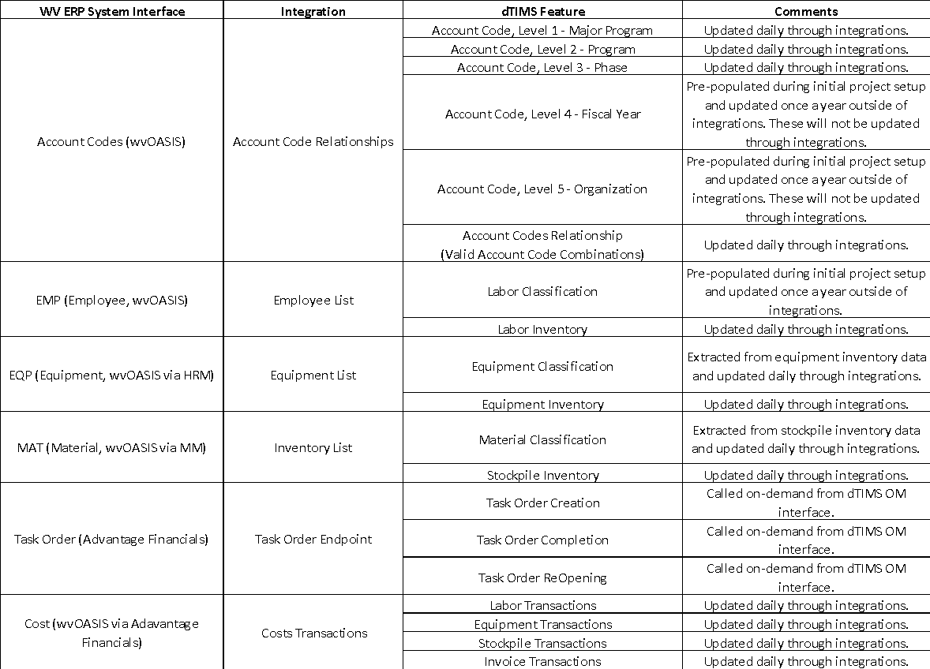
Table 1 - Integration Interfaces Summary

File Naming Convention for Integrations Utilizing CSV and FTP
A flat file integration pattern requires a properly designed file naming convention to attach metadata necessary for a reliable and robust process. This requirement was identified in the early stages of requirement clarification and refined during requirement analysis activities.

Initial Design
The integration working group produced an initial design focused on the functional requirements during the requirement clarification stages:
Pattern: <INTERFACE IDENTIFIER>_<SYSTEM>_<DEPT_CD>_<FUNCTION>_<TIMESTAMP>.csv
Example: I.XXX_OM_0803_ACC_20230209141500.csv
Where:
- INTERFACE IDENTIFIER - The first node is the unique interface ID (e.g., I.001).
- SYSTEM - The second node is the two-character target system component name (OM = O Maintenance).
- DEPT_CD - The third node is the four-character wvOASIS Department Code of the Department requesting the interface (0803 = Division of Highways).
- FUNCTION - The fourth node is the functionality the file is using (ACC).
- YYYYMMDDHH24MISS - The fifth node is the date and time when the interface source file is created. The timestamp node allows multiple files to be sent on the same day. The hours are stated using a 24-hour clock (e.g., 20230209141500 is 02/09/2023 at 2:15 pm).

Requirement Analysis
Further analysis identified additional non-functional requirements:
- The need for file consistency verification. The integration depends on the completeness of the files transmitted. This should take between 16-32 characters depending on the function used.
- The need to consider the total path length. Typically, most FTP Server implementations support approximately 250 characters before requiring configuration changes.

Planned Naming Convention
Considering the previous functional and non-functional requirements, Deighton recommends the following naming convention be used for all CSV over FTP integrations:
Pattern: sftp://<hostname:port>/directory/structure/<Interface Identifier>_<timestamp>_<file hash>.csv
Example: sftp://hostname:22/oasis_example/acc/ACC_20230209141500_1234567890abcdef.csv
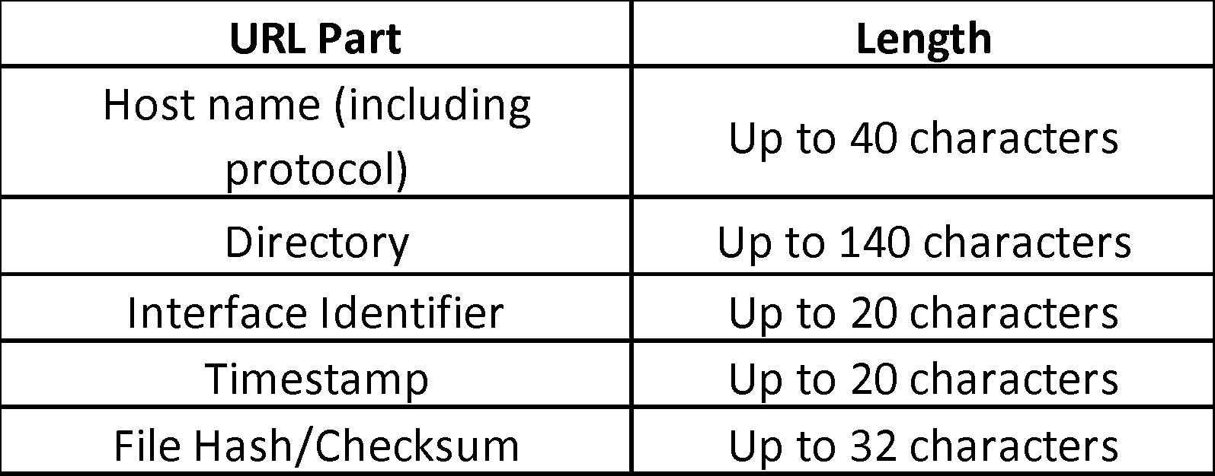
Table 2 below outlines the recommended lengths for each part of the URL.
Table 2 - Recommended URL Part Lengths

Account Codes Interface Schema (ACC)
Table 3 below outlines valid account codes and how they are transmitted into the OM software.
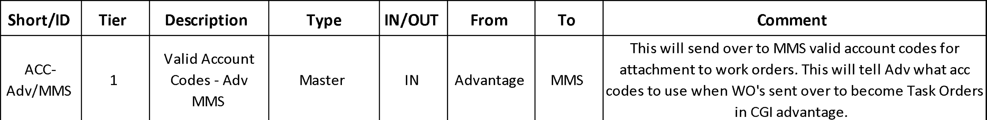
Table 3 – White Paper Reference for Account Codes Interface
As shown in Figure 1 below, the interface imports valid account code combinations from wvOASIS to dTIMS OM. Account codes in WVDOT are related to each other in the following hierarchy:
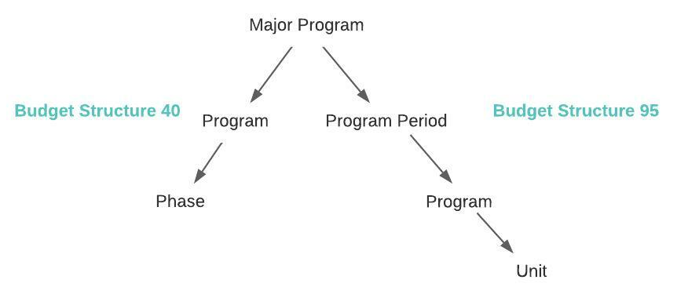
Figure 1 – Hierarchy of Budget Structure 40 and 95

Process
Account Codes interface integrations will follow the daily CSV file integration pattern.
wvOASIS will generate one CSV file on the WVDOT FTP server for dTIMS OM to consume daily. These account codes will be assigned to a Task in OM. Tasks will then be submitted to wvOASIS as Task Orders for usage in Labor time entries and equipment and material transactions.
Each account code and their combinations will have an ‘isActive’ flag to ensure dTIMS OM users only use active combinations on a Task. wvOASIS will generate one CSV file on their FTP servers daily for dTIMS OM to consume.
wvOASIS account codes will be imported into dTIMS OM through one CSV file named “I001_OM_0803_ACC_20230209141500.csv”. This CSV file will contain valid and unique account code combinations available in wvOASIS.
Since wvOASIS has 2 budget structures, one with a 3-level hierarchy and another with a 4-level hierarchy, dTIMS will expect account codes in sets of three (MajorProgramId, ProgramId, PhaseId) or four (MajorProgramId, ProgramPeriodId, ProgramId, UnitId).
The master data for Major Program, Program and Phase will be inserted in their own individual master data tables. Program Period in wvOASIS is called Fiscal Year in dTIMS. While Unit in wvOASIS is called Organization in dTIMS. Fiscal Year and Organization data is pre-populated in the dTIMS system during initial project setup and not updated through integrations as these are only updated once a year. Valid Account Code combinations are stored in the “AccountCode” table.
dTIMS Integrations will expect an additional column named ‘STRUCTURE’ which signals if the account code set belongs to a budget structure “40” or “95”. Missing account code combinations will be deactivated in dTIMS. Account code master data: MajorProgram, Program, Phase, FiscalYear and Organization will never be deactivated.
Assumptions:
- The account code combinations sent in the CSV file are unique based on the PKs noted.
- The account code combinations sent in the CSV file are valid based on the PKs noted.
- Account combinations will only be inserted in TAMS if all reference IDs (PPC_CD, UNIT_CD, etc.) on the record exist in the TAMS master data. If the reference IDs are missing or do not exist in the TAMS master data, the account code combination will not be inserted, and details of the account code combination record will be logged as an error.

Interface ID
I.389_OM_0803_ACC (Also mentioned in Appendix - Table 19)

CSV File Name
I.389_OM_0803_ACC_20230209141500.csv

Frequency
dTIMS Integrations Solution will execute this file daily at 7AM. wvOASIS will generate this file at 6AM.

Volume
~10k

Integration Methodology
CSV file

Field Mapping and Data
Account Code Combinations

Source Data Filter
Valid account code combinations filtered by DEPT_CD “0803”.

Column Mapping
Table 4 below outlines the Account Codes field mapping for Budget Structure 40.
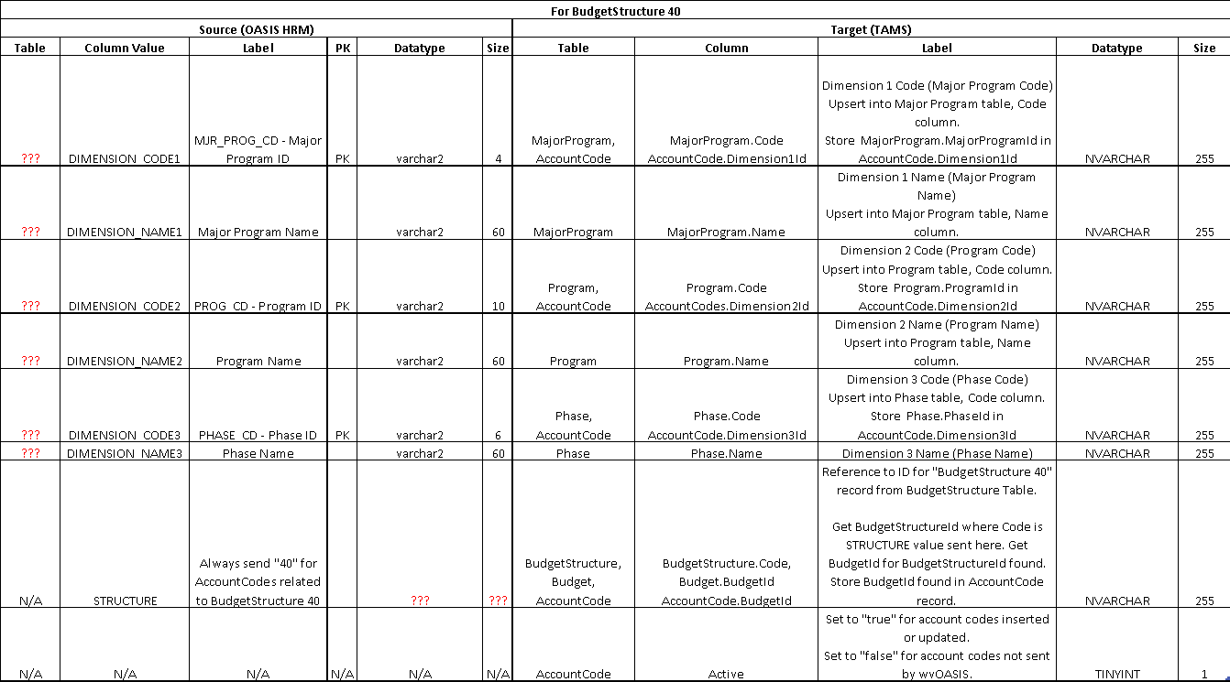
Table 4 – Account Codes Field Mapping – Budget Structure 40

Table 5 below outlines the Account Codes field mapping for Budget Structure 95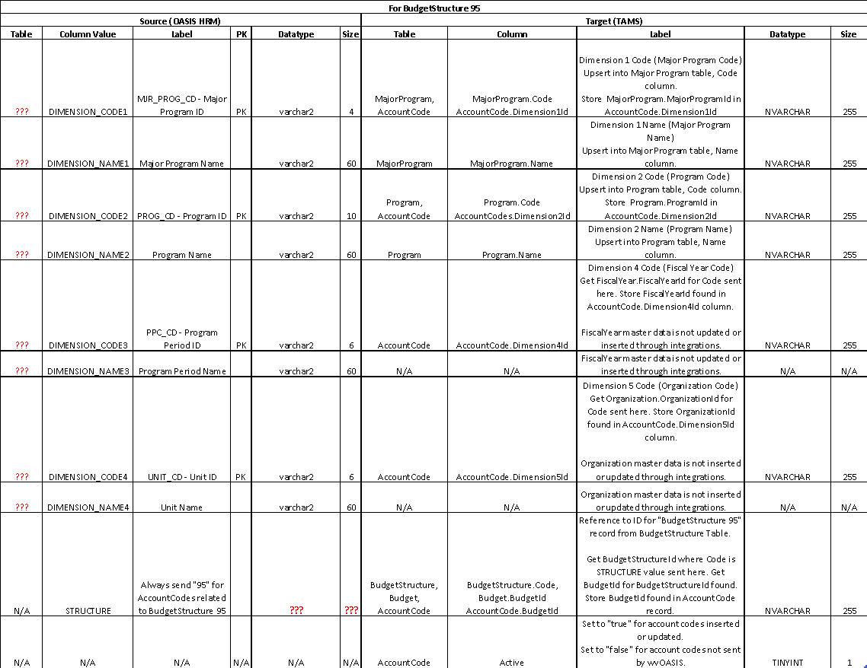
Table 5 – Account Codes Field Mapping – Budget Structure 95

Mockups
Figure 2 shows the UI mockup of the “Account Codes” dropdown on the “Task Form”
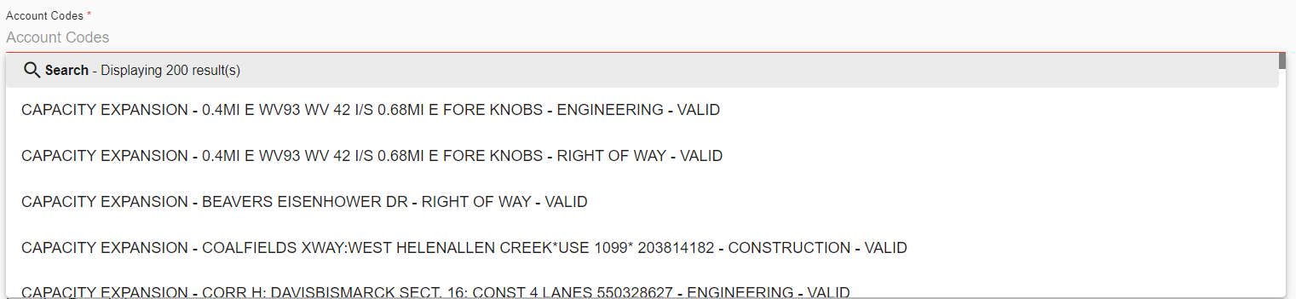
Figure 2 - Account Codes UI Mockup

Employee Interface Schema (EMP)
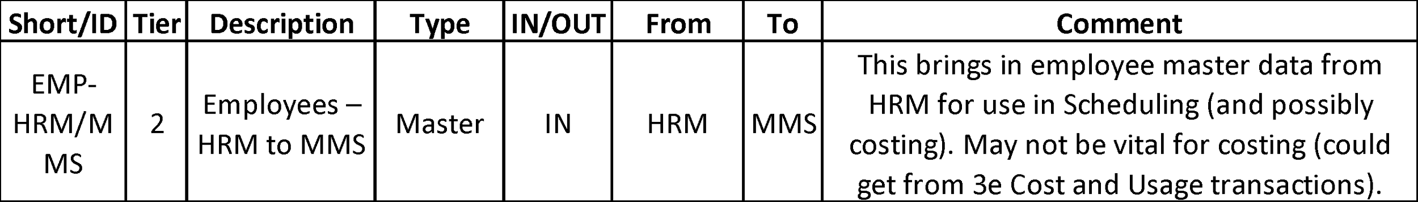
Table 6 below outlines the Whitepaper Reference for the EMP Interface.
Table 6 – Whitepaper Reference for EMP Interface

Process
This integration process imports employee master data from wvOASIS into TAMS. This data includes all active employees that may record time in the wvOASIS Advantage System HRM Module (TIMEi) for maintenance management activities. TAMS will update the entire OM Labor data set daily for which TAMS will require a unique ID to identify each labor record. An employee record not received from wvOASIS will be marked as inactive in TAMS. wvOASIS will generate one CSV file on their FTP servers daily for TAMS to consume.
Assumptions:
- Only active employee records are sent in the CSV file.
- Employee records will only be inserted in TAMS if all reference IDs (HOME_UNIT_CD, etc.) on the record exist in the TAMS master data. If the reference IDs are missing or do not exist in the TAMS master data, the employee records will not be inserted, and details of the record will be logged as an error.

Interface ID
I.387_OM_0803_EMP (Also mentioned in Appendix - Table 19)

CSV File Name
I.387_OM_0803_EMP_20230209141500.csv

Frequency
dTIMS Integrations Solution will execute this file daily at 7AM. wvOASIS will generate this file after the HR files have been input and processed at 6AM.

Volume
High

Integration Methodology
CSV file

Field Mapping and Data
Employee data will be imported into dTIMS OM through a csv file named “I.387_OM_0803_EMP_20230209141500.csv.” This table lists the source and target field mappings.

Source Data Filter
Active employees filtered by DEPT_CD “0803”.

Column Mapping
Table 7 below outlines source and target field mappings for employee records and IDs.
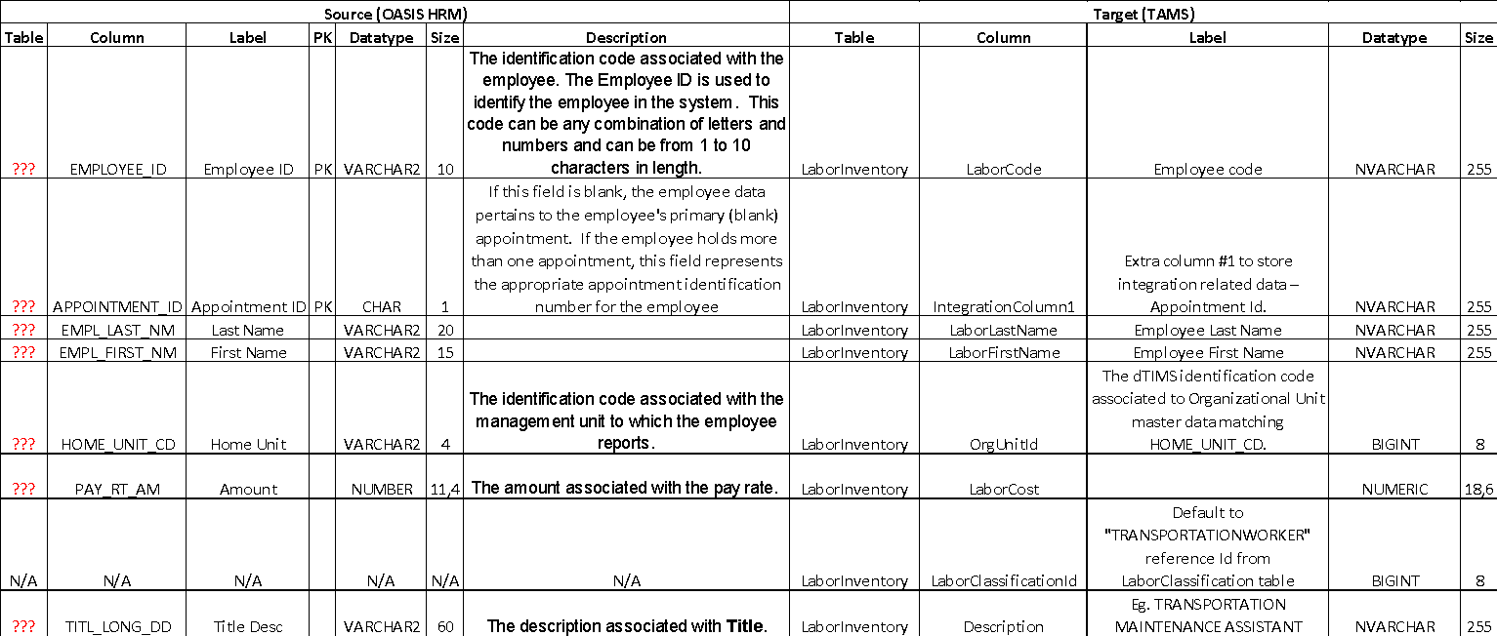
Table 7 – Field Mapping Layout – Employee

Equipment Interface Schema (EQP)
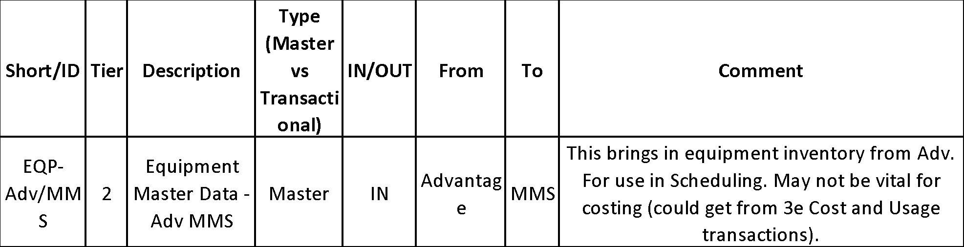
Table 8 below outlines the Whitepaper EQP Interface.
Table 8 – Whitepaper Reference – EQP Interface

Process
This integration process imports equipment master data from wvOASIS into TAMS daily. This data pertains to each piece of Equipment and is used when integrating actual costs from wvOASIS into TAMS. TAMS will also extract equipment classification master data from this data set, since WVDOH does not store equipment classifications master data separately. Unique EQUIP_CLS values will be stored as equipment classifications in dTIMS with the first DSCR as the classification name.
TAMS will update the entire OM Equipment data set daily for which it will require a unique ID to identify each equipment. Equipment not received from wvOASIS will be marked as inactive in TAMS. However, Equipment Classifications will not be deactivated as it is considered master data. wvOASIS will generate one CSV file on their FTP servers daily for TAMS to consume.
Assumptions:
- Only active equipment records are sent in the CSV file.
- Equipment will only be inserted in TAMS if all reference IDs (UNIT_CD, UnitOfMeasureId, etc.) on the record exist in the TAMS master data. If the reference IDs are missing or do not exist in the TAMS master data, the record will not be inserted, and details of the record will be logged as an error.

Interface ID
I.390_OM_0803_EQP (Also mentioned in Appendix - Table 19)

CSV File Name
I.390_OM_0803_EQP_20230209141500.csv

Frequency
dTIMS Integrations Solution will execute this integration daily at 7AM. wvOASIS will generate this file at 6AM.

Volume
~3000 to 4000

Integration Methodology
CSV file

Field Mapping and Data
Equipment data will be imported into TAMS through a csv file named “I.390_OM_0803_EQP_20230209141500.csv”. This table lists the source and target field mappings.

Source Data Filter
Active equipment’s filtered by DEPT_CD “0803”

Column Mapping
Table 9 below outlines equipment master data.
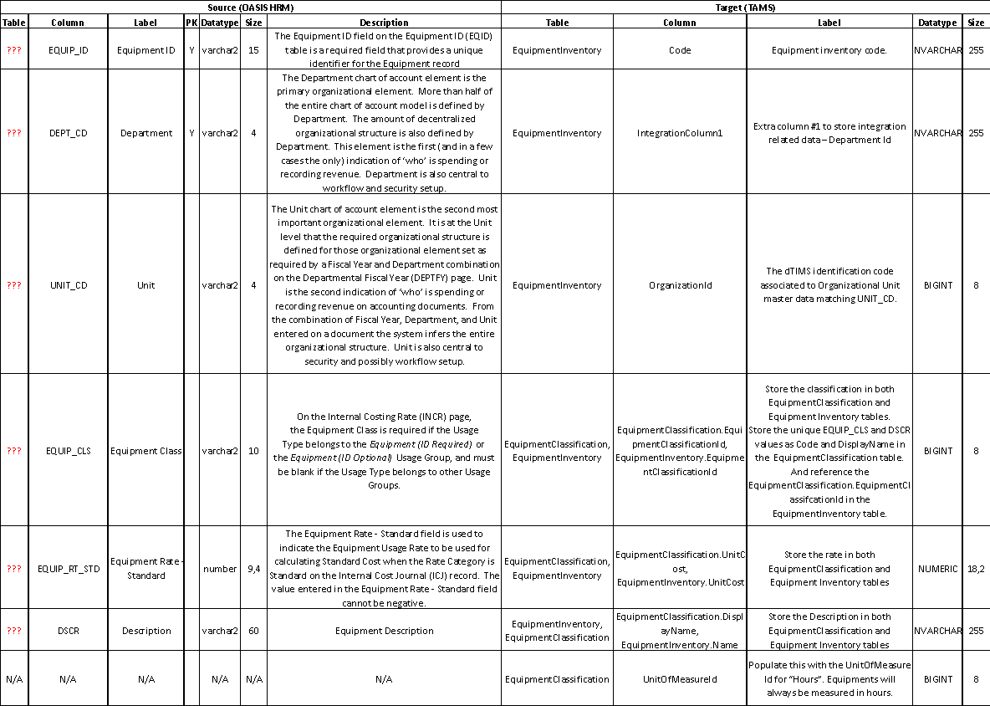
Table 9 – Equipment Master Data

Material Interface Schema (MAT)
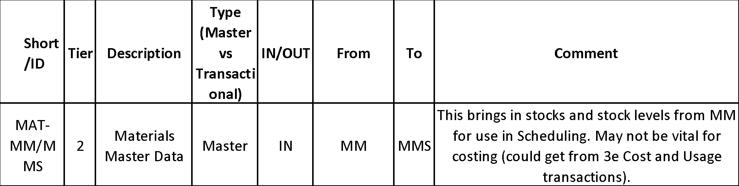
Table 10 below outlines the Whitepaper MAT interface.
Table 10 – Whitepaper Reference for MAT Interface

Process
This integration process imports material master data from wvOASIS into TAMS daily. This data pertains to the actual Materials used from Consumable Inventory in OASIS when integrating actual cost data from wvOASIS. TAMS will also extract material classification master data from this data set, since WVDOH does not store material classifications master data separately. Unique STK_COMM_CD will be stored as material classifications in dTIMS with the first STK_ITM_DSCR as the classification name.
TAMS will update the entire OM Material data set daily for which dTIMS OM will require a unique ID to identify each material. A material record not received from wvOASIS will be marked as inactive in TAMS. However, Equipment Classifications will not be deactivated as it is considered master data. wvOASIS will generate one CSV file on their FTP servers daily for TAMS to consume once a day.
Assumptions:
- Only active inventory records are sent in the CSV file.
- Materials and material classifications will only be inserted in TAMS if all reference IDs (UNIT_CD, ISS_UOM, etc.) on the record exist in the TAMS master data. If the reference IDs are missing or do not exist in the TAMS master data, the record will not be inserted, and details of the record will be logged as an error.

Interface ID
I.391_OM_0803_MAT (Also mentioned in Appendix - Table 19)

CSV File Name
I.391_OM_0803_MAT_20230209141500.csv

Frequency
dTIMS Integrations Solution will execute this integration daily at 7AM. wvOASIS will generate this file after the FIN AD chain is completed at 6AM.

Volume
~40k

Integration Methodology
CSV file

Field Mapping and Data
Material data will be imported into TAMS through a CSV file named “I.391_OM_0803_MAT_20230209141500.csv”. This table lists the source and target field mappings.

Source Data Filter
Active stockpile inventory filtered by DEPT_CD “0803”.

Column Mapping
Table 11 below outlines material master data.
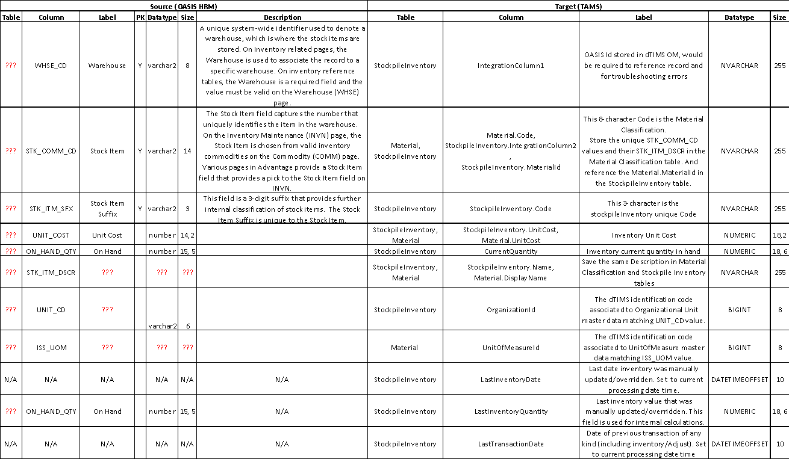
Table 11 – Material Master Data

Task Interface Schema (TASK)
There are three integrations in the Task Interface. The first integration, ‘Create Task Order,’ allows an authorized TAMS user to generate a wvOASIS Task Order from a Task in TAMS. The second integration, ‘Close Task Order,’ allows an authorized TAMS user to provide an update to wvOASIS that a Task Order is no longer active. The third integration, “Reactivate Task Order”, allows an authorized TAMS user to provide an update to wvOASIS that a Task Order is active once again.
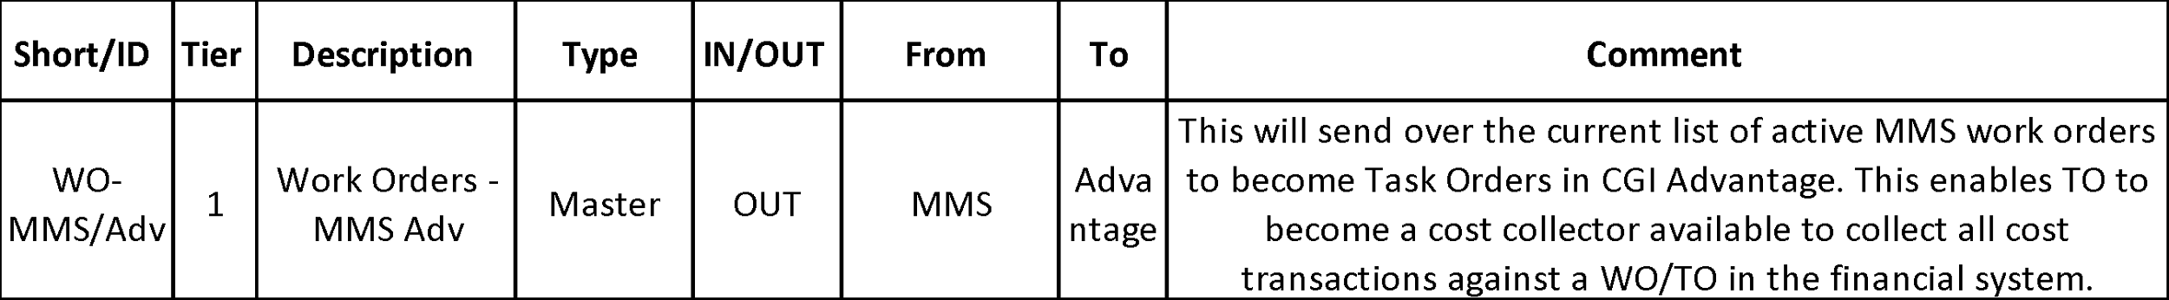
Table 12 below outlines the White Paper Reference for this interface.
Table 12 - White Paper Reference for TASK Interface

Process

Create Task Order
This integration process creates a dTIMS OM Task in wvOASIS.
When a Task in dTIMS OM is ready to be submitted to wvOASIS, the user will select the Submit Task button on the Task form. This action uses a wvOASIS web service to create a Task Order in wvOASIS.
One or more Task Orders could be created in wvOASIS as well, through the dTIMS OM Grid view, by selecting multiple dTIMS OM Tasks.
Once a Task Order is inserted into wvOASIS successfully, the dTIMS OM Task Status will change to Active and the Account Codes, Organization and Activity Definition fields will be read-only. The Task Order Identifier (TASK_ORD_CD) generated by dTIMS OM will be stored and displayed in the Task Order Id field on the dTIMS OM Task. The Submit Task action will no longer be displayed to the user, preventing the user from submitting the same Task more than once.
If the Submit Task action is unsuccessful, the dTIMS OM Task Status will remain unchanged and the user will see a message indicating the failure. The most common reason for error is when a dTIMS OM Task is set with an invalid account code. The failure message will indicate the details of the error. The user can resolve validation errors by modifying the dTIMS OM Task form field values and clicking the Submit Task action button again. If the error is due to the inability to connect to the wvOASIS web service, the user would contact Deighton Support, who would then contact WVDOH Support to fix the wvOASIS server/web service errors.

Close Task Order
Once the tasks are executed, active tasks will be set to Completed status using the Complete Task action on the dTIMS OM Task Form or Grid view. Completed tasks can be set to Closed status using the Close Task action on the dTIMS OM Task Form or Grid view.
When the Close Task action button is selected, the same wvOASIS web service is called again to update the Task Order as inactive in wvOASIS, by setting the ACT_FL to false.
If the Close Task action is unsuccessful, the dTIMS OM Task Status will remain unchanged and the user will see a message indicating the failure. The failure message will indicate the details of the error. If the error is due to the inability to connect to the wvOASIS web service, the user would contact Deighton Support, who would then contact WVDOH Support to fix the wvOASIS server/web service errors.

Reopen Task Order
Closed Tasks can be reopened using the Reopen Task action on the dTIMS OM Task Form or Grid view.
When the Reopen Task action button is selected, the wvOASIS web service is called to update the Task Order as active in wvOASIS once again, by setting the ACT_FL flag to true. If the Reopen Task action is successful, the dTIMS OM Task status is changed to Active.
If the Reopen Task action is unsuccessful, the dTIMS OM Task Status will remain unchanged and the user will see a message indicating the failure. The failure message will indicate the details of the error. If the error is due to the inability to connect to the wvOASIS web service, the user would contact Deighton Support, who would then contact WVDOH Support to fix the wvOASIS server/web service errors.

Security
dTIMS OM will generate the authentication token using the URL: https://ist311.wvoasis.gov/istapifin11/advapi/jaxrs/AuthenticationToken
The authentication token received will be used to insert a TaskOrder in OASIS using the url: https://ist311.wvoasis.gov/istapifin11/advapi/jaxrs/ImportTable
The username and password required to access the web service is stored in the dTIMS OM configuration. The dTIMS OM UI will retrieve and use these credentials to generate an authentication token. The authentication token will be used to call the web service to insert or update a TaskOrder in the wvOASIS database.

Frequency
On-Demand using a button from the dTIMS OM user interface.

Volume
1 or more Tasks at a time.

Integration methodology
Advantage Financials web service.

Field Mappings

Create Task Orders
When a user selects the Submit Task action on the OM Task form or the OM Grid View, Task Orders are inserted into the wvOASIS TaskOrder table.
Table 13 lists the dTIMS OM fields mapped to the CGI Advantage Financials web service parameters.

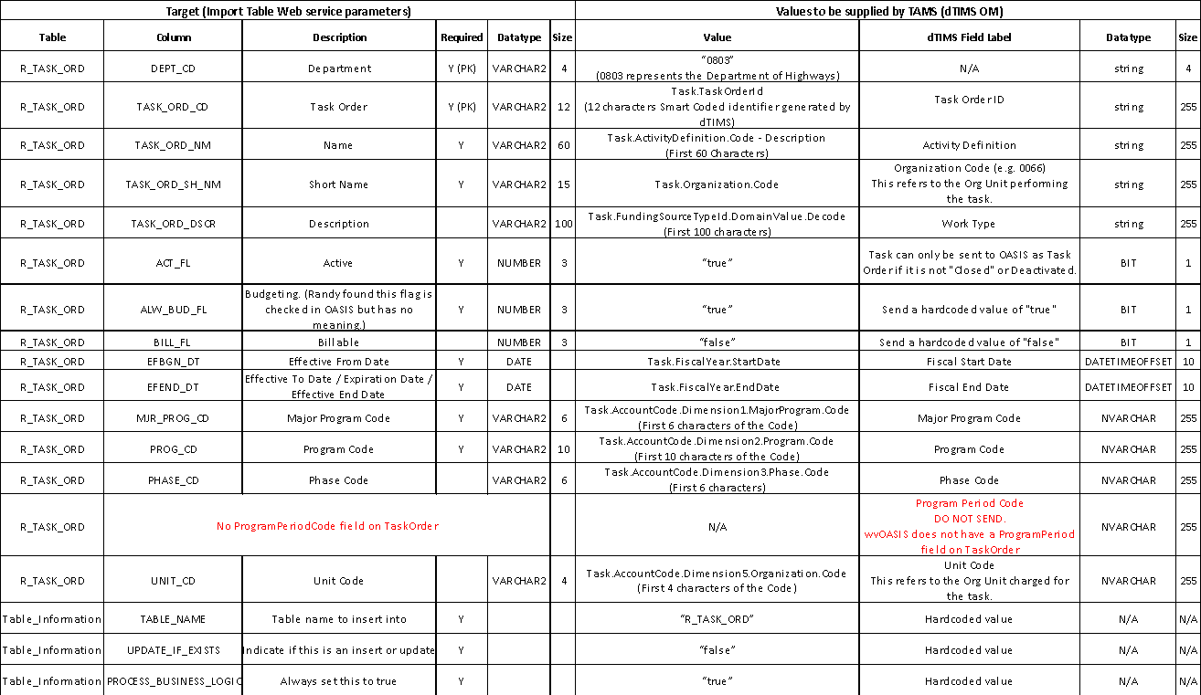
Table 13 – CGI Financials Web Service Parameters (Create Task Order)

Close Task Orders
When a user selects the Close Task button on the dTIMS OM Task Form or the Grid view, the Task Order in wvOASIS is marked as Inactive by updating the ACT_FL flag to false. Table 14 below lists the dTIMS OM fields mapped to the OASIS web service parameters.
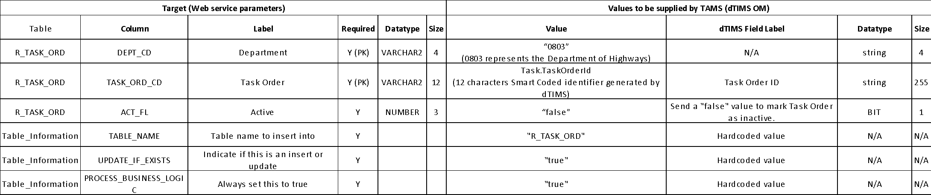
Table 14 – CGI Financials Web Service Parameters (Close Task Order)

Reopen Task Orders
When a user selects the Reopen Task button on the dTIMS OM Task Form or the Grid view, the Task Order in wvOASIS is marked as Active by updating the ACT_FL flag to true. Table 15 below lists the dTIMS OM fields mapped to the wvOASIS web service parameters.
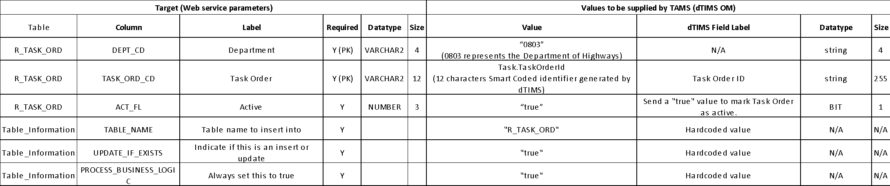
Table 15 - CGI Financials Web Service Parameters (Reopen Task Order)

Mockups
Figure 3 below is a UI mockup of the Submit Task button on the dTIMS OM Task form.
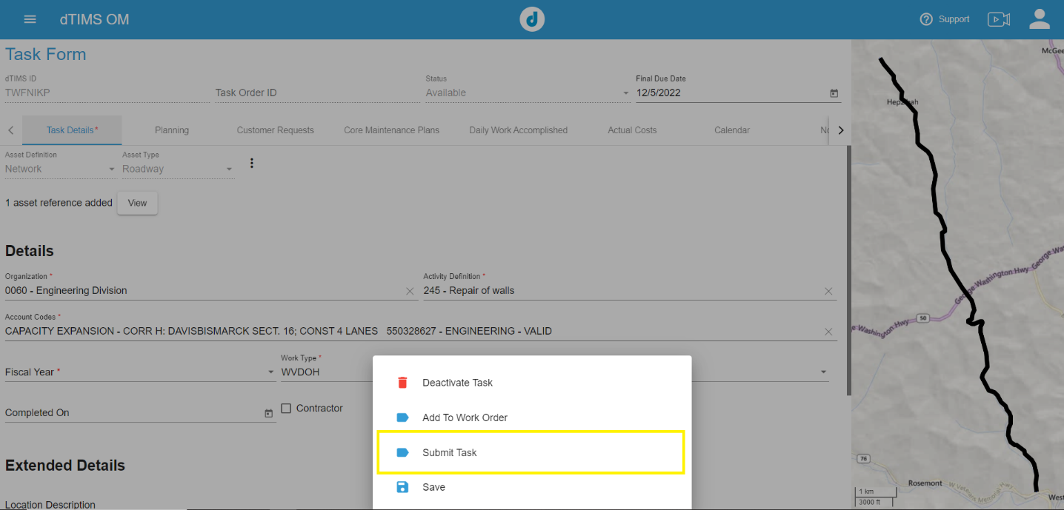
Figure 3 – Submit Task Button on the Task Form

Figure 4 below is a UI mockup of the Submit Task button on the dTIMS OM – Task All Layer – Grid view:
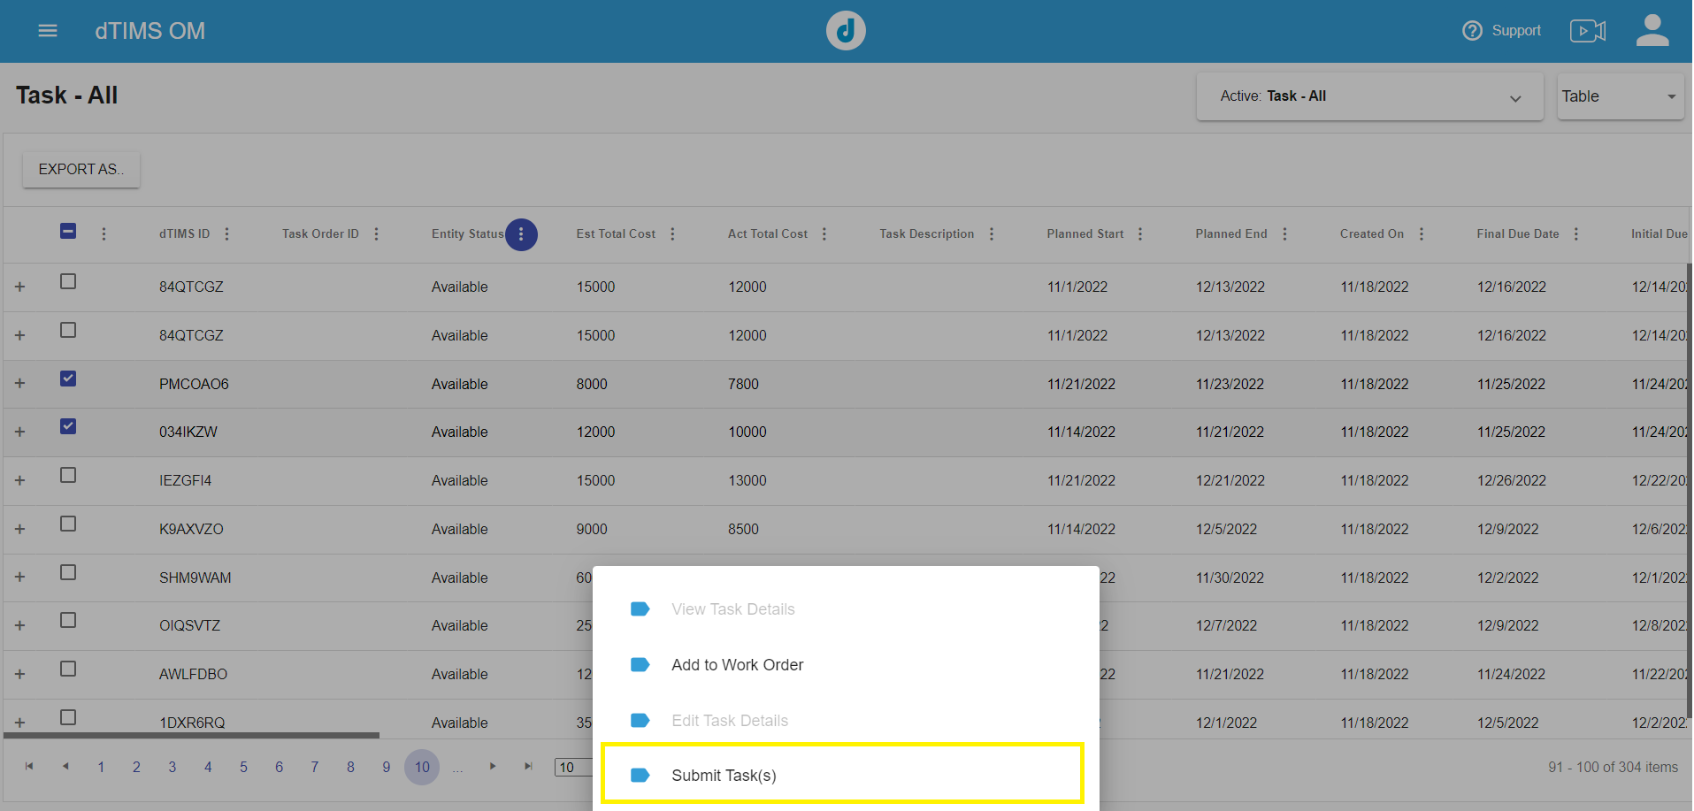
Figure 4 - Submit Task Button on Task Grid View With Possibility of Multiple Tasks Selected

Figure 5 below is a UI mockup of the Close Task button on the dTIMS OM Task form:
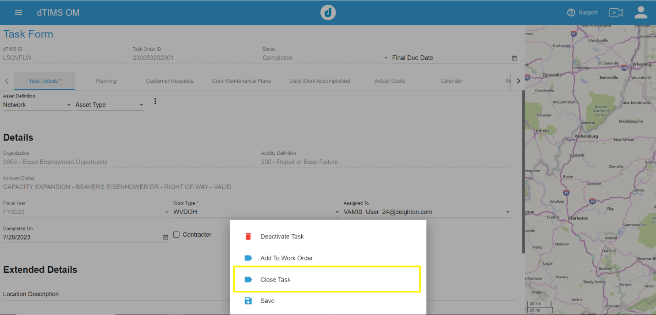
Figure 5 - Close Task Button on Task Form
Figure 6 below is a UI mockup of the Close Task button on the dTIMS OM – Task All Layer – Grid view:
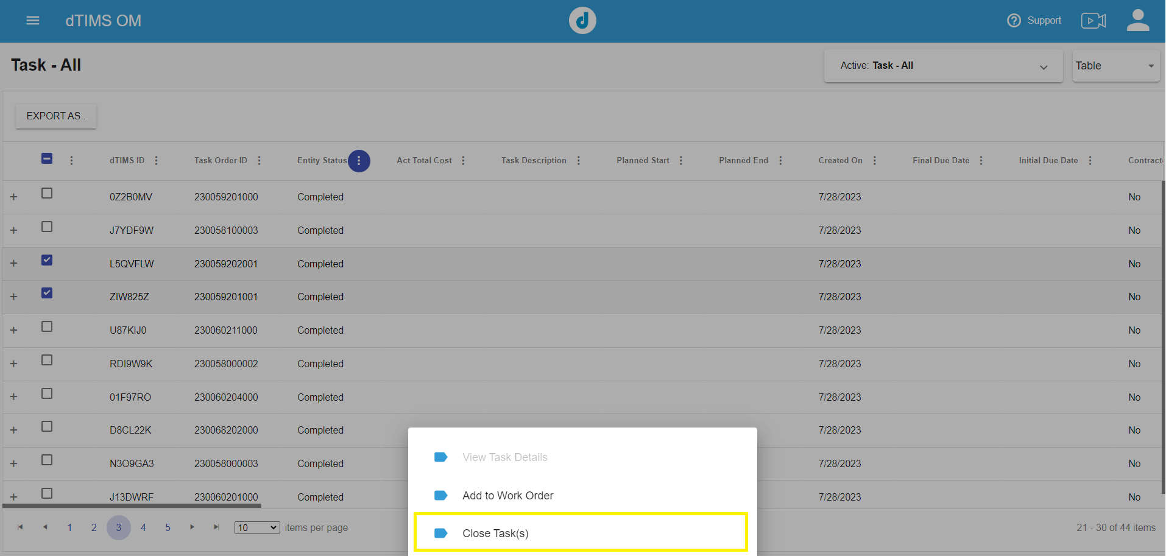
Figure 6 - Close Task Button on Task Grid View with Possibility of Multiple Tasks Selected
Figure 7 below is a UI mockup of the Reopen Task button on the dTIMS OM Task form:
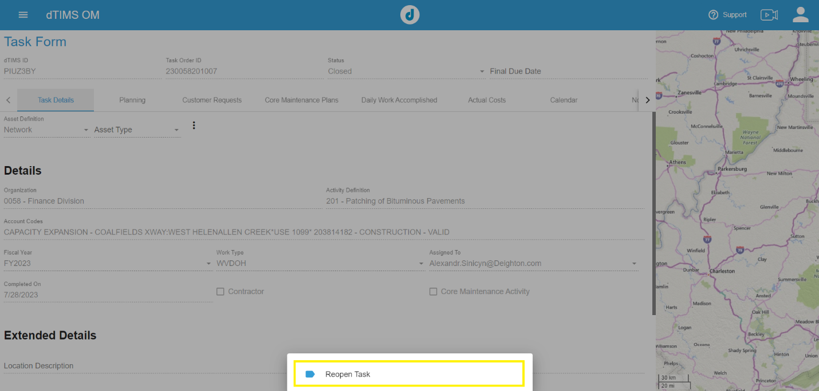
Figure 7 - Reopen Task Button on Task Form
Figure 8 below is a UI mockup of the Reopen Task button on the dTIMS OM – Task All Layer – Grid view:
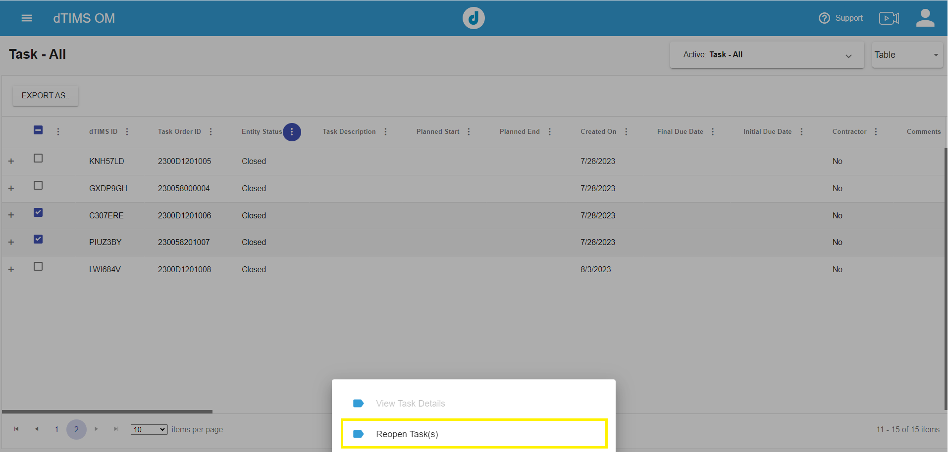
Figure 8 - Reopen Task Button on Task Grid View with Possibility of Multiple Tasks Selected
Figure 9 below is a UI mockup of an error message that is displayed when the Submit Task action fails due to the selection of an invalid account code on the dTIMS OM Task.
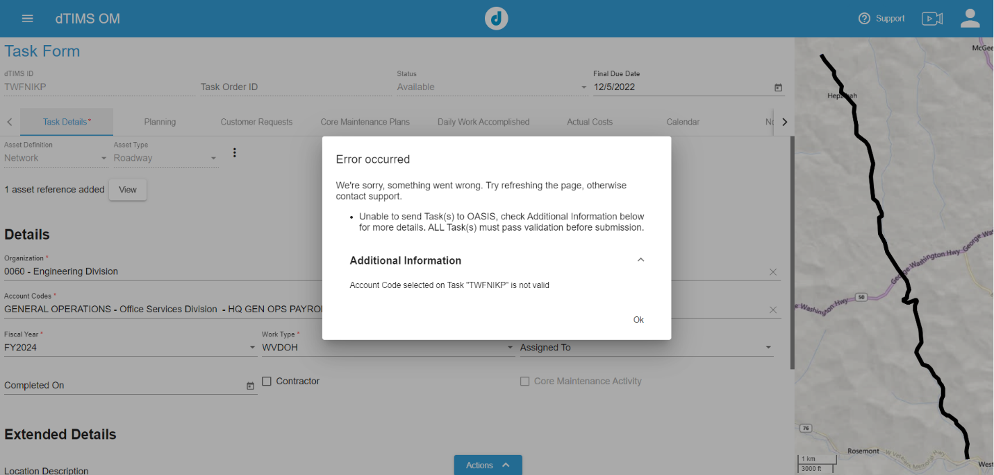
Figure 9 - Submit Task action failure message due to Invalid Account Code

Cost Interface Schema (COST)
Table 16 below outlines the Whitepaper COST interface.
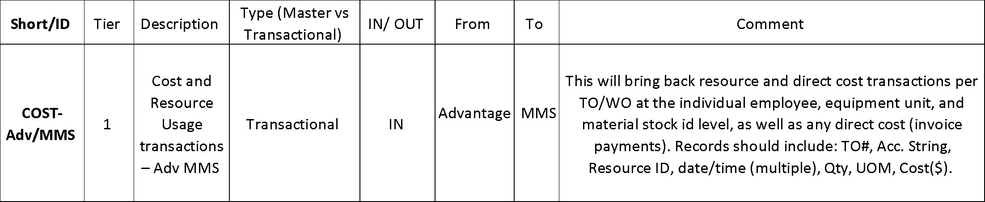
Table 16 - Whitepaper Reference for COST Interface

Process
This integration process imports labor, equipment, material, and other invoice costs applied to a TaskOrder in wvOASIS.
wvOASIS will generate two CSV files on their FTP servers daily for TAMS to consume daily, one created from their Payroll system and the other from their Financial system.
The Payroll Cost file generates:
- Labor estimate costs.
- Labor actual costs.
- Equipment estimate costs.
The Financial Cost file generates:
- Equipment actual costs.
- Stockpile inventory estimate costs.
- Stockpile inventory actual costs.
- Invoice costs.
These CSV files will contain incremental cost records, with new costs that were not previously sent to TAMS. WVDOH categorizes costs into two types: Estimates and Actuals.
Each day, dTIMS Integrations will replace ‘Estimate’ costs and add ‘Actuals’ costs into the TAMS system. When the PYRL file runs, the dTIMS Integration service will only delete estimates that were previously inserted through the PYRL file. When the FIN file runs, the dTIMS Integration service will only delete estimates that were previously inserted through the FIN file.
For Labor Costs, EMPLOYEE_ID, APPOINTMENT_ID, TASK_ORD_CD must be populated and EQUIP_ID must be blank. If EMPLOYEE_ID, APPOINTMENT_ID, TASK_ORD_CD are empty, or not matching dTIMS Labor and Task master data, the labor cost records will not be inserted.
For Equipment Costs, EQUIP_ID, DEPT_CD, TASK_ORD_CD must be populated. If EQUIP_ID, DEPT_CD, TASK_ORD_CD are empty, or not matching dTIMS Equipment and Task master data, the equipment cost transaction records will not be inserted.
For Stockpile Inventory Costs, WHSE_CD, STK_COMM_CD, STK_ITM_SFX, TASK_ORD_CD must be populated. If WHSE_CD, STK_COMM_CD, STK_ITM_SFX, TASK_ORD_CD are empty, or not matching dTIMS Stockpile Inventory and Task master data, the stockpile inventory cost transaction records will not be inserted.
If all these fields are empty: EMPLOYEE_ID, APPOINTMENT_ID, EQUIP_ID, DEPT_CD, WHSE_CD, STK_COMM_CD, STK_ITM_SFX, the cost record is considered an “Other Cost”.
Assumptions:
- Every cost record will have a TASK_ORD_CD.
- Every cost record will be associated to either an employee, equipment, stockpile inventory or be unclassified.
- Cost records will only be inserted in TAMS if all reference IDs (TASK_ORD_CD and at least one set of Inventory IDs for Labor, Equipment, Stockpile or Other) on the record exist in the TAMS master data. If the reference IDs are missing or do not exist in the TAMS master data, the record will not be inserted, and details of the record will be logged as an error.

Interface IDs
(Also mentioned in Appendix - Table 25)
- I.386_OM_0803_COST_PYRL
- I.388_OM_0803_COST_FIN

CSV File Name
- I.386_OM_0803_COST_PYRL_20230801053937.csv
- I.388_OM_0803_COST_FIN_20230801050001.csv

Frequency
Daily at 7AM. File will be generated after the FIN AD chain is completed at 6am.

Volume:
(Waiting on wvOASIS to provide)

Integration Methodology
CSV file.

Field Mapping and Data:
Cost data will be imported into TAMS through two CSV files with names prefixed with “I.386_OM_0803_COST_PYRL” or “I.388_OM_0803_COST_FIN”. Table in Section 2.7.9 lists the source and target field mappings.

Source Data Filter:
New cost transactions for DEPT_CD “0803”. (Mentioned in Appendix “B”).

Column Mapping
Fields in both I.386_OM_0803_COST_PYRL and I.388_OM_0803_COST_FIN files
Table 17, Table 18, Table 19, Table 20 on the following pages outline the cost data mapping.

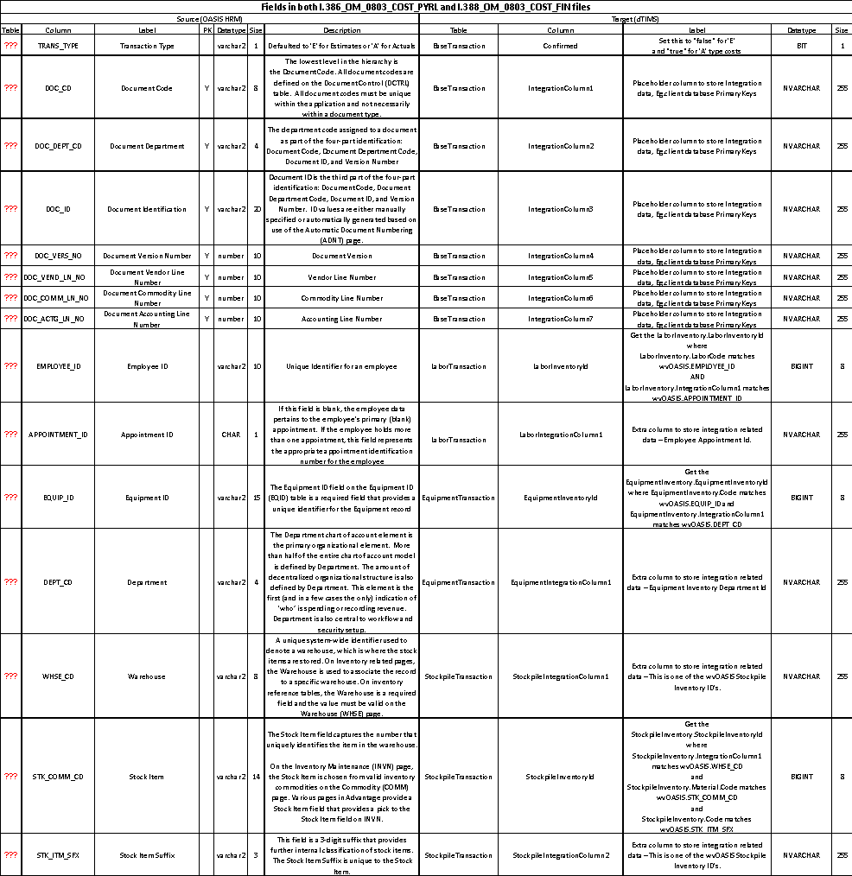
Table 17 - Cost Interface Column Mapping – Common Fields in both PYRL and FIN File (Part 1)
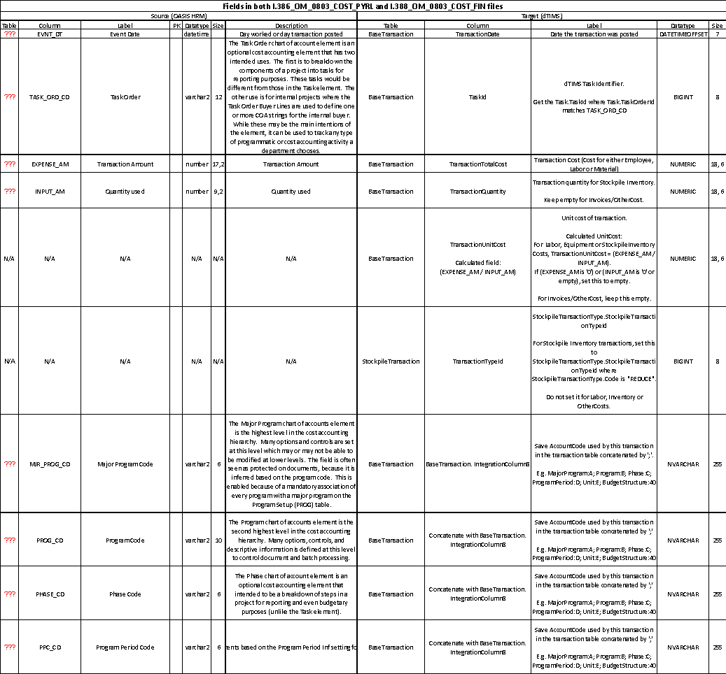
Table 18 - Cost Interface Column Mapping – Common Fields in both PYRL and FIN File (Part 2)

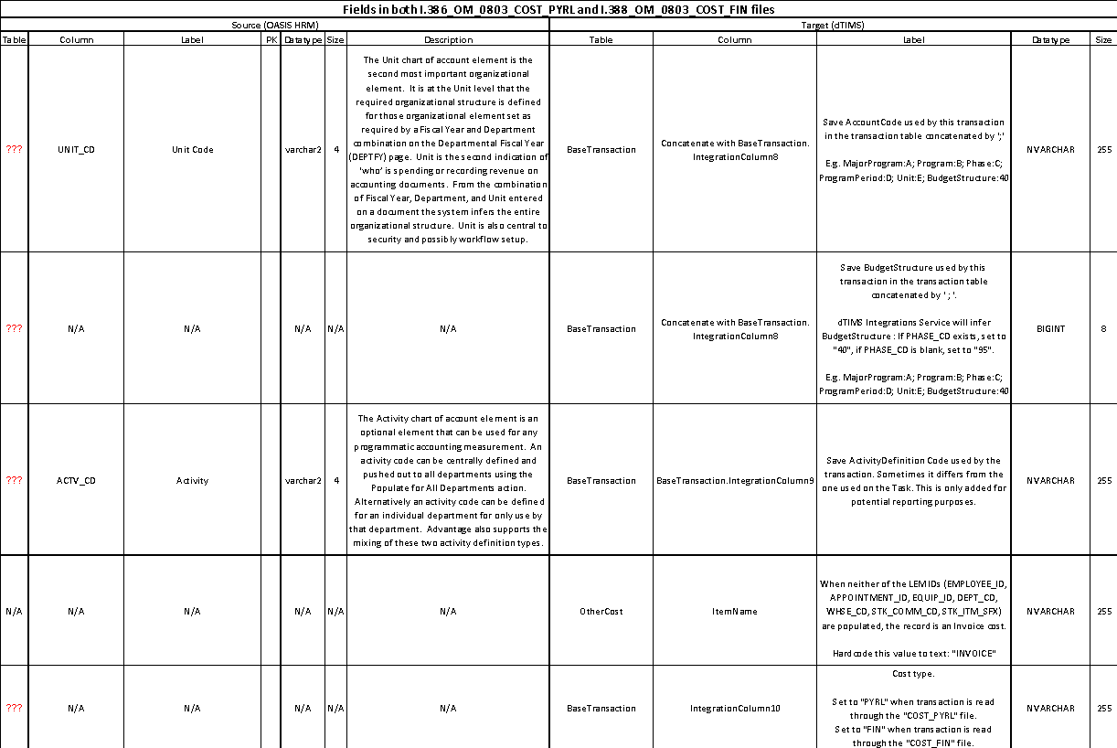
Table 19 - Cost Interface Column Mapping – Common Fields in both PYRL and FIN File (Part 3)

Additional Fields ONLY in I.388_OM_0803_COST_FIN File
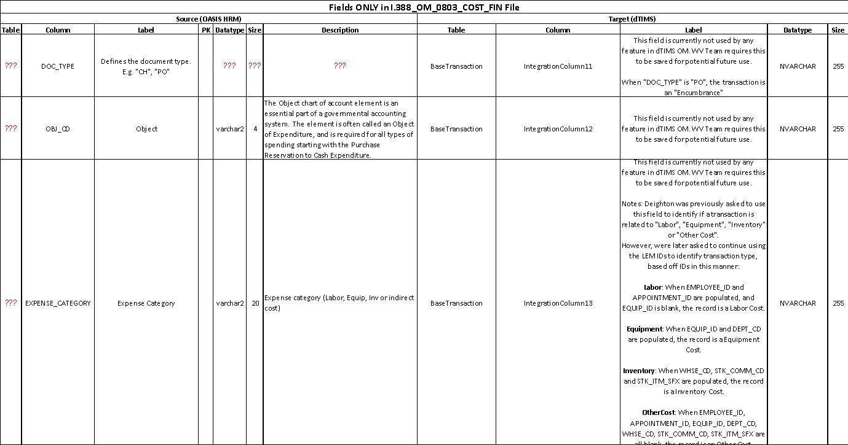
Table 20 - Cost Interface Column Mapping – Fields Only in FIN File

Mockups
Figure 10 and Figure 11 below are UI mockups of the “Actual Cost” tab on the “Task Form”, displaying the labor, equipment, material and invoice costs applied to a Task or Task Order.
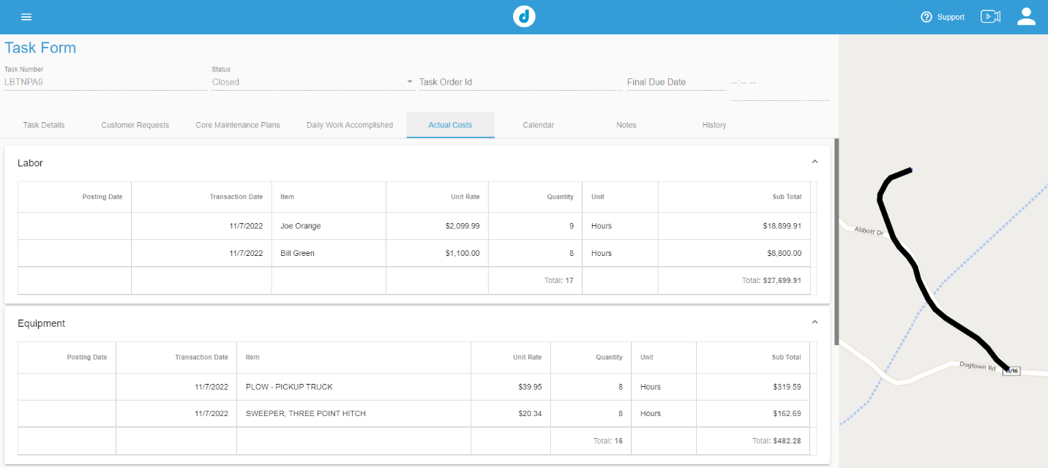
Figure 10 - Actual Cost UI Mockup - 1
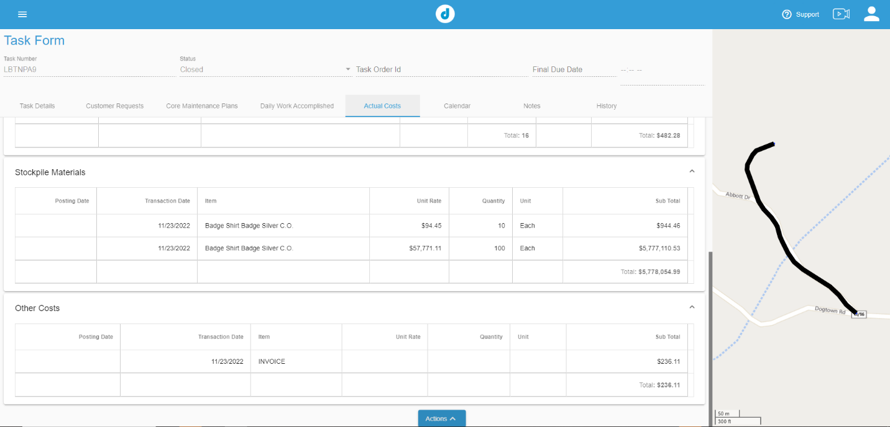
Figure 11 - Actual Cost UI Mockup - 2

Integration Execution

Scheduling
Scheduling the interface execution will be automated utilizing the Windows task scheduler feature. Deighton will set the order of tasks based on data dependency.
Integrations will run in the following order:
- I.389_OM_0803_ACC
- I.387_OM_0803_EMP
- I.390_OM_0803_EQP
- I.391_OM_0803_MAT
- I.386_OM_0803_COST_PYRL
- I.388_OM_0803_COST_FIN

If there are multiple files for a single interface, with different date time stamps, the dTIMS Integrations Service will process them sequentially in the order of date time.
Integrations could either run on a schedule or run manually on demand.

Daily Schedule
The dTIMS Integrations service will be scheduled to run every day at 7AM. This can be modified in the Windows Task Scheduler, on the server where the OM WV Integrations windows service is hosted and scheduled. Figure 12 below outlines the Daily Schedule.
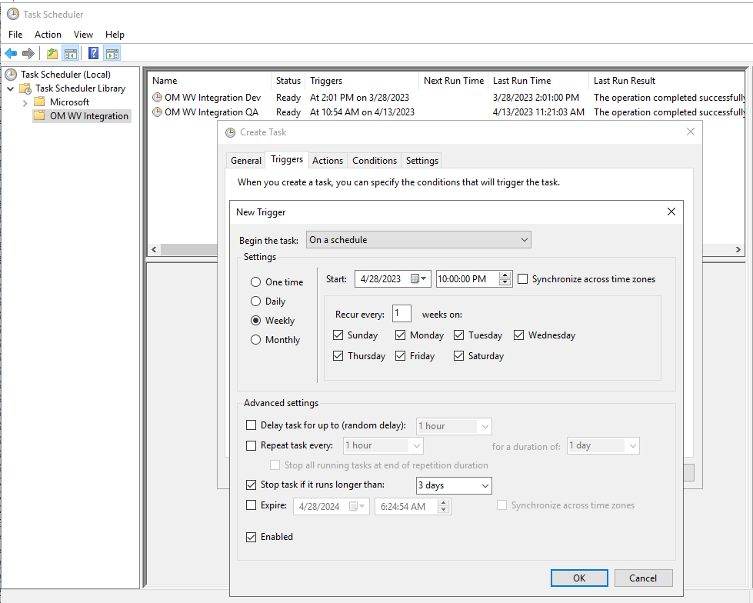
Figure 12 - OM WV Integrations Daily Schedule

Manual Scheduling
A system admin can schedule the dTIMS Integrations Service manually following these instructions:
- Open the Windows Task Scheduler
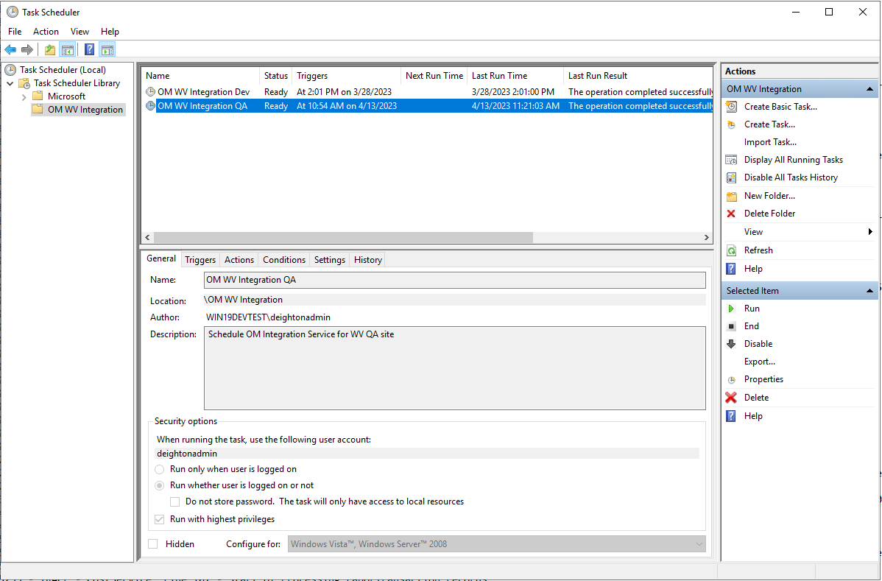
Figure 13 - Windows Task Scheduler
- Right click on the “OM WV Integration” Task in Task Scheduler and click Properties.
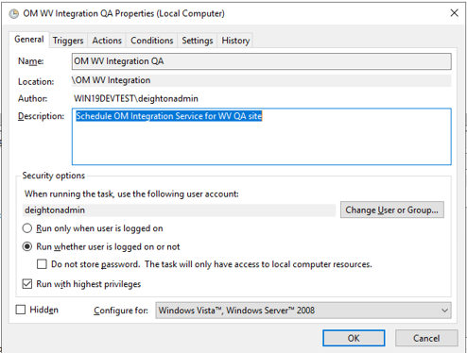
Figure 14 - Windows Task Scheduler - General Tab
- On the Trigger tab, click New. Choose the One time options and select the date and time to schedule the integrations service execution.

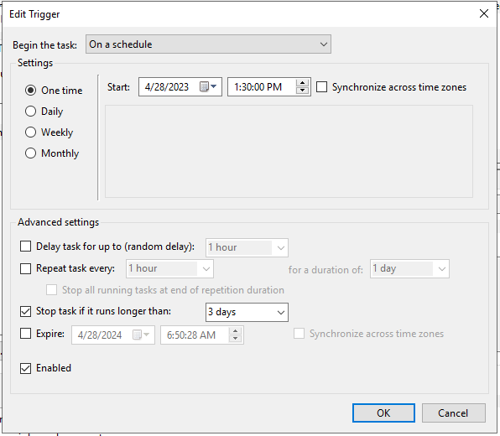
Figure 15 - Windows Task Scheduler - Trigger Tab
- Click OK button to schedule the dTIMS OM Integration service.

Error Logging
The dTIMS integration service will log errors with trace information reported during task execution. The errors will be stored in text files on the same server that runs the interface tasks. The log data will clear every 120 days.
Common logging levels supported by dTIMS integrations solutions are as follows:
- Error – An error indicates a failure of something important.
  - Figure 16 shows a sample error in the error log file:
Figure 16 - Sample Error in Error Logs

- Info – Mentions what happened.
  - Figure 17 shows a sample “Info” message in the error log file indicating the start of an integration service.
Figure 17 - Sample Info in Error Logs

  - Figure 18 shows a sample “Info” message in the error log file indicating the end of an integration service.
Figure 18 - Sample Info in Error Logs

- Trace – Very detailed log messages, potentially of a high frequency and volume.
  - Figure 19 shows a sample “Trace” message in the error log file with details of the inserted record.
Figure 19 - Sample Trace in Error Logs

- Warn – Warnings indicate that something unexpected has happened in the application
  - Figure 20 shows a sample “Warning” message in the error log file with details of a record skipped insert/update due to missing or incorrect data.
Figure 20- Sample Warning In Error Logs

Log Folder Location
<dTIMS Integration Service Folder>\IntegrationLogs\

Error Handling
A designated list of system admins from both Deighton as well as WVDOT, supporting the dTIMS-WVOASIS Integrations would be notified by email when an integration process has failed. He/she would then view the error logs to resolve the errors causing the failure.
The system admin would troubleshoot the errors and decide if it is caused by an error in the CSV file or the TAMS Integrations service/database.
If the error is due to incorrect or missing CSV data, the WVDOT support team would be contacted to update the CSV file creation process to fix the errored data.
If the error is due to incorrect or missing data in the TAMS database, a support ticket would be created to fix the data in the TAMS database.
The errored record details and archived file name will be mentioned in the email summary after every interface is run, as well as detailed in the log file. The support personnel would need to coordinate with WVDOT to fix and re-send any master data integration files. For errors in the Cost interface, the errored cost records would need to be individually resolved by the Deighton and WVDOT support teams together to bring the error count to zero.

Archive Files
CSV files processed by the dTIMS Integrations service will be archived for 120 days. Files older than 120 days will be deleted.
Archive folder location: C:\dTIMSOM_Integration_WV\{{OM_Environment}}\Archive
E.g. C:\dTIMSOM_Integration_WV\QA\Archive

E-mail Notification
When the dTIMS Integration service completes an execution, the service sends an email to a list of configurable email address, all the relevant information regarding error/success. The purpose of this email is to keep the team informed about the execution of scheduled integration tasks.
There will be 3 scenarios to receive emails:
- Integration run was completed:
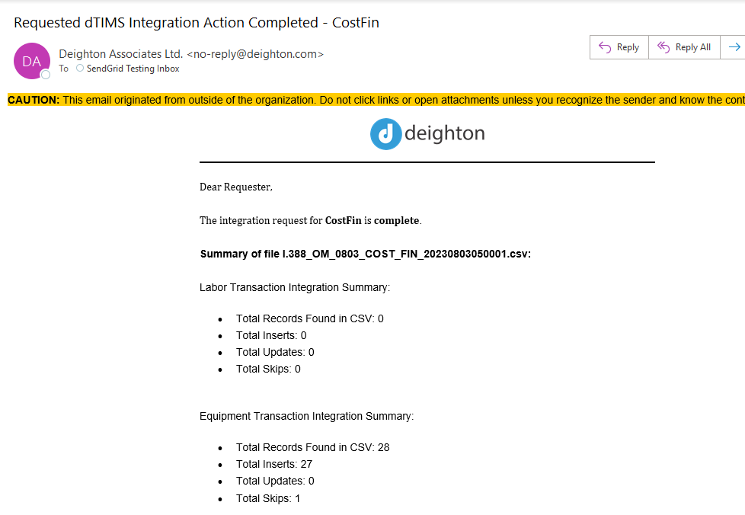
Figure 21 – Email - Integration Complete (Part 1)

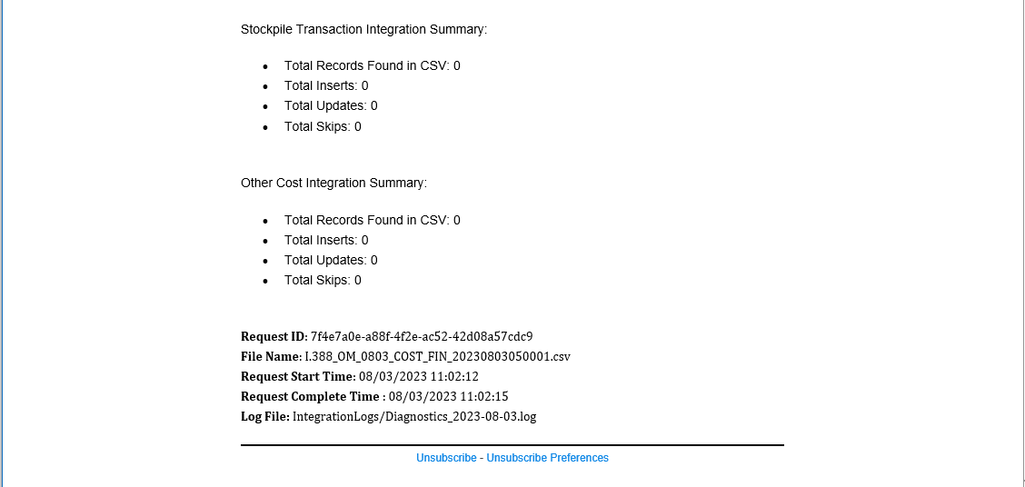
Figure 22 - Email - Integration Complete (Part 2)

- Integration failed:
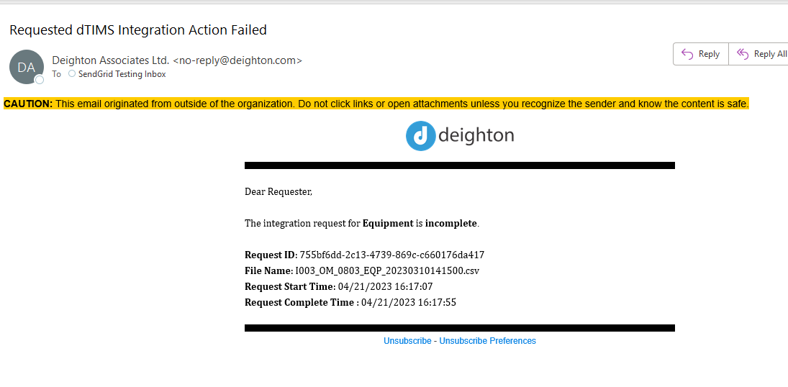
Figure 23 – Email - Integration Failed
- An integration ran; however, the CSV file did not exist on the FTP server:
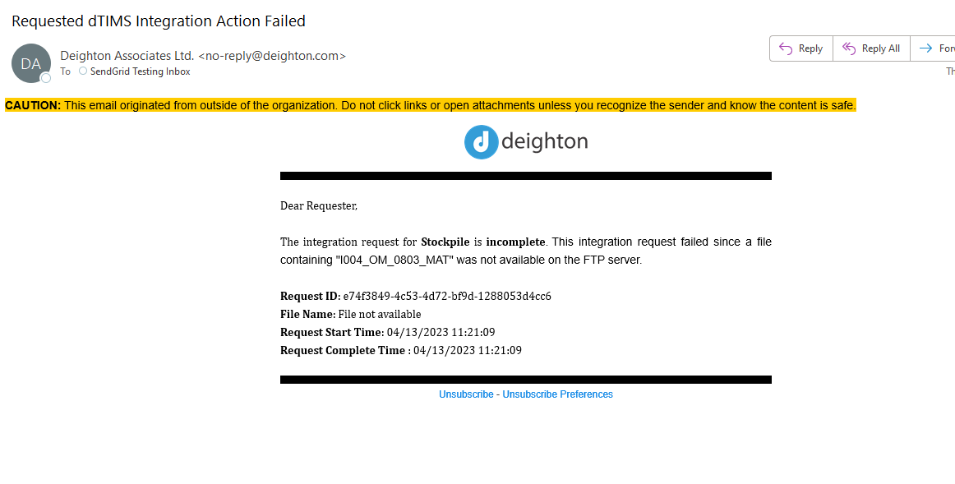
Figure 24 - Email - CSV File Missing

Glossary of Terms
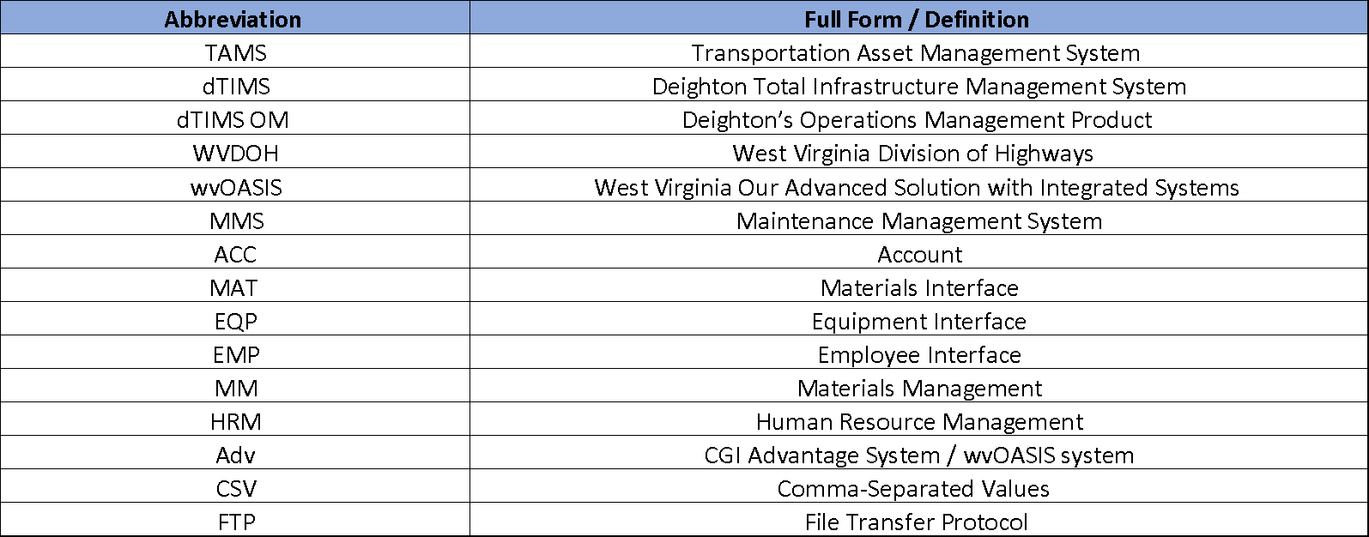
Table 21 – Glossary of Terms

Appendix “A” - SOW list of Interfaces – Current Disposition
The following represents the initial list of interfaces from the SOW with a comment on their current disposition.
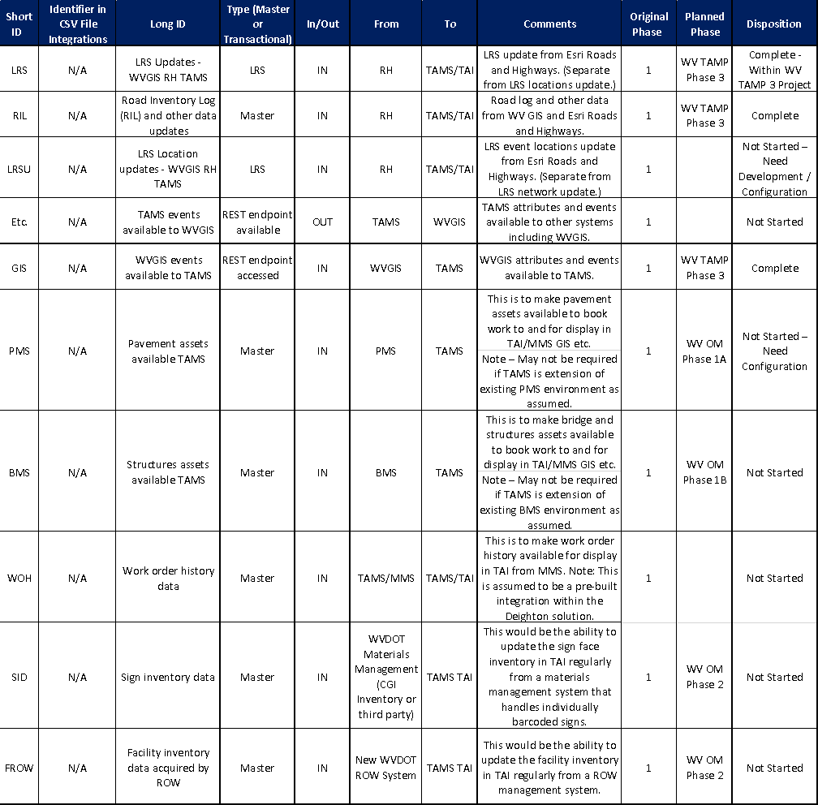

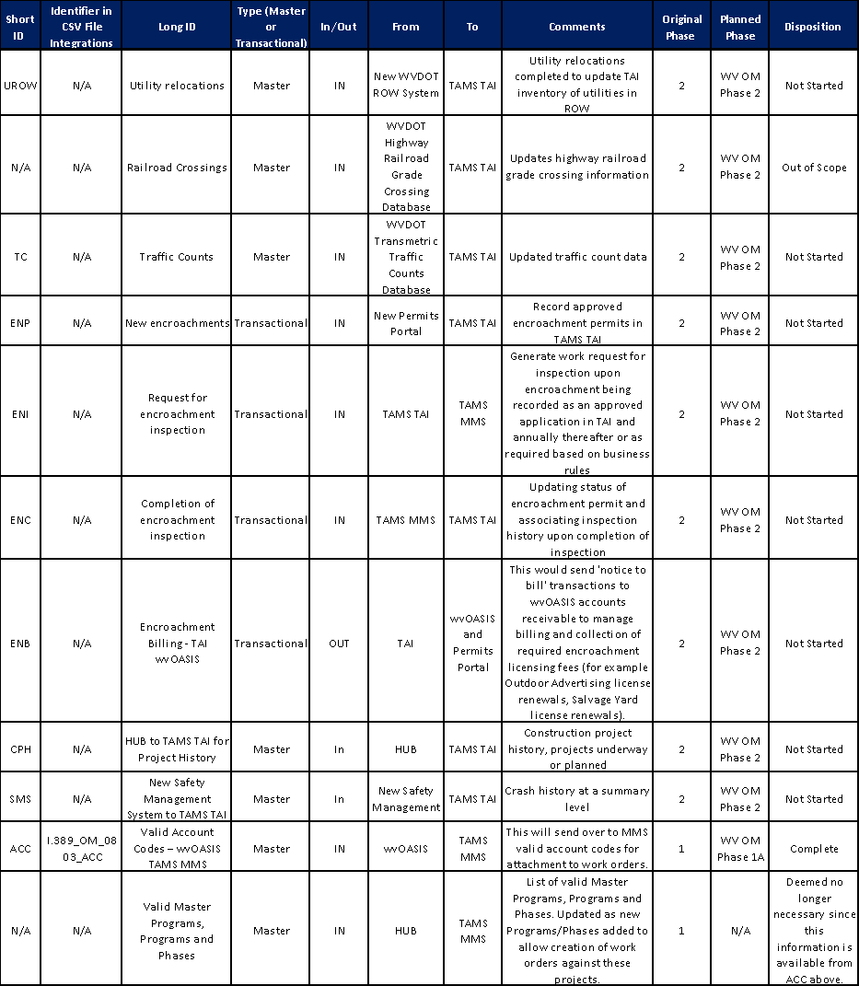
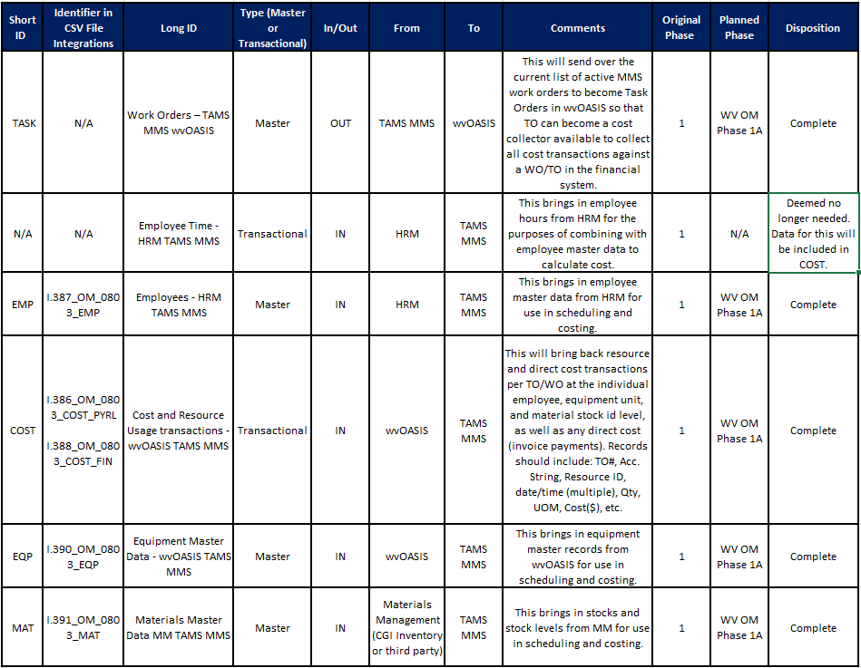
Table 22 - Interface Inventory
Appendix “B” – Referenced Documents
Account Codes – Column Mapping
Employee – Column Mapping
Equipment - Column Mapping
Material – Column Mapping
Cost – Column Mapping
Task – Column Mapping
Appendix A – List of Interfaces
Cost Interface Source Data Script from FIN and HRM Systems (WVOASIS)

ID
Phase
???
TASK
future iteration

