Taylor Colaizzi
20 October 2025
PHYS 5630
Dr. Hirosky
Intro to fitting assignment: Python
Here is data for nexperiments = 1000*100 = one-hundred thousand with 12 points.
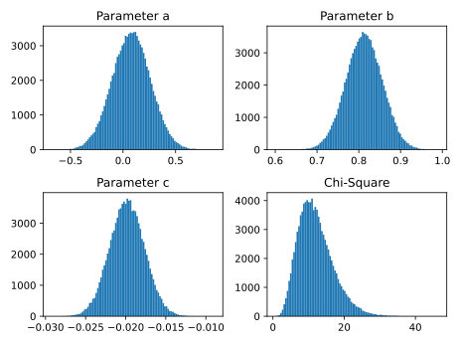
Figure 1: 1d histograms for parameters a, b, c and chi-square for 100,000 experiments. Histograms have 100 bins.
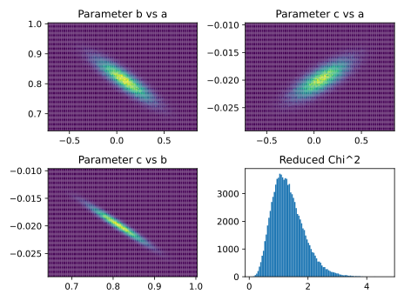
Figure 2: 2d histograms for parameter correlations and 1d histogram of reduced chi-square for 100,000 experiments. Histograms have 100 bins in each dimension.
Here are plots for nexperiments = 1000*10 = ten thousand.
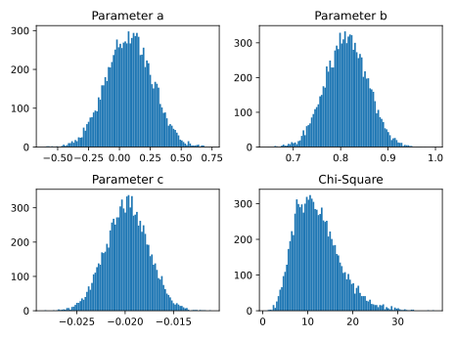
Figure 3: 1d histograms for parameters a, b, c and chi-square for 10,000 experiments. Histograms have 100 bins.
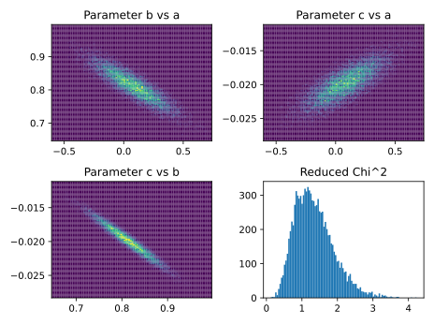
Figure 4: 2d histograms for parameter correlations and 1d histogram of reduced chi-square for 10,000 experiments. Histograms have 100 bins in each dimension.
And just for fun, how about nexperiments = 1000 = one thousand.
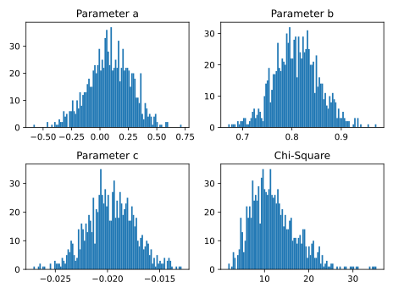
Figure 5: 1d histograms for parameters a, b, c and chi-square for 1,000 experiments. Histograms have 100 bins.
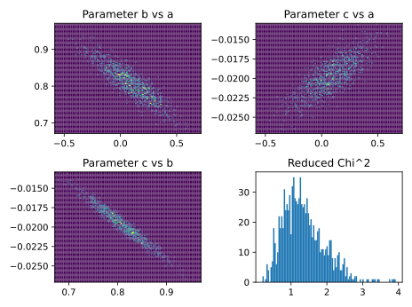
Figure 6: 2d histograms for parameter correlations and 1d histogram of reduced chi-square for 1,000 experiments. Histograms have 100 bins in each dimension.
We can clearly see that as the number of experiments increases, the 1D histograms of the parameters approach a cleaner normal distribution. Moreover, the Chi-square gets cleaner. Let’s see what happens if we change the number of points!
For this final plot of 1000 experiments and 12 points, the mean and standard deviation of chi-square and reduced chi-square are summarized in the following table:
 | Chi-square | Reduced chi-square
Mean | 12.044245814807553 | 1.338249534978617
Standard Deviation | 4.782910350510723 | 0.5314344833900804

We see the mean of chi-square is about 12, which the number of points, which is good. Reduced chi-square is around 1.33, which is 4/3 or the chi-square divided by the degrees of freedom. Since the number of points is 12 and the number of parameters is 3, the degrees of freedom is 9. 12/9 = 4/3. However, the relative error in the chi-square and reduced chi-square is 4.78/12.0, which is about 0.4, which is not that good.
Plotting nexperiments = 100,000 and nPnts = 12 * 5.
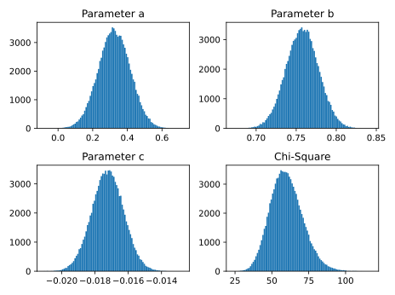
Figure 7: Same plot as 100,000 experiments, but number of points has been increased to 12*5 = 60.
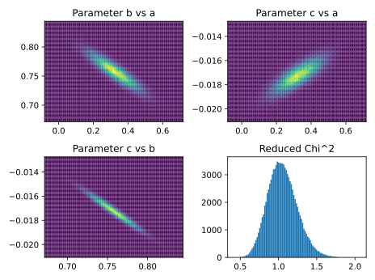
Figure 8: Same as 100,000 experiments, but number of points is now 60.
And now to make it interesting, let’s try nexperiments = 100,000 and nPnts = 12*5*5.
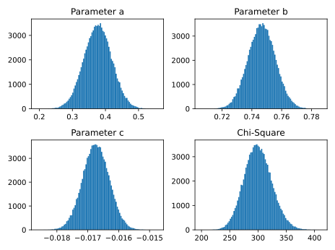
Figure 9: Again 100,000 experiments, but with 300 points.
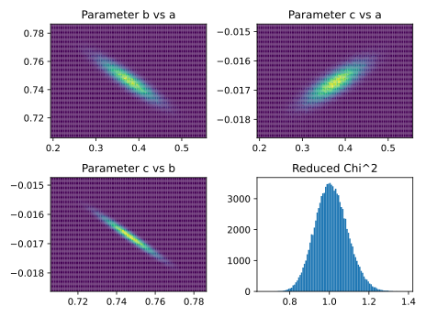
Figure 10: Looking at 100,000 experiments, 300 points.
The biggest change I see from these new plots is that as we increase the number of points, the parameter plots stay about the same. However, the chi-square plot changes a lot! It goes from this weird skewed gaussian shape to a more symmetrical gaussian shape centered at the number of points. Reduced chi-square does the same but is centered at around 1.
For this final plot of 100,1000 experiments and 300 points, the mean and standard deviation of chi-square and reduced chi-square are summarized in the following table:
 | Chi-square | Reduced chi-square
Mean | 300.0826699184066 | 1.0103793599946351
Standard Deviation | 24.521853022158496 | 0.08256516169076934

We see that the mean of chi-square is about 300, which is the number of points, which is good. For reduced chi-square, it’s nearly 1.01, which is about what you’d get if you took 300 / (300 – 3). This is all good! Now, looking at the relative error, we have a better story than the above analysis. The relative error is only about 0.08, which is much less than before.

