**Fall 2013, CS288 Test 3**

1. **Name an open source program that converts an html file to xhtml.**tagsoup
2. **What is the Python package that provides a function to convert xhtml file to DOM tree?**XML
3. **List DOM node type 1 to 4.**1 = element, 2 = attribute, 3 = text, 4 = cdata
4. **List the DOM node types that contain text?** **List numbers.**
5. **What API is required for a Python program to execute mysql queries?**import mySQLdb connect, cursor, execute
6. **The name of the method that Python uses to connect to mysql server is:**  
   conn = mysqldb.connect(host = ” “, user = “ “, password = “ “, db = “ “)
7. **The name of the method that Python uses to get access to mysql tables is:**  
   x = conn.cursor()
8. **The name of the method that Python uses to execute mysql queries is:**x.execute(SQL command here)  
   x.execute(“””INSERT INTO Table VALUES (%s)”””, (100))
9. **Consider the most active page in DOM displayed by Firebug.** **Write a Python program to return a *list of lists* each of which contains six values: symbol, name, change, %change, and volume: (a) write a function, get_text(), to extract the text pointer by an element pointer, (b) write a wrapper function that uses get_text().**
   1. **Write a recursive Python function get_text(elm) to extract all the text of a dom tree pointed by *elm*.**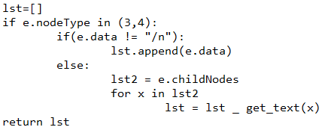
   2. **Write a Python function to find a *list of lists* for the dom tree described in the previous page. Use get_text(elm) in part (a).**

**Code from class**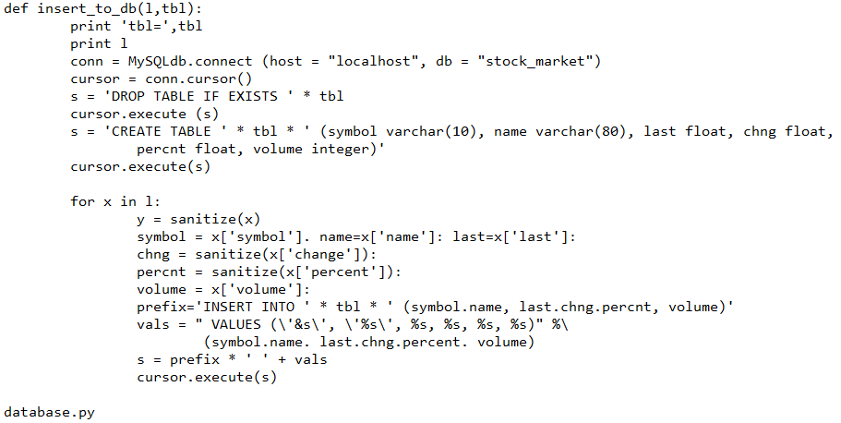

**Jacobi() & Convergence()**

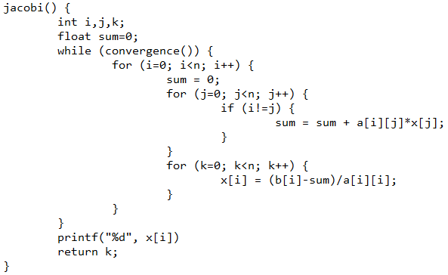

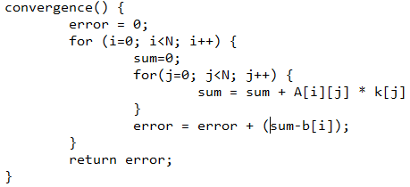

**Quiz 26/11/2014**

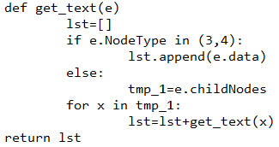

**Homework 9**

* **Useful links:**[**http://pastebin.com/2pJH9vyv**](http://pastebin.com/2pJH9vyv)[**https://github.com/alexnaspo/homework/blob/master/cs288/stock_scraper/hw7.py**](https://github.com/alexnaspo/homework/blob/master/cs288/stock_scraper/hw7.py)
* **DOWNLOAD STOCKS**

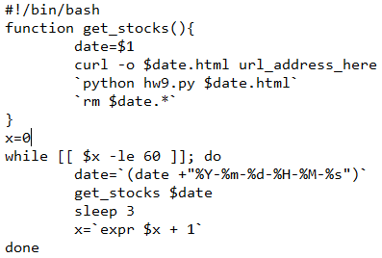

* **PYTHON FUNCTIONS**

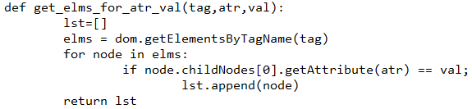

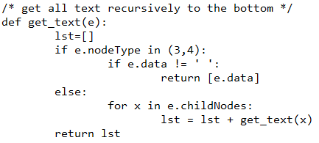

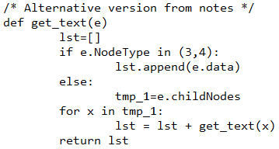

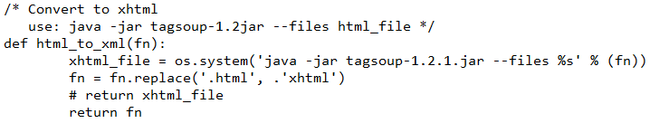

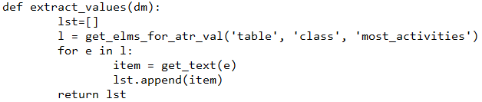

**Homework 10 [Parallel Dot Product]**

