|  |
| --- |
| Specification Document |
| 6x6x4 Tic-Tac-Toe Computer Game |

|  |
| --- |
| TEAM DITZY  Daniel Owen  Imran Khan  Taylor Rowan  Zach Meier  Yiming Zhu  Dr. Shengli Yuan  CS 3420  Spring 2016 |

Table of Contents:

Modification History 3

Major Milestones 4

Abstract 5

Document References 6

Glossary 7

Class Diagram 8

Use Case Sequence Diagram 9

Use case 1 9

Use case 2 10

Use case 3 11

Use case 4 12

Use case 5 13

Use case 6 14

User Interface 15

# Modification History

* **DITZY Game version 0.1.0 (02-20-2016):**
  + Container class for AI in progress
  + Sample GUI in progress

# Major Milestones

|  |  |
| --- | --- |
| **Date** | **Milestones** |
| 01/27/2011 | Basic design and theme decision making |
| 02/20/2011 | Easy level artificial intelligence (AI) modules in progress.  GUI in progress |

# Abstract

The design of a six by six Tic-Tac-Toe (TTT) game application using C#. The use of C# for the game development provides ease of use concerning graphic utilities, increased performance, and legibility. The concern of the project is to develop three main modules or classes for creating the application. These classes perform an interface between player and artificial intelligence (AI) using a graphical user interface (GUI), creating the AI that a player can choose based on difficulty, and the interface between AI and GUI. The GUI includes, amongst all the features, the board for selecting squares. Player who accumulates the most 4-in-a-row sets, formed horizontally, vertically, or diagonally, wins the game. The AI is based on min and max statistical data to determine selection of moves to win. The interface between the AI and GUI displays moves made by the player and AI. In order to display the winning percentage of players, each new player must register with his or her name.

# Document References

|  |  |
| --- | --- |
| **Document** | **Location** |
| Specifications | GitHub |
| Requirements | GitHub |
| Software Management Plan | GitHub |
| Minutes and Time log | GitHub |
| Testing | GitHub |

# Glossary

**Terms:**

|  |  |
| --- | --- |
| **Term** | **Definition** |
| Artificial Intelligence | A simulated version of human thought processes for calculating results without the aid of human intervention. |
| Graphical User Interface | A visual display of objects or abstractions for a user to interact without knowing all the details to run it. |
| Interface | A bridge between to objects to share information. |
| MiniMax | A decision tree to determine the best move based on the player’s choice and, by prediction, the player’s next move. |
| Alpha-Beta pruning | Search algorithm which decreases the number of nodes evaluated by MiniMax Algorithm |

**Acronyms:**

|  |  |
| --- | --- |
| **Acronym** | **Meaning** |
| DITZY | Product Name |
| GUI | Graphical User Interface |
| AI | Artificial Intelligence |
| TTT | Tic Tac Toe |
| 6x6x4 | Board game |

# Class Diagram

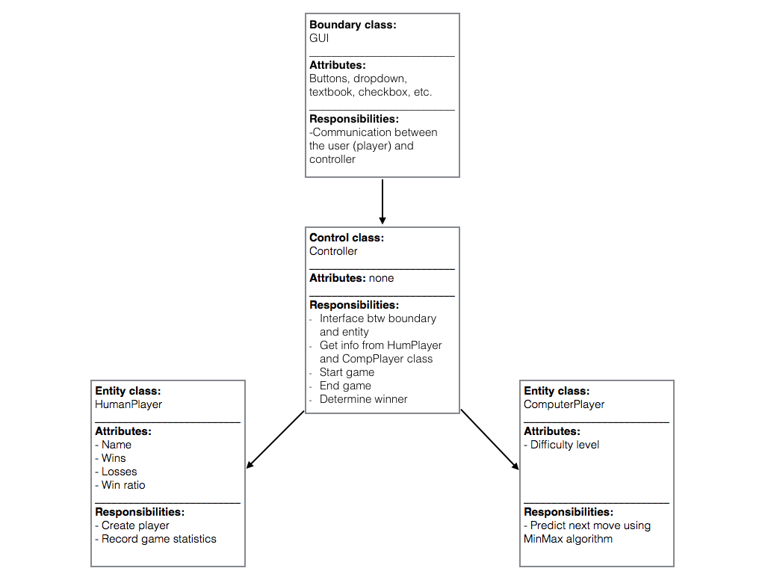

# Use Case Diagram

**Use Case 1:**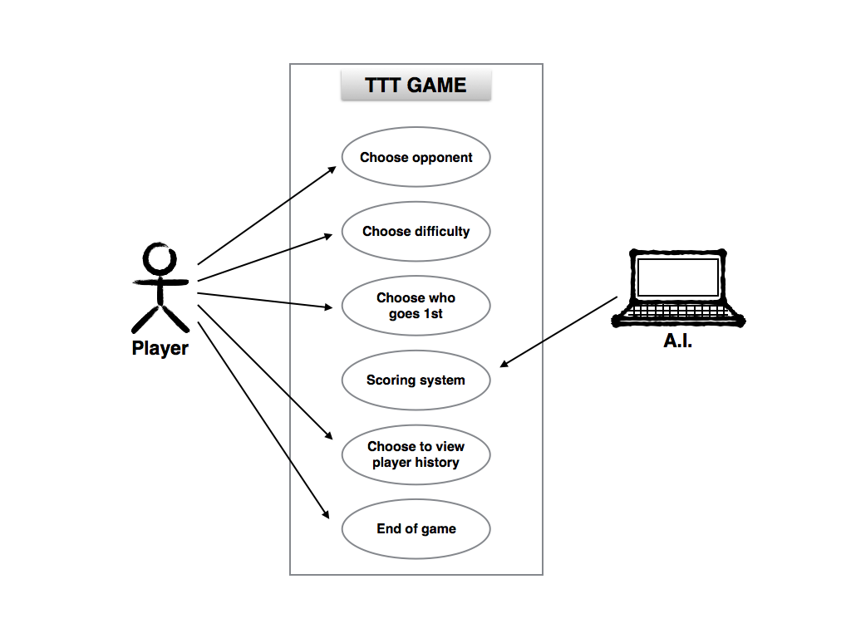

**Figure 1a.** Use Case Diagram for TTT Players

Description: Player can choose to opponent (human or computer), choose difficulty (easy, medium, or hard), choose who goes first, choose to restart or end game, and view player history as an option.

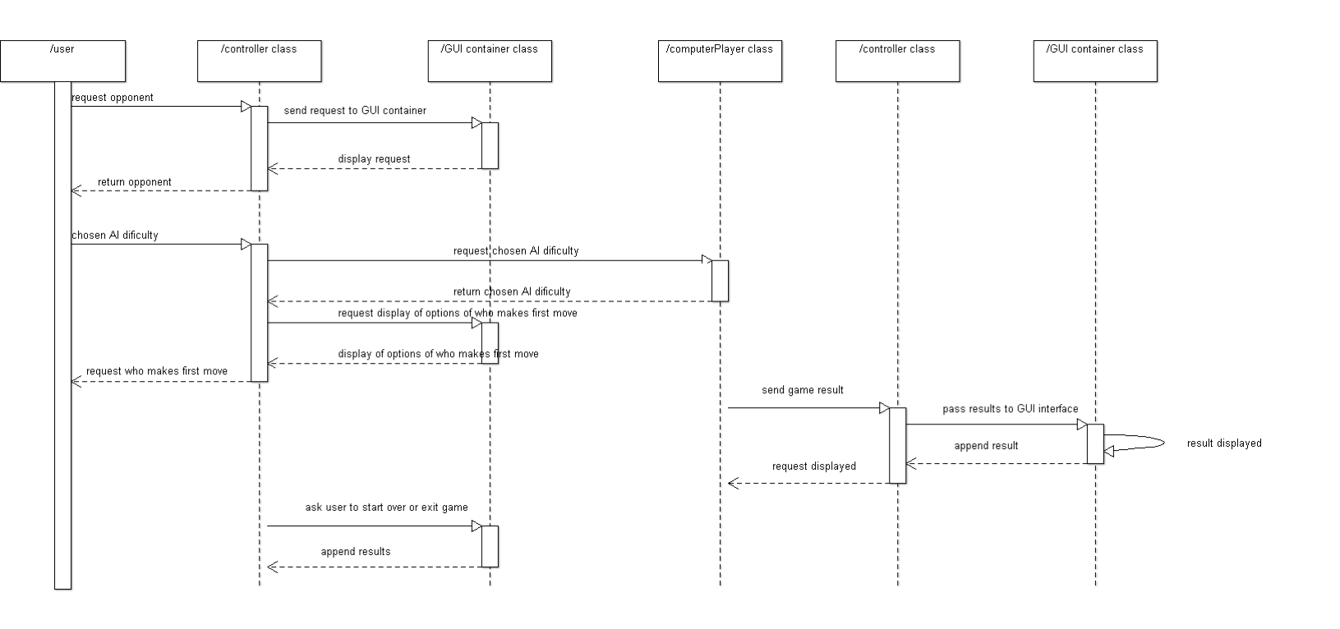

**Figure 1b.** Sequence Diagram for TTT Players

**Use Case 2:**

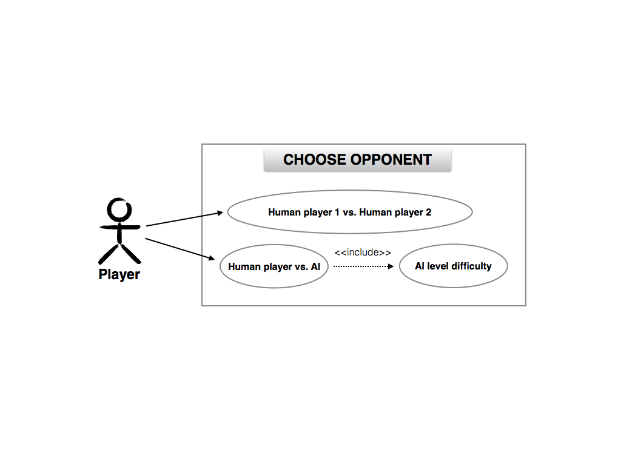

**Figure 2a.** Use Case Diagram for Opponent Selection

Description: When player chooses his or her opponent, he or she can select playing against another human or the computer, which includes 3 levels of difficulty.

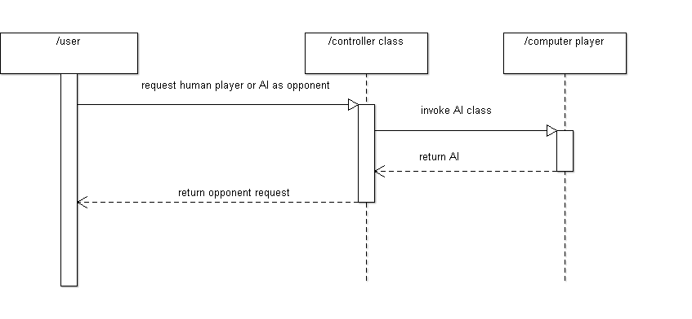

**Figure 2b.** Sequence Diagram for Opponent Selection

**Use Case 3:**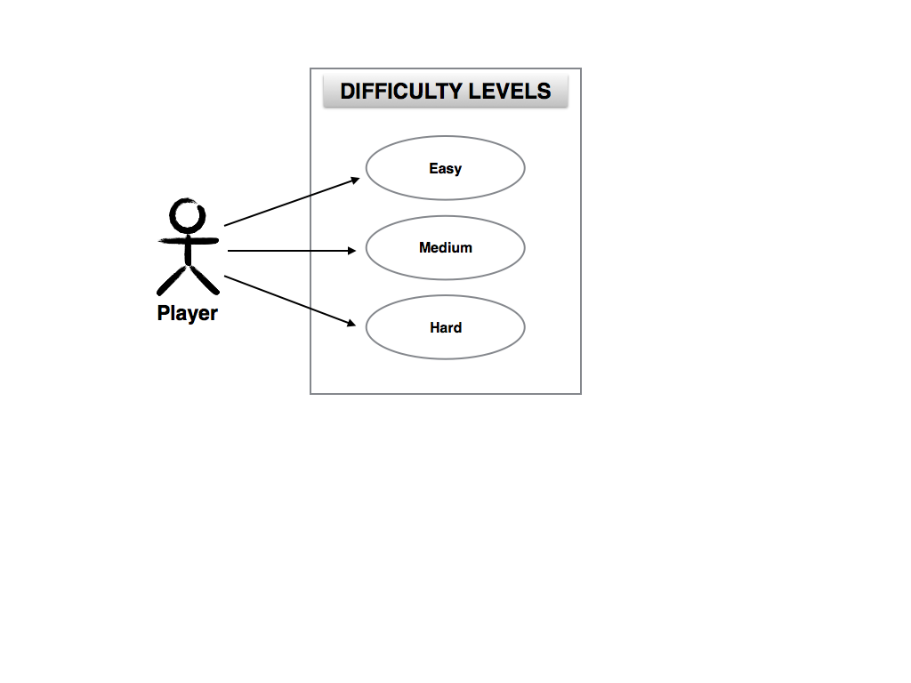

**Figure 3a.** Use Case Diagram for AI Difficulty

Description: Player is able to select level of computer difficulty.

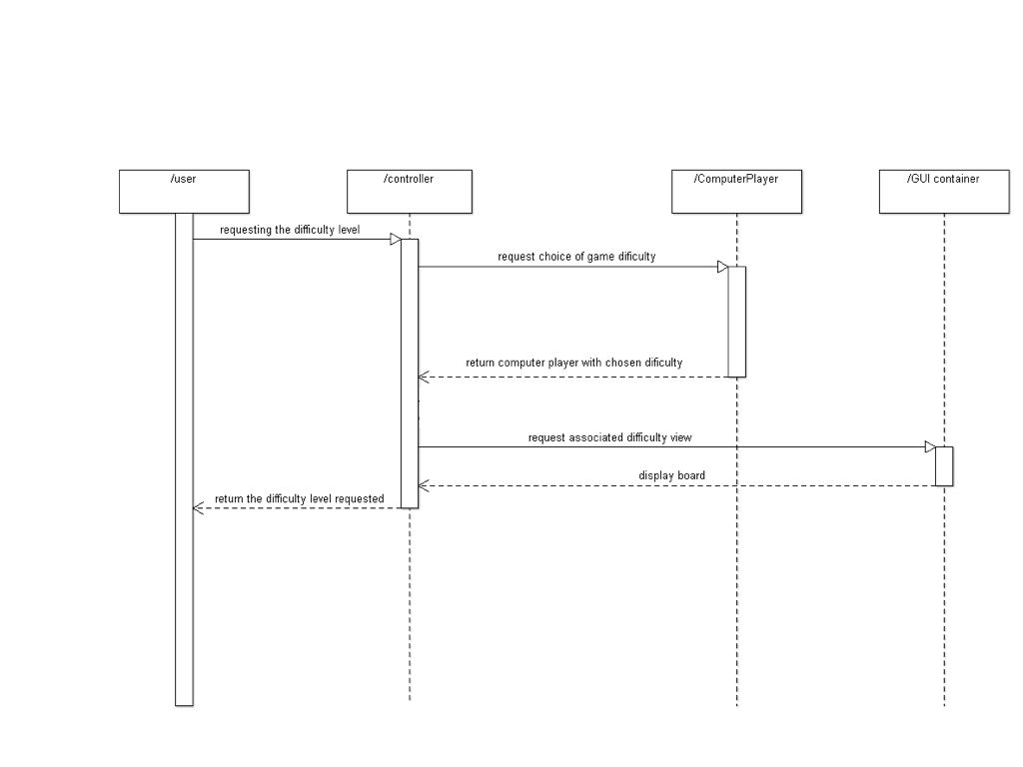

**Figure 3b.** Sequence Diagram for AI Difficulty

**Use Case 4:**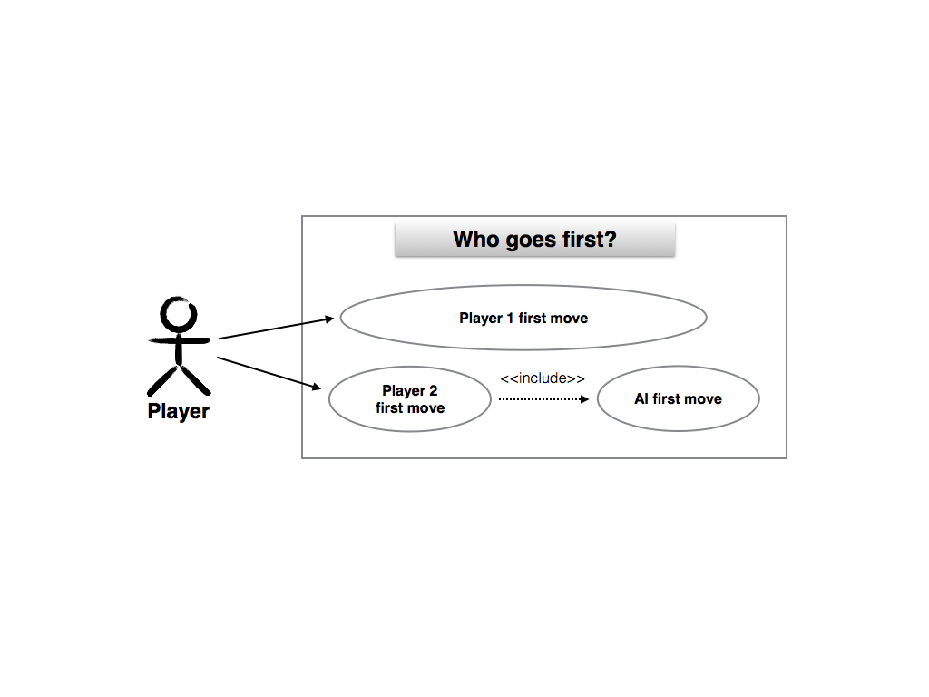

**Figure 4a.** Use Case Diagram for Who Goes First

Description: Player can choose who goes first, whether it is human or computer.

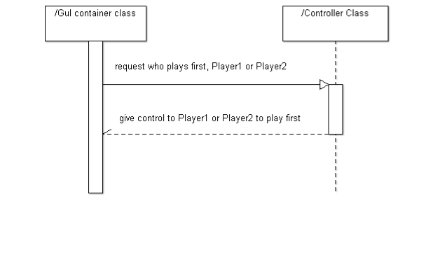

**Figure 4b.** Sequence Diagram for Who Goes First

**Use Case 5:**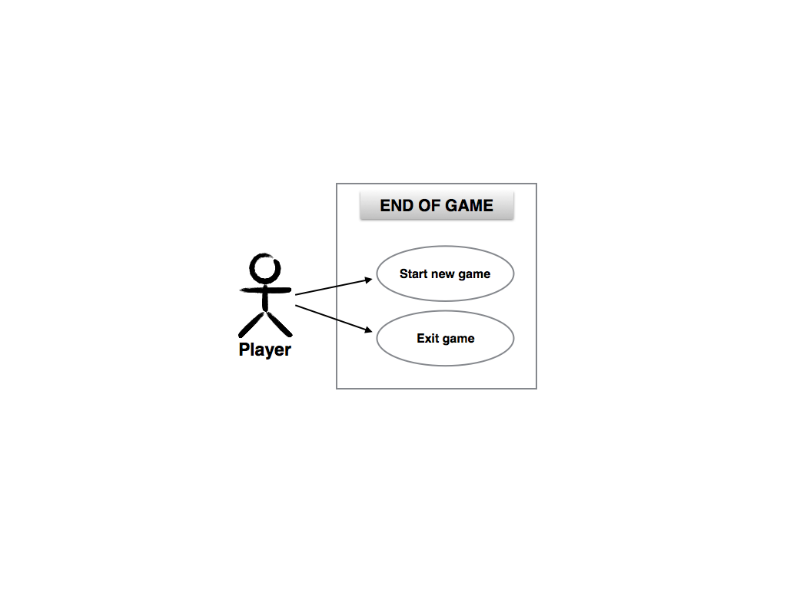

**Figure 5a.** Use Case Diagram for End of Game

Description: Player can choose to start a new game or exit game after each game played.

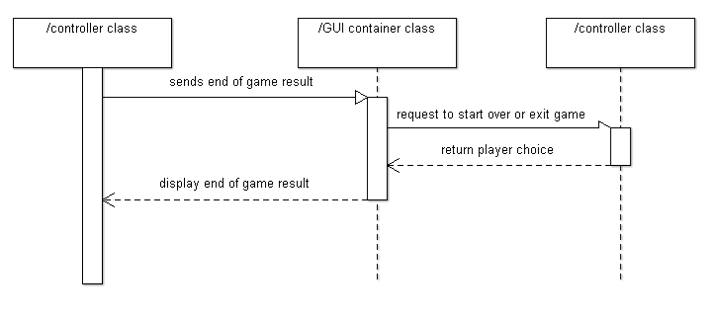

**Figure 5b.** Sequence Diagram for End of Game

**Use Case 6:**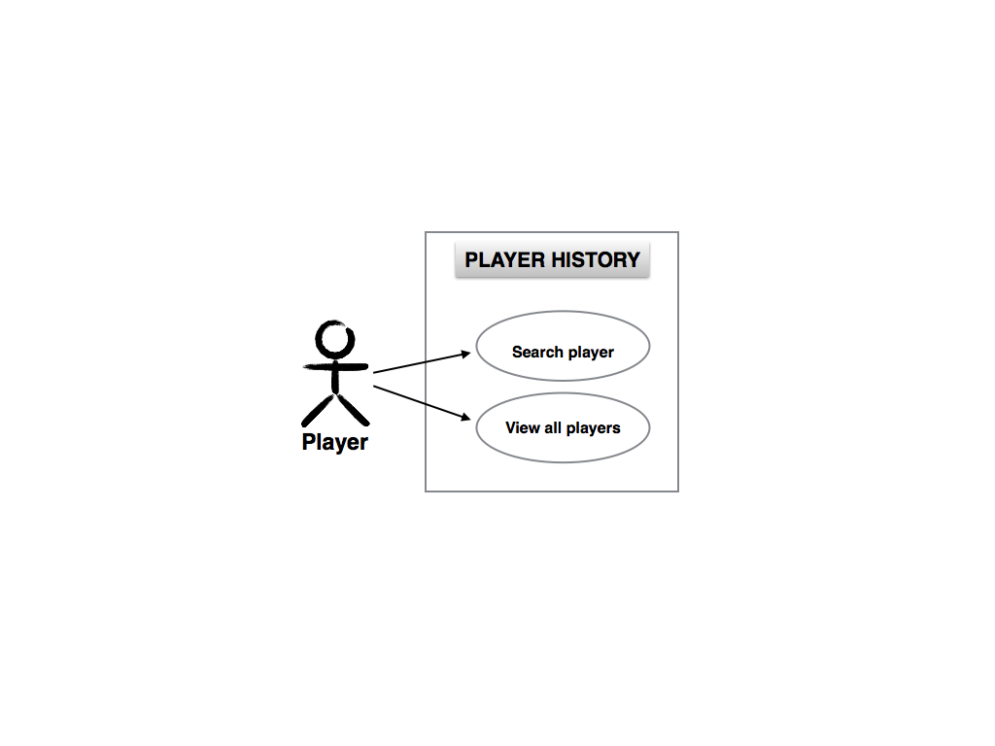

**Figure 6.** Use Case Diagram for Player History

Description: This is optional for the player to view player history, including wins, losses, draws, and win percentage.

# User Interface

Player transitions between three GUIs:

1. Player creation, game mode selection, and player history
2. Player history with search and view all features
3. Player(s) selection
4. 6x6 game board with player turn selection, win-loss record, XO designation, and AI difficulty selection (if playing against AI)

GUI #1

A new player enters his or her name and select “Create Player” to create a new player. In “Game Mode,” player selects between “Player vs. Player” or “Player vs. Computer.” The player can choose to not play at all and view existing players’ win-loss record.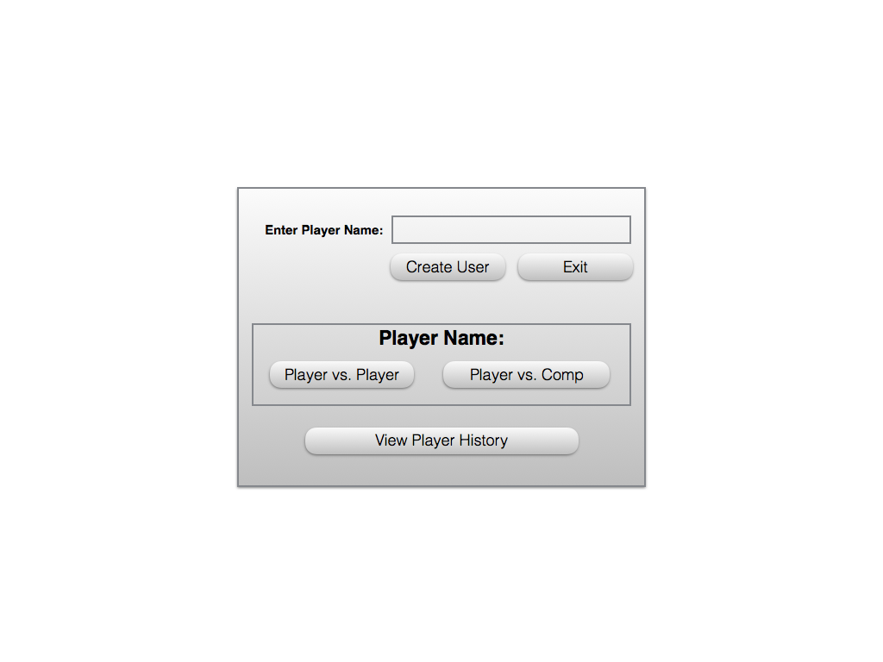

**Figure 7.** GUI #1

GUI #2

In player history, registered or non-registered player can view the win-loss record of all registered players. Features include buttons for “Search” and “View All.”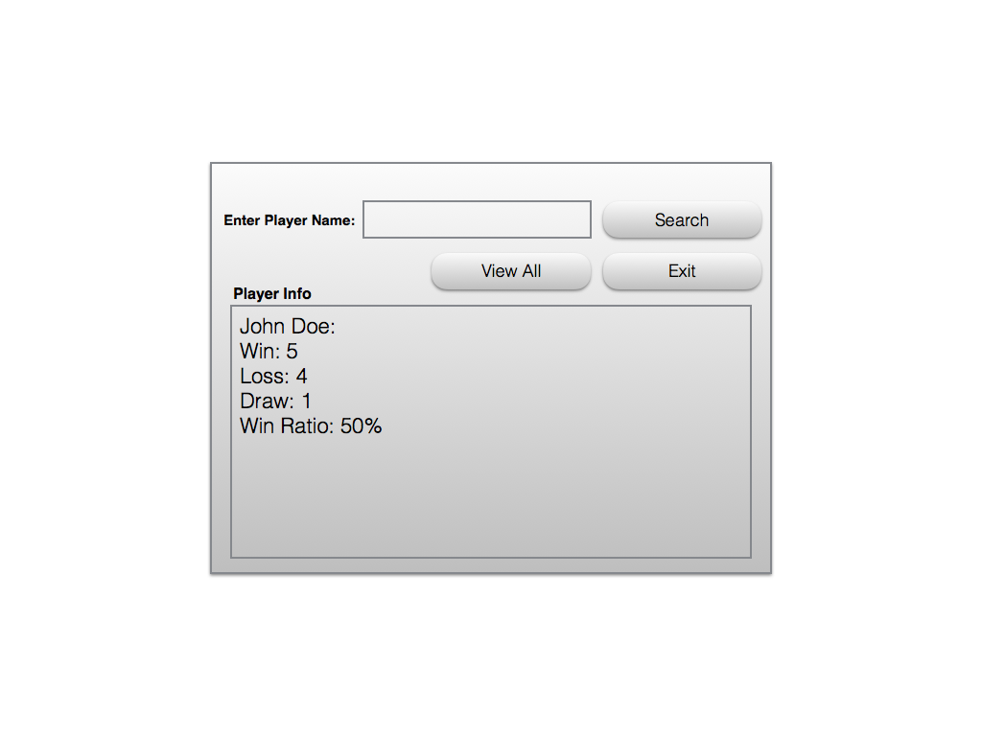

**Figure 8.** GUI #2

GUI #3

If “Player vs. Player” in GUI #1 is selected, registered players are selected for player 1 and player 2 from drop-down menu. If “Player vs. Computer” is selected, the registered player selects his or her name from the drop-down menu.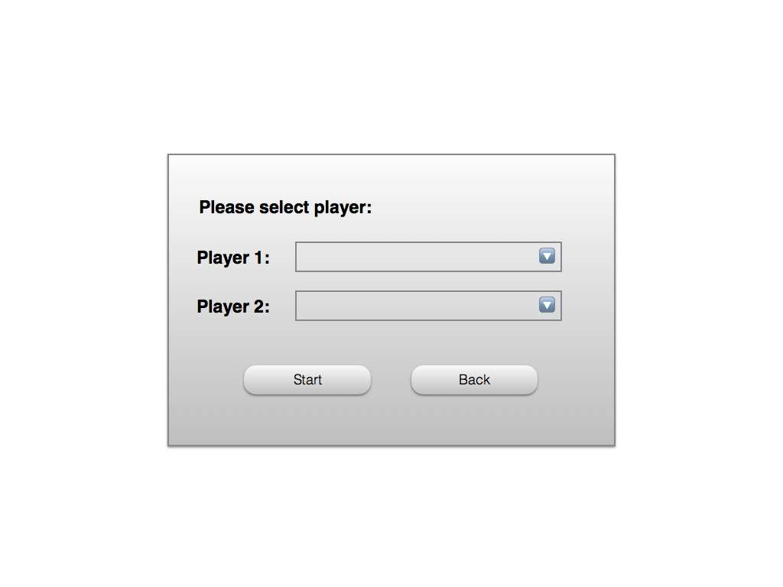

**Figure 9.** GUI #3

GUI #4

The 6x6 game board is displayed here. Player(s) decide which player to make the first move before starting the game. If “Player vs. Computer” is selected in GUI #1, player selects the difficulty: Easy, Medium, or Hard before starting the game. On the same GUI, player info is displayed to identify which player is “X” or “O.” Lastly, as long as the player(s) does not exit, win-loss record will be displayed for each continuous session.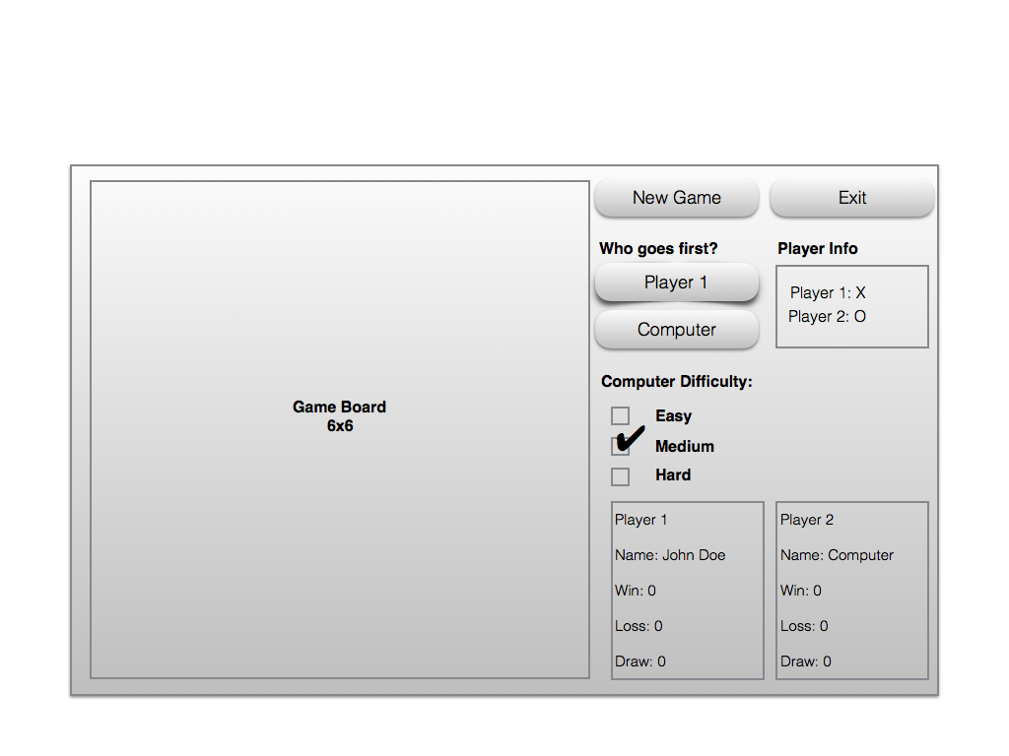

**Figure 10.** GUI #4