Influence of changing lake temperatures on coregonine embryogenesis at local to global scales

Taylor R. Stewart1, Mikko Makinen2, Chloé Goulon3, Jean Guillard3, Emilien Lasne4, Juha Karjalainen2, and Jason D. Stockwell5

1Department of Biology, University of Vermont, USA

2University of Jyväskylä, Finland

3UMR CARRTEL INRA-Université Savoie Mont Blanc, France

4UMR ESE Agrocampus Ouest-INRA, France

5Rubenstein School of Environment and Natural Resources, University of Vermont, USA

**ABSTRACT:**

**INTRODUCTION:**

Lakes present unique and difficult challenges for biodiversity conservation (Halpern et al. 2015) and are one of the most sensitive ecosystems to climate change (Woolway et al. 2020). Temperature plays an important role for most aquatic organisms, as changes in water temperature directly affect phenological and reproductive events, metabolic rates, growth, and survival (Little et al. 2020). Studies have provided overwhelming evidence that lakes are warming at an unprecedented rate on a global scale (Austin and Colman 2007, O’Reilly et al. 2015, Woolway et al. 2017). However, water temperature change is not projected to rise steadily across regions, seasons, or lake types (O’Reilly et al. 2015, McCullough et al. 2019). The greatest seasonal increase in water temperature of seasonally ice-covered lakes is projected to take place during the spring (Schindler et al. 1990, Winslow et al. 2017), and the greatest seasonal increase in air temperature will be during winter in northern Europe and North America (Christensen et al. 2007). Changes in spring conditions and increases in the frost-free season can prolong annual growing seasons with warmer summers, longer autumns, shorter ice-cover duration, and rapid spring water warming (Meehl et al. 2007). The effects of climate change on lake fishes are predicted to lead to declines in cold-water species (Fang et al. 2004, Mackenzie-Grieve and Post 2006, Jacobson et al. 2010, Herb et al. 2014) and increases in warm-water species (Lehtonen 1996, Chu et al. 2005, Sharma et al. 2007, Van Zuiden et al. 2016) as the climate warms (Comte et al. 2013, Hansen et al. 2017). ﻿Fundamental questions for evolutionary and conservation biologists in a global change context include how species will respond to climate change and what mechanisms will be involved in the process.

Freshwater whitefishes, Salmonidae Coregoninae (hereafter coregonines), are of great socio-economic value but considered to be critically sensitive to the effects of climate change because they are cold, stenothermic fishes that occur throughout northern latitudes (Stockwell et al. 2009, Elliott and Bell 2011, Jeppesen et al. 2012, Isaak 2014, Jonsson and Jonsson 2014, Karjalainen et al. 2015, 2016b). Many of these species live close to their physiological water temperature limit and are at risk under warming climate scenarios. Coregonine fisheries worldwide have experienced population declines due to highly variable and weak year-class strengths (Anneville et al. 2015; Myers et al. 2015; Nyberg et al. 2001; Vonlanthen et al. 2012). The reason for declining recruitment is unknown, but winter conditions appear to play a role in recruitment success (Karjalainen et al. 2015; Karjalainen et al. 2016; Marjomäki et al. 2004; Nyberg et al. 2001).

Identification of how coregonines have adapted across space (*i.e.,* latitudinal and longitudinal) to environmental parameters, such as water temperature, may provide further insight to climate-driven shifts in the biological characteristics of coregonine populations. High-latitude populations which experience lower water temperatures and shorter growing seasons are expected to (1) have prolonged incubation periods and (2) exhibit slower embryonic development and smaller size-at-age than populations at lower latitudes (Colby and Brooke 1973; Edsall and Colby 1970; Karjalainen et al. 2015; Karjalainen et al. 2016; Oyadomari and Auer 2008; Urpanen et al. 2005). However, a number of species (*e.g.,* Arctic char *Salvelinus alpinus*, Atlantic cod *Gadus morhua*, Atlantic silversides *Menidia menidia*, Atlantic salmon *Salmo salar*, striped bass *Morone saxatilis*, and turbot *Scophthalmus maximus*) have demonstrated an ﻿inverse relationship between the length of the growing season and life history and morphological trait performance (*i.e.,* countergradient variation; Billerbeck et al. 2000; Chavarie et al. 2010; Conover and Schultz 1995; Conover and Present 1990; Jonassen 2000; Schultz et al. 1996, 1998; Yamahira et al. 2002), where higher-latitude populations have higher trait performance potential compared with lower-latitude populations. Countergradient variation suggests that higher-latitude populations compensate for a shorter growing season by evolving a higher overall efficiency in specific traits. Conover and Present (1990) first suggested that life history traits in fishes can vary between latitudes and the driving selective force for this variation is size-dependent winter mortality in young-of-the-year. ﻿Such size-dependent winter mortality results in a strong and increasing selection pressure towards fast-growing coregonines with increasing latitude.

The identification of how different populations across space respond to changing thermal conditions during critical life stages and the mechanisms driving recruitment failure as thermal habitat and phenology continues to degrade and change for cold-water fishes is much needed. Year-class strength in coregonines is thought to be established prior to the end of the first season of growth, with the first few weeks after hatching especially critical (Hjort 1914, Cushing 1990, Ludsin et al. 2011, 2014). The response to environmental change at the embryonic and larval stages are expected to play an important role in population persistence (Myers 1997, Karjalainen et al. 2000) and have major implications on ecosystem health as coregonines contribute significantly to ecosystem function and energy transfer (Gamble et al. 2011, Muir et al. 2014, Stockwell et al. 2014, Karjalainen et al. 2015). Large-scale experimental evolution studies may aid in understanding the response of coregonines to changing environments (Hoffmann and Sgrò 2011).

Our objective was to experimentally analyze the response of different coregonine species to changing thermal regimes across broad latitudes. We hypothesized that populations are adapted to their local thermal environments and life history and morphological traits will be maximized in the native environment but reduced elsewhere (*i.e.,* temperature adaptation). However, populations may have evolved climate-driven shifts in performance to adapt to shorter growing seasons, colder summer water temperatures, and more extreme winter conditions and maximize traits across all temperatures (*i.e.,* countergradient variation). We also hypothesize that a greater magnitude of seasonal fluctuations and variation will result in lower-latitude populations having a stronger parental response (*i.e.,* heritability) to changing temperatures due to stronger selection towards thermal plasticity. Determining the evolutionary differences and mechanisms driving thermal resilience across populations, at critical early-life stages, will be important for future sustainable management practices of the ecologically and economically important coregonines.

**METHODS:**

Study Sites and Collections

We used a cross-lake, cross-continent, cross-species approach to evaluate the responses and thermal tolerances of coregonine embryos and larvae to changing thermal regimes. Wild-caught populations of cisco in Lake Superior (USA/Canada) and Lake Ontario (USA/Canada), and vendace and European whitefish in Lake Konnevesi (Finland; Figure X) were sampled using live-capture gear. Adult field collections occurred during coregonine spawning periods for Lake Ontario and Lake Superior. On Lake Konnevesi, adults were collected prior to spawning and stored in an aquaculture pool with water fed directly from the lake until spawning was initiated. A single laboratory in North America (University of Vermont (UVM), USA) and Europe (University of Jyväskylä (JYU), Finland) conducted all sampling, fertilization, and experimental work for populations on each continent.

The term population is used in many ways. For the sake of clarity, our operational use of a population is to represent a single species within a single lake (*e.g.,* cisco in Lake Superior).

Fertilization and Incubation

Eggs and milt were stripped from dams and sires from each population and artificially fertilized under a blocked, nested full-sib, half-sib fertilization design (Figure X) to create a maximum of 48 full-sibling families nested within half-siblings per population (Table X). This fertilization design was used to maximize the amount of genetic variation and minimized the potential loss of multiple families if a dam or sire produced poor quality gametes, compared to a full-factorial design. Pairing was performed by dividing the adults used in the experiment into three or four fertilization blocks. A single block consisted of four sires each paired to three unrelated dams, where all offspring of a given dam were full siblings. Fertilizations were performed block by block to ensure germ cell survival.

Approximately 200 eggs per dam were fertilized by approximately 10 μl of milt from each sire in the block. After the addition of milt, water was added to activate the germ cells and gently mixed for one minute. The embryos were rinsed 2-3 times until the water was clear. Water used during fertilizations was reconstructed freshwater (OECD ISO 6341:2012) to standardize the chemical properties of the water used among populations and between labs. Embryos were transported in coolers either by shipping overnight for Lake Superior or driven same day for Lake Ontario. A temperature logger recorded air temperature inside the cooler during transport (Lake Superior: mean = 2.80°C, sd = 0.21°C; Lake Ontario: mean = 3.28°C, sd = 0.37°C). No embryo transport was required for Lake Konnevesi. Demographic data (*e.g.,* total length and weight) were collected on adults.

Fertilization success was determined by haphazardly taking 10 embryos from each family and assessing under microscopy within 72-hours post-fertilization (Oberlercher and Wanzenböck 2016). If fertilization was low (<30%), the family was removed from the experimental setup. Embryos from successfully fertilized families were individually distributed into 24-well cell culture microplates and incubated in 2 ml of reconstructed freshwater. Reconstructed freshwater was used during incubation to maintain sterility, prevent bacterial growth in the wells, and eliminate the need for harsh fungicide treatments on the embryos. A total of 36 embryos per family were used for Lake Konnevesi and 48 embryos per family for Lake Ontario and Lake Superior. Families were randomly distributed across three or four microplates (*i.e.,* 12 eggs per family per microplate and two families per 24-well microplate). Microplates from each species and population were incubated at constant temperatures of 2.0, 4.5, 7.0, and 9.0°C and randomly placed in climate-controlled chambers at UVM (Memmert® IPP260Plus) and climate-controlled rooms at JYU (Brand). Forced airflow was used in both the climate-controlled chambers and rooms to ensure equal air circulation around the microplates. All microplates were covered to prevent excessive evaporation. Microplate orientation and position were rotated weekly to eliminate any temperature heterogeneity within the chambers and rooms. Water temperatures were recorded hourly with loggers (HOBO® Water Temperature Pro v2 at UVM and Escort iMini at JYU) and daily mean water temperatures calculated. Incubations took place in the dark, with the exception of short maintenance periods. Microplates were checked weekly for dead eggs and the eye-up stage. During the hatch period, microplates were checked on a two-day cycle for newly hatched larvae. All newly hatched larvae were photographed for life-history and morphological traits.

Statistical Analyses

All statistical analyses were performed in R version 4.0.3 (R Core Team 2020).

*Life-history and Morphological Traits*

Embryo survival was estimated as the percent of embryos surviving between the eye-up and hatch stages. Incubation period was assessed by two variables: the number of days from fertilization to hatching (DPF) and the sum of the degree-days (ADD). Total length-at-hatch (LAH; mm) and yolk-sac volume (YSV; mm3) were measured from five individuals per family at, or as close as possible to, 50% hatching for each family. YSV was calculated assuming the shape of an ellipse (Blaxter 1963):

where a = length of the yolk sac (mm) and b = height of the yolk sac (mm).

Embryo survival was analyzed as a binomial response variable, and incubation period, LAH, and YSV at hatching as continuous response variables. Early embryo mortality induced from fertilization failure produced inequalities in the number of offspring among families and an unbalanced design. The sample size for incubation period is a function of embryo survival and subsequently resulted in an unbalanced design. Therefore, binary data (*i.e.,* embryo survival) were analyzed with binomial generalized linear mixed-effects models (LMM) and normally distributed data (*i.e.,* incubation period, LAH, and YSV) were analyzed with restricted maximum likelihood LMMs with the lme4 package (Bates et al. 2015). Population and incubation temperature were included as fixed effects and sire, dam, family (sire and dam combination), and fertilization block as random effects. Because embryos were raised independently, the replication unit in the statistical models is the individual embryo. All traits were examined for population and incubation temperature effects in addition to individual parental effects (dam and/or sire effects), fertilization block, and all possible interactions with forward, stepwise effect-selection using the buildmer package (Voeten 2020). The maximal model for each trait was selected by comparing a model including or lacking the term of interest to the reference model based on changes in log-likelihood, Akaike information criterion, Bayesian information criterion, and change in explained deviance. The mixed-effects model output does not produce significance values for model effects; therefore, significance for population, incubation temperature, interaction effects, and any random-effects selected were determined using a likelihood ratio test between the maximal model and reduced models with the model effect of interest removed. Post-hoc pairwise comparisons on significant fixed effects were performed with the emmeans package (Lenth 2020).

﻿

To test our adaptation hypothesis, we used the following criteria to accept or reject contrasting hypotheses. Local temperature adaptation was accepted if the temperature that a trait performed best at was negatively correlated with latitude among populations (*i.e.,* higher latitude populations perform best at the colder temperatures and lower latitude populations perform best at the warmer temperatures). Countergradient variation was accepted if the best trait performance across all temperatures was positively correlated with latitude and occurred at the same temperature.

*Heritability*

In addition to population-level effects, life-history and morphological traits were analyzed for heritability. The variance components and heritability estimates were assessed using non-parametric bootstrapping to address unbalanced family sizes. ﻿We generated a bootstrap sample by resampling, with replacement, the individuals within each family, population, and incubation temperature treatment until the number of observations in the original sample was reproduced for each of the traits. Individuals were resampled to account for within-family variation and ensure that the genetic effects were not overestimated (Neff and Fraser 2010). From the resampled data, the phenotypic variance was partitioned into random effects for sire (VS), dam (VD), sire:dam (VS:D), fertilization block (VBlock), microplate (VPlate), and residual (VE) variance components using mixed-effects models with the fullfact package (Houde and Pitcher 2019) for each population and incubation temperature treatment. The resampling and variance calculations were repeated 10,000 times.

Under our fertilization design, the variance among half-sib families (VS) represents one-fourth of the additive genetic variance (VA) and can therefore be used to estimate VA and the narrow-sense heritability (h2; hereafter heritability), assuming that epistasis is negligible (Lynch and Walsh 1998). Additive genetic variance was calculated as four times the sire component of variation: . Dominance, or non-additive, genetic variance (VI) was calculated as four times the sire:dam component: . Total phenotypic variance (VP) was portioned into additive genetic variance, dominance variance, fertilization block variance, and residual variance: . Heritability was calculated as the ratio of additive genetic to total phenotypic variance for each population and incubation temperature treatment: . Heritability was estimated for each bootstrap resample and the bias-corrected mean and standard error was determined from the empirical bootstrapped distributions.

**FIGURES:**

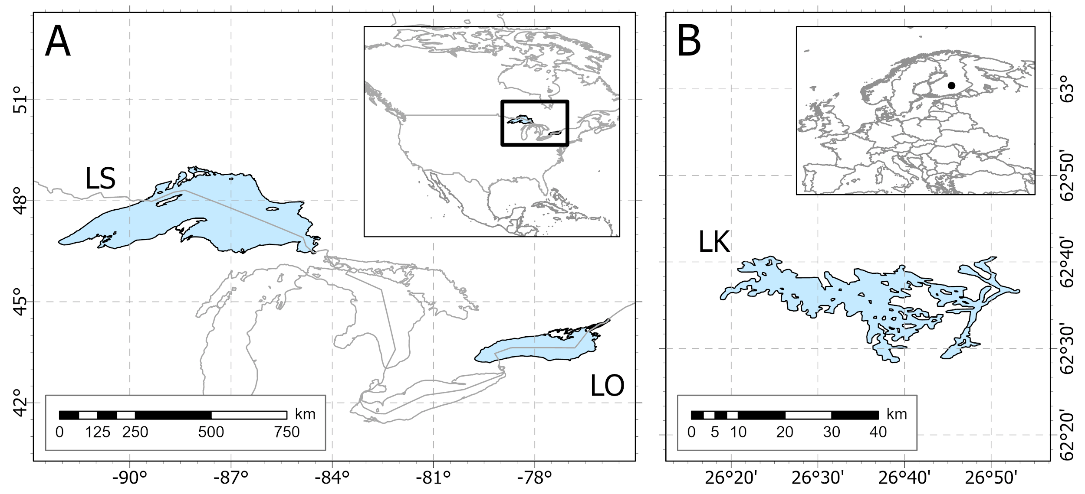

Figure X. Map showing the location of each lake (LS = Lake Superior; LO = Lake Ontario; LK = Lake Konnevesi) sampled in North America (A) and Europe (B).

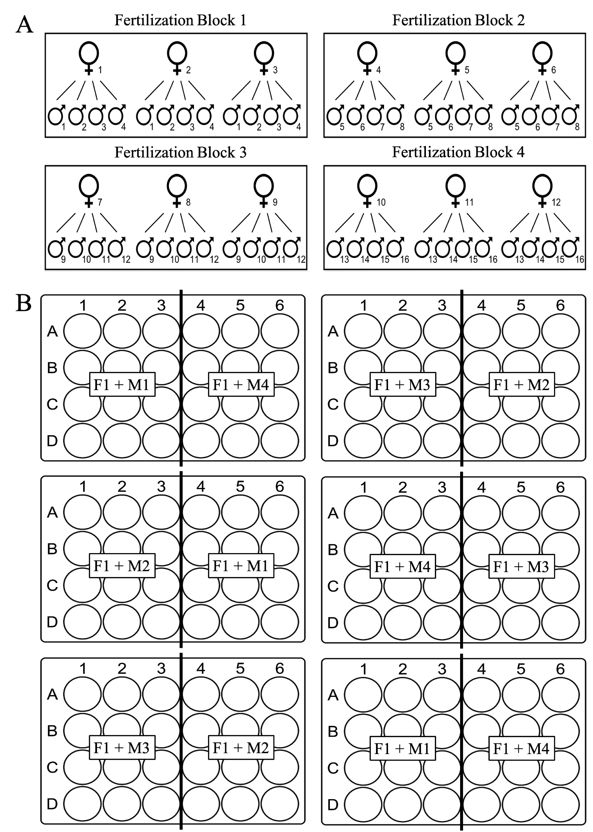

Figure X. Crossbreeding design (A) and a theoretical division of families from a single female into microplates (B) when the number of offspring equals 36.