Influence of warming temperatures on coregonine embryogenesis within and among species

Taylor R. Stewart1,5, Mikko Mäkinen2, Chloé Goulon3, Jean Guillard3, Timo J. Marjomäki2, Emilien Lasne4, Juha Karjalainen2, and Jason D. Stockwell5

1Department of Biology, University of Vermont, Burlington, Vermont, USA

2University of Jyväskylä, Jyväskylä, Finland

3University Savoie Mont Blanc, INRAE, CARRTEL, Thonon-les-Bains, France

4UMR ESE Agrocampus Ouest-INRAE, Rennes, France

5Rubenstein Ecosystem Science Laboratory, University of Vermont, Burlington, Vermont, USA

# ABSTRACT:

Will write after feedback.

# INTRODUCTION:

Freshwater lakes are one of the most sensitive ecosystems to climate change (Jenny et al. 2020, Woolway et al. 2020). One of the greatest threats of climate change to lakes is the unprecedented rise of water temperatures on a global scale (Austin and Colman 2007, O’Reilly et al. 2015, Woolway et al. 2017), although the rise is not projected to be consistent across regions, seasons, or lake types (O’Reilly et al. 2015, McCullough et al. 2019). The greatest seasonal increase in water temperature of seasonally ice-covered lakes is projected to take place during the spring (Schindler et al. 1990, Winslow et al. 2017), and the greatest seasonal increase in air temperature is expected during winter in northern Europe and North America (Christensen et al. 2007).

Warming spring water temperatures and increases in the length of the frost-free season can prolong annual growing seasons with warmer summers, longer and warmer autumns, and shorter ice-cover duration (Meehl et al. 2007). Temperature is an abiotic master factor for aquatic ecosystems because water temperature directly affects the physical and chemical properties of water, and phenological and reproductive events, metabolic rates, growth, and survival of aquatic organisms (Brett 1979, Gillooly et al. 2002, Brown et al. 2004, Ohlberger et al. 2007, Busch et al. 2012, Little et al. 2020). Although the broader impacts of climate-derived changes in lake dynamics remain unclear (Shatwell et al. 2019), the responses of many lake organisms are projected to be inadequate to counter the speed and magnitude of climate change, leaving some species vulnerable to decline and extinction (Hoffmann and Sgrò 2011). These pressures present challenges for biodiversity conservation and sustainability of ecosystem services. To navigate challenges, a foundational understanding of the primary threats to aquatic ecosystems and organisms across a range of spatial scales from local to global is needed (Vörösmarty et al. 2010, Halpern et al. 2015, Langhans et al. 2019).

The effects of increasing temperature on lake fishes are predicted to lead to declines in cold-water species and increases in warm-water species (Comte et al. 2013, Hansen et al. 2017). Species that possess narrow optimal thermal ranges, live near their thermal limits, or have long development times at cold temperatures are at-risk under warming climate scenarios as temperature can have strong direct and indirect effects at early-life stages (Blaxter 1991, Pepin 1991, Ficke et al. 2007, Mari et al. 2016, Lim et al. 2017, Dahlke et al. 2020). Unlike their marine counterparts, most freshwater fishes are restricted to lake systems, where their ability to evade the effects of climate change is impeded due to the isolated nature of lakes (Ficke et al. 2007) and limited swimming capacity during early-life stages (Herbing 2002, Downie et al. 2020). Fundamental questions for eco-evolutionary and conservation biologists in a global change context include how lake fishes will respond to rising water temperatures and what adaptive mechanisms may be involved (Hairston et al. 2005, Kinnison and Hairston 2007, Pelletier et al. 2009). Shifts in physiology of lake fish populations living close to their upper thermal limits will be required if species are to persist under increasingly stressful thermal conditions (Woolsey et al. 2015, Howells et al. 2016).

Freshwater whitefishes, Salmonidae Coregoninae (hereafter coregonines), are of great socio-economic value (Nyberg et al. 2001, Ebener et al. 2008b, 2008a, Vonlanthen et al. 2009, 2012, Lynch et al. 2015, 2016), and are also considered to be critically sensitive to the effects of climate change because they are cold, stenothermic fishes (Stockwell et al. 2009, Elliott and Bell 2011, Jeppesen et al. 2012, Isaak 2014, Jonsson and Jonsson 2014, Karjalainen et al. 2015, 2016a). Coregonine fisheries worldwide have experienced population declines due to highly variable and weak year-class strengths (Nyberg et al. 2001, Vonlanthen et al. 2012, Anneville et al. 2015, Myers et al. 2015). In the 20th century, causes of decline included fishing and stocking practices (Anneville et al. 2015) and eutrophication causing poor incubation conditions (Müller 1992, Vonlanthen et al. 2012). Today, the trophic state of lakes and fisheries management practices are improving, but coregonines continue to be the focus of reintroduction, restoration, and conservation efforts in many lakes (Favé and Turgeon 2008, Zimmerman and Krueger 2009, Bronte et al. 2017). Reasons for declining recruitment are unknown, but climate change, increasing water temperatures, and habitat degradation are hypothesized as causal factors (Nyberg et al. 2001, Marjomäki et al. 2004, Jeppesen et al. 2012, Anneville et al. 2015, Karjalainen et al. 2015, 2016a).

Coregonines generally spawn during late-autumn, embryos incubate over winter, and hatch in late-spring (Karjalainen et al. 2000, Stockwell et al. 2009). The time between fertilization and hatching is inversely related to water temperature (Colby and Brooke 1970, 1973, Luczynski and Kirklewska 1984, Pauly and Pullin 1988, Karjalainen et al. 2016a). Rising spring water temperatures trigger hatching in autumn-spawned coregonine embryos (Häkkinen et al. 2002, Urpanen et al. 2005, Karjalainen et al. 2015). The length of the newly-hatched larvae is negatively correlated with the temperature of incubation (Colby and Brooke 1970, 1973, Luczynski et al. 1984, Karjalainen et al. 2015). The long period between spawning and hatching exposes coregonines to a variety of thermal conditions, potentially resulting in a wide range of environmentally-induced phenotypes or plastic responses (Karjalainen et al. 2015, 2016a, 2016b). Some coregonines (*e.g.,* vendace *Coregonus albula* and European whitefish *C. lavaretus*) have demonstrated the ability to respond to winter temperature changes within the limits of phenotypic plasticity and through genetic adaptive changes, such as different embryo developmental rates under short and long winter conditions (Karjalainen et al. 2015, 2016a).

Geographic variation is also important to consider with phenotypic plasticity. Many fishes in high-latitudes are adapted to relatively colder waters, extensive periods of ice cover, and strong seasonal daylight variations (Reist et al. 2006). Thus, in high-latitude environments, populations can show differential long-term adaptation to climates across a latitudinal gradient (Conover and Present 1990, Yamahira and Conover 2002, Chavarie et al. 2010, Wilder et al. 2020). For example, a number of fishes have demonstrated an inverse relationship between length of the growing season and reproductive characteristics (*i.e.,* countergradient variation; Conover and Present 1990, Conover and Schultz 1995, Schultz et al. 1996, 1998, Billerbeck et al. 2000, Jonassen 2000, Yamahira and Conover 2002, Chavarie et al. 2010). Fishes at high latitudes experience lower temperatures overall and shorter growing seasons and should exhibit lower standard metabolic rates, growth rates, and smaller size-at-age than individuals at low latitudes (Reist et al. 2006, White et al. 2011). However, for cold-water stenothermic fishes, water temperatures at low latitudes may exceed their optimal range for significant portions of the growing season, or the amount of optimal thermal habitat narrow, while water temperatures at high latitudes may remain near the optimum for maximal growth efficiency throughout the growing season (Conover and Schultz 1995). Because water temperature has a great influence on fish physiology and can vary across latitudes, a wide range of responses by populations to increasing temperatures across latitudes is possible (Reist et al. 2006). Coregonines occur broadly across northern latitudes and are an ideal group to test how cold-water fishes may adapt to climate-driven shifts in environmental variables, such as water temperature. Large-scale experimental studies may aid in understanding the adaptive thermal capacity of fishes from different latitudes and what level of adaptive response is needed to mitigate the effects of changing local environments (Hoffmann and Sgrò 2011).

Our objective was to experimentally analyze the response of early-life stage coregonines, within conspecifics across lake systems, between congeners within the same lake system, and among congeners across all lake systems, to a thermal gradient using an incubation method that enables global comparisons. We hypothesized that coregonines would have differential levels of phenotypic plasticity in life-history and morphological traits of embryos in response to warming winter incubation conditions based on putative adaptation to their local environments. We predicted coregonines that share the same thermal environment respond similarly and geographically distinct groups with different thermal environments respond dissimilarly to increasing incubation temperatures.

# METHODS:

## Study Species and Locations

We used a cross-lake, cross-continent, cross-species approach to evaluate the responses and thermal tolerances of coregonine embryos to changing thermal regimes. Wild-caught populations of cisco (*C. artedi*) in Lake Superior (LS-Cisco; USA/Canada) and Lake Ontario (LO-Cisco; USA/Canada), and vendace (LK-Vendace) and European whitefish (LK-Whitefish) in Lake Southern Konnevesi (Finland; Figure 1) were sampled.

Cisco is one of the most widespread of the North American species of coregonines (Eshenroder et al. 2016) and were one of the most abundant fish in the Great Lakes (Yule et al. 2013). Cisco is found in north-central to eastern United States and throughout most of Canada, with the lower Great Lakes close to its southernmost extent (Scott and Crossman 1973). Cisco spawning is initiated when water temperatures decrease to 4-5°C in late Autumn (Pritchard 1931, Eshenroder et al. 2016) and occurs at different spawning depths. Spawning can occur at depths ranging from 1-5 m in Lake Ontario (Pritchard 1931, Paufve 2019) and 10-64 m in Lake Superior (Dryer and Beil 1964, Paufve 2019). Experimental thermal optima for normal cisco embryo development is between 2 and 8°C (Colby and Brooke 1970, Brooke and Colby 1980). However, temperature data at historical spawning grounds indicate that *in-situ* incubations typically occur between 1 and 4°C, with Lake Ontario warmer than Lake Superior (Figure 2; unpublished data).

Vendace and European whitefish are widely distributed in Northern Europe (Sipponen et al. 2006). Vendace spawning is initiated when water temperatures decrease to 6°C at the end of October in Lake Southern Konnevesi and lasts 2-3 weeks (Karjalainen & Marjomäki 2018). European whitefish spawn 2-3 weeks later in November when water temperatures decrease to 4-5°C (Karjalainen et al. 2015). Spawning of vendace occurs in the littoral and sublittoral zone of lakes and eggs dispersed widely at depths less than 20 m (Heikkilä et al. 2006, Karjalainen et al. 2021). Whitefish are known to spawn at shallower depths than vendace. Embryos are incubated at 1-2°C until the beginning of April, when water temperatures have gradually increased, and hatching peaks after ice-out at 4-6°C (Figure 2, Karjalainen et al. 2015). Although whitefish spawn later than vendace, their hatching occurs at the same time or slightly earlier than vendace (Karjalainen et al. 2015).

## Adult Collections

Adults were sampled using multi-mesh gillnets in Lake Superior, trap nets in Lake Ontario, and seines (vendace) and multi-mesh gillnets (European whitefish) in Lake Southern Konnevesi. Adult field collections occurred during coregonine spawning periods for Lake Ontario and Lake Superior. On Lake Southern Konnevesi, adults were collected prior to spawning and held in aquaculture pools with water fed directly from the lake until spawning was initiated. All sampling, fertilization, and experimental work for study groups on each continent were conducted at a single laboratory in North America (University of Vermont (UVM), USA) and Europe (University of Jyväskylä (JYU), Finland). Experiments were performed during the 2018-19 season in Finland and the 2019-20 season in the USA.

For clarity, our operational use of a study group is to represent a single species within a single lake (*e.g.,* cisco in Lake Superior).

## Crossing Design and Fertilization

Eggs and milt were stripped from 12 females and 16 males from each study group and artificially fertilized under a blocked, nested full-sib, half-sib fertilization design to create a maximum of 48 full-sibling families nested within half-siblings per group. The crossing design maximized the amount of genetic variation and minimized the potential loss of multiple families if a female or male produced poor quality gametes, for a given total number of families, compared to a full-factorial design. Adults used in the experiment were divided into three or four fertilization blocks. A single block consisted of four males each paired to three unrelated females, where all offspring of a given female were full siblings. Fertilizations were performed block by block to ensure germ cell survival.

Approximately 200 eggs per female were fertilized with an equal amount of milt (5-15 μl) from each male in the block. After the addition of milt, water was added to activate the germ cells and gently mixed for one minute. The embryos were rinsed with water 2-3 times until the water was clear. Temperature of the water used during all fertilizations was ca. 4°C. Reconstructed fresh water was used during fertilizations (OECD ISO 6341:2012) to standardize the chemical properties of the water used among study groups and between labs. Embryos were transported in coolers either by shipping overnight for Lake Superior or driven same-day for Lake Ontario. A temperature logger recorded air temperature inside the cooler during transport (Lake Superior: mean (SD) = 2.80°C (0.21); Lake Ontario: mean (SD) = 3.28°C (0.37)). No embryo transport was required for Lake Southern Konnevesi. Demographic data (*e.g.,* total length, mass, and egg diameter) were collected on adults. Fertilization success was determined by haphazardly taking 10 embryos from each family and assessing under microscopy within 72-hours post-fertilization (Oberlercher and Wanzenböck 2016). If fertilization was low (<30%), the family was removed from the experimental setup.

## Rearing Conditions

Embryos from successfully fertilized families were individually distributed into 24-well cell culture microplates and incubated in 2 ml of reconstructed fresh water (OECD ISO 6341:2012). Reconstructed fresh water was used during incubation to maintain sterility, prevent bacterial growth in the wells, and eliminate the need for fungicide treatments on the embryos. A total of 36 embryos per family were used for Lake Southern Konnevesi species and 48 embryos per family for each of Lake Ontario and Lake Superior cisco. Families were randomly distributed across three or four microplates (*i.e.,* 12 eggs per family per microplate and two families per 24-well microplate). Microplates from each study group were incubated at target constant temperatures of 2.0 (coldest), 4.5 (cold), 7.0 (warm), and 9.0°C (warmest) and randomly placed in climate-controlled chambers at UVM (Memmert® IPP260Plus) and climate-controlled rooms at JYU (Huurre®). Experimental incubation temperature treatments were chosen to mimic *in-situ* mean temperatures and to exceed optimum embryonic development temperatures. Forced airflow was used in both the climate-controlled chambers and rooms to ensure equal air circulation around the microplates. All microplates were covered to minimize evaporation. Microplate orientation and position were rotated weekly to eliminate any temperature heterogeneity within the chambers and rooms. Water temperatures were recorded hourly with loggers (HOBO® Water Temperature Pro v2 at UVM and Escort iMini at JYU) and daily mean water temperatures calculated. Incubations took place in the dark, with the exception of short (< 60 mins) maintenance periods. Microplates were checked weekly for dead eggs and the eye-up stage. During the hatch period, microplates were checked on a two-day cycle for newly hatched larvae. For cisco, all newly hatched larvae were photographed for life-history and morphological traits (Nikon® D5600 and Nikon® AF-S DX 18-55mm lens). Egg size, total length, and yolk-sac axes were measured from images using Olympus® LCmicro. For Lake Southern Konnevesi, the larvae were preserved in ethanol at hatch and flushed and soak in distilled water for 15 min before measuring the total length and fresh mass under the microscope (Karjalainen 1992).

Mean water temperature during incubations was maintained near the target incubation temperature for the cold and warm treatments at each lab. Mean incubation water temperatures for the cold and warmest treatments were lower than the target incubation temperature at JYU, but not at UVM (Table 1).

## Life-History and Morphological Traits

Embryo survival was estimated as the percent of embryos surviving between the eye-up and hatch stages to rule out unfertilized eggs which can bias mortality estimates. Incubation period was assessed by two variables: the number of days from fertilization to hatching (days post-fertilization; DPF) and the sum of the degree-days (accumulated degree-days; ADD). Total length-at-hatch (mm) and yolk-sac volume (YSV; mm3) were measured from five individuals per family at, or as close as possible to, 50% hatching for each family. Yolk-sac volume was calculated assuming the shape of an ellipse (Blaxter 1963):

where a = length of the yolk sac (mm) and b = height of the yolk sac (mm).

## Statistical Analyses and Estimation of Variance Components

Embryo survival was analyzed as a binomial response variable, and incubation period, length-at-hatch, and yolk-sac volume at hatching as continuous response variables. Early embryo mortality and variable fertilization success induced from fertilization failure produced inequalities in the number of offspring among families and an unbalanced design. The sample size for incubation period is a function of embryo survival and subsequently resulted in an unbalanced design. All non-proportional data were checked visually for approximate normality using histograms and Q-Q plots before the analysis with parametric models. A cubic transformation was applied to LAH for cisco and a cubic root transformation was applied to DPF, ADD, and YSV to normalize the distributions. Therefore, binary data (*i.e.,* embryo survival) were analyzed with binomial generalized linear mixed-effects models (LMM) and variables with distributions not strongly deviating from normal (*i.e.,* incubation period, length-at-hatch, and yolk-sac volume) were analyzed with restricted maximum likelihood LMMs with the *lme4* package (Bates et al. 2015). To eliminate any confounding effects between continents, conspecific ciscos were analyzed independently from congeners in Lake Southern Konnevesi, resulting in two models: Great Lakes (Lake Superior and Lake Ontario) cisco and Lake Southern Konnevesi vendace and European whitefish. Population (for cisco only), species (for Lake Southern Konnevesi only), and incubation temperature were included as fixed effects and female, male, family (female and male combination), and fertilization block as random effects. Because embryos were raised independently, the replication unit in the statistical models is the individual embryo. All traits were examined for population or species, depending on the continent, and incubation temperature effects in addition to individual parental effects (female, male, and family effects), fertilization block, and all possible interactions with backward, stepwise effect-selection using the *buildmer* package (Voeten 2020). The maximal model for each trait was selected by comparing a model including or lacking the term of interest to the reference model based on changes in log-likelihood, Akaike information criterion, Bayesian information criterion, and change in explained deviance. The mixed-effects model output does not produce significance values for model effects; therefore, significance for population, species, incubation temperature, interaction effects, and any random-effects selected were determined using a likelihood ratio test between the maximal model and reduced models with the model effect of interest removed.

To allow for interspecific comparisons, the response to temperature for each trait was standardized to the optimal temperature for each study group. Based on literature data (cf. above), the coldest incubation temperature treatment (2.0°C and 2.2°C; Table 1) was assumed to be the optimal incubation temperature. For each trait, the within-family mean was calculated for each temperature treatment and the percent change from the optimal temperature estimated. Standard error was calculated as the among-family variation in percent change.

The phenotypic variance components were partitioned into random effects for female, male, female x male, and random residual variance components using mixed-effects models with the *fullfact* package (Houde and Pitcher 2019) for each study group and incubation temperature treatment. Negative variance components were treated as zero (Neff and Pitcher 2005). The percent of total phenotypic variation was used to calculate the Pearson correlation coefficient between each variance component and the increase in incubation temperature for each study group. A threshold of ±0.7 was used to categorize correlations either positive and negative, with all values in between as no correlation. European whitefish from Lake Southern Konnevesi were removed from this analysis due to a low embryo survival and a low number of families.

All analyses were performed in R version 4.0.3 (R Core Team 2020).

# RESULTS:

## Spawning Adults

Total lengths and fresh mass of spawning adults used for gamete collection varied widely among study groups (Table 2). LK-Vendace were notably smaller than all other study groups. The remaining study groups varied less in size, but LK-Whitefish were smaller than LS-Cisco and LO-Cisco.

The LK-Vendace females had the smallest egg diameters and LO-Cisco females had the largest egg diameters among the study groups (Table 3). LK-Whitefish and LS-Cisco egg diameters were similar (Table 3).

## Life-History and Morphological Traits and Variance Components

All cisco traits had significant interaction effects between population and incubation temperature (maximum *P* < 0.001; Tables 4 and 5). All vendace and European whitefish traits had significant interaction effects between species and incubation temperature (maximum *P* = 0.002; Tables 4 and 5). The interaction effects precluded any interpretation of main effects, but did suggest contrasting norms of reaction for the model groups. Below we describe the interaction effects. All random effects (*i.e.,* female, male, and female x male) were significant (maximum *P* = 0.038) except male for LAH and female x male for LAH and YSV in cisco (Tables 4 and 5). All statistical model results can be found in Tables 4 and 5.

### *Embryo Survival*

Embryo survival was highest among all study groups at the coldest temperature and lowest at the warmest temperature (Figure 3). The effect of temperature for cisco depended on population because embryo survival was higher for LO-Cisco (99.3%) than LS-Cisco (80.0%) at the coldest temperature but not different between populations (<0.1%) at the warmest temperature (Figure 3). For Lake Southern Konnevesi, the effect of temperature depended on species because the difference in embryo survival between LK-Vendace and LK-Whitefish was less pronounced at the coldest temperature (29.0%) than at the warmest temperature (50.5%; Figure 3). LK-Vendace and LK-Whitefish embryo survival had a differential temperature response as LK-Whitefish had a greater decrease (74.4%) than LK-Vendace (17.7%) from the coldest to warmest incubation temperatures. LK-Whitefish had the strongest, decreasing response to increasing incubation temperatures compared to all other study groups (Figure 3).

In the phenotypic variance component analysis, the residual error was the largest component of phenotypic variation in embryo survival (means >55.2%) for all study groups (Figure 4, SI Table 1). The mean female variance had the highest percentage, excluding error, of the phenotypic variation in embryo survival for LK-Vendace (17.4%), LS-Cisco (24.1%), and LO-Cisco (19.9%; Figure 4, SI Table 1). The female variance component correlations for embryo survival had either negative or no correlations to increasing temperature; however, male and error variances had positive and no correlations suggesting that as the female component decreases at higher temperatures the importance of the male component and error increases (Table 6).

### *Incubation Period (days post-fertilization)*

The number of days post-fertilization to hatching was highest for all study groups at the coldest temperature and decreased as temperature increased (Figure 3). For cisco, DPF was higher for LO-Cisco (179.2 days) than LS-Cisco (154.3 days) at the coldest temperature and the difference between populations was less pronounced at the warmest temperature (5.0 days; Figure 3).

For Lake Southern Konnevesi, the effect of temperature depended on species because the difference in DPF between LK-Vendace and LK-Whitefish was less pronounced at the coldest temperature (8.9 days) than at warmest temperature (27.3 days; Figure 3). All study groups had similar responses to temperature, with between 54.2 to 68.3% decreases in DPF from the coldest to warmest treatments. However, LS-Cisco, LO-Cisco, and LK-Whitefish had a greater decrease in DPF (66.1, 68.3, 65.3%, respectively), than LK-Vendace (54.2%; Figure 3).

In the phenotypic variance component analysis, the residual error was the largest component of phenotypic variation in DPF (means >60.8%) for LK-Vendace and LS-Cisco (Figure 4, SI Table 1). The mean female variance was the largest phenotypic variation component in DPF for LO-Cisco (47.1%). LK-Vendace and LS-Cisco had similar mean female variances for DPF across all temperatures, with 28.1 and 21.0%, respectively (Figure 4, SI Table 1). The DPF correlations for female effect had a negative response to temperature for LS-Cisco and LO-Cisco (Table 6).

### *Incubation Period (accumulated degree-days)*

Accumulated degree-days were highest for all study groups at 6.9°C (Figure 3). The effect of temperature for cisco depended on population because ADD was higher for LO-Cisco (531.9 and 547.7 ADD) than LS-Cisco (461.0 and 492.5 ADD) at the cold and warm temperatures, respectively, and the differences between populations were less pronounced at the coldest and warmest temperatures (49.2 and 41.3 ADD, respectively; Figure 3). LS-Cisco and LO-Cisco ADD responded similarly to increasing incubation temperature. For Lake Southern Konnevesi, the effect of temperature depended on species because the difference in ADD between LK-Vendace and LK-Whitefish was less pronounced at the coldest temperature (7.7 ADD) than at the warm temperature (198.1 ADD; Figure 3). LK-Vendace and LK-Whitefish ADD had a differential temperature response as LK-Vendace had a greater increase (198.4%) than LK-Whitefish (159.4%) from the coldest to warm treatment. LK-Vendace had the strongest, increasing response to increasing incubation temperatures compared to all other study groups (Figure 3).

In the phenotypic variance component analysis and correlations, ADD had a similar response as DPF among all study groups as the data only had a different temperature scaling factor (Figure 4, SI Table 1, Table 6).

### *Length-at-Hatch*

All study groups had a common, decreasing response in LAH as temperature increased (Figure 5). For cisco, LAH was higher for LO-Cisco (11.32 and 9.75 mm) than LS-Cisco (10.21 and 8.68 mm) at the coldest and warmest temperatures, respectively, and the difference between populations was less pronounced at the cold and warm temperatures (0.99 and 0.90 mm, respectively; Figure 5). LS-Cisco and LO-Cisco responded to increasing incubation temperature with a 15.9 and 13.8% respective decrease in LAH from the coldest to warmest treatments. For Lake Southern Konnevesi, the effect of temperature depended on species because the difference in LAH between LK-Vendace and LK-Whitefish was more pronounced at the cold and warm temperatures (2.73 and 2.72 mm, respectively) than at the coldest and warmest temperatures (2.68 and 2.61 mm, respectively; Figure 5). LK-Vendace and LK-Whitefish each responded similarly to temperature with a 9.0 and 9.2% respective decrease in LAH from the coldest to warmest treatments. LS-Cisco and LO-Cisco LAH had a stronger, decreasing response to increasing incubation temperatures than LK-Vendace and LK-Whitefish (Figure 5).

In the phenotypic variance component analysis, the residual error was the largest component of phenotypic variation in LAH (means >49.2%) for all study groups (Figure 4, SI Table 2). The mean female variance had the highest percentage, excluding error, of the phenotypic variation in LAH for LK-Vendace (40.6%), LS-Cisco (38.2%), and LO-Cisco (17.1%; Figure 4, SI Table 2). The LAH correlations for each study group had a similar response to temperature with negative or no female and male correlations and positive or no female x male correlations (Table 6).

### *Yolk-sac Volume*

Yolk-sac volume was highest for all study groups at 9.0°C and decreased as temperature decreased (Figure 5). For cisco, the difference in YSV was similar between populations at the warmest incubation temperature (0.04 mm3) but diverged as incubation temperature decreased; YSV in LO-Cisco (0.40 mm3) was smaller than LS-Cisco (0.64 mm3) at the coldest temperature (Figure 5). Yolk-sac volume in LS-Cisco and LO-Cisco responded differently to incubation temperature, with a 203.6 and 311.0% respective increase from the coldest to warmest treatment. For Lake Southern Konnevesi, the effect of temperature depended on species because the difference in YSV between LK-Vendace and LK-Whitefish was less pronounced at the coldest temperature (0.20 mm3) than at the warmest temperature (1.07 mm3; Figure 5). LK-Vendace and LK-Whitefish had the strongest response to temperature with an increase in YSV of 445.0 and 536.6% from the coldest to warmest treatment, respectively. LK-Vendace and LK-Whitefish had a stronger, increasing response to increasing incubation temperatures in YSV than LS-Cisco and LO-Cisco (Figure 5).

In the phenotypic variance component analysis, the residual error was the largest component of phenotypic variation in YSV (means >53.9%) for all study groups (Figure 4, SI Table 2). The mean YSV female variance was the highest percentage, excluding error, of the phenotypic variation for LK-Vendace (23.9%), LS-Cisco (20.5%), and LO-Cisco (23.9%; Figure 4, SI Table 2). The YSV correlations for female, female x male, and error variance components had differential responses to temperature with positive female, positive female x male, and negative error correlations for LK-Vendace, while LS-Ciso had inverse correlations to LK-Vendace (Table 6). All LO-Cisco variance components had no correlation to temperature (Table 6).

# DISCUSSION:

Our incubation experiments demonstrated both similar and contrasting reaction norms to temperature for life-history and morphological traits in conspecific and congeneric coregonines. First, we found contrasting responses to temperature in embryo survival within and among study groups (*i.e.,* conspecifics and congeners). Second, incubation periods (both DPF and ADD) responded similarly to increasing temperature (negative response for DPF and positive response for ADD) among study groups, however, LK-Vendace had the strongest response and longest incubations across all temperatures. Third, all study groups had similar negative responses to temperature for LAH and positive responses in YSV, with the strongest responses for LAH in LS-Cisco and LO-Cisco and for YSV in LK-Vendace and LK-Whitefish. Lastly, differential levels of parental effects were found within and among study groups and traits.

Embryo survival had an overall negative correlation with increasing temperature among all study groups. However, populations of ciscos and congeneric species from the same lake (*i.e.,* vendace and European whitefish) had contrasting levels of response to temperature. LK-Whitefish embryo survival had the strongest, negative response to temperature (74.4% survival loss) and all other study groups were impacted less (< 26% survival loss) by increasing temperatures. The contrasting levels of response in embryo survival to increased incubation temperatures among study groups was surprising because temperature is known to be the main force determining coregonine embryo development (Karjalainen et al. 2015) and survival (Colby and Brooke 1970, Brooke and Colby 1980, Luczynski and Kirklewska 1984). If temperature was a dominant factor for embryo survival, we would have expected similar responses among all study groups. Additionally, our experiment, temperature aside, provided near-optimal incubation conditions to individually reared embryos and these conditions are idealized compared to what occurs in the wild. For instance, embryos in the wild are deposited on the substratum and are exposed to deposited sediment that can impact survival (Müller 1992). Interaction between temperature and sediments are likely, and temperature increases may act as a catalyzer of embryo sensitivity to sediment stress (Mari et al. 2016, Mari et al. 2021). Even though temperature did negatively impact embryo survival in our experiment, the effect of temperature in the wild could be even stronger.

Our result that incubation periods from LK-Vendace and LK-Whitefish were longer and had a strong response to increasing temperatures, even at the warmest incubation temperatures, supports previous knowledge that vendace and European whitefish from Lake Southern Konnevesi have a high degree of developmental flexibility (Karjalainen et al. 2015). The contrasting response between vendace and European whitefish was likely due to species differences (Karjalainen et al. 2015) and ecotypes (*i.e.,* benthic versus pelagic; Mcphee et al. 2012). Additionally, the different magnitude of temperature responses among all congeners suggests a differential level of developmental plasticity to increasing incubation temperatures among species and locations. Long, relatively cold incubations may require a shorter period of spring warming for individuals to initiate hatching, while short, relatively warm incubations may require a longer period of warmer spring conditions to hatch (Karjalainen et al. 2015). If winter water temperatures rise as embryos incubate, the ability to match optimal spring nursery conditions may be weakened (Cushing 1990, Karjalainen et al. 2015, Myers et al. 2015). Populations that are more resilient to increasing or variable winter incubation temperatures may have a better opportunity to regulate ontogeny and control the time of hatching.

Fish spawning strategies are variable, ranging in frequency from daily to once in a lifetime and in timing from the same time each year to across all seasons (McBride et al. 2015). For many species, spawning strategies and breeding patterns are constrained by the adult body condition, gonadogenesis, and the environment (Jørgensen et al. 2006, van Damme et al. 2009, Muir et al. 2014, McBride et al. 2015). In this context, the short duration of cisco embryo incubation periods when exposed to high temperatures was notable. High-latitude populations typically spawn earlier in autumn and may have the opportunity to shift timing of reproduction later into the season, while still providing an adequate incubation period for embryo development, if water temperatures continue to rise as a result of climate change. However, low-latitude coregonine populations already spawn in late-autumn and early-winter (Stockwell et al. 2009, Eshenroder et al. 2016), which begs the question: do low-latitude populations have capacity to spawn later in the winter if temperatures continue to rise? Winter spawning may lead to less vulnerability to contemporary climate change. For instance, Atlantic herring (*Clupea harengus*) have both autumn- and winter-spawning stocks in the North Sea that share the same summer feeding grounds and start oocyte development at the same time (van Damme et al. 2009). Similarly, coregonines can exhibit contrasting spawning strategies.

Sympatric coregonine species with autumn, winter, and spring-spawning stocks co-occur in several northern- and central-Eurasian lakes (Eronen and Lahti 1988, Schulz and Freyhof 2003, Schulz et al. 2006, Ohlberger et al. 2008) and allopatric spring-spawning stocks of cisco are found in Lac des Écorces (southwestern Quebec; Pariseau et al. 1983, Hénault and Fortin 1989, 1991). Winter and spring spawners continue oocyte development through autumn which results in a lower number of larger eggs compared to the autumn-spawning stocks (Eronen and Lahti 1988, Hénault and Fortin 1991). Oocyte development is driven by body energy content, and winter- and spring-spawning stocks may give iteroparous females the chance to mitigate the disproportionate energy demand toward somatic growth during the summer when metabolic demands are higher. Consequently, changes in the environment and the condition of an individual spawning adult could affect future coregonine spawning strategies. Our results suggest that the cisco embryos examined may not have the developmental plasticity to mitigate the effects of increased water temperatures during incubation. In this context, adjusting the time of spawning may be a more efficient long-term life-history strategy than the embryos adapting to increased temperatures. However, further work is needed to evaluate the reproductive plasticity of coregonine adults in the face of climate change.

Lake morphology is also important to consider for the question of a winter- or spring-spawning adaptation; deeper lakes could sufficiently provide cold thermal refuges at greater depths if suitable spawning habitat is available. Spring-spawning ciscos in Lac des Écorces, where a 4°C summer stratum does not exist, initiate spawning when spring water temperatures reach 6°C at depths ranging from 20-30 m (Hénault 1986, Hénault and Fortin 1989, 1991). This strategy of spawning in deeper, colder water allows for normal embryogenesis throughout the summer to mitigate high water temperatures during the summer period at shallow depths. Model projections of suitable thermal and oxythermal habitat for cisco indicate deeper and less eutrophic lakes will likely provide the best cold-water habitat as water temperatures and land uses change (Jacobson et al. 2010, Herb et al. 2014, Schmitt et al. 2020). While deep lakes may possess acceptable thermal refugia for coregonines, access to and requirements for suitable spawning and incubation habitat is unknown for most populations.

In addition to lower survival and shorter incubations as temperature increases, we also found both similar and contrasting responses to temperature in morphological traits (*i.e.,* length-at-hatch and yolk-sac volume) among study groups. The contrast in morphological traits among study groups and locations is likely related to different egg sizes at fertilization. Smaller eggs will produce smaller larvae, requiring a lower growth and development rate and less demand on maternal yolk than larger eggs. The demand for yolk and egg size are positively related and temperature during embryogenesis is positively related to metabolic rate (Hodson and Blunt 1986, Kamler 2008). The steady decline in YSV for LK-Vendace and LK-Whitefish as incubation temperatures decreased, but less variability in LAH across temperatures, suggests a high efficiency to convert yolk into somatic tissues across all temperatures where maximal LAH is constrained by egg size. In contrast, both cisco populations had a steady decline in YSV and increase in LAH as incubation temperatures decreased, suggesting a low yolk conversion efficiency at warmer temperatures. All study groups had a decrease in YSV with time as basal metabolism consumed yolk as a function of the length of incubation. Regardless of the mode, our results suggest a synergistic relationship among species, location, egg size, incubation period, and incubation temperature in determining the phenotype of LAH and YSV.

The trade-off between LAH and YSV is well documented in larval fish physiology (Blaxter 1991). Climate change impacts may only exacerbate the importance of each morphological trait in determining either a match or mismatch between larval coregonines and their zooplankton prey. Using winter water temperatures collected from Lake Superior, we can show the theoretical interactions among water temperature, spawning period, incubation period, LAH, and YSV supported by our results (Figure 6). If spawning does shift to a later period from rising water temperatures, we would expect the size of eggs to increase and the fecundity of females to decrease from environmentally-induced stress on gametogenesis (Figure 6). While our experiments used constant incubation temperatures due to logistical constraints, the impact different spring warming rates can have on the time of hatching and the size of larvae should not be ignored. Lake Southern Konnevesi vendace and European whitefish previously exhibited flexibility in embryo development rates and feeding windows under different warming scenarios (Karjalainen et al. 2015). Such complex responses challenges our ability to predict the downstream impacts changing autumn, winter, and spring water temperatures may have on embryo and larval phenotypic plasticity.

Traits of embryos depend not only on species, population, and incubation temperature but also on parental and transgenerational effects (Blaxter 1963, 1991, Kekäläinen et al. 2018). Our results suggest that both female and male effects control a portion of early-stage offspring trait phenotypes in coregonines. The variability in phenotypes induced by parental effects can provide more flexibility for a population to cope with changing inter-annual environmental conditions, prevent full year-class failure, and ensure population persistence (Wright and Trippel 2009, Oomen and Hutchings 2015, Karjalainen et al. 2016a). In fishes, the female effect is usually more pronounced than male and female x male interaction effects, and is stronger in traits directly related to egg size (Nagler et al. 2000, Kennedy et al. 2007, Huuskonen et al. 2011), and our results support this trend. Residual error estimates, however, remained high. Intersexual selection and mate pairing has been proposed as an important component affecting coregonine offspring fitness (Wedekind et al. 2008, Huuskonen et al. 2011, Karjalainen and Marjomäki 2018), and may play a role in conserving natural biodiversity within populations (Anneville et al. 2015). The long-term stability of commercially exploited stocks, which may experience fisheries-induced evolution, has been linked to population diversity (Schindler et al. 2010, Freshwater et al. 2019). Spawning stocks that comprise individuals of variable sizes and ages (*e.g.,* portfolio effect; Schindler et al. 2010) may contribute differently to spawning, offspring performance, and recruitment (Luck et al. 2003, Figge 2004), and is likely an important consideration as the rapid rate of climate change adds additional stressors on populations.

The methods used provide reproducible experimental conditions (*e.g.,* uniform water source between laboratories, no moving water, minimal embryo disturbance, etc.) and standardized results that can be compared to future experiments that examine temperature responses across a wider range of populations. Additionally, efforts to include more northerly populations of cisco from Canada were thwarted due to restrictions on transport of live embryos across an international border. This further highlights the importance of the standardized experimental methods we used to allow for future large-scale, cross-laboratory experiments. However, our results do suggest that some form of latitudinal variation is likely present and promote fruitful opportunities for future large-scale experimental research on coregonines and other cold, stenothermic fishes.

Additionally, interpreting the impacts of parental responses within an environmental context continues to be important to determine how parental effects may mitigate species’ responses to rapid climate change. The existence of varying parental responses raises questions concerning possible causal mechanisms. Genomic studies will be needed to better understand what is genetically impacted by increasing temperatures, how it is impacted, and when during development (*i.e.,* when is temperature most critical; Narum et al. 2013, Chen et al. 2018). A mechanistic understanding of thermal response from populations across latitudes will be essential to predict the vulnerability of species and populations to climate change. Additionally, it is also important to consider that stocking practices, including supportive breeding, may also affect the adaptive potential of populations through an artificial selection process (Ford 2002, Christie et al. 2011, Anneville et al. 2015) and their ability to respond to environmental changes.

Water temperature is fundamental in regulating fish physiology, and environmental variation during development can play a large role in generating variability in offspring through phenotypic plasticity (Little et al. 2020). How coregonines respond, during the critical embryonic stage, is important to determine whether the capacity to respond to climate change and the projected increases in their incubation temperatures exists. Knowing how populations have adapted historically to environmental variability will help us understand the range of possible responses to climate change and assist managers to keep coregonines out of hot water.

# ACKNOWLEDGMENTS:

We thank the staff at the Wisconsin Department of Natural Resources Bayfield Fisheries Field Station, United States Geological Survey (USGS) Tunison Laboratory of Aquatic Science, New York State Department of Environmental Conservation Cape Vincent Fisheries Station, and Konnevesi Research Station and local fishers for conducting field collections of spawning adults. We also thank Rachel Taylor, Mark Vinson, Dan Yule, Caroline Rosinski, Jonna Kuha, and Rosanna Sjövik for help with fertilizations and experiment maintenance. This work was funded by the USGS grant number G16AP00087 to the University of Vermont. We acknowledge INRAE, French National Research Institute for Agriculture, Food, and Environment, the UMR CARRTEL (INRAE - USMB), and the National Science Foundation (award number 1829451) for supporting a workshop to develop this experiment.

# LITERATURE CITED:

Adrian, R., C. M. O’Reilly, H. Zagarese, S. B. Baines, D. O. Hessen, W. Keller, D. M. Livingstone, R. Sommaruga, D. Straile, E. Van Donk, G. A. Weyhenmeyer, and M. Winder. 2009. Lakes as sentinels of climate change. Limnology and Oceanography 54:2283–2297.

Anneville, O., E. Lasne, J. Guillard, R. Eckmann, J. D. Stockwell, C. Gillet, and D. L. Yule. 2015. Impact of Fishing and Stocking Practices on Coregonid Diversity. Food and Nutrition Sciences 06:1045–1055.

Austin, J. A., and S. M. Colman. 2007. Lake Superior summer water temperatures are increasing more rapidly than regional temperatures: A positive ice-albedo feedback. Geophysical Research Letters 34:1–5.

Bates, D., M. Mächler, B. Bolker, and S. Walker. 2015. Fitting Linear Mixed-Effects Models Using lme4. Journal of Statistical Software; Vol 1, Issue 1 (2015).

Blaxter, J. H. S. 1963. The influence of egg size on herring larvae (Clupea harengus L). J. Cons. Int. Explor. Mer 28:211–240.

Blaxter, J. H. S. 1991. The effect of temperature on larval fishes. Netherlands Journal of Zoology 42:336–357.

Brett, J. R. 1979. Environmental factors and growth. Fish physiology, vol. VIII. Bioenergetics and growth:599–677.

Brooke, L. T., and P. J. Colby. 1980. Development and survival of embryos of lake herring at different constant oxygen concentrations and temperatures. The Progressive Fish-Culturist 42:3–9.

Brown, J. H., J. F. Gillooly, A. P. Allen, V. M. Savage, and G. B. West. 2004. Toward a metabolic theory of ecology. Ecology 85:1771–1789.

Busch, S., G. Kirillin, and T. Mehner. 2012. Plasticity in habitat use determines metabolic response of fish to global warming in stratified lakes. Oecologia 170:275–287.

Chavarie, L., J. B. Dempson, C. J. Schwarz, J. D. Reist, G. Power, and M. Power. 2010. Latitudinal variation in growth among Arctic charr in eastern North America: Evidence for countergradient variation? Hydrobiologia 650:161–177.

Christensen, J. H., B. Hewitson, A. Busuioc, A. Chen, X. Gao, R. Held, R. Jones, R. K. Kolli, W. K. Kwon, and R. Laprise. 2007. Regional climate projections. Pages 847–940 Climate Change, 2007: The Physical Science Basis. Contribution of Working group I to the Fourth Assessment Report of the Intergovernmental Panel on Climate Change, University Press, Cambridge, Chapter 11.

Colby, P. J., and L. T. Brooke. 1970. Survival and development of lake herring (Coregonus artedii) eggs at various incubation temperatures. Biology of Coregonid Fishes:417–428.

Colby, P. J., and L. T. Brooke. 1973. Effects of Temperature on Embryonic-Development of Lake Herring (Coregonus-Artedii). Journal of the Fisheries Research Board of Canada 30:799–810.

Comte, L., L. Buisson, M. Daufresne, and G. Grenouillet. 2013. Climate-induced changes in the distribution of freshwater fish: Observed and predicted trends. Freshwater Biology 58:625–639.

Conover, D. O., and M. C. Present. 1990. Countergradient variation in growth rate: compensation for lenth of the growing season among Atlantic silversides from different latitudes. Oecologica 83:316–324.

Conover, D. O., and E. T. Schultz. 1995. Phenotypic similarity and the evolutionary significance of countergradient variation. Trends in Ecology & Evolution 10:248–252.

Cushing, D. H. 1990. Plankton production and year-class strength in fish populations: An update of the match/mismatch hypothesis. Advances in Marine Biology 26:249–293.

Dahlke, F. T., S. Wohlrab, M. Butzin, and H.-O. Pörtner. 2020. Thermal bottlenecks in the life cycle define climate vulnerability of fish. Science 369:65–70.

van Damme, C. J. G., M. Dickey-Collas, A. D. Rijnsdorp, and O. S. Kjesbu. 2009. Fecundity, atresia, and spawning strategies of Atlantic herring (Clupea harengus). Canadian Journal of Fisheries & Aquatic Sciences 66.

Dryer, W. R., and J. Beil. 1964. Life history of lake herring in Lake Superior. Fish. Bull 63:493–530.

Ebener, M. P., R. E. Kinnunen, P. J. Schneeberger, L. C. Mohr, J. A. Hoyle, and P. Peeters. 2008a. Management of commercial fisheries for lake whitefish in the Laurentian Great Lakes of North America. International governance of fisheries ecosystems: learning from the past, finding solutions for the future. American Fisheries Society, Bethesda, Maryland:99–143.

Ebener, M. P., J. D. Stockwell, D. L. Yule, O. T. Gorman, T. R. Hrabik, R. E. Kinnunen, W. P. Mattes, J. K. Oyadomari, D. R. Schreiner, S. Geving, K. Scribner, S. T. Schram, M. J. Seider, and S. P. Sitar. 2008b. Status of cisco (Coregonus artedi) in Lake Superior during 1970-2006 and management and research considerations.

Elliott, J. A., and V. A. Bell. 2011. Predicting the potential long-term influence of climate change on vendace (Coregonus albula) habitat in Bassenthwaite Lake, U.K. Freshwater Biology 56:395–405.

Eronen, T., and E. Lahti. 1988. Life cycle of winter spawning vendace (Coregonus albula L.) in Lake Kajoonjärvi, eastern Finland. Finnish Fisheries Research 9:197–203.

Eshenroder, R. L., P. Vecsei, O. T. Gorman, D. L. Yule, T. C. Pratt, N. E. Mandrak, D. B. Bunnell, and A. M. Muir. 2016. Ciscoes (Coregonus, subgenus Leucichthys) of the Laurentian Great Lakes and Lake Nipigon. Page Canadian Journal of Fisheries and Aquatic Sciences. Great Lakes Fishery Commission.

Favé, M.-J., and J. Turgeon. 2008. Patterns of genetic diversity in Great Lakes bloaters (Coregonus hoyi) with a view to future reintroduction in Lake Ontario. Conservation Genetics 9:281–293.

Ficke, A. D., C. A. Myrick, and L. J. Hansen. 2007. Potential impacts of global climate change on freshwater fisheries. Reviews in Fish Biology and Fisheries 17:581–613.

Figge, F. 2004. Bio-folio: applying portfolio theory to biodiversity. Biodiversity & Conservation 13:827–849.

Freshwater, C., S. C. Anderson, K. R. Holt, A. Huang, and C. A. Holt. 2019. Weakened portfolio effects constrain management effectiveness for population aggregates. Ecological Applications 29:e01966.

Gillooly, J. F., E. L. Charnov, G. B. West, V. M. Savage, and J. H. Brown. 2002. Effects of size and temperature on developmental time. Nature 417:70–73.

Hairston, N. G., S. P. Ellner, M. A. Geber, T. Yoshida, and J. A. Fox. 2005. Rapid evolution and the convergence of ecological and evolutionary time. Ecology Letters 8:1114–1127.

Heikkilä, J., Huuskonen, H. & Karjalainen, J. 2006. Location of spawning grounds of vendace (*Coregonus albula* (L.)): implication for dispersion of newly hatched larvae. *Verhandlungen des Internationalen Verein Limnologie*  29: 1725 ̶ 1728

Häkkinen, J., E. Vehniäinen, O. Ylönen, J. Heikkilä, M. Soimasuo, J. Kaurola, A. Oikari, and J. Karjalainen. 2002. The effects of increasing UV-B radiation on pigmentation, growth and survival of coregonid embryos and larvae. Environmental Biology of Fishes 64:451–459.

Halpern, B. S., M. Frazier, J. Potapenko, K. S. Casey, K. Koenig, C. Longo, J. S. Lowndes, R. C. Rockwood, E. R. Selig, K. A. Selkoe, and S. Walbridge. 2015. Spatial and temporal changes in cumulative human impacts on the world’s ocean. Nature Communications 6:1–7.

Hansen, G. J. A., J. S. Read, J. F. Hansen, and L. A. Winslow. 2017. Projected shifts in fish species dominance in Wisconsin lakes under climate change. Global Change Biology 23:1463–1476.

Hénault, M. 1986. Statut taxonomique et bio-écologie de la population de cisco de lac (Coregonus artedii) frayant au printemps au lac des Écorces, QC: mémoire présenté à l’Université du Québec à Montréal comme exigence partielle de la maîtrise en biologie. Université du Québec.

Hénault, M., and R. Fortin. 1989. Comparison of meristic and morphometric characters among spring-and fall-spawning ecotypes of cisco (Coregonus artedii) in southern Quebec, Canada. Canadian Journal of Fisheries and Aquatic Sciences 46:166–173.

Hénault, M., and R. Fortin. 1991. Early life stages, growth, and reproduction of spring-spawning ciscoes (Coregonus artedii) in Lac des Écorces, Quebec. Canadian journal of zoology 69:1644–1652.

Herb, W. R., L. B. Johnson, P. C. Jacobson, and H. G. Stefan. 2014. Projecting cold-water fish habitat in lakes of the glacial lakes region under changing land use and climate regimes. Canadian Journal of Fisheries and Aquatic Sciences 71:1334–1348.

Hodson, P. V, and B. R. Blunt. 1986. The effect of time from hatch on the yolk conversion efficiency of rainbow trout, Salmo gairdneri. Journal of Fish Biology 29:37–46.

Hoffmann, A. A., and C. M. Sgrò. 2011. Climate change and evolutionary adaptation. Nature Australia 470:479–485.

Houde, A. L., and T. E. Pitcher. 2019. fullfact: Full Factorial Breeding Analysis.

Howells, E. J., D. Abrego, E. Meyer, N. L. Kirk, and J. A. Burt. 2016. Host adaptation and unexpected symbiont partners enable reef‐building corals to tolerate extreme temperatures. Global change biology 22:2702–2714.

Huuskonen, H., J. Kekäläinen, B. Panda, T. Shikano, and R. Kortet. 2011. Embryonic survival and larval predator-avoidance ability in mutually ornamented whitefish. Biological journal of the Linnean Society 103:593–601.

Isaak, D. J. 2014. Climate Change and the Future of Freshwater Fisheries. Page Future of Fisheries: Perspectives for Emerging Professionals.

Jacobson, P. C., H. G. Stefan, and D. L. Pereira. 2010. Coldwater fish oxythermal habitat in Minnesota lakes: influence of total phosphorus, July air temperature, and relative depth. Canadian Journal of Fisheries and Aquatic Sciences 67:2002–2013.

Jeppesen, E., T. Mehner, I. J. Winfield, K. Kangur, J. Sarvala, D. Gerdeaux, M. Rask, H. J. Malmquist, K. Holmgren, P. Volta, S. Romo, R. Eckmann, A. Sandström, S. Blanco, A. Kangur, H. Ragnarsson Stabo, M. Tarvainen, A. M. Ventelä, M. Søndergaard, T. L. Lauridsen, and M. Meerhoff. 2012. Impacts of climate warming on the long-term dynamics of key fish species in 24 European lakes.

Jonsson, B., and N. Jonsson. 2014. Early environment influences later performance in fishes.

Jørgensen, C., B. Ernande, Ø. Fiksen, and U. Dieckmann. 2006. The logic of skipped spawning in fish. Canadian Journal of Fisheries and Aquatic Sciences 63:200–211.

Kamler, E. 2008. Resource allocation in yolk-feeding fish. Reviews in Fish biology and Fisheries 18:143.

Karjalainen, J. 1992. Effects of different preservation methods on total length and weight of larval vendace (Coregonus albula (L.)). Nordic Journal of Freshwater Research (Sweden).

Karjalainen, J., H. Auvinen, H. Helminen, T. J. Marjomäki, T. Niva, J. Sarvala, and M. Viljanen. 2000. Unpredictability of ﬁsh recruitment - interannual variation in YOY abundance.

Karjalainen, J., L. Jokinen, T. Keskinen, and T. J. Marjomäki. 2016a. Environmental and genetic effects on larval hatching time in two coregonids. Hydrobiologia 780:135–143.

Karjalainen, J., T. Keskinen, M. Pulkkanen, and T. J. Marjomäki. 2015. Climate change alters the egg development dynamics in cold-water adapted coregonids. Environmental Biology of Fishes 98:979–991.

Karjalainen, J., and T. J. Marjomäki. 2018. Communal pair spawning behaviour of vendace (Coregonus albula) in the dark. Ecology of Freshwater Fish 27:542–548.

Karjalainen, J., Tuloisela, M., Nyholm, K. and Marjomäki, T.J. 2021. Vendace disperse their eggs widely during spawning. Annales Zoolocici Fennici 58: (in press).

Karjalainen, J., O. Urpanen, T. Keskinen, H. Huuskonen, J. Sarvala, P. Valkeajärvi, and T. J. Marjomäki. 2016b. Phenotypic plasticity in growth and fecundity induced by strong population fluctuations affects reproductive traits of female fish. Ecology and Evolution 6:779–790.

Kekäläinen, J., P. Oskoei, M. Janhunen, H. Koskinen, R. Kortet, and H. Huuskonen. 2018. Sperm pre-fertilization thermal environment shapes offspring phenotype and performance. Journal of Experimental Biology 221.

Kennedy, J., A. J. Geffen, and R. D. M. Nash. 2007. Maternal influences on egg and larval characteristics of plaice (Pleuronectes platessa L.). Journal of Sea Research 58:65–77.

Kinnison, M. T., and N. G. Hairston. 2007. Eco-evolutionary conservation biology: Contemporary evolution and the dynamics of persistence. Functional Ecology 21:444–454.

Langhans, S. D., S. C. Jähnig, M. Lago, A. Schmidt-Kloiber, and T. Hein. 2019. The potential of ecosystem-based management to integrate biodiversity conservation and ecosystem service provision in aquatic ecosystems. Elsevier.

Lim, M. Y.-T., R. G. Manzon, C. M. Somers, D. R. Boreham, and J. Y. Wilson. 2017. The effects of fluctuating temperature regimes on the embryonic development of lake whitefish (Coregonus clupeaformis). Comparative Biochemistry and Physiology Part A: Molecular & Integrative Physiology 214:19–29.

Little, A. G., I. Loughland, and F. Seebacher. 2020. What do warming waters mean for fish physiology and fisheries? Journal of Fish Biology.

Luck, G. W., G. C. Daily, and P. R. Ehrlich. 2003. Population diversity and ecosystem services. Trends in Ecology & Evolution 18:331–336.

Lucke, V. S., T. R. Stewart, M. R. Vinson, J. D. Glase, and J. D. Stockwell. 2020. Larval Coregonus spp. diets and zooplankton community patterns in the Apostle Islands, Lake Superior. Journal of Great Lakes Research.

Luczynski, M., and A. Kirklewska. 1984. Dependence of Coregonus albula embryogenesis rate on the incubation temperature. Aquaculture 42:43–55.

Lynch, A. J., S. J. Cooke, A. M. Deines, S. D. Bower, D. B. Bunnell, I. G. Cowx, V. M. Nguyen, J. Nohner, K. Phouthavong, B. Riley, M. W. Rogers, W. W. Taylor, W. Woelmer, S.-J. Youn, and T. D. Beard. 2016. The social, economic, and environmental importance of inland fish and fisheries. Environmental Reviews 24:115–121.

Lynch, A. J., W. W. Taylor, T. D. Beard, and B. M. Lofgren. 2015. Climate change projections for lake whitefish (Coregonus clupeaformis) recruitment in the 1836 Treaty Waters of the Upper Great Lakes. Journal of Great Lakes Research 41:415–422.

Mari, L., L. Garaud, G. Evanno, and E. Lasne. 2016. Higher temperature exacerbates the impact of sediments on embryo performances in a salmonid. Biology Letters 12:20160745.

Mari, L., M. Daufresne, J. Guillard, G. Evanno, and E. Lasne. 2021. Elevated temperature and deposited sediment jointly affect early life history traits in southernmost arctic charr populations. Canadian Journal of Fisheries and Aquatic Sciences. (in press).

Marjomäki, T. J., H. Auvinen, H. Helminen, A. Huusko, J. Sarvala, P. Valkeajärvi, M. Viljanen, and J. Karjalainen. 2004. Spatial synchrony in the inter-annual population variation of vendace (Coregonus albula (L.)) in Finnish lakes. Annales Zoologici Fennici 41:225–240.

McBride, R. S., S. Somarakis, G. R. Fitzhugh, A. Albert, N. A. Yaragina, M. J. Wuenschel, A. Alonso‐Fernández, and G. Basilone. 2015. Energy acquisition and allocation to egg production in relation to fish reproductive strategies. Fish and Fisheries 16:23–57.

McCullough, I. M., K. S. Cheruvelil, S. M. Collins, and P. A. Soranno. 2019. Geographic patterns of the climate sensitivity of lakes. Ecological Applications 29:e01836.

Mcphee, M. V, D. L. G. Noakes, and F. W. Allendorf. 2012. Developmental rate: A unifying mechanism for sympatric divergence in postglacial fishes? Current Zoology 58:21–34.

Meehl, G. A., T. F. Stocker, W. D. Collins, P. Friedlingstein, T. Gaye, J. M. Gregory, A. Kitoh, R. Knutti, J. M. Murphy, and A. Noda. 2007. Global climate projections.

Muir, A. M., M. T. Arts, M. A. Koops, T. B. Johnson, C. C. Krueger, T. M. Sutton, and J. Rosenfeld. 2014. Reproductive life-history strategies in lake whitefish ( Coregonus clupeaformis ) from the Laurentian Great Lakes. Canadian Journal of Fisheries and Aquatic Sciences 71:1256–1269.

Müller, R. 1992. Trophic state and its implications for natural reproduction of salmonid fish. Pages 261–268 The Dynamics and Use of Lacustrine Ecosystems. Springer.

Myers, J. T., D. L. Yule, M. L. Jones, T. D. Ahrenstorff, T. R. Hrabik, R. M. Claramunt, M. P. Ebener, and E. K. Berglund. 2015. Spatial synchrony in cisco recruitment. Fisheries Research 165:11–21.

Nagler, J. J., J. E. Parsons, and J. G. Cloud. 2000. Single pair mating indicates maternal effects on embryo survival in rainbow trout, Oncorhynchus mykiss. Aquaculture 184:177–183.

Neff, B. D., and T. E. Pitcher. 2005. Genetic quality and sexual selection: an integrated framework for good genes and compatible genes. Molecular ecology 14:19–38.

Nyberg, P., E. Bergstrand, E. Degerman, and O. Enderlein. 2001. Recruitment of pelagic fish in an unstable climate: studies in Sweden’s four largest lakes. Ambio 30:559–564.

O’Reilly, C. M., R. J. Rowley, P. Schneider, J. D. Lenters, P. B. Mcintyre, and B. M. Kraemer. 2015. Rapid and highly variable warming of lake surface waters around the globe. Geophysical Research Letters 42:1–9.

Oberlercher, T. M., and J. Wanzenböck. 2016. Impact of electric fishing on egg survival of whitefish, Coregonus lavaretus. Fisheries Management and Ecology 23:540–547.

Ohlberger, J., T. Mehner, G. Staaks, and F. Hölker. 2008. Is ecological segregation in a pair of sympatric coregonines supported by divergent feeding efficiencies? Canadian Journal of Fisheries and Aquatic Sciences 65:2105–2113.

Ohlberger, J., G. Staaks, and F. Hölker. 2007. Effects of temperature, swimming speed and body mass on standard and active metabolic rate in vendace (Coregonus albula). Journal of Comparative Physiology B 177:905–916.

Oomen, R. A., and J. A. Hutchings. 2015. Variation in spawning time promotes genetic variability in population responses to environmental change in a marine fish. Conservation physiology 3:cov027.

Pariseau, R., P. Dumont, and J.-G. Migneault. 1983. Découverte, dans le sud-ouest du Québec, d’une population de cisco de lac, Coregonus artedii, frayant au printemps. Canadian Journal of Zoology 61:2365–2368.

Paufve, M. R. 2019. Diversity in spawning habitat across Great Lakes Cisco populations. Cornell University.

Pauly, D., and R. S. V Pullin. 1988. Hatching time in spherical, pelagic, marine fish eggs in response to temperature and egg size. Environmental biology of fishes 22:261–271.

Pelletier, F., D. Garant, and A. P. Hendry. 2009. Eco-evolutionary dynamics. The Royal Society.

Pepin, P. 1991. Effect of temperature and size on development, mortality, and survival rates of the pelagic early life history stages of marine fish. Canadian Journal of Fisheries and Aquatic Sciences 48:503–518.

Pritchard, A. L. 1931. Spawning habits and fry of the cisco (*Leucichthys artedi*) in Lake Ontario. Contributions to Canadian Biology and Fisheries 6:225–240.

R Core Team. 2020. R: A Language and Environment for Statistical Computing. R Foundation for Statistical Computing, Vienna, Austria.

Reist, J. D., F. J. Wrona, T. D. Prowse, M. Power, J. B. Dempson, R. J. Beamish, J. R. King, T. J. Carmichael, and C. D. Sawatzky. 2006. General effects of climate change on Arctic fishes and fish populations. AMBIO: A Journal of the Human Environment 35:370–380.

Rosinski, C. L., M. R. Vinson, and D. L. Yule. 2020. Niche Partitioning among Native Ciscoes and Nonnative Rainbow Smelt in Lake Superior. Transactions of the American Fisheries Society 149:184–203.

Schindler, D. E., R. Hilborn, B. Chasco, C. P. Boatright, T. P. Quinn, L. A. Rogers, and M. S. Webster. 2010. Population diversity and the portfolio effect in an exploited species. Nature 465:609–612.

Schindler, D. W., K. G. Beaty, E. J. Fee, D. R. Cruikshank, E. R. DeBruyn, D. L. Findlay, G. A. Linsey, J. A. Shearer, M. P. Stainton, and M. A. Turner. 1990. Effects of Climatic Warming on Lakes of the Central Boreal Forest. Science 250:967–970.

Schmitt, J. D., C. S. Vandergoot, B. P. O’Malley, and R. T. Kraus. 2020. Does Lake Erie still have sufficient oxythermal habitat for cisco Coregonus artedi? Journal of Great Lakes Research 46:330–338.

Schulz, M., and J. Freyhof. 2003. Coregonus fontanae, a new spring-spawning cisco from Lake Stechlin, northern Germany (Salmoniformes: Coregonidae). Ichthyological Exploration of Freshwaters 14:209–216.

Schulz, M., J. Freyhof, R. Saint-Laurent, K. Østbye, T. Mehner, L. Bernatchez, R. Saint‐Laurent, K. Østbye, T. Mehner, and L. Bernatchez. 2006. Evidence for independent origin of two spring‐spawning ciscoes (Salmoniformes: Coregonidae) in Germany. Journal of Fish Biology 68:119–135.

Scott, W. B., and E. J. Crossman. 1973. Freshwater Fishes of Canada; Bulletin 184.

Shatwell, T., W. Thiery, and G. Kirillin. 2019. Future projections of temperature and mixing regime of European temperate lakes. Hydrology and Earth System Sciences 23:1533–1551.

Sipponen, M. , Muje, K., Marjomäki T. J., Valkeajärvi, P. & Karjalainen, J.2006. Interlocked use of inland fish resources - a new management strategy under private property rights. Fisheries Management and Ecology 13:299 ̶ 307.

Stockwell, J. D., M. P. Ebener, J. A. Black, O. T. Gorman, T. R. Hrabik, R. E. Kinnunen, W. P. Mattes, J. K. Oyadomari, S. T. Schram, D. R. Schreiner, M. J. Seider, S. P. Sitar, and D. L. Yule. 2009. A Synthesis of Cisco Recovery in Lake Superior: Implications for Native Fish Rehabilitation in the Laurentian Great Lakes. North American Journal of Fisheries Management 29:626–652.

Urpanen, O., H. Huuskonen, T. J. Marjomäki, and J. Karjalainen. 2005. Growth and size-selective mortality of vendace (Coregonus albula (L.)) and whitefish (C. lavaretus L.) larvae. Boreal Environment Research 10:225–238.

Voeten, C. C. 2020. buildmer: Stepwise Elimination and Term Reordering for Mixed-Effects Regression.

Vonlanthen, P., D. Bittner, A. G. Hudson, K. A. Young, R. Müller, B. Lundsgaard-Hansen, D. Roy, S. Di Piazza, C. R. Largiader, O. Seehausen, C. R. Largiadèr, and O. Seehausen. 2012. Eutrophication causes speciation reversal in whitefish adaptive radiations. Nature 482:357–362.

Vonlanthen, P., D. Roy, A. G. Hudson, C. R. Largiadèr, D. Bittner, and O. Seehausen. 2009. Divergence along a steep ecological gradient in lake whitefish (Coregonus sp.). Journal of Evolutionary Biology 22:498–514.

Vörösmarty, C. J., P. B. McIntyre, M. O. Gessner, D. Dudgeon, A. Prusevich, P. Green, S. Glidden, S. E. Bunn, C. A. Sullivan, and C. R. Liermann. 2010. Global threats to human water security and river biodiversity. nature 467:555–561.

Wedekind, C., G. Evanno, D. Urbach, A. Jacob, and R. Müller. 2008. ‘Good-genes’ and ‘compatible-genes’ effects in an Alpine whitefish and the information content of breeding tubercles over the course of the spawning season. Genetica 132:199–208.

Wilder, A. P., S. R. Palumbi, D. O. Conover, and N. O. Therkildsen. 2020. Footprints of local adaptation span hundreds of linked genes in the Atlantic silverside genome. Evolution letters 4:430–443.

Williamson, C. E., J. A. Brentrup, J. Zhang, W. H. Renwick, B. R. Hargreaves, L. B. Knoll, E. P. Overholt, and K. C. Rose. 2014. Lakes as sensors in the landscape: optical metrics as scalable sentinel responses to climate change. Limnology and Oceanography 59:840–850.

Winslow, L. A., J. S. Read, G. J. A. Hansen, K. C. Rose, and D. M. Robertson. 2017. Seasonality of change: Summer warming rates do not fully represent effects of climate change on lake temperatures. Limnology and Oceanography 62:2168–2178.

Woolsey, E. S., S. A. Keith, M. Byrne, S. Schmidt-Roach, and A. H. Baird. 2015. Latitudinal variation in thermal tolerance thresholds of early life stages of corals. Coral Reefs 34:471–478.

Woolway, R. I., M. T. Dokulil, W. Marszelewski, M. Schmid, D. Bouffard, and C. J. Merchant. 2017. Warming of Central European lakes and their response to the 1980s climate regime shift. Climatic Change 142:505–520.

Woolway, R. I., B. M. Kraemer, J. D. Lenters, C. J. Merchant, C. M. O’Reilly, and S. Sharma. 2020. Global lake responses to climate change. Nature Reviews Earth & Environment:1–16.

Wright, P. J., and E. A. Trippel. 2009. Fishery‐induced demographic changes in the timing of spawning: consequences for reproductive success. Fish and Fisheries 10:283–304.

Yamahira, K., and D. O. Conover. 2002. Intra- vs . Interspecific Latitudinal Variation in Growth : Adaptation to Temperature or Seasonality? Ecology 83:1252–1262.

Yule, D. L., S. A. Moore, M. P. Ebener, R. M. Claramunt, T. C. Pratt, L. L. Salawater, and M. J. Connerton. 2013. Morphometric variation among spawning cisco aggregations in the Laurentian Great Lakes: are historic forms still present. Advances in Limnology 64:119–132.

# TABLES:

Table 1. Mean (SD) water temperatures during embryo incubations at the University of Vermont (UVM) and University of Jyväskylä (JYU).

|  |  |  |  |  |
| --- | --- | --- | --- | --- |
|  | Incubation Temperature Treatment (°C) | | | |
| Laboratory | 2.0  Coldest | 4.5  Cold | 7.0  Warm | 9.0  Warmest |
| UVM | 2.0 (0.5) | 4.4 (0.2) | 6.9 (0.2) | 8.9 (0.3) |
| JYU | 2.2 (1.5) | 4.0 (0.7) | 6.9 (0.5) | 8.0 (0.6) |

Table 2. Mean (SD) total length (TL) and fresh mass (FM) of the female and males from Lake Southern Konnevesi (LK-Vendace (*Coregonus albula*) and LK-Whitefish (*C. lavaretus*)), Lake Superior (LS-Cisco (*C. artedi*)), and Lake Ontario (LO-Cisco).

|  |  |  |  |  |  |  |  |  |  |  |  |
| --- | --- | --- | --- | --- | --- | --- | --- | --- | --- | --- | --- |
|  | LK-Vendace | |  | LK-Whitefish | |  | LS-Cisco | |  | LO-Cisco | |
| Sex | TL (mm) | FM (g) |  | TL (mm) | FM (g) |  | TL (mm) | FM (g) |  | TL (mm) | FM (g) |
| Female | 144.67 (16.51) | 18.36 (5.95) |  | 256.57 (11.63) | 117.00 (19.16) |  | 428.92 (44.40) | 676.02 (181.51) |  | 380.33 (24.18) | 567.59 (122.89) |
| Male | 140.83 (9.22) | 13.85 (2.27) |  | 285.75 (40.86) | 171.34 (87.22) |  | 400.25 (34.35) | 523.82 (134.65) |  | 366.56 (25.30) | 443.29 (103.16) |

Table 3. Mean (SD) egg diameter of females with the number of eggs measured (N) from Lake Southern Konnevesi (LK-Vendace (*Coregonus albula*) and LK-Whitefish (*C. lavaretus*)), Lake Superior (LS-Cisco (*C. artedi*)), and Lake Ontario (LO-Cisco).

|  |  |  |
| --- | --- | --- |
| Population | Egg diameter (mm) | N |
| LK-Vendace | 1.58 (0.11) | 273 |
| LK-Whitefish | 2.13 (0.12) | 70 |
| LS-Cisco | 2.14 (0.12) | 140 |
| LO-Cisco | 2.30 (0.08) | 240 |

Table 4. Likelihood ratio test output for each model selected for embryo survival and incubation period (number of days post-fertilization (DPF) and accumulated degree days (°C; ADD)) from Lakes Superior and Ontario cisco (*Coregonus artedi*) and Lake Southern Konnevesi vendace (*C. albula*) and European whitefish (*C. lavaretus*). t indicates temperature, pop indicates population, and sp indicates species. The full model that was selected is bolded for each trait and species.

|  |  |  |  |  |  |  |
| --- | --- | --- | --- | --- | --- | --- |
| Trait | Species | Model | Effect Tested | df | χ2 | p-value |
| Embryo Survival | Cisco | **t + pop + t:pop + female:male + female** |  |  |  |  |
|  | pop + female:male + female | t | 3 | 443.54 | < 0.001 |
|  |  | t + female:male + female | pop | 1 | 600.61 | < 0.001 |
|  |  | t + pop + female:male + female | t:pop | 3 | 198.56 | < 0.001 |
|  |  | t + pop + t:pop + female | female:male | 1 | 181.47 | < 0.001 |
|  |  | t + pop + t:pop + female:male | female | 1 | 23.36 | < 0.001 |
|  | Vendace & European Whitefish | **t + sp + t:sp + female:male + female** |  |  |  |  |
|  | sp + female:male + female | t | 3 | 223.54 | < 0.001 |
|  | t + female:male + female | sp | 1 | 993.43 | < 0.001 |
|  |  | t + sp + female:male + female | t:sp | 3 | 52.94 | < 0.001 |
|  |  | t + sp + t:sp + female | female:male | 1 | 1042.9 | < 0.001 |
|  |  | t + sp + t:sp + female:male | female | 1 | 1015.8 | < 0.001 |
| Incubation Period (DPF) | Cisco | **t + pop + t:pop + female:male + female + male** |  |  |  |  |
|  | pop + female:male + female + male | t | 3 | 31,183.13 | < 0.001 |
|  | t + female:male + female + male | pop | 1 | 3,651.86 | < 0.001 |
|  |  | t + pop + female:male + female + male | t:pop | 3 | 315.04 | < 0.001 |
|  |  | t + pop + t:pop + female + male | female:male | 1 | 58.62 | < 0.001 |
|  |  | t + pop + t:pop + female:male + male | female | 1 | 65.04 | < 0.001 |
|  |  | t + pop + t:pop + female:male + female | male | 1 | 14.22 | <0.001 |
|  | Vendace & European Whitefish | **t + sp + t:sp + female:male + female + male** |  |  |  |  |
|  | sp + female:male + female + male | t | 3 | 7,178.37 | < 0.001 |
|  | t + female:male + female + male | sp | 1 | 904.95 | < 0.001 |
|  |  | t + sp + female:male + female + male | t:sp | 3 | 353.67 | < 0.001 |
|  |  | t + sp + t:sp + female + male | female:male | 1 | 13.55 | < 0.001 |
|  |  | t + sp + t:sp + female:male + male | female | 1 | 36.07 | < 0.001 |
|  |  | t + sp + t:sp + female:male + female | male | 1 | 4.77 | 0.029 |
| Incubation Period (ADD) | Cisco | **t + pop + t:pop + female:male + female + male** |  |  |  |  |
|  | pop + female:male + female + male | t | 3 | 15,519.48 | < 0.001 |
|  | t + female:male + female + male | pop | 1 | 3,586.18 | < 0.001 |
|  |  | t + pop + female:male + female + male | t:pop | 3 | 137.36 | < 0.001 |
|  |  | t + pop + t:pop + female + male | female:male | 1 | 54.58 | < 0.001 |
|  |  | t + pop + t:pop + female:male + male | female | 1 | 63.20 | < 0.001 |
|  |  | t + pop + t:pop + female:male + female | male | 1 | 15.34 | < 0.001 |
|  | Vendace & European Whitefish | **t + sp + t:sp + female:male + female + male** |  |  |  |  |
|  | sp + female:male + female + male | t | 3 | 3,571.72 | < 0.001 |
|  | t + female:male + female + male | sp | 1 | 763.19 | < 0.001 |
|  |  | t + sp + female:male + female + male | t:sp | 3 | 466.23 | < 0.001 |
|  |  | t + sp + t:sp + female + male | female:male | 1 | 12.70 | < 0.001 |
|  |  | t + sp + t:sp + female:male + male | female | 1 | 36.79 | < 0.001 |
|  |  | t + sp + t:sp + female:male + female | male | 1 | 4.33 | 0.038 |

Table 5. Likelihood ratio test output for each model selected for length-at-hatch (mm) and yolk-sac volume (mm3) from Lakes Superior and Ontario cisco (*Coregonus artedi*), Lake Southern Konnevesi vendace (*C. albula*), and Lake Southern Konnevesi European whitefish (*C. lavaretus*). t indicates temperature and pop indicates population. The full model that was selected is bolded for each trait and species.

|  |  |  |  |  |  |  |
| --- | --- | --- | --- | --- | --- | --- |
| Trait | Species | Model | Effect Tested | df | χ2 | p-value |
| Length-at-Hatch | Cisco | **t + pop + t:pop + female** |  |  |  |  |
|  | pop + female | t | 3 | 886.79 | < 0.001 |
|  |  | t + female | pop | 1 | 628.15 | < 0.001 |
|  |  | t + pop + female | t:pop | 3 | 19.03 | < 0.001 |
|  |  | t + pop + t:pop | female | 1 | 161.40 | < 0.001 |
|  | Vendace & European Whitefish | **t + sp + t:sp + female:male + female** |  |  |  |  |
|  | sp + female:male + female | t | 3 | 467.20 | < 0.001 |
|  | t + female:male + female | sp | 1 | 2091.33 | < 0.001 |
|  |  | t + sp + female:male + female | t:sp | 3 | 14.49 | 0.002 |
|  |  | t + sp + t:sp + female | female:male | 1 | 13.83 | < 0.001 |
|  |  | t + sp + t:sp + female:male | female | 1 | 48.81 | < 0.001 |
| Yolk-sac Volume | Cisco | **t + pop + t:pop + female** |  |  |  |  |
|  | pop + female | t | 3 | 1,163.87 | < 0.001 |
|  |  | t + female | pop | 1 | 246.56 | < 0.001 |
|  |  | t + pop + female | t:pop | 3 | 99.25 | < 0.001 |
|  |  | t + pop + t:pop | female | 1 | 410.42 | < 0.001 |
|  | Vendace & European Whitefish | **t + sp + t:sp + female + male** |  |  |  |  |
|  | sp + family + female | t | 3 | 980.02 | < 0.001 |
|  | t + family + female | sp | 1 | 805.34 | < 0.001 |
|  |  | t + sp + family + female | t:sp | 3 | 107.58 | < 0.001 |
|  |  | t + sp + t:sp + female | family | 1 | 33.33 | < 0.001 |
|  |  | t + sp + t:sp + family | female | 1 | 6.96 | 0.008 |

Table 6. Phenotypic variation component correlation directions from increasing incubation temperature for embryo survival (%), incubation period (number of days post-fertilization; DPF), incubation period (accumulated degree-days; ADD), length-at-hatch (mm), and yolk-sac volume (mm3) from Lake Southern Konnevesi vendace (LK-Vendace (*Coregonus albula*)), Lake Superior cisco (LS-Cisco (*C. artedi*)), and Lake Ontario cisco (LO-Cisco). - indicates a negative correlation, + indicates a positive correlation, and 0 indicates no correlation.

|  |  |  |  |  |  |
| --- | --- | --- | --- | --- | --- |
|  |  | Correlation Direction | | | |
| Trait | Study Group | Dam | Sire | Dam:Sire | Error |
| Embryo Survival | LK-Vendace | **-** | **+** | 0 | **+** |
| LS-Cisco | **-** | 0 | 0 | 0 |
| LO-Cisco | 0 | **+** | 0 | **+** |
| Incubation Period (DPF) | LK-Vendace | 0 | 0 | **+** | 0 |
| LS-Cisco | **-** | 0 | 0 | 0 |
| LO-Cisco | **-** | 0 | 0 | **+** |
| Incubation Period (ADD) | LK-Vendace | 0 | **-** | **+** | 0 |
| LS-Cisco | **-** | 0 | 0 | 0 |
| LO-Cisco | **-** | **-** | 0 | **+** |
| Length-at-Hatch | LK-Vendace | 0 | **-** | **+** | 0 |
| LS-Cisco | **-** | 0 | 0 | 0 |
| LO-Cisco | **-** | 0 | **+** | 0 |
| Yolk-sac Volume | LK-Vendace | **+** | 0 | **+** | **-** |
| LS-Cisco | **-** | **+** | **-** | **+** |
| LO-Cisco | 0 | 0 | 0 | 0 |

# 

# FIGURES:

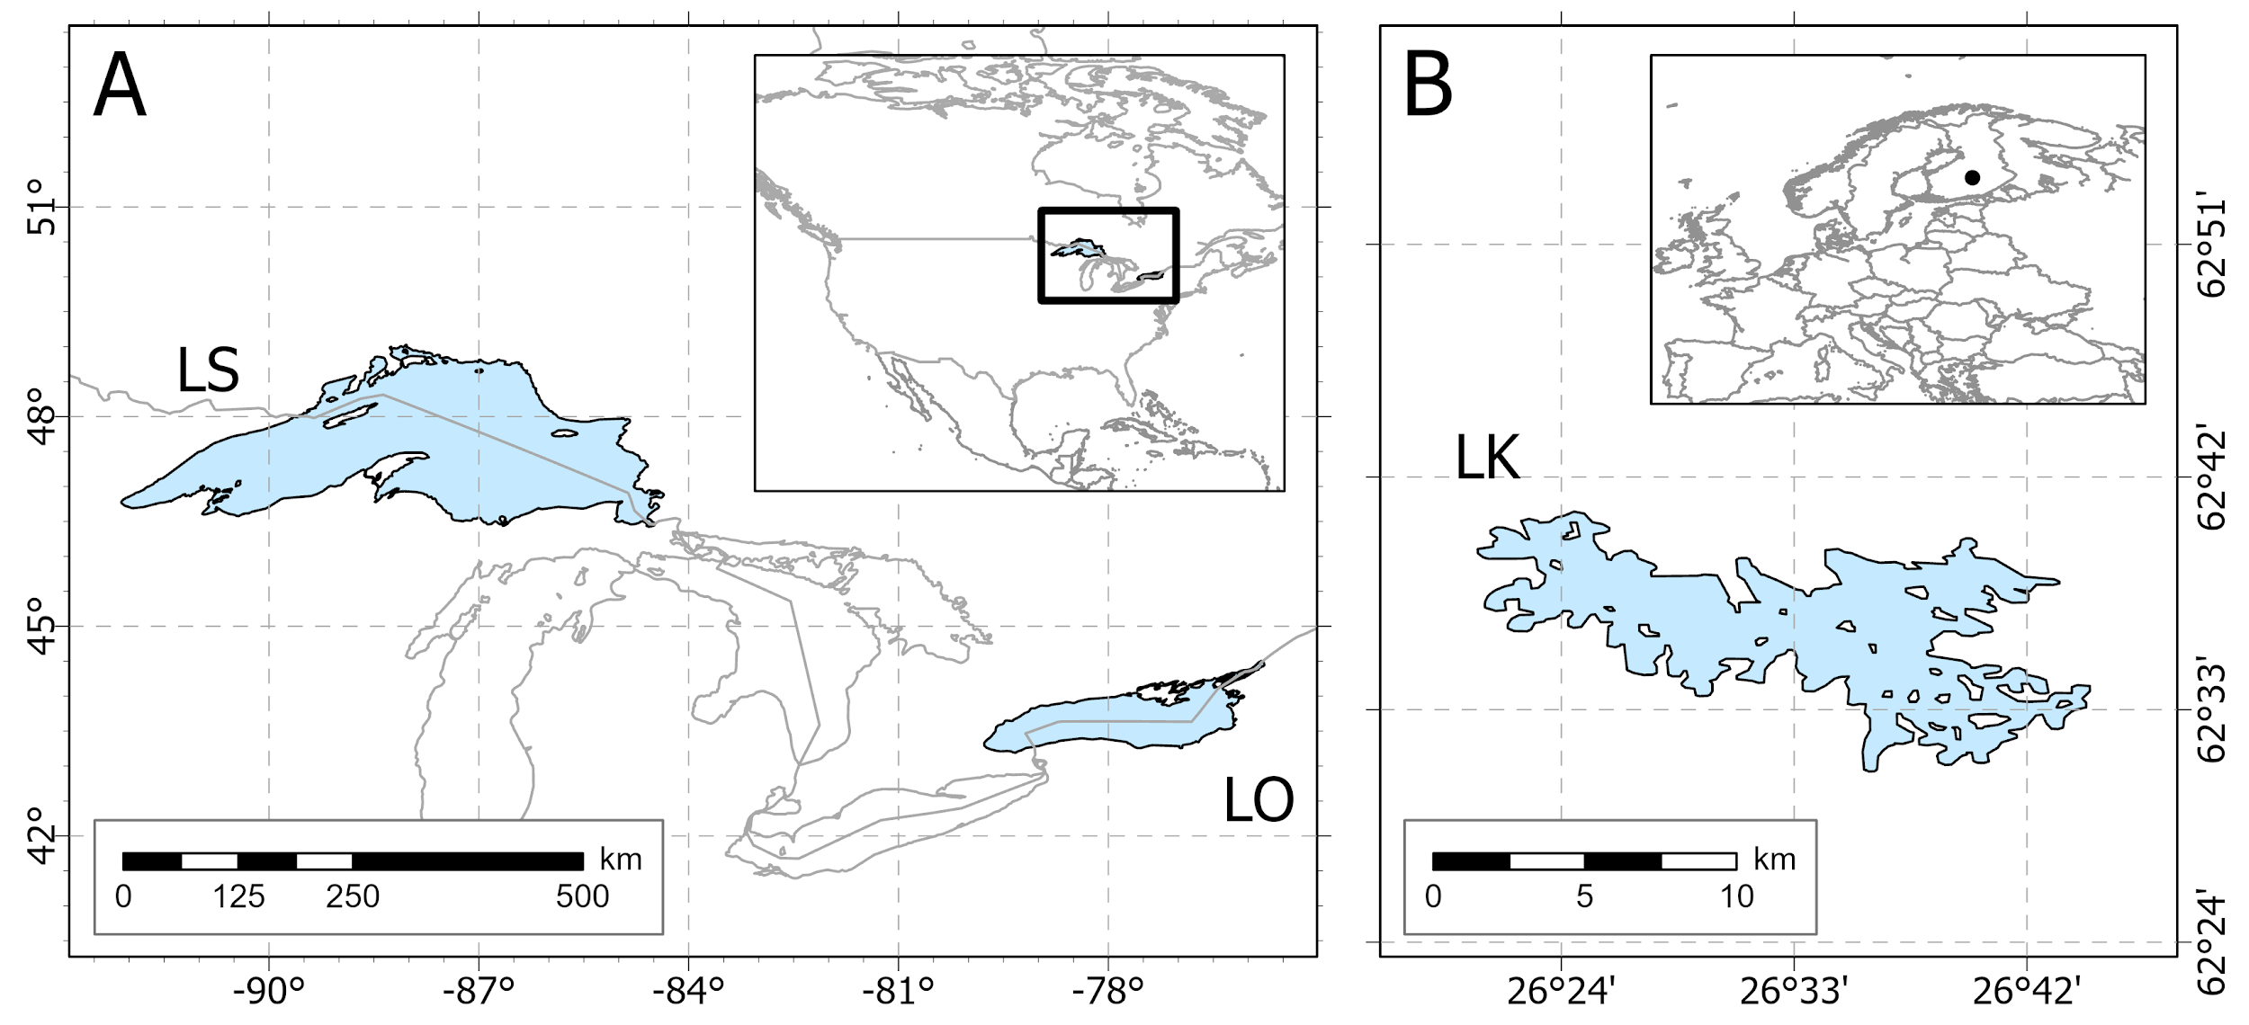

Figure 1. Map showing the location of each lake (LS = Lake Superior; LO = Lake Ontario; LK = Lake Southern Konnevesi) sampled in North America (A) and Europe (B).

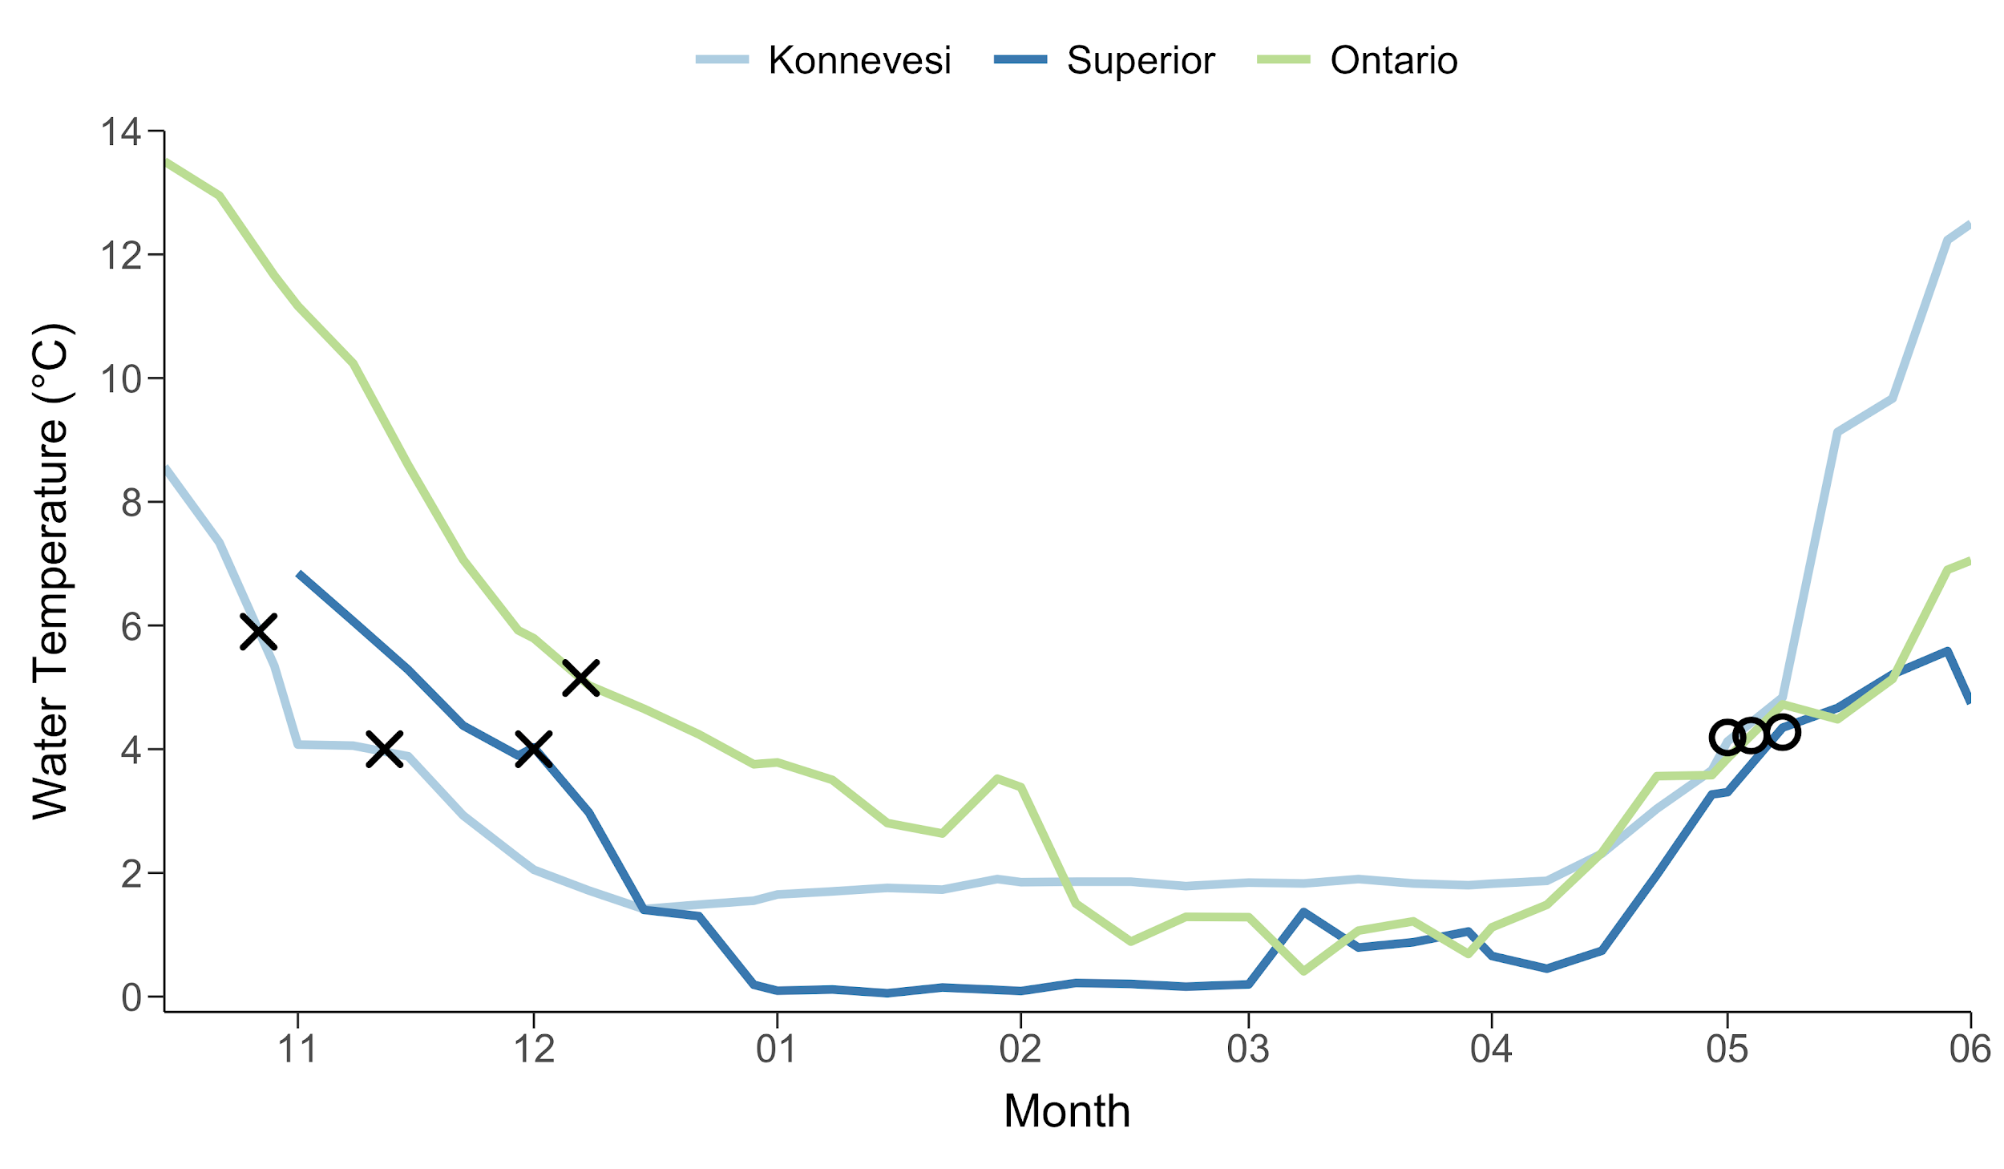

Figure 2. Winter water temperatures from Lake Southern Konnevesi, Lake Superior, and Lake Ontario. Lake Southern Konnevesi and Lake Superior data were recorded using *in-situ* sensors on the lakebed (10-m deep). Lake Ontario data was recorded using remote sensing sea surface temperatures. X indicates *ca.* spawning and O indicates *ca.* hatching.

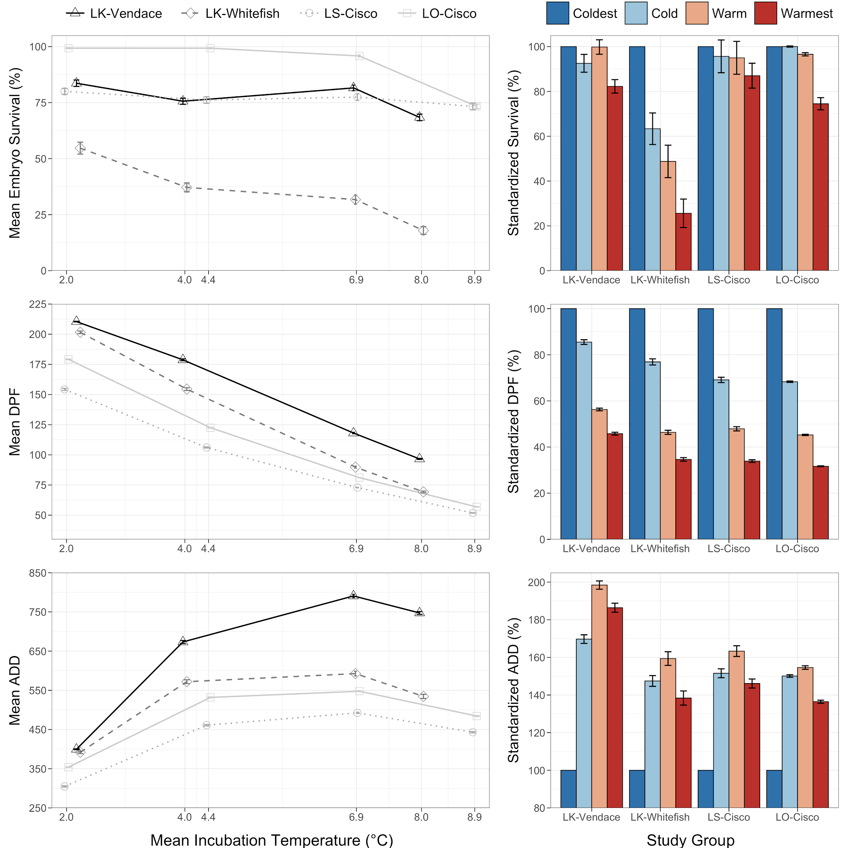

Figure 3. Mean embryo survival (%) and incubation period (number of days post-fertilization (DPF) and accumulated degree days (°C; ADD)) at each incubation temperature (°C; left) and standardized temperature responses within each study group (%; right) from Lake Southern Konnevesi (LK-Vendace (*Coregonus albula*) and LK-Whitefish (*C. lavaretus*)), Lake Superior (LS-Cisco (*C. artedi*)), and Lake Ontario (LO-Cisco). Error bars indicate standard error.

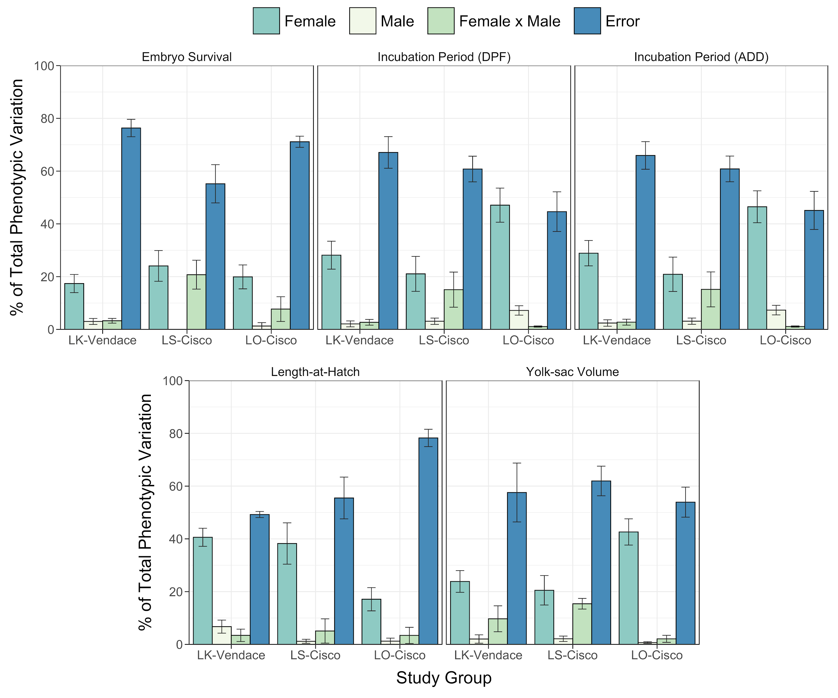

Figure 4. Mean percent of total phenotypic variation across incubation temperatures for embryo survival, incubation period (number of days post-fertilization (DPF) and accumulated degree days (°C; ADD)), length-at-hatch (mm), and yolk-sac volume (mm3) from Lake Southern Konnevesi vendace (LK-Vendace (*Coregonus albula*), Lake Superior cisco (LS-Cisco (*C. artedi*)), and Lake Ontario cisco (LO-Cisco). Error bars indicate standard error.

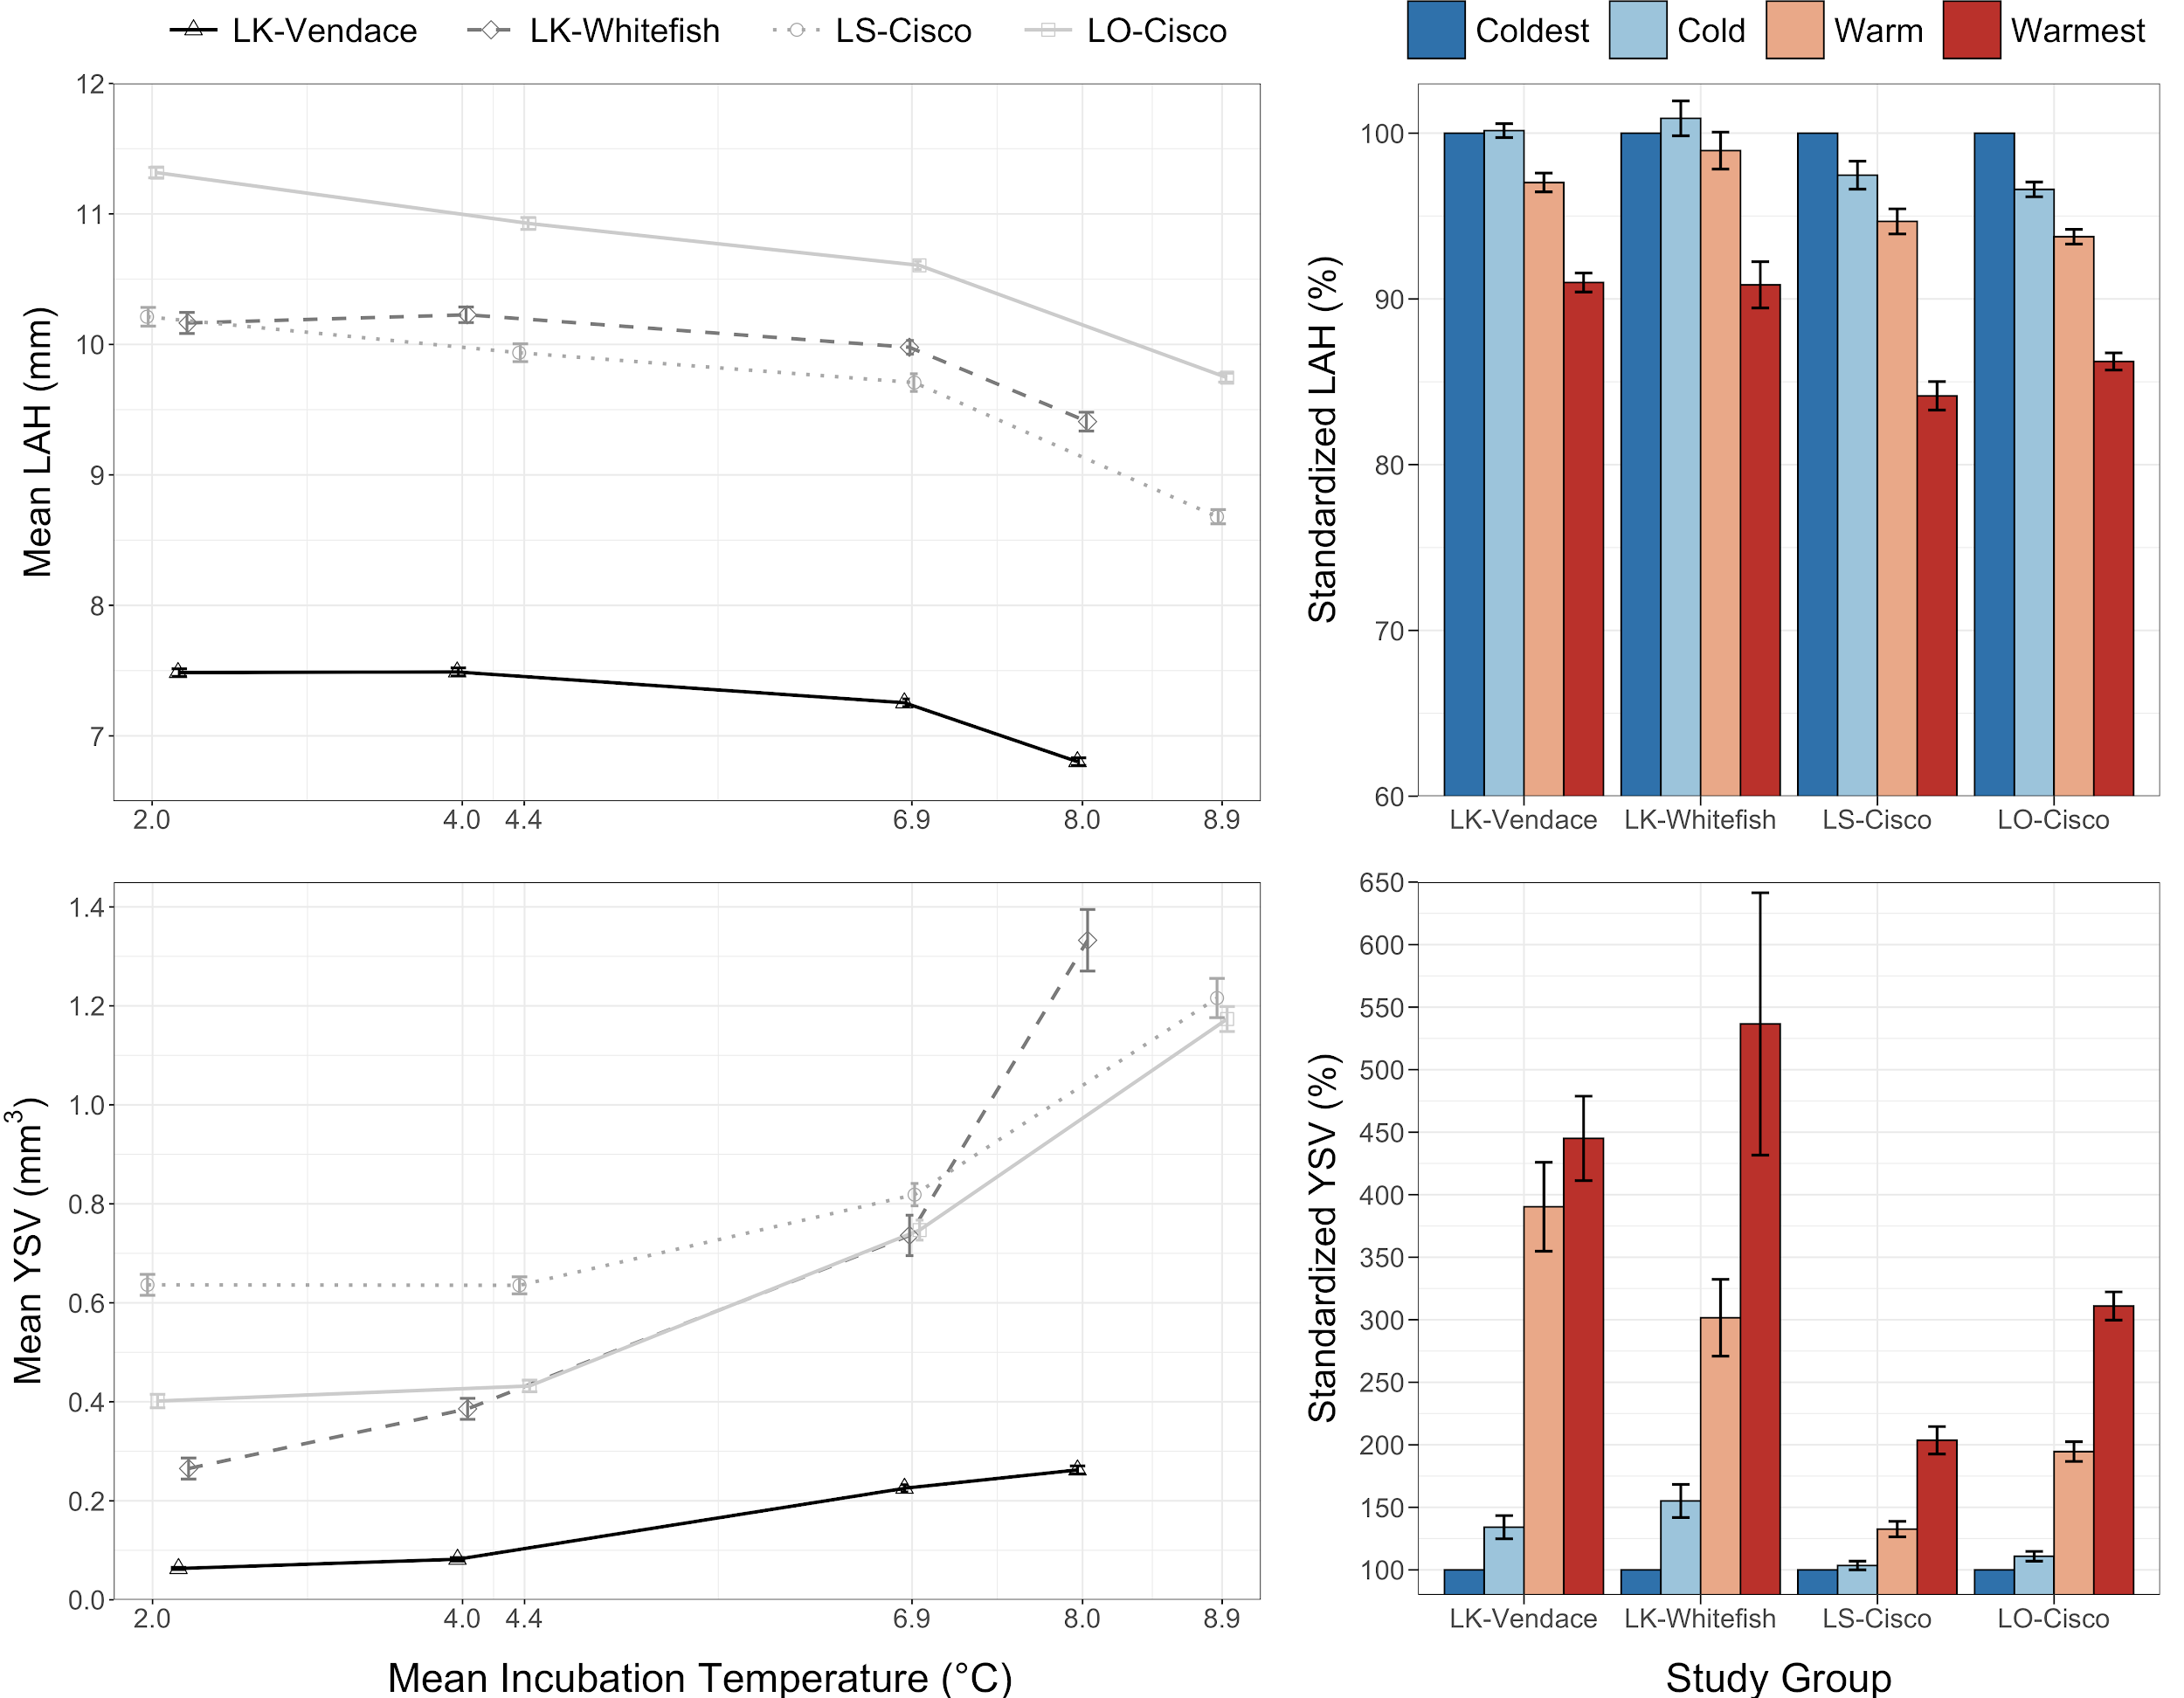

Figure 5. Mean length-at-hatch (mm; LAH) and yolk-sac volume (mm3; YSV) at each incubation temperature (°C; left) and standardized temperature responses within each study group (%; right) from Lake Southern Konnevesi (LK-Vendace (*Coregonus albula*) and LK-Whitefish (*C. lavaretus*)), Lake Superior (LS-Cisco (*C. artedi*)), and Lake Ontario (LO-Cisco). Error bars indicate standard error.

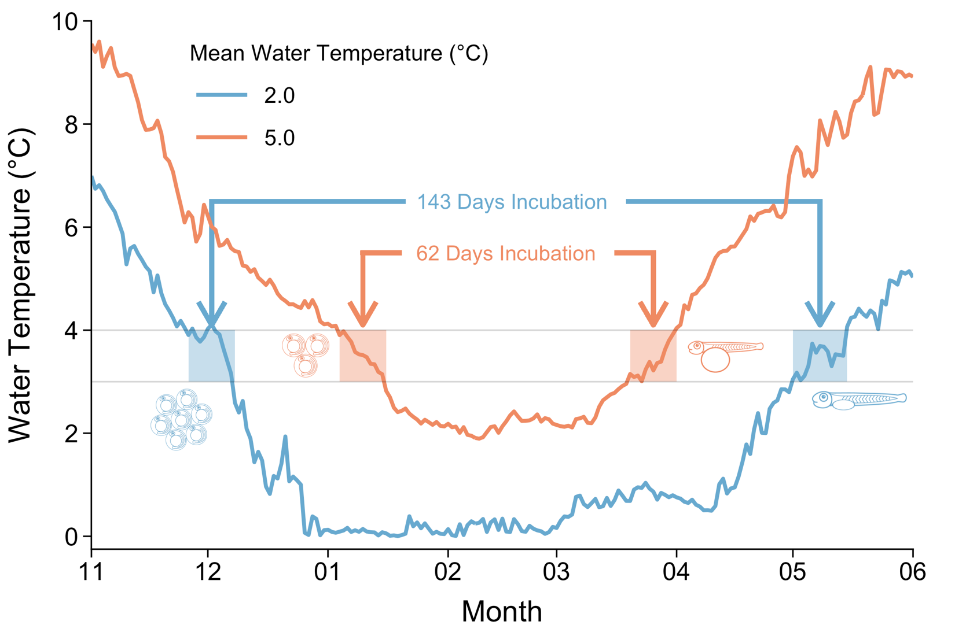

Figure 6. Theoretical winter incubation periods and responses of embryo demographics under normal (2.0°C; blue) and hypothetical warm (5.0°C; orange) winter thermal regimes. The shaded regions indicate spawning periods (left) and hatching periods (right) for cisco (*Coregonus artedi*) that may occur between 3-4°C. The 2.0°C temperature regime is water temperature data collected from Lake Superior at 10-m depth in 2018.

# APPENDIX:

SI Table 1. Phenotypic variance component analysis for embryo survival (%), incubation period (number of days post-fertilization; DPF), and incubation period (accumulated degree-days; ADD) from Lake Southern Konnevesi vendace (LK-Vendace (*Coregonus albula*)), Lake Superior cisco (LS-Cisco (*C. artedi*)), and Lake Ontario cisco (LO-Cisco) across each incubation temperature treatment (°C).

<https://drive.google.com/file/d/1cfyAJjCw9IuF6fyL7nvYYmefiCJE8ioF/view?usp=sharing>

SI Table 2. Phenotypic variance component analysis for length-at-hatch (mm) and yolk-sac volume (mm3) from Lake Southern Konnevesi vendace (LK-Vendace (*Coregonus albula*)), Lake Superior cisco (LS-Cisco (*C. artedi*)), and Lake Ontario cisco (LO-Cisco) across each incubation temperature treatment (°C).

<https://drive.google.com/file/d/1EkgOcGoUUie4hpVH0SSJqvaVbEykUqhU/view?usp=sharing>