RH: Age, Growth, and Size of Lake Superior Pygmy Whitefish

Age, Growth, and Size of Lake Superior Pygmy Whitefish (Prosopium coulterii)

TAYLOR R. STEWART and DEREK H. OGLE[1]

Department of Natural Resources, Northland College, Ashland, Wisconsin 54806

and

OWEN T. GORMAN and MARK R. VINSON

U. S. Geological Survey, Great Lakes Science Center, Lake Superior Biological Station, Ashland, Wisconsin 54806

Abstract.— Pygmy Whitefish (Prosopium coulterii) are a small, glacial relict species with a disjunct distribution in North America and Siberia. In 2013 we collected Pygmy Whitefish at 28 stations from throughout Lake Superior. Total length, weight, sex, and maturity were recorded for all fish; scales and otoliths were collected from a subsample of fish. We compared the precision of estimated ages between readers and between scales and otoliths, estimated von Bertalanffy growth parameters for male and female Pygmy Whitefish, and reported the first weight-length relationship for Pygmy Whitefish. Age estimates between scales and otoliths differed significantly (P < 0.001), with otolith ages significantly greater for most ages after age-3. Maximum otolith age was nine for females and seven for males, which is older than previously reported for Pygmy Whitefish from Lake Superior. Growth was initially fast but slowed considerably after age-3 for males and age-4 for females, falling to 3-4 mm per year at maximum estimated ages. Females were longer than males after age-3. Our results suggest the size, age, and growth of Pygmy Whitefish in Lake Superior have not changed appreciably since 1953.

**Keywords:** Lake Superior; otolith; weight-length; sexual dimorphism; age comparison

Introduction

The Pygmy Whitefish (*Prosopium coulterii*), is a small coregonine fish, perhaps best known for its notable disjunct distribution. In North America Pygmy Whitefish are widely distributed west of the Continental Divide but are patchily distributed east of the Divide (Scott and Crossman, 1973; McPhail, 2007; Wiedmer *et al.,* 2010; Witt *et al.,* 2011; Barnett and Paige, 2014; Blanchfield *et al.,* 2014). The eastern-most population is in Lake Superior (Eschmeyer and Bailey, 1955). Their range extends as far north as westcentral Alaska and the Yukon Territories and as far south as central Montana and Lake Superior (Michigan) (Blanchfield *et al.,* 2014). Pygmy Whitefish, however, are not endemic to North America as they have been collected on the Chukotsk Peninsula, Siberia (Chereshnev and Skopets, 1992).

Pygmy Whitefish is a glacial relict species (Taylor *et al.,* 2011; Blanchfield *et al.,* 2014) that was originally thought to inhabit only large, cold, deep, oligotrophic lakes (Scott and Crossman, 1973; Weisel *et al.,* 1973; Zemlak and McPhail, 2006). However, populations of Pygmy Whitefish have been described from small lakes (Taylor *et al.,* 2011), from large fast-flowing rivers (McPhail and Lindsey, 1970; Mackay, 2000), and from lakes where Pygmy Whitefish migrate into tributary rivers to spawn (Heard and Hartman, 1966; Wiesel *et al.,* 1973; Wydoski and Whitney, 2003; McPhail, 2007; Barnett and Paige, 2014). In lakes Pygmy Whitefish are generally associated with the bottom in the deepest areas (Becker, 1983; Wydoski and Whitney, 2003), though they may make diel migrations to shallower areas to forage (Wydoski and Whitney, 2003; Zemlak and McPhail, 2004; Zemlak and McPhail, 2006; Gorman *et al.,* 2012). Life history and population dynamics of Lake Superior Pygmy Whitefish have not been described since 1953 (Eschmeyer and Bailey, 1955).

Age data is a key component for understanding the ecology and population dynamics of fish populations (Maceina *et al.,* 2007; Quist *et al.,* 2012). Typically, scales have been used to estimate age of Pygmy Whitefish (Weisel and Dillon, 1954; Eschmeyer and Bailey, 1955; Heard and Hartman, 1966; McCart, 1965; Weisel *et al.,* 1973; Barnett and Paige, 2014), although otoliths have been used more recently (McPhail and Zemlak, 2001; Zemlak and McPhail, 2004; Plumb, 2006; Sullivan, 2011). Scales underestimate age for many fish (Maceina *et al.,* 2007), including several other coregonids (Aass, 1972; Jessop, 1972; Barnes and Power, 1984; Skurdal *et al.,* 1985; Yule *et al.,* 2008; Herbst and Marsden, 2011). The precision of ages estimated by multiple readers and a comparison of ages estimated from scales and otoliths have not been formally described for Pygmy Whitefish. Our first objective is to examine between-reader precision for scales and otoliths and to compare ages estimated from scales and otoliths.

Pygmy Whitefish are small, with a maximum total length (TL) for most populations between approximately 150 and 275 mm (*e.g.,* Eschmeyer and Bailey, 1955; McCart, 1965). Growth of Pygmy Whitefish appears to be fast before sexual maturity, which may occur between the second and fourth years of life (Weisel *et al.,* 1973; Heard and Hartman, 1966), and considerably slower following sexual maturity (McCart, 1965; McPhail, 2007). Growth of males and females is similar during the initial fast-growth period, but females are larger at older ages and have a longer lifespan (Eschmeyer and Bailey, 1955; McPhail and Zemlak, 2001; Zemlak and McPhail, 2004; McPhail, 2007). Our second objective is to describe the growth of Lake Superior Pygmy Whitefish and to make comparisons with other studies. One key comparison will be with the first collections of Pygmy Whitefish in Lake Superior made in 1953 by Eschmeyer and Bailey (1955), to determine if growth of Pygmy Whitefish in Lake Superior has changed in 60 y.

Finally, Froese (2006) made a strong argument for the utility and continued publication of weight-length relationships for fish from a variety of populations. Zemlak and McPhail (2004) published the only weight-length relationships (for each bimonthly summer sampling period) for Pygmy Whitefish. FishBase (Froese and Pauly, 2014) currently provides a weight-length relationship that was derived from other species with a body shape similar to Pygmy Whitefish (Froese *et al.,* 2013). Therefore, our third objective is to report the weight-length relationships for male and female Pygmy Whitefish in Lake Superior.

Materials and Methods

sampling and data collection

Pygmy Whitefish were collected at 28 stations throughout Lake Superior (Fig. 1) between 21May and 20July 2013. Fish were collected with the Research Vessel Kiyi (United States Geological Survey, Lake Superior Biological Station) using a Yankee bottom trawl with either a chain or rubber disktype foot rope. Both nets had an 11.9 m head rope, 15.5 m foot rope, and a 2.2 m wing height with stretch mesh of 89 mm at the mouth, 64 mm for the trammel, and 13 mm at the cod-end. Trawls were towed cross-contour beginning in shallower water at approximately 3.5 km/h. The tows had a mean beginning depth of 41.8 m (range: 10.6-140.0), ending depth of 91.5 m (range: 37.6-156.0), and mean distance covered of 1.77 km (range: 0.64-3.22).

All or, if the catch was large (N > 50), a subsample of captured Pygmy Whitefish were immediately measured for TL to the nearest mm and placed on ice to be further processed after the vessel was moored. If a subsample of fish was measured, then the TLs for unmeasured fish were estimated from the proportions of TLs of measured fish in the catch. Once the vessel was moored, TL, weight to the nearest 0.1 g, and sex (visually determined as female, male, or immature) were recorded for as many fish as time allowed. Saggital otoliths and scales were initially removed from as many as six fish of each sex per 10 mm TL interval. However, this scheme resulted in few males and few fish longer than 120 mm in our samples. To rectify this disparity, we extracted scales and otoliths from more males and from all fish longer than 120 mm (which proved to be females). Scales were removed from directly above the lateral line below the posterior edge of the dorsal fin and were placed in a coin envelope to air dry. Excess tissue was removed from otoliths before being placed into a vial to air dry. No frozen or preserved Pygmy Whitefish were used in this study.

In the laboratory scales were removed from the envelopes, soaked in water, gently cleaned, and mounted between two glass slides. Scales were viewed using transmitted light with a Nikon SMZ745T™ stereo microscope (20-75x magnification). Otoliths were embedded in clear epoxy (Buehler EpoKwick™ Epoxy, 5:1 ratio Resin to Hardener) before a 0.24 mm thick section through the nucleus along the dorso-ventral plane was obtained with a Buehler IsoMet™ Low Speed Saw. Otolith thin sections were lightly polished with 2000grit sandpaper before viewing in mineral oil on a black background with finely concentrated reflected light using the same stereo microscope (50x magnification). Digital images of scales and otoliths were obtained with a Nikon DS-Fi2™ camera attached to the stereo microscope.

Two readers, who were blind to any biological information related to the fish, identified annuli on the scales and otoliths from the digital images. Readers had varying levels of experience estimating ages fish. However, each reader was trained by an experienced reader using sets of Pygmy Whitefish scales and otoliths not used in this study before estimating age from fish used in this study. Annuli on scales were identified using “cutting-over” and “compaction” characteristics evident in the circuli (Quist *et al.,* 2012). Annuli on otoliths were identified by discontinuities in the otolith structure that were usually most obvious on the otolith margin lateral from the sulcus. Some fish were excluded from further analyses involving age because the scales (6.2%) or otoliths (32.6%) were deemed unreadable. Unreadable scales were generally due to regeneration. Unreadable otoliths were caused by difficulties with sectioning otoliths from small fish and from an inability to get a clear, crisp image in all portions of the otolith section (especially the center) for some specimens. When the two readers disagreed on an age estimate, they compared their results in an attempt to achieve consensus. If the readers could not agree on an age, then that fish was removed from the comparison of ages estimated from scales and otoliths but not from comparison of age estimates from the two readers on the same structures.

statistical analyses

Bias in scale ages and otolith ages between two readers (*e.g.,* one reader consistently lower than the other) and between consensus scale and otolith ages were estimated with age-bias plots (Campana *et al.,* 1995) and three measures of symmetry for the age-agreement table (Evans and Hoenig, 1998) as computed with ageBias() from the FSA package v0.4.33 (Ogle, 2014) in the RTM statistical environment v3.1.2 (R Development Core Team, 2014). If no significant bias between readers was detected, precision between readers was summarized as the percentage of fish for which the ages differed by zero to three or more years, the co- efficient of variation (CV; Chang, 1982; Kimura and Lyons, 1991), and average percentage error (APE; Beamish and Fournier, 1981) as computed with agePrecision() from the FSA package.

Estimated ages could not be validated because known-age Pygmy Whitefish were not available and collections were not made throughout the year (Campana, 2001). However, we examined the length frequency distribution of all Pygmy Whitefish from May-July 2006-2012 that were captured using bottom trawl methods similar to those described for the 2013 collection to determine if the age of some fish could be ascertained from peaks in the length frequency and compared to ages estimated from scales and otoliths. We also included in this analysis the lengths of Pygmy Whitefish captured in shallower waters (range: 2.9-14.3 m) of the Apostle Islands region in a once-only effort in late July 2008 (Gorman *et al.,* 2012).

Potential differences in the log10(W)-log10(TL) relationship among male, female, and immature Pygmy Whitefish were assessed with a dummy variable regression (Fox, 1997) using lm() in R. Potential differences in length distributions between male and female Pygmy Whitefish were determined by comparing the cumulative length frequency distribution with a Kolmogorov-Smirnov test using ks.test() and the mean ranks of lengths with a Wilcoxon signed-rank test using wilcox.test() in R (Neumann and Allen, 2007).

Growth was summarized with the Francis (1988) parameterization of the von Bertalanffy growth model (VBGM) with parameters defined by the minimum (two) and maximum (six) age in common between the two sexes and then the midpoint of these ages. Therefore, the model parameters represented the mean lengths of age-2, age-4, and age-6 fish. Differences in VBGM parameters between males and females were assessed by fitting models where all three parameters, two parameters, and one parameter differed by sex, and then comparing the fit of nested subsets of these models with an extra sum-of-squares test as described generally by Ritz and Streibig (2008) and specifically for the VBGM by Ogle (2013). Models were fit using the “port” algorithm of nls() in R with constraints on the range of values the algorithm could consider for each parameter. Parameters and lengths predicted from the VBGM for both sexes were summarized with bootstrap confidence intervals constructed with nlsBoot() from the nlstools package v1.0-0 (Baty *et al.,* 2014) of R as described in Ogle (2013). Based on our analysis of length frequency distributions, all fish of unknown sex less than 75 mm for which an age estimate (N=11) was assigned an age of 1 and randomly allocated, with equal probability, to the male or female groups to help anchor the left sides of the VBGM for model fitting.

All statistical tests used α=0.05 to determine significance.

Results

age

No significant bias in estimated ages was detected between readers for scales or otoliths (symmetry tests in Table 1). The two readers perfectly agreed on 69.7% of scale and 51.6% of otolith estimate and were within 1 y on 97.4% of scale and 96.9% of otolith estimate (Table 1). Estimated ages differed between the two readers by as much as 2 y for scales and 3 y for otoliths (Table 1). The co- efficient of variation between readers was 8.4 for scale and 10.6 for otolith estimates (Table 1). The two readers reached a consensus age on all 76 assessed scales but only on 56 of the 64 (87.5%) assessed otoliths.

A significant bias between ages from paired scale and otolith consensus estimates was detected (symmetry tests in Table 1; Fig. 2). Mean estimated age was significantly lower for scales than for otolith ages 3, 4, 5, and 8 (Fig. 2). The maximum consensus estimated age from otoliths was nine for females and seven for males.

The distribution of TL for Pygmy Whitefish captured in 2013 indicated a distinct break at approximately 75 mm (Fig. 3). A break at approximately the same length was also evident in samples from the previous 7 y. However, the sample from 2008 also exhibited a distinct break at approximately 52 mm and individuals smaller than this represented age-0 fish. From these observations, we concluded that fish sampled for age in 2013 that were less than 75 mm (no fish were less than 54 mm) were one year old. These observed lengths for Pygmy Whitefish in their first (age-0) and second (age-1) summers are consistent to that observed by Eshmeyer and Bailey (1955). The validity of estimated ages for fish less than 75 mm was very good for scales (90.9% were estimated as age-1) but poor for otoliths (50%) due to most not having a distinct annulus.

size

The TL of all 3132 Pygmy Whitefish collected in 2013 ranged from 54 to 151 mm with a mean (+SD) of 95.3 (+17.7) mm. Of the 269 subsampled Pygmy Whitefish, TL ranged from 55 to 150 mm with a mean of 97.1 (+22.5) mm and W ranged from 0.8 to 32.0 g with a mean of 6.6 (+4.5) g. Sex was not determined for 11 (4.1%) of the subsampled fish. Of the remaining 258 fish, 48.5% were female, 30.2% were male, and 21.3% were immature. Length distributions differed between subsampled females (N=125) and males (N=78; Kolmogorov-Smirnov test, D = 0.59, P < 0.0005) with females significantly (Wilcoxon test, W = 8224, P < 0.0005) longer (median TL of 114.0 mm) than males (94.5 mm).

The log10(W)-log10(TL) relationship did not differ between female, male, and immature Pygmy Whitefish (F = 1.60, P = 0.175). The weight-length relationship fit to all sampled fish was log10(W) = -5.626 + 3.204log10(TL) (r2 = 0.983). The slope and back-transformed intercept from this model are both within the confidence intervals reported for those coefficients on FishBase (Froese and Pauly, 2014).

growth

Consensus otolith ages for Pygmy Whitefish were quite variable relative to fish length (Table 2). As many as four ages were represented in one 10 mm TL interval for both males and females. Additionally, as many as three and four TL intervals were observed in one age-class for males and females, respectively.

Comparisons of VBGM indicated that the mean length-at-age-2 parameter did not differ (F = 0.37, P = 0.548) between sexes, but the mean lengths-at-age-4 (F = 22.3, P < 0.0005) and at age-6 (F = 33.2, P < 0.0005) parameters were significantly smaller for male than female Pygmy Whitefish (Fig. 4). Growth was initially fast with half of the maximum size attained in the second year of life (*i.e.,* age-1+) for male and in the third year of life (*i.e.,* age-2+) for female Pygmy Whitefish (Tables 3, 4). Annual incremental growth after age-3 (*i.e.,* change in mean length-at-age) was about double for females compared to males, which grew only a few mm per year on average (Tables 3, 4).

Discussion

We found age estimates of Pygmy Whitefish from both scales and otoliths to be difficult. Ages for fish less than 75 mm that were estimated from scales, but not from otoliths, matched the age determined from analysis of length frequency data. This result suggests Pygmy Whitefish in Lake Superior do not suffer from a missing or difficult to detect first annulus on scales as described by Zemlak and McPhail (2004). However, we did have the same difficulties as Zemlak and McPhail (2004) with otoliths from young fish which they described as “small and fragile and it was not always possible to read them.” Therefore, it appears the age of Pygmy Whitefish in their second summer may be reliably estimated from analysis of length frequency data or scales, but not from otoliths.

Scales from larger fish were difficult to assess as circuli were few and crowded at the scale margin. Heard and Hartman (1966) expressed similar difficulties estimating age from scales of older fish. Minimal growth on the scale margin of sexually mature fish corresponds to the typical 1.0 to 4.0 mm per year increase in TL observed between sequential captures of tagged mature Pygmy Whitefish by Barnett and Paige (2014).

We had considerable difficulties obtaining otolith thin sections that were clear in all areas of the section (*i.e.,* putative annuli were evident near the otolith margin but not the center, or vice versa). In addition most of the putative annuli could only be reliably detected along a transect lateral from the sulcus, rather than around the entire otolith surface. These difficulties resulted in us deeming nearly one-third of our processed otoliths as unreadable and rejecting them from further analysis. Furthermore, we often lacked confidence in our placement of a first annulus on the otoliths, had difficulty interpreting annuli at the otolith margin, and observed distinct inner-annular marks (*i.e.,* “false annuli”) on several of the oldest fish in our sample.

Our estimated ages for Pygmy Whitefish were highly variable with many age classes falling among several length-classes and many length classes falling with in a single age class. Similar levels of variability were evident in the estimated ages by Plumb (2006) (using otoliths) and Weisel *et al.* (1973) (using scales), though both of these metrics of variability were lower in Eschmeyer and Bailey (1955) and McCart (1963) (both using scales). Variability in estimated ages may be caused by pooling of fish captured at different times and locations, variability in the precision of age estimates, and the inherent growth pattern of the fish. Our pooling of fish across time and locations may have contributed to the observed variability as seasonal growth may commence in late May (McCart, 1965) before our sampling began and Eschmeyer and Bailey (1955) suggested slight spatial differences in growth of Pygmy Whitefish may occur across Lake Superior. Our sample sizes from different locations did not allow us to test for differences in age distributions or growth among locations. Low percentage of perfect agreement in age estimates between two readers and CVs that were greater than 7.6%, the median CV computed from a variety of species by Campana (2001) also likely contributed to this variability. A high level of variability in observed lengths-at-age may also occur, however, for relatively long-lived species where growth is fast for only a few initial years and then very slow at older ages. Our results illustrate this type of asymptotic pattern of growth for Pygmy Whitefish, as half of the maximum size was attained in the second year for males and the third year for females and annual growth declined steadily after age-3; from 8 mm at age-4 to 3 mm at age-7 for males and from 14 mm at age-4 to 4 mm at age-9 for females (Tables 3, 4).

Pygmy Whitefish appear to grow more slowly in Lake Superior than in most other locations, as indexed by mean length-at-age (Tables 3 and 4). This is not surprising given the cold, oligotrophic nature of Lake Superior (Schertzer and Rao, 2009). Additionally, annular increments in mean length-at-age for fish older than age-3 were smaller in our study than in most other studies, including Eschmeyer and Bailey (1955). This difference, however, may be due to a difference between our using otoliths and most other studies using scales, as our annular increments in mean lengths are consistent with the direct observations of incremental growth from tagged fish made by Barnett and Paige (2014).

When compared to Lake Superior Pygmy Whitefish from 1953 (Eschmeyer and Bailey, 1955), our fish had only a slightly longer maximum size and a similar pattern of more males at younger ages and females at older ages. Our mean lengths-at-age were somewhat lower than those reported by Eschmeyer and Bailey (1955), especially at the younger ages. We observed an older maximum age for Lake Superior Pygmy Whitefish in 2013 than 1953, though this observation is likely a result of our using otoliths to estimate age and should be treated as a provisional conclusion until otolith ages can be validated. In summary it does not appear the size, age, and growth metrics we measured have changed appreciably for Pygmy Whitefish in Lake Superior between 1953 and 2013.

*Acknowledgments.* - The vessel crew (Lori Evrard, Charles Carrier, Keith Peterson, and Joe Walters) assisted with field collections onboard the R/V Kiyi. Dalton Lebeda performed a second reading on scale samples. Hanna Fiorio, Scott Sapper, and Glenn Miller assisted with otolith preparation or initial age estimates. Mark Rogers improved the quality and clarity of the paper. Mention of trade names or commercial products does not constitute endorsement or recommendation for use. This article is contribution XXXX of the U.S. Geological Survey Great Lake Science Center.

Literature Cited

Aass, P. 1972. Age determination and year-class fluctuation of cisco, *Coregonus albula* L*.*, in the Mjøsa hydroelectric reservoir. Institute of Freshwater Research, Drottningholm, Norway. **52**:5-22.

Barnes, M. A. and G. Power. 1984. A comparison of otolith and scale ages for western Labrador lake whitefish, *Coregonus clupeaformis*. *Environ. Biol. Fishes,* **10**:297-299.

Barnett, H. K. and D. K. Paige. 2014. Characteristics of riverine broadcast spawning pygmy whitefish (*Prosopium coulterii*). *Northwest Sci.,* **88**:155-168.

Baty, F., C. Ritz, S. Charles, M. Brutsche, J. P. Flandrois, and M. L. Delignette-Muller. 2014. nlstools: A toolbox for nonlinear regression in R. URL <http://cran.r-project.org/web/packages/nlstools/index.html>.

Beamish, R. J. and D. A. Fournier. 1981. A method for comparing the precision of a set of age determinations. *Can. J. Fish. Aquatic Sci.,* **38**:982-983.

Becker, G. C. 1983. Fishes of Wisconsin. University of Wisconsin Press, Madison, Wisconsin. 1064 p.

Blanchfield, P. J., E. B. Taylor, and D. A. Watkinson. 2014. Morphological and genetic analyses identify a new record of a glacial relict: Pygmy Whitefish (*Prosopium coulterii*) from Northwestern Ontario. *Can. J. Zool.,* **92**:267–271.

Campana, S. E. 2001. Accuracy, precision and quality control in age determination, including a review of the use and abuse of age validation methods. *J. Fish Biol.,* **59**:197-242.

------, M. C. Annand, and J. I. McMillan. 1995. Graphical and statistical methods for determining the consistency of age determinations. *Trans. Am. Fish. Soc.,* **124**:131-138.

Chang, W. Y. B. 1982. A statistical method for evaluating the reproducibility of age determination. *Can. J. Fish. Aquatic Sci.,* **39**:1208-1210.

Chereshnev, I. A. and M. B. Skopets. 1992. A new record of pygmy whitefish, *Prosopium coulteri*, from Amguem River Basin (Chukotski Peninsula). *J. Ichthyology,* **32(4):**46-55.

Eschmeyer, P. H. and R. M. Bailey. 1955. The pygmy whitefish, *Coregonus coulteri*, in Lake Superior. *Trans. Am. Fish. Soc.,* **84**:161-199.

Evans, G. T. and J. M. Hoenig. 1998. Testing and viewing symmetry in contingency tables, with application to readers of fish ages. *Biometrics,* **54**:620-629.

Fox, J. 1997. Applied regression analysis, linear models, and related methods. Sage Publications, Thousand Oaks, California. 624 p.

Francis, R. I. C. C. 1988. Are growth parameters estimated from tagging and age-length data comparable?. *Can. J. Fish. Aquatic Sci.,* **45**:936-942.

Froese, R. 2006. Cube law, condition factor, and weight-length relationships: history, meta-analysis and recommendations. *J. Appl. Ichthyology,* **22**:241-253.

------ and D. Pauly. 2014. FishBase. URL <http://www.fishbase.org>, Version: Aug. 2014. Accessed 23 Sep. 2014.

------, J. T. Thorson, and Reyes R. B. Jr. 2013. A Bayesian approach for estimating length-weight relationships in fishes. *J. Appl. Ichthyology,* **30**:78-85.

Gorman, O. T., D. L. Yule, and J. D. Stockwell. 2012. Habitat use by fishes of Lake Superior. I. Diel patterns of habitat use in nearshore and offshore waters of the Apostle Islands region. *Aquatic Ecosystem Health Manag.,* **15**:333-354.

Heard, W. R. and W. L. Hartman. 1966. Pygmy whitefish, *Prosopium coulteri*, in the Naknek River system of southwest Alaska. *U.S. Fish and Wildl. Serv., Fish. Bull.* **65**:555-57.

Herbst, S. J. and J. E. Marsden. 2011. Comparison of precision and bias of scale, fin ray, and otolith age estimates for lake whitefish (*Coregonus clupeaformis*) in Lake Champlain. *J. Great Lakes Res.,* **37**:386-389.

Jessop, B. M. 1972. Aging round whitefish (*Prosopium cylindraceum*) of the Leaf River, Ungava, Quebec, by otoliths. *J. Fish. Res. Board Can.,* **29**:452-454.

Kimura, D. K. and J. J. Lyons. 1991. Between reader bias and variability in age-determination process. *Fish. Bull.* **89**:53-60.

Maceina, M. J., J. Boxrucker, D. L. Bueckmeier, R. S. Gangl, D. O. Lucchesi, D. A. Isermann, J. R. Jackson, and P. J. Martinez. 2007. Current status and review of freshwater fish aging procedures used by state and provincial fisheries agencies with recommendations for future directions. *Fisheries,* **32**:329-340.

Mackay, W. C. 2000. Status of the pygmy whitefish (*Prosopium coulteri*) in Alberta. Alberta Environ., Fish. and Wildl. Manag. Division, and Alberta Conservation Assoc., no. 27. 16 p.

McCart, P. J. 1963. Growth and morphometry of the pygmy whitefish (*Prosopium coulteri*) in British Columbia. M.Sc. Dissertation, University of British Columbia, Vancouver, British Columbia. 97 p.

------. 1965. Growth and morphometry of four British Columbia populations of pygmy whitefish (*Prosopium coulteri*). *J. Fish. Res. Board Can.,* **22**:1229-1259.

McPhail, J. D. 2007. The freshwater fishes of British Columbia. University of Alberta Press, Edmonton, Alberta. 696 p.

------ and C. C. Lindsey. 1970. Freshwater fishes of northwestern Canada and Alaska. *Fish. Res. Board Can.*, no. 173. 381 p.

------ and R. J. Zemlak. 2001. Pygmy Whitefish studies on Dina Lake #1, 2000. Peace/Williston Fish and Wildl. Compensation Program, Prince George, British Columbia, no. 245. 36 p.

Neumann, R. M. and M. S. Allen. 2007. Size Structure. p. 375-421. *In:* Guy, C. S. and M. L. Brown (eds.). Analysis and Interpretation of Freshwater Fisheries Data. American Fisheries Society, Bethesda, Maryland. 961 p.

Ogle, D. H. 2013. fishR Vignette: Von Bertalanffy Growth Models. URL <http://fishr.wordpress.com/vignettes/>. Accessed 3 Aug. 2014.

------. 2014. FSA: Fisheries stock analysis. URL <http://fishr.wordpress.com/fsa/>.

Plumb, M. P. 2006. Ecological factors influencing fish distribution in a large subarctic lake system. M.Sc. Dissertation, University of Alaska Fairbanks. 74 p.

Quist, M. C., M. A. Pegg, and D. R. DeVries. 2012. Age and growth. p. 677-731. *In:* Zale, A. V., D. L. Parrish, and T. M. Sutton (eds). Fisheries Techniques. 3rd ed. American Fisheries Society, Bethesda, Maryland.

R Development Core Team. 2015. R: a language and environment for statistical computing. R Foundation for Statistical Computing. Vienna, Austria. URL <http://R-project.org>.

Ritz, C. and J. C. Striebig. 2008. Nonlinear regression with R. Springer-Verlag, New York. 148 p.

Schertzer, W. M. and Y. R. Rao. 2009. An overview of the characteristics of Lake Superior meteorology, hydrology and physical limnology. p. 3-50. *In:* Munawar, M. and I. F. Munawar (eds). State of Lake Superior. Goodword Books, New Delhi, India.

Scott, W. B. and E. J. Crossman. 1973. Freshwater fishes of Canada. *Fish. Res. Board Can.,* no. 184.

Skurdal, J., L. A. Vollestad, and T. Qvenild. 1985. Comparison of scales and otoliths for age determination of whitefish *Coregonus lavaretus*. *Fish. Res.,* **3**:237-243.

Sullivan, M. 2011. Status of the pygmy whitefish (*Prosopium coulterii*) in Alberta: Update 2011. Alberta Wildl. Status Rep., no. 27. 46 p.

Taylor, E. B., J. L. Glow, J. Witt, and R. Zemlak. 2011. Connectivity among populations of pygmy whitefish (*Prosopium coulterii*) in northeastern North America inferred from microsatellite DNA analyses. *Can. J. Zool.,* **80**:255-266.

Weisel, G. F. and J. B. Dillon. 1954. Observations on the pygmy whitefish, *Prosopium coulteri*, from Bull Lake, Montana. *Copeia,* **1954**:124-127.

------, D. A. Hanzel, and R. L. Newell. 1973. The pygmy whitefish, *Prosopium coulteri*, in western Montana. *U.S. Fish and Wildl. Serv., Fish. Bull.* **7**:587-596.

Wiedmer, M., D. R. Montgomery, A. R. Gillespie, and H. Greenberg. 2010. Late quaternary megafloods from Glacial Lake Atna, Southcentral Alaska, U.S.A. *Quaternary Res.,* **73**:413-424.

Witt, J. D. S., R. J. Zemlak, and E. B. Taylor. 2011. Phylogeography and the origins of range disjunctions in a north temperate fish, the pygmy whitefish (*Prosopium coulterii*), inferred from mitochondrial and nuclear DNA sequence analysis. *J. Biogeography,* **38**:1557–1569.

Wydoski, R. S. and R. R. Whitney. 2003. Inland fishes of Washington. 2nd ed. American Fisheries Society, Bethesda, Maryland. 384 p.

Yule, D. L., J. D. Stockwell, J. A. Black, K. I. Cullis, G. A. Cholwek, and J. T. Myers. 2008. How systematic age underestimation can impede understanding of fish population dynamics: Lessons learned from a Lake Superior cisco stock. *Trans. Am. Fish. Soc.,* **137**:481-495.

Zemlak, R. J. and J. D. McPhail. 2004. Pygmy whitefish studies on Dina Lake #1, 2001. Peace/Williston Fish and Wildl. Compensation Program, Prince George, British Columbia, no. 270. 35 p.

------ and ------. 2006. The biology of pygmy whitefish, *Prosopium coulterii*, in a closed sub-boreal lake: spatial distribution and diel movements. *Environ. Biol. Fish.,* **76**:317-327.

Table 1.— Sample size (n), P-values from three tests of symmetry for the age-agreement table (McNemar’s, Evans-Hoenig (E-H), and Bowker’s test), coefficient of variation (CV), average percent error (APE), and percentage of fish by differences in ages for comparisons between two readers for scales, between two readers for otoliths, and between consensus ages of scales and otoliths for Lake Superior Pygmy Whitefish. The CV and APE were not computed for the scale to otolith comparison because a significant bias in age was detected

|  |  |  |  |  |  |  |  |  |  |  |
| --- | --- | --- | --- | --- | --- | --- | --- | --- | --- | --- |
|  |  | Symmetry Test P-values | | |  |  | % by Difference in Age | | | |
| Comparison | n | McNemar | E-H | Bowker | CV | APE | 0 | 1 | 2 | >3 |
| Scales | 76 | 0.532 | 0.359 | 0.601 | 8.4 | 5.9 | 69.7 | 27.6 | 2.6 | -- |
| Otoliths | 64 | 0.857 | 0.565 | 0.118 | 10.6 | 7.5 | 51.6 | 45.3 | 1.6 | 1.6 |
| Scales/Otoliths | 39 | <0.0005 | <0.0005 | 0.012 | -- | -- | 23.1 | 43.6 | 15.4 | 17.9 |

Table 2.— Frequency of female and male Lake Superior Pygmy Whitefish within each 10-mm total length (TL) interval and consensus otolith age

|  |  |  |  |  |  |  |  |  |  |  |  |  |  |  |  |  |  |  |
| --- | --- | --- | --- | --- | --- | --- | --- | --- | --- | --- | --- | --- | --- | --- | --- | --- | --- | --- |
|  |  | Female Age | | | | | | | |  | | Male Age | | | | | | |
| TL (mm) |  | 2 | 3 | 4 | 5 | 6 | 7 | 8 | 9 |  | 2 | | 3 | 4 | 5 | 6 | 7 |
| 70-79 |  | 1 | -- | -- | -- | -- | -- | -- | -- |  | 2 | | -- | -- | -- | -- | -- |
| 80-89 |  | -- | 5 | -- | -- | -- | -- | -- | -- |  | 1 | | 3 | 1 | -- | -- | -- |
| 90-99 |  | -- | 5 | 1 | -- | -- | -- | -- | -- |  | 1 | | 3 | 1 | 1 | -- | -- |
| 100-109 |  | -- | 1 | 1 | -- | -- | -- | -- | -- |  | -- | | -- | -- | -- | -- | 1 |
| 110-119 |  | -- | -- | 2 | -- | -- | -- | -- | -- |  | -- | | -- | 1 | -- | 1 | -- |
| 120-129 |  | -- | -- | 1 | 3 | -- | -- | -- | -- |  | -- | | -- | -- | -- | 1 | -- |
| 130-139 |  | -- | -- | -- | 1 | 1 | 1 | 1 | -- |  | -- | | -- | -- | -- | -- | -- |
| 140-149 |  | -- | -- | -- | -- | 1 | -- | 2 | -- |  | -- | | -- | -- | -- | -- | -- |
| 150-159 |  | -- | -- | -- | -- | -- | -- | -- | 1 |  | -- | | -- | -- | -- | -- | -- |

Table 3.— Mean observed total length-at-age (mm) and minimum and maximum total lengths for female Pygmy Whitefish from this study and from Keweenaw Bay (KB) and Isle Royale (IR) Lake Superior (Eschmeyer and Bailey, 1955); Flathead Lake (FL) (Weisel *et al.,* 1973); Brooks Lake (BKL) and Naknek Lake (NL) (Heard and Hartman, 1966); Cluculz Lake (CL), Tacheeda Lake (TL), MacLure Lake (ML), and McLeese Lake (MLL) (McCart 1963); and Dina Lake #1 (DL1) (McPhail and Zemlak, 20001). Lengths for populations marked with an asterisk were converted from fork to total length using the formula in Heard and Hartman (1966). The results from this study are predicted means from Von Bertalanffy growth models and values in parentheses are bootstrapped 95% confidence intervals

|  |  |  |  |  |  |  |  |  |  |  |  |  |
| --- | --- | --- | --- | --- | --- | --- | --- | --- | --- | --- | --- | --- |
| Age |  | This Study | KB | IR | FL | BKL* | NL* | CL* | TL* | ML* | MLL* | DL1* |
| 1+ |  | 60 (56-65) | 77 | 59 | 116 | 61 | 82 | 87 | 90 | -- | -- | 90 |
| 2+ |  | 81 (79-84) | 101 | 81 | 140 | 75 | 121 | 119 | 115 | 127 | 118 | 114 |
| 3+ |  | 98 (95-101) | 106 | 88 | 154 | 81 | 138 | 131 | 124 | 206 | 171 | 120 |
| 4+ |  | 112 (109-115) | 120 | 100 | 168 | -- | 150 | 138 | 130 | 238 | 210 | 128 |
| 5+ |  | 122 (119-125) | 126 | -- | -- | -- | 168 | 154 | 137 | 266 | 210 | 132 |
| 6+ |  | 131 (128-134) | 128 | -- | -- | -- | -- | 169 | 147 | 269 | -- | 133 |
| 7+ |  | 138 (134-142) | 136 | -- | -- | -- | -- | -- | -- | 279 | -- | 132 |
| 8+ |  | 144 (138-149) | -- | -- | -- | -- | -- | -- | -- | -- | -- | -- |
| 9+ |  | 148 (142-155) | -- | -- | -- | -- | -- | -- | -- | 294 | -- | -- |
|  |  |  |  |  |  |  |  |  |  |  |  |  |
| min TL |  | 72 | 57 | -- | 89 | 52 | 55 | 89 | 84 | 114 | 114 | 29 |
| max TL |  | 150 | 138 | -- | 150 | 84 | 168 | 171 | 150 | 298 | 211 | 233 |

Table 4.— Mean observed total length-at-age (mm) and minimum and maximum total lengths for male Pygmy Whitefish from this and other studies. Abbreviations, descriptions, and sources are the same as those for Table 3

|  |  |  |  |  |  |  |  |  |  |  |  |  |
| --- | --- | --- | --- | --- | --- | --- | --- | --- | --- | --- | --- | --- |
| Age |  | This Study | KB | IR | FL | BKL* | NL* | CL* | TL* | ML* | MLL* | DL1* |
| 1+ |  | 62 (57-69) | 76 | 63 | 117 | 61 | 83 | 99 | 88 | -- | -- | 79 |
| 2+ |  | 80 (76-85) | 94 | 78 | 128 | 69 | 118 | 123 | 97 | 131 | 120 | 101 |
| 3+ |  | 92 (87-96) | 102 | 85 | 140 | 76 | 128 | 126 | 117 | 208 | 166 | 110 |
| 4+ |  | 100 (96-104) | 106 | 92 | -- | -- | 144 | 126 | -- | 228 | 193 | 114 |
| 5+ |  | 105 (101-111) | 110 | -- | -- | -- | -- | 132 | -- | 201 | -- | -- |
| 6+ |  | 109 (103-117) | -- | -- | -- | -- | -- | -- | -- | 244 | -- | -- |
| 7+ |  | 112 (104-123) | -- | -- | -- | -- | -- | -- | -- | -- | -- | -- |
|  |  |  |  |  |  |  |  |  |  |  |  |  |
| min TL |  | 71 | 67 | -- | 84 | 48 | 55 | 95 | 84 | 114 | 114 | 67 |
| max TL |  | 124 | 118 | -- | 170 | 81 | 153 | 139 | 123 | 255 | 190 | 132 |

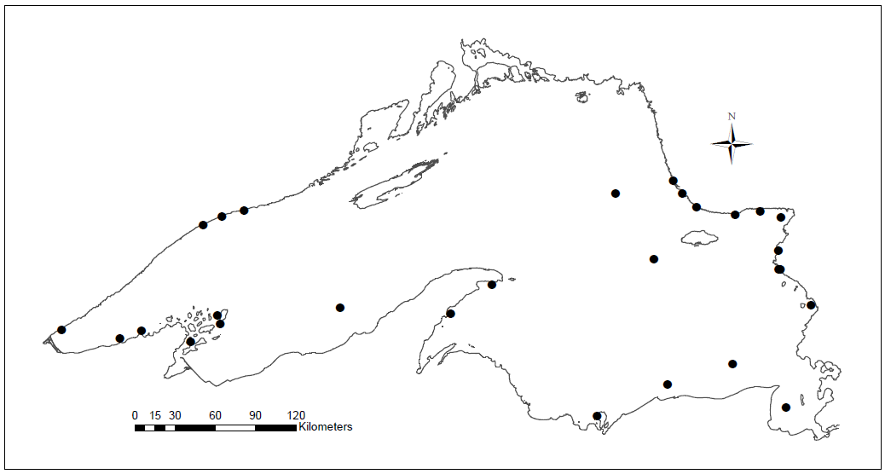

Fig. 1.— Locations of Lake Superior Pygmy Whitefish collections in 2013

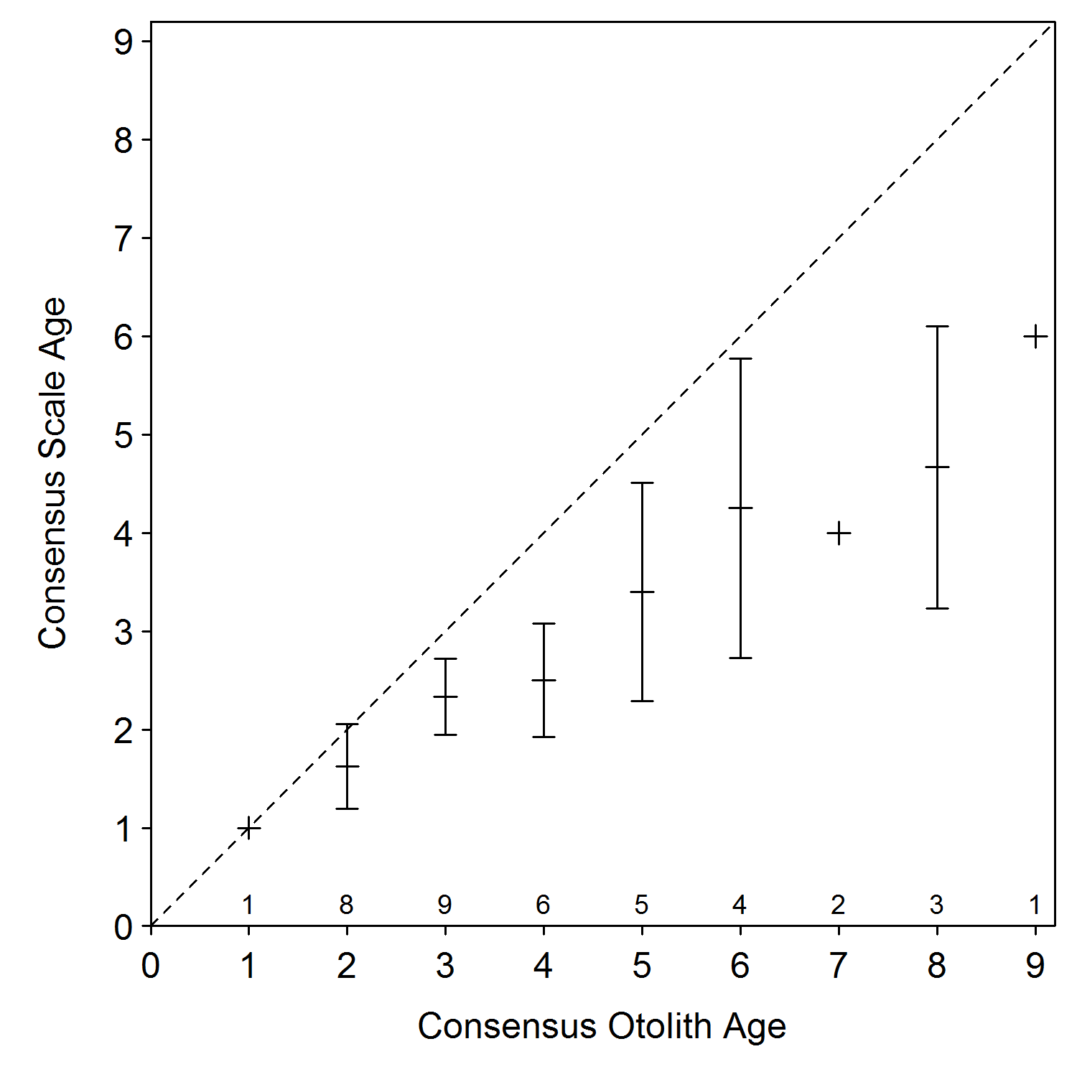

Fig. 2.— Mean (and 95% confidence intervals) consensus scale age at paired consensus otolith ages (*i.e.,* an age-bias plot) for Lake Superior Pygmy Whitefish. The diagonal dashed line is the age-agreement line. Sample size for each estimated otolith age is shown above the x-axis

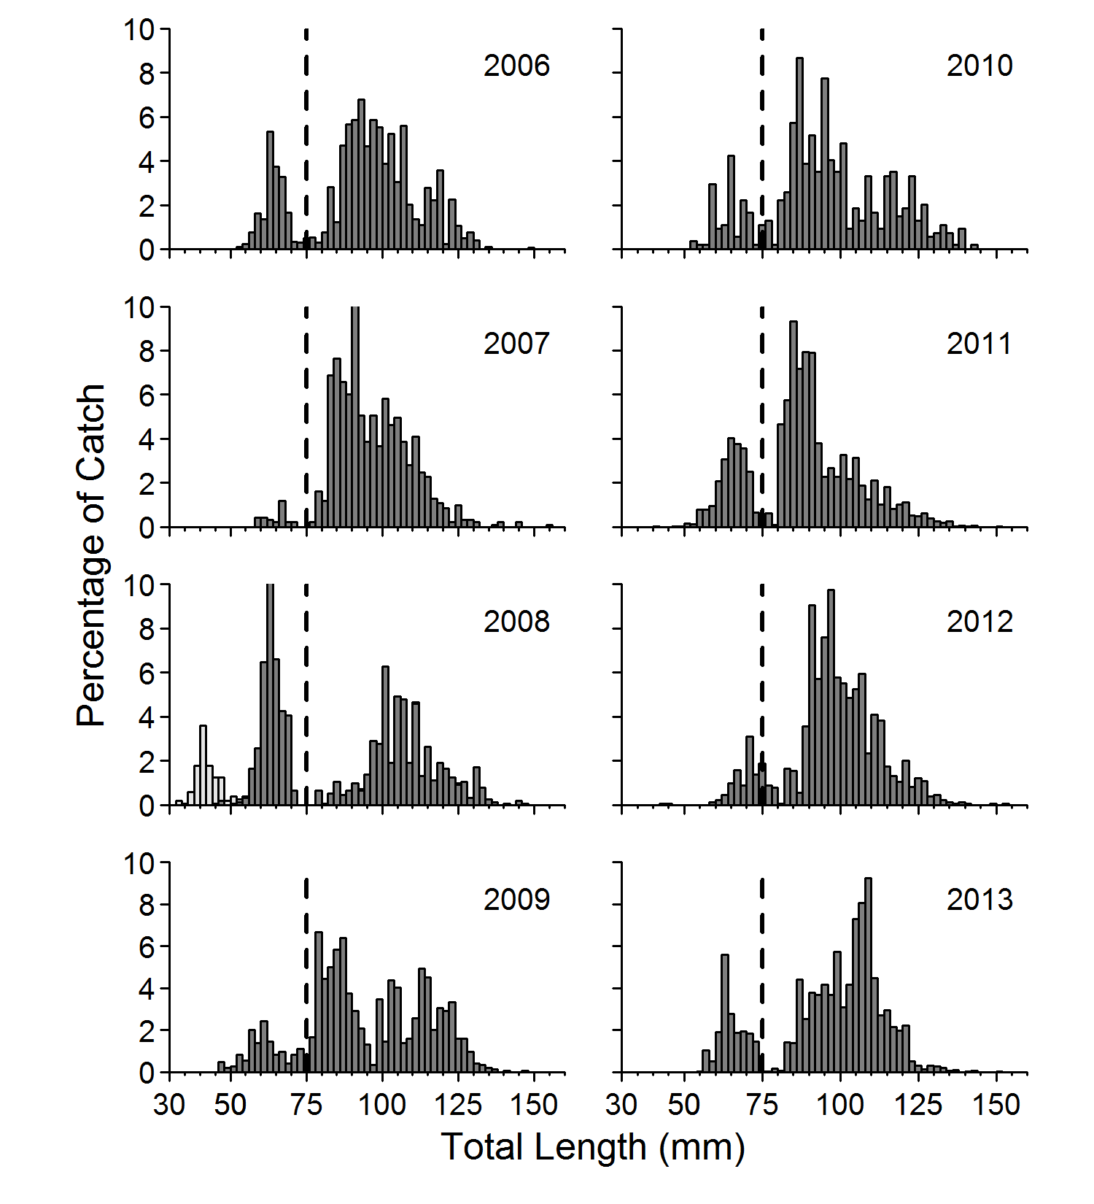

Fig. 3.— Length frequency histograms (2 mm wide bins) for Lake Superior Pygmy Whitefish by year from 2006-2013. The vertical dashed line represents the age-1 break at 75 mm. The light gray bars in 2008 are fish collected in a once only collection in shallow-waters in the Apostle Islands region (Gorman *et al.,* 2012)

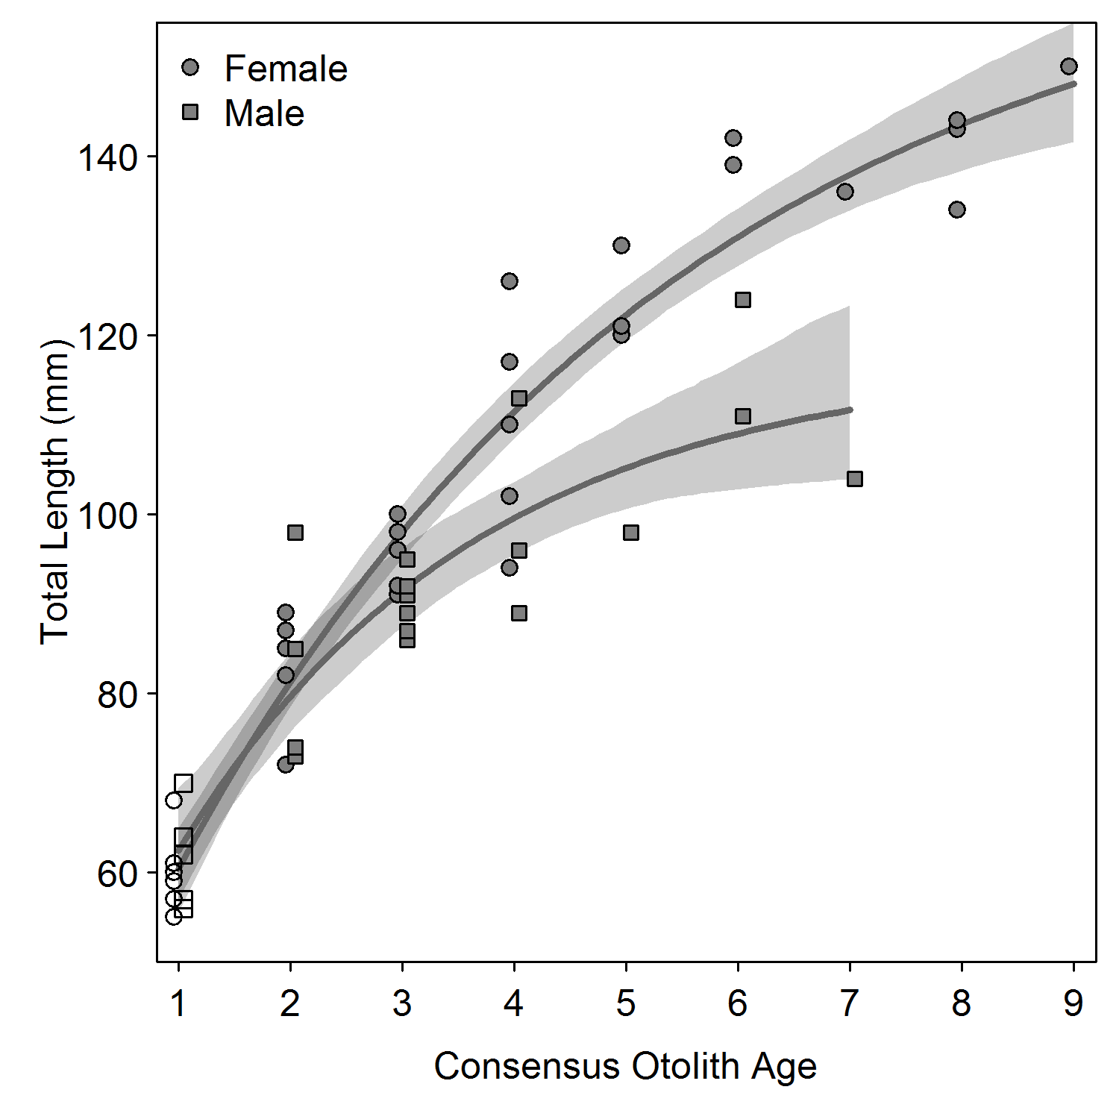

Fig. 4.— The fit (solid lines) and 95% confidence bands (shaded polygon) from Von Bertalanffy Growth Models (VBGM) fit to male and female Lake Superior Pygmy Whitefish length-at-age data. Solid symbols represent observed ages for known sex fish and open symbols are immature fish less than 75 mm total length that were randomly assigned to male or female to assist in fitting the VBGM

1. Corresponding author: e-mail: dogle@northland.edu