# 2.0 Diet Analysis of Western Basin Age-2-and-Older Yellow Perch, White Perch

**Abstract**

*Native Yellow Perch**and invasive White Perch are abundant omnivores in western Lake Erie. We evaluated diets of age-2-and older Yellow Perch and White Perch collected in Lake Erie’s western basin during spring and autumn. Evaluation metrics included frequency of occurrence and contributions of prey to predator diets by weight. Benthic macroinvertebrates contributed most to Yellow Perch and White Perch diets during spring and autumn. Bythotrephes* sp. *occurrence in Yellow Perch and White Perch diets was low in spring and considerably increased in frequency in autumn. Compiling results from 2015 with data dating back to 2005 suggested decreased utilization of zooplankton for both yellow and White Perch during spring and autumn and increased utilization of fish prey during autumn for both species.*

**Introduction**

A fish’s diet is the integrated response of multiple ecological interactions including habitat use, foraging behavior, prey community characteristics, and inter-specific interactions. Fish diet samples have quantified how the invasion of White Perch into Lake Erie in the early 1950s has influenced interactions with native Yellow Perch, which are similar in morphology and habitat use. Early research largely concluded that given the high foraging efficiency of White Perch there is both high potential for inter-specific competition and that Yellow Perch have been negatively affected by the invasion of White Perch (Parrish and Margraf 1990). More recent analyses using stable isotopes and diet contents suggest a low to moderate degree of overlap (Guzzo et al. 2013). Analysis of Yellow Perch diets has been proposed as a useful indicator of Lake Erie’s benthic community relative to direct sampling of benthos (Tyson and Knight 2001). As part of the LEBS Western Basin Forage Fish Assessment, we annually evaluate diet composition of age-2-and-older (age-2+) Yellow Perch and White Perch.

**Methods**

Yellow Perch and White Perch were collected using a bottom trawl during the USGS Western Basin Forage Assessment surveys in June (Spring) and September (Autumn), 2015 (See Section 1.0). All trawl sampling occurred during daylight hours. A maximum of five age-2+ Yellow Perch and White Perch that showed no signs of regurgitation (exposed stomach or visible food content in the mouth cavity) at each bottom trawl site were retained for diet analysis. Total length, weight, sex, site location, and date were recorded for each collection. The digestive tract from each retained fish was removed, individually frozen in tap water, and returned to the laboratory for diet analysis. Otoliths were removed and processed in the laboratory to verify that our analyses were restricted to age-2+ fish.

In the laboratory, each fish sample was slowly thawed by immersing in cold tap water. The stomach was isolated from the digestive tract at the esophagus and pyloric caeca. The stomach was placed in a 0.25 mm sieve and cut lengthwise. Stomach contents were placed into a petri dish with soapy tap water to remove the surface tension of the water, thus allowing prey items to sink to the bottom of the dish where they were more easily identified. Once in the petri dish, stomach contents were quantified using a dissecting microscope and zooplankton, macroinvertebrates, and fish were counted and identified by taxon. A subsample was taken when ≥200 individuals of a particular prey item occurred in a given sample. To subsample, a petri dish was divided into eight equal sections and a count of each prey item was taken until 200 was reached. The area that contained n=200 was recorded and then extrapolated for the entire sample. Prey items from each stomach (when applicable) were dried at 60o C for 72 hrs to obtain dry weights by prey taxon. For diet items that could not be dried and weighed, length measurements were taken and later used to estimate dry weight using length-weight and wet-weight:dry-weight conversion equations (equations and sources available upon request).

Diet analyses included percent occurrence by number and percent composition by dry weight. Diet data from non-empty stomachs were used to calculate diet contribution metrics by predator type (i.e., Yellow Perch and White Perch) and season for zooplankton, benthic macroinvertebrates, and fish prey. Percent occurrence was estimated as the number of fish examined that contained each prey item relative to the number of total fish with diet contents times 100. Percent composition by weight was calculated as the contribution of each prey type by dry weight to the total diet dry weight for each individual and then averaged across all fish for each species and season. Percent occurrence from 2015 sampling was compared to results from 2005-2014. For the historical comparison, we only used data from 2015 sampling that occurred in Michigan and Ontario waters, thus providing continuity in the time series.

**Figure 2.1**. Length distributions of age-2+ Yellow Perch (top row) and White Perch (bottom row) sampled for diet analysis during the 2015 Western Basin Forage Fish Assessment in the spring (left column) and autumn (right column).

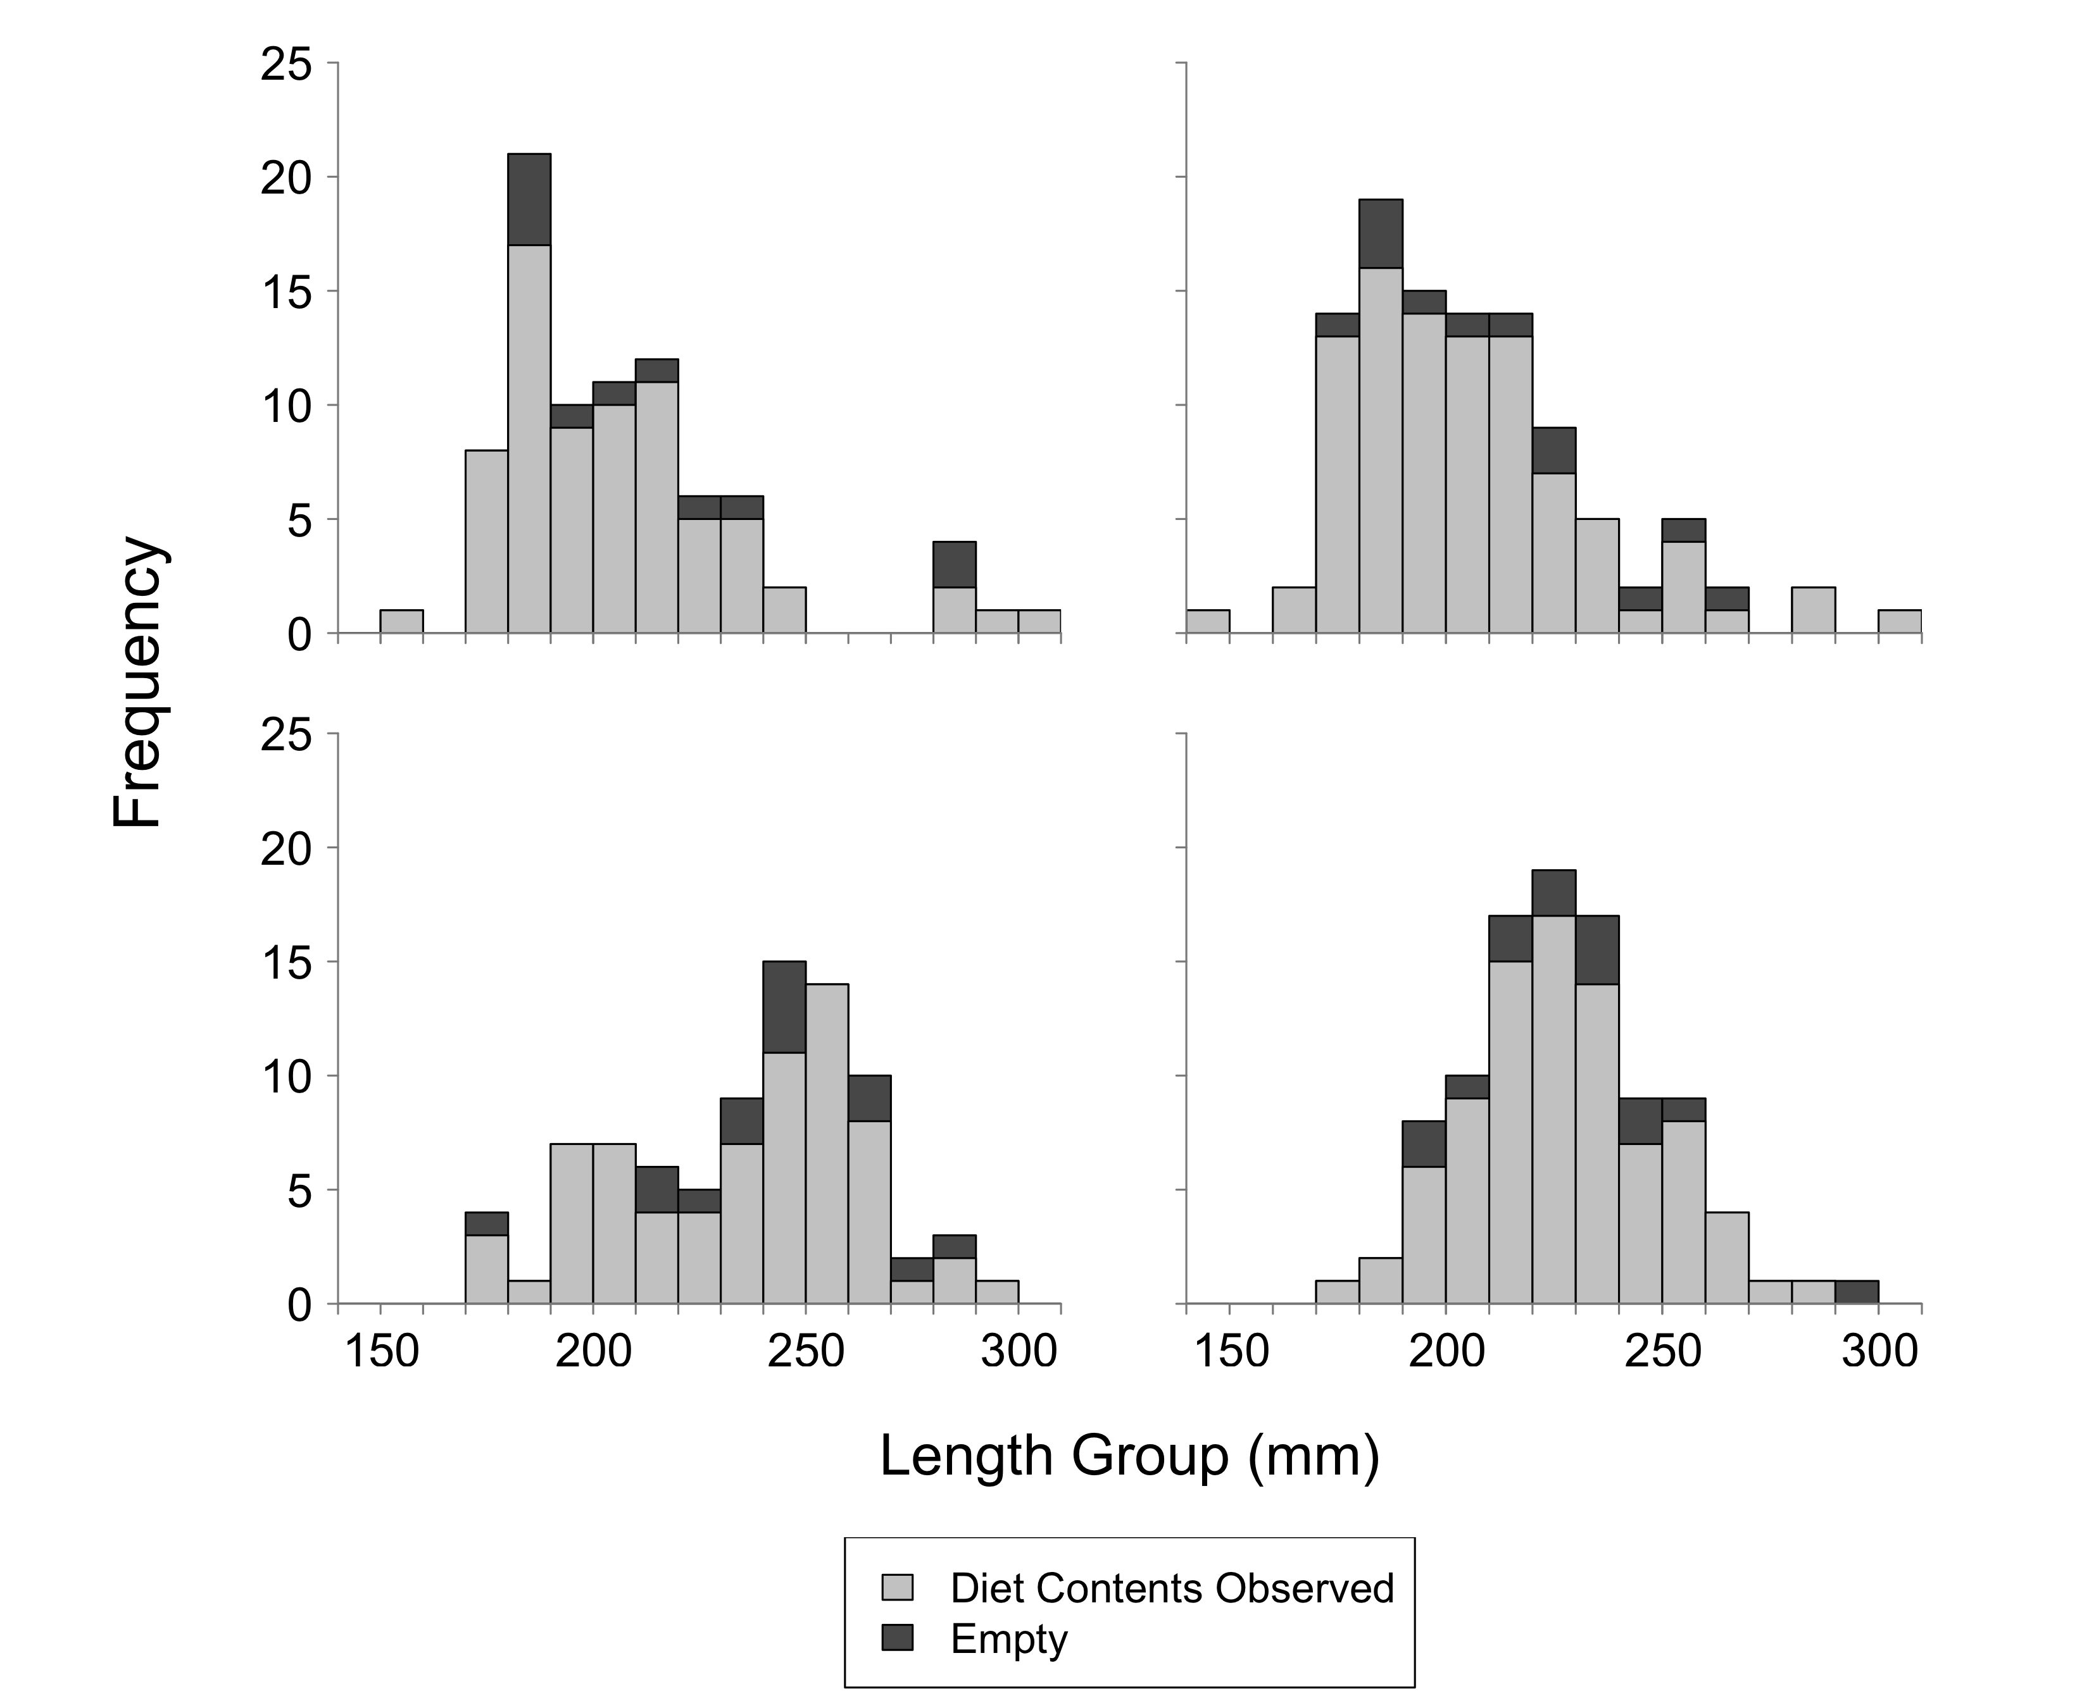

**Results**

*Frequency of occurrence*

Fish that contained diet items were representative of the total range of length groups collected for both species and seasons (Figure 2.1). Lengths of fish with diet contents were also similar between species, however a few extra-large Yellow Perch and White Perch (i.e., total length exceeding 300mm) were caught during autumn sampling (Figure 2.1). The proportion of empty stomachs, relative to the number retained, was relatively low in the autumn and spring, and thus, we subsampled the number of sites used for diet analysis in both spring and autumn (N=34 and 38 sites, respectively). Subsampling was intended to allow diet description across the spatial extent of the survey (Figure 2.2).

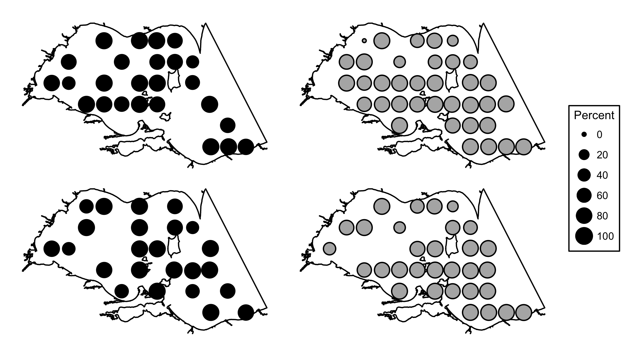

**Figure 2.2**. Percentage of stomachs with diet contents by site for Yellow Perch (top row) and White Perch (bottom row) during spring (left column) and autumn (right column).

Spring sampling provided 85 stomachs from age-2+ White Perch ranging from 170-290 mm in length. A total of 70 (82.5%) of the White Perch stomachs contained prey items. In spring, zooplankton was present in 165.7% of samples with Daphnidae and Leptodoridae occurring most frequently at 72.9% and 44.3%, respectively. Benthic macroinvertebrates occurred in 99.9% of spring stomach samples with Ephemeridae being most common (45.7%). Fish were present in 5.7% of White Perch stomachs with unidentified fish remains (2.9%) occurring most frequently during spring. During autumn sampling, stomachs of 99 age-2+ White Perch were collected from fish ranging from 171-296 mm in length with 85 (85.9%) containing prey items. Zooplankton was the most commonly occurring prey type in autumn (207.2%). A decline in occurrence for benthic macroinvertebrates (28.2%) was observed in autumn White Perch diets relative to the spring. Occurrence of fish prey increased from spring to autumn for White Perch. Fish occurred in 30.6% of diets, and unidentified fish remains was the most common fish prey occurring in 24.7% of diets. Cercopagididae was detected at low occurrence in spring (11.4%) and increased in autumn (82.4%) (Table 2.1).

|  |  |  |  |  |  |  |  |  |  |  |  |  |  |  |  |
| --- | --- | --- | --- | --- | --- | --- | --- | --- | --- | --- | --- | --- | --- | --- | --- |
| **Table 2.1**  Percent occurrence of prey items in the diets of age-2+ Yellow Perch and White Perch collected during spring and autumn 2015 in Ontario, Michigan, and Ohio waters of Lake Erie's western basin. Abbreviation: n=number of stomachs containing prey items. | | | | | | | | | | | | | | | |
|  |  | | **Yellow** | | **Perch** | | |  | | **White** | | **Perch** | |  |
| Prey Type | Prey Taxa | | 2015 Spring n=73 | | 2015 Autumn n=93 | | | | 2015 Spring n=70 | | | 2015 Autumn n=85 | |  |
| **Zooplankton** |  | | **86.2** | **151.6** | | |  | | | **165.7** | **207.2** | |  | |
|  | Bosminidae | | 0.0 | 20.4 | | |  | | | 14.3 | 22.4 | |  | |
|  | Calanoida | | 4.1 | 6.5 | | |  | | | 15.7 | 12.9 | |  | |
|  | Cercopagididae | | 8.2 | 63.4 | | |  | | | 11.4 | 82.4 | |  | |
|  | Cyclopoida | | 2.7 | 7.5 | | |  | | | 7.1 | 12.9 | |  | |
|  | Daphnidae | | 49.3 | 31.2 | | |  | | | 72.9 | 51.8 | |  | |
|  | Leptodoridae | | 21.9 | 22.6 | | |  | | | 44.3 | 22.4 | |  | |
|  | Sididae | | 0.0 | 0.0 | | |  | | | 0.0 | 2.4 | |  | |
|  |  | |  |  | | |  | | |  |  | |  | |
| **Benthic Macroinvertebrates** | |  | **142.5** |  | | **43.1** | **99.9** | | | | **28.2** | |  | |
|  | Amphipoda | | 8.2 | 11.8 | | |  | | | 11.4 | 3.5 | |  | |
|  | Chironomidae | | 24.7 | 5.4 | | |  | | | 31.4 | 12.9 | |  | |
|  | Dreissenidae | | 27.4 | 5.4 | | |  | | | 0.0 | 1.2 | |  | |
|  | Ephemeridae | | 45.2 | 7.5 | | |  | | | 45.7 | 3.5 | |  | |
|  | Gastropoda | | 5.5 | 8.6 | | |  | | | 0.0 | 1.2 | |  | |
|  | Hemimysis | | 2.7 | 0.0 | | |  | | | 2.9 | 1.2 | |  | |
|  | Hirudinea | | 5.5 | 0.0 | | |  | | | 1.4 | 0.0 | |  | |
|  | Nematoda | | 2.7 | 1.1 | | |  | | | 5.7 | 0.0 | |  | |
|  | Oligochaeta | | 0.0 | 1.1 | | |  | | | 0.0 | 0.0 | |  | |
|  | Ostracoda | | 0.0 | 2.2 | | |  | | | 0.0 | 3.5 | |  | |
|  | Sphaeriidae | | 5.5 | 0.0 | | |  | | | 1.4 | 0.0 | |  | |
|  | Trichoptera | | 15.1 | 0.0 | | |  | | | 0.0 | 1.2 | |  | |
|  |  | |  |  | | |  | | |  |  | |  | |
| **Fishes** |  | | **10.9** | **27.0** | | |  | | | **5.7** | **30.6** | |  | |
|  | Emerald Shiner | | 0.0 | 0.0 | | |  | | | 1.4 | 0.0 | |  | |
|  | Fish eggs | | 2.7 | 0.0 | | |  | | | 1.4 | 0.0 | |  | |
|  | Gizzard Shad | | 0.0 | 1.1 | | |  | | | 0.0 | 0.0 | |  | |
|  | Round Goby | | 5.5 | 3.2 | | |  | | | 0.0 | 0.0 | |  | |
|  | Spottail Shiner | | 0.0 | 1.1 | | |  | | | 0.0 | 0.0 | |  | |
|  | Unidentified fish | | 2.7 | 19.4 | | |  | | | 2.9 | 24.7 | |  | |
|  | White Bass | | 0.0 | 0.0 | | |  | | | 0.0 | 1.2 | |  | |
|  | White Perch | | 0.0 | 1.1 | | |  | | | 0.0 | 0.0 | |  | |
|  | Yellow Perch | | 0.0 | 1.1 | | |  | | | 0.0 | 4.7 | |  | |

Frequency of occurrence of zooplankton was higher for both White Perch and Yellow Perch in 2015 than in 2014 during both seasons (Figure 2.3). Zooplankton occurrence has shown a increasing trend over the past few years across both species in both seasons. Occurrence of benthic macroinvertebrates was lower in spring and autumn 2015 compared to 2014. Occurrence of fish in Yellow Perch and White Perch spring diets remained low (10.4% and 9.4%, respectively) and increased in the autumn (42.4% and 65.4%, respectively). Historically, zooplankton had a low occurrence in Yellow Perch and White Perch diets sampled in autumn, but in 2015 autumn diets sampled zooplankton occurred in higher frequency (145.5% and 200%, respectively). Benthic macroinvertebrates were found about half as often as in 2014 across both seasons and species (Figure 2.3). Occurrence of fish prey in diets has not shown unfamiliar change over recent years (Figure 2.3).

**Figure 2.3.** Historical percent occurrence in age-2+ Yellow Perch (back solid line and filled circles) and White Perch diets (gray dashed line and unfilled circles) of zooplankton (top row), benthic macroinvertebrates (middle row) and fish (bottom row) during spring (left column) and autumn (right column). Included 2015 sites were restricted to those near historical trawl sites in Michigan and Ontario.

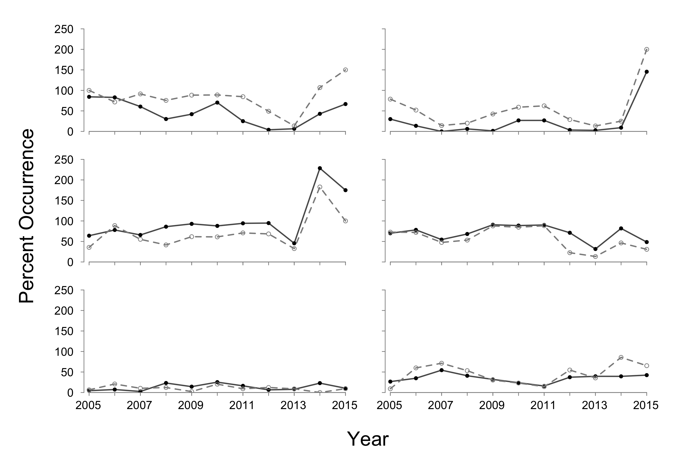

*Percent composition by weight*

Benthic macroinvertebrates contributed most to age-2+ Yellow Perch diets in spring (53.6%), followed by zooplankton (42.0%) and fish prey (4.4%, Figure 2.4). Dreissenidae (22.7%) and Ephemeridae (22.9%) were the predominate benthic macroinvertebrate contributors by weight in the spring (Figure 2.5). Daphnidae (35.9%)was the dominant zooplankton taxa, while Round Goby (4.3%) was the most prominent identifiable fish prey in spring Yellow Perch diets (Figure 2.5). In autumn, zooplankton taxa was the highest contribution to diet weights (63.0%), followed by fish prey (19.6%) and benthic macroinvertebrates (17.4%) (Figure 2.4). The major zooplankton taxa contributor in autumn was Cercopagididae (51.8%)).Gastropoda, Amphipoda, and Dreissenidae accounted for almost 100% of total benthic macroinvertebrates observed in diets. The major fish prey taxa contributors in autumn was unidentified fish remains (14.9%; Figure 2.5).

Spring White Perch diets were predominately composed of zooplankton (58.4%), followed by benthic macroinvertebrates (39.7%) and fish prey (1.9%) (Figure 2.4). Daphnidae was the dominant zooplankton taxon contributing 48.0% to diet weight on average in spring (Figure 2.4). Ephemeridaeand Emerald Shiner were the dominant contributors for their respective prey groups. Zooplankton contributed most to White Perch diets in autumn (74.6%), followed by fish prey (23.2%) and benthic macroinvertebrates (2.2%) (Figure 2.4). Cercopagididae were the major zooplankton prey taxon (67.7%) during autumn. Unidentified fish remains was the predominate fish prey taxa and Ephemeridae was the predominate benthic macroinvertebrate taxa during autumn (Figure 2.5).

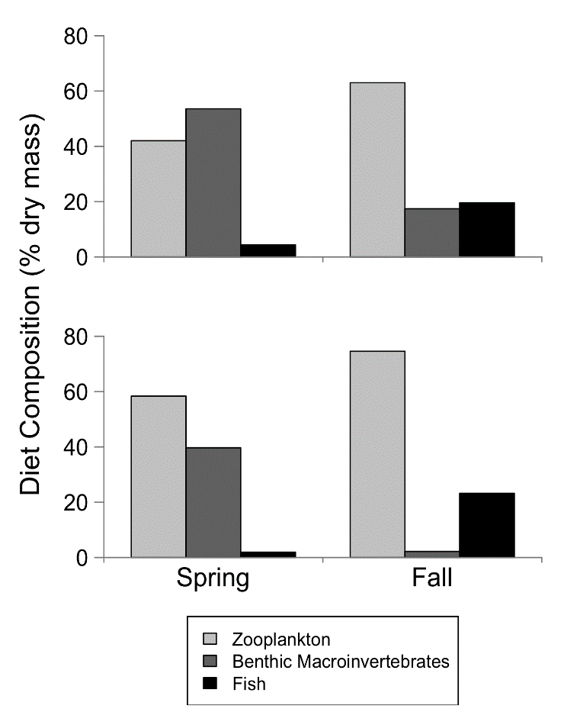

**Figure 2.4** (**right**). Age-2+ Yellow Perch (top panel) and White Perch (bottom panel) mean diet composition (% dry weight) by prey type and season.

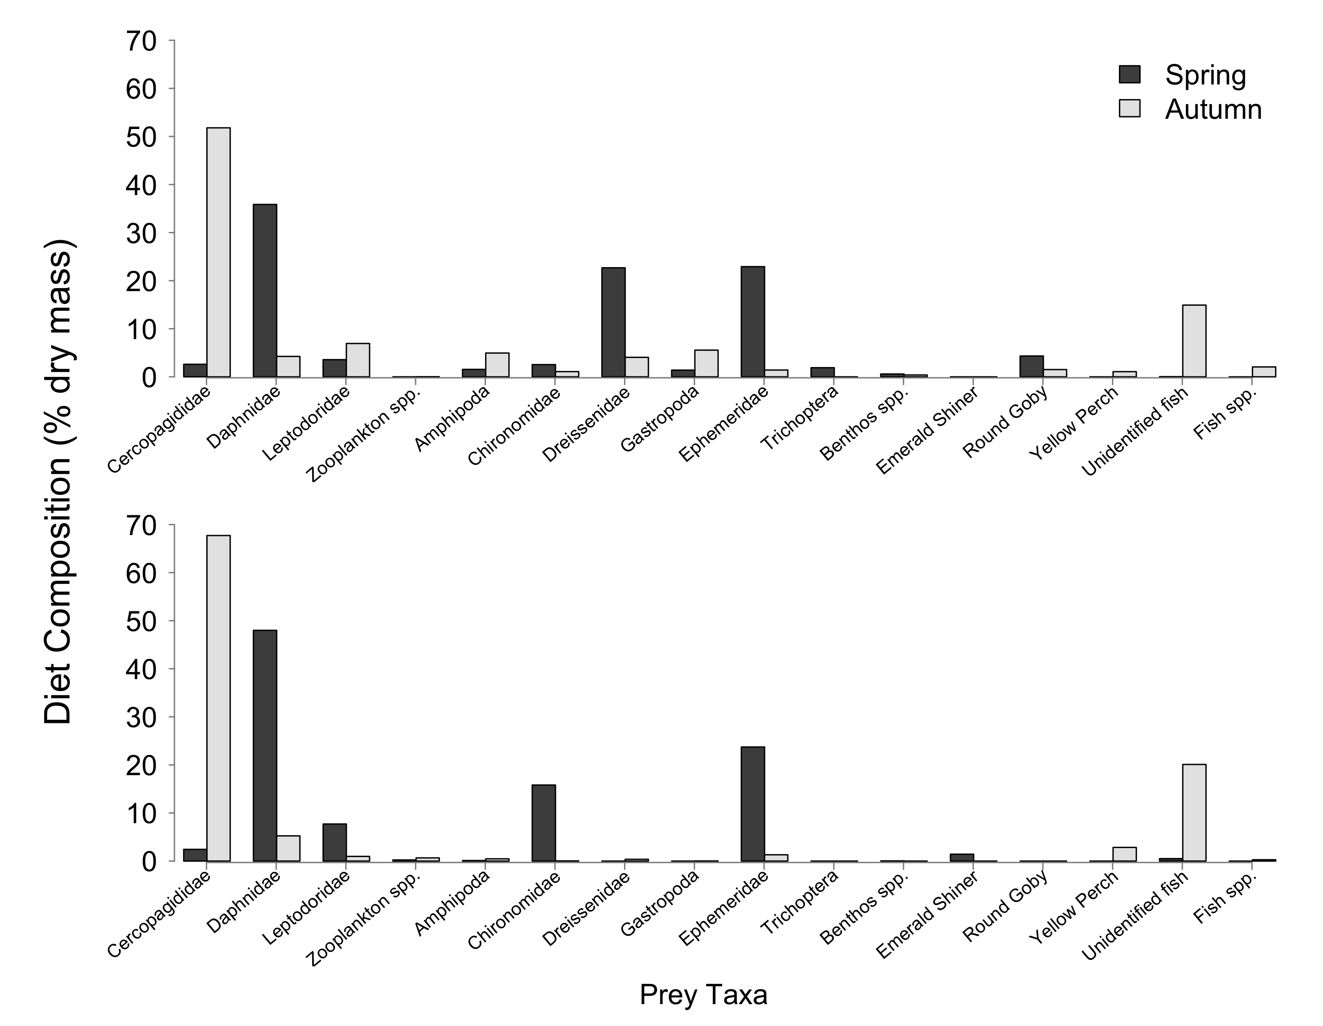

**Figure 2.5**. Age-2+ Yellow Perch (top panel) and White Perch (bottom panel) mean diet composition (% dry weight) by prey species in spring (black bars) and autumn (gray bars). Prey taxa: Zooplankton spp. include: Bosminidae, Sididae, Calanoida, and Cyclopoida; Benthos spp. include: Sphaeriidae, Hirudinea, Nematoda, Ostracoda, and hemimysis; Fish spp. include: Spottail Shiner, White Bass, Gizzard Shad, White Perch, and Fish Eggs.

In summary, Yellow Perch and White Perch diets in spring were collected across our western basin sampling area. Yellow Perch and White Perch showed a higher occurrence of zooplankton and fish prey in diets in both the spring and the autumn. In contrast, both species exhibited increased occurrence of benthic macroinvertebrates in diets in the autumn relative to the spring. Frequency of zooplankton in spring and autumn-collected diet samples has increased relative to historical data. *Hexagenia* spp. occurred frequently in diets in 2015 and contributed 46.7% to diet composition by weight in the spring. The timing of our spring sampling in 2015 coincided with a *Hexagenia* spp. hatch, and we found multiple fish with full stomachs that were comprised completely of *Hexagenia* spp. We continued to detect high occurrence of *Dreissena* spp. in Yellow Perch diets, but importance of *Dreissena* spp. to diets may be overestimated in diet content studies due to digestion and evacuation differences relative to softer prey (Brush et al. 2012). In 2015, invasive Cercopagididae was frequently observed in diets (maximum 82.4% of diets in White Perch in autumn). We observed 121 *Hemimysis* sp. in White Perch diets and 2 in Yellow Perch diet in spring. No *Cercopagis* sp. were identified in any fish diets.