# 2.0 Diet Analysis of Western Basin Age-2-and-Older Yellow Perch and White Perch

**Abstract**

*Native Yellow Perch**and invasive White Perch are abundant mid-trophic level predators in western Lake Erie. We evaluated diets of age-2-and-older Yellow Perch and White Perch collected in Lake Erie’s western basin during spring and autumn. Evaluation metrics included frequency of occurrence and contributions of prey to predator diets by weight. Benthic macroinvertebrates contributed most to Yellow Perch and White Perch diets during spring and autumn. Cercopagididae occurrence in Yellow Perch and White Perch diets was low in spring and increased in frequency in autumn. Compiling results from 2015 with data dating back to 2005 revealed increased utilization of zooplankton for both Yellow and White Perch during spring and autumn and decreased utilization of benthic macroinvertebrates and increased utilization of fish prey during autumn for both species.*

**Introduction**

A fish’s diet is the integrated response of multiple ecological interactions including habitat use, foraging behavior, prey community characteristics, and inter-specific interactions. Fish diet samples have quantified how the invasion of White Perch into Lake Erie in the early 1950s has influenced interactions with native Yellow Perch, which are similar in morphology and habitat use. Early research largely concluded that given the high foraging efficiency of White Perch there is both high potential for inter-specific competition and that the invasion of White Perch has negatively affected Yellow Perch (Parrish and Margraf 1990). Recent analyses using stable isotopes and diet contents suggest a low to moderate degree of overlap (Guzzo et al. 2013). Analysis of Yellow Perch diets can be a useful indicator of Lake Erie’s benthic community relative to direct sampling of benthos (Tyson and Knight 2001). As part of the LEBS Western Basin Forage Fish Assessment, we annually evaluate diet composition of age-2-and-older (age-2+) Yellow Perch and White Perch to…?.

**Methods**

Yellow Perch and White Perch were collected using a bottom trawl during the USGS Western Basin Forage Assessment surveys in June (Spring) and September (Autumn), 2015 (See Section 1.0). All trawl sampling occurred during daylight hours. A maximum of five age-2+ Yellow Perch and White Perch that showed no signs of regurgitation (exposed stomach or visible food content in the mouth cavity) at each bottom trawl site were retained for diet analysis. Total length, weight, sex, site location, and date were recorded for each collection. The digestive tract from each retained fish was removed, individually frozen, and returned to the laboratory for diet analysis. Otoliths were removed and processed in the laboratory to verify that our analyses were restricted to age-2+ fish.

In the laboratory, each diet sample was immersed in cold tap water to slowly thaw. The stomach was isolated from the digestive tract at the esophagus and pyloric caeca. The stomach was placed in a 0.25 mm sieve and cut lengthwise. Stomach contents were placed into a petri dish with soapy tap water to remove the surface tension of the water, thus allowing prey items to sink to the bottom of the dish where they were more easily identified. Once in the petri dish, stomach contents were counted and identified by taxon. A subsample was taken when ≥200 individuals of a particular prey item occurred in a given sample. To subsample, a petri dish was divided into eight equal sections and a count of each prey item was taken until 200 was reached. The area that contained n=200 was recorded and then extrapolated for the entire sample. Prey items from each stomach (when applicable) were dried at 60o C for 72 hrs to obtain dry weights by prey taxon. For diet items that could not be dried and weighed, length measurements were taken and later used to estimate dry weight using published length-weight and wet-weight:dry-weight conversion equations (equations and sources available upon request).

Diet analyses included percent occurrence by number and percent composition by dry weight. Diet data from non-empty stomachs were used to calculate diet contribution metrics by predator type (i.e., Yellow Perch and White Perch) and season for zooplankton, benthic macroinvertebrates, and fish prey. Percent occurrence was estimated as the number of fish examined that contained each prey item relative to the number of total fish with diet contents times 100. Percent composition by weight was calculated as the contribution of each prey type by dry weight to the total diet dry weight for each individual and then averaged across all fish for each species and season. Dry weights were not recorded in a majority of previous sampling years (2005-2012); therefore, frequency of occurrence metrics provided a comparison with previous results.. In addition, the historical collections before 2012 were only made from Michigan and Ontario waters; therefore, we restricted data from recent years to overlapping spatial areas for our analysis of historical time series.

**Figure 2.1**. Length distributions of age-2+ Yellow Perch (top row) and White Perch (bottom row) sampled for diet analysis during the 2015 Western Basin Forage Fish Assessment in the spring (left column) and autumn (right column).

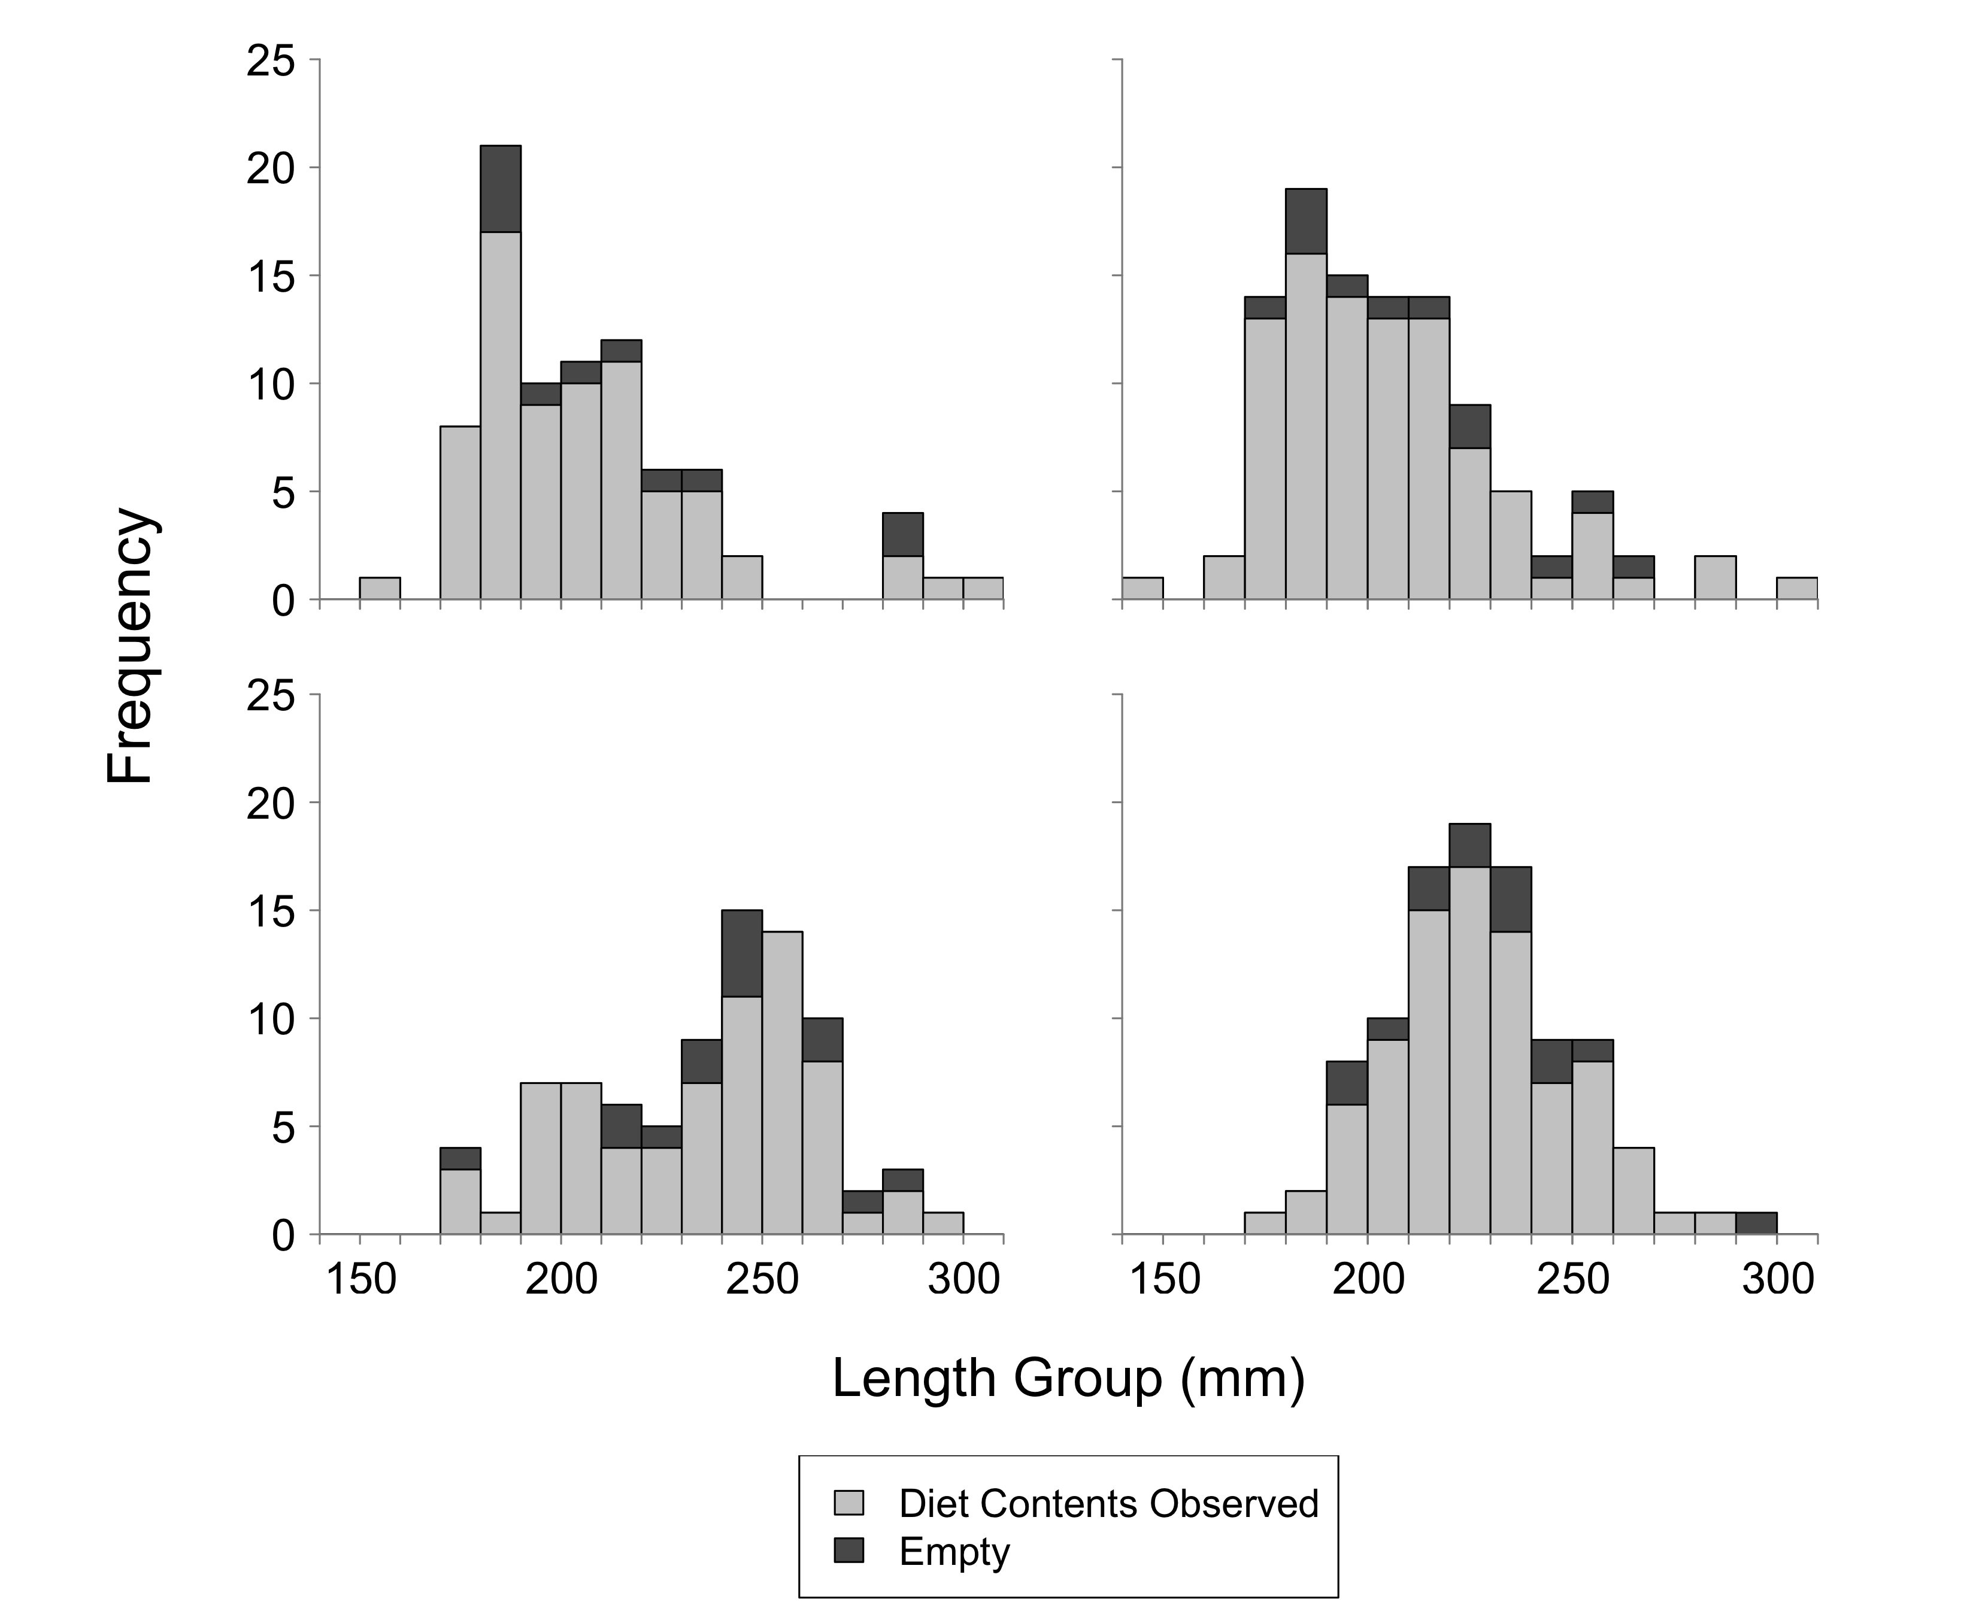

**Results**

*Frequency of occurrence*

Fish that contained diet items were representative of the total range of length groups collected for both species and seasons (Figure 2.1). Lengths of fish with diet contents were also similar between species, however a few small and extra-large Yellow Perch (i.e., total length less than 170mm and exceeding 300mm) were caught during spring and autumn sampling (Figure 2.1). The proportion of empty stomachs, relative to the number retained, was relatively low in the autumn and spring, and thus, we subsampled the number of sites used for diet analysis in both spring and autumn (N=34 and 37 sites, respectively). Subsampling was intended to allow diet description across the spatial extent of the survey (Figure 2.2).

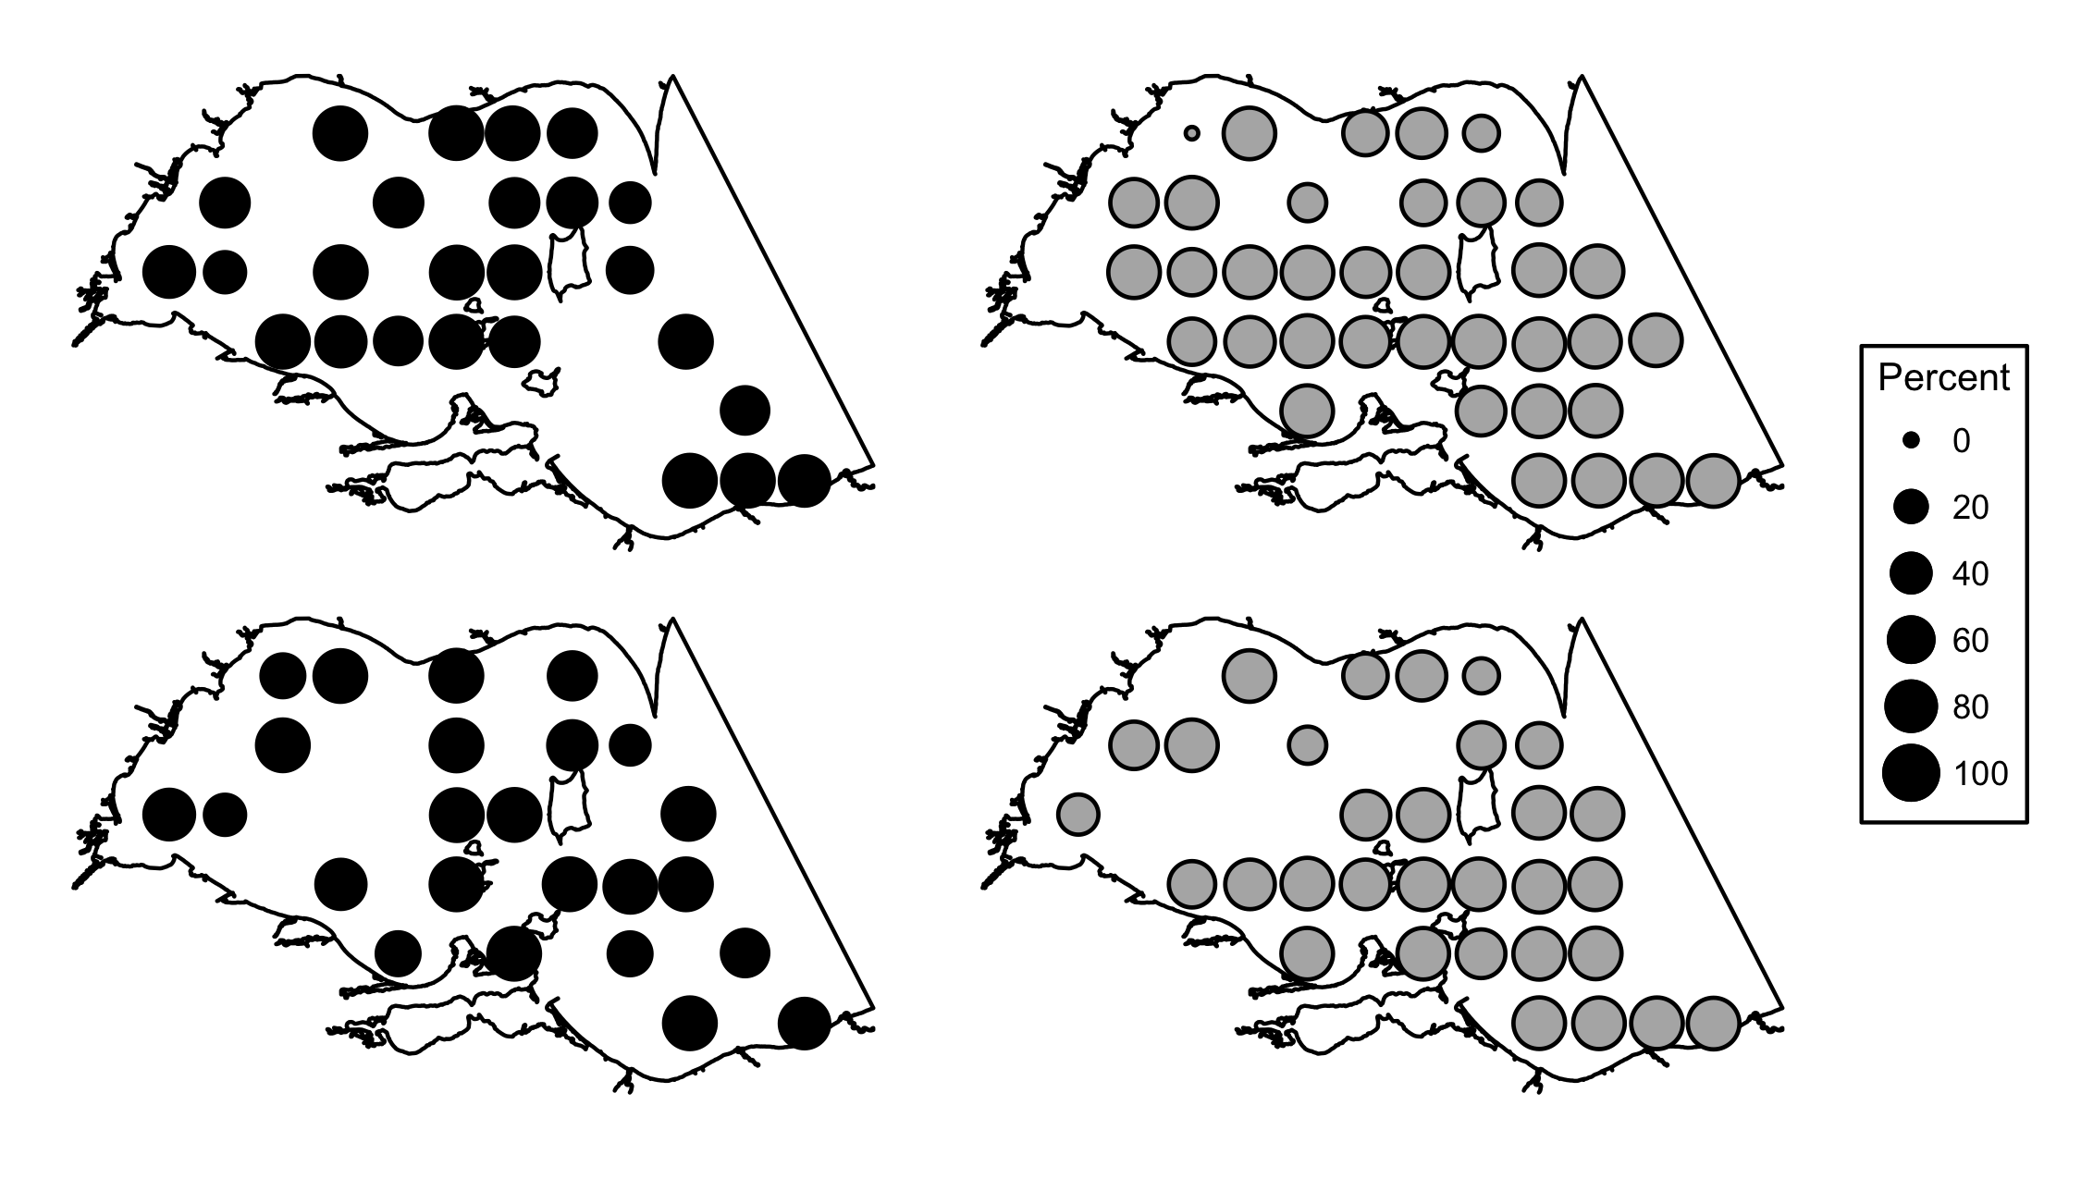

**Figure 2.2**. Percentage of stomachs with diet contents by site for Yellow Perch (top row) and White Perch (bottom row) during spring (black, left column) and autumn (gray, right column).

Spring sampling provided n=-84 age-2+ Yellow Perch stomachs that were collected from fish ranging between 159-303 mm in length with n=73 (86.9%) of the stomachs containing prey. In spring 2014, benthic macroinvertebrates were present in a majority of Yellow Perch stomachs (142.5%) and Ephemeridae (45.2%), Dreissenidae (27.4%), and Chironomidae (24.7%) were the most common benthic macroinvertebrates (Table 2.1). Zooplankton occurred in 86.2% of spring Yellow Perch stomachs with Daphnidae and Leptodoridae occurring most at 49.3% and 21.9%, respectively. Fish prey occurred in 10.9% of Yellow Perch stomachs during spring sampling with Round Goby as the most common identifiable fish taxonat 5.5% (Table 2.1).

During autumn sampling, n=105 age-2+ Yellow Perch stomachs were collected from fish ranging from 144-303 mm in length with n=93 (88.6%) stomachs containing prey. A decline in occurrence for benthic macroinvertebrates (43.1%) and an increase for zooplankton (151.6%) was observed in fall Yellow Perch diets relative to the spring. Occurrence of fish prey increased from spring to fall for Yellow Perch. Fish occurred in 27.0% of Yellow Perch stomachs, and unidentified fish remains were the most common fish prey type occurring in 19.4% of stomachs. Cercopagididae was detected at low occurrence in spring (8.2%) and increased frequency in fall (63.4%) (Table 2.1).

Spring sampling provided n=85 stomachs from age-2+ White Perch ranging from 170-290 mm in length. A total of n=70 (82.5%) of the White Perch stomachs contained prey items. In spring, zooplankton were present in 165.7% of samples with Daphnidae and Leptodoridae occurring most frequently at 72.9% and 44.3%, respectively. Benthic macroinvertebrates occurred in 99.9% of stomachs with Ephemeridae (45.7%) being most common. Fish were present in 5.7% of White Perch stomachs with unidentified fish (2.9%) occurring most frequently (Table 2.1).

During autumn sampling, stomachs of n=99 age-2+ White Perch were collected from fish ranging from 171-296 mm in length with n=85 (85.9%) containing prey items. Zooplankton was the most commonly occurring prey type in autumn (207.2%). A decline in occurrence for benthic macroinvertebrates (28.2%) was observed in autumn White Perch diets relative to the spring. Occurrence of fish prey increased from spring to autumn for White Perch. Fish occurred in 30.6% of diets, and unidentified fish remains were the most common fish prey occurring in 24.7% of diets.

Frequency of occurrence of zooplankton was higher for both White Perch and Yellow Perch in 2015 than in 2014 during both seasons (Figure 2.3). Zooplankton occurrence has shown a increasing trend over the past few years across both species in both seasons. Occurrence of benthic macroinvertebrates was lower in spring and autumn 2015 compared to 2014. Occurrence of fish in Yellow Perch and White Perch spring diets remained low (10.4% and 9.4%, respectively) and increased in the autumn (42.4% and 65.4%, respectively). Historically, zooplankton had a low occurrence in Yellow Perch and White Perch diets sampled in autumn, but in 2015 autumn diets sampled zooplankton occurred in higher frequency (145.5% and 200%, respectively). Benthic macroinvertebrates were found about half as often as in 2014 across both seasons and species (Figure 2.3). Occurrence of fish prey in diets has not shown unfamiliar change over recent years (Figure 2.3).

|  |  |  |  |  |  |  |  |  |  |  |  |  |  |  |  |
| --- | --- | --- | --- | --- | --- | --- | --- | --- | --- | --- | --- | --- | --- | --- | --- |
| **Table 2.1**  Frequency of occurrence of prey items in the diets of age-2+ Yellow Perch and White Perch collected during spring and autumn 2015 in Ontario, Michigan, and Ohio waters of Lake Erie's western basin. Abbreviation: n=number of stomachs containing prey items. | | | | | | | | | | | | | | | |
|  |  | | **Yellow** | | **Perch** | | |  | | **White** | | **Perch** | |  |
| Prey Type | Prey Taxa | | 2015 Spring n=73 | | 2015 Autumn n=93 | | | | 2015 Spring n=70 | | | 2015 Autumn n=85 | |  |
| **Zooplankton** |  | | **86.2** | **151.6** | | |  | | | **165.7** | **207.2** | |  | |
|  | Bosminidae | | 0.0 | 20.4 | | |  | | | 14.3 | 22.4 | |  | |
|  | Calanoida | | 4.1 | 6.5 | | |  | | | 15.7 | 12.9 | |  | |
|  | Cercopagididae | | 8.2 | 63.4 | | |  | | | 11.4 | 82.4 | |  | |
|  | Cyclopoida | | 2.7 | 7.5 | | |  | | | 7.1 | 12.9 | |  | |
|  | Daphnidae | | 49.3 | 31.2 | | |  | | | 72.9 | 51.8 | |  | |
|  | Leptodoridae | | 21.9 | 22.6 | | |  | | | 44.3 | 22.4 | |  | |
|  | Sididae | | 0.0 | 0.0 | | |  | | | 0.0 | 2.4 | |  | |
|  |  | |  |  | | |  | | |  |  | |  | |
| **Benthic Macroinvertebrates** | |  | **142.5** |  | | **43.1** | **99.9** | | | | **28.2** | |  | |
|  | Amphipoda | | 8.2 | 11.8 | | |  | | | 11.4 | 3.5 | |  | |
|  | Chironomidae | | 24.7 | 5.4 | | |  | | | 31.4 | 12.9 | |  | |
|  | Dreissenidae | | 27.4 | 5.4 | | |  | | | 0.0 | 1.2 | |  | |
|  | Ephemeridae | | 45.2 | 7.5 | | |  | | | 45.7 | 3.5 | |  | |
|  | Gastropoda | | 5.5 | 8.6 | | |  | | | 0.0 | 1.2 | |  | |
|  | Hemimysis | | 2.7 | 0.0 | | |  | | | 2.9 | 1.2 | |  | |
|  | Hirudinea | | 5.5 | 0.0 | | |  | | | 1.4 | 0.0 | |  | |
|  | Nematoda | | 2.7 | 1.1 | | |  | | | 5.7 | 0.0 | |  | |
|  | Oligochaeta | | 0.0 | 1.1 | | |  | | | 0.0 | 0.0 | |  | |
|  | Ostracoda | | 0.0 | 2.2 | | |  | | | 0.0 | 3.5 | |  | |
|  | Sphaeriidae | | 5.5 | 0.0 | | |  | | | 1.4 | 0.0 | |  | |
|  | Trichoptera | | 15.1 | 0.0 | | |  | | | 0.0 | 1.2 | |  | |
|  |  | |  |  | | |  | | |  |  | |  | |
| **Fishes** |  | | **10.9** | **27.0** | | |  | | | **5.7** | **30.6** | |  | |
|  | Emerald Shiner | | 0.0 | 0.0 | | |  | | | 1.4 | 0.0 | |  | |
|  | Fish eggs | | 2.7 | 0.0 | | |  | | | 1.4 | 0.0 | |  | |
|  | Gizzard Shad | | 0.0 | 1.1 | | |  | | | 0.0 | 0.0 | |  | |
|  | Round Goby | | 5.5 | 3.2 | | |  | | | 0.0 | 0.0 | |  | |
|  | Spottail Shiner | | 0.0 | 1.1 | | |  | | | 0.0 | 0.0 | |  | |
|  | Unidentified fish | | 2.7 | 19.4 | | |  | | | 2.9 | 24.7 | |  | |
|  | White Bass | | 0.0 | 0.0 | | |  | | | 0.0 | 1.2 | |  | |
|  | White Perch | | 0.0 | 1.1 | | |  | | | 0.0 | 0.0 | |  | |
|  | Yellow Perch | | 0.0 | 1.1 | | |  | | | 0.0 | 4.7 | |  | |

**Figure 2.3.** Historical percent occurrence in age-2+ Yellow Perch (back solid line and filled circles) and White Perch diets (gray dashed line and unfilled circles) of zooplankton (top row), benthic macroinvertebrates (middle row) and fish (bottom row) during spring (left column) and autumn (right column). Included 2015 sites were restricted to those near historical trawl sites in Michigan and Ontario. Percent occurrence values from 2014 were corrected in this report.

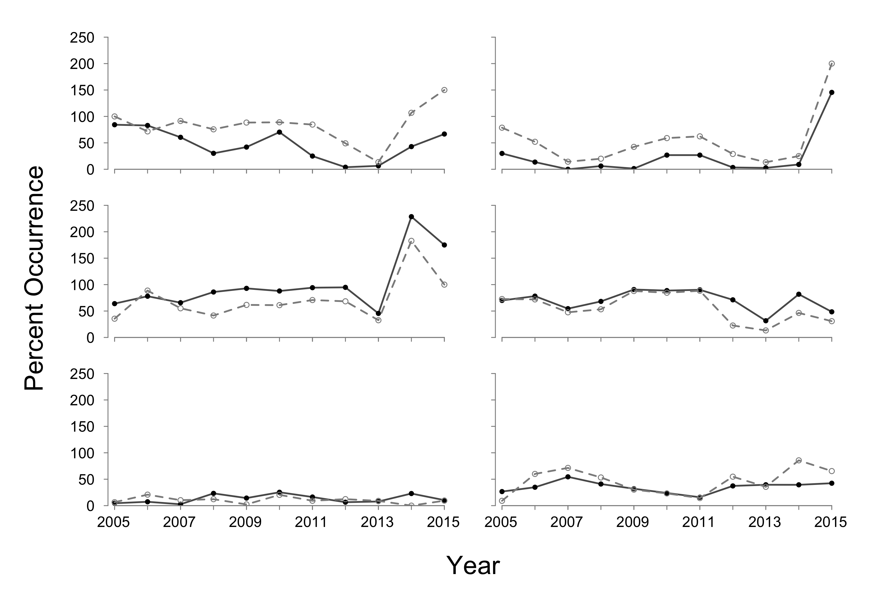

*Percent composition by weight*

Benthic macroinvertebrates contributed most to age-2+ Yellow Perch diets in spring (53.6%), followed by zooplankton (42.0%) and fish prey (4.4%, Figure 2.4). Dreissenidae (22.7%) and Ephemeridae (22.9%) were the predominate benthic macroinvertebrate contributors by weight in the spring (Figure 2.5). Daphnidae (35.9%)was the dominant zooplankton taxa, while Round Goby (4.3%) was the most prominent identifiable fish prey in spring Yellow Perch diets (Figure 2.5).

In autumn, zooplankton made the highest contribution to diets (63.0%), followed by fish prey (19.6%) and benthic macroinvertebrates (17.4%) (Figure 2.4). The major zooplankton taxa contributors in autumn were Cercopagididae (51.8%).Gastropoda, Amphipoda, and Dreissenidae, which accounted for almost 100% of total benthic macroinvertebrates observed in diets. The major fish prey taxa contributors in autumn was unidentified fish remains (14.9%; Figure 2.5).

Spring White Perch diets were predominately composed of zooplankton (58.4%), followed by benthic macroinvertebrates (39.7%) and fish prey (1.9%) (Figure 2.4). Daphnidae was the dominant zooplankton taxa contributing 48.0% to diet weight on average in spring (Figure 2.4). Ephemeridaeand Emerald Shiner were the dominant contributors for their respective prey groups.

Zooplankton contributed most to White Perch diets in autumn (74.6%), followed by fish prey (23.2%) and benthic macroinvertebrates (2.2%) (Figure 2.4). Cercopagididae were the major zooplankton prey taxa (67.7%) during autumn. Unidentified fish remains were the predominate fish prey taxa and Ephemeridae was the predominate benthic macroinvertebrate taxa during autumn (Figure 2.5).

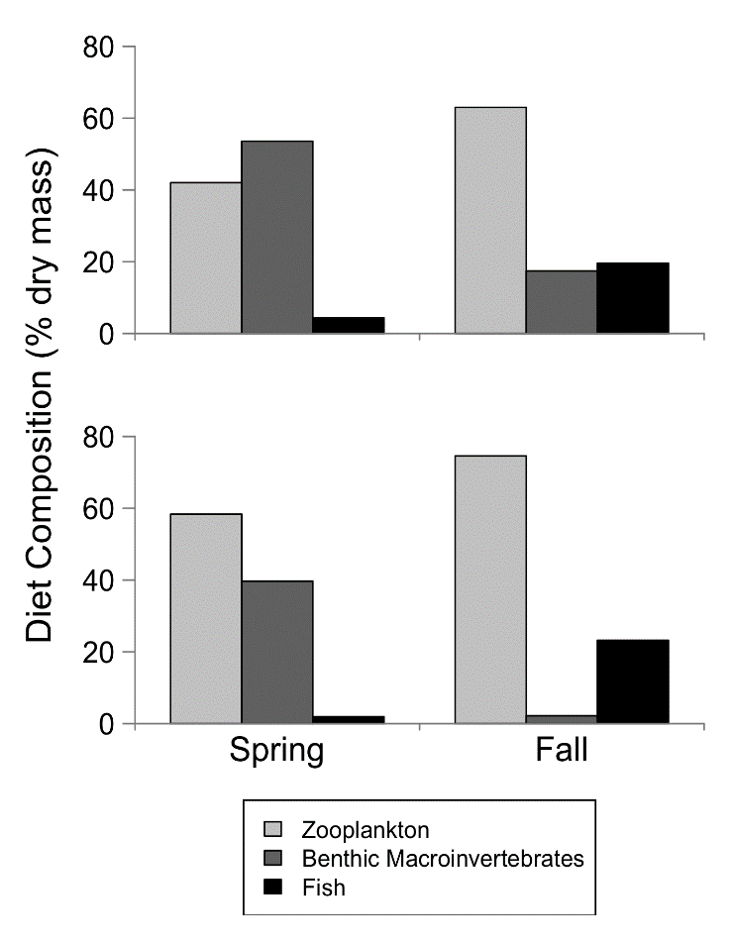

**Figure 2.4**. Diet composition (% dry weight) of Age-2+ Yellow Perch (top panel) and White Perch (bottom panel) by main prey type and season from 2015 bottom trawl samples.

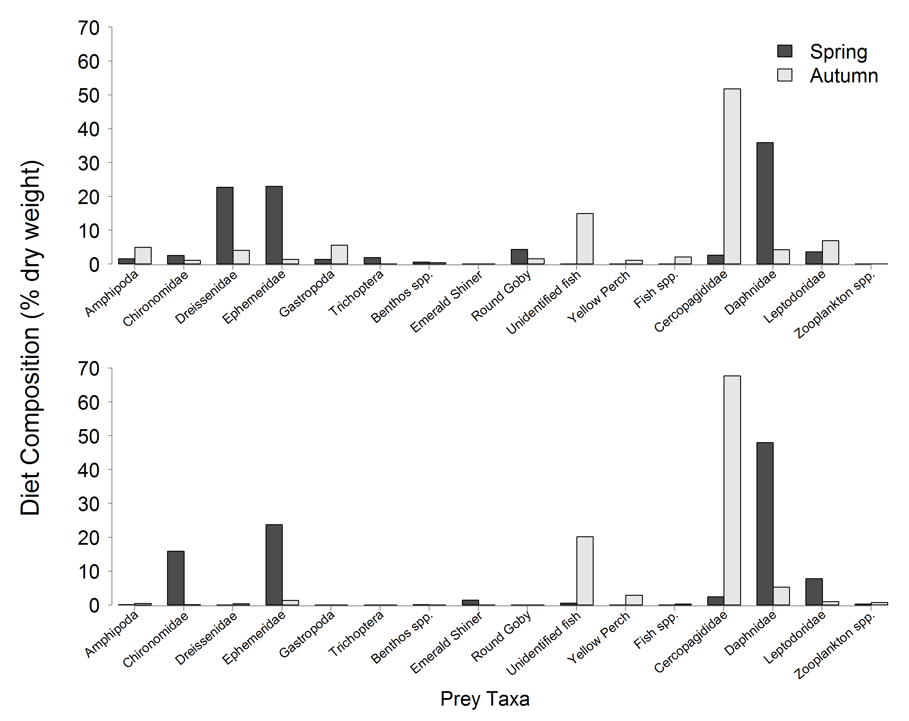

**Figure 2.5**. Age-2+ Yellow Perch (top panel) and White Perch (bottom panel) mean diet composition (% dry weight) by prey species in spring (black bars) and autumn (gray bars). Prey taxa: Zooplankton spp. include Bosminidae, Sididae, Calanoida, and Cyclopoida; Benthos spp. include Sphaeriidae, Hirudinea, Nematoda, Ostracoda, and Hemimysis; Fish spp. include Spottail Shiner, White Bass, Gizzard Shad, White Perch, and Fish Eggs.

In summary, Yellow Perch and White Perch diets in spring were collected across our western basin sampling area. Yellow Perch and White Perch showed a higher occurrence of zooplankton and fish prey in diets in both the spring and the autumn. In contrast, both species exhibited increased occurrence of benthic macroinvertebrates in diets in the autumn relative to the spring. Frequency of zooplankton in spring and autumn-collected diet samples has increased relative to historical data. Ephemeridae occurred frequently in diets in 2015 and contributed 46.7% to diet composition by weight in the spring. The timing of our spring sampling in 2015 coincided with an Ephemeridae hatch, and we found multiple fish with full stomachs that were comprised completely of Ephemeridae. We continued to detect high occurrence of Dreissenidae in Yellow Perch diets, but importance of Dreissenidae to diets may be overestimated in diet content studies due to digestion and evacuation differences relative to softer prey (Brush et al. 2012). In 2015, invasive Cercopagididae frequently occurred in diets (maximum 82.4% of diets in White Perch in autumn). We observed 121 *Hemimysis* sp. in White Perch diets and 2 in Yellow Perch diet in spring. No *Cercopagis* sp. were identified in any fish diets.