# 2.0 Diet Analysis of Western Basin Age-2-and-Older Yellow Perch and White Perch

**Abstract**

*Native Yellow Perch**and non-native White Perch are abundant mid-trophic level predators in western Lake Erie. Previous studies have suggested that the establishment of White Perch might have adversely affected the resident fish community. In order to examine possible inter-specific interactions, we evaluated diets of age-2-and-older Yellow Perch and White Perch collected in Lake Erie’s western basin during spring and autumn. Evaluation metrics included percent frequency of occurrence and contributions of prey to predator diets by dry weight. Benthic macroinvertebrates contributed most to Yellow Perch and White Perch diets during spring and autumn. Cercopagididae occurrence in Yellow Perch and White Perch diets was low in spring and increased in frequency in autumn. Compiling results from 2015 with data dating back to 2005 revealed increased utilization of zooplankton for both Yellow Perch and White Perch during spring and autumn and decreased utilization of benthic macroinvertebrates and increased utilization of fish prey during autumn for both species.*

**Introduction**

A fish’s diet is the integrated response of multiple ecological interactions including habitat use, foraging behavior, prey community characteristics, and inter-specific interactions. Fish diet samples have quantified how the invasion of White Perch into Lake Erie in the early 1950s has influenced interactions with native Yellow Perch, which are similar in morphology and habitat use. Early research largely concluded that given the high foraging efficiency of White Perch there is both high potential for inter-specific competition and that the invasion of White Perch has negatively affected Yellow Perch (Parrish and Margraf 1990). Recent analyses using stable isotopes and diet contents suggest a low to moderate degree of overlap (Guzzo et al. 2013). Analysis of Yellow Perch diets can be a useful indicator of Lake Erie’s benthic community relative to direct sampling of benthos (Tyson and Knight 2001). As part of the LEBS Western Basin Forage Fish Assessment, we annually evaluate diet composition of age-2-and-older (age-2+) Yellow Perch and White Perch to assess possible inter-specific ecological interactions.

**Methods**

Yellow Perch and White Perch were collected using a bottom trawl during the USGS Western Basin Forage Assessment surveys in June (Spring) and September (Autumn), 2015 (See Section 1.0). All trawl sampling occurred during daylight hours. We retained a maximum of five age-2+ Yellow Perch and White Perch that showed no signs of regurgitation (exposed stomach or visible food contents in the mouth cavity) at each bottom trawl site for diet analysis. We recorded total length, weight, sex, site location, and date for each collection. We removed and froze the digestive tract from each retained fish for diet analysis. We used age estimates from otoliths to verify that our analyses were restricted to age-2+ fish.

In the laboratory, we immersed each diet sample in cold tap water to thaw. The stomach was isolated from the digestive tract at the esophagus and pyloric caeca. We cut the stomach lengthwise and the placed the contents into a petri dish with soapy tap water to reduce surface tension of the water, thus allowing prey items to sink to the bottom of the dish where they were more easily identified. Once in the petri dish, we counted and identified the diet contents by taxon. We subsampled when ≥200 individuals of a particular prey item occurred in a given sample. To subsample, we divided a petri dish into eight equal sections and took a count of each prey item until 200 was reached. The area that contained n=200 was recorded and then extrapolated for the entire sample. We obtained dry weights by drying the prey items from each diet by prey taxon (when applicable) at 60o C for 72 hours. For diet items that could not be dried and weighed, length measurements were taken and later used to estimate dry weight using published length-weight and wet-weight:dry-weight conversion equations (equations and sources available upon request).

A majority of the previous sampling years (2005-2012) did not include dry weight data; therefore, percent frequency of occurrence metrics provided a comparison with previous results. In addition, prior to 2012 we only sampled Michigan and Ontario waters; therefore, we restricted data from recent years to overlapping spatial areas for our analysis of historical time series.

Diet analyses included percent occurrence by number and percent composition by weight. We used dry weights following recommendations of Bowen (1996). We used diet data from non-empty stomachs to calculate diet contribution metrics by predator type (i.e., Yellow Perch and White Perch) and season for zooplankton, benthic macroinvertebrates, and fish prey. We estimated frequency of occurrence as the number of fish examined that contained each prey item relative to the number of total fish with diet contents times 100. Percent composition by weight is the contribution of each prey type to the total diet by dry weight for each individual. We then averaged percent weight across fish to compare each predator species and season.

**Results**

*Frequency of occurrence*

Length distribution of subsampled fish with diet contents was similar between species; however, we sampled a few small and extra-large Yellow Perch (i.e., total length less than 170mm and exceeding 300mm) during spring and autumn sampling (Figure 2.1). The proportion of empty stomachs, relative to the number retained, was relatively low in the autumn and spring, and thus, we subsampled the number of sites used for diet analysis in both spring and autumn (N=34 and 37 sites, respectively). Subsampling allowed diet description across the spatial extent of the survey (Figure 2.2).

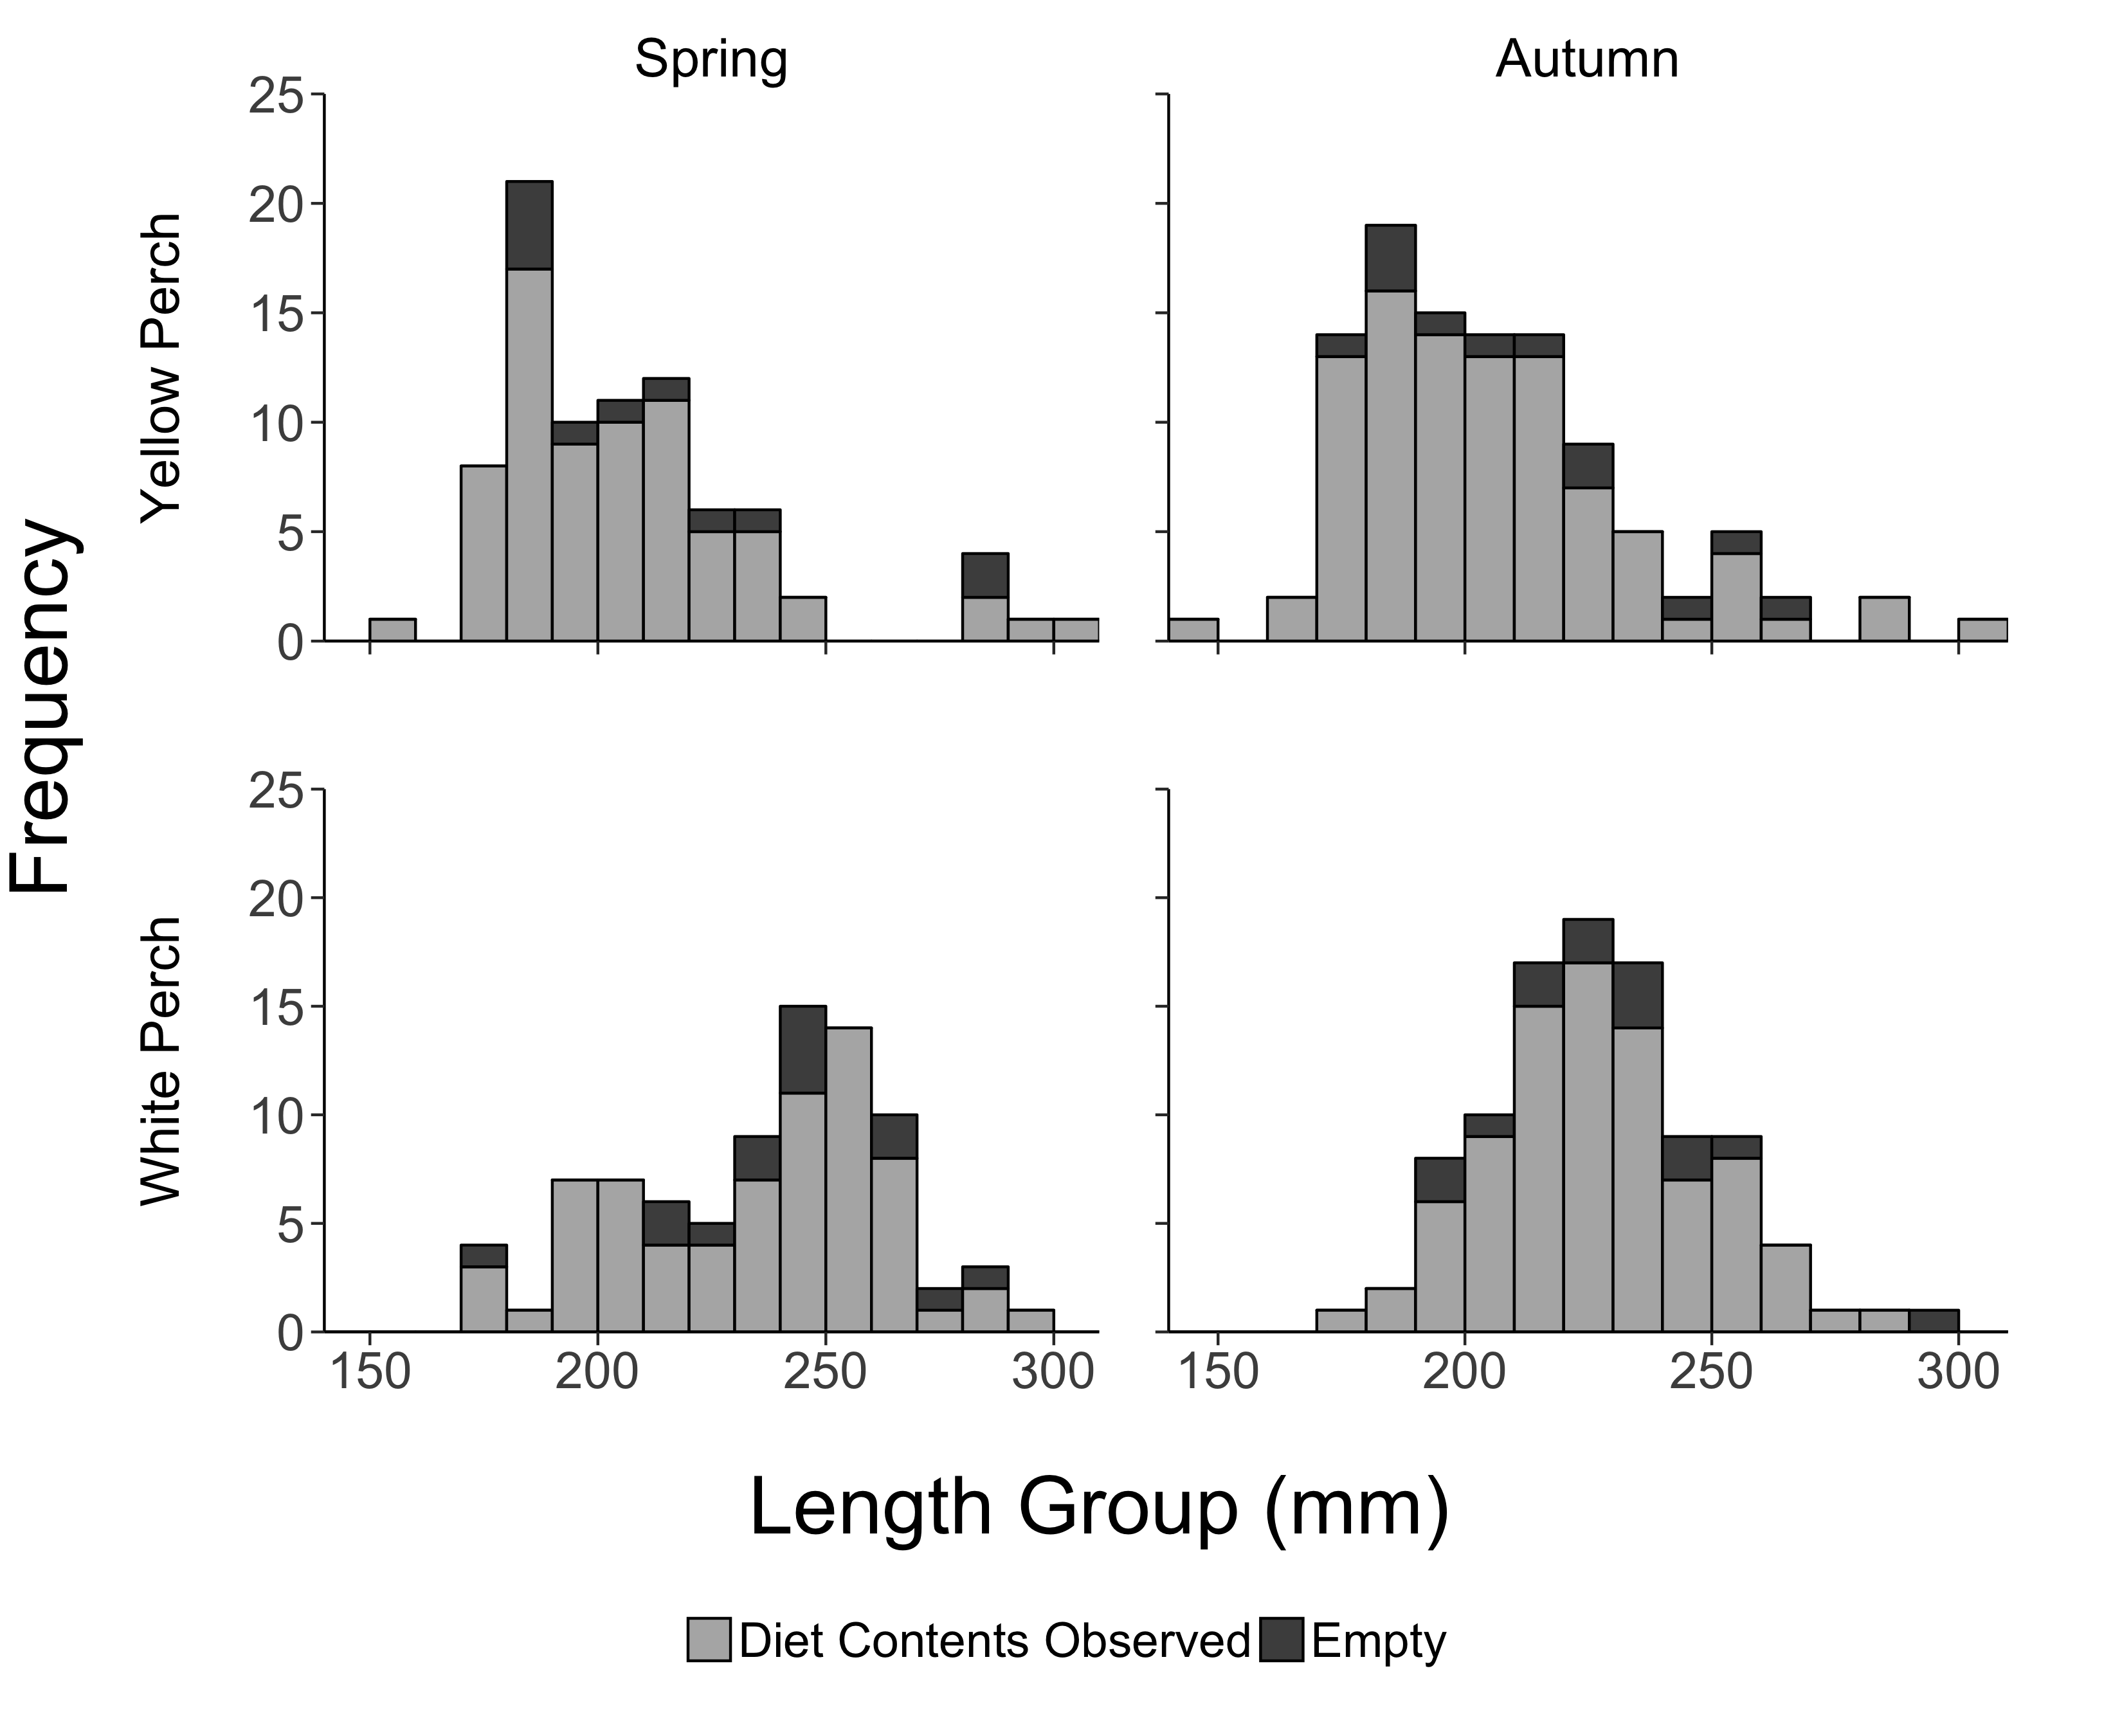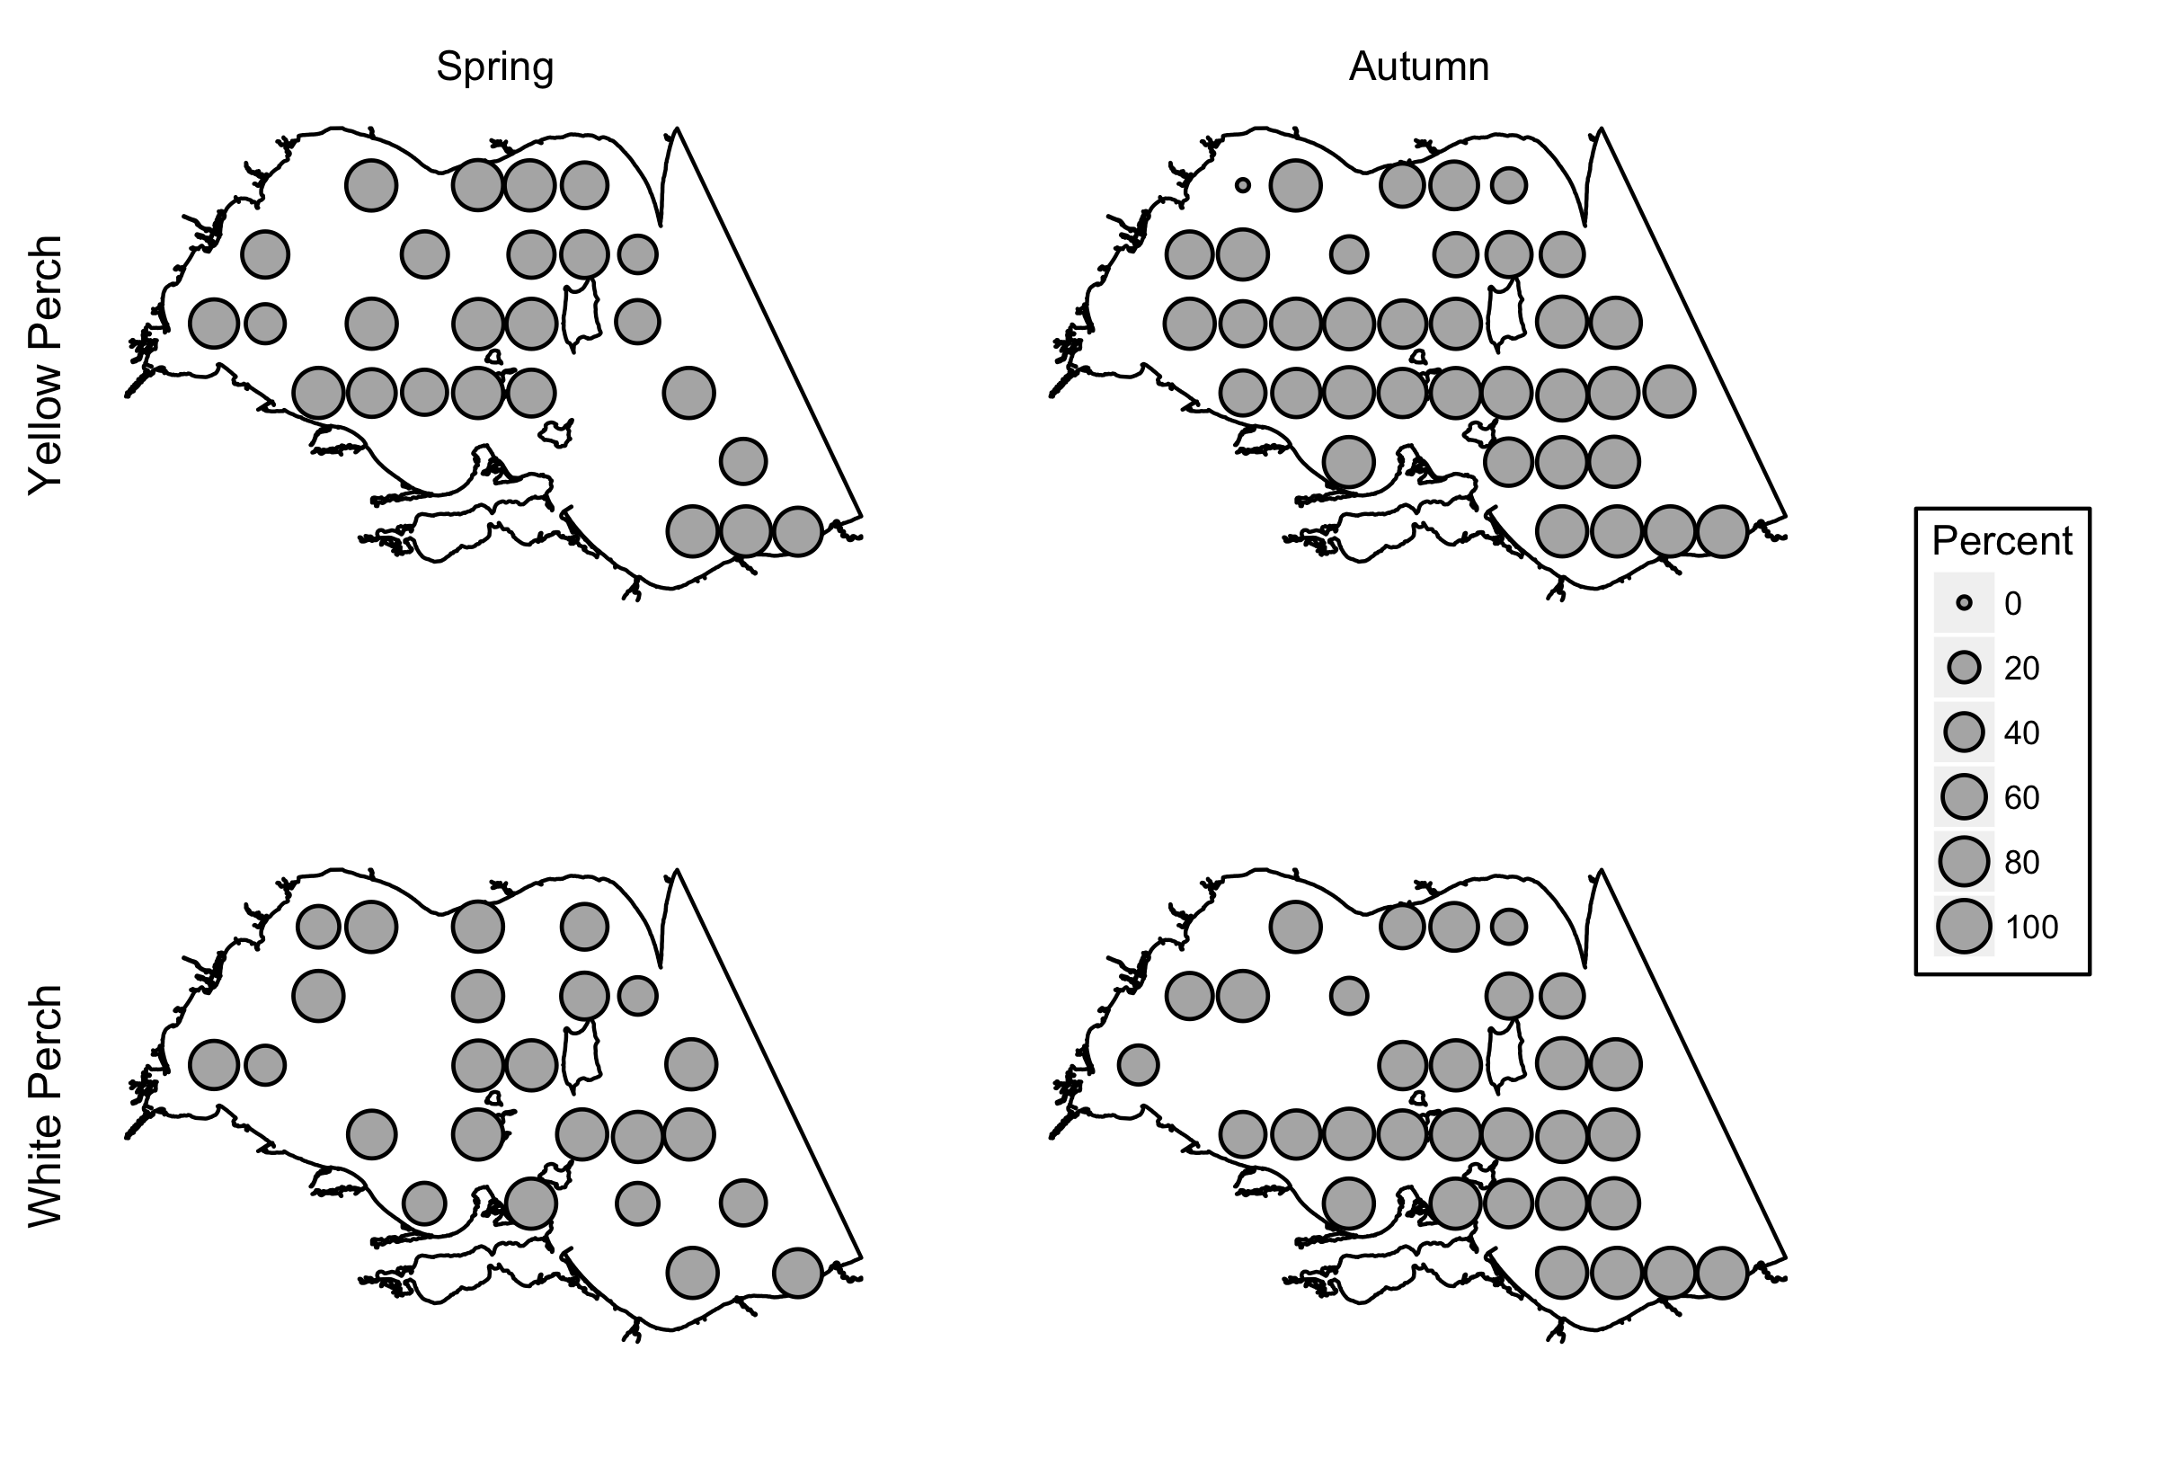

**Figure 2.1**. Length distributions of age-2+ Yellow Perch (top row) and White Perch (bottom row) sampled for diet analysis during the 2015 Western Basin Forage Fish Assessment in the spring (left column) and autumn (right column).

**Figure 2.2**. Percentage of stomachs with diet contents by site for Yellow Perch (top row) and White Perch (bottom row) during spring (left column) and autumn (right column).

Spring sampling provided n=84 age-2+ Yellow Perch diets that were collected from fish ranging between 159-303 mm total length with n=73 (86.9%) of the diets containing prey. In spring 2015, benthic macroinvertebrates were present in a majority of Yellow Perch diets (63.0%) and Ephemeridae (exclusively *Hexagenia* spp.) (45.2%), Dreissenidae (27.4%), and Chironomidae (19.2%) were the most common benthic macroinvertebrates (Table 2.1). Zooplankton occurred in 49.3% of spring Yellow Perch diets with Daphnidae (46.6%) and Leptodoridae (21.9%) occurring most frequently. Fish prey occurred in 8.2% of Yellow Perch diets during spring sampling with Round Goby as the most common identifiable fish taxon at 5.5% (Table 2.1).

During autumn sampling, n=105 age-2+ Yellow Perch diets were collected from fish ranging from 144-303 mm total length with n=93 (88.6%) diets containing prey. We observed a decline in occurrence for benthic macroinvertebrates (28.0%) and an increase for zooplankton (82.8%) in fall Yellow Perch diets relative to the spring. Cercopagididae (exclusively *Bythotrephes* sp.) exhibited a low occurrence in spring (8.2%) and increased frequency in fall (63.4%). Occurrence of fish prey increased from spring to fall for Yellow Perch. Fish occurred in 24.7% of Yellow Perch diets, and Round Goby was the most common identifiable fish prey type occurring in 3.2% of diets (Table 2.1).

Spring sampling provided n=85 diets from age-2+ White Perch ranging from 170-290 mm total length. A total of n=70 (82.5%) of the White Perch diets contained prey items. In spring, zooplankton was present in 75.7% of samples with Daphnidae (68.6%) and Leptodoridae (44.3%) occurring most frequently. Benthic macroinvertebrates occurred in 61.4% of spring diets with Ephemeridae (45.7%) being most common. Fish were present in 5.7% of White Perch diets with Emerald Shiner (2.9%) being the most frequently observed identifiable fish prey type (Table 2.1).

During autumn sampling, diets of n=99 age-2+ White Perch were collected from fish ranging from 171-296 mm total length with n=85 (85.9%) diets containing prey items. Zooplankton was the most commonly occurring prey type in autumn (90.6%). Cercopagididae exhibited a low occurrence in spring (11.4%) and increased in autumn (82.4%). We observed a decline in occurrence for benthic macroinvertebrates (20.0%) in White Perch diets in autumn relative to spring diets. Occurrence of fish prey increased from spring to autumn for White Perch. Fish occurred in 25.9% of diets, and Yellow Perch was the most common identifiable fish prey occurring in 4.7% of diets (Table 2.1).

Frequency of occurrence of zooplankton was higher for both White Perch and Yellow Perch in 2015 than in 2014 during both seasons (Figure 2.3). Zooplankton occurrence has shown an increasing trend over the past few years across both species in both seasons. Occurrence of benthic macroinvertebrates was lower in spring and autumn 2015 compared to 2014. Occurrence of fish in Yellow Perch and White Perch spring diets remained low (10.4% and 9.4%, respectively) and increased in the autumn (42.4% and 65.4%, respectively). Historically, zooplankton had a low occurrence in Yellow Perch and White Perch diets sampled in autumn, but in 2015 autumn diets zooplankton occurred in higher frequency (90.6% and 82.8%, respectively). Benthic macroinvertebrates occurred about half as often as in 2014 across both seasons and species (Figure 2.3). Occurrence of fish prey in diets has not shown unfamiliar change over recent years (Figure 2.3).

|  |  |  |  |  |  |  |  |  |  |  |  |  |  |  |  |
| --- | --- | --- | --- | --- | --- | --- | --- | --- | --- | --- | --- | --- | --- | --- | --- |
| **Table 2.1**  Percent frequency of occurrence of prey items in the diets of age-2+ Yellow Perch and White Perch collected during spring and autumn 2015 in Ontario, Michigan, and Ohio waters of Lake Erie's western basin. Abbreviation: n=number of stomachs containing prey items. | | | | | | | | | | | | | | | |
|  |  | | **Yellow** | | **Perch** | | |  | | **White** | | **Perch** | |  |
| Prey Type | Prey Taxa | | 2015 Spring n=73 | | 2015 Autumn n=93 | | | | 2015 Spring n=70 | | | 2015 Autumn n=85 | |  |
| **Zooplankton** |  | | **49.3** | **82.8** | | |  | | | **75.7** | **90.6** | |  | |
|  | Bosminidae | | 0.0 | 20.4 | | |  | | | 14.3 | 22.4 | |  | |
|  | Calanoida | | 4.1 | 6.5 | | |  | | | 15.7 | 12.9 | |  | |
|  | Cercopagididae | | 8.2 | 63.4 | | |  | | | 11.4 | 82.4 | |  | |
|  | Cyclopoida | | 2.7 | 7.5 | | |  | | | 7.1 | 12.9 | |  | |
|  | Daphnidae | | 46.6 | 31.2 | | |  | | | 68.6 | 47.1 | |  | |
|  | Leptodoridae | | 21.9 | 22.6 | | |  | | | 44.3 | 22.4 | |  | |
|  | Sididae | | 0.0 | 0.0 | | |  | | | 0.0 | 2.4 | |  | |
|  |  | |  |  | | |  | | |  |  | |  | |
| **Benthic Macroinvertebrates** | |  | **63.0** |  | | **28.0** | **61.4** | | | | **20.0** | |  | |
|  | Amphipoda | | 8.2 | 11.8 | | |  | | | 11.4 | 3.5 | |  | |
|  | Chironomidae | | 19.2 | 5.4 | | |  | | | 28.6 | 11.8 | |  | |
|  | Dreissenidae | | 27.4 | 5.4 | | |  | | | 0.0 | 1.2 | |  | |
|  | Ephemeridae | | 45.2 | 7.5 | | |  | | | 45.7 | 3.5 | |  | |
|  | Gastropoda | | 5.5 | 8.6 | | |  | | | 0.0 | 1.2 | |  | |
|  | Hemimysis | | 2.7 | 0.0 | | |  | | | 2.9 | 1.2 | |  | |
|  | Hirudinea | | 5.5 | 0.0 | | |  | | | 1.4 | 0.0 | |  | |
|  | Nematoda | | 2.7 | 1.1 | | |  | | | 5.7 | 0.0 | |  | |
|  | Oligochaeta | | 0.0 | 1.1 | | |  | | | 0.0 | 0.0 | |  | |
|  | Ostracoda | | 0.0 | 2.2 | | |  | | | 0.0 | 3.5 | |  | |
|  | Sphaeriidae | | 5.5 | 0.0 | | |  | | | 1.4 | 0.0 | |  | |
|  | Trichoptera | | 15.1 | 0.0 | | |  | | | 0.0 | 1.2 | |  | |
|  |  | |  |  | | |  | | |  |  | |  | |
| **Fishes** |  | | **8.2** | **24.7** | | |  | | | **5.7** | **25.9** | |  | |
|  | Emerald Shiner | | 0.0 | 0.0 | | |  | | | 1.4 | 0.0 | |  | |
|  | Fish eggs | | 2.7 | 0.0 | | |  | | | 1.4 | 0.0 | |  | |
|  | Gizzard Shad | | 0.0 | 1.1 | | |  | | | 0.0 | 0.0 | |  | |
|  | Round Goby | | 5.5 | 3.2 | | |  | | | 0.0 | 0.0 | |  | |
|  | Spottail Shiner | | 0.0 | 1.1 | | |  | | | 0.0 | 0.0 | |  | |
|  | Unidentified fish | | 2.7 | 19.4 | | |  | | | 2.9 | 23.5 | |  | |
|  | White Bass | | 0.0 | 0.0 | | |  | | | 0.0 | 1.2 | |  | |
|  | White Perch | | 0.0 | 1.1 | | |  | | | 0.0 | 0.0 | |  | |
|  | Yellow Perch | | 0.0 | 1.1 | | |  | | | 0.0 | 4.7 | |  | |

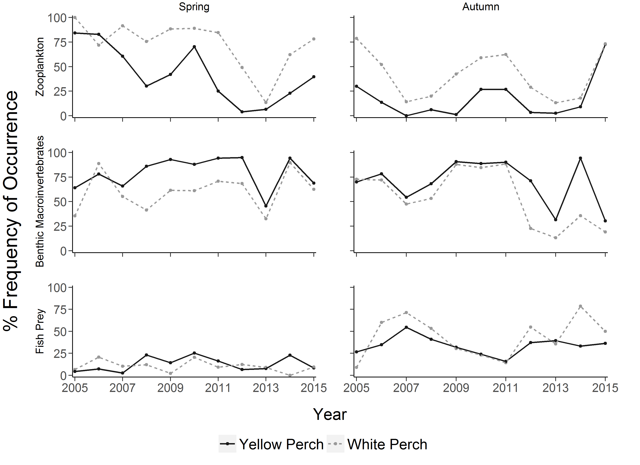

**Figure 2.3.** Historical frequency of occurrence in age-2+ Yellow Perch (black, solid line) and White Perch diets (gray, dashed line) of zooplankton (top row), benthic macroinvertebrates (middle row) and fish (bottom row) during spring (left column) and autumn (right column). Included 2013-2015 sites were restricted to those near historical trawl sites in Michigan and Ontario.

*Percent composition by weight*

Benthic macroinvertebrates contributed most to age-2+ Yellow Perch diets in spring (53.6%), followed by zooplankton (42.0%) and fish prey (4.4%, Figure 2.4). Dreissenidae (22.7%) and Ephemeridae (22.9%) were the predominate benthic macroinvertebrate contributors by weight in the spring (Figure 2.5). Daphnidae (35.9%)was the dominant zooplankton taxa, while Round Goby (4.3%) was the most prominent identifiable fish prey in spring Yellow Perch diets (Figure 2.5).

In autumn, zooplankton made the highest contribution to diets (63.0%), followed by fish prey (19.6%) and benthic macroinvertebrates (17.4%) (Figure 2.4). The major zooplankton taxon contributor in autumn was Cercopagididae (51.8%).Gastropoda, Amphipoda, and Dreissenidae, which accounted for almost 100% of total benthic macroinvertebrate weight observed in diets. The major identifiable fish prey taxon contributor in autumn was Round Goby (1.5%; Figure 2.5).

Spring White Perch diets were predominately composed of zooplankton (58.4%), followed by benthic macroinvertebrates (39.7%) and fish prey (1.9%) (Figure 2.4). Daphnidae was the dominant zooplankton taxa contributing 48.0% to diet weight on average in spring (Figure 2.4). Ephemeridaeand Emerald Shiner were the dominant contributors for their respective prey groups.

Zooplankton contributed most to White Perch diets in autumn (74.6%), followed by fish prey (23.2%) and benthic macroinvertebrates (2.2%) (Figure 2.4). Cercopagididae was the major zooplankton prey (67.7%) during autumn. Yellow Perch was the highest contributing identifiable fish prey taxon. Ephemeridae (1.3%) was the highest contributing benthic macroinvertebrate taxon during autumn (Figure 2.5).

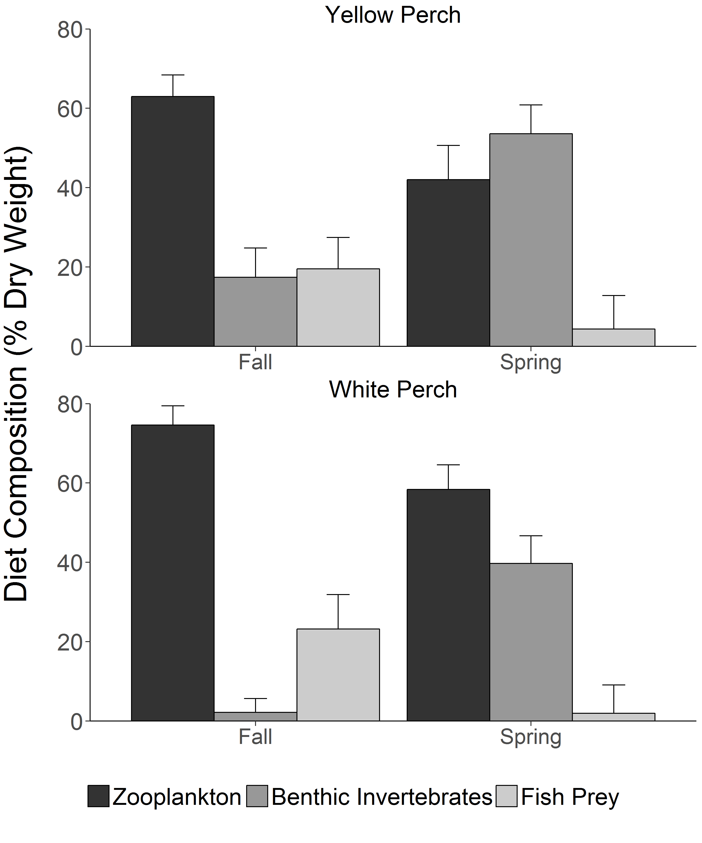

**Figure 2.4**. Diet composition (% dry weight) of Age-2+ Yellow Perch (top panel) and White Perch (bottom panel) by main prey type and season from 2015 bottom trawl samples. Error bars indicate standard error.

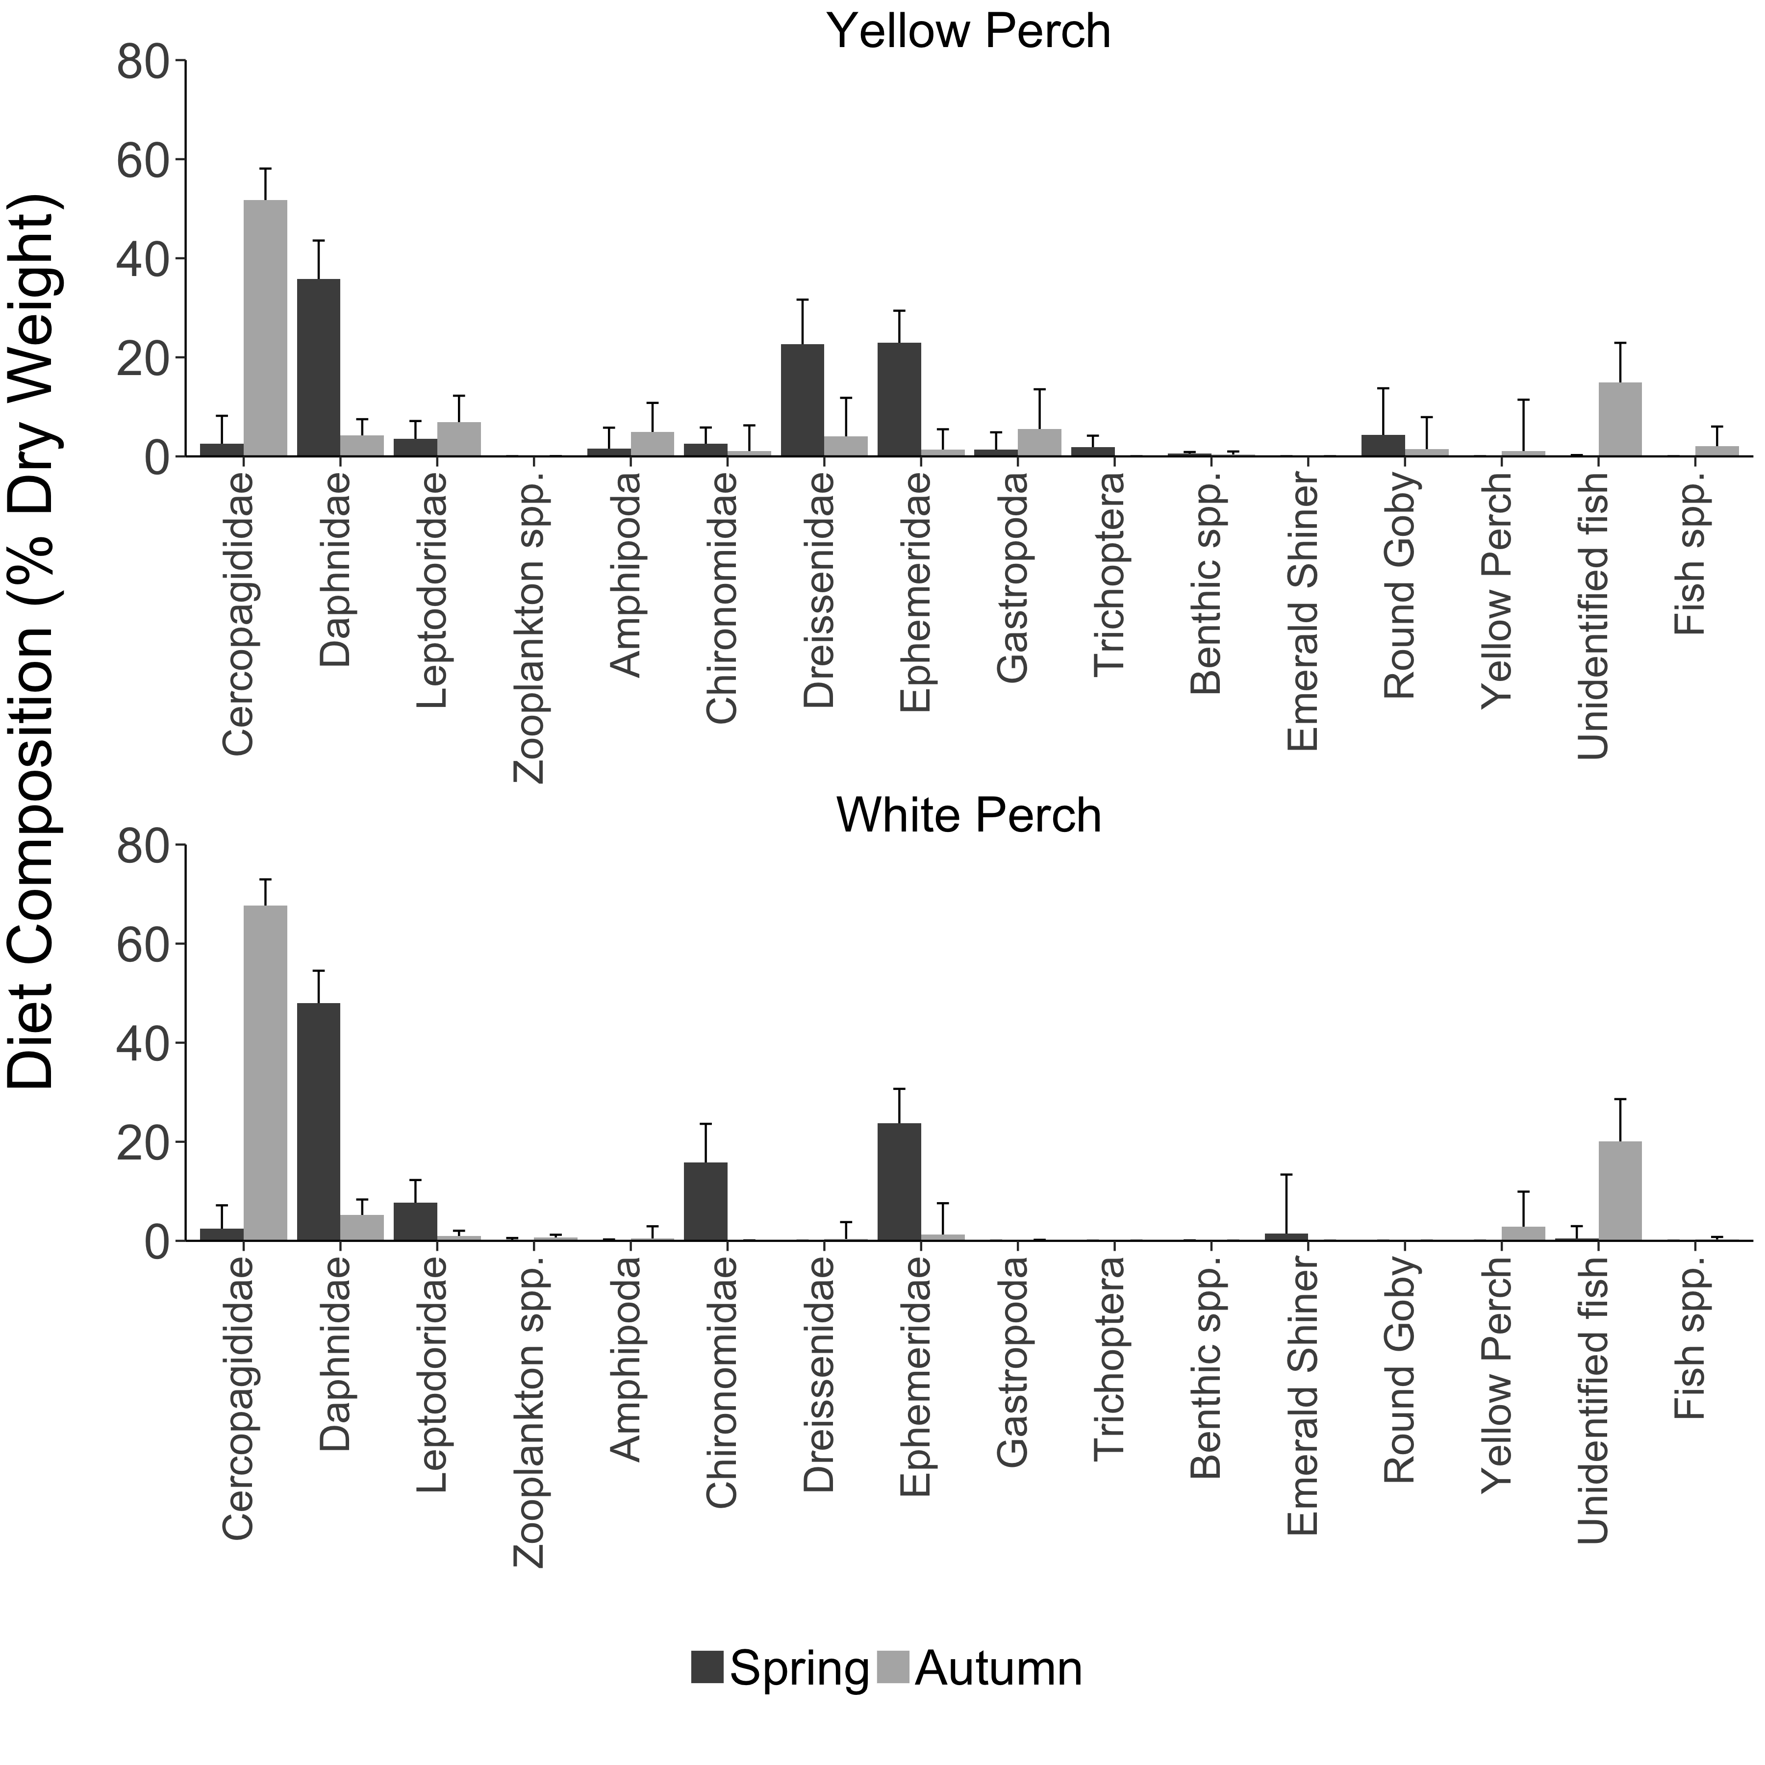

**Figure 2.5**. Age-2+ Yellow Perch (top panel) and White Perch (bottom panel) mean diet composition (% dry weight) by prey species in spring (black bars) and autumn (gray bars). Prey taxa: Zooplankton spp. include Bosminidae, Sididae, Calanoida, and Cyclopoida; Benthic spp. include Sphaeriidae, Hirudinea, Nematoda, Ostracoda, and Hemimysis; Fish spp. include Spottail Shiner, White Bass, Gizzard Shad, White Perch, and Fish Eggs. Error bars indicate standard error.

**Discussion**

A variety of measures can be used to quantify diet composition of fishes. Selecting an appropriate diet measure is strongly dependent on the research question; no single index is likely to provide a useful measure of prey importance under all conditions. It is important to recognize that each index emphasizes different information about the diet. Percent frequency of occurrence can provide information on how often a prey item was consumed, but provides no indication of the relative importance of the prey to the overall diet. In contrast, percent composition by weight tends to emphasize the relative contribution of larger prey.

When evaluating diet composition, prey dry weights are often more useful than prey occurrence because weights are measured in comparable units. For this reason, prey dry weights are more appropriate when interest lies in comparing the importance of different prey types (Bowen 1996).

The changes in diet composition of Yellow Perch and White Perch are generally consistent with observations from previous years, where diets consisted mainly of benthic macroinvertebrates in spring and shifted towards zooplankton and fish prey in autumn. Comparison between diet metrics demonstrated similar results between percent frequency of occurrence and diet composition by weight. The diet of Yellow Perch and White Perch reflected the increase of Cercopagididae weight in autumn. Ephemeridae accounted for 46.6% of the diet weight in the spring. The timing of our spring sampling in 2015 coincided with an Ephemeridae hatch, and we found multiple fish with full stomachs that were comprised completely of Ephemeridae. We continue to detect Dreissenidae contributing to diet weights in Yellow Perch, but the importance of Dreissenidae to diets is likely overestimated due to digestion and evacuation differences relative to softer prey (Brush et al. 2012). Indigestible shell material does not contribute to a fish’s diet energetically but takes space in the digestive tract. We observed 121 invasive *Hemimysis* sp. in White Perch diets and two in Yellow Perch diet in spring, one additional observation came from an autumn White Perch diet. We did not identify any invasive *Cercopagis* sp. in diets.

Our results generate further questions about the feeding ecology of Yellow Perch and White Perch for future studies. First, determine how Dreissenidae-related effects are affecting body condition and growth of Yellow Perch. If recruitment declines with lower condition, abundance of Yellow Perch may also decrease, unless management successfully intervenes. Second, evaluate if consumption of small-bodied prey could reduce energy intake due to the increased energy expenditure required to locate, capture, handle, and process smaller prey. Finally, evaluate the energy density of native and non-native prey species within the Great Lakes. Energy density of native prey may be changing in response to the invasion of Dreissenidae and Cercopagididae species.