Quantifying a potential mechanism between ice cover and cisco recruitment success: what role does light play in cisco embryonic development?

Taylor R. Stewart1,3, Mark R. Vinson2, and Jason D. Stockwell3

1 Department of Biology, University of Vermont, Burlington, Vermont, USA

2 USGS Lake Superior Biological Station, Ashland, Wisconsin, USA

3 Rubenstein Ecosystem Science Laboratory, University of Vermont, Burlington, Vermont, USA

# ABSTRACT:

# INTRODUCTION:

Freshwater whitefishes, Salmonidae Coregoninae (hereafter coregonines) have played important economic and ecological roles throughout the northern hemisphere (Nyberg et al. 2001, Ebener et al. 2008b, 2008a, Vonlanthen et al. 2009, 2012, Lynch et al. 2015, 2016). Over the past 35 years, coregonine populations worldwide have experienced declines due to highly variable and weak year-class strengths (Nyberg et al. 2001, Myers et al. 2015). In the Laurentian Great Lakes, native coregonine conservation and restoration efforts are at the forefront of fisheries management efforts (Favé and Turgeon 2008, Zimmerman and Krueger 2009, Bronte et al. 2017). Historical coregonine declines have been attributed to overfishing, invasive species, habitat alterations, and competition (Stockwell et al. 2009, Rosinski et al. 2020, Lucke et al. 2020). However, reasons for contemporary declines remain unknown, but climate-induced changes in early-life stage environments have been hypothesized, and winter ice and water temperature regimes have changed over the past 20 years or more (Austin and Colman 2007, O’Reilly et al. 2015, Sharma et al. 2019). Future climate change predictions show that the timing and physical characteristics of winter and ice regimes are likely to drive some of the most important biological changes (Sharma et al. 2007, Sharma et al. 2019, Woolway et al. 2020).

Year-class strength in most fish species, including coregonines, is thought to be established prior to the end of the first season of growth (Hjort 1914, Cushing 1990). Unlike larvae, embryos are static, leaving this early-life stage vulnerable to predation (Stockwell et al. 2014) and unable to evade inter-annual variation in winter conditions (REFS). Most coregonines are autumn spawners whose embryos incubate under ice throughout the winter and hatch in spring (Karjalainen et al. 2000, Stockwell et al. 2009). Changes in winter severity and ice cover could alter developmental rates, embryo survival, and time of hatching (Karjalainen et al. 2015). Potential mechanisms by which ice cover might influence cisco development include the reduction of physical wave action (Walter et al. 2006, Austin and Colman 2007, Wang et al. 2010, Nguyen et al. 2017), more stable winter and spring water temperatures (Magnuson et al. 1997, Winslow et al. 2017), and less sunlight reaching the lake bottom (Bolsenga and Vanderploeg 1992, Hampton et al. 2015). Recent changes in ice cover coupled with poor coregoninerecruitment has led to speculation about the relationship between ice cover and embryo survival for decades with limited rectification. Therefore, understanding how variable and declining ice regimes may impact coregonine early-life history is an important aspect of coregonine conservation and restoration efforts.

Lake ice cover can also play a critical role in physical and ecological processes (Sharma et al. 2020). Increases in spring water temperature and ice breakup cues the onset of hatching in autumn-spawning coregonines (Häkkinen et al. 2002, Urpanen et al. 2005, Karjalainen et al. 2015). Synchronization of coregonine hatching and spring plankton blooms is critical to match optimal nursery feeding conditions (Hjort 1914, Myers et al. 2015). Larval coregonines can withstand extended periods after hatching without feeding, but the time until exogenous feeding is relative to the amount of available maternal yolk for endogenous feeding (Lucke et al. 2020, Fuiman 2002). Increased metabolic rates during embryogenesis can compromise the amount of yolk retained (Hodson and Blunt 1986, Kamler 2008).

As ectotherms, fish metabolism and nearly all other biological rates increase exponentially with temperature (Brown et al. 2004, Gillooly et al 2002). Ontogenetic development and coregonines are no exception to this rule. Additionally, light intensity has been shown to be an additive effect to temperature in regulating embryo development and growth rates (Kwain 1975). Ice thickness and snow impact light penetration into the water column (Hampton et al. 2015), and can reduce light transmittance from 83% in open water to 62% under ice coverage, and to ≤ 10% under snow and ice coverage (Bolsenga and Vanderploeg 1992). Consequently, increased light during winter, as a result of reduced ice and snow cover, may act as an additional stressor during coregonine embryo development. Understanding the role ice has, given the recent high variability observed in coregoninerecruitment, can help predict what the future of these species may look like under current climate trends to inform restoration efforts.

We experimentally measured how cisco embryos responded to different photoperiod intensities, as a proxy for different ice regimes. Our objective was to identify to what extent light influences cisco embryo survival, incubation duration, length and yolk-sac volume at hatching. We hypothesized that exposure to elevated light intensity (low ice cover) would accelerate embryogenesis, resulting in smaller yolk-sacs and lower larval survival. Populations adapted to lower light levels are expected to experience more negative impacts from increasing light intensity.

# METHODS:

## Study Species and Locations

Cisco were collected from the Apostle Islands, Lake Superior (46.90, -90.57) and Chaumont Bay, Lake Ontario (44.05, -76.16) in December 2019. Lakes Superior and Ontario were chosen because they have differential spawning habitat for cisco. Lake Superior cisco spawn at deep depths, likely below the photic zone, with little or no known preference in habitat (Dryer and Beil 1964, Paufve 2019). Lake Ontario cisco spawn in shallow, protected bays on rocky shoals (Pritchard 1931, Paufve 2019). Ice conditions over spawning grounds between the two lakes vary based on depth, with shallower and more protected spawn grounds likely to have more consistent ice coverage than deeper, open waters (Figure X). However, light transmittance in deeper water is less than shallow water (Secchi 1864, Preisendorfer 1986, Ramus et al. 1976, Fleming-Lehtinen and Laamanen 2012). Lakes Superior and Ontario provide a contrast in ice cover and subsequent light exposure to coregonine embryos.

## Crossing Design and Fertilization

Eggs and milt were stripped from 12 females and 16 males and artificially fertilized under a blocked, nested full-sib, half-sib fertilization design to create 48 families from each lake. The crossing design maximized the amount of genetic variation and minimized the potential loss of multiple families if a female or male produced poor quality gametes, compared to a full-factorial design. Adults used in the experiment were divided into four fertilization blocks. A single block consisted of four males each paired with three unrelated females, where all offspring of a given female were full siblings. Fertilizations were performed block by block to ensure germ cell survival.

Approximately 200 eggs per female were fertilized with an equal amount of milt (5-15 μl) from each male in the block. After the addition of milt, water was added to activate the germ cells and gently mixed for one minute. The embryos were rinsed with water 2-3 times until the water was clear. Reconstructed fresh water was used during fertilizations (OECD ISO 6341:2012) to standardize the chemical properties of the water used between populations. Embryos were transported in coolers by shipping overnight for Lake Superior and driven same-day for Lake Ontario. A temperature logger recorded air temperature inside the cooler during transport (Lake Superior: mean (SD) = 2.80°C (0.21); Lake Ontario: mean (SD) = 3.28°C (0.37)). Demographic data (e.g., total length, mass, and egg diameter) were collected on adults. Fertilization success was determined by haphazardly taking 10 embryos from each family and assessing under microscopy within 72-hours post-fertilization (Oberlercher and Wanzenböck 2016). If fertilization was low (<30%), the family was removed from the experimental setup.

## Rearing Conditions

Embryos from successfully fertilized families were individually distributed into 24-well cell culture microplates and incubated in 2 ml of reconstructed fresh water. Reconstructed fresh water was used during incubation to maintain sterility, prevent bacterial growth in the wells, and eliminate the need for fungicide treatments on the embryos. A total of 36 embryos per family were used for each of Lake Ontario and Lake Superior cisco. Families were randomly distributed across three microplates (*i.e.,* 12 eggs per family per microplate and two families per 24-well microplate).

Microplates from each population were incubated under three experimental light treatments to represent the light intensity under 90-100, 40-60, and 0-10% ice cover (Table 1), and followed mean weekly photoperiods with gradual sunrise and sunset transitions. Light treatments were chosen to mimic *in situ* winter, lakebed light measurements recorded from Lake Superior at 10 m of water in 2016-17. Remote-sensing ice data (U.S. National Ice Center) was used to quantify the daily percentage of ice cover above the light sensor (Figure 2). Embryos were incubated at a constant target water temperature of 4.0°C in a climate-controlled chamber (Conviron® E8; Table 2). Forced airflow was used in the climate-controlled chamber to ensure equal air circulation around the microplates and opaque, plastic sheeting was used to separate light treatments.

All microplates were covered to minimize evaporation. Microplate orientation and position were rotated weekly to eliminate any temperature heterogeneity within the chamber. Water temperature and light intensity were recorded hourly with loggers (HOBO® Water Temperature Pro v2 and JFE Advantech Co., Ltd. DEFI2-L) and daily mean values calculated. Microplates were checked weekly for dead eggs and the eye-up stage. During the hatch period, microplates were checked on a three-day cycle for newly hatched larvae. All newly hatched larvae were photographed for life-history and morphological traits and preserved in 95% ethanol.

## Life-History and Morphological Traits

Embryo survival was estimated as the percent of embryos surviving between the eye-up and hatch stages. Incubation period was assessed by two variables: the number of days from fertilization to hatching (days post-fertilization; DPF) and the sum of the degree-days (accumulated degree-days; ADD). Total length-at-hatch (LAH; mm) and yolk-sac volume (YSV; mm3) were measured from five individuals per family at, or as close as possible to, 50% hatching for each family. Yolk-sac volume was calculated assuming the shape of an ellipse (Blaxter 1963):

where a = length of the yolk sac (mm) and b = height of the yolk sac (mm).

## Statistical Analyses and Estimation of Variance Components

Embryo survival was analyzed as a binomial response variable, and incubation period, length-at-hatch, and yolk-sac volume at hatching as continuous response variables. Early embryo mortality induced from fertilization failure produced inequalities in the number of offspring among families and an unbalanced design. The sample size for incubation period is a function of embryo survival and subsequently resulted in an unbalanced design. Therefore, binary data (i.e., embryo survival) were analyzed with binomial generalized linear mixed-effects models (LMM) and normally distributed data (i.e., incubation period, length-at-hatch, and yolk-sac volume) were analyzed with restricted maximum likelihood LMMs with the lme4 package (Bates et al. 2015). Population and incubation light treatment were included as fixed effects and female, male, family (female and male combination), and fertilization block as random effects. Because embryos were raised independently, the replication unit in the statistical models is the individual embryo. All traits were examined for population and incubation light effects in addition to individual parental effects (female, male, and family effects), fertilization block, and all possible interactions with backward, stepwise effect-selection using the buildmer package (Voeten 2020). The maximal model for each trait was selected by comparing a model including or lacking the term of interest to the reference model based on changes in log-likelihood, Akaike information criterion, Bayesian information criterion, and change in explained deviance. The mixed-effects model output does not produce significance values for model effects; therefore, significance for population, species, incubation temperature, interaction effects, and any random-effects selected were determined using a likelihood ratio test between the maximal model and reduced models with the model effect of interest removed.

To allow for population comparisons, the response to temperature for each trait was standardized to the optimal light treatment. The low light treatment (Table 1) was assumed to be the optimal incubation light intensity. For each trait, the within-family mean was calculated for each light treatment and the percent change from the optimal light intensity estimated. Standard error was calculated as the among-family variation in percent change.

# RESULTS:

## Spawning Adults

Lake Superior spawning adults used for gamete collection were larger in size (*i.e.,* total lengths and fresh mass) than Lake Ontario adults. However, Lake Ontario females had larger egg diameters than Lake Superior females (Table 3).

## Life-History and Morphological Traits and Variance Components

All traits, except embryo survival and LAH, had significant interaction effects between population and incubation temperature (maximum *P* = 0.005; Table 4). The interaction effects precluded any interpretation of main effects, but did suggest contrasting norms of reaction between populations. Below we describe the interaction effects and the light pairwise comparisons for embryo survival. All random effects (*i.e.,* female, male, and family) were significant (maximum *P* = 0.009) except female for embryo survival, male for embryo survival and YSV, and family for embryo survival, LAH and YSV (Table 4). All statistical model results can be found in Table 4.

### *Embryo Survival*

Embryo survival was highest for both populations at the medium light treatment, but lowest at the low light treatment for Lake Ontario and at the high light treatment for Lake Superior (Figure 3). Light and population main effects were significant, and all pairwise light treatment comparisons were significant (maximum *P* < 0.005). Embryo survival was higher for Lake Ontario at the high (98.4%) and medium (99.6%) light treatments than Lake Superior (85.3 and 89.3%, respectively) but not different between populations (0.9%) at the low light treatment (Figure 3).

### *Incubation Period (days post-fertilization)*

The number of days post-fertilization to hatching was highest for Lake Ontario at the low light treatment (115.47 days) and for Lake Superior at the high light treatment (101.22 days; Figure 3). Incubation period (DPF) was higher for Lake Ontario than Lake Superior across all light treatments. Lake Ontario cisco had a decrease in DPF from the low light to the high light treatments (-0.7%), while Lake Superior had an increase from the low light to the high light treatments (1.9%; Figure 3).

### *Incubation Period (accumulated degree-days)*

The effect of population depended on light because ADD was higher for Lake Ontario (497.7 and 485.9 ADD) than Lake Superior (427.5 and 420.8 ADD) at the low and medium light treatments, respectively, and the difference between populations was less pronounced at the high light treatment (60.8 ADD; Figure 3). Lake Ontario ADD had a negative response from the low to high light treatments (-2.5%), while ADD for Lake Superior did not change from the low to high light treatments (0.05%; Figure 3).

### *Length-at-Hatch*

Light was not a component returned in the stepwise-selected model, but the population main effect between Lake Ontario and Lake Superior was significant (*P* < 0.001; Table 4). Lake Ontario had a higher LAH than Lake Superior across all light treatments (Figure 4). Lake Superior and Lake Ontario responded to increasing light intensity with a 3.2 and 0.2% respective decrease in LAH from the low to high light treatments (Figure 4).

### *Yolk-sac Volume*

Yolk-sac volume had a differential response to light intensity between populations (Figure 4). The effect of population depended on light because YSV was lower for Lake Ontario (0.35 and 0.37 mm3) than Lake Superior (0.67 and 0.63 mm3) at the high and medium light treatments, respectively, and the difference between populations was less pronounced at the low light treatment (0.22 mm3; Figure 4). Lake Superior YSV had a positive response from the low to high light treatments (15.3%), while YSV for Lake Ontario had a negative response from the low to high light treatments (-5.5%; Figure 4).

# DISCUSSION:

# ACKNOWLEDGMENTS:

We thank the staff at the Wisconsin Department of Natural Resources Bayfield Fisheries Field Station, United States Geological Survey (USGS) Tunison Laboratory of Aquatic Science, and New York State Department of Environmental Conservation Cape Vincent Fisheries Station for conducting field collections of spawning adults. We also thank Rachel Taylor, Dan Yule, Caroline Rosinski for help with fertilizations and experiment maintenance. XXXX provided the USGS solicited review that strengthened the manuscript, as did anonymous peer reviewers. This work was funded by the USGS grant number XXXX. Any use of trade, product, or firm names is for descriptive purposes only and does not imply endorsement by the U.S. Government.

# LITERATURE CITED:

# TABLES:

Table 1. Mean ± SD photon flux (μmol m-2 s-1) for three ice regimes from Lake Superior and corresponding laboratory experimental light conditions.

|  |  |  |  |
| --- | --- | --- | --- |
|  | Ice Cover (Light Treatment) | | |
| Location | > 90% (Low) | 40-60% (Medium) | < 10% (High) |
| Lake Superior | 1.96 ± 1.07 | 3.35 ± 2.54 | 5.45 ± 5.88 |
| Laboratory | 0.62 ± 0.06 | 3.85 ± 1.88 | 6.15 ± 0.99 |

Table 2. Mean ± SD water temperatures (°C) during embryo incubations from each light treatment for Lakes Superior and Ontario.

|  |  |  |  |
| --- | --- | --- | --- |
|  | Light Treatment | | |
| Lake | High | Medium | Low |
| Superior | 4.25 ± 0.24 | 4.28 ± 0.28 | 4.34 ± 0.34 |
| Ontario | 4.24 ± 0.25 | 4.28 ± 0.28 | 4.36 ± 0.36 |

Table 3. Mean ± SD total length (TL) and fresh mass (FM) of the female and males and egg diameters (ED) of the females from Lakes Superior and Ontario cisco (*Coregonus artedi*)..

|  |  |  |  |  |  |  |  |
| --- | --- | --- | --- | --- | --- | --- | --- |
|  | Lake Superior | | |  | Lake Ontario | | |
| Sex | TL (mm) | FM (g) | ED (mm) |  | TL (mm) | FM (g) | ED (mm) |
| Female | 428.92  ± 44.40 | 676.02  ± 181.51 | 2.14  ± 0.12 |  | 380.33  ± 24.18 | 567.59  ± 122.89 | 2.30  ± 0.08 |
| Male | 400.25  ± 34.35 | 523.82  ± 134.65 | -- |  | 366.56  ± 25.30 | 443.29  ± 103.16 | -- |

Table 4. Likelihood ratio test output for each model selected for embryo survival (%), incubation period (number of days post-fertilization; DPF), incubation period (accumulated degree-days; ADD), length-at-hatch (mm), and yolk-sac volume (mm3) from Lakes Superior and Ontario cisco (*Coregonus artedi*). pop indicates population. The full model that was selected is bolded for each trait.

|  |  |  |  |  |  |
| --- | --- | --- | --- | --- | --- |
| Trait | Model | Effect Tested | df | χ2 | p-value |
| Embryo Survival | **light + pop** |  |  |  |  |
| pop | light | 2 | 181.92 | < 0.001 |
|  | light | pop | 1 | 95.00 | < 0.001 |
| Incubation Period (DPF) | **light + pop + light:pop + female:male + female + male** |  |  |  |  |
| pop + female:male + female + male | light | 2 | 11.12 | 0.004 |
| light + female:male + female + male | pop | 1 | 2974.54 | < 0.001 |
|  | light + pop + female:male + female + male | light:pop | 2 | 10.75 | 0.005 |
|  | light + pop + light:pop + female + male | female:male | 1 | 84.36 | < 0.001 |
|  | light + pop + light:pop + female:male + male | female | 1 | 25.07 | < 0.001 |
|  | light + pop + light:pop + female:male + female | male | 1 | 10.78 | 0.001 |
| Incubation Period (ADD) | **light + pop + light:pop + female:male + female + male** |  |  |  |  |
| pop + female:male + female + male | light | 2 | 56.01 | < 0.001 |
| light + female:male + female + male | pop | 1 | 3,041.75 | < 0.001 |
|  | light + pop + female:male + female + male | light:pop | 2 | 17.39 | < 0.001 |
|  | light + pop + light:pop + female + male | female:male | 1 | 84.44 | < 0.001 |
|  | light + pop + light:pop + female:male + male | female | 1 | 10.76 | 0.001 |
|  | light + pop + light:pop + female:male + female | male | 1 | 25.03 | < 0.001 |
| Length-at-Hatch | **pop + female + male** |  |  |  |  |
| female + male | pop | 1 | 334.33 | < 0.001 |
|  | pop + male | female | 1 | 74.32 | < 0.001 |
|  | pop + female | male | 1 | 6.80 | 0.009 |
| Yolk-sac Volume | **light + pop + light:pop + female + male** |  |  |  |  |
| pop + female + male | light | 2 | 7.18 | 0.028 |
| light + female + male | pop | 1 | 712.29 | < 0.001 |
|  | light + pop + female + male | light:pop | 2 | 26.84 | < 0.001 |
|  | light + pop + light:pop + male | female | 1 | 130.50 | < 0.001 |
|  | light + pop + light:pop + female | male | 1 | 2.87 | 0.090 |

# FIGURES:

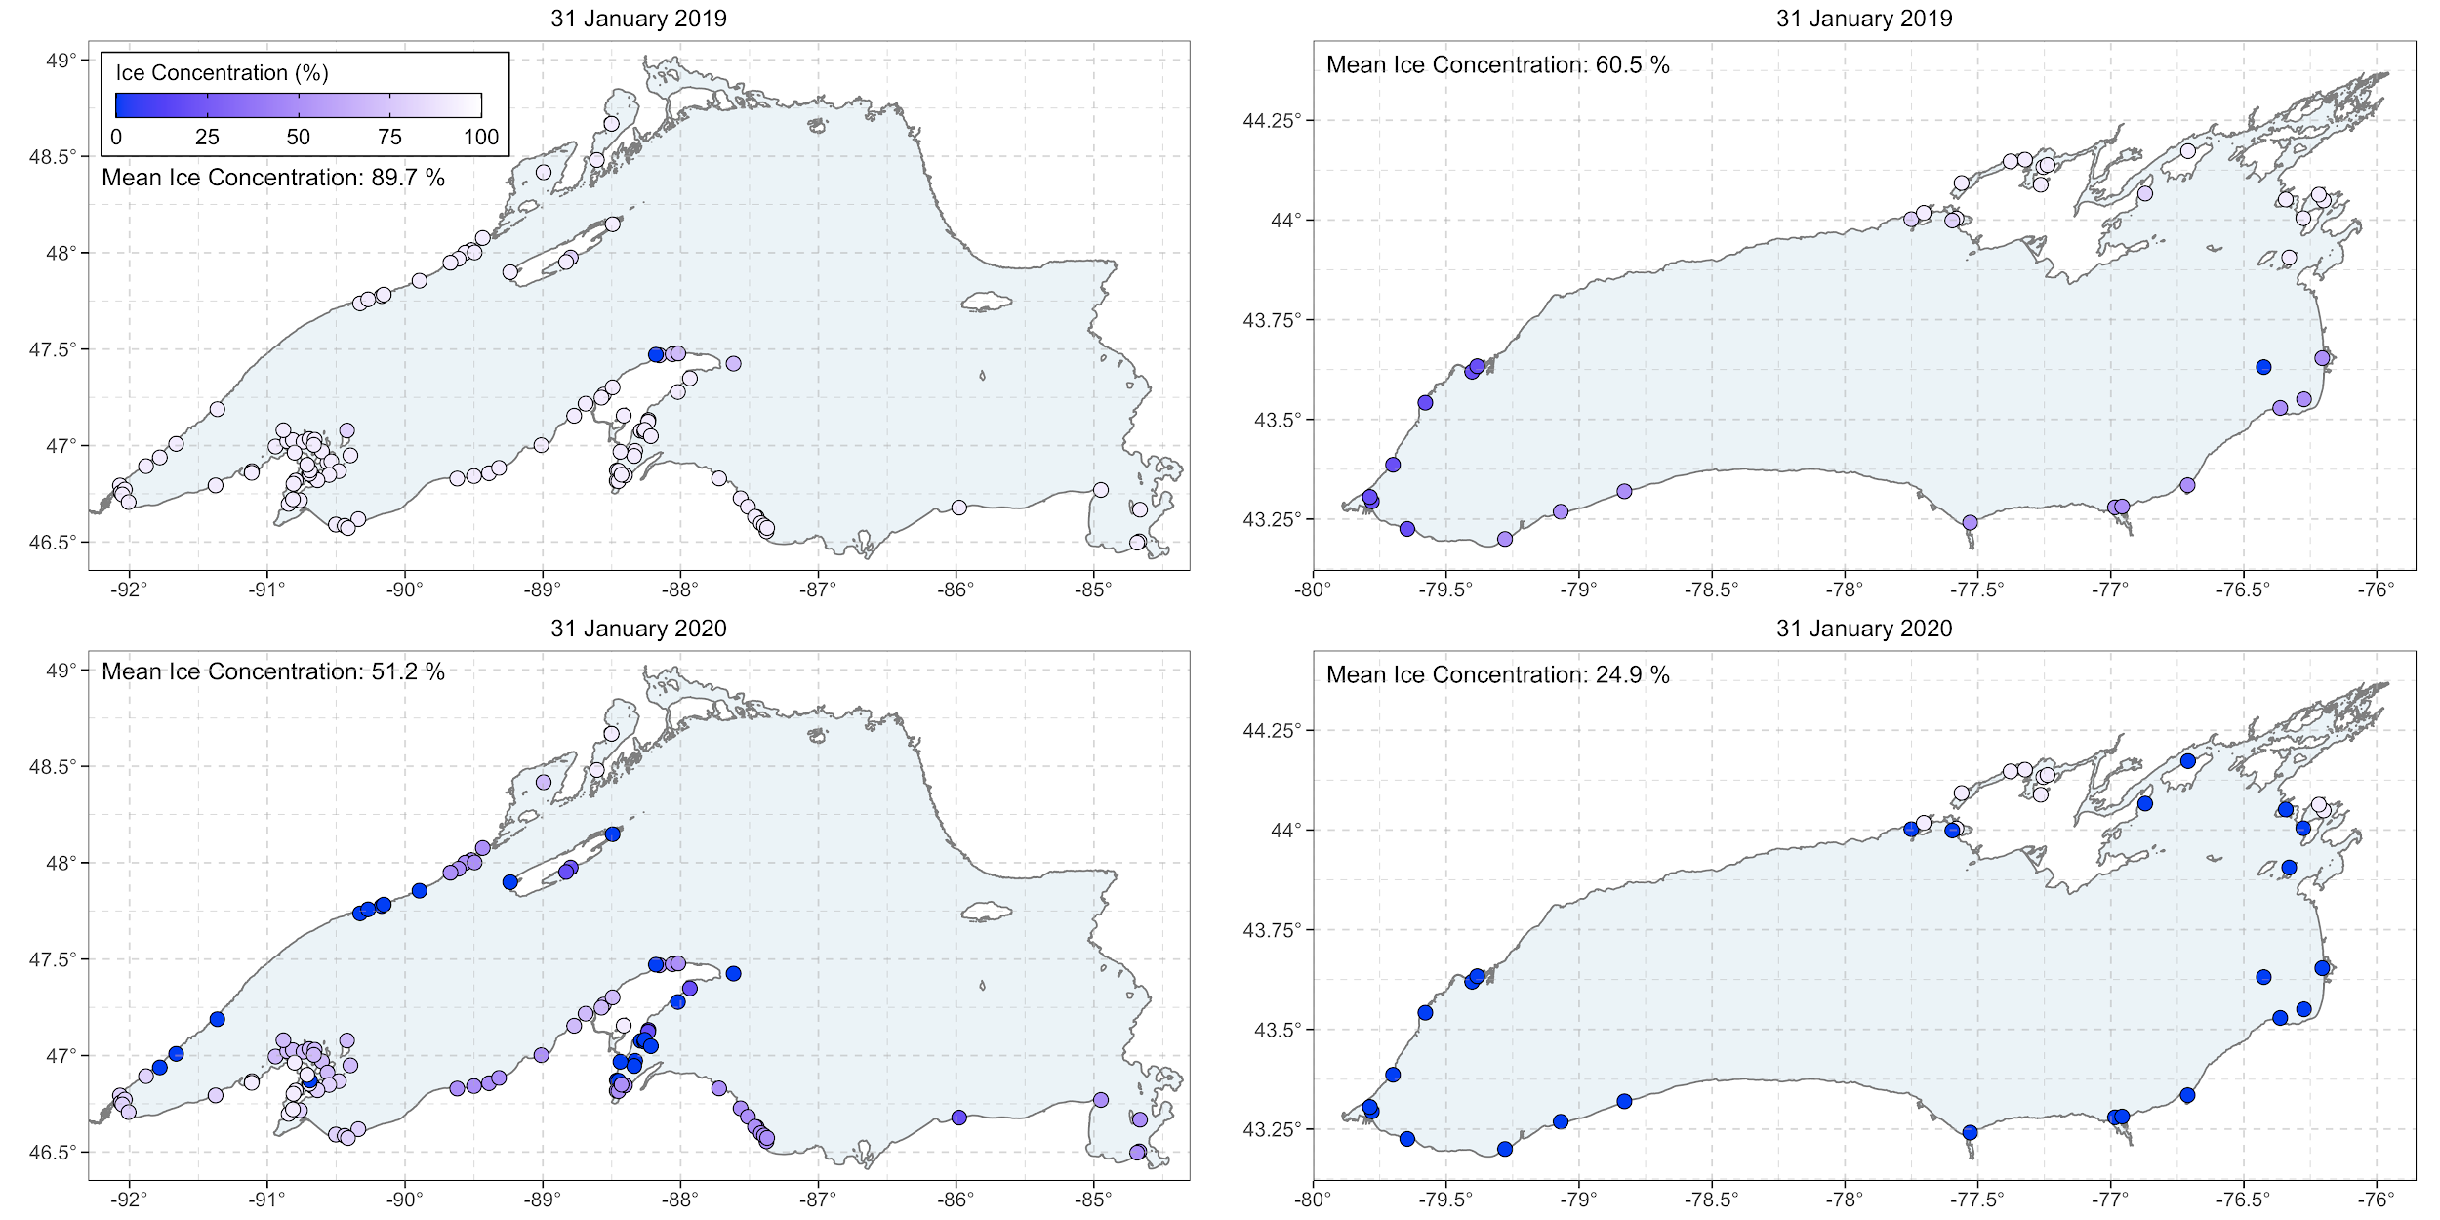

Figure 1. ??? Not sure what figure will be here yet. I would like to do something with the Goodyear atlas spawning locations and ice. Still visualizing how.

Figure 2. Daily ice coverage (%; blue line) and light intensity (μmol m-2 s-1) relationship based on light sensors set at 10 m depth off Sand Island, Lake Superior. Ice coverage data above the sensor was collected from the U.S. National Ice Center.

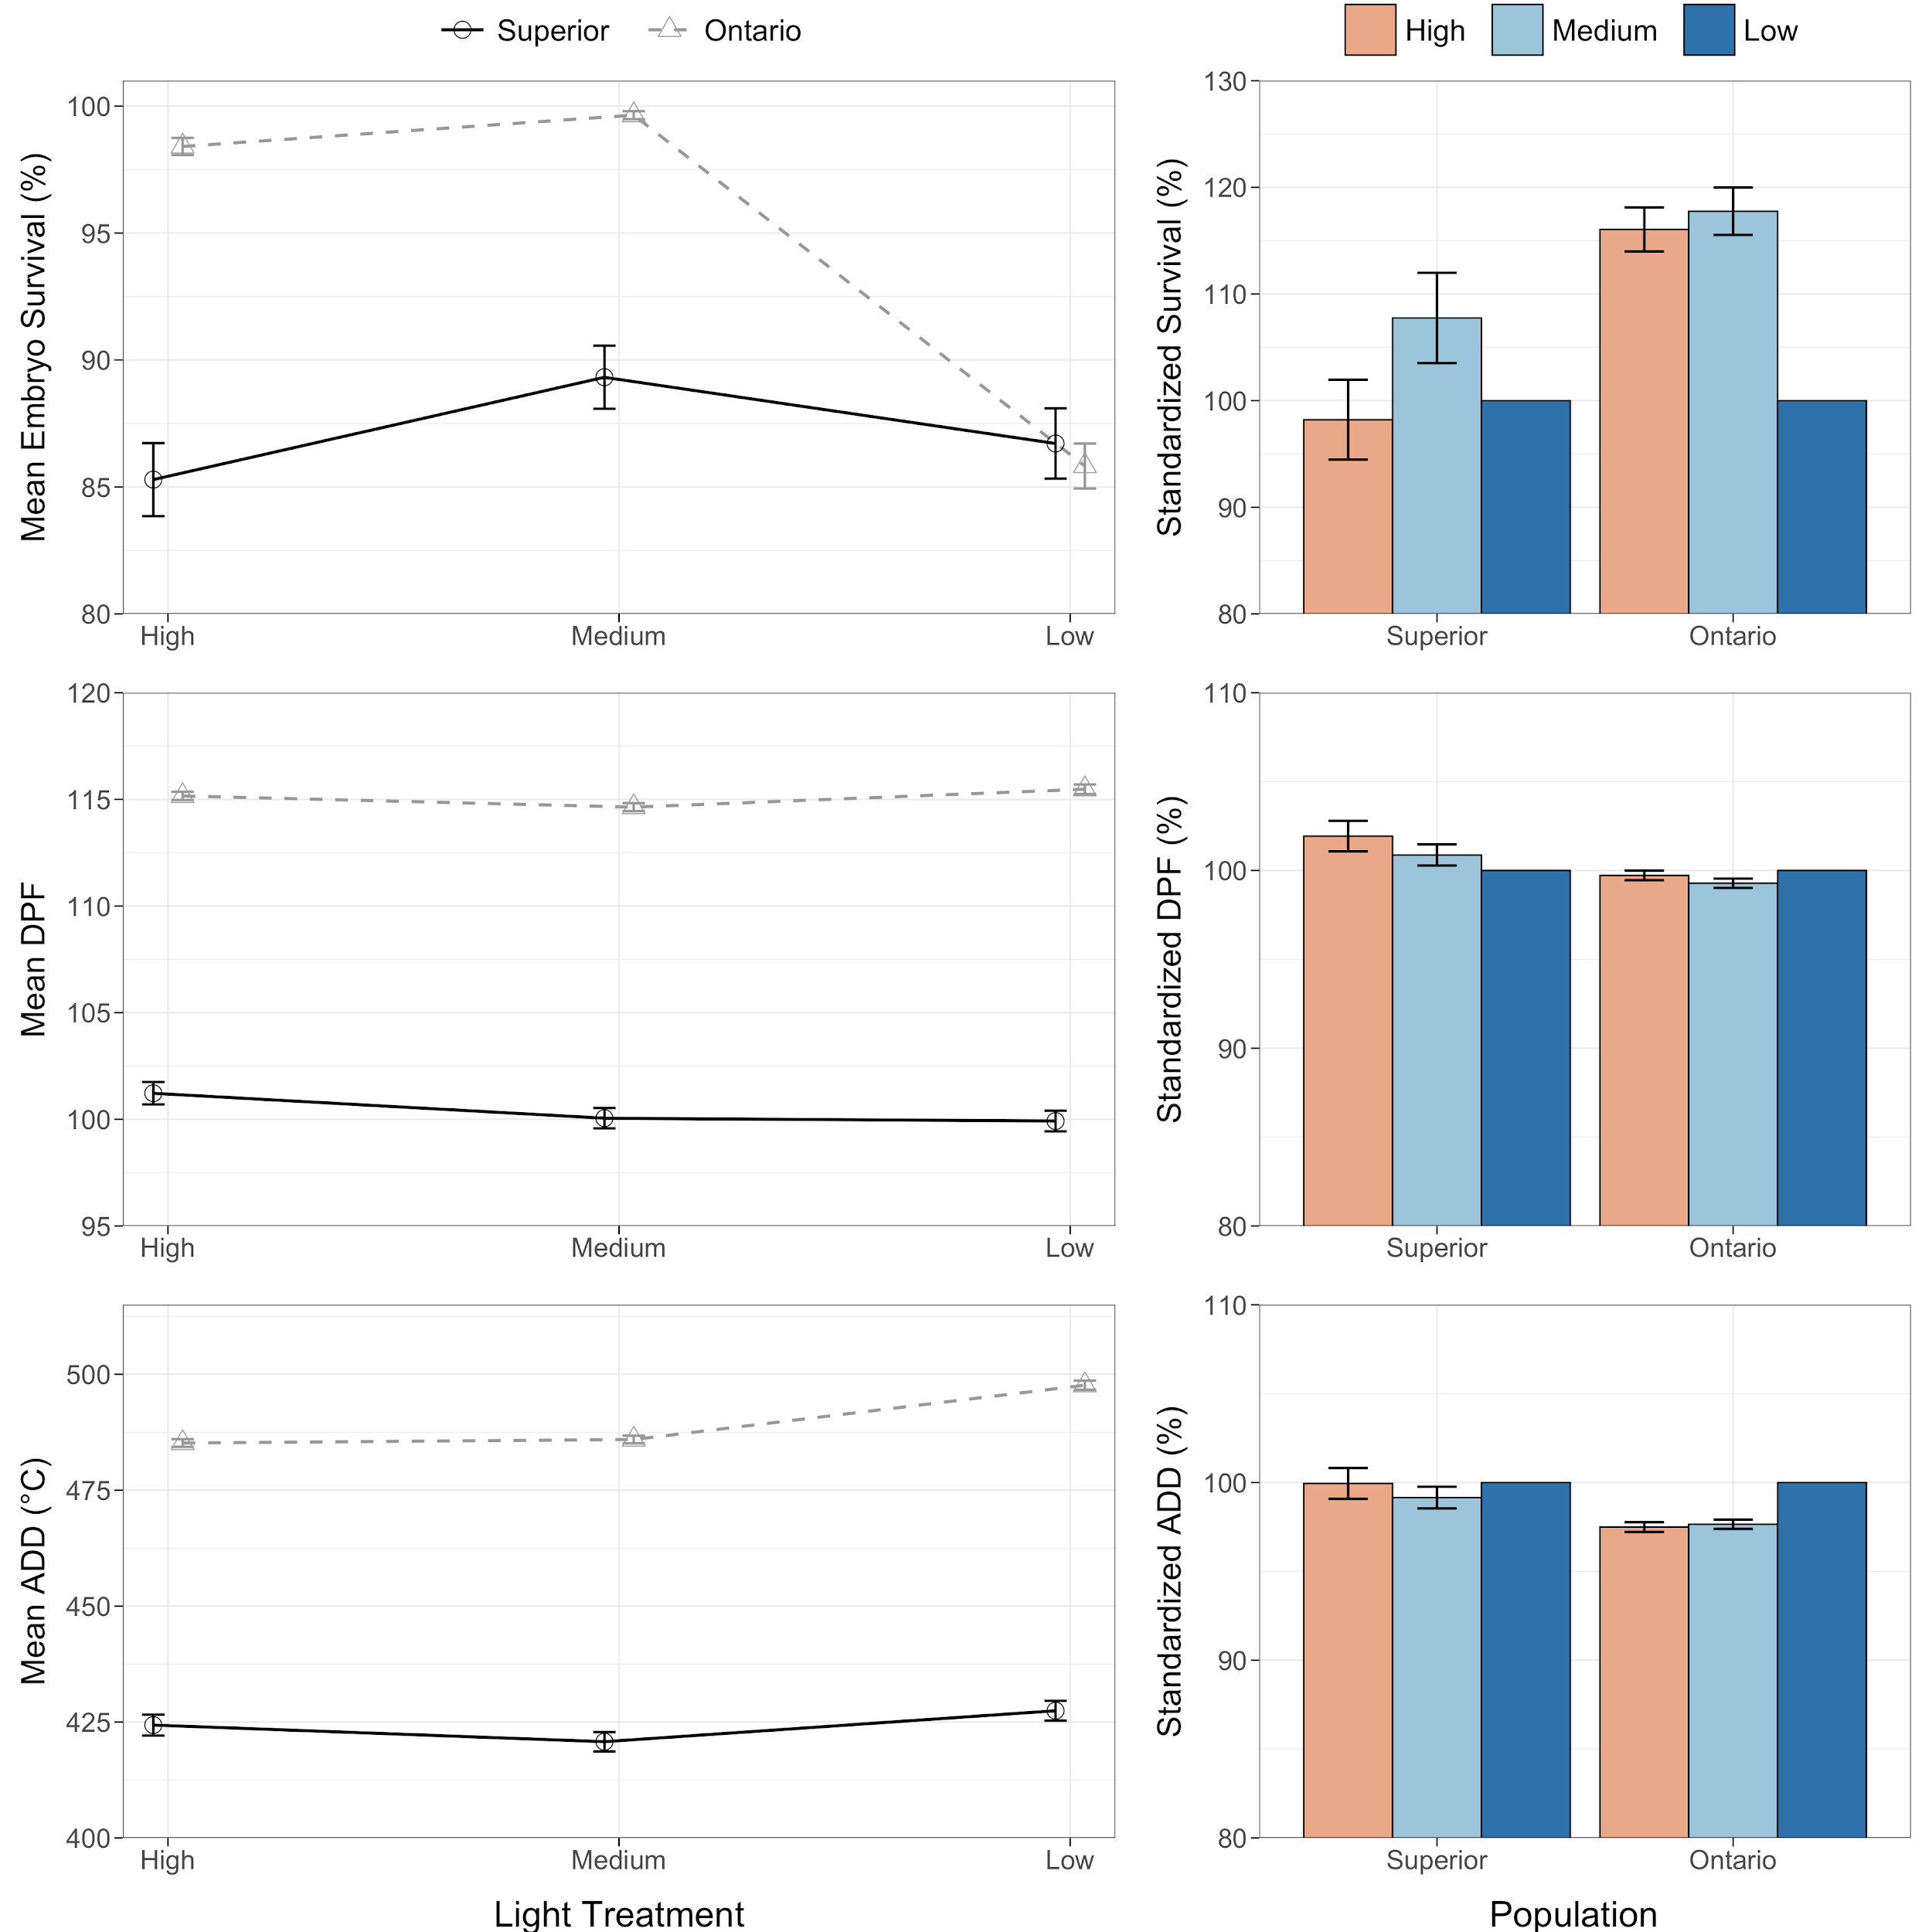

Figure 3. Mean embryo survival (%), incubation period (number of days post-fertilization; DPF), and incubation period (accumulated degree days (°C); ADD) at each incubation light treatment (left) and standardized responses to light within each population (right) from Lake Superior and Lake Ontario cisco (*Coregonus artedi*). Error bars indicate standard error.

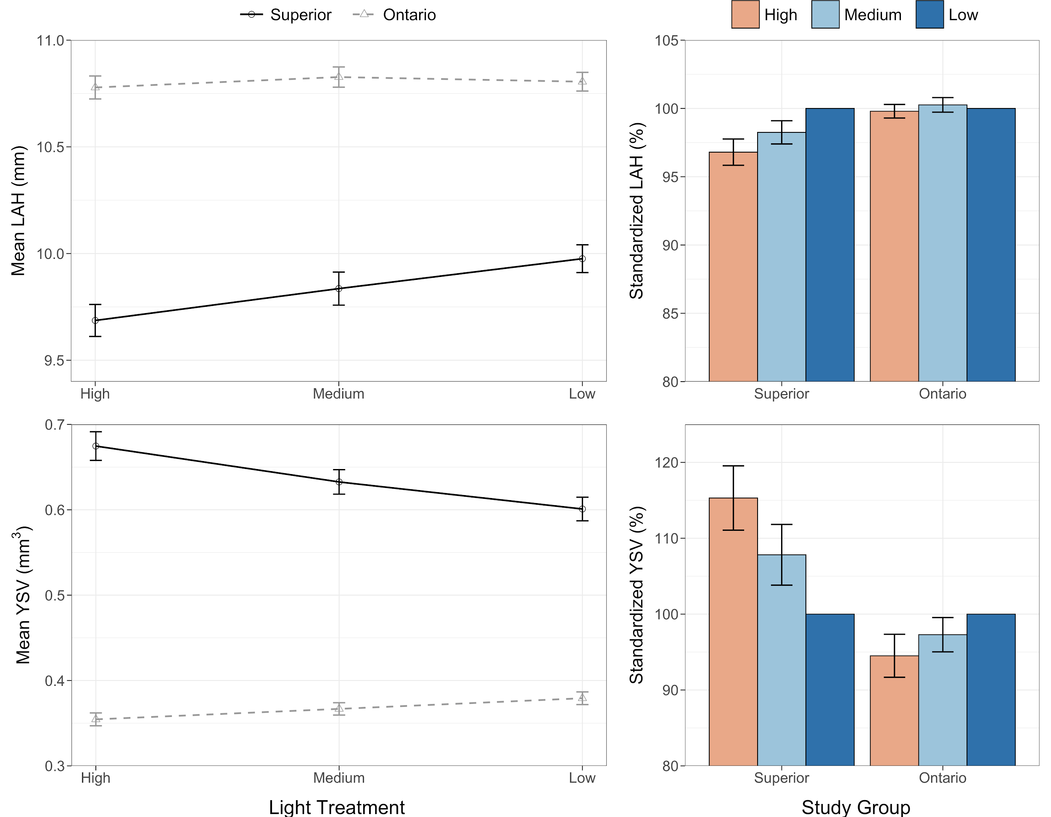

Figure 4. Mean length-at-hatch (mm; LAH) and yolk-sac volume (mm3; YSV) at each incubation light treatment (left) and standardized responses to light within each population (right) from Lake Superior and Lake Ontario cisco (*Coregonus artedi*). Error bars indicate standard error.