Shining a light on Laurentian Great Lakes cisco (*Coregonus artedi*): how ice coverage may impact embryonic development

Shining a light on cisco (*Coregonus artedi*): what role does ice and light availability play in cisco embryonic development?

Shining a light on Laurentian Great Lakes cisco (*Coregonus artedi*) embryonic development: how ice coverage may influence embryo survival and fitness-related traits of free embryos

Taylor R. Stewart1,2*, Mark R. Vinson3, and Jason D. Stockwell2

1 Department of Biology, University of Vermont, Burlington, Vermont, USA

2 Rubenstein Ecosystem Science Laboratory, University of Vermont, Burlington, Vermont, USA

3 U.S. Geological Survey Lake Superior Biological Station, Ashland, Wisconsin, USA

*Corresponding Author: Taylor R. Stewart, Department of Biology, Rubenstein Ecosystem Science Laboratory, University of Vermont, 3 College St, Burlington, VT 05401, USA.

Email: [taylor.stewart@uvm.edu](mailto:taylor.stewart@uvm.edu)

# ABSTRACT:

# INTRODUCTION:

Freshwater whitefishes, Salmonidae Coregoninae (hereafter coregonines) play important economic (Ebener et al., 2008) and ecological (Lynch et al., 2010; Nyberg et al., 2001; Stockwell et al., 2014) roles throughout the northern hemisphere, but populations have declined over the past century (Eshenroder et al., 2016). Historical coregonine declines were attributed to overfishing, invasive species, habitat alterations, and competition (Anneville et al., 2009; Rosinski et al., 2020; Stockwell et al., 2009). More recently, coregonine populations worldwide have experienced declines due to highly variable and low survival to age-1 (Lepak et al., 2017; Nyberg et al., 2001; Parks and Rypel, 2018) which have been associated with climate-induced changes in early-life stage environments (Nyberg et al., 2001). However, an underlying mechanism between changing lake environments and coregonine year-class strength has yet to be established.

Year-class strength in most fish species, including coregonines, is thought to be established prior to the end of the first season of growth (Cushing, 1990; Hjort, 1914; Karjalainen et al., 2015). Most coregonines are autumn spawners whose embryos incubate under ice throughout the winter (Karjalainen et al., 2000; Stockwell et al., 2009). Embryos are static, which leaves them vulnerable to predation (Stockwell et al., 2014) and unable to evade detrimental changes in winter environmental conditions (Pepin, 1991). Changes in winter conditions, such as decreased ice coverage and duration, that have been observed over the past 20+ years (Austin and Colman, 2007; O’Reilly et al., 2015; Sharma et al., 2019), could alter developmental rates, embryo survival, and time of hatching (Karjalainen et al., 2015). Potential mechanisms by which ice coverage influences coregonine embryonic development include reduction of physical wave action (Austin and Colman, 2007; Nguyen et al., 2017; Walter et al., 2006; Wang et al., 2010), more stable winter and spring water temperatures (Magnuson et al., 1997; Winslow et al., 2017), and less sunlight reaching the lake bottom (Bolsenga and Vanderploeg, 1992; Hampton et al., 2015).

Sunlight (*i.e.,* photoperiod) is the most consistent abiotic factor in nature (Ruchin, 2020) and can regulate fish development phenology, behavior, and physiology (Ruchin, 2007; Villamizar et al., 2011). The length of photoperiods characterize circadian rhythms and ensure that biological processes are synchronized with the environment (Gaston et al., 2013; Marchesan et al., 2005; Ruchin, 2020). In seasonally ice-covered lakes, winter lake light levels are regulated by ice coverage (Bolsenga and Vanderploeg, 1992; Hampton et al., 2015). Ice can reduce light transmittance to 62% under clear ice, and to ≤ 10% under snow and ice coverage (Bolsenga and Vanderploeg, 1992).

Salmonid embryos incubated under elevated light levels had higher mortality and deformity rates, slower formation of cartilaginous skeletal elements, decreased time to hatching, and smaller size-at-age; with accelerated development after organogenesis (Chernyaev, 2007; Eisler, 1961, 1958; Kwain, 1975; MacCrimmon and Kwain, 1969). However, other teleosts (*e.g.,* turbot *Scophthalmus maximus*, Atlantic halibut *Hippoglossus hippoglossus*, brown-marbled grouper *Epinephelus fuscoguttatus*) exhibit opposite responses, or no response, to light illumination (Iglesias et al., 1995; Mangor‐Jensen and Waiwood, 1995; Ruchin, 2020; Seth et al., 2014). To the best of our knowledge, no previous work has examined the effects of light on coregonine embryos from North America.

We conducted an experiment to evaluate how cisco (*Coregonus artedi*) embryos responded to different photoperiod intensities, as a proxy for different ice coverages. We hypothesized that exposure to elevated light intensity (a proxy for low ice coverage) decreases embryo survival and accelerates embryogenesis, resulting in earlier hatching, larger yolk-sacs, and smaller lengths-at-hatch. Our objective was to identify the extent to which light influences cisco embryo survival, incubation duration, and length and yolk-sac volume at hatching. If our hypothesis is supported, we would expect populations adapted to lower light levels (high ice coverage) to experience a greater magnitude of change as light intensity increases.

# METHODS:

## Study Species and Locations

Mature cisco were collected from the Apostle Islands, Lake Superior (46.85°, -90.55°) and Chaumont Bay, Lake Ontario (44.05°, -76.20°) in December 2019. Lake Superior cisco were collected at an open lake location at depths between 15 and 50 m. Lake Ontario cisco were collected in a shallow, protected bay on rocky shoals at depths between 2 to 5 m. Historical (1973-2020) ice conditions over the sampled spawning locations varied between lakes with the shallower, more protected Lake Ontario spawning site having more consistent ice coverage between January and March than the deeper, open location in Lake Superior (Figure 1). The different spawning habitats provide a contrast in light levels that coregonine embryos from each population naturally experience because maximum light availability decreases with depth (Fleming-Lehtinen and Laamanen, 2012; Preisendorfer, 1986; Ramus et al., 1976; Secchi, 1864) and winter light availability is further restricted with variable ice and snow conditions.

## Crossing Design and Fertilization

The design is fully described in Stewart et al. (In review). Briefly, gametes were stripped from 12 females and 16 males from each lake and artificially fertilized to create 48 families from each lake. Reconstructed fresh water was used during fertilizations and rearing (OECD ISO 6341:2012) to standardize the chemical properties of the water used between lakes. Embryos were transported to the University of Vermont in coolers by shipping overnight for Lake Superior samples and driven the same-day for Lake Ontario samples. A temperature logger recorded air temperature inside the cooler during transport (Lake Superior: mean (SD) = 2.80°C (0.21); Lake Ontario: mean (SD) = 3.28°C (0.37); Stewart et al. In review). Demographic data (total length, mass, and egg diameter) were collected from adults. Fertilization success was determined by assessing 10 haphazardly selected embryos under microscopy (Oberlercher and Wanzenböck, 2016). If fertilization was low (<30%), the family was removed from the experiment.

## Rearing Conditions

Embryos were individually distributed into 24-well cell culture microplates and incubated in 2 ml of reconstructed fresh water (Stewart et al., In Review). A total of 36 embryos were used for each Lake Ontario and Lake Superior cisco family. Families were randomly distributed across three microplates (*i.e.,* 12 eggs per family per microplate resulting in two families per 24-well microplate).

Microplates from each population were incubated under three experimental light treatments (0.6-6.2 μmol m-2 s-1) that represented day-light intensity under 0-10 (low), 40-60 (medium), and 90-100 % (high) ice coverage (Table 1), and followed mean weekly photoperiods with gradual sunrise and sunset transitions. Light intensities for each treatment were chosen to mimic *in situ* winter, lakebed light measurements that were previously recorded with a photometer (JFE Advantech Co., Ltd. DEFI2-L) from Lake Superior (46.97°, -90.99°) at 10 m of water in 2016-17. Remote-sensing ice data (U.S. National Ice Center; usicecenter.gov) were used to quantify the daily percentage of ice coverage above the light sensor (Figure 2). Embryos were incubated at a constant target water temperature of 4.0°C in a climate-controlled chamber (Conviron® E8; Table 2). Forced airflow was used in the climate-controlled chamber to ensure equal air circulation around the microplates and opaque, plastic sheeting was used to separate light treatments. Microplates were covered with transparent lids to minimize evaporation and rotated (*i.e.,* orientation and position within the incubator) weekly. Water temperature and light intensity were recorded hourly with loggers (HOBO® Water Temperature Pro v2 and JFE Advantech Co., Ltd. DEFI2-L) and daily mean values calculated. During the hatch period, microplates were checked on a three-day cycle for newly hatched embryos. All hatched embryos were photographed ventrally (Nikon® D5600 and Nikon® AF-S DX 18-55mm lens) and then immediately preserved in 95% ethanol. Egg size at fertilization, total length-at-hatch, and post-hatching yolk-sac axes were measured from photographed images using Olympus® LCmicro.

## Developmental and Morphological Traits

Embryo survival was estimated as the percent of embryos surviving between eye-up and post-hatch stages. Incubation period was assessed with two variables: the number of days from fertilization to hatching (days post-fertilization; DPF) and the sum of the degree-days (accumulated degree-days; ADD). Total length-at-hatch (LAH; mm) and yolk-sac volume (YSV; mm3) were measured from five individuals per family at, or as close as possible to, 50% hatching for each family. Yolk-sac volume was calculated assuming the shape of an ellipse (Blaxter, 1963; Stewart et al., In Review):

$$YSV= \frac{π}{6}ab^{2},$$

where a = length of the yolk sac (mm) and b = height of the yolk sac (mm).

## Statistical Analyses and Estimation of Variance Components

Embryo survival was analyzed as a binomial response variable, with incubation period, length-at-hatch, and yolk-sac volume at hatching as continuous response variables. Because embryos were raised independently, the replication unit in the statistical models is the individual embryo and the design was unbalanced due to different levels of embryo mortality. All non-proportional data were visually checked for approximate normality using histograms and Q-Q plots. A cubic transformation was applied to LAH and a cubic root transformation was applied to DPF, ADD, and YSV to normalize the distributions. Binary data (*i.e.,* embryo survival) were analyzed with binomial generalized linear mixed-effects models, and variables with distributions not strongly deviating from normal (i.e., incubation period, LAH, and YSV) were analyzed with restricted maximum likelihood linear mixed-effects models with the *lme4* package v.1.1-26 (Bates et al., 2015). Population and incubation light treatment were included as fixed effects and female, male, female x male, and fertilization block as random effects. All traits and possible interactions were examined with backward, stepwise effect-selection using the *buildmer* package v.1.7.1 (Voeten, 2020). The maximal model for each trait was selected by comparing a model including or lacking the term of interest to the reference model based on changes in log-likelihood, Akaike information criterion, Bayesian information criterion, and change in explained deviance. The significance for population, species, incubation temperature, interaction effects, and any random-effects selected were determined using a likelihood ratio test between the maximal model and reduced models with the model effect of interest removed.

To enable population comparisons, the response to temperature for each trait was standardized to what we assumed was the optimal light treatment - the low light treatment (Table 1). For each trait, the within-family mean was calculated for each light treatment and the percent change from the optimal light intensity estimated. Standard error was calculated as the among-family variation in percent change.

All analyses were performed in R version 4.0.4 (R Core Team, 2021).

# RESULTS:

## Spawning Adult and Egg Measurements

Lake Superior spawning adults ranged from 326-503 mm (total length mean (SD) = 412.5 (40.8) mm) and 298.9-970.0 g (fresh mass mean (SD) = 589.1 (171.4) g), and were larger in total length and fresh mass than Lake Ontario adults which ranged from 321-425 mm (mean (SD) = 372.5 (25.3) mm) and 280.5-795.8 g (mean (SD) = 496.6 (126.4) g). Egg diameter was larger in Lake Ontario (mean (SD) = 2.30 (0.08) mm) than Lake Superior (mean (SD) = 2.14 (0.12) mm).

## Developmental and Morphological Traits

Incubation period (both DPF and ADD) and YSV had significant interaction effects between population and light treatments (maximum *P* = 0.008; Table 3). The interaction effects precluded any interpretation of main effects for incubation period and YSV, but did suggest contrasting norms of reaction between populations. Below we describe the interaction effects for incubation period and YSV, and the population main effects and light treatment pairwise comparisons for embryo survival and LAH. All random effects (*i.e.,* female, male, and female x male) were significant (maximum *P* = 0.009) except female for embryo survival, male for embryo survival and YSV, and female x male for embryo survival and LAH (Table 3). All statistical model results can be found in Table 3.

### *Embryo Survival*

Embryo survival was highest for both populations at the medium light treatment, but lowest at the low light treatment for Lake Ontario and at the high light treatment for Lake Superior (Figure 3). Light and population main effects were significant. Only Lake Ontario pairwise light treatment comparisons with the low light treatment were significant (Low - Medium *P* < 0.001; Low - High *P* < 0.001). All pairwise light treatment comparisons for Lake Superior were not significant (minimum *P* = 0.089). Embryo survival was higher for Lake Ontario at the high (98.4%) and medium (99.6%) light treatments than for Lake Superior (85.3 and 89.3%, respectively) but there was no difference between populations at the low light treatment (0.9%; Figure 3).

### *Incubation Period (days post-fertilization)*

The number of days between fertilization and hatching was highest for Lake Ontario at the low light treatment (115.47 days) and for Lake Superior at the high light treatment (101.22 days; Figure 3). Lake Ontario cisco had a decrease in DPF from the low light to the high light treatments (-0.7%), while Lake Superior had an increase from the low light to the high light treatments (1.9%; Figure 3). Incubation period (DPF) was longer for Lake Ontario than Lake Superior across all light treatments (mean (SD) difference = 13.9 (0.8) days).

### *Incubation Period (accumulated degree-days)*

The effect of light depended on population because the difference in ADD between populations was less pronounced at the high light treatment (difference = 60.8 ADD), while ADD was higher for Lake Ontario at the low and medium light treatments (497.7 and 485.9 ADD, respectively) than Lake Superior (427.5 and 420.8 ADD, respectively; Figure 3). Lake Ontario ADD had a negative response from the low to high light treatments (-2.5%), while ADD for Lake Superior did not change from the low to high light treatments (0.05%; Figure 3).

### *Length-at-Hatch*

Light was not a component returned in the stepwise-selected model, but the population main effect between Lake Ontario and Lake Superior was significant (*P* < 0.001; Table 3). Lake Ontario had a higher LAH than Lake Superior across all light treatments (Figure 4). Length-at-hatch decreased with increasing light by 3.2 and 0.2% in Lake Superior and Lake Ontario populations, respectively (Figure 4).

### *Yolk-sac Volume*

Yolk-sac volume had a different response to light intensity between populations (Figure 4). The effect of light depended on population because the difference in YSV between populations was less pronounced at the low light treatment (0.22 mm3), while YSV was lower for Lake Ontario at the high and medium light treatments (0.35 and 0.37 mm3, respectively) than Lake Superior (0.67 and 0.63 mm3, respectively; Figure 4). YSV increased from the low to high light treatments (15.3%) in Lake Superior and decreased from the low to high light treatments (-5.5%) in Lake Ontario (Figure 4).

# DISCUSSION:

Developmental and morphological traits for Lake Superior and Lake Ontario cisco populations demonstrated similar and contrasting reaction norms to incubation light intensity. First, we found different responses to light intensity in embryo survival. Second, increasing light intensity had minimal impact on incubation periods (DPF and ADD) for both populations. Lastly, both populations responded differently to light for LAH and YSV. Consequently, cisco from lakes Superior and Ontario are likely to have different responses to changes in ice coverage and subsequent light conditions.

Our hypothesis that embryo survival would be highest at the lowest light treatment was not supported. Embryo survival was highest for both populations at the medium light levels, suggesting that populations may be adapted to withstand some light exposure from high inter-annual variability in ice coverage. This result was contradictory to that observed in two Pacific salmonid species (chinook salmon *Oncorhynchus tshawytscha* and rainbow trout *Oncorhynchus mykiss*) for which embryo survival was highest at the lowest light exposures evaluated (0.04 μmol m-2 s-1; Eisler, 1961, 1958; Kwain, 1975). Lake Ontario cisco had a sharper decrease in survival than Lake Superior cisco at the low light treatment. The difference was surprising because average historical ice coverage over the Lake Ontario spawning location is higher as compared to the Lake Superior spawning location, and thus low light conditions are more likely to occur for Lake Ontario cisco embryos. However, the Lake Ontario cisco spawning location is shallow (< 5 m) and would have high light intensity with little or no ice coverage. Higher variability in winter illuminance may allow the population of Lake Ontario cisco sampled to have greater flexibility to variable light conditions than deeper spawning cisco sampled from Lake Superior.

Our hypothesis that elevated light intensity would accelerate embryogenesis was not supported. ﻿The greatest difference in incubation periods was between populations which was likely due to differences in embryo size, as larger embryos (*i.e.,* Lake Ontario cisco) require more time to develop (Hodson and Blunt, 1986; Kamler, 2008). Previous studies of other salmonid species (European whitefish *Coregonus lavaretus*, chinook salmon, rainbow trout) found increasing light intensity decreased the length of incubation (Chernyaev, 2007; Eisler, 1958; Kwain, 1975).

In contrast to incubation period, LAH and YSV responded to the light treatment and matched our hypotheses, but responses differed between populations. Lake Ontario cisco exhibited minimal change in LAH as light increased, but YSV decreased, suggesting that light intensity increased the metabolic demand of embryos and diverted energy away from somatic growth. In comparison, Lake Superior cisco showed a trade-off between LAH and YSV. A negative relationship between LAH and YSV is a common finding in fish temperature incubation studies (Blaxter, 1991; Karjalainen et al., 2015; Stewart et al., In Review), but the relationship is usually found alongside a change in incubation period as basal metabolic demand consumes yolk as a function of the length of incubation. We found that light influenced incubation periods similarly among light treatments; therefore, the trade-off between LAH and YSV in Lake Superior cisco suggests decreased rates of yolk conversion into somatic tissue occurred as light intensity increased. This suggests future decreases in ice coverage and subsequent increases in embryonic light exposure may result in potentially smaller, less-robust larvae, which may explain the lack of observed survival of Lake Superior cisco and other coregonines to age-1 over the past 20 years (Lepak et al., 2017; Lucke et al., 2020; Stockwell et al., 2009). The reasons underlying differences between Lakes Ontario and Superior remain unknown. However, the contrasting responses in LAH and YSV between populations suggests that embryogenesis for each population has different levels of plasticity to light.

﻿Embryo development is sensitive to environmental conditions, which can greatly influence life-history trajectories, performances, and reproductive success (Colby and Brooke, 1970; Karjalainen et al., 2016, 2015; Luczynski, 1991). We did not quantify developmental stages, except eye pigmentation, so specific life-stage developmental rates are unknown. Changes in the frequency of light (*i.e.,* periodicity) can have adverse effects on fish embryos after yolk plug closure and first verberate trunk segment formation (Abdel-Rahim et al., 2019; Chernyaev, 2007, 1993; Ruchin, 2020). Fluctuating light cycles (*e.g.,* 6:6h light:dark) and constant light (*e.g.,* 24h light) accelerated the rate of embryonic development compared to ‘normal’ photoperiods (*e.g.,* 12:12h light:dark; Chernyaev, 2007, 1993; John and Hasler, 1956; Ruchin, 2020). Photoperiod disruptions can inhibit the pineal organ and melatonin synthesis, which is critical to regulate and synchronize diurnal and seasonal biological rhythms (Delgado et al., 1987; Ekstrzöm and Meissl, 1997; Falcón et al., 2010; Roberts, 1978). The role photoperiod and the endocrine system plays in embryo development and phenology remains unknown for coregonines. Further studies that examine the impact of changing light intensities and photoperiods throughout incubations (*e.g.,* decreased or no light during winter from ice coverage and increased light intensity and periodicity during spring ice-out) will help determine the fine-scale influence light and photoperiod may have on specific development stages (*i.e.,* hatching), hormone regulation, and organ, tissue, and skeletal formation.

Sunlight intensity, albedo, and attenuation are strongly influenced by the angle of the sunlight, which is determined by season and latitude (Forsythe et al., 1995; Goldberg and Klein, 1977). Latitude and sun angle are negatively correlated and this negative relationship is strongest at the winter solstice in the northern hemisphere (Goldberg and Klein, 1977; Wielgolaski and Inouye, 2003). Lake Ontario is at a lower latitude and thus experiences a higher sun angle than Lake Superior, which results in a more intense and longer period of daylight. Our light treatments were calculated from light sensors deployed only in Lake Superior; thus, the experimental light intensity treatments for Lake Ontario cisco may not have captured an accurate light environment representation. Under-ice light data from more lakes, depths, and habitats would add to our understanding of cisco embryo light environments and improve the accuracy of experimental treatments. Additionally, comparing populations from high latitude lakes which experience decreased winter sunlight would provide an additional contrast for local adaptation and plasticity across geographic regions.

﻿Turbidity also contributes to light attenuation, and spring ice-out and river discharge can drastically increase the presence of suspended particulates and light absorption (Shao et al., 2019). Hydrological responses to climate change indicate earlier and protracted winter/spring runoff and higher runoff volume (Blahušiaková et al., 2020; Cutforth et al., 1999; Shen et al., 2018). Seasonal runoff, including snowmelt pulses, often drive high nutrient loads and primary productivity in temperate lakes (Isles et al., 2017; Rosenberg and Schroth, 2017). Runoff entering ice-covered lakes is expected to suspend near the ice surface, rather than mixing into the water column (Cortés et al., 2017; Yang et al., 2020), and therefore, have implications on when nutrients are utilized by primary producers and the onset of spring plankton blooms (Sommer et al., 2012). If the timing of spring plankton blooms changes from earlier and protracted winter/spring nutrient loads, the potential mis-match between interacting species may produce bottom-up consequences (Rogers et al., 2020). Our results showed changing light intensities did not affect cisco hatch dates; thus, the ability of cisco to match optimal spring nursery conditions may be weakened if the coregonines do not respond to changing ice conditions similarly to the plankton community (Cushing, 1990; Myers et al., 2015). The proximity of spawning and nursery grounds to shoreline and river outlets would likely impact the synchrony between coregonine larvae and planktonic prey.

Many fish species are iteroparous and in some species individuals repeatedly use the same spawning location (Marsden et al., 1995; Skjæraasen et al., 2011; Thorrold et al., 2001). The question of what constrains the choice of a spawning location cannot be separated from the question of what constrains early-life development and survival (Ciannelli et al., 2015; Iles and Sinclair, 1982; Petitgas et al., 2012; Sinclair and Iles, 1989). Embryo survival is largely determined by incubation habitat (*e.g.,* water temperature, light exposure, oxygen availability, protection from predators), thus, selective pressure is focused on 'correct' and adaptive choices of spawning sites by the parents. The amount of spawning plasticity (*e.g.,* spawning site selection, fidelity to spawning sites, spawning time) among populations could serve as an indicator for the level of evolutionary constraints for offspring (Ciannelli et al., 2015). For example, Atlantic herring (*Clupea harengus*) exhibit a wide range of reproductive strategies across diverse geographical locations, but have limited spawning site plasticity because embryo survival is dependent on substrate and vegetation (Petitgas et al., 2012). Coregonines are considered to be behaviorally and developmentally plastic and do not appear to be constrained by a spawning habitat type (Karjalainen et al., 2015; Muir et al., 2013; Paufve, 2019); however, our understanding of coregonine reproductive behavior and spawning-site selection is limited. The selection of deeper or shallower spawning locations would provide a gradient in environment conditions (*e.g.,* light, temperature) depending on population-specific habitat requirements, and both suitable nearshore and offshore spawning habitats are likely to be present in each sampled lake (Goodyear, 1982; Paufve, 2019).

The existence of varying trait responses between populations raises questions concerning causal mechanisms. Genomic studies can aid our understanding by determining what functional pathways could be up or down-regulated due to light energy. Any potential changes in metabolic or catabolic genes from light will enhance trait analyses and allow further partitioning of the effects of light from other energy demanding environmental variables (*e.g.,* temperature).

Given the extensive degree of developmental plasticity in coregonines, propagation has been proposed as a practical way to reintroduce native species from lakes with extirpated or reduced population levels (Bronte et al., 2017; Zimmerman and Krueger, 2009). A key uncertainty to maximizing restoration efforts is whether managers should prioritize survival in propagation methods by mimicking natural environmental conditions (Bronte et al., 2017). Our study highlights the potential role of winter light conditions, the influence of light intensity on cisco embryo development, and the impact changing ice regimes may have on cisco survival and recruitment in the wild. We did not identify a consistent directional reaction between and within the two cisco populations to increasing light, and ﻿light is likely to have a differential effect on a number of physiological and biochemical processes. Large-scale, cross-lake propagation and reintroduction efforts are likely to be limited by the ability to match cisco phenotypes and optimal incubation conditions. Our results provide a step towards better understanding the recent high variability observed in coregonine recruitment and may help predict what the future of this species may look like under current climate trends.

# ACKNOWLEDGMENTS:

We thank the staff at the Wisconsin Department of Natural Resources Bayfield Fisheries Field Station, United States Geological Survey (USGS) Tunison Laboratory of Aquatic Science, and New York State Department of Environmental Conservation Cape Vincent Fisheries Station for conducting field collections of spawning adults. The staff at Apostle Islands National Lakeshore (U.S. National Park Service) conducted sensor deployment and retrieval. We also thank Rachel Taylor, Dan Yule, and Caroline Rosinski for help with fertilizations and experiment maintenance. XXXX provided the USGS solicited review that strengthened the manuscript, as did anonymous peer reviewers and the Stockwell and Marsden lab members. This work was funded by the USGS grant numbers G17AC00042 and XXXX. Any use of trade, product, or firm names is for descriptive purposes only and does not imply endorsement by the U.S. Government.

# LITERATURE CITED:

Abdel-Rahim, M.M., Lotfy, A.M., Aly, H.A., Sallam, G.R., Toutou, M.M., 2019. Effects of light source, photoperiod, and intensity on technical and economic performance of meagre, Argyrosomus regius, on intensive land-based farms. Aquac. Aquarium, Conserv. Legis. 12, 1531–1545.

Anneville, O., Souissi, S., Molinero, J.C., Gerdeaux, D., 2009. Influences of human activity and climate on the stock‐recruitment dynamics of whitefish, Coregonus lavaretus, in Lake Geneva. Fish. Manag. Ecol. 16, 492–500.

Austin, J.A., Colman, S.M., 2007. Lake Superior summer water temperatures are increasing more rapidly than regional temperatures: A positive ice-albedo feedback. Geophys. Res. Lett. 34, 1–5. https://doi.org/10.1029/2006GL029021

Bates, D., Mächler, M., Bolker, B., Walker, S., 2015. Fitting Linear Mixed-Effects Models Using lme4. J. Stat. Softw. 67, 1–48.

Blahušiaková, A., Matoušková, M., Jenicek, M., Ledvinka, O., Kliment, Z., Podolinská, J., Snopková, Z., 2020. Snow and climate trends and their impact on seasonal runoff and hydrological drought types in selected mountain catchments in Central Europe. Hydrol. Sci. J. 65, 2083–2096.

Blaxter, J.H.S., 1991. The effect of temperature on larval fishes. Netherlands J. Zool. 42, 336–357. https://doi.org/10.1163/156854291X00379

Blaxter, J.H.S., 1963. The influence of egg size on herring larvae (Clupea harengus L). J. du Cons. / Cons. Perm. Int. pour l’Exploration la Mer 28, 211–240. https://doi.org/10.1093/icesjms/28.2.211

Bolsenga, S.J., Vanderploeg, H.A., 1992. Estimating photosynthetically available radiation into open and ice-covered freshwater lakes from surface characteristics; a high transmittance case study. Hydrobiologia 243–244, 95–104. https://doi.org/10.1007/BF00007024

Bronte, C.R., Bunnell, D.B., David, S.R., Gordon, R., Gorsky, D., Millard, M.J., Read, J., Stein, R.A., Vaccaro, L., 2017. Report from the workshop on coregonine restoration science. US Geological Survey. https://doi.org/10.3133/ofr20171081

Chernyaev, Z.A., 2007. Factors and possible mechanisms causing changes in the rate of embryonic development of bony fish (with reference to Coregonidae). J. Ichthyol. 47, 494–503.

Chernyaev, Z.A., 1993. The Impact of Light Factor on the Embryonic Development of Coregonids. Izv. Akad. Nauk. Ser. Biol 64–73.

Ciannelli, L., Bailey, K., Olsen, E.M., 2015. Evolutionary and ecological constraints of fish spawning habitats. ICES J. Mar. Sci. 72, 285–296.

Colby, P.J., Brooke, L.T., 1970. Survival and development of lake herring (Coregonus artedii) eggs at various incubation temperatures. Biol. Coregonid Fishes 417–428.

Cortés, A., MacIntyre, S., Sadro, S., 2017. Flowpath and retention of snowmelt in an ice‐covered arctic lake. Limnol. Oceanogr. 62, 2023–2044.

Cushing, D.H., 1990. Plankton production and year-class strength in fish populations: An update of the match/mismatch hypothesis. Adv. Mar. Biol. 26, 249–293. https://doi.org/10.1016/S0065-2881(08)60202-3

Cutforth, H.W., McConkey, B.G., Woodvine, R.J., Smith, D.G., Jefferson, P.G., Akinremi, O.O., 1999. Climate change in the semiarid prairie of southwestern Saskatchewan: Late winter–early spring. Can. J. Plant Sci. 79, 343–350.

Delgado, M.J., Gutiérrez, P., Alonso-Bedate, M., 1987. Melatonin and photoperiod alter growth and larval development in Xenopus laevis tadpoles. Comp. Biochem. Physiol. Part A Physiol. 86, 417–421.

Ebener, M.P., Stockwell, J.D., Yule, D.L., Gorman, O.T., Hrabik, T.R., Kinnunen, R.E., Mattes, W.P., Oyadomari, J.K., Schreiner, D.R., Geving, S., Scribner, K., Schram, S.T., Seider, M.J., Sitar, S.P., 2008. Status of cisco (Coregonus artedi) in Lake Superior during 1970-2006 and management and research considerations. Ann Arbor, Michigan Gt. Lakes Fish. Comm. Lake Super. Tech. Rep. 1, 126.

Eisler, R., 1961. Effects of visible radiation on salmonoid embryos and larvae. Growth 25, 281–346.

Eisler, R., 1958. Some effects of artificial light on salmon eggs and larvae. Trans. Am. Fish. Soc. 87, 151–162.

Ekstrzöm, P., Meissl, H., 1997. The pineal organ of teleost fishes. Rev. Fish Biol. Fish. 7, 199–284.

Eshenroder, R.L., Vecsei, P., Gorman, O.T., Yule, D.L., Pratt, T.C., Mandrak, N.E., Bunnell, D.B., Muir, A.M., 2016. Ciscoes (Coregonus, subgenus Leucichthys) of the Laurentian Great Lakes and Lake Nipigon, Canadian Journal of Fisheries and Aquatic Sciences. Great Lakes Fishery Commission.

Falcón, J., Migaud, H., Munoz-Cueto, J.A., Carrillo, M., 2010. Current knowledge on the melatonin system in teleost fish. Gen. Comp. Endocrinol. 165, 469–482.

Fleming-Lehtinen, V., Laamanen, M., 2012. Long-term changes in Secchi depth and the role of phytoplankton in explaining light attenuation in the Baltic Sea. Estuar. Coast. Shelf Sci. 102, 1–10.

Forsythe, W.C., Rykiel Jr, E.J., Stahl, R.S., Wu, H., Schoolfield, R.M., 1995. A model comparison for daylength as a function of latitude and day of year. Ecol. Modell. 80, 87–95.

Gaston, K.J., Bennie, J., Davies, T.W., Hopkins, J., 2013. The ecological impacts of nighttime light pollution: a mechanistic appraisal. Biol. Rev. 88, 912–927.

Goldberg, B., Klein, W.H., 1977. Variations in the spectral distribution of daylight at various geographical locations on the earth’s surface. Sol. Energy 19, 3–13.

Goodyear, C.D., 1982. Atlas of the spawning and nursery areas of Great Lake fishes. US Fish and Wildlife Service.

Hampton, S.E., Moore, M. V, Ozersky, T., Stanley, E.H., Polashenski, C.M., Galloway, A.W.E., 2015. Heating up a cold subject: prospects for under-ice plankton research in lakes. J. Plankton Res. 37, 277–284.

Hjort, J., 1914. Fluctuations in the great fisheries of Northern Europe, in: Rapports et Procés-Verbaux. ICES, pp. 1–228.

Hodson, P. V, Blunt, B.R., 1986. The effect of time from hatch on the yolk conversion efficiency of rainbow trout, Salmo gairdneri. J. Fish Biol. 29, 37–46. https://doi.org/10.1111/j.1095-8649.1986.tb04924.x

Iglesias, J., Rodríguez-Ojea, G., Peleteiro, J.B., 1995. Effect of light and temperature on the development of turbot eggs (Scophthalmus maximus L.), in: ICES Marine Science Symposia. Copenhagen, Denmark: International Council for the Exploration of the Sea, 1991-, pp. 40–44.

Iles, T.D., Sinclair, M., 1982. Atlantic herring: stock discreteness and abundance. Science (80-. ). 215, 627–633.

Isles, P.D.F., Xu, Y., Stockwell, J.D., Schroth, A.W., 2017. Climate-driven changes in energy and mass inputs systematically alter nutrient concentration and stoichiometry in deep and shallow regions of Lake Champlain. Biogeochemistry 133, 201–217.

John, K.R., Hasler, A.D., 1956. Observations on Some Factors Affecting the Hatching of Eggs and the in Lake Mendota , Wisconsin. Limnol. Oceanogr. 1, 176–194.

Kamler, E., 2008. Resource allocation in yolk-feeding fish. Rev. Fish Biol. Fish. 18, 143–200. https://doi.org/10.1007/s11160-007-9070-x

Karjalainen, J., Auvinen, H., Helminen, H., Marjomäki, T.J., Niva, T., Sarvala, J., Viljanen, M., 2000. Unpredictability of ﬁsh recruitment - interannual variation in YOY abundance. J. Fish Biol. https://doi.org/DOI 10.1006/jfbi.1999.1206

Karjalainen, J., Jokinen, L., Keskinen, T., Marjomäki, T.J., 2016. Environmental and genetic effects on larval hatching time in two coregonids. Hydrobiologia 780, 135–143. https://doi.org/10.1007/s10750-016-2807-6

Karjalainen, J., Keskinen, T., Pulkkanen, M., Marjomäki, T.J., 2015. Climate change alters the egg development dynamics in cold-water adapted coregonids. Environ. Biol. Fishes 98, 979–991. https://doi.org/10.1007/s10641-014-0331-y

Kwain, W.-H., 1975. Embryonic development, early growth and meristic variation in rainbow trout (Salmo gairdneri) exposed to combinations of light intensity and temperature. J. Fish. Res. Board Canada 32, 397–402. https://doi.org/10.1139/f75-046

Lepak, T.A., Ogle, D.H., Vinson, M.R., 2017. Age, year-class strength variability, and partial age validation of Kiyis from Lake Superior. North Am. J. Fish. Manag. 37, 1151–1160.

Lucke, V.S., Stewart, T.R., Vinson, M.R., Glase, J.D., Stockwell, J.D., 2020. Larval Coregonus spp. diets and zooplankton community patterns in the Apostle Islands, Lake Superior. J. Great Lakes Res.

Luczynski, M., 1991. Temperature requirements for growth and survival of larval vendace, Coregonus albula (L.). J. Fish Biol. 38, 29–35.

Lynch, A.J., Taylor, W.W., Smith, K.D., 2010. The influence of changing climate on the ecology and management of selected Laurentian Great Lakes fisheries. J. Fish Biol. 77, 1964–1982. https://doi.org/10.1111/j.1095-8649.2010.02759.x

MacCrimmon, H.R., Kwain, W.-H., 1969. Influence of light on early development and meristic characters in the rainbow trout, Salmo gairdneri Richardson. Can. J. Zool. 47, 631–637.

Magnuson, J.J., Webster, K.E., Assel, R.A., Bowser, C.J., Dillon, P.J., Eaton, J.G., Evans, H.E., Fee, E.J., Hall, R.I., Mortsch, L.R., 1997. Potential effects of climate changes on aquatic systems: Laurentian Great Lakes and Precambrian Shield Region. Hydrol. Process. 11, 825–871.

Mangor‐Jensen, A., Waiwood, K.G., 1995. The effect of light exposure on buoyancy of halibut eggs. J. Fish Biol. 47, 18–25.

Marchesan, M., Spoto, M., Verginella, L., Ferrero, E.A., 2005. Behavioural effects of artificial light on fish species of commercial interest. Fish. Res. 73, 171–185.

Marsden, J.E., Casselman, J.M., Edsall, T.A., Elliott, R.F., Fitzsimons, J.D., Horns, W.H., Manny, B.A., McAughey, S.C., Sly, P.G., Swanson, B.L., 1995. Lake trout spawning habitat in the Great Lakes—a review of current knowledge. J. Great Lakes Res. 21, 487–497.

Muir, A.M., Vecsei, P., Pratt, T.C., Krueger, C.C., Power, M., Reist, J.D., 2013. Ontogenetic shifts in morphology and resource use of cisco Coregonus artedi. J. Fish Biol. 82, 600–617. https://doi.org/10.1111/jfb.12016

Myers, J.T., Yule, D.L., Jones, M.L., Ahrenstorff, T.D., Hrabik, T.R., Claramunt, R.M., Ebener, M.P., Berglund, E.K., 2015. Spatial synchrony in cisco recruitment. Fish. Res. 165, 11–21. https://doi.org/10.1016/j.fishres.2014.12.014

Nguyen, T.D., Hawley, N., Phanikumar, M.S., 2017. Ice cover, winter circulation, and exchange in Saginaw Bay and Lake Huron. Limnol. Oceanogr. 62, 376–393. https://doi.org/10.1002/lno.10431

Nyberg, P., Bergstrand, E., Degerman, E., Enderlein, O., 2001. Recruitment of pelagic fish in an unstable climate: studies in Sweden’s four largest lakes. Ambio 30, 559–564. https://doi.org/10.1579/0044-7447-30.8.559

O’Reilly, C.M., Rowley, R.J., Schneider, P., Lenters, J.D., Mcintyre, P.B., Kraemer, B.M., 2015. Rapid and highly variable warming of lake surface waters around the globe. Geophys. Res. Lett. 42, 1–9. https://doi.org/10.1002/2015GL066235

Oberlercher, T.M., Wanzenböck, J., 2016. Impact of electric fishing on egg survival of whitefish, Coregonus lavaretus. Fish. Manag. Ecol. 23, 540–547. https://doi.org/10.1111/fme.12197

Parks, T.P., Rypel, A.L., 2018. Predator–prey dynamics mediate long-term production trends of cisco (Coregonus artedi) in a northern Wisconsin lake. Can. J. Fish. Aquat. Sci. 75, 1969–1976.

Paufve, M.R., 2019. Diversity in spawning habitat across Great Lakes Cisco populations [Master’s thesis]. Cornell University.

Pepin, P., 1991. Effect of temperature and size on development, mortality, and survival rates of the pelagic early life history stages of marine fish. Can. J. Fish. Aquat. Sci. 48, 503–518. https://doi.org/10.1139/f91-065

Petitgas, P., Alheit, J., Peck, M.A., Raab, K., Irigoien, X., Huret, M., Van Der Kooij, J., Pohlmann, T., Wagner, C., Zarraonaindia, I., 2012. Anchovy population expansion in the North Sea. Mar. Ecol. Prog. Ser. 444, 1–13.

Preisendorfer, R.W., 1986. Secchi disk science: Visual optics of natural waters 1. Limnol. Oceanogr. 31, 909–926.

R Core Team, 2021. R: A Language and Environment for Statistical Computing.

Ramus, J., Beale, S.I., Mauzerall, D., Howard, K.L., 1976. Changes in photosynthetic pigment concentration in seaweeds as a function of water depth. Mar. Biol. 37, 223–229.

Roberts, A., 1978. Pineal eye and behaviour in Xenopus tadpoles. Nature 273, 774–775.

Rogers, T.L., Munch, S.B., Stewart, S.D., Palkovacs, E.P., Giron‐Nava, A., Matsuzaki, S.S., Symons, C.C., 2020. Trophic control changes with season and nutrient loading in lakes. Ecol. Lett. 23, 1287–1297.

Rosenberg, B.D., Schroth, A.W., 2017. Coupling of reactive riverine phosphorus and iron species during hot transport moments: impacts of land cover and seasonality. Biogeochemistry 132, 103–122.

Rosinski, C.L., Vinson, M.R., Yule, D.L., 2020. Niche Partitioning among Native Ciscoes and Nonnative Rainbow Smelt in Lake Superior. Trans. Am. Fish. Soc. 149, 184–203.

Ruchin, A.B., 2020. Effect of illumination on fish and amphibian: development, growth, physiological and biochemical processes. Rev. Aquac.

Ruchin, A.B., 2007. Effect of photoperiod on growth, physiologica and hematological indices of juvenile Siberian sturgeon Acipenser baerii. Biol. Bull. 34, 583–589.

Secchi, P.A., 1864. Relazione delle esperienze fatte a bordo della pontificia pirocorvetta Imacolata Concezione per determinare la trasparenza del mare. Mem. del PA Secchi. Nuovo Cim. G. Fis. Chim. e Stor. Nat. Ottobre 1864, Publ. 1865 20, 205–237.

Seth, S.N.M., Nai, H.T., Rosli, M.K., Saad, S., Noor, N.M., Yukinori, M., 2014. Egg hatching rates of brown-marbled grouper, Epinephelus fuscoguttatus under different light wavelengths and intensities. MJS 33, 150–154.

Shao, T., Wang, T., Liang, X., Li, L., 2019. Seasonal dynamics of light absorption by suspended particulate matter and CDOM in highly turbid inland rivers on the Loess Plateau, China. River Res. Appl. 35, 905–917.

Sharma, S., Blagrave, K., Magnuson, J.J., O’Reilly, C.M., Oliver, S., Batt, R.D., Magee, M.R., Straile, D., Weyhenmeyer, G.A., Winslow, L.A., 2019. Widespread loss of lake ice around the Northern Hemisphere in a warming world. Nat. Clim. Chang. 9, 227. https://doi.org/10.1038/s41558-018-0393-5

Shen, Y.-J., Shen, Y., Fink, M., Kralisch, S., Chen, Y., Brenning, A., 2018. Trends and variability in streamflow and snowmelt runoff timing in the southern Tianshan Mountains. J. Hydrol. 557, 173–181.

Sinclair, M., Iles, T.D., 1989. Population regulation and speciation in the oceans. ICES J. Mar. Sci. 45, 165–175.

Skjæraasen, J.E., Meager, J.J., Karlsen, Ø., Hutchings, J.A., Fernö, A., 2011. Extreme spawning-site fidelity in Atlantic cod. ICES J. Mar. Sci. 68, 1472–1477.

Sommer, U., Adrian, R., De Senerpont Domis, L., Elser, J.J., Gaedke, U., Ibelings, B., Jeppesen, E., Lürling, M., Molinero, J.C., Mooij, W.M., 2012. Beyond the Plankton Ecology Group (PEG) model: mechanisms driving plankton succession. Annu. Rev. Ecol. Evol. Syst. 43, 429–448.

Stewart, T.R., Mäkinen, M., Goulon, C., Guillard, J., Marjomäki, T.J., Lasne, E., Karjalainen, J., Stockwell, J.D. Influence of warming temperatures on coregonine embryogenesis within and among species. *In Review.*

Stockwell, J.D., Ebener, M.P., Black, J.A., Gorman, O.T., Hrabik, T.R., Kinnunen, R.E., Mattes, W.P., Oyadomari, J.K., Schram, S.T., Schreiner, D.R., Seider, M.J., Sitar, S.P., Yule, D.L., 2009. A Synthesis of Cisco Recovery in Lake Superior: Implications for Native Fish Rehabilitation in the Laurentian Great Lakes. North Am. J. Fish. Manag. 29, 626–652. https://doi.org/10.1577/M08-002.1

Stockwell, J.D., Yule, D.L., Hrabik, T.R., Sierszen, M.E., Isaac, E.J., 2014. Habitat coupling in a large lake system: Delivery of an energy subsidy by an offshore planktivore to the nearshore zone of Lake Superior. Freshw. Biol. 59, 1197–1212. https://doi.org/10.1111/fwb.12340

Thorrold, S.R., Latkoczy, C., Swart, P.K., Jones, C.M., 2001. Natal homing in a marine fish metapopulation. Science (80-. ). 291, 297–299.

Villamizar, N., Blanco-Vives, B., Migaud, H., Davie, A., Carboni, S., Sanchez-Vazquez, F.J., Sánchez-Vázquez, F.J., 2011. Effects of light during early larval development of some aquacultured teleosts: a review. Aquaculture 315, 86–94. https://doi.org/10.1016/j.aquaculture.2010.10.036

Voeten, C.C., 2020. buildmer: Stepwise Elimination and Term Reordering for Mixed-Effects Regression.

Walter, B., Cavalieri, D.J., Thornhill, K.L., Gasiewski, A.J., 2006. Aircraft measurements of heat fluxes over wind-driven coastal polynyas in the Bering Sea. IEEE Trans. Geosci. Remote Sens. 44, 3118–3134.

Wang, J., Hu, H., Schwab, D., Leshkevich, G., Beletsky, D., Hawley, N., Clites, A., 2010. Development of the Great Lakes ice-circulation model (GLIM): application to Lake Erie in 2003–2004. J. Great Lakes Res. 36, 425–436.

Wielgolaski, F.E., Inouye, D.W., 2003. High latitude climates, in: Phenology: An Integrative Environmental Science. Springer, pp. 175–194.

Winslow, L.A., Read, J.S., Hansen, G.J.A., Rose, K.C., Robertson, D.M., 2017. Seasonality of change: Summer warming rates do not fully represent effects of climate change on lake temperatures. Limnol. Oceanogr. 62, 2168–2178. https://doi.org/10.1002/lno.10557

Yang, B., Wells, M.G., Li, J., Young, J., 2020. Mixing, stratification, and plankton under lake‐ice during winter in a large lake: Implications for spring dissolved oxygen levels. Limnol. Oceanogr. 65, 2713–2729.

Zimmerman, M.S., Krueger, C.C., 2009. An Ecosystem Perspective on Re-establishing Native Deepwater Fishes in the Laurentian Great Lakes. North Am. J. Fish. Manag. 29, 1352–1371. https://doi.org/10.1577/M08-194.1

# TABLES:

Table 1. Mean ± SD light intensity (μmol m-2 s-1) for three ice coverage classes from Lake Superior and corresponding laboratory experimental light conditions.

|  |  |  |  |
| --- | --- | --- | --- |
|  | Ice Coverage (Light Treatment) | | |
| Location | > 90% (Low) | 40-60% (Medium) | < 10% (High) |
| Lake Superior | 2.0 ± 1.1 | 3.4 ± 2.5 | 5.5 ± 5.9 |
| Laboratory | 0.6 ± 0.1 | 3.9 ± 1.9 | 6.2 ± 1.0 |

Table 2. Mean ± SD water temperatures (°C) during embryo incubations from each light treatment for Lakes Superior and Ontario.

|  |  |  |  |
| --- | --- | --- | --- |
|  | Light Treatment | | |
| Lake | High | Medium | Low |
| Superior | 4.3 ± 0.2 | 4.3 ± 0.3 | 4.3 ± 0.3 |
| Ontario | 4.2 ± 0.3 | 4.3 ± 0.3 | 4.4 ± 0.4 |

Table 3. Likelihood ratio test output for each model selected for embryo survival (%), incubation period (number of days post-fertilization (DPF) and accumulated degree days (°C; ADD)), length-at-hatch (mm), and yolk-sac volume (mm3) from Lakes Superior and Ontario cisco (*Coregonus artedi*). pop indicates population. The full model that was selected is bolded for each trait.

|  |  |  |  |  |  |
| --- | --- | --- | --- | --- | --- |
| Trait | Model | Effect Tested | df | χ2 | p-value |
| Embryo Survival | **light + pop** |  |  |  |  |
| pop | light | 2 | 181.92 | < 0.001 |
|  | light | pop | 1 | 95.00 | < 0.001 |
| Incubation Period (DPF) | **light + pop + light:pop + female:male + female + male** |  |  |  |  |
| pop + female:male + female + male | light | 2 | 10.80 | 0.005 |
| light + female:male + female + male | pop | 1 | 3,023.89 | < 0.001 |
|  | light + pop + female:male + female + male | light:pop | 2 | 9.66 | 0.008 |
|  | light + pop + light:pop + female + male | female:male | 1 | 79.91 | < 0.001 |
|  | light + pop + light:pop + female:male + male | female | 1 | 25.29 | < 0.001 |
|  | light + pop + light:pop + female:male + female | male | 1 | 10.80 | 0.001 |
| Incubation Period (ADD) | **light + pop + light:pop + female:male + female + male** |  |  |  |  |
| pop + female:male + female + male | light | 2 | 51.72 | < 0.001 |
| light + female:male + female + male | pop | 1 | 3,092.41 | < 0.001 |
|  | light + pop + female:male + female + male | light:pop | 2 | 13.23 | 0.001 |
|  | light + pop + light:pop + female + male | female:male | 1 | 79.99 | < 0.001 |
|  | light + pop + light:pop + female:male + male | female | 1 | 25.25 | < 0.001 |
|  | light + pop + light:pop + female:male + female | male | 1 | 10.75 | < 0.001 |
| Length-at-Hatch | **pop + female + male** |  |  |  |  |
| female + male | pop | 1 | 373.34 | < 0.001 |
| pop + male | female | 1 | 100.97 | < 0.001 |
|  | pop + female | male | 1 | 11.37 | < 0.001 |
| Yolk-sac Volume | **light + pop + light:pop + female:male + female** |  |  |  |  |
| pop + female:male + female | light | 2 | 1.96 | 0.376 |
| light + female:male + female | pop | 1 | 712.18 | < 0.001 |
| light + pop + female:male + female | light:pop | 2 | 19.04 | < 0.001 |
|  | light + pop + light:pop + female | female:male | 1 | 6.52 | < 0.001 |
|  | light + pop + light:pop + female:male | female | 1 | 38.94 | < 0.001 |

# FIGURES:

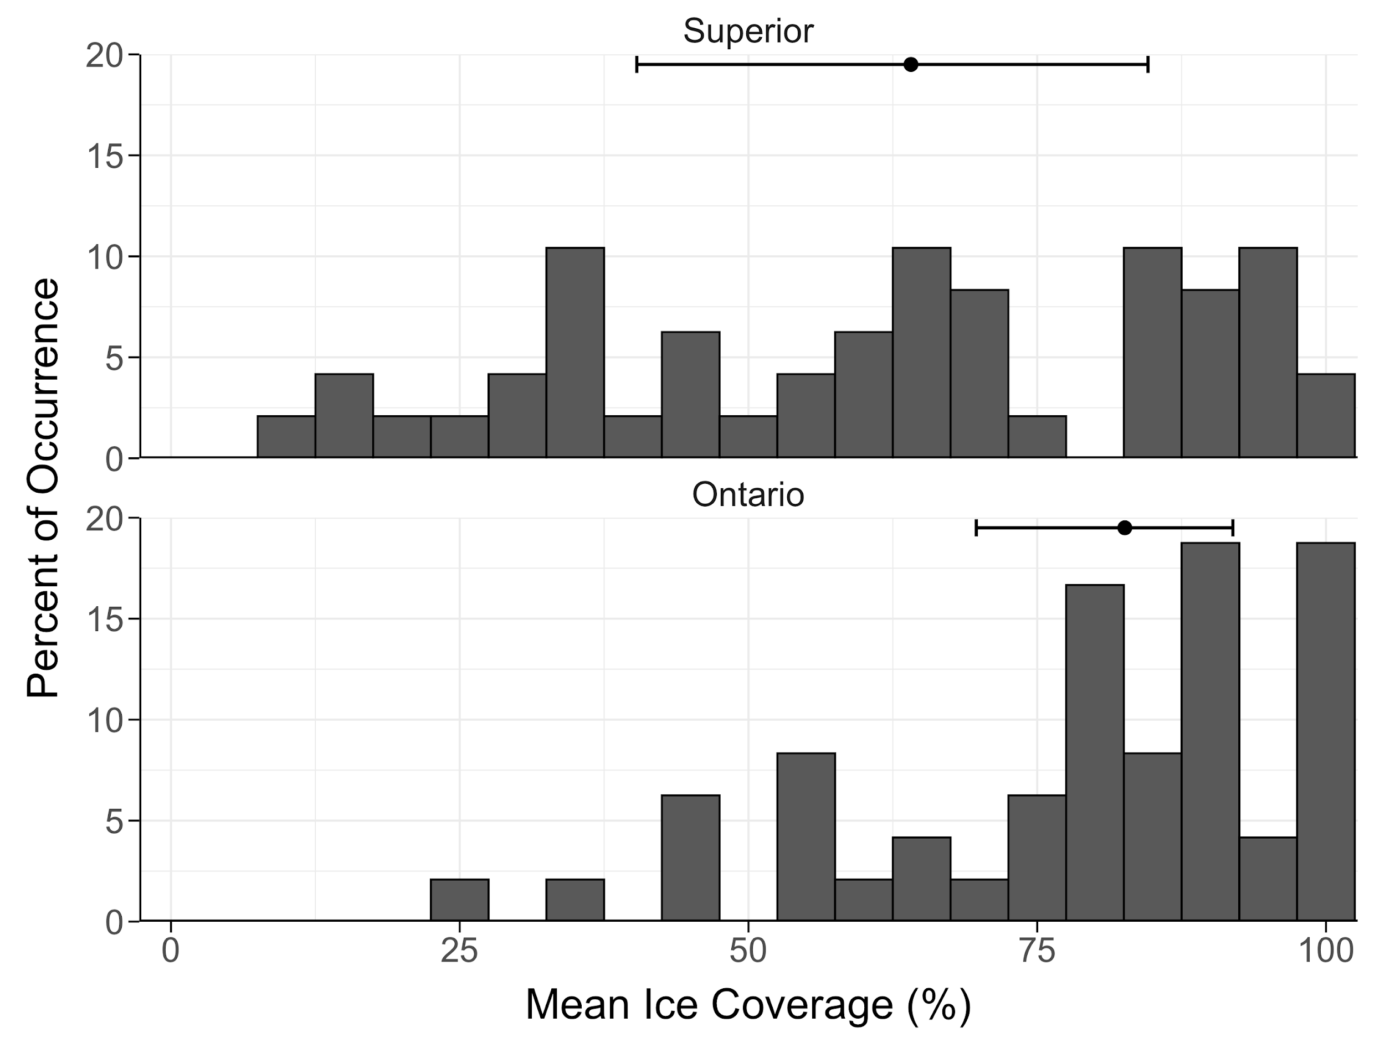

Figure 1. Histogram of annual mean ice coverage between 1-Jan and 15-Mar from 1973-2020 for the sampling location in Lake Superior (top) and Lake Ontario (bottom). Error bars represent the interquartile range and point indicates median. Ice coverage data was obtained from the U.S. National Ice Center (usicecenter.gov/).

Figure 2. Daily ice coverage (%; blue line) and light intensity (μmol m-2 s-1; gray line) relationship based on light sensors set at 10 m depth off Sand Island, Lake Superior. Ice coverage data above the sensor was obtained from the U.S. National Ice Center (usicecenter.gov/).

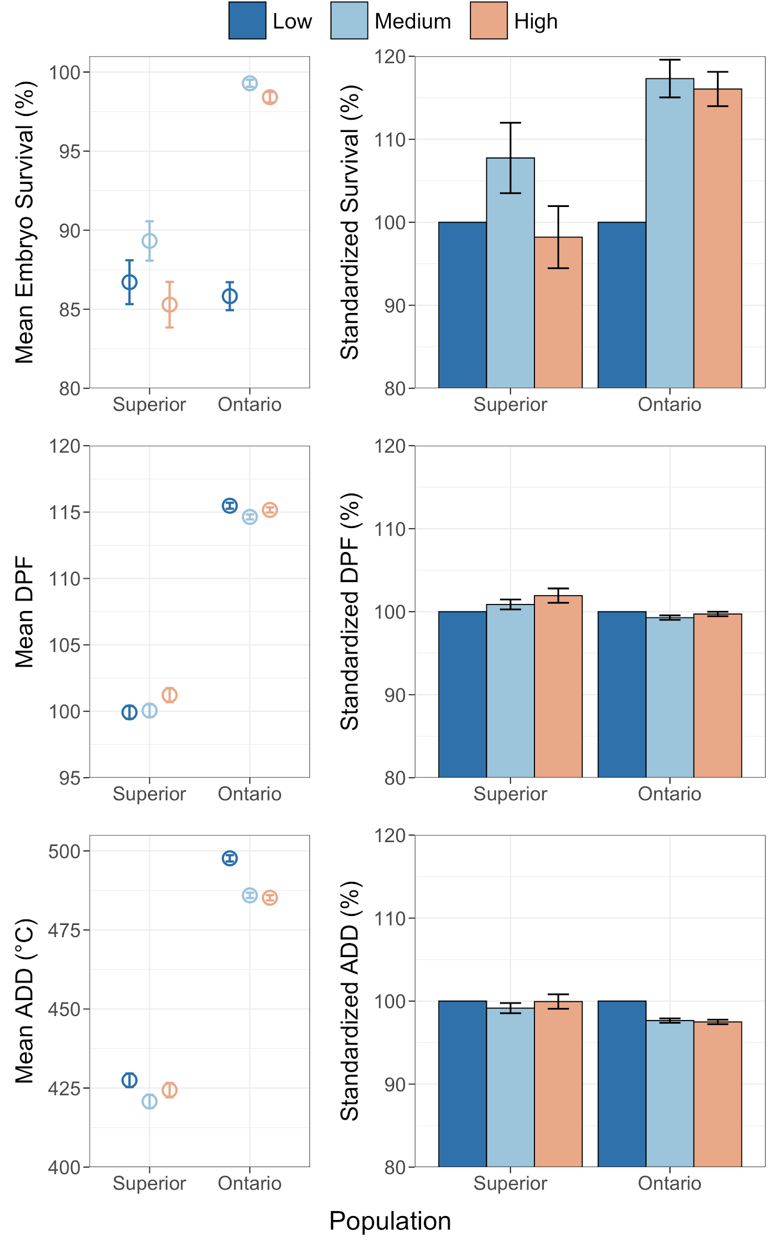

Figure 3. Mean embryo survival (%) and incubation period (number of days post-fertilization (DPF) and accumulated degree days (°C; ADD)) at each incubation light treatment (left) and standardized responses to assumed optimal light conditions (*i.e.,* low) within each population (%; right) from Lake Superior and Lake Ontario cisco (*Coregonus artedi*). Error bars indicate standard error.

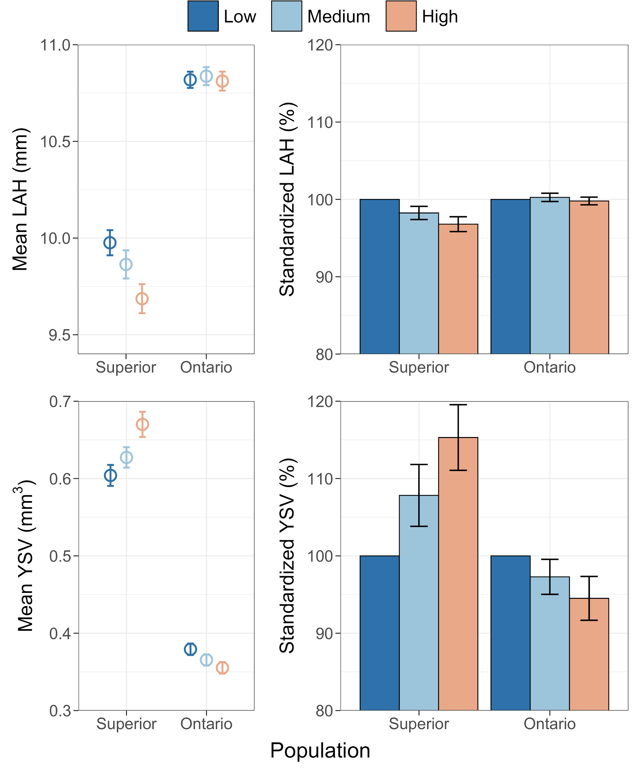

Figure 4. Mean length-at-hatch (mm; LAH) and yolk-sac volume (mm3; YSV) at each incubation light treatment (left) and standardized responses to assumed optimal light conditions (*i.e.,* low) within each population (%; right) from Lake Superior and Lake Ontario cisco (*Coregonus artedi*). Error bars indicate standard error.