#### Dear Editor:

Please consider our manuscript entitled “Post-hatching response to warming incubation temperature for Laurentian Great Lakes cisco (*Coregonus artedi*) larval survival, growth, and critical thermal limit” for review as a full length article.

This study will be of interest to the readership of the *Journal of Great Lakes Research* due to our results and implications on current and proposed restoration efforts of *Coregonus* spp. in the Great Lakes. Re-establishing native species, including cisco, in the Great Lakes is an active area of research. Key uncertainties associated with cisco restoration include understanding the role the environment plays in the development of phenotypes and the extent of plasticity within populations. We used common garden experiments to identify the downstream physiological effects warming winter incubation temperatures may have on the survival, growth, and critical thermal limit of larvae. We expect this paper to be well-received based on extensive coregonine restoration and conservation efforts underway throughout North America and Eurasia.

We experimentally tested how the incubation environment of cisco embryos from lakes Superior and Ontario may impact larvae post-hatch. Our key findings were that 1) cisco larvae from lakes Superior and Ontario were negatively impacted from warming incubation temperatures and 2) larvae from Lake Superior had a greater magnitude of change from the coldest to warmest incubation temperatures than Lake Ontario cisco in all traits examined. Our results suggest that cisco recruitment from both populations could be greatly reduced from warming winter incubation conditions, and that early-life stage cisco from Lake Superior may possess a narrower ability to acclimate to and cope with increasing winter water temperatures from climate change than cisco from Lake Ontario.

All authors contributed to the study conception and funding acquisition. Material preparation, data collection, and data analysis were performed by Taylor R. Stewart (TS). The first draft of the manuscript was written by TS and all authors commented on subsequent versions of the manuscript. All authors read and approved the final manuscript.

This research has not been previously published and is not under consideration at any other journal. Our submission has been posted on a preprint server (bioRxiv.org) and we agree to update the preprint link with a link to our JGLR submission if it is accepted. Thank you for your time and consideration. Please do not hesitate to contact me with any further questions.

We look forward to your response.

Sincerely,

signature

Taylor R. Stewart (on behalf of all co-authors)

Department of Biology, Rubenstein Ecosystem Science Laboratory

University of Vermont

Email: [taylor.stewart@uvm.edu](mailto:taylor.stewart@uvm.edu)

#### Potential Reviewers:

Gretchen Hansen, University of Minnesota, ghansen@umn.edu

Andrew Muir, Great Lakes Fishery Commission, amuir@glfc.org

Peter Jacobson, Minnesota Department of Natural Resources, peter.jacobson@state.mn.us

David “Bo” Bunnell, USGS Great Lakes Science Center, dbunnell@usgs.gov

Andrew Honsey, USGS Great Lakes Science Center, ahonsey@usgs.gov

Kevin Keeler, USGS Great Lakes Science Center, kkeeler@usgs.gov

Marc Chalupnicki, USGS Tunison Laboratory of Aquatic Science, mchalupnicki@usgs.gov

Alfred Sandström, Swedish University of Agricultural Sciences, alfred.sandstrom@slu.se

Josef Wanzenböck, University of Innsbruck, josef.wanzenböck@uibk.ac.at

Eva Enders, Fisheries and Oceans Canada, [Eva.Enders@dfo-mpo.gc.ca](mailto:Eva.Enders@dfo-mpo.gc.ca)

Jared Myers, US Fish & Wildlife Service, [jared_myers@fws.gov](mailto:jared_myers@fws.gov)

#### Author Statement:

**Taylor R. Stewart:** Writing- Original draft preparation, Conceptualization, Methodology, Investigation, Formal analysis, Visualization, Data curation, Funding acquisition. **Mark R. Vinson:** Writing- Reviewing and Editing, Conceptualization, Funding acquisition. **Jason D. Stockwell**: Writing- Reviewing and Editing, Conceptualization, Funding acquisition, Supervision

Post-hatching response to warming incubation temperature for Laurentian Great Lakes cisco (*Coregonus artedi*) larval survival, growth, and critical thermal limit

Taylor R. Stewarta,b*, Mark R. Vinsonc, and Jason D. Stockwellb

a Department of Biology, University of Vermont, 109 Carrigen Drive, Burlington, VT 05405, USA

b Rubenstein Ecosystem Science Laboratory, University of Vermont, 3 College Street, Burlington, VT 05401, USA

c U.S. Geological Survey, Lake Superior Biological Station, 2800 Lake Shore Drive East, Ashland, WI 54806, USA

*Corresponding Author: Taylor R. Stewart, Department of Biology, Rubenstein Ecosystem Science Laboratory, University of Vermont, 3 College St, Burlington, VT 05401, USA.

Email: [taylor.stewart@uvm.edu](mailto:taylor.stewart@uvm.edu)

#### Abstract (250 words):

One of the greatest threats to freshwater systems and biodiversity is climate change and the unprecedented rise of water temperatures on a global scale. Ectotherms, such as fish, are directly affected by their thermal environment, and the embryo stage is a critical thermal bottleneck. We experimentally evaluated the consequences of different embryo incubation temperatures on post-hatching survival, growth, and critical thermal maximum of larval cisco (*Coregonus artedi*) sampled from Lake Superior and Lake Ontario. Embryos were incubated at water temperatures of 2.0, 4.4, 6.9, and 8.9°C to simulate increased winter temperatures, and successfully hatched larvae were reared under a common environment. For both populations of cisco, larval survival and critical thermal maximum were negatively related to incubation temperature, and larval growth was positively related to incubation temperature. The magnitude of change across incubation temperatures was greater in the population sampled from Lake Superior than Lake Ontario for all traits examined, which suggests that early-life stage cisco from Lake Superior may possess a narrower ability to acclimate to and cope with increasing winter water temperatures than cisco from Lake Ontario. Our results of the downstream physiological effects from warming incubation conditions improves our understanding of how larval cisco may respond to changing and variable spring and summer environmental and feeding conditions. Our results also highlight the importance of integrating natural habitat preferences and maximizing phenotypic variability into propagation and restoration programs to ensure offspring are set up for success upon reintroduction.

#### Introduction:

One of the greatest threats to freshwater systems and biodiversity is climate change and the unprecedented rise of water temperatures on a global scale (Austin and Colman, 2008; Maberly et al., 2020; O’Reilly et al., 2015; Woolway et al., 2020).

Ectotherms, such as fish, have thermal limits and tolerance ranges (Comte and Olden, 2017; Dahlke et al., 2020; Little et al., 2020) that Th vary with ontogenetic development (Dahlke et al., 2020) and effect reproduction, metabolic rates, growth, and overall survival (Brett, 1979; Brown et al., 2004; Busch et al., 2012; Gillooly et al., 2002; Little et al., 2020; Ohlberger et al., 2007). . Vulnerability of fishes to climatic warming is highest for cold stenothermic species and specific vulnerability of local populations will likely be dependent on future thermal dynamics and the temperature requirements of spawners and embryos (Dahlke et al., 2020; Sunday et al. 2020) . In the short-term, lacustrine spawners may cope with changing thermal conditions by shifting spawning timing or potentially in the long-term thermal through adaptation across generations. Adaptation though may be too slow to keep pace with changing thermal conditions (Bruge et al. 2016) and spawning later in the season after waters have cooled may still impact embryo development due to spring warming. The physiological effect of thermal stress from non-optimal embryo incubation temperatures on post-hatching survival and performance is unclear, even though the larval period is critical for year-class success (Cushing, 1990; Hjort, 1914).

﻿

Freshwater whitefishes, Salmonidae Coregoninae (hereafter coregonines), are cold, stenothermic fishes of great ecological and socio-economic importance throughout the northern hemisphere (Elliott and Bell, 2011; Isaak, 2014; Jeppesen et al., 2012; Jonsson and Jonsson, 2014; Karjalainen et al., 2015; Stockwell et al., 2009). In the Laurentian Great Lakes isco (*Coregonus artedi*) was historically the most abundant species, a primary prey fish of lake trout (Salvelinus namaycush), and was a target of commercial fisheries since they began in the 1800s (Baldwin et al., 2009; Stockwell et al., 2009). Most cisco spawning stocks collapsed by the middle of the 20th century (Rook et al., 2021; Stockwell et al., 2009), though some stocks partially recovered by the early 1990s, primarily in Lake Superior, but contemporary abundance is considered to be below historical levels. Present Lake Superior cisco population abundance is thought to be limited by reduced and inconsistent survival of fish to age-1 and lower overall ecosystem productivity due to reduced phosphorus inputs as compared to 1900-1970 (Rook et al., 2021). Variable and weak year-class strength of coregonines has been observed worldwide over the past several decades and has been associated with annual variations in lake ice formation and winter-spring thermal conditions (Anneville et al., 2015; Karjalainen et al., 2015; Marjomäki et al., 2004; Nyberg et al., 2001).

Most coregonines spawn in late-autumn, embryos incubate under ice, and hatch in late-spring near ice-out, when rising spring water temperatures trigger hatching (Karjalainen et al., 2015; Stockwell et al., 2009). Increases in air and water temperatures of seasonally ice-covered lakes is projected to be greatest during the winter and spring, respectively (Christensen et al., 2007; Schindler et al., 1990; Winslow et al., 2017). The effect of elevated temperatures on embryonic and larval coregonine development and survival has been speculated from theorized (CITES), but the thermal trigger for the response and the mechanism of the response are unknown.

To address this question, we experimentally evaluated how cisco embryo incubation temperatures influenced the survival and performance of hatching larvae within and between two Great Lakes populations. We hypothesized that cisco embryos artificially incubated at temperatures that mimic cold, pre-climate change conditions would have increased larval survival, growth, and critical thermal limits compared to warmer, sub-optimal incubation temperatures. If our hypothesis is supported, we would expect wild cisco populations to have a negative relationship between embryo incubation temperature and larval survival and performance when reared artificially.

#### Methods:

##### *Ethics*

All work described here was approved for ethical animal care under University of Vermont’s Institutional Animal Care and Use Committee (Protocol # PROTO202000021).

##### *Crossing Design and Fertilization*

Cisco were collected from the Apostle Islands, Lake Superior (46.85°, -90.55°) and Chaumont Bay, Lake Ontario (44.05°, -76.20°) in December 2019. Eggs and milt were stripped from 12 females and 16 males from each population and artificially fertilized under a blocked, nested full-sib, half-sib fertilization design to create a maximum of 48 families. A single fertilization block consisted of four males each paired to three unrelated females, where all offspring of a given female were full siblings (Stewart et al., 2021).

For clarity, our operational use of a population represents a single species sampled from a single location within a single lake (*e.g.,* cisco from the Apostle Islands region in Lake Superior). A single location within large lakes does not likely capture the possible genetic variation within a species or population.

##### *Rearing Conditions*

Full embryo incubation methods can be found in Stewart et al. (2021). Briefly, embryos were incubated in 24-well cell culture microplates at mean (SD) constant temperatures of 2.0 (0.5), 4.4 (0.2), 6.9 (0.2), and 8.9 (0.3)°C, and randomly placed in climate-controlled chambers (Memmert® IPP260Plus). Reconstituted freshwater medium was used during fertilizations and incubations (ISO 6341, 2012) to standardize the chemical properties of the water among all treatments and between populations. After hatching, larvae were photographed alive and ventrally (Nikon® D5600 and Nikon® AF-S DX 18-55mm lens). Total length was measured from images using Olympus® LCmicro.

Newly-hatched larvae were transferred to rearing tanks segregated by population and incubation temperature. Larvae from Lake Superior were reared in four (4 incubation treatments x 1 replicate) 150-liter oval tanks. Larvae from Lake Ontario were reared in eight (4 incubation treatments x 2 replicates) 150-liter oval tanks. Lake Ontario larvae were divided equally by families (*i.e.,* up to 24 of 48 total larvae per family per replicate tank) into replicate tanks per incubation temperature treatment. Lake Superior larvae were unreplicated as a result of low fertilization success and embryo survival - insufficient numbers were available for multiple rearing tanks. All rearing tanks were supplied with chilled, recirculating water maintained at 6.5°C (mean (SD) = 6.36 (1.17)). Water temperatures (±0.2°C) were recorded hourly. Larvae in all rearing tanks were exposed to the same photoperiod cycle (*i.e.,*12-hr light, 12-hr dark) with gradual sunrise and sunset transitions. ﻿Full spectrum (*i.e.,* 380-780 nm), white LED lights (AquaShift® MLA-WH) were used to simulate daylight. Dead larvae were removed and counted each day. Larvae were fed *Artemia* and transitioned to Otohime A dry feed ﻿one-week post-hatch. Food was provided *ad libitum*.

##### *Thermal Challenge*

After 60 days, larvae from each population, incubation treatment, and replicate rearing tank were thermally challenged. Because larvae within and among rearing tanks did not hatch on the same day, 60-days post-hatch was calculated from the date of 50% hatching for each rearing tank. Larvae were transferred to 5.4-liter clear, rectangular tanks, with two replicate tanks per rearing tank and approximately 50 larvae, or as many available, were used in each replicate tank. Larvae were acclimated at 10.0°C for 12 hours prior to the thermal challenge. The water in the thermal challenge system was recirculated among all replicate tanks and aerated. During the thermal challenge, water temperatures were raised from 10.0°C at a constant rate of 0.5°C per 30 minutes until all larvae were deceased. Larvae were considered terminated when loss of equilibrium was achieved and were motionless for at least 5 seconds. Once endpoint criteria were met, larvae were euthanized, photographed, and preserved in 95% ethanol. The elapsed time and temperature at termination of each individual larvae was recorded and total length was measured.

All larvae from the 8.9°C treatment died during the acclimation period from an unknown cause, thus, only thermal challenge data from 2.0, 4.4, and 6.9°C are presented.

##### *Statistical Analyses*

All statistical analyses were performed in R version 4.0.5 (R Core Team, 2021).

Larval survival was estimated for each rearing tank, across all families, as the percent of larvae surviving between hatching and 60 days after the date of 50% hatching. Our estimates of larval survival from Lake Superior are unreplicated. However, useful information can still be gleaned without strict statistical testing (*e.g.*, Davies and Gray, 2015). Observations of single estimates of larval survival across incubation temperatures could suggest further hypotheses and lead to more focused studies.

Similar to larval survival estimates, larval growth rate estimates for Lake Superior were unreplicated. To this end, we qualitatively compared absolute growth rates across populations and incubation temperatures by generating bootstrapped confidence intervals for the observed absolute growth rate estimates. For each population, incubation temperature treatment, and replicate rearing tank, a bootstrapped mean length-at-hatch was calculated from random sampling with replacement from the observed lengths-at-hatch, and a bootstrapped mean final length was calculated from random sampling with replacement from the observed final lengths. The difference between the bootstrapped mean final length and bootstrapped mean length-at-hatch was calculated and divided by the duration of the larval experiment (*i.e.,* absolute growth rate). The resampling procedure was repeated 10,000 times. The bootstrapped absolute growth rate distributions were used to calculate the 2.5 and 97.5 percentile values (*i.e.,* 95% confidence interval) as a measure of variation around the observed absolute growth rate, and to qualitatively assess the likelihood of differences in growth among populations and incubation temperature treatments, in absence of replication. For Lake Ontario, the 95% confidence intervals were calculated as the mean 2.5 and 97.5% percentiles across replicate tanks. Comparisons were made by examining the overlap of the observed mean absolute growth rate to the bootstrapped 95% confidence intervals of all pairwise comparisons.

The critical thermal maxima (CTMax) of larval cisco from each population and incubation temperature treatment was expressed as the arithmetic mean of the temperature at which endpoint criteria were reached (Mora and Ospina, 2001). Although we have estimates for each individual larva within replicate thermal challenge tanks, the larvae from Lake Superior were reared in a single rearing tank and thus the estimates are not independent and cannot be treated as true replicates. Therefore, a similar bootstrap approach as described for larval growth was used to qualitatively compare CTMax among populations and incubation temperature treatments. For each population, incubation temperature treatment, and replicate rearing tank, we generated a bootstrap sample by randomly assigning, with replacement, a termination temperature to a bootstrapped fish, with the total number of bootstrapped fish equal to the number of observations in the original sample. The CTMax was calculated for each bootstrapped sample and the distribution of bootstrapped CTMax was used to calculate the 95% confidence interval as a measure of variation around the observed CTMax. The resampling procedure was repeated 10,000 times. For Lake Ontario, the 95% confidence intervals were calculated as the mean 2.5 and 97.5% percentiles across replicate tanks. Comparisons were made by examining the overlap of the observed mean CTMax to the bootstrapped 95% confidence intervals of all pairwise comparisons.

#### Results:

##### *Larval Survival*

A total of 9,605 larvae hatched and were reared from Lake Superior and Lake Ontario across all incubation temperatures. Larval survival was highest at the 2.0°C incubation temperature and decreased with warming incubation temperatures in both Lake Superior and Lake Ontario (XX% survival, Figure 1). Survival rates were XX% at 2.0°C, XX%W at 4.4°C, 1.1% at 6.9°C, and 5.4% at 8.9°C for Lake Superior larvae. SAME SENTENCE FOR LAKE ONTARIO. USE % SURVIVAL SO IT MATCHES FIGURE. YES IT’S BORING, BUT IT STATES THE RESULTS WHICH IS WHY PEOPLE ARE READING THE PAPER Larval survival was higher for Lake Ontario larvae across all incubation temperature treatments, except 8.9°C, compared to Lake Superior. Lake Ontario larvae incubated at 2.0 and 4.4°C had similar survival rates (< 9% difference). Lake Superior larval survival decreased 21% from the 2.0° to 4.4°C incubation temperatures (Figure 1).

##### *Larval Growth*

Absolute growth rate in larval cisco increased with warming incubation temperatures in Lake Superior and Lake Ontario (Figure 2). Larvae from Lake Superior had lower absolute growth rates at 2.0 and 4.4°C (0.049 and 0.044 mm day-1, respectively) compared to Lake Ontario (0.056 and 0.061 mm day-1, respectively). Absolute growth rates increased at 6.9°C for Lake Superior (0.057 mm day-1) and 8.9°C for Lake Ontario (0.078 mm day-1), and both populations had similar absolute growth rates at 6.9 and 8.9°C (mean difference <0.001 and 0.012 mm day-1, respectively; Figure 2).

##### *Thermal Challenge*

Critical thermal limit in larval cisco decreased with warming incubation temperatures in Lake Superior and Lake Ontario (Figure 3). Larvae from Lake Superior incubated at 2.0°C had the highest CTMax (25.81°C). However, CTMax in Lake Superior decreased from 2.0°C to 4.4 (difference 0.83°C) and 6.9°C (difference from 2°C 1.60°C). CTMax was similar for Lake Ontario larvae incubated at 2.0 and 4.4°C (24.99 and 24.96°C, respectively) but decreased at 6.9°C (24.67°C).

#### Discussion:

My thinking - discussion should focus on the effect of incubation temperature on larval survival and growth and how this relates to natural populations and hatchery raised populations. The hatchery connection of too warm of water is potentially the most valuable contribution of this study.

Survival, growth rates, and critical thermal limits of cisco larvae from lakes Superior and Ontario were all influenced by embryo incubation temperatures that were warmer than current natural winter water temperatures in these lakes. First, we found a negative relationship between larval survival and embryo incubation temperature. Second, warmer embryo incubation temperatures increased larval growth rates. Third, critical thermal limits decreased with warming incubation temperatures. Lastly, the magnitude of change across incubation temperature treatments was greater in cisco from the historically colder Lake Superior than Lake Ontario for all traits examined. These results suggest increased risk to Laurentian Great Lakes ciscoe populations in response to projected climatic warming (CITES).

Our hypothesis that larval survival would be highest at the coldest incubation temperature, which mimicked the natural lake environment, was supported. Between the two lakes, Lake Superior cisco had a sharper decline in larval survival from 2.0 to 4.4°C as compared to Lake Ontario cisco. Though both populations are cold adapted, this suggests Lake Superior cisco were more cold-water adapted than those from Lake Ontario. Spawning cisco from Lake Superior were collected at an open lake location, whereas spawning cisco from Lake Ontario cisco were collected in a shallow, protected bay. Water temperatures in shallower protected habitats increase more rapidly after ice-out and have higher maximum spring and summer temperatures (*i.e.,* Lake Ontario sampling location) compared to deeper, open-water locations (*i.e.,* Lake Superior sampling location) because the heat capacity of water is positively related to depth and there is less mixing of water in protected bays (Assel et al., 2003; Gan and Liu, 2020; Verburg and Antenucci, 2010). Spring warming rate can regulate nursery habitat conditions for larvae of autumn-spawning coregonines, and play a critical role in prey availability, growth, and survival (Lucke et al., 2020; Myers et al., 2014).

Higher winter temperatures induce earlier coregonine embryo hatching and cause larvae to have smaller lengths-at-hatch and larger yolk-sac volumes (Karjalainen et al., 2015; Stewart et al., 2021). The transition from endogenous to exogenous feeding is a critical life-stage thought to influence larval fish survival after hatching (Cushing, 1990; Hjort, 1914). In wild populations, earlier hatching may increase the mismatch between the onset of spring plankton blooms and larval prey, increasing the risk for starvation and higher larval mortality (Cushing, 1990; Myers et al., 2014). However, larvae hatching with larger yolk sacs may allow more time to transition to exogenous feeding (Hjort, 1914; Lucke et al., 2020; Miller et al., 1988), but at a cost to swimming efficiency and predator avoidance (Darowski et al., 1988; Myers et al., 2014). Our experiment provided cisco larvae a predator-free environment with *ad libitum* food immediately after hatching, yet we still observed sharp declines in larval survival for those incubated at increased temperatures. An additional or alternative hypothesis for a survival bottleneck under climate change scenarios, suggested by our results, is that larval cisco survival may not be as limited by prey availability but instead by their physiological condition induced from downstream effects of warmer embryo incubations.

Fast growth and high larval survival are typically associated (Blaxter, 1986; Houde, 1989; Miller et al., 1988; Myers et al., 2014; Ware, 1975). However, larval cisco exhibited low survival in our experiments, despite higher absolute growth rates when incubated at warmer temperatures and did not support our hypothesis. This unexpected result is plausible as growth is directly related to metabolism in fishes and an increase in temperature, within their preferred thermal breadth, is likely to be beneficial to larval growth because it results in more energy and faster enzyme reactions (Brown et al., 2004; McCormick et al., 1971; Myers et al., 2014). However, all larvae were reared at the same temperature post-hatching which suggests larval metabolism may not be the source of increased growth under higher incubation temperatures.

Coregonine embryos incubated at high temperatures often hatch prematurely and underdeveloped (Colby and Brooke, 1970; Price, 1940). Such conditions may require free-floating embryos to rapidly convert yolk for development. In this sense, the higher absolute growth rates gained from warming incubation temperatures may not be optimal for survival and year-class strength. Larval cisco from Lake Superior use a mixed-feeding strategy with endogenous energy reserves (*i.e.,* yolk) and exogenous feeding overlapping at lengths between 10 and 12 mm (Lucke et al., 2020). Embryos incubated at colder temperatures (*i.e.,* 2.0 and 4.4°C) from the sampled populations of lakes Superior and Ontario cisco had mean length-at-hatch ranging from 9.9-11.3 mm, whereas mean lengths-at-hatch ranged from 8.7-9.7 mm at the warmest incubation temperature (*i.e.,* 8.9°C; Stewart et al., 2021). The combination of field and experimental data suggests that cold, long incubations with prolonged development, larger length-at-hatch with less endogenous energy reserves, the ability to immediately use a mixed endogenous and exogenous feeding strategy, and lower growth rates creates the best scenario to maximize larval survival (Lucke et al., 2020; Stewart et al., 2021). However, this ‘goldilocks scenario’ only works if all biotic and abiotic conditions (*e.g.,* water temperature, appropriately sized prey, etc.) match cisco phenotypes (REFS). The validity of this hypothesis remains to be tested, as our experiments provided a stable and optimal temperature and feeding environment, conditions that cannot be assumed to occur in the wild.

The ability of larval cisco to use favorable nursery habitat near the lake surface is directly related to their ability to tolerate the seasonal increase in surface water temperatures. The increase in CTMax with decreased incubation temperature supported our hypothesis that cold, pre-climate change conditions would maximize thermal performance. The different magnitudes of change between cisco from lakes Superior and Ontario could be explained from evolutionary adaptations to local conditions. Fish populations from high-latitude, low-temperature locales often compensate for slower metabolism and lower growth rates by having more efficient physiological performance than low-latitude populations (*i.e.,* countergradient variation; Conover & Present, 1990; Jonassen, 2000; Reist et al., 2006). Lake Superior experiences colder and less seasonal variation in water temperature than Lake Ontario (Calamita et al., 2021; Zhang et al., 2018), and larval cisco from Lake Superior may have more efficient physiological adaptations (*e.g.,* cardiac and respiratory performance) which could explain the high thermal tolerance at cold incubation temperatures and sensitivity to increased temperatures. Our results suggest research on mechanisms driving the observed differences in CTMax between populations (*e.g.,* cardiac failure, oxidative damage to tissue, body mass, stress biomarkers, protein denaturation, etc.) may prove insightful.

The results of this study have implications for current and proposed hatchery-based restoration efforts of coregonines in the Laurentian Great Lakes (Bronte et al., 2017). We found that cisco offspring from two of the Great Lakes raised at warm incubation temperatures (i.e., > 4.5°C) have lower overall performance than individuals incubated at cold temperatures (i.e., < 4.5°C). Many coregonine hatchery facilities around the Great Lakes do not have the capability to incubate embryos under natural lake thermal conditions (*i.e.,* cold water temperatures, < 4.5°C).

Offspring from parents haphazardly selected for artificial breeding and reared in captivity before release have the potential to induce strong directional selection and harm naturally recruiting populations (Araki and Schmid, 2010; Tingley III et al., 2019). Transgenerational effect of lower larval performance and its potential effect on the response to selection are unknown but warrants investigation. The consequences an artificial environment may have on the genetic diversity within a population and fitness of post-stocking individuals needs to be considered in ongoing restoration and conservation efforts.

Identifying the genetic mechanisms (*i.e.,* SNPs and gene expression) involved in the thermal adaptation and acclimation of coregonine populations is an important next step. Variation in certain genetic markers and survival under thermal stress may allow managers to determine thegenotypes associated with increased survival at variable or increasing temperatures (Narum et al., 2013). Examining gene expression across populations and temperature treatments will help identify and evaluate the function of differentially expressed genes and potential physiological pathways that may be disproportionately under- or over-represented with thermal stress (Rougeux et al., 2018). Furthermore, the combination of genomic tools (*e.g.,* genome-wide association study and RNA-seq) in thermal ecology experiments can provide valuable insight into the functional significance of markers associated with thermal tolerance (Rougeux et al., 2018).

#### Conclusion:

Incorporating knowledge of the downstream effects from warming incubation conditions will improve our understanding of how larval cisco survival and performance may be impacted by a warming climate. Our results also highlight the importance of integrating natural habitat preferences into propagation programs to ensure offspring are set up for success upon reintroduction. A challenge for managers and propagation facilities is to consider the impact embryo incubation conditions may have on larval survival and performance in relation to production targets. Additionally, propagation and stocking may accomplish the short-term restoration objective of supplementing wild populations, but other limiting factors (*e.g.,* habitat loss, anthropogenic disturbances, water quality, invasive species) also need to be addressed to achieve long-term population conservation and viability (Tingley III et al., 2019). Our results warrant further hypotheses and more focused studies. Maximizing phenotypic variation and adaptability to changing conditions (*i.e.,* portfolio effect; Schindler et al., 2015, 2010) is a strong consideration in restoration and conservation efforts. Embracing management strategies to foster increased early-life stage fitness could improve the ability of coregonines to cope with environmental change in the wild and aid in addressing recruitment bottlenecks.

#### Acknowledgments:

We thank the staff at the Wisconsin Department of Natural Resources Bayfield Fisheries Field Station, United States Geological Survey (USGS) Tunison Laboratory of Aquatic Science, and New York State Department of Environmental Conservation Cape Vincent Fisheries Station for conducting field collections of spawning adults. We also thank Rachel Taylor, Dan Yule, and Caroline Rosinski for help with fertilizations and incubation experiment maintenance. Stockwell and Marsden lab members and anonymous peer reviewers strengthened the manuscript. This work was funded by the USGS under Grant/Cooperative Agreement No. G16AP00087 to the Vermont Water Resources and Lakes Studies Center and G17AC00042 to the University of Vermont. Additionally, this work was made possible with funds made available to Lake Champlain by Senator Patrick Leahy through the Great Lakes Fishery Commission.

#### References:

Anneville, O., Lasne, E., Guillard, J., Eckmann, R., Stockwell, J.D., Gillet, C., Yule, D.L., 2015. Impact of Fishing and Stocking Practices on Coregonid Diversity. Food Nutr. Sci. 06, 1045–1055. https://doi.org/10.4236/fns.2015.611108

Araki, H., Berejikian, B.A., Ford, M.J., Blouin, M.S., 2008. Fitness of hatchery‐reared salmonids in the wild. Evol. Appl. 1, 342–355. https://doi.org/10.1111/j.1752-4571.2008.00026.x

Araki, H., Schmid, C., 2010. Is hatchery stocking a help or harm?: Evidence, limitations and future directions in ecological and genetic surveys. Aquaculture 308, S2–S11. https://doi.org/10.1016/j.aquaculture.2010.05.036

Assel, R., Cronk, K., Norton, D., 2003. Recent trends in Laurentian Great Lakes ice cover. Clim. Change 57, 185–204. https://doi.org/10.1023/A:1022140604052

Austin, J.A., Colman, S.M., 2008. A century of temperature variability in Lake Superior. Limnol. Oceanogr. 53, 2724–2730. https://doi.org/10.4319/lo.2008.53.6.2724

Bailey, M.M., Lachapelle, K.A., Kinnison, M.T., 2010. Ontogenetic selection on hatchery salmon in the wild: natural selection on artificial phenotypes. Evol. Appl. 3, 340–351. https://doi.org/10.1111/j.1752-4571.2009.00115.x

Baldwin, N.A., Saalfeld, R.W., Dochoda, M.R., Buettner, H.J., Eshenroder, R.L., 2009. Commercial fish production in the Great Lakes, 1867–2006. Gt. Lakes Fish. Comm. Ann Arbor, Michigan. Available http//www. glfc. org/databases/commercial/commerc. php.(December 2009).

Bay, R.A., Harrigan, R.J., Underwood, V. Le, Gibbs, H.L., Smith, T.B., Ruegg, K., 2018. Genomic signals of selection predict climate-driven population declines in a migratory bird. Science. 359, 83–86. https://doi.org/10.1126/science.aan4380

Blaxter, J.H.S., 1986. Development of sense organs and behaviour of teleost larvae with special reference to feeding and predator avoidance. Trans. Am. Fish. Soc. 115, 114–980.

Brett, J.R., 1979. Environmental Factors and Growth, in: Hoar, W.S., Randall, D.J., Brett, J.R. (Eds.), Fish Physiology. Elsevier Science, pp. 599–677. https://doi.org/10.1016/S1546-5098(08)60033-3

Bronte, C.R., Bunnell, D.B., David, S.R., Gordon, R., Gorsky, D., Millard, M.J., Read, J., Stein, R.A., Vaccaro, L., 2017. Report from the workshop on coregonine restoration science. US Geological Survey. https://doi.org/10.3133/ofr20171081

Brown, J.H., Gillooly, J.F., Allen, A.P., Savage, V.M., West, G.B., 2004. Toward a metabolic theory of ecology. Ecology 85, 1771–1789. https://doi.org/10.1890/03-9000

Bruge, A., Alvarez, P., Fontán, A., Cotano, U. and Chust, G., 2016. Thermal niche tracking and future distribution of Atlantic mackerel spawning in response to ocean warming. Frontiers in Marine Science, 3, p.86.

Busch, S., Kirillin, G., Mehner, T., 2012. Plasticity in habitat use determines metabolic response of fish to global warming in stratified lakes. Oecologia 170, 275–287. https://doi.org/10.1007/s00442-012-2286-z

Christensen, J.H., Hewitson, B., Busuioc, A., Chen, A., Gao, X., Held, R., Jones, R., Kolli, R.K., Kwon, W.K., Laprise, R., 2007. Regional climate projections, in: Climate Change, 2007: The Physical Science Basis. Contribution of Working Group I to the Fourth Assessment Report of the Intergovernmental Panel on Climate Change, University Press, Cambridge, Chapter 11. pp. 847–940. https://doi.org/10.1007/978-81-322-1967-5_4

Christie, M.R., Ford, M.J., Blouin, M.S., 2014. On the reproductive success of early‐generation hatchery fish in the wild. Evol. Appl. 7, 883–896. https://doi.org/10.1111/eva.12183

Clady, M.D., 1976. Distribution and abundance of larval ciscoes, Coregonus artedii, and burbot, Lota lota, in Oneida Lake. J. Great Lakes Res. 2, 234–247. https://doi.org/10.1016/S0380-1330(76)72288-3

Colby, P.J., Brooke, L.T., 1970. Survival and development of lake herring (Coregonus artedii) eggs at various incubation temperatures, in: Lindsey, C., Woods, C. (Eds.), Biology of Coregonid Fishes. University of Manitoba Press, pp. 417–428.

Comte, L., Olden, J.D., 2017. Evolutionary and environmental determinants of freshwater fish thermal tolerance and plasticity. Glob. Chang. Biol. 23, 728–736. https://doi.org/10.1111/gcb.13427

Cowx, I.G., 1994. Stocking strategies. Fish. Manag. Ecol. 1, 15–30.

Cushing, D.H., 1990. Plankton production and year-class strength in fish populations: An update of the match/mismatch hypothesis. Adv. Mar. Biol. 26, 249–293. https://doi.org/10.1016/S0065-2881(08)60202-3

Dahlke, F.T., Wohlrab, S., Butzin, M., Pörtner, H.-O., 2020. Thermal bottlenecks in the life cycle define climate vulnerability of fish. Science. 369, 65–70. https://doi.org/10.1126/science.aaz3658

Darimont, C.T., Carlson, S.M., Kinnison, M.T., Paquet, P.C., Reimchen, T.E., Wilmers, C.C., 2009. Human predators outpace other agents of trait change in the wild. Proc. Natl. Acad. Sci. 106, 952–954. https://doi.org/10.1073/pnas.0809235106

Darowski, K., Takashima, F., Law, Y.K., 1988. Bioenergetic model of planktivorous fish feeding, growth and metabolism: theoretical optimum swimming speed of fish larvae. J. Fish Biol. 32, 443–458. https://doi.org/10.1111/j.1095-8649.1988.tb05380.x

Davies, G.M., Gray, A., 2015. Don’t let spurious accusations of pseudoreplication limit our ability to learn from natural experiments (and other messy kinds of ecological monitoring). Ecol. Evol. 5, 5295–5304. https://doi.org/10.1002/ece3.1782

Elliott, J.A., Bell, V.A., 2011. Predicting the potential long-term influence of climate change on vendace (Coregonus albula) habitat in Bassenthwaite Lake, U.K. Freshw. Biol. 56, 395–405. https://doi.org/10.1111/j.1365-2427.2010.02506.x

Eshenroder, R.L., Vecsei, P., Gorman, O.T., Yule, D.L., Pratt, T.C., Mandrak, N.E., Bunnell, D.B., Muir, A.M., 2016. Ciscoes (Coregonus, subgenus Leucichthys) of the Laurentian Great Lakes and Lake Nipigon. Gt. Lakes Fish. Comm. Misc. Publ. 1, 156.

Favé, M.-J., Turgeon, J., 2008. Patterns of genetic diversity in Great Lakes bloaters (Coregonus hoyi) with a view to future reintroduction in Lake Ontario. Conserv. Genet. 9, 281–293. https://doi.org/10.1007/s10592-007-9339-6

Gaines, S.D., Costello, C., Owashi, B., Mangin, T., Bone, J., Molinos, J.G., Burden, M., Dennis, H., Halpern, B.S., Kappel, C. V, 2018. Improved fisheries management could offset many negative effects of climate change. Sci. Adv. 4, 1–8. https://doi.org/10.1126/sciadv.aao1378

Gan, G., Liu, Y., 2020. Heat Storage Effect on Evaporation Estimates of China’s Largest Freshwater Lake. J. Geophys. Res. Atmos. 125, 1–14. https://doi.org/10.1029/2019JD032334

George, A.L., Kuhajda, B.R., Williams, J.D., Cantrell, M.A., Rakes, P.L., Shute, J.R., 2009. Guidelines for propagation and translocation for freshwater fish conservation. Fisheries 34, 529–545. https://doi.org/10.1577/1548-8446-34.11.529

Gillooly, J.F., Charnov, E.L., West, G.B., Savage, V.M., Brown, J.H., 2002. Effects of size and temperature on developmental time. Nature 417, 70–73. https://doi.org/doi.org/10.1038/417070a

Halpern, B.S., Frazier, M., Potapenko, J., Casey, K.S., Koenig, K., Longo, C., Lowndes, J.S., Rockwood, R.C., Selig, E.R., Selkoe, K.A., Walbridge, S., 2015. Spatial and temporal changes in cumulative human impacts on the world’s ocean. Nat. Commun. 6, 1–7. https://doi.org/10.1038/ncomms8615

Hatch, J.T., Underhill, J.C., Hoyt, R.D., 1988. Abundance, distribution, growth, and mortality of larval lake herring in western Lake Superior, in: American Fisheries Society Symposium. pp. 96–103.

Hilborn, R., Amoroso, R.O., Anderson, C.M., Baum, J.K., Branch, T.A., Costello, C., De Moor, C.L., Faraj, A., Hively, D., Jensen, O.P., 2020. Effective fisheries management instrumental in improving fish stock status. Proc. Natl. Acad. Sci. 117, 2218–2224. https://doi.org/10.1073/pnas.1909726116

Hjort, J., 1914. Fluctuations in the great fisheries of Northern Europe, in: Rapports et Procés-Verbaux. ICES, pp. 1–228.

Houde, E.D., 1989. Comparative growth, mortality, and energetics of marine fish larvae: temperature and implied latitudinal effects. Fish. Bull. 87, 471–495.

Hrabik, T.R., Jensen, O.P., Martell, S.J.D., Walters, C.J., Kitchell, J.F., 2006. Diel vertical migration in the Lake Superior pelagic community. I. Changes in vertical migration of coregonids in response to varying predation risk. Can. J. Fish. Aquat. Sci. 63, 2286–2295. https://doi.org/10.1139/F06-125

Isaak, D.J., 2014. Climate Change and the Future of Freshwater Fisheries, in: Taylor, W.W., Lynch, A.J., Leonard, N.J. (Eds.), Future of Fisheries: Perspectives for Emerging Professionals. American Fisheries Society, Bethesda, MD, pp. 435–441.

ISO 6341, 2012. Water quality — Determination of the inhibition of the mobility of Daphnia magna Straus (Cladocera, Crustacea) — Acute toxicity test. Int. Organ. Stand., from https://www.iso.org/standard/54614.html.

Jenny, J.-P., Anneville, O., Arnaud, F., Baulaz, Y., Bouffard, D., Domaizon, I., Bocaniov, S.A., Chèvre, N., Dittrich, M., Dorioz, J.-M., 2020. Scientists’ Warning to Humanity: Rapid degradation of the world’s large lakes. J. Great Lakes Res. 46, 686–702. https://doi.org/10.1016/j.jglr.2020.05.006

Jeppesen, E., Mehner, T., Winfield, I.J., Kangur, K., Sarvala, J., Gerdeaux, D., Rask, M., Malmquist, H.J., Holmgren, K., Volta, P., Romo, S., Eckmann, R., Sandström, A., Blanco, S., Kangur, A., Ragnarsson Stabo, H., Tarvainen, M., Ventelä, A.M., Søndergaard, M., Lauridsen, T.L., Meerhoff, M., 2012. Impacts of climate warming on the long-term dynamics of key fish species in 24 European lakes. Hydrobiologia 694, 1–39. https://doi.org/10.1007/s10750-012-1182-1

Jonsson, B., Jonsson, N., 2014. Early environment influences later performance in fishes. J. Fish Biol. 85, 151–188. https://doi.org/10.1111/jfb.12432

Karjalainen, J., Keskinen, T., Pulkkanen, M., Marjomäki, T.J., 2015. Climate change alters the egg development dynamics in cold-water adapted coregonids. Environ. Biol. Fishes 98, 979–991. https://doi.org/10.1007/s10641-014-0331-y

Klerks, P.L., Athrey, G.N., Leberg, P.L., 2019. Response to selection for increased heat tolerance in a small fish species, with the response decreased by a population bottleneck. Front. Ecol. Evol. 7, 270. https://doi.org/10.3389/fevo.2019.00270

Layton, K.K.S., Snelgrove, P.V.R., Dempson, J.B., Kess, T., Lehnert, S.J., Bentzen, P., Duffy, S.J., Messmer, A.M., Stanley, R.R.E., DiBacco, C., 2021. Genomic evidence of past and future climate-linked loss in a migratory Arctic fish. Nat. Clim. Chang. 11, 158–165. https://doi.org/10.1038/s41558-020-00959-7

Little, A.G., Loughland, I., Seebacher, F., 2020. What do warming waters mean for fish physiology and fisheries? J. Fish Biol. 97, 328–340. https://doi.org/10.1111/jfb.14402

Loftus, D.H., Hulsman, P.F., 1986. Predation on larval lake whitefish (Coregonus clupeaformis) and lake herring (C. artedii) by adult rainbow smelt (Osmerus mordax). Can. J. Fish. Aquat. Sci. 43, 812–818. https://doi.org/10.1139/f86-100

Lucke, V.S., Stewart, T.R., Vinson, M.R., Glase, J.D., Stockwell, J.D., 2020. Larval Coregonus spp. diets and zooplankton community patterns in the Apostle Islands, Lake Superior. J. Great Lakes Res. 46, 1391–1401. https://doi.org/10.1016/j.jglr.2020.07.001

Maberly, S.C., O’Donnell, R.A., Woolway, R.I., Cutler, M.E.J., Gong, M., Jones, I.D., Merchant, C.J., Miller, C.A., Politi, E., Scott, E.M., 2020. Global lake thermal regions shift under climate change. Nat. Commun. 11, 1–9. https://doi.org/10.1038/s41467-020-15108-z

Marjomäki, T.J., Auvinen, H., Helminen, H., Huusko, A., Sarvala, J., Valkeajärvi, P., Viljanen, M., Karjalainen, J., 2004. Spatial synchrony in the inter-annual population variation of vendace (Coregonus albula (L.)) in Finnish lakes. Ann. Zool. Fennici 41, 225–240.

McCormick, J.H., Jones, B.R., Syrett, R.F., 1971. Temperature requirements for growth and survival of larval ciscos (Coregonus artedii). J. Fish. Board Canada 28, 924–927. https://doi.org/10.1139/f71-134

Miller, T.J., Crowder, L.B., Rice, J.A., Marschall, E.A., 1988. Larval Size and Recruitment Mechanisms in Fishes: Toward a Conceptual Framework. Can. J. Fish. Aquat. Sci. 45, 1657–1670. https://doi.org/10.1139/f88-197

Mora, C., Ospina, A., 2001. Tolerance to high temperatures and potential impact of sea warming on reef fishes of Gorgona Island (tropical eastern Pacific). Mar. Biol. 139, 765–769. https://doi.org/10.1007/s002270100626

Muir, A.M., Vecsei, P., Pratt, T.C., Krueger, C.C., Power, M., Reist, J.D., 2013. Ontogenetic shifts in morphology and resource use of cisco Coregonus artedi. J. Fish Biol. 82, 600–617. https://doi.org/10.1111/jfb.12016

Myers, J.T., Jones, M.L., Stockwell, J.D., Yule, D.L., 2009. Reassessment of the Predatory Effects of Rainbow Smelt on Ciscoes in Lake Superior. Trans. Am. Fish. Soc. 138, 1352–1368. https://doi.org/10.1577/T08-131.1

Myers, J.T., Yule, D.L., Jones, M.L., Ahrenstorff, T.D., Hrabik, T.R., Claramunt, R.M., Ebener, M.P., Berglund, E.K., 2015. Spatial synchrony in cisco recruitment. Fish. Res. 165, 11–21. https://doi.org/10.1016/j.fishres.2014.12.014

Myers, J.T., Yule, D.L., Jones, M.L., Quinlan, H.R., Berglund, E.K., 2014. Foraging and predation risk for larval cisco (Coregonus artedi) in Lake Superior: A modelling synthesis of empirical survey data. Ecol. Modell. 294, 71–83. https://doi.org/10.1016/j.ecolmodel.2014.09.009

Narum, S.R., Campbell, N.R., Meyer, K.A., Miller, M.R., Hardy, R.W., 2013. Thermal adaptation and acclimation of ectotherms from differing aquatic climates. Mol. Ecol. 22, 3090–3097. https://doi.org/10.1111/mec.12240

Nyberg, P., Bergstrand, E., Degerman, E., Enderlein, O., 2001. Recruitment of pelagic fish in an unstable climate: studies in Sweden’s four largest lakes. Ambio 30, 559–564. https://doi.org/10.1579/0044-7447-30.8.559

O’Reilly, C.M., Rowley, R.J., Schneider, P., Lenters, J.D., Mcintyre, P.B., Kraemer, B.M., 2015. Rapid and highly variable warming of lake surface waters around the globe. Geophys. Res. Lett. 42, 1–9. https://doi.org/10.1002/2015GL066235

Ohlberger, J., Staaks, G., Hölker, F., 2007. Effects of temperature, swimming speed and body mass on standard and active metabolic rate in vendace (Coregonus albula). J. Comp. Physiol. 177, 905–916. https://doi.org/10.1139/F08-120

Oyadomari, J.K., Auer, N.A., 2004. Inshore-offshore distribution of larval fishes in Lake Superior off the western coast of the Keweenaw Peninsula, Michigan. J. Great Lakes Res. 30, 369–384. https://doi.org/10.1016/S0380-1330(04)70398-6

Palkovacs, E.P., Kinnison, M.T., Correa, C., Dalton, C.M., Hendry, A.P., 2012. Fates beyond traits: ecological consequences of human‐induced trait change. Evol. Appl. 5, 183–191. https://doi.org/10.1111/j.1752-4571.2011.00212.x

Parks, T.P., Rypel, A.L., 2018. Predator–prey dynamics mediate long-term production trends of cisco (Coregonus artedi) in a northern Wisconsin lake. Can. J. Fish. Aquat. Sci. 75, 1969–1976. https://doi.org/10.1139/cjfas-2017-0302

Price, J.W., 1940. Time-temperature relations in the incubation of the whitefish, Coregonus clupeaformis (Mitchill). J. Gen. Physiol. 23, 449–468. https://doi.org/10.1085/jgp.23.4.449

Pritchard, A.L., 1931. Spawning habits and fry of the cisco (Leucichthys artedi) in Lake Ontario. Contrib. to Can. Biol. Fish. 6, 225–240. https://doi.org/10.1139/f31-009

R Core Team, 2021. R: A Language and Environment for Statistical Computing.

Rakes, P.L., Shute, J.R., Shute, P.W., 1999. Reproductive behavior, captive breeding, and restoration ecology of endangered fishes. Environ. Biol. Fishes 55, 31–42. https://doi.org/10.1023/A:1007531927209

Rook, B.J., Hansen, M.J., Goldsworthy, C.A., Ray, B.A., Gorman, O.T., Yule, D.L., Bronte, C.R., 2021. Was historical cisco Coregonus artedi yield consistent with contemporary recruitment and abundance in Lake Superior? Fish. Manag. Ecol. https://doi.org/10.1111/fme.12474

Rougeux, C., Gagnaire, P.-A., Praebel, K., Seehausen, O., Bernatchez, L., 2018. Convergent transcriptomic landscapes under polygenic selection accompany inter- continental parallel evolution within a Nearctic Coregonus (Salmonidae) sister- species complex. bioRxiv. https://doi.org/10.1101/311464

Sala, O.E., Chapin, F.S., Armesto, J.J., Berlow, E., Bloomfield, J., Dirzo, R., Huber-Sanwald, E., Huenneke, L.F., Jackson, R.B., Kinzig, A., 2000. Global biodiversity scenarios for the year 2100. Science. 287, 1770–1774. https://doi.org/10.1126/science.287.5459.1770

Schindler, D.E., Armstrong, J.B., Reed, T.E., 2015. The portfolio concept in ecology and evolution. Front. Ecol. Environ. 13, 257–263. https://doi.org/10.1890/140275

Schindler, D.E., Hilborn, R., Chasco, B., Boatright, C.P., Quinn, T.P., Rogers, L.A., Webster, M.S., 2010. Population diversity and the portfolio effect in an exploited species. Nature 465, 609–612. https://doi.org/10.1038/nature09060

Schindler, D.W., Beaty, K.G., Fee, E.J., Cruikshank, D.R., DeBruyn, E.R., Findlay, D.L., Linsey, G.A., Shearer, J.A., Stainton, M.P., Turner, M.A., 1990. Effects of Climatic Warming on Lakes of the Central Boreal Forest. Science. 250, 967–970. https://doi.org/10.1126/science.250.4983.967

Selgeby, J.H., Maccallum, W.R., Hoff, M.H., 1994. Rainbow smelt-larval lake herring interactions: competitors or casual acquaintances? U.S. Natl. Biol. Surv. 25.

Stewart, T.R., Mäkinen, M., Goulon, C., Guillard, J., Marjomäki, T.J., Lasne, E., Karjalainen, J., Stockwell, J.D., 2021. Influence of warming temperatures on coregonine embryogenesis within and among species. Hydrobiologia In review. https://doi.org/10.1101/2021.02.13.431107

Stockwell, J.D., Ebener, M.P., Black, J.A., Gorman, O.T., Hrabik, T.R., Kinnunen, R.E., Mattes, W.P., Oyadomari, J.K., Schram, S.T., Schreiner, D.R., Seider, M.J., Sitar, S.P., Yule, D.L., 2009. A Synthesis of Cisco Recovery in Lake Superior: Implications for Native Fish Rehabilitation in the Laurentian Great Lakes. North Am. J. Fish. Manag. 29, 626–652. https://doi.org/10.1577/M08-002.1

Stockwell, J.D., Hrabik, T.R., Jensen, O.P., Yule, D.L., Balge, M., 2010. Empirical evaluation of predator-driven diel vertical migration in Lake Superior. Can. J. Fish. Aquat. Sci. 67, 473–485. https://doi.org/10.1139/F09-198

Strayer, D.L., Dudgeon, D., 2010. Freshwater biodiversity conservation: recent progress and future challenges. J. North Am. Benthol. Soc. 29, 344–358. https://doi.org/10.1899/08-171.1

Struve, D., 2007. Complexity of coupled human and natural systems. Science. 317, 1981. https://doi.org/10.1126/science.1144004

Sunday, J.M., 2020. When do fish succumb to heat? Science. 369, 35–36. https://doi.org/10.1126/science.abd1272

Thompson, L.M., Lynch, A.J., Beever, E.A., Engman, A.C., Falke, J.A., Jackson, S.T., Krabbenhoft, T.J., Lawrence, D.J., Limpinsel, D., Magill, R.T., 2020. Responding to ecosystem transformation: resist, accept, or direct? Fisheries. https://doi.org/10.1002/fee.2253

Thurman, L.L., Stein, B.A., Beever, E.A., Foden, W., Geange, S.R., Green, N., Gross, J.E., Lawrence, D.J., LeDee, O., Olden, J.D., 2020. Persist in place or shift in space? Evaluating the adaptive capacity of species to climate change. Front. Ecol. Environ. 18, 520–528. https://doi.org/10.1002/fee.2253

Tickner, D., Opperman, J.J., Abell, R., Acreman, M., Arthington, A.H., Bunn, S.E., Cooke, S.J., Dalton, J., Darwall, W., Edwards, G., 2020. Bending the curve of global freshwater biodiversity loss: an emergency recovery plan. Bioscience 70, 330–342. https://doi.org/10.1093/biosci/biaa002

Tillotson, M.D., Barnett, H.K., Bhuthimethee, M., Koehler, M.E., Quinn, T.P., 2019. Artificial selection on reproductive timing in hatchery salmon drives a phenological shift and potential maladaptation to climate change. Evol. Appl. 12, 1344–1359. https://doi.org/10.1111/eva.12730

Tingley III, R.W., Paukert, C., Sass, G.G., Jacobson, P.C., Hansen, G.J.A., Lynch, A.J., Shannon, P.D., 2019. Adapting to climate change: guidance for the management of inland glacial lake fisheries. Lake Reserv. Manag. 35, 435–452. https://doi.org/10.1080/10402381.2019.1678535

Verburg, P., Antenucci, J.P., 2010. Persistent unstable atmospheric boundary layer enhances sensible and latent heat loss in a tropical great lake: Lake Tanganyika. J. Geophys. Res. Atmos. 115. https://doi.org/10.1029/2009JD012839

Vitousek, P.M., 1994. Beyond global warming: Ecology and global change. Ecology 75, 1861–1876. https://doi.org/10.2307/1941591

Walther, G.R., Post, E., Convey, P., Menzel, A., Parmesan, C., Beebee, T.J.C.C., Fromentin, J.M., Hoegh-Guldberg, O., Bairlein, F., 2002. Ecological responses to recent climate change. Nature 416, 389–395. https://doi.org/10.1038/416389a

Ware, D.M., 1975. Relation between egg size, growth, and natural mortality of larval fish. J. Fish. Board Canada 32, 2503–2512. https://doi.org/10.1139/f75-288

Winslow, L.A., Read, J.S., Hansen, G.J.A., Rose, K.C., Robertson, D.M., 2017. Seasonality of change: Summer warming rates do not fully represent effects of climate change on lake temperatures. Limnol. Oceanogr. 62, 2168–2178. https://doi.org/10.1002/lno.10557

Woolway, R.I., Kraemer, B.M., Lenters, J.D., Merchant, C.J., O’Reilly, C.M., Sharma, S., 2020. Global lake responses to climate change. Nat. Rev. Earth Environ. 1–16. https://doi.org/10.1038/s43017-020-0067-5

Worm, B., Hilborn, R., Baum, J.K., Branch, T.A., Collie, J.S., Costello, C., Fogarty, M.J., Fulton, E.A., Hutchings, J.A., Jennings, S., 2009. Rebuilding global fisheries. Science. 325, 578–585. https://doi.org/10.1126/science.1173146

Zimmerman, M.S., Krueger, C.C., 2009. An Ecosystem Perspective on Re-establishing Native Deepwater Fishes in the Laurentian Great Lakes. North Am. J. Fish. Manag. 29, 1352–1371. https://doi.org/10.1577/M08-194.1

Figures:

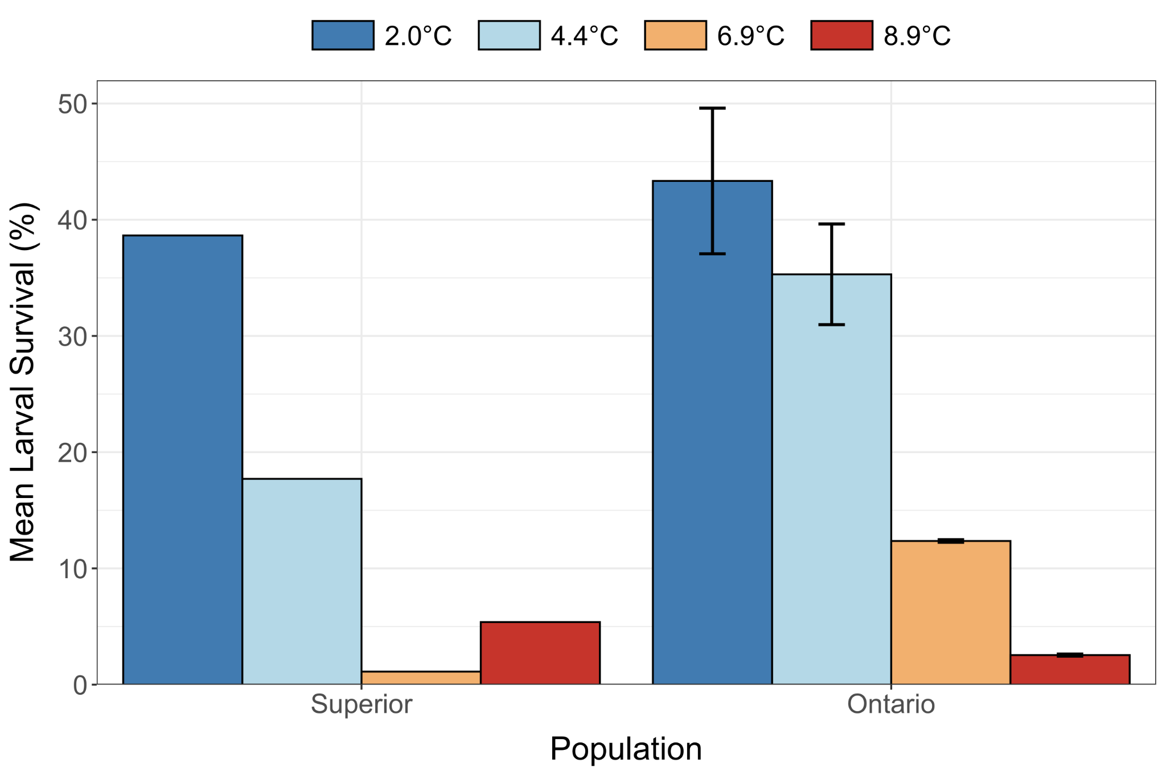

#### Figure 1. Mean larval survival (%) for larval cisco (*Coregonus artedi*) across replicate rearing tanks from Lakes Superior and Ontario incubated at 2.0, 4.4, 6.9, and 8.9°C. Error bars indicate standard error.

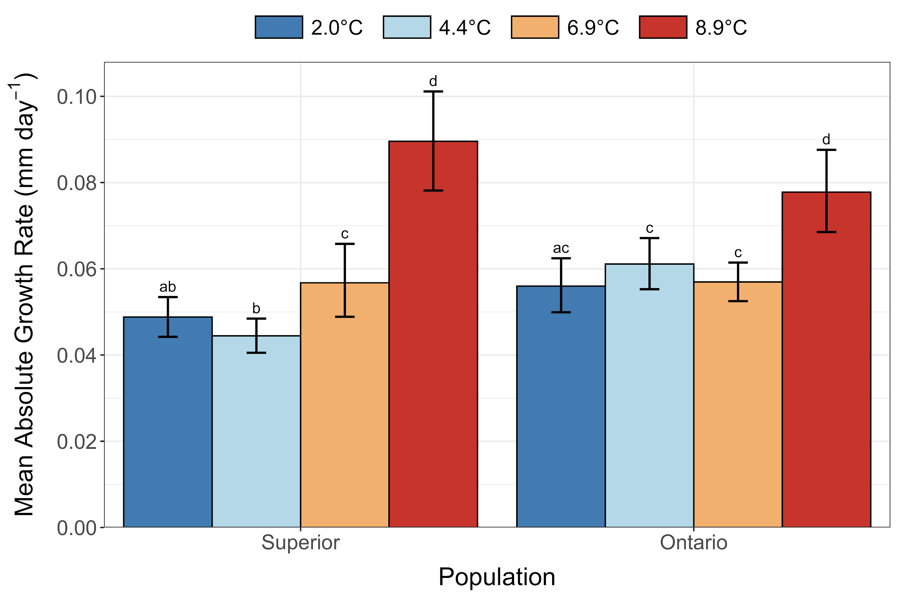

#### Figure 2. Mean absolute growth rates (mm day-1) for larval cisco (*Coregonus artedi*) from Lakes Superior and Ontario incubated at 2.0, 4.4, 6.9, and 8.9°C. Error bars indicate 95% bootstrapped confidence intervals. Letters indicate overlap of the observed mean absolute growth rate to the bootstrapped 95% confidence intervals of all pairwise comparisons.

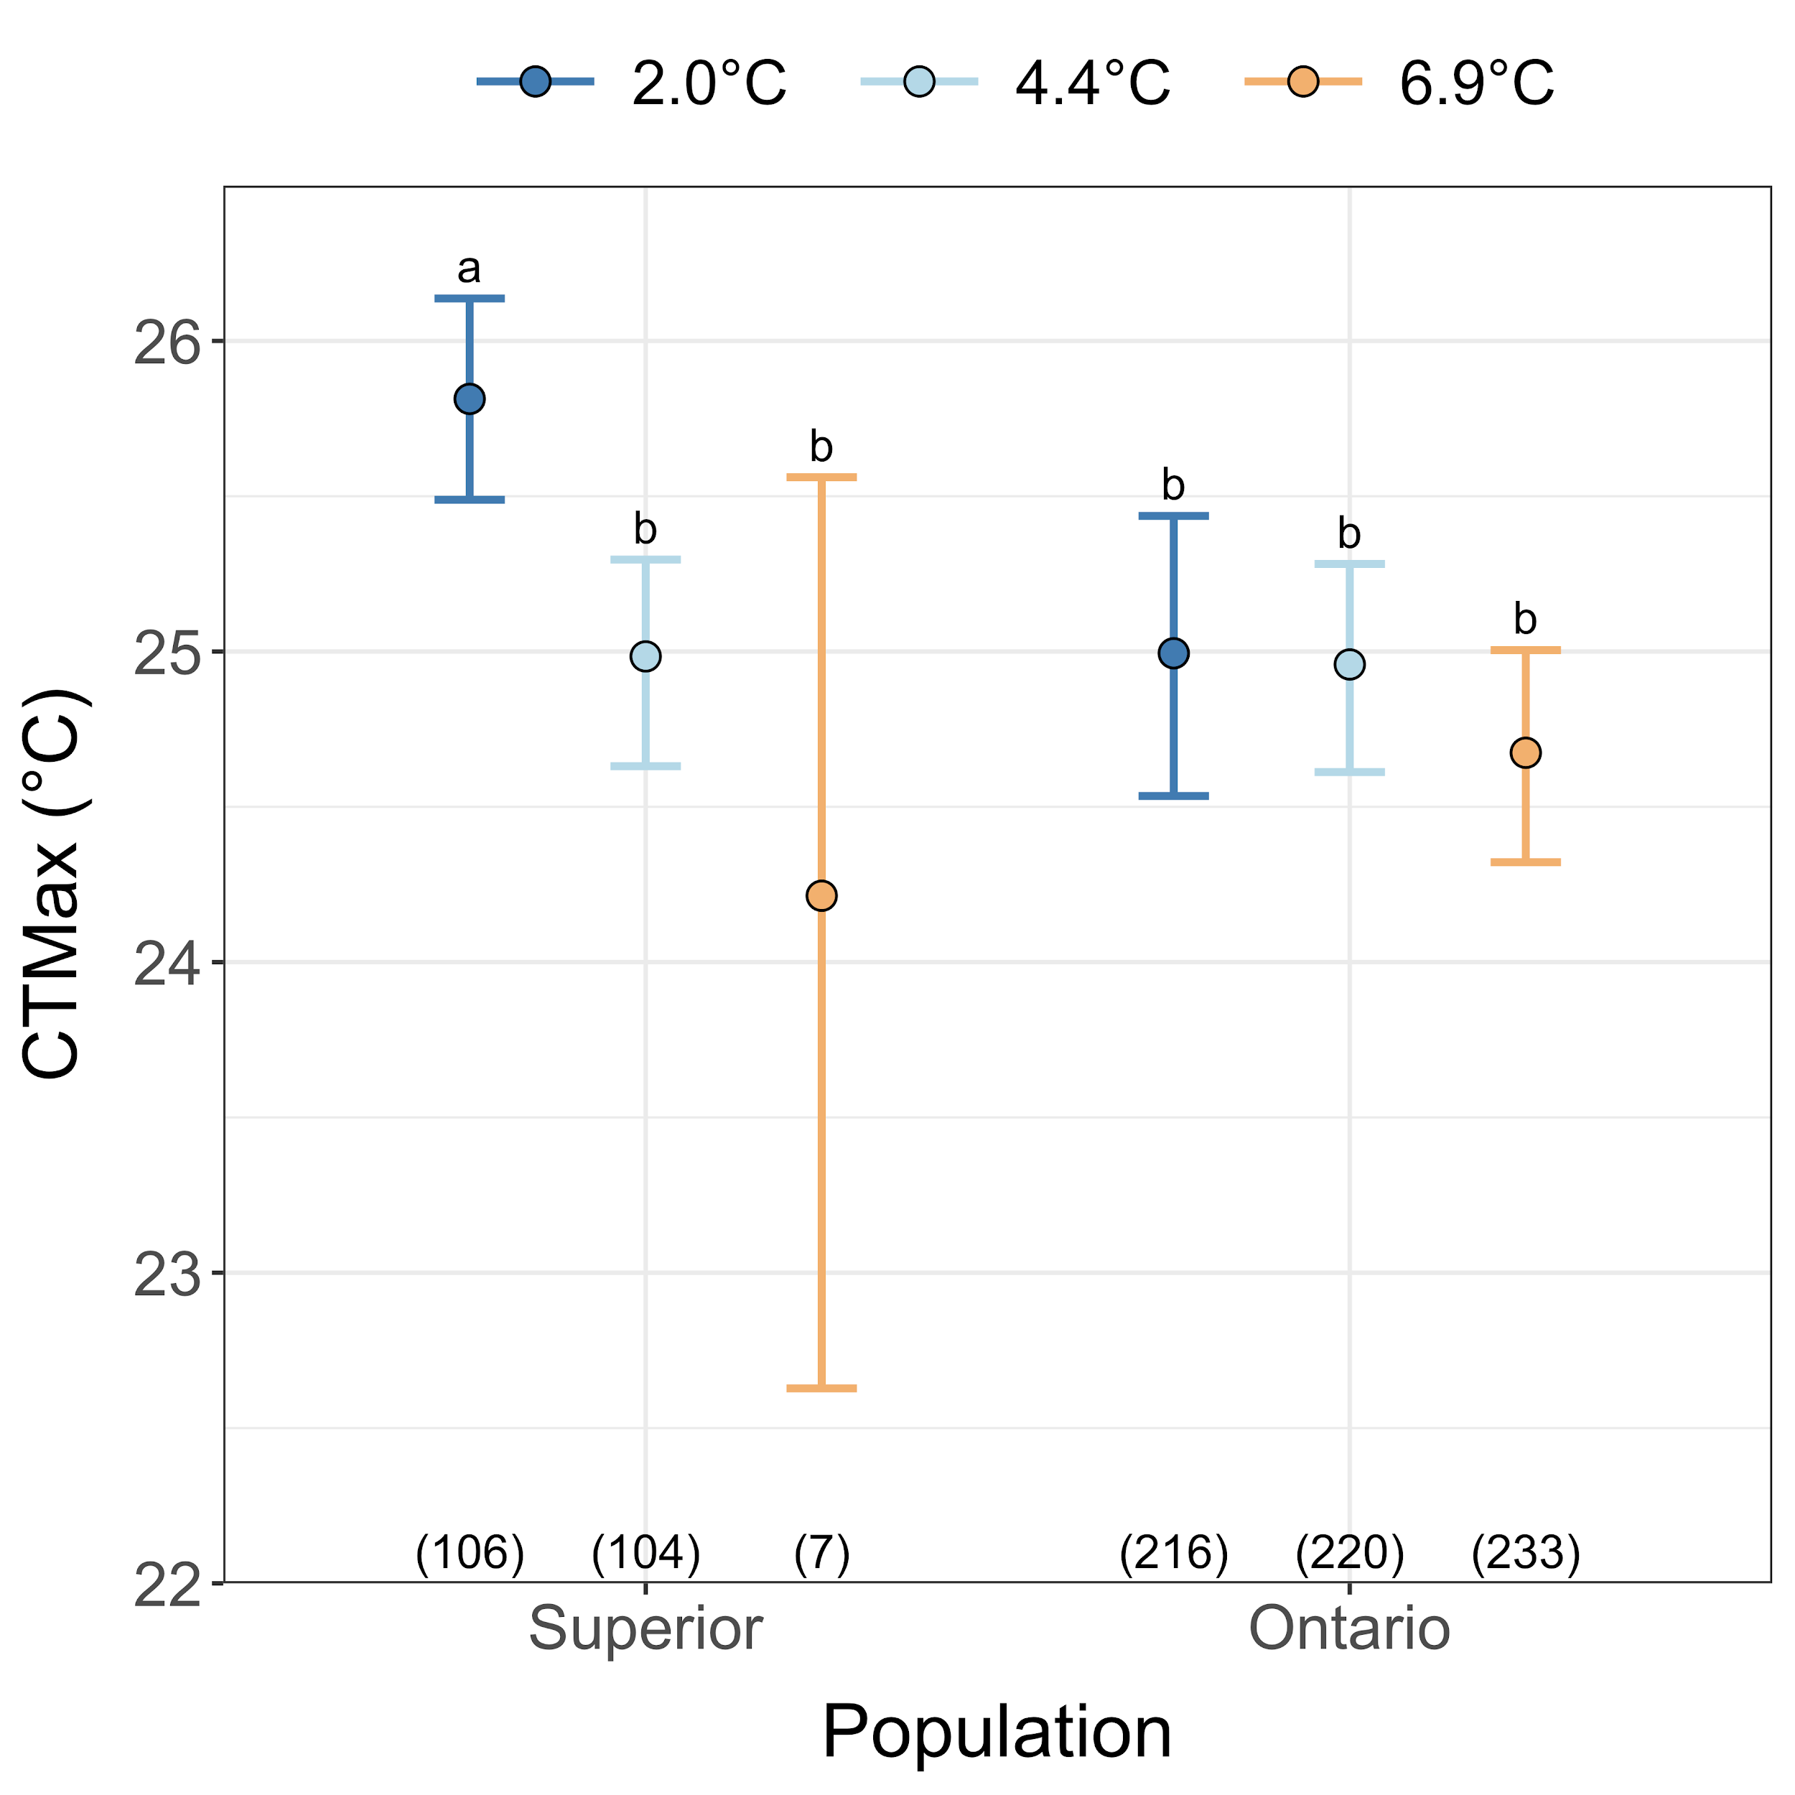

#### Figure 3. Critical thermal maxima (CTMax; °C) for larval cisco (*Coregonus artedi*) from Lakes Superior and Ontario incubated at 2.0, 4.4, and 6.9°C. Error bars indicate 95% bootstrapped confidence intervals. Letters indicate overlap of the observed CTMax to the bootstrapped 95% confidence intervals of all pairwise comparisons. Sample sizes are indicated in parentheses.