**Workout 2019-10-16, Template Pattern #2 Name: _____________________________**

Instructions: Work in pairs for this assignment. We’ll flip the room in assigning pairs. No individual assignments will be accepted. You will write code for the last question in this assignment. Answer all the other questions in this document and place it in the root directory of your code. Make sure the name of both of you appear at the top of this document and in a comment at the top of the class containing main for your code.

# Problem

Gilbarco manufactures most, if not all, pay at the pump gas stations. Gas stations have slightly different processes for pay at the pump, but all processes have basically the same sequence of actions. The ideas of the template pattern are the same as in your last workout; however, the template method will be more complex.

1. Carefully think through what you do when you purchase gas at different stations. Develop an abstract list of steps that describe a generalized process that can fit most any gas station. I’ll get you started:
   1. Initiate purchase process
   2. Swipe or insert card
   3. Validate accepted cards
      1. Each station will have its specific list of cards accepted.
      2. Validation sometimes requires additional data like zip code.
      3. Cancel purchase if card not accepted.
   4. Select carwash (if available at the station)
   5. Life handle
   6. Select gas type
   7. Begin pumping
   8. Finish Pump
   9. Process payment
   10. Receipt
   11. Thank you

You choose the rest through printing a receipt.

1. Given your list of steps in the process and using the Template pattern. Draw the UML for your solution.

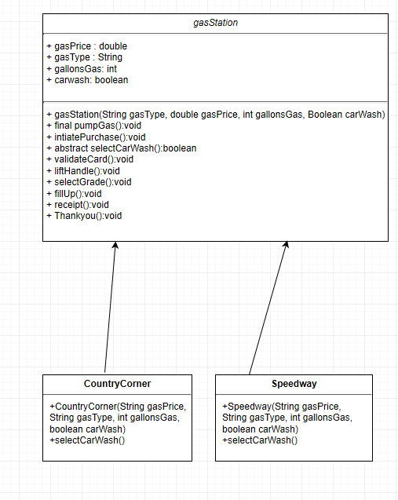

1. Now write the code for your solution and create two concrete gas stations. For most steps you will simply print a statement saying what happens, but some steps will require some user input. Let one out of three card verifications fail so you can test that code. Include a Client class with main that instantiates two concrete stations and pumps gas with each 5 times. Include print statements that clearly separate and briefly describes what station is being used.