Data Analysis Report: Lap Times of Selected Formula 1 Drivers – US Grand Prix 2023

Executive Summary

I provide a brief overview of my analysis, “Lap Times of Selected Formula 1 Drivers – US Grand Prix 2023”, using data sourced from the Pitwall App, Formula 1 Database (<https://pitwall.app/analysis/compare-lap-times>).

Objectives

1. To analyse fastest average lap times.
2. To analyse fastest lap time.

Key Findings

1. Fastest average lap time was set by Max Verstappen (101.38 secs), closely followed by Lewis Hamilton (101.42 secs), then Lando Norris (101.66 secs), Lance Stroll (102.13 secs), Charles Leclerc (102.22 secs) and Yuki Tsunoda (102.31secs).
2. Fastest lap time was set by Yuki Tsunoda (98.139 secs).

Data

Data Source

Data was sourced from the Pitwall App, Formula 1 Database (<https://pitwall.app/analysis/compare-lap-times>). The website has driver’s lap times from every Formula 1 race dating back to 1996.

Data Cleaning

I extracted the data from the website into Microsoft Excel. I deleted ‘DELTA’ as this was missing data. I placed ‘LAP’, ‘DRIVER’, ‘POSITION’ and ‘TIME’ into their own columns for better readability. I converted lap times from minutes and seconds into just seconds to compute the data from Python into my Violin Plot.

Methodology

I loaded my cleaned data from Microsoft Excel into a Python file using Visual Studio Code. I imported pandas to read the data and I imported Seaborn and matplotlib to create the violin plot.

I filtered out anomalies (lap times greater than 115 seconds) as these were pit stops and I filtered out the 1st lap as well.

I filtered pit stops out as I did not want to take into account the different team’s pit crew’s performance. I purely wanted to focus on race pace performance as this would give a more accurate representation of a driver’s true pace.

I filtered out the 1st lap because Lance Stroll started from the pit lane due to modifications made to his car after qualifying. This would make his Lap 1 much slower than the rest of the drivers and not reflect his true race pace. Also, Lap 1 is usually congested and chaotic – again, not fully representing true race pace.

I calculated the average lap times for each driver and then sorted them from fastest average lap time to slowest average lap time.

I created a violin plot to show these findings and assigned a colour to each driver’s violin plot. My selected driver’s were from 6 separate teams so I used the driver’s team colour for their violin plot. I did this because viewer’s quickly identify red with Ferrari and Turquoise with Mercedes for example and also it helps distinguish each driver’s violin plot from each other.

I then added the average lap times inside the violins, in the colour white to stand out. I then added the title and labels.

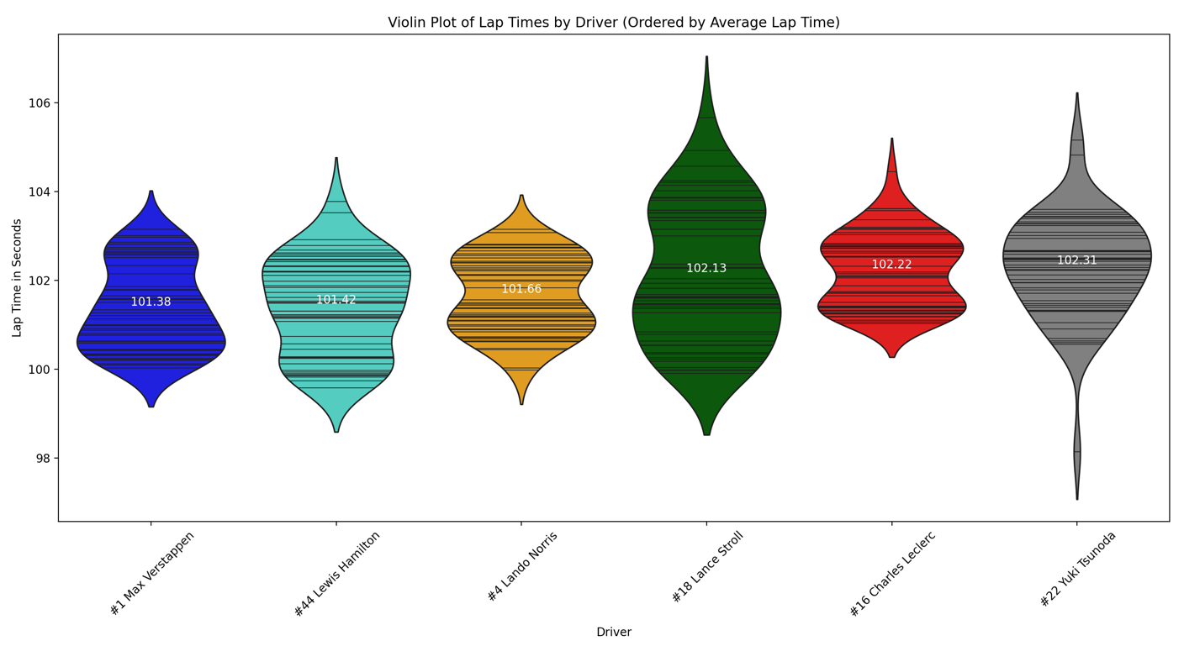

Data Analysis Findings & Discussion

Fastest average lap time was set by Max Verstappen (101.38 secs), closely followed by Lewis Hamilton (101.42 secs), then Lando Norris (101.66 secs), Lance Stroll (102.13 secs), Charles Leclerc (102.22 secs) and Yuki Tsunoda (102.31secs):

This finding reconfirms data from the rest of this season. Reconfirming Max Verstappen as the fastest driver as well as improved recent race pace from Lewis Hamilton and Lando Norris.

What is surprising is the small gap (0.04 secs) between Verstappen and Hamilton. We know from the race that Verstappen was managing break issues and that Hamilton had plank wear irregularities. This perhaps gave Hamilton an unrepresentative advantage – he was consequently disqualified from the race. We do not know how much advantage Hamilton had and how much disadvantage Verstappen had, but we can see from this data that the race pace of Hamilton’s Mercedes is certainly encouraging. Leclerc was also disqualified with the same infringement and we can see that Hamilton had a 0.8secs better average lap time than the Ferrari driver.

As established, Charles Leclerc also had a competitive advantage but this was not shown in his average lap time. His pace was far slower than Constructor rivals Mercedes and also a resurgent McLaren. He was also slower than Aston Martin and closer in race pace to an AlphaTauri. This is discouraging for Leclerc and Ferrari, reconfirming the idea that there are underlying issues with tyre wear and team strategy.

Lance Stroll’s data is particularly interesting. Aston Martin’s recent upgrades have had a detrimental effect to their race pace, therefore they made the decision to change their set up before this race. Consequently, he started from the pit lane but enjoyed excellent race pace (102.13 secs). It is clear that Aston Martin are figuring out how to get the best out of their new upgrades but this race pace suggests there is potential for them to be very competitive in future races.

Fastest lap time was set by Yuki Tsunoda (98.139 secs):

Yuki Tsunoda also enjoyed decent race pace with one of the slowest cars on the grid. His pace allowed him to make a tactical decision to pit for fastest lap at the end – and was duly rewarded. This is an impressive feat and shows a great tactical decision by Tsunoda and his AlphaTauri team. This is an indication that in a strong tactical environment, Tsunoda can cause positive disruption at the faster end of the field, amongst more established drivers and faster cars.

Conclusion & Recommendations

We can conclude that:

* Max Verstappen: Strong race pace, even while managing brake issues.
* Lewis Hamilton: Strong race pace. Plank wear irregularities resulting in disqualification may make data slightly unrepresentative of true race pace.
* Lando Norris: Strong race pace, continuing an upward trend.
* Lance Stroll: Surprisingly good race race, improved set up choice. Potential for higher finishes in future races.
* Charles Leclerc: Weak race pace. Plank wear irregularities resulting in disqualification may make data slightly unrepresentative of true race pace. Issues in race pace, strategy and tyre wear may indicate poor performance in future races.
* Yuki Tsunoda: Fastest lap, displaying strong tactics and excellent execution. A positive indication of impressive performances while being towards the front.

I recommend to pair this analysis with more lap time data from Grand Prix’s in the 2023 Formula 1 season. This is to ensure even more accurate predictions for driver’s future race pace.