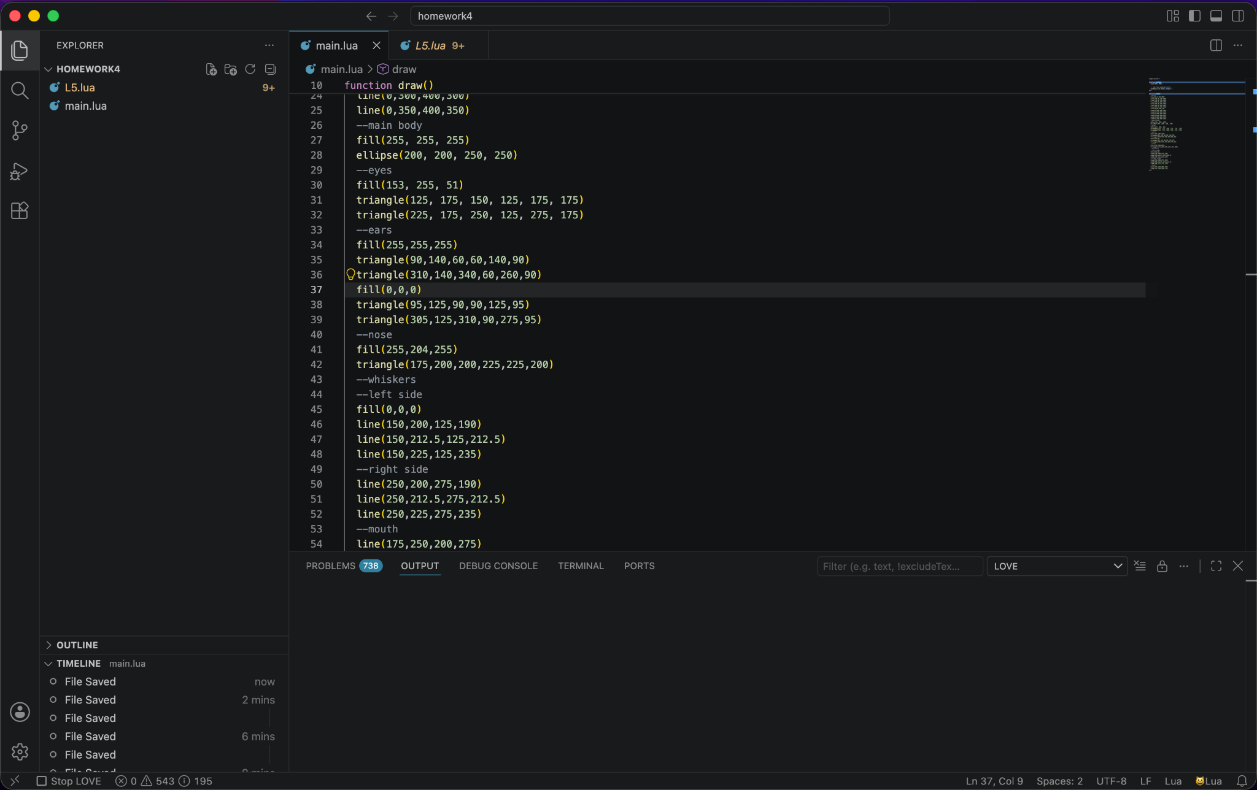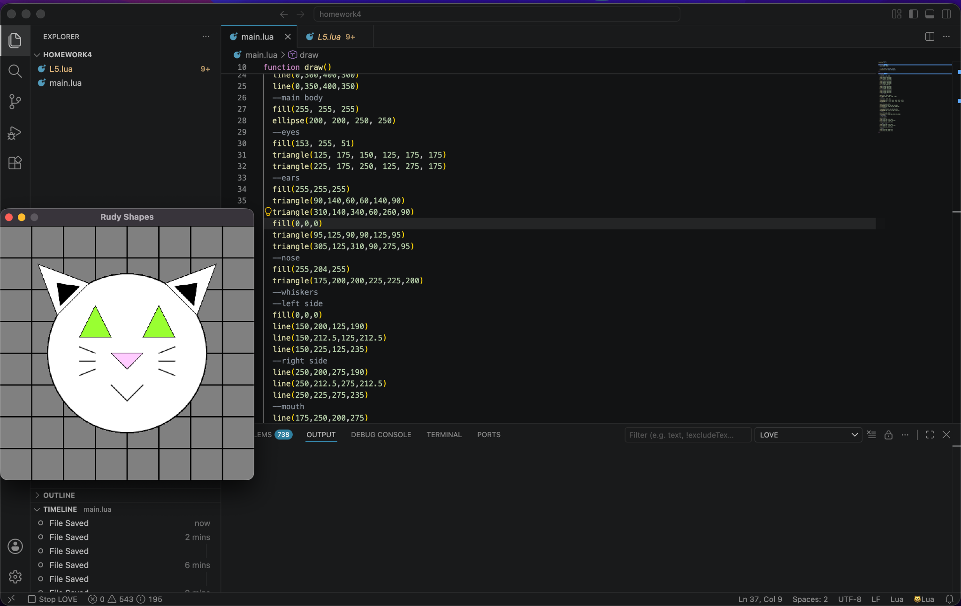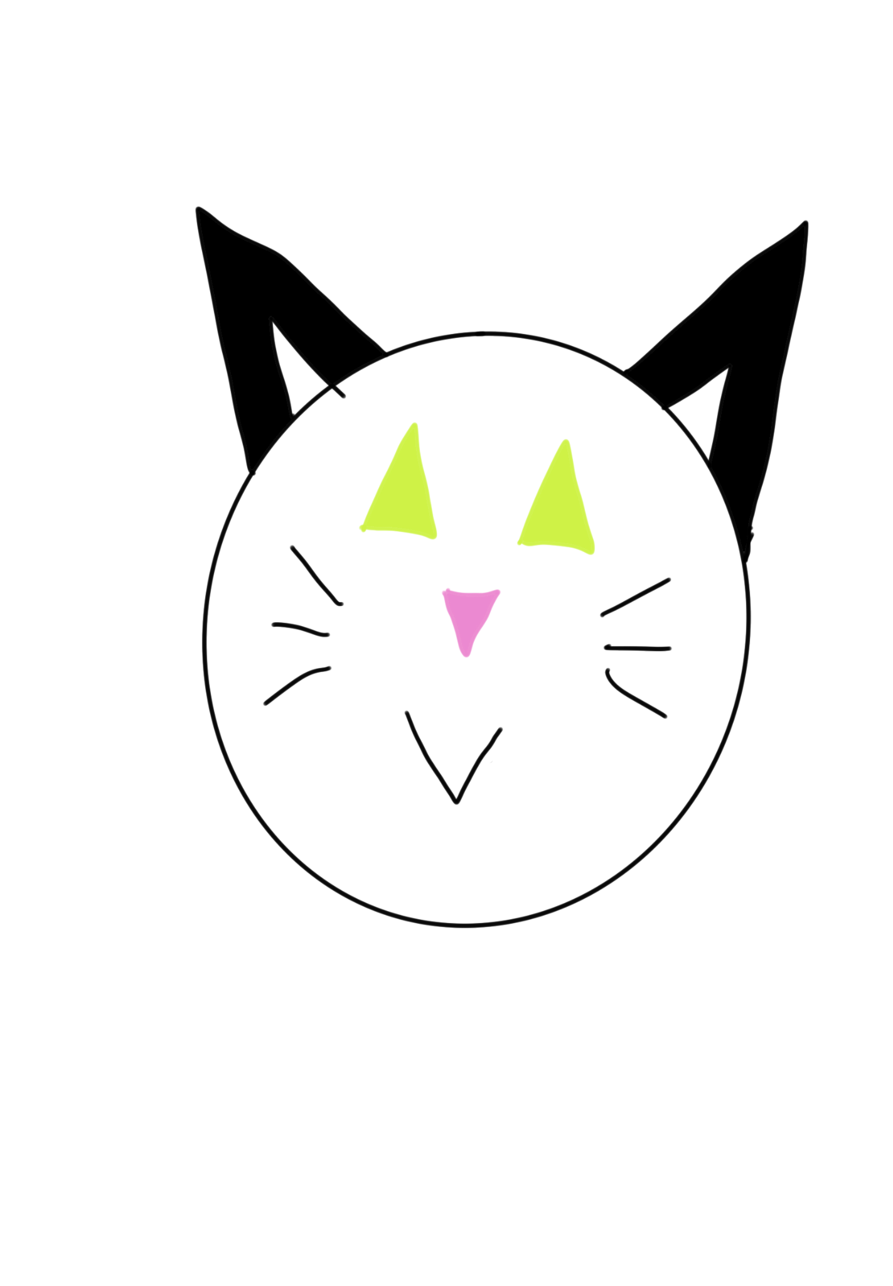
require("L5")

function setup()
size(400, 400)

-- Set the program title
windowTitle("Rudy Shapes")
end

function draw()
--grid
line(50,0,50,400)
line(100,0,100,400)
line(150,0,150,400)
line(200,0,200,400)
line(250,0,250,400)
line(300,0,300,400)
line(350,0,350,400)
line(0,50,400,50)
line(0,100,400,100)
line(0,150,400,150)
line(0,200,400,200)
line(0,250,400,250)
line(0,300,400,300)
line(0,350,400,350)
--main body
fill(255, 255, 255)
ellipse(200, 200, 250, 250)
--eyes
fill(153, 255, 51)
triangle(125, 175, 150, 125, 175, 175)
triangle(225, 175, 250, 125, 275, 175)
--ears
fill(255,255,255)
triangle(90,140,60,60,140,90)
triangle(310,140,340,60,260,90)
fill(0,0,0)
triangle(95,125,90,90,125,95)
triangle(305,125,310,90,275,95)
--nose
fill(255,204,255)
triangle(175,200,200,225,225,200)
--whiskers
--left side
fill(0,0,0)
line(150,200,125,190)
line(150,212.5,125,212.5)
line(150,225,125,235)
--right side
line(250,200,275,190)
line(250,212.5,275,212.5)
line(250,225,275,235)
--mouth
line(175,250,200,275)
line(225,250,200,275)
end

