Question 3

Point on the Z axis [0,0,3]

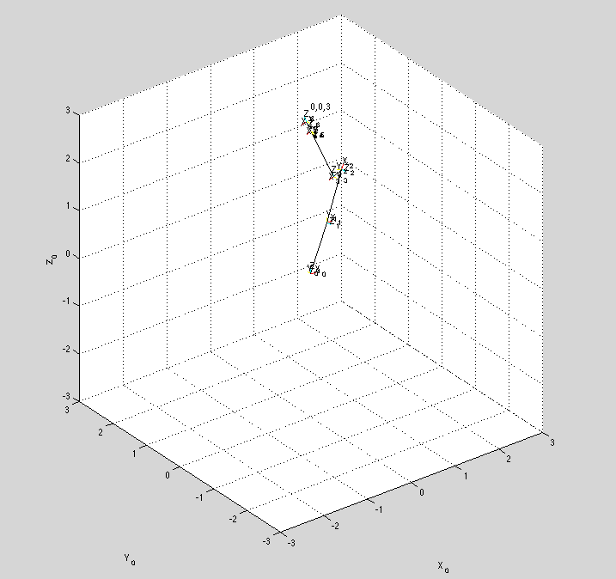

Angles (theta 1-6):

0

1.2495

2.3208

0

0

0

Random point [1,2,1]

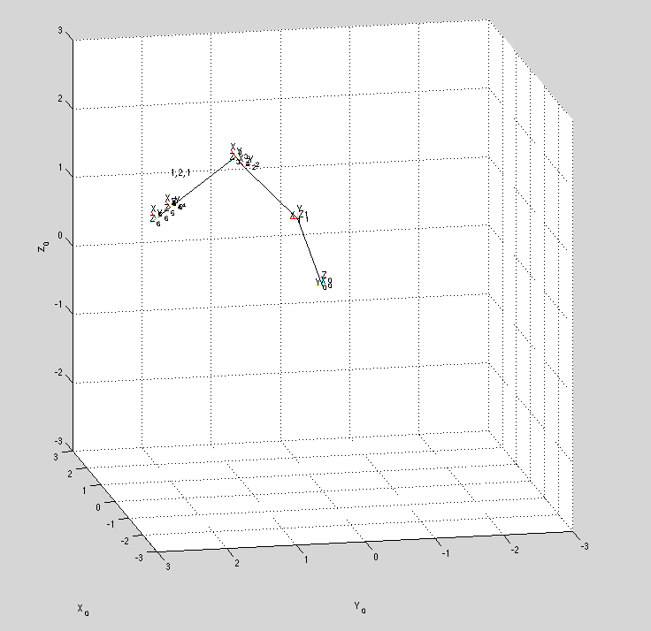

Angles (theta 1-6):

1.1071

0.7322

6.4222

0

0

0

Question 6:

Forward kinematics:

theta = [-pi/4;pi/2;-pi;pi/3;pi/4;3\*pi/2]

T =

0.3536 0.0670 -0.9330 -0.8742

0.3536 -0.9330 0.0670 0.6403

-0.8660 -0.3536 -0.3536 1.7045

0 0 0 1.0000

Computed Angles From M900INV:

2.3562

2.3672

5.4197

-2.0334

0.7536

-1.6557

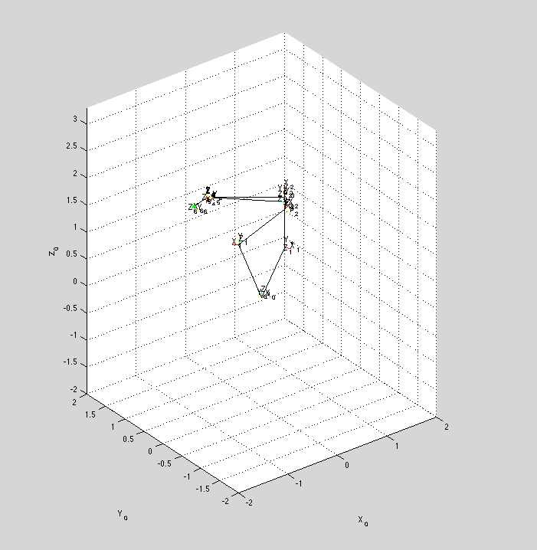

Forward Kinematics:

theta = [0;pi/2;2\*pi/3;pi/3;pi;3\*pi/10]

T =

0.8613 0.0905 0.5000 -0.2932

0.1045 -0.9945 -0.0000 -0.0000

0.4973 0.0523 -0.8660 2.7487

0 0 0 1.0000

Computed Angles From M900INV:

-3.1416

2.0947

6.6923

-3.1416

3.0275

-0.1047

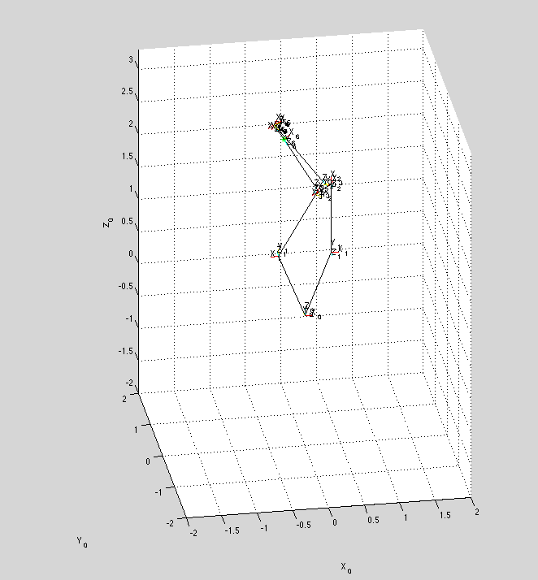

Question 7:

Given:

theta = [-pi/12;pi/2;pi;pi/3;-pi/4;3\*pi/5];

Created a transformation matrix then added 8 to the x value so that the point becomes unreachable

T = FWD(theta);

T(1,4) = T(1,4)+8;

This is the output

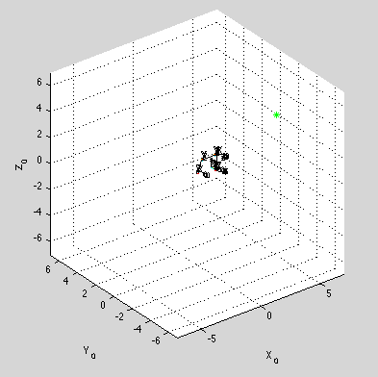

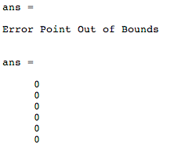

This makes sense because M900INV calls THREEINV which checks if the point is within the reachable bounds of the robot so it should spit out that the point is not reachable. M900INV then checks if THREEINV says the point is unreachable and if it is unreachable the angles are just left as 0.

Question 8:

Forward Kinematics

theta = [0;pi/2;2\*pi/3;pi/4;0;pi/4];

T =

-0.0000 0.8660 -0.5000 -0.5632

-1.0000 -0.0000 0.0000 0.0000

0.0000 0.5000 0.8660 3.2164

0 0 0 1.0000

Angles Computed from M900INV:

-3.1416

2.0947

6.6923

0

0

0

M900INV just chooses one set of angles that will satisfy the conditions that are given. It doesn’t matter that there are multiple solutions because Matlab atan2 just chooses one solution.

