Halloween Hideout

Taylor Rosby

CST-452 Capstone Project Requirements Document

Grand Canyon University

Instructor: Professor Mark Reha

Revision: 1

Date: April 4, 2020

**ABSTRACT**

Halloween Hideout is a 2D iOS platformer centered around surviving Halloween night, from the hours of 7 pm to 7 am. The game will consist of three (3) levels, each level will take place at different times in the game will get progressively harder. Throughout the player’s journey, they will collect candy pieces with a value ranging from one (1) to fifteen(15). These candy pieces will be used in the in-game store to buy costumes that will randomly appear throughout the levels. The player will be able to run, jump, and attack to clear the levels and complete the game.

|  |
| --- |
| History and Signoff Sheet |

**Change Record**

|  |  |  |
| --- | --- | --- |
| **Date** | **Author** | **Revision Notes** |
| 11/1/20 | Tay Rosby | Initial draft for review/discussion |
| 11.29.20 | Tay Rosby | Updated Character Design |
| 3.22.20 | Tay Rosby | Update Enemies and Playable Characters |
| 4/4/20 | Tay Rosby | Changed CoreData to NSUserDefaults. Updated Flow Chart |

|  |
| --- |
| **Overall Instructor Feedback/Comments** |

|  |
| --- |
| **Overall Instructor Feedback/Comments** |

**Integrated Instructor Feedback into Project Documentation**

Yes  No

**TABLE OF CONTENTS**

Functional Requirements 4

Non-Functional Requirements 5

Technical Requirements 7

Logical System Design 8

User Interface Design 10

Functional Requirements

The functional requirements for this project will be on the excel sheet provided.

**Use Cases**

Non-Functional Requirements

Below are the nonfunctional requirements for this project.

**User Stories**

|  |  |  |  |  |  |
| --- | --- | --- | --- | --- | --- |
| ID | Feature | As a(n) <actor> | I would like to <description> | So that <outcome> | Estimate |
|  | Platform Compatibility | As a System | I want the game to resize to 2778x1284 for an iPhone 12 Pro Max | So that the user has access to necessary buttons |  |
|  |  | As a System | I want the game to resize to 2532x1170 for an iPhone 12 Pro | So that the user has access to necessary buttons |  |
|  |  | As a System | I want the game to resize to 2532x1170 for an iPhone 12 | So that the user has access to necessary buttons |  |
|  |  | As a System | I want the game to resize to 2340x1080 for an iPhone 12 Mini | So that the user has access to necessary buttons |  |
|  |  | As a System | I want the game to resize to 2688x1242 for an iPhone 11 Pro Max | So that the user has access to necessary buttons |  |
|  |  | As a System | I want the game to resize to 2436x1125 for an iPhone 11 Pro | So that the user has access to necessary buttons |  |
|  |  | As a System | I want the game to resize to 1792x828 for an iPhone 11 | So that the user has access to necessary buttons |  |
|  |  | As a System | I want the game to resize to 2688x1242 for an iPhone XS Max | So that the user has access to necessary buttons |  |
|  |  | As a System | I want the game to resize to 2436x1125 for an iPhone XS | So that the user has access to necessary buttons |  |
|  |  | As a System | I want the game to resize to 1792x828 for an iPhone XR | So that the user has access to necessary buttons |  |
|  |  | As a System | I want the game to resize to 2436x1125 for an iPhone X | So that the user has access to necessary buttons |  |
|  |  | As a System | I want the game to resize to 1920x1080 for an iPhone 8 Plus | So that the user has access to necessary buttons |  |
|  |  | As a System | I want the game to resize to 1334x750 for an iPhone 8 | So that the user has access to necessary buttons |  |
|  |  | As a System | I want the game to resize to 1920x1080 for an iPhone 7 Plus | So that the user has access to necessary buttons |  |
|  |  | As a System | I want the game to resize to 1334x750 for an iPhone 7 | So that the user has access to necessary buttons |  |
|  |  | As a System | I want the game to resize to 1920x1080 for an iPhone 6s Plus | So that the user has access to necessary buttons |  |
|  |  | As a System | I want the game to resize to 1334x750 for an iPhone 6s | So that the user has access to necessary buttons |  |
|  |  | As a System | I want the game to resize to 1920x1080 for an iPhone 6 Plus | So that the user has access to necessary buttons |  |
|  |  | As a System | I want the game to resize to 1334x750 for an iPhone 6 | So that the user has access to necessary buttons |  |

Technical Requirements

Provided is a list of the languages, frameworks, libraries, and tools with their versions that will be used in this project.

Tools

* XCode v. 12.1

Languages

* Swift v. 5.3

Frameworks

* SwiftUI v. 5.3

Libraries

* SpriteKit v. 5.3
* CoreAudio v. 5.3
* CoreAudioKit v. 5.3
* CoreAnimation v. 5.3
* NSUserDefaults v. 5.3
* GameplayKit v. 5.3

Logical System Design

Provided are two figures describing the logical system of the application. The first diagram shows how the user’s input and data will interact with the application. The second is a high-level flowchart, showing how the user would play the game.

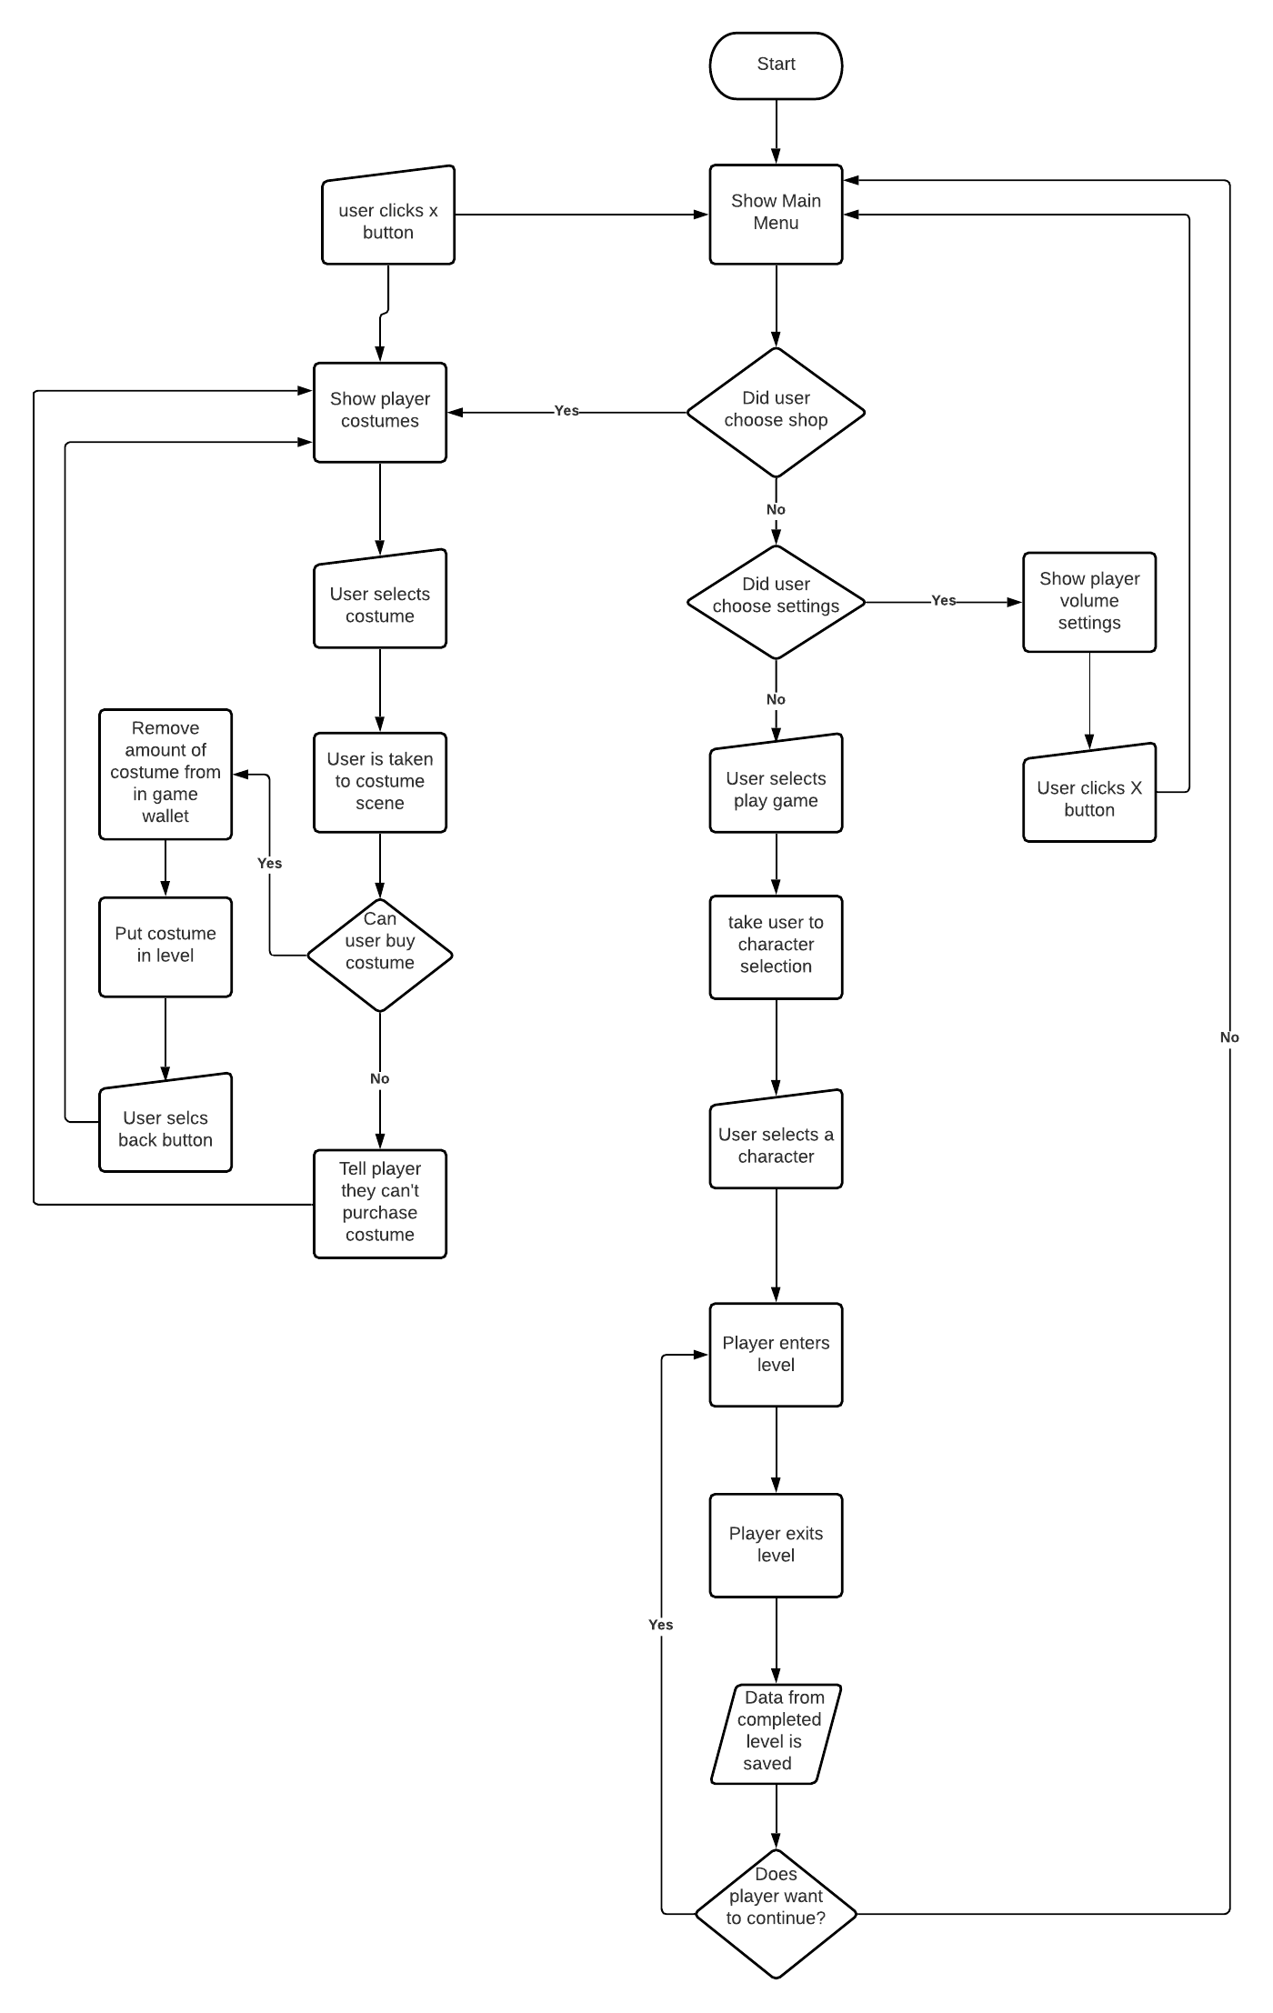

User Interface Design

Provided are User Interface diagrams showing the main hub of the game, storyboarding for a level in the game, and character, enemy, and costume designs.

|  |
| --- |
|  |
| The first-page user will see upon opening the application. One button will start the game, another will take them to the costume shop when unlocked, and the final button will go to the settings page |
|  |
| The settings page will allow the user to adjust the sound effects volume, background music volume, or the master volume. They can get back to the previous screen by clicking the back button. |
|  |
| This screen is the costume shop. Each costume will be placed in the image placeholder. They can scroll through the costumes by using the arrow on the bottom right. They can return to the previous screen by clicking the button in the bottom left. |
|  |
| This popup will appear when the user clicks on a costume. It shows another image of the costume, a description of the costume, a button to purchase the costume, and a button to return to the rest of the shop. |
|  |
| This is the character selection screen. The user will select a character and be taken to the first game screen. |
|  |
| In this scene, the user has been placed in the level. There is a candy to collect and an enemy to defeat. |
|  |
| The user collects the candy by jumping on the block, giving them 10 pieces of candy in their in-game wallet. |
|  |
| The user jumps off the block and approaches the enemy. |
|  |
| The user defeats the enemy and makes it to the end of the level. |

|  |  |
| --- | --- |
| Enemies   * Will need to be hit 1 time to be defeated   Movement   * Run * Jump * Attack * Idle * Die * Hurt |  |
| Costumes   * Provide varying buffs for 5 seconds   + Attack up, invincibility. Invisibility * Costumes can be bought in the costume shop * Costumes cost different amounts of candy * Will be placed into level once purchased by the player |  |
| Playable Characters   * Each character has the same stats and abilities * The player gets to choose what their character’s base costume is   Movement   * Run * Jump * Attack * Idle * Die * Hurt |  |